Supplementary materials

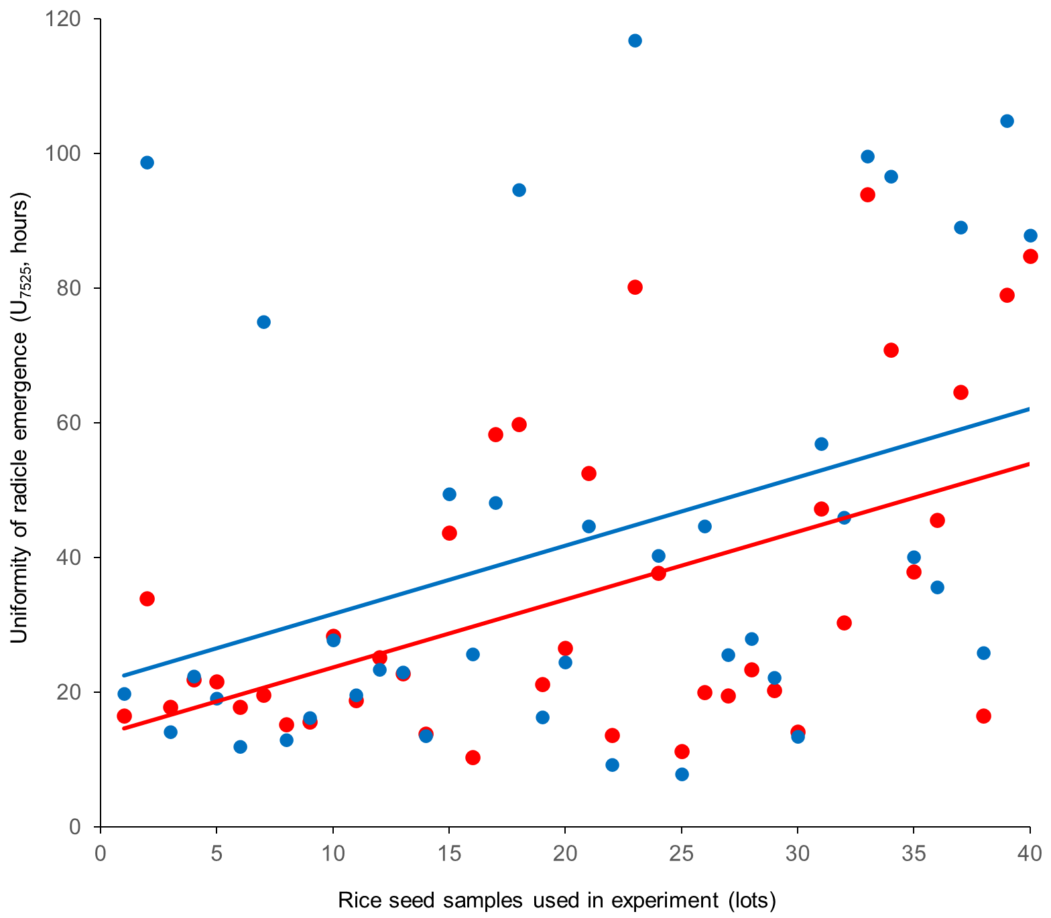

Supplementary material 1. Uniformity of radicle emergence of indica rice seeds after scoring using different methods, where red is visual analysis and blue is SVRice software. Linear regression lines are shown.

Supplementary material 2. Outputs of k-means cluster analysis of 40 rice seed samples used in the experiment. *

Code | Storage time (months) | Storage condition | Maximum radicle emergence (%) | Radicle emergence speed (hours) | Uniformity of radicle emergence (hours) | Area under the curve of the radicle emergence fitted curve | Mean radicle emergence time (hours) | K-mean (K=2) | K-mean (K=3)
A | 0 | Controlled | 98.5 | 75.1 | 28.5 | 209.3 | 78.8 | 1 | 1
B | 0 | Controlled | 80.8 | 184.3 | 107.5 | 86.0 | 164.0 | 2 | 2
C | 0 | Controlled | 95.8 | 80.5 | 22.9 | 194.7 | 82.8 | 1 | 1
D | 0 | Controlled | 92.3 | 76.8 | 31.1 | 192.3 | 81.1 | 1 | 1
E | 0 | Controlled | 91.3 | 78.1 | 27.9 | 193.0 | 81.5 | 1 | 1
F | 0 | Controlled | 95.3 | 57.4 | 20.7 | 218.3 | 60.1 | 1 | 1
G | 0 | Controlled | 91.0 | 90.2 | 83.7 | 171.7 | 97.8 | 1 | 3
H | 0 | Controlled | 93.8 | 68.9 | 21.7 | 201.1 | 71.3 | 1 | 1
A | 6 | Controlled | 100.0 | 64.1 | 25.0 | 229.7 | 67.5 | 1 | 1
B | 6 | Controlled | 100.0 | 76.1 | 36.5 | 215.5 | 81.9 | 1 | 1
C | 6 | Controlled | 99.8 | 69.9 | 28.3 | 223.9 | 73.8 | 1 | 1
D | 6 | Controlled | 100.0 | 66.6 | 32.1 | 227.5 | 71.8 | 1 | 1
E | 6 | Controlled | 96.0 | 73.2 | 31.7 | 212.1 | 77.9 | 1 | 1
F | 6 | Controlled | 100.0 | 49.5 | 22.3 | 245.3 | 53.1 | 1 | 1
G | 6 | Controlled | 98.3 | 80.0 | 58.2 | 202.2 | 89.6 | 1 | 1
H | 6 | Controlled | 98.5 | 59.6 | 34.4 | 217.1 | 65.6 | 1 | 1
A | 6 | Ambient | 97.3 | 114.8 | 56.9 | 167.6 | 120.6 | 1 | 3
B | 6 | Ambient | 92.3 | 144.7 | 103.4 | 129.1 | 138.2 | 2 | 3
C | 6 | Ambient | 99.5 | 83.4 | 25.0 | 210.6 | 86.0 | 1 | 1
D | 6 | Ambient | 99.5 | 72.3 | 33.2 | 221.1 | 77.5 | 1 | 1
E | 6 | Ambient | 98.0 | 104.0 | 53.4 | 181.2 | 110.9 | 1 | 3
F | 6 | Ambient | 99.0 | 54.5 | 18.0 | 238.4 | 56.8 | 1 | 1
G | 6 | Ambient | 48.3 | 219.3 | 155.6 | 42.3 | 154.7 | 2 | 2
H | 6 | Ambient | 98.8 | 80.5 | 49.0 | 203.7 | 88.5 | 1 | 1
A | 12 | Controlled | 98.0 | 74.9 | 16.6 | 206.6 | 76.3 | 1 | 1
B | 12 | Controlled | 97.0 | 88.4 | 53.4 | 191.9 | 96.6 | 1 | 1
C | 12 | Controlled | 99.3 | 79.4 | 34.3 | 208.2 | 84.3 | 1 | 1
D | 12 | Controlled | 99.5 | 77.1 | 36.7 | 208.5 | 82.9 | 1 | 1
E | 12 | Controlled | 95.5 | 78.2 | 30.9 | 195.8 | 82.4 | 1 | 1
F | 12 | Controlled | 100.0 | 61.0 | 22.1 | 230.2 | 63.9 | 1 | 1
G | 12 | Controlled | 94.3 | 102.2 | 65.6 | 166.6 | 109.9 | 1 | 3
H | 12 | Controlled | 100.0 | 77.7 | 54.7 | 202.7 | 85.1 | 1 | 1
A | 12 | Ambient | 72.3 | 203.8 | 108.3 | 66.0 | 173.7 | 2 | 2
B | 12 | Ambient | 48.0 | 195.9 | 105.3 | 48.5 | 170.4 | 2 | 2
C | 12 | Ambient | 98.8 | 112.0 | 48.9 | 177.2 | 117.8 | 1 | 3
D | 12 | Ambient | 98.8 | 89.2 | 44.4 | 200.3 | 95.8 | 1 | 1
E | 12 | Ambient | 75.0 | 198.4 | 97.8 | 72.8 | 178.0 | 2 | 2
F | 12 | Ambient | 98.8 | 71.5 | 34.6 | 217.7 | 77.0 | 1 | 1
G | 12 | Ambient | 4.5 | 214.4 | 113.6 | 4.3 | 171.5 | 2 | 2
H | 12 | Ambient | 93.5 | 133.4 | 96.6 | 143.1 | 129.8 | 2 | 3

* Values represent the arithmetic mean of radicle emergence indices from the SVRice package after storage for 0, 6 and 12 months under controlled and ambient conditions.

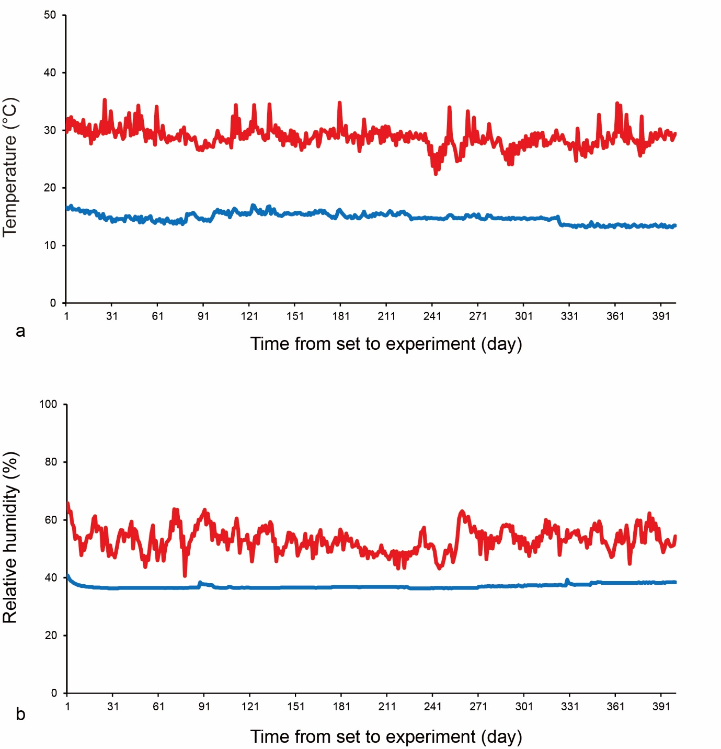

Supplementary material 3. Changes in a temperature and b relative humidity during storage under different conditions. Storage in GrainPro® bag and controlled atmosphere chamber (blue line), storage in polyethylene bag and ambient conditions on a laboratory bench (red line).

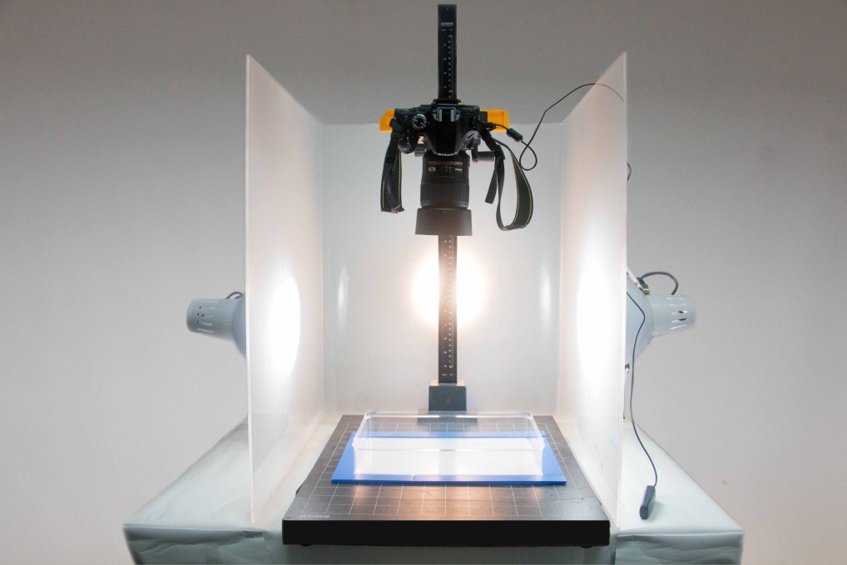

Supplementary material 4. Color imaging system used in the experiment. Device: Nikon D5200; lens: 40 mm f/2.8 G; focal length: 40 mm; focus mode: AF-S; aperture: f/16; shutter speed: 1/15 sec; exposure comp.: +1.7 EV; ISO sensitivity: ISO 1000; color space: sRGB; and filter: Nisi DW1 Wide Band Super Pro MC UV filter 52 mm.

