Supplementary information
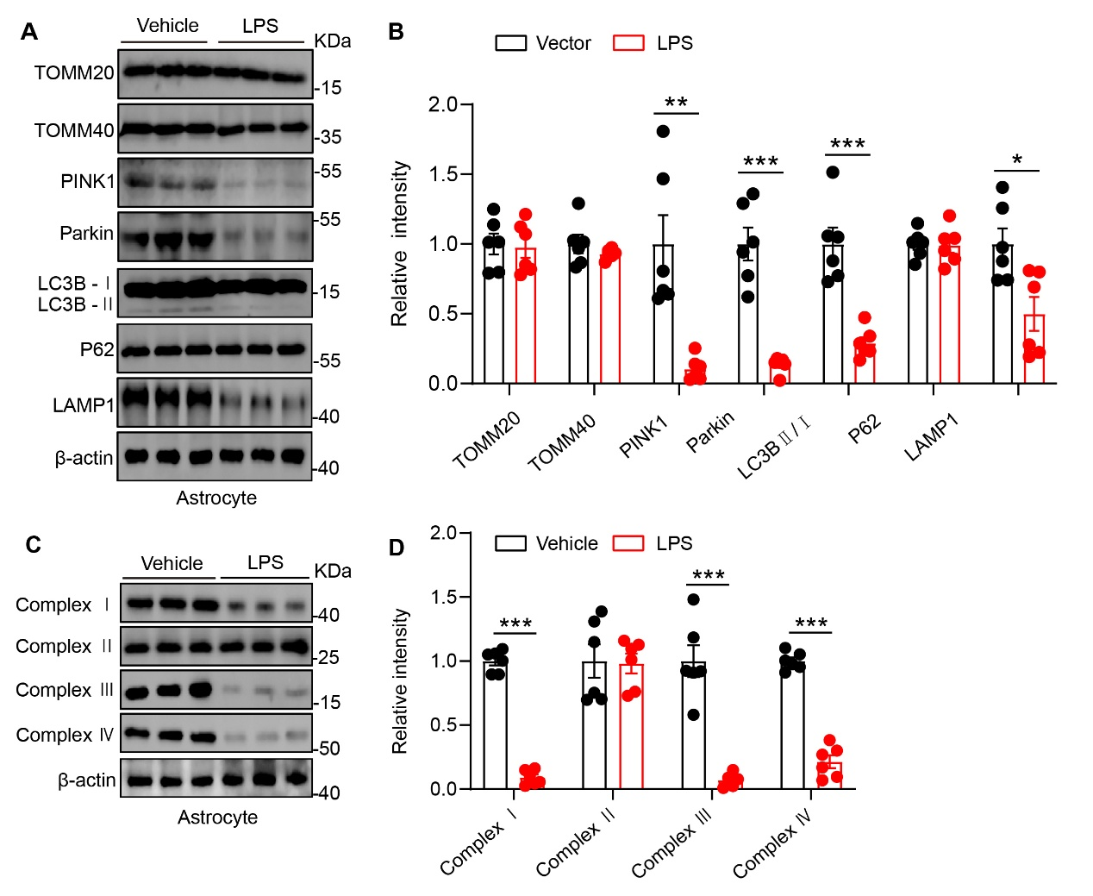
Supplementary Figure 1 Impaired mitophagy and mitochondrial electron transport chain in LPS-stimulated astrocytes.
(A and B) Western blotting analysis and quantification of hippocampal lysates probed for mitochondrial membrane proteins (TOMM20, TOMM40) and mitophagy-related markers (PINK1, Parkin, LC3B-I/II, p62, LAMP1) in primary cultured astrocytes treated with LPS or vehicle. N = 6 per group; unpaired Student’s t-test. (C and D) Western blotting analysis and quantification of mitochondrial electron transport chain complexes (I–IV) in primary cultured astrocytes treated with LPS or vehicle. N = 6 per group; unpaired Student’s t-test. Data are presented as mean ± SEM; *p < 0.05, **p < 0.01, ***p < 0.001.

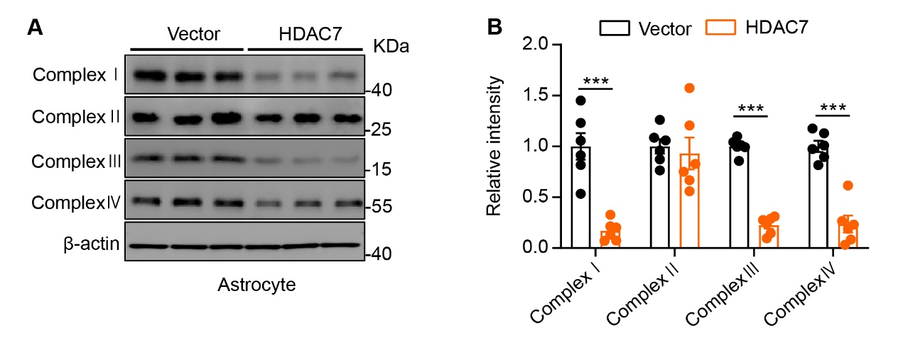
Supplementary Figure 2 HDAC7 overexpression impairs mitochondrial electron transport chain in cultured astrocytes.
(A and B) Western blotting analysis and quantification of mitochondrial respiratory chain complexes (I–IV) in primary cultured astrocytes overexpressed with HDAC7 or vector. N = 6 for each group, unpaired Student’s t test. Data are presented as the mean ± SEM, ***p < 0.001.

