Appendices
Appendix A

Fig. A1 Technical and scale efficiency comparisons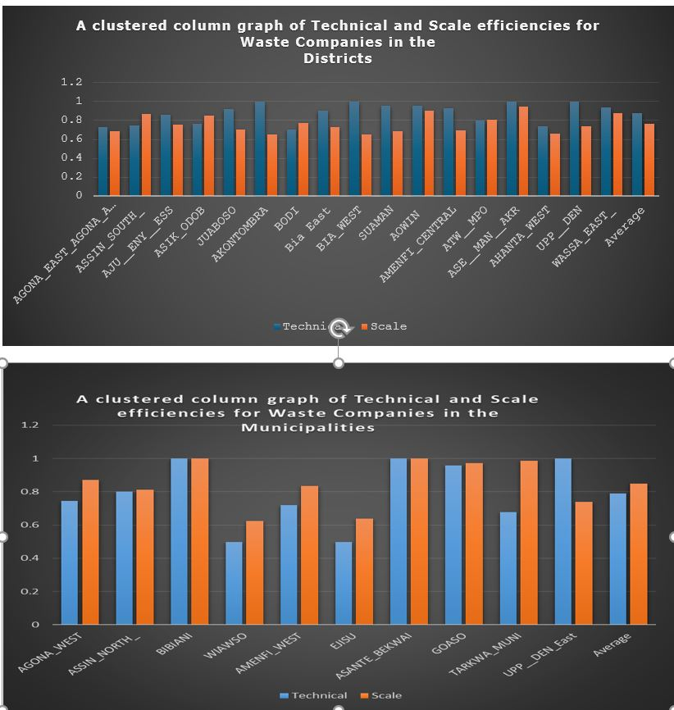

Fig. A2 Inputs and output slacks

The Theory of estimating efficiency (θ) - Input Oriented DEA /Multiplier Model
Let the technological production set be ѱ (consisting of inputs and outputs). If
j is the number of waste companies (DMUs) starting from j = 1,2, 3……., n
where m= total number of inputs starting from i = 1,2, 3……m are applied to produce s = non-negative total number of outputs starting from r = I,2,3,4,5……s
it implies x∈ R^{m}+ and ƴ ∈ R^{s}+. Based on this general theory, we define technology set for the input-output combination set is defined as:
ѱ = {(x, y) ∈ R+ s+m /x can produce y}
According to the CCR (1978) model (Charnes, Cooper, & Rhodes, 1978), efficiency is the maximum ratio of weighted outputs to weighted inputs, subject to the condition that similar ratios for every waste company (DMU) must be less than or equal to 100%.
Efficiency = minf₀ (U,V) $\sum_{i=1}^{m}{.} ViXi0$
⁻⁻⁻⁻⁻⁻⁻⁻⁻⁻⁻⁻⁻⁻⁻⁻⁻⁻⁻
$\sum_{r=1}^{s}{UrYr0}$

Subject to: minf₀ (U,V) $\sum_{i=1}^{m}{.} ViXi0$
⁻⁻⁻⁻⁻⁻⁻⁻⁻⁻⁻⁻⁻⁻⁻⁻⁻⁻⁻ ≥ 1 j= 1, …. n
$\sum_{r=1}^{s}{UrYr0}$

U_{r} V_{i} ≥ i =1….m r=1. …. s
The input-oriented multiplier FPP can be linearized by normalizing the weighted inputs (the denominator in the ratio) by one or any constant and minimizing the numerator
Fractional Linear programming:
Setting the constant which is the input = 1 normalizes the FPP to LPP
Constraint:
$\sum_{i=1}^{m}{.} ViXi0$ ₌ ₁
For input minimization the efficiency constant θ* = min θ
For a DMU O, the efficiency using the CCR model is found as the solution to the following the linear programming (Cooper et al., 2006):
$\sum_{i=1}^{n}{}$ ^{λ}_{j} ^{X}_{i0} ≤ θx_{i0} I = 1, …., m ^{…………….(1)}

$\sum_{j=1}^{n}{}$λ y_{ro} ≥ Y_{ro} r = 1, …,s ……….(2)

$\sum_{j=1}^{n}{}$λ_{j}(VRS) λ_{j} ≥0 j=1,…,n ………..(3)

For λj and λj ≥ 0

This set of linear equations is solved for each DMU, and the solution, θ*, provides a measure of the (Farrell) efficiency of DMUO relative to the set of DMUs evaluated. If θ*<1, then 1 − θ* represents the inputs' maximum radial reduction, which will still ensure that the given outputs are producible for DMUO (Brettenny & Sharp, 2016). This approach is consistent with the objective of this study, which is to find out how waste companies can reduce input consumption and obtain the same output level (Prieto et al., 2007). Because these waste companies operate in different districts and municipalities, the study did not apply the assumption under the CRS technology that all participating DMUs are assumed to perform at an optimal scale (Murillo-Zamorano, 2004). Therefore, the study applied the Banker-Charnes-Cooper BCC DEA model (Charnes, Cooper, & Rhodes, 1978), which allows for varying returns to scale (VRS)

Appendix B
Questionnaire for SWM
The items were rated on a five-point Likert scale: 1, strongly disagree; 2, disagree; 3, Prefer not to answer; 4, agree; 5, strongly agree
Variables |  | 1 | 2 | 3 | 4 | 5 | T
Technical and organizational structure.
The is an established environmental sanitation unit within the municipality with oversight responsibility in all sanitation matters called DESAP/MESAP. | TOSQ1.
People recruited into SWM have formal education and technical training | TOSQ2.
The sanitation office is fully equipped with the required human resource and other logistics/tools. | TOSQ3.
There is an organization chat that specifies each SWM team member's task and administrative procedures. | TOSQ4.
People working recruited in SWM in distict and municipal waste companies are poorly paid. | TOSQ5
The municipality often organizes workshops and training to enable members to perform effectively in their roles. | TOSQ6
Institutional Arrangements.
There are sanitation by-laws that regulates activities of solid waste management activities in the municipality. | IAQ1
The laws are reviewed at regular intervals to sufficiently address all and emerging functional areas in solid waste management. | IAQ2
The municipality has in place administrative mechanisms that reward and punish both employees that perform/underperform in their SWM responsibilities. | IAQ3
Motivation mechanisms have been designed to incentivize workers to work harder. | IAQ4
There are motivation mechanisms to encourage domestic consumers of sachet and bottle water to separate waste substances. | IAQ5
Social Context (PCQ)
People are punish for disobeying municipal/district sanitation by-laws | SAQ1
There are regular public education/interactions regarding solid waste management | SAQ2
Rewards are given to communities and villages which are clean or free from trash. | SAQ3
Motivation mechanisms have been designed to incentivize workers to work harder. | SAQ4
Public waste communal containers are placed at short distances from residential homes. | SAQ5
Cultural Context (CCQ)
People in the area have uncaring attitude regarding how waste is managed by the authorities. | CCQ1
People do not care so much about their environment
Members of the community like to manage solid waste in their own way irrespective of existing social arrangement | CCQ2
Community members feel the preserve of managing waste lies within the purview of municipalities and not their responsibility | CCQQ3
People prefer to burn solid waste where available than to dispose them using communal containers or private collection systems. | CCQQ4
Collection of solid waste is not regular and is often delayed | CCQQ5

