Supplemental Materials

Table S1 psychometric variable names
Psychometric variable | HCP-YA variable name | HCP Lifespan (HCP-A and HCP-D) variable name
Total cognition | CogTotalComp_AgeAdj | nih_totalcogcomp_ageadjusted in cogcomp01.txt
Crystallized cognition | CogCrystalComp_AgeAdj | nih_crycogcomp_ageadjusted in cogcomp01.txt
Fluid cognition | CogFluidComp_AgeAdj | nih_fluidcogcomp_ageadjusted in cogcomp01.txt
Cognitive flexibility | CardSort_AgeAdj | nih_dccs_ageadjusted in dccs01.txt
Inhibitory control | Flanker_AgeAdj | nih_flanker_ageadjusted in flanker01.txt
Reading | ReadEng_AgeAdj | read_acss in orrt01.txt
Picture vocabulary | PicVocab_AgeAdj | tpvt_acss in tpvt01.txt
Processing speed | ProcSpeed_AgeAdj | nih_patterncomp_ageadjusted in pcps01.txt
Working memory | ListSort_AgeAdj | age_corrected_standard_score in lswmt01.txt
Anger affect | AngAffect_Unadj | anger_ts in prang01.txt
Fear affect | FearAffect_Unadj | anx_ts in preda01.txt
Sadness | Sadness_Unadj | add_ts in predd01.txt
Positive affect | PosAffect_Unadj | tlbxpa_ts in tlbx_wellbeing01.txt
Emotional support | EmotSupp_Unadj | nih_tlbx_tscore in tlbx_emsup01.txt
Friendship | Friendship_Unadj | nih_tlbx_tscore in tlbx_friend01.txt
Loneliness | Loneliness_Unadj | soil_ts in prsi01.txt
Neuroticism (NEO) | NEOFAC_N | neo2_score_ne in nffi01.txt
Extraversion (NEO) | NEOFAC_E | neo2_score_ex in nffi01.txt
Openness (NEO) | NEOFAC_O | neo2_score_op in nffi01.txt
Agreeableness (NEO) | NEOFAC_A | neo2_score_ag in nffi01.txt
Conscientiousness (NEO) | NEOFAC_C | neo2_score_co in nffi01.txt

B. Supplementary Figures

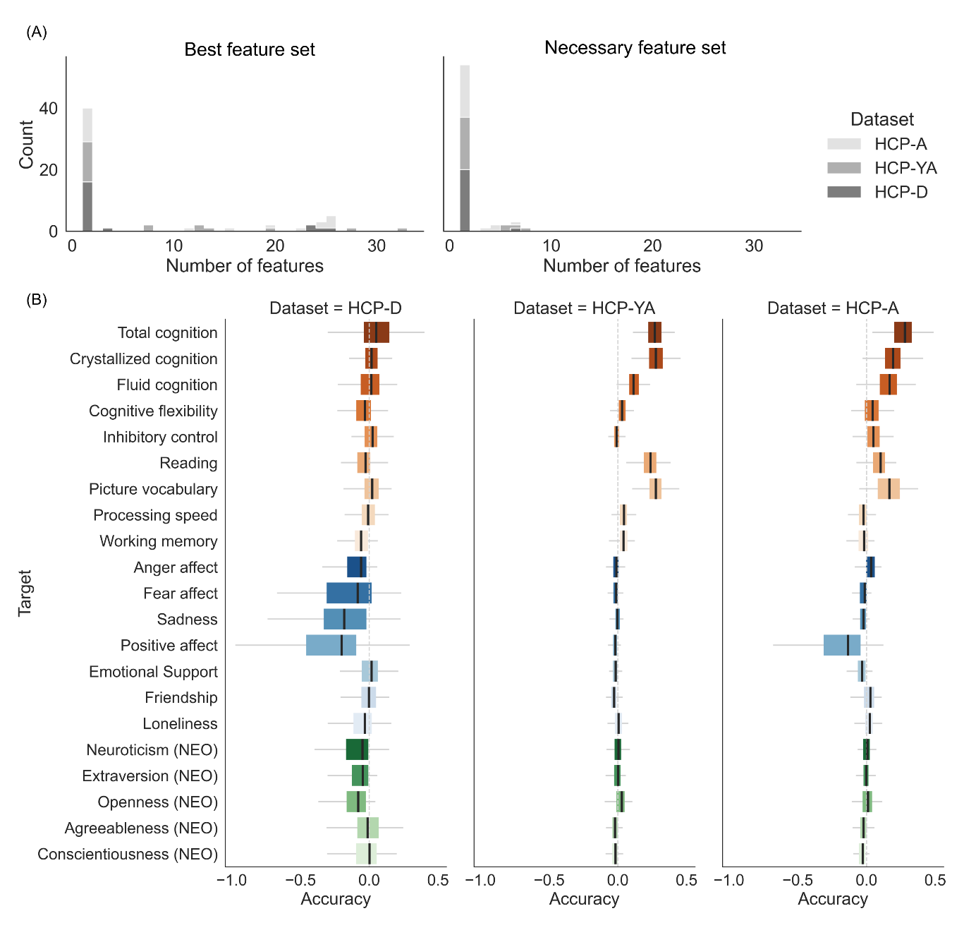
Figure S1. (A) Distribution of number of feature types integrated for the “best” feature sets (left column) and for the “necessary” feature sets (right column) based on COD accuracy. Colour hues represent which dataset the feature sets were found in. (B) Prediction accuracies by COD for each psychometric variable using the integrated-features set model corresponding the “necessary” feature set, in each cohort. The light grey vertical line in each column marks the accuracy of R = 0.

