Supplementary Figures
Figure S1: Map of collection sites, numbers correlate to values in supplementary table 1.
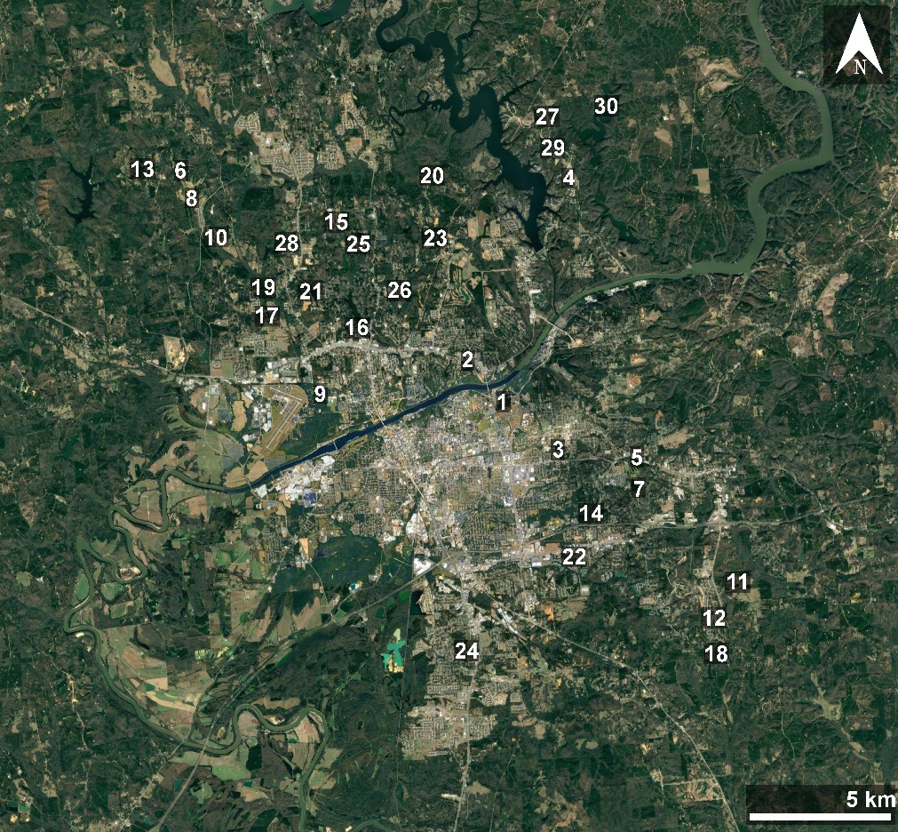

Figure S2: Rarefaction curves for showing observed OTUs for all samples by sequencing depth. We rarefied samples to 4000 reads (red arrow).
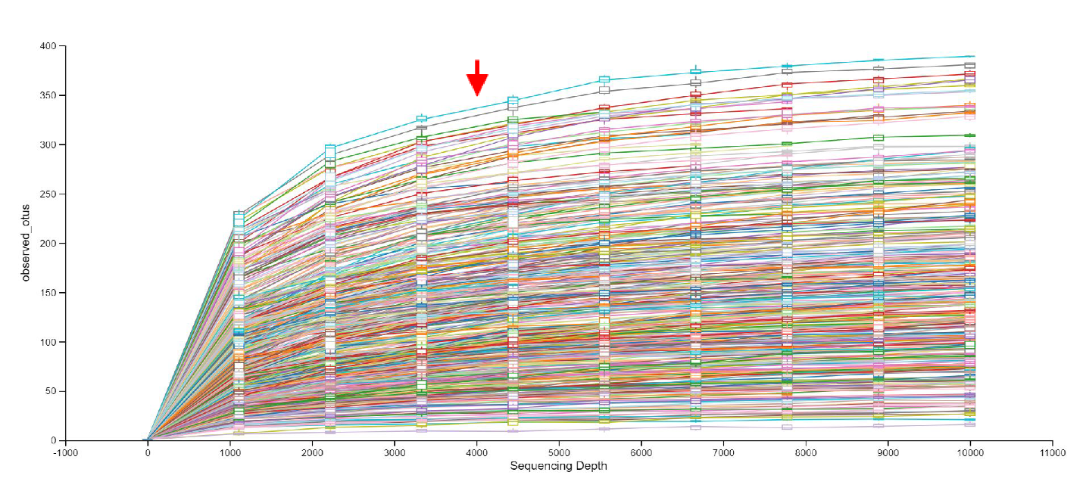

Figure S3: Biplot showing PCA ordination on water chemistry variables. Sites with high disturbance (>45% disturbed) are shown by black points, and those with low disturbance (<45% disturbed) are shown by gray points. Means ± SD can be found in supplementary table 1.
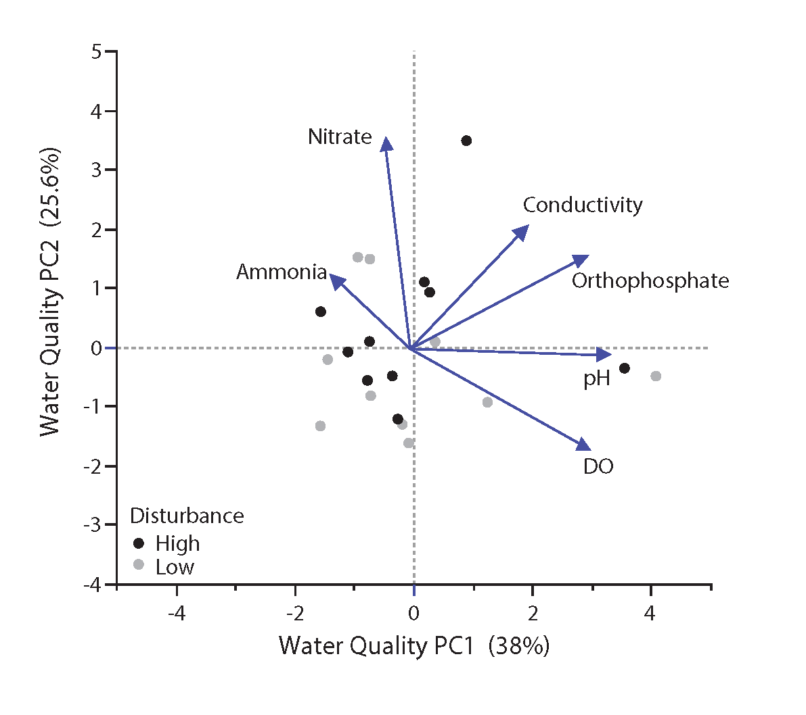
Figure S: Spider plot showing microbiome similarity (Bray-Curtis distance) for L. catesbeianus from sites with low (grey) and high (black) levels of habitat disturbance.
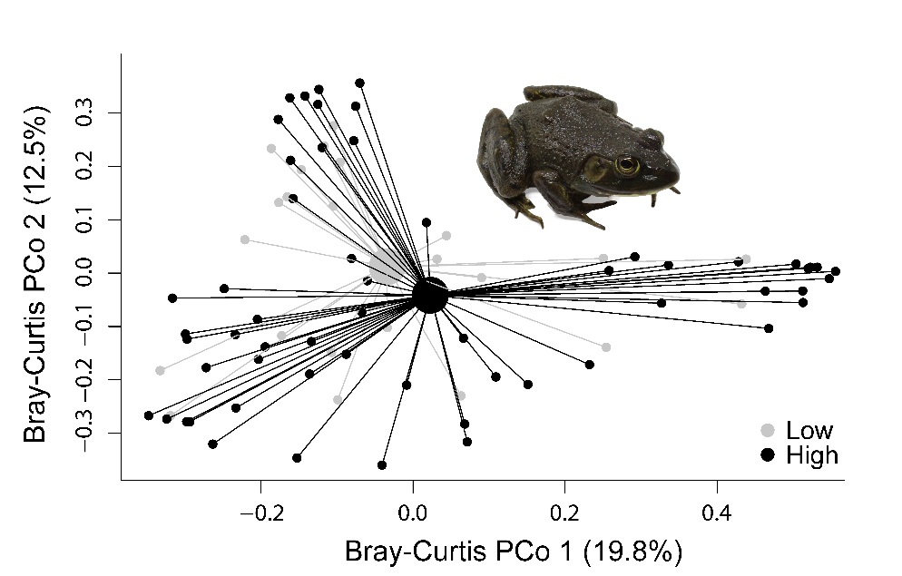
Figure S5: Spider plot showing microbiome similarity (Bray-Curtis distance) between frog (grey) and water (black) samples.
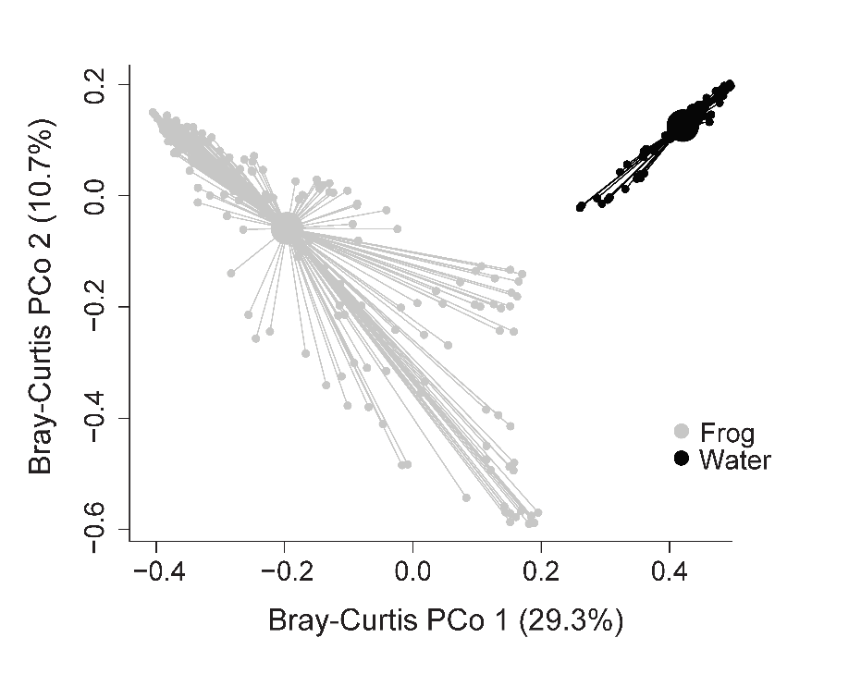

Supplementary Tables
Table S1: Frog capture data by site and species, with number of frogs captured at each location. Also included is percent disturbance, dissolved oxygen (DO) levels, conductivity, pH, ammonia levels, orthophosphate levels, and nitrate levels from each site. Values consist of mean ± standard deviation.
Site | Host species | # captured | Disturbance (%) | DO (%) | Conductivity (µS/cm) | pH | Ammonia (µg/L) | Orthophosphate (µg/L) | Nitrate (µg/L)
1 | - |  | 69.10% | 143.33 ± 20.3 | 150.37 ± 2.89 | 7.64 ± 0.08 | 40.24 ± 12.22 | 12.58 ± 6.05 | 616.82 ± 47.19
2 | L. catesbeianus | 13 | 86.35% | 74.97 ± 6.79 | 97.6 ± 0.3 | 7.31 ± 0.06 | 74.75 ± 31.26 | 26.44 ± 17.23 | 96.78 ± 3.4
3 | - |  | 52.15% | 76.2 ± 2.7 | 117.23 ± 0.67 | 7.13 ± 0.09 | 156.24 ± 69.7 | 9.21 ± 1.92 | 202.92 ± 30.22
4 | L. catesbeianus | 11 | 60.11% | 158 ± 5.47 | 63.33 ± 2.35 | 9.38 ± 0.09 | 82.13 ± 6.31 | 106.8 ± 3.52 | 30.92 ± 6.74
5 | - |  | 78.64% | 91.27 ± 2.42 | 34.03 ± 0.21 | 7.54 ± 0.75 | 819.54 ± 166.84 | 6.68 ± 0.98 | 44.65 ± 6.55
6 | A. crepitans | 15 | 42.92% | 94.9 ± 13.52 | 28.7 ± 0.7 | 7.1 ± 0.42 | 617.7 ± 68.87 | 9.44 ± 1.34 | 94.6 ± 9.52
7 | - |  | 67.63% | 110.2 ± 4.48 | 64.17 ± 0.12 | 6.32 ± 0.13 | 252.94 ± 143.23 | 6.13 ± 0.87 | 27.81 ± 10.1
8 | A. crepitans | 15 | 70.98% | 89.4 ± 1.13 | 52.37 ± 34.84 | 6.81 ± 0.17 | 843 ± 50.26 | 10.05 ± 0.58 | 94.7 ± 19.32
9 | A. crepitans | 16 | 59.73% | 70.4 ± 12.08 | 90.37 ± 7.72 | 7.17 ± 0.07 | 259.75 ± 327.44 | 108.79 ± 158.82 | 330.3 ± 516.91
10 | - |  | 58.66% | 96.07 ± 2.26 | 34.93 ± 0.29 | 6.71 ± 0.28 | 69 ± 12.66 | 10.86 ± 2.06 | 51.07 ± 9.2
11 | A. crepitans | 18 | 42.52% | 96.97 ± 5.15 | 36 ± 0.96 | 7.91 ± 0.16 | 67.27 ± 6.74 | 8.66 ± 0.83 | 16.4 ± 4.36
12 | A. crepitans | 16 | 41.11% | 160.93 ± 17.7 | 95.97 ± 3.85 | 7.05 ± 0.18 | 14.69 ± 3.53 | 7.44 ± 0.9 | -10.43 ± 3.14
13 | A. crepitans | 13 | 50.80% | 72 ± 7.55 | 50.53 ± 14.52 | 6.8 ± 0.09 | 95.65 ± 13.19 | 10.22 ± 2.2 | 100.85 ± 19.71
14 | - |  | 35.38% | 81.33 ± 2.8 | 90.13 ± 0.06 | 7.39 ± 0.03 | 78.43 ± 33.48 | 9.9 ± 1.12 | 324.51 ± 12.95
15 | A. crepitans | 17 | 47.61% | 71.7 ± 29.74 | 61.3 ± 1.66 | 6.99 ± 0.21 | 32.08 ± 12.84 | 11.33 ± 2.85 | 104.37 ± 7.32
16 | - |  | 67.36% | 87 ± 3.54 | 95.6 ± 0.17 | 6.9 ± 0.05 | 272.59 ± 27.81 | 9.01 ± 0.64 | 143.74 ± 8.25
17 | L. catesbeianus | 5 | 52.19% | 77.63 ± 2.43 | 79.03 ± 0.38 | 8.08 ± 0.2 | 216.32 ± 14.82 | 18.02 ± 1.35 | 169.42 ± 16.51
18 | A. crepitans | 16 | 42.06% | 92.37 ± 5.82 | 62 ± 0.53 | 6.51 ± 0.31 | 29.97 ± 17.98 | 6.01 ± 1.33 | -5.24 ± 27.53
19 | - |  | 32.99% | 136.63 ± 6.3 | 110.47 ± 1.1 | 9.39 ± 0.06 | 471.37 ± 148.7 | 8.67 ± 0.31 | 41.75 ± 6.48
20 | L. catesbeianus | 8 | 13.92% | 124.47 ± 6.4 | 62.17 ± 1.7 | 7.65 ± 0.08 | 195.03 ± 108.58 | 15.7 ± 4.73 | 149.12 ± 3.13
21 | - |  | 25.06% | 84.5 ± 3.63 | 37.03 ± 10.26 | 7.21 ± 0.11 | 496.54 ± 44.45 | 22.71 ± 11.23 | 39.35 ± 9.12
22 | - |  | 75.43% | 86.23 ± 13.16 | 97.3 ± 0.36 | 7.06 ± 0.15 | 34.48 ± 6.7 | 7.7 ± 0.14 | 28.32 ± 3.72
23 | L. catesbeianus | 7 | 37.39% | 107.7 ± 2.46 | 34.73 ± 0.06 | 7.83 ± 0.26 | 25.58 ± 5.09 | 6.05 ± 0.31 | -13.21 ± 14.41
24 | A. crepitans | 10 | 73.58% | 88.6 ± 2.61 | 44.73 ± 0.15 | 6.84 ± 0.34 | 59.4 ± 9.19 | 42.09 ± 46.66 | 46.58 ± 16.83
25 | A. crepitans | 20 | 50.63% | 106.47 ± 13.21 | 52.63 ± 0.29 | 7.19 ± 0.07 | 21.6 ± 3.05 | 4.76 ± 0.77 | -8.33 ± 14.7
26 | L. catesbeianus | 15 | 25.20% | 92.07 ± 11.2 | 53.53 ± 0.32 | 6.73 ± 0.25 | 53.3 ± 8.39 | 9.52 ± 1.77 | 357.72 ± 20.4
27 | L. catesbeianus | 13 | 38.81% | 190.37 ± 34.53 | 85.07 ± 12.7 | 9.55 ± 0.36 | 46.53 ± 8.32 | 77.43 ± 13.37 | 44.87 ± 5.09
28 | L. catesbeianus | 12 | 32.13% | 92.9 ± 12.35 | 36.6 ± 0.2 | 5.82 ± 0.21 | 35.57 ± 26.61 | 4.76 ± 0.98 | -8.44 ± 27.88
29 | L. catesbeianus | 16 | 42.05% | 64.43 ± 8.09 | 83.9 ± 2.27 | 7.15 ± 0.2 | 217.72 ± 11.76 | 5.8 ± 1.2 | 204.28 ± 8.01
30 | A. crepitans | 7 | 7.35% | 100.73 ± 6.19 | 35.6 ± 0.78 | 6.05 ± 0.29 | 75.43 ± 12.32 | 8.69 ± 3.52 | 14.71 ± 7.02

Table S2: Linear mixed-effects model rankings.
(a) Response: Bd prevalence
A. crepitans
Model | R² | RMSE | AICc | Δ AICc
Number of OTUs | 0.204 | 0.178 | 1.631 | 0.000
Environmental bacteria PCo1 | 0.156 | 0.183 | 2.224 | 0.592
Habitat disturbance | 0.094 | 0.190 | 2.924 | 1.292
Environmental PC2 | 0.091 | 0.190 | 2.955 | 1.324
Temperature | 0.077 | 0.192 | 3.110 | 1.479

L. catesbeianus
Model | R² | RMSE | AICc | Δ AICc
Temperature | 0.358 | 0.211 | 6.048 | 0.000
Habitat disturbance | 0.164 | 0.241 | 8.428 | 2.380
Environmental bacteria PCo1 | 0.127 | 0.246 | 8.817 | 2.769
Environmental PC1 | 0.043 | 0.257 | 9.638 | 3.590
Number of OTUs | 0.001 | 0.263 | 10.023 | 3.975

(b) Response: Bd loads
A. crepitans
Model | R² | RMSE | AICc | Δ AICc
Number of OTUs | 0.1967 | 1.0327 | 36.7904 | 0.000
Habitat disturbance | 0.1601 | 1.0560 | 37.2363 | 0.4459
Temperature | 0.0859 | 1.1016 | 38.0821 | 1.2917
Environmental PC1 | 0.0059 | 1.1488 | 38.9217 | 2.1313
Environmental bacteria PCo1 | 0.0007 | 1.1518 | 38.9736 | 2.1832

L. catesbeianus
Model | R² | RMSE | AICc | Δ AICc
Number of OTUs | 0.2632 | 1.0278 | 34.5729 | 0.000
Environmental PC2 | 0.2459 | 1.0399 | 34.7825 | 0.2096
Environmental PC1 | 0.1159 | 1.1259 | 36.2132 | 1.6403
Habitat disturbance | 0.1043 | 1.1333 | 36.3309 | 1.758
Environmental bacteria PCo1 | 0.0922 | 1.1409 | 36.4516 | 1.8787

(c) Response: Microbiome dispersion (Bray-Curtis)
A. crepitans
Model | R² | RMSE | AICc | Δ AICc
Habitat disturbance | 0.615 | 0.051 | -23.239 | 0.000
Number of OTUs, Habitat disturbance | 0.733 | 0.046 | -20.891 | 2.348
Environmental bacteria PCo1, Habitat disturbance | 0.639 | 0.053 | -17.862 | 5.377
Habitat disturbance, Environmental PC1 | 0.620 | 0.055 | -17.360 | 5.879
Habitat disturbance, Temperature | 0.619 | 0.055 | -17.330 | 5.909

L. catesbeianus
Model | R² | RMSE | AICc | Δ AICc
Environmental PC2 | 0.414 | 0.036 | -25.936 | 0.000
Environmental bacteria PCo1, Environmental PC2 | 0.656 | 0.030 | -23.533 | 2.403
Habitat disturbance | 0.199 | 0.042 | -23.121 | 2.815
Temperature, Environmental PC2 | 0.639 | 0.030 | -23.088 | 2.848
Temperature | 0.085 | 0.045 | -21.918 | 4.018

Table S3: Results of linear mixed-effects models.
(a) Response: Bd prevalence
A. crepitans
Predictor | Estimate | Std. Error | X² | p | VIF
Number of OTUs | 0.007 | 0.009 | 0.682 | 0.409 | 1
Whole model: R² = 0.20
L. catesbeianus
Predictor | Estimate | Std. Error | X² | p | VIF
Temperature | -0.198 | 0.096 | 4.604 | 0.0319* | 1
Whole model: R² = 0.36

(b) Response: Bd loads
A. crepitans
Predictor | Estimate | Std. Error | t | p | VIF
Number of OTUs | 0.020 | 0.014 | 1.40 | 0.1990 | 1
Whole model: R² = 0.65
L. catesbeianus
Predictor | Estimate | Std. Error | t | p | VIF
Number of OTUs | -0.011 | 0.007 | -1.58 | 0.1578 | 1
Whole model: R² = 0.26

(c) Response: Microbiome dispersion (Bray-Curtis)
A. crepitans
Predictor | Estimate | Std. Error | t | p | VIF
Habitat disturbance | 0.510 | 0.143 | 12.79 | 0.0072* | 1
Whole model: R² = 0.62
L. catesbeianus
Predictor | Estimate | Std. Error | t | p | VIF
Environmental PC2 | 0.024 | 0.0107 | 4.95 | 0.0615 | 1
Whole model: R² = 0.41

Table S4: Results of simplified piecewise structural equation models.
A. crepitans
Response | Predictor | Estimate | Std. error | DF | Crit. Value | p | Std. estimate
Bd prevalence | Habitat disturbance | -1.288 | 0.440 | 6 | -2.927 | 0.026 | -0.822
Bd prevalence | Environmental bacteria PCo1 | -0.618 | 0.240 | 6 | -2.582 | 0.042 | -0.671
Bd prevalence | Environmental PC2 | 0.071 | 0.034 | 6 | 2.055 | 0.086 | 0.524
Bray-Curtis dispersion | Habitat disturbance | 0.510 | 0.143 | 8 | 3.576 | 0.007 | 0.784
Environmental bacteria PCo1 | Habitat disturbance | -0.760 | 0.538 | 8 | -1.412 | 0.196 | -0.447
Environmental PC2 | Habitat disturbance | 4.767 | 3.742 | 8 | 1.274 | 0.238 | 0.411
~Bd prevalence | ~Bray-Curtis dispersion | 0.221 | - | 10 | 0.600 | 0.284 | 0.221
Whole model: Fisher's C = 0; p = 1; AIC = 34.00
Response | R²
Bd prevalence | 0.21
Bray-Curtis dispersion | 0.66
Environmental bacteria PCo1 | 0.35
Environmental PC2 | 0.06

L. catesbeianus
Response | Predictor | Estimate | Std. error | DF | Crit. Value | p | Std. estimate
Bd prevalence | Temperature | -0.055 | 0.028 | 7 | -1.975 | 0.089 | -0.598
Bray-Curtis dispersion | Environmental PC2 | 0.024 | 0.011 | 7 | 2.225 | 0.062 | 0.644
Environmental bacteria PCo1 | Temperature | 0.035 | 0.012 | 6 | 2.909 | 0.027 | 0.536
Environmental bacteria PCo1 | Environmental PC1 | 0.045 | 0.017 | 6 | 2.719 | 0.035 | 0.501
Environmental PC1 | Temperature | 0.456 | 0.213 | 7 | 2.138 | 0.070 | 0.629
~Bd prevalence | ~Bray-Curtis dispersion | -0.263 | - | 9 | -0.666 | 0.265 | -0.263
Whole model: Fisher's C = 10.65; p = 0.83; AIC = 36.65
Response | R²
Bd prevalence | 0.36
Bray-Curtis dispersion | 0.41
Environmental bacteria PCo1 | 0.88
Environmental PC1 | 0.76

