Table 1 | Optimization of the reaction conditions from solvents, palladium, base and N-arylsulfonylhydrazones
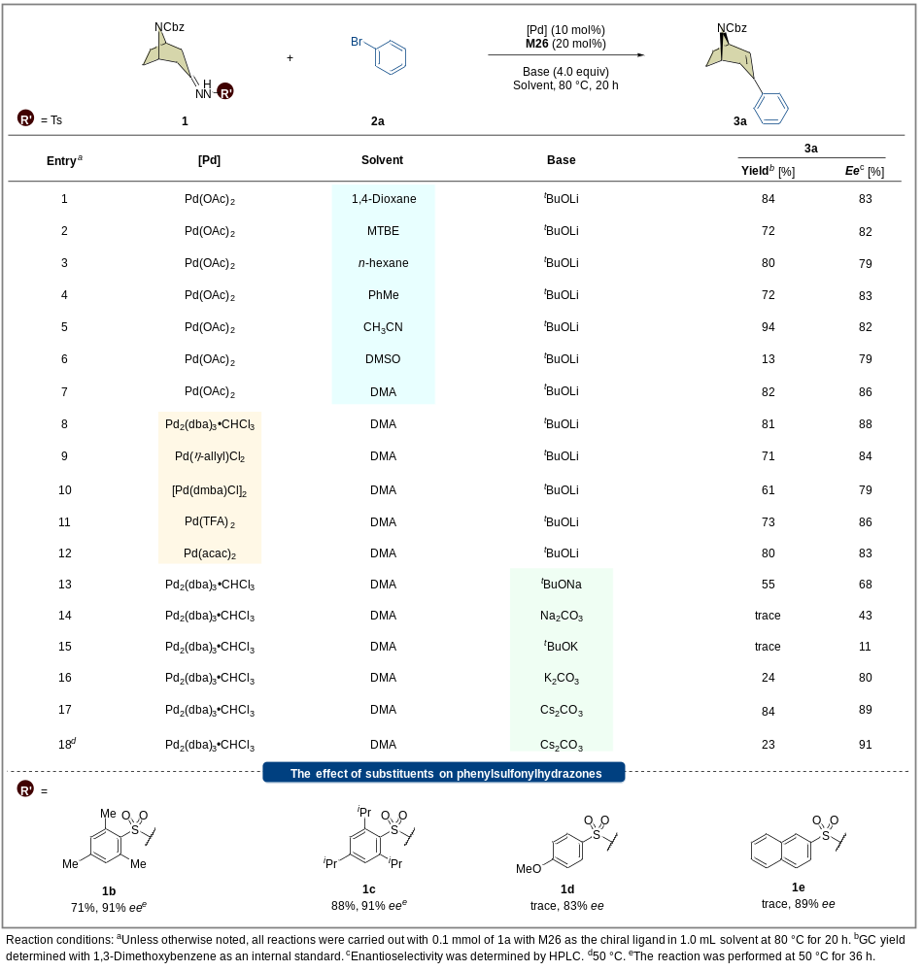

Table 2 | Substrate scope for various functionalized aryl bromides and N-arylsulfonylhydrazones
