Supporting Information
Asymmetric Synthesis of [3.2.1]Tropane Scaffolds via Enantioselective β-H Elimination Reaction
Chao Fang¹, Junpeng Ai⁵, Quanpu Wang¹, Bing Xu², Junliang Zhang^{1,4,6,7*} & Zhan-Ming Zhang^{1,3,6*}
¹Department of Chemistry, Fudan University, 2005 Songhu Road, Shanghai, 200438, P. R. China.
² School of Pharmacy, Naval Medical University, Shanghai 200433, China.
³Fudan Zhangjiang Institute, Shanghai, 201203, P. R. China.
⁴State Key Laboratory of Organometallic Chemistry, Shanghai Institute of Organic Chemistry, Chinese Academy of Sciences, Shanghai, 200032, P. R. China.
⁵Chemical Engineering and Materials Science & Collaborative Innovation Center of Suzhou Nano Science and Technology, Soochow University, Suzhou 215123, P. R. China.
⁶State Key Laboratory of Green Chemical Synthesis and Conversion.
⁷School of Chemistry and Chemical Engineering, Henan Normal University, Xinxiang, Henan, 453007, P. R. China.
*Corresponding Authors: junliangzhang@fudan.edu.cn; zhanmingzhang@fudan.edu.cn.
Contents
  - General Information S1
  - Screening for Palladium-Catalyzed Enantioselective β-H Eimination Reaction. S2
  - General Procedure for the Synthesis of N-arylsulfonylhydrazones 1a-1h S3
  - General Procedure for the Synthesis of Products 3a-3ce, 4a-4k. S8
  - General Procedure for the Synthesis of Products 7-22. S54
  - Bioactive investigations. S67
  - Non-Linear Effect Experiments S68
  - Kinetic Studies: Kinetic Orders in Palladium/Ming-Phos-catalyzed Enantioselective β−H Elimination Reaction S70
  - Data: Deuterium Kinetic Isotope Experiments S78
  - Hammett Plots Experiments S81
  - X-Ray Structure and Crystal Data of 3bd S82
  - ¹H , ¹⁹F, ³¹P, ¹³C NMR, HPLC Spectra S94
  - References S263
- General Information
All reactions were carried out under an atmosphere of argon in sealed tube with magnetic stirring. ¹H NMR spectra, ¹⁹F NMR spectra, ³¹P NMR spectra, ¹³C NMR spectra were recorded on a Bruker 400MHz spectrometer in CDCl₃. All signals are reported in ppm with the internal TMS signal at 0 ppm as a standard. Data for ¹H NMR spectra are reported as follows: chemical shift (ppm, referenced to TMS; s = singlet, d = doublet, t = triplet, dd = doublet of doublets, m = multiplet), coupling constant (Hz), and integration. Data for ¹³C NMR are reported in terms of chemical shift (ppm) relative to residual solvent peak (CDCl₃: 77.0 ppm). Reactions were monitored by thin layer chromatography (TLC) using silica gel plates. Flash column chromatography was performed over silica gel (300-400 mesh). The spectral data of the substrates were consistent with that reported in the literature. A Sadphos kit was purchased from Daicel. The enantiomeric excesses of the products were determined by HPLC with Chiralpak IA, IBN5, IF, IG, ADH, ODH, OJH.

- Screening for Palladium-Catalyzed Enantioselective β-H Elimination Reaction
Table S1. Screening of various types of commercially available ligands and sadphos.
- General Procedure for the Synthesis of N-arylsulfonylhydrazones 1a-1h.
- Typical procedure for the synthesis of sulfonylhydrazones 1a-1h: A mixture of I (5 mmol), II (5 mmol), TsOH (10 mol%) in MeOH (20 mL) was stirred at 50 ºC overnight. After completion of the reaction (monitored by TLC), the crude material was purified by column chromatography to provide 1.

- Synthesis of benzyl (1R,5S)-3-(2-tosylhydrazineylidene)-8-azabicyclo[3.2.1]octane-8-carboxylate (1a).
¹H NMR (400 MHz, CDCl₃) δ 8.03 – 7.92 (m, 1 H), 7.82 – 7.80 (m, 2 H), 7.37 – 7.26 (m, 6 H), 5.11 (d, J = 3.2 Hz, 2 H), 4.38 (s, 2 H), 2.53 (d, J = 15.8 Hz, 2 H), 2.42 (s, 3 H), 2.35 – 2.12 (m, 2 H), 1.98 – 1.87 (m, 2 H), 1.61 – 1.53 (d, J = 10.6 Hz, 1 H), 1.37 (t, J = 9.4 Hz, 1 H).
¹³C NMR (101 MHz, CDCl₃) δ 153.43, 144.08, 136.42, 135.24, 129.53, 128.50, 128.09, 127.92, 127.89, 67.00, 53.42, 52.18, 40.98 (d, J = 57.6 Hz), 33.74 (d, J = 71.8 Hz), 29.38(d, J = 76.8 Hz), 21.56.
HRMS (ESI) calculated for [M+H]⁺ = [C₂₂H₂₆N₃O₄S]⁺: 428.1639 found: 428.1641.

- Synthesis of benzyl (1R,5S)-3-(2-(mesitylsulfonyl)hydrazineylidene)-8-azabicyclo[3.2.1]octane-8-carboxylate (1b).
¹H NMR (400 MHz, CDCl₃) δ 7.82 (s, 1 H), 7.38 – 7.28 (m, 4 H), 6.95 (s, 2 H), 5.13 (s, 2 H), 4.41 (s, 2 H), 2.65 (s, 6 H), 2.52 (t, J = 15.1 Hz, 2 H), 2.29 (s, 3 H), 2.27 – 2.11 (m, 2 H), 1.99 – 1.92 (m, 2 H), 1.54 (t, J = 9.3 Hz, 1 H), 1.43 – 1.34 (m, 1 H).
¹³C NMR (101 MHz, CDCl₃) δ 153.44, 142.82, 140.08, 136.44, 131.80, 128.55, 128.49, 128.09, 127.99, 127.89, 67.00, 53.44, 52.17, 41.29 (d, J = 57.6 Hz), 33.68 (d, J = 67.0 Hz), 28.41 (d, J = 40.6 Hz), 23.15, 20.94.
HRMS (ESI) calculated for [M+H]⁺ = [C₂₄H₃₀N₃O₄S]⁺: 456.1952 found: 456.1953.

- Synthesis of benzyl (1R,5S)-3-(2-((2,4,6-triisopropylphenyl)sulfonyl)hydrazineylidene)-8-azabicyclo[3.2.1]octane-8-carboxylate (1c).
¹H NMR (400 MHz, CDCl₃) δ 7.40 – 7.29 (m, 5 H), 7.16 (s, 2 H), 5.13 (s, 2 H), 4.43 (s, 2 H), 4.25 – 4.14 (m, 2 H), 2.96 – 2.85 (m, 1 H), 2.50 (d, J = 15.2 Hz, 2 H), 2.29 (d, J = 15.3 Hz, 2 H), 1.99 – 1.95 (m, 2 H), 1.62 (d, J = 16.0 Hz, 2 H), 1.46 – 1.37 (m, 1 H), 1.29 – 1.20 (m, 18 H).
¹³C NMR (101 MHz, CDCl₃) δ 153.31, 151.31, 136.46, 131.17, 128.53, 128.14, 127.95, 123.79, 67.05, 53.42, 52.12, 34.14, 29.92, 24.79, 24.77, 23.53, 23.51.
HRMS (ESI) calculated for [M+H]⁺ = [C₃₀H₄₂N₃O₄S]⁺: 540.2891 found: 540.2893.

- Synthesis of benzyl (1R,5S)-3-(2-((4-methoxyphenyl)sulfonyl)hydrazineylidene)-8-azabicyclo[3.2.1]octane-8-carboxylate (1d).
¹H NMR (400 MHz, CDCl₃) δ 8.07 – 7.84 (m, 3 H), 7.37 – 7.27 (m, 4 H), 6.96 (dd, J = 8.6, 1.5 Hz, 2 H), 5.11 (s, 2 H), 4.39 – 4.38 (m, 2 H), 3.85 (t, J = 1.4 Hz, 3 H), 2.54 (d, J = 15.9 Hz, 2 H), 2.37 – 2.09 (m, 2 H), 1.91 (d, J = 7.6 Hz, 2 H), 1.62 – 1.56 (m, 1 H), 1.42 – 1.33 (m, 1 H).
¹³C NMR (101 MHz, CDCl₃) δ 163.32, 153.43, 136.42, 130.09, 128.50, 128.09, 127.98, 127.88, 114.09, 67.00, 55.59, 53.43, 52.19, 41.31(d, J = 56.2 Hz) , 34.07 (d, J = 60.2 Hz), 28.96 (d, J = 83.0 Hz).
HRMS (ESI) calculated for [M+H]⁺ = [C₂₂H₂₆N₃O₅S]⁺: 444.1588 found: 444.1590.

- Synthesis of benzyl (1R,5S)-3-(2-(naphthalen-2-ylsulfonyl)hydrazineylidene)-8-azabicyclo[3.2.1]octane-8-carboxylate (1e).
¹H NMR (400 MHz, CDCl₃) δ 8.52 (d, J = 1.8 Hz, 1 H), 8.00 – 7.86 (m, 4 H), 7.67 – 7.58 (m, 2 H), 7.35 – 7.25 (m, 5 H), 5.09 (s, 2 H), 4.37 (s, 2 H), 2.52 (d, J = 15.5 Hz, 2 H), 2.54 – 2.16 (m, 2 H), 1.91 – 1.88 (m, 2 H), 1.53 (s, 1 H), 1.37 (d, J = 10.2 Hz, 1 H).
¹³C NMR (101 MHz, CDCl₃) δ 136.39, 135.06, 132.06, 129.71, 129.36, 129.18, 129.05, 128.50, 128.11, 127.88, 127.54, 122.83, 67.03, 53.39, 52.13, 40.86 (d, J = 56.2 Hz) , 34.07 (d, J = 60.2 Hz), 28.42 (d, J = 83.0 Hz).
HRMS (ESI) calculated for [M+H]⁺ = [C₂₅H₂₆N₃O₄S]⁺: 464.1639 found: 464.1640.

- Synthesis of tert-butyl (1R,5S-3-(2-((2,4,6-triisopropylphenyl)sulfonyl)hydrazineylidene)-8-azabicyclo[3.2.1]octane-8-carboxylate (1f).
¹H NMR (400 MHz, CDCl₃) δ 7.56 (s, 1 H), 7.16 (s, 2 H), 4.30 – 4.17 (m, 4 H), 2.95 – 2.85 (m, 1 H), 2.60 – 2.47 (m, 2 H), 2.25 (d, J = 15.3 Hz, 2 H), 1.99 – 1.92 (m, 2 H), 1.67 (dt, J = 75.3, 7.0 Hz, 2 H), 1.44 (d, J = 0.9 Hz, 9 H), 1.33 – 1.19 (m, 18 H).
¹³C NMR (101 MHz, CDCl₃) δ 153.23, 151.33, 131.21, 123.74, 79.97, 51.91, 34.11, 29.87, 28.40, 24.76, 23.52, 23.51.
HRMS (ESI) calculated for [M+H]⁺ = [C₂₇H₄₄N₃O₄S]⁺: 506.3047 found: 506.3047.

- Synthesis of N'-((1R,5S)-8-benzoyl-8-azabicyclo[3.2.1]octan-3-ylidene)-2,4,6-triisopropylbenzenesulfonohydrazide (1g).
¹H NMR (400 MHz, CDCl₃) δ 7.71 – 7.52 (m, 1 H), 7.48 – 7.37 (m, 5 H), 7.16 (s, 2 H), 4.92 (s, 1 H), 4.26 – 4.12 (m, J = 6.8 Hz, 3 H), 2.96 – 2.83 (m, 1 H), 2.60 – 2.45 (m, 2 H), 2.29 – 2.15 (s, 2 H), 2.00 (s, 2 H), 1.69 (t, J = 8.9 Hz, 1 H), 1.52 (q, J = 7.8 Hz, 1 H), 1.25 (dd, J = 6.8, 5.4 Hz, 18 H)..
¹³C NMR (101 MHz, CDCl₃) δ 153.34, 151.32, 135.61, 130.40, 128.65, 128.56, 127.10, 127.05, 123.79, 34.13, 29.90, 24.78, 23.53, 23.50.
HRMS (ESI) calculated for [M+H]⁺ = [C₂₉H₄₀N₃O₃S]⁺: 510.2785 found: 510.2787.

- Synthesis of ethyl (1R,5S)-3-(2-((2,4,6-triisopropylphenyl)sulfonyl)hydrazineylidene)-8-azabicyclo[3.2.1]octane-8-carboxylate (1h).
¹H NMR (400 MHz, CDCl₃) δ 7.64 (s, 1 H), 7.16 (s, 2 H), 4.38 (s, 2 H), 4.25 – 4.18 (m, 2 H), 4.13 (q, J = 7.1 Hz, 2 H), 2.95 – 2.85 (m, 1 H), 2.53 (d, J = 15.4 Hz, 2 H), 2.28 (d, J = 15.3 Hz, 2 H), 1.97 – 1.90 (m, 2 H), 1.59 (d, J = 10.5 Hz, 1 H), 1.45 (s, 1 H), 1.31 – 1.22 (m, 21 H).
¹³C NMR (101 MHz, CDCl₃) δ 153.75, 153.25, 151.31, 131.21, 123.76, 61.25, 53.25, 51.99, 34.12, 29.88, 24.77, 23.52, 23.50, 14.66.
HRMS (ESI) calculated for [M+H]⁺ = [C₂₅H₄₀N₃O₄S]⁺: 478.2734 found: 478.2739.
- General Procedure for the Synthesis of Products 3a-3ce, 4a-4k.
Typical procedure A for the chiral N-bridged [3.2.1] Tropane derivatives.
A 10 mL oven-dried sealed tube was added substrate 1 (0.30 mmol, 1.0 equiv.), Pd₂(dba)₃•CHCl₃ (15.5 mg, 0.015 mmol, 5 mol%), M26 (38.3 mg, 0.06 mmol, 20 mol%), Cs₂CO₃ (391.2 mg, 1.2 mmol, 4.0 equiv.). The flask was evacuated and refilled with argon. Then, substrate 2 (0.36 mmol, 1.2 equiv.), DMA (3 mL) were added to the tube, and stirred at room temperature for 1 h. Then the mixture was stirred at 50 °C for 36-60 h. After the reaction was complete (monitored by TLC), the solvent was removed under reduced pressure. The crude product was then purified by flash column chromatography on silica gel to afford the desired product 3.

Typical procedure B for the chiral N-bridged [3.2.1] Tropane derivatives.
A 10 mL oven-dried sealed tube was added substrate 1 (0.30 mmol, 1.0 equiv.), Pd₂(dba)₃•CHCl₃ (15.5 mg, 0.015 mmol, 5 mol%), M27 (38.3 mg, 0.06 mmol, 20 mol%), Cs₂CO₃ (391.2 mg, 1.2 mmol, 4.0 equiv.). The flask was evacuated and refilled with argon. Then, substrate 2 (0.36 mmol, 1.2 equiv.), DMA (3 mL) were added to the tube, and stirred at room temperature for 1 h. Then the mixture was stirred at 50 °C for 36-60 h. After the reaction was complete (monitored by TLC), the solvent was removed under reduced pressure. The crude product was then purified by flash column chromatography on silica gel to afford the desired product 3.

Typical procedure C for the chiral N-bridged [3.2.1] Tropane derivatives.
A 10 mL oven-dried sealed tube was added substrate 1 (0.30 mmol, 1.0 equiv.), Pd₂(dba)₃•CHCl₃ (15.5 mg, 0.015 mmol, 5 mol%), M27 (38.3 mg, 0.06 mmol, 20 mol%), Cs₂CO₃ (391.2 mg, 1.2 mmol, 4.0 equiv.). The flask was evacuated and refilled with argon. Then, substrate 2 (0.36 mmol, 1.2 equiv.), PhMe (3 mL) were added to the tube, and stirred at room temperature for 1 h. Then the mixture was stirred at 50 °C for 36-60 h. After the reaction was complete (monitored by TLC), solvent was removed under reduced pressure. The crude product was then purified by flash column chromatography on silica gel to afford the desired product 3

  - Synthesis of benzyl (1R,5S)-3-phenyl-8-azabicyclo[3.2.1]oct-2-ene-8-carboxylate (3a).
Prepared according to typical procedure A from N-sulfonylhydrazone 1c (162.0 mg, 0.3 mmol), after a flash column chromatography (hexanes:EA = 8:1) afforded the product 3a as a colorless oil (84.6 mg, 88% yield) with 91% ee. ¹H NMR (400 MHz, CDCl₃) δ 7.35 – 7.22 (m, 10 H), 6.43 (d, J = 12.1 Hz, 1 H), 5.14 (d, J = 3.9 Hz, 2 H), 4.57 (d, J = 21.5 Hz, 2 H), 3.11 (dd, J = 70.3, 17.1 Hz, 1 H), 2.24 (dd, J = 14.8, 8.4 Hz, 2 H), 2.07 – 1.95 (m, 2 H), 1.72 (dt, J = 14.9, 8.1 Hz, 1 H). ¹³C NMR (101 MHz, CDCl₃) δ 154.06, 139.71, 136.91, 133.90, 133.39, 128.42, 128.32, 127.84, 127.73, 127.43, 124.86, 66.67, 53.38, 52.23, 36.16 (d, J = 69.8 Hz), 34.52 (d, J = 68.6 Hz), 29.93 (d, J = 54.2 Hz). HRMS (EI) calculated for [C₂₁H₂₁NO₂]⁺: 315.1967 found: 319.1568. Enantiomeric excess was determined by HPLC with a Chiralpak ODH column (hexanes:2-propanol = 95:5, 1.0 mL/min, 254 nm); minor enantiomer Rt = 11.8 min, major enantiomer Rt = 12.4 min. [α]_{D}²⁰ = 32.1 (c = 0.3, CHCl₃).

  - Synthesis of benzyl (1R,5S)-3-(p-tolyl)-8-azabicyclo[3.2.1]oct-2-ene-8-carboxylate (3b).
Prepared according to typical procedure A from N-sulfonylhydrazone 1c (162.0 mg, 0.3 mmol), after a flash column chromatography (hexanes:EA = 8:1) afforded the product 3b as a white solid (94.3 mg, 94% yield) with 90% ee. Mp: 86-88 ºC. ¹H NMR (400 MHz, CDCl₃) δ 7.37 – 7.30 (m, 5 H), 7.25 (d, J = 7.7 Hz, 2 H), 7.13 (d, J = 7.9 Hz, 2 H), 6.41 (s, 1 H), 5.15 (d, J = 3.9 Hz, 2 H), 4.60 (s, 2 H), 3.11 (dd, J = 68.6, 16.4 Hz, 1 H), 2.35 (s, 3 H), 2.27 – 2.19 (m, 2 H), 2.08 – 1.91 (m, 2 H), 1.77 – 1.70 (m, 1 H). ¹³C NMR (101 MHz, CDCl₃) δ 154.03, 137.17, 136.91, 136.85, 133.65, 133.12, 128.97, 128.39, 127.80, 127.67, 124.70, 66.61, 53.36, 52.22, 36.18 (d, J = 71.2 Hz), 34.52 (d, J = 70.1 Hz), 29.91 (d, J = 52.4 Hz), 21.00. HRMS (ESI) calculated for [M+Na]⁺ = [C₂₂H₂₃NNaO₂]⁺: 356.1621 found: 356.1619. Enantiomeric excess was determined by HPLC with a Chiralpak IA column (hexanes:2-propanol = 90:10, 1.0 mL/min, 254 nm); major enantiomer Rt = 8.8 min, minor enantiomer Rt = 9.6 min. [α]_{D}²⁰ = 15.0 (c = 0.3, CHCl₃).

  - Synthesis of benzyl (1R,5S)-3-(4-isopropylphenyl)-8-azabicyclo[3.2.1]oct-2-ene-8-carboxylate (3c).
Prepared according to typical procedure A from N-sulfonylhydrazone 1c (162.0 mg, 0.3 mmol), after a flash column chromatography (hexanes:EA = 8:1) afforded the product 3c as a colorless oil (88.7 mg, 82% yield) with 94% ee. ¹H NMR (400 MHz, CDCl₃) δ 7.38 – 7.30 (m, 7 H), 7.21 – 7.19 (m, 2 H), 6.42 (s, 1 H), 5.15 (d, J = 5.5 Hz, 2 H), 4.61 (s, 2 H), 3.12 (dd, J = 73.2, 16.9 Hz, 1 H), 2.96 – 2.86 (m, 1 H), 2.30 – 2.16 (m, 2 H), 2.08 – 1.95 (m, 2 H), 1.74 (d, J = 8.2 Hz, 1 H), 1.26 (d, J = 6.9 Hz, 6 H). ¹³C NMR (101 MHz, CDCl₃) δ 154.04, 148.26, 137.19, 136.92, 133.69, 133.15, 128.39, 127.74 (d, J = 12.1 Hz), 127.11, 126.35, 124.76, 66.62, 53.39, 52.24, 36.12 (d, J = 71.6 Hz), 34.52 (d, J = 68.3 Hz), 33.72, 29.72 (d, J = 91.2 Hz), 23.90 (d, J = 1.4 Hz). HRMS (EI) calculated for [C₂₄H₂₇NO₂]⁺: 361.2036 found: 361.2039. Enantiomeric excess was determined by HPLC with a Chiralpak IA column (hexanes: 2-propanol = 90:10, 1.0 mL/min, 254 nm); major enantiomer Rt = 8.3 min, minor enantiomer Rt = 9.1 min. [α]_{D}²⁰ = 36.5 (c = 0.3, CHCl₃).

  - Synthesis of benzyl (1R,5S)-3-([1,1'-biphenyl]-4-yl)-8-azabicyclo[3.2.1]oct-2-ene-8-carboxylate (3d).
Prepared according to typical procedure A from N-sulfonylhydrazone 1c (162.0 mg, 0.3 mmol), after a flash column chromatography (hexanes:EA = 8:1) afforded the product 3d as a white solid (89.2 mg, 75% yield) with 90% ee. Mp: 117-119 ºC. ¹H NMR (400 MHz, CDCl₃) δ 7.65 – 7.58 (m, 4 H), 7.50 – 7.45 (m, 4 H), 7.41 – 7.31 (m, 6 H), 6.53 (s, 1 H), 5.20 (d, J = 4.2 Hz, 2 H), 4.67 (s, 2 H), 3.19 (dd, J = 73.5, 17.0 Hz, 1 H), 2.30 (dd, J = 18.2, 13.1 Hz, 2 H), 2.13 – 1.98 (m, 2 H), 1.81 – 1.74 (m, 1 H). ¹³C NMR (101 MHz, CDCl₃) δ 154.00, 140.50, 140.13, 138.53, 136.85, 133.32, 132.84, 128.70, 128.37, 127.80, 127.67, 127.23, 126.91, 126.82, 125.16, 66.62, 53.37, 52.18, 36.04 (d, J = 70.6 Hz), 34.46 (d, J = 68.4 Hz), 29.70 (d, J = 90.6 Hz). HRMS (EI) calculated for [C₂₇H₂₅NO₂]⁺: 395.1880 found: 395.1880. Enantiomeric excess was determined by HPLC with a Chiralpak IA column (hexanes:2-propanol = 90:10, 1.0 mL/min, 254 nm); major enantiomer Rt = 13.4 min, minor enantiomer Rt = 15.6 min. [α]_{D}²⁰ = 51.1 (c = 0.3, CHCl₃).

  - Synthesis of benzyl (1R,5S)-3-(4-methoxyphenyl)-8-azabicyclo[3.2.1]oct-2-ene-8-carboxylate (3e).
Prepared according to typical procedure A from N-sulfonylhydrazone 1c (162.0 mg, 0.3 mmol), after a flash column chromatography (hexanes:EA = 6:1) afforded the product 3e as a colorless oil (80.5 mg, 77% yield) with 91% ee. Mp: 103-104 ºC. ¹H NMR (400 MHz, CDCl₃) δ 7.38 – 7.29 (m, 7 H), 6.90 – 6.85 (m, 2 H), 6.35 (s, 1 H), 5.16 (d, J = 3.8 Hz, 2 H), 4.61 (s, 2 H), 3.81 (s, 3 H), 3.10 (dd, J = 70.3, 16.8 Hz, 1 H), 2.26 – 2.19 (m, 2 H), 2.09 – 1.99 (m, 2 H), 1.73 (dt, J = 12.8, 8.0 Hz, 1 H). ¹³C NMR (101 MHz, CDCl₃) δ 158.99, 153.96, 136.86, 133.10, 132.19, 128.33, 127.74, 126.50, 126.06, 125.84, 113.59, 66.54, 55.16, 53.31, 52.16, 36.15 (d, J = 71.3 Hz), 34.48 (d, J = 68.1 Hz), 29.65 (d, J = 90.4 Hz). HRMS (EI) calculated for [C₂₂H₂₃NO₃]⁺: 349.1672 found: 349.1674. Enantiomeric excess was determined by HPLC with a Chiralpak IA column (hexanes:2-propanol = 90:10, 1.0 mL/min, 254 nm); major enantiomer Rt = 12.1 min, minor enantiomer Rt = 13.5 min. [α]_{D}²⁰ = 60.2 (c = 0.3, CHCl₃).

  - Synthesis of benzyl (1R,5S)-3-(4-(tert-butoxy)phenyl)-8-azabicyclo[3.2.1]oct-2-ene-8-carboxylate (3f).
Prepared according to typical procedure A from N-sulfonylhydrazone 1c (162.0 mg, 0.3 mmol), after a flash column chromatography (hexanes:EA = 6:1) afforded the product 3f as colorless oil (95.1 mg, 78% yield) with 93% ee. ¹H NMR (400 MHz, CDCl₃) δ 7.34 – 7.24 (m, 7 H), 6.94 – 6.92 (m, 2 H), 6.39 (s, 1 H), 5.13 (d, J = 4.9 Hz, 2 H), 4.59 (s, 2 H), 3.08 (d, J = 59.8 Hz, 1 H), 2.24 (d, J = 17.2 Hz, 2 H), 2.07 – 1.95 (m, 2 H), 1.76 – 1.68 (m, 1 H), 1.34 (s, 9 H). ¹³C NMR (101 MHz, CDCl₃) δ 154.93, 153.97, 136.95, 134.68, 128.42, 127.83, 127.70, 127.44, 126.85, 125.24, 123.90, 66.66, 53.40, 52.25, 35.80, 34.88, 29.94 (d, J = 52.4 Hz), 29.68, 28.83. HRMS (EI) calculated for [C₂₅H₂₉NO₃]⁺: 391.2142 found: 391.2140. Enantiomeric excess was determined by HPLC with a Chiralpak IF column (hexanes:2-propanol = 95:5, 1.0 mL/min, 254 nm); major enantiomer Rt = 17.6 min, minor enantiomer Rt = 18.6 min. [α]_{D}²⁰ = 16.3 (c = 0.3, CHCl₃).

  - Synthesis of benzyl (1R,5S)-3-(4-(benzyloxy)phenyl)-8-azabicyclo[3.2.1]oct-2-ene-8-carboxylate (3g).
Prepared according to typical procedure A from N-sulfonylhydrazone 1c (162.0 mg, 0.3 mmol), after a flash column chromatography (hexanes: EA = 6:1) afforded the product 3g as a white solid (105.5 mg, 83% yield) with 91% ee. Mp: 99-101 ºC. ¹H NMR (400 MHz, CDCl₃) δ 7.24 – 7.07 (m, 12 H), 6.76 – 6.71 (m, 2 H), 6.13 (s, 1 H), 4.95 (d, J = 4.1 Hz, 2 H), 4.86 (s, 2 H), 4.39 (s, 2 H), 2.88 (dd, J = 71.4, 17.0 Hz, 1 H), 2.04 – 1.99 (m, 2 H), 1.86 – 1.73 (m, 2 H), 1.51 (dt, J = 12.8, 8.0 Hz, 1 H). ¹³C NMR (101 MHz, CDCl₃) δ 158.17, 153.96, 136.87, 133.06, 132.44, 128.47, 128.33, 127.84, 127.75, 127.65, 127.30, 126.62, 126.18, 125.86, 114.58, 69.89, 66.55, 53.31, 52.16, 36.12 (d, J = 71.9 Hz), 34.46 (d, J = 68.9 Hz), 29.65 (d, J = 91.1 Hz). HRMS (EI) calculated for [C₂₈H₂₇NO₃]⁺: 425.1985 found: 425.1985. Enantiomeric excess was determined by HPLC with a Chiralpak IA column (hexanes:2-propanol = 90:10, 1.0 mL/min, 254 nm); major enantiomer Rt = 21.0 min, minor enantiomer Rt = 25.4 min. [α]_{D}²⁰ = 28.4 (c = 0.3, CHCl₃).

  - Synthesis of (R)-1-(4-(3-((perfluorophenyl)methyl)-2,3-dihydrobenzofuran-3-yl)butyl)pyrrolidine-2,5-dione (3h).
Prepared according to typical procedure A from N-sulfonylhydrazone 1c (162.0 mg, 0.3 mmol), after a flash column chromatography (hexanes:EA = 7:1) afforded the product 3h as a white solid (89.9 mg, 74% yield) with 87% ee. Mp: 66-67 ºC. ¹H NMR (400 MHz, CDCl₃) δ 7.36 – 7.26 (m, 7 H), 7.15 (d, J = 8.3 Hz, 2 H), 6.43 (d, J = 13.1 Hz, 1 H), 5.14 (d, J = 4.5 Hz, 2 H), 4.61 (s, 2 H), 3.09 (dd, J = 73.0, 17.2 Hz, 1 H), 2.23 (t, J = 13.5 Hz, 2 H), 2.09 – 1.95 (m, 2 H), 1.76 – 1.66 (m, 1 H). ¹³C NMR (101 MHz, CDCl₃) δ 154.07, 148.47, 138.45, 136.84, 129.33, 128.89, 128.44, 127.91, 127.76, 126.21, 120.77, 120.44 (qm, J_{F} = 129.3 Hz), 66.75, 53.34, 52.14, 36.16 (d, J = 70.0 Hz), 34.43 (d, J = 67.4 Hz), 29.74 (d, J = 88.5 Hz). ¹⁹F NMR (376 MHz, CDCl₃) δ -57.88. HRMS (EI) calculated for [C₂₂H₂₀F₃NO₃]⁺: 403.1390 found: 403.1390. Enantiomeric excess was determined by HPLC with a Chiralpak IA column (hexanes:2-propanol = 90:10, 1.0 mL/min, 254 nm); major enantiomer Rt = 10.1 min, minor enantiomer Rt = 13.0 min. [α]_{D}²⁰ = 58.5 (c = 0.3, CHCl₃).

  - Synthesis of benzyl (1R,5S)-3-(4-(difluoromethoxy)phenyl)-8-azabicyclo[3.2.1]oct-2-ene-8-carboxylate (3i).
Prepared according to typical procedure A from N-sulfonylhydrazone 1c (162.0 mg, 0.3 mmol), after a flash column chromatography (hexanes:EA = 7:1) afforded the product 3i as a colorless oil (84.9 mg, 74% yield) with 90% ee. ¹H NMR (400 MHz, CDCl₃) δ 7.35 – 7.26 (m, 7 H), 7.06 (d, J = 8.3 Hz, 2 H), 6.50 (t, J = 72.0 Hz, 1 H), 6.41 (d, J = 12.2 Hz, 1 H), 5.15 (d, J = 4.2 Hz, 2 H), 4.61 (s, 2 H), 3.09 (dd, J = 71.3, 17.2 Hz, 1 H), 2.23 (t, J = 12.6 Hz, 2 H), 2.08 – 1.95 (m, 2 H), 1.76 – 1.69 (m, 1 H). ¹³C NMR (101 MHz, CDCl₃) δ 154.02, 150.40 (tm, J_{F} = 2.9 Hz), 137.05, 136.83, 132.89,128.64, 128.40, 127.86, 127.71, 126.22, 119.32, 115.81 (tm, J_{F} = 259.8 Hz), 66.68, 53.31, 52.12, 36.15 (d, J = 70.8 Hz), 34.42 (d, J = 68.3 Hz), 29.70 (d, J = 89.4 Hz). ¹⁹F NMR (376 MHz, CDCl₃) δ -80.77 (d, J = 73.8 Hz). HRMS (EI) calculated for [C₂₂H₂₁F₂NO₃]⁺: 385.1484 found: 385.1485. Enantiomeric excess was determined by HPLC with a Chiralpak IA column (hexanes:2-propanol = 90:10, 1.0 mL/min, 254 nm); major enantiomer Rt = 15.4 min, minor enantiomer Rt = 19.2 min. [α]_{D}²⁰ = 45.3 (c = 0.3, CHCl₃).

  - Synthesis of benzyl (1R,5S)-3-(4-(methylthio)phenyl)-8-azabicyclo[3.2.1]oct-2-ene-8-carboxylate (3j).
Prepared according to typical procedure A from N-sulfonylhydrazone 1c (162.0 mg, 0.3 mmol), after a flash column chromatography (hexanes:EA = 7:1) afforded the product 3j as a white solid (79.0 mg, 72% yield) with 91% ee. Mp: 97-99 ºC. ¹H NMR (400 MHz, CDCl₃) δ 7.36 – 7.26 (m, 7 H), 7.22 – 7.18 (m, 2 H), 6.42 (s, 1 H), 5.14 (d, J = 4.0 Hz, 2 H), 4.60 (s, 2 H), 3.08 (dd, J = 65.9, 15.5 Hz, 1 H), 2.48 (s, 3 H), 2.25 – 2.19 (m, 2 H), 2.08 – 1.95 (m, 2 H), 1.76 – 1.69 (m, 1 H). ¹³C NMR (101 MHz, CDCl₃) δ 154.01, 137.57, 136.87, 136.54, 133.22, 128.40, 127.83, 127.69, 127.40, 126.48, 125.20, 66.65, 53.35, 52.17, 36.04 (d, J = 70.8 Hz), 34.47 (d, J = 70.1 Hz), 29.71 (d, J = 90.5 Hz), 15.86. HRMS (EI) calculated for [C₂₂H₂₃NO₂S]⁺: 365.1444 found: 365.1443. Enantiomeric excess was determined by HPLC with a Chiralpak IF column (hexanes:2-propanol = 90:10, 1.0 mL/min, 254 nm); major enantiomer Rt = 17.8 min, major enantiomer Rt = 21.6 min. [α]_{D}²⁰ = 45.3 (c = 0.3, CHCl₃).

  - Synthesis of benzyl (1R,5S)-3-(4-((trifluoromethyl)thio)phenyl)-8-azabicyclo[3.2.1]oct-2-ene-8-carboxylate (3k).
Prepared according to typical procedure B from N-sulfonylhydrazone 1c (162.0 mg, 0.3 mmol), after a flash column chromatography (hexanes:EA = 8:1) afforded the product 3k as a yellow solid (103.3 mg, 82% yield) with 92% ee. Mp: 76-77 ºC. ¹H NMR (400 MHz, CDCl₃) δ 7.59 (d, J = 8.1 Hz, 2 H), 7.38 – 7.26 (m, J = 20.0, 17.1, 9.9 Hz, 7 H), 6.53 (s, 1 H), 5.15 (d, J = 4.7 Hz, 2 H), 4.62 (s, 2 H), 3.10 (d, J = 65.8 Hz, 1 H), 2.24 (t, J = 12.6 Hz, 2 H), 2.10 – 1.99 (m, 2 H), 1.76 – 1.67 (m, 1 H). ¹³C NMR (101 MHz, CDCl₃) δ 154.06, 142.27, 136.29, 132.90, 132.41, 131.05, 130.56, 130.11, 129.88 (qm, J_{F} = 428.2 Hz), 128.44, 127.85 (d, J = 15.1 Hz), 125.84, 66.77, 53.36, 52.11, 35.92 (d, J = 71.4 Hz), 34.37 (d, J = 70.0 Hz), 29.75 (d, J = 90.6 Hz). ¹⁹F NMR (376 MHz, CDCl₃) δ -42.84. HRMS (ESI) calculated for [M+Na]⁺ = [C₂₂H₂₀F₃NNaO₂]⁺: 442.1060 found: 442.1069. Enantiomeric excess was determined by HPLC with a Chiralpak IA column (hexanes:2-propanol = 90:10, 1.0 mL/min, 254 nm); major enantiomer Rt = 11.7 min, minor enantiomer Rt = 15.1 min. [α]_{D}²⁰ = 43.6 (c = 0.3, CHCl₃).

  - Synthesis of benzyl (1R,5S)-3-(4-(dimethylamino)phenyl)-8-azabicyclo[3.2.1]oct-2-ene-8-carboxylate (3l).
Prepared according to typical procedure A from N-sulfonylhydrazone 1c (162.0 mg, 0.3 mmol), after a flash column chromatography (hexanes:EA = 6:1) afforded the product 3l as a yellow solid (76.4 mg, 70% yield) with 85% ee. Mp: 117-119 ºC. ¹H NMR (400 MHz, CDCl₃) δ 7.38 – 7.26 (m, 7 H), 6.72 – 6.68 (m, 2 H), 6.32 (s, 1 H), 5.16 (d, J = 4.8 Hz, 2 H), 4.61 (s, 2 H), 3.22 – 3.03 (m, 1 H), 2.96 (s, 6 H), 2.25 (t, J = 13.7 Hz, 2 H), 2.08 – 1.98 (m, 2 H), 1.75 (dd, J = 12.9, 7.5 Hz, 1 H). ¹³C NMR (101 MHz, CDCl₃) δ 153.97, 149.94, 136.95, 133.14, 132.64, 128.33, 127.75 (d, J = 7.7 Hz), 125.44, 124.68, 124.21, 112.18, 66.51, 53.39, 52.24, 40.43, 36.07 (d, J = 71.8 Hz), 34.60 (d, J = 68.8 Hz), 29.65 (d, J = 91.5 Hz). HRMS (ESI) calculated for [M+Na]⁺ = [C₂₃H₂₆N₂NaO₂]⁺: 385.1887 found: 385.1888. Enantiomeric excess was determined by HPLC with a Chiralpak ADH column (hexanes:2-propanol = 90:10, 1.0 mL/min, 254 nm); major enantiomer Rt = 14.6 min, minor enantiomer Rt = 16.6 min. [α]_{D}²⁰ = 59.6 (c = 0.3, CHCl₃).

  - Synthesis of benzyl (1R,5S)-3-(4-fluorophenyl)-8-azabicyclo[3.2.1]oct-2-ene-8-carboxylate (3m).
Prepared according to typical procedure A from N-sulfonylhydrazone 1c (162.0 mg, 0.3 mmol), after a flash column chromatography (hexanes:EA = 8:1) afforded the product 3m as a colorless oil (76.9 mg, 76% yield) with 90% ee. ¹H NMR (400 MHz, CDCl₃) δ 7.36 – 7.26 (m, 7 H), 6.99 (t, J = 8.7 Hz, 2 H), 6.37 (s, 1 H), 5.20 – 5.11 (m, 2 H), 4.60 (s, 2 H), 3.08 (dd, J = 69.6, 17.5 Hz, 1 H), 2.28 – 2.18 (m, 2 H), 2.08 – 1.92 (m, 2 H), 1.76 – 5.11 (m, 1 H). ¹³C NMR (101 MHz, CDCl₃) δ 163.47, 161.02, 154.06, 136.88, 135.83, 128.43, 127.88, 126.49, 126.42, 115.23, 115.02, 66.71, 53.34, 52.17, 36.31 (d, J = 72.2 Hz), 34.48 (d, J = 68.5 Hz), 29.75 (d, J = 91.1 Hz). ¹⁹F NMR (376 MHz, CDCl₃) δ -115.02. HRMS (EI) calculated for [C₂₁H₂₀FNO₂]⁺: 337.1473 found: 337.1473. Enantiomeric excess was determined by HPLC with a Chiralpak IA column (hexanes: 2-propanol = 90:10, 1.0 mL/min, 254 nm); major enantiomer Rt = 10.3 min, minor enantiomer Rt = 12.0 min. [α]_{D}²⁰ = 42.0 (c = 0.3, CHCl₃).

  - Synthesis of benzyl (1R,5S)-3-(4-chlorophenyl)-8-azabicyclo[3.2.1]oct-2-ene-8-carboxylate (3n).
Prepared according to typical procedure A from N-sulfonylhydrazone 1c (162.0 mg, 0.3 mmol), after a flash column chromatography (hexanes:EA = 8:1) afforded the product 3n as a white solid (80.7 mg, 76% yield) with 90% ee. Mp: 101-102 ºC. ¹H NMR (400 MHz, CDCl₃) δ 7.34 – 7.23 (m, 9 H), 6.42 (d, J = 13.6 Hz, 1 H), 5.18 – 5.11 (m, 2 H), 4.60 (s, 2 H), 3.18 – 2.91 (m, 1 H), 2.21 (t, J = 15.1 Hz, 2 H), 2.09 – 1.94 (m, 2 H), 1.75 – 1.68 (m, 1 H). ¹³C NMR (101 MHz, CDCl₃) δ 154.01, 138.13, 136.82, 133.12, 132.92, 128.89, 128.60, 128.40, 127.87, 127.71, 126.12, 66.69, 53.31, 52.11, 36.06 (d, J = 71.5 Hz), 34.41 (d, J = 68.2 Hz), 29.71 (d, J = 90.3 Hz). HRMS (EI) calculated for [C₂₁H₂₀ClNO₂]⁺: 353.1177 found: 353.1180. Enantiomeric excess was determined by HPLC with a Chiralpak IA column (hexanes:2-propanol = 90:10, 0.3 mL/min, 210 nm); major enantiomer Rt = 11.3 min, minor enantiomer Rt = 13.9 min. [α]_{D}²⁰ = 44.2 (c = 0.3, CHCl₃).

  - Synthesis of benzyl (1R,5S)-3-(4-(trifluoromethyl)phenyl)-8-azabicyclo[3.2.1]oct-2-ene-8-carboxylate (3o).
Prepared according to typical procedure C from N-sulfonylhydrazone 1c (162.0 mg, 0.3 mmol), after a flash column chromatography (hexanes: EA = 8:1) afforded the product 3o as a white solid (88.2 mg, 76% yield) with 94% ee. Mp: 94-95 ºC. ¹H NMR (400 MHz, CDCl₃) δ 7.57 – 7.28 (m, 9 H), 6.53 (s, 1 H), 5.19 – 5.12 (m, 2 H), 4.64 (s, 2 H), 3.24 – 3.01 (m, 1 H), 2.25 (dd, J = 14.9, 8.2 Hz, 2 H), 2.11 – 1.97 (m, 2 H), 1.77 – 1.70 (m, 1 H). ¹³C NMR (101 MHz, CDCl₃) δ 154.04, 143.19, 136.78, 133.02, 130.61, 129.32 (dm, J_{F} = 32.3 Hz), 128.43, 127.92, 127.77, 124.13 (qm, J_{F} = 270.0 Hz), 125.21 (tm, J_{F} = 17.2 Hz), 125.12, 66.76, 53.33, 52.09, 36.02 (d, J = 68.2 Hz), 34.39 (d, J = 67.3 Hz), 29.75 (d, J = 89.7 Hz). ¹⁹F NMR (376 MHz, CDCl₃) δ -62.51. HRMS (ESI) calculated for [M+Na]⁺ = [C₂₂H₂₀F₃NNaO₂]⁺: 410.1338 found: 410.1333. Enantiomeric excess was determined by HPLC with a Chiralpak IA column (hexanes:2-propanol = 90:10, 1.0 mL/min, 254 nm); major enantiomer Rt = 11.3 min, major enantiomer Rt = 15.3 min. [α]_{D}²⁰ = 61.6 (c = 0.3, CHCl₃).

  - Synthesis of benzyl (1R,5S)-3-(4-(methoxycarbonyl)phenyl)-8-azabicyclo[3.2.1]oct-2-ene-8-carboxylate (3p).
Prepared according to typical procedure C from N-sulfonylhydrazone 1c (162.0 mg, 0.3 mmol), after a flash column chromatography (hexanes:EA = 4:1) afforded the product 3p as a white solid (83.2 mg, 74% yield) with 93% ee. Mp: 85-86 ºC. ¹H NMR (400 MHz, CDCl₃) δ 7.97 (d, J = 8.1 Hz, 2 H), 7.39 – 7.26 (m, 7 H), 6.55 – 6.54 (m, 1 H), 5.18 – 5.11 (m, 2 H), 4.62 (s, 2 H), 3.90 (d, J = 1.5 Hz, 3 H), 3.11 (dd, J = 68.2, 17.0 Hz, 1 H), 2.24 (d, J = 16.7 Hz, 2 H), 2.08 – 1.95 (m, 2 H), 1.75 – 1.68 (m, 1 H). ¹³C NMR (101 MHz, CDCl₃) δ 166.69, 153.94, 143.99, 136.71, 133.15, 132.65, 130.54, 130.11, 129.54, 128.82, 128.32, 127.80, 127.64, 124.63, 66.63, 53.28, 52.03, 51.91, 35.84 (d, J = 71.5 Hz), 34.27 (d, J = 68.9 Hz), 29.64 (d, J = 88.9 Hz). HRMS (ESI) calculated for [M+Na]⁺ = [C₂₃H₂₃NNaO₄]⁺: 400.1519 found: 400.1515. Enantiomeric excess was determined by HPLC with a Chiralpak IA column (hexanes: 2-propanol = 85:15, 1.0 mL/min, 254 nm); major enantiomer Rt = 13.9 min, minor enantiomer Rt = 16.1 min. [α]_{D}²⁰ = 55.5 (c = 0.3, CHCl₃).

  - Synthesis of benzyl (1R,5S)-3-(4-(trimethylsilyl)phenyl)-8-azabicyclo[3.2.1]oct-2-ene-8-carboxylate (3q).
Prepared according to typical procedure A from N-sulfonylhydrazone 1c (162.0 mg, 0.3 mmol), after a flash column chromatography (hexanes:EA = 8:1) afforded the product 3q as a white solid (111.3 mg, 95% yield) with 91% ee. Mp: 95-97 ºC. ¹H NMR (400 MHz, CDCl₃) δ 7.52 – 7.49 (m, 2 H), 7.37 – 7.29 (m, 7 H), 6.49 (s, 1 H), 5.17 (d, J = 4.8 Hz, 2 H), 4.63 (s, 2 H), 3.15 (dd, J = 74.1, 17.2 Hz, 1 H), 2.27 (t, J = 13.3 Hz, 2 H), 2.10 – 1.98 (m, 2 H), 1.77 – 1.71 (m, 1 H), 0.29 (s, 9 H). ¹³C NMR (101 MHz, CDCl₃) δ 154.02, 140.04, 139.65, 136.88, 133.82, 133.36, 128.39, 128.06, 127.82, 127.69, 124.14, 66.64, 53.39, 52.21, 36.01 (d, J = 69.9 Hz), 34.49 (d, J = 68.9 Hz), 29.71 (d, J = 91.2 Hz), -1.20. HRMS (EI) calculated for [C₂₄H₂₉NO₂Si]⁺: 391.1962 found: 391.1962. Enantiomeric excess was determined by HPLC with a Chiralpak IA column (hexanes:2-propanol = 90:10, 1.0 mL/min, 254 nm); major enantiomer Rt = 7.5 min, minor enantiomer Rt = 8.3 min. [α]_{D}²⁰ = 49.1 (c = 0.3, CHCl₃).

  - Synthesis of benzyl (1R,5S)-3-(4-vinylphenyl)-8-azabicyclo[3.2.1]oct-2-ene-8-carboxylate (3r).
Prepared according to typical procedure A from allyl ether N-sulfonylhydrazone 1c (162.0 mg, 0.3 mmol), after a flash column chromatography (hexanes:EA = 8:1) afforded the product 3r as a white solid (77.6 mg, 75% yield) with 90% ee. Mp: 87-89 ºC. ¹H NMR (400 MHz, CDCl₃) δ 7.37 – 7.26 (m, 9 H), 6.70 (dd, J = 17.6, 10.9 Hz, 1 H), 6.46 (d, J = 11.7 Hz, 1 H), 5.75 (d, J = 17.6 Hz, 1 H), 5.24 (d, J = 10.9 Hz, 1 H), 5.15 (d, J = 4.2 Hz, 2 H), 4.61 (s, 2 H), 3.11 (dd, J = 69.6, 17.8 Hz, 1 H), 2.24 (dd, J = 19.3, 10.1 Hz, 2 H), 2.08 – 1.96 (m, 2 H), 1.77 – 1.69 (m, 1 H). ¹³C NMR (101 MHz, CDCl₃) δ 154.03, 139.07, 136.88, 136.72, 136.30, 133.69, 133.15, 128.41, 127.84, 127.68, 126.14, 124.92, 113.70, 66.66, 53.38, 52.19, 36.05 (d, J = 70.2 Hz), 34.47 (d, J = 68.6 Hz), 29.71 (d, J = 90.3 Hz). HRMS (EI) calculated for [C₂₃H₂₃NO₂]⁺: 345.1728 found: 345.1723. Enantiomeric excess was determined by HPLC with a Chiralpak IA column (hexanes:2-propanol = 90:10, 1.0 mL/min, 254 nm); major enantiomer Rt = 10.4 min, major enantiomer Rt = 11.9 min. [α]_{D}²⁰ = 33.9 (c = 0.3, CHCl₃).

  - Synthesis of benzyl (1R,5S)-3-(m-tolyl)-8-azabicyclo[3.2.1]oct-2-ene-8-carboxylate (3s).
Prepared according to typical procedure A from N-sulfonylhydrazone 1c (162.0 mg, 0.3 mmol), after a flash column chromatography (hexanes:EA= 8:1) afforded the product 3s as a white solid (86.8 mg, 87% yield) with 90% ee. Mp: 54-56 ºC. ¹H NMR (400 MHz, CDCl₃) δ 7.38 – 7.28 (m, 5 H), 7.24 – 7.15 (m, 3 H), 7.09 (d, J = 7.3 Hz, 1 H), 6.42 (s, 1 H), 5.16 (d, J = 3.6 Hz, 2 H), 4.61 (s, 2 H), 3.12 (dd, J = 71.4, 17.1 Hz, 1 H), 2.36 (s, 3 H), 2.28 – 2.20 (m, 2 H), 2.02 (m, 2 H), 1.74 (d, J = 11.1 Hz, 1 H). ¹³C NMR (101 MHz, CDCl₃) δ 154.03, 139.73, 137.80, 136.90, 133.98, 133.45, 128.38, 128.19, 128.15, 127.80, 125.65, 121.98, 66.62, 53.37, 52.23, 36.21 (d, J = 71.8 Hz), 34.50 (d, J = 69.1 Hz), 29.72 (d, J = 92.4 Hz), 21.43. HRMS (EI) calculated for [C₂₂H₂₃NO₂]⁺: 333.1723 found: 333.1725. Enantiomeric excess was determined by HPLC with a Chiralpak IA column (hexanes:2-propanol = 90:10, 1.0 mL/min, 254 nm); major enantiomer Rt = 8.1 min, minor enantiomer Rt = 9.0 min. [α]_{D}²⁰ = 26.7 (c = 0.3, CHCl₃).

  - Synthesis of benzyl (1R,5S)-3-(3-(tert-butyl)phenyl)-8-azabicyclo[3.2.1]oct-2-ene-8-carboxylate (3t).
Prepared according to typical procedure C from N-sulfonylhydrazone 1c (162.0 mg, 0.3 mmol), after a flash column chromatography (hexanes:EA= 8:1) afforded the product 3t as a white solid (88.1 mg, 78% yield) with 91 % ee. Mp: 82-84 ºC. ¹H NMR (400 MHz, CDCl₃) δ 7.40 – 7.25 (m, 8 H), 7.18 (d, J = 7.7 Hz, 1 H), 6.46 (s, 1 H), 5.17 (d, J = 5.5 Hz, 2 H), 4.63 (s, 2 H), 3.15 (dd, J = 79.9, 17.1 Hz, 1 H), 2.32 – 2.21 (m, 2 H), 2.10 – 1.98 (m, 2 H), 1.80 – 1.73 (m, 1 H), 1.35 (s, 9 H). ¹³C NMR (101 MHz, CDCl₃) δ 154.01, 151.09, 139.36, 136.91, 134.28, 133.84, 128.39, 128.01, 127.81, 127.69, 124.56, 122.09, 121.71, 66.63, 53.39, 52.24, 36.25 (d, J = 68.4 Hz), 34.69, 34.18, 31.31, 29.72 (d, J = 94.3 Hz). HRMS (EI) calculated for [C₂₅H₂₉NO₂]⁺: 375.2193 found: 375.2194. Enantiomeric excess was determined by HPLC with a Chiralpak ADH column (hexanes:2-propanol = 90:10, 1.0 mL/min, 254 nm); major enantiomer Rt = 13.1 min, minor enantiomer Rt = 13.8 min. [α]_{D}²⁰ = 49.8 (c = 0.3, CHCl₃).

  - Synthesis of benzyl (1R,5S)-3-([1,1'-biphenyl]-3-yl)-8-azabicyclo[3.2.1]oct-2-ene-8-carboxylate (3u).
Prepared according to typical procedure A from N-sulfonylhydrazone 1c (162.0 mg, 0.3 mmol), after a flash column chromatography (hexanes: EA = 8:1) afforded the product 3u as a white solid (98.7 mg, 83% yield) with 90% ee. Mp: 151-152 ºC. ¹H NMR (400 MHz, CDCl₃) δ 7.61 (dd, J = 8.9, 7.1 Hz, 3 H), 7.53 – 7.50 (m, 3 H), 7.44 – 7.31 (m, 8 H), 6.54 (d, J = 14.1 Hz, 1 H), 5.24 – 5.17 (m, 2 H), 4.67 (s, 2 H), 3.34 – 3.10 (m, 1 H), 2.32 (dd, J = 23.5, 13.8 Hz, 2 H), 2.08 – 2.01 (m, 2 H), 1.84 – 1.75 (m, 1 H). ¹³C NMR (101 MHz, CDCl₃) δ 154.02, 141.30, 141.09, 140.20, 136.84, 133.87, 133.36, 128.68, 128.66, 128.36, 127.79, 127.27, 127.11, 126.25, 123.83, 123.78, 66.62, 53.36, 52.19, 36.20 (d, J = 71.5 Hz), 34.45 (d, J = 68.8 Hz), 29.70 (d, J = 91.3 Hz). HRMS (EI) calculated for [C₂₇H₂₅NO₂]⁺: 395.1880 found: 395.1879. Enantiomeric excess was determined by HPLC with a Chiralpak IA column (hexanes:2-propanol = 90:10, 1.0 mL/min, 210 nm); major enantiomer Rt = 14.2 min, minor enantiomer Rt = 15.7 min. [α]_{D}²⁰ = 34.5(c = 0.3, CHCl₃).

  - Synthesis of benzyl (1R,5S)-3-(3-methoxyphenyl)-8-azabicyclo[3.2.1]oct-2-ene-8-carboxylate (3v).
Prepared according to typical procedure A from N-sulfonylhydrazone 1c (162.0 mg, 0.3 mmol), after a flash column chromatography (hexanes:EA = 6:1) afforded the product 3v as a colorless oil (85.9 mg, 82% yield) with 90% ee. ¹H NMR (400 MHz, CDCl₃) δ 7.39 – 7.29 (m, 5 H), 7.25 (t, J = 8.0 Hz, 1 H), 6.97 – 6.81 (m, 3 H), 6.45 (s, 1 H), 5.17 (d, J = 4.0 Hz, 2 H), 4.63 – 4.62 (m, 2 H), 3.82 (s, 3 H), 3.13 (dd, J = 72.6, 17.0 Hz, 1 H), 2.28 – 2.21 (m, 2 H), 2.09 – 1.97 (m, J = 14.7, 11.7, 4.8 Hz, 2 H), 1.78 – 1.71 (m, 1 H). ¹³C NMR (101 MHz, CDCl₃) δ 159.53, 141.18, 136.80, 133.70, 133.21, 129.16, 128.53, 128.32, 128.11, 127.68 (d, J = 14.3 Hz), 117.33, 112.62, 110.74, 66.56, 55.08, 53.27, 52.12, 36.12 (d, J = 69.6 Hz), 34.39 (d, J = 69.2 Hz), 29.63 (d, J = 91.4 Hz). HRMS (EI) calculated for [C₂₂H₂₃NO₃]⁺: 349.1672 found: 349.1675. Enantiomeric excess was determined by HPLC with a Chiralpak IA column (hexanes:2-propanol = 90:10, 1.0 mL/min, 254 nm); major enantiomer Rt = 13.2 min, minor enantiomer Rt = 15.9 min. [α]_{D}²⁰ = 45.9 (c = 0.3, CHCl₃).

  - Synthesis of benzyl (1R,5S)-3-(3-chlorophenyl)-8-azabicyclo[3.2.1]oct-2-ene-8-carboxylate (3w).
Prepared according to typical procedure B from N-sulfonylhydrazone 1c (162.0 mg, 0.3 mmol), after a flash column chromatography (hexanes:EA = 8:1) afforded the product 3w as a white solid (86.7 mg, 82% yield) with 91% ee. Mp: 80-82 ºC. ¹H NMR (400 MHz, CDCl₃) δ 7.33 (dd, J = 12.0, 4.1 Hz, 6 H), 7.24 – 7.19 (m, 3 H), 6.45 (d, J = 13.4 Hz, 1 H), 5.18 – 5.11 (m, 2 H), 4.60 (s, 2 H), 3.08 (dd, J = 68.8, 17.0 Hz, 1 H), 2.26 – 2.18 (m, 2 H), 2.08 – 1.95 (m, 2 H), 1.75 – 1.66 (m, 1 H). ¹³C NMR (101 MHz, CDCl₃) δ 154.06, 141.64, 136.82, 134.35,132.98, 132.49, 129.52, 129.27, 128.44, 127.91, 127.37, 125.17, 123.02, 66.74, 53.32, 52.13, 36.07 (d, J = 70.4 Hz), 34.42 (d, J = 69.3 Hz), 29.74 (d, J = 88.7 Hz). HRMS (EI) calculated for [C₂₁H₂₀ClNO₂]⁺: 353.1177 found: 353.1181. Enantiomeric excess was determined by HPLC with a Chiralpak IA column (hexanes:2-propanol = 90:10, 1.0 mL/min, 254 nm); major enantiomer Rt = 9.8 min, minor enantiomer Rt = 11.6 min. [α]_{D}²⁰ = 41.9 (c = 0.3, CHCl₃).

  - Synthesis of benzyl (1R,5S)-3-(3-fluorophenyl)-8-azabicyclo[3.2.1]oct-2-ene-8-carboxylate (3x).
Prepared according to typical procedure B from N-sulfonylhydrazone 1c (162.0 mg, 0.3 mmol), after a flash column chromatography (hexanes:Et₂O = 8:1) afforded the product 3x as a colorless oil (81.4 mg, 81% yield) with 91% ee. ¹H NMR (400 MHz, CDCl₃) δ 7.35 – 7.24 (m, 6 H), 7.12 (s, 1 H), 7.02 (d, J = 10.7 Hz, 1 H), 6.94 (td, J = 8.3, 2.5 Hz, 1 H), 6.46 (s, 1 H), 5.18 – 5.11 (m, 2 H), 4.61 (s, 2 H), 3.08 (d, J = 61.8 Hz, 1 H), 2.23 (t, J = 14.1 Hz, 2 H), 2.09 – 1.96 (m, 2 H), 1.76 – 1.68 (m, 1 H). ¹³C NMR (101 MHz, CDCl3) δ 164.14, 161.71, 154.05, 142.07 (d, J_{F} = 7.3 Hz), 136.83, 133.01, 129.70 (d, J_{F} = 8.4 Hz), 129.07, 128.43, 127.90, 120.46 (d, J_{F} = 2.7 Hz), 114.15 (d, J_{F} = 21.4 Hz), 111.82 (d, J_{F} = 22.2 Hz), 66.73, 53.30, 52.13, 36.07 (d, J = 70.2 Hz), 34.40 (d, J = 67.8 Hz), 29.73 (d, J = 89.4 Hz). ¹⁹F NMR (376 MHz, CDCl₃) δ -113.39. HRMS (EI) calculated for [C₂₁H₂₀FNO₂]⁺: 337.1473 found: 337.1475. Enantiomeric excess was determined by HPLC with a Chiralpak IA column (hexanes:2-propanol = 90:10, 1.0 mL/min, 254 nm); minor enantiomer Rt = 10.1 min, major enantiomer Rt = 12.0 min. [α]_{D}²⁰ = 54.5 (c = 0.3, CHCl₃).

  - Synthesis of benzyl (1R,5S)-3-(3-(methoxycarbonyl)phenyl)-8-azabicyclo[3.2.1]oct-2-ene-8-carboxylate (3y).
Prepared according to typical procedure C from N-sulfonylhydrazone 1c (162.0 mg, 0.3 mmol), after a flash column chromatography (hexanes: EA = 4:1) afforded the product 3y as a colorless oil (78.7 mg, 70% yield) with 91% ee. ¹H NMR (400 MHz, CDCl₃) δ 8.02 (s, 1 H), 7.92 (d, J = 7.7 Hz, 1 H), 7.51 (d, J = 7.9 Hz, 1 H), 7.39 – 7.26 (m, 6 H), 6.50 (d, J = 12.7 Hz, 1 H), 5.15 – 5.14 (m, 2 H), 4.61 (s, 2 H), 3.91 (d, J = 1.8 Hz, 3 H), 3.24 – 3.19 (m, 1 H), 2.27 (d, J = 16.8 Hz, 2 H), 2.08– 1.96 (m, 2 H), 1.76 – 1.69 (m, 1 H). ¹³C NMR (101 MHz, CDCl₃) δ 166.88, 153.96, 139.95, 136.76,133.13, 130.14, 129.19, 128.81, 128.37, 128.33, 128.33, 127.78, 127.64, 125.96, 66.62, 53.26, 52.08, 52.01, 36.02 (d, J = 70.4 Hz), 34.34 (d, J = 69.3 Hz), 29.65 (d, J = 88.7 Hz). HRMS (EI) calculated for [C₂₃H₂₃NO₄]⁺: 377.1622 found: 377.1623. Enantiomeric excess was determined by HPLC with a Chiralpak IA column (hexanes:2-propanol = 85:15, 1.0 mL/min, 254 nm); major enantiomer Rt = 15.1 min, minor enantiomer Rt = 16.6 min. [α]_{D}²⁰ = 43.3 (c = 0.5, CHCl₃).

  - Synthesis of benzyl (1R,5S)-3-(o-tolyl)-8-azabicyclo[3.2.1]oct-2-ene-8-carboxylate (3z).
Prepared according to typical procedure A from N-sulfonylhydrazone 1c (162.0 mg, 0.3 mmol), after a flash column chromatography (hexanes:EA = 8:1) afforded the product 3z as a colorless oil (55.7 mg, 56% yield) with 84% ee. ¹H NMR (400 MHz, CDCl₃) δ 7.43 – 7.31 (m, 5 H), 7.19 – 7.12 (m, 3 H), 6.98 (d, J = 6.7 Hz, 1 H), 5.89 (d, J = 9.9 Hz, 1 H), 5.29 – 5.13 (m, 2 H), 4.60 – 4.49 (m, 2 H), 3.10 – 2.88 (m, 1 H), 2.29 (dd, J = 12.7, 7.3 Hz, 1 H), 2.23 (s, 3 H), 2.11 – 1.98 (m, 3 H), 1.86 (dt, J = 15.7, 8.3 Hz, 1 H). ¹³C NMR (101 MHz, CDCl₃) δ 154.22, 141.31, 136.94, 135.95 (d, J = 60.8 Hz), 134.84, 130.66, 130.50 (d, J = 32.8 Hz), 128.39, 128.03, 127.84, 126.93, 125.52, 116.83, 66.61, 53.26, 52.47, 39.06 (d, J = 83.1 Hz), 34.73 (d, J = 70.3 Hz), 29.92 (d, J = 88.9 Hz), 19.43. HRMS (EI) calculated for [C₂₂H₂₃NO₂]⁺: 333.1723 found: 333.1725. Enantiomeric excess was determined by HPLC with a Chiralpak IA column (hexanes: 2-propanol = 90:10, 1.0 mL/min, 254 nm); major enantiomer Rt = 7.4 min, minor enantiomer Rt = 7.7 min. [α]_{D}²⁰ = 26.1 (c = 0.3, CHCl₃).

  - Synthesis of benzyl (1R,5S)-3-(2-methoxyphenyl)-8-azabicyclo[3.2.1]oct-2-ene-8-carboxylate (3ba).
Prepared according to typical procedure A from N-sulfonylhydrazone 1c (162.0 mg, 0.3 mmol), after a flash column chromatography (hexanes:EA = 6:1) afforded the product 3ba as a colorless oil (63.9 mg, 61% yield) with 86% ee. ¹H NMR (400 MHz, CDCl₃) δ 7.40 – 7.21 (m, 6 H), 7.07 (s, 1 H), 6.92 – 6.84 (m, 2 H), 6.08 (s, 1 H), 5.19 (d, J = 9.3 Hz, 2 H), 4.53 (d, J = 33.9 Hz, 2 H), 3.78 (s, 3 H), 3.06 (dd, J = 59.3, 17.5 Hz, 1 H), 2.26 (dd, J = 31.3, 13.8 Hz, 2 H), 2.08 – 1.98 (m, 2 H), 1.87 (s, 1 H).¹³C NMR (101 MHz, CDCl₃) δ 156.88, 154.05, 137.08, 134.70, 130.71, 130.28, 129.91, 129.24, 128.37, 127.74, 127.63, 120.53, 110.90, 66.50, 55.36, 53.45, 52.49, 37.64 (d, J = 65.3 Hz), 34.81 (d, J = 68.9 Hz), 29.46 (d, J = 88.2 Hz). HRMS (ESI) calculated for [M+Na]⁺ = [C₂₂H₂₃NNaO₃]⁺: 372.1577 found: 372.1570. Enantiomeric excess was determined by HPLC with a Chiralpak IA column (hexanes:2-propanol = 90:10, 1.0 mL/min, 254 nm); major enantiomer Rt = 8.9 min, minor enantiomer Rt = 9.9 min. [α]_{D}²⁰ = 25.0 (c = 0.3, CHCl₃).

  - Synthesis of benzyl (1R,5S)-3-(3,4-dimethylphenyl)-8-azabicyclo[3.2.1]oct-2-ene-8-carboxylate (3bb).
Prepared according to typical procedure A from N-sulfonylhydrazone 1c (162.0 mg, 0.3 mmol), after a flash column chromatography (hexanes: EA = 10:1) afforded the product 3bb as a colorless oil (77.7 mg, 75% yield) with 90% ee. ¹H NMR (400 MHz, CDCl₃) δ 7.38 – 7.26 (m, 5 H), 7.11 (d, J = 19.4 Hz, 3 H), 6.39 (d, J = 13.0 Hz, 1 H), 5.15 (d, J = 3.5 Hz, 2 H), 4.60 (s, 2 H), 3.11 (dd, J = 70.7, 17.0 Hz, 1 H), 2.26 (d, J = 4.2 Hz, 7 H), 2.05 – 1.98 (m, 2 H), 1.77 – 1.73 (m, 1 H). ¹³C NMR (101 MHz, CDCl₃) δ 154.04, 137.40, 136.94, 136.33, 135.85, 133.83, 129.55, 128.39, 127.79, 127.35, 126.92, 126.17, 122.28, 66.60, 53.39, 52.25, 36.24 (d, J = 72.1 Hz), 34.55 (d, J = 69.3 Hz), 29.72 (d, J = 90.6 Hz), 19.81, 19.34. HRMS (EI) calculated for [C₂₃H₂₅NO₂]⁺: 347.1880 found: 347.1880. Enantiomeric excess was determined by HPLC with a Chiralpak IF column (hexanes:2-propanol = 90:10, 1.0 mL/min, 254 nm); major enantiomer Rt = 9.9 min, minor enantiomer Rt = 11.1 min. [α]_{D}²⁰ = 48.3 (c = 0.3, CHCl₃).

  - Synthesis of benzyl (1R,5S)-3-(4-fluoro-3-methylphenyl)-8-azabicyclo[3.2.1]oct-2-ene-8-carboxylate (3bc) .
Prepared according to typical procedure A from N-sulfonylhydrazone 1c (162.0 mg, 0.3 mmol), after a flash column chromatography (hexanes: EA = 8:1) afforded the product 3bc as a white solid (72.3 mg, 69% yield) with 92% ee. Mp: 77-79 ºC. ¹H NMR (400 MHz, CDCl₃) δ 7.37 – 7.26 (m, 5 H), 7.16 – 7.0 (m, 2 H), 6.93 (t, J = 8.9 Hz, 1 H), 6.34 (s, 1 H), 5.19 – 5.12 (m, 2 H), 4.60 (s, 2 H), 3.07 (dd, J = 70.4, 17.1 Hz, 1 H), 2.27 – 2.18 (m, 5 H), 2.08 – 1.95 (m, 2 H), 1.82 – 1.69 (m, 1 H). ¹³C NMR (101 MHz, CDCl₃) δ 162.00, 159.56, 154.03, 136.88, 135.58 (d, J_{F} = 3.6 Hz), 133.17, 132.61, 128.39, 128.04, 127.99, 127.83, 127.72, 124.43 (d, J_{F} = 17.5 Hz), 123.76 (d, J_{F} = 7.9 Hz), 114.70 (d, J_{F} = 22.4 Hz), 66.64, 53.33, 52.17, 36.32 (d, J = 72.9 Hz), 34.47 (d, J = 67.9 Hz), 29.71 (d, J = 90.4 Hz), 14.57 (d, J = 3.4 Hz). ¹⁹F NMR (376 MHz, CDCl₃) δ -119.27. HRMS (EI) calculated for [C₂₂H₂₂FNO₂]⁺: 351.1629 found: 351.1633. Enantiomeric excess was determined by HPLC with a Chiralpak IA column (hexanes: 2-propanol = 90:10, 1.0 mL/min, 254 nm); major enantiomer Rt = 8.7 min, minor enantiomer Rt = 10.4 min. [α]_{D}²⁰ = 41.9 (c = 0.3, CHCl₃).

  - Synthesis of benzyl (1R,5S)-3-(4-fluoro-3-methoxyphenyl)-8-azabicyclo[3.2.1]oct-2-ene-8-carboxylate (3bd).
Prepared according to typical procedure A from N-sulfonylhydrazone 1c (162.0 mg, 0.3 mmol), after a flash column chromatography (hexanes:EA = 7:1) afforded the product 3bd as a white solid (76.0 mg, 69% yield) with 93% ee. Mp: 74-76 ºC. ¹H NMR (400 MHz, CDCl₃) δ 7.36 – 7.25 (m, 5 H), 7.02 – 6.92 (m, 2 H), 6.84 (s, 1 H), 6.38 – 6.36 (m, 1 H), 5.22 – 5.12 (m, 2 H), 4.61 (s, 2 H), 3.88 (s, 3 H), 3.20 – 2.97 (m, 1 H), 2.24 (d, J = 8.5 Hz, 2 H), 2.08 – 1.96 (m, 2 H), 1.73 (dt, J = 12.9, 8.0 Hz, 1 H). ¹³C NMR (101 MHz, CDCl₃) δ 153.91, 153.07, 150.63, 147.20 (d, J_{F} = 10.9 Hz), 136.74, 136.32 (d, J_{F} = 3.7 Hz), 133.16, 132.71, 128.29, 127.67 (d, J = 16.1 Hz), 117.33 (d, J_{F} = 6.6 Hz), 115.53 (d, J_{F} = 18.5 Hz), 110.24, 66.56, 56.08, 53.21, 52.04, 36.20 (d, J = 70.1 Hz), 34.33 (d, J = 68.6 Hz), 29.59 (d, J = 91.5 Hz). HRMS (EI) calculated for [C₂₂H₂₂FNO₃]⁺: 367.1578 found: 367.1578. ¹⁹F NMR (376 MHz, CDCl₃) δ -136.52 (d, J = 13.0 Hz). Enantiomeric excess was determined by HPLC with a Chiralpak IF column (hexanes:2-propanol = 90:10, 1.0 mL/min, 254 nm); major enantiomer Rt = 15.2 min, minor enantiomer Rt = 19.0 min. [α]_{D}²⁰ = 19.3 (c = 0.3, CHCl₃).

  - Synthesis of benzyl (1R,5S)-3-(2-fluoro-[1,1'-biphenyl]-4-yl)-8-azabicyclo[3.2.1]oct-2-ene-8-carboxylate (3be).
Prepared according to typical procedure C from N-sulfonylhydrazone 1c (162.0 mg, 0.3 mmol), after a flash column chromatography (hexanes:EA = 8:1) afforded the product 3be as a white solid (82.6 mg, 67% yield) with 94% ee. Mp: 97-98 ºC. ¹H NMR (400 MHz, CDCl₃) δ 7.58 – 7.55 (m, 2 H), 7.48 – 7.30 (m, 9 H), 7.21 (dd, J = 8.1, 1.8 Hz, 1 H), 7.14 (d, J = 12.5 Hz, 1 H), 6.54 (d, J = 14.1 Hz, 1 H), 5.17 (d, J = 4.2 Hz, 2 H), 4.65 (s, 2 H), 3.25 – 3.03 (m, 1 H), 2.26 (d, J = 17.1 Hz, 2 H), 2.11 – 1.98 (m, 2 H), 1.75 (d, J = 11.2 Hz, 1 H). ¹³C NMR (101 MHz, CDCl₃) δ 160.93, 158.47, 154.03, 140.87 (d, J_{F} = 7.9 Hz), 136.80, 135.41 (d, J_{F} = 1.4 Hz), 132.61, 130.39 (d, J_{F} = 4.2 Hz), 129.45, 128.83, 128.80, 128.41, 127.89, 127.71, 127.63, 120.66 (d, J_{F} = 3.2 Hz), 112.45 (d, J_{F} = 24.0 Hz), 66.73, 53.32, 52.12, 35.97 (d, J = 71.5 Hz), 34.41 (d, J = 67.5 Hz), 29.74 (d, J = 89.3 Hz). ¹⁹F NMR (376 MHz, CDCl₃) δ -118.10 (d, J = 12.6 Hz). HRMS (EI) calculated for [C₂₇H₂₄FNO₂]⁺: 413.1786 found: 413.1787. Enantiomeric excess was determined by HPLC with a Chiralpak IA column (hexanes:2-propanol = 90:10, 1.0 mL/min, 254 nm); major enantiomer Rt = 12.9 min, minor enantiomer Rt = 15.9 min. [α]_{D}²⁰ = 53.0 (c = 0.3, CHCl₃).

  - Synthesis of benzyl (1R,5S)-3-(3-fluoro-4-methoxyphenyl)-8-azabicyclo[3.2.1]oct-2-ene-8-carboxylate (3bf).
Prepared according to typical procedure A from N-sulfonylhydrazone 1c (162.0 mg, 0.3 mmol), after a flash column chromatography (hexanes:EA = 8:1) afforded the product 3bf as a white solid (75.0 mg, 68% yield) with 89% ee. Mp: 91-93 ºC. ¹H NMR (400 MHz, CDCl₃) δ 7.34 – 7.28 (m, 5 H), 7.09 – 7.02 (m, 2 H), 6.91 – 6.85 (m, 1 H), 6.35 (s, 1 H), 5.13 (t, J = 4.1 Hz, 2 H), 4.58 (s, 2 H), 3.87 (d, J = 4.6 Hz, 3 H), 3.04 (d, J = 62.6 Hz, 1 H), 2.17 (dd, J = 17.1, 4.6 Hz, 2 H), 2.04 – 1.95 (m, 2 H), 1.72 (d, J = 9.5 Hz, 1 H). ¹³C NMR (101 MHz, CDCl₃) δ 153.72 (d, J_{F} = 58.3 Hz), 150.99, 146.93 (d, J_{F} = 11.1 Hz), 136.77 (d, J_{F} = 16.0 Hz), 133.02 (d, J_{F} = 16.1 Hz), 128.32 (d, J_{F} = 15.9 Hz), 127.85, 127.69, 120.44, 120.28, 113.00 (d, J_{F} = 16.2 Hz), 112.64 (d, J_{F} = 16.1 Hz), 112.38, 66.66, 56.27, 53.29, 52.12, 36.00 (d, J = 67.2 Hz), 34.36 (d, J = 60.5 Hz), 29.61 (d, J = 83.3 Hz). ¹⁹F NMR (376 MHz, CDCl₃) δ -135.36. HRMS (EI) calculated for [C₂₂H₂₂FNO₃]⁺: 367.1578 found: 367.1581. Enantiomeric excess was determined by HPLC with a Chiralpak IA column (hexanes: 2-propanol = 90:10, 1.0 mL/min, 254 nm); major enantiomer Rt = 14.7 min, minor enantiomer Rt = 18.9 min. [α]_{D}²⁰ = 50.0 (c = 0.3, CHCl₃).

  - Synthesis of benzyl (1R,5S)-3-(3,5-dimethylphenyl)-8-azabicyclo[3.2.1]oct-2-ene-8-carboxylate (3bg).
Prepared according to typical procedure A from N-sulfonylhydrazone 1c (162.0 mg, 0.3 mmol), after a flash column chromatography (hexanes:EA = 10:1) afforded the product 3bg as a white solid (92.0 mg, 88% yield) with 94% ee. Mp: 90-92 ºC. ¹H NMR (400 MHz, CDCl₃) δ 7.38 – 7.26 (m, 5 H), 6.94 (d, J = 21.6 Hz, 3 H), 6.39 (s, 1 H), 5.15 (d, J = 3.4 Hz, 2 H), 4.60 (s, 2 H), 3.11 (dd, J = 71.7, 17.1 Hz, 1 H), 2.32 (s, 6 H), 2.34 – 2.20 (m, 2 H), 2.08 – 1.95 (m, 2 H), 1.80 – 1.72 (m, 1 H). ¹³C NMR (101 MHz, CDCl₃) δ 154.06, 139.84, 137.73, 136.95, 134.12, 129.05, 128.40, 128.09, 127.80, 127.69, 122.85, 66.61, 53.40, 52.27, 36.32 (d, J = 72.8 Hz), 34.53 (d, J = 70.7 Hz), 29.72 (d, J = 92.0 Hz), 21.31. HRMS (EI) calculated for [C₂₃H₂₅NO₂]⁺: 347.1880 found: 347.1881. Enantiomeric excess was determined by HPLC with a Chiralpak IF column (hexanes:2-propanol = 90:10, 1.0 mL/min, 254 nm); major enantiomer Rt = 9.1 min, minor enantiomer Rt = 10.3 min. [α]_{D}²⁰ = 67.1 (c = 0.5, CHCl₃).

  - Synthesis of benzyl (1R,5S)-3-(3,5-dimethoxyphenyl)-8-azabicyclo[3.2.1]oct-2-ene-8-carboxylate (3bh).
Prepared according to typical procedure B from N-sulfonylhydrazone 1c (162.0 mg, 0.3 mmol), after a flash column chromatography (hexanes:EA = 4:1) afforded the product 3bh as a white solid (89.6 mg, 79% yield) with 92% ee. Mp: 130-132 ºC. ¹H NMR (400 MHz, CDCl₃) δ 7.37 – 7.26 (m, 5 H), 6.50 (d, J = 2.2 Hz, 1 H), 6.44 (s, 1 H), 6.39 (t, J = 2.3 Hz, 2 H), 5.15 (d, J = 4.1 Hz, 2 H), 4.60 (s, 2 H), 3.79 (s, 6 H), 3.09 (dd, J = 74.3, 17.0 Hz, 1 H), 2.22 (d, J = 17.2 Hz, 2 H), 2.08 – 1.96 (m, 2 H), 1.74 (m, 1 H). ¹³C NMR (101 MHz, CDCl₃) δ 160.67, 153.98, 142.00, 136.84, 133.41, 128.81, 128.38, 127.81, 127.67, 103.34, 99.35, 66.63, 55.26, 53.29, 52.16, 36.27 (d, J = 66.9 Hz), 34.45 (d, J = 68.8 Hz), 29.68 (d, J = 92.6 Hz). HRMS (EI) calculated for [C₂₃H₂₅NO₄]⁺: 379.1778 found: 379.1779. Enantiomeric excess was determined by HPLC with a Chiralpak IA column (hexanes:2-propanol = 80:20, 1.0 mL/min, 254 nm); major enantiomer Rt = 10.5 min, minor enantiomer Rt = 12.4 min. [α]_{D}²⁰ = 52.1 (c = 0.3, CHCl₃).

  - Synthesis of benzyl (1R,5S)-3-(3,5-difluorophenyl)-8-azabicyclo[3.2.1]oct-2-ene-8-carboxylate (3bi).
Prepared according to typical procedure C from N-sulfonylhydrazone 1c (162.0 mg, 0.3 mmol), after a flash column chromatography (hexanes: EA =8:1) afforded the product 3bi as a colorless oil (82.0 mg, 77% yield) with 90% ee.¹H NMR (400 MHz, CDCl₃) δ 7.33 (dd, J = 11.7, 4.1 Hz, 5 H), 6.83 (d, J = 8.0 Hz, 2 H), 6.71 – 6.66 (m, 1 H), 6.48 (s, 1 H), 5.18 – 5.11 (m, 2 H), 4.61 (s, 2 H), 3.15 – 2.94 (m, 1 H), 2.20 (dd, J = 37.5, 13.9 Hz, 2 H), 2.08 – 1.95 (m, 2 H), 1.74 – 1.67 (m, 1 H). ¹³C NMR (101 MHz, CDCl₃) δ 164.24 (d, J_{F} = 13.2 Hz), 161.78 (d, J_{F} = 13.3 Hz), 154.02, 143.12 (t, J_{F} = 9.2 Hz), 136.73, 132.29, 130.39 (d, J = 41.1 Hz), 128.43, 127.86 (d, J = 15.9 Hz), 108.07 – 107.41 (m, J_{F} = 66.7 Hz), 102.53 (t, J_{F} = 25.6 Hz), 66.77, 53.21, 52.01, 35.89 (d, J = 70.9 Hz), 34.28 (d, J = 67.3 Hz), 29.70 (d, J = 88.4 Hz). ¹⁹F NMR (376 MHz, CDCl₃) δ -110.19. HRMS (ESI) calculated for [M+Na]⁺ = [C₂₁H₁₉F₂NNaO₂]⁺: 378.1276 found: 378.1277. Enantiomeric excess was determined by HPLC with a Chiralpak IA column (hexanes: 2-propanol = 90:10, 1.0 mL/min, 254 nm); major enantiomer Rt = 9.7 min, major enantiomer Rt = 12.6 min. [α]_{D}²⁰ = 47.3 (c = 0.3, CHCl₃).

  - Synthesis of benzyl (1R,5S)-3-(bicyclo[4.2.0]octa-1,3,5-trien-3-yl)-8-azabicyclo[3.2.1]oct-2-ene-8-carboxylate (3bj).
Prepared according to typical procedure A from N-sulfonylhydrazone 1c (162.0 mg, 0.3 mmol), after a flash column chromatography (hexanes:EA = 8:1) afforded the product 3bj as a white solid (86.2 mg, 83% yield) with 90% ee. Mp: 61-63 ºC. ¹H NMR (400 MHz, CDCl₃) δ 7.35 (dd, J = 13.8, 4.2 Hz, 5 H), 7.19 (d, J = 7.7 Hz, 1 H), 7.06 – 7.00 (m, 2 H), 6.36 – 6.32 (m, 1 H), 5.17 (d, J = 3.1 Hz, 2 H), 4.61 (s, 2 H), 3.23 – 3.00 (m, 5 H), 2.27 – 2.20 (m, 2 H), 2.08 – 1.96 (m, 2 H), 1.78 – 1.71 (m, 1 H). ¹³C NMR (101 MHz, CDCl₃) δ 153.94, 145.75, 145.16, 138.93, 136.90, 134.84, 128.36, 127.76, 127.69, 127.07, 123.73, 122.29, 119.21, 66.55, 53.36, 52.23, 36.55 (d, J = 71.2 Hz), 34.50 (d, J = 67.2 Hz), 30.09, 29.34, 29.27. HRMS (EI) calculated for [C₂₃H₂₃NO₂]⁺: 345.1723 found: 345.1725. Enantiomeric excess was determined by HPLC with a Chiralpak IA column (hexanes:2-propanol = 90:10, 1.0 mL/min, 260 nm); major enantiomer Rt = 8.9 min, minor enantiomer Rt = 9.9 min. [α]_{D}²⁰ = 51.3 (c = 0.4, CHCl₃).

  - Synthesis of benzyl benzyl (1R,5S)-3-(3-oxo-2,3-dihydro-1H-inden-5-yl)-8-azabicyclo[3.2.1]oct-2-ene-8-carboxylate (3bk).
Prepared according to typical procedure B from N-sulfonylhydrazone 1c (162.0 mg, 0.3 mmol), after a flash column chromatography (hexanes:EA = 2:1) afforded the product 3bk as a red solid (95.6 mg, 85% yield) with 90% ee. Mp: 115-117 ºC. ¹H NMR (400 MHz, CDCl₃) δ 7.70 – 7.66 (m, 1 H), 7.59 (d, J = 8.0 Hz, 1 H), 7.41 (d, J = 8.1 Hz, 1 H), 7.34 – 7.26 (m, 5 H), 6.49 (s, 1 H), 5.13 (t, J = 2.3 Hz, 2 H), 4.61 (s, 2 H), 3.13 – 3.10 (m, 3 H), 2.72 – 2.68 (m, 2 H), 2.27 – 2.20 (m, 2 H), 2.08 – 1.95 (m, 2 H), 1.78 – 1.70 (m, 1 H). ¹³C NMR (101 MHz, CDCl₃) δ 206.94, 154.25,154.01,139.26, 137.16, 136.78, 133.24, 131.46, 129.31, 129.01, 128.41, 127.88, 126.49, 119.63, 66.71, 53.31, 52.12, 36.53, 35.90(d, J = 70.4 Hz), 34.10(d, J = 69.3 Hz), 29.65(dm, J = 88.7 Hz), 25.49. HRMS (EI) calculated for [C₂₄H₂₃NO₃]⁺: 373.1675 found: 373.1672. Enantiomeric excess was determined by HPLC with a Chiralpak IA column (hexanes: 2-propanol = 70:30, 1.0 mL/min, 254 nm); major enantiomer Rt = 11.8 min, minor enantiomer Rt = 15.2 min. [α]_{D}²⁰ = 32.0 (c = 0.5, CHCl₃).

  - Synthesis of benzyl (1R,5S)-3-(benzo[d][1,3]dioxol-5-yl)-8-azabicyclo[3.2.1]oct-2-ene-8-carboxylate (3bl).
Prepared according to typical procedure B from N-sulfonylhydrazone 1c (162.0 mg, 0.3 mmol), after a flash column chromatography (hexanes:EA = 6:1) afforded the product 3bl as a white solid (91.5 mg, 84% yield) with 90% ee. Mp: 120-122 ºC. ¹H NMR (400 MHz, CDCl₃) δ 7.37 – 7.26 (m, 5 H), 6.86 – 6.74 (m, 3 H), 6.31 (s, 1 H), 5.93 (s, 2 H), 5.15 (d, J = 3.7 Hz, 2 H), 4.59 (s, 2 H), 3.17 – 2.95 (m, 1 H), 2.27 – 2.16 (m, 2 H), 2.10 – 1.94 (m, 2 H), 1.75 – 1.68 (m, 1 H). ¹³C NMR (101 MHz, CDCl₃) δ 153.94, 147.70, 146.90, 136.84, 134.12, 133.34, 128.34, 127.71 (d, J = 12.8 Hz), 127.17, 126.74, 118.29, 107.88, 105.36, 100.93, 66.57, 53.26, 52.12, 36.37 (d, J = 71.8 Hz), 34.44 (d, J = 68.1 Hz), 29.63 (d, J = 89.7 Hz). HRMS (EI) calculated for [C₂₂H₂₁NO₄]⁺: 3631465 found: 363.1466. Enantiomeric excess was determined by HPLC with a Chiralpak IA column (hexanes:2-propanol = 90:10, 1.0 mL/min, 230 nm); major enantiomer Rt = 17.4 min, minor enantiomer Rt = 23.3 min. [α]_{D}²⁰ = 33.3 (c = 0.3, CHCl₃).

  - Synthesis of benzyl (1R,5S)-3-(2,3-dihydrobenzo[b][1,4]dioxin-6-yl)-8-azabicyclo[3.2.1]oct-2-ene-8-carboxylate (3bm).
Prepared according to typical procedure A from N-sulfonylhydrazone 1c (162.0 mg, 0.3 mmol), after a flash column chromatography (hexanes:EA = 6:1) afforded the product 3bm as a white solid (92.5 mg, 82% yield) with 90% ee. Mp: 125-127 ºC. ¹H NMR (400 MHz, CDCl₃) δ 7.36 – 7.26 (m, 5 H), 6.88 – 6.80 (m, 3 H), 6.33 (s, 1 H), 5.15 (d, J = 3.9 Hz, 2 H), 4.59 (s, 2 H), 4.23 (s, 4 H), 3.06 (dd, J = 65.4, 17.0 Hz, 1 H), 2.21 (dd, J = 14.5, 8.7 Hz, 2 H), 2.06 – 1.93 (m, 2 H), 1.71 (dt, J = 13.0, 8.0 Hz, 1 H). ¹³C NMR (101 MHz, CDCl₃) δ 153.90, 143.14, 142.95, 136.82, 133.26, 132.95, 132.43, 128.30, 127.72, 127.59, 126.90, 126.50, 117.86, 116.86, 113.65, 66.51, 64.28, 64.21, 53.24, 52.10, 36.07 (d, J = 71.3 Hz), 34.41 (d, J = 68.7 Hz), 29.60 (d, J = 88.6 Hz). HRMS (EI) calculated for [C₂₃H₂₃NO₄]⁺: 377.1622 found: 377.1622. Enantiomeric excess was determined by HPLC with a Chiralpak IA column (hexanes:2-propanol = 85:15, 1.0 mL/min, 254 nm); minor enantiomer Rt = 14.9 min, major enantiomer Rt = 17.8 min. [α]_{D}²⁰ = 11.3 (c = 0.3, CHCl₃).

  - Synthesis of benzyl (1R,5S)-3-(5,5,8,8-tetramethyl-5,6,7,8-tetrahydronaphthalen-2-yl)-8-azabicyclo[3.2.1]oct-2-ene-8-carboxylate (3bn).
Prepared according to typical procedure B from N-sulfonylhydrazone 1c (162.0 mg, 0.3 mmol), after a flash column chromatography (hexanes:EA = 8:1) afforded the product 3bn as a white solid (116.3 mg, 90% yield) with 93% ee. Mp: 116-118 ºC. ¹H NMR (400 MHz, CDCl₃) δ 7.40 – 7.26 (m, 7 H), 7.18 (d, J = 8.4 Hz, 1H), 6.46 (s, 1 H), 5.17 (d, J = 10.3 Hz, 2 H), 4.63 (s, 2 H), 3.15 (dd, J = 84.7, 17.1 Hz, 1 H), 2.28 (t, J = 17.4 Hz, 2 H), 2.07 – 1.98 (m, 2 H), 1.86 – 1.70(m, 5 H), 1.32 (d, J = 7.7 Hz, 12 H). ¹³C NMR (101 MHz, CDCl₃) δ 154.01, 144.70, 144.34, 136.90, 136.62, 133.67, 133.22, 128.37, 127.78, 127.43, 126.89, 126.48, 122.67, 122.12, 66.60, 53.38, 52.23, 36.00 (d, J = 68.8 Hz), 35.11, 34.94, 34.26, 34.03, 31.80, 31.78, 31.72, 29.68 (d, J = 94.9 Hz). HRMS (EI) calculated for [C₂₉H₃₅NO₂]⁺: 429.2665 found: 429.2662. Enantiomeric excess was determined by HPLC with a Chiralpak IF column (hexanes: 2-propanol = 90:10, 1.0 mL/min, 254 nm); major enantiomer Rt = 7.1 min, minor enantiomer Rt = 7.5 min. [α]_{D}²⁰ = 37.4 (c = 0.3, CHCl₃).

  - Synthesis of benzyl (1R,5S)-3-(9,9-dimethyl-9H-fluoren-3-yl)-8-azabicyclo[3.2.1]oct-2-ene-8-carboxylate (3bo).
Prepared according to typical procedure B from N-sulfonylhydrazone 1c (162.0 mg, 0.3 mmol), after a flash column chromatography (hexanes: EA = 8:1) afforded the product 3bo as a colorless oil (117.9 mg, 90% yield) with 91% ee. ¹H NMR (400 MHz, CDCl₃) δ 7.76 – 7.67 (m, 2 H), 7.47 – 7.29 (m, 10 H), 6.58 – 6.54 (m, 1 H), 5.20 (d, J = 5.4 Hz, 2 H), 4.67 (s, 2 H), 3.23 (dd, J = 80.6, 16.9 Hz, 1 H), 2.33 (dd, J = 32.7, 13.6 Hz, 2 H), 2.13 – 2.00 (m, 2 H), 1.84 – 1.77 (m, 1 H), 1.52 (s, 6 H). ¹³C NMR (101 MHz, CDCl₃) δ 154.05, 153.77, 153.67, 138.80, 138.73, 138.62, 136.89, 134.08, 133.62, 128.38, 128.08, 127.79, 127.67, 127.15, 126.92, 123.83, 122.50, 119.91, 119.74, 118.90, 66.63, 53.43, 52.25, 46.76, 36.34 (d, J = 72.5 Hz), 34.50 (d, J = 69.8 Hz), 29.71 (d, J = 94.0 Hz), 27.13. HRMS (ESI) calculated for [M+Na]⁺ = [C₃₀H₂₉NNaO₂]⁺: 458.2095 found: 458.2090. Enantiomeric excess was determined by HPLC with a Chiralpak IF column (hexanes: 2-propanol = 90:10, 1.0 mL/min, 254 nm); minor enantiomer Rt = 9.8 min, major enantiomer Rt = 10.9 min. [α]_{D}²⁰ = 14.2 (c = 0.3, CHCl₃).

  - Synthesis of tert-butyl 3-((1R,5S)-8-((benzyloxy)carbonyl)-8-azabicyclo[3.2.1]oct-2-en-3-yl)-9H-carbazole-9-carboxylate (3bp).
Prepared according to typical procedure A from N-sulfonylhydrazone 1c (162.0 mg, 0.3 mmol), after a flash column chromatography (hexanes:EA = 6:1) afforded the product 3bp as a yellow oil (115.5 mg, 87% yield) with 90% ee. ¹H NMR (400 MHz, CDCl₃) δ 8.29 (dd, J = 26.6, 8.6 Hz, 2 H), 8.00 – 7.94 (m, 2 H), 7.51 – 7.47 (m, 2 H), 7.40 – 7.28 (m, 6 H), 6.55 (d, J = 15.1 Hz, 1 H), 5.20 (d, J = 3.7 Hz, 2 H), 4.69 (s, 2 H), 3.27 (dd, J = 75.7, 16.8 Hz, 1 H), 2.43 – 2.29 (m, 2 H), 2.14 – 2.03 (m, 2 H), 1.84 (d, J = 6.9 Hz, 1 H), 1.79 (s, 9 H). ¹³C NMR (101 MHz, CDCl₃) δ 154.06, 150.88, 138.74, 137.81, 136.88, 134.84, 133.82, 133.33, 128.36, 127.78, 127.68, 127.06, 125.68, 125.63, 124.10, 122.95, 119.41, 116.22, 115.90, 115.72, 83.86, 66.61, 53.43, 52.26, 36.87, 34.51 (d, J = 69.8 Hz), 29.74 (d, J = 91.6 Hz), 28.29. HRMS (ESI) calculated for [M+Na]⁺ = [C₃₂H₃₂N₂NaO₄]⁺: 531.2257 found: 531.2254. Enantiomeric excess was determined by HPLC with a Chiralpak IA column (hexanes: 2-propanol = 85:15, 1.0 mL/min, 254 nm); major enantiomer Rt = 14.6 min, minor enantiomer Rt = 19.3 min. [α]_{D}²⁰ = 48.5 (c = 0.3, CHCl₃).

  - Synthesis of benzyl (1R,5S)-3-(dibenzo[b,d]thiophen-2-yl)-8-azabicyclo[3.2.1]oct-2-ene-8-carboxylate (3bq).
Prepared according to typical procedure B from N-sulfonylhydrazone 1c (162.0 mg, 0.3 mmol), after a flash column chromatography (hexanes: EA = 4:1) afforded the product 3bq as a yellow solid (89.1 mg, 70% yield) with 92% ee. Mp: 91-92 ºC. ¹H NMR (400 MHz, CDCl₃) δ 8.17 – 8.08 (m, 2 H), 7.86 – 7.76 (m, 2 H), 7.40 – 7.28 (m, 8 H), 6.54 (s, 1 H), 5.23 – 5.16 (m, 2 H), 4.68 (s, 2 H), 3.41 – 3.14 (m, 1 H), 2.34 (dd, J = 39.2, 14.2 Hz, 2 H), 2.14 – 2.02 (m, 2 H), 1.82 (dd, J = 13.3, 7.4 Hz, 1 H).¹³C NMR (101 MHz, CDCl₃) δ 154.09, 139.80, 138.44, 136.88, 136.42, 135.59, 135.40, 133.89, 133.40, 128.41, 128.11, 127.85, 127.98 (d, J = 26.8 Hz), 124.33, 123.90, 122.83, 122.45, 121.45, 117.72, 66.68, 53.44, 52.26, 36.49 (d, J = 71.4 Hz), 34.51 (d, J = 69.3 Hz), 29.76 (d, J = 92.0 Hz). HRMS (ESI) calculated for [M+Na]⁺ = [C₂₇H₂₃NNaO₂S]⁺: 448.1348 found: 448.1342. Enantiomeric excess was determined by HPLC with a Chiralpak ADH column (hexanes:2-propanol = 60:40, 1.0 mL/min, 254 nm); major enantiomer Rt = 14.6 min, minor enantiomer Rt = 22.5 min. [α]_{D}²⁰ = 21.9 (c = 0.3, CHCl₃).

  - Synthesis of benzyl (1R,5S)-3-(benzofuran-5-yl)-8-azabicyclo[3.2.1]oct-2-ene-8-carboxylate (3br).
Prepared according to typical procedure B from N-sulfonylhydrazone 1c (162.0 mg, 0.3 mmol), after a flash column chromatography (hexanes: EA = 8:1) afforded the product 3br as a white solid (88.3 mg, 82% yield) with 92% ee. Mp: 62-64 ºC. ¹H NMR (400 MHz, CDCl₃) δ 7.61 (d, J = 2.2 Hz, 1 H), 7.55 (d, J = 1.9 Hz, 1 H), 7.44 (d, J = 8.6 Hz, 1 H), 7.39 – 7.28 (m, 6 H), 6.75 (dd, J = 2.2, 0.9 Hz, 1 H), 6.42 (d, J = 12.8 Hz, 1 H), 5.18 (d, J = 3.2 Hz, 2 H), 4.64 (s, 2 H), 3.29 – 3.07 (m, 1 H), 2.34 – 2.22 (m, 2 H), 2.10 – 1.98 (m, 2 H), 1.81 – 1.73 (m, 1 H). ¹³C NMR (101 MHz, CDCl₃) δ 154.40, 154.04, 145.37, 136.89, 134.99, 134.12, 133.57, 128.37, 127.79, 127.65, 127.40, 121.68, 117.47, 110.98, 106.63, 66.60, 53.39, 52.24, 36.72 (d, J = 73.3 Hz), 34.51 (d, J = 68.1 Hz), 29.71 (d, J = 90.0 Hz). HRMS (EI) calculated for [C₂₃H₂₁NO₃]⁺: 359.1516 found: 359.1516. Enantiomeric excess was determined by HPLC with a Chiralpak IA column (hexanes:2-propanol = 90:10, 1.0 mL/min, 254 nm); major enantiomer Rt =12.8 min, minor enantiomer Rt = 14.4 min. [α]_{D}²⁰ = 87.0 (c = 0.3, CHCl₃).

  - Synthesis of benzyl (1R,5S)-3-(benzo[b]thiophen-5-yl)-8-azabicyclo[3.2.1]oct-2-ene-8-carboxylate (3bs).
Prepared according to typical procedure B from N-sulfonylhydrazone 1c (162.0 mg, 0.3 mmol), after a flash column chromatography (hexanes:EA = 8:1) afforded the product 3bs as a yellow solid (90.0 mg, 80% yield) with 92% ee. Mp: 104-105 ºC. ¹H NMR (400 MHz, CDCl₃) δ 7.82 – 7.76 (m, 2 H), 7.48 – 7.28 (m, 8 H), 6.49 (s, 1 H), 5.18 (d, J = 3.4 Hz, 2 H), 4.65 (s, 2 H), 3.20 (dd, J = 71.4, 17.0 Hz, 1 H), 2.36 – 2.23 (m, 2 H), 2.11 – 2.00 (m, 2 H), 1.81 – 1.74 (m, 1 H). ¹³C NMR (101 MHz, CDCl₃) δ 139.75, 138.68, 136.87, 136.20, 133.42, 133.38, 128.38, 127.80, 127.67, 126.81, 123.92, 123.56, 122.13, 121.59, 119.73, 66.63, 53.40, 52.24, 36.81, 34.49 (d, J = 68.0 Hz), 29.49 (d, J = 41.9 Hz). HRMS (EI) calculated for [C₂₃H₂₁NO₂S]⁺: 375.1288 found: 375.1287. Enantiomeric excess was determined by HPLC with a Chiralpak IF column (hexanes: 2-propanol = 90:10, 1.0 mL/min, 254 nm); major enantiomer Rt = 14.8 min, minor enantiomer Rt = 17.2 min. [α]_{D}²⁰ = 37.9 (c = 0.3, CHCl₃).

  - Synthesis of benzyl (1R,5S)-3-(benzo[b]thiophen-6-yl)-8-azabicyclo[3.2.1]oct-2-ene-8-carboxylate (3bt).
Prepared according to typical procedure B from N-sulfonylhydrazone 1c (162.0 mg, 0.3 mmol), after a flash column chromatography (hexanes:EA = 8:1) afforded the product 3bt as a white solid (91.5 mg, 81% yield) with 94% ee. Mp: 98-100 ºC. ¹H NMR (400 MHz, CDCl₃) δ 7.81 – 7.74 (m, 2 H), 7.42 – 7.29 (m, 8 H), 6.51 (d, J = 15.9 Hz, 1 H), 5.21 – 5.14 (m, 2 H), 4.65 (s, 2 H), 3.30 – 3.12 (m, 1 H), 2.30 (dd, J = 24.8, 13.6 Hz, 2 H), 2.11 – 1.73 (m, 2 H), 1.76 (p, J = 8.0 Hz, 1 H). ¹³C NMR (101 MHz, CDCl₃) δ 154.05, 140.10, 138.79, 136.87, 136.11, 133.79, 133.23, 128.39, 128.21, 127.83, 126.57, 123.51, 123.18, 121.60, 118.58, 66.66, 53.43, 52.23, 36.38 (d, J = 69.8 Hz), 34.47 (d, J = 69.3 Hz), 29.90 (d, J = 53.8 Hz). HRMS (ESI) calculated for [M+Na]⁺ = [C₂₃H₂₁NNaO₂S]⁺: 398.1185 found: 398.1185. Enantiomeric excess was determined by HPLC with a Chiralpak IA column (hexanes: 2-propanol = 90:10, 1.0 mL/min, 254 nm); major enantiomer Rt = 15.4 min, minor enantiomer Rt = 18.1 min. [α]_{D}²⁰ = 55.9 (c = 0.3, CHCl₃).

  - Synthesis of tert-butyl 5-((1R,5S)-8-((benzyloxy)carbonyl)-8-azabicyclo[3.2.1]oct-2-en-3-yl)isoindoline-2-carboxylate (3bu).
Prepared according to typical procedure A from N-sulfonylhydrazone 1c (162.0 mg, 0.3 mmol), after a flash column chromatography (hexanes:EA = 4:1) afforded the product 3bu as a yellow solid (114.6 mg, 83% yield) with 90% ee. Mp: 74-75 ºC. ¹H NMR (400 MHz, CDCl₃) δ 7.38 – 7.28 (m, 5 H), 7.26 – 7.14 (m, 3 H), 6.41 (s, 1 H), 5.19 – 5.10 (d, J = 3.0 Hz, 2 H), 4.64 (d, J = 16.6 Hz, 6 H), 3.09 (d, J = 58.2 Hz, 1 H), 2.25 – 2.20 (m, 2 H), 2.11 – 1.96 (m, 2 H), 1.72 (dt, J = 14.6, 7.9 Hz, 1 H), 1.52 (s, 9 H). ¹³C NMR (101 MHz, CDCl₃) δ 153.99, 149.52, 136.88, 134.54, 134.50, 134.06, 133.54, 130.51, 128.33, 127.58, 127.14, 126.21, 121.46, 117.15, 114.74, 107.32, 66.54, 53.38, 52.24, 36.52 (d, J = 70.7 Hz), 34.49 (d, J = 68.0 Hz), 29.68 (d, J = 88.9 Hz), 28.07. HRMS (ESI) calculated for [M+Na]⁺ = [C₂₈H₃₂N₂NaO₄]⁺: 483.2248 found: 483.2254. Enantiomeric excess was determined by HPLC with a Chiralpak IA column (hexanes:2-propanol = 80:20, 1.0 mL/min, 254 nm); major enantiomer Rt = 12.3 min, minor enantiomer Rt = 13.8 min. [α]_{D}²⁰ = 23.0 (c = 0.3, CHCl₃).

  - Synthesis of benzyl (1R,5S)-3-(pyridin-3-yl)-8-azabicyclo[3.2.1]oct-2-ene-8-carboxylate (3bv).
Prepared according to typical procedure B from N-sulfonylhydrazone 1c (162.0 mg, 0.3 mmol), after a flash column chromatography (hexanes:EA = 2:1) afforded the product 3bv as a yellow oil (58.0 mg, 60% yield) with 87% ee. ¹H NMR (400 MHz, CDCl₃) δ 8.57 – 8.45 (m, 2 H), 7.56 (dt, J = 8.1, 2.1 Hz, 1 H), 7.32 – 7.28 (m, 6 H), 6.46 (s, 1 H), 5.16 – 5.09 (m, 2 H), 4.60 (s, 2 H), 3.18 – 2.97 (m, 1 H), 2.20 (d, J = 16.8 Hz, 2 H), 2.07 – 1.97 (m, 2 H), 1.71 (dt, J = 12.8, 8.1 Hz, 1 H). ¹³C NMR (101 MHz, CDCl₃) δ 153.88, 148.37, 146.34, 136.62, 134.92, 131.93, 131.26, 130.78, 129.83 (d, J = 38.7 Hz), 128.28, 127.69 (d, J = 17.3 Hz), 122.96, 66.60, 53.18, 51.92, 35.63 (d, J = 70.5 Hz), 34.99 – 33.46 (dm, J = 53.5 Hz), 29.59 (d, J = 88.2 Hz). HRMS (ESI) calculated for [M+Na]⁺ = [C₂₀H₂₀N₂NaO₂]⁺: 343.1417 found: 343.1418. Enantiomeric excess was determined by HPLC with a Chiralpak IA column (hexanes:2-propanol = 70:30, 1.0 mL/min, 254 nm); major enantiomer Rt = 10.4 min, minor enantiomer Rt = 11.9 min. [α]_{D}²⁰ = 66.8 (c = 0.3, CHCl₃).

  - Synthesis of benzyl (1R,5S)-3-(4-((S)-2-((tert-butoxycarbonyl)amino)-3-methoxy-3-oxopropyl)phenyl)-8-azabicyclo[3.2.1]oct-2-ene-8-carboxylate (3ca).
Prepared according to typical procedure from N-sulfonylhydrazone 1c (162.0 mg, 0.3 mmol), after a flash column chromatography (hexanes: EA = 6:1) afforded the product 3ca as a yellow oil (76.2 mg, 58% yield) with 25:1 dr. ¹H NMR (400 MHz, CDCl₃) δ 7.34 – 7.26 (m, 7 H), 7.06 (d, J = 7.9 Hz, 2 H), 6.42 (s, 1 H), 5.13 (d, J = 4.5 Hz, 2 H), 4.99 (d, J = 8.3 Hz, 1 H), 4.56 (d, J = 15.9 Hz, 3 H), 3.71 (s, 3 H), 3.13 –3.00 (m, 3 H), 2.25 – 2.20 (m, 2 H), 2.07 – 1.94 (m, 2 H), 1.72 (dd, J = 13.0, 7.5 Hz, 1 H), 1.42 (s, 9 H). ¹³C NMR (101 MHz, CDCl₃) δ 172.20, 155.00, 154.00, 138.35, 136.84, 135.20, 133.40, 129.21, 128.37, 128.21, 127.80, 127.67, 124.93, 79.85, 66.62, 54.30, 53.33, 52.16, 52.14, 37.82, 36.03 (d, J = 70.9 Hz), 34.43 (d, J = 67.8 Hz), 29.69 (d, J = 90.6 Hz), 28.22. Diastereomeric Ratio was determined by HPLC with a Chiralpak IA column (hexanes:2-propanol = 70:30, 0.5 mL/min, 254 nm); major diastereomer Rt = 24.9 min, minor diastereomer Rt = 27.2 min. HRMS (ESI) calculated for [M+Na]⁺ = [C₃₀H₃₆N₂NaO₆]⁺: 543.2466 found: 543.2463. [α]_{D}²⁰ = 44.4 (c = 0.3, CHCl₃).

  - Synthesis of benzyl (1R,5S)-3-(4-((((1R,2S,5R)-2-isopropyl-5-methylcyclohexyl)oxy)methyl)phenyl)-8-azabicyclo[3.2.1]oct-2-ene-8-carboxylate (3cb).
Prepared according to typical procedure from N-sulfonylhydrazone 1c (162.0 mg, 0.3 mmol), after a flash column chromatography (hexanes: EA = 8:1) afforded the product 3cb as a colorless oil (124.0 mg, 85% yield) with 16:1 dr. ¹H NMR (400 MHz, CDCl₃) δ 7.37 – 7.23 (m, 9 H), 6.42 (s, 1 H), 5.16 (d, J = 3.7 Hz, 2 H), 4.64 (t, J = 12.2 Hz, 3 H), 4.40 (d, J = 11.6 Hz, 1 H), 3.18 (td, J = 10.5, 4.2 Hz, 2 H), 2.31 – 2.17 (m, 4 H), 2.08 – 1.96 (m, 2 H), 1.78 – 1.61 (m, 3 H), 1.40 – 1.27 (m, 3 H), 1.06 – 1.03 (m, 1 H), 0.95 (dd, J = 6.4, 2.6 Hz, 3 H), 0.91 (dd, J = 7.9, 3.1 Hz, 3 H), 0.86 (d, J = 3.3 Hz, 1 H).0.74 (d, J = 6.9 Hz, 3 H). ¹³C NMR (101 MHz, CDCl₃) δ 153.99, 138.84, 138.40, 136.88, 133.70, 133.18, 128.37, 127.78, 127.70, 124.76, 78.70, 69.94, 66.60, 53.33, 52.18, 48.27, 40.25, 36.19 (d, J = 71.2 Hz), 34.48 (d, J = 67.7 Hz), 34.51, 31.49, 29.69 (d, J = 89.8 Hz), 25.48, 23.23, 22.32, 20.95, 16.08. Diastereomeric Ratio was determined by HPLC with a Chiralpak ASH column (hexanes: 2-propanol = 90:10, 1.0 mL/min, 254 nm); major diastereomer Rt = 4.2 min, minor diastereomer Rt = 5.1 min. HRMS (EI) calculated for [C₃₂H₄₁NO₃]⁺: 487.3081 found: 487.3083. [α]_{D}²⁰ = -12.3 (c = 0.3, CHCl₃).

  - Synthesis of benzyl (1R,5S)-3-(4-((((R)-2,5,7,8-tetramethyl-2-((4R,8R)-4,8,12-trimethyltridecyl)chroman-6-yl)oxy)methyl)phenyl)-8-azabicyclo[3.2.1]oct-2-ene-8-carboxylate (3cc).
Prepared according to typical procedure from N-sulfonylhydrazone 1c (162.0 mg, 0.3 mmol), after a flash column chromatography (hexanes:EA = 8:1) afforded the product 3cc as a white solid (198.8 mg, 87% yield) with >20:1 dr. Mp: 81-82 ºC. ¹H NMR (400 MHz, CDCl₃) δ 7.46 – 7.30 (m, 9 H), 6.46 (s, 1 H), 5.16 (d, J = 3.6 Hz, 2 H), 4.66 (d, J = 25.6 Hz, 4 H), 3.13 (d, J = 62.4 Hz, 1 H), 2.60 (t, J = 6.8 Hz, 2 H), 2.28 (d, J = 16.8 Hz, 2 H), 2.23 (s, 3 H), 2.17 (s, 3 H), 2.11 (s, 3 H), 2.06 – 1.98 (m, 2 H), 1.87 – 1.74 (m, 3 H), 1.59 – 1.50 (m, 3 H), 1.47 – 1.33 (m, 4 H), 1.30 – 1.20 (m, 10 H), 1.21 – 1.06 (m, 6 H), 0.89 – 0.85 (m, 11 H). ¹³C NMR (101 MHz, CDCl₃) δ 156.67, 154.07, 148.15, 147.91, 139.28, 137.35, 136.93, 133.74, 133.23, 128.44, 127.87, 127.63, 125.89, 124.97, 122.92, 117.59, 74.81, 74.33, 66.70, 53.42, 52.25, 40.03, 39.36, 37.47, 37.45, 37.41, 37.28, 36.19 (d, J = 71.2 Hz), 34.48 (d, J = 67.7 Hz), 32.79, 32.69, 31.33, 29.69 (d, J = 89.8 Hz), 27.96, 24.78, 24.43, 23.87, 22.70, 22.61, 21.02, 20.67, 19.74, 19.65, 12.86, 11.99, 11.79. Diastereomeric Ratio was determined by HPLC with a Chiralpak IF column (hexanes:2-propanol = 80:20, 1.0 mL/min, 254 nm); major diastereomer Rt = 7.1 min, minor diastereomer Rt = 7.8 min. HRMS (ESI) calculated for [M+Na]⁺ = [C₅₁H₇₁NNaO₄]⁺: 784.5290 found: 784.5275. [α]_{D}²⁰ = 30.3 (c = 0.3, CHCl₃).

  - Synthesis of benzyl (1R,5S)-3-(4-((((8R,9S,13S,14S)-13-methyl-17-oxo-7,8,9,11,12,13,14,15,16,17-decahydro-6H-cyclopenta[a]phenanthren-3-yl)oxy)methyl)phenyl)-8-azabicyclo[3.2.1]oct-2-ene-8-carboxylate (3cd).
Prepared according to typical procedure from N-sulfonylhydrazone 1c (162.0 mg, 0.3 mmol), after a flash column chromatography (hexanes:EA = 8:1) afforded the product 3cd as a colorless oil (161.1 mg, 89% yield) with 40:1 dr. ¹H NMR (400 MHz, CDCl₃) δ 7.36 (td, J = 12.8, 6.4 Hz, 9 H), 7.20 (d, J = 8.6 Hz, 1 H), 6.80 – 6.73 (m, 2 H), 6.46 – 6.45 (m, 1 H), 5.27 – 5.12 (m, 2 H), 5.03 (s, 2 H), 4.61 (s, 2 H), 3.12 (dd, J = 69.9, 17.0 Hz, 1 H), 2.93 – 2.88 (m, 2 H), 2.51 (dd, J = 18.9, 8.6 Hz, 1 H), 2.44 – 2.34 (m, 2 H), 2.28 – 2.23 (m, 2 H), 2.19 – 1.95 (m, 6 H), 1.71 (dd, J = 16.2, 9.7 Hz, 2 H), 1.63 – 1.44 (m, 5 H), 0.91 (s, 3 H).¹³C NMR (101 MHz, CDCl₃) δ 207.58, 156.63, 153.69 (d, J = 45.1 Hz), 139.18, 137.61, 136.77,136.37, 133.44, 132.18, 128.43, 128.29, 128.07, 127.76 (d, J = 15.9 Hz), 127.25, 126.17, 124.89, 114.77, 112.24, 69.42, 67.05, 66.52, 53.26, 52.09, 50.24, 48.89, 47.81, 43.82, 38.18, 35.69, 34.39 (d, J = 64.2 Hz), 31.44, 29.29 (d, J = 33.3 Hz), 26.38, 25.75, 21.42, 13.69. Diastereomeric Ratio was determined by HPLC with a Chiralpak IF column (hexanes: 2-propanol = 60:40, 1.0 mL/min, 254 nm); major diastereomer Rt = 26.9 min, minor diastereomer Rt = 30.8 min. HRMS (ESI) calculated for [M+Na]⁺ = [C₄₀H₄₃NNaO₄]⁺: 624.3080 found: 624.3084. [α]_{D}²⁰ = 67.6 (c = 0.3, CHCl₃).

  - Synthesis of benzyl (1R,5S)-3-(4-((((3S,10R,13R)-10,13-dimethyl-17-((R)-6-methylheptan-2-yl)-2,3,4,7,8,9,10,11,12,13,14,15,16,17-tetradecahydro-1H-cyclopenta[a]phenanthren-3-yl)oxy)methyl)phenyl)-8-azabicyclo[3.2.1]oct-2-ene-8-carboxylate (3ce).
Prepared according to typical procedure from N-sulfonylhydrazone 1c (162.0 mg, 0.3 mmol), after a flash column chromatography (hexanes: EA = 8:1) afforded the product 3ce as a white solid (188.9 mg, 88% yield) with 25:1 dr. Mp: 113-114 ºC. ¹H NMR (400 MHz, CDCl₃) δ 7.34 – 7.26 (m, 9 H), 6.42 (d, J = 11.6 Hz, 1 H), 5.35 – 5.33 (m, 1 H), 5.14 (d, J = 3.7 Hz, 2 H), 4.60 – 4.51 (m, 4 H), 3.30 – 2.94 (m, 2 H), 2.46 – 2.38 (m, 1 H), 2.31 – 2.22 (m, 3 H), 2.04 – 1.92 (m, 5 H), 1.89 – 1.80 (m, 2 H), 1.76 – 1.69 (m, 1 H), 1.63 (s, 1 H), 1.61 – 1.43 (m, 6 H), 1.44 – 1.29 (m, 4 H), 1.32 – 1.25 (m, 1 H), 1.19 – 1.05 (m, 6 H), 1.03 – 0.99(s, 5 H), 0.92 (d, J = 6.5 Hz, 4 H), 0.87 (dd, J = 6.6, 1.8 Hz, 6 H), 0.68 (s, 3 H). ¹³C NMR (101 MHz, CDCl₃) δ 154.04, 140.91, 138.90, 138.37, 136.92, 129.63, 128.42, 127.84, 127.73, 127.54, 124.87, 121.58, 78.42, 69.48, 66.67, 56.76, 56.14, 53.38, 52.23, 50.18, 42.30, 39.77, 39.50, 39.13, 37.21, 36.87, 36.64 (d, J = 71.2 Hz), 36.17, 35.76, 34.54 (d, J = 68.5 Hz), 31.92, 31.87, 29.77 (d, J = 90.5 Hz), 28.42, 28.21, 27.99, 24.27, 23.80, 22.79, 22.54, 21.05, 19.37, 18.70, 11.84. Diastereomeric Ratio was determined by HPLC with a Chiralpak IF column (hexanes: 2-propanol = 80:20, 1.0 mL/min, 254 nm); major diastereomer Rt = 8.8 min, minor diastereomer Rt = 9.7 min. HRMS (ESI) calculated for [M+Na]⁺ = [C₄₉H₆₇NNaO₃]⁺: 740.5005 found: 740.5013. [α]_{D}²⁰ = 10.4 (c = 0.3, CHCl₃).

  - Synthesis of tert-butyl (1R,5S)-3-(4-(tert-butyl)phenyl)-8-azabicyclo[3.2.1]oct-2-ene-8-carboxylate (4a).
Prepared according to typical procedure from N-sulfonylhydrazone 1f (151.5 mg, 0.3 mmol), after a flash column chromatography (hexanes:EA = 8:1) afforded the product 4a as a white solid (82.6 mg, 96% yield) with 93% ee. Mp: 88-90 ºC. ¹H NMR (400 MHz, CDCl₃) δ 7.42 – 7.22 (m, 5 H), 6.43 (s, 1 H), 4.53 (s, 2 H), 3.11 (d, J = 46.1 Hz, 1 H), 2.21 (s, 2 H), 2.05 – 1.92 (m, 2 H), 1.70 (dt, J = 15.4, 8.1 Hz, 1 H), 1.46 (s, 9 H). ¹³C NMR (101 MHz, CDCl₃) δ 153.97, 139.94, 133.24, 128.78, 128.26, 127.26, 124.80, 79.26, 53.23 (d, J = 79.6 Hz), 51.99 (d, J = 62.6 Hz), 35.86, 34.37 (d, J = 53.2 Hz), 29.72 (d, J = 73.7 Hz), 28.38. HRMS (ESI) calculated for [M+Na]⁺ = [C₁₈H₂₃NNaO₂]⁺: 308.1617 found: 308.1621. Enantiomeric excess was determined by HPLC with a Chiralpak IF column (hexanes:2-propanol = 90:10, 1.0 mL/min, 254 nm); major enantiomer Rt = 6.7 min, minor enantiomer Rt = 7.9 min. [α]_{D}²⁰ = 37.9 (c = 0.3, CHCl₃).

  - Synthesis of tert-butyl (1R,5S)-3-(4-(tert-butyl)phenyl)-8-azabicyclo[3.2.1]oct-2-ene-8-carboxylate (4b).
Prepared according to typical procedure from N-sulfonylhydrazone 1f (151.5 mg, 0.3 mmol), after a flash column chromatography (hexanes:EA = 8:1) afforded the product 4b as a white solid (73.6 mg, 72% yield) with 93% ee. Mp: 94-96 ºC. ¹H NMR (400 MHz, CDCl₃) δ 7.36 – 7.31 (m, 4 H), 6.42 (s, 1 H), 4.50 (d, J = 28.8 Hz, 2 H), 3.11 (d, J = 54.9 Hz, 1 H), 2.22 (s, 2 H), 2.05 – 1.91 (m, 2 H), 1.70 (t, J = 10.2 Hz, 1 H), 1.46 (s, 9 H), 1.32 (s, 9 H). ¹³C NMR (101 MHz, CDCl₃) δ 154.01, 150.36, 137.02, 133.38, 132.79, 128.14, 127.45, 125.20, 124.46, 79.25, 53.29 (d, J = 78.1 Hz), 52.04 (d, J = 60.9 Hz), 35.85 (d, J = 33.8 Hz), 35.20 – 33.81 (m), 31.24, 30.37 – 29.09 (m), 28.41. HRMS (ESI) calculated for [M+Na]⁺ = [C₂₂H₃₁NNaO₂]⁺: 364.2251 found: 364.2247. Enantiomeric excess was determined by HPLC with a Chiralpak IA column (hexanes: 2-propanol = 95:5, 1.0 mL/min, 254 nm); major enantiomer Rt = 4.9 min, minor enantiomer Rt = 6.0 min. [α]_{D}²⁰ = 74.4 (c = 0.3, CHCl₃).

  - Synthesis of tert-butyl (1R,5S)-3-(4-fluorophenyl)-8-azabicyclo[3.2.1]oct-2-ene-8-carboxylate (4c).
Prepared according to typical procedure from N-sulfonylhydrazone 1f (151.5 mg, 0.3 mmol), after a flash column chromatography (hexanes:EA = 8:1) afforded the product 4c as a yellow oil (73.6 mg, 85% yield) with 93% ee. ¹H NMR (400 MHz, CDCl₃) δ 7.33 – 7.25 (m, 2 H), 6.95 (t, J = 8.7 Hz, 2 H), 6.33 (s, 1 H), 4.48 (s, 2 H), 3.16 – 2.94 (m, 1 H), 2.22 – 2.11 (m, 2 H), 2.01 – 1.85 (m, 2 H), 1.69 – 1.59 (m, 1 H), 1.43 (s, 9 H). ¹³C NMR (101 MHz, CDCl₃) δ 162.01 (d, J_{F} = 246.4 Hz)., 135.93 (tm, J_{F} = 180.7 Hz), 132.73, 128.25 (dm, J_{F} = 53.5 Hz), 127.15, 126.4 (dm, J_{F} = 348.5 Hz), 114.92 (d, J_{F} = 21.4 Hz)., 79.17, 53.09 (d, J = 79.0 Hz), 51.84 (d, J = 58.6 Hz), 35.95 (d, J = 32.4 Hz), 34.21 (d, J = 52.0 Hz), 29.61 (d, J = 73.7 Hz), 28.24. ¹⁹F NMR (376 MHz, CDCl₃) δ -115.13. HRMS (ESI) calculated for [M+Na]⁺ = [C₁₈H₂₂FNNaO₂]⁺: 326.1527 found: 326.1527. Enantiomeric excess was determined by HPLC with a Chiralpak IF column (hexanes:2-propanol = 90:10, 1.0 mL/min, 254 nm); major enantiomer Rt = 5.7 min, minor enantiomer Rt = 7.0 min. [α]_{D}²⁰ = 28.8 (c = 0.3, CHCl₃).

  - Synthesis of tert-butyl (1R,5S)-3-(4-(methoxycarbonyl)phenyl)-8-azabicyclo[3.2.1]oct-2-ene-8-carboxylate (4d).
Prepared according to typical procedure from N-sulfonylhydrazone 1f (151.5 mg, 0.3 mmol), after a flash column chromatography (hexanes: EA = 8:1) afforded the product 4d as a white solid (73.6 mg, 76% yield) with 93% ee. Mp: 72-74 ºC. ¹H NMR (400 MHz, CDCl₃) δ 7.99 – 7.97 (m, 2 H), 7.43 – 7.41 (m, 2 H), 6.57 (s, 1 H), 4.54 (s, 2 H), 3.91 (s, 3 H), 3.12 (d, J = 37.4 Hz, 1 H), 2.24 (d, J = 16.0 Hz, 2 H), 2.07 –1.94 (m, 2 H), 1.71 (dt, J = 15.0, 8.1 Hz, 1H), 1.46 (s, 9 H). ¹³C NMR (101 MHz, CDCl₃) δ 166.76, 153.91, 144.31, 133.11, 130.71 (d, J = 65.3 Hz), 129.59, 128.77, 124.65, 79.42, 53.22 (d, J = 75.9 Hz), 51.95, 51.58 (d, J = 40.4 Hz), 35.73, 34.24 (d, J = 48.5 Hz), 29.70 (d, J = 75.8 Hz), 28.34. HRMS (ESI) calculated for [M+Na]⁺ = [C₂₀H₂₅NNaO₄]⁺: 366.1680 found: 366.1676. Enantiomeric excess was determined by HPLC with a Chiralpak IF column (hexanes: 2-propanol = 85:15, 1.0 mL/min, 254 nm); major enantiomer Rt = 9.8 min, minor enantiomer Rt = 12.6 min. [α]_{D}²⁰ = 47.7 (c = 0.3, CHCl₃).

  - Synthesis of tert-butyl (1R,5S)-3-(4-((benzyloxy)methyl)phenyl)-8-azabicyclo[3.2.1]oct-2-ene-8-carboxylate (4e).
Prepared according to typical procedure from N-sulfonylhydrazone 1f (151.5 mg, 0.3 mmol), after a flash column chromatography (hexanes:EA = 8:1) afforded the product 4e as a yellow oil (100.9 mg, 83% yield) with 94% ee. ¹H NMR (400 MHz, CDCl₃) δ 7.41 – 7.29 (m, 9 H), 6.46 (s, 1 H), 4.61 – 4.39 (m, 6 H), 3.14 (d, J = 47.6 Hz, 1 H), 2.25 (d, J = 17.0 Hz, 2 H), 2.07 – 1.97 (m, 2 H), 1.73 – 1.70 (m, 1 H), 1.49 (s, 9 H). ¹³C NMR (101 MHz, CDCl₃) δ 153.91, 139.23, 138.12, 137.27, 133.36, 128.62, 128.23, 127.63, 127.57, 127.46, 124.75, 79.16, 71.85, 71.58, 53.17 (d, J = 77.7 Hz), 51.92 (d, J = 60.4 Hz), 35.85 (d, J = 35.2 Hz), 34.28 (d, J = 53.0 Hz), 29.65 (d, J = 76.9 Hz), 28.30. Enantiomeric excess was determined by HPLC with a Chiralpak IF column (hexanes:2-propanol = 90:10, 1.0 mL/min, 254 nm); major enantiomer Rt = 8.0 min, minor enantiomer Rt = 10.2 min. HRMS (ESI) calculated for [M+Na]⁺ = [C₂₆H₃₁NNaO₃]⁺: 428.2196 found: 428.2205. [α]_{D}²⁰ = 36.4 (c = 0.3, CHCl₃).

  - Synthesis of tert-butyl (1R,5S)-3-(4-(hydroxymethyl)phenyl)-8-azabicyclo[3.2.1]oct-2-ene-8-carboxylate (4f).
Prepared according to typical procedure from N-sulfonylhydrazone 1f (151.5 mg, 0.3 mmol), after a flash column chromatography (hexanes:EA = 6:1) afforded the product 4f as a white solid (81.9 mg, 91% yield) with 93% ee. Mp: 144-145 ºC. ¹H NMR (400 MHz, CDCl₃) δ 7.38 – 7.29 (m, 4 H), 6.41 (d, J = 5.4 Hz, 1 H), 4.65 (s, 2 H), 4.48 (s, 2 H), 3.08 (d, J = 27.6 Hz, 1 H), 2.21 (s, 3 H), 2.03 – 1.91 (m, 2 H), 1.72 – 1.65 (m, 1 H), 1.44 (s, 9 H). ¹³C NMR (101 MHz, CDCl₃) δ 154.03, 140.12, 139.24, 128.76, 128.09, 126.91, 124.95, 79.39, 64.83, 53.25 (d, J = 81.7 Hz), 52.01 (d, J = 62.3 Hz), 35.88, 34.37 (d, J = 52.6 Hz), 29.74 (d, J = 74.4 Hz), 28.38. Enantiomeric excess was determined by HPLC with a Chiralpak IA column (hexanes:2-propanol = 90:10, 1.0 mL/min, 254 nm); major enantiomer Rt = 12.9 min, minor enantiomer Rt = 15.2 min. HRMS (ESI) calculated for [M+Na]⁺ = [C₁₉H₂₅NNaO₃]⁺: 338.1727 found: 338.1720. [α]_{D}²⁰ = 38.7 (c = 0.3, CHCl₃).

  - Synthesis of tert-butyl (1R,5S)-3-(3,4-dichlorophenyl)-8-azabicyclo[3.2.1]oct-2-ene-8-carboxylate (4g).
Prepared according to typical procedure from N-sulfonylhydrazone 1f (151.5 mg, 0.3 mmol), after a flash column chromatography (hexanes: EA = 20:1) afforded the product 4g as a white solid (75.0 mg, 70% yield) with 87% ee. Mp: 92-94 ºC. ¹H NMR (400 MHz, CDCl₃) δ 7.41 – 7.34 (m, 2 H), 7.17 (dd, J = 8.5, 2.2 Hz, 1 H), 6.45 (s, 1 H), 4.50 (s, 2 H), 3.04 (d, J = 32.2 Hz, 1 H), 2.18 (dd, J = 31.5, 14.4 Hz, 2 H), 2.05 – 1.90 (m, 2 H), 1.67 (d, J = 9.0 Hz, 1 H), 1.45 (s, 9 H). ¹³C NMR (101 MHz, CDCl₃) δ 153.93, 140.00, 132.46, 132.02, 131.03, 130.57, 130.15, 126.81, 124.12, 79.55, 53.17 (d, J = 74.2 Hz), 51.84 (d, J = 55.4 Hz), 35.78, 33.99, 29.67, 28.39. Enantiomeric excess was determined by HPLC with a Chiralpak IF column (hexanes: 2-propanol = 90:10, 1.0 mL/min, 254 nm); minor enantiomer Rt = 6.2 min, minor enantiomer Rt = 8.7 min. HRMS (ESI) calculated for [M+Na]⁺ = [C₁₈H₂₁Cl₂NNaO₂]⁺: 376.0842 found: 376.0837. [α]_{D}²⁰ = 25.7 (c = 0.3, CHCl₃).

  - Synthesis of ((1R,5S)-3-(4-(tert-butyl)phenyl)-8-azabicyclo[3.2.1]oct-2-en-8-yl)(phenyl)methanone (4h).
Prepared according to typical procedure from N-sulfonylhydrazone 1g (152.7 mg, 0.3 mmol), after a flash column chromatography (hexanes:EA = 10:1) afforded the product 4h as a white solid (91.0 mg, 88% yield) with 91% ee. Mp: 97-98 ºC. ¹H NMR (400 MHz, CDCl₃) δ 7.67 – 7.33 (m, 9 H), 6.49 – 6.33 (m, 1 H), 5.12 (d, J = 14.7 Hz, 1 H), 4.34 (d, J = 23.6 Hz, 1 H), 3.38 – 2.92 (m, 1 H), 2.37 (dd, J = 17.2, 8.1 Hz, 1 H), 2.27 (t, J = 6.6 Hz, 1 H), 2.03 (s, 2 H), 1.80 (d, J = 12.1 Hz, 1 H), 1.32 (s, 9 H). ¹³C NMR (101 MHz, CDCl₃) δ 167.56 (d, J = 84.4 Hz), 150.72, 136.16 (d, J = 41.0 Hz), 133.53 (d, J = 183.9 Hz), 129.81, 128.20 (d, J = 9.9 Hz), 127.20, 126.86, 125.85, 125.24, 124.40, 55.57 (d, J = 105.9 Hz), 50.78 (d, J = 94.8 Hz), 37.15 (d, J = 130.7 Hz), 34.44 (d, J = 130.7 Hz), 34.39, 31.16, 29.34 (d, J = 185.4 Hz). HRMS (ESI) calculated for [M+Na]⁺ = [C₂₄H₂₇NNaO]⁺: 368.1991 found: 458.2090. Enantiomeric excess was determined by HPLC with a Chiralpak IA column (hexanes:2-propanol = 85:15, 1.0 mL/min, 254 nm); major enantiomer Rt = 8.4 min, minor enantiomer Rt = 14.0 min. [α]_{D}²⁰ = 63.5 (c = 0.3, CHCl₃).

  - Synthesis of ethyl (1R,5S)-3-(4-(tert-butyl)phenyl)-8-azabicyclo[3.2.1]oct-2-ene-8-carboxylate (4i).
Prepared according to typical procedure from N-sulfonylhydrazone 1h (143.1 mg, 0.3 mmol), after a flash column chromatography (hexanes:EA = 10:1) afforded the product 4i as a white solid (74.6 mg, 79% yield) with 92% ee. Mp: 67-69 ºC. ¹H NMR (400 MHz, CDCl₃) δ 7.37 – 7.31 (m, 4 H), 6.44 (d, J = 5.7 Hz, 1 H), 4.57 (s, 2 H), 4.18 –4.10 (m, 2 H), 3.12 (d, J = 52.5 Hz, 1 H), 2.26 (d, J = 18.0 Hz, 2 H), 2.07 – 1.94 (m, 2 H), 1.73 (dd, J = 12.7, 7.4 Hz, 1 H), 1.33 (s, 9 H), 1.26 (t, J = 7.1 Hz, 3 H). ¹³C NMR (101 MHz, CDCl₃) δ 154.29, 150.40, 136.73, 133.24, 127.38 (d, J = 52.2 Hz), 125.15, 124.38, 60.82, 53.18, 52.00, 35.89 (d, J = 44.8 Hz), 34.48 (d, J = 57.6 Hz), 34.37, 31.18, 29.66 (d, J = 85.0 Hz), 14.62. HRMS (ESI) calculated for [M+Na]⁺ = [C₂₀H₂₇NNaO₂]⁺: 336.1935 found: 336.1934. Enantiomeric excess was determined by HPLC with a Chiralpak IA column (hexanes:2-propanol = 85:15, 1.0 mL/min, 254 nm); major enantiomer Rt = 5.0 min, minor enantiomer Rt = 5.5 min. [α]_{D}²⁰ = 65.2 (c = 0.3, CHCl₃).

  - Synthesis of (1R,5S)-3-(4-(tert-butyl)phenyl)-8-tosyl-8-azabicyclo[3.2.1]oct-2-ene (4j).
Prepared according to typical procedure from N-sulfonylhydrazone 1i (167.7 mg, 0.3 mmol), after a flash column chromatography (hexanes:EA = 5:1) afforded the product 4j as a white solid (73.6 mg, 72% yield) with 94% ee. Mp: 181-183 ºC. ¹H NMR (400 MHz, CDCl₃) δ 7.79 – 7.74 (m, 2 H), 7.324 – 7.10 (m, 6 H), 6.27 – 6.21 (m, 1 H), 4.53 – 4.45 (m, 2 H), 2.95 – 2.89 (m, 1 H), 2.35 (d, J = 5.8 Hz, 3 H), 2.25 (dd, J = 16.9, 5.8 Hz, 1 H), 2.10 – 2.00 (m, 1 H), 1.95 – 1.80 (m, 2 H), 1.67 – 1.58 (m, 1 H), 1.40 – 1.28 (m, 9 H). ¹³C NMR (101 MHz, CDCl₃) δ 150.57, 143.20, 137.38, 136.34, 133.22, 129.39 (d, J = 2.6 Hz), 127.50 (d, J = 2.7 Hz), 125.99, 125.09 (d, J = 2.5 Hz), 124.44 (d, J = 2.1 Hz), 55.76, 55.18, 37.21, 35.17, 34.42, 31.20, 30.07, 21.38. HRMS (ESI) calculated for [M+Na]⁺ = [C₂₄H₂₉NNaO₂S]⁺: 418.1811 found: 415.1815. Enantiomeric excess was determined by HPLC with a Chiralpak IG column (hexanes: 2-propanol = 85:15, 1.0 mL/min, 254 nm); minor enantiomer Rt = 23.1 min, major enantiomer Rt = 24.7 min. [α]_{D}²⁰ = 12.8 (c = 0.3, CHCl₃).

  - Synthesis of (1R,5S)-3-(4-(tert-butyl)phenyl)-8-oxabicyclo[3.2.1]oct-2-ene (4k).
Prepared according to typical procedure from N-sulfonylhydrazone 1j (121.8 mg, 0.3 mmol), after a flash column chromatography (hexanes: EA = 20:1) afforded the product 4k as a white solid (75.0 mg, 70% yield) with 95% ee. Mp: 104-105 ºC. ¹H NMR (400 MHz, CDCl₃) δ 7.38 – 7.32 (m, 4 H), 6.35 (d, J = 4.6 Hz, 1 H), 4.73 (t, J = 6.5 Hz, 1 H), 4.64 (t, J = 5.3 Hz, 1 H), 3.03 (dd, J = 17.0, 5.0 Hz, 1 H), 2.22 – 2.14 (m, 2 H), 2.09 – 1.96 (m, 2 H), 1.78 – 1.71 (m, 1 H), 1.33 (s, 9 H). ¹³C NMR (101 MHz, CDCl₃) δ 150.34, 136.84, 131.79, 127.00, 125.20, 124.37, 73.27, 72.99, 36.15, 35.13, 34.43, 31.25, 29.73. HRMS (ESI) calculated for [M+Na]⁺ = [C₁₇H₂₂NaO]⁺: 265.1563 found: 265.1559. Enantiomeric excess was determined by HPLC with a Chiralpak OJH column (hexanes: 2-propanol = 98:2, 1.0 mL/min, 254 nm); minor enantiomer Rt = 9.7 min, minor enantiomer Rt = 12.1 min. [α]_{D}²⁰ = -18.9 (c = 0.3, CHCl₃).

- General Procedure for the Synthesis of products 7-22
5.1. Synthesis of (9H-fluoren-9-yl)methyl (1R,5S)-3-(4-(tert-butyl)phenyl)-8-azabicyclo[3.2.1]oct-2-ene-8-carboxylate (5)^{1, 2}.
4b (102.4 mg, 0.3 mmol) was suspended in DCM (3 mL). Then the mixture was treated with TFA (1mL) for 1 h. After the reaction was diluted by DCM, saturated aqueous NaHCO₃ was added dropwise. The organic layer was separated and the aqueous layer was extracted with DCM. The combined organic phases were dried over Na₂SO₄ and concentrated in vacuo. The residue was used in the next step without any further purification.
The reaction mixture was suspended in DCM (10 mL) at 0 ℃, Then TEA (60.6 mg, 0.6 mmol) and FmocCl (155.4 mg, 0.6 mmol) was added successively, the reaction mixture was then quenched with saturated NaHCO₃ solution and extracted with DCM. The combined organic layers were dried over Na₂SO₄ and concentrated in vacuo. The residue was purified by flash column chromatography to provide analytically pure product 5 as a white solid (112.3 mg, 81% yield) with 91% ee. Mp: 98-100 ºC. ¹H NMR (400 MHz, CDCl₃) δ 7.77 (t, J = 7.2 Hz, 2 H), 7.61 (dd, J = 7.6, 3.5 Hz, 2 H), 7.43 – 7.27 (m, 8 H), 6.44 (dt, J = 5.6, 1.7 Hz, 1 H), 4.61 – 4.25 (m, 5 H), 3.02 (dd, J = 143.6, 17.0 Hz, 1 H), 2.24 (s, 2 H), 2.02 (s, 2 H), 1.76 – 1.69 (m, 1 H), 1.34 (s, 9 H). ¹³C NMR (101 MHz, CDCl₃) δ 153.88, 150.52, 144.05, 141.26, 136.61, 133.53,132.84 127.53, 126.96, 126.91, 125.18, 125.00, 124.45, 119.86, 66.70 (d, J = 22.9 Hz), 53.35 (d, J = 15.4 Hz), 52.21, 47.36, 35.90 (d, J = 61.1 Hz), 35.00 – 33.90 (m), 31.22, 29.71 (d, J = 97.3 Hz). HRMS (ESI) calculated for [M+Na]⁺ = [C₃₂H₃₃NNaO₂]⁺: 486.2404 found: 486.2411. Enantiomeric excess was determined by HPLC with a Chiralpak IA column (hexanes: 2-propanol = 90:10, 1.0 mL/min, 254 nm); major enantiomer Rt = 12.9 min, minor enantiomer Rt = 17.0 min. [α]_{D}²⁰ = 14.6 (c = 0.3, CHCl₃).

  - Synthesis of (1R,5S)-3-(4-(tert-butyl)phenyl)-8-(ethylsulfonyl)-8-azabicyclo[3.2.1]oct-2-ene (6) ^{1, 2}.
4b (102.4 mg, 0.3 mmol) was suspended in DCM (3 mL). Then the mixture was treated with TFA (1mL) for 1 h. After the reaction was diluted by DCM, saturated aqueous NaHCO₃ was added dropwise. The organic layer was separated and the aqueous layer was extracted with DCM. The combined organic phases were dried over Na₂SO₄ and concentrated in vacuo. The residue was used in the next step without any further purification.
The reaction mixture was suspended in DCM (10 mL) at 0 ℃, Then TEA (60.6 mg, 0.6 mmol) and Ethanesulfonyl chloride (77.4 mg, 0.6 mmol) was added successively, the reaction mixture was then quenched with saturated NaHCO₃ solution and extracted with DCM. The combined organic layers were dried over Na₂SO₄ and concentrated in vacuo. The residue was purified by flash column chromatography to provide analytically pure product 6 as a yellow solid (80.5 mg, 81% yield) with 91% ee. Mp: 78-80 ºC. ¹H NMR (400 MHz, CDCl₃) δ 7.38 – 7.31 (m, 4 H), 6.44 – 6.40 (m, 1 H), 4.51 – 4.45 (m, 2 H), 3.12 – 3.02 (m, 3 H), 2.43 – 2.22 (m, 2 H), 2.20 – 2.01 (m, 2 H), 1.77 – 1.69 (m, 1 H), 1.36 (td, J = 7.4, 1.5 Hz, 3 H), 1.32 (d, J = 1.5 Hz, 9 H). ¹³C NMR (101 MHz, CDCl₃) δ 150.83, 136.19, 132.38 (d, J = 178.2 Hz), 126.12, 125.32, 124.39, 55.97, 55.42, 48.35, 37.53, 36.03, 34.45, 31.20, 30.39, 8.31. HRMS (ESI) calculated for [M+Na]⁺ = [C₁₉H₂₇NNaO₂S]⁺: 356.1655 found: 356.1659. Enantiomeric excess was determined by HPLC with a Chiralpak ADH column (hexanes: 2-propanol = 90:10, 1.0 mL/min, 210 nm); major enantiomer Rt = 8.2 min, minor enantiomer Rt = 9.4 min. [α]_{D}²⁰ = 47.9 (c = 0.3, CHCl₃).

  - Synthesis of (1R,5S)-3-(4-(tert-butyl)phenyl)-8-phenyl-8-azabicyclo[3.2.1]oct-2-ene (7) ^{1, 3}.
4b (102.4 mg, 0.3 mmol) was suspended in DCM (3 mL). Then the mixture was treated with TFA (1mL) for 1 h. After the reaction was diluted by DCM, saturated aqueous NaHCO₃ was added dropwise. The organic layer was separated and the aqueous layer was extracted with DCM. The combined organic phases were dried over Na₂SO₄ and concentrated in vacuo. The residue was used in the next step without any further purification.
A 10 mL oven-dried sealed tube was added the reaction mixture, Pd₂(dba)₃ (13.8 mg, 0.015 mmol, 5 mol%), Brettphos (24.0 mg, 0.06 mmol, 20 mol%), Nao^{t}Pent (66.0mg, 0.45 mmol, 1.5 equiv.). The flask was evacuated and refilled with argon. Then, PhBr (0.48 mmol, 1.6 equiv.), toluene (3 mL) were added to the tube, and stirred at 100 ℃ for 24 h. After the reaction was complete (monitored by TLC), the solvent was removed under reduced pressure. The crude product was then purified by flash column chromatography on silica gel to afford the desired product 7 as a white solid (67.2 mg, 71% yield) with 89% ee. Mp: 119-121 ºC. ¹H NMR (400 MHz, CDCl₃) δ 7.39 – 7.21 (m, 6 H), 7.04 – 6.96 (m, 2 H), 6.80 – 6.76 (m, 1 H), 6.64 (dt, J = 5.1, 1.6 Hz, 1 H), 4.55 (dd, J = 7.8, 4.5 Hz, 1 H), 4.41 (t, J = 5.4 Hz, 1 H), 3.06 – 3.00 (m, 1 H), 2.46 – 2.36 (m, 1 H), 2.26 – 2.07 (m, 3 H), 1.92 – 1.85 (m, 1 H), 1.35 (d, J = 2.9 Hz, 9 H). ¹³C NMR (101 MHz, CDCl₃) δ 150.13, 147.56, 136.92, 132.68, 128.91, 127.49, 125.06, 124.30, 118.14, 116.47, 54.25, 53.96, 34.36, 34.32, 32.69, 31.22, 29.97. HRMS (ESI) calculated for [M+H]⁺ = [C₂₃H₂₈N]⁺: 318.2216 found: 318.2211. Enantiomeric excess was determined by HPLC with a Chiralpak ODH column (hexanes: 2-propanol = 95:5, 1.0 mL/min, 254 nm); minor enantiomer Rt = 4.8 min, major enantiomer Rt = 5.1 min. [α]_{D}²⁰ = -6.7 (c = 0.3, CHCl₃).

  - Synthesis of benzyl (1R,2S,3R,5S)-2-hydroxy-3-(4-isopropylphenyl)-8-azabicyclo[3.2.1]octane-8-carboxylate (8) ⁴.
3c (108.3 mg, 0.3 mmol) was suspended in THF (3 mL) at -15 ºC. Then the mixture was treated with BH₃·DMS (0.9 mL, 0.9 mmol) and was stirred overnight. NaBO₃·4H₂O (153.0 mg, 1.5 mmol) and THF/H₂O were added slowly in order at 0 ºC, and the mixture was stirred for 8 h at room temperature. After the indicated time the reaction mixture was extracted with EA, and the combined organic phases were dried over Na₂SO₄ and concentrated in vacuo. The residue was purified by flash silica gel column chromatography to provide analytically pure product 8 as a colorless oil (78.5 mg, 69% yield) with 92% ee. ¹H NMR (400 MHz, CDCl₃) δ 7.50 – 7.21 (m, 6 H), 7.18 – 7.10 (m, 3 H), 5.21 (d, J = 22.2 Hz, 2 H), 4.43 – 4.38 (m, 2 H), 3.66 (s, 1 H), 2.97 –2.83 (m, 1 H), 2.44 – 2.34 (m, 2 H), 2.34 (s, 1 H), 2.15 (d, J = 11.0 Hz, 1 H), 1.99 – 1.81 (m, 2 H), 1.69 (s, 1 H), 1.58 – 1.53 (m, 1 H), 1.27 – 1.23 (m, 6 H). ¹³C NMR (101 MHz, CDCl₃) δ 154.18, 148.12, 143.75, 136.85 (d, J = 11.6 Hz), 128.53, 127.89 (d, J = 4.5 Hz), 126.60, 126.29, 125.25, 81.30, 71.32, 66.81, 60.00, 52.17, 44.13 (d, J = 100.1 Hz), 34.12 (d, J = 98.5 Hz), 31.56 (d, J = 47.6 Hz), 29.29 – 26.96 (m), 23.94. HRMS (ESI) calculated for [M+Na]⁺ = [C₂₄H₂₉NNaO₃]⁺: 402.2040 found: 402.2044. Enantiomeric excess was determined by HPLC with a Chiralpak ODH column (hexanes: 2-propanol = 85:15, 1.0 mL/min, 210 nm); minor enantiomer Rt = 7.2 min, major enantiomer Rt = 7.8 min. [α]_{D}²⁰ = -8.9 (c = 0.3, CHCl₃).

  - Synthesis of benzyl (1R,5S)-3-(4-(tert-butyl)phenyl)-2-oxo-8-azabicyclo[3.2.1]octane-8-carboxylate (9) ^{4, 5}.
3c (108.3 mg, 0.3 mmol) was suspended in THF (3 mL) at -15 ºC. Then the mixture was treated with BH₃·DMS (0.9 mL, 0.9 mmol) and was stirred overnight. NaBO₃·4H₂O (153.0 mg, 1.5 mmol) and THF/H₂O were added slowly in order at 0 ºC, and the mixture was stirred for 8 h at room temperature. After the indicated time the reaction mixture was extracted with EA, and the combined organic phases were dried over Na₂SO₄ and concentrated in vacuo. The residue was used in the next step without any further purification.
A round-bottom flask was added the residue and Dess-Martin periodinane (254.4 mg, 0.6 mmol) in DCM and the reaction mixture was stirred at room temperature for 2 h. After the indicated time the reaction mixture was quenched with water and extracted with EA. The combined organic phases were washed with brine, dried over anhydrous Na₂SO₄, and concentrated at the reduced pressure. The residue was purified by flash silica gel column chromatography to provide analytically pure product 9 as a colorless oil (70.4 mg, 60% yield) with 90% ee. ¹H NMR (400 MHz, CDCl₃) δ 7.39 – 7.32 (m, 5 H), 7.21 – 7.09 (m, 4 H), 5.18 (s, 2 H), 4.61 (d, J = 6.3 Hz, 2 H), 3.67 (dd, J = 11.5, 7.9 Hz, 1 H), 2.93 – 2.83 (m, 1 H), 2.34 – 2.16 (m, 4 H), 2.00 (t, J = 7.4 Hz, 2 H), 1.24 (d, J = 6.9 Hz, 6 H). ¹³C NMR (101 MHz, CDCl₃) δ 204.08, 154.08, 147.61, 136.38, 135.23, 128.79, 128.54, 128.09, 126.72, 126.71, 67.21, 64.43, 54.03, 48.95, 41.28, 33.69, 29.70, 27.50 (d, J = 84.6 Hz), 23.90. HRMS (ESI) calculated for [M+Na]⁺ = [C₂₄H₂₇NNaO₃]⁺: 400.1883 found: 400.1882. Enantiomeric excess was determined by HPLC with a Chiralpak IBN5 column (hexanes: 2-propanol = 90:10, 1.0 mL/min, 210 nm); minor enantiomer Rt = 10.2 min, major enantiomer Rt = 14.1 min. [α]_{D}²⁰ = 41.2 (c = 0.2, CHCl₃).

  - Synthesis of benzyl (1R,2R,4R,6S)-4-(4-(tert-butyl)phenyl)-3-oxa-9-azatricyclo[4.2.1.02,4]nonane-9-carboxylate (10)⁶.
3c (108.3 mg, 0.3 mmol) was suspended in DCM (3 mL) at -15 ºC. Then m-CPBA was added. The reaction mixture was stirred at -15 ºC for 4 h, and then diluted with 10% aq. NaOH (10.0 mL). The reaction mixture was warmed up to ambient temperature. Two phases were separated, and the aqueous layer was extracted with DCM. The combined organic phases were dried over Na₂SO₄ and concentrated in vacuo. The residue was purified by flash silica gel column chromatography to provide analytically pure product 10 as a colorless oil (94.0 mg, 84% yield) with 91% ee and >20:1 dr. ¹H NMR (400 MHz, CDCl₃) δ 7.48 – 7.21 (m, 9 H), 5.32 – 5.15 (m, 2 H), 4.66 – 4.51 (m, 1 H), 4.33 – 4.20 (m, 1 H), 3.03 – 2.86 (m, 2 H), 2.78 – 2.50 (m, 1 H), 2.34 – 2.23 (m, 1 H), 2.14 – 1.91 (m, 3 H), 1.88 – 1.76 (m, 1 H), 1.27 (td, J = 8.7, 4.7 Hz, 6 H). ¹³C NMR (101 MHz, CDCl₃) δ 155.21, 148.20, 138.42, 136.88, 128.36, 127.81, 127.76, 126.45, 125.29, 66.72 (d, J = 5.7 Hz), 62.37 (d, J = 38.6 Hz), 56.74 (d, J = 30.6 Hz), 52.84, 50.20 (d, J = 20.6 Hz), 34.56, 33.68, 33.58, 28.98 (d, J = 101.1 Hz), 25.62 (d, J = 78.9 Hz). HRMS (ESI) calculated for [M+Na]⁺ = [C₃₀H₂₉NNaO₂]⁺: 400.1883 found: 400.1886. Enantiomeric excess was determined by HPLC with a Chiralpak ODH column (hexanes: 2-propanol = 90:10, 1.0 mL/min, 210 nm); minor enantiomer Rt = 8.7 min, major enantiomer Rt = 9.5 min. [α]_{D}²⁰ = 14.5 (c = 0.3, CHCl₃).

  - Synthesis of benzyl (1R,2R,3R,5S)-2,3-dihydroxy-3-(4-isopropylphenyl)-8-azabicyclo[3.2.1]octane-8-carboxylate (11) ⁷.
3c (108.3 mg, 0.3 mmol) was suspended in acetone (3 mL). Then K₂OsO₄·2H₂O (28.0 mg, 0.09mmol) and NMO (140.4, 1.2 mmol) were added. The reaction mixture was stirred at room temperature overnight. After the indicated time the reaction mixture was quenched with Na₂SO₃ solution and extracted with EA. The combined organic phases were washed with brine, dried over anhydrous Na₂SO₄, and concentrated at the reduced pressure. The residue was purified by flash silica gel column chromatography to provide analytically pure product 11 as a yellow solid (100.5 mg, 85% yield) with 92% ee and >20:1 dr. Mp: 82-84 ºC. ¹H NMR (400 MHz, CDCl3) δ 7.49 – 7.29 (m, 7 H), 7.21 (d, J = 8.2 Hz, 2 H), 5.22 – 5.14 (m, 2 H), 4.46 (dd, J = 15.6, 7.1 Hz, 2 H), 4.04 (d, J = 5.6 Hz, 1 H), 3.30 (d, J = 38.8 Hz, 1 H), 2.95 – 2.84 (m, 1 H), 2.44 – 2.33 (m, 1 H), 2.05 – 1.97 (m, 2 H), 1.86 – 1.75 (m, 1 H), 1.62 – 1.56 (m, 2 H), 1.53 – 1.46 (m, 1 H), 1.24 (d, J = 6.9 Hz, 6 H). ¹³C NMR (101 MHz, CDCl3) δ 150.04, 148.06, 142.43, 136.62, 128.46, 127.99, 127.87, 126.27, 125.57, 78.35, 72.04, 67.13, 58.88, 51.71, 40.52, 33.57, 29.72, 26.25, 23.87 (d, J = 1.9 Hz). HRMS (ESI) calculated for [M+Na]⁺ = [C₂₄H₂₉NNaO₄]⁺: 418.1989 found: 418.1999. Enantiomeric excess was determined by HPLC with a Chiralpak IA column (hexanes: 2-propanol = 70:30, 1.0 mL/min, 210 nm); minor enantiomer Rt = 6.8 min, major enantiomer Rt = 7.2 min. [α]_{D}²⁰ = 50.1 (c = 0.2, CHCl₃).

  - Synthesis of benzyl (1R,2S,3R,5S)-2-chloro-3-(4-isopropylphenyl)-8-azabicyclo[3.2.1]octane-8-carboxylate (12) ⁸.
3c (108.3 mg, 0.3 mmol) was suspended in THF (3 mL) at -15 ºC, and treated with BH₃·DMS (0.9 mL, 0.9 mmol). The mixture was stirred overnight. NaBO₃·4H₂O (153.0 mg, 1.5 mmol) and THF/H₂O were added slowly in order at 0 ºC, and the mixture was stirred for 8 h at room temperature. After the indicated time the reaction mixture was extracted with EA, and the combined organic phases were dried over Na₂SO₄ and concentrated in vacuo. The residue was used in the next step without any further purification.
To a round-bottom flask was added the residue in DMF (3 mL) at 0 ºC. Then POCl₃ (0.3 mL) in DMF (3.5 mL) was added dropwise. The reaction mixture was allowed to reach rt overnight. After the indicated time the reaction mixture was quenched with NaOH solution (1.0M) and extracted with EA. The combined organic phases were washed with brine, dried over anhydrous Na₂SO₄, and concentrated at the reduced pressure. The residue was purified by flash silica gel column chromatography to provide analytically pure product 12 as a colorless oil (48.9 mg, 41% yield) with 91% ee. ¹H NMR (400 MHz, CDCl₃) δ 7.88 (d, J = 58.8 Hz, 1 H), 7.42 – 7.26 (m, 5 H), 7.17 – 7.12 (m, 3 H), 5.26 – 5.09 (m, 2 H), 4.90 (d, J = 8.6 Hz, 1 H), 4.49 – 4.37 (m, 2 H), 2.92 – 2.83 (m, 1 H), 2.74 (dt, J = 11.1, 8.2 Hz, 1 H), 2.50 (s, 1 H), 2.20 – 2.12 (m, 1 H), 1.99 – 1.85 (m, 2 H), 1.63 – 1.56 (m, 1 H), 1.49 – 1.38 (m, 1 H), 1.24 (d, J = 6.9 Hz, 6 H). ¹³C NMR (101 MHz, CDCl3) δ 160.57, 147.34, 137.96, 136.74, 128.42, 127.96, 127.77, 127.57, 126.50, 81.27, 66.83, 57.79, 51.20, 39.76, 34.56 (d, J = 79.3 Hz), 33.54, 31.27 (d, J = 76.6 Hz), 27.61 (d, J = 51.4 Hz), 23.86. HRMS (EI) calculated for [C₂₄H₂₈ClNO₂]⁺: 397.1809 found: 397.1809. Enantiomeric excess was determined by HPLC with a Chiralpak IC column (hexanes:2-propanol = 85:15, 1.0 mL/min, 210 nm); major enantiomer Rt = 14.3 min, minor enantiomer Rt = 15.7 min. [α]_{D}²⁰ = -14.5 (c = 0.2, CHCl₃).

  - Synthesis of tert-butyl (1R,2S,3R,5S)-3-(4-((benzyloxy)methyl)phenyl)-2-hydroxy-8-azabicyclo[3.2.1]octane-8-carboxylate (13) ⁴.
4e (810 mg, 2.0 mmol) was suspended in THF (15 mL) at -15 ºC, and treated with BH₃·DMS (6.0 mL, 6.0 mmol). The mixture was stirred overnight. NaBO₃·4H₂O (1.02 g, 10.0 mmol) and THF/H₂O were added slowly in order at 0 ºC, and the mixture was stirred for 8 h at room temperature. After the indicated time the reaction mixture was extracted with EA, and the combined organic phases were dried over Na₂SO₄ and concentrated in vacuo. The residue was purified by flash silica gel column chromatography to provide analytically pure product 13 as a colorless oil (652.0 mg, 77% yield) with 94% ee. ¹H NMR (400 MHz, CDCl3) δ 7.39 – 7.23 (m, 9 H), 4.55 (d, J = 10.5 Hz, 4 H), 4.33 (d, J = 20.3 Hz, 2 H), 3.66 (d, J = 7.3 Hz, 1 H), 2.46 (dd, J = 18.0, 10.2 Hz, 2 H), 2.20 – 2.10 (m, 1 H), 1.94 – 1.82 (m, 1 H), 1.70 – 1.64 (d, J = 15.8 Hz, 1 H), 1.53 (s, 9 H), 1.37 – 1.28 (m, 2 H). ¹³C NMR (101 MHz, CDCl3) δ 145.97, 141.71, 138.19, 136.58, 128.29, 127.95, 127.66, 127.52, 125.37, 81.41, 79.87, 72.03, 71.72, 59.64, 51.62 (d, J = 134.3 Hz), 44.94, 43.81, 34.44, 31.55, 28.36. HRMS (ESI) calculated for [M+Na]⁺ = [C₂₆H₃₃NNaO₄]⁺: 446.2308 found: 446.2302. Enantiomeric excess was determined by HPLC with a Chiralpak IBN5 column (hexanes: 2-propanol = 80:20, 1.0 mL/min, 210 nm); minor enantiomer Rt = 6.9 min, major enantiomer Rt = 7.4 min. [α]_{D}²⁰ = -3.7 (c = 0.3, CHCl₃).

  - Synthesis of tert-butyl (1R,2S,3R,5S)-3-(4-((benzyloxy)methyl)phenyl)-2-(naphthalen-1-ylmethoxy)-8-azabicyclo[3.2.1]octane-8-carboxylate (14) .
NaH (1.54 mmol) was suspended in THF (10 mL) at rt. A solution of 13 (325.0 mg, 0.77 mmol) in THF (10 mL) was then added dropwise. The mixture was stirred for 2 hours. 2-(Bromomethyl)naphthalene (340.0 mg, 1.54 mmol) was added, and the reaction mixture was stirred for an additional 8 h. After the indicated time the reaction was quenched with water and extracted with EA. The combined organic phases were dried over Na₂SO₄ and concentrated in vacuo. The residue was purified by flash silica gel column chromatography to provide analytically pure product 8 as a colorless oil (330.8 mg, 76% yield) with 94% ee. ¹H NMR (400 MHz, CDCl₃) δ 7.80 – 7.78 (m, 1 H), 7.71 – 7.69 (m, 2 H), 7.50 – 7.40 (m, 7 H), 7.37 – 7.33 (m, 3 H), 7.25 (d, J = 7.8 Hz, 2 H), 7.20 – 7.18 (m, 1 H), 4.82 – 4.78 (m, 1 H), 4.71 – 4.38 (m, 7 H), 3.48 (d, J = 8.5 Hz, 1 H), 2.83 – 2.78 (m, 1 H), 2.58 – 2.49 (m, 1 H), 2.15 (d, J = 11.8 Hz, 1 H), 1.97 – 1.88 (m, 1 H), 1.59 (s, 9 H), 1.54 – 1.49 (m, 2 H), 1.34 – 1.27 (m, 1 H). ¹³C NMR (101 MHz, CDCl₃) δ 154.54, 142.31, 138.21, 136.19, 135.62, 132.96, 132.64, 128.24, 128.15, 127.68, 127.65, 127.63, 127.59, 127.45, 127.41, 126.09, 125.71, 125.46, 125.33, 86.75 (d, J = 118.8 Hz), 79.16, 72.00, 71.82, 70.01, 56.17 (d, J = 37.2 Hz), 50.83 (d, J = 116.7 Hz), 42.12, 34.68 (d, J = 51.9 Hz), 31.54, 28.31, 27.72 (d, J = 59.3 Hz). HRMS (ESI) calculated for [M+Na]⁺ = [C₃₇H₄₁NNaO₄]⁺: 586.2928 found: 586.2936. Enantiomeric excess was determined by HPLC with a Chiralpak ODH*2 column (hexanes: 2-propanol = 95:5, 1.0 mL/min, 210 nm); major enantiomer Rt = 17.5 min, minor enantiomer Rt = 23.5 min. [α]_{D}²⁰ = -7.3 (c = 0.3, CHCl₃).

  - Synthesis of (1R,2S,3R,5S)-3-(4-((benzyloxy)methyl)phenyl)-2-(naphthalen-1-ylmethoxy)-8-azabicyclo[3.2.1]octane (15) ⁴.
14 (330.8 mg, 0.59 mmol) was suspended in DCM (10 mL), and treated with TFA (6mL) for 1 h. After the reaction was diluted by DCM, saturated aqueous NaHCO₃ was added dropwise. The organic layer was separated and the aqueous layer was extracted with DCM. The combined organic layers were dried over Na₂SO₄ and concentrated in vacuo. The residue was purified by flash column chromatography to provide analytically pure product 5 as a white solid (274.0 mg, >99% yield) with 94% ee. Mp: 78-80 ºC. ¹H NMR (400 MHz, CDCl3) δ 7.78 – 7.75 (m, 1 H), 7.68 (d, J = 8.5 Hz, 2 H), 7.50 (s, 1 H), 7.45 – 7.36 (m, 6 H), 7.34 – 7.28 (m, 3 H), 7.24 (d, J = 8.0 Hz, 2 H), 7.19 (dd, J = 8.4, 1.6 Hz, 1 H), 4.71 (d, J = 12.6 Hz, 1 H), 4.59 (d, J = 12.1 Hz, 4 H), 4.54 (d, J = 12.6 Hz, 1 H), 3.71 (d, J = 7.9 Hz, 1 H), 3.60 (t, J = 7.1 Hz, 1 H), 3.41 (d, J = 7.6 Hz, 1 H), 2.99 – 2.92 (m, 1 H), 2.28 – 2.21 (m, 2 H), 2.05 – 1.93 (m, 1 H), 1.80 – 1.71 (m, 1 H), 1.55 – 1.45 (m, 2 H), 1.37 – 1.22 (m, 1 H). ¹³C NMR (101 MHz, CDCl3) δ 143.46, 138.31, 136.05, 135.85, 133.09, 132.75, 128.35, 128.03, 127.80, 127.72, 127.55, 127.51, 126.04, 125.80, 125.58, 125.56, 86.29, 72.10, 71.92, 70.45, 57.41, 51.50, 40.62, 34.38, 32.67, 27.83. HRMS (ESI) calculated for [M+H]⁺ = [C₃₂H₃₄NO₂]⁺: 464.2584 found: 464.2593. Enantiomeric excess was determined by HPLC with a Chiralpak ODH column (hexanes:2-propanol = 95:5, 1.0 mL/min, 210 nm); major enantiomer Rt = 16.1 min, minor enantiomer Rt = 21.1 min. [α]_{D}²⁰ = -11.8 (c = 0.3, CHCl₃).
(Note: Determination of ee value of 15: Dissolve 15, NEt₃ (1.0 eq) and Di-tert-butyl decarbonate (1.0 eq) in THF and stir for 1 h, the equivalent is converted into 14, and then the ee value is determined.)

  - Synthesis of tert-butyl (1R,2S,3R,5S)-3-(4-fluorophenyl)-2-hydroxy-8-azabicyclo[3.2.1]octane-8-carboxylate (18) ⁴.
4c (610 mg, 2.0 mmol) was suspended in THF (15 mL) at -15 ºC, and treated with BH₃·DMS (6.0 mL, 6.0 mmol). The mixture was stirred overnight. NaBO₃·4H₂O (1.02 g, 10.0 mmol) and THF/H₂O were added slowly in order at 0 ºC, and the mixture was stirred for 8 h at room temperature. After the indicated time, the reaction mixture was extracted with EA, and the combined organic phases were dried over Na₂SO₄ and concentrated in vacuo. The residue was purified by flash silica gel column chromatography to provide analytically pure product 8 as a colorless oil (437.0 mg, 68% yield) with 5:1 dr, 94% ee. ¹H NMR (400 MHz, CDCl3) δ 7.51 – 7.12 (m, 2 H), 7.02 – 6.93 (m, 2 H), 4.27 (d, J = 22.6 Hz, 2 H), 3.55 (t, J = 7.6 Hz, 1 H), 2.42 – 2.18 (m, 3 H), 2.20 – 2.18 (m, 1 H), 1.85 – 1.77 (m, 1 H), 1.66 – 1.60 (m, 1 H), 1.48 (s, 9 H), 1.45 (d, J = 5.1 Hz, 1 H), 1.30 – 1.21 (m, 1 H). ¹³C NMR (101 MHz, CDCl3) δ 161.49 (d, J = 244.7 Hz), 140.42 (dd, J_{F} = 8.0 Hz), 129.30 (d, J = 8.0 Hz), 115.09 (d, J = 21.1 Hz), 114.67 (d, J = 21.1 Hz), 81.53, 79.87, 70.86, 59.99 (d, J = 59.3 Hz), 51.93 (d, J = 45.4 Hz), 44.43, 31.66, 28.28, 28.14 (d, J = 189.9 Hz). HRMS (ESI) calculated for [M+Na]⁺ = [C₁₈H₂₄NNaO₃]⁺: 344.1632 found: 344.1633. Enantiomeric excess was determined by HPLC with a Chiralpak IF column (hexanes:2-propanol = 90:10, 1.0 mL/min, 210 nm); minor enantiomer Rt = 9.9 min, major enantiomer Rt = 11.1 min. [α]_{D}²⁰ = -8.0 (c = 0.3, CHCl₃).

  - Synthesis of (1R,5S)-3-(3,4-dichlorophenyl)-8-azabicyclo[3.2.1]oct-2-ene (21) ⁴.
4g (716.2 mg, 2.0 mmol) was suspended in DCM (8 mL), and treated with TFA (4 mL) for 1 h. After the reaction was diluted by DCM, saturated aqueous NaHCO₃ was added dropwise. The organic layer was separated and the aqueous layer was extracted with DCM. The combined organic layers were dried over Na₂SO₄ and concentrated in vacuo. The residue was purified by flash column chromatography to provide analytically pure product 5 as a white solid (505.8 mg, >99% yield) with 87% ee. Mp: 120-122 ºC. ¹H NMR (400 MHz, CDCl3) δ 7.41 – 7.39 (m, 2 H), 7.26 – 7.15 (m, 2 H), 6.25 (d, J = 5.8 Hz, 1 H), 4.28 (q, J = 5.8 Hz, 2 H), 3.30 (dd, J = 17.8, 4.7 Hz, 1 H), 2.46 – 2.31 (m, 3 H), 2.20 (dd, J = 12.1, 9.3 Hz, 1 H), 1.85 – 1.82 (m, 1 H). ¹³C NMR (101 MHz, CDCl3) δ 138.15, 132.90, 132.82, 132.32, 130.49, 127.18, 124.47, 124.02, 53.46, 52.99, 35.41, 33.20, 27.98. HRMS (ESI) calculated for [M+H]⁺ = [C₁₃H₁₄Cl₂N]⁺: 254.0498 found: 254.0505. Enantiomeric excess was determined by HPLC with a Chiralpak IF column (hexanes:2-propanol = 90:10, 1.0 mL/min, 254 nm); minor enantiomer Rt = 6.7 min, major enantiomer Rt = 9.2 min. [α]_{D}²⁰ = 5.9 (c = 0.3, CHCl₃).
(Note: Determination of ee value of 21: Dissolve 21, NEt₃ (1.0 eq) and Di-tert-butyl decarbonate (1.0 eq) in THF and stir for 1 h, the equivalent is converted into 4j, and then the ee value is determined.)

  - Synthesis of (1R,5S)-3-(4-fluorophenyl)-8-azabicyclo[3.2.1]oct-2-ene (22) ⁴.
4c (606.4 mg, 2.0 mmol) was suspended in DCM (6 mL), and treated with TFA (2 mL) for 1 h. After the reaction was diluted by DCM, saturated aqueous NaHCO₃ was added dropwise. The organic layer was separated and the aqueous layer was extracted with DCM. The combined organic layers were dried over Na₂SO₄ and concentrated in vacuo. The residue was purified by flash column chromatography to provide analytically pure product 5 as a yellow solid (406.2 mg, >99% yield) with 93% ee. Mp: 34-36 ºC. ¹H NMR (400 MHz, CDCl3) δ 7.32 – 7.25 (m, 2 H), 6.96 (t, J = 8.7 Hz, 2 H), 6.37 – 6.35 (m, 1 H), 3.86 – 3.77 (m, 2 H), 2.81 (dd, J = 17.1, 4.8 Hz, 1 H), 2.18 (d, J = 17.0 Hz, 1 H), 2.11 – 2.02 (m, 1 H), 2.00 – 1.94 (m, 1 H), 1.92 – 1.83 (m, 2 H), 1.66 – 1.59 (m, 1 H). ¹³C NMR (101 MHz, CDCl3) δ 161.99 (d, J = 246.0 Hz), 136.42, 131.40, 130.23 (d, J = 1.7 Hz), 126.13 (d, J = 7.9 Hz), 114.96 (d, J = 21.2 Hz), 53.67, 52.80, 37.84, 35.34, 30.03. HRMS (ESI) calculated for [M+H]⁺ = [C₁₃H₁₅FN]⁺: 204.1183 found: 204.1187. Enantiomeric excess was determined by HPLC with a Chiralpak IF column (hexanes:2-propanol = 90:10, 1.0 mL/min, 254 nm); major enantiomer Rt = 5.9 min, minor enantiomer Rt = 7.2 min. [α]_{D}²⁰ = 8.8 (c = 0.3, CHCl₃).
(Note: Determination of ee value of 22: Dissolve 22, NEt₃ (1.0 eq) and Di-tert-butyl decarbonate (1.0 eq) in THF and stir for 1 h, the equivalent is converted into 4c, and then the ee value is determined.)

- Bioactive investigations
The cytotoxic effects of the newly synthesized compounds were evaluated against A549 cancer cell lines using by Cell Counting Kit-8 assay (CCK-8). Initially, the antitumor activities of these compounds were initially screened at the concentration of 20 μM, Subsequently, the half maximal inhibitory concentration (IC₅₀) values of selected compounds with relatively strong activity, were determined by testing a series of concentration in the cancer cell lines.

Table S2. The cytotoxicity screen of representative compounds against A549 cancer cells.
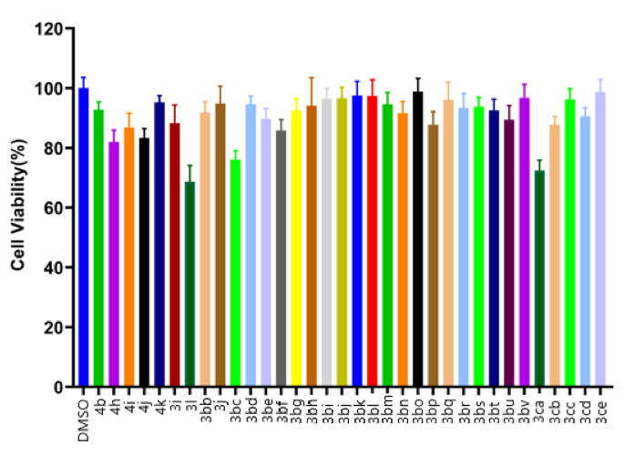
The preliminary screening results demonstrated that many of the compounds exhibited significant cytotoxic effects against cancer cells at 20 μM.

- Non-Linear effect experiments ⁹
Non-Linear effect reactions were set up with standard substrates (0.1 mmol). In this case, the amount of palladium precatalyst and M26 enantiomers were weighed on an analytical balance, and the amount of solvent was measured with volumetric syringe. The reactions were allowed to run for 36 h, purification as described in standard procedure. Each experiment was repeated three times. The relationship between enantiomeric excess of M26 ligand and product is listed here.

Table S3. Non-Linear effect experiments
Ligand  ee | (S,R)- M26 amount  weighed (mg) | (R,S)- M26 amount  weighed (mg) | Product first ee | Product  second ee | Product  third ee | Product  average ee
0 | 6.2 | 6.2 | 0.3% | 0.02% | 0.7% | 0.37%
20% | 7.4 | 5.0 | 16.7% | 18.4% | 14.5% | 16.5%
40% | 8.7 | 3.7 | 37.7% | 39.7% | 36.2% | 37.9%
60% | 9.9 | 2.5 | 50.1% | 50.7% | 53.7% | 51.5%
80% | 11.2 | 1.2 | 72.5% | 70.6% | 70.3% | 71.1%
100% | 12.4 | 0 | 90.5% | 90.6% | 90.4% | 90.5%

- Kinetic Studies: Kinetic Orders in Palladium/Ming-Phos-catalyzed enantioselective β−H elimination reaction
A: Kinetic Order in Catalyst
General procedure: Catalyst was measured from a stock solution (52.0 mg Pd₂(dba)₃·CHCl₃ and 124.0 mg M26 dissolved in 2.5 mL DMA using a Hamilton gastight syringe into 10 mL oven-dried sealed tube. Solvent was removed under reduced pressure, to the oven-dried sealed tube containing the resulting solid was added substrate 1c (54.0 mg, 0.10 mmol, 1.0 equiv.), Cs₂CO₃ (130.4 mg, 0.4 mmol, 4.0 equiv.). The flask was evacuated and refilled with argon. Then, 2a (18.8 mg, 0.12 mmol, 1.2 equiv.), DMA (1 mL), dimethoxybenzene as internal were added to the tube. The tube was tightly sealed with a Teflon-lined screw cap and heated to 50 °C in a preheated aluminum heating block. After the desired reaction time (measured precisely by a timer), the reaction was flash-cooled in a liquid nitrogen bath until frozen solid (about 45 s). The reaction was then allowed to warm back up to room temperature and analyzed by GC.

B: Kinetic Order in N-sulfonylhydrazone 1c
General procedure: Catalyst was measured from a stock solution (52.0 mg Pd₂(dba)₃·CHCl₃ and 124.0 mg M26 dissolved in 2.5 mL DMA using a Hamilton gastight syringe into 10 mL oven-dried sealed tube. Solvent was removed under reduced pressure, to the oven-dried sealed tube containing the resulting solid was added substrate 1c (from 0.06 to 0.1 mmol)), Cs₂CO₃ (130.4 mg, 0.4 mmol, 4.0 equiv.). The flask was evacuated and refilled with argon. Then, 2a (18.8 mg, 0.12 mmol, 1.2 equiv.), DMA (1 mL), dimethoxybenzene as internal were added to the tube. The tube was tightly sealed with a Teflon-lined screw cap and heated to 50 °C in a preheated aluminum heating block. After the desired reaction time (measured precisely by a timer), the reaction was flash-cooled in a liquid nitrogen bath until frozen solid (about 45 s). The reaction was then allowed to warm back up to room temperature and analyzed by GC.

C: Kinetic Order in PhBr 2a
General procedure: Catalyst was measured from a stock solution (52.0 mg Pd₂(dba)₃·CHCl₃ and 124.0 mg M26 dissolved in 2.5 mL DMA using a Hamilton gastight syringe into 10 mL oven-dried sealed tube. Solvent was removed under reduced pressure, to the oven-dried sealed tube containing the resulting solid was added substrate 1c (0.1 mmol), Cs₂CO₃ (130.4 mg, 0.4 mmol, 4.0 equiv.). The flask was evacuated and refilled with argon. Then, 2a (from 0.11 to 0.15 mmol), DMA (1 mL), dimethoxybenzene as internal were added to the tube. The tube was tightly sealed with a Teflon-lined screw cap and heated to 50 °C in a preheated aluminum heating block. After the desired reaction time (measured precisely by a timer), the reaction was flash-cooled in a liquid nitrogen bath until frozen solid (about 45 s). The reaction was then allowed to warm back up to room temperature and analyzed by GC.

- Kinetic Data: Deuterium Kinetic Isotope Experiment ⁹

Side-by- side reaction
General procedure:
An oven-dried sealed tube containing the resulting solid was charged with substrate 1c or [D]-1c (0.10 mmol, 1.0 equiv.), Pd₂(dba)₃·CHCl₃ (5.2 mg, 0.005 mmol), M26 (12.4 mg, 0.02 mmol), Cs₂CO₃ (130.4 mg, 0.4 mmol, 4.0 equiv.). The flask was evacuated and refilled with argon. Then, 2a (18.8 mg, 0.12 mmol, 1.2 equiv.), DMA (1 mL), dimethoxybenzene as internal were added to the tube. The tube was tightly sealed with a Teflon-lined screw cap and heated to 50 °C in a preheated aluminum heating block. After the desired reaction time (measured precisely by a timer), the reaction was flash-cooled in a liquid nitrogen bath until frozen solid (about 45 s). The reaction was then allowed to warm back up to room temperature and analyzed by GC.

Table S4. Yield(%) verse time (h) using 1c as a substrate.
Entry | Concentration of catalyst | Reaction time (min) | Yield (%)
1 | 5.0 mol% | 120 | 8.3
2 | 5.0 mol% | 180 | 11.8
3 | 5.0 mol% | 240 | 16.1
4 | 5.0 mol% | 300 | 20.2
5 | 5.0 mol% | 360 | 24.2

Figure S1. Plot of yield(%) verse time (h) using 1c as a substrate.

Table S5. Yield(%) verse time (h) using [D]-1c as a substrate.
Entry | Concentration of catalyst | Reaction time (h) | Average Yield (%)
1 | 5.0 mol% | 120 | 6.0
2 | 5.0 mol% | 180 | 9.2
3 | 5.0 mol% | 240 | 13.1
4 | 5.0 mol% | 300 | 16.8
5 | 5.0 mol% | 360 | 20.7

Figure S2. Plot of yield(%) verse time (h) using 2a as a substrate.

Intermolecular competition reaction:
General procedure: The general procedure for reaction monitoring by ¹H NMR was used, using 0.5 equiv of both 1c and [D]-1c. The KIE value was obtained using the generation of (3a or [D]-3a]).

Table S6. Intermolecular competition experiments

Figure S3. Intermolecular competition reaction monitoring by ¹H NMR.

- Hammett plots of aryl bromides
The general procedure for rate determination was followed using 4-methoxybromobenzene (22.4 mg, 0.12 mmol, 1.2 equiv), p-Bromotoluene (20.5 mg, 0.12 mmol, 1.2 equiv), Bromobenzene (18.8 mg, 0.12 mmol, 1.2 equiv), 4-fluorobromobenzene (21.0, 0.12 mmol, 1.2 equiv), 4-chlorobromobenzene (23.0 mg, 0.12 mmol, 1.2 equiv), and 4-(trifluoromethyl)bromobenzene (27.0 mg, 0.12 mmol, 1.2 equiv). The quantitative rates of hydroaralation of these substrates are provided below with a corresponding Hammett plot.
Table S7. Yield(%) verse time (h) using various para-substituted aryl bromides as substrates.
R | σ | Rate (mM/min)
OMe | -0.27 | 0.0609
Me | -0.17 | 0.0649
H | 0 | 0.0662
F | 0.062 | 0.0662
Cl | 0.227 | 0.0675
CF₃ | 0.54 | 0.0705

- X-Ray Structure and Crystal Data of 3bd
Table 1 Crystal data and structure refinement for 3bd.
Identification code | 3bd
Empirical formula | C₂₂H₂₂FNO_{3'}
Formula weight | 367.40
Temperature/K | 183(18)
Crystal system | monoclinic
Space group | P 1 2₁ 1
a/Å | 6.07440(10)
b/Å | 8.1716(2)
c/Å | 36.5392(7)
α/° | 90
β/° | 90
γ/° | 90
Volume/Å³ | 1813.72(6)
Z | 4
ρ_{calc}g/cm³ | 1.346
μ/mm⁻¹ | 0.788
F(000) | 776
Crystal size/mm³ | 0.32
Radiation | CuKα (λ = 1.54184)
2Θ range for data collection/° | 7.26 to 134.158
Index ranges | -7 ≤ h ≤ 7, -9 ≤ k ≤ 9, -43 ≤ l ≤ 43
Reflections collected | 42947
Independent reflections | 6469 [R_{int} = 0.0520, R_{sigma} = 0.0303]
Data/restraints/parameters | 6469/1/489
Goodness-of-fit on F² | 1.038
Final R indexes [I>=2σ (I)] | R₁ = 0.0359, wR₂ = 0.0914
Final R indexes [all data] | R₁ = 0.0376, wR₂ = 0.0926
Largest diff. peak/hole / e Å⁻³ | 0.164/-0.214
Flack parameter | -0.05(10)

Table 2 Fractional Atomic Coordinates and Equivalent Isotropic Displacement Parameters (Å²) for 3bd. U_{eq} is defined as 1/3 of of the trace of the orthogonalised U_{IJ} tensor.
Atom | x | y | z | U(eq)
F1 | 0.5120(4) | 0.5406(4) | -0.01091(5) | 0.0557(7)
O1 | 1.0490(3) | 0.4569(3) | 0.20218(5) | 0.0238(5)
O2 | 0.7142(3) | 0.3481(3) | 0.21486(6) | 0.0270(5)
O3 | 0.8446(3) | 0.7283(3) | 0.00621(5) | 0.0343(6)
N1 | 0.7628(4) | 0.6254(3) | 0.21045(7) | 0.0208(6)
C1 | 0.9764(5) | 0.2622(5) | 0.13571(8) | 0.0371(8)
H1 | 0.846263 | 0.316281 | 0.143554 | 0.045
C2 | 0.9957(6) | 0.2055(6) | 0.09977(10) | 0.0505(11)
H2 | 0.876587 | 0.220252 | 0.083255 | 0.061
C3 | 1.1833(6) | 0.1293(6) | 0.08793(10) | 0.0524(11)
H3 | 1.194322 | 0.092163 | 0.063360 | 0.063
C4 | 1.3566(6) | 0.1065(5) | 0.11192(11) | 0.0491(10)
H4 | 1.486579 | 0.052510 | 0.103951 | 0.059
C5 | 1.3404(5) | 0.1623(5) | 0.14753(9) | 0.0359(8)
H5 | 1.461277 | 0.148439 | 0.163738 | 0.043
C6 | 1.1513(4) | 0.2380(4) | 0.15991(8) | 0.0259(6)
C7 | 1.1412(4) | 0.2947(4) | 0.19928(8) | 0.0242(6)
H7A | 1.050210 | 0.217313 | 0.213632 | 0.029
H7B | 1.291450 | 0.294499 | 0.209785 | 0.029
C8 | 0.8314(4) | 0.4660(4) | 0.20947(7) | 0.0198(6)
C9 | 0.8783(4) | 0.7600(4) | 0.19185(7) | 0.0216(6)
H9 | 1.038481 | 0.762012 | 0.198151 | 0.026
C10 | 0.7564(5) | 0.9079(4) | 0.20768(9) | 0.0263(7)
H10A | 0.759565 | 1.001366 | 0.190433 | 0.032
H10B | 0.821917 | 0.942489 | 0.231249 | 0.032
C11 | 0.5184(5) | 0.8443(4) | 0.21313(9) | 0.0283(7)
H11A | 0.469450 | 0.861275 | 0.238691 | 0.034
H11B | 0.415105 | 0.901241 | 0.196490 | 0.034
C12 | 0.5299(5) | 0.6623(4) | 0.20410(8) | 0.0231(7)
H12 | 0.433956 | 0.597512 | 0.220984 | 0.028
C13 | 0.4770(4) | 0.6230(4) | 0.16411(7) | 0.0265(7)
H13A | 0.457028 | 0.503331 | 0.161538 | 0.032
H13B | 0.336123 | 0.676179 | 0.157468 | 0.032
C14 | 0.6512(4) | 0.6780(4) | 0.13795(7) | 0.0228(6)
C15 | 0.8418(4) | 0.7432(4) | 0.15091(8) | 0.0252(6)
H15 | 0.952426 | 0.778289 | 0.134299 | 0.030
C16 | 0.6098(4) | 0.6482(4) | 0.09838(8) | 0.0253(6)
C17 | 0.4388(5) | 0.5474(5) | 0.08741(8) | 0.0380(9)
H17 | 0.342832 | 0.502288 | 0.105298 | 0.046
C18 | 0.4050(6) | 0.5109(6) | 0.05055(9) | 0.0476(10)
H18 | 0.286421 | 0.442326 | 0.043340 | 0.057
C19 | 0.5432(6) | 0.5742(5) | 0.02515(8) | 0.0369(8)
C20 | 0.7166(5) | 0.6760(4) | 0.03462(8) | 0.0265(7)
C21 | 0.7490(4) | 0.7129(4) | 0.07118(8) | 0.0256(7)
H21 | 0.866832 | 0.782975 | 0.078029 | 0.031
C22 | 1.0168(6) | 0.8394(6) | 0.01461(9) | 0.0446(10)
H22A | 1.100752 | 0.863529 | -0.007646 | 0.067
H22B | 1.114522 | 0.790465 | 0.032925 | 0.067
H22C | 0.953951 | 0.940909 | 0.024341 | 0.067
F2 | 0.4867(4) | 0.4753(3) | 0.51084(4) | 0.0473(6)
O4 | 0.2748(3) | 0.6495(3) | 0.28557(6) | 0.0272(5)
O5 | -0.0611(3) | 0.5421(3) | 0.29886(5) | 0.0226(5)
O6 | 0.1559(3) | 0.2832(3) | 0.49392(5) | 0.0323(5)
N2 | 0.2225(4) | 0.3741(3) | 0.29045(7) | 0.0202(6)
C23 | 0.0168(5) | 0.7413(5) | 0.36498(8) | 0.0333(8)
H23 | 0.147299 | 0.689223 | 0.356607 | 0.040
C24 | 0.0056(6) | 0.7945(6) | 0.40084(9) | 0.0437(10)
H24 | 0.124349 | 0.775443 | 0.417211 | 0.052
C25 | -0.1817(7) | 0.8763(5) | 0.41255(10) | 0.0506(11)
H25 | -0.190183 | 0.915532 | 0.436983 | 0.061
C26 | -0.3558(7) | 0.9011(6) | 0.38894(10) | 0.0508(10)
H26 | -0.482440 | 0.958964 | 0.397021 | 0.061
C27 | -0.3461(5) | 0.8414(5) | 0.35326(9) | 0.0364(8)
H27 | -0.468352 | 0.854961 | 0.337343 | 0.044
C28 | -0.1579(4) | 0.7619(4) | 0.34090(8) | 0.0246(6)
C29 | -0.1519(5) | 0.7055(4) | 0.30182(8) | 0.0258(7)
H29A | -0.303051 | 0.706340 | 0.291676 | 0.031
H29B | -0.061365 | 0.782159 | 0.287212 | 0.031
C30 | 0.1577(4) | 0.5318(4) | 0.29148(7) | 0.0203(6)
C31 | 0.4578(4) | 0.3353(4) | 0.29646(7) | 0.0205(6)
H31 | 0.557270 | 0.403993 | 0.280981 | 0.025
C32 | 0.4608(5) | 0.1537(4) | 0.28493(8) | 0.0248(6)
H32A | 0.577895 | 0.093221 | 0.298043 | 0.030
H32B | 0.485340 | 0.142939 | 0.258249 | 0.030
C33 | 0.2309(5) | 0.0891(4) | 0.29567(9) | 0.0276(7)
H33A | 0.155877 | 0.039901 | 0.274273 | 0.033
H33B | 0.242504 | 0.005648 | 0.315214 | 0.033
C34 | 0.1045(4) | 0.2407(4) | 0.30940(7) | 0.0218(6)
H34 | -0.053602 | 0.236639 | 0.301837 | 0.026
C35 | 0.1267(4) | 0.2637(4) | 0.35106(7) | 0.0234(6)
H35A | 0.013235 | 0.342108 | 0.359492 | 0.028
H35B | 0.098556 | 0.157699 | 0.363321 | 0.028
C36 | 0.3512(4) | 0.3258(4) | 0.36236(7) | 0.0223(6)
C37 | 0.5054(4) | 0.3544(4) | 0.33694(8) | 0.0237(6)
H37 | 0.648263 | 0.387639 | 0.344486 | 0.028
C38 | 0.3894(4) | 0.3627(4) | 0.40180(7) | 0.0226(6)
C39 | 0.2531(4) | 0.2970(4) | 0.42884(7) | 0.0235(6)
H39 | 0.137176 | 0.225237 | 0.421987 | 0.028
C40 | 0.2838(5) | 0.3345(4) | 0.46556(8) | 0.0264(7)
C41 | 0.4565(5) | 0.4374(5) | 0.47485(8) | 0.0323(8)
C42 | 0.5902(5) | 0.5069(5) | 0.44910(8) | 0.0382(8)
H42 | 0.704001 | 0.580187 | 0.456172 | 0.046
C43 | 0.5575(5) | 0.4689(5) | 0.41244(8) | 0.0340(8)
H43 | 0.650692 | 0.515776 | 0.394386 | 0.041
C44 | -0.0164(6) | 0.1724(6) | 0.48570(9) | 0.0434(9)
H44A | -0.116342 | 0.222293 | 0.467840 | 0.065
H44B | -0.097908 | 0.146680 | 0.508125 | 0.065
H44C | 0.045676 | 0.071668 | 0.475460 | 0.065

Table 3 Anisotropic Displacement Parameters (Å²) for 3bd. The Anisotropic displacement factor exponent takes the form: -2π²[h²a*²U₁₁+2hka*b*U₁₂+…].
Atom | U₁₁ | U₂₂ | U₃₃ | U₂₃ |  | U₁₃ | U₁₂
F1 | 0.0702(13) | 0.0802(19) | 0.0169(10) | -0.0071(11) |  | -0.0002(10) | -0.0319(14)
O1 | 0.0231(9) | 0.0229(12) | 0.0253(10) | 0.0011(9) |  | 0.0025(8) | -0.0004(9)
O2 | 0.0288(10) | 0.0236(12) | 0.0286(12) | 0.0025(10) |  | 0.0061(9) | -0.0044(9)
O3 | 0.0451(11) | 0.0374(14) | 0.0205(11) | 0.0011(11) |  | 0.0070(9) | -0.0082(12)
N1 | 0.0235(12) | 0.0173(14) | 0.0216(13) | -0.0008(10) |  | 0.0043(10) | -0.0036(10)
C1 | 0.0348(15) | 0.051(2) | 0.0252(16) | -0.0051(18) |  | 0.0024(12) | -0.0045(19)
C2 | 0.0500(19) | 0.072(3) | 0.0297(18) | -0.009(2) |  | -0.0012(15) | -0.020(2)
C3 | 0.066(2) | 0.057(3) | 0.0343(19) | -0.021(2) |  | 0.0174(18) | -0.022(2)
C4 | 0.058(2) | 0.037(2) | 0.052(2) | -0.009(2) |  | 0.0223(18) | 0.0015(19)
C5 | 0.0384(16) | 0.0276(18) | 0.0417(19) | 0.0014(17) |  | 0.0086(15) | 0.0040(16)
C6 | 0.0302(13) | 0.0217(16) | 0.0259(15) | 0.0018(14) |  | 0.0029(11) | -0.0016(14)
C7 | 0.0268(13) | 0.0238(16) | 0.0220(14) | 0.0017(13) |  | -0.0010(11) | 0.0028(12)
C8 | 0.0236(13) | 0.0203(16) | 0.0154(13) | -0.0024(12) |  | 0.0022(10) | 0.0000(12)
C9 | 0.0218(11) | 0.0226(16) | 0.0204(14) | 0.0014(13) |  | -0.0012(10) | -0.0057(13)
C10 | 0.0318(17) | 0.0210(16) | 0.0261(15) | 0.0007(13) |  | -0.0004(13) | -0.0022(12)
C11 | 0.0259(14) | 0.0265(17) | 0.0324(16) | -0.0010(14) |  | 0.0077(12) | -0.0010(13)
C12 | 0.0226(13) | 0.0258(16) | 0.0208(15) | 0.0000(13) |  | 0.0042(11) | -0.0016(12)
C13 | 0.0227(12) | 0.0368(17) | 0.0201(13) | -0.0004(12) |  | 0.0026(10) | -0.0032(12)
C14 | 0.0267(13) | 0.0249(16) | 0.0168(14) | -0.0005(13) |  | 0.0029(11) | 0.0004(13)
C15 | 0.0279(12) | 0.0249(15) | 0.0228(14) | 0.0031(13) |  | 0.0057(10) | -0.0046(13)
C16 | 0.0286(13) | 0.0269(16) | 0.0205(14) | 0.0014(13) |  | 0.0020(11) | 0.0005(13)
C17 | 0.0404(17) | 0.050(2) | 0.0239(16) | 0.0019(16) |  | 0.0034(13) | -0.0180(17)
C18 | 0.051(2) | 0.066(3) | 0.0260(17) | -0.002(2) |  | -0.0022(14) | -0.031(2)
C19 | 0.0490(19) | 0.046(2) | 0.0162(15) | -0.0030(16) |  | -0.0002(13) | -0.0070(18)
C20 | 0.0332(14) | 0.0259(17) | 0.0203(14) | 0.0035(14) |  | 0.0040(11) | -0.0014(13)
C21 | 0.0305(14) | 0.0243(16) | 0.0222(14) | 0.0002(13) |  | 0.0022(11) | -0.0030(12)
C22 | 0.0440(17) | 0.062(3) | 0.0279(16) | 0.0087(19) |  | 0.0049(14) | -0.020(2)
F2 | 0.0627(12) | 0.0600(15) | 0.0192(10) | -0.0050(10) |  | -0.0004(9) | -0.0216(12)
O4 | 0.0307(10) | 0.0218(12) | 0.0291(12) | 0.0007(10) |  | 0.0088(9) | -0.0045(9)
O5 | 0.0211(9) | 0.0206(11) | 0.0262(10) | -0.0019(9) |  | 0.0022(8) | -0.0003(8)
O6 | 0.0406(11) | 0.0351(13) | 0.0214(11) | 0.0020(11) |  | 0.0063(8) | -0.0089(11)
N2 | 0.0181(11) | 0.0242(15) | 0.0183(12) | 0.0011(10) |  | 0.0008(9) | 0.0003(10)
C23 | 0.0282(13) | 0.042(2) | 0.0294(16) | -0.0041(17) |  | 0.0009(12) | -0.0048(17)
C24 | 0.0510(18) | 0.055(3) | 0.0254(16) | -0.0029(18) |  | 0.0000(14) | -0.020(2)
C25 | 0.076(3) | 0.045(3) | 0.0314(19) | -0.0127(19) |  | 0.0180(18) | -0.020(2)
C26 | 0.070(2) | 0.038(2) | 0.045(2) | -0.007(2) |  | 0.0272(19) | 0.010(2)
C27 | 0.0425(17) | 0.0321(19) | 0.0346(17) | 0.0027(16) |  | 0.0094(14) | 0.0076(17)
C28 | 0.0292(13) | 0.0194(15) | 0.0254(15) | 0.0009(14) |  | 0.0059(11) | -0.0056(13)
C29 | 0.0277(13) | 0.0228(16) | 0.0269(15) | 0.0022(13) |  | 0.0019(12) | 0.0038(12)
C30 | 0.0217(13) | 0.0262(17) | 0.0129(13) | 0.0013(12) |  | 0.0024(10) | -0.0035(12)
C31 | 0.0197(12) | 0.0229(16) | 0.0191(14) | -0.0008(12) |  | 0.0041(10) | -0.0007(11)
C32 | 0.0290(14) | 0.0214(15) | 0.0241(14) | -0.0009(13) |  | 0.0019(11) | 0.0037(12)
C33 | 0.0310(16) | 0.0219(17) | 0.0299(17) | -0.0010(14) |  | 0.0006(13) | -0.0030(13)
C34 | 0.0213(11) | 0.0222(15) | 0.0219(14) | 0.0009(13) |  | 0.0019(10) | -0.0046(13)
C35 | 0.0224(11) | 0.0293(16) | 0.0185(13) | 0.0023(13) |  | 0.0006(10) | -0.0046(12)
C36 | 0.0227(12) | 0.0204(15) | 0.0237(15) | 0.0030(13) |  | -0.0001(11) | -0.0005(12)
C37 | 0.0206(11) | 0.0281(15) | 0.0223(13) | -0.0014(11) |  | 0.0000(10) | 0.0000(11)
C38 | 0.0242(12) | 0.0240(16) | 0.0197(14) | 0.0014(13) |  | 0.0014(10) | 0.0016(13)
C39 | 0.0248(13) | 0.0238(16) | 0.0219(14) | 0.0000(13) |  | -0.0003(11) | 0.0003(12)
C40 | 0.0319(14) | 0.0278(17) | 0.0194(14) | 0.0032(14) |  | 0.0049(11) | 0.0040(14)
C41 | 0.0430(17) | 0.036(2) | 0.0180(15) | -0.0036(15) |  | -0.0019(13) | -0.0091(16)
C42 | 0.0430(17) | 0.046(2) | 0.0260(16) | -0.0027(17) |  | -0.0002(13) | -0.0188(17)
C43 | 0.0381(16) | 0.043(2) | 0.0209(15) | 0.0005(15) |  | 0.0027(12) | -0.0153(16)
C44 | 0.0452(18) | 0.054(2) | 0.0306(17) | 0.0046(19) |  | 0.0067(15) | -0.0166(19)
Table 4 Bond Lengths for 3bd.
Atom |  | Atom | Length/Å |  | Atom | Atom | Length/Å
F1 |  | C19 | 1.359(4) |  | F2 | C41 | 1.363(3)
O1 |  | C7 | 1.443(4) |  | O4 | C30 | 1.216(4)
O1 |  | C8 | 1.350(3) |  | O5 | C29 | 1.449(4)
O2 |  | C8 | 1.214(4) |  | O5 | C30 | 1.359(3)
O3 |  | C20 | 1.365(3) |  | O6 | C40 | 1.361(3)
O3 |  | C22 | 1.418(4) |  | O6 | C44 | 1.416(4)
N1 |  | C8 | 1.368(4) |  | N2 | C30 | 1.348(4)
N1 |  | C9 | 1.471(4) |  | N2 | C31 | 1.481(3)
N1 |  | C12 | 1.465(4) |  | N2 | C34 | 1.477(4)
C1 |  | H1 | 0.9500 |  | C23 | H23 | 0.9500
C1 |  | C2 | 1.397(5) |  | C23 | C24 | 1.382(4)
C1 |  | C6 | 1.396(4) |  | C23 | C28 | 1.389(4)
C2 |  | H2 | 0.9500 |  | C24 | H24 | 0.9500
C2 |  | C3 | 1.369(6) |  | C24 | C25 | 1.387(5)
C3 |  | H3 | 0.9500 |  | C25 | H25 | 0.9500
C3 |  | C4 | 1.382(6) |  | C25 | C26 | 1.379(6)
C4 |  | H4 | 0.9500 |  | C26 | H26 | 0.9500
C4 |  | C5 | 1.382(5) |  | C26 | C27 | 1.393(5)
C5 |  | H5 | 0.9500 |  | C27 | H27 | 0.9500
C5 |  | C6 | 1.381(4) |  | C27 | C28 | 1.390(4)
C6 |  | C7 | 1.512(4) |  | C28 | C29 | 1.501(4)
C7 |  | H7A | 0.9900 |  | C29 | H29A | 0.9900
C7 |  | H7B | 0.9900 |  | C29 | H29B | 0.9900
C9 |  | H9 | 1.0000 |  | C31 | H31 | 1.0000
C9 |  | C10 | 1.531(4) |  | C31 | C32 | 1.542(4)
C9 |  | C15 | 1.519(4) |  | C31 | C37 | 1.515(4)
C10 |  | H10A | 0.9900 |  | C32 | H32A | 0.9900
C10 |  | H10B | 0.9900 |  | C32 | H32B | 0.9900
C10 |  | C11 | 1.549(4) |  | C32 | C33 | 1.544(4)
C11 |  | H11A | 0.9900 |  | C33 | H33A | 0.9900
C11 |  | H11B | 0.9900 |  | C33 | H33B | 0.9900
C11 |  | C12 | 1.525(5) |  | C33 | C34 | 1.542(4)
C12 |  | H12 | 1.0000 |  | C34 | H34 | 1.0000
C12 |  | C13 | 1.530(4) |  | C34 | C35 | 1.540(4)
C13 |  | H13A | 0.9900 |  | C35 | H35A | 0.9900
C13 |  | H13B | 0.9900 |  | C35 | H35B | 0.9900
C13 |  | C14 | 1.495(4) |  | C35 | C36 | 1.513(4)
C14 |  | C15 | 1.359(4) |  | C36 | C37 | 1.340(4)
C14 |  | C16 | 1.488(4) |  | C36 | C38 | 1.490(4)
C15 |  | H15 | 0.9500 |  | C37 | H37 | 0.9500
C16 |  | C17 | 1.385(5) |  | C38 | C39 | 1.396(4)
C16 |  | C21 | 1.408(4) |  | C38 | C43 | 1.395(4)
C17 |  | H17 | 0.9500 |  | C39 | H39 | 0.9500
C17 |  | C18 | 1.394(4) |  | C39 | C40 | 1.389(4)
C18 |  | H18 | 0.9500 |  | C40 | C41 | 1.387(5)
C18 |  | C19 | 1.354(5) |  | C41 | C42 | 1.367(4)
C19 |  | C20 | 1.386(5) |  | C42 | H42 | 0.9500
C20 |  | C21 | 1.383(4) |  | C42 | C43 | 1.390(4)
C21 |  | H21 | 0.9500 |  | C43 | H43 | 0.9500
C22 |  | H22A | 0.9800 |  | C44 | H44A | 0.9800
C22 |  | H22B | 0.9800 |  | C44 | H44B | 0.9800
C22 |  | H22C | 0.9800 |  | C44 | H44C | 0.9800

Table 5 Bond Angles for 3bd.
Atom | Atom | Atom | Angle/˚ |  | Atom | Atom | Atom |  | Angle/˚
C8 | O1 | C7 | 116.4(2) |  | C30 | O5 | C29 |  | 116.4(2)
C20 | O3 | C22 | 117.1(2) |  | C40 | O6 | C44 |  | 117.2(2)
C8 | N1 | C9 | 123.7(2) |  | C30 | N2 | C31 |  | 118.9(2)
C8 | N1 | C12 | 119.1(3) |  | C30 | N2 | C34 |  | 123.4(2)
C12 | N1 | C9 | 103.5(2) |  | C34 | N2 | C31 |  | 103.9(2)
C2 | C1 | H1 | 120.5 |  | C24 | C23 | H23 |  | 119.2
C6 | C1 | H1 | 120.5 |  | C24 | C23 | C28 |  | 121.6(3)
C6 | C1 | C2 | 119.0(3) |  | C28 | C23 | H23 |  | 119.2
C1 | C2 | H2 | 119.4 |  | C23 | C24 | H24 |  | 120.5
C3 | C2 | C1 | 121.2(4) |  | C23 | C24 | C25 |  | 119.0(3)
C3 | C2 | H2 | 119.4 |  | C25 | C24 | H24 |  | 120.5
C2 | C3 | H3 | 120.2 |  | C24 | C25 | H25 |  | 119.8
C2 | C3 | C4 | 119.7(3) |  | C26 | C25 | C24 |  | 120.4(3)
C4 | C3 | H3 | 120.2 |  | C26 | C25 | H25 |  | 119.8
C3 | C4 | H4 | 120.1 |  | C25 | C26 | H26 |  | 120.0
C5 | C4 | C3 | 119.9(3) |  | C25 | C26 | C27 |  | 120.1(3)
C5 | C4 | H4 | 120.1 |  | C27 | C26 | H26 |  | 120.0
C4 | C5 | H5 | 119.5 |  | C26 | C27 | H27 |  | 119.9
C6 | C5 | C4 | 121.0(3) |  | C28 | C27 | C26 |  | 120.2(3)
C6 | C5 | H5 | 119.5 |  | C28 | C27 | H27 |  | 119.9
C1 | C6 | C7 | 121.9(3) |  | C23 | C28 | C27 |  | 118.6(3)
C5 | C6 | C1 | 119.3(3) |  | C23 | C28 | C29 |  | 123.2(3)
C5 | C6 | C7 | 118.8(3) |  | C27 | C28 | C29 |  | 118.2(3)
O1 | C7 | C6 | 111.5(3) |  | O5 | C29 | C28 |  | 111.3(3)
O1 | C7 | H7A | 109.3 |  | O5 | C29 | H29A |  | 109.4
O1 | C7 | H7B | 109.3 |  | O5 | C29 | H29B |  | 109.4
C6 | C7 | H7A | 109.3 |  | C28 | C29 | H29A |  | 109.4
C6 | C7 | H7B | 109.3 |  | C28 | C29 | H29B |  | 109.4
H7A | C7 | H7B | 108.0 |  | H29A | C29 | H29B |  | 108.0
O1 | C8 | N1 | 110.9(2) |  | O4 | C30 | O5 |  | 124.0(3)
O2 | C8 | O1 | 124.2(3) |  | O4 | C30 | N2 |  | 125.5(3)
O2 | C8 | N1 | 124.9(3) |  | N2 | C30 | O5 |  | 110.5(3)
N1 | C9 | H9 | 111.7 |  | N2 | C31 | H31 |  | 112.3
N1 | C9 | C10 | 100.7(2) |  | N2 | C31 | C32 |  | 100.2(3)
N1 | C9 | C15 | 108.5(2) |  | N2 | C31 | C37 |  | 107.9(2)
C10 | C9 | H9 | 111.7 |  | C32 | C31 | H31 |  | 112.3
C15 | C9 | H9 | 111.7 |  | C37 | C31 | H31 |  | 112.3
C15 | C9 | C10 | 111.9(3) |  | C37 | C31 | C32 |  | 111.3(3)
C9 | C10 | H10A | 111.0 |  | C31 | C32 | H32A |  | 110.9
C9 | C10 | H10B | 111.0 |  | C31 | C32 | H32B |  | 110.9
C9 | C10 | C11 | 103.6(3) |  | C31 | C32 | C33 |  | 104.4(3)
H10A | C10 | H10B | 109.0 |  | H32A | C32 | H32B |  | 108.9
C11 | C10 | H10A | 111.0 |  | C33 | C32 | H32A |  | 110.9
C11 | C10 | H10B | 111.0 |  | C33 | C32 | H32B |  | 110.9
C10 | C11 | H11A | 110.8 |  | C32 | C33 | H33A |  | 110.8
C10 | C11 | H11B | 110.8 |  | C32 | C33 | H33B |  | 110.8
H11A | C11 | H11B | 108.8 |  | H33A | C33 | H33B |  | 108.8
C12 | C11 | C10 | 104.9(3) |  | C34 | C33 | C32 |  | 105.0(3)
C12 | C11 | H11A | 110.8 |  | C34 | C33 | H33A |  | 110.8
C12 | C11 | H11B | 110.8 |  | C34 | C33 | H33B |  | 110.8
N1 | C12 | C11 | 102.1(3) |  | N2 | C34 | C33 |  | 101.5(2)
N1 | C12 | H12 | 110.9 |  | N2 | C34 | H34 |  | 111.2
N1 | C12 | C13 | 108.1(2) |  | N2 | C34 | C35 |  | 109.3(2)
C11 | C12 | H12 | 110.9 |  | C33 | C34 | H34 |  | 111.2
C11 | C12 | C13 | 113.7(3) |  | C35 | C34 | C33 |  | 112.1(3)
C13 | C12 | H12 | 110.9 |  | C35 | C34 | H34 |  | 111.2
C12 | C13 | H13A | 108.9 |  | C34 | C35 | H35A |  | 109.0
C12 | C13 | H13B | 108.9 |  | C34 | C35 | H35B |  | 109.0
H13A | C13 | H13B | 107.7 |  | H35A | C35 | H35B |  | 107.8
C14 | C13 | C12 | 113.5(2) |  | C36 | C35 | C34 |  | 112.9(2)
C14 | C13 | H13A | 108.9 |  | C36 | C35 | H35A |  | 109.0
C14 | C13 | H13B | 108.9 |  | C36 | C35 | H35B |  | 109.0
C15 | C14 | C13 | 119.9(2) |  | C37 | C36 | C35 |  | 120.0(2)
C15 | C14 | C16 | 123.1(2) |  | C37 | C36 | C38 |  | 121.7(3)
C16 | C14 | C13 | 116.9(2) |  | C38 | C36 | C35 |  | 118.2(2)
C9 | C15 | H15 | 119.9 |  | C31 | C37 | H37 |  | 119.2
C14 | C15 | C9 | 120.2(2) |  | C36 | C37 | C31 |  | 121.7(3)
C14 | C15 | H15 | 119.9 |  | C36 | C37 | H37 |  | 119.2
C17 | C16 | C14 | 120.3(3) |  | C39 | C38 | C36 |  | 120.9(3)
C17 | C16 | C21 | 118.0(3) |  | C43 | C38 | C36 |  | 120.6(3)
C21 | C16 | C14 | 121.5(3) |  | C43 | C38 | C39 |  | 118.4(3)
C16 | C17 | H17 | 119.4 |  | C38 | C39 | H39 |  | 119.4
C16 | C17 | C18 | 121.1(3) |  | C40 | C39 | C38 |  | 121.3(3)
C18 | C17 | H17 | 119.4 |  | C40 | C39 | H39 |  | 119.4
C17 | C18 | H18 | 120.4 |  | O6 | C40 | C39 |  | 126.2(3)
C19 | C18 | C17 | 119.3(3) |  | O6 | C40 | C41 |  | 115.6(3)
C19 | C18 | H18 | 120.4 |  | C41 | C40 | C39 |  | 118.2(3)
F1 | C19 | C20 | 118.0(3) |  | F2 | C41 | C40 |  | 118.4(3)
C18 | C19 | F1 | 120.0(3) |  | F2 | C41 | C42 |  | 119.3(3)
C18 | C19 | C20 | 122.0(3) |  | C42 | C41 | C40 |  | 122.2(3)
O3 | C20 | C19 | 115.5(3) |  | C41 | C42 | H42 |  | 120.5
O3 | C20 | C21 | 125.8(3) |  | C41 | C42 | C43 |  | 119.0(3)
C21 | C20 | C19 | 118.7(3) |  | C43 | C42 | H42 |  | 120.5
C16 | C21 | H21 | 119.5 |  | C38 | C43 | H43 |  | 119.6
C20 | C21 | C16 | 120.9(3) |  | C42 | C43 | C38 |  | 120.8(3)
C20 | C21 | H21 | 119.5 |  | C42 | C43 | H43 |  | 119.6
O3 | C22 | H22A | 109.5 |  | O6 | C44 | H44A |  | 109.5
O3 | C22 | H22B | 109.5 |  | O6 | C44 | H44B |  | 109.5
O3 | C22 | H22C | 109.5 |  | O6 | C44 | H44C |  | 109.5
H22A | C22 | H22B | 109.5 |  | H44A | C44 | H44B |  | 109.5
H22A | C22 | H22C | 109.5 |  | H44A | C44 | H44C |  | 109.5
H22B | C22 | H22C | 109.5 |  | H44B | C44 | H44C |  | 109.5
Table 6 Torsion Angles for 3bd.
Atom |  | Atom | Atom | Atom |  |  |  | Angle/˚
F1 |  | C19 | C20 | O3 |  |  |  | -2.1(5)
F1 |  | C19 | C20 | C21 |  |  |  | 179.3(3)
O3 |  | C20 | C21 | C16 |  |  |  | -178.2(3)
N1 |  | C9 | C10 | C11 |  |  |  | -33.2(3)
N1 |  | C9 | C15 | C14 |  |  |  | 31.6(4)
N1 |  | C12 | C13 | C14 |  |  |  | -42.3(4)
C1 |  | C2 | C3 | C4 |  |  |  | 0.5(7)
C1 |  | C6 | C7 | O1 |  |  |  | -43.5(4)
C2 |  | C1 | C6 | C5 |  |  |  | 1.5(6)
C2 |  | C1 | C6 | C7 |  |  |  | -179.5(4)
C2 |  | C3 | C4 | C5 |  |  |  | -0.7(7)
C3 |  | C4 | C5 | C6 |  |  |  | 1.4(6)
C4 |  | C5 | C6 | C1 |  |  |  | -1.7(6)
C4 |  | C5 | C6 | C7 |  |  |  | 179.1(4)
C5 |  | C6 | C7 | O1 |  |  |  | 135.5(3)
C6 |  | C1 | C2 | C3 |  |  |  | -0.9(7)
C7 |  | O1 | C8 | O2 |  |  |  | 2.7(4)
C7 |  | O1 | C8 | N1 |  |  |  | -178.2(2)
C8 |  | O1 | C7 | C6 |  |  |  | 95.6(3)
C8 |  | N1 | C9 | C10 |  |  |  | -170.4(3)
C8 |  | N1 | C9 | C15 |  |  |  | 72.0(3)
C8 |  | N1 | C12 | C11 |  |  |  | 171.9(3)
C8 |  | N1 | C12 | C13 |  |  |  | -68.0(4)
C9 |  | N1 | C8 | O1 |  |  |  | 23.3(4)
C9 |  | N1 | C8 | O2 |  |  |  | -157.6(3)
C9 |  | N1 | C12 | C11 |  |  |  | -46.3(3)
C9 |  | N1 | C12 | C13 |  |  |  | 73.9(3)
C9 |  | C10 | C11 | C12 |  |  |  | 6.0(3)
C10 |  | C9 | C15 | C14 |  |  |  | -78.6(4)
C10 |  | C11 | C12 | N1 |  |  |  | 23.6(3)
C10 |  | C11 | C12 | C13 |  |  |  | -92.6(3)
C11 |  | C12 | C13 | C14 |  |  |  | 70.3(4)
C12 |  | N1 | C8 | O1 |  |  |  | 157.1(2)
C12 |  | N1 | C8 | O2 |  |  |  | -23.8(4)
C12 |  | N1 | C9 | C10 |  |  |  | 50.1(3)
C12 |  | N1 | C9 | C15 |  |  |  | -67.5(3)
C12 |  | C13 | C14 | C15 |  |  |  | 5.1(5)
C12 |  | C13 | C14 | C16 |  |  |  | -178.5(3)
C13 |  | C14 | C15 | C9 |  |  |  | 0.1(5)
C13 |  | C14 | C16 | C17 |  |  |  | -11.8(5)
C13 |  | C14 | C16 | C21 |  |  |  | 171.9(3)
C14 |  | C16 | C17 | C18 |  |  |  | -176.4(4)
C14 |  | C16 | C21 | C20 |  |  |  | 176.0(3)
C15 |  | C9 | C10 | C11 |  |  |  | 81.9(3)
C15 |  | C14 | C16 | C17 |  |  |  | 164.5(3)
C15 |  | C14 | C16 | C21 |  |  |  | -11.8(5)
C16 |  | C14 | C15 | C9 |  |  |  | -176.0(3)
C16 |  | C17 | C18 | C19 |  |  |  | 0.6(7)
C17 |  | C16 | C21 | C20 |  |  |  | -0.4(5)
C17 |  | C18 | C19 | F1 |  |  |  | -179.7(4)
C17 |  | C18 | C19 | C20 |  |  |  | -0.7(7)
C18 |  | C19 | C20 | O3 |  |  |  | 178.9(4)
C18 |  | C19 | C20 | C21 |  |  |  | 0.3(6)
C19 |  | C20 | C21 | C16 |  |  |  | 0.3(5)
C21 |  | C16 | C17 | C18 |  |  |  | 0.0(6)
C22 |  | O3 | C20 | C19 |  |  |  | 176.8(3)
C22 |  | O3 | C20 | C21 |  |  |  | -4.7(5)
F2 |  | C41 | C42 | C43 |  |  |  | -179.5(3)
O6 |  | C40 | C41 | F2 |  |  |  | 1.4(5)
O6 |  | C40 | C41 | C42 |  |  |  | -175.8(4)
N2 |  | C31 | C32 | C33 |  |  |  | -32.2(3)
N2 |  | C31 | C37 | C36 |  |  |  | 30.8(4)
N2 |  | C34 | C35 | C36 |  |  |  | -37.9(3)
C23 |  | C24 | C25 | C26 |  |  |  | 1.3(6)
C23 |  | C28 | C29 | O5 |  |  |  | 44.7(4)
C24 |  | C23 | C28 | C27 |  |  |  | 1.4(5)
C24 |  | C23 | C28 | C29 |  |  |  | -179.9(3)
C24 |  | C25 | C26 | C27 |  |  |  | 1.1(7)
C25 |  | C26 | C27 | C28 |  |  |  | -2.4(6)
C26 |  | C27 | C28 | C23 |  |  |  | 1.1(6)
C26 |  | C27 | C28 | C29 |  |  |  | -177.7(4)
C27 |  | C28 | C29 | O5 |  |  |  | -136.5(3)
C28 |  | C23 | C24 | C25 |  |  |  | -2.6(6)
C29 |  | O5 | C30 | O4 |  |  |  | -3.8(4)
C29 |  | O5 | C30 | N2 |  |  |  | 178.3(3)
C30 |  | O5 | C29 | C28 |  |  |  | -94.8(3)
C30 |  | N2 | C31 | C32 |  |  |  | -168.7(3)
C30 |  | N2 | C31 | C37 |  |  |  | 74.8(3)
C30 |  | N2 | C34 | C33 |  |  |  | 173.9(3)
C30 |  | N2 | C34 | C35 |  |  |  | -67.5(3)
C31 |  | N2 | C30 | O4 |  |  |  | 24.4(4)
C31 |  | N2 | C30 | O5 |  |  |  | -157.7(2)
C31 |  | N2 | C34 | C33 |  |  |  | -46.7(3)
C31 |  | N2 | C34 | C35 |  |  |  | 71.9(3)
C31 |  | C32 | C33 | C34 |  |  |  | 4.9(3)
C32 |  | C31 | C37 | C36 |  |  |  | -78.2(4)
C32 |  | C33 | C34 | N2 |  |  |  | 24.4(3)
C32 |  | C33 | C34 | C35 |  |  |  | -92.1(3)
C33 |  | C34 | C35 | C36 |  |  |  | 73.9(3)
C34 |  | N2 | C30 | O4 |  |  |  | 158.3(3)
C34 |  | N2 | C30 | O5 |  |  |  | -23.8(4)
C34 |  | N2 | C31 | C32 |  |  |  | 49.6(3)
C34 |  | N2 | C31 | C37 |  |  |  | -66.9(3)
C34 |  | C35 | C36 | C37 |  |  |  | -0.1(4)
C34 |  | C35 | C36 | C38 |  |  |  | 176.4(3)
C35 |  | C36 | C37 | C31 |  |  |  | 3.4(5)
C35 |  | C36 | C38 | C39 |  |  |  | 19.4(4)
C35 |  | C36 | C38 | C43 |  |  |  | -158.1(3)
C36 |  | C38 | C39 | C40 |  |  |  | -178.2(3)
C36 |  | C38 | C43 | C42 |  |  |  | 178.4(3)
C37 |  | C31 | C32 | C33 |  |  |  | 81.7(3)
C37 |  | C36 | C38 | C39 |  |  |  | -164.2(3)
C37 |  | C36 | C38 | C43 |  |  |  | 18.3(5)
C38 |  | C36 | C37 | C31 |  |  |  | -172.9(3)
C38 |  | C39 | C40 | O6 |  |  |  | 177.1(3)
C38 |  | C39 | C40 | C41 |  |  |  | -1.0(5)
C39 |  | C38 | C43 | C42 |  |  |  | 0.7(5)
C39 |  | C40 | C41 | F2 |  |  |  | 179.7(3)
C39 |  | C40 | C41 | C42 |  |  |  | 2.5(6)
C40 |  | C41 | C42 | C43 |  |  |  | -2.3(6)
C41 |  | C42 | C43 | C38 |  |  |  | 0.6(6)
C43 |  | C38 | C39 | C40 |  |  |  | -0.5(5)
C44 |  | O6 | C40 | C39 |  |  |  | 4.5(5)
C44 |  | O6 | C40 | C41 |  |  |  | -177.4(3)

- ¹H , ¹⁹F, ³¹P, ¹³C NMR and HPLC Spectra
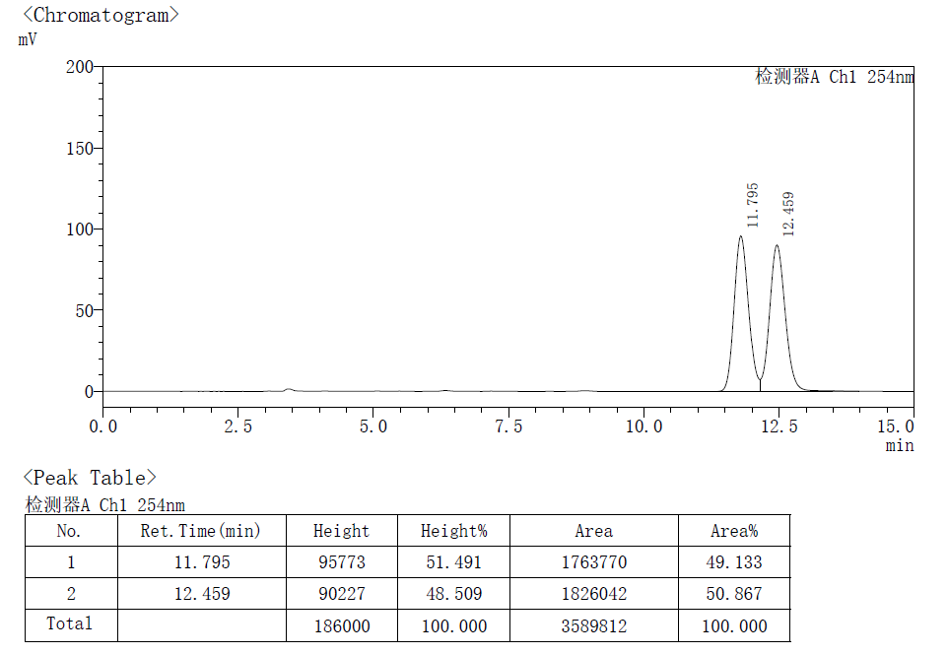
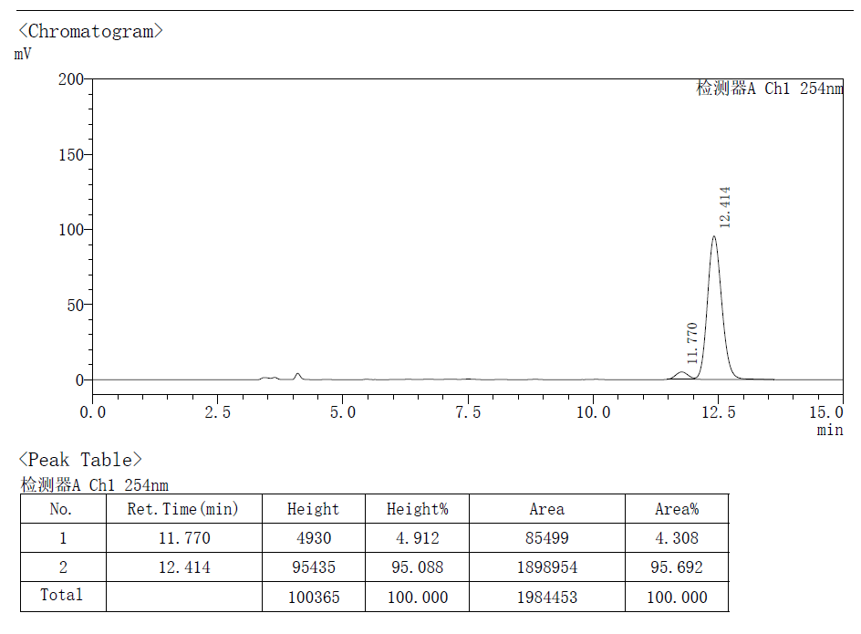

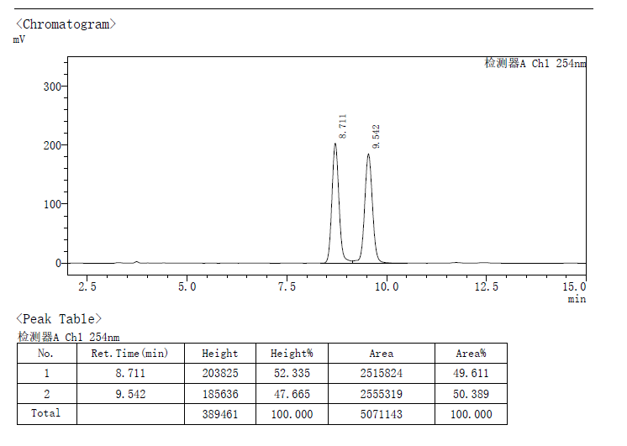
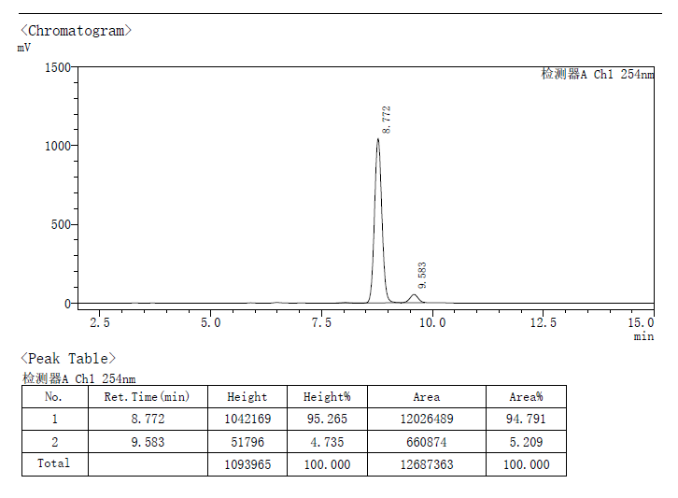

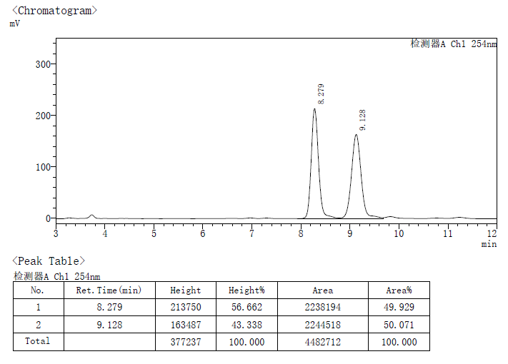
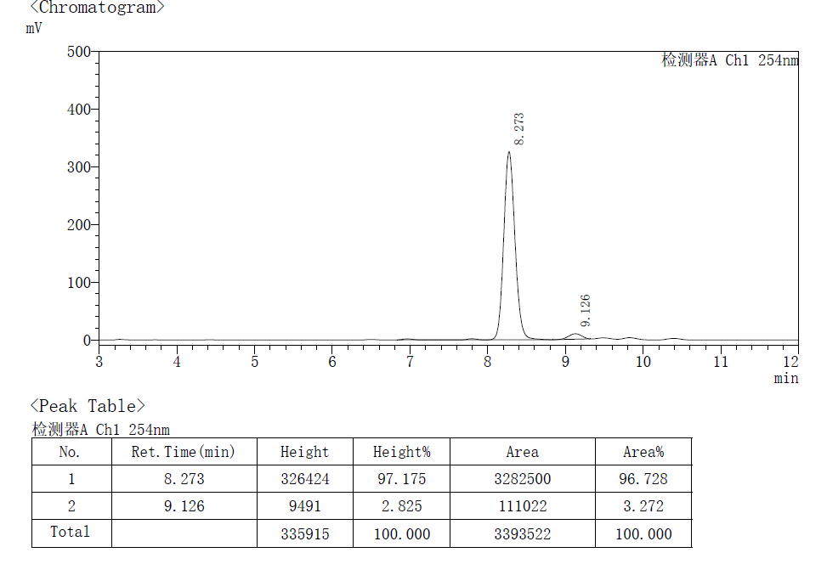
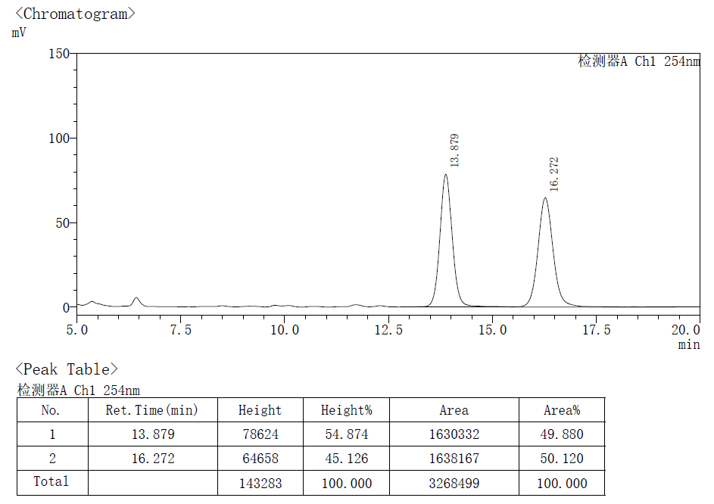
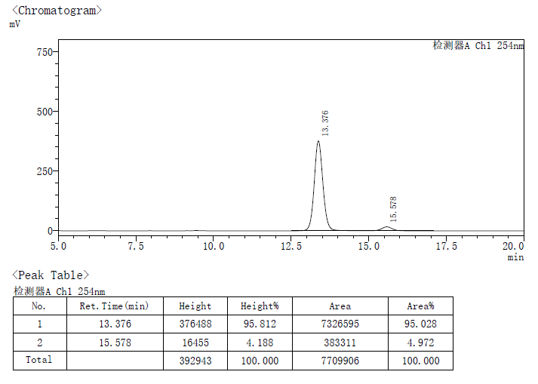
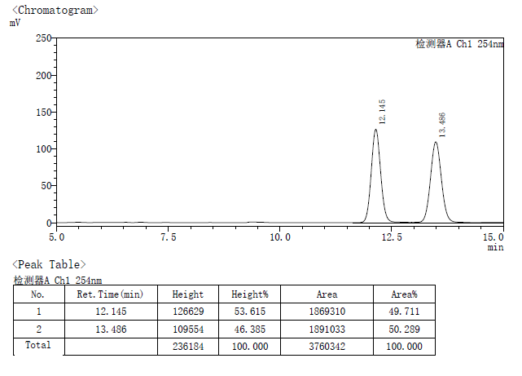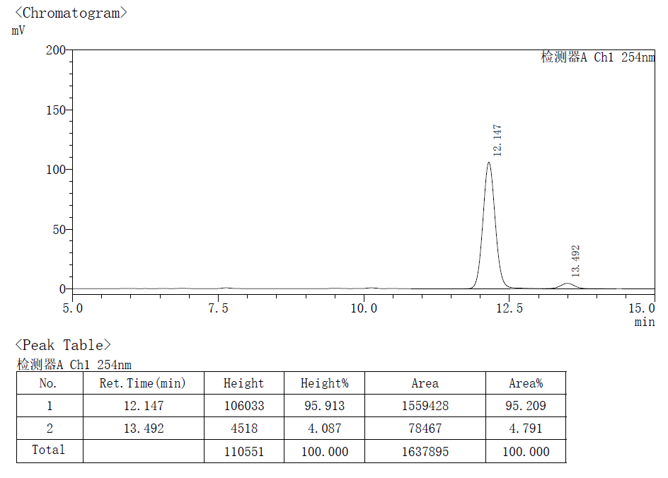
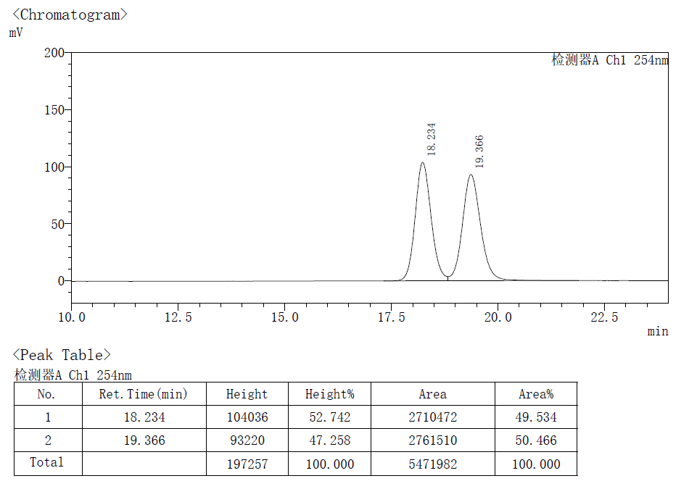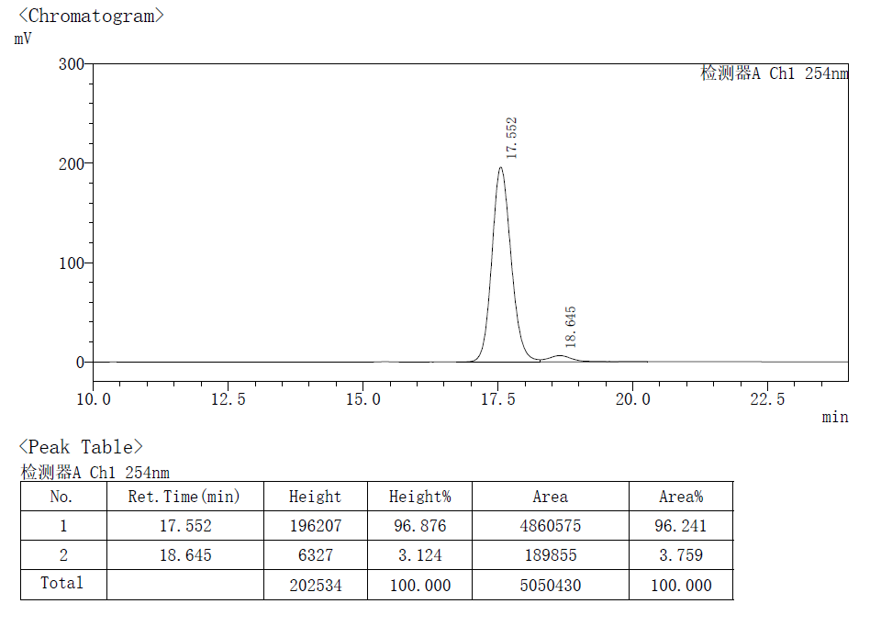
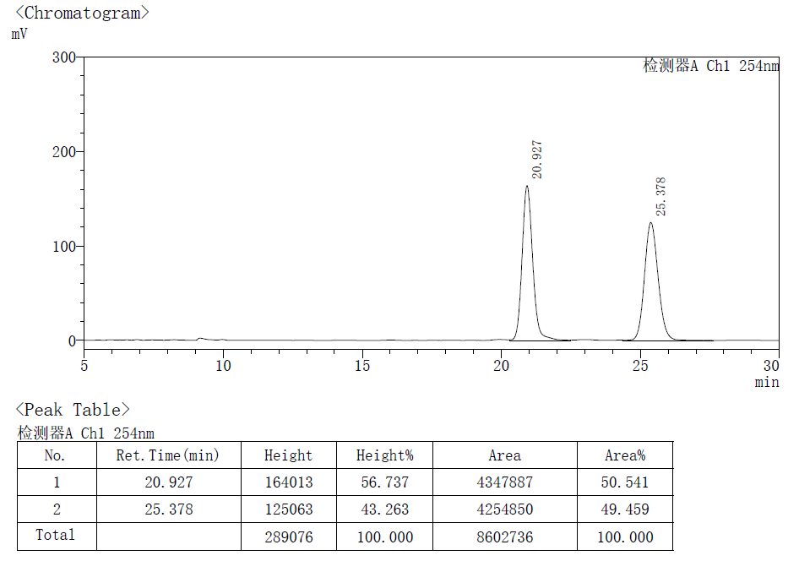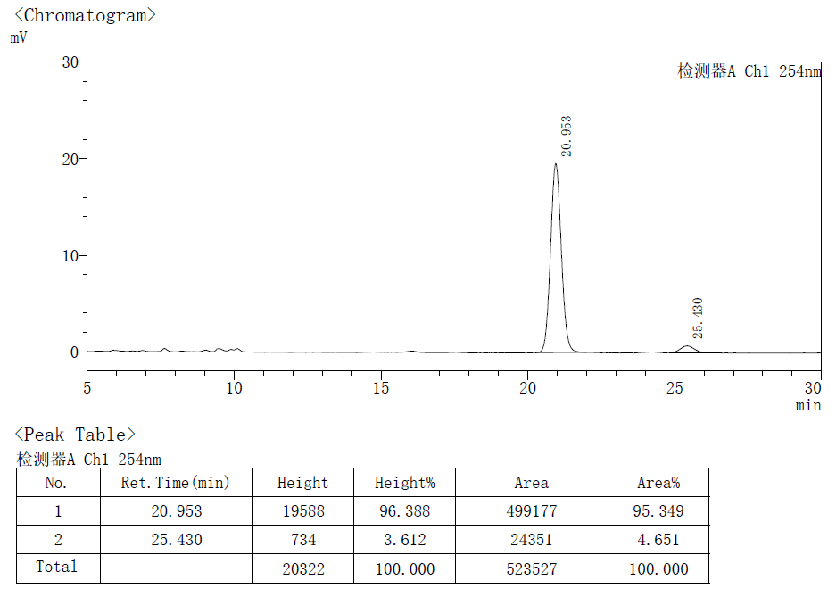
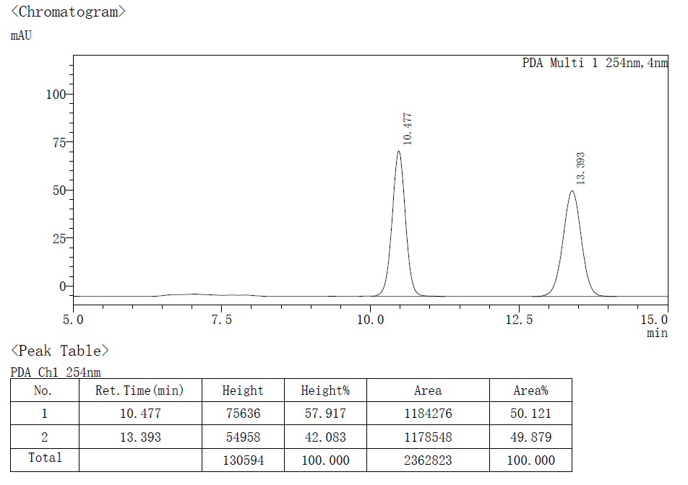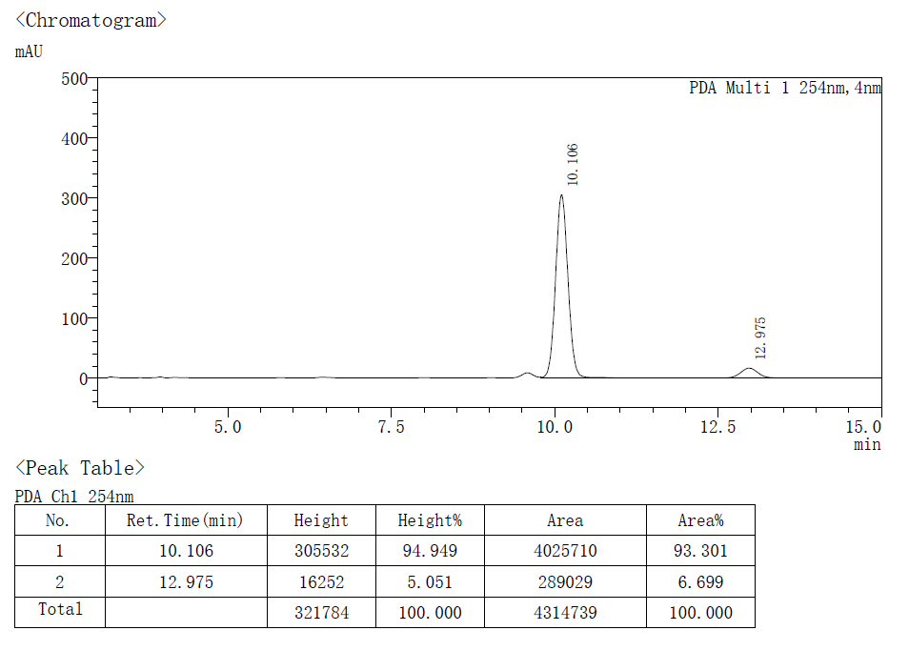

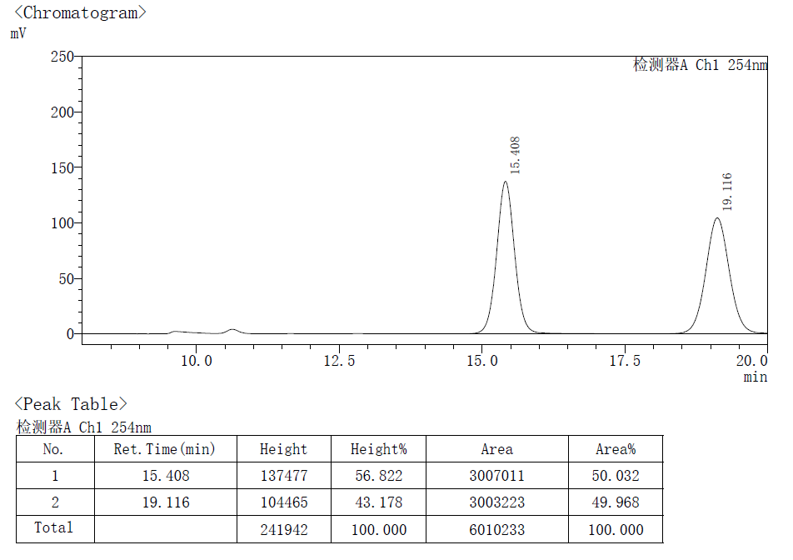
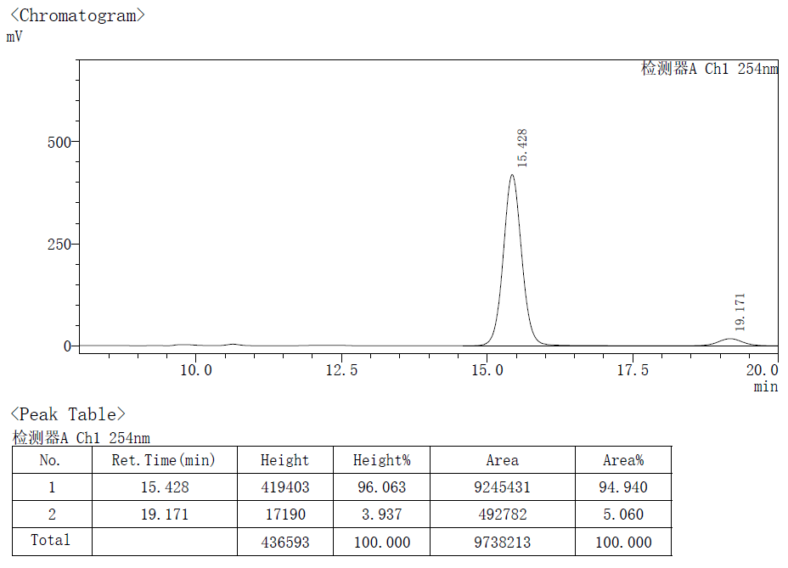
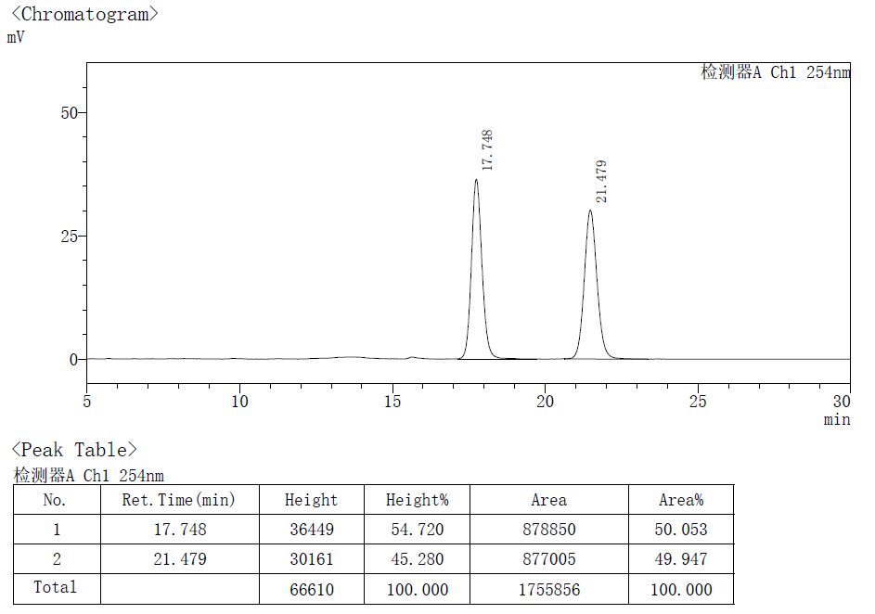
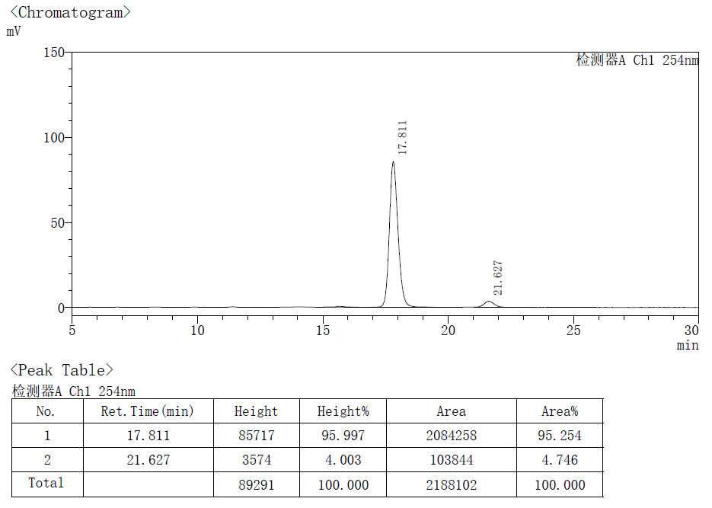
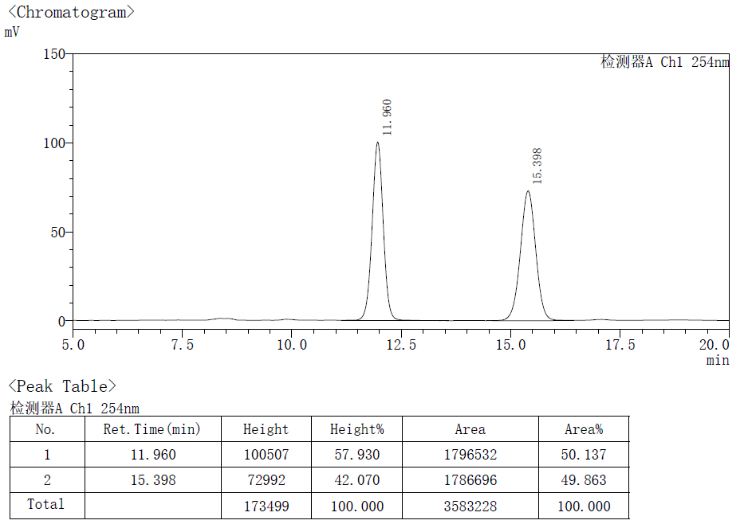
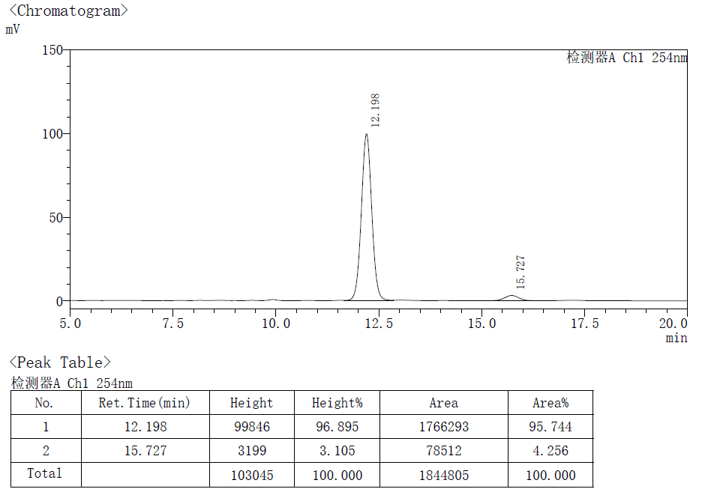
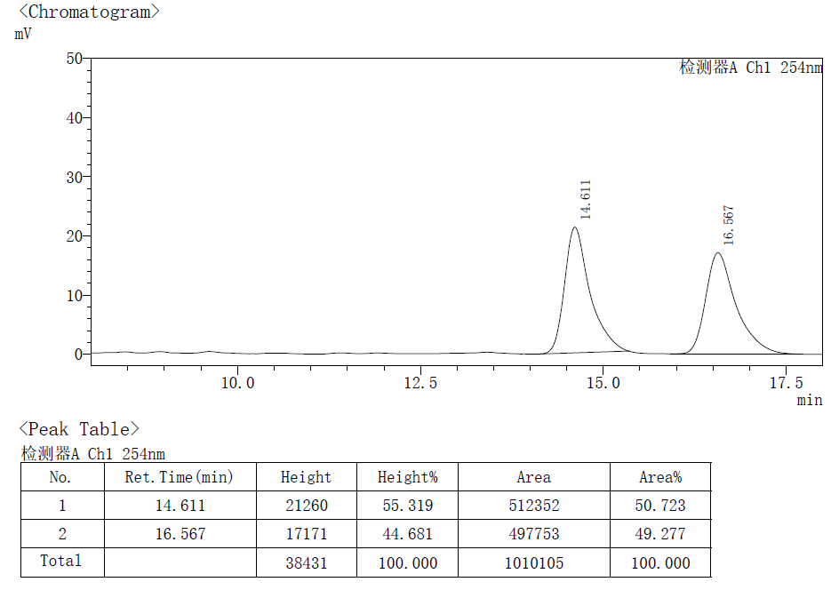
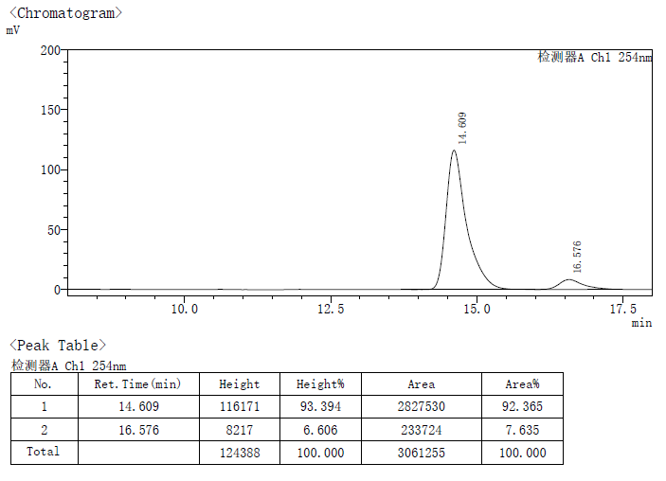
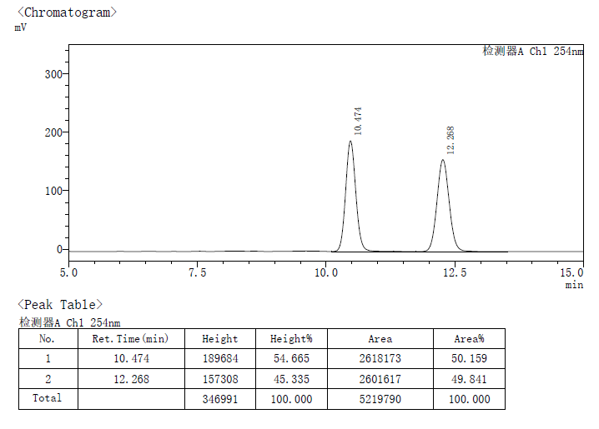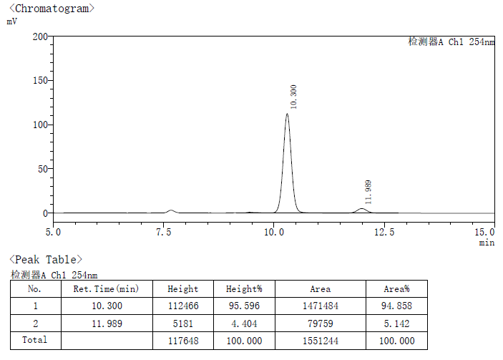
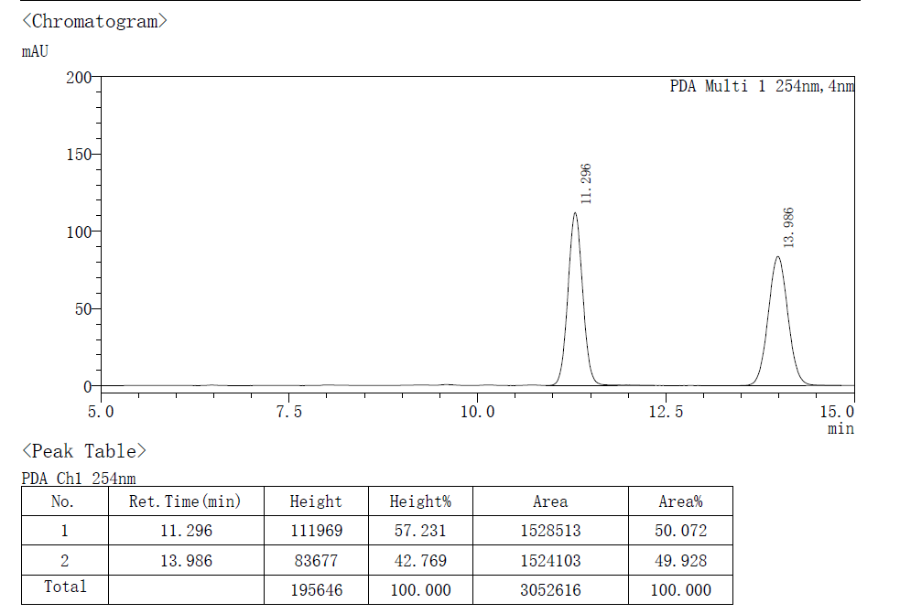
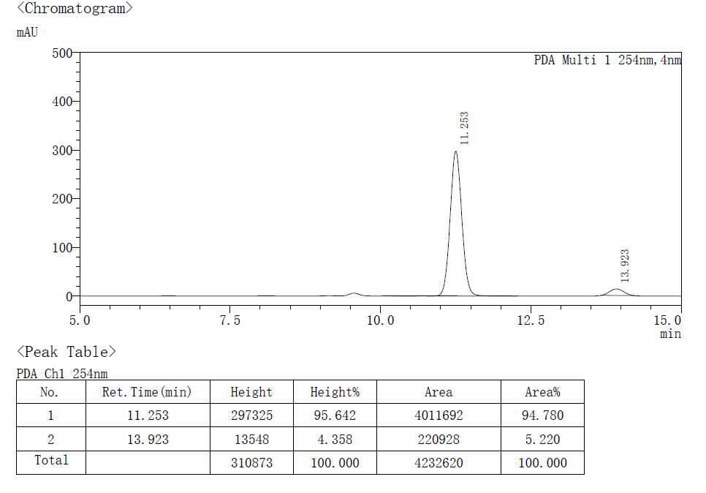
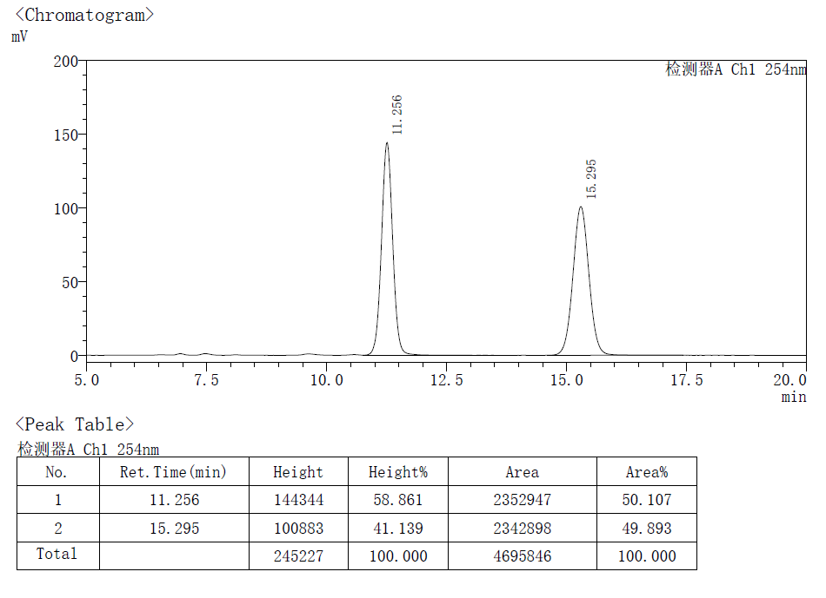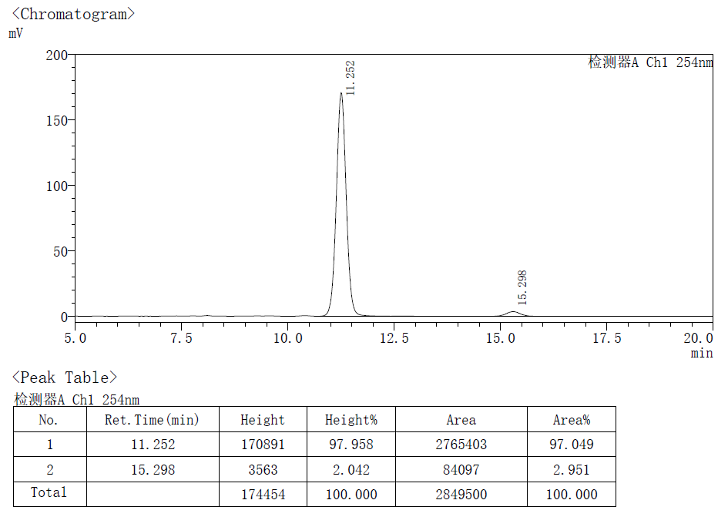

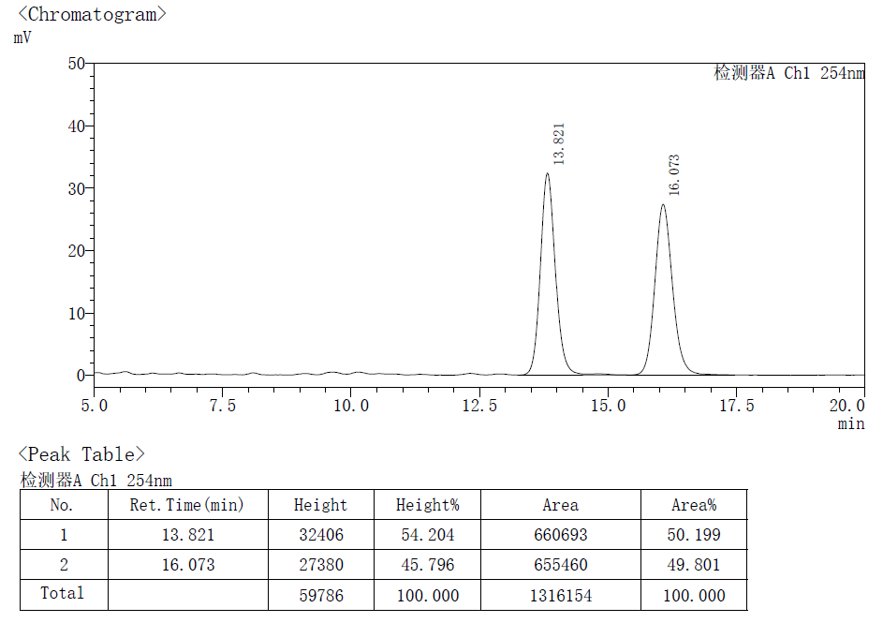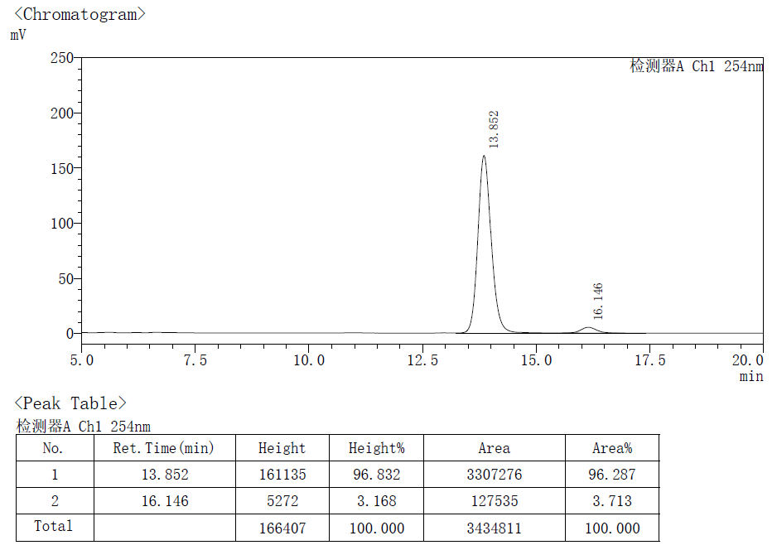

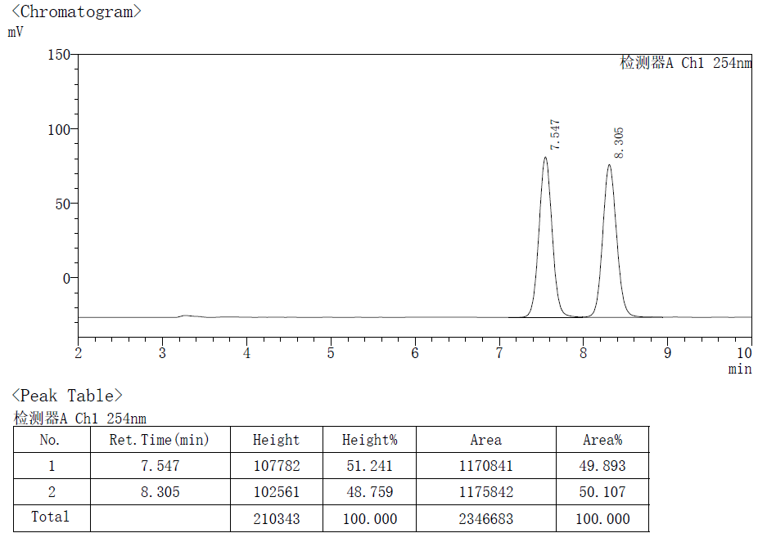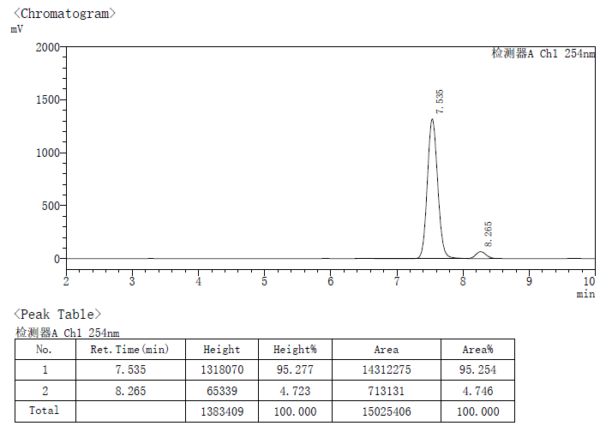

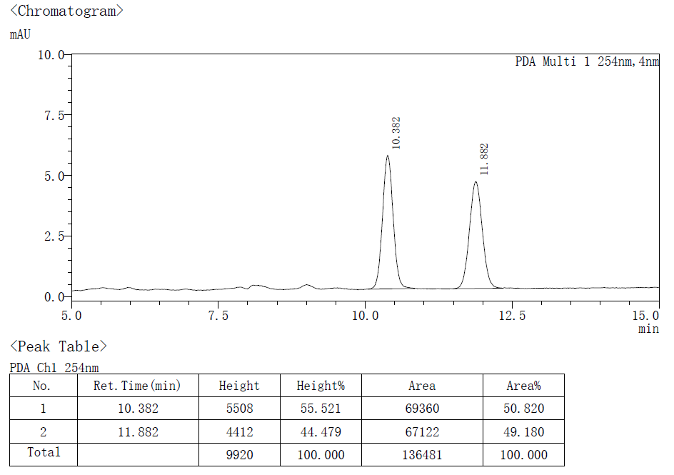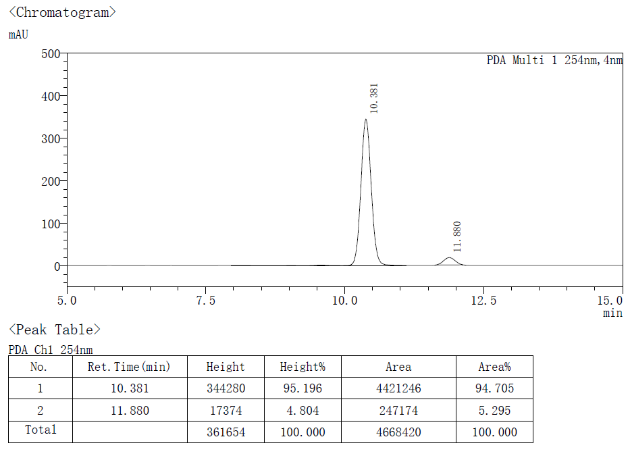

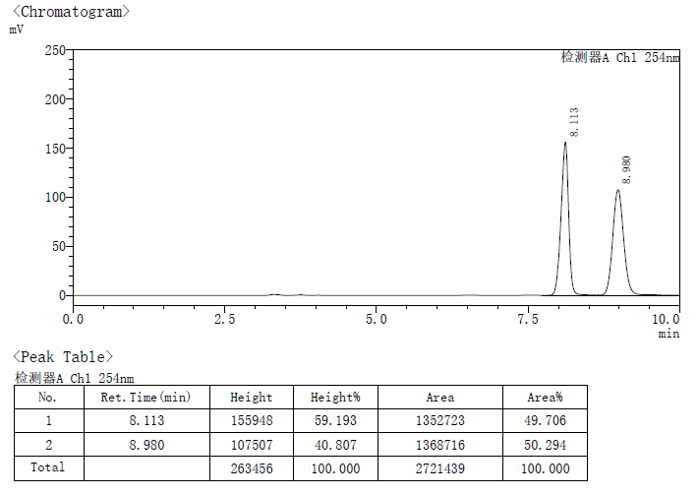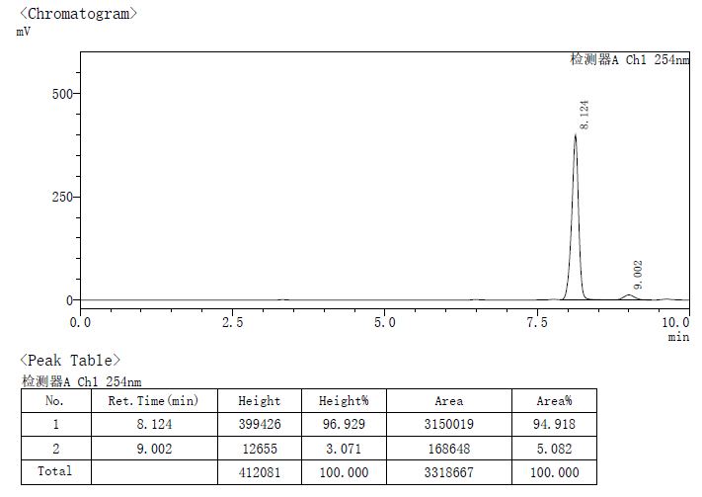
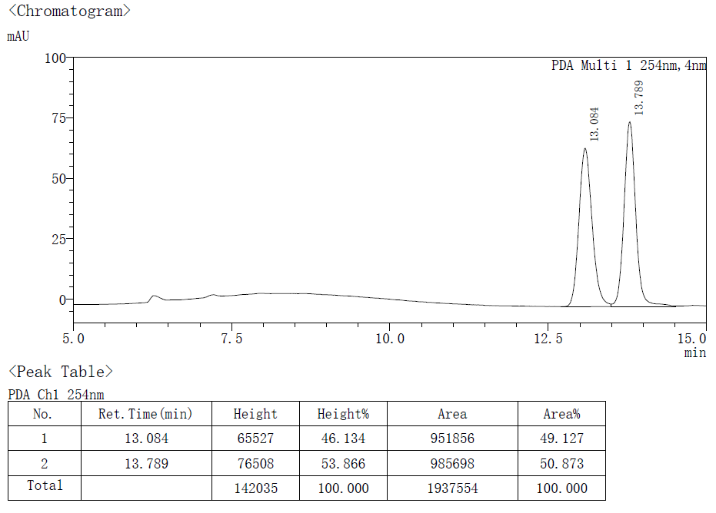
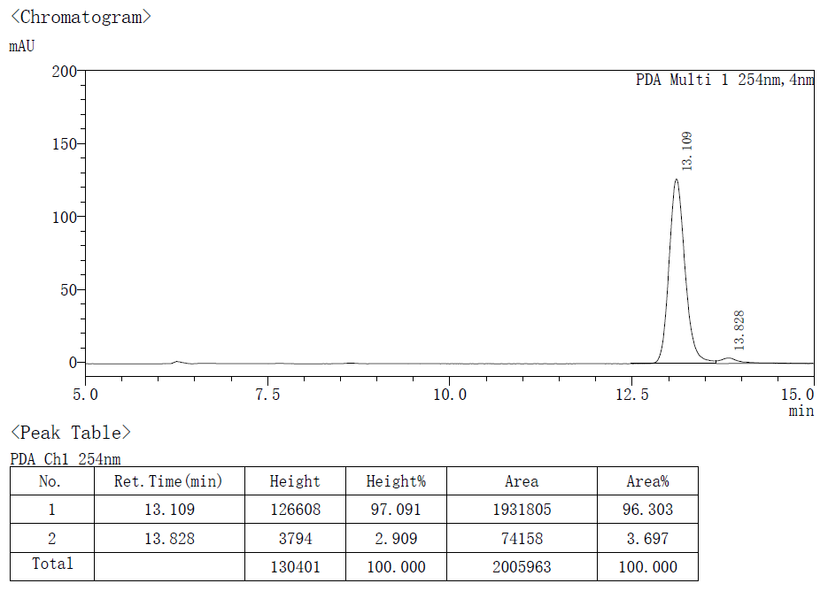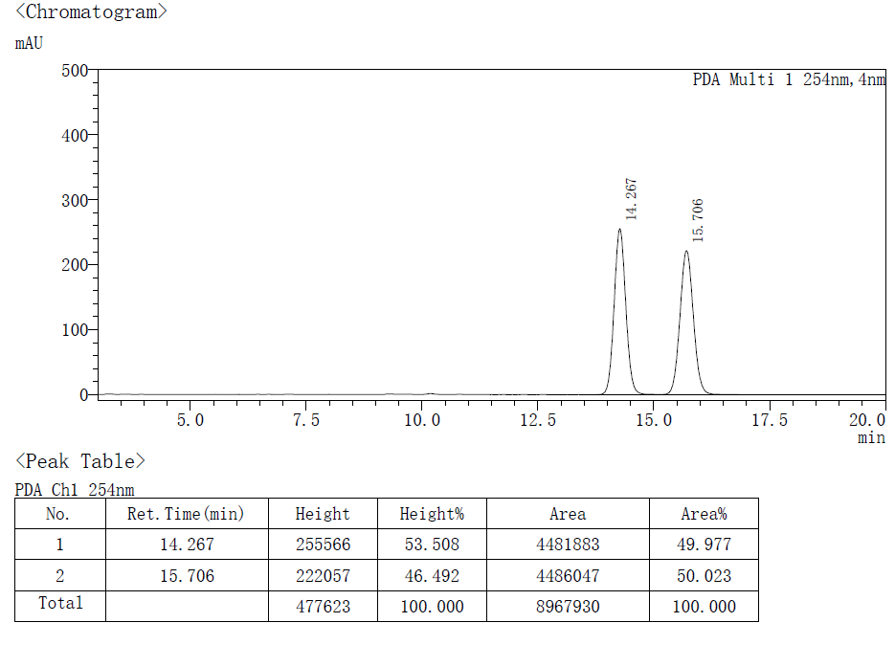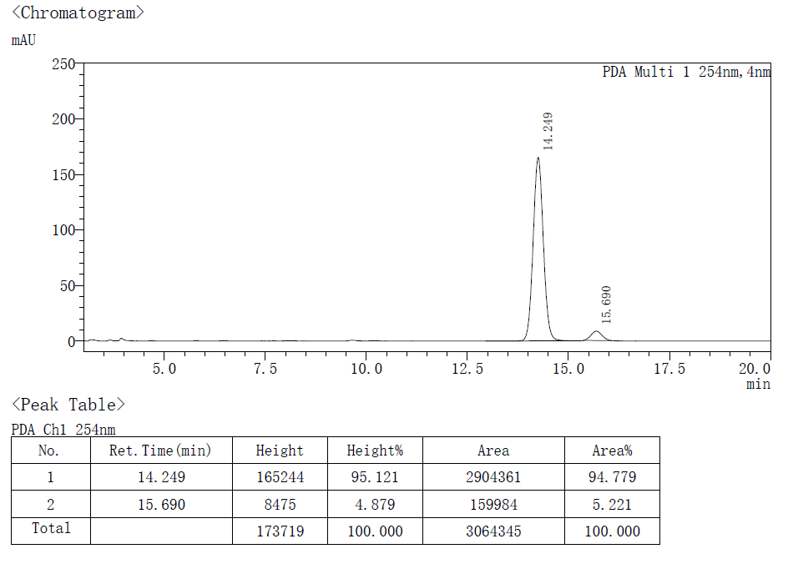
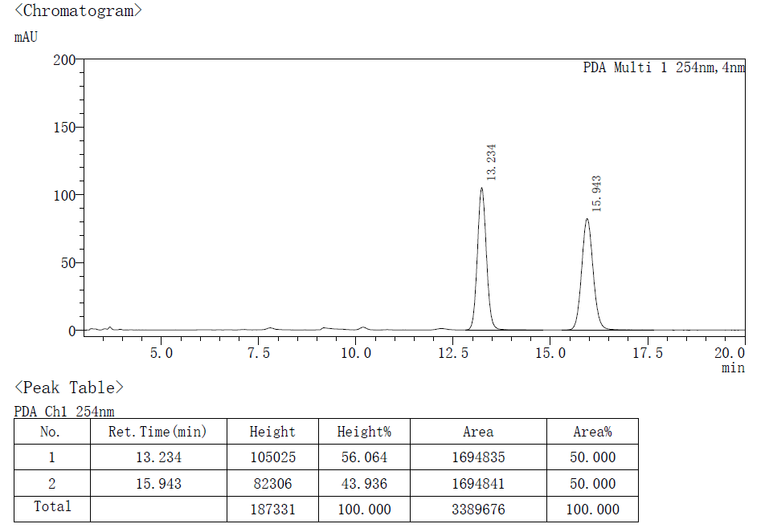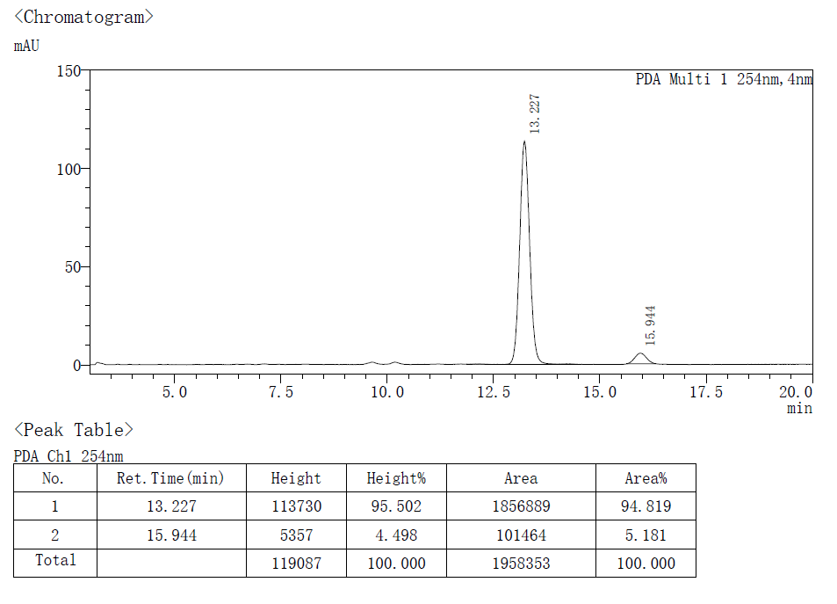
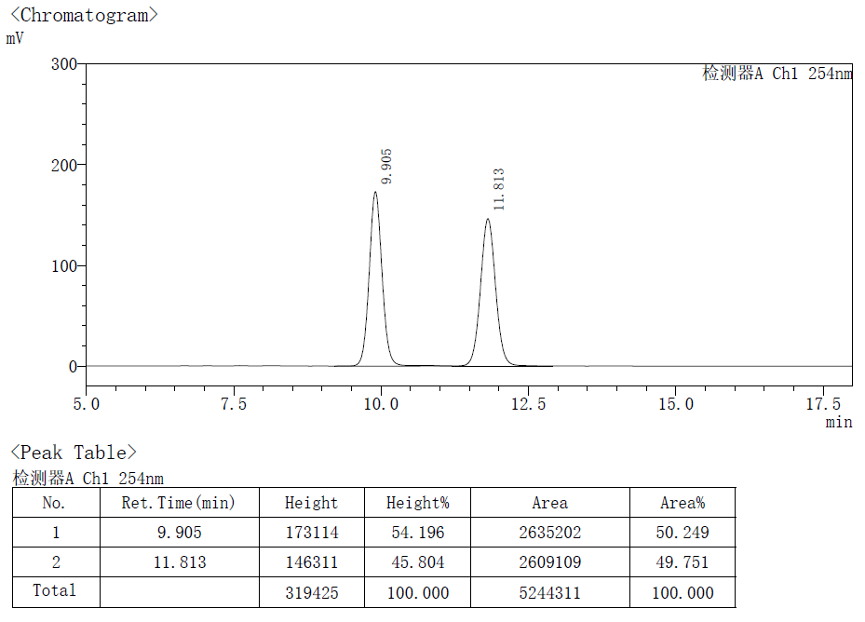
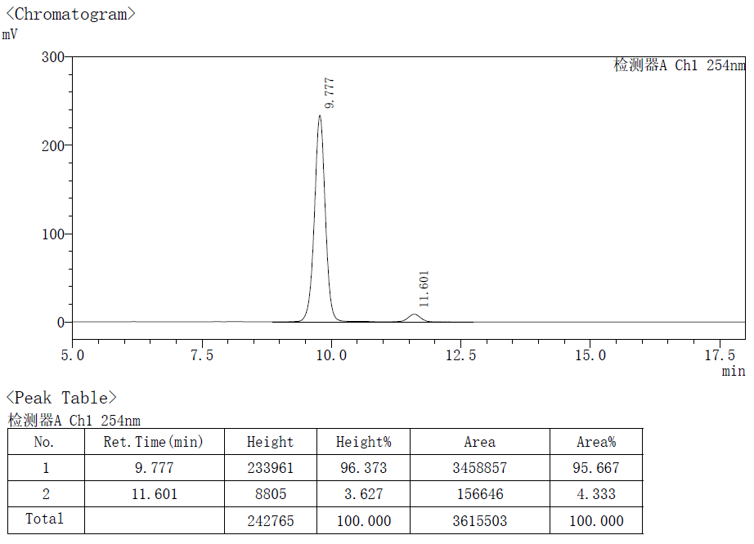

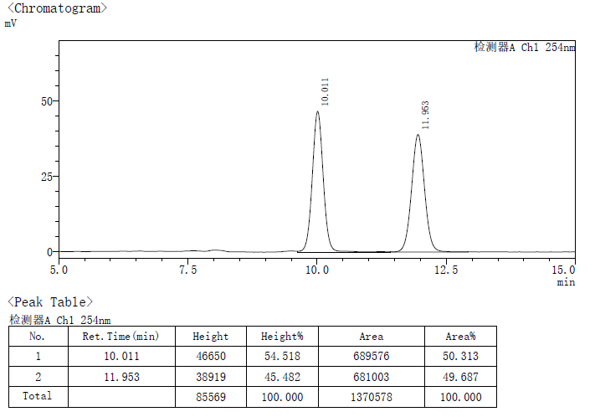
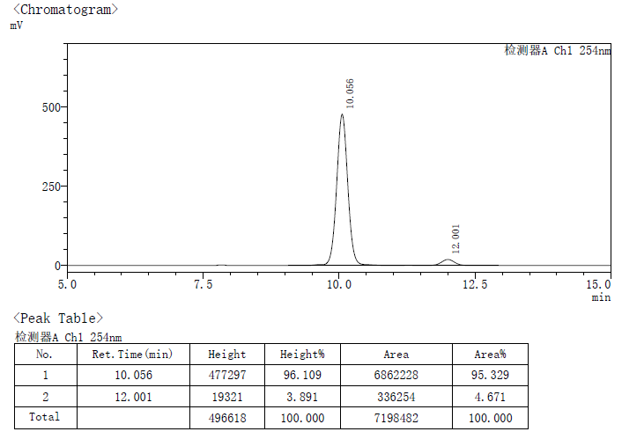
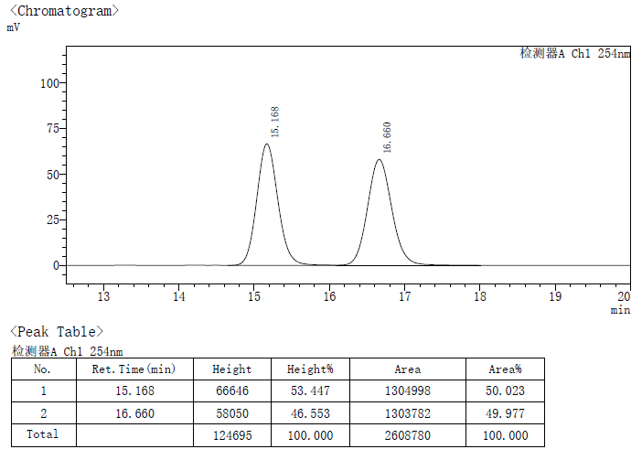
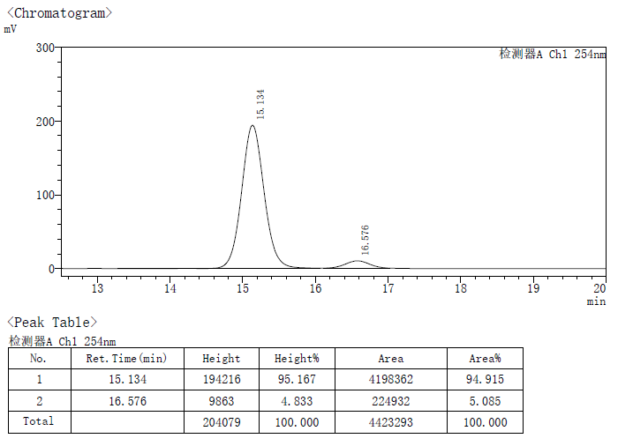
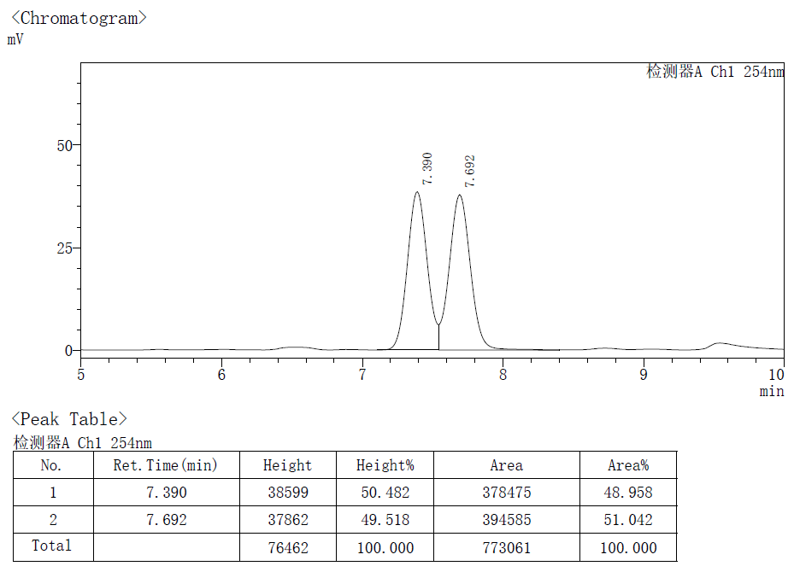
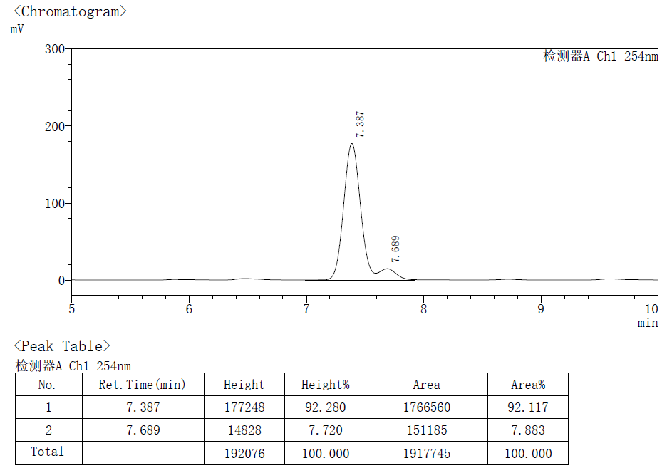
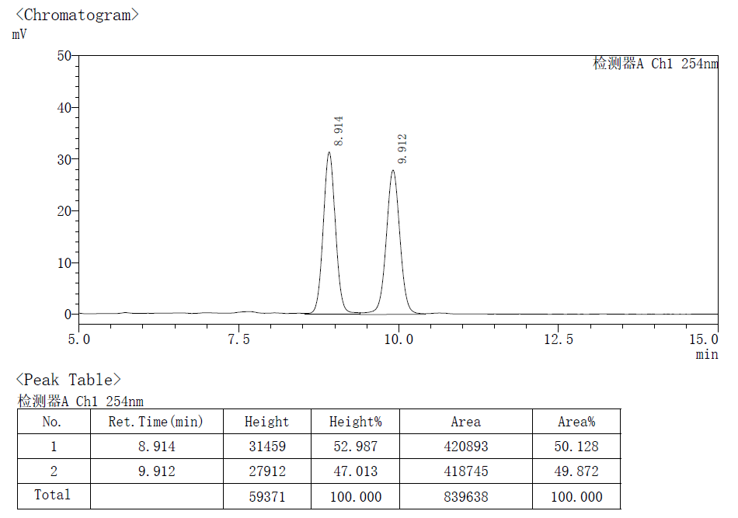
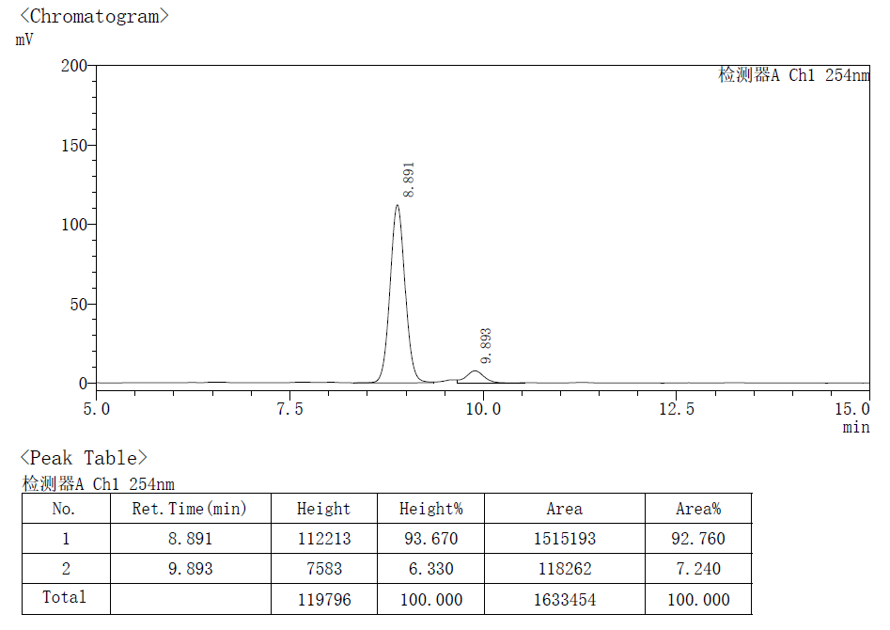
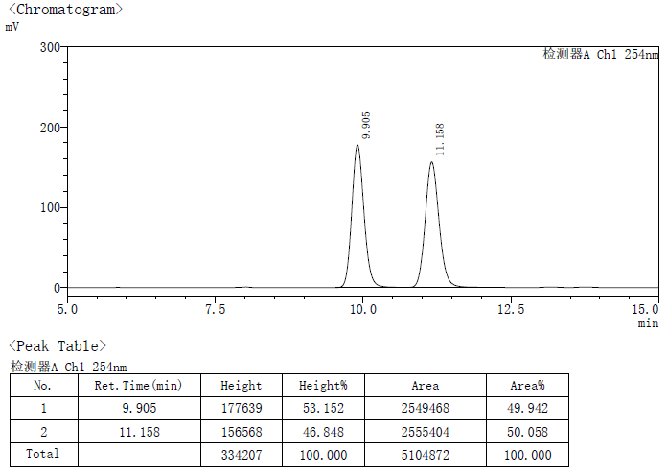
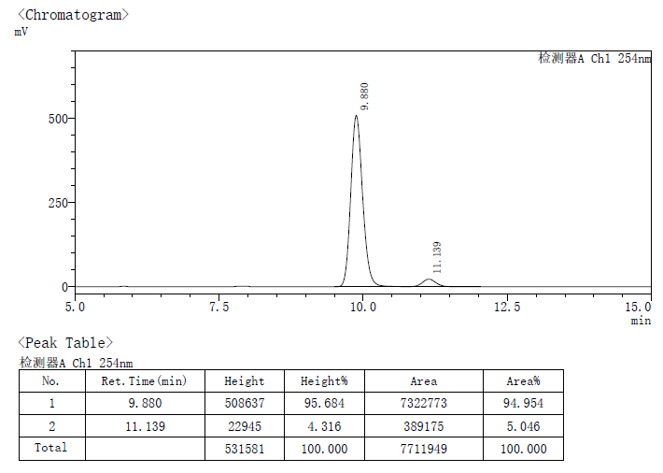
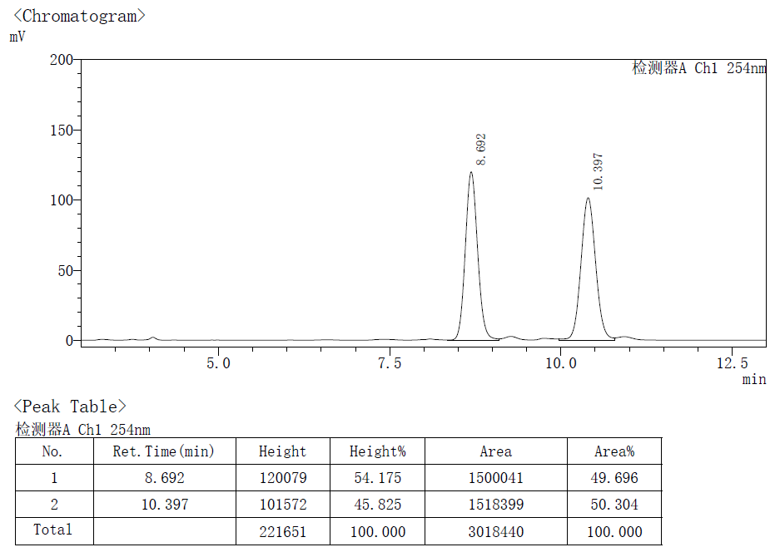
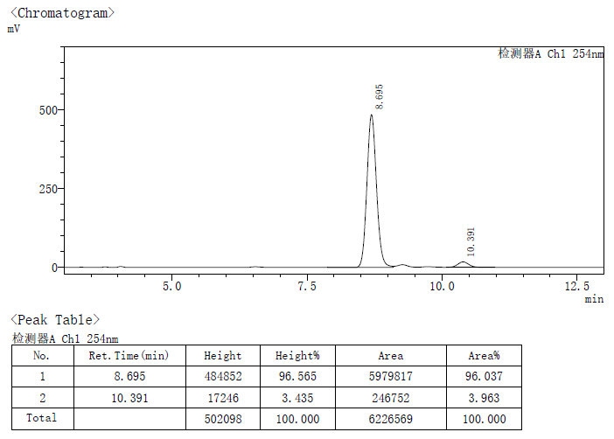
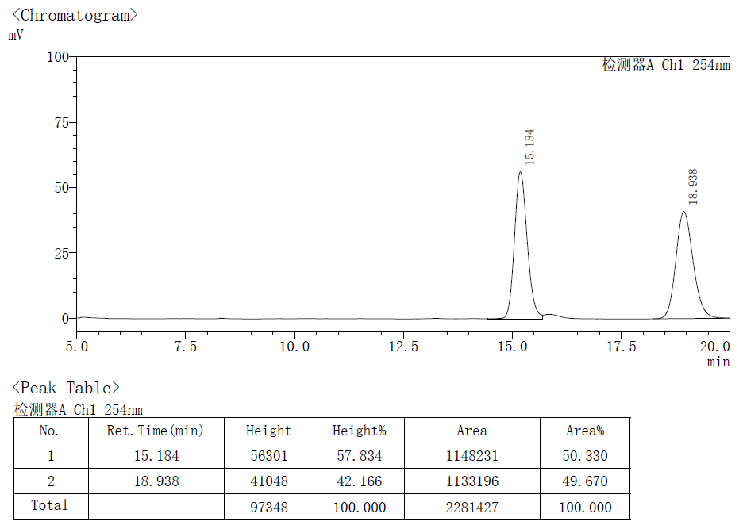
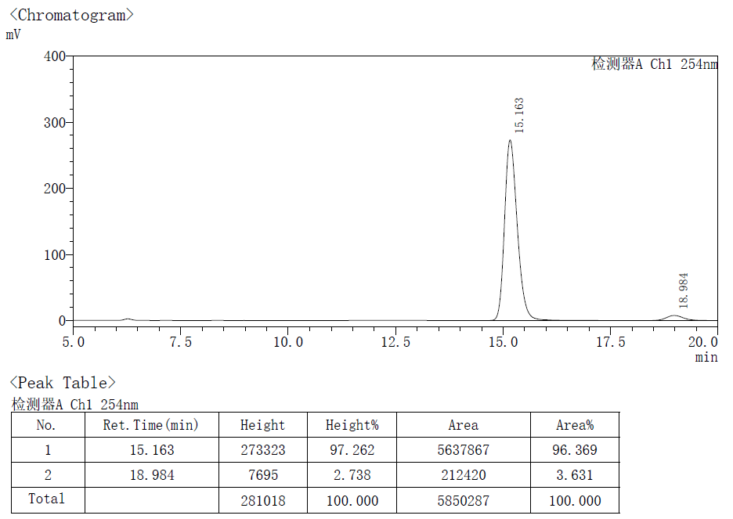
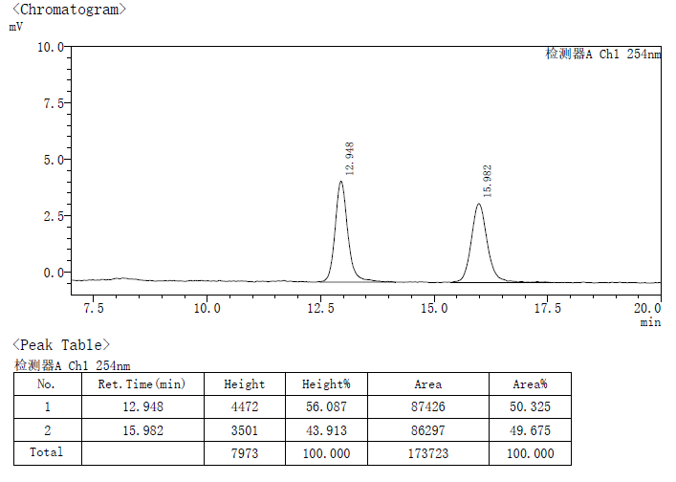
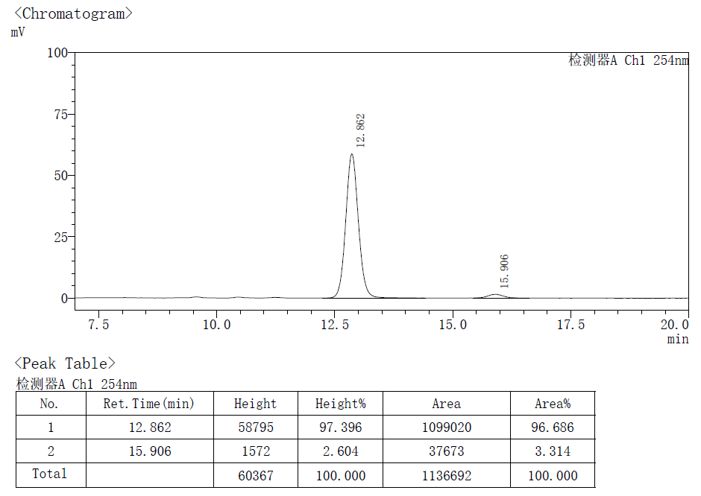
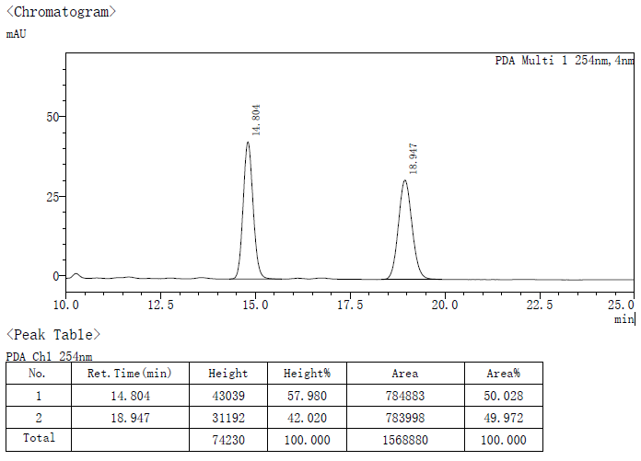
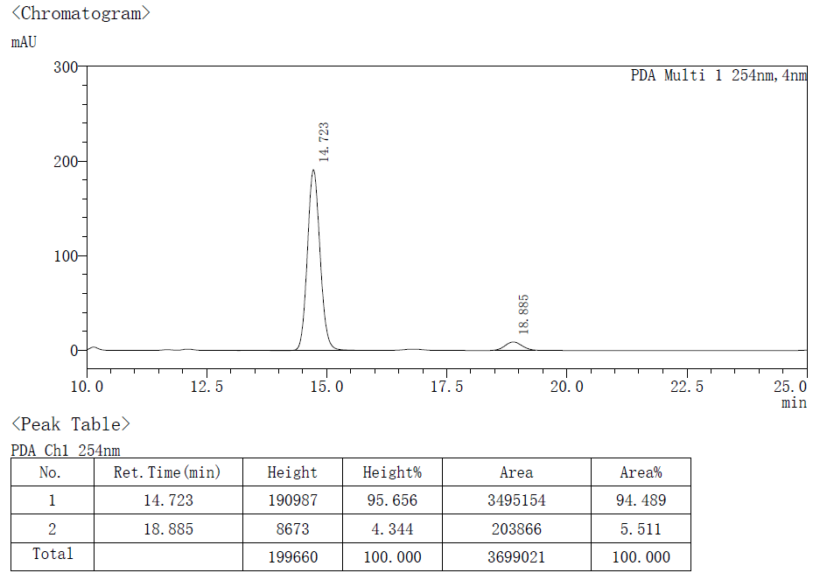
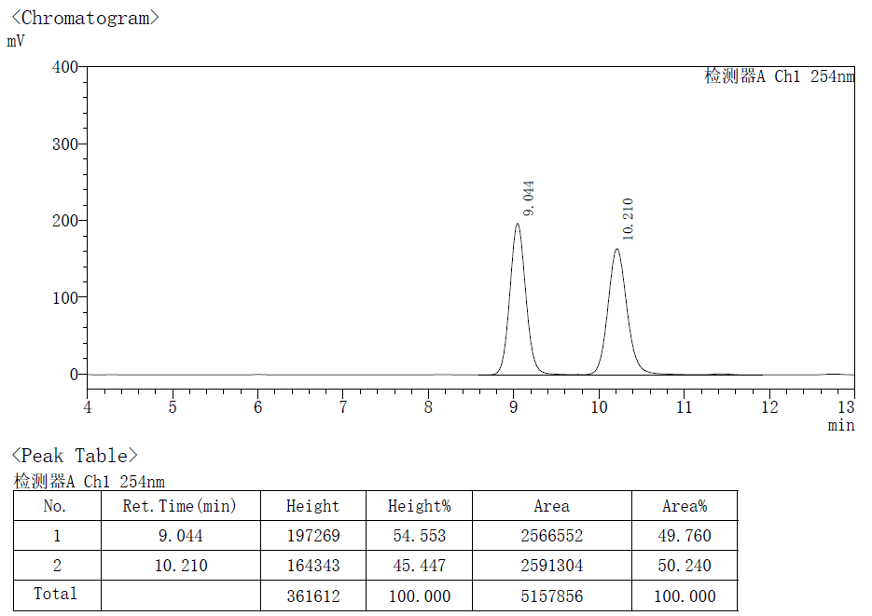
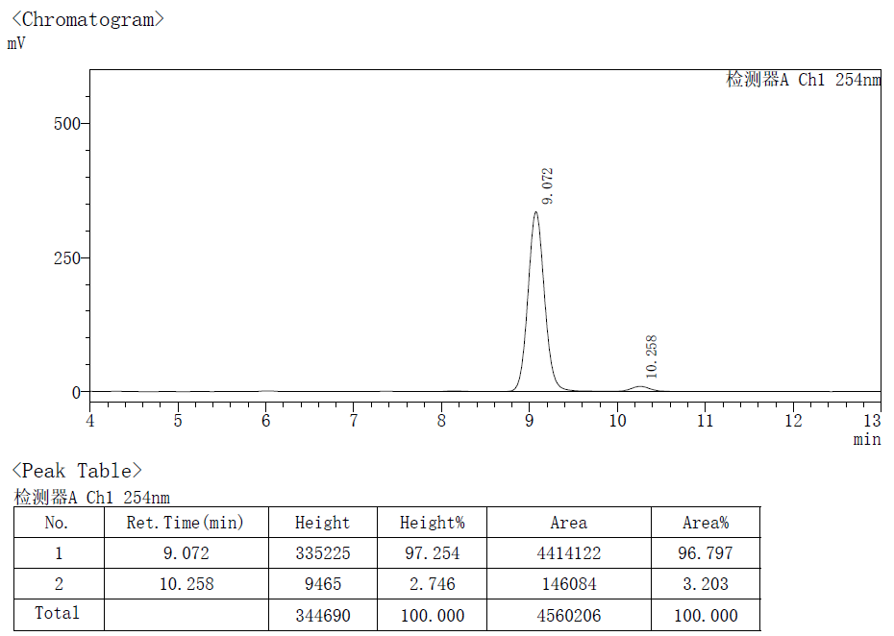
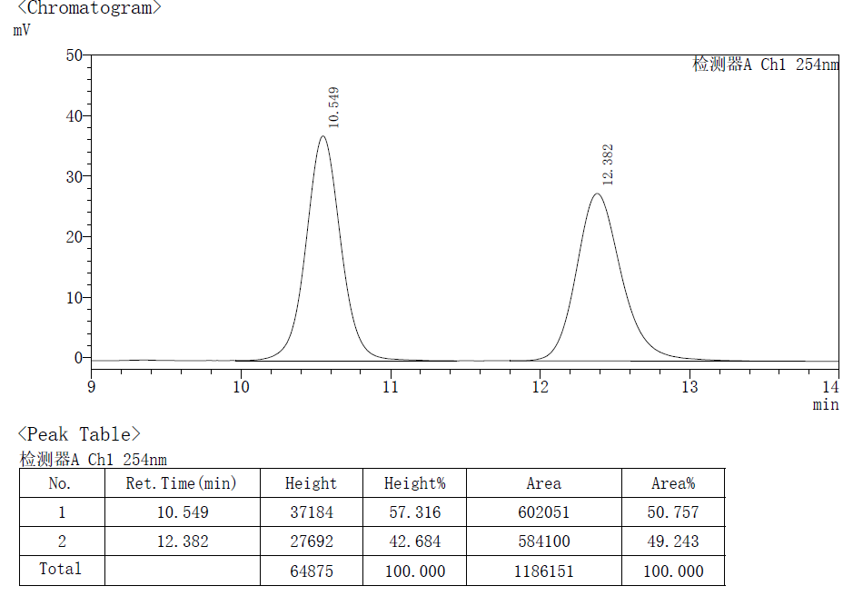
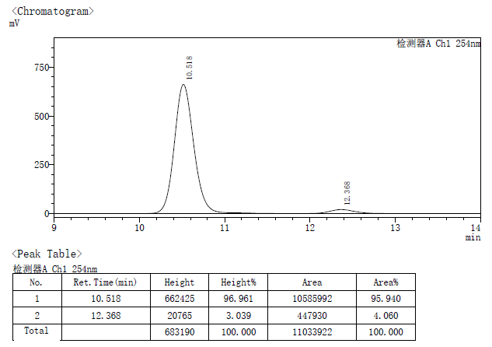
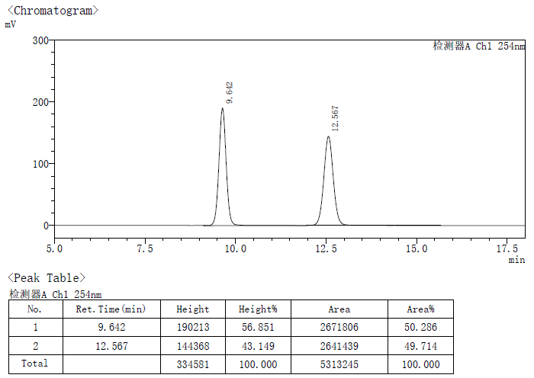
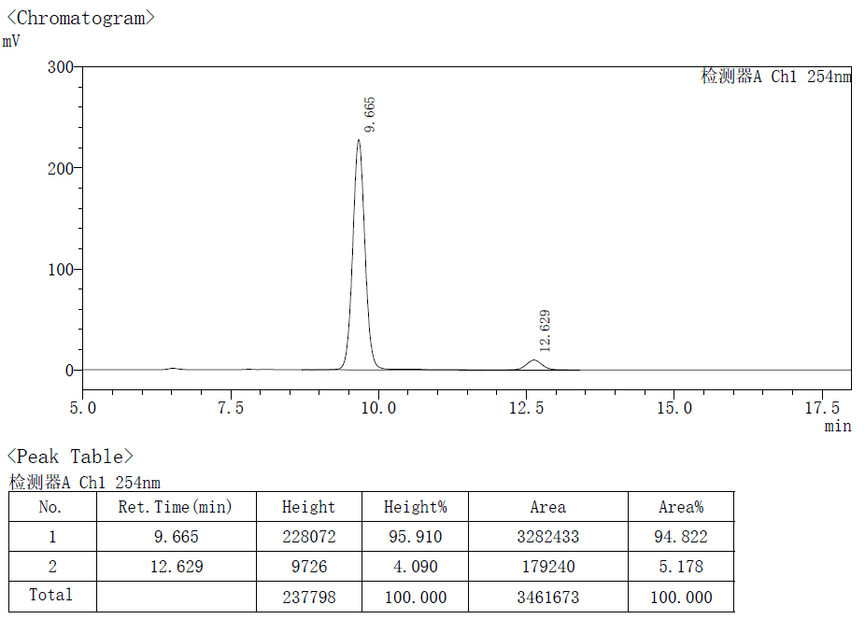

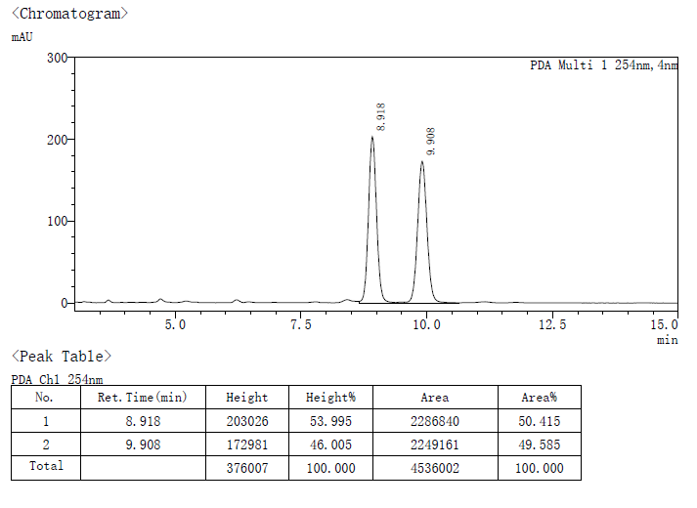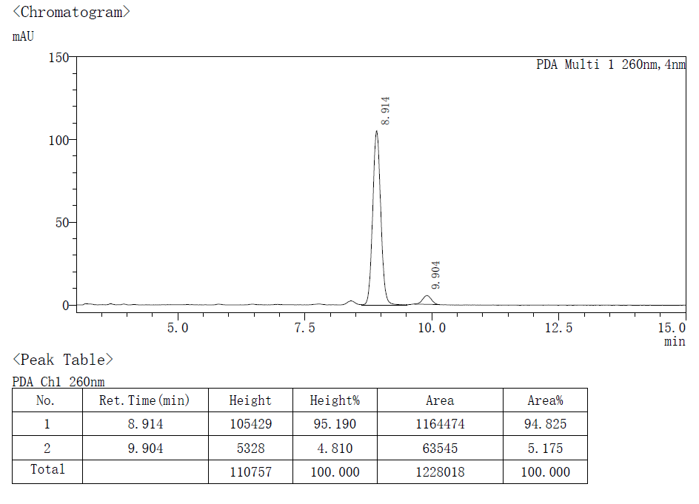
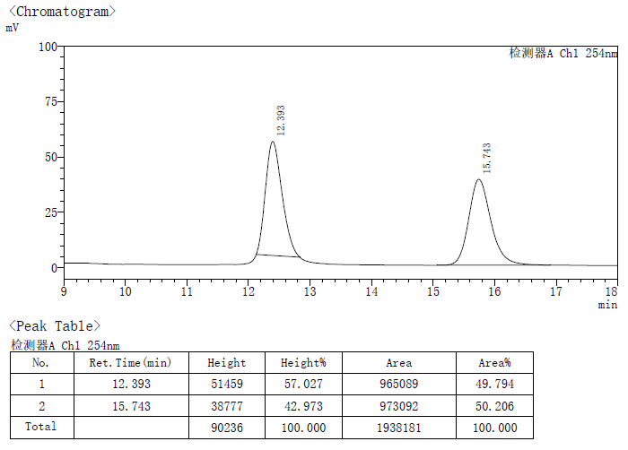
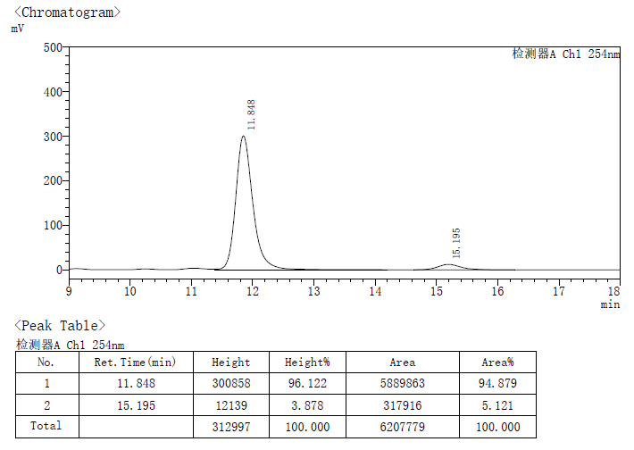
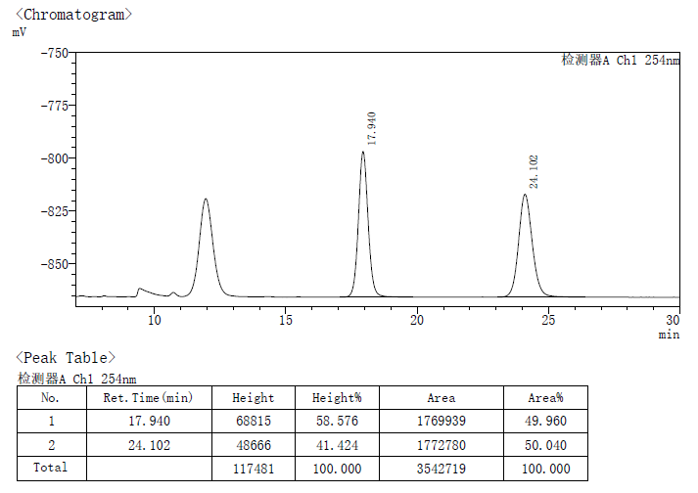
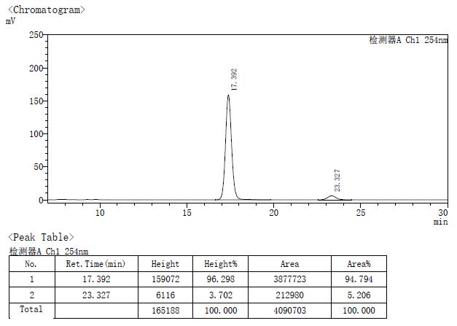
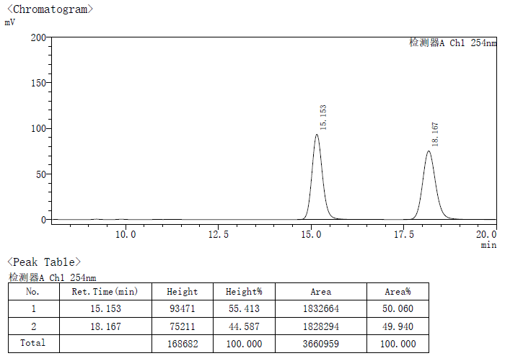
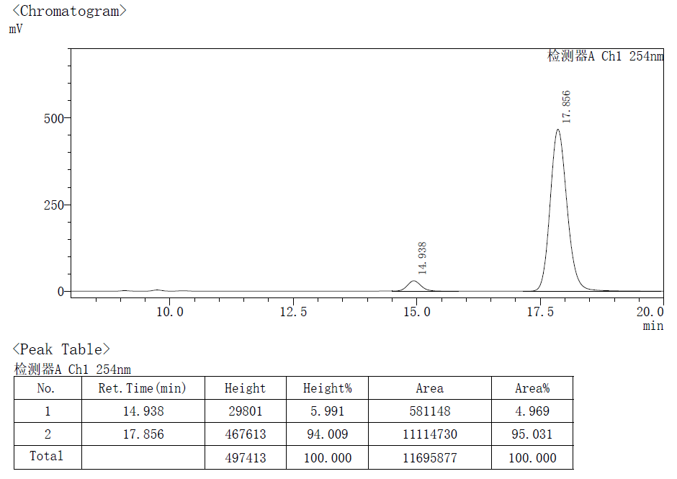
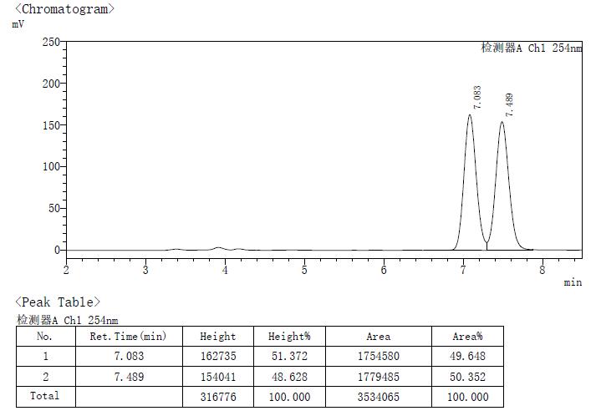
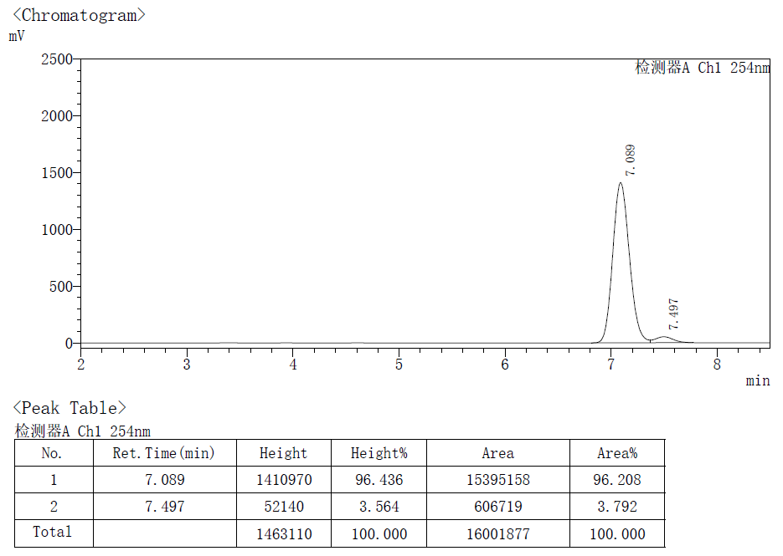
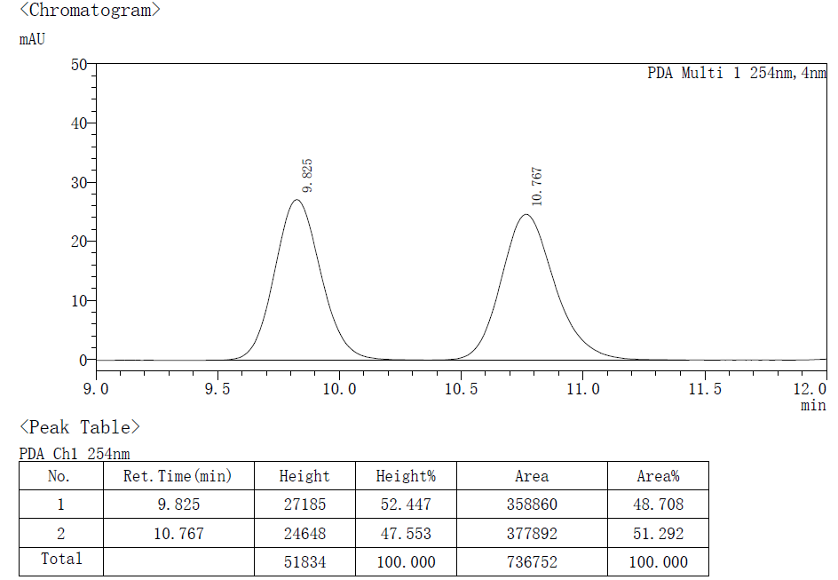
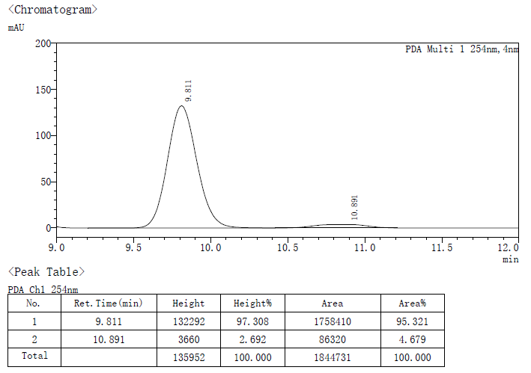
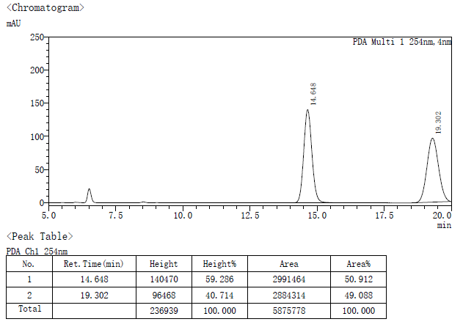
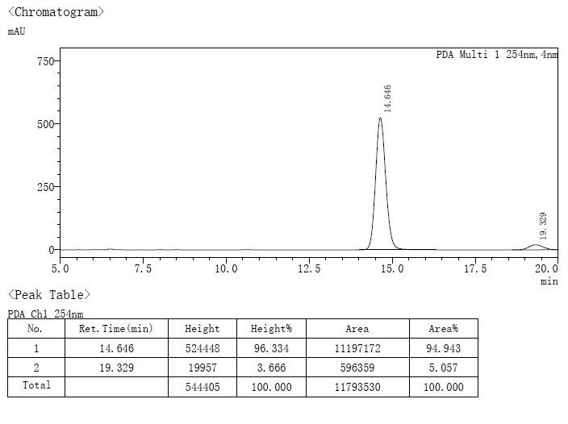
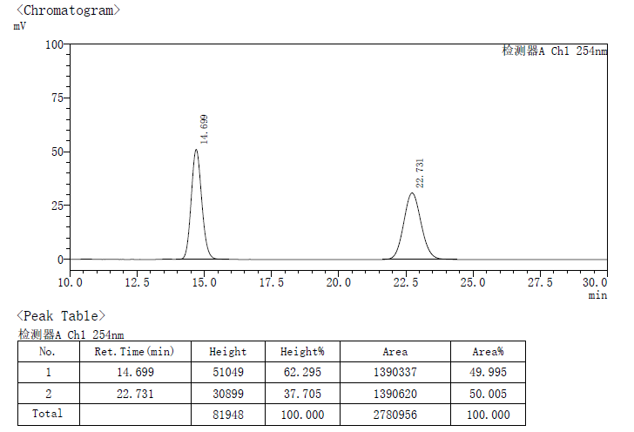
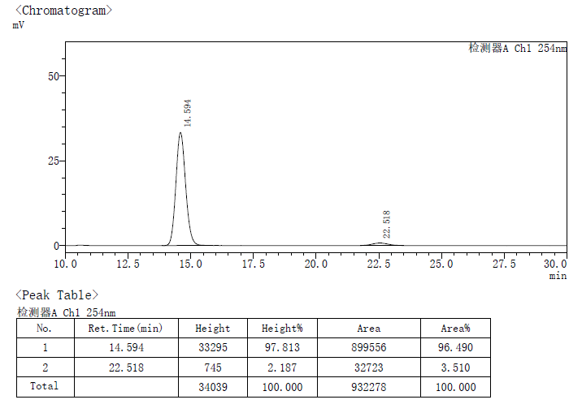
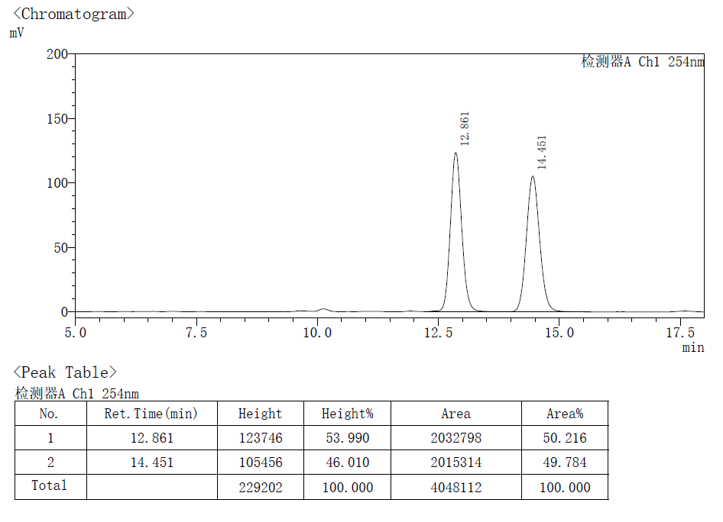
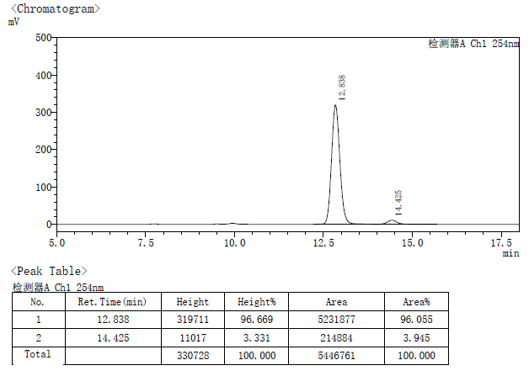
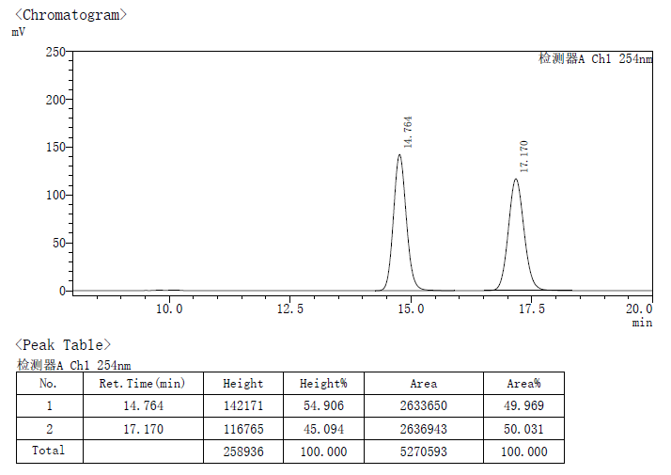
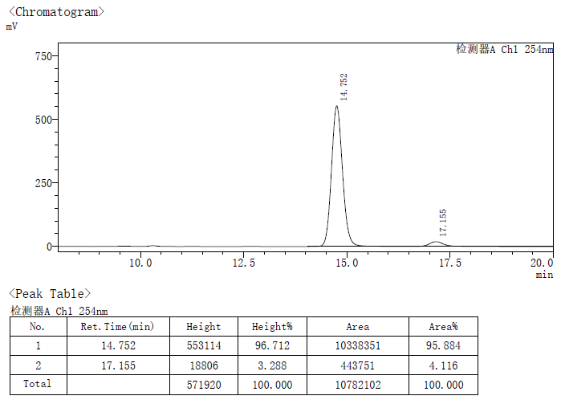
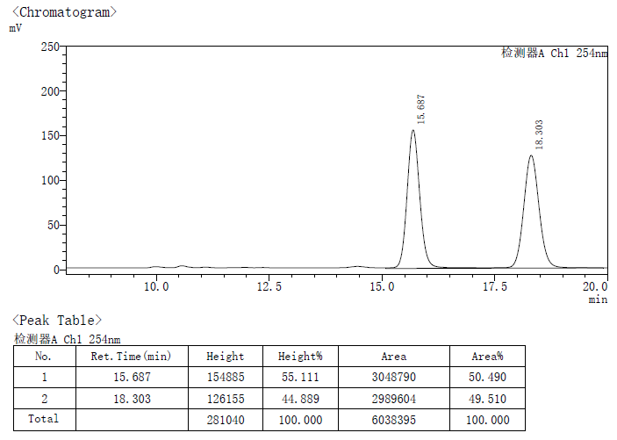
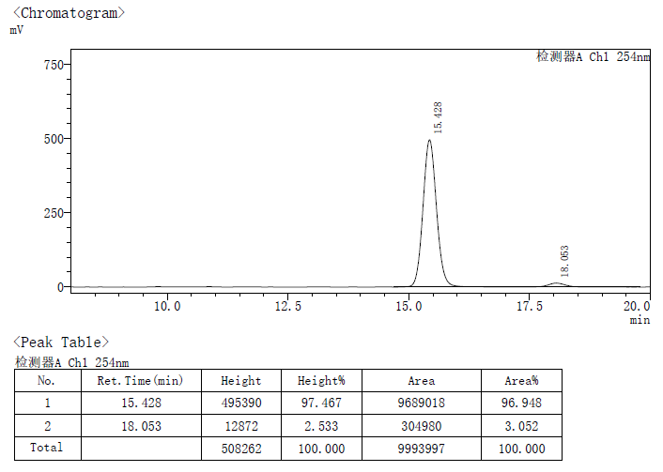
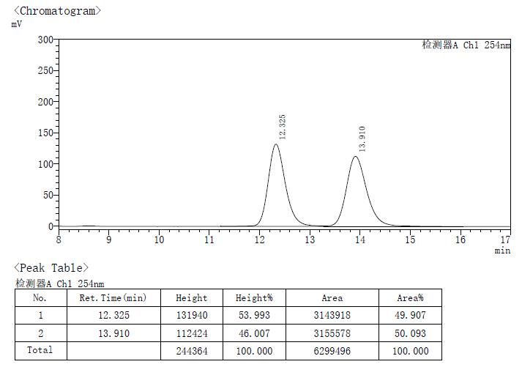
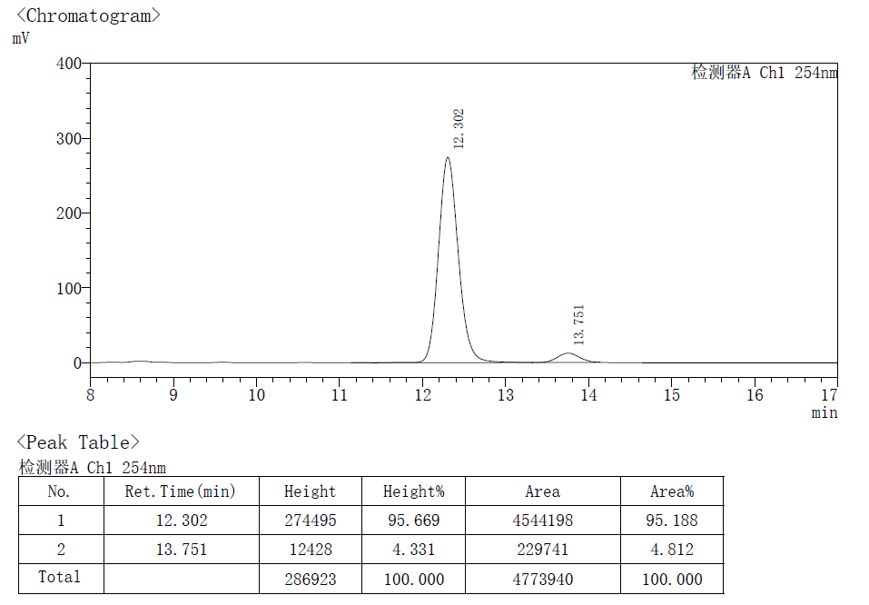
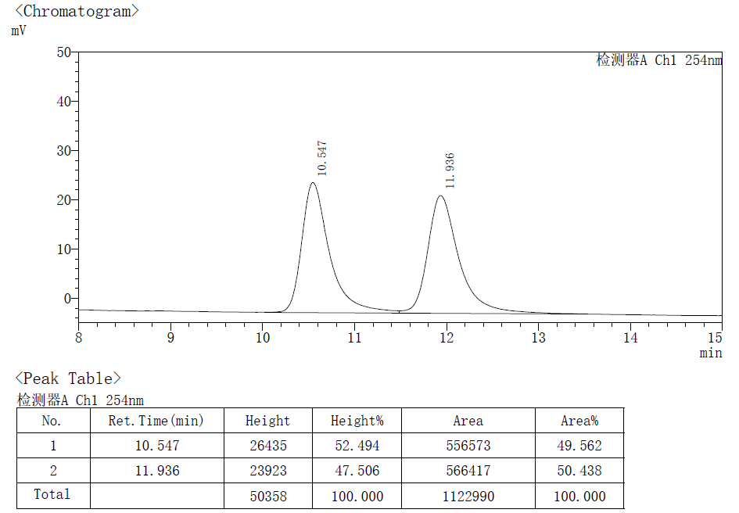
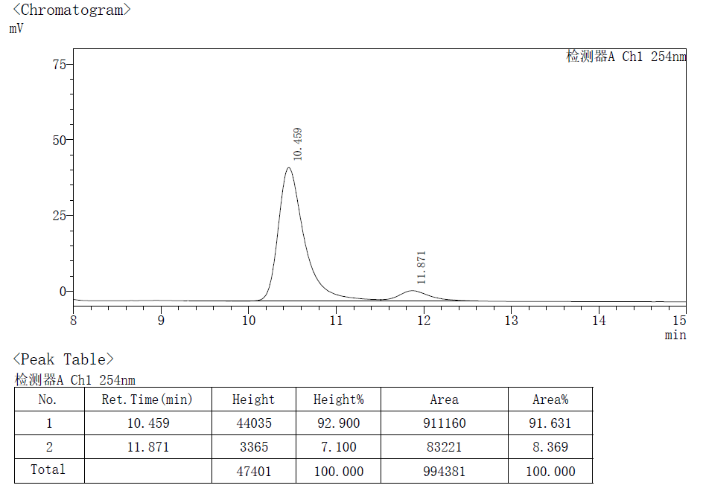

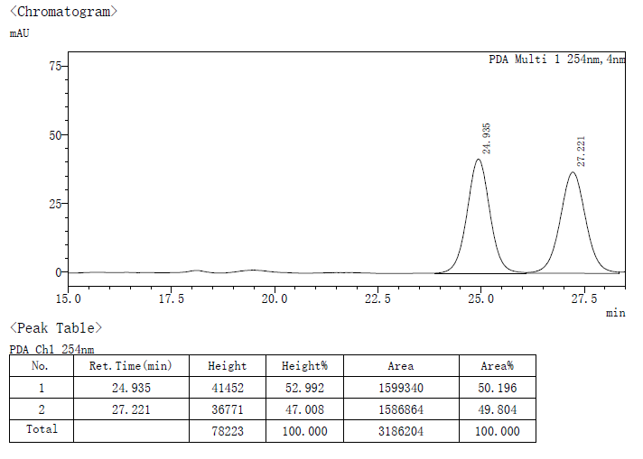
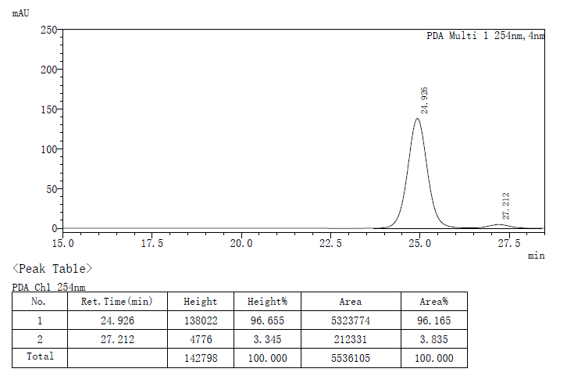
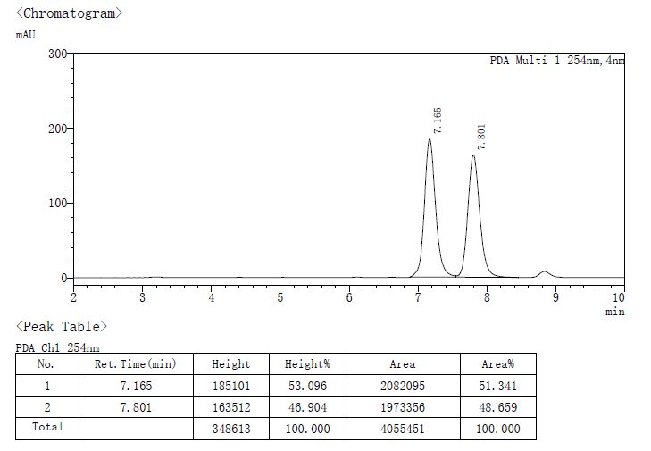
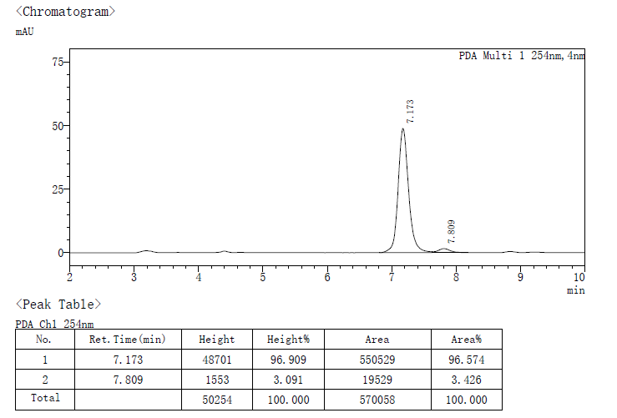
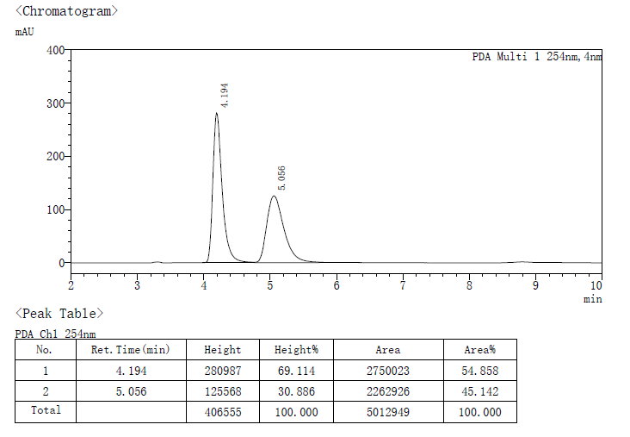
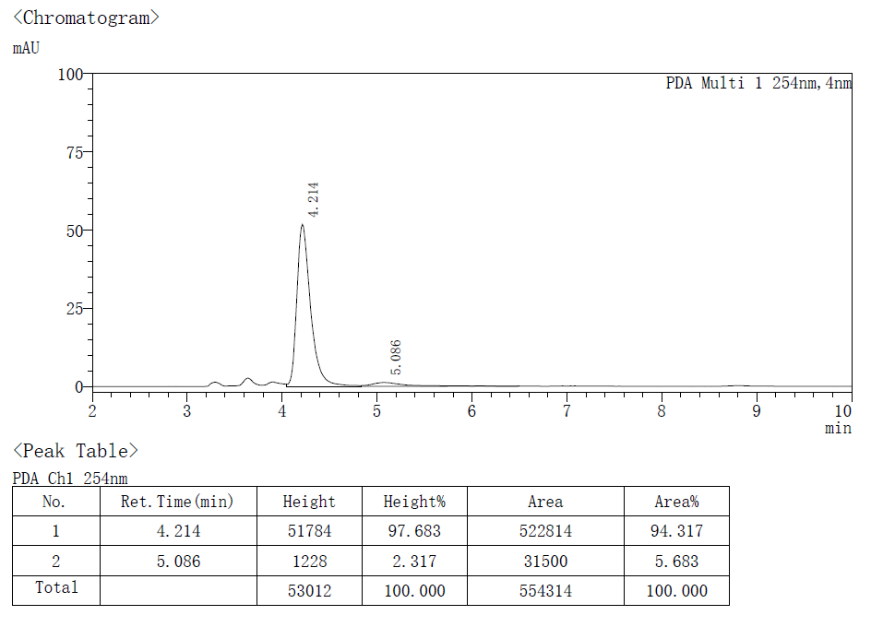
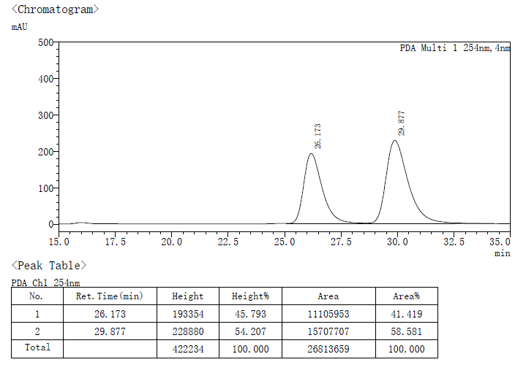
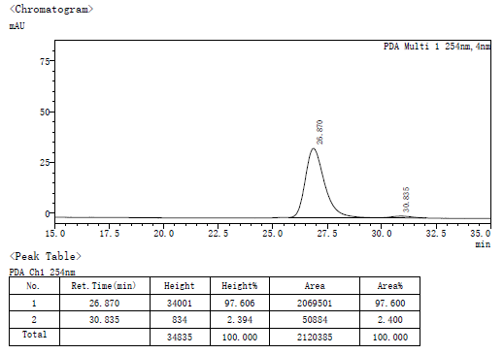
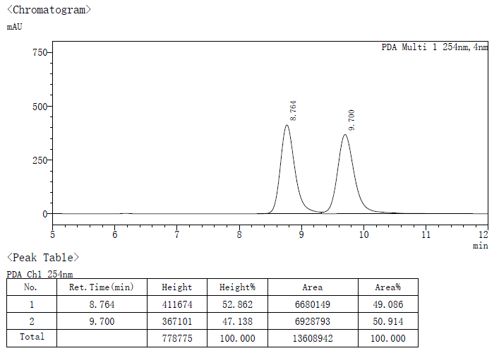
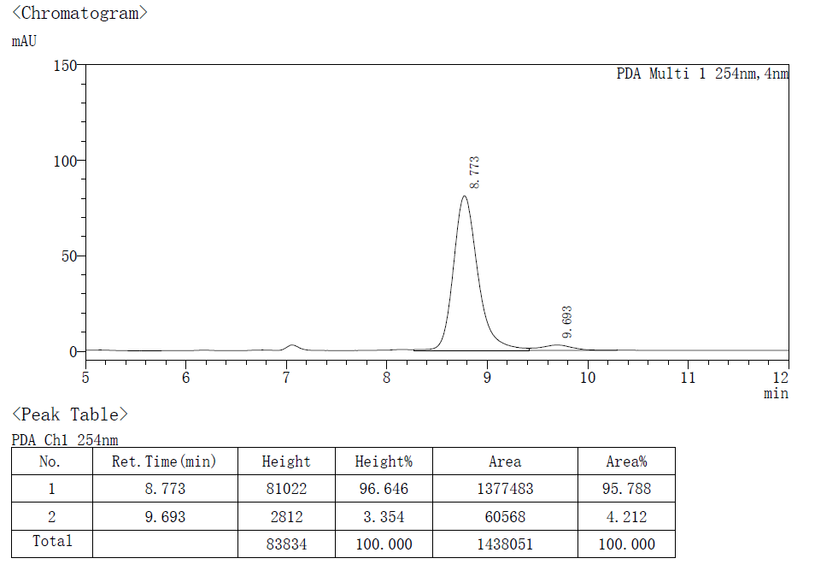
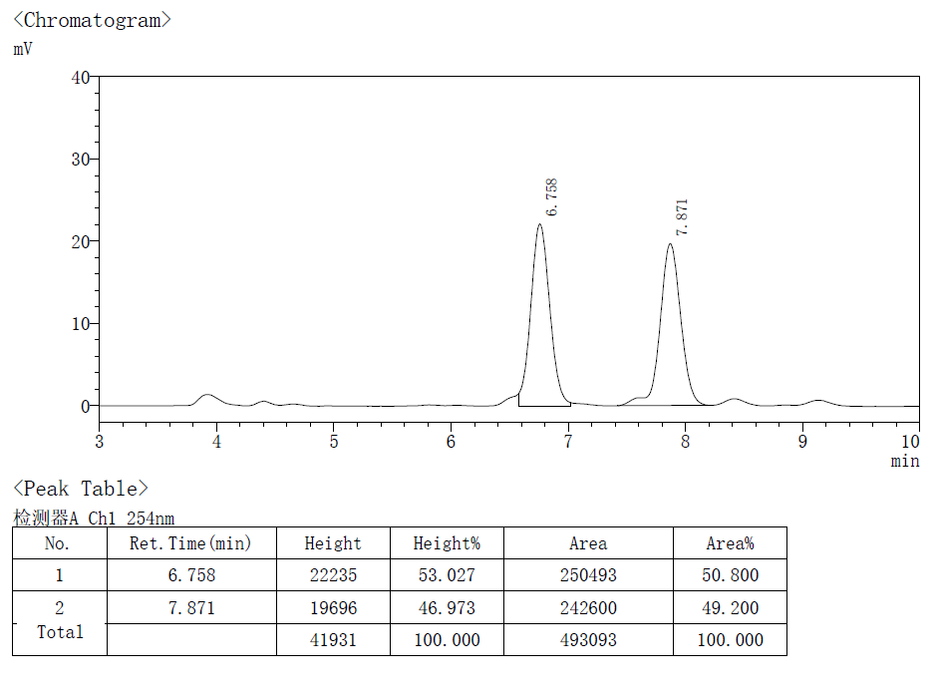
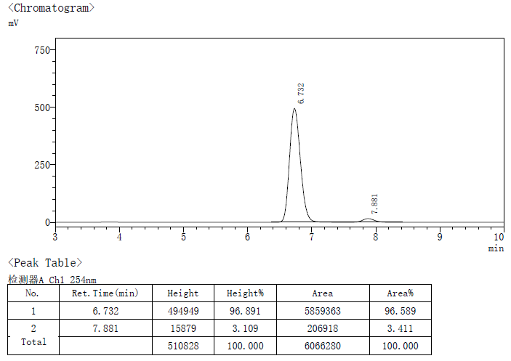
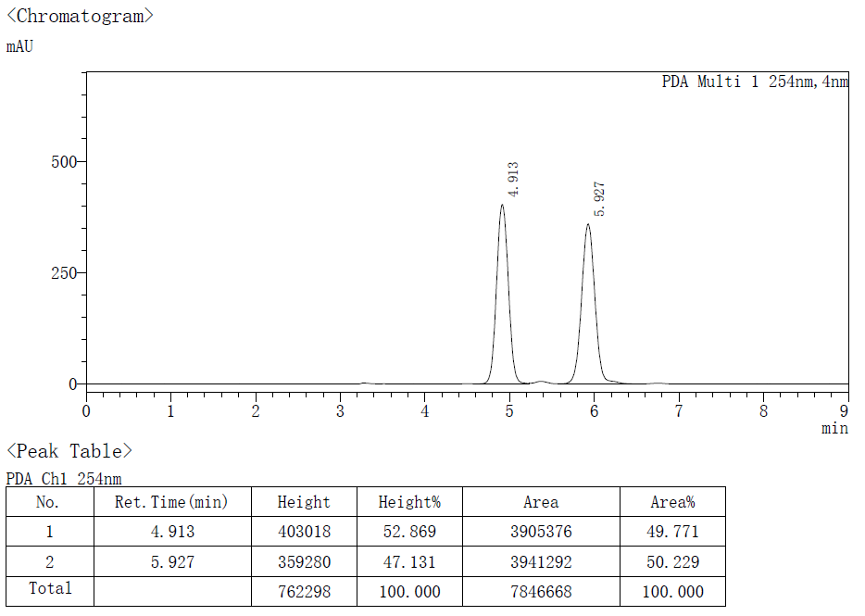
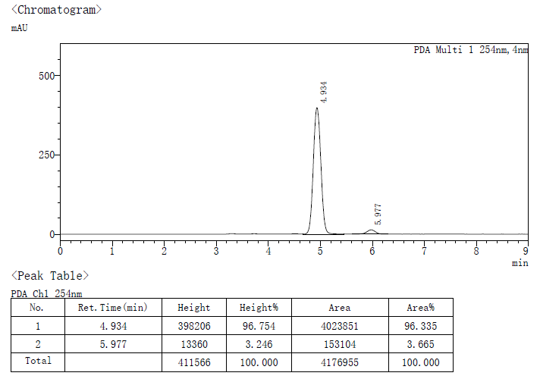
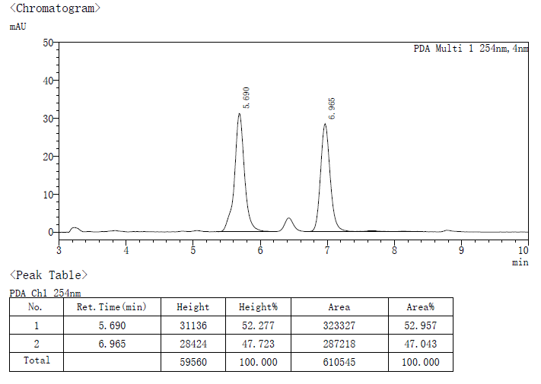
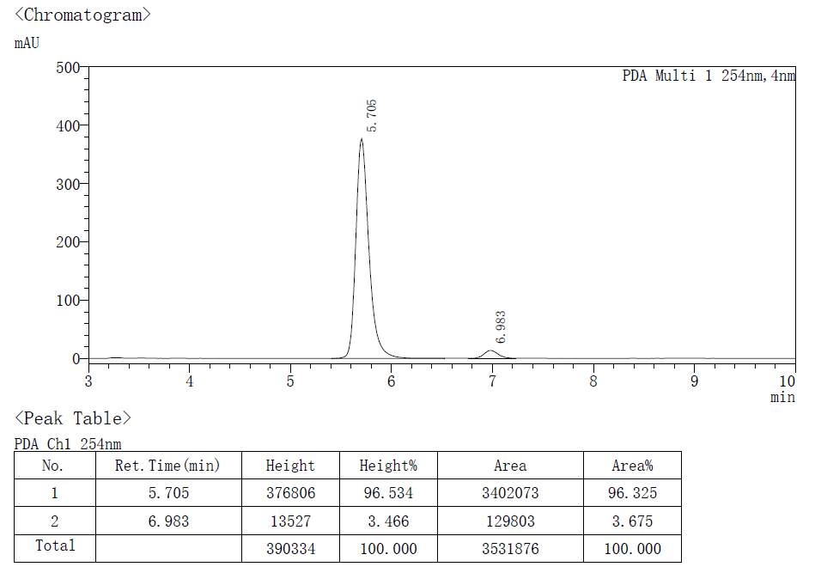
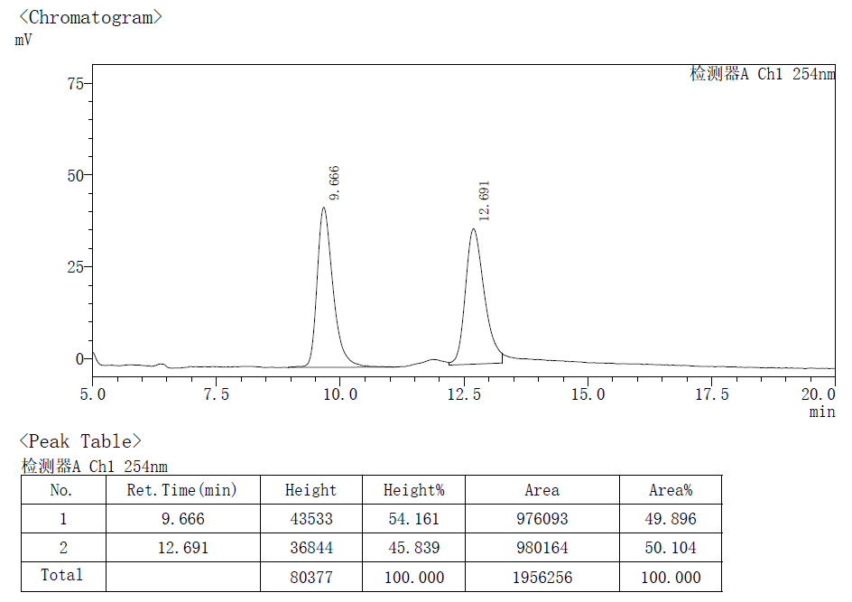
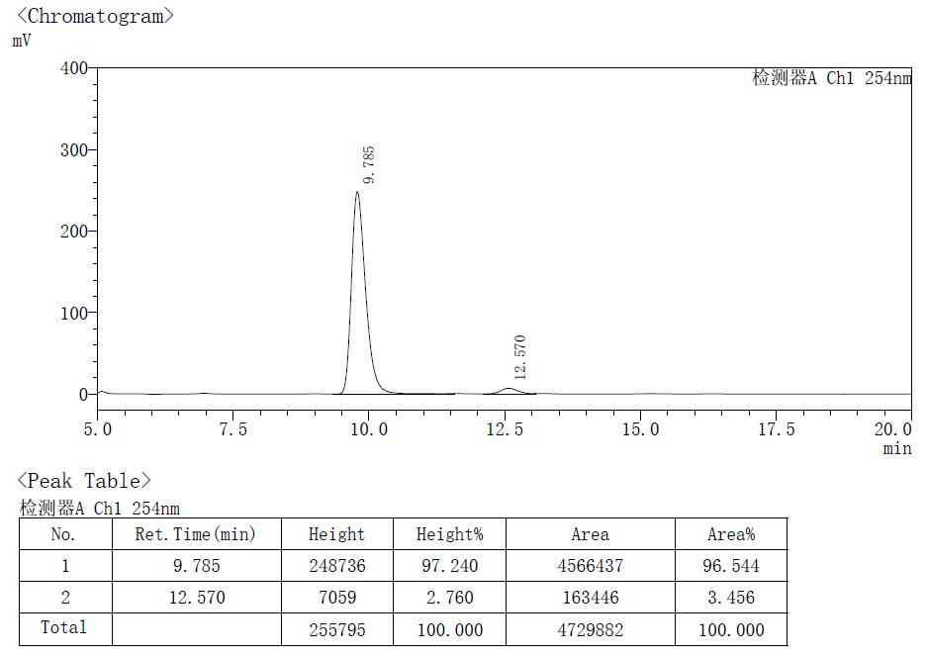
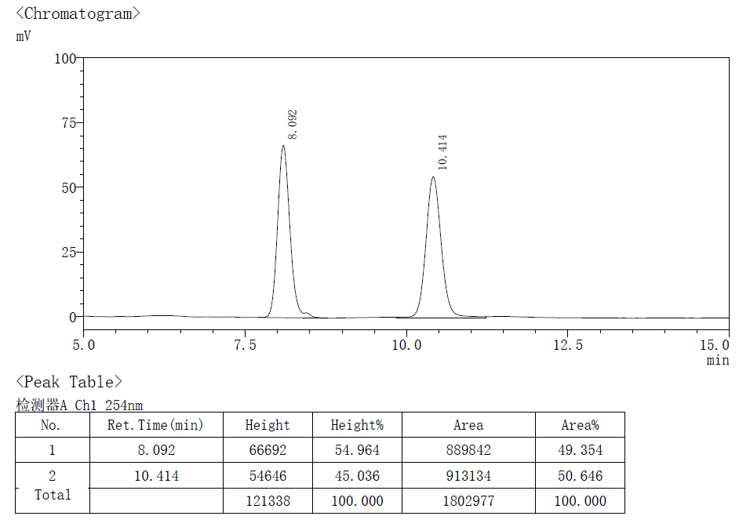
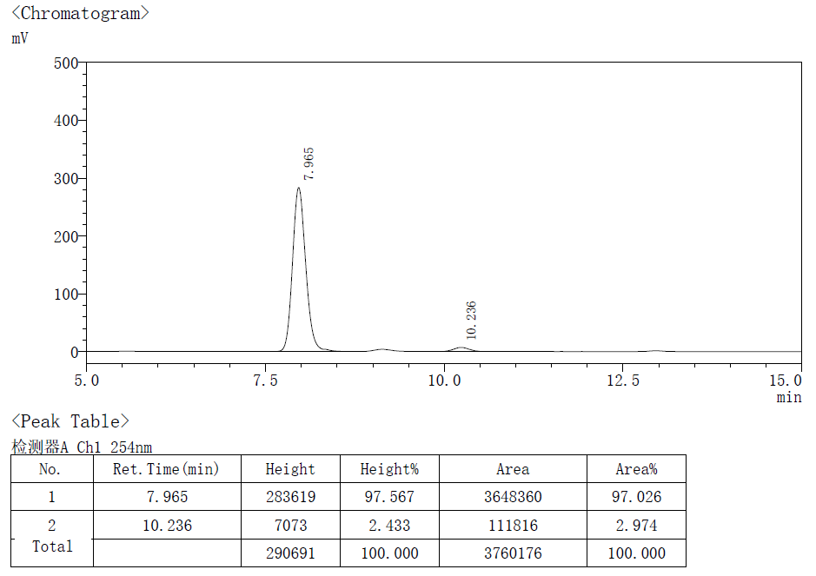
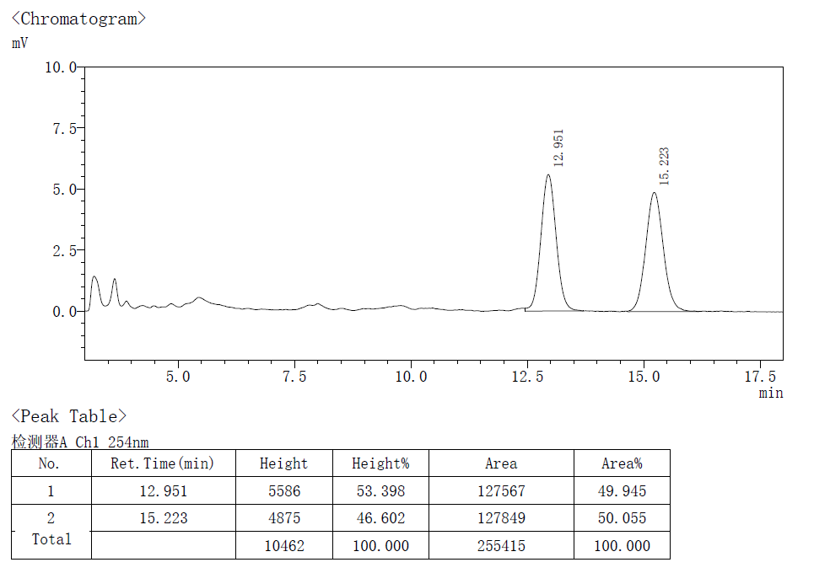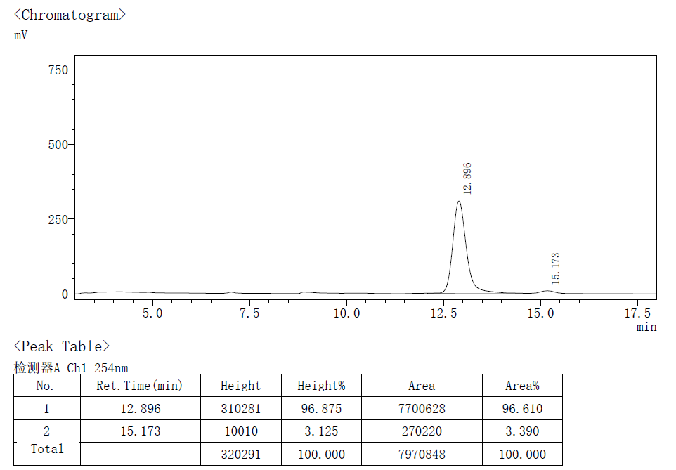
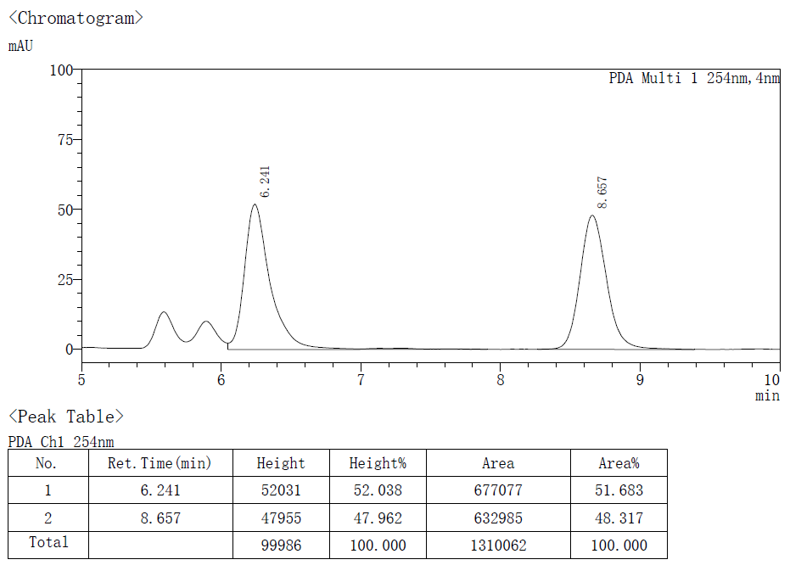
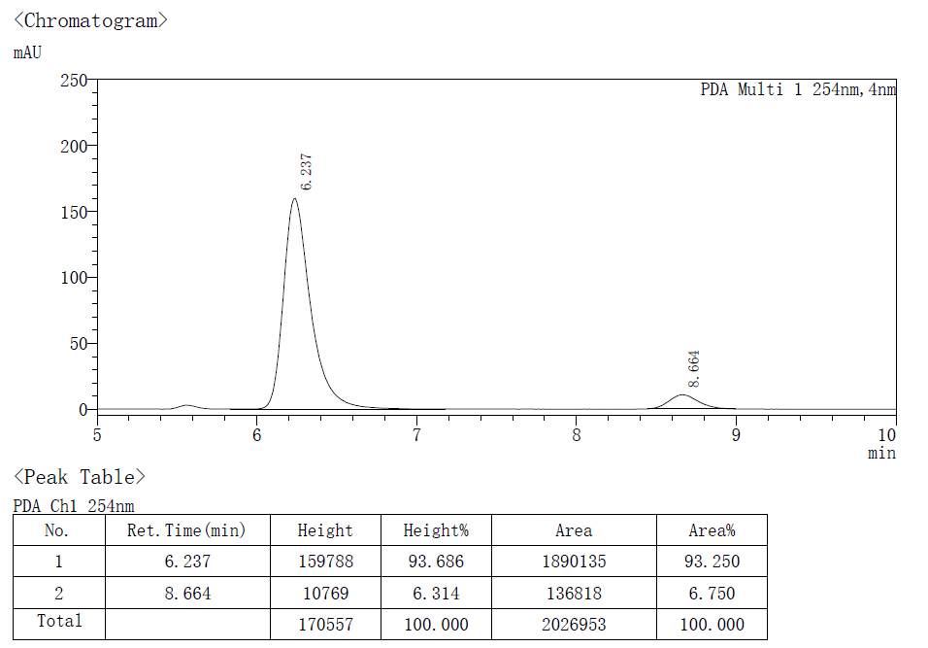

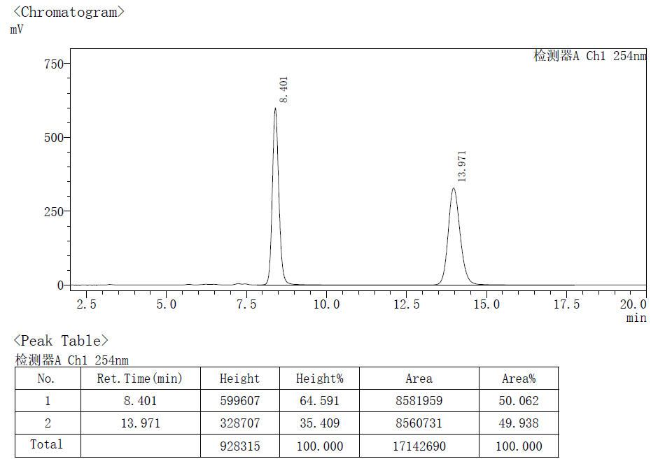
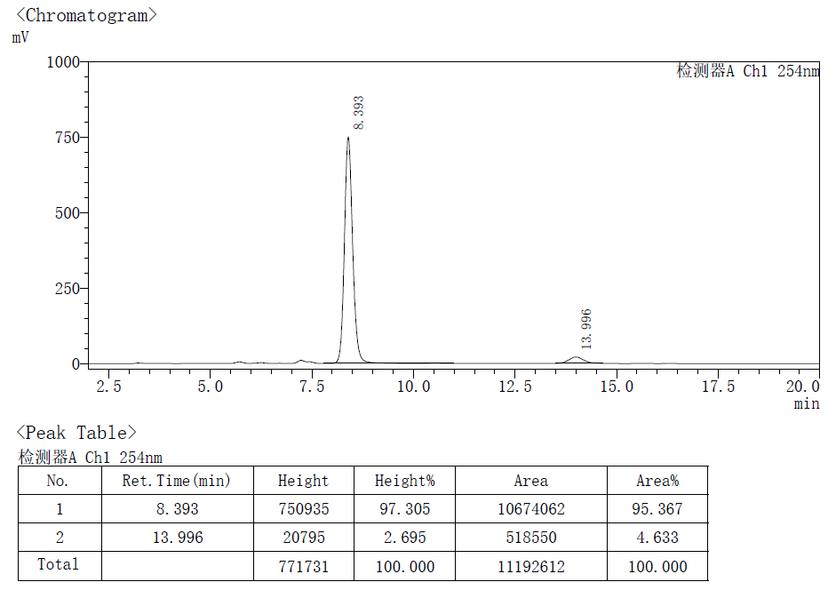
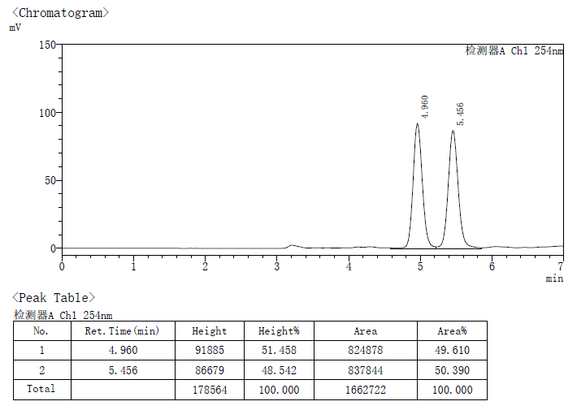
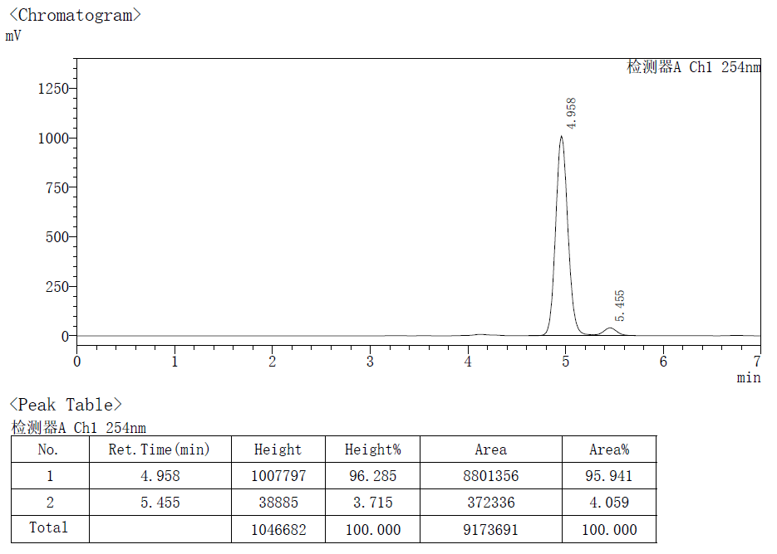
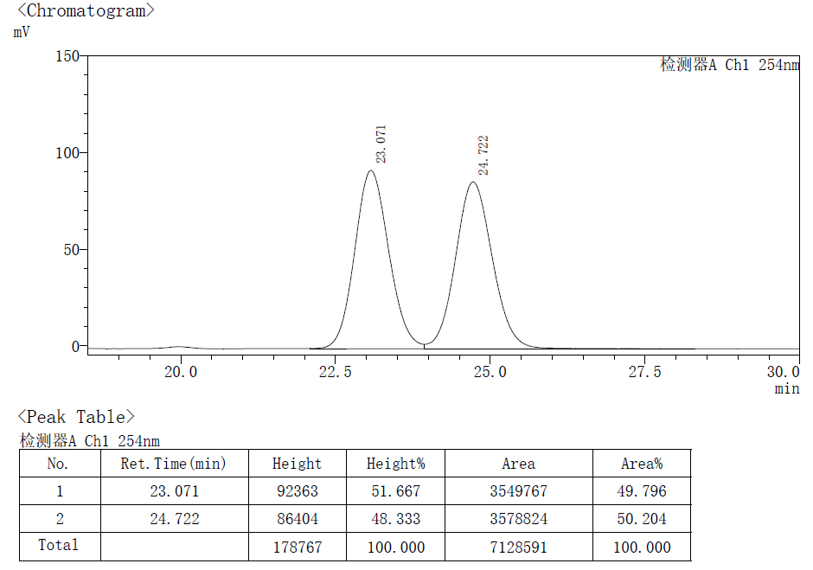
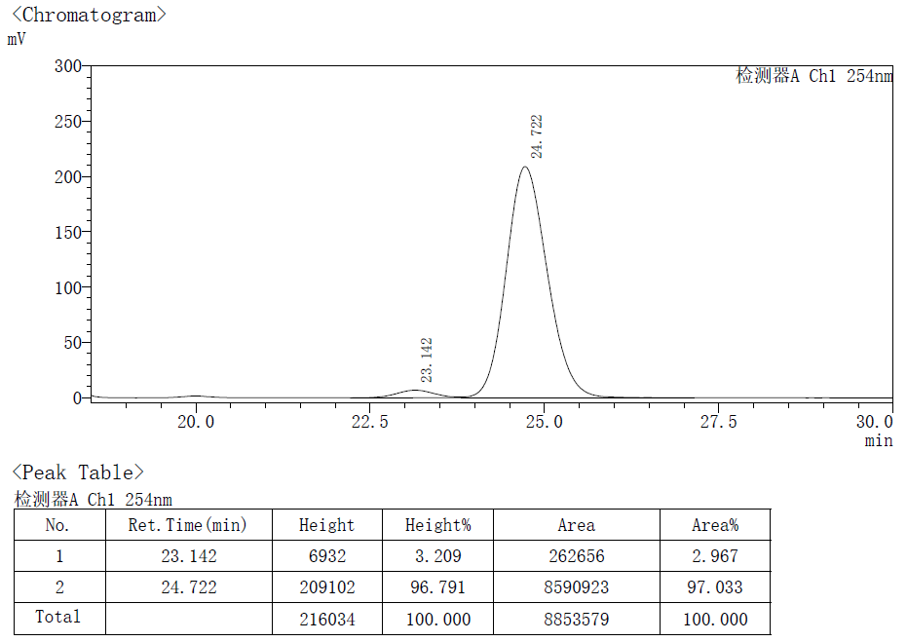
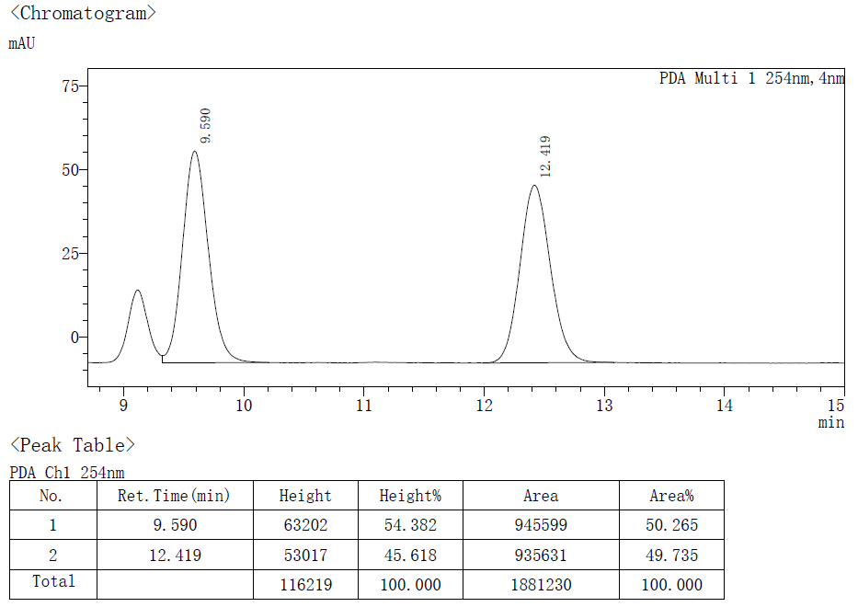
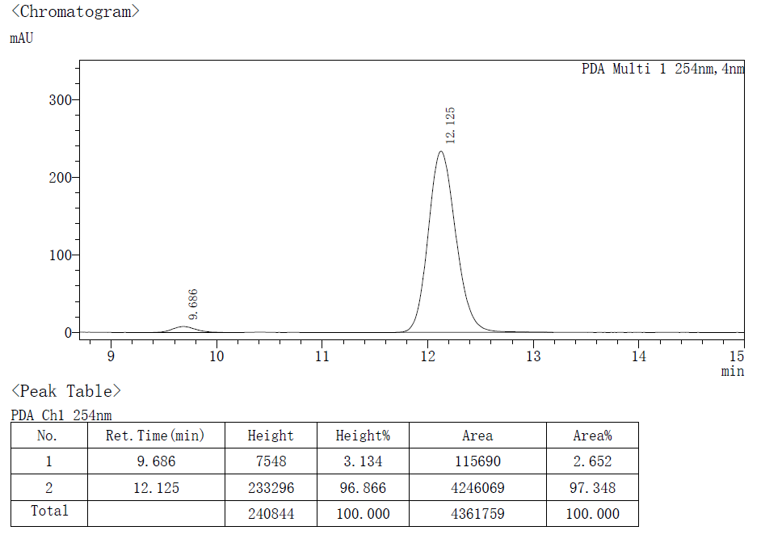
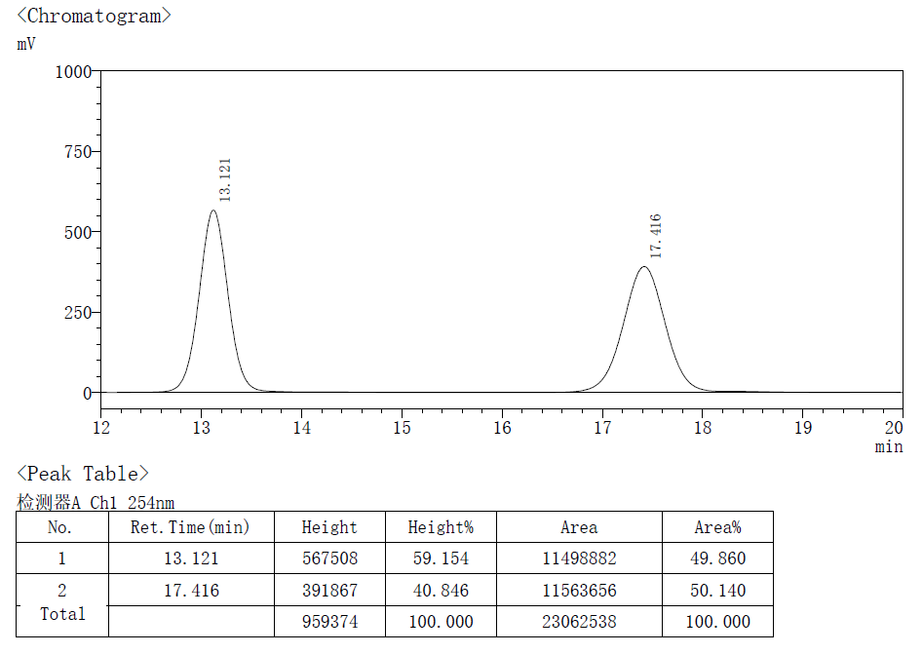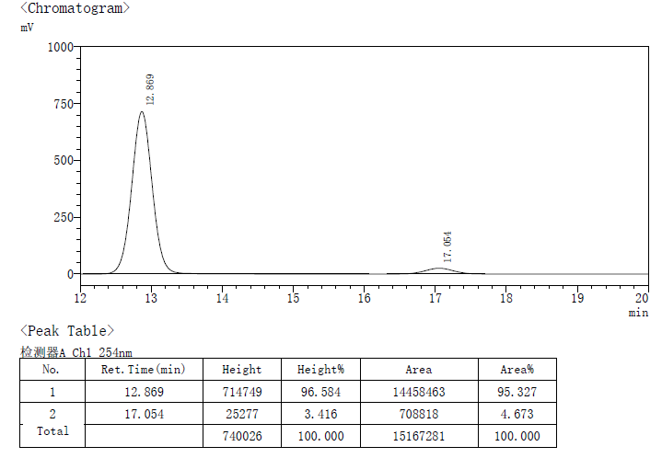
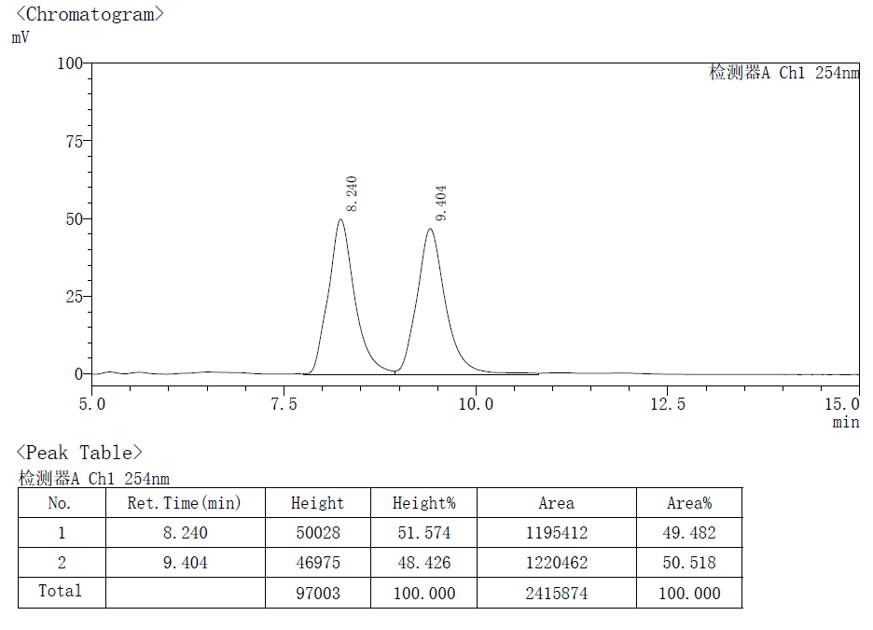
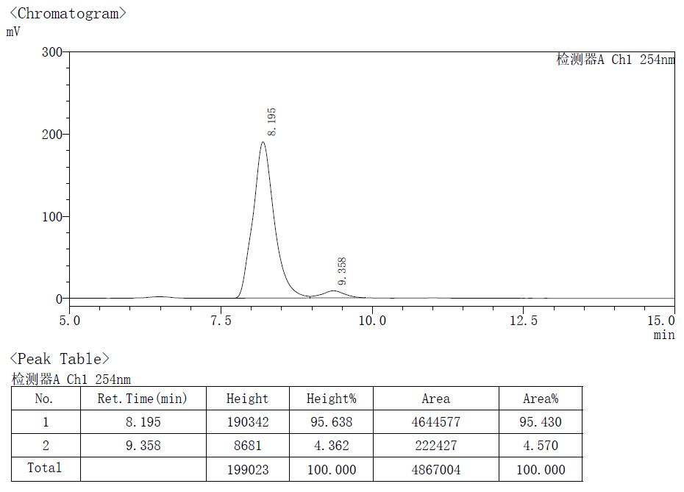
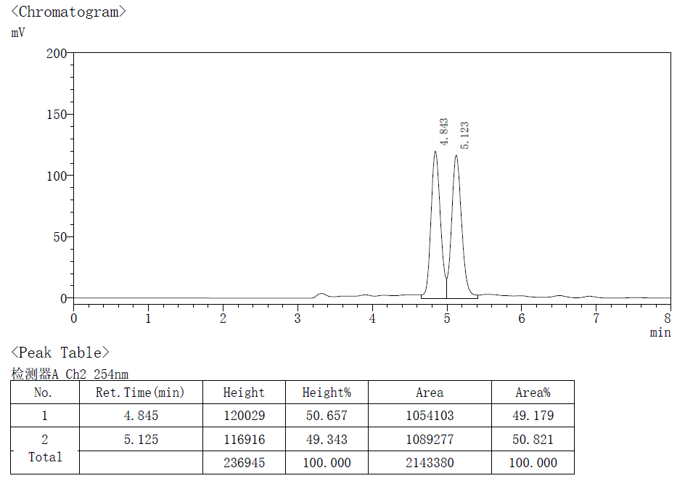
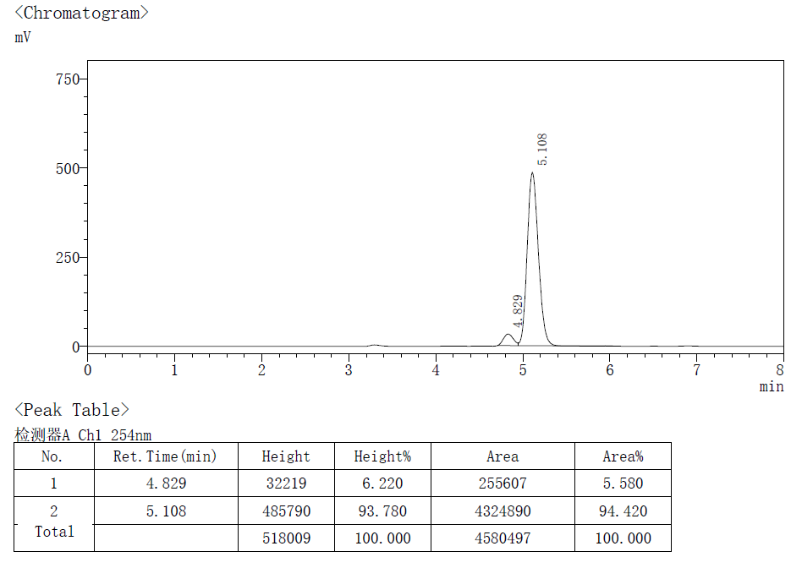
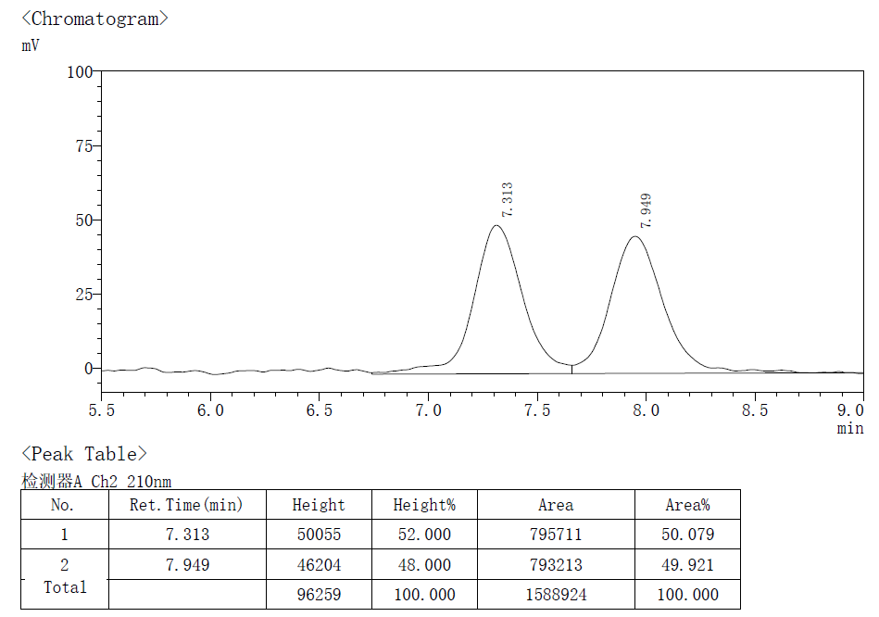
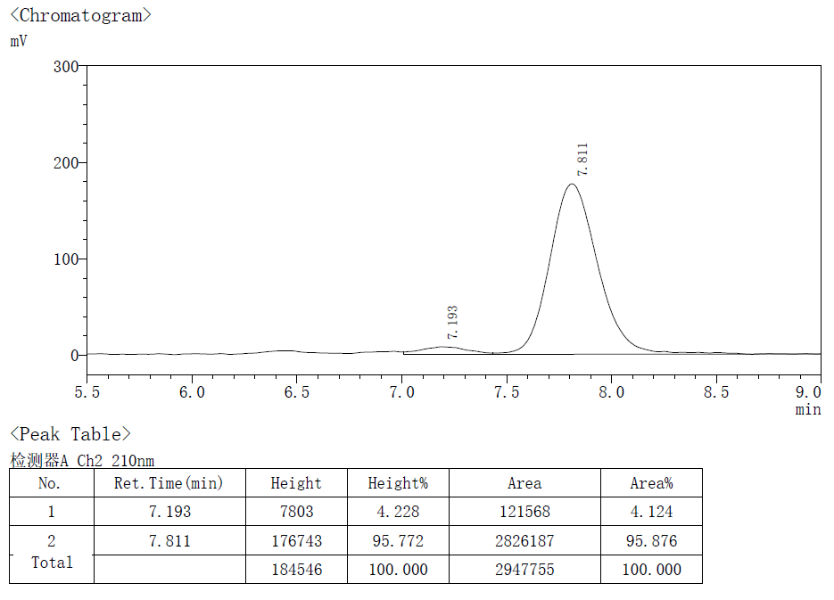
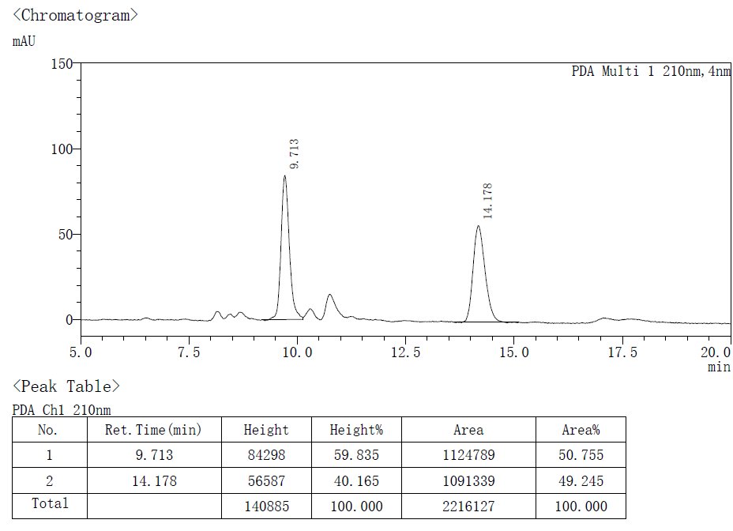
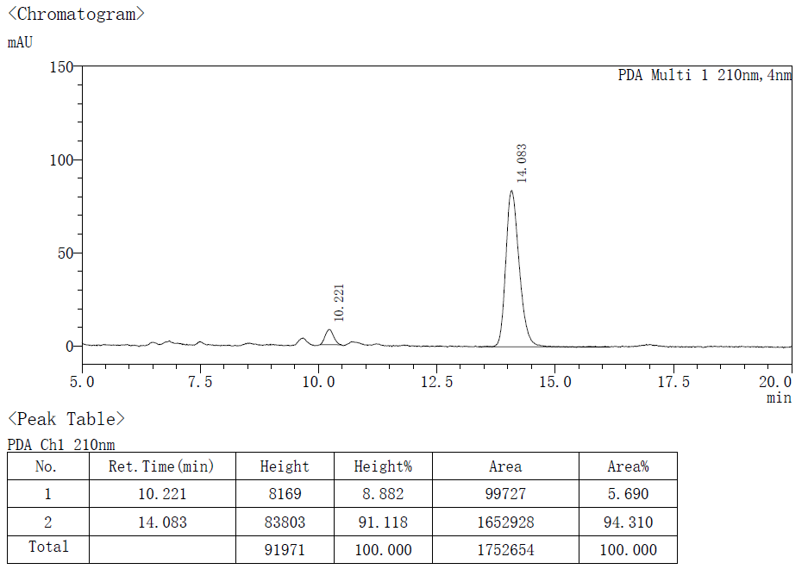
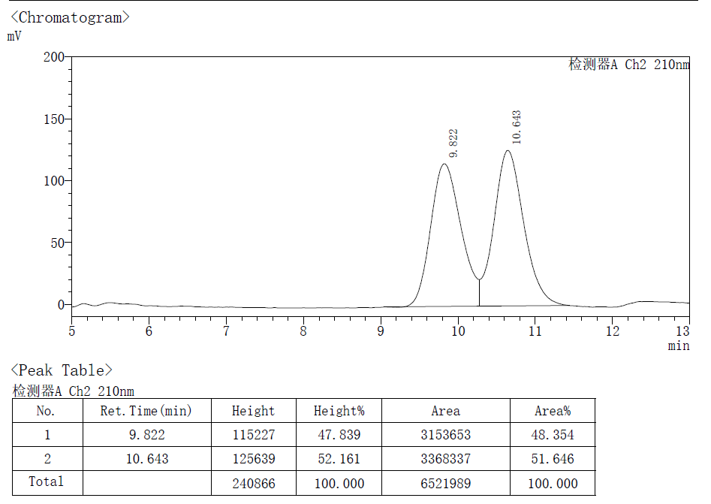
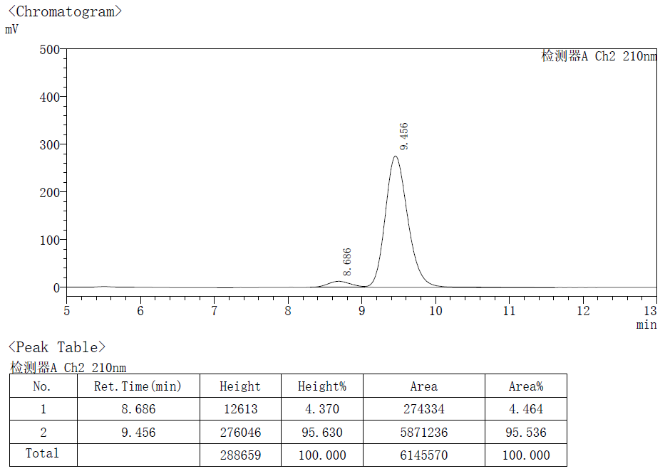
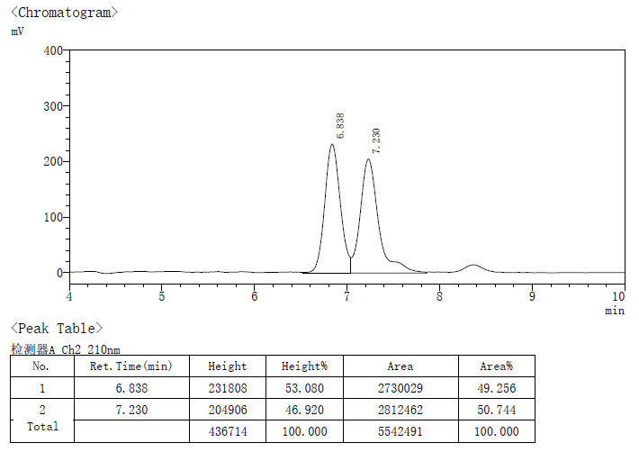
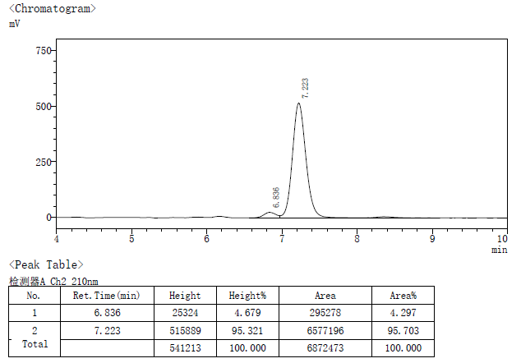

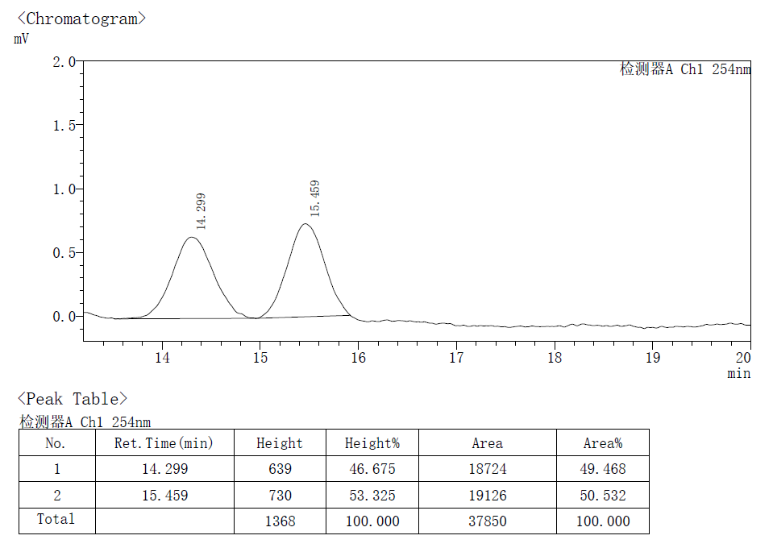
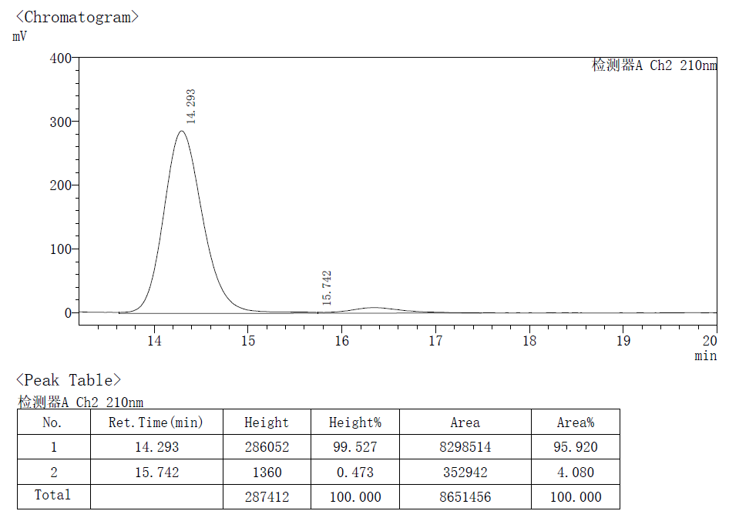
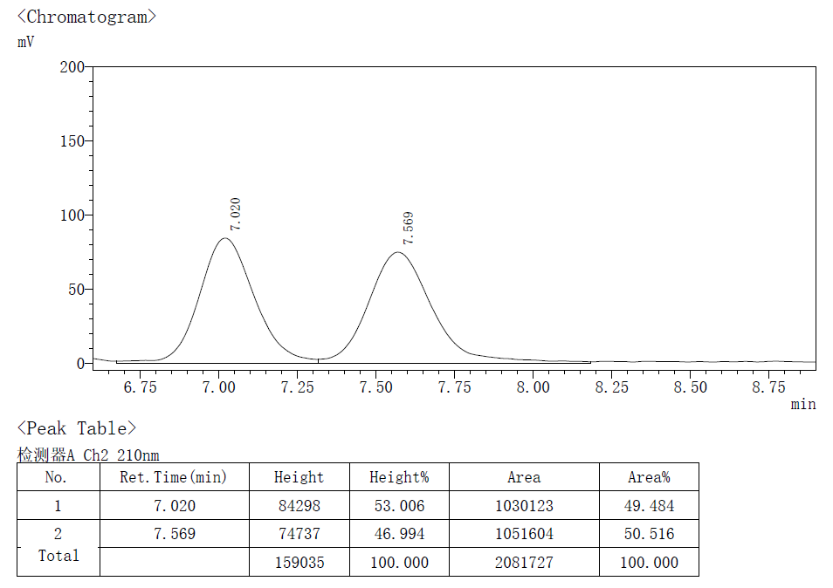
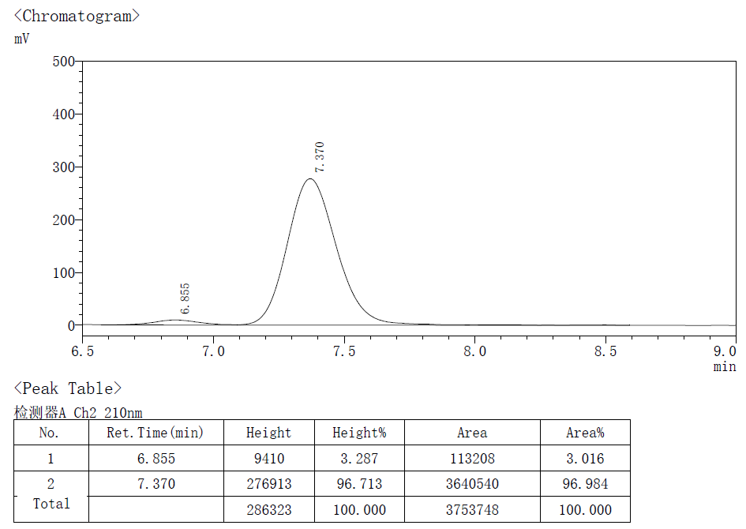
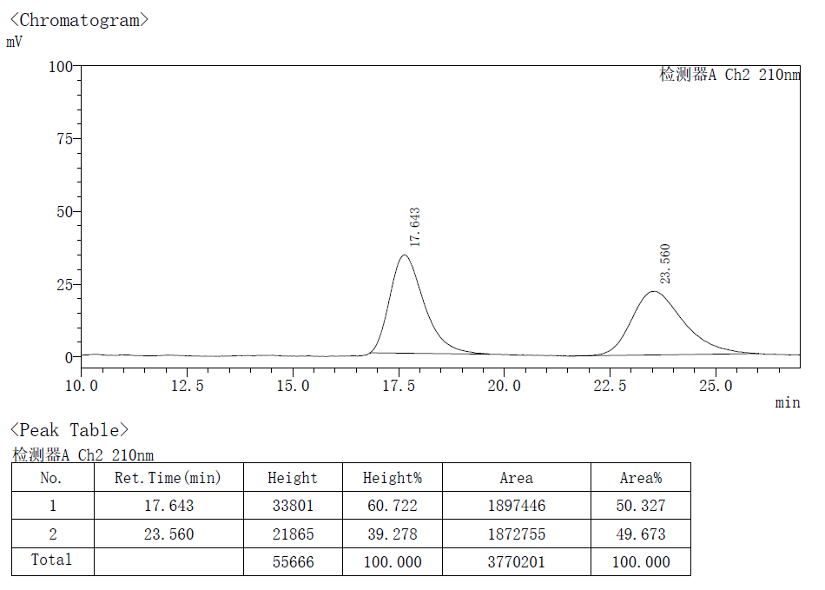
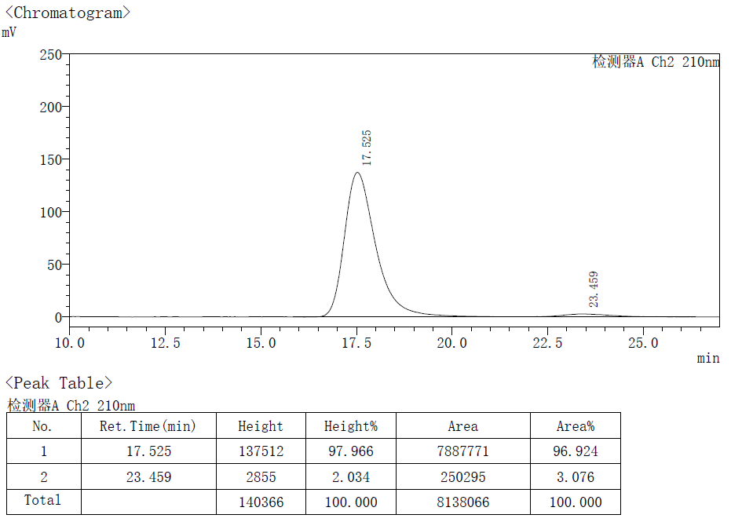
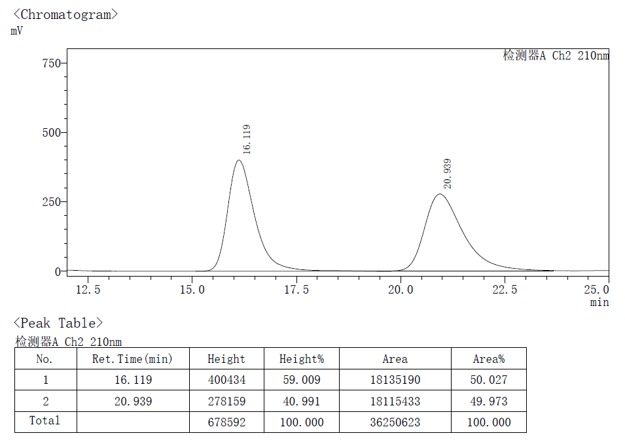
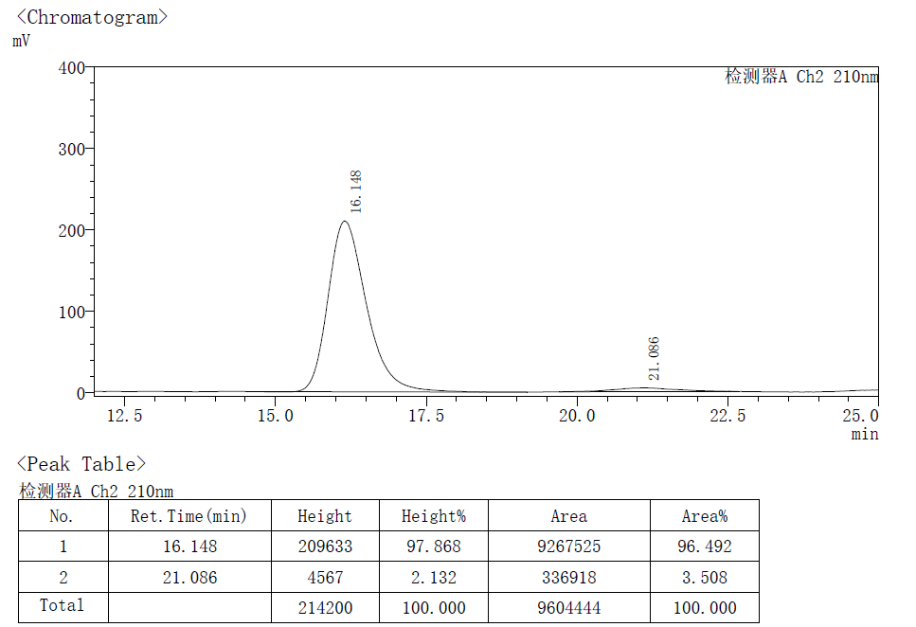
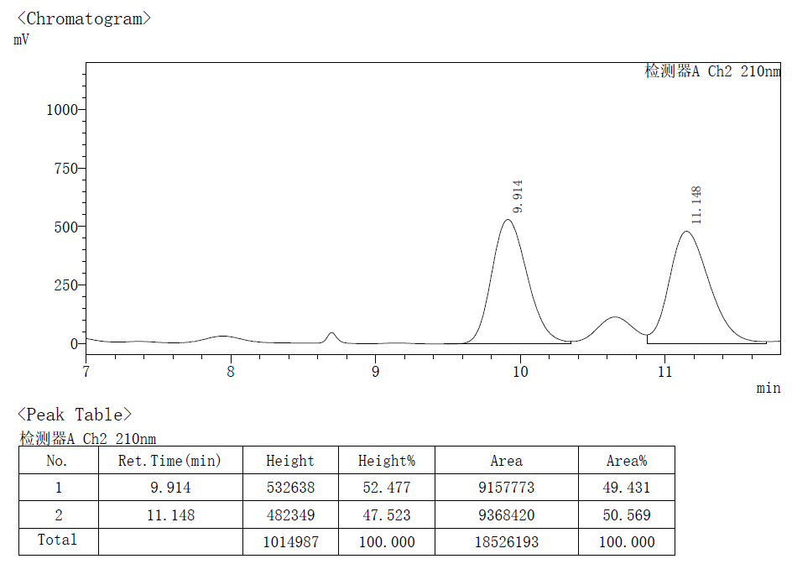
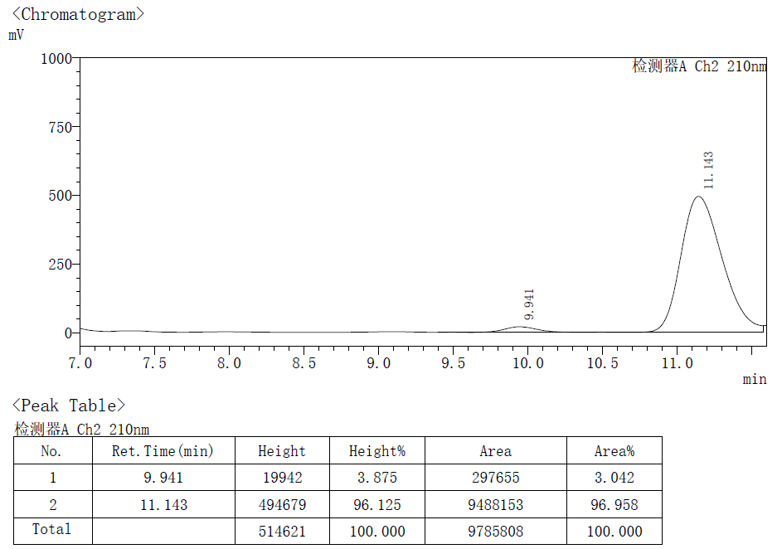
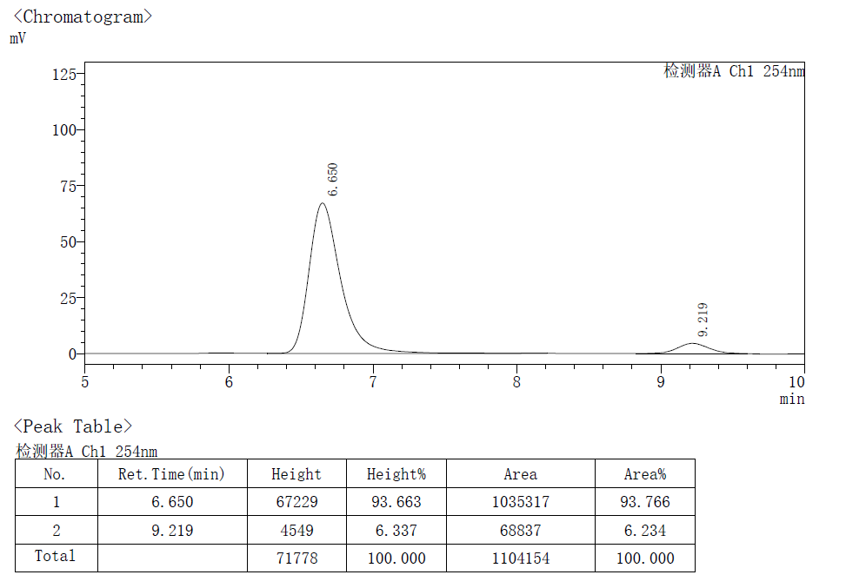
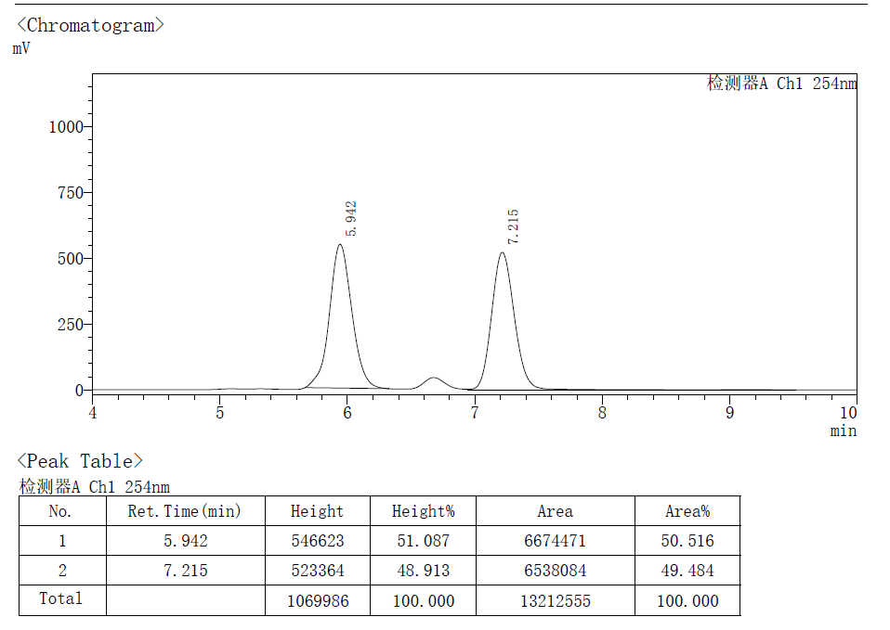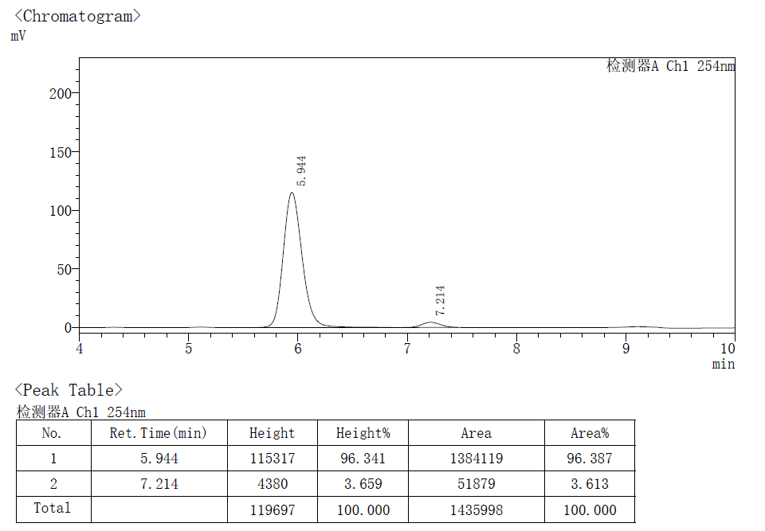
- References
- Cheng, G., Wang, X., Zhu, R., Shao, C., Xu, J., Hu, Y., and Li, Z. (2011). Total Synthesis of (-)-Cocaine and (-)-Ferruginine. J. Org. Chem. 76, 2694−2700.
- Tan, J.-P., Li, X., Chen, Y., Rong, X., Zhu, L., Jiang, C., Xiao, K., and Wang, T. (2020). Highly Stereoselective Construction of Polycyclic Benzofused Tropane Scaffolds and Their Latent Bioactivities: Bifunctional Phosphonium Salt-enabled Cyclodearomatization Process. Sci. China. Chem. 63, 1091−1099.
- Xia, Q., Li, Y., Cheng, L., Liang, X., Cao, C., Dai, P., Deng, H., Zhang, W., and Wang, Q. (2020). Electron Donor−Acceptor Complex-Initiated PhotochemicalCyanation for the Preparation of α‑Amino Nitriles. Org. Lett. 22, 9638−9643.
- Patel, S. C., Smith, M. W., Mercer, J. A., Suzuki, K., and Burns, N. Z. (2021). Enantioselective Cyclobutenylation of Oleﬁns Using N‑Sulfonyl-1,2,3-Triazoles as Vicinal Dicarbene Equivalents. Org. Lett. 23, 6530–6535.
- Yue, S., Zhou, K., Ma, C., Li, Z., and Zhang, J. (2024). Rhodium/Ming-Phos-catalyzed asymmetric annulation reaction of silacyclobutanes with terminal alkynes. Green. Synth. Catal. 5, 205–210.
- Rong, X., Yang, J., Liu, S., Lan, Y., and Liu, Q. (2023). Remote Stereocontrol of All-Carbon Quaternary Centers via Cobalt-Catalyzed Asymmetric Oleﬁn Isomerization. CCS. Chem. 5, 1293–1300
- Wang, J., Xu, B., Wang, Y., Xia, G., Zhang, Z.-M., and Zhang, J. (2024). Pd-Catalyzed Enantioselective Three-Component Carboamination of 1,3-Cyclohexadiene J. Am. Chem. Soc. 146, 21231−21238.
- Zhang, Y., Goetzke, F. W., Christensen, K. E., and Fletcher, S. P. (1975). Asymmetric synthesis of nortropanes via Rh-catalyzed allylic arylation. ACS. Catal. 8, 239−245.
- Xu, B., Ji, D., Wu, L., Zhou, L., Liu, Y., Zhang, Z.-M., and Zhang, J. (2022). Palladium/Xu-Phos-catalyzed enantioselective cascade Heck/remote C(sp²)–H alkylation reaction. Chem. 8, 836−849.

