Fig.S1. Adsorption experiment of blank silicon aluminum ball carrier

Fig.S2. Degradation effects of individual ozone oxidation and blank silicon aluminum ball carrier catalyzed ozone oxidation: (a) Nor removal rate, (b) COD removal rate

Fig.S3. Effect of Ce-Ni@WSA on Nor removal rate under different conditions: (a)Active metal combination, (b)Metal load ratio (c)Roasting temperature

Fig.S4. Effect of Ce-Ni@WSA on COD removal rate under different conditions: (a)Active metal combination, (b)Metal load ratio,(c)Roasting temperature

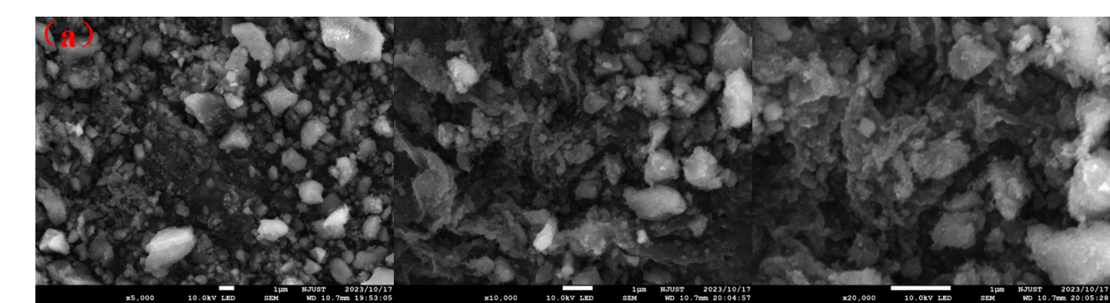
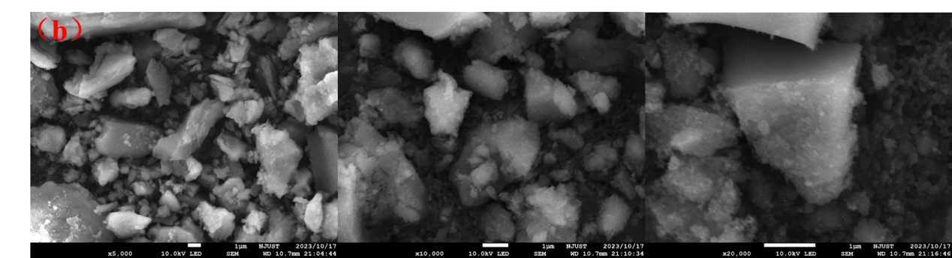
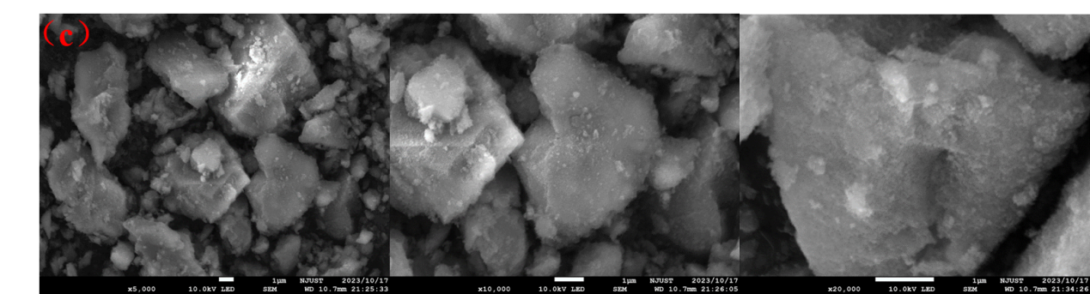
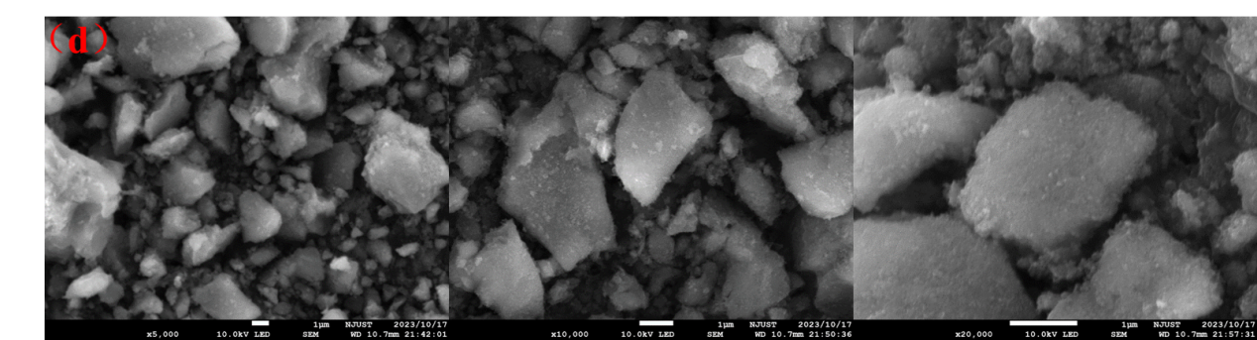
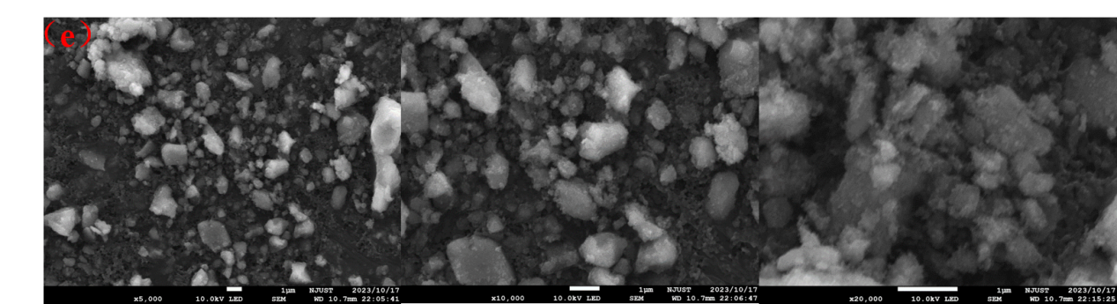
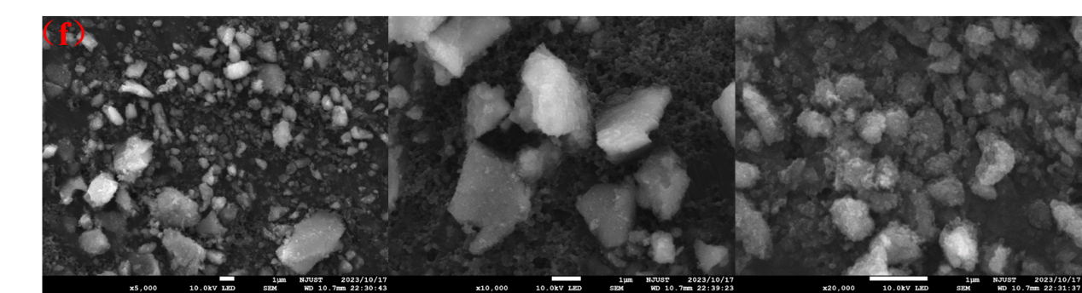
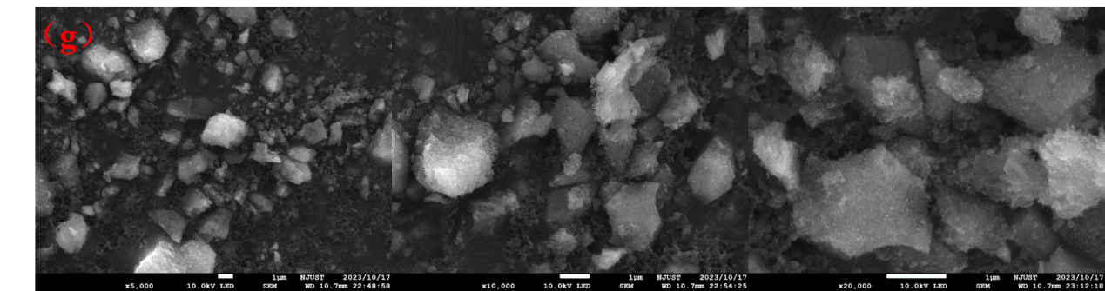
Fig. S5. SEM characterization of Ce-Ni@WSA catalysts: (a) Blank silicon aluminum ball carrier, (b) 350℃, (c) 450℃, (d) 550℃, (e) 650℃, (f) 750℃, (g) Ce-Ni@WSA repeated 50 times

Fig.S6. BET characterization of Ce-Ni@WSA : (a)Blank Silicon aluminum ball carrier, (b) Ce-Ni@WSA, (c) Ce-Ni@WSA repeated 50 times, (d) Pore size distribution

Fig.S7. Peak fitting diagram of Ce-Ni@WSA catalysts: (a)Ni, (b)Ce

Fig.S8. Mechanical strength of Ce-Ni@WSA catalysts

Table S1 Tetracycline parent compounds and degradation products
Serial number | Chemical formula | Structural type | Molecular weight (m/z)
M1 | C₁₆H₁₈FN₃O₃ | 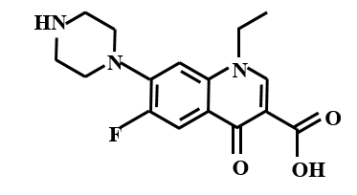 | 319
Ma1 | C₁₆H₁₉N₃O₄ | 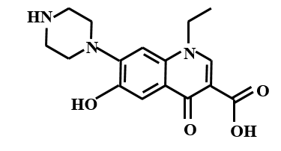 | 317
Ma2 | C₁₆H₁₉N₃O₃ | 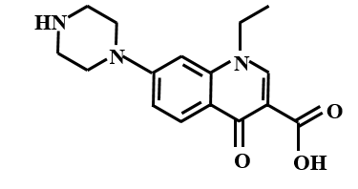 | 301
Mb1 | C₁₆H₁₈FN₃O₅ | 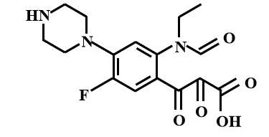 | 351
Mb2 | C₁₆H₂₀FN₃O₄ | 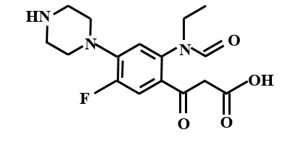 | 337
Mb3 | C₁₅H₁₈FN₃O₃ | 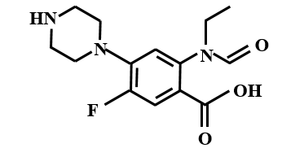 | 307
Mb4 | C₁₆H₂₀FN₃O | 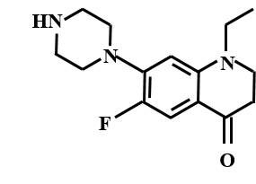 | 277
Mb5 | C₁₆H₂₂FN₃ | 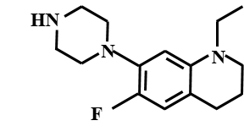 | 263
Mc1 | C₁₆H₁₆FN₃O₄ | 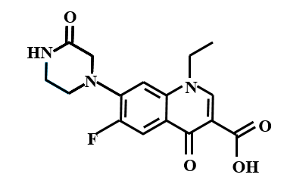 | 333
Mc2 | C₁₅H₁₆FN₃O₄ | 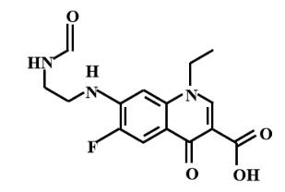 | 321
Mc3 | C₁₄H₁₆FN₃O₃ | 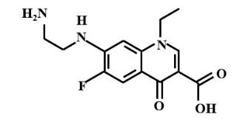 | 309
Mc4 | C₁₂H₁₁FN₂O₃ | 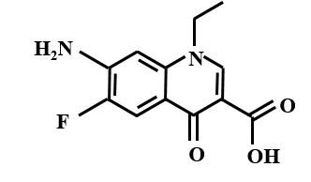 | 266
Mc5 | C₁₂H₁₁N₂O₃ | 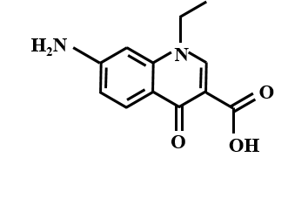 | 247
Mc6 | C₁₁H₁₁FN₂O₃ | 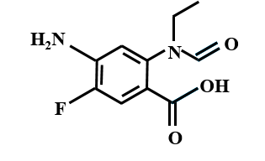 | 238
Mc7 | C₁₁H₁₅FN₂ | 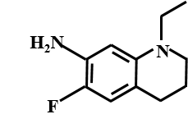 | 194

Fig.S9. Fitted kinetic curve for reaction of the ozone system alone: (a) zero-order, (b) first-order, (c) second-order

Fig.S10. Fitted kinetic curve for the reaction of catalytic ozonation system: (a) zero-order, (b) first-order, (c) second-order

Table S2 Fitted parameters for reaction kinetic analysis
Reaction system | Reaction order | R2 | Reaction rate k
Individual ozone oxidation | Zero-order | 0.9502 | 0.81143
Individual ozone oxidation | First-order | 0.9490 | 0.00446
Individual ozone oxidation | Second-order | 0.9476 | 2.458×10-5
Ce-Ni@WSA catalytic ozone oxidation | Zero-order | 0.9124 | 2.75257
Ce-Ni@WSA catalytic ozone oxidation | First-order | 0.9844 | 0.0447
Ce-Ni@WSA catalytic ozone oxidation | Second-order | 0.9668 | 7.971×10-4

Table S3 Correlation index
Index | Serial number | Item
Input index X | X₁ | Initial pH
Input index X | X₂ | ozone dosage (g/L/h)
Input index X | X₃ | Catalyst filling ratio (%)
Input index X | X₄ | Humic acid dosage (mg/L)
Output index Y | Y₁ | Nor removal rate (%)
Output index Y | Y₂ | COD removal rate (%)

Table S4 Evaluation criteria
index | explanation
Comprehensive benefit evaluation | When θ = 1, it is DEA effective ; when θ < 1, it is non-DEA effective ;
Scale benefit value | When the value is 1, it is the optimal state. When it is less than 1, it is the increasing return to scale, indicating that too small scale can increase the benefit of scale increase. When it is greater than 1, it is the decreasing return to scale, indicating that too large scale can reduce the benefit of scale increase.
Inputs redundancy | Too much investment, need to reduce (s⁻)
Output deficiency | Too little output, need to increase (s⁺)

Table S5 Research data summary
Item | X₁ | X₂ | X₃ | X₄ | Y₁ | Y₂
1 | 3 | 0.4 | 5 | 0 | 80.22 | 92.54
2 | 5 | 0.4 | 5 | 0 | 81.31 | 93.41
3 | 7.42 | 0.4 | 5 | 0 | 84.95 | 93.52
4 | 9 | 0.4 | 5 | 0 | 77.69 | 91.12
5 | 11 | 0.4 | 5 | 0 | 76.06 | 90.93
6 | 7.42 | 0.2 | 5 | 0 | 72.02 | 82.20
7 | 7.42 | 0.6 | 5 | 0 | 84.95 | 94.43
8 | 7.42 | 0.8 | 5 | 0 | 80.28 | 85.23
9 | 7.42 | 1.0 | 5 | 0 | 64.68 | 73.13
10 | 7.42 | 0.4 | 10 | 0 | 53.21 | 87.10
11 | 7.42 | 0.4 | 15 | 0 | 62.39 | 92.48
12 | 7.42 | 0.4 | 20 | 0 | 85.49 | 93.97
13 | 7.42 | 0.4 | 25 | 0 | 80.12 | 90.89
14 | 7.42 | 0.4 | 5 | 2 | 54.13 | 81.62
15 | 7.42 | 0.4 | 5 | 4 | 55.05 | 84.96
16 | 7.42 | 0.4 | 5 | 6 | 56.33 | 87.25
17 | 7.42 | 0.4 | 5 | 8 | 60.09 | 90.40
18 | 7.42 | 0.4 | 5 | 10 | 50.79 | 81.13
Note : X₁ is the initial pH ; X₂ is ozone dosage (g/L/h) ; X₃ is the catalyst filling ratio (%) ; X₄ is the speculative amount of humic acid (mg/L) ; Y₁ is Nor removal rate (%) ; Y₂ is COD removal rate (%).

Table S6 Validity analysis result
Item | TE | SE | OE | S⁻ | S⁺ | validity
1 | 1 | 0.954 | 0.954 | 1.892 | 2.542 |  | non-DEA effective
2 | 1 | 1 | 1 | 0 | 0 |  | DEA effective
3 | 1 | 1 | 1 | 0 | 0 |  | DEA effective
4 | 1 | 0.974 | 0.974 | 1.539 | 5.08 |  | non- DEA effective
5 | 1 | 0.972 | 0.972 | 3.481 | 6.537 |  | non- DEA effective
6 | 1 | 0.932 | 0.932 | 0.169 | 1.879 |  | non- DEA effective
7 | 1 | 1 | 1 | 0 | 0 |  | DEA effective
8 | 1 | 0.945 | 0.945 | 0.189 | 3.149 |  | non- DEA effective
9 | 1 | 0.774 | 0.774 | 0.155 | 1.108 |  | non- DEA effective
10 | 1 | 0.93 | 0.93 | 0 | 25.949 |  | non- DEA effective
11 | 1 | 0.986 | 0.986 | 0 | 21.702 |  | non- DEA effective
12 | 1 | 1 | 1 | 0 | 0 |  | DEA effective
13 | 1 | 0.967 | 0.967 | 0.048 | 2.568 |  | non- DEA effective
14 | 1 | 0.873 | 0.873 | 1.746 | 20.01 |  | non- DEA effective
15 | 1 | 0.908 | 0.908 | 3.634 | 22.124 |  | non- DEA effective
16 | 1 | 0.933 | 0.933 | 5.598 | 22.925 |  | non- DEA effective
17 | 1 | 0.967 | 0.967 | 7.733 | 22.026 |  | non- DEA effective
18 | 1 | 0.868 | 0.868 | 8.675 | 22.905 |  | non- DEA effective
Note : TE is technical benefit, SE is scale benefit, OE is comprehensive benefit.

Table S7 Detailed analysis results
 | Item | Input redundancy rate (%) |  |  |  | Underemployment rate of output (%) |  | Return to scale  coefficient | Type
 | Item | X₁ | X₂ | X₃ | X₄ | Y₁ | Y₂ | Return to scale  coefficient
 | 1 | 0.125 | 0 | 0 | 0 | 0.089 | 0 | 0.976 | Increasing returns to scale
 | 2 | 0 | 0 | 0 | 0 | 0 | 0 | 1 | Fixed returns to scale
 | 3 | 0 | 0 | 0 | 0 | 0 | 0 | 1 | Fixed returns to scale
 | 4 | 0.171 | 0 | 0 | 0 | 0.065 | 0 | 0.974 | Increasing returns to scale
 | 5 | 0.3 | 0 | 0 | 0 | 0.086 | 0 | 0.972 | Increasing returns to scale
 | 6 | 0 | 0.398 | 0 | 0 | 0 | 0.685 | 0.965 | Increasing returns to scale
 | 7 | 0 | 0 | 0 | 0 | 0 | 0 | 1 | Fixed returns to scale
 | 8 | 0 | 0.473 | 0 | 0 | 0 | 0.037 | 0.945 | Increasing returns to scale
 | 9 | 0 | 0.31 | 0 | 0 | 0.017 | 0 | 0.774 | Increasing returns to scale
 | 10 | 0 | 0 | 0 | 0 | 0.488 | 0 | 0.93 | Increasing returns to scale
 | 11 | 0 | 0 | 0 | 0 | 0.348 | 0 | 0.986 | Increasing returns to scale
 | 12 | 0 | 0 | 0 | 0 | 0 | 0 | 1 | Fixed returns to scale
13 |  | 0 | 0 | 0.193 | 0 | 0.032 | 0 | 0.967 | Increasing returns to scale
 | 14 | 0 | 0 | 0 | 0.868 | 0.37 | 0 | 0.873 | Increasing returns to scale
 | 15 | 0 | 0 | 0 | 0.906 | 0.402 | 0 | 0.908 | Increasing returns to scale
 | 16 | 0 | 0 | 0 | 0.931 | 0.407 | 0 | 0.933 | Increasing returns to scale
 | 17 | 0 | 0 | 0 | 0.965 | 0.367 | 0 | 0.967 | Increasing returns to scale
 | 18 | 0 | 0 | 0 | 0.867 | 0.451 | 0 | 0.868 | Increasing returns to scale

TEXT S1:
Suppose there are n DMUs, m input indexes and s output indexes, then DMU_{j} has m inputs and s outputs, which are expressed as matrix input X_{j} and output Y_{j} :
X_{j}=(x_{1j},x_{2j},…,x_{mj})^{T} (7-1)
Y_{j}=(y_{1j},y_{2j},…,y_{mj})^{T} (7-2)
In the formula :
x_{ij}- The total input of the jth DMU_{i} to the ith type of input, x_{ij}>0;
y_{ij}- The total input of the jth DMU_{i} to the rth type of input, y_{ij}>0;
i=1,2, … ,m;
r=1,2, … , s;
j=1,2, … , n;
Construct the model as follows :
min[θ-ε(e^{-T}s⁻+ e^{T}s⁺)] （7-3）
s.t.$\sum_{j=1}^{n}{X}$_{j}λ_{j}+s⁺=θX₀ （7-4）
$\sum_{j=1}^{n}{Y}$_{j}λ_{j}-s⁺=Y₀ （7-5）
Satisfies λj ≥ 0, s + ≥ 0, s- ≥ 0, j = 1,2,..., n ;
In the formula :
ε- Dimensionless;
λ_{j}-Weight variable;
θ- Undetermined parameter variable;
s⁺- Relaxation variable of output;
s⁻- Input slack variables;

