Pseudochrobactrum albidum sp. nov., a dimethylformamide-degrading bacterium isolated from activated sludge of a wastewater treatment plant.

Qiyun Zheng^{1,2#}, Wenwu Zhang^{3#}, Yue Su³, Yusi Yang³, Xiaoyu Bai³, Hongzhe Hu³, Shasha Qiu¹, Xinyi Huang², Tao Wang⁴, Can Chen¹*

Affiliation
¹ College of Life Science, Zhejiang University, Hangzhou 310000, PR China
² College of Animal Science, Zhejiang University, Hangzhou 310000, PR China
³ Trend Biotech Co., Ltd., Hangzhou, 311121, PR China
⁴ Department of Microbiology, University of Georgia, Athens, GA, USA

Correspondence: Can Chen, Email: chen_can_1990@163.com

Running title: Taxonomic identification of Pseudochrobactrum

Abbreviations:
ANI, average nucleotide identity; CAZy, carbohydrate-active enzyme; dDDH, digital DNA-DNA hybridization; Q-10: Ubiquinone-10; KCTC, Korean Collection for Type Cultures; LB, Luria-Bertani broth; MCCC, Marine Culture Collection of China; ML, maximum-likelihood; MP, maximum-parsimony; NJ, neighbour-joining; PC: Phosphatidylcholine; DPG: diphosphatidylglycerol; PG: phosphatidylglycerol; PE: phosphatidylethanolamine; PME: phosphatidylmonomethylethanolamine; PGL: phospho glycolipid; AL: amino lipid; PL: phospholipid; L: lipid; DMF: N,N-dimethylformamide.

Data availability:
The GenBank accession number for the 16S rRNA gene sequence of strain HB0163^{T} is PV945978; and the genome sequences of strain HB0163^{T} is JBPVTR000000000.

Fig. S1. Transmission electron microscope of cells of strain HB0163^{T} grown on LB for 3 days at 28 °C.
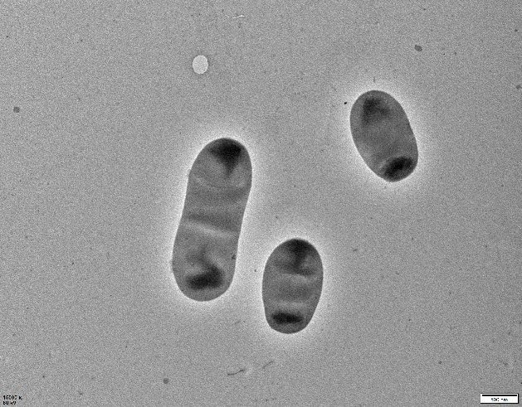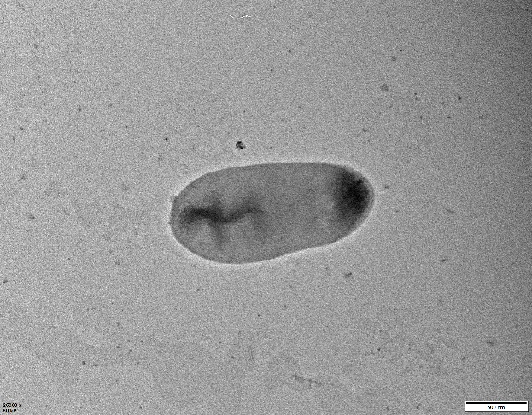
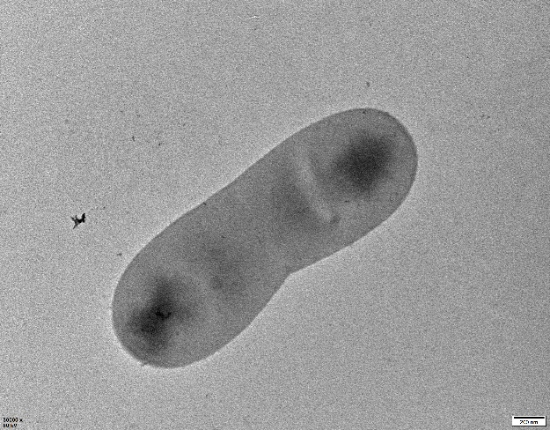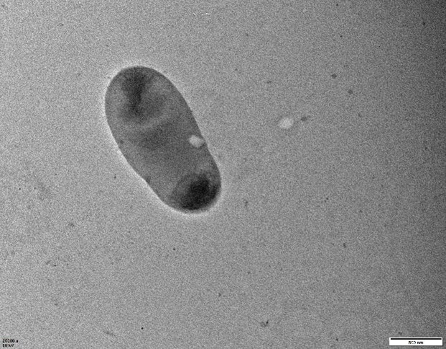

Fig. S2. Two-dimensional TLC plate images of total polar lipids of strain HB0163^{T} with different spraying reagents molybdophosphoric acid(a); ninhydrin reagent(b); molybdenum blue(c); sulfuric acid(d).
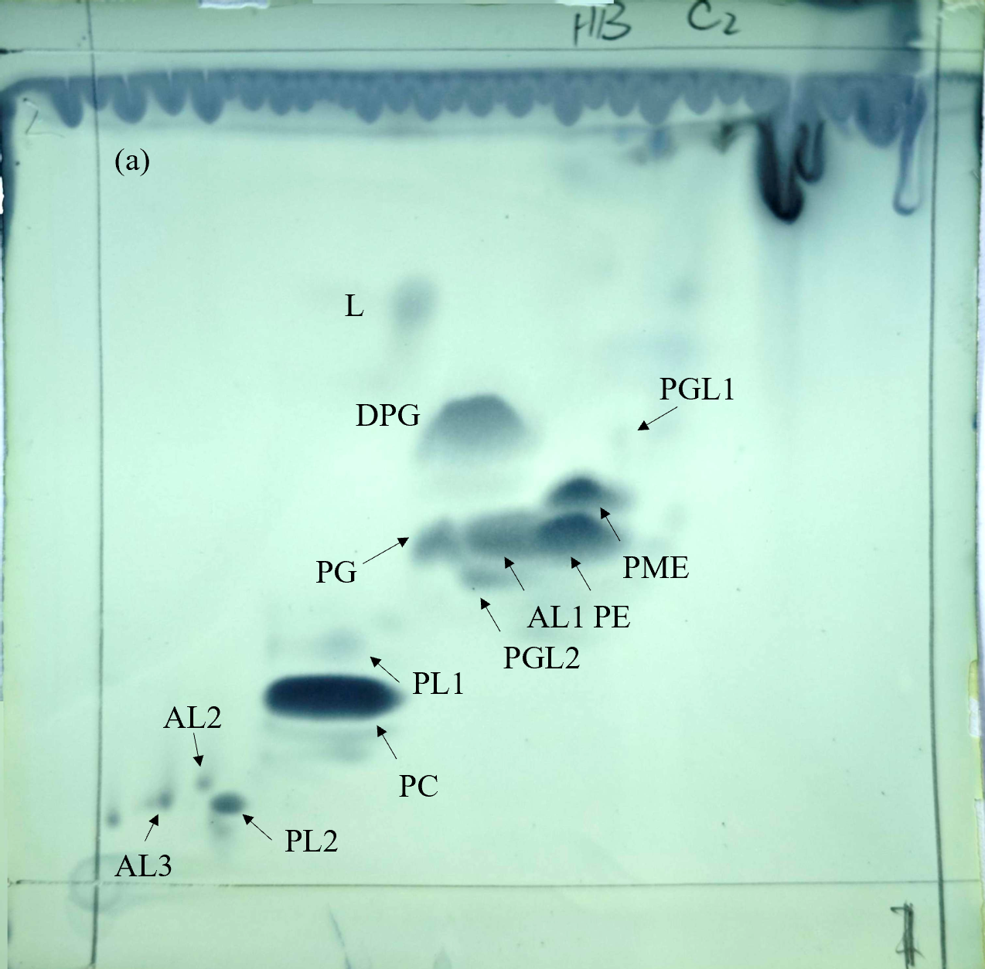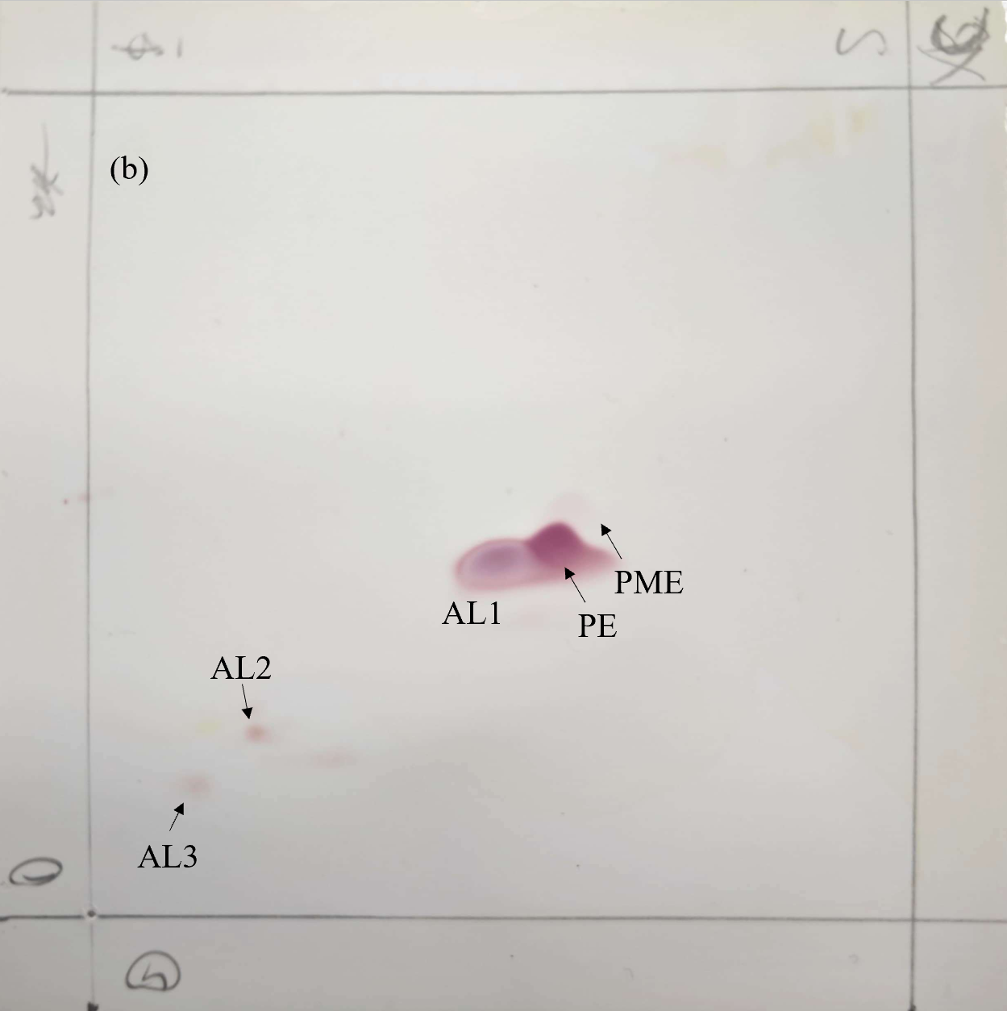

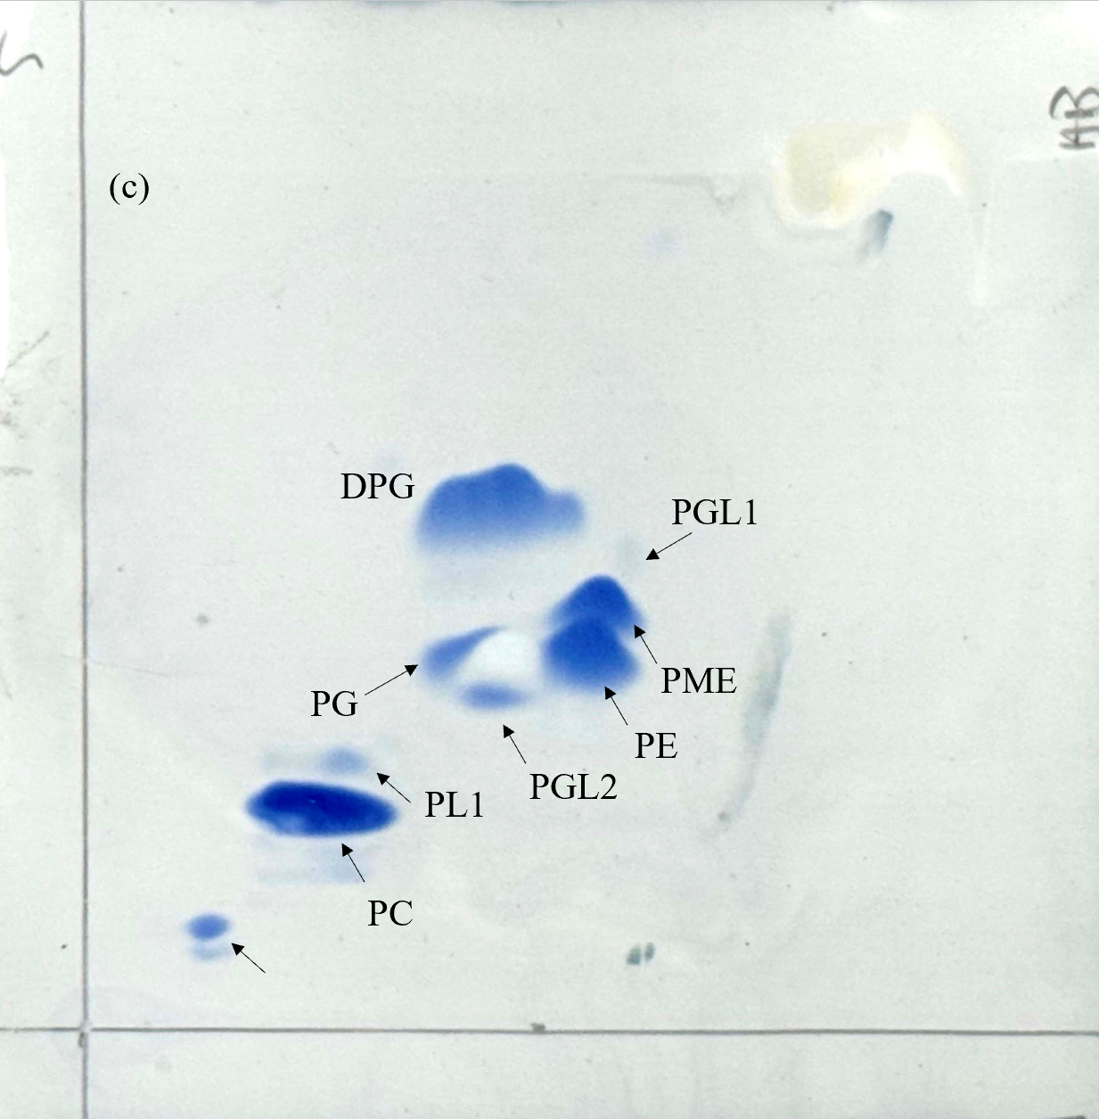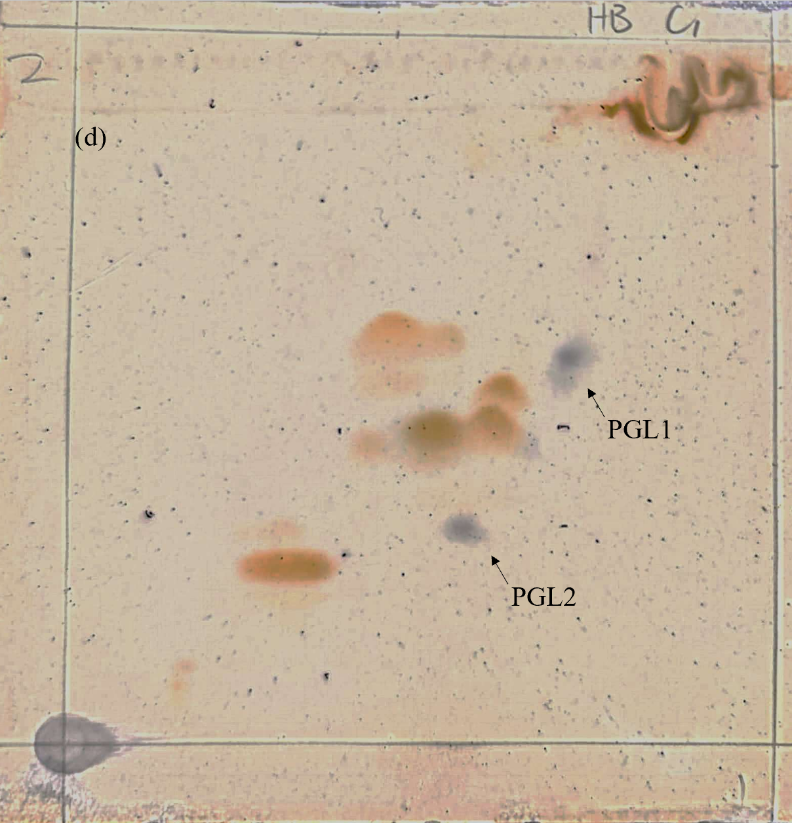

Fig. S3. Maximum-parsimony phylogenetic tree reconstructed based on the 16S rRNA gene
sequences of strain HB0163^{T} and the related taxa. Bootstrap values based on 1000 replicates are listed as percentages at branching points and less than 50 % are not shown.
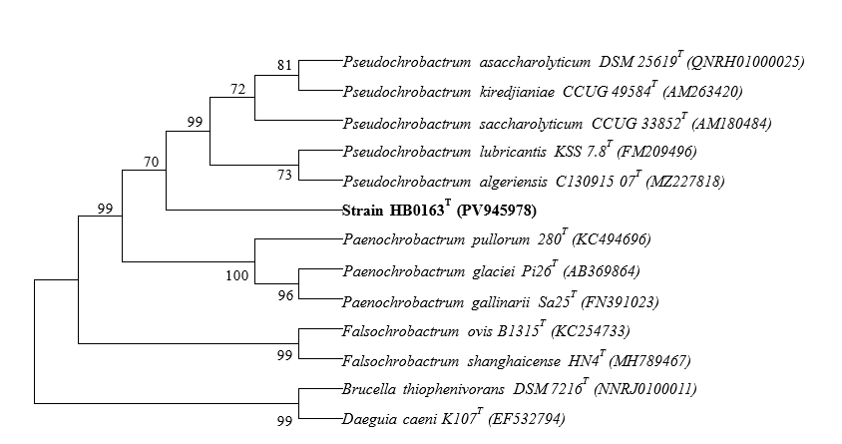

Fig. S4. Maximum-likelihood phylogenetic tree reconstructed based on the 16S rRNA gene
sequences of strain HB0163^{T} and the related taxa. Bootstrap values based on 1000 replicates are listed as percentages at branching points and less than 50 % are not shown. Bar, 0.005 substitutions per nucleotide position.
