Supplementary information
Integration of a single photon source with a photonic waveguide
Aurélie Broussier^{1x}, Muhammad H. Muhammad^{1,2+}, Nancy Rahbany³, Abdelhamid Hmima¹, Paul Robineau¹⁼, Cyrille Vezy¹, Régis Déturche¹, Antoine Kevorkian², Sylvain Blaize¹, Christophe Couteau^{1,4*}
¹Laboratory Light, nanomaterials and nanotechnologies-L2n, Université de Technologie de Troyes-UTT & CNRS UMR 7076, 12 rue Marie Curie, 10004 Troyes Cedex, France
²Teem Photonics, 61 Chemin du Vieux Chêne, 38246 Meylan, France
³Department of Physics and Astronomy, Faculty of Natural and Applied Sciences,
Notre Dame University-Louaize, Zouk Mosbeh, Lebanon
⁴EUT+ Institute of Nanomaterials and Nanotechnologies EUTINN,
European University of Technology, European Union, Troyes, France
*Corresponding author: christophe.couteau@utt.fr
^{x}Currently at FEMTO-ST Institute, Besançon, France
⁺Currently at Synopsys photonics solutions, France
⁼Currently at LASIRE, UMR 8516 CNRS-Université de Lille, Lille France

S1: Nanocrystal synthesis
The synthesis of the nanocrystals was performed in two steps. First, the CdSe cores were obtained following the "Cao" method¹. The estimation of the average core size and the concentration of the colloidal solution was obtained from the absorption spectrum of a diluted solution (10 µL in 3 mL of n-hexane), following²⁻³, to find: R cores = 1,45 nm and C = 25,6 µM. From these data, shell growth was performed via the SILAR method and the resulting solution characterized in absorption and photoluminescence⁴⁻⁵. The resulting NCs have oleic acid (OA) ligands, solubilized in n-hexane. Extinction coefficient from the core/shell structures at 350 nm was 1,72 × 10⁶ M⁻¹cm⁻¹, estimated through the absorption spectrum under the assumption of conserved concentration between core & core/shell solutions.
One quarter of the NCs synthesis (2,5 mL) are introduced into a 250 mL tricol, with 10 g of trioctylphosphine oxide (TOPO) and 5 mL of tricoctylphosphine (TOP). The whole solution is heated under stirring until 70°C is reached, which melts the TOPO. The contents of the tricol are then degassed to evacuate the hexane and oxygen, before passing under argon atmosphere. The mixture is left under stirring for 1 h at 70°C. The resulting solution is then separated in 4 Falcon tubes of 50 mL and completed with ethanol. After centrifugation at 10 000 RCF for 5 min, the supernatant can be discarded and the precipitated NCs[TOP/TOPO] are resolubilised in toluene. The resolublisation in toluene is done with 2,5 mL to keep the concentration as unchanged as possible. Optical properties in solution are typically unchanged for this kind of ligand exchange.

S2: Microscope and AFM images of the TiO₂ waveguides
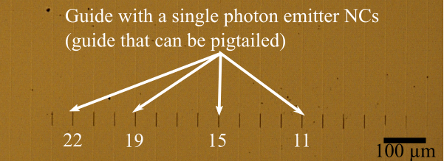
Figure S2-1: Bright field image of the sample with TiO₂ structure on the IEWs.
Figure S2-1 presents a bright field image of the sample, after fabrication, with TiO₂ structures on top of the IEWs. After NCs functionalization, we carried out an Atomic Force Microscope (AFM) study on the sample at the level of the TiO₂ structures to know their dimension’s parameters (Figures S2-2a & S2-2b).
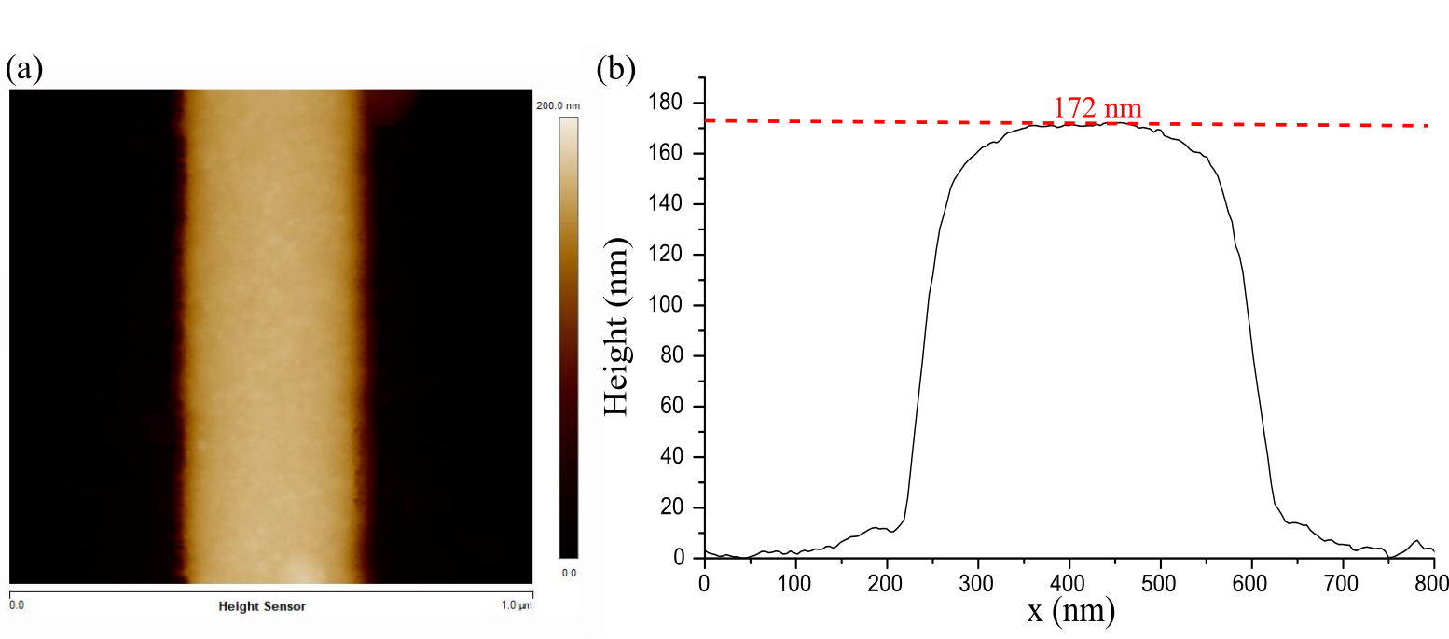
Figure S2-2: S2-2a) AFM Image, S2-2b) TiO₂ structure profile.
Five TiO₂ structures have been studied to have an average of the height, length and width parameters. In the following table, the parameters obtained are compared with the theoretical parameters.
 | Theoretical parameters | Experimental parameters
Width (nm) | 190 | 205$±$10
Height (nm) | 175 | 173.4$±$5
Length (µm) | 35 | 34.5$±$5

The values obtained via AFM are of the same order of magnitude as those theoretical.

S3: Nanocrystal ensembles over the waveguide sample
To have NCs everywhere on the sample, after the evaporation of the TiO₂, the sample was directly developed in acetone. Then we took up the principle of functionalization as explained in the article.
NCs photoluminescence was observed with an excitation at 532 nm directly on the glass part of the IEW-TiO₂ structure sample. This NC photoluminescence on glass is shown in black in Figure S3-1a. CdSe/ZnS NCs emit at 610 nm or so and have a FWHM of 27 nm. The laser is then placed on a waveguide. The emission obtained is represented by the red curve. The NCs emission peak is centered at 610 nm with a FWHM of 34.6 nm, the fluorescence of the waveguide with the structure is also present with a maximum at 675 nm (in red in Figure S3-1a). The NCs photoluminescence is also studied at the level of the structure of TiO₂ on IEW, represented in Figure S3-1a in blue. The NCs emission is present at 610 nm (FWHM = 32.6nm), but there is also fluorescence from the guide which is present at 675 nm. The addition of the TiO₂ structure on waveguide reduces the photoluminescence of the NCs compared to the case of the bare guide. The purpose of this high index layer is to allow a better coupling of the emission of the NCs in the waveguide, it is therefore expected to have a decrease in this photoluminescence in the case of the TiO₂ structure. A shift in the red is observed when the NCs are close to the guide or the TiO₂, which can be caused by a change of index between the substrate, the guide, and the TiO₂ structure.
The waveguide fluorescence has been studied to better understand the NCs spectrum on the waveguide (red spectrum in Figure S3-1a). The 532 nm laser was placed on a blank IEW sample on a guide, and the fluorescence is obtained from 575 to 750 nm with two peaks, one at 617 nm or so (FWHM = 59.5 nm) and the second at 676 nm (FWHM = 51.4 nm)^{6,7}. In Figure S-3b, the laser was placed at different locations to observe the fluorescence of different elements. When the laser is placed at the level of the TiO₂ structure on the guide, the fluorescence increases but is the same as that of the guide alone. If the laser is placed at the level of the TiO₂ on glass (pink spectrum in Figure S3-1b) there is a small peak of fluorescence at 675 nm⁸. The glass does not fluoresce for a 532 nm excitation as shown by the black curve in Figure S3-1b.
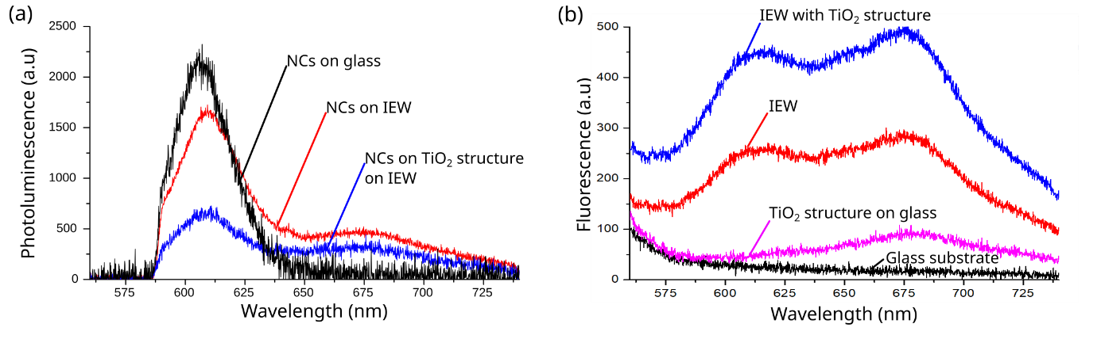
Figure S3-1: Excitation with a CW 532 nm laser. S3-1a) NCs photoluminescence spectrum, on glass in black, on IEW in red and on a TiO₂ structure on IEW in blue. S3-1b) Fluorescence of glass substrate in black, of IEW in red, of IEW with TiO₂ structure in blue and of TiO₂ structure in pink.
Following this, the NCs lifetime is studied in different environments. In Figure S3-2, in black, the lifetime of the NCs on the substrate is represented as a reference. In Figure S3-2, the NCs lifetime when the NCs placed on the waveguide (red curve) decreases compared to the case on glass. This decrease in the lifetime represents the coupling of NCs emissions into the waveguide. If a TiO₂ structure is added to the waveguide, the NCs lifetime decreases further (blue curve). The addition of a high index structure allows better coupling of the NCs in the waveguide.
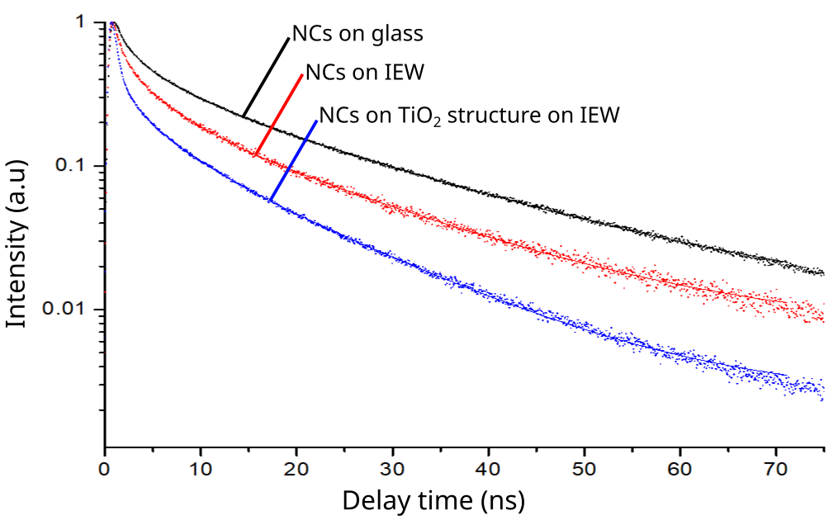
Figure S3-2: NCs lifetime measurement on different substrate: on glass in black, on IEW in red and on a TiO₂ structure on IEW in blue.
To know the lifetime of CdSe/ZnS NCs in different environments, we modeled the following formula:
$$I\left(t\right)=I_{0}+A_{1}e^{\frac{-t}{τ_{1}}}+A_{2}e^{\frac{-t}{τ_{2}}}$$ | (6)

The values obtained are presented in the following table according to the environment in which the NCs were placed:
 | $τ_{1}$ en ns | $τ_{2}$ en ns
NCs in glass substrate | 3.39 | 20.09
NCs in IEW | 3.2 | 18.46
NCs in TiO₂ structure on IEW | 3.05 | 16.53

From the lifetimes obtained on the different structures, the Purcell factor can be calculated as follows:
$P_{f}=\frac{3}{4π^{2}}{\left(\frac{λ_{em}}{n}\right)}^{3}\left(\frac{Q}{V}\right)=\frac{Γ}{Γ_{0}}=\frac{τ_{0}}{τ}$ (7)
where $τ_{0}$ represents the NC lifetime on the glass which serves as a reference and where $τ$ represents the NC lifetime near the waveguide or near the TiO₂ on the waveguide.
The Purcell factor was calculated in the case where the NCs are on the waveguide and the case where the NCs are on the TiO₂ structure to find:
$$\left\{\begin{aligned}P_{f\left(IEW\right)}=\frac{τ_{0}}{τ_{IEW}}=\frac{11.74}{10.83}=1.08 \\ P_{f\left(IEW+{TiO}_{2}\right)}=\frac{τ_{0}}{τ_{IEW+{TiO}_{2}}}=\frac{11.74}{9.79}=1.22\end{aligned}\right.$$ | (8)
A single mean value for the lifetime is calculated by taking the average of the two characteristic times $τ_{1}$ and $τ_{2}$ with an equal weight for each contribution.
The values obtained experimentally are of the same magnitude as that expected by the simulations (see main article). By adding a high index structure of TiO₂ to the waveguide, it is thus possible to increase the Purcell factor and to increase the coupling efficiency in the guide.
The sample was then pigtailed with optical fiber by the company TeemPhotonics. A 532 nm CW laser is initially placed on the IEW pigtail. The NCs will be excited and emitted at 610 nm. NCs emission will be coupled into the waveguide. To verify this, the photoluminescence at the fiber output obtained, Figure S3-3 red curve, corresponds to the NC emission at 610 nm. The laser was then placed on the TiO₂ structure, as before, photoluminescence at 610 nm is obtained as shown in the blue curve in Figure S3-3. In the case of TiO₂, the emission at the fiber is greater (multiplication by 1.5) compared to that obtained directly when the laser is on the waveguide. The TiO₂ high index structure allows a better coupling of the NCs emission in IEW.
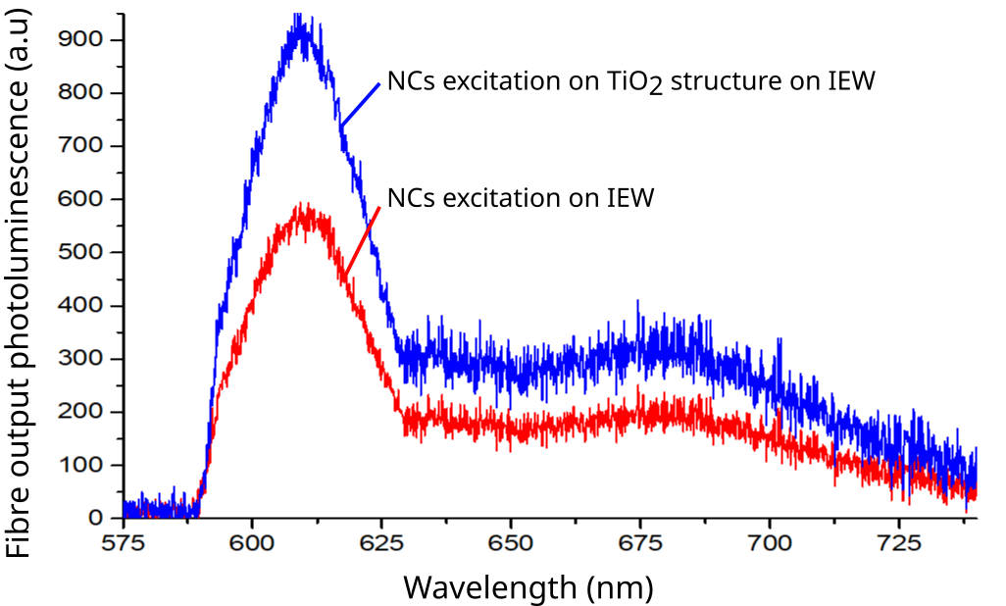
Figure S3-3: Fibre output photoluminescence for different position of the 532 nm CW laser, in red on the IEW alone and in blue on the TiO2 structure on the guide.

S4: Other hybrid photonic sources
Two other IEWs have been identified as single photon sources, on the same sample as what we presented in the article. Figure S4-1a shows the emission of NCs on the TiO₂ structure on IEW by an excitation at 532 nm. All photoluminescence spectra show emission a fine peak at 610 nm (FWHM ≈ 28 nm) corresponding to NCs photoluminescence, as well as the fluorescence of TiO₂ on the waveguide with a wide peak at 675 nm (FWHM ≈ 55 nm). These two IEWs were then assembled with a fibre by Teem Photonic. The emission at the fiber exit, figure S4-1b, represents that of the NCs at 610 nm. Figures S4-1c S4-1d present the g⁽²⁾ autocorrelation measurement of these two NCs. These 2 NCs are single photon emitters because the g⁽²⁾(τ=0) is less than 0.5 in both cases. The deposition method is therefore reproducible and makes it possible to create sources of fibered single photons.

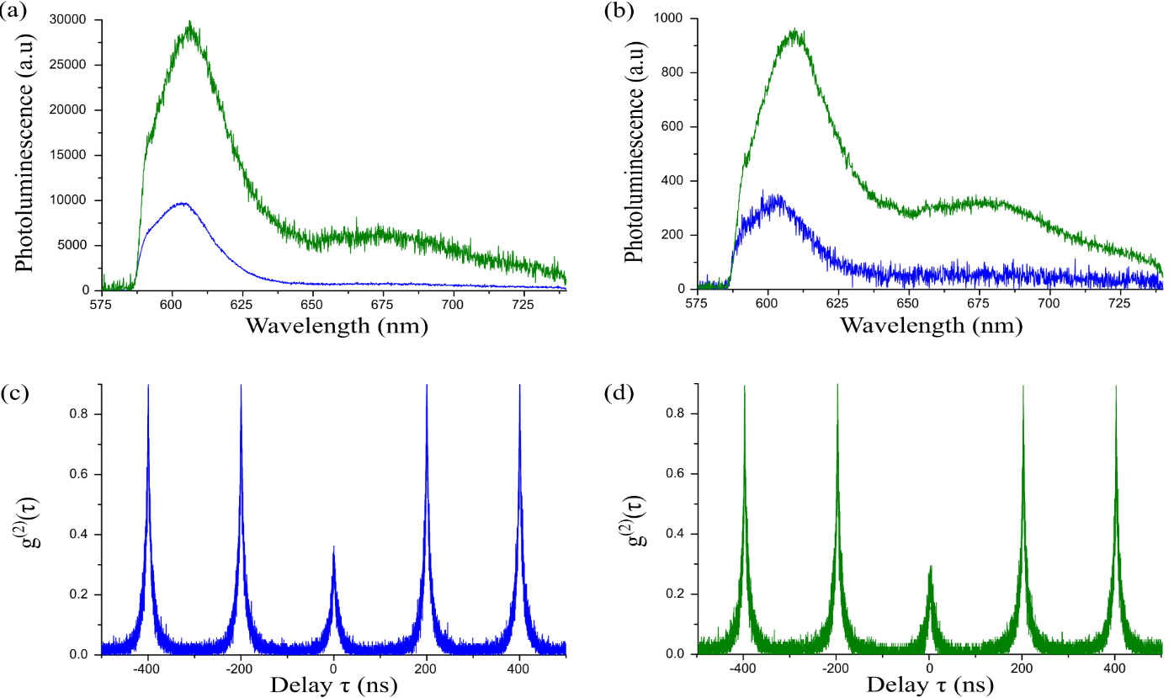
Figure S4-1: S4-1a) NC photoluminescence spectrum on a TiO₂ structure on a waveguide via objective detection S4-1b) Emission at fiber end, S4-1c & d) second-order autocorrelation functions corresponding to the spectra in S4-1a, for two different IEWs, with pulsed laser at 532 nm.
For each unique NC we measured the lifetime of this one and we went back to the Purcell factor. The values obtained are presented in the following table.
Summary of the different tester guides:
 | IEW 2 | IEW 3 | Theory
NC lifetime | 9.81 | 9.86 | /
Purcell factor | 1.2 | 1.19 | 1.45

The addition of a high index structure allows a better coupling of the emitter emission in the waveguide. As has been demonstrated, by adding the structure of TiO₂ the Purcell factor is higher which allows a better coupling efficiency. The unique NC via this high index structure makes it possible to obtain fluorescence at the output of the optical fiber.

Acknowledgements and funding statement
The authors would like to thank the Graduate School (École Universitaire de Recherche) “NANO-PHOT”, contract ANR-18-EURE-0013, they acknowledge the use of the nano’mat platform from the CNRS Renatech network and funding from the FEDER, the Grand Est Region and the Aube Department. This work received support from French National Agency for Research-ANR of the OQuLuS project under the France 2030 initiative, contract ANR-23-PETQ-0013. The authors thank CNRS-Innovation and the SATT SAYENS for funding A. B. via the projects InteQ and InteQ2.
Author contributions
A. B. contributed to the fabrication and characterisation work and contributed significantly to the writing of the article, M. H. M. contributed to the characterisation and simulation work, N. R. contributed to the simulation work, A. H. contributed to the fabrication work, P. R. & C. V. contributed to the synthesis work, R. D. contributed to the data acquistion of the work, A. K. contributed to the discussions, S. B. contributed to the discussions, C. C. designed and supervised the work & contributed significantly to the writing of the article as well as the discussions. All authors reviewed the article.
Competing interests
The authors declare no competing interests.
Bibliography
(1) Yang, Y. A.; Wu, H.; Williams, K. R.; Cao, Y. C. Synthesis of CdSe and CdTe Nanocrystals without Precursor Injection. Angew. Chem., (2005), 44, 6712−6715
(2) Leatherdale, C. A.; Woo, W. K.; Mikulec, F. V.; Bawendi, M. G. On the Absorption Cross Section of CdSe Nanocrystal Quantum Dots. J. Phys. Chem. B 2002, 106, 7619-7622.
(3) Yu, W. W.; Qu, L.; Guo, W.; Peng, X. Experimental Determination of the Extinction Coefficient of CdTe, CdSe, and CdS Nanocrystals. Chem. Mater. 2003, 15, 2854-2860.
(4) Li, J. J.; Wang, Y. A.; Guo, W.; Keay, J. C.; Mishima, T. D.; Johnson, M. B.; Peng, X. Large-Scale Synthesis of Nearly Monodisperse CdSe/CdS Core/Shell Nanocrystals Using Air-Stable Reagents via Successive Ion Layer Adsorption and Reaction. J. Am. Chem. Soc. 2003, 125, 12567-12575.
(5) Renguo Xie, Ute Kolb, Jixue Li, Thomas Basché, and Alf Mews, Synthesis and Characterization of Highly Luminescent CdSe−Core CdS/Zn0.5Cd0.5S/ZnS Multishell Nanocrystals J. Am. Chem. Soc. 2005, 127, 20, 7480–7488
(6) Weisser, M.; Thoma, F.; Menges, B.; Langbein, U.; Mittler-Neher, S. Fluorescence in Ion Exchanged
BK7 Glass Slab Waveguides and Its Use for Scattering Free Loss Measurements. Optics Communications
1998, 153 (1), 27–31. https://doi.org/10.1016/S0030-4018(98)00222-3.

(7) Hassanzadeh, A.; Nitsche, M.; Armstrong, S.; Nabavi, N.; Harrison, R.; Dixon, S. J.; Langbein, U.;
Mittler, S. Optical Waveguides Formed by Silver Ion Exchange in Schott SG11 Glass for Waveguide
Evanescent Field Fluorescence Microscopy: Evanescent Images of HEK293 Cells. J. Biomed. Opt. 2010,
15 (3), 036018. https://doi.org/10.1117/1.3443796.

(8) Jin, C.; Liu, B.; Lei, Z.; Sun, J. Structure and Photoluminescence of the TiO2 Films Grown by Atomic
Layer Deposition Using Tetrakis-Dimethylamino Titanium and Ozone. Nanoscale Res Lett 2015, 10 (1),
95. https://doi.org/10.1186/s11671-015-0790-x.

