Supporting information
Synergistic Adsorption-Photocatalytic Degradation of Tetracycline on Bi(OH)₃
Junhua Wen, Dongbin Liu, Lihui Fan, Yanming Shen
(Department of Chemical Engineering, Shenyang University of Chemical Technology, Shenyang 110141)

*Corresponding author:
Yanming Shen
Department of Chemical Engineering, Shenyang University of Chemical Technology
E-mail address: sym6821@sina.com.cn

Table of contents
1. Text S1: introductions to the investigations for the effects of factors on the TC adsorption efficiency.
2. Table S1: The pore structures of sample before and after TC adsorption.
3. Figures:
Fig.S1 Effects of (a) photocatalyst dosage and (b) initial TC concentration, (c) pH, and (d) adsorption temperature on the TC adsorption efficiency.
Fig.S2 variation of Zeta potential with pH.
Fig.S3 TG curves of Bi(OH)₃ (a) before and (b) after adsorption.
Fig.S4 XPS spectra of C1s, Bi 4f and O1s before and after adsorption of TC.
Fig.S5 Uv-vis scanning curves of TC solution during the adsorption and photocatalysis.
Fig.S6. Schematic diagram for photocatalytic degradation of TC.

Text S1:

Investigations to the effects of photocatalyst dosage (m), initial TC concentration (C₀), pH and adsorption temperature (T) on the TC adsorption efficiency were conducted according to the steps described in the experiment section. The conditions that were used to investigate these factors are as follows.
Effect of photocatalyst dosage: The photocatalyst dosage was taken as 0.1, 0.3, 0.5 and 1.0 g/L, respectively, while other conditions were set as C₀ = 30 mg/L, pH = ~5, T = 25 ºC.
Effect of initial TC concentration: The initial TC concentration was taken as 10, 30 and 50 mg/L, respectively, while other conditions were set as m = 0.5 g/L, pH = ~5, T = 25 ºC.
Effect of pH: The pH was taken as 5, 7, 9 and 11, respectively, while other conditions were set as C₀ = 30 mg/L, m = 0.5 g/L, T = 25 ºC.
Effect of adsorption temperature: The adsorption temperature was taken as 25, 35, 45 and ºC, respectively, while other conditions were set as C₀ = 30 mg/L, pH = ~5, m = 0.5 g/L.

Tables:

Table S1 Porous structure of Bi(OH)₃ before and after adsorption
Sample | S_{BET} (m²/g) | V_{m} (cm³/g) | d (nm)
Bi(OH)₃ | 27.30 | 0.210 | 30.69
Bi(OH)₃-TC | 10.32 | 0.113 | 43.70

Figures:

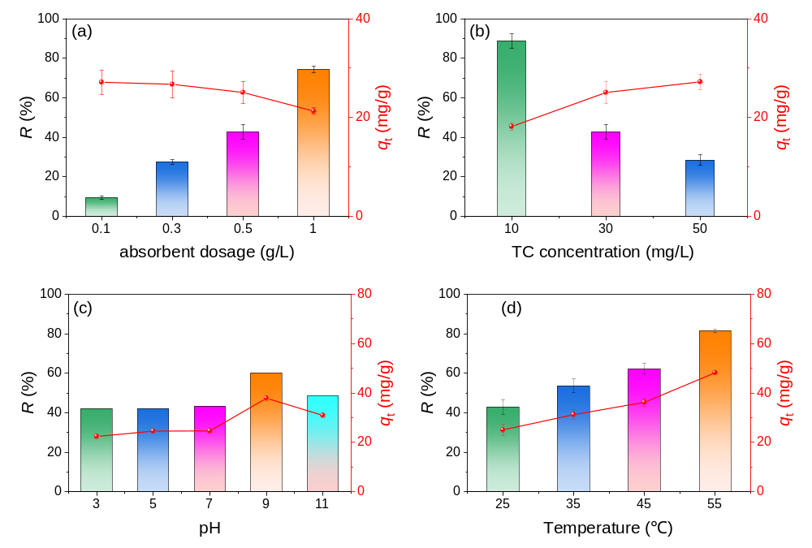
Fig. S1 Effects of (a) photocatalyst dosage and (b) initial TC concentration, (c) pH, and (d) adsorption temperature on the TC adsorption efficiency.
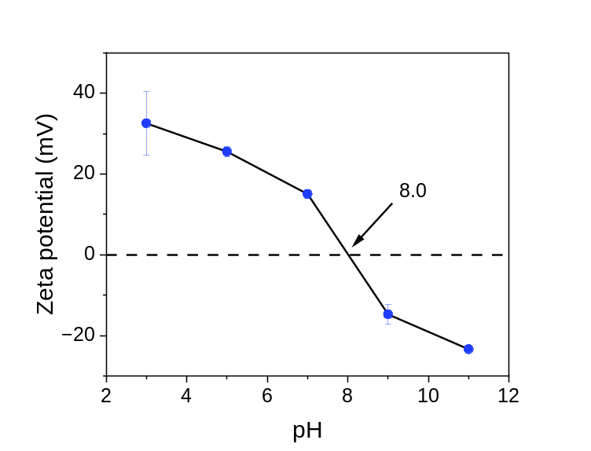
Fig.S2 Variation of Zeta potential with pH
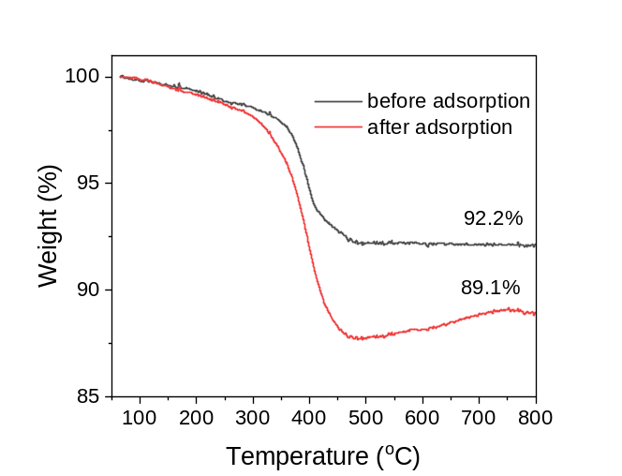
Fig S3 TG curves of Bi(OH)₃ (a) before and (b) after adsorption

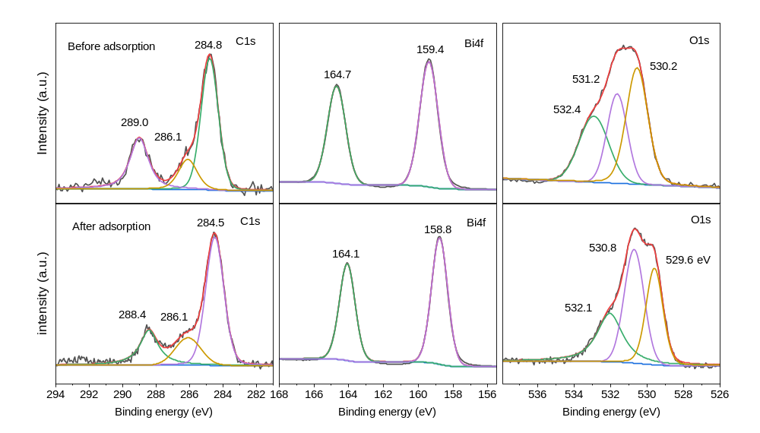
Fig.S4 XPS spectra of element C, Bi and O before and after adsorption of TC

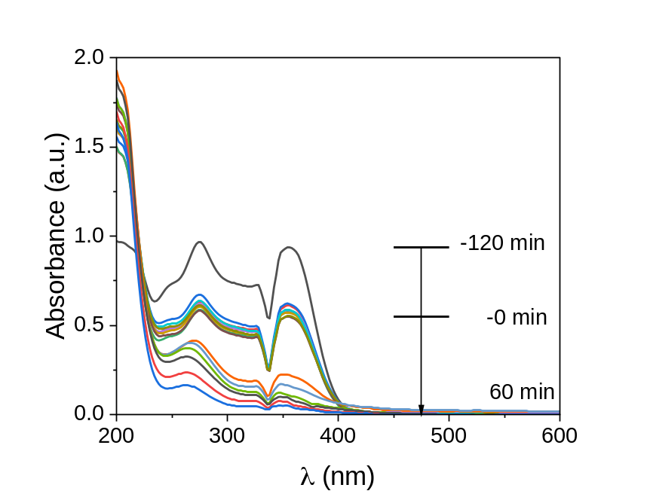
Fig.S5 Uv-vis scanning curves of TC solution during the adsorption and photocatalysis. Reaction conditions: C₀ = 30 mg/L, m = 0.5 g/L, pH = ~5, T = 25 ºC.

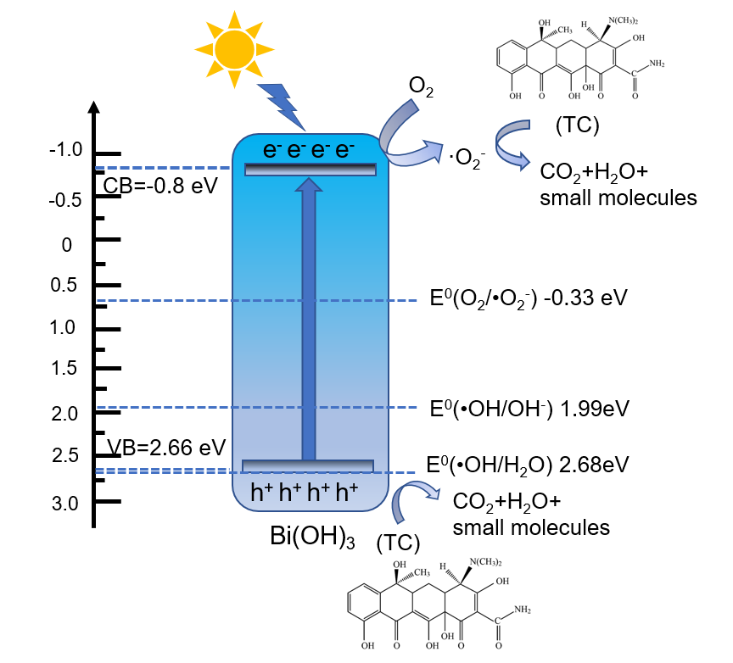
Fig.S6. Schematic diagram for photocatalytic degradation of TC.

