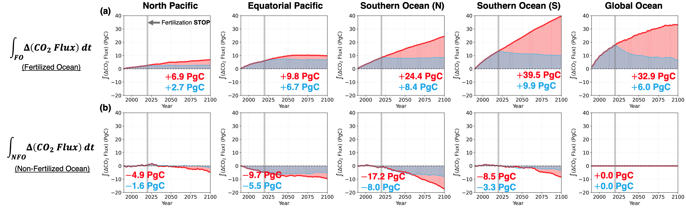
Figure S1. Decomposition of long-term accumulated impacts of fertilization-induced carbon uptake. Regionally cumulative carbon uptake within fertilized regions (a) and carbon outgassing from non-fertilized regions (b) from 1990 to 2100 are shown for the control simulation (CTRL, black), fertilization experiment (FERT, red), and termination experiment (STOP, blue). The grey vertical line marks the year 2020, when iron addition is halted in the STOP experiment. Cumulative impacts of fertilization-induced carbon uptake are quantified as the integrated differences in air-sea CO₂ flux between the FERT and STOP simulations relative to CTRL. Numbers represent the total additional carbon uptakes over the 110-year period in each FERT and STOP experiment.
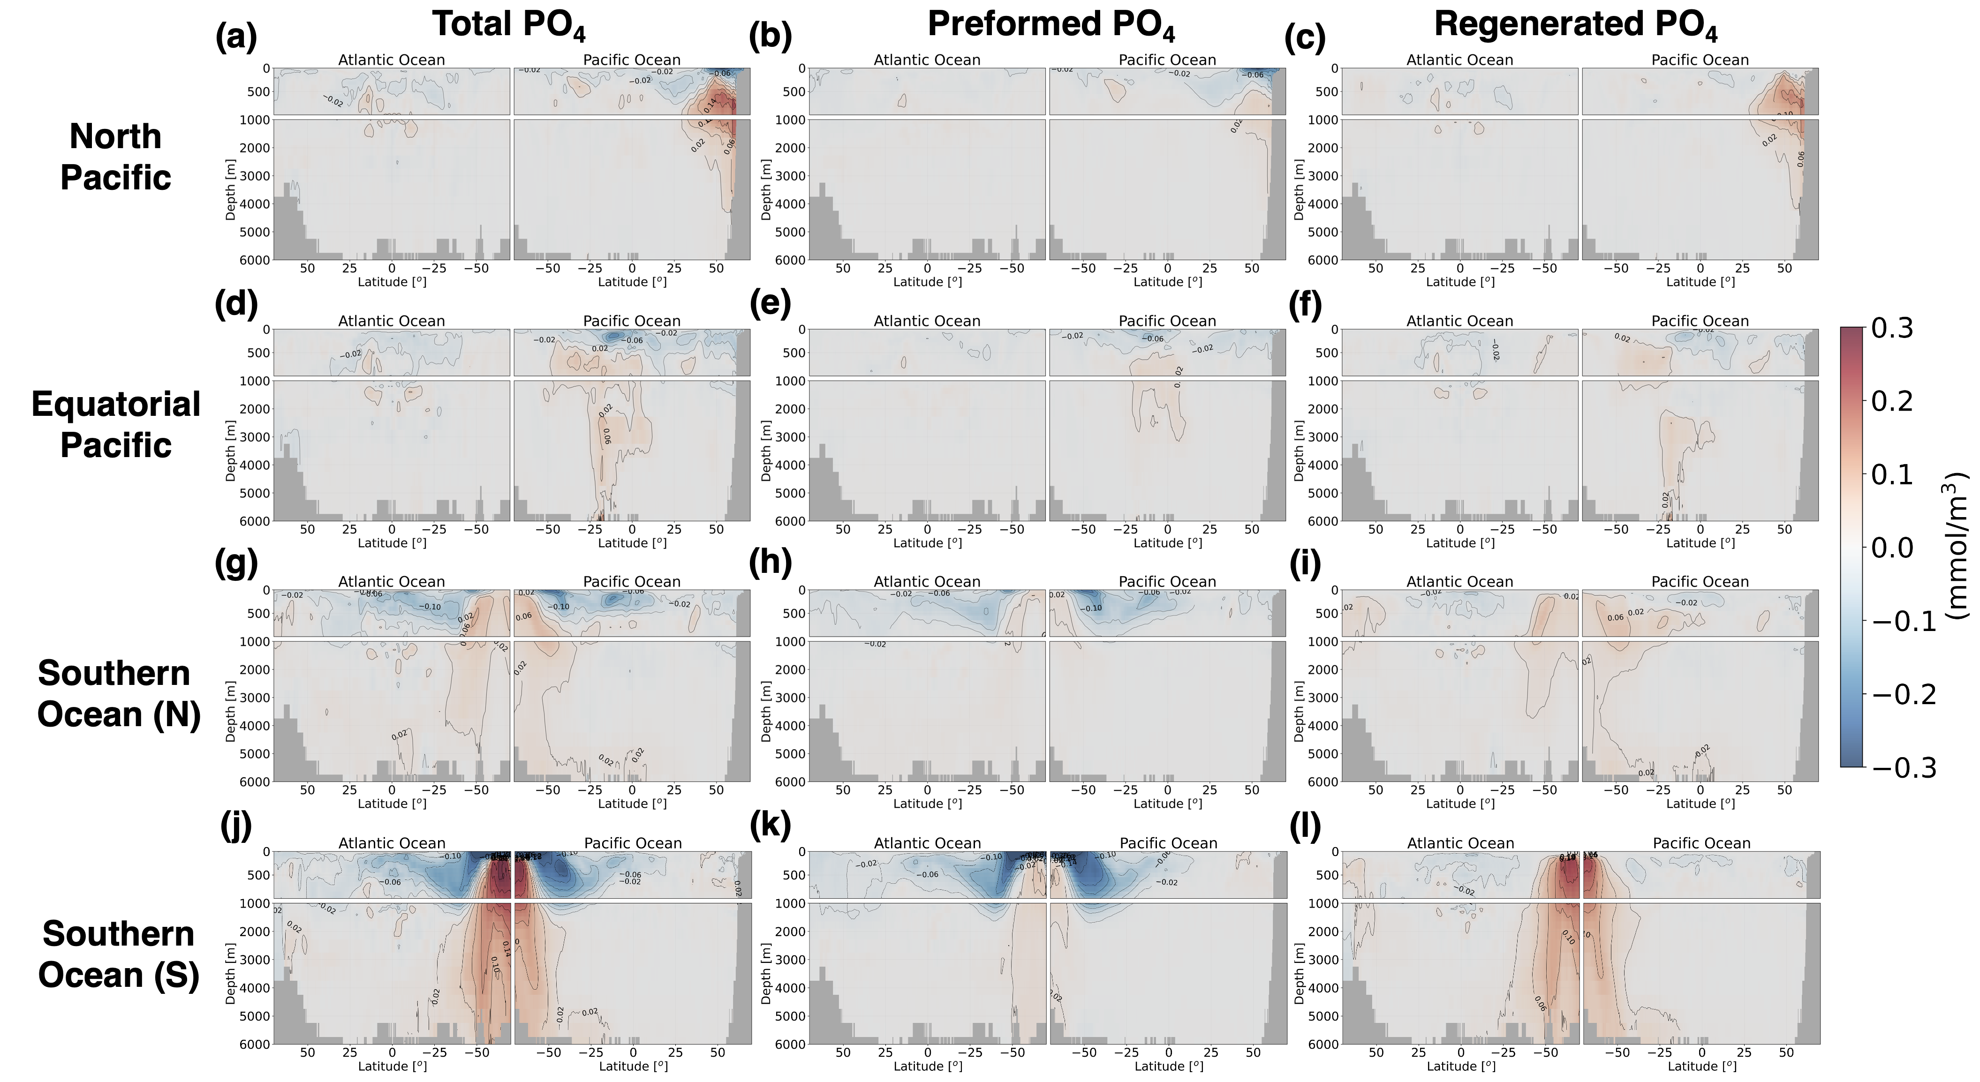
Figure S2. Comparison in vertical propagation of long-term fertilization signals. Phosphate (PO₄) was used as a tracer to monitor fertilization-induced enhancements in biological activity, characterized by reductions in preformed nutrients and increases in regenerated nutrients below the euphotic zone. Fertilization-induced changes in phosphate concentrations were zonally averaged for the Atlantic and Pacific basins. Regenerated phosphate was estimated using changes in Apparent Oxygen Utilization ($Δ$AOU), applying a stoichiometric ratio of 170:1 ($-$O₂:PO₄) for organic matter remineralization⁶⁶. Preformed phosphate was derived by subtracting regenerated phosphate from total phosphate. The spatial analysis covers the North Pacific (a–c), Equatorial Pacific (d–f), Southern Ocean (North) (g–i), and Southern Ocean (South) (j–l). Fertilization-induced signals were integrated over the final 30 years of the simulation period (2070–2100).

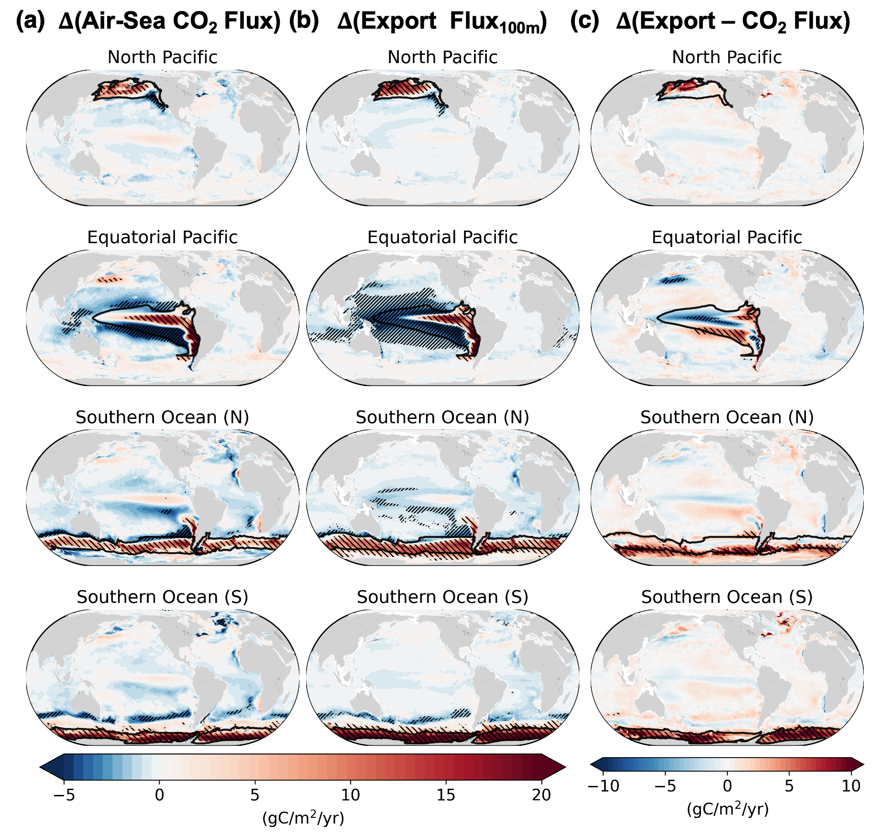
Figure S3. Long-term spatial pattern of fertilization-induced responses. Spatial pattern of averaged (a) air-sea CO₂ fluxes, (b) carbon export fluxes anomalies at 100 m depth, and (c) difference between these two fluxes under iron fertilization. The responses to fertilization are quantified as the average differences between the fertilization experiment and the control simulation across the full simulation period (1990–2100). Red shading indicates enhanced uptake and export production, reflecting the potential of fertilization to sequester more carbon from the surface to depth, while blue shading indicates outgassing and reduced carbon transport. Hatched areas indicate regions where fertilization-induced signals exceed natural climate variability, defined by the interannual standard deviation during the present climate period (1990–2020) at each grid point.

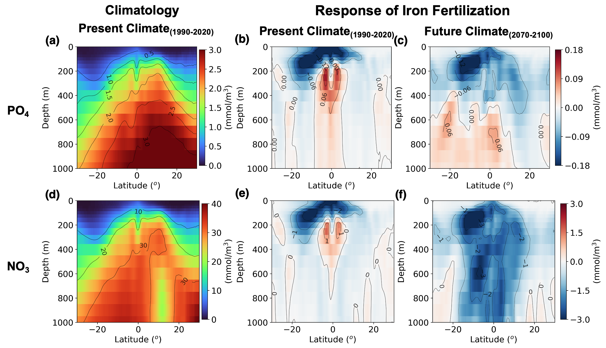
Figure S4. Vertical Response in Equatorial Pacific Iron Fertilization. Climatology and fertilization-induced changes in the Equatorial Pacific are shown for (a-c) phosphate (PO₄) and (d-f) nitrate (NO₃). The climatology represents the mean state during the present-day period (1990-2020), while the response is defined as the difference between the iron fertilization experiment and the control simulation for each period: present (1990–2020) and future (2070-2100). All vertical sections are zonally averaged across the Pacific Ocean from 160$°$E to 265$°$E, which covers the fertilized regions in the Equatorial Pacific fertilization.

