Table S1. Comparison of baseline characteristics between participants included (n = 8204), and excluded due to incomplete baseline data or confirmed diagnosis of dementia and/or Parkinson’s disease or cognitive impairment (n = 3375)
Characteristic | Included (n = 8204) | Excluded (n = 3375) | p for difference*
Age (years), mean ± SD | 60.09 ± 6.37 | 61.38 ± 7.00 | <0.001
Male sex, n (%) | 4289 (52.3) | 1462 (43.3) | <0.001
Educational level, n (%) |  |  | <0.001
No formal education | 3551 (43.3) | 2151 (63.8)
Primary school | 2011 (24.5) | 572 (17.0)
Middle or high school | 2270 (27.7) | 562 (16.7)
College or above | 372 (4.5) | 87 (2.6)
Married, n (%) | 7310 (89.1) | 2878 (85.3) | <0.001
Rural residence, n (%) | 4906 (59.8) | 2272 (67.3) | <0.001
High household income, n (%) | 2450 (29.9) | 753 (22.3)
Current smoker, n (%) | 2757 (33.6) | 653 (22.3) | <0.001
Current drinker, n (%) | 2856 (34.8) | 1000 (29.8) | <0.001
Poor self-report of health, n (%) | 2107 (25.7) | 1289 (38.3)
Depressive symptoms, n (%) | 2854 (34.8) | 2194 (65.0) | <0.001
Restriction on ADL, n (%) | 1157 (14.1) | 813 (24.1) | <0.001
Visual impairment, n (%) | 464 (5.7) | 277 (8.2) | <0.001
Hearing impairment, n (%) | 600 (7.3) | 412 (12.2) | <0.001
Comorbidity ≥ 2, n (%) | 5097 (62.1) | 2446 (72.5) | <0.001
BMI (kg/m²), mean ± SD | 23.54 ± 3.92 | 22.76 ± 3.89 | <0.001
Global cognitive scores, mean ± SD | 11.71 ± 3.43 | 3.18 ± 0.93 | <0.001
Mental intactness scores, mean ± SD | 7.82 ± 2.64 | 1.77 ± 0.96 | <0.001
Episodic memory scores, mean ± SD | 3.89 ± 1.61 | 1.41 ± 0.90 | <0.001
*The differences between participants included and excluded were tested using the t-test or chi-square test.

Table S2. Comparison of baseline characteristics between participants included (n = 8204) and excluded due to loss to follow-up (n = 759)
Characteristic | Included (n = 8204) | Loss to follow-up (n = 759) | p for difference*
Age (years), mean ± SD | 60.09 ± 6.37 | 60.43 ± 7.14 | 0.16
Male sex, n (%) | 4289 (52.3) | 418 (55.1) | 0.14
Educational level, n (%) |  |  | <0.001
No formal education | 3551 (43.3) | 231 (30.5)
Primary school | 2011 (24.5) | 172 (22.7)
Middle or high school | 2270 (27.7) | 271 (35.8)
College or above | 372 (4.5) | 84 (11.1)
Married, n (%) | 7310 (89.1) | 670 (88.3) | 0.48
Rural residence, n (%) | 4906 (59.8) | 246 (32.4) | <0.001
High household income, n (%) | 2450 (29.9) | 265 (34.9) | <0.001
Current smoker, n (%) | 2757 (33.6) | 249 (32.8) | 0.67
Current drinker, n (%) | 2856 (34.8) | 253 (33.3) | 0.41
Poor self-report of health, n (%) | 2107 (25.7) | 219 (28.9) | 0.16
Depressive symptoms, n (%) | 2854 (34.8) | 251 (33.1) | 0.34
Restriction on ADL, n (%) | 1157 (14.1) | 144 (19.0) | <0.001
Visual impairment, n (%) | 464 (5.7) | 45 (5.9) | 0.76
Hearing impairment, n (%) | 600 (7.3) | 44 (5.8) | 0.12
Comorbidity ≥ 2, n (%) | 5097 (62.1) | 613 (80.8) | <0.001
BMI (kg/m²), mean ± SD | 23.54 ± 3.92 | 23.77 ± 4.37 | 0.20
Global cognitive scores, mean ± SD | 11.71 ± 3.43 | 12.25 ± 3.50 | <0.001
Mental intactness scores, mean ± SD | 7.82 ± 2.64 | 8.24 ± 2.59 | <0.001
Episodic memory scores, mean ± SD | 3.89 ± 1.61 | 4.01 ± 1.73 | 0.062
*The differences between participants included and excluded were tested using the t-test or chi-square test.

Table S3. Multinomial logistic regression analysis for the associations of intellectual activities and social activities with the membership to global cognitive scores trajectory group
 | Persistently low  (vs Persistently high) |  |  | Persistently moderate  (vs Persistently high)
 | OR (95% CI)* | p value |  | OR (95% CI)* | p value
Social activities scores
0 | 1.00 (reference) |  |  | 1.00 (reference)
1-2 | 0.82 (0.66-1.03) | 0.083 |  | 0.88 (0.75-1.03) | 0.104
≥ 3 | 0.87 (0.71-1.07) | 0.182 |  | 0.79 (0.68-0.92) | 0.002
Intellectual activities scores
0 | 1.00 (reference) |  |  | 1.00 (reference)
1-2 | 0.47 (0.36-0.61) | <0.001 |  | 0.74 (0.63-0.87) | <0.001
≥ 3 | 0.45 (0.30-0.68) | <0.001 |  | 0.58 (0.46-0.75) | <0.001
Note: OR = Odd Ratio, 95% CI = 95% confidence intervals.
*Adjusted for age at baseline (continuous), sex (male, female), education (no formal education, primary school, middle or high school, college or above), marital status (married, others), residence (urban, rural), household income (low, medium, high), smoking (yes, no), drinking (yes, no), body mass index (< 18.5, 18.5-23.9, 24.0-27.9, ≥ 28.0 kg/m2), self-report of health (good, fair, poor), comorbidity (0, 1, ≥ 2), depressive symptoms (yes, no), restriction on activities of daily living (yes, no), visual impairment (yes, no), and hearing impairment (yes, no).

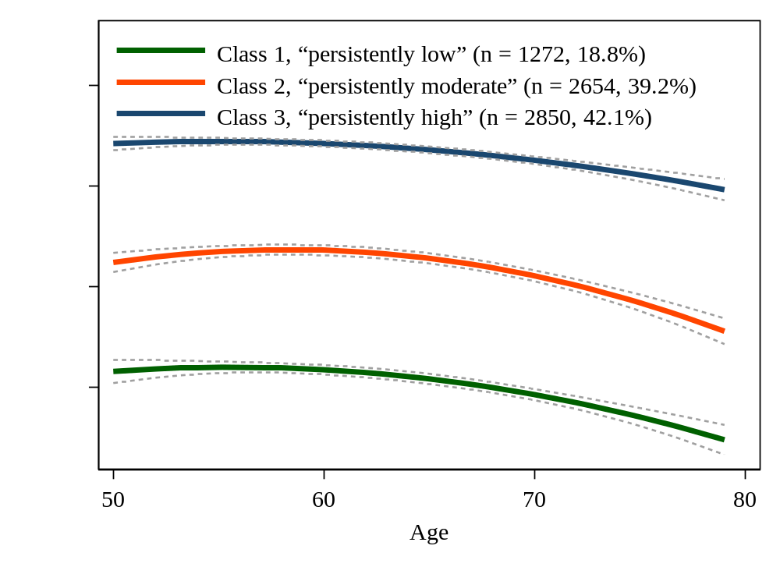
Fig. S1 Mean trajectories of global cognitive scores by increasing age among older adults among 6776 participants with completed all three waves cognitive function data.

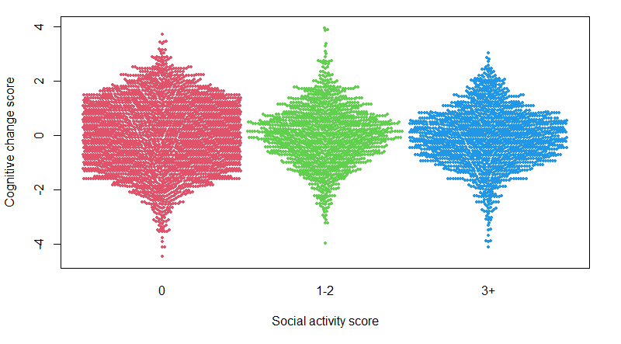
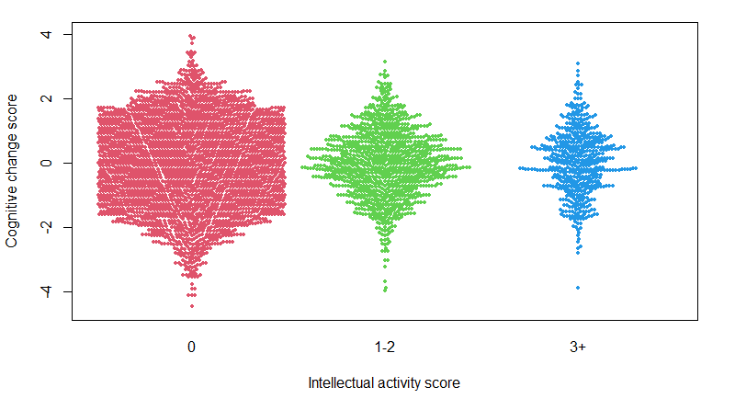
Fig. S2 The beeswarm plot demonstrating the differences in cognitive change score by difference level of social/intellectual activity

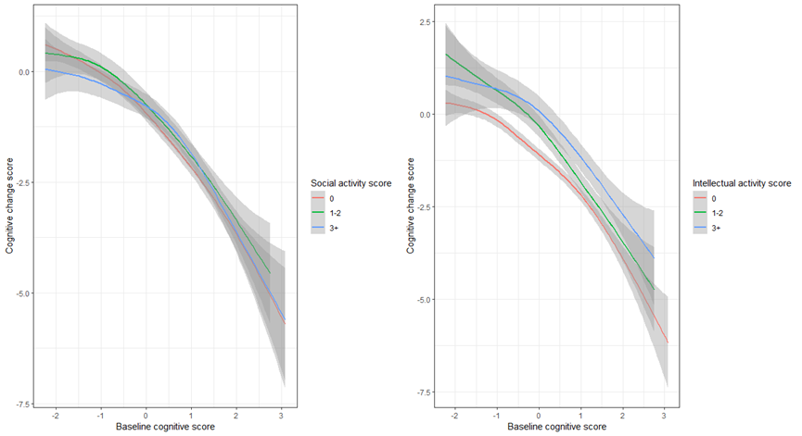
Fig. S3 The association of cognitive score at baseline and cognitive change score by each of the social/intellectual activity score

