SUPPLEMENTARY INFORMATION (SI)
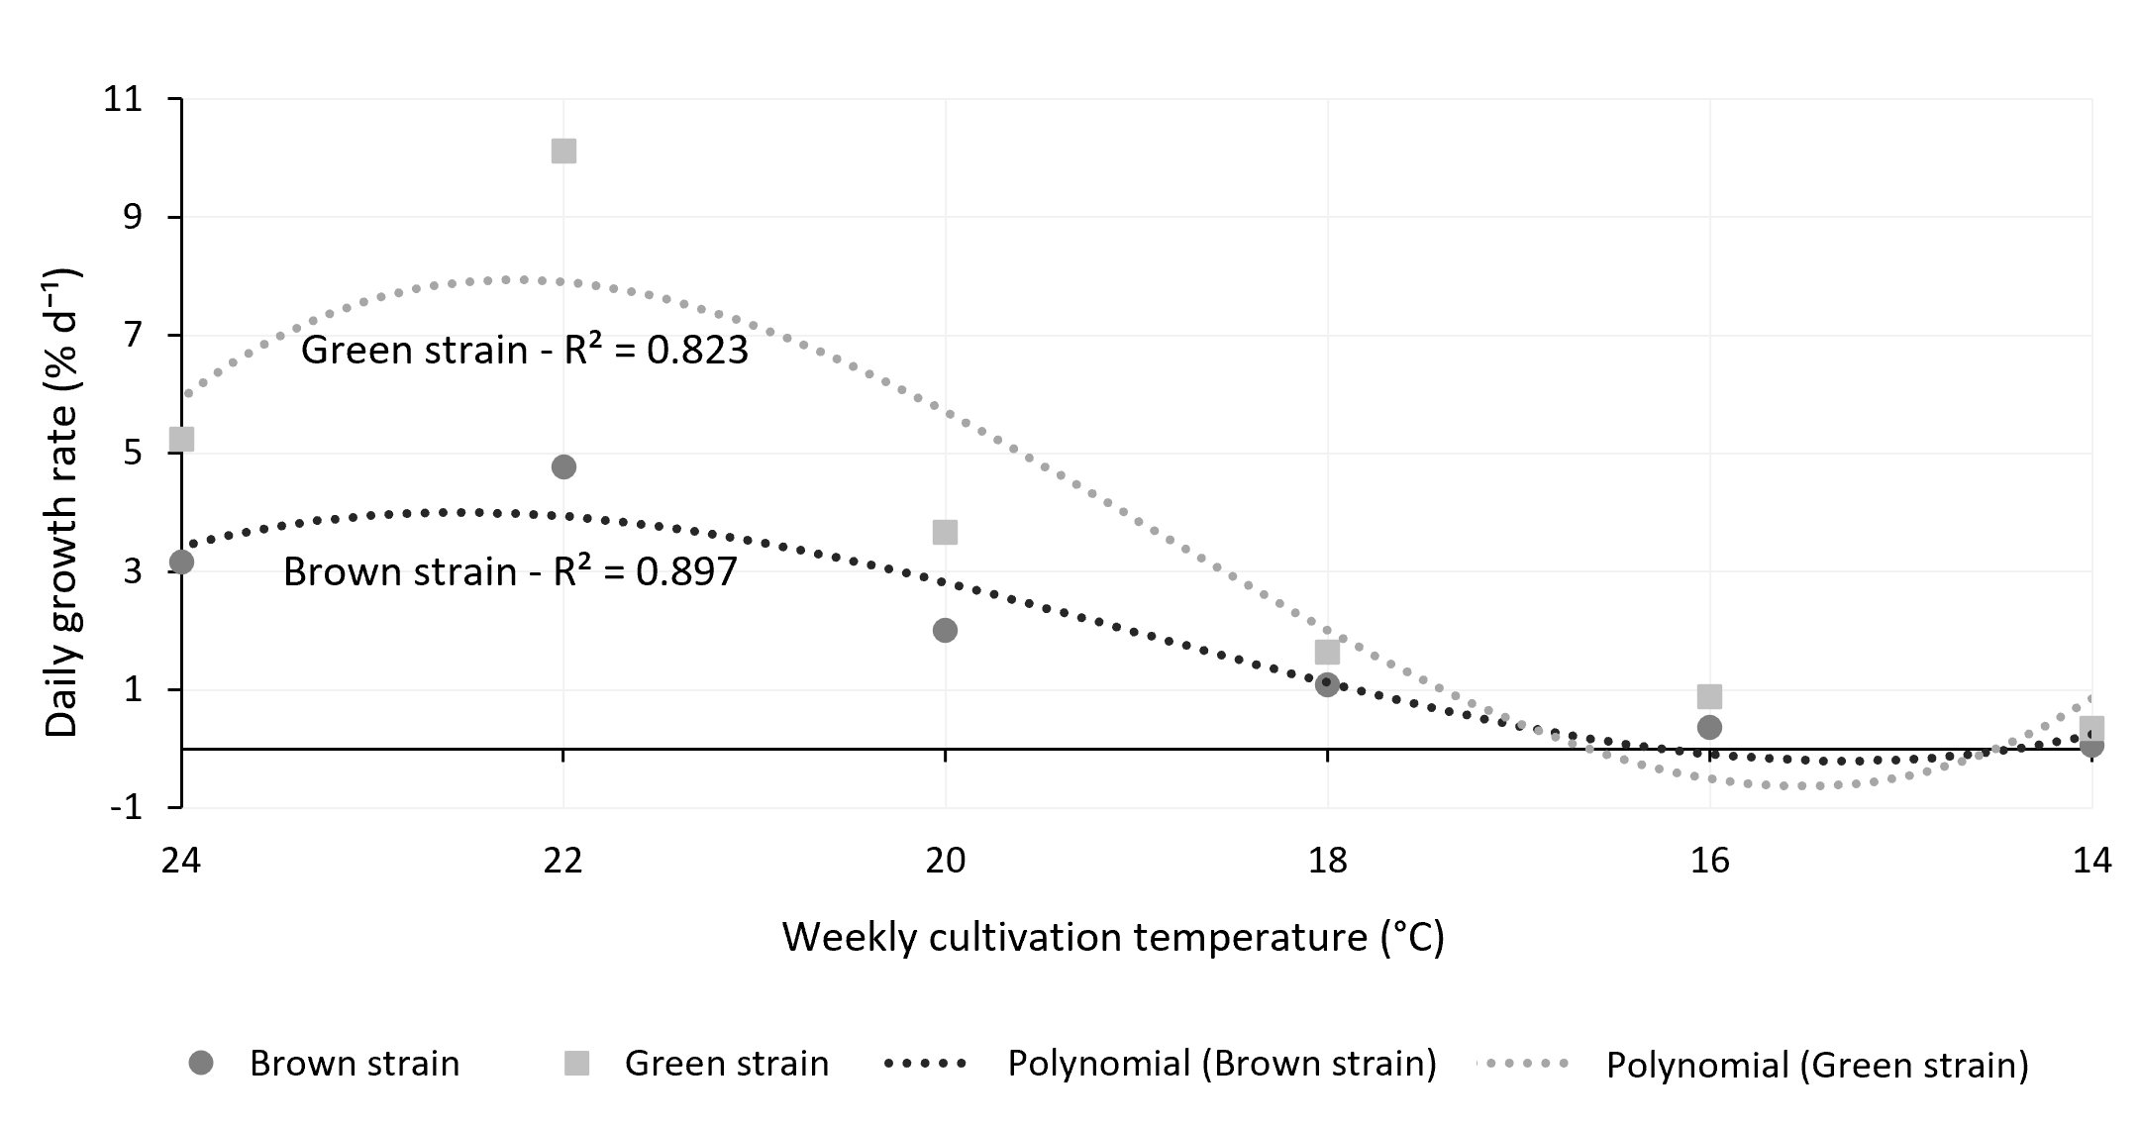
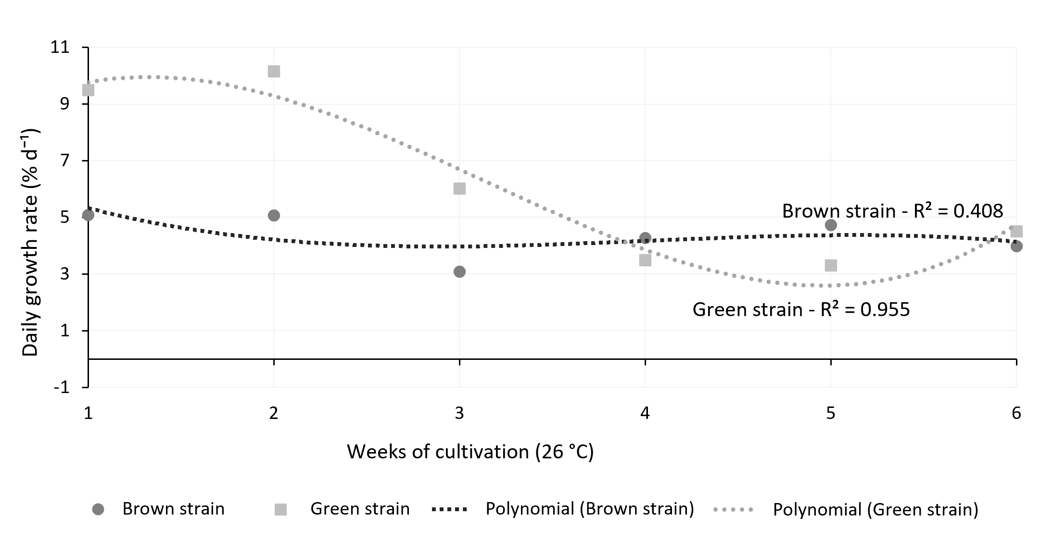
A
B

Fig. S1. Polynomial regression curves of the mean daily growth rate (% d⁻¹) of Kappaphycus alvarezii green and brown strains cultivated under two conditions, with (A) control at 26 °C for six weeks and (B) gradual thermal variation from 24 °C to 14 °C over six weeks. Dots represent mean values, and dashed lines represent polynomial regressions. The coefficients of determination (R²) are indicated, and the adjusted polynomial equations were as follows. (A) Control – Green strain: y = 0.3061x³ − 2.8831x² + 6.0165x + 6.33; Brown strain: y = −0.0725x³ + 0.8714x² − 3.2204x + 7.75. (B) Thermal variation – Green strain: y = −0.055x³ + 3.167x² − 57.902x + 344.14; Brown strain: y = −0.022x³ + 1.251x² − 22.798x + 134.68.

