SUPPLEMENTAL MATERIALS AND METHODS
Materials
- Analytes (see Table 5)
- Phosphate-buffered saline (Sigma-Aldrich #P3813)
- BioThreat Panel v2.5 Kit* (RFIT-ASY-0094)
*In this study, lots 317724D, 317824D, and 317924D were used
- BIOFIRE FILMARRAY 2.0 instruments (Build Version 2.0.0.9)
- BIOFIRE SPOTFIRE instruments (Build Version 4.0.0.11)
- QuantStudio™ Absolute Q™ MAP16 Plate Kit and (DNA) Master Mix (A53301)
- QuantStudio™ Absolute Q™ MAP16 Plate Kit and 1-Step RT-dPCR Master Mix (A55165)
- QuantStudio™ Absolute Q™ MAP16 Plate Kit (A52865)
- Absolute Q™ DNA Digital PCR Master Mix (5× at 360µL) (A52490)
- Absolute Q™ 1-Step RT-dPCR Master Mix (4× at 450µL) (A55146)
- QuantStudio™ Absolute Q™ Isolation Buffer (3mL) (A52730)
- QuantStudio™ Absolute Q™ Digital PCR Starter Kit (A52732)
- QuantStudio™ Absolute Q™ Digital PCR System (A52864)
- QuantStudio™ Absolute Q™ Digital PCR System software
Methods
BioThreat Panel v2.5 pouch testing
All work was performed in a certified BSL-2 laboratory following institutional biosafety guidelines. All testing was performed with contrived samples, wherein analytes were spiked in phosphate-buffered saline (PBS). BioThreat Panel v2.5 pouches were loaded with sample and tested according to the BioThreat Panel v2.5 Instructions for Use. Three unique BioThreat Panel v2.5 kit lots were used during these investigations. During pouch testing, the number of pouches tested with each pouch lot was distributed between three BioThreat Panel v2.5 kit lots, for each analyte.
Analyte quantification
Analyte quantification by digital PCR (dPCR) was performed based on the instructions provided in manuals accompanying the QuantStudio™ Absolute Q™ PCR system.

SUPPLEMENTAL TABLES
Table S1. Interpretation Scheme for Assays Associated with Bacillus species
Assays |  |  | Results
Chromosome Element | pXO1 | pXO2 | Interpretation
Pos | Pos | Pos | Bacillus anthracis Detected
Neg | Neg | Neg | Bacillus anthracis Not Detected
Pos | Neg | Neg | Bacillus species Detected
Neg | Neg | Pos | Bacillus species Detected
Pos | Neg | Pos | Bacillus species Detected
Neg | Pos | Neg | Bacillus species Detected
Pos | Pos | Neg | Bacillus species Detected
Neg | Pos | Pos | Bacillus species Detected
The BioThreat Panel v2.5 contains three assays for the detection of Bacillus anthracis and other Bacillus species. Two assays target regions on the pXO1 and pXO2 virulence plasmids, respectively, and the third targets a chromosomal region of the Bacillus genus. If at least one of the assays is positive, but not all three, the result is reported as Bacillus species Detected. If all three assays are positive the result is reported as Bacillus anthracis Detected.
Table S2. Interpretation Scheme for Assays Associated with Brucella species
Assays |  | Results
Species-Specific | Genus | Interpretation
Pos | Pos | Brucella melitensis Detected
Neg | Neg | Brucella melitensis Not Detected
Pos | Neg | Brucella melitensis Detected
Neg | Pos | Brucella species Detected
The BioThreat Panel v2.5 contains two assays for the detection of Brucella melitensis and other Brucella species. One assay is specific to Brucella melitensis, and one assay targets the Brucella genus. If the assay specific to Brucella melitensis is positive, the result is reported as Brucella melitensis Detected. If only the genus level assay is positive, the result is reported as Brucella species Detected.
Table S3. Interpretation Scheme for Assays Associated with Rickettsia species
Assays |  | Results
Genus | Species-Specific | Interpretation
Pos | Pos | Rickettsia prowazekii Detected
Neg | Neg | Rickettsia prowazekii Not Detected
Pos | Neg | Rickettsia species Detected
Neg | Pos | Rickettsia prowazekii Detected
The BioThreat Panel v2.5 contains two assays for the detection of Rickettsia prowazekii and other Rickettsia species. One assay is specific to Rickettsia prowazekii, and one assay targets the Rickettsia genus. If the species-specific assay is positive, the result is reported as Rickettsia prowazekii Detected. If only the genus level assay is positive, the result is reported as Rickettsia species Detected.
Table S4. Interpretation Scheme for Assays Associated with Yersinia pestis
Assays |  | Results
YPT1 | YPT3 | FILMARRAY 2.0 Interpretation | SPOTFIRE Interpretation
Pos | Pos | Yersinia pestis Detected | Yersinia pestis Detected
Neg | Neg | Yersinia pestis Not Detected | Yersinia pestis Not Detected
Pos | Neg | Yersinia pestis Detected | Possible Detection
Neg | Pos | Yersinia pestis Detected | Yersinia pestis Detected
The BioThreat Panel v2.5 contains two assays for the detection of Yersinia pestis, YPT1 and YPT3. When tested on the FILMARRAY 2.0, if either assay is positive, the result is reported as Yersinia pestis Detected. When tested on the SPOTFIRE, if the YPT3 assay is positive, the result is reported as Yersinia pestis Detected. If the YPT1 assay is positive, but the YPT3 assay is negative, then the software will return an interpretation indicating there is uncertainty as to whether nucleic acid specific to Yersinia pestis is present and to refer to the product instructions for additional information.
SUPPLEMENTAL DATA
Analysis of PCR Amplification Curves
To determine if an analyte is detected or not, the software performs amplicon melt analysis as described in the Introduction (Analysis of Melt Curves). Separately, PCR amplification curves for all wells on the PCR2 array are analyzed. A crossing point (Cp) value is calculated which corresponds to the PCR cycle where the fluorescent signal of an amplification curve meets a predefined threshold. Of note, Cp values are a combined output of all in-pouch steps, not an absolute quantitative value for any single test run as the Biothreat Panel v2.5 on BIOFIRE instruments is a qualitative detection system.
Bacillus anthracis
Three assays target Bacillus anthracis: Chromosome element, pXO1, and pXO2. The pXO1 and pXO2 assays target extra-chromosomal elements necessary for Bacillus anthracis to be fully virulent. All three assays need to be called positive for the Panel software to produce a “Bacillus anthracis Detected” interpretation. If at least one, but not all, of the three assays targeting Bacillus anthracis are positive, the Panel software produces a “Bacillus species Detected” interpretation (Table S1).
Two strains of Bacillus anthracis (Bacillus anthracis Ames and Bacillus anthracis Sterne 34F2) were used in this testing. Both strains were tested independently of each other, and LoD was established for each. Bacillus anthracis Ames is a formalin-inactivated strain that expresses both extra-chromosomal elements. A “Bacillus anthracis Detected” interpretation was expected for this strain. Pouches tested with Bacillus anthracis Ames at a concentration of 8.0E+03 copies/mL produced a “Bacillus anthracis Detected” interpretation in 20/20 pouches tested on both instrument platforms (Figure S1). Reducing the concentration to 8.0E+02 copies/mL produced a “Bacillus anthracis Detected” interpretation in 9/20 pouches tested on FILMARRAY 2.0 and 5/20 pouches tested on SPOTFIRE. These data confirm the LoD for Bacillus anthracis Ames at 8.0E+03 copies/mL.
Bacillus anthracis Sterne is a live strain that does not contain the pXO2 extra-chromosomal element, therefore, a “Bacillus species Detected” interpretation is expected for this analyte. Pouches tested with this analyte at a concentration of 4.0E+03 copies/mL produced a “Bacillus species Detected” interpretation in 20/20 pouches tested with Bacillus anthracis Sterne on both instrument platforms (Figure S2). Reducing the concentration to 4.0E+02 copies/mL produced a “Bacillus species Detected” interpretation in 12/20 pouches tested on FILMARRAY 2.0 and 10/20 pouches tested on SPOTFIRE. These data confirm the LoD for Bacillus anthracis Sterne at 4.0E+03 copies/mL.
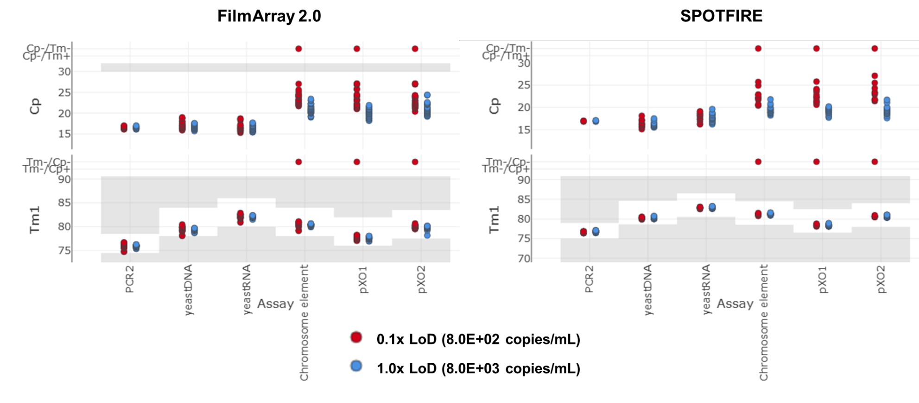
Figure S1. LoD Confirmation Testing Data for Bacillus anthracis Ames.
Bacillus anthracis Ames was tested at 1× LoD (blue) and 0.1× LoD (red). 20 pouches were tested at each concentration on the FILMARRAY 2.0 instrument (left panel) and SPOTFIRE instrument (right panel). Median pouch Cp values (top) and Tm values (bottom) are presented for the assays associated with this analyte.

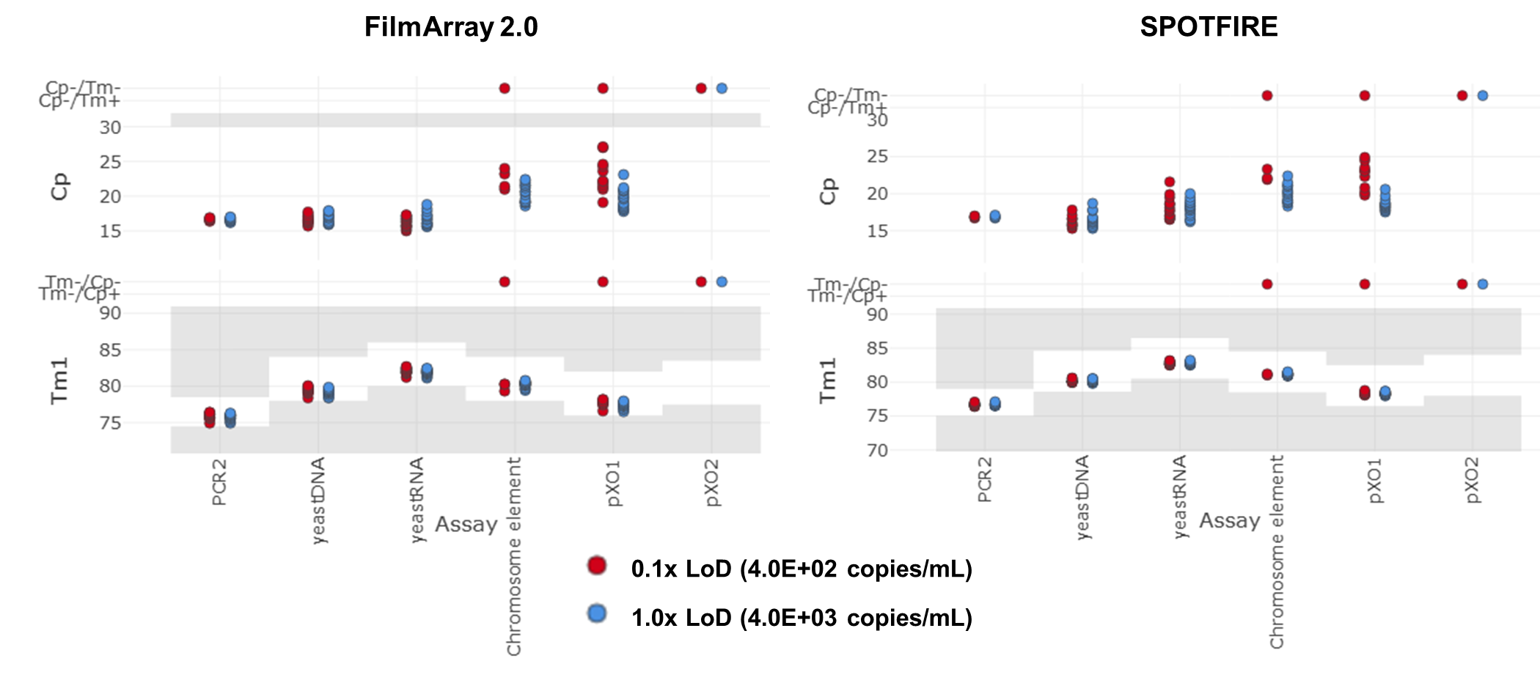
Figure S2. LoD Confirmation Testing Data for Bacillus anthracis Sterne.
Bacillus anthracis Sterne was tested at 1× LoD (blue) and 0.1× LoD (red). 20 pouches were tested at each concentration on the FILMARRAY 2.0 instrument (left panel) and SPOTFIRE instrument (right panel). Median pouch Cp values (top) and Tm values (bottom) are presented for the assays associated with this analyte. The Sterne strain does not contain the pXO2 extra-chromosomal plasmid.

Brucella melitensis
This testing used Brucella melitensis 16M, a formalin-inactivated organism. Two assays target Brucella melitensis, BRT2 (species-specific) and BRT4 (genus). Table S2 illustrates how these assays combine for different interpretations by the panel software. The analyte strain tested here was expected to produce a “Brucella melitensis Detected” interpretation. Pouches tested with this analyte at a concentration of 1.0E+02 copies/mL produced a “Brucella melitensis Detected” interpretation in 20/20 pouches tested on FILMARRAY 2.0 and 19/20 pouches tested on SPOTFIRE. (Figure S3). Reducing the concentration to 1.0E+01 copies/mL produced a “Brucella melitensis Detected” interpretation in 10/20 pouches tested on FILMARRAY 2.0 and 4/20 pouches tested on SPOTFIRE. These data confirm the LoD for Brucella melitensis at 1.0E+02 copies/mL.
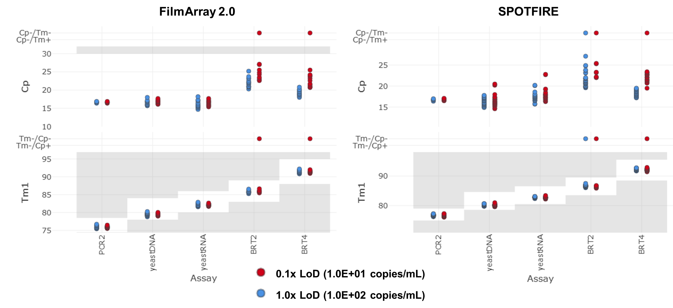
Figure S3. LoD Confirmation Testing Data for Brucella melitensis.
Brucella melitensis was tested at 1× LoD (blue) and 0.1× LoD (red). 20 pouches were tested at each concentration on the FILMARRAY 2.0 instrument (left panel) and SPOTFIRE instrument (right panel). Median pouch Cp values (top) and Tm values (bottom) are presented for the assays associated with this analyte.

Burkholderia pseudomallei
This testing used formalin-inactivated Burkholderia pseudomallei strain MSHR146. Two assays target Burkholderia pseudomallei, Burk2 and Burk8. A positive call in either assay will result in a “Burkholderia mallei/pseudomallei Detected” interpretation. Pouches tested with this analyte at a concentration of 4.8E+02 copies/mL produced a “Burkholderia mallei/pseudomallei Detected” interpretation in 19/20 pouches tested on both instrument types. (Figure S4). Reducing the concentration to 4.8E+01 copies/mL produced a “Burkholderia mallei/pseudomallei Detected” interpretation in 7/20 pouches tested on FILMARRAY 2.0 and 9/20 pouches tested on SPOTFIRE. These data confirm the LoD for Burkholderia pseudomallei at 4.8E+02 copies/mL.
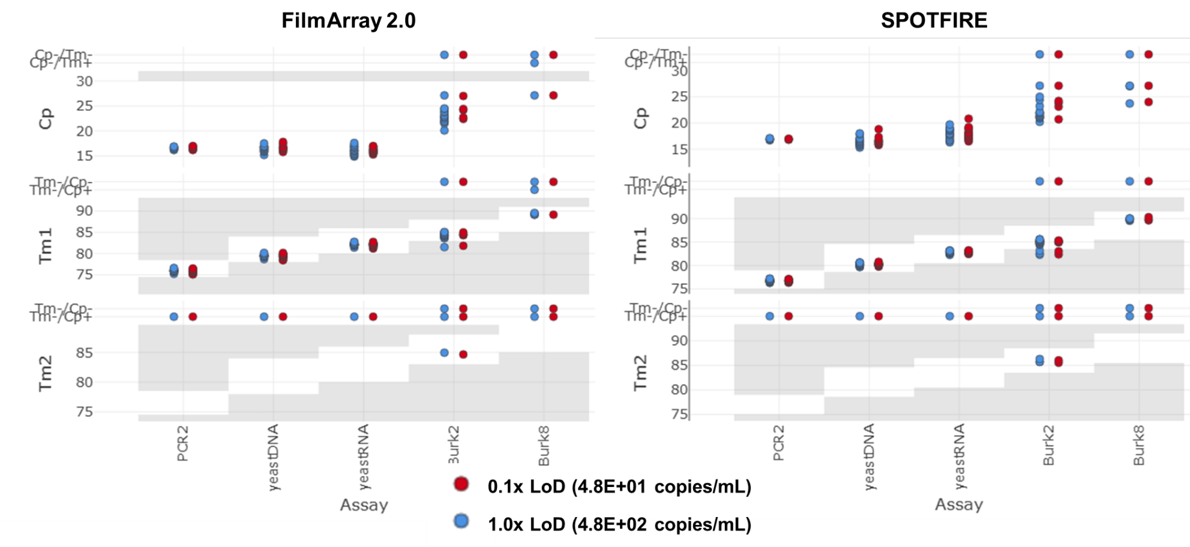
Figure S4. LoD Confirmation Testing Data for Burkholderia pseudomallei.
Burkholderia pseudomallei was tested at 1× LoD (blue) and 0.1× LoD (red). 20 pouches were tested at each concentration on the FILMARRAY 2.0 instrument (left panel) and SPOTFIRE instrument (right panel). Median pouch Cp values (top) and Tm values (bottom) are presented for the assays associated with this analyte.

Coxiella burnetii
Two assays target Coxiella burnetii, CbT1 and CbT2. A positive call in either assay will result in a “Coxiella burnetii Detected” interpretation. A synthetic DNA template, CHEM-GBK-0485, which is complementary to the CbT1 assay was used to estimate the LoD for Coxiella burnetii. Pouches tested with this analyte at a concentration of 3.0E+04 copies/mL produced a “Coxiella burnetii Detected” interpretation in 20/20 pouches tested on both instrument types (Figure S5). Reducing the concentration to 3.0E+03 copies/mL produced a “Coxiella burnetii Detected” interpretation in 14/20 pouches tested on FILMARRAY 2.0 and 17/20 pouches tested on SPOTFIRE. These data confirm the LoD for Coxiella burnetii at 3.0E+04 copies/mL.
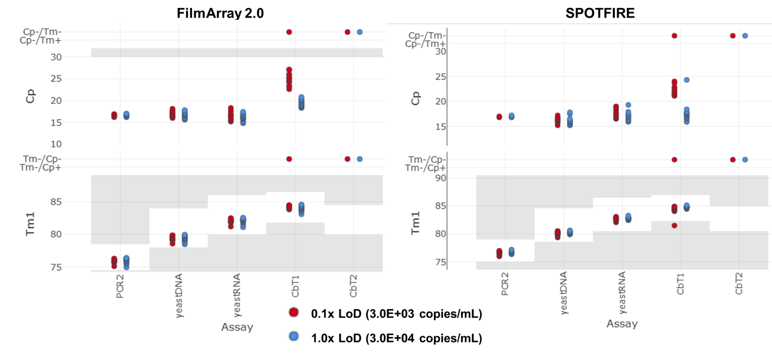
Figure S5. LoD Confirmation Testing Data for Coxiella burnetii.
Synthetic DNA simulating Coxiella burnetii was tested at 1× LoD (blue) and 0.1× LoD (red). 20 pouches were tested at each concentration on the FILMARRAY 2.0 instrument (left panel) and SPOTFIRE instrument (right panel). Median pouch Cp values (top) and Tm values (bottom) are presented for the assays associated with this analyte.

Francisella tularensis
Two assays target Francisella tularensis, FTT2 and FTT3. A positive call in either assay will result in a “Francisella tularensis Detected” interpretation. This testing used a formalin-inactivated strain of Francisella tularensis subsp. tularensis (SCHU S4). Pouches tested with this analyte at a concentration of 2.4E+02 copies/mL produced a “Francisella tularensis Detected” interpretation in 20/20 pouches tested on both instrument types (Figure S6). Reducing the concentration to 2.4E+01 copies/mL produced a “Francisella tularensis Detected” interpretation in 11/20 pouches tested on FILMARRAY 2.0 and 7/20 pouches tested on SPOTFIRE. These data confirm the LoD for Francisella tularensis at 2.4E+02 copies/mL.
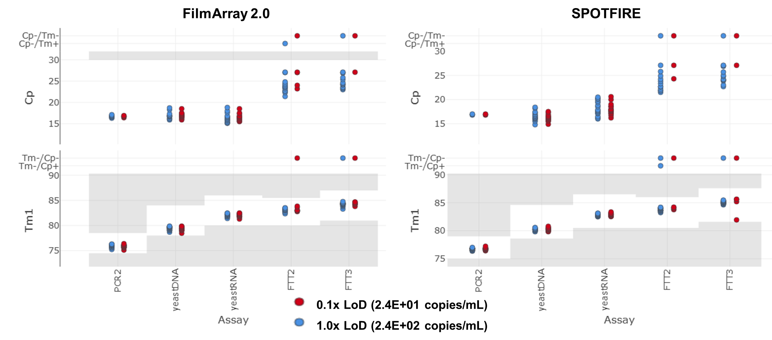
Figure S6. LoD Confirmation Testing Data for Francisella tularensis.
Francisella tularensis was tested at 1× LoD (blue) and 0.1× LoD (red). 20 pouches were tested at each concentration on the FILMARRAY 2.0 instrument (left panel) and SPOTFIRE instrument (right panel). Median pouch Cp values (top) and Tm values (bottom) are presented for the assays associated with this analyte.

Rickettsia prowazekii
Two assays target Rickettsia prowazekii, RIK1 (genus) and RIK2 (species-specific). Table S3 illustrates how these assays combine for different interpretations by the panel software. This testing used an inactivated Breinl strain of Rickettsia prowazekii; this analyte is expected to produce a “Rickettsia prowazekii Detected” interpretation. Pouches tested at a concentration of 1.7E+03 copies/mL produced a “Rickettsia prowazekii Detected” interpretation in 20/20 pouches on FILMARRAY 2.0 and in 18/20 pouches on SPOTFIRE (Figure S7). The concentration was adjusted to 1.7E+02 copies/mL for testing on FILMARRAY 2.0 where the analyte was detected in 4/20 pouches and to 8.7E+03 copies/mL on SPOTFIRE where the analyte was detected in 20/20 pouches. These data confirm the LoD for Rickettsia prowazekii at 1.7E+03 copies/mL on FILMARRAY 2.0 and at 8.7E+03 copies/mL on SPOTFIRE.
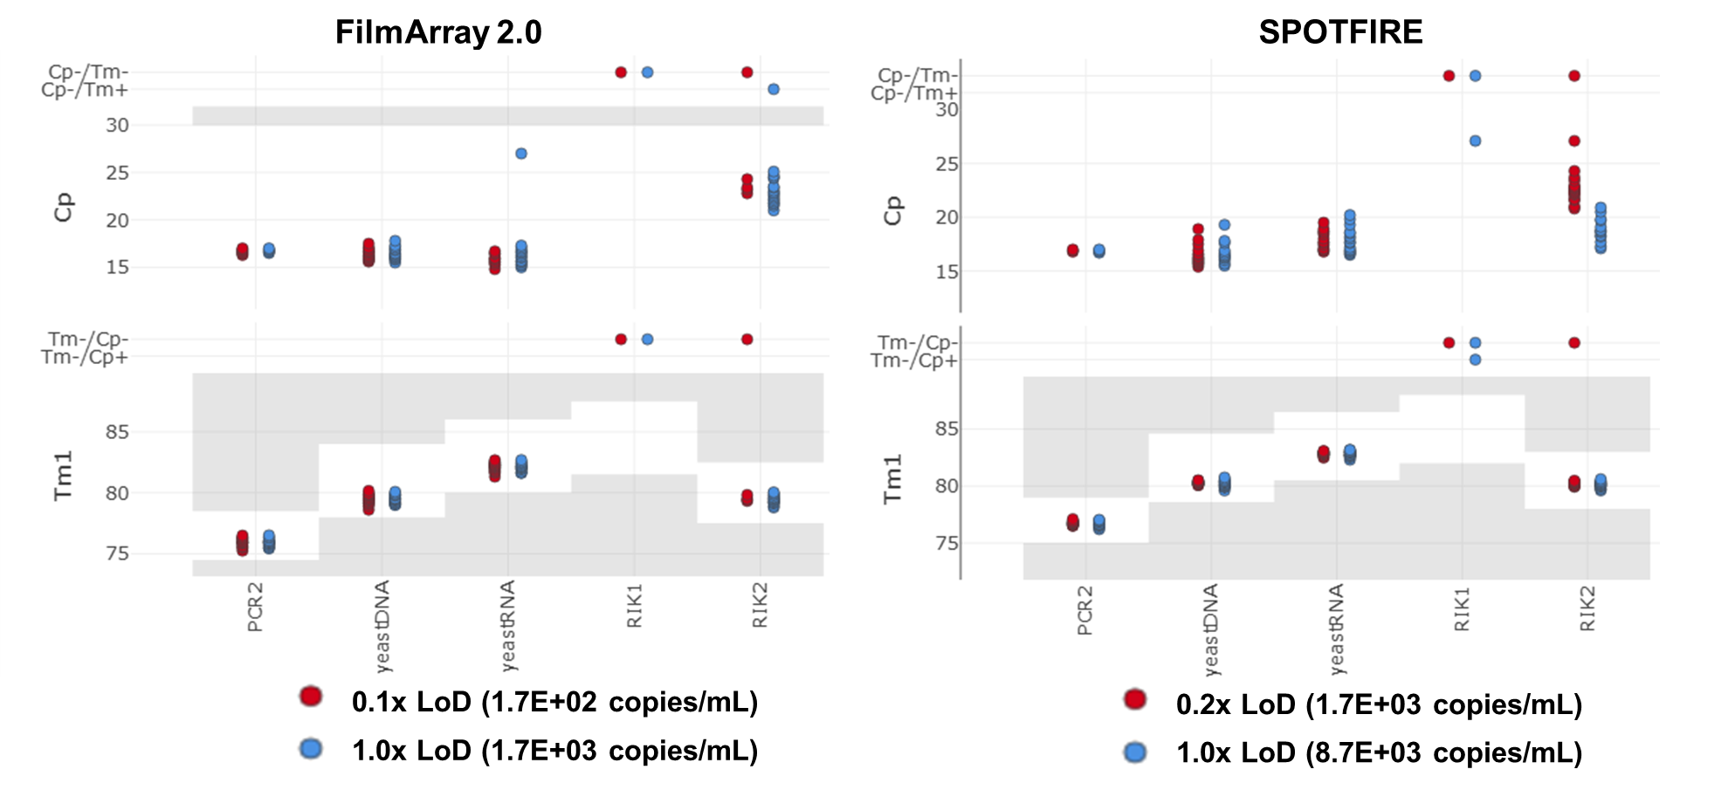
Figure S7. LoD Confirmation Testing Data for Rickettsia prowazekii.
Rickettsia prowazekii was tested at 1× LoD (blue) and a sub-LoD concentration (red). 20 pouches were tested at each concentration on the FILMARRAY 2.0 instrument (left panel) and SPOTFIRE instrument (right panel). Median pouch Cp values (top) and Tm values (bottom) are presented for the assays associated with this analyte.

Yersinia pestis
Two assays target Yersinia pestis, YPT1 and YPT3. On the FILMARRAY 2.0, if either assay is positive, a “Yersinia pestis Detected” interpretation results. For SPOTFIRE, if the YPT3 assay is positive a “Yersinia pestis Detected” interpretation will result. If YPT1 is positive and YPT3 is negative, an interpretation indicating a “Possible Detection” (Table S4). This testing used genomic DNA isolated from Yersinia pestis CO92. On FILMARRAY 2.0, pouches tested at a concentration of 4.4E+01 copies/mL produced a “Yersinia pestis Detected” interpretation in 20/20 pouches and in 6/20 pouches when tested at 4.4E+00 copies/mL. On SPOTFIRE, pouches tested at 2.2E+03 copies/mL produced a “Yersinia pestis Detected” interpretation in 20/20 pouches and in 18/20 pouches tested at 2.2E+02 copies/mL (Figure S8). These data confirm the LoD for Yersinia pestis at 4.4E+01 copies/mL on FILMARRAY 2.0 and at 2.2E+03 copies/mL on SPOTFIRE.
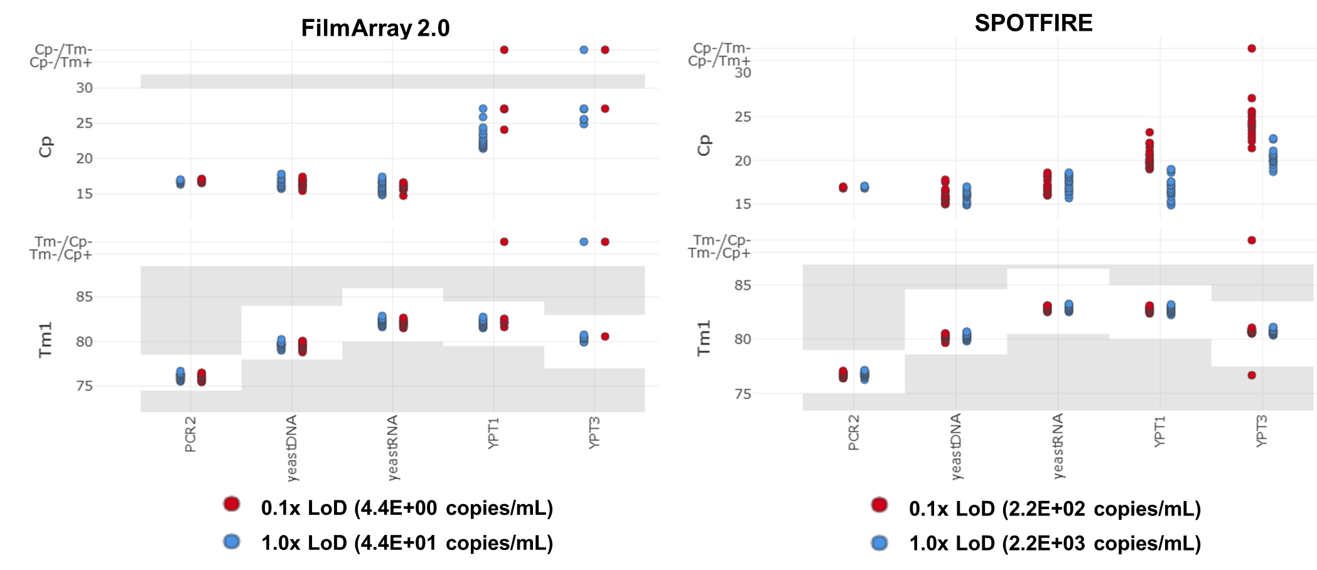
Figure S8. LoD Confirmation Testing Data for Yersinia pestis.
Yersinia pestis genomic DNA was tested at 1× LoD (blue) and 0.1× LoD (red). 20 pouches were tested at each concentration on the FILMARRAY 2.0 instrument (left panel) and SPOTFIRE instrument (right panel). Median pouch Cp values (top) and Tm values (bottom) are presented for the assays associated with this analyte.

Orthoebolavirus zairense
Orthoebolavirus zairense is targeted by the EB2 assay. A positive EB2 assay call will produce a “Ebola Zaire Detected” interpretation. A gamma-irradiated Mayinga strain of Orthoebolavirus zairense was used in this study. Pouches tested at a concentration of 7.4E+03 copies/mL produced a “Ebola Zaire Detected” interpretation in 10/20 pouches on FILMARRAY 2.0 and 15/20 pouches on SPOTFIRE (Figure S9). The concentration was adjusted to 3.7E+04 copies/mL where the analyte was detected in 18/20 pouches on FILMARRAY 2.0 and 20/20 pouches of SPOTFIRE. The concentration was increased to 1.8E+05 copies/mL where the analyte was detected in 20/20 pouches on FILMARRAY 2.0. These data confirm the LoD for Orthoebolavirus zairense at 1.8E+05 copies/mL on FILMARRAY 2.0 and at 3.7E+04 copies/mL on SPOTFIRE.
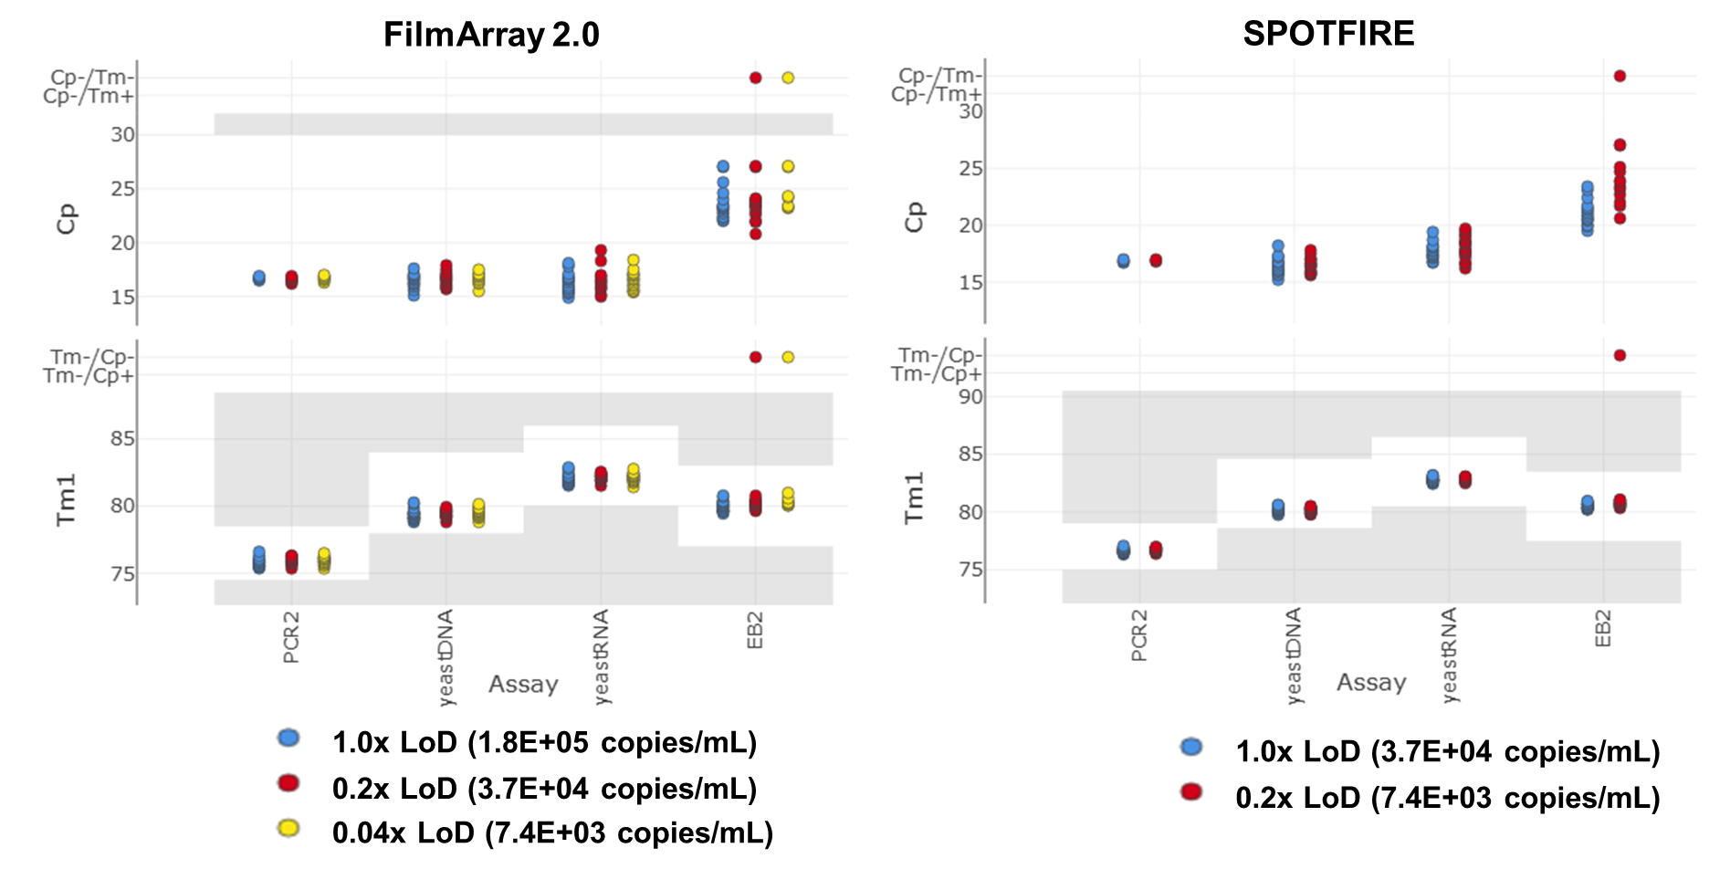
Figure S9. LoD Confirmation Testing Data for Orthoebolavirus zairense.
Yersinia pestis genomic DNA was tested at 1× LoD (blue) and sub-LoD concentrations (red and yellow). 20 pouches were tested at each concentration on the FILMARRAY 2.0 instrument (left panel) and SPOTFIRE instrument (right panel). Median pouch Cp values (top) and Tm values (bottom) are presented for the assays associated with this analyte.

Eastern Equine Encephalitis virus
The EEE01 assay targets Eastern Equine Encephalitis (EEE) virus. A positive call for EEE01 will result in a “EEE Virus Detected” interpretation. Since no organisms or extracted nucleic acid were available at a BSL2 or lower level, a synthetic RNA template, CHEM-RNA-0039, which is complementary to the EEE01 assay was used to estimate the LoD. The RNA template was tested at three concentrations on FILMARRAY 2.0: 5.9E+05 copies/mL, 5.9E+04 copies/mL, and 5.9E+03 copies/mL with the corresponding rates of detection: 20/20, 17/20, and 3/20 (Figure S10). The RNA template was tested at three concentrations on SPOTFIRE: 7.4E+04 copies/mL, 7.4E+03 copies/mL, and 7.4E+02 copies/mL with the corresponding rates of detection: 20/20, 19/20, and 2/20. These data confirm the LoD for EEE virus at 5.9E+05 copies/mL on FILMARRAY 2.0 and at 7.4E+03 copies/mL on SPOTFIRE.
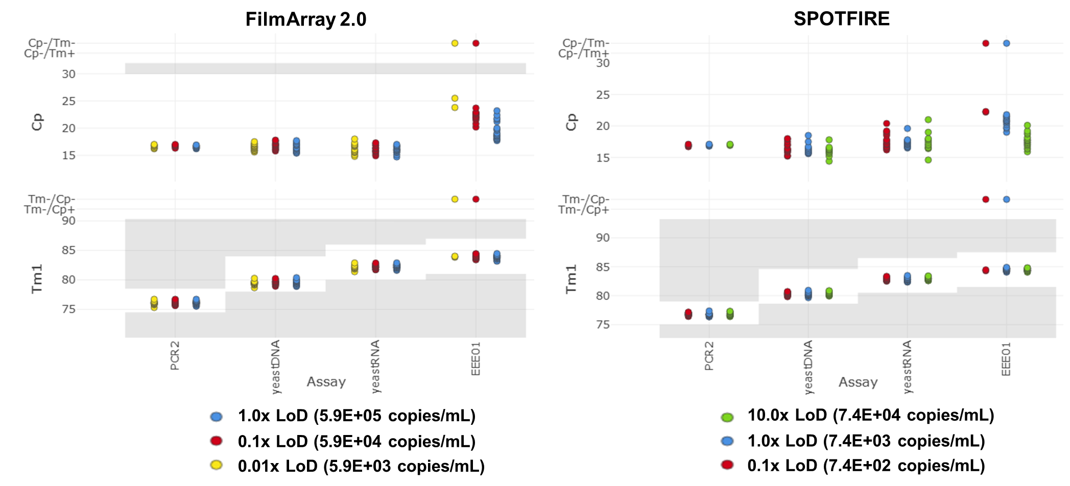
Figure S10. LoD Confirmation Testing Data for Eastern Equine Encephalitis Virus.
Synthetic RNA simulating Eastern Equine Encephalitis virus was tested at 10× LoD (green), 1× LoD (blue) and sub-LoD concentrations (red and yellow). 20 pouches were tested at each concentration on the FILMARRAY 2.0 instrument (left panel) and SPOTFIRE instrument (right panel). Median pouch Cp values (top) and Tm values (bottom) are presented for the assays associated with this analyte.

Orthomarburgvirus marburgense
The Marb2 and Marb3 assays target Orthomarburgvirus marburgense. A positive call for either Marb2 or Marb3 will produce a “Marburg virus Detected” interpretation. This testing independently established LoD for two strains of Orthomarburgvirus marburgense: Ravn and German Voege. Both strains used in this study were inactivated by gamma irradiation. Marburg Ravn was tested at two concentrations on FILMARRAY 2.0: 6.5E+03 copies/mL and 6.5E+02 copies/mL with the corresponding rates of detection: 19/20 and 10/20 (Figure S11). Marburg Ravn was tested at three concentrations on SPOTFIRE: 3.2E+04 copies/mL, 6.5E+03 copies/mL, and 1.3E+03 copies/mL with the corresponding rates of detection: 20/20, 18/20, and 17/20. These data confirm the LoD for Marburg Ravn at 6.5E+03 copies/mL on FILMARRAY 2.0 and at 3.2E+04 copies/mL on SPOTFIRE.
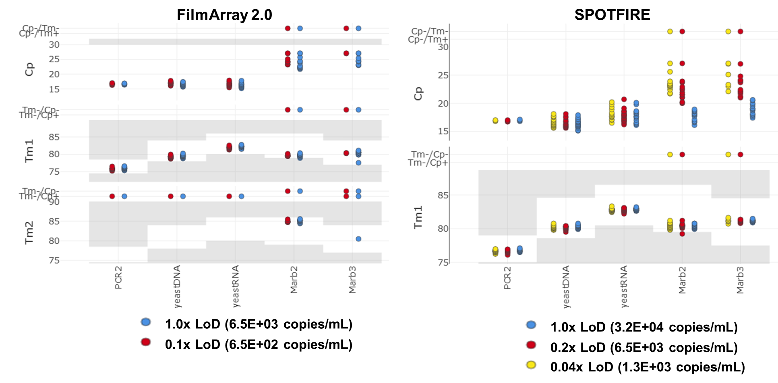
Figure S11. LoD Confirmation Testing Data for Marburg Ravn.
Marburg Ravn was tested at 1× LoD (blue) and a sub-LoD concentration (red and yellow). 20 pouches were tested at each concentration on the FILMARRAY 2.0 instrument (left panel) and SPOTFIRE instrument (right panel). Median pouch Cp values (top) and Tm values (bottom) are presented for the assays associated with this analyte.
Pouches tested with the German Voege strain at a concentration of 1.4E+04 copies/mL produced a “Marburg virus Detected” interpretation in 20/20 pouches on FILMARRAY 2.0 and SPOTFIRE (Figure S12). The concentration was adjusted to 1.4E+03 copies/mL where the analyte was detected in 11/20 pouches on FILMARRAY 2.0 and 17/20 pouches on SPOTFIRE. These data confirm the LoD for the German Voege strain of Marburg at 1.4E+04 copies/mL both on FILMARRAY 2.0 and SPOTFIRE.
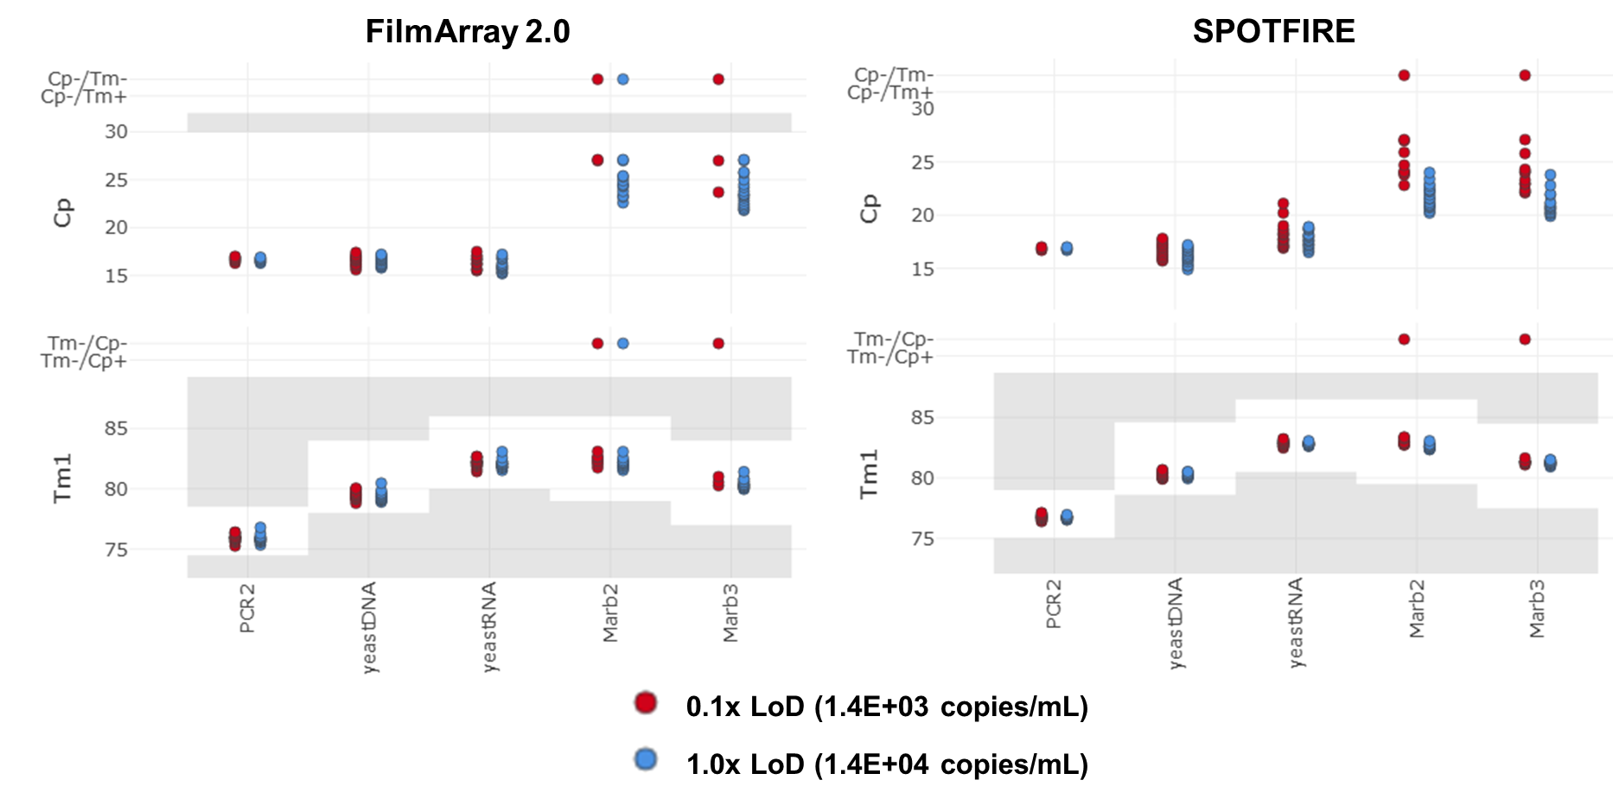
Figure S12. LoD Confirmation Testing Data for Marburg German Voege.
Marburg German Voege was tested at 1× LoD (blue) and at 0.1× LoD (red). 20 pouches were tested at each concentration on the FILMARRAY 2.0 instrument (left panel) and SPOTFIRE instrument (right panel). Median pouch Cp values (top) and Tm values (bottom) are presented for the assays associated with this analyte.

Modified Vaccinia Ankara virus
Modified Vaccinia Ankara (MVA) virus is targeted by the OPX2 and Var3 assays. A positive call for either assay will produce a “Orthopox genus virus Detected” interpretation. A live strain of MVA virus was used in this study. Pouches tested at a concentration of 6.0E+02 copies/mL produced a “Orthopox genus virus Detected” interpretation in 20/20 pouches on FILMARRAY 2.0 and 17/20 pouches on SPOTFIRE (Figure S13). At 6.0E+01 copies/mL, the analyte was detected in 7/20 pouches on FILMARRAY 2.0. The concentration was increased to 3.0E+03 copies/mL where the analyte was detected in 20/20 pouches on SPOTFIRE. These data confirm the LoD for MVA virus at 6.0E+02 copies/mL on FILMARRAY 2.0 and at 3.0E+03 copies/mL on SPOTFIRE.
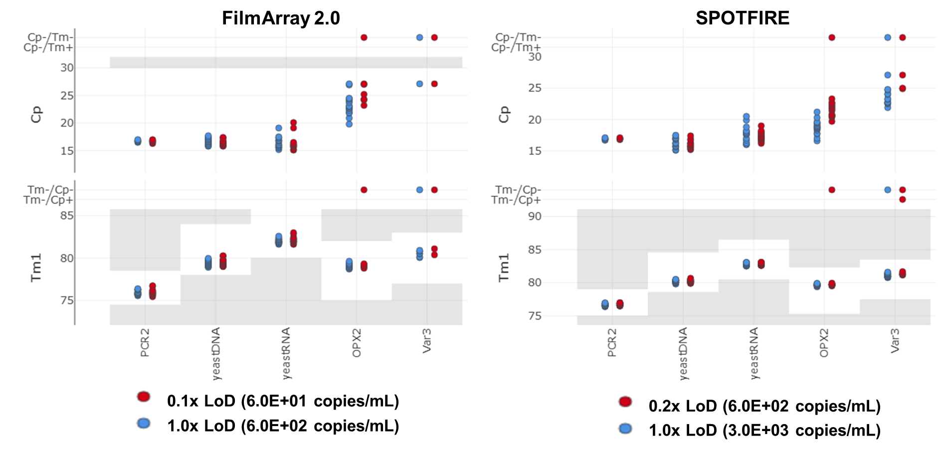
Figure S13. LoD Confirmation Testing Data for Modified Vaccinia Ankara Virus.
Modified Vaccinia Ankara virus was tested at 1× LoD (blue) and a sub-LoD concentration (red). 20 pouches were tested at each concentration on the FILMARRAY 2.0 instrument (left panel) and SPOTFIRE instrument (right panel). Median pouch Cp values (top) and Tm values (bottom) are presented for the assays associated with this analyte.

Variola virus
Variola virus is targeted by four assays: OPX2, Var1a, Var1b, and Var3. A positive call for all four assays is required to produce a “Variola virus Detected” interpretation. Since access to variola virus in any form (organism, extracted nucleic acid, etc.) was not possible for this study, three synthetic DNA templates targeting the four assays, spiked at the same concentration, were used as a surrogate. The DNA templates were tested at two concentrations on FILMARRAY 2.0: 4.0E+03 copies/mL and 4.0E+02 copies/mL with the corresponding rates of detection: 20/20 and 15/20 (Figure S14). The DNA templates were tested at two concentrations on SPOTFIRE: 8.0E+03 copies/mL and 8.0E+02 copies/mL with the corresponding rates of detection: 20/20 and 11/20. These data confirm the LoD for variola virus at 4.0E+03 copies/mL on FILMARRAY 2.0 and at 8.0E+03 copies/mL on SPOTFIRE.
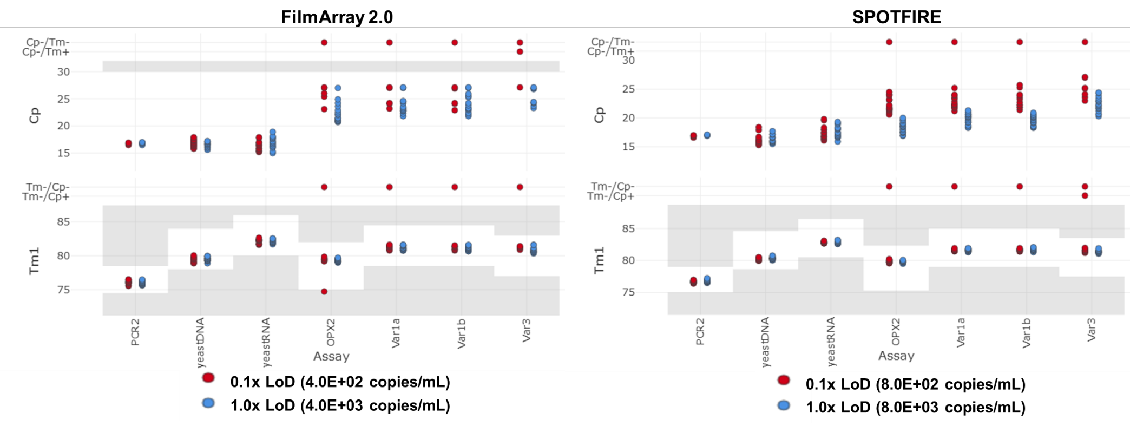
Figure S14. LoD Confirmation Testing Data for Variola Virus.
Three DNA templates were used as a surrogate for variola virus and were tested at 1× LoD (blue) and at 0.1× LoD (red). 20 pouches were tested at each concentration on the FILMARRAY 2.0 instrument (left panel) and SPOTFIRE instrument (right panel). Median pouch Cp values (top) and Tm values (bottom) are presented for the assays associated with this analyte.

Venezuelan Equine Encephalitis virus
Two assays target Venezuelan Equine Encephalitis (VEE) virus, VEE-MP2 and VEE-RC3. A positive call in either assay will result in a “VEE virus Detected” interpretation. This testing used a formalin-inactivated strain of VEE virus (Trinidad). The VEE virus analyte was tested at two concentrations on FILMARRAY 2.0: 1.2E+04 copies/mL and 1.2E+03 copies/mL with the corresponding rates of detection: 20/20 and 5/20 (Figure S15). The VEE virus analyte was tested at two concentrations on SPOTFIRE: 2.4E+03 copies/mL and 2.4E+02 copies/mL with the corresponding rates of detection: 19/20 and 4/20. These data confirm the LoD for VEE virus at 1.2E+04 copies/mL on FILMARRAY 2.0 and at 2.4E+03 copies/mL on SPOTFIRE.
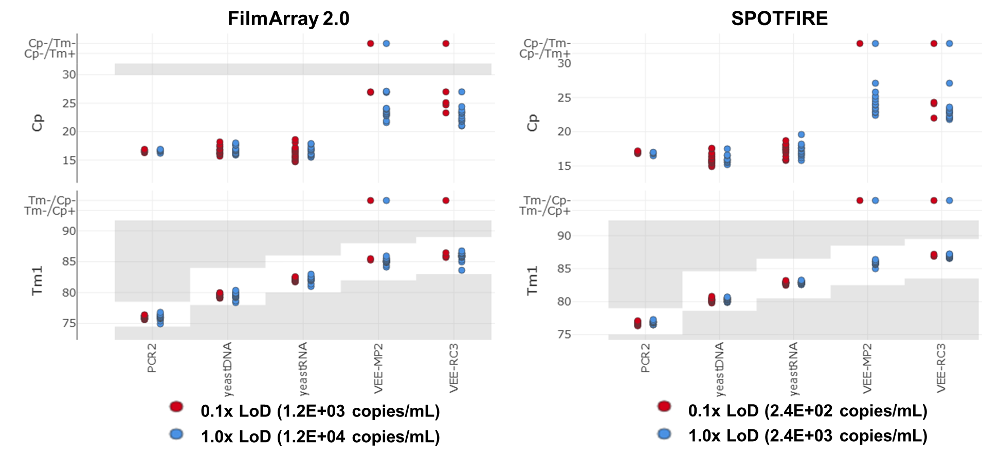
Figure S15. LoD Confirmation Testing Data for Venezuelan Equine Encephalitis Virus.
Venezuelan Equine Encephalitis virus was tested at 1× LoD (blue) and a sub-LoD concentration (red). 20 pouches were tested at each concentration on the FILMARRAY 2.0 instrument (left panel) and SPOTFIRE instrument (right panel). Median pouch Cp values (top) and Tm values (bottom) are presented for the assays associated with this analyte.

Western Equine Encephalitis virus
The WEE01 assay targets Western Equine Encephalitis (WEE) virus. A positive call for the WEE01 assay will result in a “WEE virus Detected” interpretation. This testing used a formalin-inactivated strain of WEE virus (CBA87 Alpha 025). The WEE virus analyte was tested at three concentrations on FILMARRAY 2.0: 2.4E+03 copies/mL, 4.8E+02 copies/mL, and 9.6E+01 copies/mL with the corresponding rates of detection: 20/20, 18/20, and 8/20 (Figure S16). The WEE virus analyte was tested at two concentrations on SPOTFIRE: 4.8E+02 copies/mL and 9.6E+01 copies/mL with the corresponding rates of detection: 20/20 and 10/20. These data confirm the LoD for WEE virus at 2.4E+03 copies/mL on FILMARRAY 2.0 and at 4.8E+02 copies/mL on SPOTFIRE.
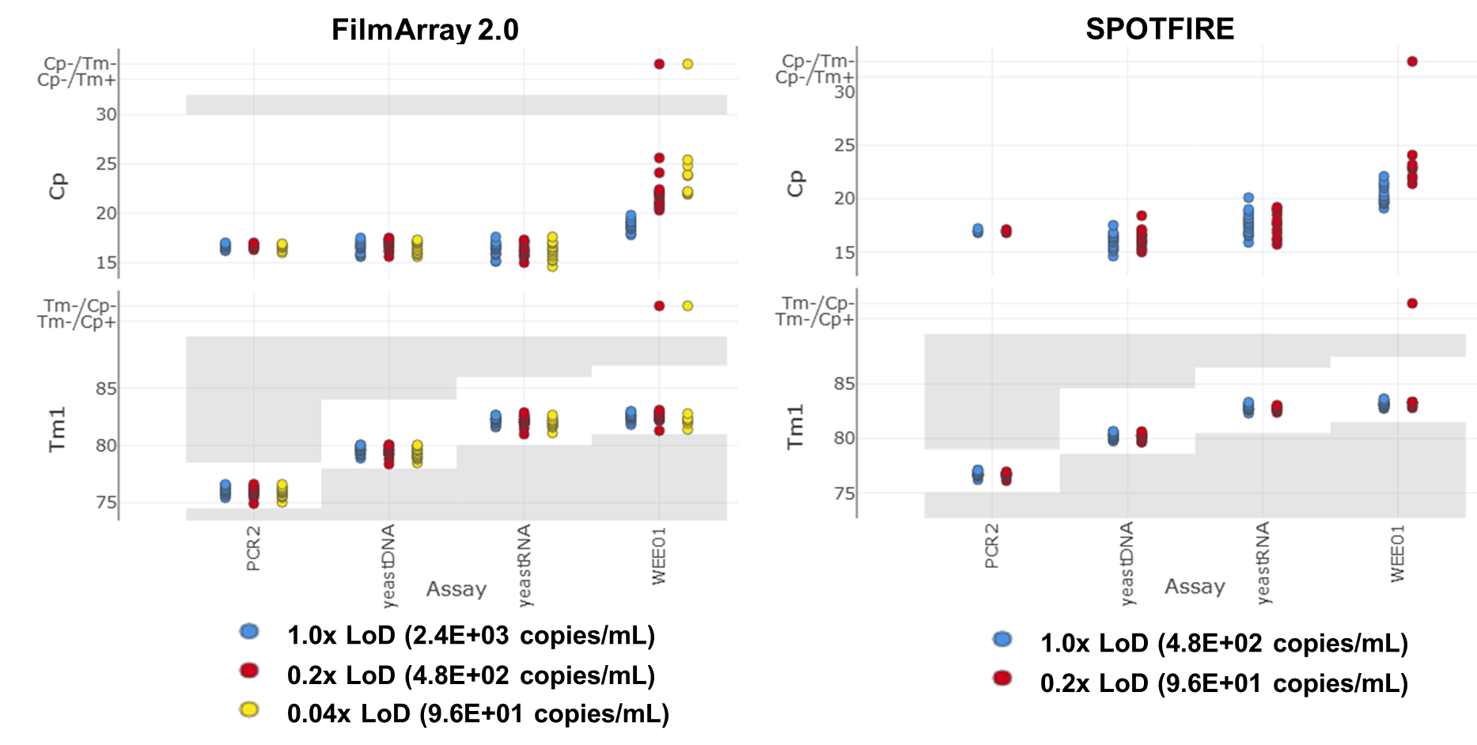
Figure S16. LoD Confirmation Testing Data for Western Equine Encephalitis Virus.
Western Equine Encephalitis virus was tested at 1× LoD (blue) and sub-LoD concentrations (red and yellow). 20 pouches were tested at each concentration on the FILMARRAY 2.0 instrument (left panel) and SPOTFIRE instrument (right panel). Median pouch Cp values (top) and Tm values (bottom) are presented for the assays associated with this analyte.

Clostridium botulinum
The BoNTA assay targets the botulinum toxin-encoding gene in Clostridium botulinum. A positive call for the BoNTA assay will result in a “Clostridium botulinum Detected” interpretation. Since no organisms or extracted nucleic acid were available at a BSL2 or lower level, a synthetic RNA template, CHEM-RNA-0031, which is complementary to the BoNTA assay was used to estimate the LoD. The RNA template was tested at three concentrations on FILMARRAY 2.0: 3.1E+06 copies/mL, 3.1E+05 copies/mL, and 3.1E+04 copies/mL with the corresponding rates of detection: 20/20, 14/20, and 6/20 (Figure S17). The RNA template was tested at three concentrations on SPOTFIRE as well: 3.1E+05 copies/mL, 6.2E+04 copies/mL, and 6.2E+03 copies/mL with the corresponding rates of detection: 20/20, 18/20, and 7/20. These data confirm the LoD for Clostridium botulinum at 3.1E+06 copies/mL on FILMARRAY 2.0 and at 3.1E+05 copies/mL on SPOTFIRE.
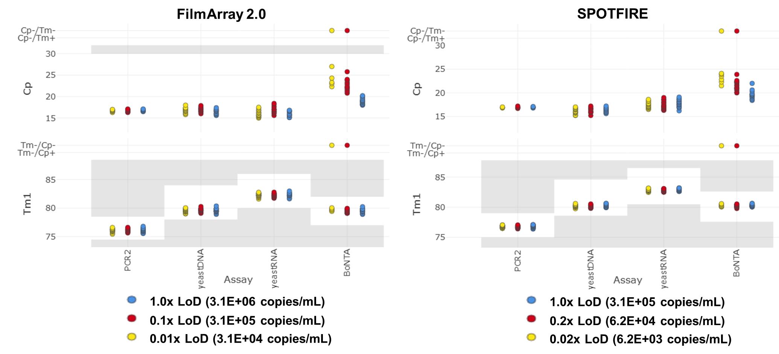
Figure S17. LoD Confirmation Testing Data for Clostridium botulinum.
A synthetic RNA template simulating Clostridium botulinum was tested at 1× LoD (blue) and sub-LoD concentrations (red and yellow). 20 pouches were tested at each concentration on the FILMARRAY 2.0 instrument (left panel) and SPOTFIRE instrument (right panel). Median pouch Cp values (top) and Tm values (bottom) are presented for the assays associated with this analyte.

Ricinus communis
The RCN2 assay targets the ricin toxin-encoding gene in Ricinus communis. A positive call for the RCN2 assay will result in a “Ricinus communis Detected” interpretation. Genomic DNA extracted from the Zanzibarensis cultivar of castor bean (Ricinus communis) was used to determine LoD. Genomic DNA was tested at two concentrations on FILMARRAY 2.0: 8.0E+02 copies/mL and 8.0E+01 copies/mL with the corresponding rates of detection: 20/20, and 9/19 (Figure S18). Genomic DNA was tested at two concentrations on SPOTFIRE as well: 4.0E+02 copies/mL and 4.0E+01 copies/mL with the corresponding rates of detection: 19/20 and 4/20. These data confirm the LoD for Ricinus communis at 8.0E+02 copies/mL on FILMARRAY 2.0 and at 4.0E+02 copies/mL on SPOTFIRE.
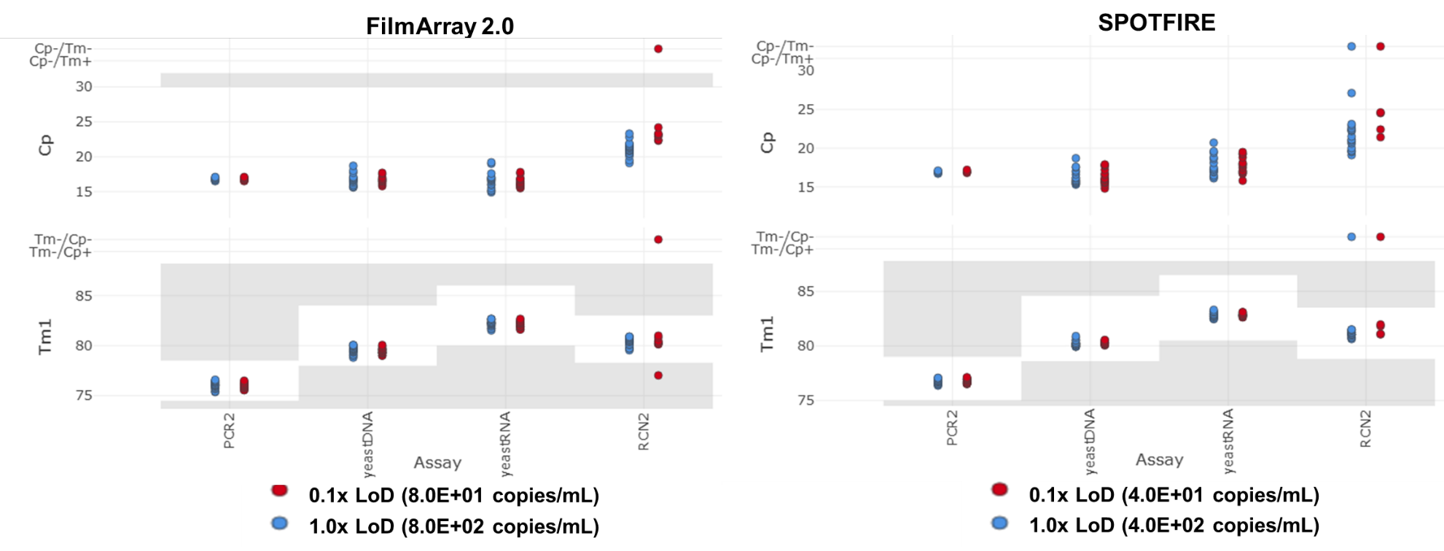
Figure S18. LoD Confirmation Testing Data for Ricinus communis.
Genomic DNA from Ricinus communis was tested at 1× LoD (blue) and 0.1× LoD (red). 20 pouches were tested at each concentration on the FILMARRAY 2.0 instrument (left panel) and SPOTFIRE instrument (right panel). Median pouch Cp values (top) and Tm values (bottom) are presented for the assays associated with this analyte.
A comparison of median Cp values between pouches tested on FILMARRAY 2.0 and SPOTFIRE was also conducted (Table 5). For each analyte tested, the median Cp for each targeted assay was evaluated at the confirmed LoD concentration. For analytes where LoD was confirmed at a different concentration on SPOTFIRE than FILMARRAY 2.0, comparison of median Cp values was performed for each concentration.

