Title: Individual-specific associations between head impact kinematics and acute symptoms changes: An exploratory study in boxing sparring

- Supplemental Figure 1. Evolution of the number of symptoms and the total severity score for all complete athlete-sessions
- Supplemental Figure 2. Heatmaps representing the correlation analysis between all kinematic metrics
- Supplemental Table 1. Mean and standard deviation for each athlete-session and each metric
- Supplemental Table 2. Median and inter-quartile range [IQR] for each athlete-session and each metric
- Supplemental Table 3. Maximum value for each athlete-session and each metric
- Supplemental Table 4. Cumulative sum for each athlete-session and each metric
- Supplemental Table 5. Inverse Time-Weighted Exposure for each athlete-session and each metric
- Supplemental Figure 3. Control charts for all participants not presented in the main manuscript.

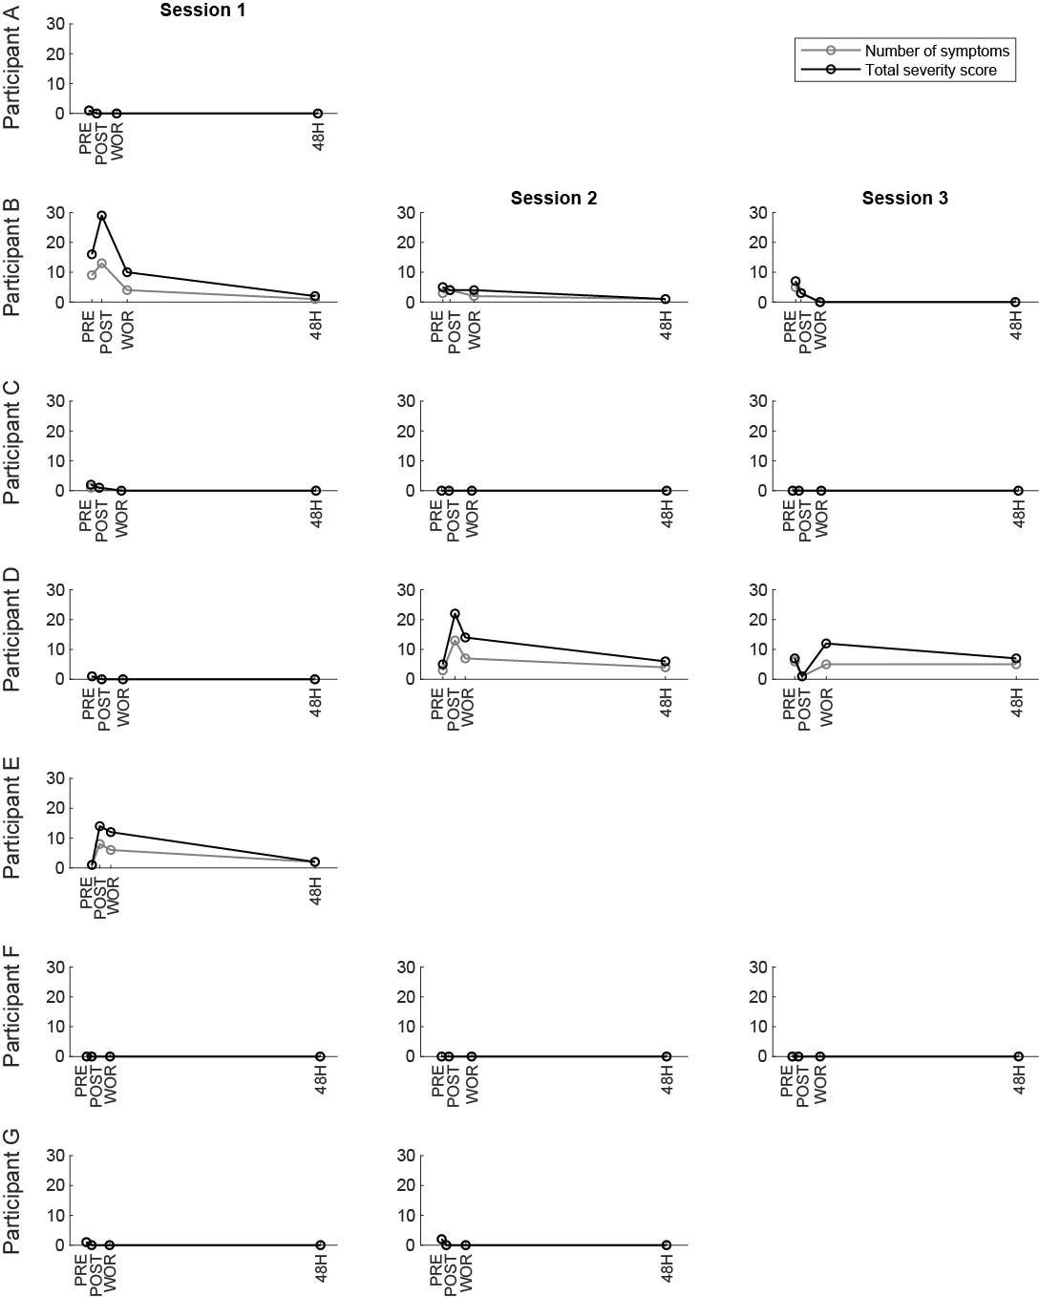
Supplemental Figure 1. Evolution of the number of symptoms and the total severity score for each athlete-session. PRE: pre-sparring, POST: immediately post-sparring, WOR: self-reported worst time where the participant experienced symptoms at the highest intensity, 48H: approximately 48 hours post-sparring.

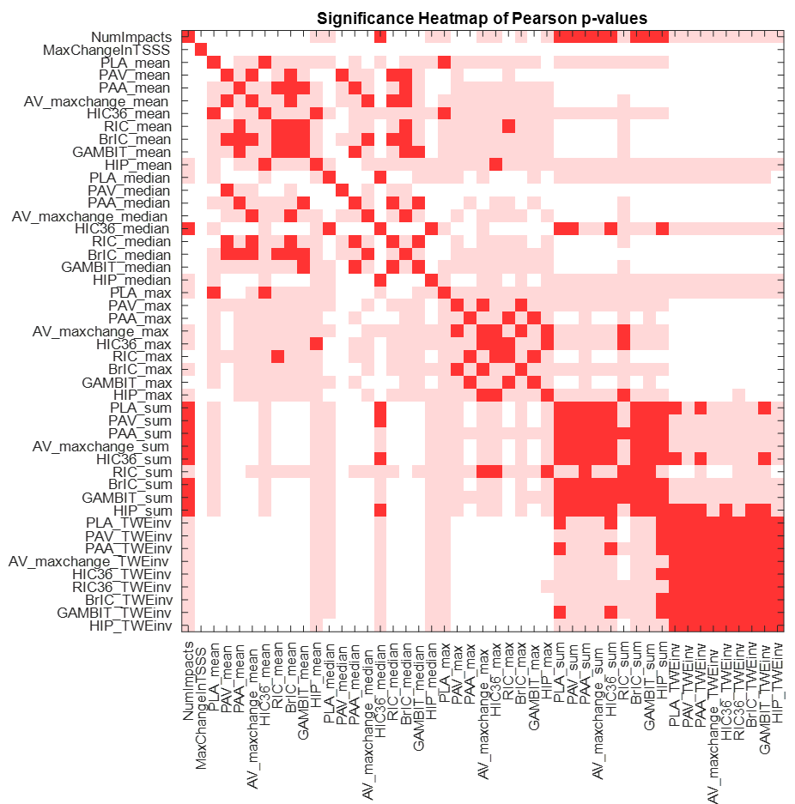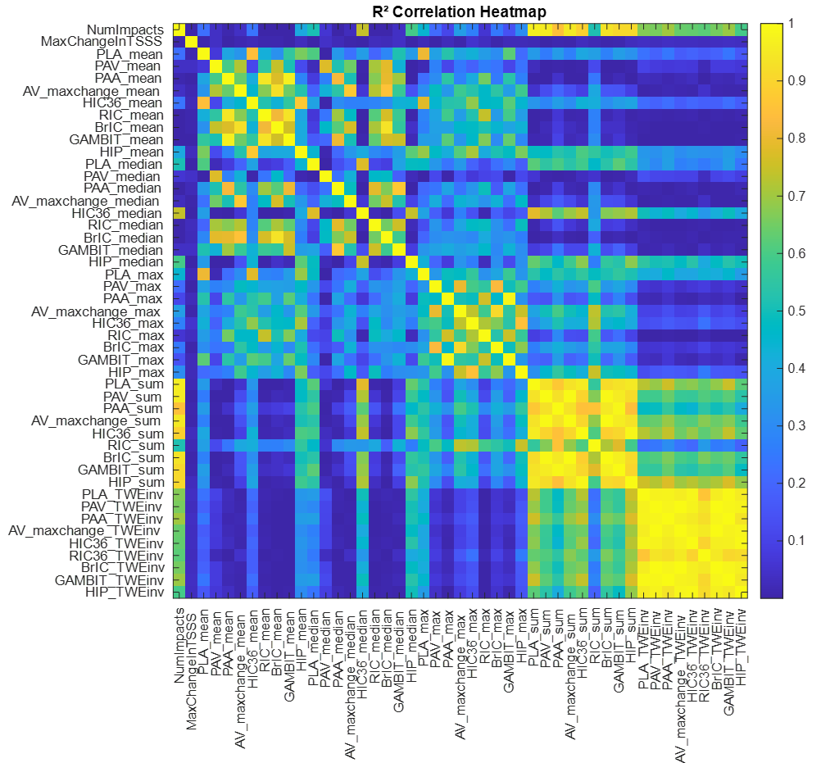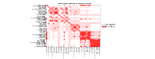
Supplemental Figure 2. Heatmaps representing the correlation analysis between all kinematic metrics. Colors are based on p-values of the Pearson’s test (left) or R² values (right).

Supplemental Table 1. Means and standard deviations for each athlete-session and each metric, for all individual video-verified, high-quality head acceleration events.
 | Mean ± SD
Athlete-session | PLA (g) | PAV (rad.s⁻¹) | PAA (rad.s⁻²) | ${Δω}_{max}$ (rad.s⁻¹) | HIC₃₆ | RIC₃₆ | BrIC | GAMBIT | HIP (W)
Participant A
Session 1 | 19.1 ± 8.7 | 11.5 ± 4.2 | 2001.4 ± 1240.4 | 11.1 ± 4.4 | 8.4 ± 8.3 | 9.9E+05 ± 1.7E+06 | 0.2 ± 0.1 | 0.3 ± 0.2 | 714.4 ± 653.4
Participant B
Session 1* | 12.5 ± 6 | 12.9 ± 4.1 | 1394.9 ± 621.3 | 11.4 ± 4.1 | 4.7 ± 5.7 | 5.0E+05 ± 6.3E+05 | 0.2 ± 0.1 | 0.2 ± 0.1 | 513.7 ± 542.8
Session 2 | 19.6 ± 13.8 | 13.7 ± 4.7 | 2429.1 ± 1480.2 | 12.8 ± 4.6 | 11.9 ± 19.1 | 1.6E+06 ± 2.7E+06 | 0.3 ± 0.1 | 0.3 ± 0.2 | 798.8 ± 871.6
Session 3 | 12 ± 3.8 | 12.6 ± 3.6 | 1373.6 ± 575.8 | 9.1 ± 3.6 | 2.9 ± 2.2 | 3.8E+05 ± 3.1E+05 | 0.2 ± 0.1 | 0.2 ± 0.1 | 351.9 ± 310.5
Participant C
Session 1 | 17.4 ± 8.7 | 14.9 ± 5.2 | 2252.8 ± 1190.4 | 14.2 ± 5.7 | 10.2 ± 13.8 | 1.4E+06 ± 1.7E+06 | 0.3 ± 0.1 | 0.3 ± 0.2 | 918.6 ± 1081.7
Session 2 | 16.8 ± 7.1 | 13.8 ± 3.9 | 1830.6 ± 724.3 | 12.4 ± 3.2 | 6.7 ± 5.3 | 7.7E+05 ± 6.1E+05 | 0.3 ± 0.1 | 0.3 ± 0.1 | 606.9 ± 450.9
Session 3 | 13.2 ± 4.4 | 12.8 ± 2.8 | 1780.4 ± 650.6 | 11.2 ± 2.8 | 4.9 ± 5.3 | 6.3E+05 ± 5.2E+05 | 0.2 ± 0.1 | 0.2 ± 0.1 | 546.1 ± 507.6
Participant D
Session 1 | 18 ± 6.8 | 16 ± 6.6 | 2431.6 ± 1293.4 | 14.8 ± 5.5 | 8.9 ± 10.7 | 1.6E+06 ± 2.1E+06 | 0.3 ± 0.1 | 0.3 ± 0.2 | 803.2 ± 851.1
Session 2* | 17.1 ± 5.9 | 14.1 ± 4.8 | 1866.6 ± 605.3 | 12 ± 3.6 | 6.1 ± 3.7 | 6.9E+05 ± 4.6E+05 | 0.3 ± 0.1 | 0.3 ± 0.1 | 501.6 ± 306.6
Session 3* | 17.2 ± 7.9 | 13.5 ± 4.7 | 1990.9 ± 1129.4 | 12.2 ± 4.3 | 8.2 ± 10.1 | 1.0E+06 ± 1.6E+06 | 0.3 ± 0.1 | 0.3 ± 0.1 | 629.9 ± 575.3
Participant E
Session 1* | 15.5 ± 5.7 | 13.5 ± 4.4 | 1752.9 ± 870.4 | 12.1 ± 5 | 7 ± 5.7 | 7.4E+05 ± 6.3E+05 | 0.3 ± 0.1 | 0.2 ± 0.1 | 676 ± 593
Participant F
Session 1 | 20 ± 8.5 | 12 ± 5.2 | 1461.7 ± 703.9 | 11.2 ± 5.1 | 11.3 ± 9.8 | 5.3E+05 ± 5.2E+05 | 0.2 ± 0.1 | 0.2 ± 0.1 | 951.3 ± 719.3
Session 2 | 15.2 ± 5.2 | 11 ± 4.3 | 1240.6 ± 537.3 | 9.6 ± 3.6 | 6 ± 3.9 | 3.3E+05 ± 4.1E+05 | 0.2 ± 0.1 | 0.2 ± 0.1 | 541.3 ± 341.2
Session 3 | 13.1 ± 5.2 | 11.5 ± 4.4 | 1376.6 ± 271.9 | 8.6 ± 1.8 | 3 ± 2.6 | 3.2E+05 ± 1.7E+05 | 0.2 ± 0.1 | 0.2 ± 0 | 291.8 ± 229.8
Participant G
Session 1 | 17.2 ± 7.8 | 12.2 ± 4.1 | 1521.8 ± 674.4 | 12.3 ± 4.9 | 8.6 ± 8.9 | 6.2E+05 ± 5.8E+05 | 0.3 ± 0.1 | 0.2 ± 0.1 | 834.2 ± 764.7
Session 2 | 14.3 ± 5.9 | 12.2 ± 4.5 | 1331.1 ± 519.6 | 11.1 ± 4.6 | 5.2 ± 4.7 | 3.9E+05 ± 3.2E+05 | 0.2 ± 0.1 | 0.2 ± 0.1 | 544.9 ± 419.3
Overall mean ± SD | 16.8 ± 7.6 | 12.9 ± 4.7 | 1728.9 ± 934.7 | 11.8 ± 4.7 | 7.9 ± 8.7 | 7.7E+05 ± 1.1E+06 | 0.2 ± 0.1 | 0.2 ± 0.1 | 705.6 ± 677.7
An asterisk and highlighted row indicate the sessions where the participant reported an increase in total symptom severity score (TSSS) equal or greater than 5 between pre-sparring and any time point post-sparring.

Supplemental Table 2. Median and inter-quartile range [IQR] for each athlete-session and each metric, for all individual video-verified, high-quality head acceleration events.
 | Median [IQR]
Athlete-session | PLA (g) | PAV (rad.s⁻¹) | PAA (rad.s⁻²) | ${Δω}_{max}$ (rad.s⁻¹) | HIC₃₆ | RIC₃₆ | BrIC | GAMBIT | HIP (W)
Participant A
Session 1 | 18.1 [12.9 - 23.7] | 10.4 [8.6 - 13.7] | 1730.1 [1219.5 - 2458.3] | 10.2 [8.6 - 13.1] | 5.1 [3 - 11.4] | 3.7E+05 [1.9E+05 - 8.7E+05] | 0.2 [0.2 - 0.3] | 0.2 [0.2 - 0.3] | 441.1 [214.1 - 1015.4]
Participant B
Session 1* | 10.5 [8.7 - 13.8] | 12.4 [10.3 - 14.9] | 1216.8 [920.5 - 1718.7] | 10.4 [9.1 - 12.6] | 2.5 [1.7 - 4.9] | 3.0E+05 [2.1E+05 - 5.4E+05] | 0.2 [0.2 - 0.3] | 0.2 [0.1 - 0.2] | 342.2 [200.6 - 611.3]
Session 2 | 12 [10.1 - 32.6] | 12.4 [10.1 - 15.8] | 1894.5 [1638.1 - 2626.8] | 11.2 [10.3 - 13.7] | 2.4 [1.7 - 14.5] | 5.8E+05 [3.0E+05 - 1.2E+06] | 0.3 [0.2 - 0.3] | 0.2 [0.2 - 0.4] | 393.2 [147 - 1451.5]
Session 3 | 10.6 [10.1 - 14.6] | 13.3 [11.2 - 15.4] | 1122 [1036.7 - 1890.5] | 8.1 [6.8 - 12.5] | 2.2 [1.6 - 3] | 2.3E+05 [1.8E+05 - 6.8E+05] | 0.2 [0.2 - 0.3] | 0.2 [0.1 - 0.2] | 239.5 [130.1 - 409]
Participant C
Session 1 | 16.5 [10.8 - 24.8] | 14.9 [10.5 - 18.7] | 2033.6 [1285.3 - 3061.3] | 13.3 [9.9 - 18.7] | 5.4 [2.3 - 13.6] | 9.6E+05 [3.9E+05 - 1.6E+06] | 0.3 [0.2 - 0.4] | 0.3 [0.2 - 0.4] | 495.7 [248.5 - 1275.5]
Session 2 | 16.3 [11.8 - 20.2] | 13.2 [10.3 - 16.9] | 1762.7 [1271 - 2286.8] | 12.4 [9.9 - 14.1] | 4.7 [3.2 - 8.1] | 4.9E+05 [3.3E+05 - 1.2E+06] | 0.3 [0.2 - 0.3] | 0.2 [0.2 - 0.3] | 377.8 [256 - 828.5]
Session 3 | 11.9 [10.4 - 15.3] | 11.5 [10.8 - 14.1] | 1480.3 [1430 - 2353.6] | 11.2 [8.9 - 13.4] | 3.6 [2.4 - 4.8] | 4.6E+05 [2.8E+05 - 8.1E+05] | 0.2 [0.2 - 0.3] | 0.2 [0.2 - 0.3] | 427.7 [324.3 - 564.1]
Participant D
Session 1 | 17.1 [13.4 - 21.7] | 14.7 [10.6 - 20.2] | 1894.8 [1404.7 - 3365.2] | 13.6 [11.7 - 19.3] | 4.1 [3.1 - 8.5] | 7.3E+05 [3.8E+05 - 1.7E+06] | 0.3 [0.2 - 0.4] | 0.2 [0.2 - 0.4] | 424.8 [307.4 - 780.9]
Session 2* | 17 [11.6 - 22.4] | 14.6 [10.9 - 18.2] | 1760.6 [1440.6 - 2327.1] | 11.7 [9 - 14.6] | 5.4 [3.2 - 7.8] | 6.0E+05 [3.6E+05 - 9.0E+05] | 0.3 [0.2 - 0.3] | 0.2 [0.2 - 0.3] | 407.7 [253.4 - 763.6]
Session 3* | 15.3 [11.7 - 21.3] | 12.6 [10 - 16] | 1744.4 [1210.8 - 2119.7] | 11.8 [8.9 - 14.4] | 4.5 [2.8 - 10.1] | 5.5E+05 [3.4E+05 - 8.2E+05] | 0.3 [0.2 - 0.3] | 0.2 [0.2 - 0.3] | 455.4 [318.9 - 702.8]
Participant E
Session 1* | 15 [11.4 - 19.4] | 12.2 [9.9 - 17.7] | 1780.2 [907.3 - 2415.1] | 10.6 [8.4 - 16.2] | 5 [2.9 - 9.2] | 6.4E+05 [2.2E+05 - 1.0E+06] | 0.2 [0.2 - 0.3] | 0.2 [0.1 - 0.3] | 508 [251.6 - 941.7]
An asterisk and highlighted row indicate the sessions where the participant reported an increase in total symptom severity score (TSSS) equal or greater than 5 between pre-sparring and any time point post-sparring.

Supplemental Table 2 (continued). Median and inter-quartile range [IQR] for each athlete-session and each metric, for all individual video-verified, high-quality head acceleration events.
 | Median [IQR]
Athlete-session | PLA (g) | PAV (rad.s⁻¹) | PAA (rad.s⁻²) | ${Δω}_{max}$ (rad.s⁻¹) | HIC₃₆ | RIC₃₆ | BrIC | GAMBIT | HIP (W)
Participant F
Session 1 | 19.6 [13.6 - 24.5] | 10.6 [8.3 - 14.6] | 1300.4 [982 - 2018.1] | 10.2 [7.6 - 13] | 8 [3.7 - 16.6] | 3.1E+05 [1.4E+05 - 8.8E+05] | 0.2 [0.1 - 0.3] | 0.2 [0.1 - 0.3] | 736.3 [381.7 - 1496.2]
Session 2 | 15 [11.6 - 18.3] | 10.3 [7.1 - 14.3] | 1116.1 [859 - 1517.5] | 9.2 [6.6 - 12.2] | 5.8 [3.7 - 7.4] | 2.2E+05 [1.4E+05 - 3.6E+05] | 0.2 [0.1 - 0.3] | 0.2 [0.1 - 0.2] | 457.7 [301 - 716.2]
Session 3 | 11.7 [9.4 - 17] | 10.7 [8.5 - 13.3] | 1488.2 [1062.9 - 1578.7] | 9 [6.9 - 9.2] | 2 [1.1 - 4.7] | 3.1E+05 [1.5E+05 - 4.7E+05] | 0.2 [0.2 - 0.2] | 0.2 [0.2 - 0.2] | 199.9 [135.9 - 498.3]
Participant G
Session 1 | 16.2 [11.3 - 20.9] | 11.7 [9.5 - 15.7] | 1416.1 [1033.6 - 1838.2] | 11.6 [8.5 - 15.6] | 5.9 [2.8 - 11.2] | 4.6E+05 [2.1E+05 - 8.5E+05] | 0.2 [0.2 - 0.3] | 0.2 [0.2 - 0.2] | 623 [307.6 - 1060.8]
Session 2 | 13.9 [10.8 - 16.5] | 12.7 [9.4 - 15.4] | 1126.5 [999.2 - 1668] | 11.2 [7.4 - 13.8] | 4.1 [2.4 - 5.1] | 2.7E+05 [1.9E+05 - 4.5E+05] | 0.2 [0.2 - 0.3] | 0.2 [0.2 - 0.2] | 508.3 [281.1 - 602.2]
Overall median [IQR] | 15.5 [11.4 - 20.9] | 12.2 [9.5 - 16] | 1502.5 [1070.3 - 2120.8] | 11 [8.6 - 14.5] | 4.9 [2.7 - 9.2] | 4.2E+05 [2.1E+05 - 8.7E+05] | 0.23 [0.18 - 0.3] | 0.21 [0.16 - 0.29] | 482.6 [275.4 - 903.7]
An asterisk and highlighted row indicate the sessions where the participant reported an increase in total symptom severity score (TSSS) equal or greater than 5 between pre-sparring and any time point post-sparring.

Supplemental Table 3. Maximum values for each athlete-session and each metric, for all individual video-verified, high-quality head acceleration events
 | Maximum value
Athlete-session | PLA  (g) | PAV  (rad.s⁻¹) | PAA  (rad.s⁻²) | ${Δω}_{max}$ (rad.s⁻¹) | HIC₃₆ | RIC₃₆ | BrIC | GAMBIT | HIP  (W)
Participant A
Session 1 | 40.8 | 23.4 | 6760.1 | 23.4 | 35.5 | 7.80E+06 | 0.5 | 0.8 | 2379.8
Participant B
Session 1* | 26.6 | 22.8 | 3251.5 | 23.1 | 22.0 | 2.53E+06 | 0.5 | 0.4 | 2307.6
Session 2 | 41.4 | 21.8 | 5292.3 | 21.5 | 49.5 | 7.02E+06 | 0.5 | 0.7 | 2273.5
Session 3 | 18.7 | 17.6 | 2375.0 | 15.3 | 8.2 | 9.35E+05 | 0.3 | 0.3 | 983.5
Participant C
Session 1 | 38.3 | 29.7 | 5134.9 | 32.9 | 78.9 | 1.07E+07 | 0.6 | 0.7 | 5518.3
Session 2 | 38.0 | 21.6 | 4057.2 | 21.4 | 25.2 | 2.05E+06 | 0.4 | 0.5 | 1790.1
Session 3 | 24.1 | 18.7 | 3317.5 | 15.6 | 23.3 | 2.07E+06 | 0.4 | 0.4 | 2282.9
Participant D
Session 1 | 32.1 | 30.2 | 5204.9 | 26.1 | 40.8 | 7.65E+06 | 0.6 | 0.7 | 3449.7
Session 2* | 31.1 | 21.2 | 2778.3 | 20.3 | 16.0 | 1.63E+06 | 0.4 | 0.4 | 1173.3
Session 3* | 37.7 | 30.8 | 5876.5 | 29.7 | 50.0 | 7.21E+06 | 0.7 | 0.7 | 3193.2
Participant E
Session 1* | 28.4 | 20.5 | 3483.6 | 22.0 | 23.0 | 2.70E+06 | 0.5 | 0.5 | 2494.6
Participant F
Session 1 | 41.4 | 27.5 | 4107.7 | 25.8 | 39.9 | 2.26E+06 | 0.5 | 0.6 | 2798.0
Session 2 | 30.8 | 20.4 | 3386.0 | 19.4 | 22.7 | 2.75E+06 | 0.4 | 0.5 | 1561.8
Session 3 | 21.5 | 18.9 | 1632.0 | 11.2 | 7.5 | 5.37E+05 | 0.3 | 0.2 | 650.8
Participant G
Session 1 | 43.0 | 22.7 | 3178.7 | 23.5 | 48.1 | 2.74E+06 | 0.5 | 0.4 | 3657.9
Session 2 | 27.9 | 20.5 | 2575.0 | 20.3 | 19.9 | 1.28E+06 | 0.5 | 0.4 | 2010.4
Mean ± SD | 32.6 ± 7.7 | 23 ± 4.2 | 3900.7 ± 1402.9 | 22 ± 5.4 | 31.9 ± 18.6 | 3.87E+06 ± 3.10E+06 | 0.5 ± 0.1 | 0.5 ± 0.2 | 2407.8 ± 1184.3
An asterisk and highlighted row indicate the sessions where the participant reported an increase in total symptom severity score (TSSS) equal or greater than 5 between pre-sparring and any time point post-sparring.

Supplemental Table 4. Cumulative sum for each athlete-session and each metric, for all individual video-verified, high-quality head acceleration events
 | Cumulative sum
Athlete-session | PLA  (g) | PAV  (rad.s⁻¹) | PAA  (rad.s⁻²) | ${Δω}_{max}$ (rad.s⁻¹) | HIC₃₆ | RIC₃₆ | BrIC | GAMBIT | HIP  (W)
Participant A
Session 1 | 842.3 | 508.1 | 88059.9 | 486.3 | 371.8 | 4.35E+07 | 10.6 | 12.2 | 31432.3
Participant B
Session 1* | 299.2 | 309 | 33476.8 | 273.5 | 113.7 | 1.21E+07 | 5.8 | 4.5 | 12328.4
Session 2 | 117.9 | 82.2 | 14574.5 | 76.5 | 71.5 | 9.86E+06 | 1.8 | 1.9 | 4792.9
Session 3 | 120.1 | 125.7 | 13735.8 | 91 | 29.3 | 3.85E+06 | 2 | 1.9 | 3518.8
Participant C
Session 1 | 837.6 | 714.5 | 108134.7 | 680.5 | 490.3 | 6.65E+07 | 14.4 | 14.2 | 44093.3
Session 2 | 552.8 | 454.4 | 60408.9 | 408.9 | 221.2 | 2.54E+07 | 8.8 | 8.3 | 20026.9
Session 3 | 211.6 | 205.6 | 28486.1 | 179 | 78.2 | 1.01E+07 | 3.7 | 3.7 | 8737.7
Participant D
Session 1 | 378.1 | 336 | 51062.7 | 311.2 | 185.9 | 3.30E+07 | 6.6 | 6.6 | 16867.6
Session 2* | 360 | 297 | 39198.4 | 251.9 | 127.3 | 1.46E+07 | 5.4 | 5.4 | 10534.6
Session 3* | 637.3 | 498.3 | 73664.6 | 452.2 | 304.1 | 3.83E+07 | 9.8 | 9.9 | 23306.2
Participant E
Session 1* | 433.9 | 377.3 | 49079.8 | 339.2 | 195.5 | 2.07E+07 | 7.2 | 6.6 | 18927.6
Participant F
Session 1 | 1159.1 | 693.2 | 84777.9 | 647.4 | 655.9 | 3.10E+07 | 12.8 | 13.1 | 55178.2
Session 2 | 744.4 | 537.6 | 60789.5 | 469 | 293.3 | 1.61E+07 | 9.8 | 9.1 | 26525.4
Session 3 | 78.9 | 69 | 8259.4 | 51.6 | 18.2 | 1.89E+06 | 1.1 | 1.1 | 1750.9
Participant G
Session 1 | 1064.6 | 758.2 | 94350.3 | 761.5 | 535 | 3.84E+07 | 15.7 | 13.7 | 51717.4
Session 2 | 272.6 | 232.4 | 25291.0 | 211.3 | 99.3 | 7.45E+06 | 4.6 | 3.6 | 10352.8
Mean ± SD | 506.9 ± 341.2 | 387.4 ± 220.5 | 52084.4 ± 31088.4 | 355.7 ± 217.5 | 236.9 ± 191.3 | 2.33E+07 ± 1.75E+07 | 7.5 ± 4.5 | 7.2 ± 4.4 | 21255.7 ± 16729.6
An asterisk and highlighted row indicate the sessions where the participant reported an increase in total symptom severity score (TSSS) equal or greater than 5 between pre-sparring and any time point post-sparring.
Supplemental Table 5. Inverse Time-Weighted Exposure for each athlete-session and each metric, for all individual video-verified, high-quality head acceleration events
 | Inverse Time-Weighted Exposure
Athlete-session | PLA  (g) | PAV  (rad.s⁻¹) | PAA  (rad.s⁻²) | ${Δω}_{max}$ (rad.s⁻¹) | HIC₃₆ | RIC₃₆ | BrIC | GAMBIT | HIP  (W)
Participant A
Session 1 | 1.46E+06 | 9.61E+05 | 1.41E+08 | 8.83E+05 | 4.86E+05 | 4.47E+10 | 2.00E+04 | 1.99E+04 | 4.00E+07
Participant B
Session 1* | 1.33E+05 | 1.40E+05 | 1.65E+07 | 1.27E+05 | 7.57E+04 | 8.62E+09 | 2.68E+03 | 2.18E+03 | 7.97E+06
Session 2 | 1.68E+03 | 1.39E+03 | 2.33E+05 | 1.33E+03 | 7.61E+02 | 1.17E+08 | 3.17E+01 | 3.00E+01 | 5.15E+04
Session 3 | 6.98E+03 | 7.74E+03 | 8.27E+05 | 5.37E+03 | 1.50E+03 | 2.31E+08 | 1.21E+02 | 1.11E+02 | 1.88E+05
Participant C
Session 1 | 6.25E+05 | 4.93E+05 | 7.61E+07 | 4.81E+05 | 3.25E+05 | 4.27E+10 | 1.03E+04 | 1.01E+04 | 2.94E+07
Session 2 | 5.91E+05 | 4.10E+05 | 7.29E+07 | 3.89E+05 | 2.55E+05 | 3.10E+10 | 8.61E+03 | 9.65E+03 | 2.13E+07
Session 3 | 1.21E+05 | 1.12E+05 | 1.61E+07 | 9.89E+04 | 3.86E+04 | 3.08E+09 | 2.04E+03 | 2.10E+03 | 4.47E+06
Participant D
Session 1 | 5.39E+04 | 4.56E+04 | 7.50E+06 | 4.14E+04 | 3.07E+04 | 5.49E+09 | 8.73E+02 | 9.65E+02 | 2.42E+06
Session 2* | 2.71E+05 | 1.60E+05 | 2.29E+07 | 1.38E+05 | 1.07E+05 | 6.85E+09 | 2.96E+03 | 3.38E+03 | 9.02E+06
Session 3* | 5.35E+05 | 3.79E+05 | 5.50E+07 | 3.40E+05 | 2.72E+05 | 2.79E+10 | 7.35E+03 | 7.64E+03 | 1.78E+07
Participant E
Session 1* | 2.74E+05 | 3.17E+05 | 3.36E+07 | 2.39E+05 | 1.08E+05 | 1.38E+10 | 5.30E+03 | 4.45E+03 | 1.08E+07
Participant F
Session 1 | 2.85E+06 | 1.59E+06 | 2.05E+08 | 1.44E+06 | 1.33E+06 | 5.84E+10 | 2.92E+04 | 3.19E+04 | 1.14E+08
Session 2 | 5.10E+05 | 3.12E+05 | 3.50E+07 | 2.87E+05 | 1.97E+05 | 7.25E+09 | 5.97E+03 | 5.54E+03 | 1.79E+07
Session 3 | 7.36E+03 | 6.13E+03 | 8.47E+05 | 4.93E+03 | 1.65E+03 | 1.94E+08 | 1.03E+02 | 1.14E+02 | 1.73E+05
Participant G
Session 1 | 3.49E+06 | 2.56E+06 | 2.89E+08 | 2.57E+06 | 1.84E+06 | 1.39E+11 | 5.06E+04 | 4.29E+04 | 1.83E+08
Session 2 | 5.92E+04 | 5.27E+04 | 7.06E+06 | 5.59E+04 | 1.80E+04 | 1.82E+09 | 1.31E+03 | 9.43E+02 | 1.81E+06
Mean ± SD | 6.87E+05 ± 1.05E+06 | 4.72E+05 ± 6.96E+05 | 6.13E+07 ± 8.30E+07 | 4.44E+05 ± 6.82E+05 | 3.18E+05 ± 5.22E+05 | 2.44E+10 ± 3.56E+10 | 9.22E+03 ± 1.36E+04 | 8.87E+03 ± 1.24E+04 | 2.88E+07 ± 4.97E+07
An asterisk and highlighted row indicate the sessions where the participant reported an increase in total symptom severity score (TSSS) equal or greater than 5 between pre-sparring and any time point post-sparring.

Supplemental Figure 3. (next pages) Control charts: representation of the magnitude of all video-verified high-quality head acceleration events collected over the available athlete-sessions (except for participants B and D, presented in the main manuscript). Each plot shows 70 minutes and covers the full sparring session. The upper border of the shaded areas represents the participants’ mean or the mean and one or two standard deviations (SD). Participant’s mean and SD values were calculated over all athlete-sessions available for the participant. Each vertical line represents one recording and is blue by default. The orange and red vertical lines represent the recordings for which the magnitude was above the participant’s mean +1SD (orange) or mean +2SD (red) values. The triangles highlight the recordings that were above the control limits for all 10 metrics. The asterisks by the session number (above the plots) indicate the sessions where the participant reported an increase in total symptom severity score ≥ 5 from pre- to post-sparring.
