8. Appendices

Appendix A: Amortization Schedule (Base Case $15000 per day with 5% escalation in revenue and 2$ in OPEX cost each year)
Year | Principal Repaid | Interest Paid | Closing Balance
1 | 1,052,588 | 1,470,000 | 23,447,412
2 | 1,115,743 | 1,406,845 | 22,331,669
3 | 1,182,688 | 1,339,900 | 21,148,982
4 | 1,253,649 | 1,268,939 | 19,895,333
5 | 1,328,868 | 1,193,720 | 18,566,465
6 | 1,408,600 | 1,113,988 | 17,157,865
7 | 1,493,116 | 1,029,472 | 15,664,750
8 | 1,582,703 | 939,885 | 14,082,047
9 | 1,677,665 | 844,923 | 12,404,382
10 | 1,778,325 | 744,263 | 10,626,057
11 | 1,885,024 | 637,563 | 8,741,033
12 | 1,998,126 | 524,462 | 6,742,907
13 | 2,118,013 | 404,574 | 4,624,894
14 | 2,245,094 | 277,494 | 2,379,800
15 | 2,379,800 | 142,788 | 0

Appendix B: Closing Value Schedule
Year | Closing Value
1 | 31,100,304
2 | 27,635,112
3 | 24,556,012
4 | 21,819,984
5 | 19,388,804
6 | 17,228,506
7 | 15,308,908
8 | 13,603,191
9 | 12,087,525
10 | 10,740,735
11 | 9,544,003
12 | 8,480,612
13 | 7,535,703
14 | 6,696,076
15 | 5,950,000

Appendix C: IRR Sensitivity (Hire Rate × Interest Cost) with no escalation in revenue and OPEX
Hire Rate (USD/day) | IRR @ 4.5% | IRR @ 6.0% | IRR @ 7.5%
12000 | -13.85 | - | -
13500 | 0.55 | -4.78 | -12.55
15000 | 9.95 | 5.84 | 1.16
16500 | 18.47 | -14.58 | 10.46
18000 | 27.10 | -23.09 | 18.97
19500 | 36.37 | 32.00 | 27.62
21000 | 46.68 | 41.78 | 36.94
22500 | 58.45 | 52.83 | 47.32
24000 | 72.15 | 65.58 | 59.19
25500 | 88.40 | 80.57 | 73.03
28500 | 108.00 | 98.51 | 89.44
30000 | 132.15 | 98.51 | 109.28

Appendix D: Fleet Age Structure & Supply Metrics
Age Group (years) | Fleet Share (%)
<5 | 20
5–9 | 19
10–14 | 36
15–19 | 12
20–24 | 7
25+ | 6
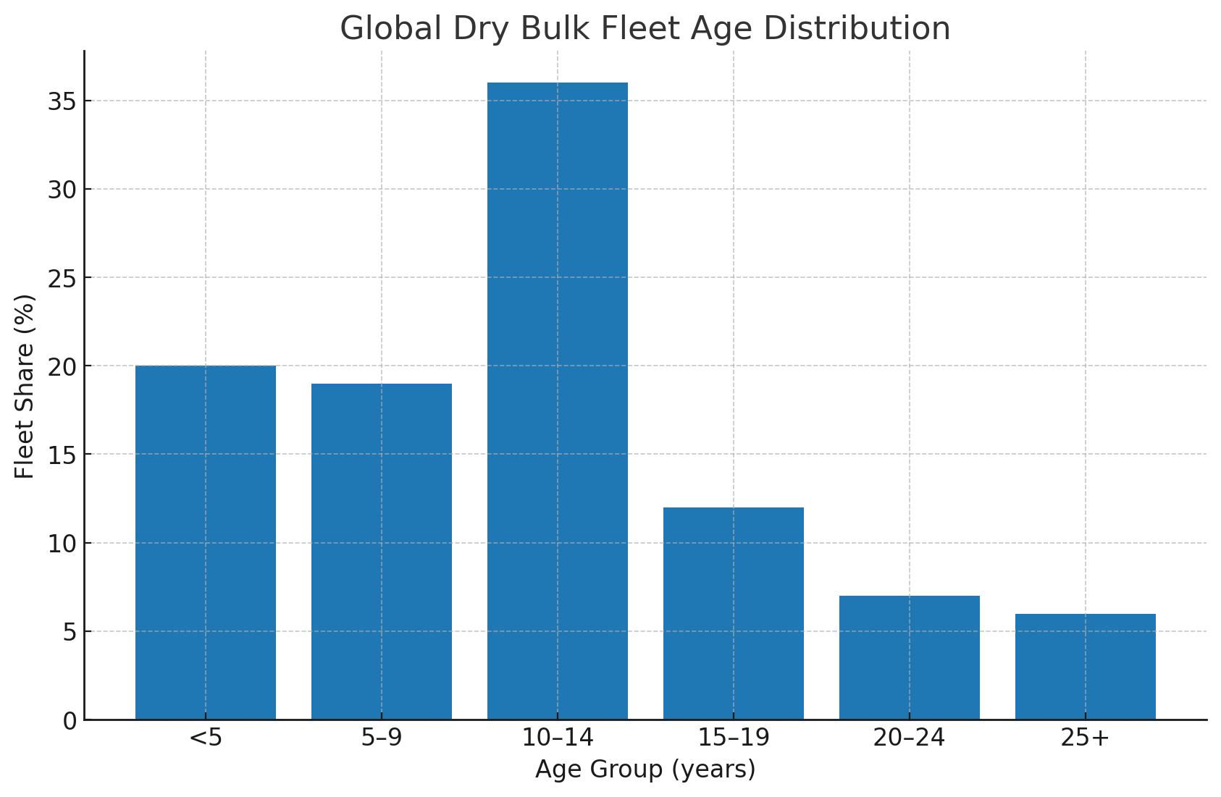
Figure D1. Global dry bulk fleet age distribution.

Metric | Value
Dry bulk vessels on order (2024–2029) | 1,500
Fleet aging out (>20 years by 2035) | 8,500
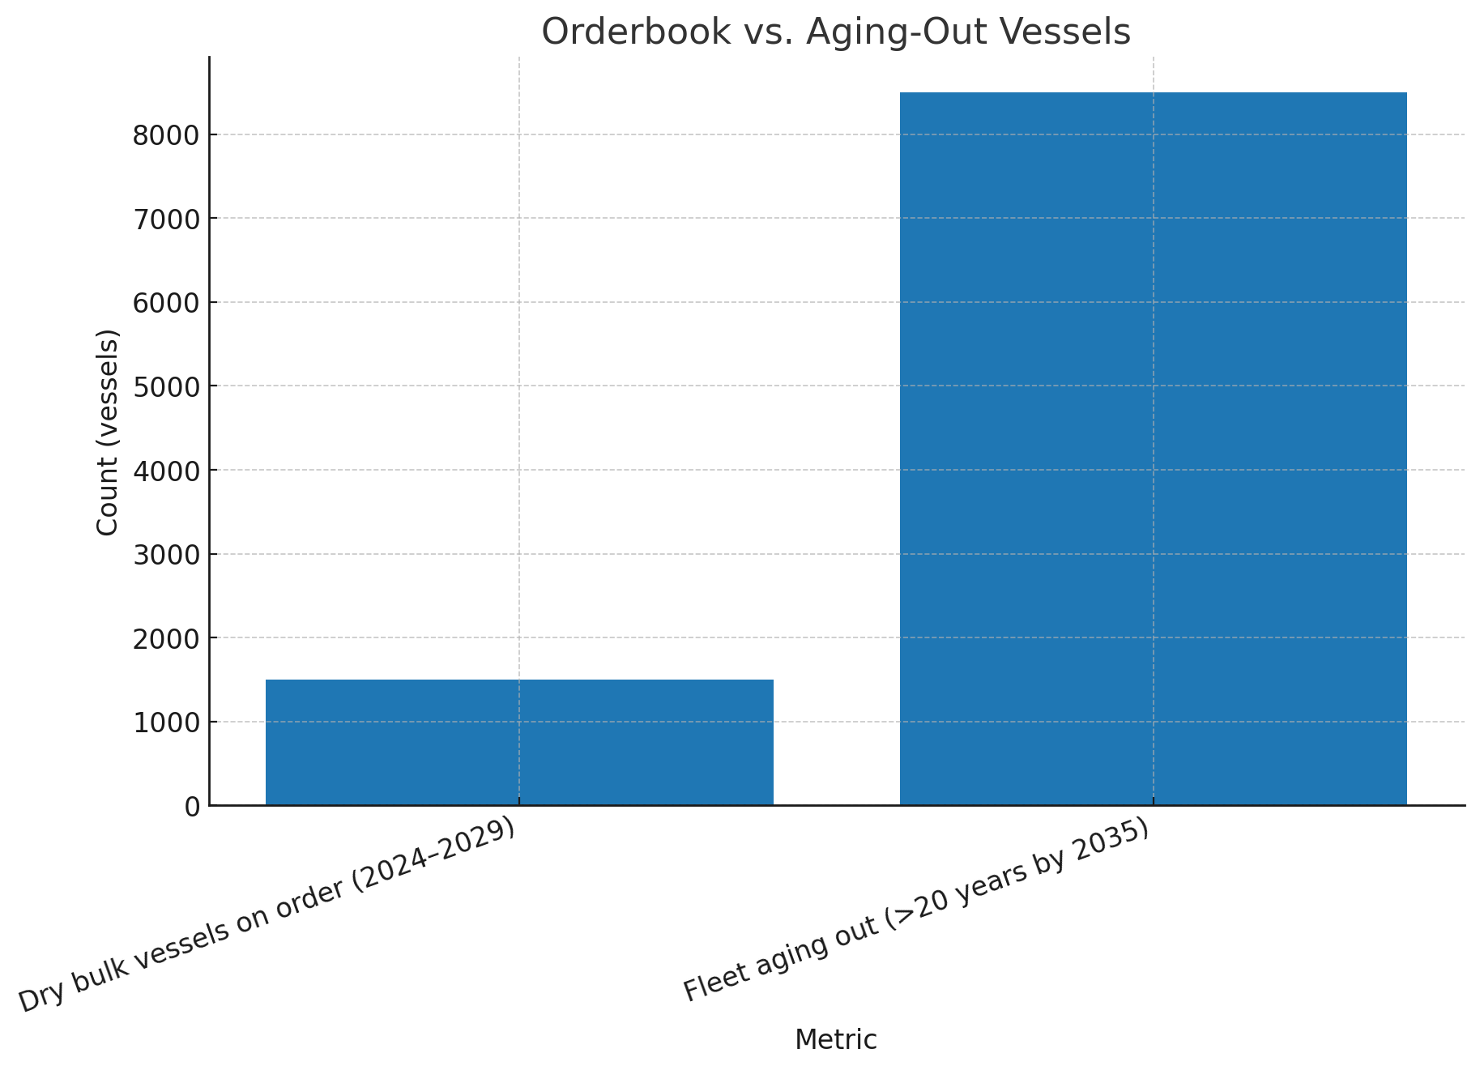
Figure D2. Orderbook (2024–2029) vs. vessels aging out (>20 years by 2035).

Appendix E: Financing Markets – Indicative Terms (US, Japan & Global Hubs)

Market | Instrument | LTV | Base Rate | Spread | All‑in | Tenor | Notes
United States | Bank term loan (secured) | 60–70% | SOFR | +2.25–3.50% | SOFR + 2.25–3.50% | 5–7y | Amortizing; covenants
Japan | JOLCO | Up to 100% | JPY (TONA) | Yield driven | USD‑eq. ~4–6% | 8–12y | Tax‑advantaged
Japan | Megabank term loan | 60–70% | TONA | +1.5–2.5% | TONA + 1.5–2.5% | 5–10y | Cross‑currency hedge
Japan | JBIC/NEXI loan | 70–80% | TONA | +1–2% | TONA + 1–2% | 8–12y | Policy/ECA support
Singapore | Bank loan (SORA) | 60–70% | SORA | +2.0–3.0% | SORA + 2.0–3.0% | 5–7y | Amortizing; club loans
Hong Kong | Bank loan (HIBOR) | 60–70% | HIBOR | +2.0–3.0% | HIBOR + 2.0–3.0% | 5–7y | Chinese/intl banks
Hong Kong | PRC Leasing | Up to 100% | HIBOR/USD | Yield driven | ~4.5–6.5% | 8–10y | PRC leasing arms
London | Bank syndication | 60–70% | SONIA | +2.25–3.5% | SONIA + 2.25–3.5% | 5–7y | Syndication pool
London | Private credit | 65–80% | Fixed | 8–10% | 8–10% | 3–5y | Funds; covenant‑light
Dubai | Islamic finance | 70–80% | SOFR/USD | 6–8% | 6–8% | 5–7y | Sharia‑compliant
Dubai | Regional bank loan | 60–70% | SOFR | +3–4% | SOFR + 3–4% | 5–7y | Regional banks
Geneva | Commodity trade loan | 60–70% | SOFR/SONIA | +2.5–3.5% | SOFR/SONIA + 2.5–3.5% | 5–7y | Cargo/vessel‑backed
Geneva | Private trade finance | 65–80% | Fixed | 7–9% | 7–9% | 3–5y | Trade funds

Appendix F: Net Return by Financing Market (Base & Up‑Cycle Scenarios) with no escalation.

• US – Bank loans breakeven ~6%, modest margin; private credit/ABS (10–12%) negative at base, positive ≥15k/day.
• Japan – JOLCO/JBIC/NEXI/megabanks 4–5%, +3–4% spreads vs base IRR.
• Singapore / Hong Kong – positive spreads at 12.5k–15k/day, close to Japan.
• London – modest spreads, breakeven ~15k/day.
• Dubai – positive spreads only at 15k–20k/day.
• Geneva – trade loans positive at base case; private trade finance needs ≥15k/day.
Markets | Financing cost
Markets | Financing cost | HIRE PER DAY (1st year then 6.5% increase on TCE and 2% on OPEX YoY up to 15 years
Markets | Financing cost | 12000 | 13500 | 15000
Japan  Geneva | 2.50% | 13.35% | 19.91% | 26.60%
Japan  Geneva | 3.00% | 12.69% | 19.22% | 25.85%
Japan  Geneva | 3.50% | 12.03% | 18.52% | 25.09%
Singapore | 4.00% | 11.35% | 17.82% | 24.33%
Singapore | 4.50% | 10.67% | 17.11% | 23.57%
Singapore | 5.00% | 9.99% | 16.40% | 22.80%
Hong Kong  US | 5.50% | 9.29% | 15.69% | 22.04%
Hong Kong  US | 6.00% | 8.59% | 14.98% | 21.28%
Hong Kong  US | 6.50% | 7.89% | 14.26% | 20.51%
London  Dubai | 7.00% | 7.17% | 13.54% | 19.75%
London  Dubai | 7.50% | 6.45% | 12.82% | 18.98%
London  Dubai | 8.00% | 5.73% | 12.09% | 18.22%
London Private Credit  ABS  Geneva Private Credit | 8.50% | 4.99% | 11.36% | 17.46%
London Private Credit  ABS  Geneva Private Credit | 9.00% | 4.25% | 10.63% | 16.70%
London Private Credit  ABS  Geneva Private Credit | 9.50% | 3.50% | 9.89% | 15.94%
London Private Credit  ABS  Geneva Private Credit | 10.00% | 2.74% | 9.16% | 15.18%

Hire Rate (USD/day) | Market | Equity IRR (%) | Cost of Finance (%) | Net Spread (%)
12000 | US | 7.89 | 6.50 | 1.39
12000 | Japan | 12.69 | 3.00 | 9.39
12000 | Singapore | 10.67 | 4.50 | 6.17
12000 | Hong Kong | 9.29 | 5.50 | 3.79
12000 | London | 7.17 | 7.00 | 0.17
12000 | Dubai | 6.45 | 7.50 | -1.05
12000 | Geneva | 12.03 | 3.50 | 8.67
13500 | US | 14.26 | 6.50 | 7.76
13500 | Japan | 19.22 | 3.00 | 16.22
13500 | Singapore | 17.11 | 4.50 | 12.61
13500 | Hong Kong | 15.69 | 5.50 | 10.19
13500 | London | 13.54 | 7.00 | 6.54
13500 | Dubai | 12.82 | 7.50 | 5.32
13500 | Geneva | 18.52 | 3.50 | 15.02
15000 | US | 20.51 | 6.50 | 14.01
15000 | Japan | 25.85 | 3.00 | 22.85
15000 | Singapore | 23.57 | 4.50 | 21.07
15000 | Hong Kong | 22.04 | 5.50 | 16.54
15000 | London | 19.75 | 7.00 | 12.75
15000 | Dubai | 18.98 | 7.50 | 11.48
15000 | Geneva | 25.09 | 3.50 | 21.59

Appendix G: Valuation Tear‑Sheet (Summary by Hub & Scenario)
Hire Rate (USD/day) | Market | Equity IRR (%) | Cost of Finance (%) | Net Spread (%)
12000 | US | 7.89 | 6.50 | 1.39
12000 | Japan | 12.69 | 3.00 | 9.39
12000 | Singapore | 10.67 | 4.50 | 6.17
12000 | Hong Kong | 9.29 | 5.50 | 3.79
12000 | London | 7.17 | 7.00 | 0.17
12000 | Dubai | 6.45 | 7.50 | -1.05
12000 | Geneva | 12.03 | 3.50 | 8.67
13500 | US | 14.26 | 6.50 | 7.76
13500 | Japan | 19.22 | 3.00 | 16.22
13500 | Singapore | 17.11 | 4.50 | 12.61
13500 | Hong Kong | 15.69 | 5.50 | 10.19
13500 | London | 13.54 | 7.00 | 6.54
13500 | Dubai | 12.82 | 7.50 | 5.32
13500 | Geneva | 18.52 | 3.50 | 15.02
15000 | US | 20.51 | 6.50 | 14.01
15000 | Japan | 25.85 | 3.00 | 22.85
15000 | Singapore | 23.57 | 4.50 | 21.07
15000 | Hong Kong | 22.04 | 5.50 | 16.54
15000 | London | 19.75 | 7.00 | 12.75
15000 | Dubai | 18.98 | 7.50 | 11.48
15000 | Geneva | 25.09 | 3.50 | 21.59
Figure G1. Tear‑sheet: Net Spreads by Hub across 12k / 13.5k / 15k scenarios
Hire Rate: $12000 per day 1st year thereafter escalation of 6.5% in TCE and 2.0% in OPEX YoY for 15 years

Hire Rate: $13500 per day 1st year thereafter escalation of 6.5% in TCE and 2.0% in OPEX YoY for 15 years

Hire Rate: $15000 per day 1st year thereafter escalation of 6.5% in TCE and 2.0% in OPEX YoY for 15 years

Appendix H: Current Benchmark Interest Rates (as of September 2025)
Figure H1. Comparative benchmark interest rates plus spread across major hubs (including Dubai and Geneva).

Table H1: Benchmark Interest Rates (as of September 2025)
The following 12 M benchmark with reference rates provide context for the financing assumptions applied in this study:
• SOFR (Secured Overnight Financing Rate, US) – ~3.58% (CME Term SOFR September 12, 2025).
• TONA (Tokyo Overnight Average Rate, Japan) – ~0.80% (OIS, JPY TONA 12M, September 12, 2025).
• LIBOR (London Interbank Offered Rate, USD) – Fully discontinued as of September 2024; legacy levels (2023–2024) were ~4.8–5.0% for 1M–3M tenors.
• SONIA (Sterling Overnight Index Average, UK) – ~4.28% (via ICE/FTSE, September 12, 2025).
• HIBOR (Hong Kong Interbank Offered Rate, 1M) – ~3.286% (HKAB, September 15, 2025).
• SORA (Singapore Overnight Rate Average) – ~1.86% 6 month (MAS, September 12, 2025).
• EIBOR (Emirates Interbank Offered Rate) – ~3.98% (UAE banks published fixings, September 12, 2025).
• SARON (Swiss Average Rate Overnight) – ~0.428% (Benchmark Administrator, Six, September 05, 2025).

These rates are indicative and vary slightly by tenor. They contextualize the financing spreads and IRR modeling assumptions, demonstrating how funding costs differ across jurisdictions. With LIBOR discontinued, SONIA, SOFR, TONA, SORA, and HIBOR have become the principal benchmarks shaping shipping finance globally.

Appendix I: Benchmark + Spread → All‑in Financing Costs
Benchmark | Base Rate | Typical Spread | Indicative All‑in Cost
SOFR (US) | 3.58% | +2.5–3.5% | 6.08–7.08%
TONA (Japan) | 0.80% | +1.5–2.5% | 2.30–3.30%
SONIA (UK) | 4.40% | +2.25–3.5% | 6.65–7.90%
HIBOR (HK) | 3.20% | +2.0–3.0% | 5.20–6.20%
SORA (Singapore) | 1.86% | +2.0–3.0% | 3.86–4.86%
EIBOR (Dubai) | 3.98% | +3.0–4.0% | 6.98–7.98%
SARON (Geneva) | 0.45% | +2.5–3.5% | 2.95–3.95%

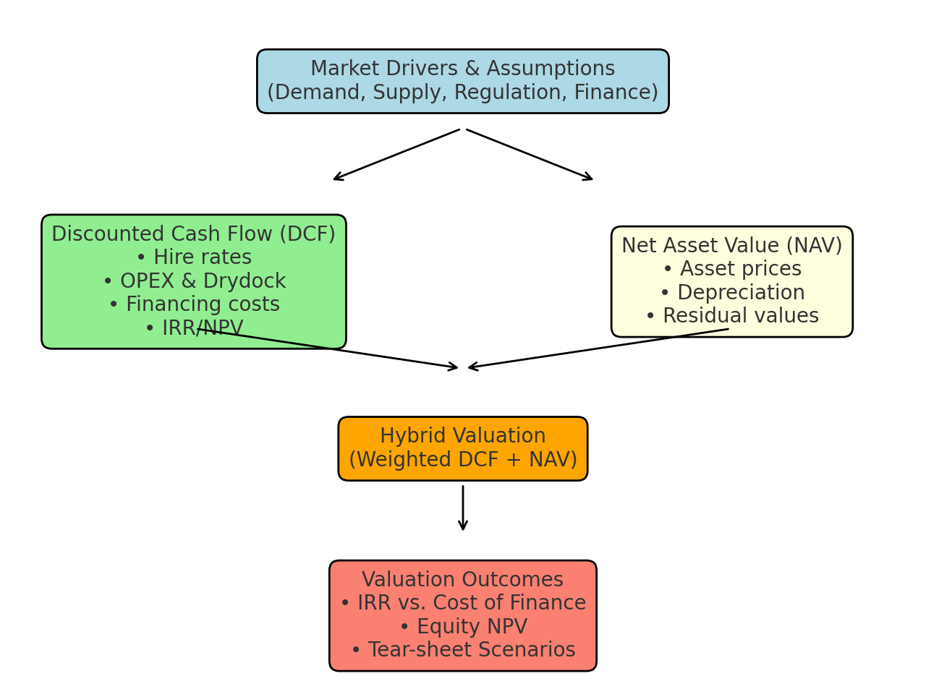

Appendix K: IRR without escalation in TCE and OPEX for various TCE for 15 years.

During the 2004-2008 super cycle Supramax were fixed at USD 25000 per day for 5 years period, considering 42k modern handies at par or slight better and prolonged super cycle based on the assumed drivers repeat of such rates are realistic.

IRR TABLE
IRR TABLE |  | Hire per day
IRR TABLE | #N/A | 15000 | 18000 | 21000 | 24000 | 27000 | 30000
INT RATE | 2.50% | 6.17% | 23.39% | 42.15% | 66.07% | 99.22% | 148.79%
INT RATE | 3.00% | 4.87% | 22.19% | 40.71% | 64.16% | 96.48% | 144.53%
INT RATE | 3.50% | 3.51% | 20.97% | 39.26% | 62.24% | 93.76% | 140.34%
INT RATE | 4.00% | 2.07% | 19.73% | 37.82% | 60.34% | 91.06% | 136.21%
INT RATE | 4.50% | 0.55% | 18.47% | 36.37% | 58.45% | 88.40% | 132.15%
INT RATE | 5.00% | -1.08% | 17.20% | 34.91% | 56.56% | 85.76% | 128.16%
INT RATE | 5.50% | -2.85% | 15.90% | 33.46% | 54.69% | 83.15% | 124.24%
INT RATE | 6.00% | -4.78% | 14.58% | 32.00% | 52.83% | 80.57% | 120.39%
INT RATE | 6.50% | -6.96% | 13.24% | 30.54% | 50.98% | 78.02% | 116.61%
INT RATE | 7.00% | -9.48% | 11.87% | 29.09% | 49.14% | 75.51% | 112.91%
INT RATE | 7.50% | -12.55% | 10.46% | 27.62% | 47.32% | 73.03% | 109.28%
INT RATE | 8.00% | -16.65% | 9.02% | 26.16% | 45.51% | 70.58% | 105.72%
INT RATE | 8.50% | -23.62% | 7.53% | 24.69% | 43.72% | 68.17% | 102.23%
INT RATE | 9.00% | #N/A | 5.98% | 23.22% | 41.94% | 65.79% | 98.82%
INT RATE | 9.50% | #N/A | 4.37% | 21.74% | 40.18% | 63.45% | 95.47%
INT RATE | 10.00% | #N/A | 2.69% | 20.26% | 38.43% | 61.14% | 92.20%

Appendix L: Special note on Indian IPOs and Indian investors.
Disclaimer: The following discussion is purely speculative, based on publicly available information, and does not represent the views or strategies of Tata Capital or the Tata Group.

Tata Capital IPO and the Perceived Shipping Angle

The Tata Capital IPO is set to capture strong investor interest, thanks to the Group’s reputation and Tata Capital’s presence in consumer finance, wholesale lending, wealth management, and infrastructure finance. While the IPO is primarily a financial services story, there is a perceived shipping angle that may emerge from the Group’s integrated supply chain requirements.

Shipping within the Tata Ecosystem

Tata Group companies such as Tata Steel, Tata International, Tata Power and Tata Chemicals are heavily dependent on maritime logistics for global trade flows. Historically, Tata NYK Shipping has been a key player, with Integrated Shipping Logistics (ISL) also connected to the Group’s wider shipping ecosystem.

Looking forward, possible scenarios could include:

- ISL being absorbed into Tata NYK.
- Both Tata NYK and ISL being placed under a broader umbrella structure.
- Tata Capital supporting financing structures for logistics consolidation.
- Potential partnerships with external shipping players, creating joint platforms to strengthen freight procurement and vessel ownership.

These scenarios are speculative but consistent with global industry trends of integration and financing-led consolidation.

Financing Flexibility

Shipping remains capital-intensive, requiring funding for vessels, charters, and working capital. Here, Tata Capital could step in:

- By funding Tata Steel and related group entities, Tata Capital indirectly strengthens their freight position.
- If Tata Steel later acquires shipping assets, declarations are not immediately required under relevant laws, allowing strategic flexibility.
- This makes Tata Capital a key enabler without the Group needing to list or directly promote a shipping IPO.

Investor Perspective: Shipping vs. Finance

Indian investors have historically been cautious about shipping IPOs because of:

- Low freight rates in the current market.
- Cyclical volatility makes earnings unpredictable.
- Long-term nature of shipping returns, dependent on trade cycles.

By comparison, the Indian equity market often provides stable ~12% returns, making the Tata Capital IPO a safer and more attractive option. This difference is central to investor decision-making.

IRR Sensitivity: Equity raised via Tata Capital and external debt from external financial markets.

Base Case $12,000/day 13,500/day and 15,000/day with 6.5% escalation in TCE and 2% OPEX YOY for 15 years, 70% LTV, 6% debt, 30% Equity raised by Tata Steel through Tata Capital at 9% finance, effective WACC 6.7%)

Markets | Interest | TCE (USD)
Markets | Interest | 12000 | 13500 | 15000
Japan  Geneva | 2.50% | 13.35% | 19.91% | 26.60%
Japan  Geneva | 3.00% | 12.69% | 19.22% | 25.85%
Japan  Geneva | 3.50% | 12.03% | 18.52% | 25.09%
Singapore | 4.00% | 11.35% | 17.82% | 24.33%
Singapore | 4.50% | 10.67% | 17.11% | 23.57%
Singapore | 5.00% | 9.99% | 16.40% | 22.80%
Hong Kong  US | 5.50% | 9.29% | 15.69% | 22.04%
Hong Kong  US | 6.00% | 8.59% | 14.98% | 21.28%
Hong Kong  US | 6.50% | 7.89% | 14.26% | 20.51%
London  Dubai | 7.00% | 7.17% | 13.54% | 19.75%
London  Dubai | 7.50% | 6.45% | 12.82% | 18.98%
London  Dubai | 8.00% | 5.73% | 12.09% | 18.22%
London Private Credit  ABS  Geneva (Private Trade Finance) | 8.50% | 4.99% | 11.36% | 17.46%
London Private Credit  ABS  Geneva (Private Trade Finance) | 9.00% | 4.25% | 10.63% | 16.70%
London Private Credit  ABS  Geneva (Private Trade Finance) | 9.50% | 3.50% | 9.89% | 15.94%
London Private Credit  ABS  Geneva (Private Trade Finance) | 10.00% | 2.74% | 9.16% | 15.18%
note: All in financial cost for various markets is not accurate and updated and for reference only. Spread would vary depending upon credit ratings of borrower.
Sensitivity table is taking into consideration that the above TCE would be for 15 years to calculate IRR.
IRR and DCF are for resale ex yard or tonnage less than 3 years

The IRR sensitivity analysis assumes a 70/30 debt–equity ratio with financing costs benchmarked across multiple markets. This provides a useful comparative picture of how shipping returns vary with TCE and interest rates.

However, if Tata Capital funds Tata Steel directly, those loans would likely carry a financing cost in the 9–12% range. This implies that the Weighted Average Cost of Capital (WACC) for any shipping-related investment would not remain static — it would shift based on:

- The precise debt–equity structure adopted at the project level.
- The source of external debt (domestic-ILFS, Gift City vs. overseas markets).
- The rate at which Tata Capital intermediates funds to Tata Steel.

The IRR sensitivity table highlights the stark contrast:

- Shipping IRR can swing dramatically with Time Charter Equivalent (TCE) rates and interest costs — highly profitable in upcycles but vulnerable in downcycles.
- Tata Capital IRR is steadier, driven by lending spreads and financial products, giving investors’ confidence in more predictable returns.

This comparison explains why many Indian investors may prefer participating in Tata Capital rather than a volatile shipping IPO, at least in the near term.

Illustrative DCF Cash Flow
Year Revenue OPEX Dry-dock Interest Principal Equity FCF
1 4,375,000 1,825,000 250,000 1,641,500 997,722 -505,889
2 4,659,375 1,861,500 250,000 1,574,653 1,064,570 -258,014
3 4,962,234 1,898,730 250,000 1,503,326 1,135,896 7,615
4 5,284,780 1,936,705 250,000 1,427,221 1,212,001 292,186
5 5,628,290 1,975,439 250,000 1,346,017 1,293,205 596,963
6 5,994,129 2,014,947 250,000 1,259,373 1,379,850 923,293
7 6,383,748 2,055,246 250,000 1,166,923 1,472,300 1,272,612
8 6,798,691 2,096,351 250,000 1,068,279 1,570,944 1,646,451
9 7,240,606 2,138,278 250,000 963,025 1,676,197 2,046,439
10 7,711,245 2,181,044 250,000 850,720 1,788,502 2,474,313
11 8,212,476 2,224,665 250,000 730,891 1,908,332 2,931,923
12 8,746,287 2,269,158 250,000 603,032 2,036,190 3,421,240
13 9,314,796 2,314,541 250,000 466,608 2,172,615 3,944,366
14 9,920,258 2,360,832 250,000 321,042 2,318,180 4,503,537
15 10,565,075 2,408,049 250,000 165,724 2,473,498 5,101,137

Conclusion

The Tata Capital IPO is primarily about expanding financial services, but it also carries a perceived shipping angle. Whether through consolidation of Tata NYK and ISL, financing Tata Steel’s trade flows, or even partnering with external shipping players, Tata Capital could indirectly support the Group’s maritime needs.

For investors, the IPO represents stability with a possible long-term strategic upside in shipping — without exposing them to the direct volatility of freight markets.

