Supplementary Materials

Supplementary Methods
DPX-Survivac Treatment
Briefly, DPX-Survivac was formulated by combining the following peptides: SurA1.T (FTELTLGEF), SurA2.M (LMLGEFLKL), SurA3.K (RISTFKNWPK), SurA24 (STFKNWPFL), and SurB7 (LPPAWQPFL), and the tetanus toxin universal T-helper peptide TT_{830–843}(AQYIKANSKFIGITEL; A16L). DPX-Survivac was resuspended in Montanide ISA 51 VG (SEPPIC, France).
CD8⁺ Cytotoxic T Lymphocyte (CTL) Isolation & Labeling
Myeloid Cell (MC) Isolation & Labeling

Immunohistochemistry

Supplementary Figures

Target | Use | Fluorescent Tag
CD3 | CTL labelling | APC
CD4 | CTL labelling | PerCP
CD8 | CTL labelling | BV510
Anti-PD-1 | CTL labelling | APCef780
Anti-CTLA-4 | CTL labelling | BV421
Anti-TIM3 | CTL labelling | PE
Ki67 | CTL labelling | AF488
CCR7 | CTL labelling | PE-Cy7
Survivin-Dextramer | CTL labelling | PE
CD11c | MC labelling | APC780
CD11b | MC labelling & TIL analysis | PE
F4/80 | MC labelling | Cy5.5
MHCII | MC labelling | BV510
CD8 | MC labelling & Ascites analysis | FITC
CD19 | TIL analysis | BV650
F4/80 | TIL analysis & Ascites Analysis | FITC
CD45 | TIL analysis | PerCP
CD8 | TIL analysis | APC
CD3 | TIL analysis | APCef780
CD11c | TIL analysis | BV605
CD25 | TIL analysis | BV515
CD3 | Ascites analysis | PerCP
CD4 | Ascites analysis | PE
CD45 | Ascites analysis | APC
CD11c | Ascites analysis | PE

Supplementary Table 1: Fluorescent Antibodies Used.

Supplementary Figure 1. Survival curve. Kaplan-Meier curve of survival for both untreated and treated mice. There was no significant difference in survival between the two groups, however the experiment was terminated at day 56 regardless of mice status so a true survival comparison was not possible.

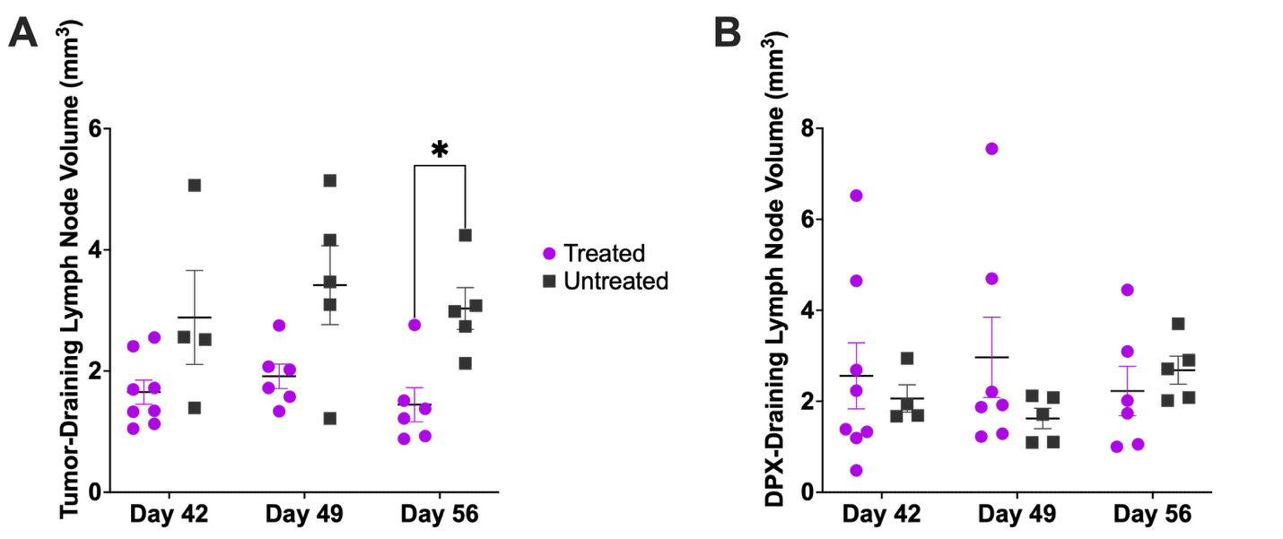

Supplementary Figure 2. Inguinal Lymph Node Volumes. Lymph nodes were quantified at each time point (days 42, 49, and 56 post-MOSE-implant) by hand-drawing the region of interest. (A) Quantified lymph node volumes for (A) Tumor-draining lymph node (left lymph node) B) DPX-draining lymph node (right lymph node). Volumes of Tumor-Draining lymph node were found to be significantly different due to treatment using a mixed effects analysis (p<0.001). Data were pooled from three separate experiments, average +/- SEM, n=5-14, Student’s t test, *p $≤$ 0.05.

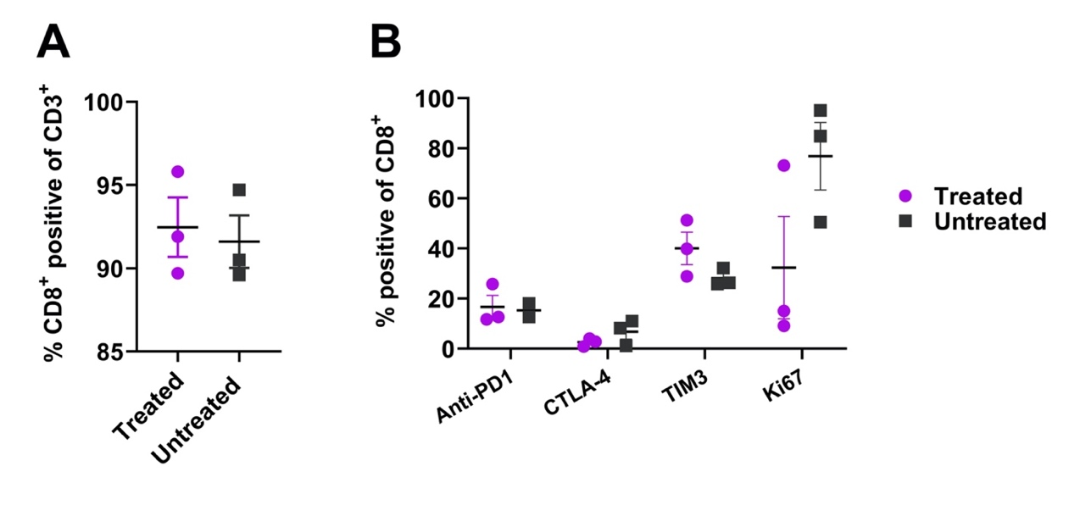
Supplementary Figure 3. Phenotyping of cytotoxic T lymphocytes. Flow cytometric analysis of cytotoxic T lymphocytes isolated and proliferated from inguinal lymph nodes. A) Percentage of CD3+CD8+ T cells, B) Percentage of various T cell markers on CD8+ T cells. Cultures were analyzed from both treated (n = 3) and untreated (n = 3) mice with individual values and average +/- SEM shown. Samples were gated to remove debris and as otherwise indicated on graphs. There were no statistically significant differences between cultures from treated and untreated mice. Analysis of SPIO-labeled vs unlabeled CTLs can be found in previous work done in ²¹.

Supplementary Figure 4. IHC of CD8+ T cells and CD11+ myeloid cells in lymph nodes sections. IHC of CTLs (top) or MCs (bottom) in lymph node sections from untreated mice. Far left panel is the individual cell label. Cells were tested separately and either CD8+ or CD11b+ cells were labeled with Alexa 633. Second left panel is the SPIO-Rhodamine B tag (Rod B). All cells that have taken up SPIO will have this fluorescent tag. Third panel is the DAPI stain of nuclei. Far right panel is the combination of all 3 colors. IHC demonstrates strong localization of injected cell type and SPIO-rhodamine B. Green arrows indicate some sample cells of interest. Size bar is visible in 4th panel.

