SI Files
Co-Sputtered CuNi Heteroatomic Electrocatalyst For Enhance 5-Hydroxymethylfurfural Selective Electrochemical Conversion
Moumita Dikshit^{a#}, Baleeswaraiah Muchharla^{b#}, Luz Vazquez Rivera ^{b} , Kapil Kumarª, Sunita Sanwaria^{c}, Kishor Kumar Sadasivuni^{d}, Abdennaceur Karoui^{b}, Sandeep Kumar^{e}. Adetayo Adedeji^{b}, Bijandra Kumar^{b*}
ª Laboratory of Environmental Sustainability and Energy Research (LESER), National Institute of Technology Delhi, New Delhi, 110036 India
^{b} Department of Math. Comp. Science and Eng. Technology, Elizabeth City State University, Elizabeth City, NC 27909 USA
^{c} Government Nagarjuna Post Graduate College of Science, Raipur 492010, Chhattisgarh, India
^{d} Center for Advanced Materials, Qatar University, PO Box 2713, Doha, Qatar
^{e} Biomass Research Laboratory (BRL), Old Dominion University, Norfolk, VA, United States
# equal contributions

Co-Sputtered CuNi Heteroatomic Electrocatalyst For 5-Hydroxymethylfurfural to 2,5-Bis-hydroxymethylfuran Selective Electrochemical Conversion

Figure S1. Schematic of co-sputtering set-up for CuNi sample preparation.

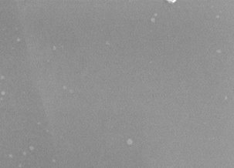

Figure S2. SEM image of pristine polished Cu. Scale bar on SEM images is 250 nm.

Table S1. Composition of the as-prepared sputtered catalysts.
 | Sample | Cu at% | Ni at%
1. | Cu | 100 | 0
2. | Cu98_3Ni1_7 | 26.675 | 0.4725
3. | Cu88Ni12 | 15.58 | 2.133333
4. | Cu64Ni36 | 6.86 | 3.8633
5. | Ni | 0 | 100

Figure S3. X-ray photoelectron spectroscopy (XPS) survey scan spectrum of Cu.

Figure S4. XPS survey scan spectrum of Cu_{98.3}Ni_{1.7}.

Figure S5. XPS survey scan spectrum of Cu₈₈Ni₁₂.

Figure S6. XPS survey scan spectrum of Cu₆₄Ni₃₆.
Figure S7. XPS survey scan spectrum of Ni.

Figure S8. Two compartment electrochemical cell: (A) Schematic and (B) experimental cell.

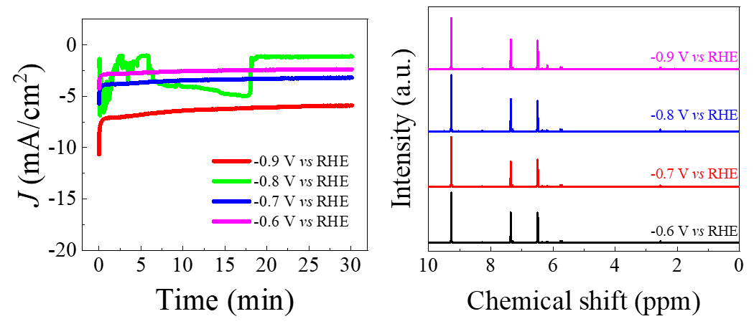
Figure S9. Ni catalyst: Chronoamperometry experiments and corresponding NMR analysis.

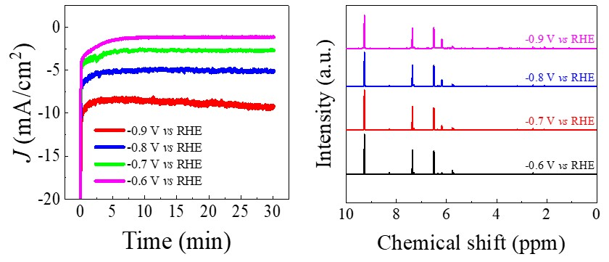

Figure S10. Cu₆₄Ni₃₆ catalyst: Chronoamperometry experiments and corresponding NMR analysis.

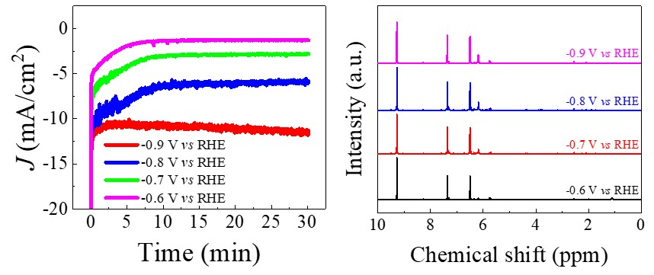
Figure S11. Cu₈₈Ni₁₂ catalyst: Chronoamperometry experiments and corresponding NMR analysis.
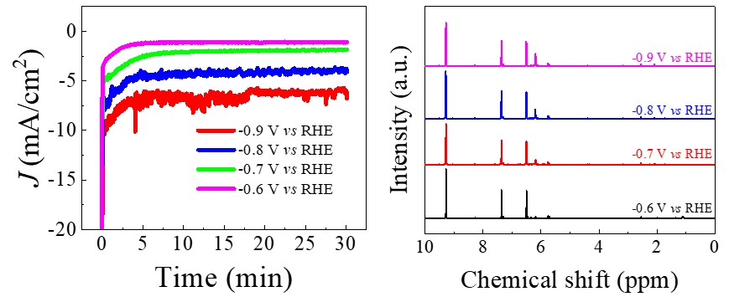
Figure S12. Cu_{98.3}Ni_{1.7} catalyst: Chronoamperometry experiments and corresponding NMR analysis.

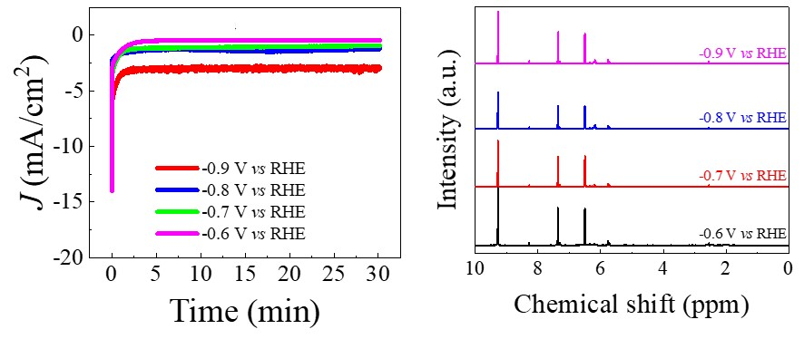
Figure S13. Cu catalyst: Chronoamperometry experiments and corresponding NMR analysis.

Figure S14. Ratio of NMR peaks; A₂ (associated to BHMF) to A (associated to HMF) NMR peaks for (A) (A) Ni, (B) Cu₆₄Ni₃₆, (C) Cu₈₈Ni₁₂, (D) Cu_{98.3}Ni_{1.7} thin films, and (E) Cu foil and (F) comparison of peaks recorded at 0.9V vs RHE for all catalysts.

Figure S15. Representative NMR data of the products collected at 0.9 V vs RHE for different catalysts.

Hydroegn Faradaic Efficiency Calculation
Calculation of Faradaic Efficiency (%) of H₂:
e_{Output} = No. of moles of electrons required for reducing CO₂ to H₂
= 2* H₂ moles produced

e_{Input} = I (A) * t /(6.022*10²³*1.602*10⁻¹⁹)
I (A) = recorded current in amp
t (s) = the time required to fill the sampling loop= V/r/60
V= volume of sampling loop (cm³)
r = recorded flow rate (sccm) = r/60 (cm³/s)

Faradaic efficiency = Output/input *100%
Similary the BHMF FEs were calculated using NMR calibration curve.

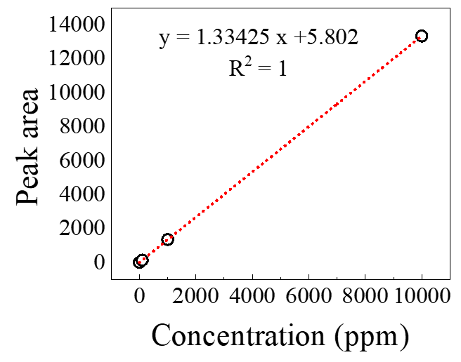
Figure S16. The provided figure represents a hydrogen calibration graph obtained via plotting the hydrogen concentration (or amount) and the corresponding detector response (peak area) in gas chromatography.

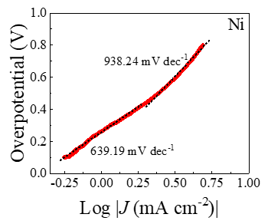
Figure S17. Tafel slop for Ni Catalyst in electrolyte without HMF..
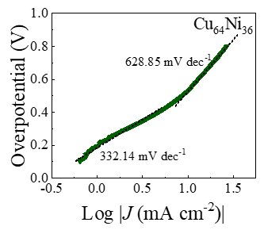
Figure S18. Tafel slop for Cu₆₄Ni₃₆ catalyst in electrolyte without HMF.

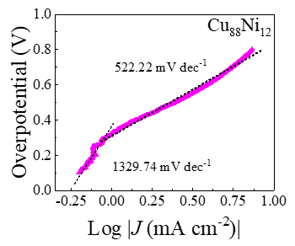
Figure S19. Tafel slop for Cu₈₈Ni₁₂ catalyst in electrolyte without HMF.
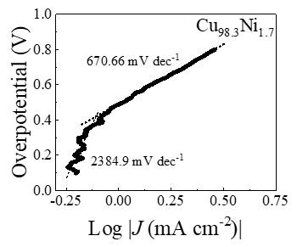
Figure S20. Tafel slop for Cu_{98.3}Ni_{1.7} catalyst in electrolyte without HMF.

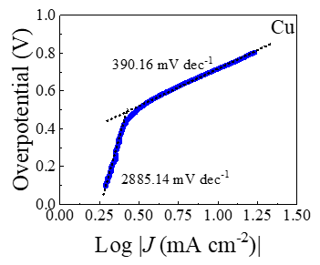
Figure S21. Tafel slop for Cu catalyst in electrolyte without HMF.

Table S2. Tafel slop analysis of the catalysts in electrolyte without HMF.
​ | Tafel slope mV/dec)​
​ | Lower potential​ | Higher potential​
Cu​ | 2885.14​ | 390.16​
Cu_{98.3}Ni_{1.7}​ | 2384.9​ | 670.66​
Cu₈₈Ni₁₂​ | 1329.74​ | 522.22​
Cu₆₄Ni₃₆​ | 332.14​ | 628.85​
Ni​ | 639.19​ | 938.24​

