Appendices A

Appendix A.1. Chemical composition of cement, metakaolin, granite dust, and dolomitic limestone
 | SiO₂ | Al₂O₃ | Fe₂O₃ | TiO₂ | CaO | MgO | SO₃ | K₂O | Na₂O | LOI
C | 23.5 | 5.7 | 3.8 | 0.2 | 58.5 | 2.6 | 2.5 | 0.6 | 0.4 | 2.1
M | 54.4 | 42.1 | 2.0 | 0.2 | 0.0 | 0.3 | 0.1 | 0.1 | 0.1 | 0.7
G | 73.0 | 13.2 | 2.9 | 0.2 | 2.1 | 1.0 | 0.2 | 4.5 | 2.7 | 0.3
L | 20.13 | 4.86 | 3.37 | 0.21 | 64.24 | 2.31 | 2.61 | 0.42 | 0.22 | 1.62

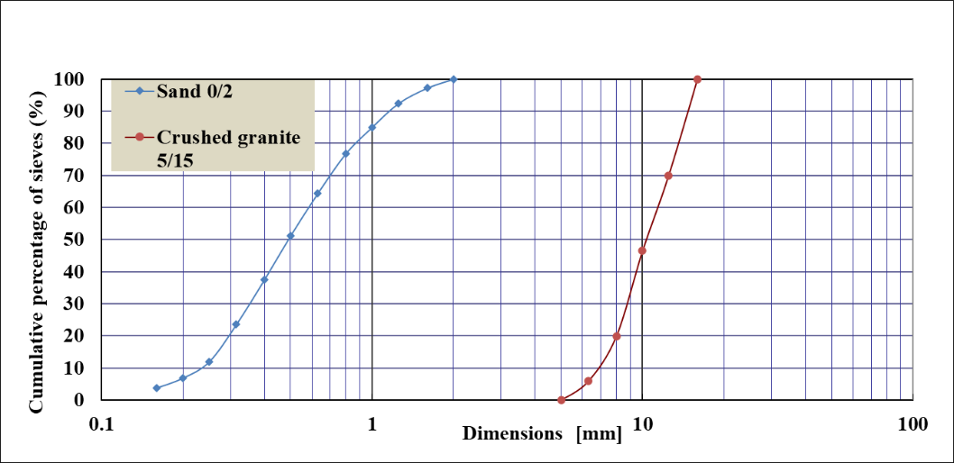

Appendix A.2. Granulometric curve of sand and gravel

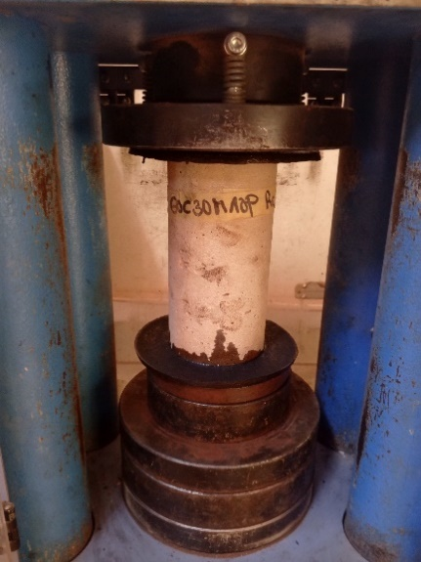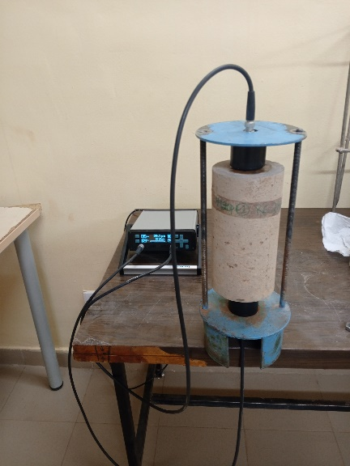
b)
a)

Appendix A.3.a) Compression test; b) pundit test : propagation of ultrasonic pulses

Appendix A.4. Environmental profile of low-carbon concrete:
- Contribution of components of the concrete containing granite powder to global warming (kg CO2 eq)
Design | Total | Cement Portland CEM I 45 MPa | MK production {BF}| | Granite Sand by-product {BF} | Gravel, crushed Granite {BF} | Sand {BF | Tap water {GLO -BF} | Plasticiser, for concrete, based on sulfonated melamine formaldehyde {GLO-BF} | Concrete mixing factory {RoW} | Synthetic rubber {GLO} | Lubricating oil {RER}| market for lubricating oil | Diesel, burned in building machine {GLO} | Electricity, medium voltage {BF} | Municipal solid waste {RoW} | Waste concrete {RoW}
C100 | 354.03 | 319.67 | 0 | 0 | 11.34 | 15.57 | 0.1233 | 2.1768 | 1.8189 | 0.3053 | 0.0246 | 0.0456 | 2.8622 | 0.0540 | 0.0451
60C30M10G | 281.64 | 212.40 | 28.23 | 0.12 | 11.34 | 15.57 | 0.1233 | 8.7072 | 0.3053 | 1.8189 | 0.0246 | 0.0456 | 2.8622 | 0.0540 | 0.0451
55C30M15G | 263.99 | 194.70 | 28.23 | 0.18 | 11.34 | 15.57 | 0.1233 | 8.7072 | 0.3053 | 1.8189 | 0.0246 | 0.0456 | 2.8622 | 0.0540 | 0.0451
50C30M20G | 247.80 | 177.00 | 28.23 | 0.24 | 11.34 | 15.57 | 0.1233 | 10.1584 | 0.3053 | 1.8189 | 0.0246 | 0.0456 | 2.8622 | 0.0540 | 0.0451
- Selected relative indicator of concrete containing granite powder (G) or dolomitic limestone (L) (%)
Indicator | C100 | 60C30M10G | 55C30M15G | 50C30M20G | 100C | 60C30M10L | 55C30M15L | 50C30M20L
Global warming | 100 | 80 | 75 | 70 | 100 | 84 | 80 | 76
Ozone formation, Human health | 100 | 85 | 82 | 78 | 98 | 100 | 98 | 96
Fine particulate matter formation | 100 | 91 | 87 | 84 | 99 | 100 | 96 | 94
Terrestrial ecotoxicity | 100 | 84 | 80 | 77 | 99 | 100 | 96 | 94
Mineral resource scarcity | 35 | 97 | 95 | 94 | 35 | 100 | 99 | 97
Water consumption | 91 | 95 | 93 | 92 | 83 | 100 | 98 | 98

