SUPPLEMENTARY INFORMATION

Label-free classification of breast cancer subtypes in ex vivo human tissues using Raman spectroscopy and machine learning

Ahmed Ezzat†, Zhiyu Zhu†, Alfie Roddan, Yingwei Hou, Nilanjan Mandal, Jiacheng Xu, Ziqi Zhang, Mengyi Zhou, Ara Darzi, Simon Dryden, Daniel R. Leff††,*, Alex J. Thompson††,*

Hamlyn Centre, Department of Surgery and Cancer, Imperial College London, London SW7 2AZ, UK
†,†† These authors contributed equally.
* Corresponding authors: d.leff@imperial.ac.uk; alex.thompson08@imperial.ac.uk

This PDF file includes:
Supplementary Figures S1-S5
Supplementary Tables S1-S2

Supplementary Figures
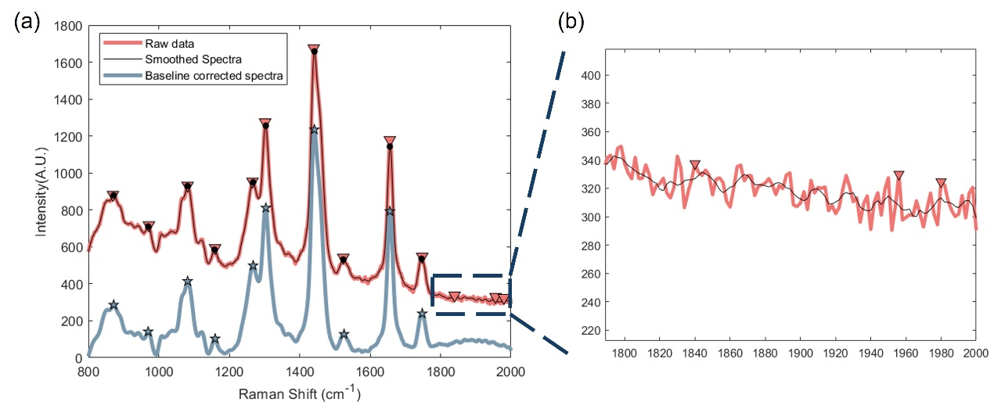
Fig. S1. Pre-processing process and background signal analysis of Raman spectra. (a) Comparison of the original spectra, the smoothed processed spectra and the baseline corrected spectra, with the marked asterisks and triangles indicating peak positions. (b) Zoom-in to show the raw and smoothed signals in the 1800-2000 cm⁻¹ region, demonstrating the effect of the smoothing.

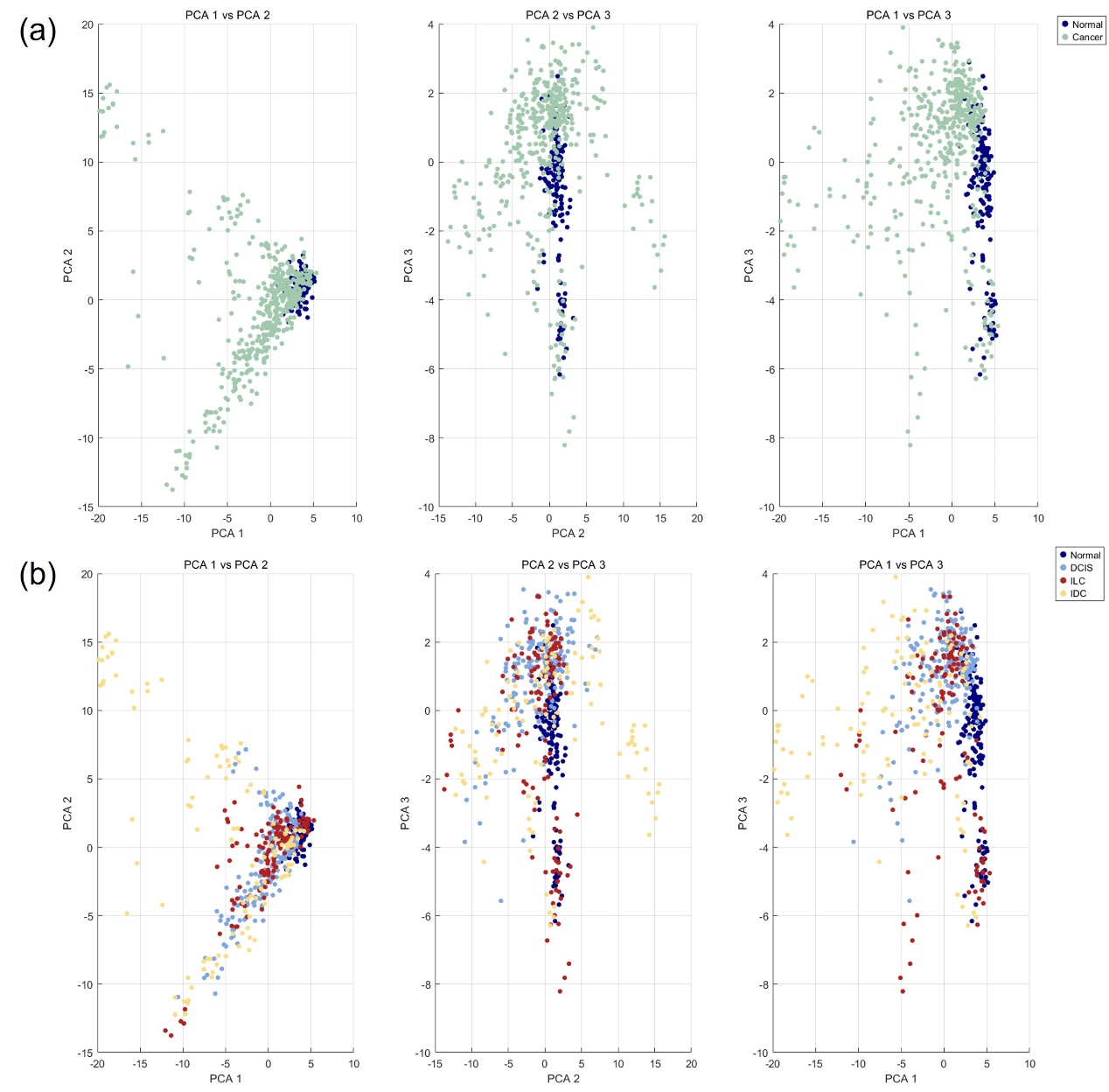
Fig. S2. Two-dimensional PCA visualization of Raman spectral data. (a) Two-class PCA results (normal and cancer) in three sets of principal component pairs (PC1 vs. PC2, PC2 vs. PC3, and PC1 vs. PC3). (b) Four-class PCA results (normal, DCIS, ILC and IDC) in the three sets of principal component pairs.

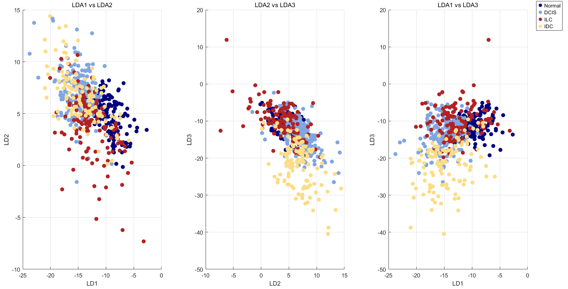
Fig. S3. LDA visualization of Raman spectral data for four-class classification. The scatter plots show the distribution of normal, DCIS, ILC and IDC samples along the first three linear discriminants (LD1 vs. LD2, LD2 vs. LD3, and LD1 vs. LD3).

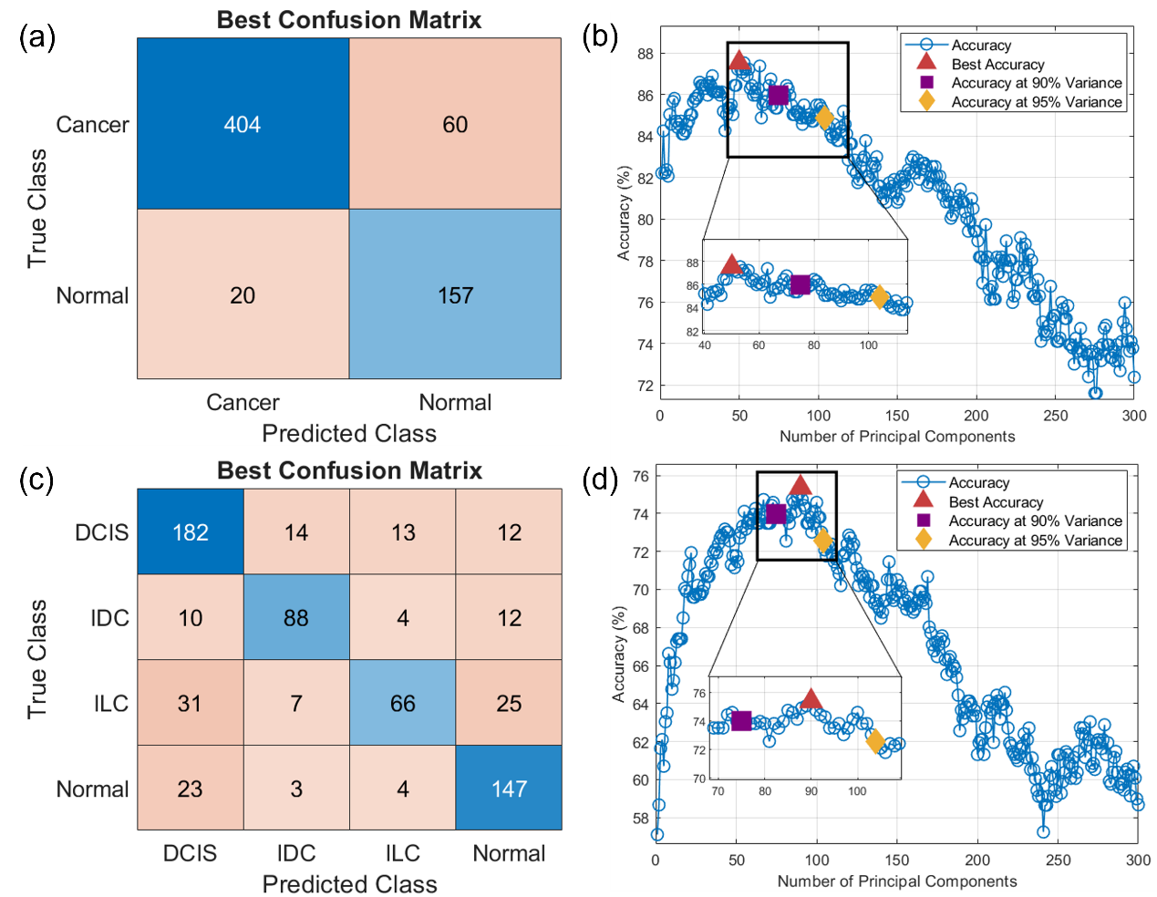
Fig. S4. LDA classification results with 10-fold cross-validation. (a) Confusion matrix for binary classification (cancer vs. normal). (b) Classification accuracy as a function of number of PCs included in classification model for the binary task. Three highlighted markers indicate best accuracy (red triangle, 50 PCs), accuracy at the number of PCs explaining 90% of the total variance (purple square, 75 PCs), and accuracy at the number of PCs explaining 95% of total variance (yellow diamond, 104 PCs). Inset plot shows detail of graph around the highlighted accuracies. (c) Confusion matrix for four-class classification. (d) Classification accuracy as a function of number of PCs included in classification model for the four-class task. Three highlighted markers indicate best accuracy (red triangle, 90 PCs), accuracy at 90% explained variance (purple square, 75 PCs), and accuracy at 95% explained variance (yellow diamond, 104 PCs). Inset plot shows detail of graph around the highlighted accuracies. Confusion matrices were calculated based on optimal model performance (using 50 PCs for two-class classification, 90 PCs for four-class classification).

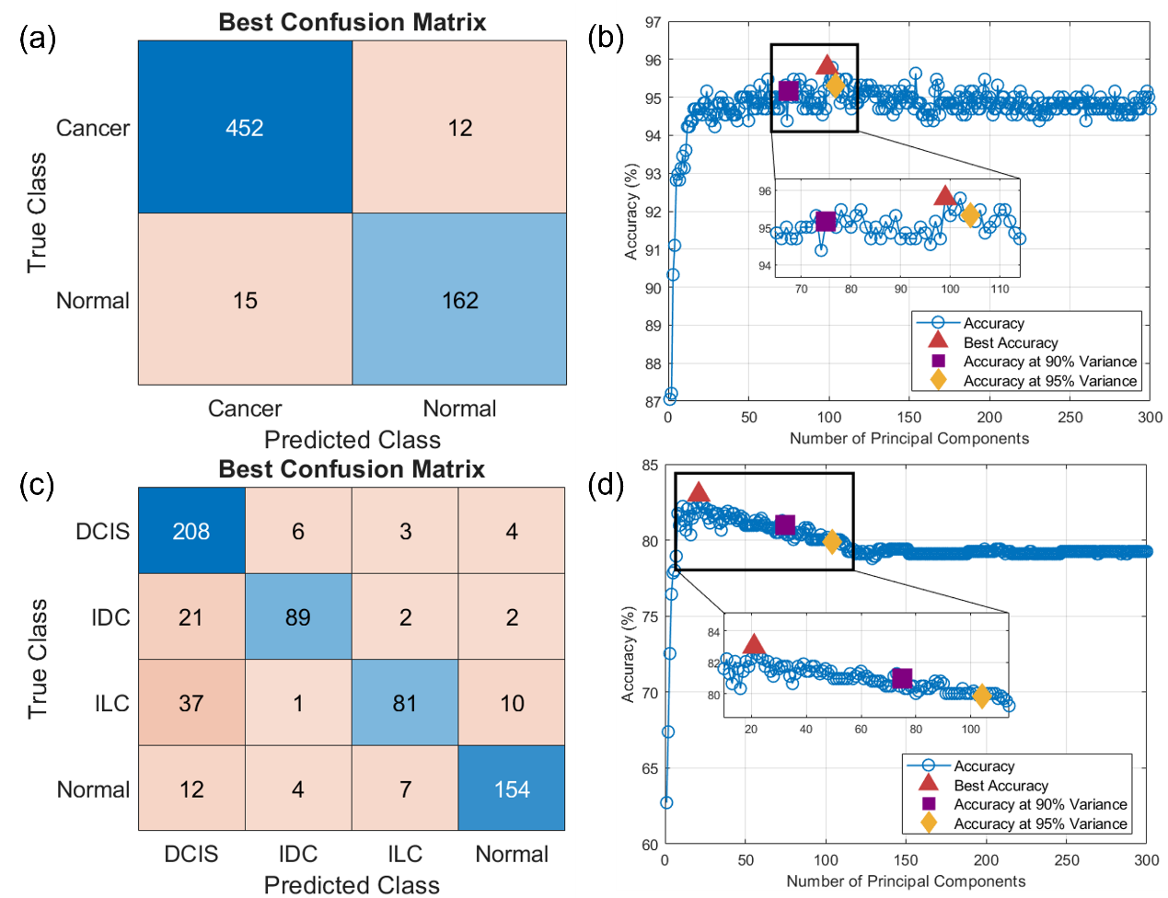
Fig. S5. SVM classification results with 10-fold cross-validation. (a) Confusion matrix for binary classification (cancer vs. normal). (b) Classification accuracy as a function of number of PCs included in classification model for the binary task. Three highlighted markers indicate best accuracy (red triangle, 99 PCs), accuracy at the number of PCs explaining 90% of the total variance (purple square, 75 PCs), and accuracy at the number of PCs explaining 95% of total variance (yellow diamond, 104 PCs). Inset plot shows detail of graph around the highlighted accuracies. (c) Confusion matrix for four-class classification. (d) Classification accuracy as a function of number of PCs included in classification model for the four-class task. Three highlighted markers indicate best accuracy (red triangle, 21 PCs), accuracy at 90% explained variance (purple square, 75 PCs), and accuracy at 95% explained variance (yellow diamond, 104 PCs). Inset plot shows detail of graph around the highlighted accuracies. Confusion matrices were calculated based on optimal model performance (using 99 PCs for two-class classification, 21 PCs for four-class classification).

Supplementary Tables
Table S1. LDA classification performance metrics for two- and four-class classification tasks, including sensitivity, specificity, precision, overall accuracy, and accuracy at the number of PCs explaining 90% and 95% of the total variance (based on 10-fold cross-validation). Metrics (except for 90/95% explained variance accuracy) were calculated based on optimal model performance (using 50 PCs for two-class classification, 90 PCs for four-class classification).
Classification Task | Classes | Sensitivity | Specificity | Precision | Total Accuracy | 90/95% Explained Variance Accuracy
Two-class | Cancer vs. Normal | 87.07% | 88.70% | 95.28% | 87.5% | 85.96% /  84.87%
Four-class | DCIS vs. Non-DCIS | 82.35% | 84.76% | 73.98% | 75.35% | 73.95% /  72.55%
Four-class | IDC vs. Non-IDC | 77.19% | 95.45% | 78.57% | 75.35% | 73.95% /  72.55%
Four-class | ILC vs. Non-ILC | 51.16% | 95.90% | 75.86% | 75.35% | 73.95% /  72.55%
Four-class | Cancer vs. Normal | 83.05% | 89.44% | 75.00% | 75.35% | 73.95% /  72.55%

Table S2. SVM classification performance metrics for two- and four-class classification tasks, including sensitivity, specificity, precision, overall accuracy, and accuracy at the number of PCs explaining 90% and 95% of total variance (based on 10-fold cross-validation). Metrics (except for 90/95% explained variance accuracy) were calculated based on optimal model performance (using 99 PCs for two-class classification, 21 PCs for four-class classification).
Classification Task | Classes | Sensitivity | Specificity | Precision | Total Accuracy | 90/95% Explained Variance  Accuracy
Two-class | Cancer vs. Normal | 97.41% | 91.53% | 96.79% | 95.79% | 95.16% /  95.32%
Four-class | DCIS vs. Non-DCIS | 94.12% | 83.33% | 74.82% | 83.00% | 80.97% /  79.88%
Four-class | IDC vs. Non-IDC | 78.07% | 97.91% | 89.00% | 83.00% | 80.97% /  79.88%
Four-class | ILC vs. Non-ILC | 62.79% | 97.66% | 87.10% | 83.00% | 80.97% /  79.88%
Four-class | Cancer vs. Normal | 87.01% | 96.55% | 90.59% | 83.00% | 80.97% /  79.88%

