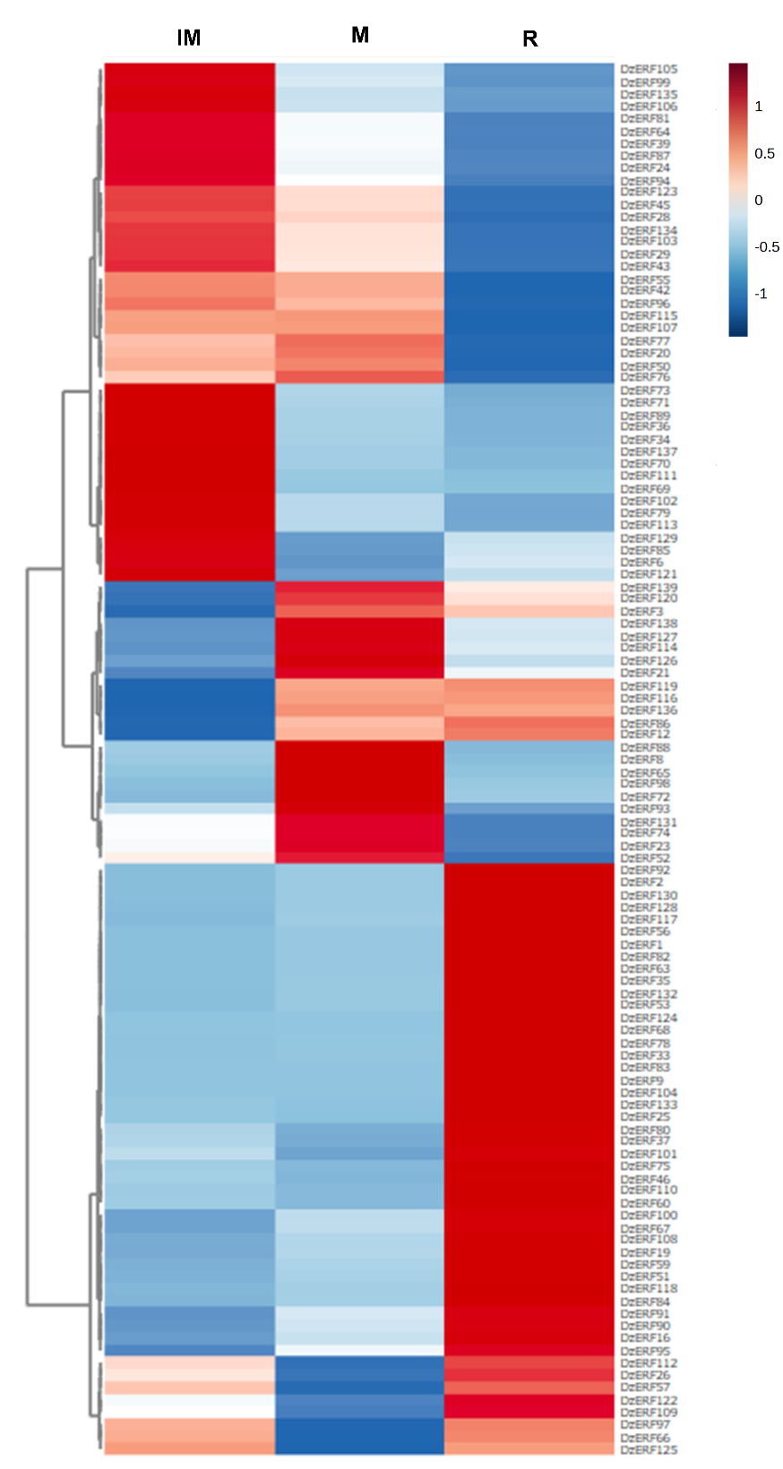
Supplementary Figure S1. Expression profiles of APETALA2/ethylene response factor genes during the developmental and ripening stages of Monthong durian pulp. The heatmap was generated using MetaboAnalyst 5.0 (Pang et al., 2021). Gene expression is presented as a color scale, with red indicating high expression and blue indicating low expression. Three biological replicates were used for each group. IM, immature stage (85 days after anthesis); M, mature/harvesting stage (105 days after anthesis); R, ripe stage (5 days after harvesting).
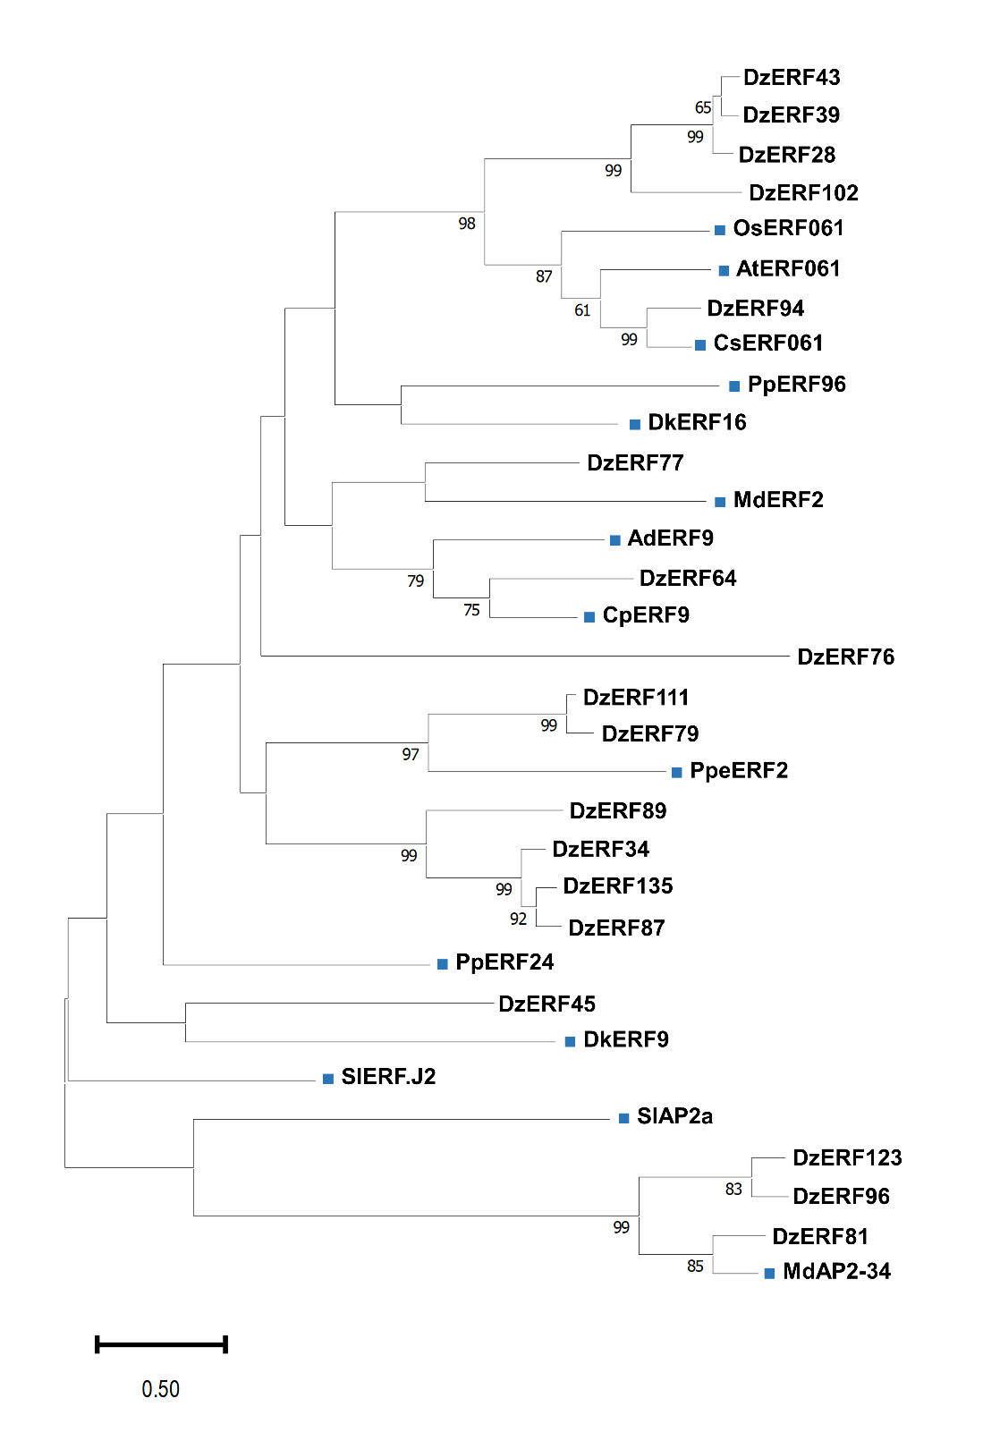
Supplementary Figure S2. Phylogenetic tree of Durio zibethinus APETALA2 (AP2)/ethylene response factor (ERF) proteins and AP2/ERF proteins from other species. ClustalW was utilized for multiple alignment, whereas MEGA 11 was employed to construct the tree using the maximum likelihood method with default parameters and 1000 replicates (Tamura et al., 2021). Blue squares (■) indicate the DzAP2/ERFs.

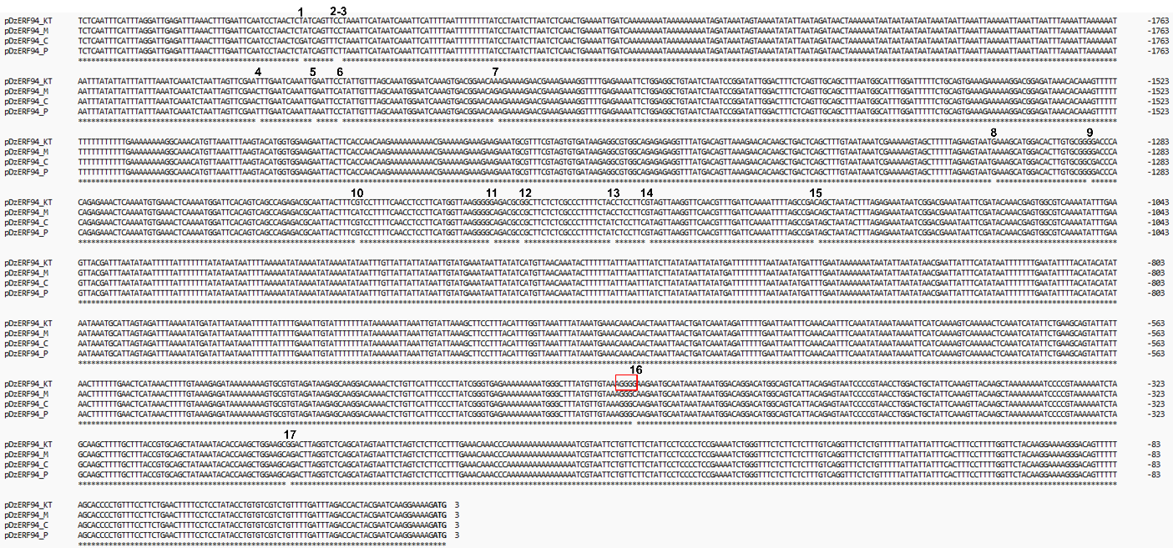
Supplementary Figure S3. Sequence alignment of DzERF94 promoter from different cultivars of durian. Multiple alignment was conducted using ClustalW with default parameters. The red box indicates the Stress Response Element (STRE) found only in the KT cultivar. The Arabic numerals indicate the Single-Nucleotide Polymorphism (SNP) numbers. The bold letters indicate the start codon of DzERF94. KT: Kathoei Nueakhao; M: Monthong; C: Chanee; P: Phuangmanee.

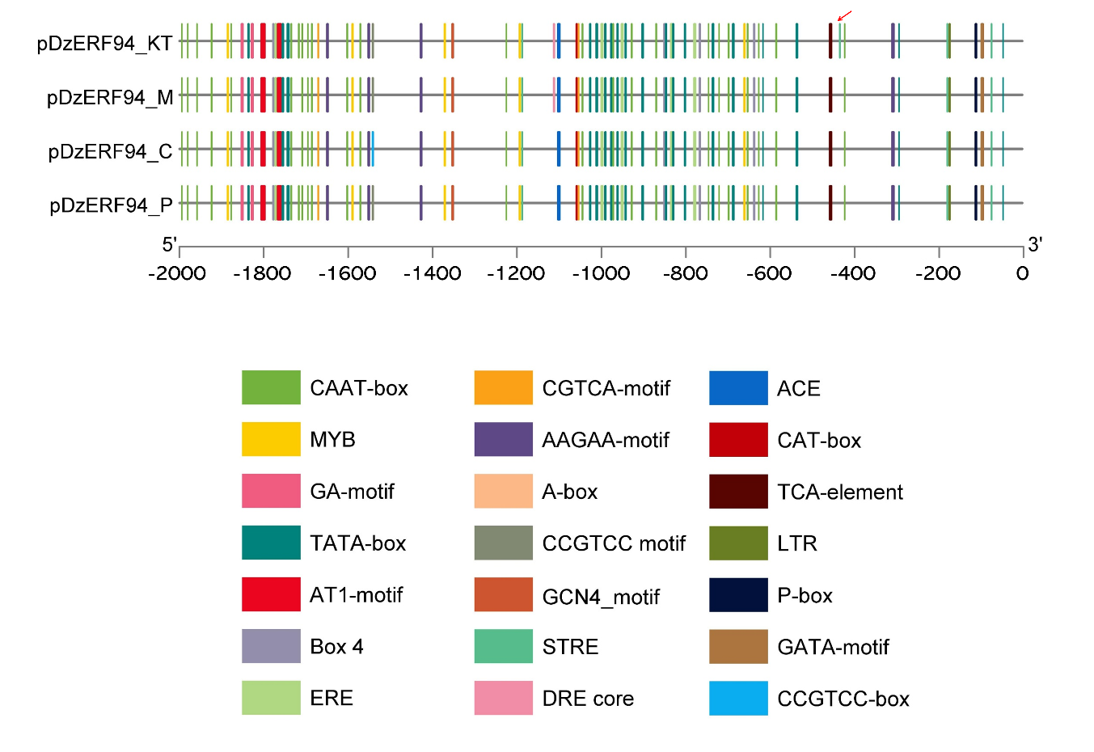
Supplementary Figure S4. Analysis of cis-acting elements in the DzERF94 promoter from different durian cultivars. The 2.0-kb sequences upstream of the DzERF94 start codon were analyzed using the PlantCARE database and visualized with TBtools (Chen et al., 2020; Lescot et al., 2002). The red arrow indicates the Stress Response Element (STRE) found only in the KT cultivar. KT: Kathoei Nueakhao; M: Monthong; C: Chanee; P: Phuangmanee.

