Supplementary figures
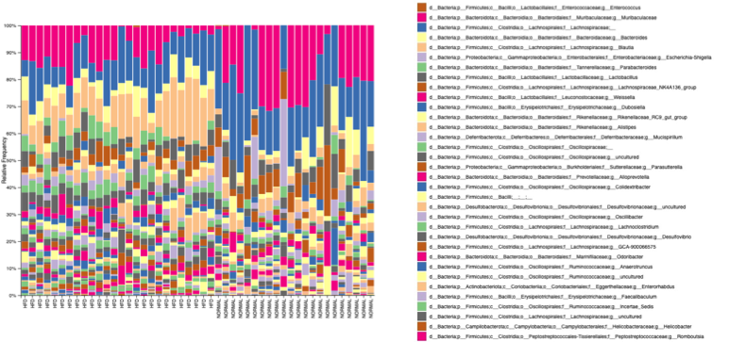
Supplementary figure 1. Gut microbiota composition across diet types.
Stacked bar plots representing the relative abundance of bacterial genera across individual fecal samples. Taxa are shown at the genus level, with taxonomy annotated down to species where available. Each bar represents one sample, and colors correspond to distinct bacterial taxa, as indicated in the legend on the right.

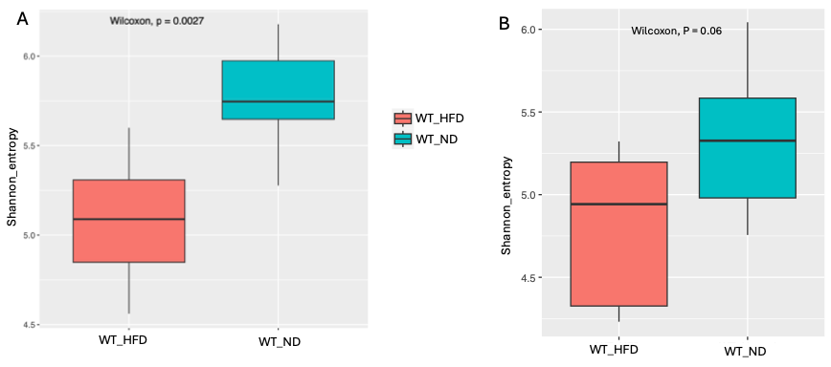
Supplementary figure 2. Comparison of alpha diversity in wild-type WT mice fed either a ND or a HFD.
(A) Shannon diversity index of fecal microbiota based on 16S rRNA gene sequencing, showing significantly reduced microbial diversity in WT mice fed a HFD (WT_H) compared to those on a ND (WT_N) (p = 0.0027, Wilcoxon test).
(B) Shannon diversity index of caecal microbiota based on shotgun metagenomic sequencing. A trend toward reduced diversity in WT_HFD compared to WT_Normal was observed (p = 0.06, Wilcoxon test).
These results suggest a consistent diet-associated reduction in microbial diversity across different gut compartments and sequencing platforms.

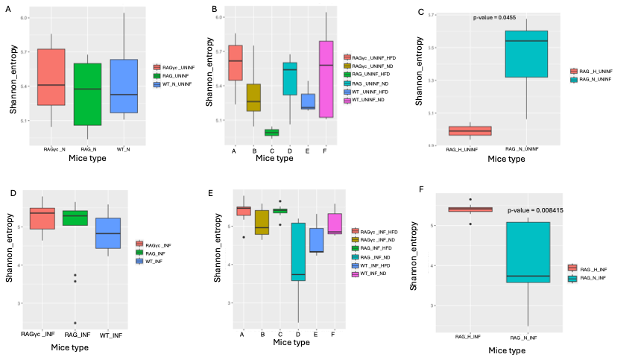
Supplementary Figure3. Gut microbial alpha diversity (Shannon index) in naive and infected mice across immune genotypes and dietary groups.
(A–C) Comparisons of Shannon diversity in naive (uninfected) mice.
(A) Alpha diversity by immune genotype (WT, RAG-KO, RAGγc-KO), regardless of diet.
(B) Diversity stratified by both immune genotype and diet (ND vs HFD).
(C) Focused comparison within RAG-KO naive mice, showing reduced diversity in mice on a HFD (RAG_H) versus ND (RAG_N). (D–F) Corresponding comparisons now including infected mice, to assess how Trichuris muris infection modifies gut microbial diversity across the same strata.
(D) Diversity by genotype (infected vs naive mice combined),
(E) Stratified by both genotype and diet,
(F) Focused comparison within RAG-KO mice on HFD vs ND under infection.

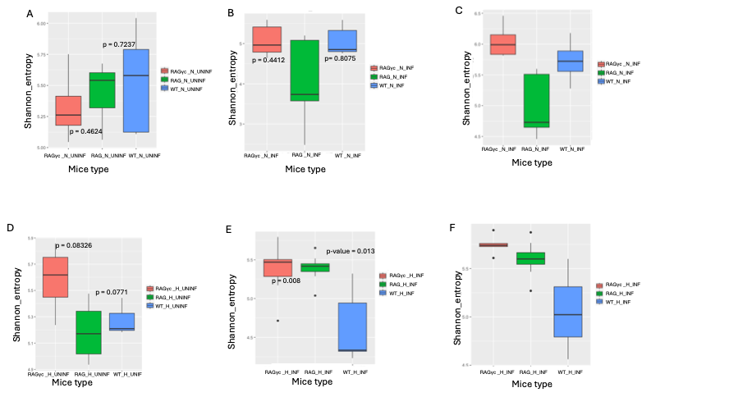
Supplementary Figure 4. Microbial diversity (Shannon index) across different mouse genotypes under varying dietary and infection conditions. (A)Naive RAGγc-KO, RAG-KO, and WT mice on a ND, profiled using 16S rRNA sequencing of fecal samples. (B) Infected RAGγc-KO, RAG-KO, and WT mice on a ND, also assessed by 16S rRNA sequencing of fecal samples. (C) Infected RAGγc-KO, RAG-KO, and WT mice on a ND, profiled via shotgun metagenomics of fecal samples. (D) Naive RAGγc-KO, RAG-KO, and WT mice on a HFD, analyzed using 16S rRNA sequencing of fecal samples. (E) Infected RAGγc-KO, RAG-KO, and WT mice on a HFD, with microbial diversity assessed from fecal samples using 16S rRNA sequencing. (F) Infected RAGγc-KO, RAG-KO, and WT mice on a HFD, profiled by shotgun metagenomics of caecal content. This comparative design highlights genotype-specific shifts in microbial diversity across dietary and infectious states, using both amplicon- and shotgun-based profiling approaches.

