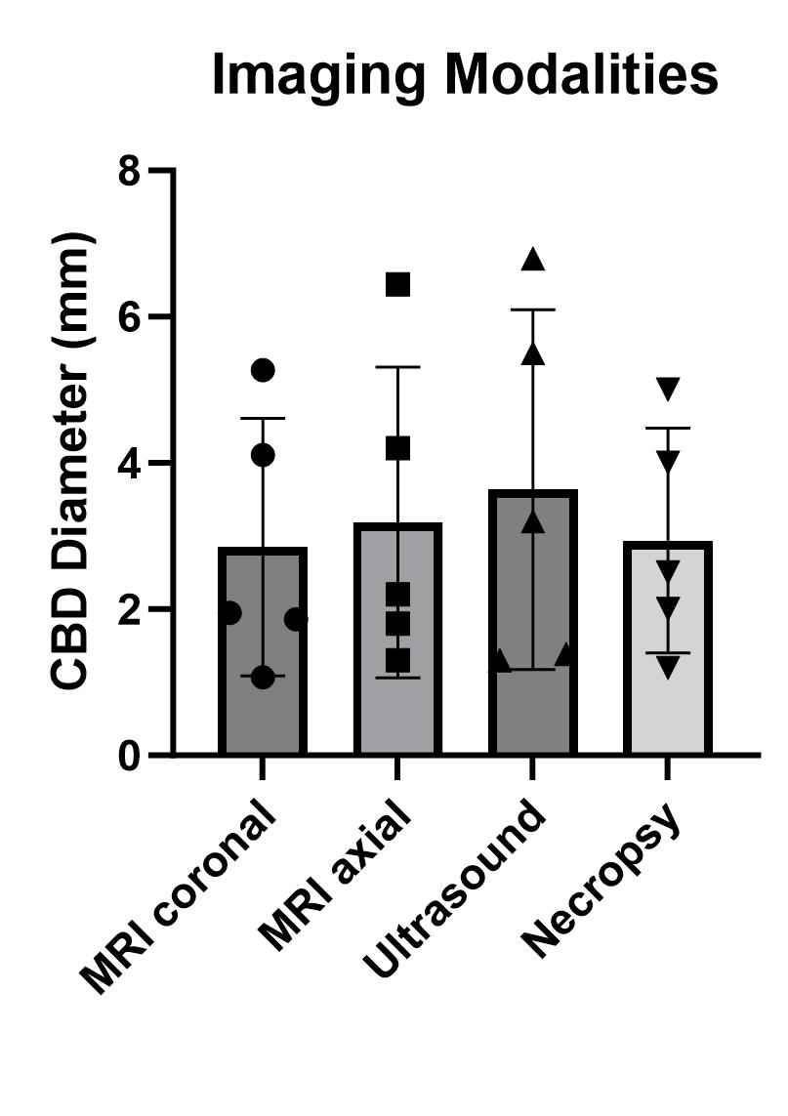
Supplemental Fig. 1 The diameter of choledochal cyst as measured by T2-weighted MRI, ultrasound, and gross necropsy; mean CBD by coronal MRI 2.852 mm was compared to other groups by multiple one-way ANOVA: mean CBD by axial MRI 3.188 mm (p=0.5131), mean CBD by ultrasound 3.638 mm (p=0.3471), mean CBD by necropsy 2.940 mm (p=0.9159); CBD: common bile duct

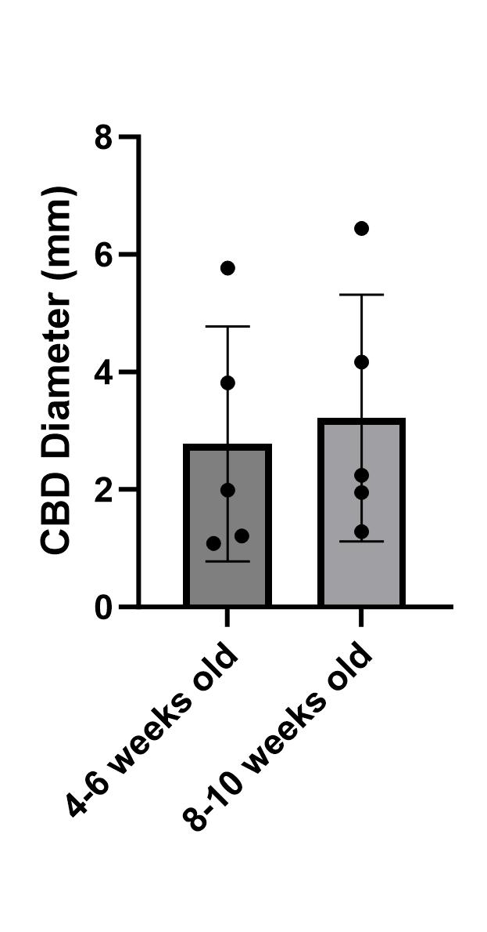
Supplemental Fig. 2 The maximum bile duct diameter in experimental mice as measured on coronal T2-weighted abdominal MRI paired t-test p-value 0.1120, CBD: common bile duct

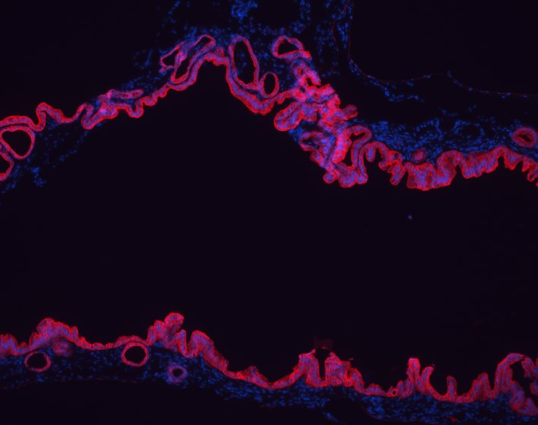
Supplemental Fig. 3 Immunohistochemistry demonstrates preserved epithelial cell identity (red fluorescence for CK-19) at 12-weeks of age in experimental mouse bile duct (10x magnification)

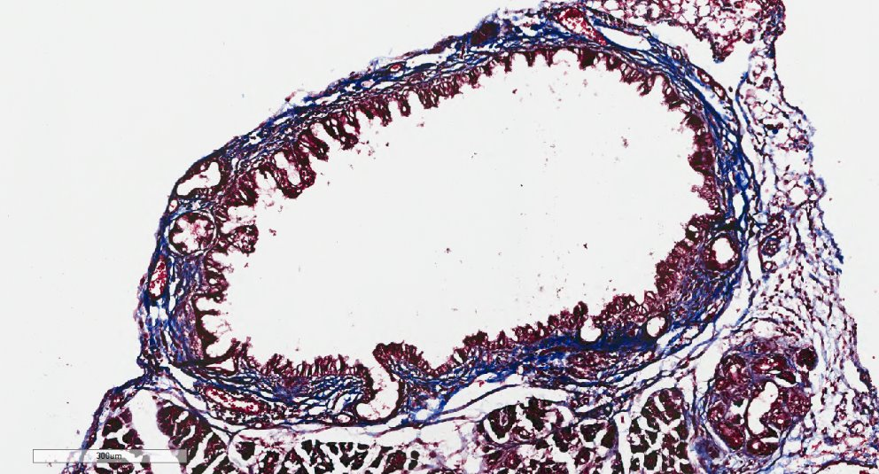
Supplemental Fig. 4a Experimental mouse bile duct harvested at 12-weeks of age demonstrates collagen (Masson’s trichrome staining in blue) in the wall of the bile duct specimen (10x magnification)

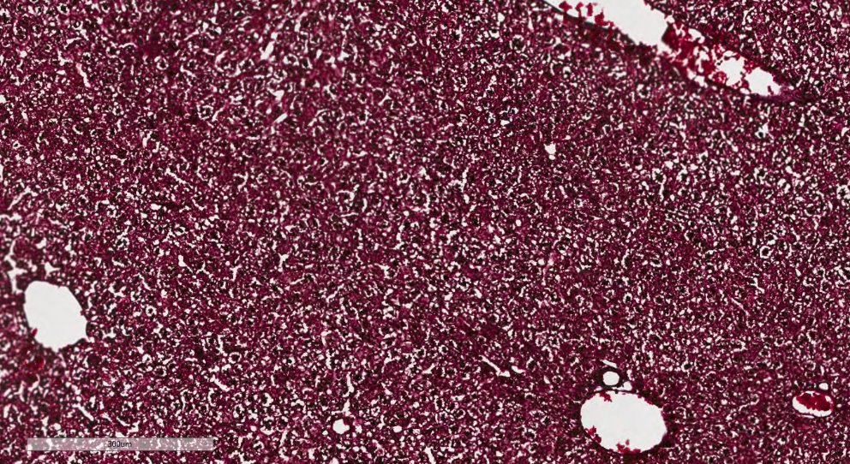
Supplemental Fig. 4b Experimental mouse liver harvested at 12-weeks of age demonstrates lack of fibrosis (lack of Masson’s trichrome blue staining) in the liver specimen (10x magnification)

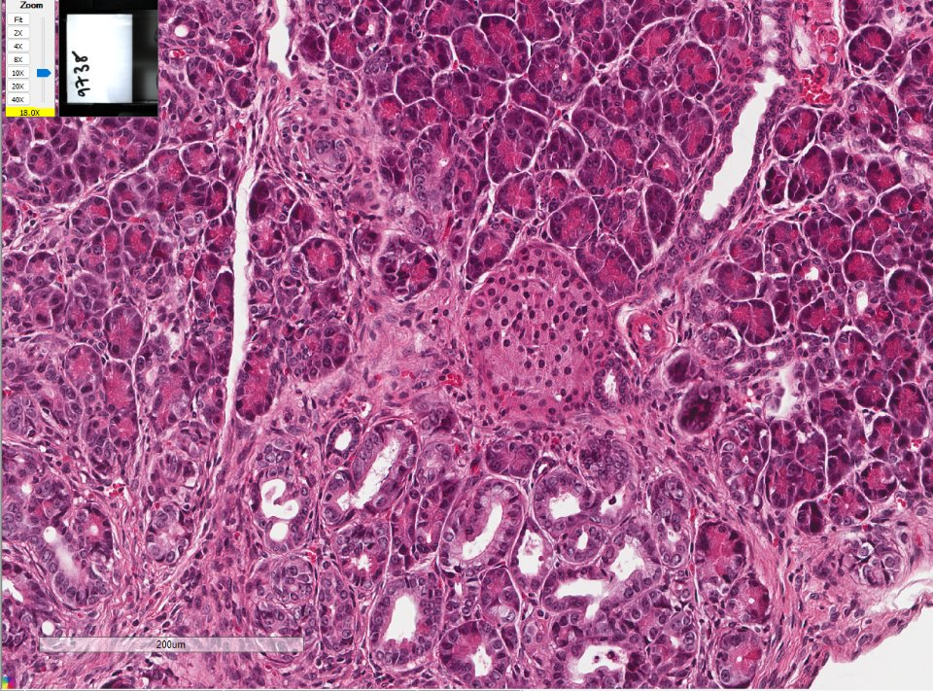
Supplemental Fig. 5 Hematoxylin and eosin staining of experimental mouse pancreas harvested at 12-weeks of age demonstrates pancreatic intraepithelial lesions (blue arrow), normal islet of Langerhans (white arrow), and normal acinar tissue (red arrow) at 20x magnification

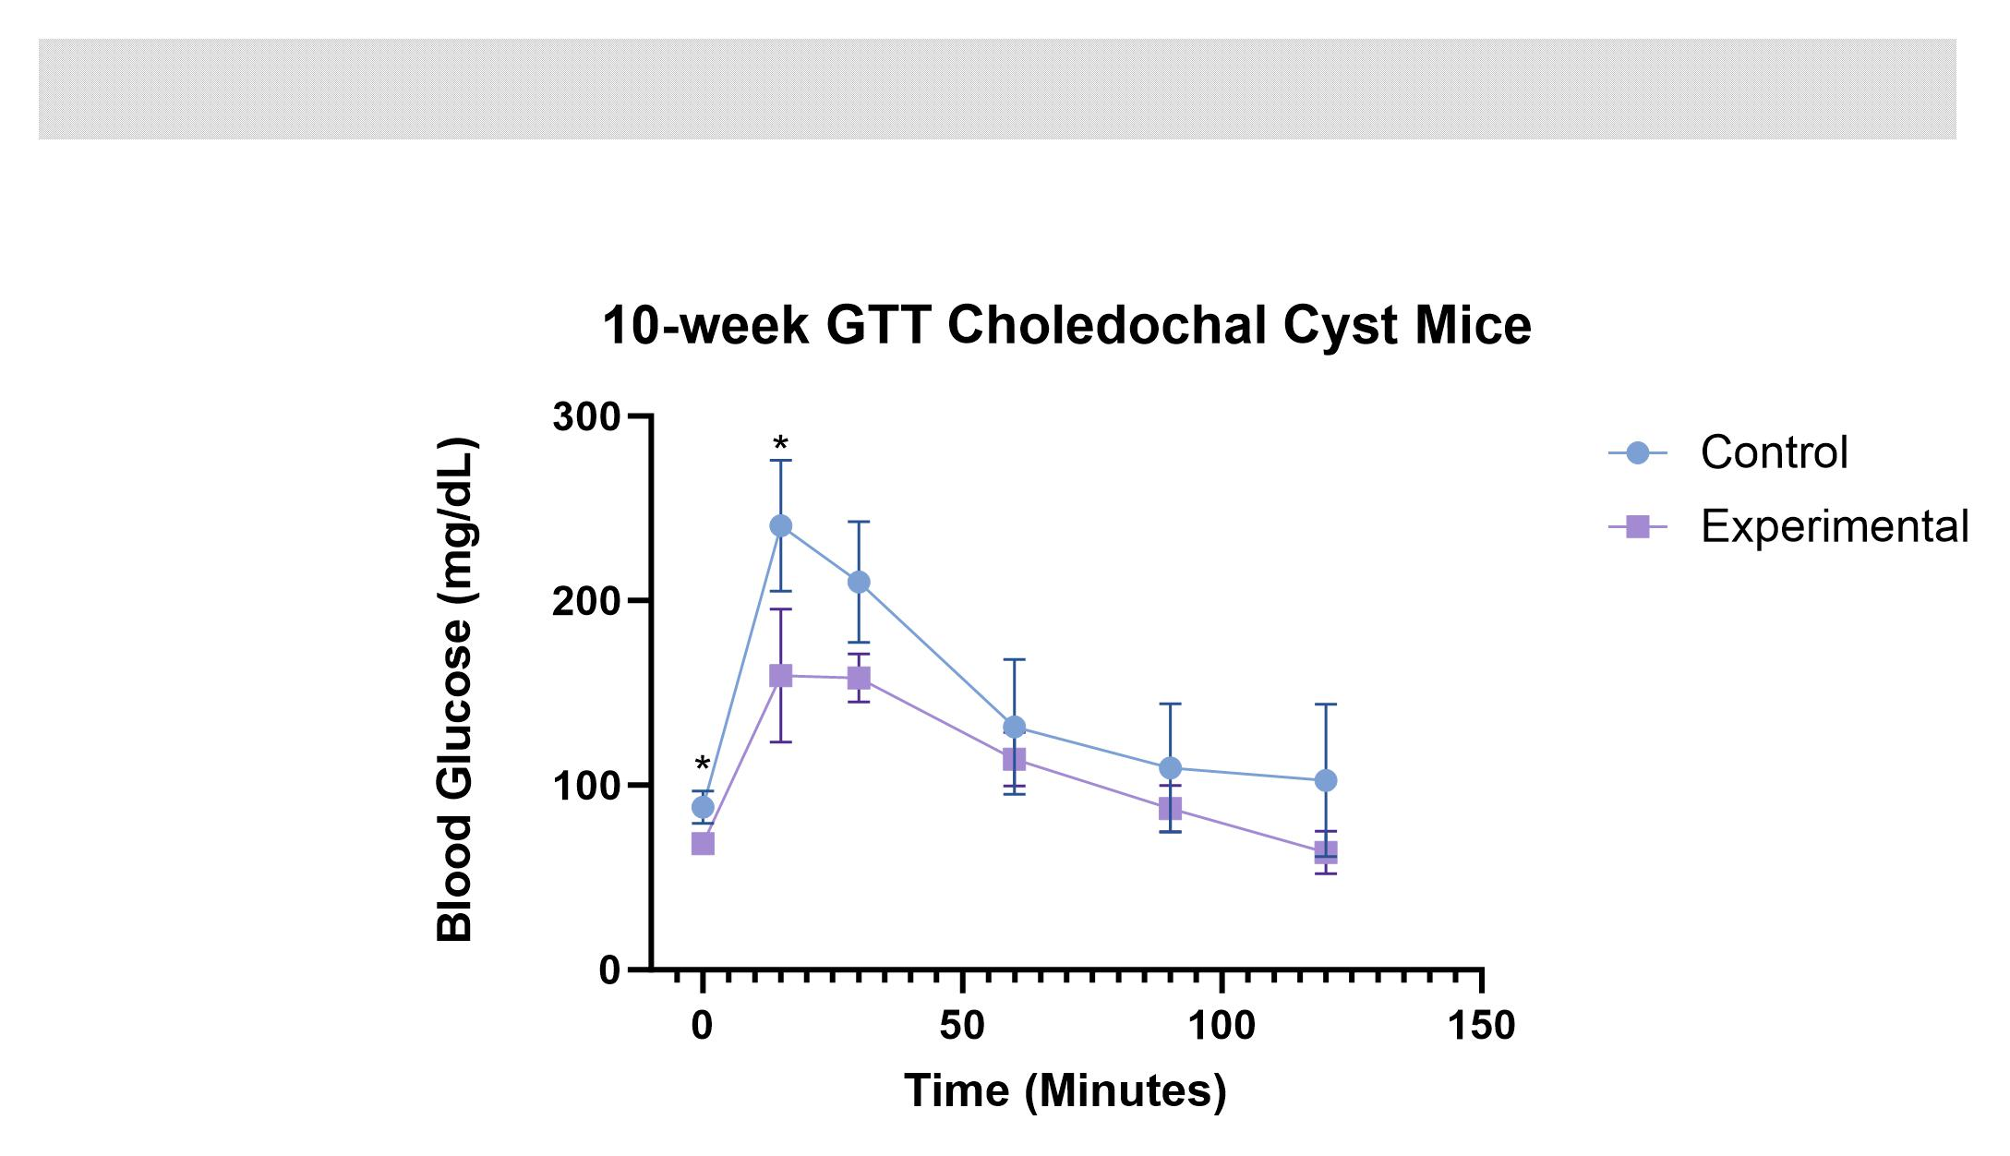
Supplemental Fig. 6 Intraperitoneal glucose tolerance testing in control and experimental mice were performed at 10 weeks of age on mice in both groups; Multiple unpaired t-tests (* denotes p<0.05)

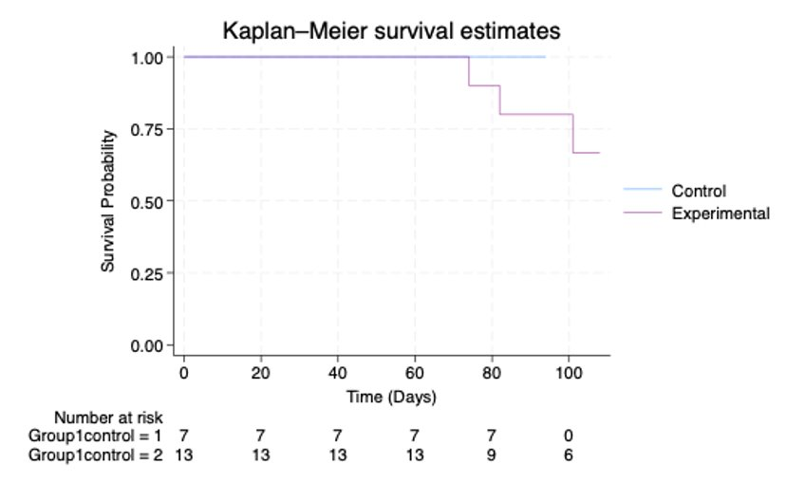 Supplemental Fig. 7 Kaplan-Meier curves of control and experimental mice demonstrate survival during the study period; two experimental mice were sacrificed early for clinical signs; the rest of the mice were sacrificed at the end of study (~84 days); log-rank analysis was performed between groups (p-value = 0.224)

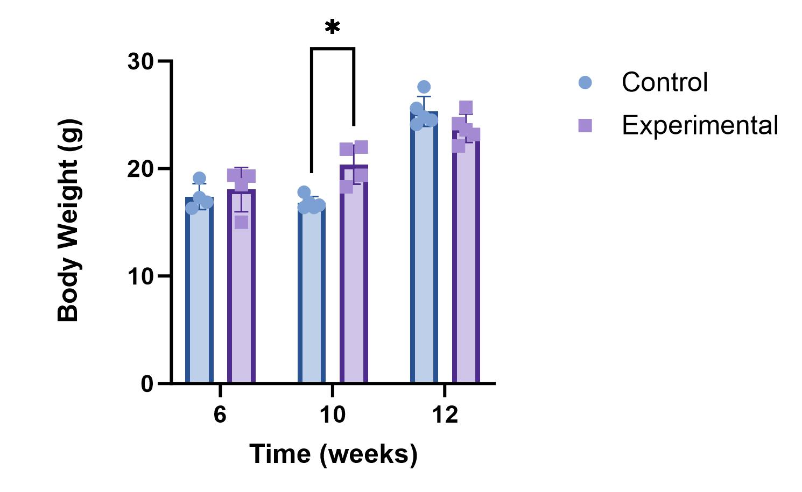
Supplemental Figure 8: Body weight of control and experimental mice
Body weights obtained of mice in both groups at multiple timepoints throughout the experimental time course.

