nature portfolio
Supplementary Information
Weak arene/nickel interaction lights on monoarylation of alcohols
In the format provided by the
authors and unedited

Weak arene/nickel interaction lights on monoarylation of alcohols
Kun Xie¹, Ge Meng¹, Jun He², Mingsong Shi², Junjie Ma¹, Huan Gao¹, Tingting Qiu¹, Yuxia Zhao¹, Shuang Yang¹, Xinyu Wei¹, Jiaxin Yan¹, Kang Wang¹, Jiadong Cai¹, Sheng Li¹, Dong Xue¹ and Zhiyan Huang¹*

¹Key Laboratory of Applied Surface and Colloid Chemistry, Ministry of Education, Key Laboratory of the Ministry of Education for Medicinal Resources and Natural Pharmaceutical Chemistry, National Engineering Laboratory for Resource Development of Endangered Crude Drugs in Northwest of China, Key Laboratory of Macromolecular Science of Shaanxi Province and School of Chemistry and Chemical Engineering, Shaanxi Normal University (SNNU), Xi’an, 710119, China.
²State Key Laboratory of Biotherapy and Cancer Center/Collaborative Innovation Center for Biotherapy, West China Hospital, Sichuan University, Chengdu 610041, China.
*zyhuang@snnu.edu.cn

Table of contents
1. General Information 2
2. Preparation of photocatalysts and substrates 4
3. The photophysical and electrochemical properties of photocatalysts 8
4. Optimization of reaction conditions 14
5. General procedure for arylation of alcohols 19
6. Substrate Scope 20
7. Synthetic Applications 50
8. Mechanistic investigations 61
9. Computational Details 72
10. X-Ray Diffraction Analysis 76
11. References 82
12. NMR Spectra 84

List of abbreviations
DABCO | 1,4-diazabicyclo[2.2.2]octanetriethylenediamine
DBU | 1,8-diazabicyclo[5.4.0]undec-7-ene
DCE | dichloroethane
DCM | dichloromethane
DCyA | N,N-dicyclohexylamine
DCyMA | N,N-dicyclohexylmethylamine
DECyA | N,N-diethylcyclohexylamine
DEF | N,N-diethylformamide
DIPEA | N,N-diisopropylethylamine
DMA | N,N-dimethylacetamide
DMAP | 4-dimethylaminopyridine
DMCyA | N,N-dimethylcyclohexylamine
DME | 1,2-dimethoxyethane
DMF | dimethylformamide
DMIPA | N,N-dimethylisopropylamine
DMSO | dimethyl sulfoxide
HMTA | hexamethylenetetramine
MeCN | acetonitrile
MeOH | methanol
PE | petroleum ether (60-90°C)
PTSA⋅H₂O | p-toluenesulfonic acid monohydrate
TBAPF₆ | tetrabutylammonium hexafluorophosphate
TEA | triethylamine
THF | tetrahydrofuran
Tol | toluene
TPP | 5,10,15,20-tetraphenylporphyrin

1. General Information
General Procedure: Unless otherwise specified, all reactions were carried out with rigorous exclusion of air and moisture. Reactions were monitored by thin-layer (TLC) on precoated Silica Gel 60 F₂₅₄ plates and gas chromatography (GC, Thermo trace 1310), visualizing with UV light (254 or 365 nm) or phosphomolybdic acid as a staining reagent. The organic solution was concentrated under reduced pressure using a rotary evaporator. Automated column chromatography was performed using silica gel (200-300 mesh) with distilled petroleum ether and ethyl acetate.
Solvents and reagents: Unless otherwise specified, all chemical reagents were purchased from commercial suppliers and used without further purification. Solvents were purified by using the following methods: Ether solvents, such as THF, DME and dioxane were dried and deoxygenated by distillation over sodium with benzophenone as an indicator under nitrogen atmosphere. DCM and DMF were distilled from CaH₂ under nitrogen atmosphere. Distilled solvents were stored over activated 4 Å molecular sieves in Schlenk tubes in the glove box degassed by nitrogen bubbling before use. NiBr₂ was purchased from Sigma Aldrich and other nickel salts were purchased from Alfa Aesar. (Hetero-)Aryl bromides were purchased from Adamas. Alcohols were purchased from Adamas and TCI. The GC internal standard, n-dodecane was degassed and dried over by activated 4 Å molecular sieves before use.
Instruments: ¹H NMR spectra were acquired at 400 MHz or 600 MHz instruments (Bruker Advance spectrometer and JEOL spectrometer) and chemical shifts were recorded relative to SiMe₄ (TMS: δ 0.00 ppm) or residual protiated solvents (CDCl₃: δ 7.26 ppm; DMSO-d₆: δ 2.50 ppm). ¹H NMR data were reported as follows: chemical shift, multiplicity (s = singlet, d = doublet, t = triplet, q = quartet, m = multiplet, dd = doublet of doublets, dt = doublet of triplets, ddd = doublet of doublet of doublets, ddt = doublet of doublet of triplets, td = triplet of doublets, br = broad), the number of protons (n) for a given resonance was indicated by nH. Coupling constants were reported as a J value in Hz. ¹³C NMR spectra were obtained at 100 MHz on 400 MHz or 150 MHz on 600 MHz instruments and chemical shifts were recorded in ppm relative to solvent resonance (CDCl₃: δ 77.16 ppm; DMSO-d₆: δ 39.52 ppm). Proof of purity of new compounds were assessed by using copies of ¹H, ¹³C, ¹¹B and ¹⁹F NMR spectra. HRMS data were obtained on a Thermo Scientific LTQ Orbitrap Discovery spectrometer (Bremen, Germany). GC analysis was conducted with Agilent J&W GC column (30 m × 0.32 mm, 1.00 μm, DB-1). Chiral HPLC analysis was performed on a Shimadzu LC-20AD instrument. Preparative chromatography was performed on an Agilent 1260 Infinity instrument. Optical rotation was measured using an Autopol IV equipped with a sodium vapor lamp at 589 nm and the concentration of samples was denoted as c (g/100 mL, CHCl₃ or MeOH). Single crystal was collected on Bruker CMOS PHOTON 100 detector. The UV-vis absorption spectra were recorded on a TU-1950 recording spectrophotometer in a 1 cm quartz cuvette. Photoluminescence (PL) spectra were measured on a Hitachi F-7100 fluorescence spectrophotometer in a 1 cm quartz cuvette. The absolute PL quantum yields were measured using a Hamamatsu C9920-02G integrating sphere system coupled with a 150 W Xenon lamp and a PMA-12 photonic multichannel analyzer. Fluorescence lifetimes were obtained on an FLS 1000 instrument in DCM (1 ×10⁻⁵ M) in a 1 cm quartz cuvette. Cyclic voltammetry (CV) was carried out using nitrogen-purged anhydrous DCM for the oxidation and reduction scan at room temperature with a CHI voltammetric analyzer. TBAPF₆ (0.1 M) was used as the supporting electrolyte. The conventional there-electrode configuration consists of a 0.07 cm² glassy-carbon electrode as the working electrode, a platinum wire as auxiliary electrode, and Ag/AgCl (saturated KCl) as a reference electrode. Cyclic voltammograms were recorded at a scan rate of 100 mV/s.
The light source (white, 6000-6500 K) were purchased from WATTCASTM, and relevant experiments were performed in a WATTECS WP-TEC-1020 parallel reactor.
Light Output
Emission spectra were measured on a photocatalytic spectrometer (PCS-230850). Emission spectrum from a 2 W white LED with emission maximum at λ_{max} = 448 nm.
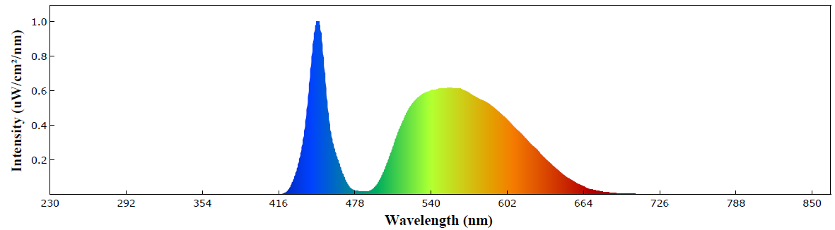
Figure S1. Emission spectrum for light source.

2. Preparation of photocatalysts and substrates
2.1 Preparation of photocatalysts
Scheme S1. Synthesis of DABDP photocatalysts.
2.1.1 Synthesis of Et-BDP [131083-16-4]
Et-BDP was synthesized according to a reported procedure with slightly modification¹. Acetyl chloride (4.8 g, 60.5 mmol, 2.33 eq) was added dropwise to a stirred solution of 2,4-dimethyl-3-ethyl-1H-pyrrole (3.2 g, 26.0 mmol, 1.0 eq) in dry DCM (20 mL) at room temperature under nitrogen atmosphere. The deep red solution was heated to reflux for 1 h. After cooling and concentrated to dryness using vacuum rotary evaporator, n-hexane (50 mL), DCM (120 mL) and TEA (7.6 g, 75.0 mmol, 2.88 eq) were added to the residual mixture. The mixture was stirred at room temperature for 10 min, and then BF₃·Et₂O (16.0 g, 112.5 mmol, 4.32 eq) was added dropwise and stirred for 1 h at room temperature. The deep red solution was washed with saturated aqueous Na₂CO₃ solution (3 × 100 mL), dried over anhydrous Na₂SO₄, filtrated and concentrated using a rotary evaporator. The residue was purified by a column chromatography (PE/DCM = 3:1) to give the desired compound Et-BDP as a reddish orange solid (2.2 g, 53%). Data are as follows and matching with the previous literature¹.
¹H NMR (400 MHz, CDCl₃): δ 2.60 (s, 3H), 2.49 (s, 6H), 2.39 (q, J = 7.6 Hz, 4H), 2.33 (s, 6H), 1.04 (t, J = 7.5 Hz, 6H).
2.1.2 Synthesis of Et-DABDP
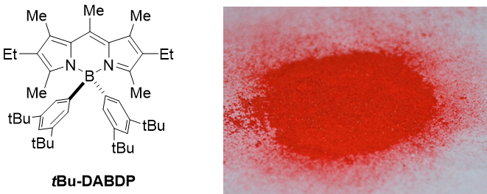
(3,5-Di-tert-butylphenyl) magnesium bromide (0.4 M in THF, 10 mL, 4.0 mmol) was added dropwise to a solution of Et-BDP (63.64 mg, 0.2 mmol) in dry DCM (40.0 mL) at room temperature under nitrogen atmosphere. The mixture was stirred at 50 °C for 6 h, until the complete consumption of Et-BDP, which was monitored by TLC. The reaction mixture was quenched with 1.0 M HCl, and the aqueous phase was extracted with DCM (3 x 30 mL) and the combined organic layers were washed with brine and then dried over anhydrous Na₂SO₄, filtrated and concentrated under vacuum. The residue was then purified by flash column chromatography (PE/DCM = 100:1). The title compound Et-DABDP was obtained as a reddish orange solid (46 mg, 35% yield). Single crystals suitable for X-ray diffraction measurement were grown from a solution of Et-DABDP in n-pentane/diethyl ether.
¹H NMR (600 MHz, CDCl₃): δ 7.14 (t, J = 2.9 Hz, 2H), 6.96 (d, J = 2.9 Hz, 4H), 2.64 (s, 3H), 2.37-2.33 (m, 10H), 1.68 (s, 6H), 1.21 (s, 36H), 0.98 (t, J = 7.5 Hz, 6H).
¹³C NMR (100 MHz, CDCl₃): δ 151.2, 148.3, 139.8, 133.2, 132.8, 132.2, 128.0, 127.7, 118.4, 34.8, 31.8, 18.2, 17.5, 15.4, 14.8, 14.5.
¹¹B NMR (192 MHz, CDCl₃): δ 0.14 (s, 1B).
HRMS (ESI) m/z calcd. for C₄₆H₆₈BN₂ [M + H]⁺: 659.5476, found: 659.5463.
2.1.3 Synthesis of Et-DABDP-Ph [221159-19-9]
According to similar procedure, (3,5-di-tert-butylphenyl) magnesium bromide was replaced by equimolar phenyl magnesium bromide, and the rest of the operation was unchanged. The title compound Et-DABDP-Ph was obtained as a reddish orange solid (33.87 mg, 39% yield). Single crystals suitable for X-ray diffraction measurement were grown from a solution of Et-DABDP-Ph in n-pentane/diethyl ether. Data are as follows and matching with the previous literature^{1,2}.
¹H NMR (400 MHz, CDCl₃): δ 7.24-7.14 (m, 10H), 2.66 (s, 3H), 2.37 (s, 6H), 2.33 (q, J = 7.4 Hz, 4H), 1.70 (s, 6H), 0.96 (t, J = 7.5 Hz, 6H).
HRMS (ESI) m/z calcd. for C₃₀H₃₅BN₂Na [M + Na]⁺: 457.2791, found: 457.2791.
2.1.4 Synthesis of Et-DABDP-Naph [907589-97-3]
According to similar procedure, (3,5-di-tert-butylphenyl) magnesium bromide was replaced by equimolar 2-naphthyl magnesium bromide, and the rest of the operation was unchanged. The title compound Et-DABDP-Naph was obtained as a reddish orange solid (43.81 mg, 41% yield). Data are as follows and matching with the previous literature².
¹H NMR (400 MHz, CDCl₃): δ 7.79-7.77 (m, 2H), 7.72-7.69 (m, 6H), 7.45 (d, J = 8.2 Hz, 2H), 7.40-7.36 (m, 4H), 2.70 (s, 3H), 2.40 (s, 6H), 2.34 (q, J = 7.5 Hz, 4H), 1.72 (s, 6H), 0.97 (t, J = 7.4 Hz, 6H).
¹³C NMR (100 MHz, CDCl₃): δ 151.5, 140.3, 133.9, 133.5, 132.9, 132.7, 132.6, 132.5, 132.2, 128.2, 127.5, 126.4, 125.0, 124.8, 18.1, 17.6, 15.2, 14.9, 14.8.
¹¹B NMR (192 MHz, CDCl₃): δ -0.19 (s, 1B).
HRMS (ESI) m/z calcd. for C₃₈H₃₉BN₂Na [M + Na]⁺: 557.3104, found: 557.3083.
2.2 Preparation of substrates
2.2.1 Synthesis of methyl 3-(allyloxy)-4-iodobenzoate [501892-70-2]
To a dry RBF, SOCl₂ (3.4 g, 28.4 mmol) was added slowly to a solution of 6a (5.0 g, 18.9 mmol) in MeOH (50 mL) at 0 °C. The resulting mixture was stirred at 50 °C for 3 h. After completion of the reaction, the mixture was cooled to room temperature, and then concentrated to provide crude methyl 3-hydroxy-4-iodobenzoate (6.2 g) as a white solid, which was used directly in the next step.
Allyl bromide (1.7 g, 14.0 mol) was slowly added into a mixture of K₂CO₃ (4.5 g, 32.4 mol) and the solution of 3-hydroxy-4-iodobenzoate (3.0 g, obtained in the last step) in acetone (25 mL). And the resulting mixture was heated to 65 °C for 2 h. After cooling to room temperature, distilled water (30 mL) was added to quench the reaction. After remobing acetone, the residue was extracted with DCM (25 mL x 3). The combined organic layers were washed with brine, dried over anhydrous Na₂SO₄, filtered and concentrated by a rotary vacuum evaporator. The resulting residue was purified by chromatography using PE/EtOAc (10:1) as eluent. The title compound was obtained as a white solid (2.9 g, 84%).
¹H NMR (600 MHz, CDCl₃): δ 7.86 (d, J = 8.0 Hz, 1H), 7.43 (d, J = 1.7 Hz, 1H), 7.37 (dd, J = 8.1, 1.9 Hz, 1H), 6.10-6.04 (m, 1H), 5.55 (dq, J = 17.2, 1.7 Hz, 1H), 5.34 (dq, J = 10.6, 1.4 Hz, 1H), 4.66 (dt, J = 4.7, 1.6 Hz, 2H), 3.91 (s, 3H).
¹³C NMR (150 MHz, CDCl₃): δ 166.7, 157.3, 139. 7, 132.2, 131.7, 123.6, 118.1, 112.7, 93.4, 70.0, 52.5.
HRMS (ESI) m/z calcd. for C₁₁H₁₁INaO₃ [M + Na]⁺: 340.9645, found: 340.9645.
2.2.2 Synthesis of (4aR,6S,7R,8R,8aS)-6-methoxy-2,2-dimethylhexahydropyrano- [3,2-d] [1,3]dioxine-7,8-diol 73b [15354-29-7]
The titled compound was synthesized according to a reported procedure with slightly modification³. To a round bottom flask charged with α-methyl glucopyranoside 73a (3.0 g, 15.4 mmol) and PTSA⋅H₂O (0.3 g, 1.5 mmol) was added acetone (30 mL, 0.77 M). Dimethoxypropane (3 mL, 23.2 mmol) and DMF were added successively until the reaction became homogeneous (approximately 4 mL). A reflux condenser was fitted to the flask and the reaction mixture was refluxed for 13 hours. After cooling to ambient temperature, TEA was added. The resulting mixture was filtered through a celite pad and washed with acetone. The volatiles were concentrated on a rotary evaporation under reduced pressure. The residue was subjected to flash column chromatography (DCM/MeOH = 20:1) to give 73b as a white solid (1.5 g, 40% yield). Data are as follows and matching with the previous literature³.
¹H NMR (400 MHz, CDCl₃): δ 4.75 (d, J = 2.6 Hz, 1H), 3.88-3.85 (m, 1H), 3.78-3.72 (m, 2H), 3.63-3.55 (m, 2H), 3.52 (t, J = 6.3 Hz, 1H), 3.42 (s, 3H), 2.85 (s, 1H), 2.38 (d, J = 6.3 Hz, 1H), 1.51 (s, 3H), 1.43 (s, 3H).

3. The photophysical and electrochemical properties of photocatalysts
3.1 Normalized UV-Vis absorption and emission spectra in DCM for photocatalysts
Figure S2. Normalized UV-Vis absorption (left) and emission (right) spectra in DCM (1 × 10⁻⁵ M)
for Et-BDP, Et-DABDP-Ph, Et-DABDP-Naph and Et-DABDP.
3.2 Photophysical properties of photocatalysts
Table S1. Photophysical properties of PC in DCM
PC | λ_{abs} (nm)ª | ε(10⁴ M⁻¹  cm⁻¹)ª | λ_{em} (nm)^{b} | Stokes shift  (nm) | Φ_{F,sol} [%]^{c} | τ_{flu} (ns)^{d}
Et-BDP | 520 | 8.92 | 547 | 27 | 93 | 7.07
Et-DABDP-Ph | 514 | 8.96 | 558 | 44 | 70 | 5.87
Et-DABDP-Naph | 514 | 8.12 | 559 | 45 | 69 | 5.97
Et-DABDP | 514 | 8.04 | 558 | 44 | 65 | 5.64
ªLinear absorption band maximum and molar absorptivity in DCM solution. ^{b}Emission band maximum in DCM solution. ^{c}Emission quantum yield measured using the calibrated integrating sphere system. ^{d}Time-resolved emission data in DCM solution.

3.3 Electrochemical properties of photocatalysts
Table S2. Electrochemical properties of PC in DCM
PC | E(PC⁺/PC)  (V)ª | E(PC/PC⁻)  (V)ª | E(PC⁺/PC*)  (V)^{b} | E(PC*/PC⁻)  (V)^{b} | E_{em} (eV)^{c}
Et-BDP | 1.06 | -1.33 | -1.21 | 0.94 | 2.27
Et-DABDP-Ph | 0.88 | -1.63 | -1.35 | 0.60 | 2.23
Et-DABDP-Naph | 0.89 | -1.61 | -1.33 | 0.61 | 2.22
Et-DABDP | 0.84 | -1.73 | -1.39 | 0.50 | 2.23
ªAll redox potentials reported vs. SCE. Measurements were performed in deoxygenated DCM at room temperature. ^{b}Excited state oxidation and reduction potentials were calculated by the following approximate formulas¹:

E(PC*/PC⁻) = E(PC/PC⁻) - E and E(PC⁺/PC*) = E(PC⁺/PC) + E.
^{c}E_{em} = 1242/λ_{max}
PC⁺ + e → PC E(PC⁺/PC)
PC → PC* E = -E_{em}/e
PC + e → PC⁻ E(PC/PC⁻)
PC⁺ + e → PC* E(PC⁺/PC*) = E(PC⁺/PC) + E
PC* + e → PC⁻ E(PC*/PC⁻) = E(PC/PC⁻) - E

3.4 Photoredox characteristics for each photocatalyst
3.4.1 Photoredox characteristics for Et-BDP
E_{1/2}(PC⁺/PC*) = -1.21 V, E_{1/2}(PC*/PC⁻) = 0.94 V, E_{1/2}(PC⁺/PC) = 1.06 V, E_{1/2}(PC/PC⁻) = -1.33 V. All potentials are given vs. SCE.
Figure S3. Cyclic voltammogram of Et-BDP in DCM, using 0.1 M TBAPF₆ as supporting electrolyte.
Figure S4. UV/Vis absorption and emission spectrum of Et-BDP in DCM (1×10⁻⁵ M).
Figure S5. Fluorescence decay curve of Et-BDP in DCM (1×10⁻⁵ M)
Life time τ in DCM: 7.07 ns, R² = 0.9969.
3.4.2 Photoredox characteristics for Et-DABDP-Ph
E_{1/2}(PC⁺/PC*) = -1.35 V, E_{1/2}(PC*/PC⁻) = 0.60 V, E_{1/2}(PC⁺/PC) = 0.88 V, E_{1/2}(PC/PC⁻) = -1.63 V. All potentials are given vs. SCE.
Figure S6. Cyclic voltammogram of Et-DABDP-Ph in DCM, using 0.1 M TBAPF₆ as supporting electrolyte.
Figure S7. UV/Vis absorption and emission spectrum of Et-DABDP-Ph in DCM (1×10⁻⁵ M).
Figure S8. Fluorescence decay curve of Et-DABDP-Ph in DCM (1×10⁻⁵ M)
Life time τ in DCM: 5.87 ns, R² = 0.9963.
3.4.3 Photoredox characteristics for Et-DABDP-Naph
E_{1/2}(PC⁺/PC*) = -1.33 V, E_{1/2}(PC*/PC⁻) = 0.61 V, E_{1/2}(PC⁺/PC) = 0.89 V, E_{1/2}(PC/PC⁻) =
-1.61 V. All potentials are given vs. SCE.
Figure S9. Cyclic voltammogram of Et-DABDP-Naph in DCM, using 0.1 M TBAPF₆ as supporting electrolyte.
Figure S10. UV/Vis absorption and emission spectrum of Et-DABDP-Naph in DCM (1×10⁻⁵ M).
Figure S11. Fluorescence decay curve of Et-DABDP-Naph in DCM (1×10⁻⁵ M)
Life time τ in DCM: 5.97 ns, R² = 0.9967.

3.4.4 Photoredox characteristics for Et-DABDP
E_{1/2}(PC⁺/PC*) = -1.39 V, E_{1/2}(PC*/PC⁻) = 0.50 V, E_{1/2}(PC⁺/PC) = 0.84 V, E_{1/2}(PC/PC⁻) = -1.73 V. All potentials are given vs. SCE.
Figure S12. Cyclic voltammogram of Et-DABDP in DCM, using 0.1 M TBAPF₆ as supporting electrolyte.
Figure S13. UV/Vis absorption and emission spectrum of Et-DABDP in DCM (1×10⁻⁵ M).
Figure S14. Fluorescence decay curve of Et-DABDP in DCM (1×10⁻⁵ M)
Life time τ in DCM: 5.64 ns, R² = 0.9965.

4. Optimization of reaction conditions
4.1 General procedure for condition optimization:
For example as entry 4 in table S3: In a nitrogen-filled glove box, an oven-dried 10 mL Schlenk tube equipped with a stir bar was charged with 4-bromobenzonitrile (18.2 mg, 0.1 mmol, 1.0 eq), benzyl alcohol (16.2 mg, 1.5 mmol, 1.5 eq), NiBr₂ (1.74 mg, 0.008 mmol, 0.08 eq.), Na₂CO₃ (2.2 mg, 0.02 mmol, 0.20 eq), DCyMA (35.2 mg, 0.18 mmol, 1.8 eq), a DMF solution of Et-DABDP (20 μL, 0.0025 M/L, 5 × 10⁻⁵ mmol, 5 × 10⁻⁴ eq), n-dodecane (10 μL), 0.5 mL DMF. The catalytic reaction was conducted at 60 °C and irradiated with 2 w white LEDs (at approximately 1 cm away from the light source) for 24 hours. The reaction mixture was diluted with DCM (2 mL) at room temperature and for GC analysis. The GC yield of the C-O cross coupling product was calculated with n-dodecane as internal standard.
Table S3. The Screening of PC
Entry | PC | yield(%)ª
1 | Et-BDP | 73
2 | Et-DABDP-Ph | 88
3 | Et-DABDP-Naph | 90
4 | Et-DABDP | 95
5 | Nile Red | 29
6 | Eosin Y | 35
7 | TPP | 11
8 | Acridine Orange Base | 42
9 | Rhodamine B | 30
10 | Alizarin red S | 0
11 | Ir(dtbbpy)(ppy)₂[PF₆] | 42
12 | Ir[dF(CF₃)ppy]₂(dtbbpy)PF₆ | 48
13 | Ru(bpy)₃Cl₂ | 44
Reaction conditions: 1 (1.0 eq., 0.1 mmol), 2 (1.5 eq., 0.15 mmol), NiBr₂ (8.0 mol%), PC (0.05 mol%), DCyMA (1.8 eq., 0.18 mmol), Na₂CO₃ (0.2 eq., 0.02 mmol), DMF (0.5 mL), white LED (2 w), 60 °C, N₂, 24 h. ªGC yield.
Table S4. The Screening of Base
Entry | Base | yield(%)ª
1 | DCyMA | 95
2 | DMCyA | 55
3 | DECyA | 23
4 | DMIPA | 42
5 | DIPEA | 6
6 | DMAP | 5
7 | K₂CO₃ | 0
8 | Cs₂CO₃ | 28
9 | KOAc | 0
10 | HMTA | 0
11 | K₃PO₄ | 11
12 | DBU | 7
13 | DABCO | 8
Reaction conditions: 1 (1.0 eq., 0.1 mmol), 2 (1.5 eq., 0.15 mmol), NiBr₂ (8.0 mol%), Et-DABDP (0.05 mol%), base (1.8 eq., 0.18 mmol), Na₂CO₃ (0.2 eq., 0.02 mmol), DMF (0.5 mL), white LED (2 w), 60 °C, N₂, 24 h. ªGC yield.
Table S5. The Screening of metal sources
Entry | [M] | yield(%)ª
1 | Ni(cod)₂ | 92
2 | NiCl₂ | 93
3 | NiBr₂ | 95
4 | Ni(OTf)₂ | 90
5 | Ni(acac)₂ | 89
6 | Nil₂ | 77
7 | Pd(OAc)₂ | 24
8 | PdCl₂ | 28
Reaction conditions: 1 (1.0 eq., 0.1 mmol), 2 (1.5 eq., 0.15 mmol), [M] (8.0 mol%), Et-DABDP (0.05 mol%), DCyMA (1.8 eq., 0.18 mmol), Na₂CO₃ (0.2 eq., 0.02 mmol), DMF (0.5 mL), white LED (2 w), 60 °C, N₂, 24 h. ªGC yield.
Table S6. The Screening of Solvents
Entry | Solvent | yield(%)ª
1 | DMF | 95
2 | DMA | 49
3 | DEF | 68
4 | DCE | 21
5 | DMSO | 24
6 | Acetone | 24
7 | MeCN | 80
8 | DME | 1
9 | Tol | 0
10 | THF | 11
Reaction conditions: 1 (1.0 eq., 0.1 mmol), 2 (1.5 eq., 0.15 mmol), NiBr₂ (8.0 mol%), Et-DABDP (0.05 mol%), DCyMA (1.8 eq., 0.18 mmol), Na₂CO₃ (0.2 eq., 0.02 mmol), solvent (0.5 mL), white LED (2 w), 60 °C, N₂, 24 h. ªGC yield.
Table S7. The Screening of Light Source
Entry | Light source | yield(%)ª
1 | Green (530 nm) | 93
2 | Purple (365 nm) | 82
3 | Blue (465 nm) | 94
4 | Yellow (590 nm) | 1
5 | White (6000-6500 K) | 95
Reaction conditions: 1 (1.0 eq., 0.1 mmol), 2 (1.5 eq., 0.15 mmol), NiBr₂ (8.0 mol%), Et-DABDP (0.05 mol%), DCyMA (1.8 eq., 0.18 mmol), Na₂CO₃ (0.2 eq., 0.02 mmol), DMF (0.5 mL), LED (2 w), 60 °C, N₂, 24 h. ªGC yield.

Table S8. The Screening of amount of benzyl alcohol
Entry | Equivalent of BnOH | yield(%)ª
1 | 1.2 | 87
2 | 1.5 | 95
3 | 2.0 | 95
Reaction conditions: 1 (1.0 eq., 0.1 mmol), 2 (x eq., 0.15 mmol), NiBr₂ (8.0 mol%), Et-DABDP (0.05 mol%), DCyMA (1.8 eq., 0.18 mmol), Na₂CO₃ (0.2 eq., 0.02 mmol), DMF (0.5 mL), white LED (2 w), 60 °C, N₂, 24 h. ªGC yield.
Table S9. The Screening of amount of NiBr₂
Entry | NiBr₂/% | yield(%)ª
1 | 2 | 56
2 | 4 | 88
3 | 6 | 91
4 | 8 | 95
5 | 10 | 94
Reaction conditions: 1 (1.0 eq., 0.1 mmol), 2 (1.5 eq., 0.15 mmol), NiBr₂ (x mol%), Et-DABDP (0.05 mol%), DCyMA (1.8 eq., 0.18 mmol), Na₂CO₃ (0.2 eq., 0.02 mmol), DMF (0.5 mL), white LED (2 w), 60 °C, N₂, 24 h. ªGC yield.
Table S10. The Screening of reaction temperature
Entry | Temperature (°C) | yield (%)ª
1 | 40 | 87
2 | 50 | 92
3 | 60 | 95
4 | 80 | 96
Reaction conditions: 1 (1.0 eq., 0.1 mmol), 2 (1.5 eq., 0.15 mmol), NiBr₂ (x mol%), Et-DABDP (0.05 mol%), DCyMA (1.8 eq., 0.18 mmol), Na₂CO₃ (0.2 eq., 0.02 mmol), DMF (0.5 mL), white LED (2 w), x °C, N₂, 24 h. ªGC yield.
Table S11. The Screening of Ligands
Entry | Ligand | yield(%)ª
1 | no | 95
2 | L1 | 5
3 | L2 | 11
4 | L3 | 10
5 | L4 | 12
Reaction condition: 1 (1.0 eq., 0.1 mmol), 2 (1.5 eq., 0.15 mmol), NiBr₂ (8.0 mol%), Et-DABDP (0.05 mol%), DCyMA (1.8 eq., 0.18 mmol), Na₂CO₃ (0.2 eq., 0.02 mmol), Ligand (8 mol%), DMF (0.5 mL), white LED (2 w), 60 °C, N₂, 24 h. ªGC yield.
Table S12. Control experiment
Entry | Deviation from the standard conditions | Yield(%)ª
1 | None | 95
2 | without photocatalyst | 20
3 | without light | 0
4 | without nickel catalyst | 0
5 | without base | 0
6 | Air instead of N₂ | 15

5. General procedure for arylation of alcohols
5.1 General procedure for the synthesis of aryl ethers
In a glove box, NiBr₂ (8.7 mg, 0.04 mmol, 0.08 eq), Na₂CO₃ (10.6 mg, 0.1 mmol, 0.2 eq) and DMF (2.5 mL) were added to a 10 mL Schlenk tube with a stir bar. And then aryl electrophiles (0.5 mmol), alcohol (1.0 mmol, 1.5 eq), DCyMA (175.8 mg, 0.9 mmol, 1.8 eq) and a DMF solution of Et-DABDP (100 μL, 0.0025 M/L, 2.5 × 10⁻⁴ mmol, 5 × 10⁻⁴ eq) were added to the reaction mixture successively. The reaction was then heated to 60-80 °C and irradiated on white LEDs (2 w, at approximately 1 cm away from the light source). After the reaction was stirred at 60-80 °C for 24 h, the crude reaction mixture was diluted with DCM (15 mL) and brine (10 mL). The organic phase was separated and the aqueous layer was extracted twice with DCM (2 × 10 mL). The combined organic layers dried over Na₂SO₄, filtered and concentrated on a rotary evaporator. The residue was purified by silica gel chromatography using PE/EtOAc as eluent to afford the corresponding desired aryl ethers.
5.2 General Procedure for monoarylation of diols and triols
In a nitrogen-filled glove box, NiBr₂ (8.7 mg, 0.04 mmol, 0.08 eq), and DMF (2.5 mL) were added to a 10mL Schlenk tube with a stir bar. And then aryl electrophiles (0.5 mmol), diol or triol (0.75 mmol, 2.0 eq), DCyMA (175.8 mg, 0.9 mmol, 1.8 eq) and a DMF solution of Et-DABDP (100 μL, 0.0025 M/L, 2.5 × 10⁻⁴ mmol, 5 × 10⁻⁴ eq) were added to the reaction mixture successively. The reaction was then heated to 40-60 °C and irradiated on white LEDs (2 w, at approximately 1 cm away from the light source) for 12-36 hours. After aryl electrophiles were fully consumed (monitored by GC and TLC), the crude reaction mixture was diluted with DCM (15 mL) and brine (10 mL). The organic phase was separated and the aqueous layer was extracted twice with DCM (2 × 10 mL). The combined organic layers dried over Na₂SO₄, filtered and concentrated on a rotary evaporator. The residue was purified by silica gel chromatography using PE/EtOAc as eluent to afford the corresponding mono-arylated aryl ethers.
Figure S15. Pictures of reaction set-ups.

6. Substrate Scope
4,4'-Dimethyl-1,1'-biphenyl 5 [613-33-2]. This compound was prepared according to the general procedure 5.1. The reaction was conducted at room temperature and irradiated with 2 w white LED (at approximately 1 cm away from the light source) for 10 hours. The resulting residue was purified by column chromatography using hexane as eluent. The title compound was obtained as a white solid (42 mg, 92% yield). Data are as follows and matching with the previous literature⁴.
¹H NMR (600 MHz, CDCl₃): δ 7.50-7.49 (m, 4H), 7.25-7.24 (m, 4H), 2.40 (s, 6H).
¹³C NMR (150 MHz, CDCl₃): δ 138.4, 136.8, 129.6, 126.9, 21.2.

(±)-cis-Methyl 3-(allyloxy)-4-(2-hydroxycyclohexyl)oxy)benzoate 8. This compound was prepared according to the general procedure 5.2. The reaction was conducted at 80 ℃ and irradiated with 2 w white LED (at approximately 1 cm away from the light source) for 48 hours. The resulting residue was purified by column chromatography using PE/EtOAc (3:1) as eluent. The title compound was obtained as colorless oil (73 mg, 48% yield).
¹H NMR (600 MHz, CDCl₃): δ 7.64-7.62 (m, 1H), 7.57-7.56 (m, 1H), 7.00 (d, J = 8.4 Hz, 1H), 6.10-6.04 (m, 1H), 5.46-5.43 (m, 1H), 5.31 (d, J = 10.5 Hz, 1H), 4.60 (d, J = 4.9 Hz, 2H), 4.31-4.29 (m, 1H), 3.88 (s, 3H), 3.84 (s, 1H), 2.85 (d, J = 4.7 Hz, 1H), 2.04-2.00 (m, 1H), 1.91-1.89 (m, 1H), 1.70-1.69 (m, 3H), 1.61-1.59 (m, 1H), 1.37-1.34 (m, 2H).
¹³C NMR (150 MHz, CDCl₃): δ 166.7, 151.8, 149.8, 132.7, 124.5, 123.8, 118.3, 117.9, 115.0, 81.5, 69.9, 68.9, 52.2, 30.4, 27.3, 22.2, 21.3.
HRMS (ESI) m/z calcd. for C₁₇H₂₂NaO₅ [M + Na]⁺: 329.1359, found: 329.1357.
(±)-cis-Methyl 3-hydroxy-4-((2-hydroxycyclohexyl)oxy)benzoate 9. This compound was prepared according to the general procedure 5.2. The reaction was conducted at 80 ℃ and irradiated with 2 w white LED (at approximately 1 cm away from the light source) for 48 hours. The resulting residue was purified by column chromatography using PE/EtOAc (3:1) as eluent. The title compound was obtained as colorless oil (20 mg, 15% yield).
¹H NMR (600 MHz, CDCl₃): δ 7.57 (s, 1H), 7.50 (d, J = 8.4 Hz, 1H), 6.87-6.85 (m, 1H), 4.30 (d, J = 7.6 Hz, 1H), 4.03 (d, J = 6.3 Hz, 1H), 3.86 (s, 3H), 1.98-1.93 (m, 2H), 1.67 (m, 4H), 1.38 (m, 2H).
¹³C NMR (150 MHz, CDCl₃): δ 167.2, 149.4, 147.3, 124.1, 122.4, 117.3, 115.0, 79.7, 69.7, 52.1, 30.5, 26.6, 21.8, 21.3.
HRMS (ESI) m/z calcd. for C₁₄H₁₈NaO₅ [M + Na]⁺: 289.1046, found: 289.1049.

4-Benzyloxybenzonitrile 14 [52805-36-4]. This compound was prepared according to the general procedure 5.1. The reaction was conducted at 60 °C and irradiated with 2 w white LED (at approximately 1 cm away from the light source) for 24 hours. The resulting residue was purified by column chromatography using PE/EtOAc (10:1) as eluent. The title compound was obtained as a white solid (99 mg, 95% yield). Data are as follows and matching with the previous literature⁵.
m.p. 93-94 °C.
¹H NMR (400 MHz, CDCl₃): δ 7.61-7.57 (m, 2H), 7.41-7.40 (m, 4H), 7.39-7.34 (m, 1H), 7.04-7.00 (m, 2H), 5.12 (s, 2H).
¹³C NMR (100 MHz, CDCl₃): δ 162.1, 135.8, 134.1, 128.9, 128.5, 127.6, 119.3, 115.7, 104.4, 70.4.

4-((4-Chlorobenzyl)oxy)benzonitrile 15 [79185-31-2]. This compound was prepared according to the general procedure 5.1. The reaction was conducted at 60 °C and irradiated with 2 w white LED (at approximately 1 cm away from the light source) for 24 hours. The resulting residue was purified by column chromatography using PE/EtOAc (10:1) as eluent. The title compound was obtained as a white solid (119 mg, 98% yield). Data are as follows and matching with the previous literature⁶.
m.p. 89-90 °C.
¹H NMR (400 MHz, CDCl₃): δ 7.59 (d, J = 8.9 Hz, 2H), 7.39-7.33 (m, 4H), 7.00 (d, J = 8.9, 2H), 5.08 (s, 2H).
¹³C NMR (100 MHz, CDCl₃): δ 161.8, 134.4, 134.3, 134.2, 129.1, 128.9, 119.2, 115.7, 104.6, 69.6.
HRMS (ESI) m/z calcd. for C₁₄H₁₀ClNNaO [M + Na]⁺: 266.0343, found: 266.0351.

4-((4-Trifluoromethyl)benzyloxy)benzonitrile 16 [262296-84-4]. This compound was prepared according to the general procedure 5.1. The reaction was conducted at 60 ℃ and irradiated with 2 w white LED (at approximately 1 cm away from the light source) for 24 hours. The resulting residue was purified by column chromatography using PE/EtOAc (10:1) as eluent. The title compound was obtained as a white solid (131 mg, 95% yield). Data are as follows and matching with the previous literature⁷.
m.p. 69-70 ℃.
¹H NMR (400 MHz, CDCl₃): δ 7.67 (d, J = 8.2 Hz, 2H), 7.63-7.59 (m, 2H), 7.54 (d, J = 8.1 Hz, 2H), 7.04-7.00 (m, 2H), 5.18 (s, 2H).
¹³C NMR (100 MHz, CDCl₃): δ 161.6, 139.9, 134.2, 130.6 (q, J = 32.2 Hz), 127.5, 125.8 (q, J = 3.1 Hz), 124.1 (q, J = 272.4 Hz), 119.1, 115.6, 104.7, 69.4.
¹⁹F NMR (376 MHz, CDCl₃): δ -62.55 (s, 3F).
HRMS (ESI) m/z calcd. for C₁₅H₁₀F₃NNaO [M + Na]⁺: 300.0607, found: 300.0619.

4-(4-Methoxybenzyloxy)benzonitrile 17 [31574-12-6]. This compound was prepared according to the general procedure 5.1. The reaction was conducted at 60 °C and irradiated with 2 w white LED (at approximately 1 cm away from the light source) for 24 hours. The resulting residue was purified by column chromatography using PE/EtOAc (10:1) as eluent. The title compound was obtained as a white solid (110 mg, 92% yield). Data are as follows and matching with the previous literature⁸.
m.p. 116-117 °C.
¹H NMR (400 MHz, CDCl₃): δ 7.60-7.57 (m, 2H), 7.36-7.32 (m, 2H), 7.03-6.99 (m, 2H), 6.95-6.91 (m, 2H), 5.04 (s, 2H), 3.82 (s, 3H).
¹³C NMR (100 MHz, CDCl₃): δ 162.1, 159.9, 134.1, 129.4, 127.8, 119.3, 115.7, 114.3, 104.2, 70.2, 55.4.
HRMS (ESI) m/z calcd. for C₁₅H₁₃NNaO₂ [M + Na]⁺: 262.0838, found: 262.0837.

4-Methoxybenzonitrile 18 [874-90-8]. This compound was prepared according to the general procedure 5.1. The reaction was conducted at 60 °C and irradiated with 2 w white LED (at approximately 1 cm away from the light source) for 24 hours. The resulting residue was purified by column chromatography using PE/EtOAc (10:1) as eluent. The title compound was obtained as a white solid (61 mg, 92% yield). Data are as follows and matching with the previous literature⁹.
m.p. 57-58 °C.
¹H NMR (400 MHz, CDCl₃): δ 7.61-7.57 (m, 2H), 6.97-6.93 (m, 2H), 3.86 (s, 3H).
¹³C NMR (100 MHz, CDCl₃): δ 163.0, 134.1, 119.3, 114.9, 104.1, 55.7.
4-(Methoxy-d3)benzonitrile 19 [1404321-27-2]. This compound was prepared according to the general procedure 5.1. The reaction was conducted at 60 °C and irradiated with 2 w white LED (at approximately 1 cm away from the light source) for 24 hours. The resulting residue was purified by column chromatography using PE/EtOAc (10:1) as eluent. The title compound was obtained as a white solid (65 mg, 96% yield). Data are as follows and matching with the previous literature¹⁰.
m.p. 57-58 °C.
¹H NMR (400 MHz, CDCl₃): δ 7.61-7.57 (m, 2H), 6.97-6.93 (m, 2H).
¹³C NMR (100 MHz, CDCl₃): δ 163.0, 134.1, 119.4, 114.9, 104.1.
HRMS (ESI) m/z calcd. for C₈H₄D₃NNaO [M + Na]⁺: 159.0608, found: 159.0613.

4-(2,2,2-Trifluoroethoxy)benzonitrile 20 [56935-76-3]. This compound was prepared according to the general procedure 5.1. The reaction was conducted at 60 °C and irradiated with 2 w white LED (at approximately 1 cm away from the light source) for 24 hours. The resulting residue was purified by column chromatography using PE/EtOAc (10:1) as eluent. The title compound was obtained as a white solid (88 mg, 88% yield). Data are as follows and matching with the previous literature¹¹.
m.p. 52-53 °C.
¹H NMR (400 MHz, CDCl₃): δ 7.66-7.63 (m, 2H), 7.04-7.00 (m, 2H), 4.41 (q, J = 7.9 Hz, 2H).
¹³C NMR (100 MHz, CDCl₃): δ 160.4, 134.3, 123.0 (q, J = 276.4 Hz), 118.6, 115.6, 106.3, 65.7 (q, J = 7.9 Hz).
¹⁹F NMR (376 MHz, CDCl₃): δ -73.72- -73.76 (m, 3F).

4-(2-Fluoroethoxy)benzonitrile 21 [132838-32-5]. This compound was prepared according to the general procedure 5.1. The reaction was conducted at 60 °C and irradiated with 2 w white LED (at approximately 1 cm away from the light source) for 24 hours. The resulting residue was purified by column chromatography using PE/EtOAc (10:1) as eluent. The title compound was obtained as a white solid (64 mg, 78% yield). Data are as follows and matching with the previous literature¹².
m.p. 71-72 °C.
¹H NMR (400 MHz, CDCl₃): δ 7.62-7.58 (m, 2H), 7.00-6.97 (m, 2H), 4.85-4.71 (m, 2H), 4.31-4.22 (m, 2H).
¹³C NMR (100 MHz, CDCl₃): δ 161.8, 134.2, 119.1, 115.4, 104.9, 81.6 (d, J = 170.8 Hz), 67.5 (d, J = 20.4 Hz).
¹⁹F NMR (376 MHz, CDCl₃): δ -223.56- -223.96 (m, 1F).
HRMS (ESI) m/z calcd. for C₉H₈FNNaO [M + Na]⁺: 188.0488, found: 188.0475.

4-Butoxybenzonitrile 22 [5203-14-5]. This compound was prepared according to the general procedure 5.1. The reaction was conducted at 60 °C and irradiated with 2 w white LED (at approximately 1 cm away from the light source) for 24 hours. The resulting residue was purified by column chromatography using PE/EtOAc (10:1) as eluent. The title compound was obtained as colorless oil (66 mg, 75% yield). Data are as follows and matching with the previous literature¹³.
¹H NMR (400 MHz, CDCl₃): δ 7.58-7.55 (m, 2H), 6.93 (d, J = 8.8 Hz, 2H), 4.00 (t, J = 6.5 Hz, 2H), 1.82-1.75 (m, 2H), 1.54-1.44 (m, 2H), 0.98 (t, J = 7.4 Hz, 3H).
¹³C NMR (100 MHz, CDCl₃): δ 162.6, 134.1, 119.5, 115.3, 103.8, 68.2, 31.1, 19.3, 13.9.

4-(Cyclopropylmethoxy)benzonitrile 23 [1019619-83-0]. This compound was prepared according to the general procedure 5.1. The reaction was conducted at 60 °C and irradiated with 2 w white LED (at approximately 1 cm away from the light source) for 24 hours. The resulting residue was purified by column chromatography using PE/EtOAc (10:1) as eluent. The title compound was obtained as a white solid (78 mg, 90% yield).
m.p. 62-63 °C.
¹H NMR (400 MHz, CDCl₃): δ 7.59-7.55 (m, 2H), 6.95-6.92 (m, 2H), 3.85 (d, J = 7.0 Hz, 2H), 1.31-1.24 (m, 1H), 0.70-0.65 (m, 2H), 0.39-0.35 (m, 2H).
¹³C NMR (100 MHz, CDCl₃): δ 162.4, 134.0, 119.3, 115.3, 103.8, 73.2, 10.1, 3.4.
HRMS (ESI) m/z calcd. for C₁₁H₁₁NNaO [M + Na]⁺: 196.0733, found: 196.0733.

(E)-4-(But-2-en-1-yloxy)benzonitrile 24 [61493-65-0]. This compound was prepared according to the general procedure 5.1. The reaction was conducted at 60 °C and irradiated with 2 w white LED (at approximately 1 cm away from the light source) for 24 hours. The resulting residue was purified by column chromatography using PE/EtOAc (10:1) as eluent. The title compound was obtained as a white solid (79 mg, 91% yield).
m.p. 64-65 °C.
¹H NMR (400 MHz, CDCl₃): δ 7.57 (d, J = 8.9 Hz, 2H), 6.94 (d, J = 8.9 Hz, 2H), 5.93-5.84 (m, 1H), 5.74-5.66 (m, 1H), 4.51 (d, J = 6.0 Hz, 2H), 1.77 (dd, J = 6.4, 1.0 Hz, 3H).
¹³C NMR (100 MHz, CDCl₃): δ 162.1, 134.1, 131.7, 125.1, 119.4, 115.6, 104.0, 69.1, 18.0.
HRMS (ESI) m/z calcd. for C₁₁H₁₁NNaO [M + Na]⁺: 196.0733, found: 196.0734.

4-(2-Methoxyethoxy)benzonitrile 25 [80407-66-5]. This compound was prepared according to the general procedure 5.1. The reaction was conducted at 60 °C and irradiated with 2 w white LED (at approximately 1 cm away from the light source) for 24 hours. The resulting residue was purified by column chromatography using PE/EtOAc (10:1) as eluent. The title compound was obtained as a white solid (81 mg, 92% yield). Data are as follows and matching with the previous literature¹⁴.
m.p. 43-44 °C.
¹H NMR (600 MHz, CDCl₃): δ 7.57 (d, J = 8.6 Hz, 2H), 6.97 (d, J = 8.7 Hz, 2H), 4.15 (t, J = 4.4 Hz, 2H), 3.76 (t, J = 4.6 Hz, 2H), 3.44 (s, 3H).
¹³C NMR (150 MHz, CDCl₃): δ 162.2, 134.1, 119.3, 115.4, 104.3, 70.8, 67.8, 59.4.
HRMS (ESI) m/z calcd. for C₁₀H₁₁NNaO₂ [M + Na]⁺: 200.0682, found: 200.0682.

4-(2-(2-Methoxyethoxy)ethoxy)benzonitrile 26 [1095251-42-5]. This compound was prepared according to the general procedure 5.1. The reaction was conducted at 60 °C and irradiated with 2 w white LED (at approximately 1 cm away from the light source) for 24 hours. The resulting residue was purified by column chromatography using PE/EtOAc (10:1) as eluent. The title compound was obtained as a white solid (105 mg, 95% yield).
m.p. 66-67 °C.
¹H NMR (400 MHz, CDCl₃): δ 7.59-7.56 (m, 2H), 6.98-6.95 (m, 2H), 4.18 (t, J = 4.6 Hz, 2H), 3.88 (t, J = 4.8 Hz, 2H), 3.73-3.70 (m, 2H), 3.59-3.56 (m, 2H), 3.39 (s, 3H).
¹³C NMR (100 MHz, CDCl₃): δ 162.2, 134.0, 119.3, 115.4, 104.2, 72.0, 71.0, 69.5, 67.9, 59.2.
HRMS (ESI) m/z calcd. for C₁₁H₁₁NNaO [M + Na]⁺: 244.0944, found: 244.0948.

Methyl 2-(4-cyanophenoxy)acetate 27. This compound was prepared according to the general procedure 5.1. The reaction was conducted at 60 °C and irradiated with 2 w white LED (at approximately 1 cm away from the light source) for 24 hours. The resulting residue was purified by column chromatography using PE/EtOAc (10:1) as eluent. The title compound was obtained as a white solid (81 mg, 85% yield).
m.p. 64-65 °C.
¹H NMR (400 MHz, CDCl₃): δ 7.61 (d, J = 8.8 Hz, 2H), 6.96 (d, J = 8.8 Hz, 2H), 4.69 (s, 2H), 3.82 (s, 3H).
¹³C NMR (100 MHz, CDCl₃): δ 168.4, 161.0, 134.2, 118.9, 115.5, 105.4, 65.2, 52.6.
HRMS (ESI) m/z calcd. for C₁₀H₉NNaO₃ [M + Na]⁺: 214.0475, found: 214.0480.

4-((2,2-Dimethyl-1,3-dioxolan-4-yl)methoxy)benzonitrile 28. This compound was prepared according to the general procedure 5.1. The reaction was conducted at 60 °C and irradiated with 2 w white LED (at approximately 1 cm away from the light source) for 24 hours. The resulting residue was purified by column chromatography using PE/EtOAc (10:1) as eluent. The title compound was obtained as colorless oil (91 mg, 78% yield).
¹H NMR (600 MHz, CDCl₃): δ 7.57 (d, J = 8.8 Hz, 2H), 6.96 (d, J = 8.9 Hz, 2H), 4.50-4.45 (m, 1H), 4.16 (dd, J = 8.5, 6.5 Hz, 1H), 4.09-3.97 (m, 2H), 3.89 (dd, J = 8.6, 5.7 Hz, 1H), 1.44 (s, 3H), 1.39 (s, 3H).
¹³C NMR (150 MHz, CDCl₃): δ 161.9, 134.1, 119.1, 115.4, 110.1, 104.6, 73.8, 69.1, 66.6, 26.8, 25.4.
HRMS (ESI) m/z calcd. for C₁₃H₁₅NNaO₃ [M + Na]⁺: 256.0944, found: 256.0949.

4-Cyclohexyloxybenzonitrile 29 [270260-65-6]. This compound was prepared according to the general procedure 5.1. The reaction was conducted at 60 °C and irradiated with 2 w white LED (at approximately 1 cm away from the light source) for 24 hours. The resulting residue was purified by column chromatography using PE/EtOAc (10:1) as eluent. The title compound was obtained as colorless oil (64 mg, 64% yield). Data are as follows and matching with the previous literature¹⁵.
¹H NMR (400 MHz, CDCl₃): δ 7.55 (d, J = 8.8 Hz, 2H), 6.92 (d, J = 8.8 Hz, 2H), 4.34-4.30 (m, 1H), 1.99-1.94 (m, 2H), 1.82-1.78 (m, 2H), 1.59-1.52 (m, 3H), 1.40-1.35 (m, 3H).
¹³C NMR (150 MHz, CDCl₃): δ 161.4, 134.1, 119.5, 116.3, 103.4, 75.8, 31.6, 25.5, 23.7.
HRMS (ESI) m/z calcd. for C₁₃H₁₅NNaO [M + Na]⁺: 224.1046, found: 224.1052.

(±)-4-((1-Methoxypropan-2-yl)oxy)benzonitrile 30 [1344062-36-7]. This compound was prepared according to the general procedure 5.1. The reaction was conducted at 60 °C and irradiated with 2 w white LED (at approximately 1 cm away from the light source) for 24 hours. The resulting residue was purified by column chromatography using PE/EtOAc (6:1) as eluent. The title compound was obtained as colorless oil (80 mg, 84% yield).
¹H NMR (400 MHz, CDCl₃): δ 7.58-7.55 (m, 2H), 6.99-6.95 (m, 2H), 4.64-4.60 (m, 1H), 3.60-3.49 (m, 2H), 3.40 (s, 3H), 1.33 (d, J = 6.3 Hz, 3H).
¹³C NMR (150 MHz, CDCl₃): δ 161.5, 134.0, 119.3, 116.3, 103.8, 75.6, 73.5, 59.4, 16.6.
HRMS (ESI) m/z calcd. for C₁₁H₁₃NNaO₂ [M + Na]⁺: 214.0838, found: 214.0838.

(±)-4-((3-Oxobutan-2-yl)oxy)benzonitrile 31 [306979-60-2]. This compound was prepared according to the general procedure 5.1. The reaction was conducted at 60 °C and irradiated with 2 w white LED (at approximately 1 cm away from the light source) for 24 hours. The resulting residue was purified by column chromatography using PE/EtOAc (10:1) as eluent. The title compound was obtained as a white solid (78 mg, 83% yield).
m.p. 72-73 °C.
¹H NMR (400 MHz, CDCl₃): δ 7.61-7.57 (m, 2H), 6.91-6.88 (m, 2H), 4.68 (q, J = 20.6 Hz, 1H), 2.17 (s, 3H), 1.54 (d, J = 6.8 Hz, 3H).
¹³C NMR (150 MHz, CDCl₃): δ 208.1, 160.6, 134.2, 118.8, 115.6, 104.9, 79.3, 24.8, 17.3.
HRMS (ESI) m/z calcd. for C₁₁H₁₁NNaO₂ [M + Na]⁺: 212.0682, found: 212.0682.

Methyl (2R)-2-(4-cyanophenoxy)propanoate 32 [165334-00-9]. This compound was prepared according to the general procedure 5.1. The reaction was conducted at 60 °C and irradiated with 2 w white LED (at approximately 1 cm away from the light source) for 24 hours. The resulting residue was purified by column chromatography using PE/EtOAc (10:1) as eluent. The title compound was obtained as colorless oil (89 mg, 87% yield). The spectra is as follows and matching with the previous literature¹⁶.
98% ee, HPLC conditions: Lux 5u Cellulose column, n-hexane/isopropanol 99:1 (v/v); flow rate = 1 mL/min; UV detection at 254 nm; t_{R} = 14.1 min (minor), t_{R} = 14.7 min (major).
[α]²⁰_{D} = - 47.2° (c = 0.94, CHCl₃).
¹H NMR (300 MHz, CDCl₃): δ 7.56 (d, J = 8.8 Hz, 2H), 6.89 (d, J = 8.8 Hz, 2H), 4.81 (q, J = 6.8 Hz, 1H), 3.75 (s, 3H), 1.63 (d, J = 6.8 Hz, 3H);
¹³C NMR (100 MHz, CDCl₃): δ 171.6, 160.8, 134.1, 119.0, 115.7, 105.0, 72.6, 52.6, 18.4.
HRMS (ESI) m/z calcd. for C₁₁H₁₁NNaO₃ [M + Na]⁺: 228.0631, found: 228.0631.
tert-Butyl (3S)-(1-(4-cyanophenoxy)-3-phenylpropan-2-yl)carbamate 33. This compound was prepared according to the general procedure 5.1. The reaction was conducted at 60 °C and irradiated with 2 w white LED (at approximately 1 cm away from the light source) for 24 hours. The resulting residue was purified by column chromatography using PE/EtOAc (10:1) as eluent. The title compound was obtained as a white solid (149 mg, 85% yield).
[α]²⁰_{D} = + 10.0° (c = 0.54, CHCl₃).
m.p. 104-105 °C.
¹H NMR (400 MHz, CDCl₃): δ 7.59 (d, J = 8.8 Hz, 2H), 7.29-7.18 (m, 5H), 6.94 (d, J = 8.8 Hz, 2H), 4.86 (d, J = 8.2 Hz, 1H), 4.20 (s, 1H), 3.95-3.91 (m, 2H), 3.00-2.95 (m, 2H), 1.43 (s, 9H).
¹³C NMR (100 MHz, CDCl₃): δ 161.9, 155.3, 137.4, 134.2, 129.4, 128.8, 126.9, 119.2, 115.4, 104.6, 80.0, 68.4, 51.0, 37.7, 28.5.
HRMS (ESI) m/z calcd. for C₂₁H₂₄N₂NaO₃ [M + Na]⁺: 375.1679, found: 375.1684.

(S)-4-(1-Phenylethoxy)benzonitrile 34. This compound was prepared according to the general procedure 5.1. The reaction was conducted at 60 °C and irradiated with 2 w white LED (at approximately 1 cm away from the light source) for 24 hours. The resulting residue was purified by column chromatography using PE/EtOAc (10:1) as eluent. The title compound was obtained as a white solid (78 mg, 70% yield).
99% ee, HPLC conditions: Lux 5u Cellulose column, n-hexane/isopropanol 90:10 (v/v); flow rate = 1 mL/min; UV detection at 254 nm; t_{R} = 11.1 min (minor), t_{R} = 11.9 min (major).
[α]²⁰_{D} = - 22.1° (c = 0.77, CHCl₃).
m.p. 67-68 °C.
¹H NMR (400 MHz, CDCl₃): δ 7.48 (d, J = 8.8 Hz, 2H), 7.37-7.27 (m, 5H), 6.89 (d, J = 8.8 Hz, 2H), 5.35 (q, J = 6.4 Hz, 1H), 1.66 (d, J = 6.4 Hz, 3H).
¹³C NMR (100 MHz, CDCl₃): δ 161.4, 142.0, 134.0, 129.0, 128.1, 125.5, 119.3, 116.6, 104.0, 76.7, 24.5.
HRMS (ESI) m/z calcd. for C₁₅H₁₃NNaO [M + Na]⁺: 246.0889, found: 246.0899.

(±)-cis-4-((4-Hydroxytetrahydrofuran-3-yl)oxy)benzonitrile 35. This compound was prepared according to the general procedure 5.2. The reaction was conducted at 60 °C and irradiated with 2 w white LED (at approximately 1 cm away from the light source) for 24 hours. The resulting residue was purified by column chromatography using PE/EtOAc (3:1) as eluent. The title compound was obtained as a white solid (93 mg, 91% yield).
m.p. 123-124 °C.
¹H NMR (400 MHz, CDCl₃): δ 7.62 (d, J = 8.8 Hz, 2H), 7.00 (d, J = 8.8 Hz, 2H), 4.83-4.79 (m, 1H), 4.55-4.52 (m, 1H), 4.16 (dd, J = 10.2, 5.6 Hz, 1H), 4.07 (dd, J = 9.5, 5.6 Hz, 1H), 3.93 (dd, J = 10.2, 4.1 Hz, 1H), 3.82 (dd, J = 9.5, 5.3 Hz, 1H), 2.37 (d, J = 7.4 Hz, 1H).
¹³C NMR (100 MHz, CDCl₃): δ 160.5, 134.4, 118.8, 116.2, 105.6, 77.3, 72.9, 71.3, 70.6.
HRMS (ESI) m/z calcd. for C₁₁H₁₁NNaO₃ [M + Na]⁺: 228.0631, found: 228.0625.
(±)-trans-4-((2-Hydroxycyclohexyl)oxy)benzonitrile 36. This compound was prepared according to the general procedure 5.2. The reaction was conducted at 60 °C and irradiated with 2 w white LED (at approximately 1 cm away from the light source) for 24 hours. The resulting residue was purified by column chromatography using PE/EtOAc (3:1) as eluent. The title compound was obtained as a white solid (101 mg, 93% yield).
m.p. 96-97 °C.
¹H NMR (400 MHz, CDCl₃): δ 7.57 (d, J = 8.8 Hz, 2H), 6.99 (d, J = 8.8 Hz, 2H), 4.13-4.07 (m, 1H), 3.78-3.72 (m, 1H), 2.37 (d, J = 2.3 Hz, 1H), 2.13-2.09 (m, 2H), 1.79-1.77 (m, 2H), 1.44-1.32 (m, 4H).
¹³C NMR (150 MHz, CDCl₃): δ 161.6, 134.2, 119.3, 116.5, 104.3, 82.3, 73.2, 32.4, 29.1, 24.0, 23.9.
HRMS (ESI) m/z calcd. for C₁₁H₁₅NNaO₂ [M + Na]⁺: 240.0995, found: 240.0992.

(±)-cis-4-((2-Hydroxycyclooctyl)oxy)benzonitrile 37. This compound was prepared according to the general procedure 5.2. The reaction was conducted at 40 °C and irradiated with 2 w white LED (at approximately 1 cm away from the light source) for 12 hours. The resulting residue was purified by column chromatography using PE/EtOAc (3:1) as eluent. The title compound was obtained as a colorless oil (113 mg, 92% yield).
¹H NMR (400 MHz, CDCl₃): δ 7.61-7.57 (m, 2H), 6.95-6.91 (m, 2H), 4.53 (dt, J = 9.0, 2.1 Hz, 1H), 4.09 (dt, 8.8, 2.7 Hz, 1H), 2.31 (s, 1H), 2.23-2.13 (m, 1H), 1.99-1.89 (m, 1H), 1.86-1.74 (m, 3H) ,1.73-1.43 (m, 7H).
¹³C NMR (100 MHz, CDCl₃): δ 160.9, 134.2, 119.2, 116.4, 104.1, 80.4, 71.7, 29.6, 27.0, 26.1, 25.2, 25.2, 21.7.
HRMS (ESI) m/z calcd. for C₁₅H₁₉NNaO₂ [M + Na]⁺: 268.1308, found: 268.1301.

(±)-4-((3-Hydroxybutan-2-yl)oxy)benzonitrile 38 [1527764-97-1]. This compound was prepared according to the general procedure 5.2. The reaction was conducted at 60 °C and irradiated with 2 w white LED (at approximately 1 cm away from the light source) for 24 hours. The resulting residue was purified by column chromatography using PE/EtOAc (3:1) as eluent. The title compound was obtained as colorless oil (86 mg, 90% yield).
¹H NMR (400 MHz, CDCl₃): δ 7.60-7.57 (m, 2H), 6.98-6.94 (m, 2H), 4.44-4.38 (m, 0.5H), 4.28-4.21 (m, 0.5H), 4.07-4.00 (m, 0.5H), 3.92-3.86 (m, 0.5H), 2.34 (d, J = 3.7 Hz, 0.5H), 1.94 (d, J = 5.0 Hz, 0.5H), 1.31-1.27 (m, 3H), 1.26 (d, J = 6.5 Hz, 3H).
¹³C NMR (100 MHz, CDCl₃): δ 161.3, 161.2, 134.2, 134.1, 119.2, 119.2, 116.4, 116.3, 104.2, 104.0, 79.1, 77.8, 70.6, 69.5, 18.6, 18.1, 15.5, 13.7.
HRMS (ESI) m/z calcd. for C₁₁H₁₃NNaO₂ [M + Na]⁺: 214.0838, found: 214.0835.

(±)-cis-4-(2-Hydroxy-1,2-diphenylethoxy)benzonitrile 39 [2247038-13-5]. This compound was prepared according to the general procedure 5.2. The reaction was conducted at 60 °C and irradiated with 2 w white LED (at approximately 1 cm away from the light source) for 24 hours. The resulting residue was purified by column chromatography using PE/EtOAc (4:1) as eluent. The title compound was obtained as colorless oil (143 mg, 91% yield).
¹H NMR (400 MHz, CDCl₃): δ 7.48 (d, J = 8.9 Hz, 2H), 7.25-7.19 (m, 6H), 7.11-7.09 (m, 2H), 7.03-7.00 (m, 2H), 6.93 (d, J = 8.8 Hz, 2H), 5.17 (d, J = 7.6 Hz, 1H), 4.98-4.96 (m, 1H), 3.05 (d, J = 2.2 Hz, 1H).
¹³C NMR (100 MHz, CDCl₃): δ 161.0, 138.3, 136.1, 134.0, 128.6, 128.5, 128.3, 128.2, 127.4, 127.2, 119.0, 116.8, 104.6, 85.7, 78.4.
HRMS (ESI) m/z calcd. for C₂₁H₁₇NNaO₂ [M + Na]⁺: 338.1151, found: 338.1149.

4-(3-Hydroxypropoxy)benzonitrile 40 [147749-97-1]. This compound was prepared according to the general procedure 5.2. The reaction was conducted at 60 °C and irradiated with 2 w white LED (at approximately 1 cm away from the light source) for 24 hours. The resulting residue was purified by column chromatography using PE/EtOAc (4:1) as eluent. The title compound was obtained as colorless oil (75 mg, 85% yield). Data are as follows and matching with the previous literature¹⁷.
m.p. 34-35 °C.
¹H NMR (400 MHz, CDCl₃): δ 7.53 (d, J = 8.8 Hz, 2H), 6.93 (d, J = 8.8 Hz, 2H), 4.14 (t, J = 6.4 Hz, 2H), 3.82 (t, J = 5.6 Hz, 2H), 2.06-2.00 (m, 3H).
¹³C NMR (100 MHz, CDCl₃): δ 162.3, 134.0, 119.3, 115.3, 103.8, 65.5, 59.4, 31.8.

4-(4-Hydroxybutoxy)benzonitrile 41 [97844-76-3]. This compound was prepared according to the general procedure 5.2. The reaction was conducted at 60 °C and irradiated with 2 w white LED (at approximately 1 cm away from the light source) for 24 hours. The resulting residue was purified by column chromatography using PE/EtOAc (4:1) as eluent. The title compound was obtained as colorless oil (79 mg, 83% yield). Data are as follows and matching with the previous literature¹⁸.
m.p. 62-63 °C.
¹H NMR (400 MHz, CDCl₃): δ 7.57 (d, J = 8.8 Hz, 2H), 6.93 (d, J = 8.8 Hz, 2H), 4.05 (t, J = 6.4 Hz, 2H), 3.73 (t, J = 6.4 Hz, 2H), 1.95-1.88 (m, 2H), 1.79-1.72 (m, 2H), 1.60 (br, 1H).
¹³C NMR (100 MHz, CDCl₃): δ 162.3, 134.0, 119.3, 115.2, 103.6, 68.2, 62.2, 29.1, 25.6.
HRMS (ESI) m/z calcd. for C₁₁H₁₃NNaO₂ [M + Na]⁺: 214.0844, found: 214.0835.

tert-Butyl-(2-(4-cyanophenoxy)ethyl)(2-hydroxyethyl)carbamate 42 [2247038-16-8]. This compound was prepared according to the general procedure 5.2. The reaction was conducted at 60 °C and irradiated with 2 w white LED (at approximately 1 cm away from the light source) for 24 hours. The resulting residue was purified by column chromatography using PE/EtOAc (3:1) as eluent. The title compound was obtained as colorless oil (126 mg, 82% yield).
¹H NMR (400 MHz, CDCl₃): δ 7.57 (d, J = 8.4 Hz, 2H), 6.94 (d, J = 8.4 Hz, 2H), 4.20-4.14 (m, 2H), 3.77 (br, 2H), 3.66 (br, 2H), 3.50 (br, 2H), 3.01 (s, 0.5H), 2.25 (s, 0.5H), 1.45 (s, 9H).
¹³C NMR (100 MHz, CDCl₃): δ 161.9, 134.2, 119.1, 115.3, 104.5, 80.7, 67.0, 62.5, 61.9, 51.9, 48.3, 28.5.
HRMS (ESI) m/z calcd. for C₁₆H₂₂N₂NaO₄ [M + Na]⁺: 329.1472, found: 329.1471.

(S)-4-((1-(tert-butylamino)-3-hydroxypropan-2-yl)oxy)benzonitrile 43-1. This compound was prepared according to the general procedure 5.2. The reaction was conducted at 40 °C and irradiated with 2 w white LED (at approximately 1 cm away from the light source) for 12 hours. The resulting residue was purified by column chromatography using DCM/MeOH (15:1) as eluent. The title compound was obtained as a white solid (34 mg, 27% yield).
[α]²⁰_{D} = - 8.6° (c = 0.28, CHCl₃).
m.p. 73-74 °C.
¹H NMR (600 MHz, CDCl₃): δ 7.58 (d, J = 8.9 Hz, 2H), 6.98 (d, J = 8.9 Hz, 2H), 4.05-4.00 (m, 2H), 3.96-3.92 (m, 1H), 2.88-2.86 (m, 1H), 2.68-2.64 (m, 1H), 1.12 (s, 9H).
¹³C NMR (150 MHz, CDCl₃): δ 162.2, 134.1, 119.3, 115.4, 104.4, 70.9, 68.4, 50.7, 44.5, 29.3.
HRMS (ESI) m/z calcd. for C₁₄H₂₁N₂O₂ (M+H)⁺: 249.1598, found: 249.1591.

(S)-4-((1-(tert-butylamino)-3-hydroxypropan-2-yl)oxy)benzonitrile 43-2. This compound was prepared according to the general procedure 5.2. The reaction was conducted at 40 °C and irradiated with 2 w white LED (at approximately 1 cm away from the light source) for 12 hours. The resulting residue was purified by column chromatography using DCM/MeOH (15:1) as eluent. The title compound was obtained as a white solid (84 mg, 68% yield).
[α]²⁰_{D} = + 2.6° (c = 0.78, CHCl₃).
m.p. 84-85 °C.
¹H NMR (600 MHz, CDCl₃): δ 7.58 (d, J = 8.8 Hz, 2H), 7.02 (d, J = 8.8 Hz, 2H), 4.54 (s, 1H), 3.99-3.91 (m, 3H), 3.14-3.09 (m, 2H), 1.18 (s, 9H).
¹³C NMR (150 MHz, CDCl₃): δ 160.8, 134.3, 119.1, 116.4, 104.7, 75.4, 64.5, 51.9, 45.0, 28.4.
HRMS (ESI) m/z calcd. for C₁₄H₂₁N₂O₂ (M+H)⁺: 249.1598, found: 249.1591.

4-(2-Hydroxy-2-methylpropoxy)benzonitrile 44 [1182426-00-1]. This compound was prepared according to the general procedure 5.2. The reaction was conducted at 60 °C and irradiated with 2 w white LED (at approximately 1 cm away from the light source) for 24 hours. The resulting residue was purified by column chromatography using PE/EtOAc (3:1) as eluent. The title compound was obtained as a white solid (81 mg, 85% yield).
m.p. 89-90 °C.
¹H NMR (400 MHz, CDCl₃): δ 7.56 (d, J = 8.6 Hz, 2H), 6.96 (d, J = 8.7 Hz, 2H), 3.82 (s, 2H), 2.31 (s, 1H), 1.34 (s, 6H).
¹³C NMR (100 MHz, CDCl₃): δ 162.1, 134.1, 119.2, 115.4, 104.3, 76.2, 70.0, 26.2.
HRMS (ESI) m/z calcd. for C₁₁H₁₃NNaO₂ [M + Na]⁺: 214.0838, found: 214.0841.

(±)-4-((4-Hydroxy-4-methylpentan-2-yl)oxy)benzonitrile 45. This compound was prepared according to the general procedure 5.2. The reaction was conducted at 40 °C and irradiated with 2 w white LED (at approximately 1 cm away from the light source) for 12 hours. The resulting residue was purified by column chromatography using PE/EtOAc (3:1) as eluent. The title compound was obtained as colorless oil (109 mg, 90% yield).
¹H NMR (400 MHz, CDCl₃): δ 7.58-7.55 (m, 2H), 6.97-6.94 (m, 2H), 4.82-4.74 (m, 1H), 2.22 (s, 1H), 2.07-2.01 (m, 1H), 1.76-1.71 (m, 1H), 1.32 (d, J = 6.0 Hz, 3H), 1.25 (s, 3H), 1.23 (s, 3H).
¹³C NMR (100 MHz, CDCl₃): δ 160.7, 134.2, 119.3, 116.3, 104.1, 72.1, 70.3, 49.2, 30.1, 30.0, 20.6.
HRMS (ESI) m/z calcd. for C₁₃H₁₇NNaO₂ [M + Na]⁺: 242.1151, found: 242.1145.

4-(((1R,2R,3S,5R)-2-Hydroxy-2,6,6-trimethylbicyclo[3.1.1]heptan-3-yl)oxy)benzonitrile 46. This compound was prepared according to the general procedure 5.2. The reaction was conducted at 40 °C and irradiated with 2 w white LED (at approximately 1 cm away from the light source) for 12 hours. The resulting residue was purified by column chromatography using PE/EtOAc (3:1) as eluent. The title compound was obtained as a white solid (129 mg, 95% yield).
[α]²⁰_{D} = - 58.7° (c = 0.31, CHCl₃).
m.p. 79-80 °C.
¹H NMR (400 MHz, CDCl₃): δ 7.63-7.59 (m, 2H), 7.02-6.99 (m, 2H), 4.63-4.59 (m, 1H), 3.24 (s, 1H), 2.62-2.55 (m, 1H), 2.31-2.25 (m, 1H), 2.08 (t, J = 5.8 Hz, 1H), 2.03-1.98 (m, 1H), 1.78-1.73 (m, 1H), 1.61-1.59 (m, 1H), 1.35 (s, 3H), 1.32 (s, 3H), 1.03 (s, 3H).
¹³C NMR (100 MHz, CDCl₃): δ 160.8, 134.2, 119.0, 116.7, 104.8, 76.2, 73.9, 53.9, 40.4, 38.6, 35.2, 30.6, 28.3, 27.9, 24.5.
HRMS (ESI) m/z calcd. for C₁₇H₂₁NNaO₂ [M + Na]⁺: 294.1465, found: 294.1458.

4-(((1S,3R,5S)-2-Hydroxy-2,6,6-trimethylbicyclo[3.1.1]heptan-3-yl)oxy)benzonitrile 47. This compound was prepared according to the general procedure 5.2. The reaction was conducted at 40 °C and irradiated with 2 w white LED (at approximately 1 cm away from the light source) for 12 hours. The resulting residue was purified by column chromatography using PE/EtOAc (3:1) as eluent. The title compound was obtained as a white solid (122 mg, 90% yield).
[α]²⁰_{D} = + 66.8° (c = 0.68, CHCl₃).
m.p. 82-83 °C.
¹H NMR (400 MHz, CDCl₃): δ 7.62-7.59 (m, 2H), 7.02-6.99 (m, 2H), 4.63-4.59 (m, 1H), 3.24 (s, 1H), 2.62-2.55 (m, 1H), 2.31-2.25 (m, 1H), 2.08 (t, J = 1.8 Hz, 1H), 2.03-1.98 (m, 1H), 1.78-1.73 (m, 1H), 1.60 (d, J = 10.6 Hz, 1H), 1.35 (s, 3H), 1.32 (s, 3H), 1.03 (s, 3H).
¹³C NMR (100 MHz, CDCl₃): δ 160.9, 134.3, 119.1, 116.7, 104.8, 76.2, 73.9, 53.9, 40.5, 38.6, 35.2, 30.7, 28.3, 27.9, 24.6.
HRMS (ESI) m/z calcd. for C₁₇H₂₁NNaO₂ [M + Na]⁺: 294.1465, found: 294.1458.

1-(Benzyloxy)-4-(trifluoromethyl)benzene 48 [70097-65-3]. This compound was prepared according to the general procedure 5.1. The reaction was conducted at 60 °C and irradiated with 2 w white LED (at approximately 1 cm away from the light source) for 24 hours. The resulting residue was purified by column chromatography using PE/EtOAc (100:1) as eluent. The title compound was obtained as a white solid (102 mg, 81% yield). Data are as follows and matching with the previous literature¹⁹.
m.p. 83-84 °C.
¹H NMR (400 MHz, CDCl₃): δ 7.55 (d, J = 8.8 Hz, 2H), 7.45-7.33 (m, 5H), 7.04 (d, J = 8.8 Hz, 2H), 5.11 (s, 2H).
¹³C NMR (100 MHz, CDCl₃): δ 161.3, 136.4, 128.8, 128.6, 128.4, 127.1 (q, J = 3.7 Hz), 124.6 (q, J = 269.3 Hz), 123.3 (q, J = 32.5 Hz), 115.0, 70.3.
¹⁹F NMR (376 MHz, CDCl₃): δ -61.41 (s, 3F).

Methyl 4-(benzyloxy)benzoate 49 [32122-11-5]. This compound was prepared according to the general procedure 5.1. The reaction was conducted at 60 °C and irradiated with 2 w white LED (at approximately 1 cm away from the light source) for 24 hours. The resulting residue was purified by column chromatography using PE/EtOAc (10:1) as eluent. The title compound was obtained as white solid (103 mg, 85% yield). Data are as follows and matching with the previous literature²⁰.
m.p. 96-97 °C.
¹H NMR (400 MHz, CDCl₃): δ 8.00 (d, J = 8.8 Hz, 2H), 7.45-7.34 (m, 5H), 7.00 (d, J = 8.8 Hz, 2H), 5.12 (s, 2H), 3.89 (s, 3H).
¹³C NMR (100 MHz, CDCl₃): δ 166.9, 162.6, 136.4, 131.7, 128.8, 128.3, 127.6, 123.0, 114.6, 70.2, 52.0.

1-(4-(Benzyloxy)phenyl)ethan-1-one 50 [54696-05-8]. This compound was prepared according to the general procedure 5.1. The reaction was conducted at 60 °C and irradiated with 2 w white LED (at approximately 1 cm away from the light source) for 24 hours. The resulting residue was purified by column chromatography using PE/EtOAc (10:1) as eluent. The title compound was obtained as a white solid (90 mg, 80% yield). Data are as follows and matching with the previous literature¹³.
m.p. 91-92 °C.
¹H NMR (400 MHz, CDCl₃): δ 7.94 (d, J = 8.8 Hz, 2H), 7.45-7.35 (m, 5H), 7.01 (d, J = 8.8 Hz, 2H), 5.14 (s, 2H), 2.56 (s, 3H).
¹³C NMR (100 MHz, CDCl₃): δ 196.8, 162.8, 136.3, 130.7, 130.7, 128.8, 128.4, 127.6, 114.7, 70.3, 26.5.

4-(Benzyloxy)benzaldehyde 51 [4397-53-9]. This compound was prepared according to the general procedure 5.1. The reaction was conducted at 60 °C and irradiated with 2 w white LED (at approximately 1 cm away from the light source) for 24 hours. The resulting residue was purified by column chromatography using PE/EtOAc (20:1) as eluent. The title compound was obtained as a white solid (101 mg, 95% yield). Data are as follows and matching with the previous literature²¹.
m.p. 69-70 °C.
¹H NMR (400 MHz, CDCl₃): δ 9.89 (s, 1H), 7.84 (d, J = 8.8 Hz, 2H), 7.45-7.34 (m, 5H), 7.08 (d, J = 8.8 Hz, 2H), 5.16 (s, 2H).
¹³C NMR (100 MHz, CDCl₃): δ 190.8, 163.8, 136.0, 132.1, 130.2, 128.8, 128.4, 127.6, 115.2, 70.4.

1-(Benzyloxy)-4-chlorobenzene 52 [7700-27-8]. This compound was prepared according to the general procedure 5.1. The reaction was conducted at 60 °C and irradiated with 2 w white LED (at approximately 1 cm away from the light source) for 24 hours. The resulting residue was purified by column chromatography using PE/EtOAc (30:1) as eluent. The title compound was obtained as colorless oil (89 mg, 82% yield). Data are as follows and matching with the previous literature²².
¹H NMR (400 MHz, CDCl₃): δ 7.43-7.33 (m, 5H), 7.23 (d, J = 8.8 Hz, 2H), 6.90 (d, J = 8.8 Hz, 2H), 5.04 (s, 2H).
¹³C NMR (100 MHz, CDCl₃): δ 157.5, 136.8, 129.5, 128.8, 128.2, 127.6, 126.0, 116.4, 70.5.

1-(Benzyloxy)-4-fluorobenzene 53 [370-78-5]. This compound was prepared according to the general procedure 5.1. The reaction was conducted at 60 °C and irradiated with 2 w white LED (at approximately 1 cm away from the light source) for 24 hours. The resulting residue was purified by column chromatography using PE/EtOAc (30:1) as eluent. The title compound was obtained as a white solid (82 mg, 81% yield). Data are as follows and matching with the previous literature²³.
m.p. 51-52 °C.
¹H NMR (400 MHz, CDCl₃): δ 7.44-7.32 (m, 5H), 7.00-6.90 (m, 2H), 5.03 (s, 2H).
¹³C NMR (100 MHz, CDCl₃): δ 157.5 (d, J = 237.0 Hz), 155.1 (d, J = 2.1 Hz), 137.0, 128.8, 128.2, 127.6, 116.1 (d, J = 3.9 Hz), 116.0 (d, J = 22.9 Hz), 70.9.
¹⁹F NMR (376 MHz, CDCl₃): δ -123.60- -123.67 (m, 1F).
HRMS (ESI) m/z calcd. for C₁₃H₁₇NNaO₄ [M + Na]⁺: 274.1055, found: 274.1050.

Benzyloxybenzene 54 [946-80-5]. This compound was prepared according to the general procedure 5.1. The reaction was conducted at 60 °C and irradiated with 2 w white LED (at approximately 1 cm away from the light source) for 24 hours. The resulting residue was purified by column chromatography using PE/EtOAc (30:1) as eluent. The title compound was obtained as a white solid (72 mg, 78% yield). Data are as follows and matching with the previous literature²⁴.
m.p. 35-36 °C.
¹H NMR (400 MHz, CDCl₃): δ 7.47-7.28 (m, 7H), 7.01-6.96 (m, 3H), 5.08 (s, 2H).
¹³C NMR (100 MHz, CDCl₃): δ 158.9, 137.2, 129.6, 128.7, 128.0, 127.6, 121.1, 115.0, 70.0.

1-(Benzyloxy)-4-methoxybenzene 55 [6630-18-8]. This compound was prepared according to the general procedure 5.1. The reaction was conducted at 60 °C and irradiated with 2 w white LED (at approximately 1 cm away from the light source) for 24 hours. The resulting residue was purified by column chromatography using PE/EtOAc (20:1) as eluent. The title compound was obtained as a white solid (64 mg, 60% yield). Data are as follows and matching with the previous literature²⁵.
m.p. 68-69 °C.
¹H NMR (400 MHz, CDCl₃): δ 7.44-7.32 (m, 5H), 6.92 (d, J = 9.1 Hz, 2H), 6.83 (d, J = 9.2 Hz, 2H), 5.02 (s, 2H), 3.77 (s, 3H).
¹³C NMR (100 MHz, CDCl₃): δ 154.1, 153.1, 137.4, 128.7, 128.0, 127.6, 116.0, 114.8, 70.8, 55.8.

2-(Benzyloxy)naphthalene 56 [613-62-7]. This compound was prepared according to the general procedure 5.1. The reaction was conducted at 60 °C and irradiated with 2 w white LED (at approximately 1 cm away from the light source) for 24 hours. The resulting residue was purified by column chromatography using PE/EtOAc (20:1) as eluent. The title compound was obtained as a white solid (96 mg, 82% yield). Data are as follows and matching with the previous literature²⁶.
m.p. 98-99 °C.
¹H NMR (400 MHz, CDCl₃): δ 7.79-7.72 (m, 3H), 7.51-7.49 (m, 2H), 7.46-7.40 (m, 3H), 7.37-7.33 (m, 2H), 7.25-7.23 (m, 2H), 5.19 (s, 2H).
¹³C NMR (100 MHz, CDCl₃): δ 156.9, 137.1, 134.7, 129.6, 129.2, 128.7, 128.1, 127.8, 127.7, 126.9, 126.5, 123.8, 119.2, 107.3, 70.2.

3-(Benzyloxy)quinoline 57 [162976-62-7]. This compound was prepared according to the general procedure 5.1. The reaction was conducted at 60 °C and irradiated with 2 w white LED (at approximately 1 cm away from the light source) for 24 hours. The resulting residue was purified by column chromatography using PE/EtOAc (20:1) as eluent. The title compound was obtained as a white solid (94 mg, 80% yield). Data are as follows and matching with the previous literature²⁷.
m.p. 61-62 °C.
¹H NMR (400 MHz, CDCl₃): δ 8.76 (d, J = 2.9 Hz, 1H), 8.05 (d, J = 8.3 Hz, 1H), 7.72 (d, J = 8.1 Hz, 1H), 7.59-7.35 (m, 8H), 5.20 (s, 2H).
¹³C NMR (100 MHz, CDCl₃): δ 152.3, 144.9, 143.8, 136.1, 129.3, 128.9, 128.5, 127.7, 127.2, 126.9, 126.9, 113.8, 70.5.
HRMS (ESI) m/z calcd. for C₁₆H₁₄NO₅ (M+H)⁺: 236.1070, found: 236.1072.

5-Methoxypicolinonitrile 58 [89809-63-2]. This compound was prepared according to the general procedure 5.1 using 5-Bromo-2-cyanopyridine or 5-Chloro-2-cyanopyridine as the starting material. The reaction was conducted at 60 °C and irradiated with 2 w white LED (at approximately 1 cm away from the light source) for 24 or 36 hours. The resulting residue was purified by column chromatography using PE/EtOAc (10:1) as eluent. The title compound was obtained as a white solid (60 mg, 90% yield) from 5-Bromo-2-cyanopyridine and (58 mg, 88% yield) from 5-Chloro-2-cyanopyridine. Data are as follows and matching with the previous literature²⁸.
m.p. 88-89 °C.
¹H NMR (400 MHz, CDCl₃): δ 8.37 (d, J = 2.9 Hz, 1H), 7.65 (d, J = 8.6 Hz, 1H), 7.25-7.23 (m, 1H), 3.93 (s, 3H).
¹³C NMR (100 MHz, CDCl₃): δ 158.0, 140.3, 129.7, 125.5, 119.9, 117.6, 56.1.
HRMS (ESI) m/z calcd. for C₇H₇N₂O (M+H)⁺: 135.0553, found: 135.0548.

5-(2-(2-Methoxyethoxy)ethoxy)picolinonitrile 59 [1880584-64-4]. This compound was prepared according to the general procedure 5.1. The reaction was conducted at 60 °C and irradiated with 2 w white LED (at approximately 1 cm away from the light source) for 24 hours. The resulting residue was purified by column chromatography using PE/EtOAc (5:1) as eluent. The title compound was obtained as a white solid (100 mg, 90% yield).
m.p. 41-42 °C.
¹H NMR (400 MHz, CDCl₃): δ 8.36 (d, J = 2.8 Hz, 1H), 7.61 (d, J = 8.6 Hz, 1H), 7.27-7.24 (m, 1H), 4.22 (t, J = 4.4 Hz, 2H), 3.87 (t, J = 4.7 Hz, 2H), 3.68 (t, J = 4.3 Hz, 2H), 3.53 (t, J = 4.8 Hz, 2H), 3.35 (s, 3H).
¹³C NMR (100 MHz, CDCl₃): δ 157.3, 140.6, 129.5, 125.3, 120.6, 117.5, 71.9, 70.9, 69.3, 68.4, 59.1.
HRMS (ESI) m/z calcd. for C₁₁H₁₄N₂NaO₃ [M + Na]⁺: 245.0897, found: 245.0906.

(±)-cis-2-(p-Tolyloxy)cyclohexan-1-ol 60. This compound was prepared according to the general procedure 5.2 using p-Iodotoluene as the starting material. The reaction was conducted at 80 °C and irradiated with 2 w white LED (at approximately 1 cm away from the light source) for 24 hours. The resulting residue was purified by column chromatography using PE/EtOAc (10:1) as eluent. The title compound was obtained as colorless oil (84 mg, 82% yield). Data are as follows and matching with the previous literature²⁹.
¹H NMR (600 MHz, CDCl₃): δ 7.09 (d, J = 8.5 Hz, 2H), 6.86 (d, J = 8.5 Hz, 2H), 4.33-4.32 (m, 1H), 3.94 (s, 1H), 2.41-2.39 (m, 1H), 2.30 (s, 3H), 1.99-1.88 (m, 2H), 1.75-1.59 (m, 4H), 1.39-1.31 (m, 2H).
¹³C NMR (150 MHz, CDCl₃): δ 155.3, 130.7, 130.0, 116.6, 77.8, 69.3, 30.5, 26.6, 21.8, 21.5, 20.6.
HRMS (ESI) m/z calcd. for C₁₃H₁₈NaO₂ [M + Na]⁺: 229.1199, found: 229.1197.

(±)-cis-2-(4-Methoxyphenoxy)cyclohexan-1-ol 61. This compound was prepared according to the general procedure 5.2 using 4-Iodoanisole as the starting material. The reaction was conducted at 80 °C and irradiated with 2 w white LED (at approximately 1 cm away from the light source) for 36 hours. The resulting residue was purified by column chromatography using PE/EtOAc (8:1) as eluent. The title compound was obtained as a white solid (83 mg, 75% yield).
m.p. 39-40°C.
¹H NMR (600 MHz, CDCl₃): δ 6.89-6.88 (m, 2H), 6.82-6.81 (m, 2H), 4.22-4.21 (m, 1H), 3.91 (s, 1H), 3.76 (s, 3H), 2.36 (s, 1H), 1.94-1.85 (m, 2H), 1.73-1.55 (m, 4H), 1.38-1.28 (m, 2H).
¹³C NMR (150 MHz, CDCl₃): δ 154.4, 151.4, 118.2, 114.7, 78.8, 69.3, 55.7, 30.5, 26.7, 21.8, 21.6.
HRMS (ESI) m/z calcd. for C₁₃H₁₈NaO₃ [M + Na]⁺: 245.1148, found: 245.1148.

(±)-cis-4-((-2-Hydroxycyclohexyl)oxy)benzonitrile 62. This compound was prepared according to the general procedure 5.2 using 4-Bromobenzonitrile or 4-Chlorobenzonitrile as the starting material. The reaction was conducted at 40 or 60 °C and irradiated with 2 w white LED (at approximately 1 cm away from the light source) for 12 hours. The resulting residue was purified by column chromatography using PE/EtOAc (3:1) as eluent. The title compound was obtained as colorless oil (99 mg, 91% yield) from 4-Bromobenzonitrile and (101 mg, 93% yield) from 4-Chlorobenzonitrile.
¹H NMR (600 MHz, CDCl₃): δ 7.58 (d, J = 8.8 Hz, 2H), 6.99 (d, J = 8.8 Hz, 2H), 4.49-4.46 (m, 1H), 3.97-3.94 (m, 1H), 2.00-1.89 (m, 3H), 1.76-1.60 (m, 4H), 1.44-1.34 (m, 2H).
¹³C NMR (150 MHz, CDCl₃): δ 161.1, 134.2, 119.2, 116.6, 104.4, 77.8, 69.4, 30.6, 26.5, 21.6.
HRMS (ESI) m/z calcd. for C₁₃H₁₅NNaO₂ [M + Na]⁺: 240.0995, found: 240.0993.

(±)-cis-4-((2-Hydroxycyclohexyl)oxy)-3-methylbenzonitrile 63. This compound was prepared according to the general procedure 5.2. The reaction was conducted at 40 °C and irradiated with 2 w white LED (at approximately 1 cm away from the light source) for 12 hours. The resulting residue was purified by column chromatography using PE/EtOAc (3:1) as eluent. The title compound was obtained as white solid (103 mg, 89% yield).
m.p. 74-75 °C.
¹H NMR (600 MHz, CDCl₃): δ 7.45 (d, J = 2.12, 1H), 7.43 (s, 1H), 6.90 (d, J = 2.12, 1H), 4.55-4.54 (m, 1H), 3.93 (s, 1H), 2.26 (s, 3H), 2.02-1.97 (m, 2H), 1.91-1.86 (m, 1H), 1.76-1.74 (m, 2H), 1.64-1.55 (m, 2H), 1.41-1.39 (m, 2H).
¹³C NMR (150 MHz, CDCl₃): δ 159.2, 134.6, 131.9, 129.1, 119.5, 112.7, 103.8, 70.0, 30.7, 26.8, 22.0, 21.4, 16.5.
HRMS (ESI) m/z calcd. for C₁₄H₁₇NNaO₂ [M + Na]⁺: 254.1151, found: 254.1143.

(±)-cis-4-((2-Hydroxycyclohexyl)oxy)-2-methoxybenzonitrile 64. This compound was prepared according to the general procedure 5.2. The reaction was conducted at 40 °C and irradiated with 2 w white LED (at approximately 1 cm away from the light source) for 12 hours. The resulting residue was purified by column chromatography using PE/EtOAc (2:1) as eluent. The title compound was obtained as colorless oil (116 mg, 94% yield).
¹H NMR (600 MHz, CDCl₃): δ 7.41 (d, J = 2.13, 1H), 6.52-6.50 (m, 2H), 4.46-4.44 (m, 1H), 3.9 (s, 1H), 3.86 (s, 3H), 2.18 (s, 1H), 1.98-1.94 (m, 1H), 1.86-1.84 (m, 1H), 1.71-1.68 (m, 2H), 1.63-1.59 (m, 2H), 1.39-1.37 (m, 2H).
¹³C NMR (150 MHz, CDCl₃): δ 162.9, 162.8, 134.9, 116.9, 107.3, 100.4, 94.0, 77.8, 69.3, 56.1, 30.4, 26.6, 21.5.
HRMS (ESI) m/z calcd. for C₁₄H₁₇NNaO₃ [M + Na]⁺: 270.1101, found: 270.1092.

(±)-cis-4-((2-Hydroxycyclohexyl)oxy)-2-(trifluoromethoxy)benzonitrile 65. This compound was prepared according to the general procedure 5.2. The reaction was conducted at 40 °C and irradiated with 2 w white LED (at approximately 1 cm away from the light source) for 12 hours. The resulting residue was purified by column chromatography using PE/EtOAc (3:1) as eluent. The title compound was obtained as a white solid (143 mg, 95% yield).
m.p. 102-103 °C.
¹H NMR (600 MHz, CDCl₃): δ 7.73 (d, J = 8.5 Hz, 1H), 7.31 (s, 1H), 7.16 (d, J = 7.1 Hz, 1H), 4.56-4.55 (m, 1H), 3.95 (s, 1H), 2.04 (s, 1H), 2.00-1.98 (m, 1H), 1.89-1.86 (m, 1H), 1.73-1.59 (m, 4H), 1.41-1.40 (m, 2H).
¹³C NMR (150 MHz, CDCl₃): δ 161.1, 136.7, 134.9 (q, J = 32.3 Hz), 122.3 (q, J = 272.4 Hz), 118.3, 115.9, 115.3 (q, J = 4.8 Hz), 101.4, 78.5, 69.5, 30.5, 26.5, 21.7, 21.3.
¹⁹F NMR (376 MHz, CDCl₃): δ - 62.18 (s, 3F).
HRMS (ESI) m/z calcd. for C₁₄H₁₄F₃NNaO₃ [M + Na]⁺: 324.0818, found: 324.0812.

(±)-cis-4-((2-Hydroxycyclohexyl)oxy)-2-(trifluoromethyl)benzonitrile 66. This compound was prepared according to the general procedure 5.2. The reaction was conducted at 40 °C and irradiated with 2 w white LED (at approximately 1 cm away from the light source) for 12 hours. The resulting residue was purified by column chromatography using PE/EtOAc (3:1) as eluent. The title compound was obtained as colorless oil (140 mg, 98% yield).
¹H NMR (600 MHz, CDCl₃): δ 7.58 (d, J = 8.46, 1H), 7.26 (s, 1H), 6.93-6.92 (m, 2H), 4.49 (m, 1H), 3.39 (s, 1H), 2.11-2.08 (m, 1H), 1.99-1.97 (m, 1H), 1.88-1.85 (m, 1H), 1.72 (s, 1H), 1.65-1.59 (m, 2H), 1.39-1.38 (m, 2H).
¹³C NMR (150 MHz, CDCl₃): δ 162.5, 151.5, 135.1, 120.3 (q, J = 259.3 Hz), 114.7, 114.2, 109.5, 98.8, 78.6, 69.4, 30.5, 26.5, 21.5 (d, J = 38.9 Hz).
¹⁹F NMR (376 MHz, CDCl₃): δ -57.63.
HRMS (ESI) m/z calcd. for C₁₄H₁₄F₃NNaO₂ [M + Na]⁺: 308.0869, found: 308.0860.

(±)-cis-2,6-Difluoro-4-((2-hydroxycyclohexyl)oxy)benzonitrile 67. This compound was prepared according to the general procedure 5.2. The reaction was conducted at 40 °C and irradiated with 2 w white LED (at approximately 1 cm away from the light source) for 12 hours. The resulting residue was purified by column chromatography using PE/EtOAc (3:1) as eluent. The title compound was obtained as colorless oil (123 mg, 97% yield).
¹H NMR (300 MHz, CDCl₃): δ 7.26 (s, 1H), 6.61 (s, 1H), 6.58 (s, 1H), 4.45-4.43 (m, 1H), 3.39 (s, 1H), 2.13 (s, 1H), 2.01-1.99 (m, 1H), 1.89-1.86(m, 1H), 1.71-1.53 (m, 4H), 1.40-1.37 (m, 2H).
¹³C NMR (100 MHz, CDCl₃): δ 165.3 (d, J = 7.7 Hz), 163.8 (td, J = 12.5, 1.7), 163.6 (d, J = 7.8 Hz), 109.7, 100.3 (dd, J = 22.86, 3.05), 84.4 (t, J =19.43), 79.2, 69.3, 30.4, 26.5, 21.4 (d, J = 37.8 Hz).
¹⁹F NMR (376 MHz, CDCl₃): δ -102.92, -102.94 (m, 2F).
HRMS (ESI) m/z calcd. for C₁₃H₁₃F₂NNaO₂ [M + Na]⁺: 276.0807, found: 276.0797.

7. Synthetic Applications
7.1 Preparation of key intermediate of drugs
7.1.1 Preparation of key intermediate of Pioglitazone
According to the general procedure 5.1. In a glove box, NiBr₂ (8.7 mg, 0.04 mmol, 0.08 eq.) Na₂CO₃ (10.6 mg, 0.1 mmol, 0.20 eq.) and DMF (0.5 mL) were added to a 10-mL Schlenk tube with a stir bar. And then 4-bromobenzaldehyde (92.3 mg, 0.5 mmol, 1.0 eq.), 2-(5-ethylpyridin-2-yl)ethan-1-ol (151.1 mg, 1.0 mmol, 2.0 eq.), DCyMA (175.8 mg, 0.9 mmol, 1.8 eq.) and a DMF solution of Et-DABDP (100 μL, 0.0025 M/L, 2.5 × 10⁻⁴ mmol, 5 × 10⁻⁴ eq) were added to the reaction mixture successively. The reaction was then heated to 80 °C and irradiated on white LEDs (2 w, at approximately 1 cm away from the light source) for 24 h. After work-up, the residue was purified by silica gel chromatography PE/EtOAc (10:1) to give the desired compound 70 as a colorless oil (115 mg, yield: 90%). Data are as follows and matching with the previous literature³⁰.
¹H NMR (400 MHz, CDCl₃): δ 9.87 (s, 1H), 8.40 (d, J = 2.3 Hz, 1H), 7.81 (d, J = 8.7 Hz, 2H), 7.47-7.45 (m, 1H), 7.18 (d, J = 7.9 Hz, 1H), 7.00 (d, J = 8.7 Hz, 2H), 4.44 (t, J = 6.7 Hz, 2H), 3.26 (t, J = 6.7 Hz, 2H), 2.63 (q, J = 7.6 Hz, 2H), 1.24 (t, J = 7.6 Hz, 3H).
¹³C NMR (100 MHz, CDCl₃): δ 190.9, 164.1, 155.2, 149.3, 137.4, 136.0, 132.1, 130.1, 123.4, 115.0, 67.8, 37.5, 25.9, 15.5.
HRMS (ESI) m/z calcd. for C₁₆H₁₈NO₂ [M + H]⁺: 256.1332, found: 256.1332.
7.1.2 Preparation of key intermediate of Pimavanserin
According to the general procedure 5.1. In a glove box, NiBr₂ (8.7 mg, 0.04 mmol, 0.08 eq.) Na₂CO₃ (10.6 mg, 0.1 mmol, 0.20 eq.) and DMF (2.5 mL) were added to a 10-mL Schlenk tube with a stir bar. And then 4-bromobenzaldehyde (92.3 mg, 0.5 mmol, 1.0 eq.), iso-butanol (74 mg, 1.0 mmol, 2.0 eq.), DCyMA (175.8 mg, 0.9 mmol, 1.8 eq.) and a DMF solution of Et-DABDP (100 μL, 0.0025 M/L, 2.5 × 10⁻⁴ mmol, 5 × 10⁻⁴ eq) were added to the reaction mixture successively. The reaction was then heated to 80 °C and irradiated on white LEDs (2 w, at approximately 1 cm away from the light source) for 24 h. After work-up, the residue was purified by silica gel chromatography PE/EtOAc (10:1) to give the desired compound 72 as a colorless oil (62 mg, yield: 70%). Data are as follows and matching with the previous literature³¹.
¹H NMR (400 MHz, CDCl₃): δ 9.88 (s, 1H), 7.83 (d, J = 8.7 Hz, 2H), 6.99 (d, J = 8.7 Hz, 2H), 3.80 (d, J = 6.5 Hz, 2H), 2.15-2.09 (m, 1H), 1.04 (d, J = 6.7 Hz, 6H).
¹³C NMR (100 MHz, CDCl₃): δ 190.9, 164.5, 132.1, 129.9, 114.9, 74.8, 28.3, 19.3.
7.2 Late stage functionalization of bioactive molecules & drugs
7.2.1 Late stage functionalization of glucoside
According to the general procedure 5.2. In a glove box, NiBr₂ (8.7 mg, 0.04 mmol, 0.08 eq.) and DMF (2.5 mL) were added to a 10-mL Schlenk tube with a stir bar. And then 4-bromobenzonitrile 1 (91 mg, 0.5 mmol, 1.0 eq.), 73b (234.2 mg, 1.0 mmol, 2.0 eq.), DCyMA (175.8 mg, 0.9 mmol, 1.8 eq.) and a DMF solution of Et-DABDP (100 μL, 0.0025 M/L, 2.5 × 10⁻⁴ mmol, 5 × 10⁻⁴ eq) were added to the reaction mixture successively. The reaction was then heated to 60 °C and irradiated on white LEDs (2 w, at approximately 1 cm away from the light source) for 24 h. After work-up, the residue was analyzed by Shimadzu LC-20AD instrument and purified by normal phase preparative chromatography (Agilent 1260 Infinity, Chiral INC 5μ, n-hexane/isopropanol 70:30 (v/v)) to give the desired compound.
73-C2:73-C3 = 1.5:1, HPLC conditions: Chiral INC column, n-hexane/isopropanol 70:30 (v/v); flow rate = 1 mL/min; UV detection at 254 nm; t_{R} = 4.4 min (major), t_{R} = 5.2 min (minor). The title compound 73-C2 was obtained as a white solid (93 mg, 56% yield).
[α]²⁰_{D} = + 50.1° (c = 0.69, CHCl₃).
m.p. 164-165 ℃.
¹H NMR (600 MHz, CDCl₃): δ 7.53 (d, J = 8.6 Hz, 2H), 7.14 (d, J = 8.8 Hz, 2H), 4.83 (d, J = 3.9 Hz, 1H), 4.38 (t, J = 8.9 Hz, 1H), 3.93-3.90 (m, 1H), 3.84 (td, J = 9.2, 3.8 Hz, 1H), 3.79-3.76 (m, 1H), 3.75-3.72 (m, 2H), 3.46 (s, 3H), 2.17 (s, 1H), 1.45 (s, 1H), 1.35 (s, 3H).
¹³C NMR (150 MHz, CDCl₃): δ 163.6, 133.8, 119.3, 117.9, 104.9, 100.0, 99.9, 80.3, 73.3, 72.3, 63.8, 62.5, 55.6, 29.1, 19.1.
HRMS (ESI) m/z calcd. for C₁₇H₂₁NNaO₆ [M + Na]⁺: 358.1261, found: 358.1256.
The title compound 73-C3 was obtained as a white solid (62 mg, 37% yield). The structure was determined by single-crystal X-ray diffraction measurement. Single crystals suitable for X-ray diffraction measurement was grown from a solution of 73-C3 in n-pentane/dichloromethane.
[α]²⁰_{D} = + 110.5° (c = 0.38, CHCl₃).
m.p. 115-116 ℃.
¹H NMR (400 MHz, CDCl₃): δ 7.57 (d, J = 8.8 Hz, 2H), 7.10 (d, J = 8.8 Hz, 2H), 4.87 (d, J = 3.6 Hz, 1H), 4.34-4.31 (m, 1H), 4.17 (t, J = 9.0 Hz, 1H), 3.92-3.88 (m, 1H), 3.79-3.71 (m, 2H), 3.63 (t, J = 9.0 Hz, 1H), 3.38 (s, 3H), 2.73 (s, 1H), 1.52 (s, 3H), 1.45 (s, 3H).
¹³C NMR (100 MHz, CDCl₃): δ 163.5, 133.8, 119.4, 117.8, 104.7, 100.0, 99.9, 80.2, 73.2, 72.2, 63.7, 62.5, 55.6, 29.1, 19.0.
HRMS (ESI) m/z calcd. for C₁₇H₂₁NNaO₆ [M + Na]⁺: 358.1261, found: 358.1256.
7.2.2 Late stage functionalization of 3b,5-Dihydroxy-6b,7b:15b,16b-dimethylene-5b-androstan-17-one (CAS No. 82543-16-6)
According to the general procedure 5.2. In a glove box, NiBr₂ (8.7 mg, 0.04 mmol, 0.08 eq.) and DMF (2.5 mL) were added to a 10-mL Schlenk tube with a stir bar. And then 4-bromobenzonitrile 1 (91 mg, 0.5 mmol), 3b,5-Dihydroxy-6b,7b:15b,16b-dimethylene-5b-androstan-17-one (330 mg. 1.0 mmol, 2.0 eq.), DCyMA (175.8 mg, 0.9 mmol, 1.8 eq.) and a DMF solution of Et-DABDP (100 μL, 0.0025 M/L, 2.5 × 10⁻⁴ mmol, 5 × 10⁻⁴ eq) were added to the reaction mixture successively. The reaction was then heated to 60 °C and irradiated on white LEDs (2 w, at approximately 1 cm away from the light source) for 48 h. After work-up, the residue was purified by silica gel chromatography PE/EtOAc (4:1) to give the desired compound 74 as a white solid (198 mg, 92% yield). [α]²⁰_{D} = + 3.4° (c = 0.88, CHCl₃). m.p. 233-234 °C.
¹H NMR (400 MHz, CDCl₃): δ 7.59 (d, J = 7.7 Hz, 2H), 6.96 (d, J = 8.2 Hz, 2H), 4.74 (s, 1H), 3.01 (s, 1H), 2.41-2.38 (m, 1H), 2.23-2.15 (m, 3H), 1.80-1.71 (m, 6H), 1.56-1.50 (m, 2H), 1.30-1.28 (m, 4H), 1.19 (q, J = 7.5 Hz, 1H), 1.12 (s, 1H), 0.96 (s, 3H), 0.96 (s, 3H), 0.91 (s, 3H), 0.87-0.86 (m, 3H), 0.74-0.73 (m, 1H).
¹³C NMR (100 MHz, CDCl₃): δ 160.3, 134.3, 119.1, 116.4, 104.6, 74.2, 73.3, 52.4, 43.1, 41.3, 40.7, 35.3, 33.6, 26.1, 23.8, 22.5, 21.4, 20.3, 19.1, 17.8, 13.8, 11.8.
HRMS (ESI) m/z calcd. for C₂₈H₃₃NNaO₃ [M + Na]⁺: 454.2353, found: 454.2351.
7.2.3 Late stage functionalization of rosuvastatin derivative
According to the general procedure 5.2. In a glove box, NiBr₂ (8.7 mg, 0.04 mmol, 0.08 eq.) and DMF (2.5 mL) were added to a 10-mL Schlenk tube with a stir bar. And then 4-bromobenzonitrile 1 (91 mg, 0.5 mmol, 1.0 eq.), tert-butyl ester of rosuvastatin (537.2 mg, 1.0 mmol, 2.0 eq.), DCyMA (175.8 mg, 0.9 mmol, 1.8 equiv) and a DMF solution of Et-DABDP (100 μL, 0.0025 M/L, 2.5 × 10⁻⁴ mmol, 5 × 10⁻⁴ eq) were added to the reaction mixture successively. The reaction was then heated to 60 ℃ and irradiated on white LEDs (2 w, at approximately 1 cm away from the light source) for 24 h. After work-up, the residue was analyzed by Shimadzu LC-20AD instrument and purified by normal phase preparative chromatography (Agilent 1260 Infinity, Chiral INC 5μ, n-hexane/isopropanol 80:20 (v/v)) to give the desired compound.
75-C3:75-C5 = 1:2.2, HPLC conditions: Lux 5u Cellulose column, n-hexane/isopropanol 80:20 (v/v); flow rate = 1 mL/min; UV detection at 254 nm; t_{R} = 23.3 min (major), t_{R} = 32.7 min (minor).
The title compound 75-C3 was obtained as colorless oil (86 mg, 27% yield).
[α]²⁰_{D} = - 58.9° (c = 0.54, CHCl₃).
¹H NMR (600 MHz, CDCl₃): δ 7.57 (d, J = 8.6 Hz, 2H), 7.53-7.51 (m, 2H), 7.00 (t, J = 8.4 Hz, 2H), 6.94 (d, J = 8.5 Hz, 2H), 6.66 (d, J = 16.3 Hz, 1H), 5.46 (dd, J = 16.3, 6.5 Hz, 1H), 5.08 (q, J = 6.5 Hz, 1H), 3.75 (s, 1H), 3.54 (s, 3H), 3.49 (s, 3H), 3.43 (s, 1H), 3.05-3.01 (m, 1H), 2.34-2.33 (m, 2H), 2.03-1.98 (m, 1H), 1.62-1.58 (m, 1H), 1.47 (s, 9H), 1.25 (s, 1H), 1.22 (t, J = 7.1 Hz, 1H), 1.16-1.14 (m, 6H).
¹³C NMR (100 MHz, CDCl₃): δ 174.9, 172.4, 163.9, 163.3 (d, J = 248.6 Hz), 161.0, 157.6, 135.5, 134.5 (d, J = 3.4 Hz), 134.0, 131.9 (d, J = 8.3 Hz), 126.9, 120.8, 119.1, 116.7, 115.3 (d, J = 21.5 Hz), 104.5, 82.0, 75.5, 64.7, 42.6, 42.0, 41.2, 33.2, 32.4, 28.2, 21.6, 21.5.
¹⁹F NMR (376 MHz, CDCl₃): δ -111.00- -111.08 (m, 1F).
HRMS (ESI) m/z calcd. for C₃₃H₃₉FN₄NaO₆S [M + Na]⁺: 661.2467, found: 661.2467.
The title compound 75-C5 was obtained as a white solid (201 mg, 63% yield). The sturcture was determined by single-crystal X-ray diffraction measurement. Single crystals suitable for X-ray diffraction measurement was grown from a solution of 75-C5 in n-pentane/dichloromethane.
³²²⁰_{D} = - 15.9° (c = 0.82, CHCl₃).
m.p. 127-128 °C.
¹H NMR (600 MHz, CDCl₃): δ 7.61-7.56 (m, 4H), 7.04 (d, J = 7.1 Hz, 2H), 6.97 (d, J = 8.7 Hz, 2H), 6.57 (d, J = 16.0 Hz, 1H), 5.48 (dd, J = 16.1, 5.8 Hz, 1H), 4.89 (t, J = 6.1 Hz, 1H), 4.34 (d, J = 3.1 Hz, 1H), 3.56 (s, 3H), 3.50 (s, 3H), 3.30-3.26 (m, 1H), 2.70-2.58 (m, 2H), 2.27-2.25 (m, 1H), 1.96-1.91 (m, 1H), 1.77-1.73 (m, 1H), 1.40 (s, 9H), 1.23 (d, J = 6.6 Hz, 6H).
¹³C NMR (100 MHz, CDCl₃): δ 174.9, 169.9, 163.7, 163.3 (d, J = 248.6 Hz), 160.8, 157.5, 139.1, 134.5 (d, J = 3.3 Hz), 134.3, 132.2 (d, J = 8.3 Hz), 123.9, 121.0, 119.1, 116.4, 115.2 (d, J = 21.5 Hz), 104.6, 81.7, 72.8, 69.5, 42.5, 40.9, 40.4, 33.2, 32.2, 28.1, 21.8, 21.7.
¹⁹F NMR (376 MHz, CDCl₃): δ -111.17- -111.25 (m, 1F).
HRMS (ESI) m/z calcd. for C₃₃H₃₉FN₄NaO₆S [M + Na]⁺: 661.2467, found: 661.2467.
7.2.4 Late stage functionalization of atorvastatin derivative
According to the general procedure 5.2. In a glove box, NiBr₂ (8.7 mg, 0.04 mmol, 0.08 eq.) and DMF (2.5 mL) were added to a 10-mL Schlenk tube with a stir bar. And then 4-bromobenzonitrile 1 (91 mg, 0.5 mmol), tert-butyl ester of atorvastatin (614.8 mg, 1.0 mmol, 2.0 eq.), DCyMA (175.8 mg, 0.9 mmol, 1.8 equiv) and a DMF solution of Et-DABDP (100 μL, 0.0025 M/L, 2.5 × 10⁻⁴ mmol, 5 × 10⁻⁴ eq) were added to the reaction mixture successively. The reaction was then heated to 60 °C h and irradiated on white LEDs (2 w, at approximately 1 cm away from the light source) for 24. After work-up, the residue was analyzed by Shimadzu LC-20AD instrument and purified by normal phase preparative chromatography (Agilent 1260 Infinity, Chiral INC 5μ, n-hexane/isopropanol 85:15 (v/v)) to give the desired compound.
76-C3:76-C5 = 1:1.5, HPLC conditions: Lux 5u Cellulose column, n-hexane/isopropanol 85:15 (v/v); flow rate = 1 mL/min; UV detection at 254 nm; t_{R} = 13.6 min (major), t_{R} = 16.5 min (minor).
The title compound 76-C3 was obtained as colorless oil (131 mg, 37% yield).
[α]²⁰_{D} = - 0.8° (c = 0.77, CHCl₃).
¹H NMR (600 MHz, CDCl₃): δ 7.54 (d, J = 8.8 Hz, 2H), 7.21-7.13 (m, 9H), 7.06 (d, J = 7.7 Hz, 2H), 6.97 (q, J = 7.7 Hz, 3H), 6.86 (d, J = 8.7 Hz, 3H), 4.52-4.49 (m, 1H), 4.12-4.07 (m, 1H), 4.00-3.95 (m, 1H), 3.81-3.80 (m, 1H), 3.59-3.54 (m, 1H), 3.42 (s, 1H), 2.28 (d, J = 6.1 Hz, 2H), 2.05-2.01 (m, 1H), 1.93-1.88 (m, 1H), 1.86-1.82 (m, 1H), 1.51 (d, J = 2.0 Hz, 3H), 1.50 (d, J = 2.0 Hz, 3H), 1.45 (s, 9H).
¹³C NMR (150 MHz, CDCl₃): δ 172.1, 164.7, 162.4 (d, J = 246.9 Hz), 160.7, 141.5, 138.4, 134.5, 134.2, 133.2 (d, J = 7.8 Hz), 130.5, 128.9, 128.8, 128.5, 128.2 (d, J = 1.9 Hz), 126.8, 123.7, 122.1, 119.7, 119.2, 116.0, 115.7, 115.5 (d, J = 21.4 Hz), 104.2, 82.0, 72.6, 64.9, 42.2, 40.9, 38.9, 35.0, 28.2, 26.2, 21.9, 21.8.
¹⁹F NMR (376 MHz, CDCl₃): δ -112.91- -112.99 (m, 1F).
HRMS (ESI) m/z calcd. for C₄₄H₄₆FN₃NaO₅ [M + Na]⁺: 738.3314, found: 738.3313.
The title compound 76-C5 was obtained as a white solid (209 mg, 58% yield).
[α]²⁰_{D} = - 1.6° (c = 0.88, CHCl₃).
m.p. 90-91℃.
¹H NMR (600 MHz, CDCl₃): δ 7.57 (d, J = 8.8 Hz, 2H), 7.19-7.13 (m, 9H), 7.06-7.05 (m, 2H), 7.00-6.93 (m, 5H), 6.85 (s, 1H), 4.84-4.80 (m, 1H), 4.14-4.09 (m, 1H), 3.95-3.90 (m, 1H), 3.62-3.61 (m, 1H), 3.57-3.53 (m, 1H), 2.65-2.62 (m, 1H), 2.51-2.47 (m, 1H), 2.23-2.22 (m, 1H), 1.88-1.83 (m, 1H), 1.70-1.67 (m, 2H), 1.63-1.59 (m, 1H), 1.52-1.51 (m, 6H), 1.40 (s, 9H).
¹³C NMR (100 MHz, CDCl₃): δ 170.0, 164.8, 162.3 (d, J = 246.6 Hz), 160.5, 141.5, 138.4, 134.6, 134.3, 133.2 (d, J = 8.0 Hz), 130. 6, 128.8, 128.5, 128.4 (d, J = 3.4 Hz), 126.8, 123.7, 122.1, 119.7, 119.1, 116.4, 115.6 (d, J = 21.4 Hz), 115.5, 104.8, 81.9, 77.4, 73.1, 66.9, 41.6, 41.4, 40.3, 39.1, 28.1, 26.3, 21.9, 21.8.
¹⁹F NMR (376 MHz, CDCl₃): δ -113.05--113.13 (m, 1F).
HRMS (ESI) m/z calcd. for C₄₄H₄₆FN₃NaO₅ [M + Na]⁺: 738.3314, found: 738.3313.
7.2.5 Late stage functionalization of fingolimod
According to the general procedure 5.2. In a glove box, NiBr₂ (8.7 mg, 0.04 mmol, 0.08 eq.) and DMF (2.5 mL) were added to a 10-mL Schlenk tube with a stir bar. And then 4-bromobenzonitrile 1 (91 mg, 0.5 mmol, 1.0 eq.), fingolimod (307.5 mg, 1.0 mmol, 2.0 eq.), DCyMA (175.8 mg, 0.9 mmol, 1.8 eq.) and a DMF solution of Et-DABDP (100 μL, 0.0025 M/L, 2.5 × 10⁻⁴ mmol, 5 × 10⁻⁴ eq) were added to the reaction mixture successively. The reaction was then heated to 60 ℃ and irradiated on white LEDs (2 w, at approximately 1 cm away from the light source) for 12 h. After work-up, the residue was purified by silica gel chromatography DCM/MeOH (20:1) to give the desired compound 77 as colorless oil (186 mg, 91% yield).
¹H NMR (600 MHz, CDCl₃): δ 7.57 (d, J = 8.4 Hz, 2H), 7.08 (s, 4H), 6.95 (d, J = 8.4 Hz, 2H), 3.91 (s, 2H), 3.65-3.54 (m, 2H), 2.65 (t, J = 8.3 Hz, 2H), 2.55 (t, J = 7.6 Hz, 2H), 1.91-1.81 (m, 3H), 1.57-1.56 (m, 2H), 1.30-1.26 (m, 12H), 0.88 (t, J = 6.5 Hz, 3H).
¹³C NMR (150 MHz, CDCl₃): δ 162.0, 140.9, 138.8, 134.1, 128.6, 128.2, 119.2, 115.4, 104.5, 71.8, 66.3, 55.6, 37.4, 35.6, 32.0, 31.7, 29.6, 29.5, 29.4, 29.3, 22.8, 14.2.
HRMS (APCI) m/z calcd. for C₂₆H₃₇N₂O₂ [M + H]⁺: 409.2850, found: 409.2850.
7.2.6 Late stage functionalization of methylprednisolone
According to the general procedure 5.2. In a glove box, NiBr₂ (8.7 mg, 0.04 mmol, 0.08 eq.) and DMF (2.5 mL) were added to a 10-mL Schlenk tube with a stir bar. And then 4-bromobenzonitrile 1 (91 mg, 0.5 mmol,1.0 eq), methylprednisolone (374.5, 1.0 mmol, 2.0 eq.), DCyMA (175.8 mg, 0.9 mmol, 1.8 equiv) and a DMF solution of Et-DABDP (100 μL, 0.0025 M/L, 2.5 × 10⁻⁴ mmol, 5 × 10⁻⁴ eq) were added to the reaction mixture successively. The reaction was then heated to 40 °C and irradiated on white LEDs (2 w, at approximately 1 cm away from the light source) for 12 h. After work-up, the residue was purified by silica gel chromatography DCM/MeOH (100:1) to give the desired compound 78 as a white solid (219 mg, 92% yield).
[α]²⁰_{D} = + 26.6° (c = 0.73, MeOH).
m.p. 220-221 ℃.
¹H NMR (600 MHz, DMSO-d₆): δ 7.76 (d, J = 8.8 Hz, 2H), 7.34 (d, J = 10.0 Hz, 1H), 7.03 (d, J = 8.8 Hz, 2H), 6.19 (dd, J = 10.0, 1.2 Hz, 1H), 5.83 (s, 1H), 5.55 (s, 1H), 5.38-5.35 (m, 1H), 4.88-4.85 (m, 1H), 4.66 (s, 1H), 4.31 (s, 1H), 2.67-2.62 (m, 1H), 2.15-2.09 (m, 1H), 2.06-2.03 (m, 1H), 1.95-1.93 (m, 1H) ,1.68-1.62 (m, 3H), 1.50-1.45 (m, 1H), 1.39 (s, 3H), 1.35-1.30 (m, 1H), 1.05 (d, J = 6.1 Hz, 3H), 0.87 (dd, J = 11.0, 2.4 Hz, 1H), 0.80 (s, 3H), 0.73 (q, J = 12.2 Hz, 1H).
¹³C NMR (150 MHz, DMSO-d₆): δ 206.1, 185.1, 173.4, 161.6, 157.2, 134.0, 126.7, 119.0, 118.8, 115.6, 103.0, 88.7, 79.2, 71.1, 68.4, 55.8, 51.0, 46.8, 44.0, 42.8, 33.2, 32.4, 30.8, 23.5, 21.3, 17.6, 16.9.
HRMS (ESI) m/z calcd. for C₂₉H₃₃NNaO₅ [M + Na]⁺: 498.2251, found: 498.2261.
7.2.7 Late stage functionalization of cortisol
According to the general procedure 5.2. In a glove box, NiBr₂ (8.7 mg, 0.04 mmol, 0.08 eq.) and DMF (2.5 mL) were added to a 10-mL Schlenk tube with a stir bar. And then 4-bromobenzonitrile 1 (91 mg, 0.5 mmol, 1.0 eq.), methylprednisolone (362.2 mg, 1.0 mmol, 2.0 eq.), DCyMA (175.8 mg, 0.9 mmol, 1.8 equiv) and a DMF solution of Et-DABDP (100 μL, 0.0025 M/L, 2.5 × 10⁻⁴ mmol, 5 × 10⁻⁴ eq) were added to the reaction mixture successively. The reaction was then heated to 40 ℃ and irradiated on white LEDs (2 w, at approximately 1 cm away from the light source) for 12 h. After work-up, the residue was purified by silica gel chromatography DCM/MeOH (100:1) to give the desired compound 79 as a white solid (220 mg, 95% yield).
[α]²⁰_{D} = + 30.8° (c = 0.59, MeOH).
m.p. 223-224 ℃.
¹H NMR (400 MHz, DMSO-d₆): δ 7.76 (d, J = 8.7 Hz, 2H), 7.02 (d, J = 8.8 Hz, 2H), 5.58-5.57 (m, 2H), 5.41-5.36 (m, 1H), 4.31-4.29 (m, 2H), 2.55 (s, 1H), 2.49-2.35 (m, 2H), 2.21-2.08 (m, 3H), 1.99-1.92 (m, 3H), 1.78-1.65 (m, 4H), 1.51-1.46 (m, 1H), 1.37 (s, 3H), 1.29-1.23 (m, 1H), 1.05-0.94 (m, 1H), 0.88 (d, J = 10.1 Hz, 1H), 0.78 (s, 3H). ¹³C NMR (150 MHz, DMSO-d₆): δ 206.0, 198.0, 172.2, 161.6, 134.1, 103.0, 88.8, 71.1, 66.5, 55.5, 54.9, 51.6, 46.6, 34.1, 33.5, 33.2, 32.7, 31.4, 31.2, 23.4, 20.4, 17.0.
HRMS (APCI) m/z calcd. for C₂₈H₃₄NO₅ [M + H]⁺: 464.2431, found: 464.2436.

8. Mechanistic investigations
8.1 Evaluation of Et-DABDP-assisted oxidative addition
8.1.1 Et-DABDP-assisted oxidative addition
To verify the key roles of light and Et-DABDP in the oxidative addition process, two control experiments were conducted in the Photo thermal parallel reactor starting from 1 h to 10 h. The first experiment was performed with Et-DABDP in the presence of white light. The remaining experiment was carried out with Et-DABDP in the absence of white light. The results show that Et-DABDP and light have an obvious effect on the oxidative addition of Ni(cod)₂ to aryl bromide 4.
Figure S16. The effect of light and Et-DABDP in oxidative addition step.
Reaction conditions: 1-bromo-4-methylbenzene (0.5 mmol, 1 eq.), Ni(cod)₂ (0.3 mmol, 0.6 eq.), and Ni(cod)₂ (83 mg, every 1 hour adding 8.3 mg), Et-DABDP (0.05 mol%), DMF (2 ml), THF (1 ml), white LED (2 w), rt, N₂, 10 h. ªGC yield.
8.2 The possible mechanism of Et-DABDP -assisted oxidative addition
To understand possible mechanism of Et-DABDP-assisted oxidative addition of nickel to aryl electrophiles, a radical clock experiment was conducted to verify whether radical intermediates involved or not in our coupling conditions. We examined the coupling of (1R,2S)-cyclohexane-1,2-diol with methyl 3-(allyloxy)-4-iodobenzoate (a radical probe) with our novel catalyst. Uncyclized coupling products 8 and 9 were obtained in this C–O bond-forming reaction in 48% and 15% yields, respectively. This observation suggested that radical mechanism was not likely involved in oxidative addition step.
Reaction conditions: (1R,2S)-cyclohexane-1,2-diol (0.2 mmol, 2 eq.), methyl 3-(allyloxy)-4-iodobenzoate (0.1 mmol, 1 eq.), NiBr₂ (8 mol%), Et-DABDP (0.05 mol%), DCyMA (1.8 eq., 0.9 mmol), DMF (0.50 mL), white LED (2 w), 80 °C, N₂, 36 h.
8.3 Kinetic studies
8.3.1 Studying the order of reaction in arylation of alcohol
The experiment was conducted in the Photo thermal parallel reactor according general procedure 5.1. And the conversion and GC yield were recorded from 0.5 h to 24 h, respectively.
Figure S17. Order of reaction in arylation of alcohol.
Reaction conditions: 1 (0.1 mmol, 1.0 eq.), 2 (0.15 mmol, 1.5 eq.), NiBr₂ (8.0 mol%), Et-DABDP (0.05 mol%), DCyMA (0.18 mmol, 1.8 eq.), Na₂CO₃ (0.02 mmol, 0.2 eq.), DMF (0.5 mL), white LEDs (2 w), 60 °C, N₂. ªGC yield.
8.3.2 Comparing the differences of nickel sources in arylation of alcohol
To understand the difference of Ni(II), Ni(0) or combination of Ni(II) and Ni(0) in the reaction, five experiments were run in the Photo thermal parallel reactor according to the general procedure 5.1. GC yields of desired compound 3 were collected from 0.5 h to 24 h in the presence of 8 mol% NiBr₂, 8 mol% Ni(cod)₂ or combination of NiBr₂ and Ni(cod)₂ (ratio = 1:1, 8 mol%, 12 mol%, 16 mol% in total nickel source). The data suggested NiBr₂ as single nickel source show the highest catalytic efficiency in arylation of alcohol (Fig. S18).
Figure S18. Comparing the differences of nickel sources in arylation of alcohol.
Reaction conditions: 1 (0.1 mmol, 1.0 eq.), 2 (0.15 mmol, 1.5 eq.), NiBr₂ (8.0 mol%), Ni(cod)₂ (8 mol%) or [NiBr₂ + Ni(cod)₂] (1:1, 8mol%, 12 mol%, 16 mol%), Et-DABDP (0.05 mol%), DCyMA (1.8 eq., 0.18 mmol), Na₂CO₃ (0.2 eq., 0.02 mmol), DMF (0.5 mL), white LEDs (2 w), 60 °C, N₂. ªGC yield.
8.4 DCyMA as reducing agent to generate zerovalent nickel
We concern whether DCyMA serves as a reducing reagent in reduction of NiBr₂ to Ni⁰, or not. The related demethylation byproduct dicyclohexylamine (DCyA) was monitored and the yield was recorded by GC analysis. The GC yield of DCyA was around 6.3% (the amount of NiBr₂ is 8%.) which indicated that DCyMA is responsible for generating active zerovalent nickel. Furthermore, we haven’t detected the formation of benzaldehyde which indicated benzyl alcohol was not responsible for the generation of Ni(0).
Figure S19. DCyMA as reducing agent to generate zerovalent nickel.
Reaction conditions: 1 (0.1 mmol, 1.0 eq.), 2 (0.15 mmol, 1.5 eq.), NiBr₂ (8.0 mol%), Et-DABDP (0.05 mol%), DCyMA (0.18 mmol, 1.8 eq.), Na₂CO₃ (0.02 mmol, 0.2 eq.), DMF (0.5 mL), white LEDs (2 w), 60 °C, N₂. ªGC yield.
8.5 Stern-Volmer Luminescence Quenching Analysis
Emission intensities were recorded using a HITACHI F-7100 Fluorescence Spectrometer. All samples used in the luminescence quenching-based screening studies were prepared under oxygen-free conditions. The photosensitizer and potential quenchers were weighed into vials and placed inside a glove box under positive pressure of nitrogen. DMF and THF were degassed by nitrogen sparging for 30 min and then moved to the glove box. Stern-Volmer luminescence quenching studies were carried out using a 1 × 10⁻⁵ M solution of photosensitizer and variable concentrations of quencher 4-bromobenzonitrile, benzyl alcohol, DCyMA, NiBr₂ was replaced by NiBr₂·glyme for solubility reason, Ni(cod)₂, 1,5-cod, Ni(PPh₃)₂(CO)₂, PPh₃ and TEMPO in dry DMF/THF (2:1) at room temperature under a nitrogen atmosphere. (I₀ = emission intensity of the photocatalyst in isolation at the specified wavelength; I = observed intensity as a function of the quencher concentration).
Figure S20. Fluorescence quenching device.
8.5.1 The absorption and emission spectra of Et-DABDP
Figure S21. The absorption and emission spectra of Et-DABDP.
8.5.2 Emission quenching experiments for Et-DABDP
The solutions were irradiated at 514 nm and the luminescence were measured at 559 nm. The ratio of each reaction component to Et-DABDP was calculated and shown in.
Table S13. The ratio of each reaction component to Et-DABDP
Entry | Reaction partners | Ratio to Et-DABDP
1 | nickel | 160
2 | DCyMA | 3600
3 | 4-bromobenzonitrile | 2000
4 | Benzyl alcohol | 3000
Figure S22. Et-DABDP emission quenching by 4-bromobenzonitrile (1 M).
Figure S23. Et-DABDP emission quenching by benzyl alcohol (1 M).
Figure S24. Et-DABDP emission quenching by DCyMA (1 M).
Figure S25. Et-DABDP emission quenching by NiBr₂·glyme (0.01 M).
Figure S26. Et-DABDP emission quenching by Ni(cod)₂ (0.01 M).
Figure S27. Et-DABDP emission quenching by 1,5-COD (0.02 M).
Figure S28. Et-DABDP emission quenching by Ni(PPh₃)₂(CO)₂ (0.01 M).
Figure S29. Et-DABDP emission quenching by PPh₃ (0.02 M).
Figure S30. Et-DABDP emission quenching by TEMPO (1 M).
8.6 Stern-Volmer Bimolecular Quenching Studies
Stern-Volmer studies were prepared using varying concentration of a stock solution of the Ni(cod)₂ quencher (0.01 M) and taking them to a final volume of 4 mL using a stock solution of Et-DABDP at a concentration of approximately 10 μM. All spectra were recorded in an anhydrous solution of DMF:THF (2:1) (1 × 10⁻⁵ M) in a 1 cm quartz cuvette. Time-resolved emission data were fit to a single exponential decay to obtain the lifetime. Where I₀ or τ₀ refer to integrated emission intensity in the absence of the quencher and I or τ refer to integrated emission intensity in the presence of the quencher.
Figure S31. Time-Resolved Stern-Volmer Experiment.
Figure S32. Combined Quenching experiment.
8.7 UV-Vis Spectra Analysis
UV-Vis absorption spectra were recorded on a TU-1950 recording spectrophotometer. All spectra were recorded in a 1 cm path quartz cuvette using an anhydrous solution of DMF:THF (2:1) (1 × 10⁻⁵ M) as a background solution.
Figure S33. UV-Vis experimental device.
Figure S34. Combined Electronic Absorption Spectrum (UV-Vis) of Et-DABDP and Ni(cod)₂.
Figure S35. Combined Electronic Absorption Spectrum (UV-Vis) of Et-DABDP and Ni(cod)₂ at 0 min to 60 min.
Figure S36. Combined Electronic Absorption Spectrum (UV-Vis) of DCyMA and Ni(cod)₂.
Figure S37. Combined Electronic Absorption Spectrum (UV-Vis) of a mixture of Et-DABDP/DCyMA (1:3600) and Ni(cod)₂.
Figure S38. Combined Electronic Absorption Spectrum (UV-Vis) of a mixture of Et-DABDP/ Ni(cod)₂ (1:40) and DCyMA.

9. Computational Details
9.1 Methods
The DFT calculations were performed with Gaussian16 package. The optimizations of those compounds were performed with functional B3LYP in combination of the basis set 6-311+G(d,p) in all the theoretical calculations presented in this article. The geometry optimization, vibration analysis, and NBO calculations were done in the gas phase. The vibrational frequencies were also computed to obtain thermal enthalpic and binding free energy at 298.15 K with the same level. All the stationary point structures have been subject to geometry optimization and then vibration analysis. Following, the single point energy calculations were performed using the M6 functional with 6-311+G (d, p) basis set. The label of the calculation systems was shown in the Figures S39-42. The optimized geometries for the ground state of photocatalyst and nickel were shown in the Figures S43-46. The calculated energy for those systems were listed in the Table S14.
9.2 The label of photocatalyst and nickel
Figure S39. The label of Et-BDP system.
Figure S40. The label of Et-DABDP system.

Figure S41. The label of Et-DABDP-Naph system.
Figure S42. The label of Et-DABDP-Ph system.
9.3 The optimized geometries for the ground state of photocatalyst and nickel
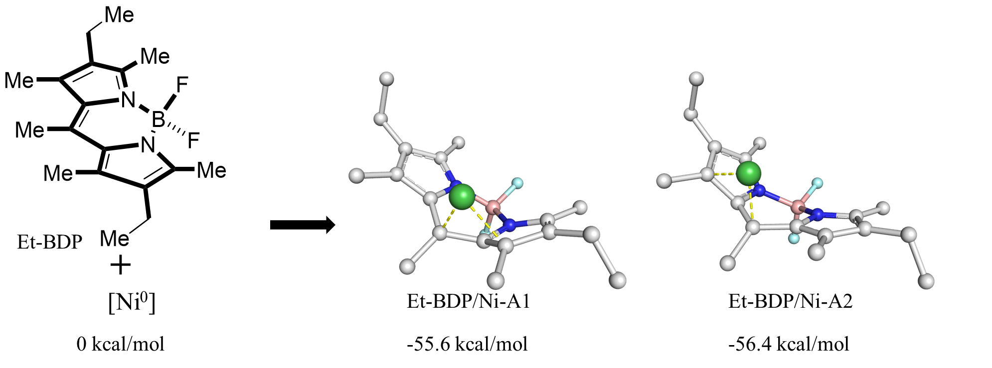
Figure S43. The optimized geometries for the ground state of Et-BDP and nickel.
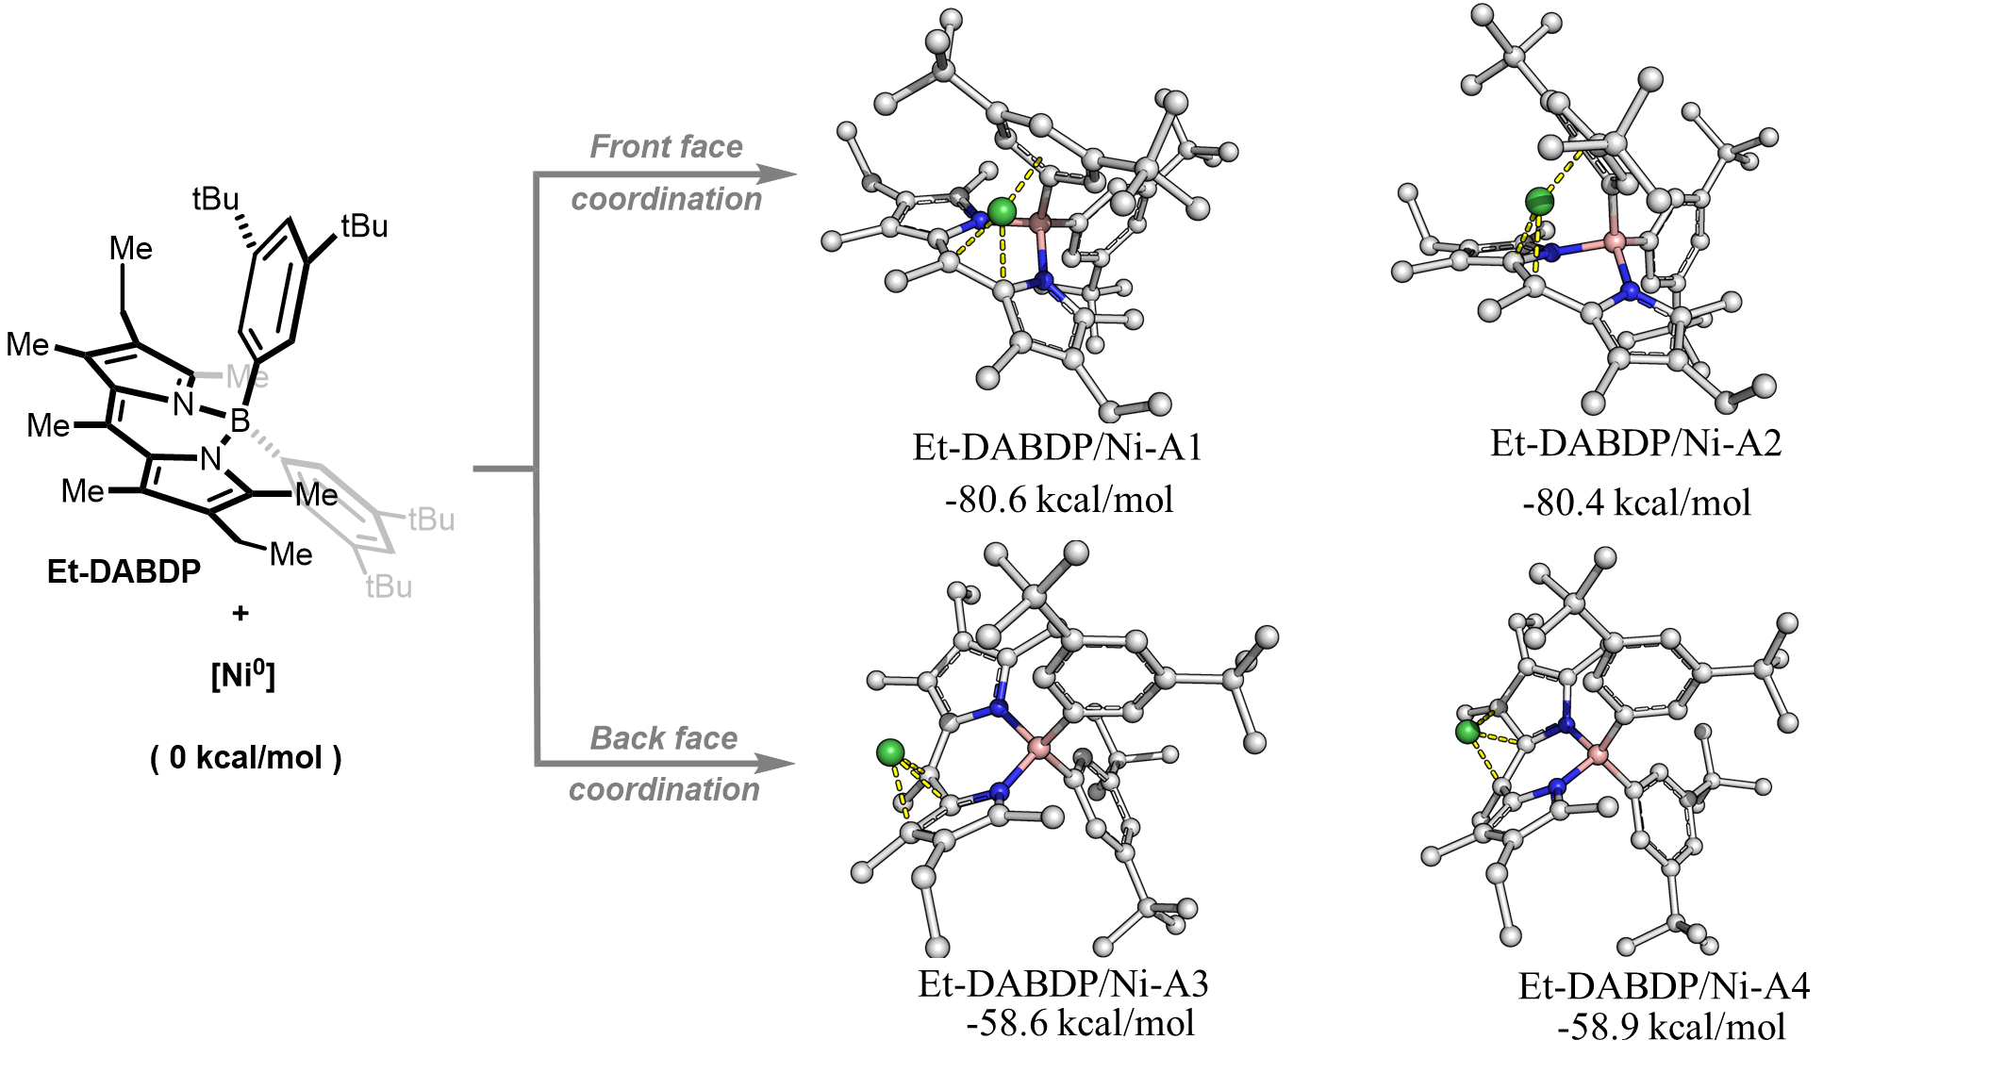
Figure S44. The optimized geometries for the ground state of Et-DABDP and nickel.
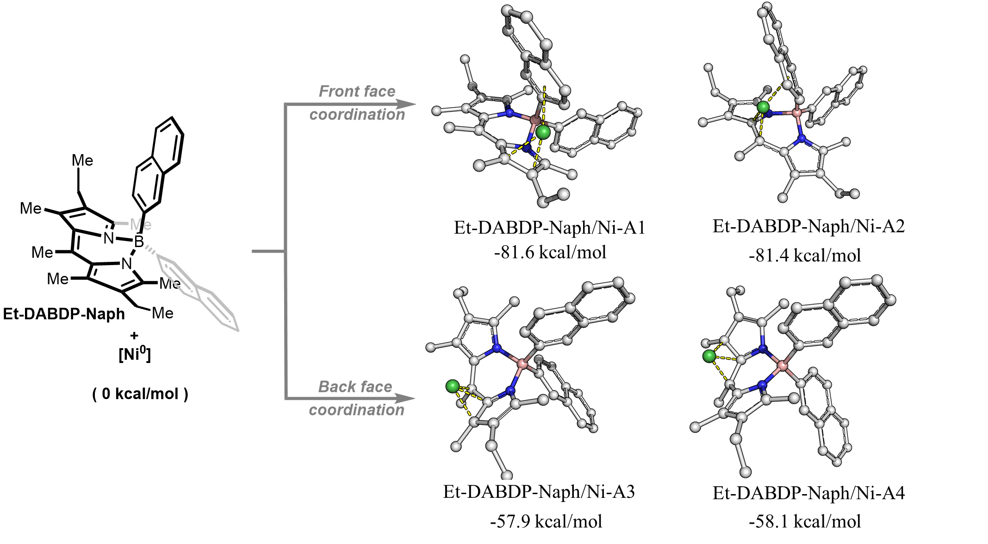
Figure S45. The optimized geometries for the ground state of Et-DABDP-Naph.
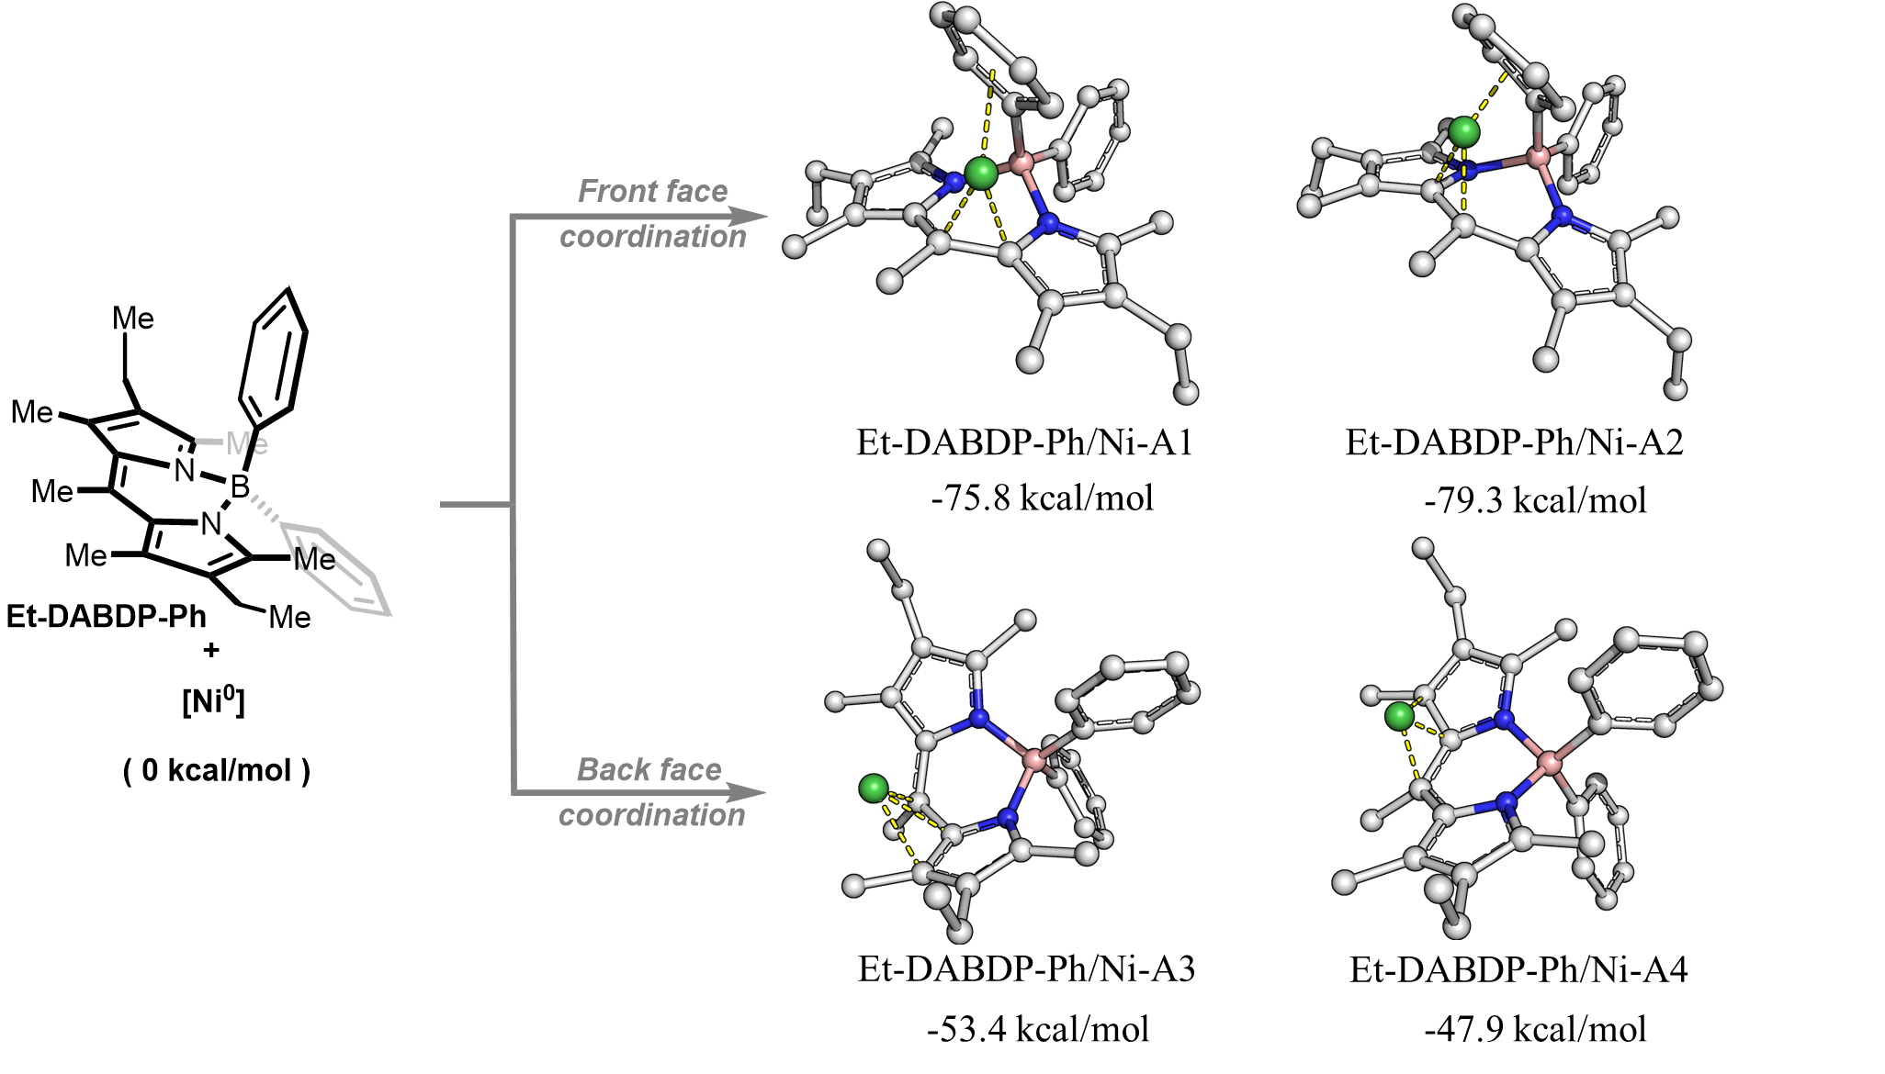
Figure S46. The optimized geometries for the ground state of Et-DABDP-Ph.

Table S14. The calculated energy for the systems
Energy (kcal/mol) | Et-BDP | Et-DABDP | Et-DABDP-Naph | Et-DABDP-Ph
Ni-A1 | -55.55 | -80.63 | -81.56 | -75.81
Ni-A2 | -56.36 | -80.40 | -81.41 | -79.34
Ni-A3 | NA | -58.55 | -57.90 | -53.44
Ni-A4 | NA | -58.87 | -58.14 | -47.86
NA: No this conformation.
The energy was calculated with $∆E=E_{ligand-Ni}-E_{ligand}-E_{Ni}$ which the E with the sum of electronic and thermal free energies.

10. X-Ray Diffraction Analysis
10.1 X-Ray Diffraction Analysis of compound Et-DABDP-Ph
CCDC number: CCDC 2098228
The crystal was obtained from a mixed solution (n-pentane/diethyl ether) at room temperature.
Identification code | s_pl
Empirical formula | C₃₀H₃₅BN₂
Formula weight | 434.41
Temperature/K | 153.15
Crystal system | orthorhombic
Space group | Pca2₁
a/Å | 19.5752(7)
b/Å | 11.4919(4)
c/Å | 22.0397(8)
α/° | 90
β/° | 90
γ/° | 90
Volume/Å³ | 4958.0(3)
Z | 8
Density (calculated) g/cm³ | 1.164
μ/ mm⁻¹ | 0.501
F(000) | 1872.0
Crystal size/mm³ | 0.5 × 0.4 × 0.3
Radiation | CuKα (λ = 1.54178)
2Θ range for data collection/° | 7.692 to 136.484
Index ranges | -23 ≤ h ≤ 22, -13 ≤ k ≤ 13, -26 ≤ l ≤ 26
Reflections collected | 172401
Independent reflections | 9066 [R_{int} = 0.0513, R_{sigma} = 0.0155]
Data/restraints/parameters | 9066/1/610
Goodness-of-fit on F² | 1.043
Final R indexes [I>=2σ (I)] | R₁ = 0.0331, wR₂ = 0.0841
Final R indexes [all data] | R₁ = 0.0356, wR₂ = 0.0863
Largest diff. peak/hole / e Å⁻³ | 0.21/-0.18
Flack parameter | 0.5(4)
10.2 X-Ray Diffraction Analysis of compound Et-DABDP
CCDC number: CCDC 2098229
The crystal was obtained from a mixed solution (n-pentane/diethyl ether) at room temperature.
Identification code | s
Empirical formula | C₄₆H₆₇BN₂
Formula weight | 658.82
Temperature/K | 153.0
Crystal system | orthorhombic
Space group | Pbcn
a/Å | 35.459(4)
b/Å | 11.8152(14)
c/Å | 20.094(2)
α/° | 90
β/° | 90
γ/° | 90
Volume/Å³ | 8418.4(17)
Z | 8
Density (calculated) g/cm³ | 1.040
μ/ mm⁻¹ | 0.434
F(000) | 2896.0
Crystal size/mm³ | 0.5 × 0.4 × 0.3
Radiation | CuKα (λ = 1.54178)
2Θ range for data collection/° | 9.034 to 136.968
Index ranges | -42 ≤ h ≤ 42, -14 ≤ k ≤ 12, -24 ≤ l ≤ 24
Reflections collected | 116543
Independent reflections | 7709 [R_{int} = 0.0520, R_{sigma} = 0.0198]
Data/restraints/parameters | 7709/39/493
Goodness-of-fit on F² | 1.035
Final R indexes [I>=2σ (I)] | R₁ = 0.0542, wR₂ = 0.1440
Final R indexes [all data] | R₁ = 0.0602, wR₂ = 0.1502
Largest diff. peak/hole / e Å⁻³ | 1.32/-0.19
10.3 X-Ray Diffraction Analysis of compound 73-C3
CCDC number: CCDC 2098221
The crystal was obtained from a mixed solution (n-pentane/dichloromethane) at room temperature.
Identification code | s
Empirical formula | C₁₇H₂₁NO₆
Formula weight | 335.35
Temperature/K | 153.0
Crystal system | orthorhombic
Space group | P2₁2₁2₁
a/Å | 5.5370(2)
b/Å | 13.7235(5)
c/Å | 21.9097(8)
α/° | 90
β/° | 90
γ/° | 90
Volume/Å³ | 1664.85(10)
Z | 4
Density (calculated) g/cm³ | 1.338
μ/ mm⁻¹ | 0.850
F(000) | 712.0
Crystal size/mm³ | 0.5 × 0.4 × 0.3
Radiation | CuKα (λ = 1.54178)
2Θ range for data collection/° | 8.07 to 136.3
Index ranges | -6 ≤ h ≤ 6, -16 ≤ k ≤ 16, -26 ≤ l ≤ 26
Reflections collected | 22901
Independent reflections | 3048 [R_{int} = 0.0302, R_{sigma} = 0.0169]
Data/restraints/parameters | 3048/0/221
Goodness-of-fit on F² | 1.085
Final R indexes [I>=2σ (I)] | R₁ = 0.0245, wR₂ = 0.0633
Final R indexes [all data] | R₁ = 0.0252, wR₂ = 0.0639
Largest diff. peak/hole / e Å-3 | 0.15/-0.16
Flack parameter | 0.07(4)
10.4 X-Ray Diffraction Analysis of compound 75-C5
CCDC number: CCDC 2098343
The crystal was obtained from a mixed solution (n-pentane/dichloromethane) at room temperature.
Identification code | s
Empirical formula | C₃₃H₃₉FN₄O₆S
Formula weight | 638.74
Temperature/K | 231.0
Crystal system | triclinic
Space group | P1
a/Å | 6.1301(8)
b/Å | 11.0266(16)
c/Å | 24.339(3)
α/° | 90.650(6)
β/° | 95.349(6)
γ/° | 90.385(6)
Volume/Å³ | 1637.8(4)
Z | 2
Density (calculated) g/cm³ | 1.295
μ/ mm⁻¹ | 1.340
F(000) | 676.0
Crystal size/mm³ | 0.5 × 0.4 × 0.3
Radiation | CuKα (λ = 1.54178)
2Θ range for data collection/° | 3.646 to 138.346
Index ranges | -7 ≤ h ≤ 7, -13 ≤ k ≤ 13, -27 ≤ l ≤ 29
Reflections collected | 40643
Independent reflections | 11065 [R_{int} = 0.0645, R_{sigma} = 0.0582]
Data/restraints/parameters | 11065/3/827
Goodness-of-fit on F² | 1.053
Final R indexes [I>=2σ (I)] | R₁ = 0.0470, wR₂ = 0.1131
Final R indexes [all data] | R₁ = 0.0621, wR₂ = 0.1294
Largest diff. peak/hole / e Å-3 | 0.31/-0.51
Flack parameter | 0.059(10)

11. References
1 Yang, L. et al. Synthesis of Phenols: Organophotoredox/Nickel Dual Catalytic Hydroxylation of Aryl Halides with Water. Angew. Chem. Int. Ed. 57, 1968-1972, doi:https://doi.org/10.1002/anie.201710698 (2018).
2 Goze, C. et al. Synthesis and Photophysical Properties of Borondipyrromethene Dyes Bearing Aryl Substituents at the Boron Center. J. Am. Chem. Soc. 128, 10231-10239, doi:10.1021/ja062405a (2006).
3 Kasun, Z. A., Geary, L. M. & Krische, M. J. Ring expansion of cyclic 1,2-diols to form medium sized rings via ruthenium catalyzed transfer hydrogenative [4+2] cycloaddition. Chem. Commun. 50, 7545-7547, doi:10.1039/C4CC03983A (2014).
4 Uzelac, M. et al. Tandem Mn–I Exchange and Homocoupling Processes Mediated by a Synergistically Operative Lithium Manganate. Angew. Chem. Int. Ed. 60, 3247-3253, doi:https://doi.org/10.1002/anie.202013153 (2021).
5 Wang, H. et al. Atomically Dispersed Ru on Manganese Oxide Catalyst Boosts Oxidative Cyanation. ACS Catal. 10, 6299-6308, doi:10.1021/acscatal.0c00485 (2020).
6 Yeon, S. K. et al. Synthesis and evaluation of biaryl derivatives for structural characterization of selective monoamine oxidase B inhibitors toward Parkinson’s disease therapy. Biorg. Med. Chem. 26, 232-244, doi:https://doi.org/10.1016/j.bmc.2017.11.036 (2018).
7 Jagadeesh, R. V., Junge, H. & Beller, M. Green synthesis of nitriles using non-noble metal oxides-based nanocatalysts. Nat. Commun. 5, 4123, doi:10.1038/ncomms5123 (2014).
8 Cheng, X. et al. Identification of 2-[4-[(4-Methoxyphenyl)methoxy]-phenyl]acetonitrile and Derivatives as Potent Oct3/4 Inducers. J. Med. Chem. 58, 4976-4983, doi:10.1021/acs.jmedchem.5b00144 (2015).
9 Murugesan, K., Donabauer, K. & König, B. Visible-Light-Promoted Metal-Free Synthesis of (Hetero)Aromatic Nitriles from C(sp3)−H Bonds**. Angew. Chem. Int. Ed. 60, 2439-2445, doi:https://doi.org/10.1002/anie.202011815 (2021).
10 Liu, Y.-Y., Liang, D., Lu, L.-Q. & Xiao, W.-J. Practical heterogeneous photoredox/nickel dual catalysis for C–N and C–O coupling reactions. Chem. Commun. 55, 4853-4856, doi:10.1039/C9CC00987F (2019).
11 Wang, D.-Y., Yang, Z.-K., Wang, C., Zhang, A. & Uchiyama, M. From Anilines to Aryl Ethers: A Facile, Efficient, and Versatile Synthetic Method Employing Mild Conditions. Angew. Chem. Int. Ed. 57, 3641-3645, doi:https://doi.org/10.1002/anie.201712618 (2018).
12 Rangarajan, T. M. et al. BrettPhos Ligand Supported Palladium-Catalyzed CO Bond Formation through an Electronic Pathway of Reductive Elimination: Fluoroalkoxylation of Activated Aryl Halides. Chem. Eur. J. 20, 14218-14225, doi:https://doi.org/10.1002/chem.201404121 (2014).
13 Yang, L. et al. Light-Promoted Nickel Catalysis: Etherification of Aryl Electrophiles with Alcohols Catalyzed by a NiII-Aryl Complex. Angew. Chem. Int. Ed. 59, 12714-12719, doi:https://doi.org/10.1002/anie.202003359 (2020).
14 Sarju, J., Danks, T. N. & Wagner, G. Rapid microwave-assisted synthesis of phenyl ethers under mildly basic and nonaqueous conditions. Tetrahedron Lett. 45, 7675-7677, doi:https://doi.org/10.1016/j.tetlet.2004.08.087 (2004).
15 Mao, R., Balon, J. & Hu, X. Decarboxylative C(sp3)−O Cross-Coupling. Angew. Chem. Int. Ed. 57, 13624-13628, doi:https://doi.org/10.1002/anie.201808024 (2018).
16 Szigeti, M., Dobi, Z. & Soós, T. The Goldilocks Principle in Phase Labeling. Minimalist and Orthogonal Phase Tagging for Chromatography-Free Mitsunobu Reaction. J. Org. Chem. 83, 2869-2874, doi:10.1021/acs.joc.8b00014 (2018).
17 Ercole, F. et al. Macromolecular Hydrogen Sulfide Donors Trigger Spatiotemporally Confined Changes in Cell Signaling. Biomacromolecules 17, 371-383, doi:10.1021/acs.biomac.5b01469 (2016).
18 Zheng, Y. et al. Ligand-free Cu-catalyzed O-arylation of aliphatic diols. RSC Adv. 5, 66104-66108, doi:10.1039/C5RA12529D (2015).
19 Escobar, R. A. & Johannes, J. W. A Unified and Practical Method for Carbon–Heteroatom Cross-Coupling using Nickel/Photo Dual Catalysis. Chem. Eur. J. 26, 5168-5173, doi:https://doi.org/10.1002/chem.202000052 (2020).
20 Cavedon, C., Madani, A., Seeberger, P. H. & Pieber, B. Semiheterogeneous Dual Nickel/Photocatalytic (Thio)etherification Using Carbon Nitrides. Org. Lett. 21, 5331-5334, doi:10.1021/acs.orglett.9b01957 (2019).
21 Lombardi, L. et al. Allylic and Allenylic Dearomatization of Indoles Promoted by Graphene Oxide by Covalent Grafting Activation Mode. Chem. Eur. J. 26, 10427-10432, doi:https://doi.org/10.1002/chem.202001373 (2020).
22 Sedano, C., Velasco, R., Feberero, C., Suárez-Pantiga, S. & Sanz, R. α-Lithiobenzyloxy as a Directed Metalation Group in ortho-Lithiation Reactions. Org. Lett. 22, 6365-6369, doi:10.1021/acs.orglett.0c02199 (2020).
23 Li, J. et al. Photoredox catalysis with aryl sulfonium salts enables site-selective late-stage fluorination. Nat. Chem. 12, 56-62, doi:10.1038/s41557-019-0353-3 (2020).
24 Radfar, I., Kazemi Miraki, M., Esfandiary, N., Ghandi, L. & Heydari, A. Fe3O4@SiO2-copper sucrose xanthate as a green nanocatalyst for N-, O- and S-arylation. Appl. Organomet. Chem. 33, e4619, doi:https://doi.org/10.1002/aoc.4619 (2019).
25 Chen, Z., Jiang, Y., Zhang, L., Guo, Y. & Ma, D. Oxalic Diamides and tert-Butoxide: Two Types of Ligands Enabling Practical Access to Alkyl Aryl Ethers via Cu-Catalyzed Coupling Reaction. J. Am. Chem. Soc. 141, 3541-3549, doi:10.1021/jacs.8b12142 (2019).
26 Li, G. et al. Transition-metal-free formal cross-coupling of aryl methyl sulfoxides and alcohols via nucleophilic activation of C-S bond. Nat. Commun. 11, 2890, doi:10.1038/s41467-020-16713-8 (2020).
27 Schwenninger, R. & Ongania, K. H. Synthesis of benzanellated carbacephams. II. Monatsh. Chem. 126, 187-199 (1995).
28 Qin, Y., Martindale, B. C. M., Sun, R., Rieth, A. J. & Nocera, D. G. Solar-driven tandem photoredox nickel-catalysed cross-coupling using modified carbon nitride. Chem. Sci. 11, 7456-7461, doi:10.1039/D0SC02131H (2020).
29 Bai, W.-J., Xie, J.-H., Li, Y.-L., Liu, S. & Zhou, Q.-L. Enantioselective Synthesis of Chiral β-Aryloxy Alcohols by Ruthenium-Catalyzed Ketone Hydrogenation via Dynamic Kinetic Resolution (DKR). Adv. Synth. Catal. 352, 81-84, doi:https://doi.org/10.1002/adsc.200900675 (2010).
30 Madivada, L. R. et al. An Improved Process for Pioglitazone and Its Pharmaceutically Acceptable Salt. Org. Process Res. Dev. 13, 1190-1194, doi:10.1021/op900131m (2009).
31 Xiong, Y. et al. Regulating the piezofluorochromism of 9,10-bis(butoxystyryl)anthracenes by isomerization of butyl groups. Chem. Commun. 51, 3403-3406, doi:10.1039/C4CC10196K (2015).
32 Li, C. et al. Decarboxylative borylation. Science 356, eaam7355, doi:10.1126/science.aam7355 (2017).

12. NMR Spectra
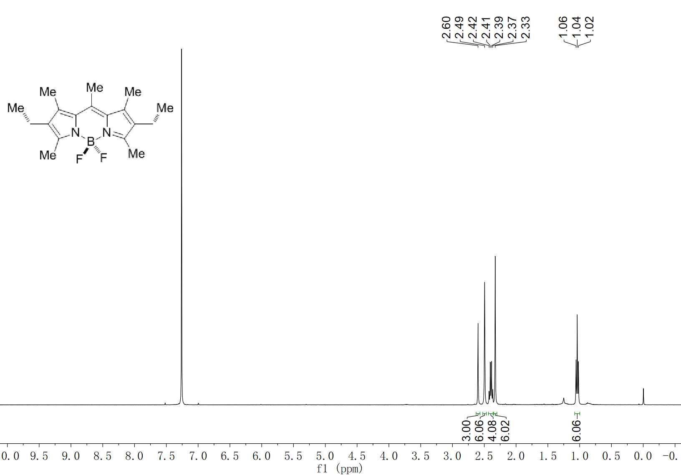
Et-BDP ¹H NMR (400 MHz, CDCl₃)

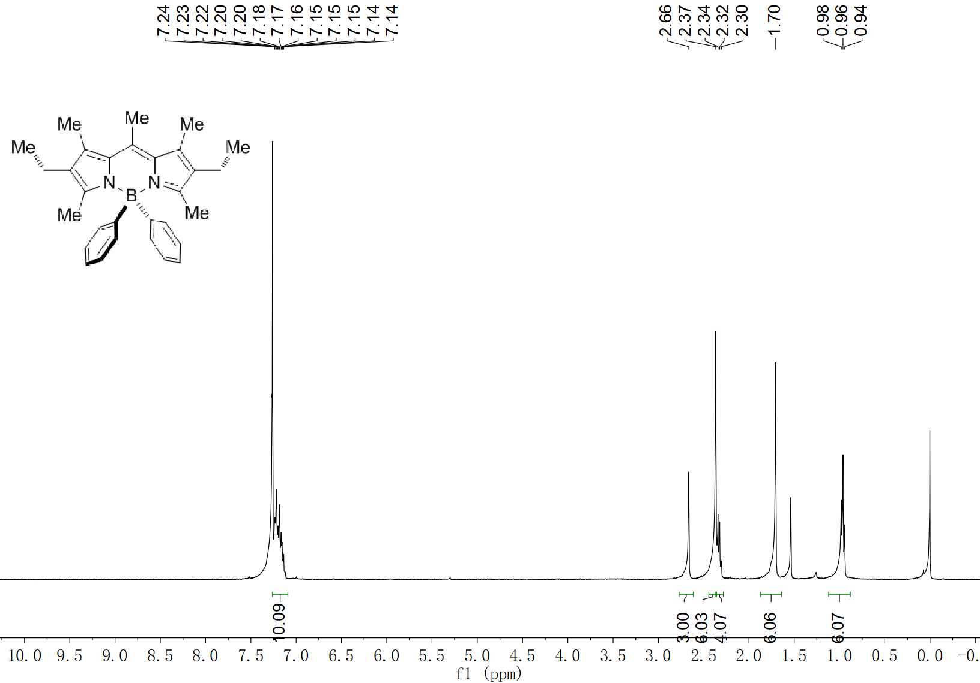
Et-DABDP-Ph ¹H NMR (400 MHz, CDCl₃)

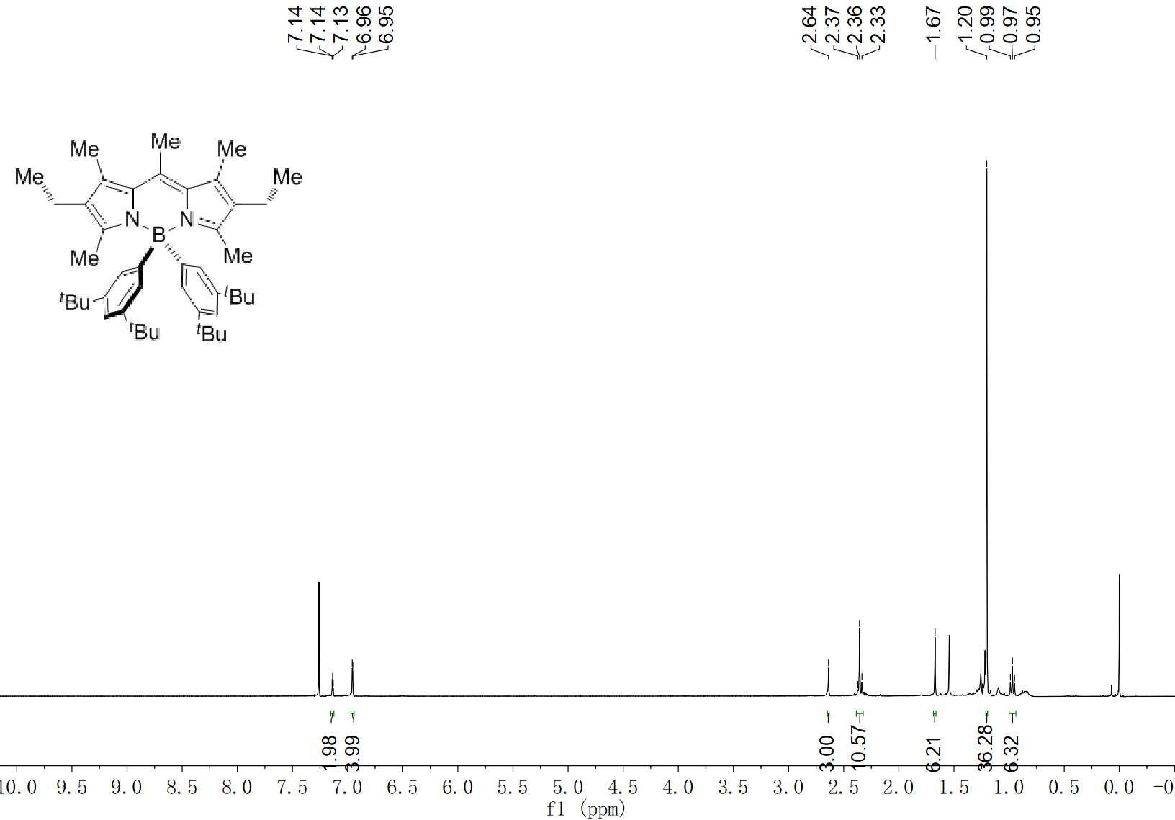
Et-DABDP ¹H NMR (400 MHz, CDCl₃)

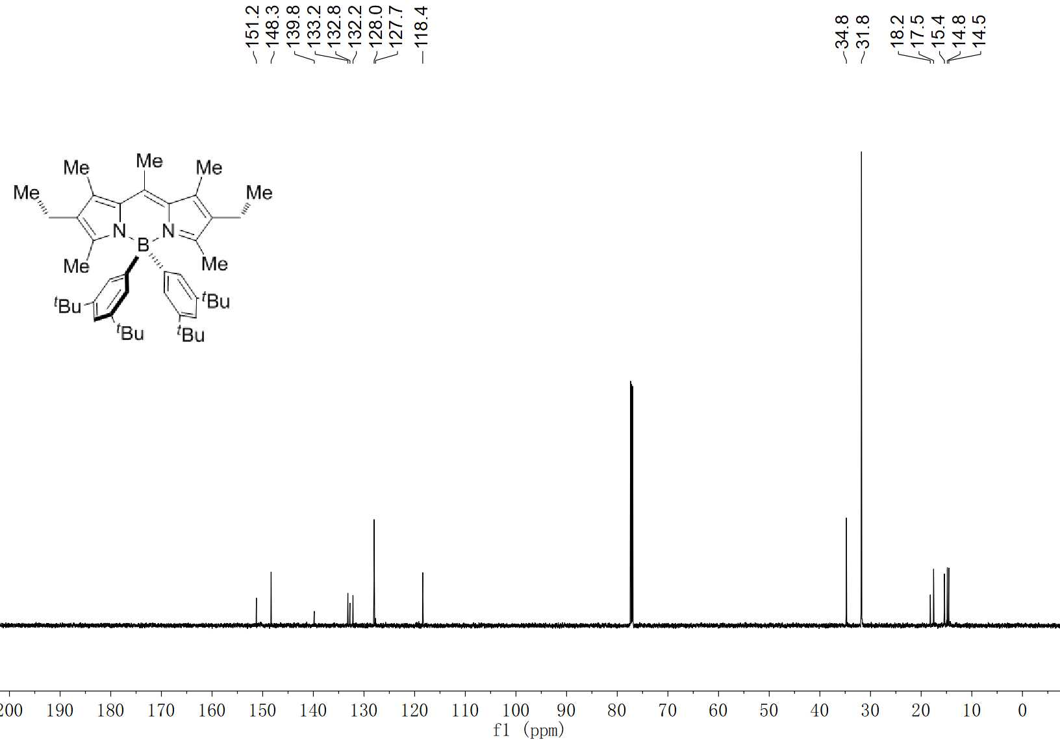
Et-DABDP ¹³C NMR (100 MHz, CDCl₃)

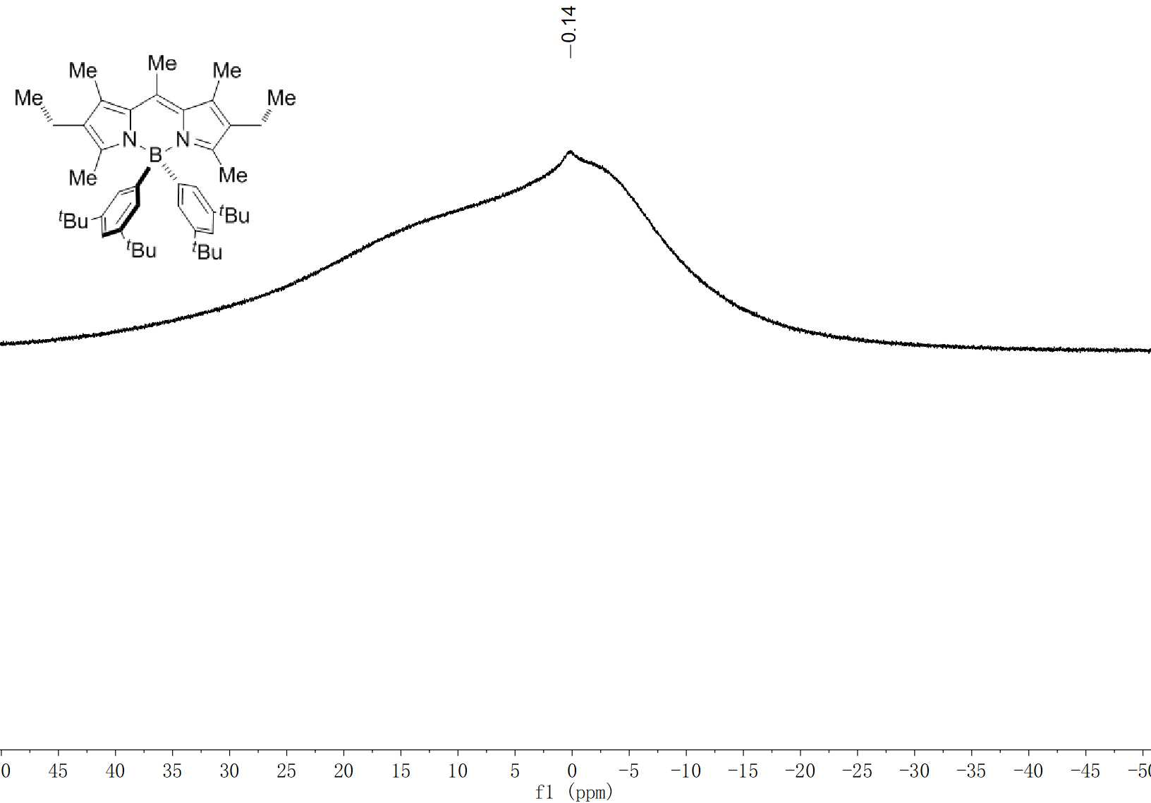
Et-DABDP ¹¹B NMR (192 MHz, CDCl₃)

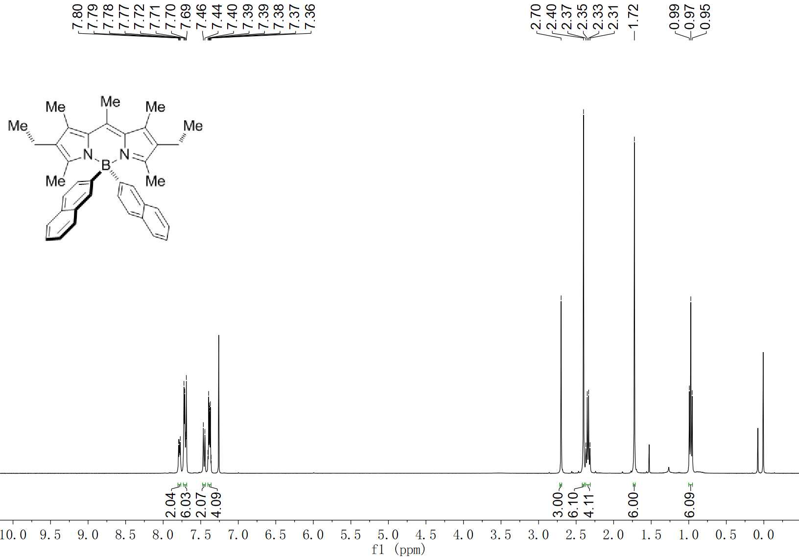
Et-DABDP-Naph ¹H NMR (400 MHz, CDCl₃)

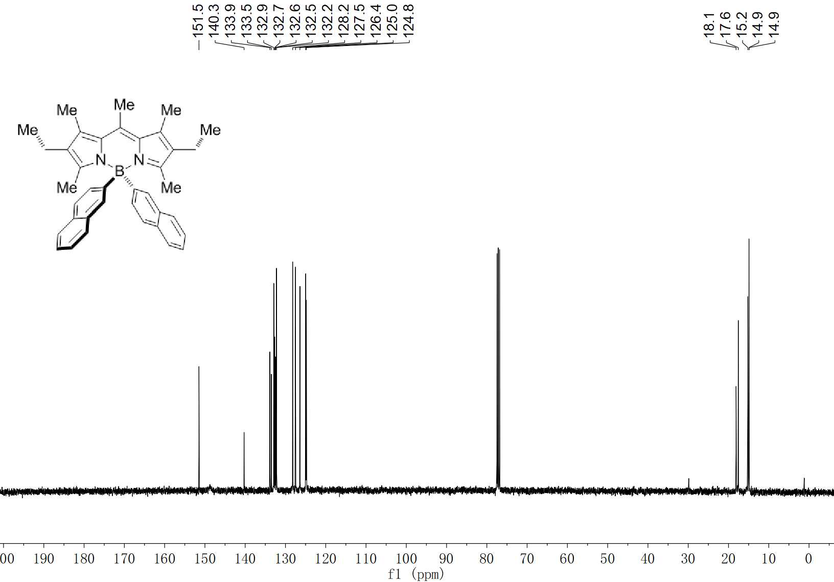
Et-DABDP-Naph ¹³C NMR (100 MHz, CDCl₃)

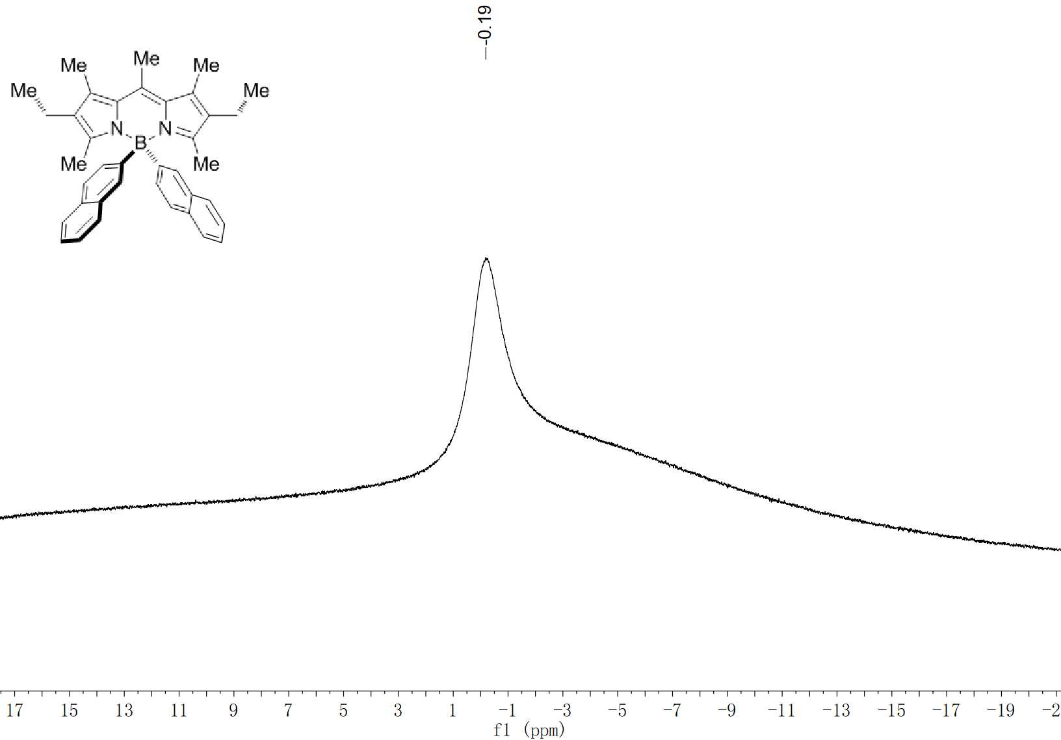
Et-DABDP-Naph ¹¹B NMR (192 MHz, CDCl₃)

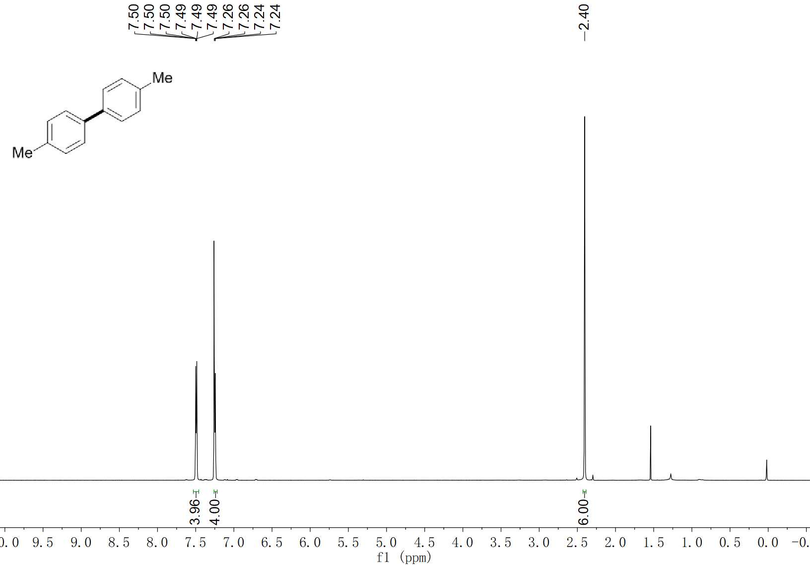
5 ¹H NMR (600 MHz, CDCl₃)

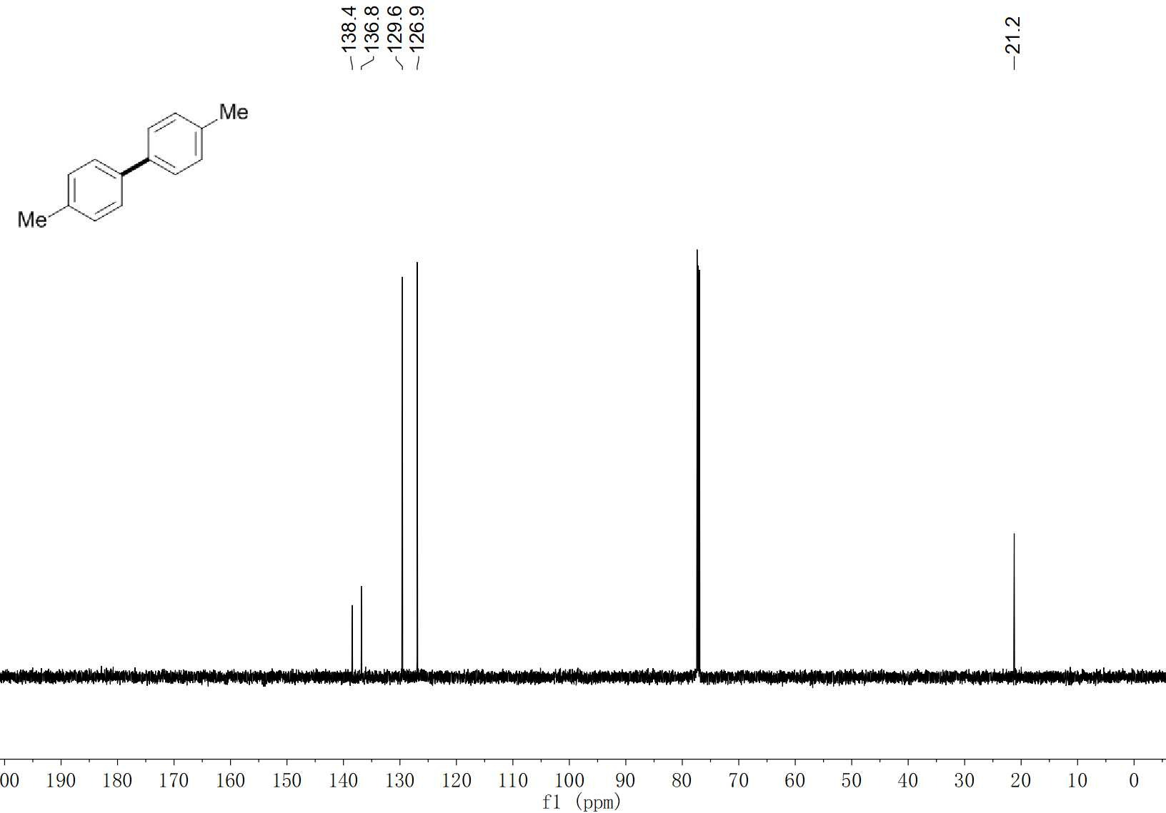
5 ¹³C NMR (150 MHz, CDCl₃)

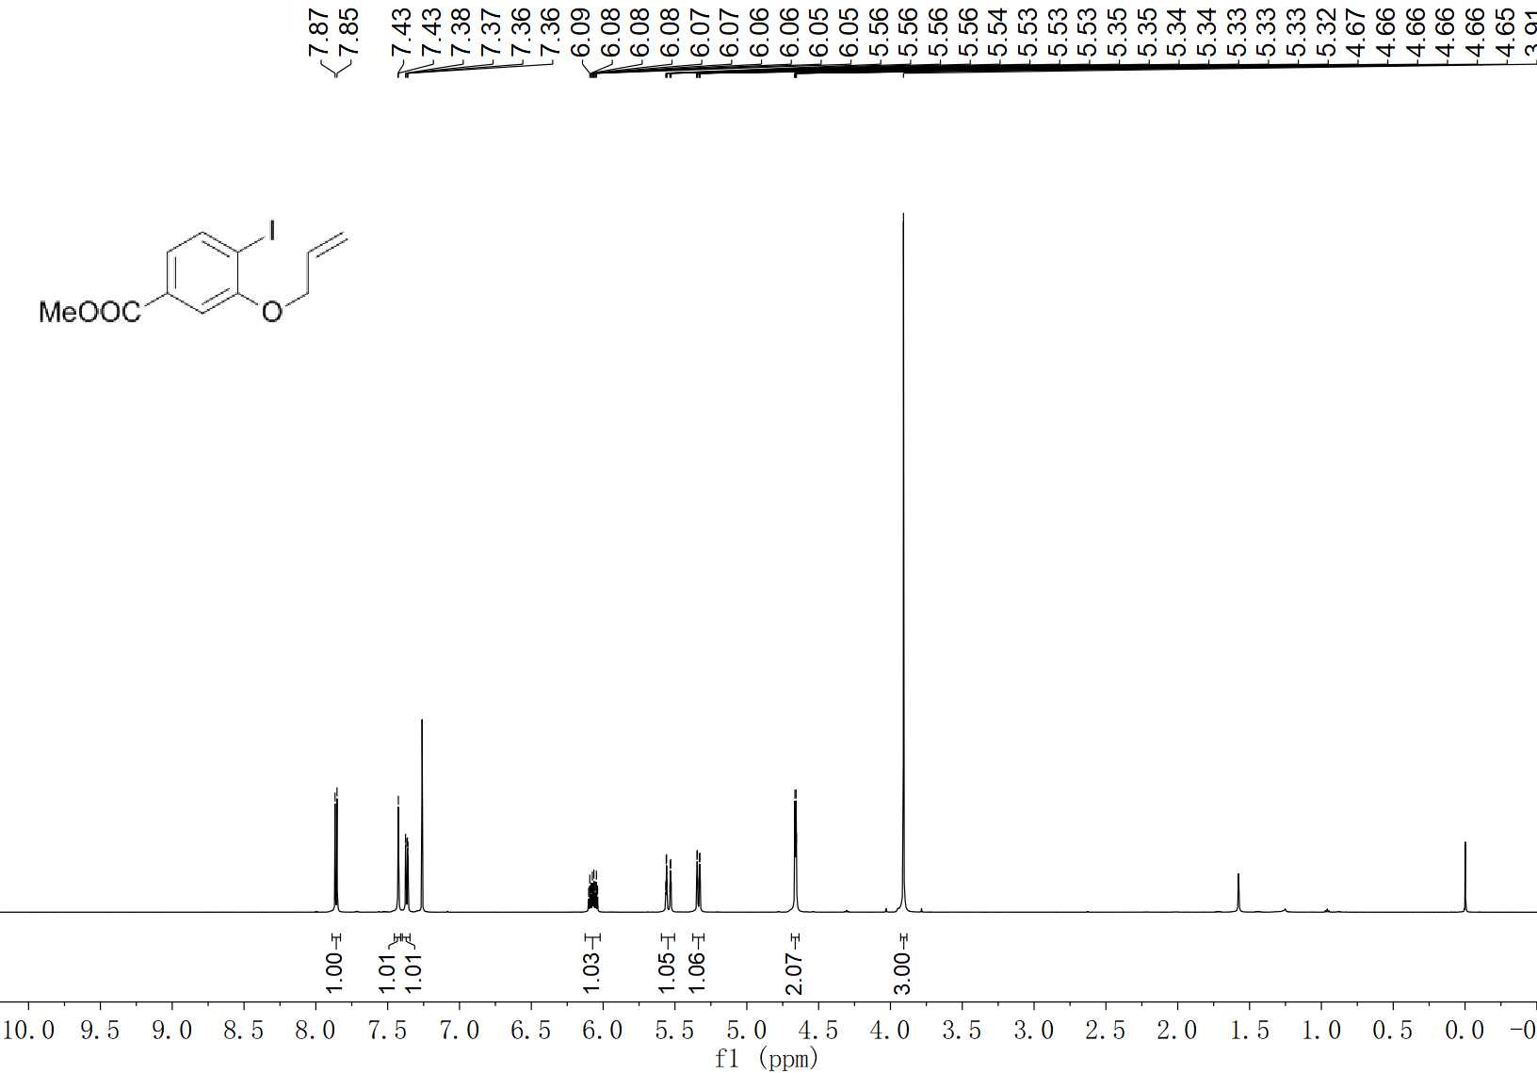
6 ¹H NMR (600 MHz, CDCl₃)

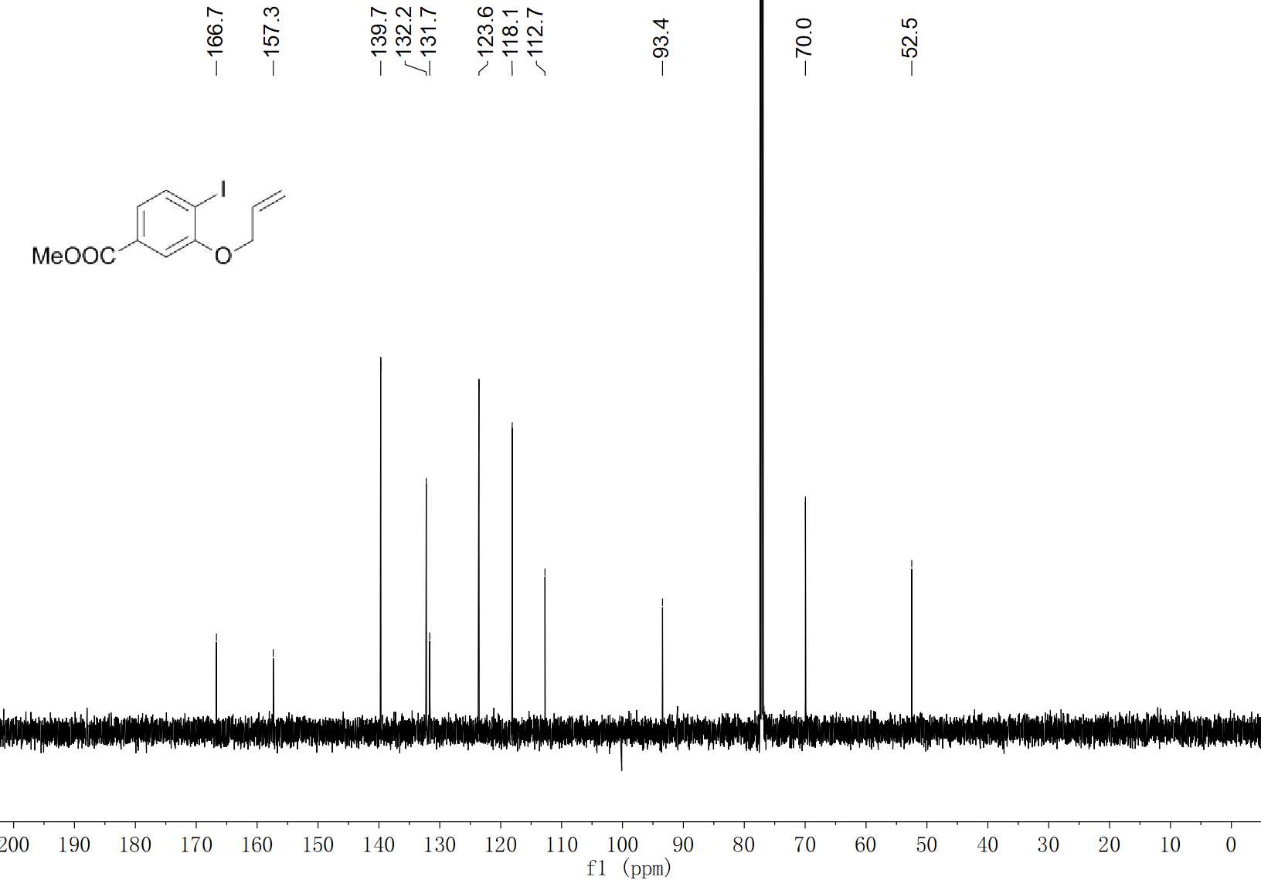
6 ¹³C NMR (150 MHz, CDCl₃)

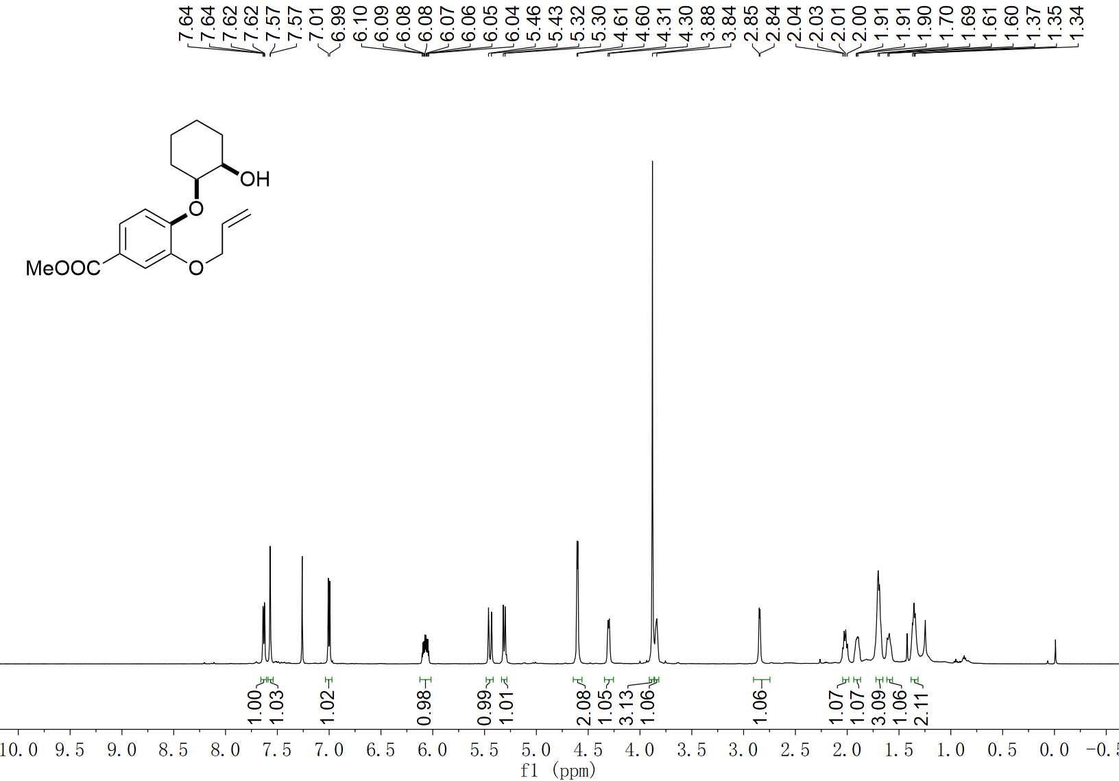
8 ¹H NMR (400 MHz, CDCl₃)

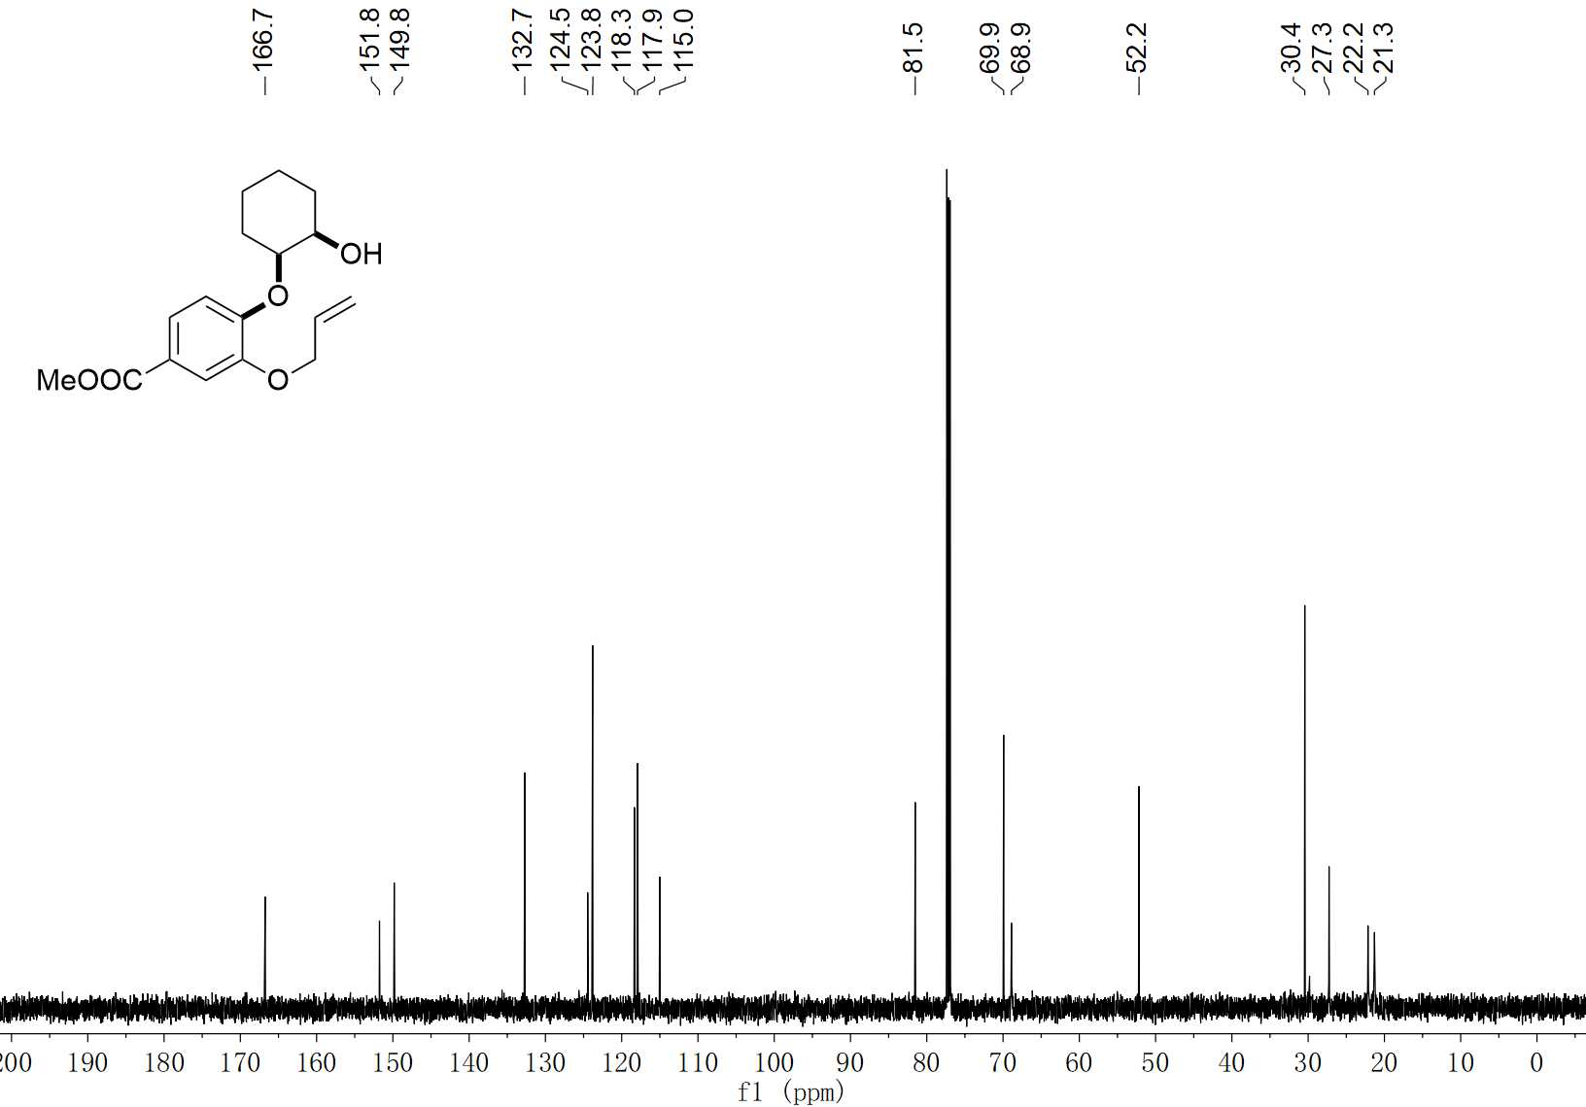
8 ¹³C NMR (150 MHz, CDCl₃)

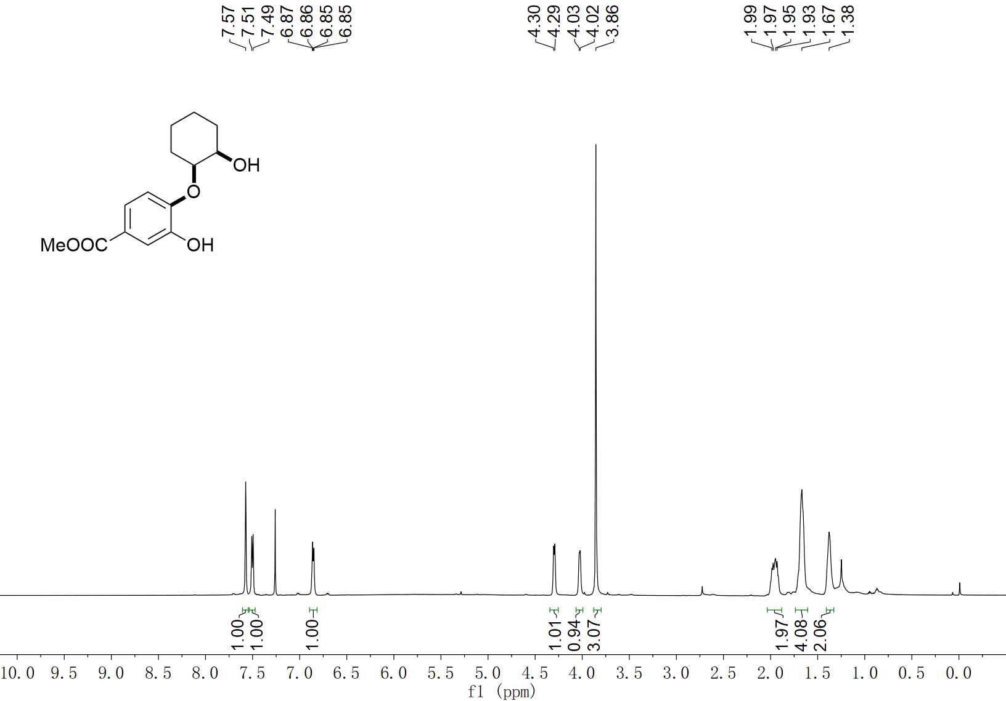
9 ¹H NMR (400 MHz, CDCl₃)

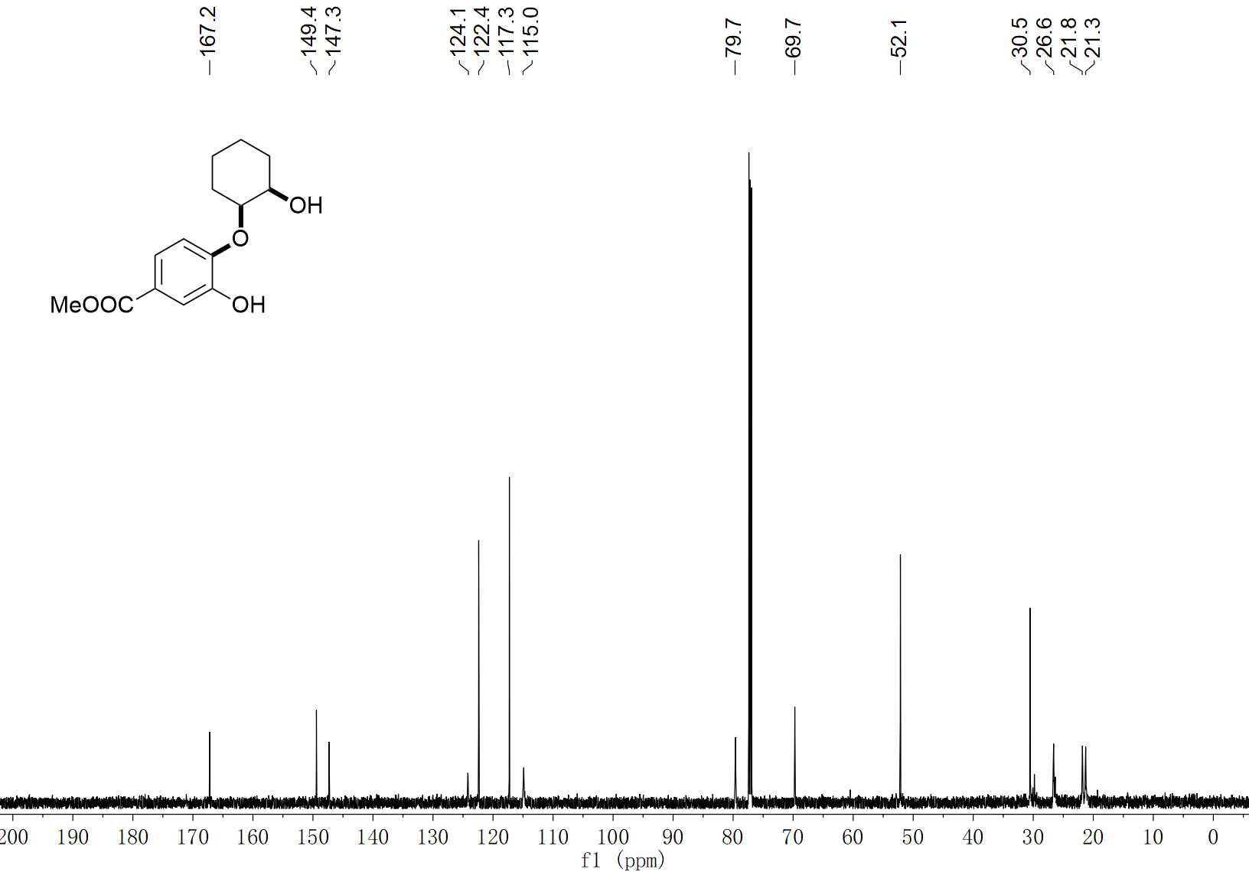
9 ¹³C NMR (150 MHz, CDCl₃)

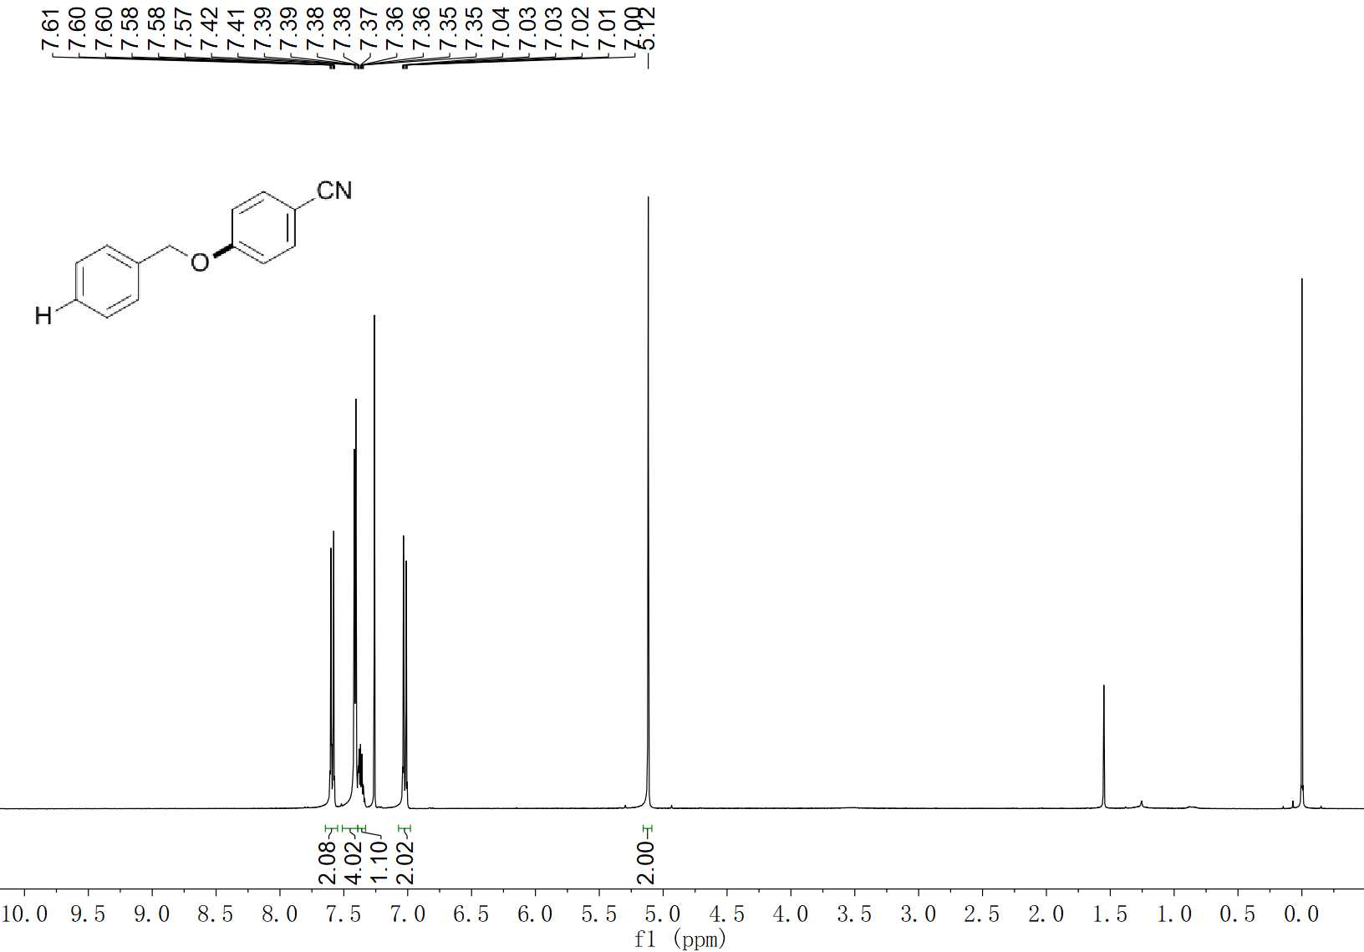
14 ¹H NMR (400 MHz, CDCl₃)

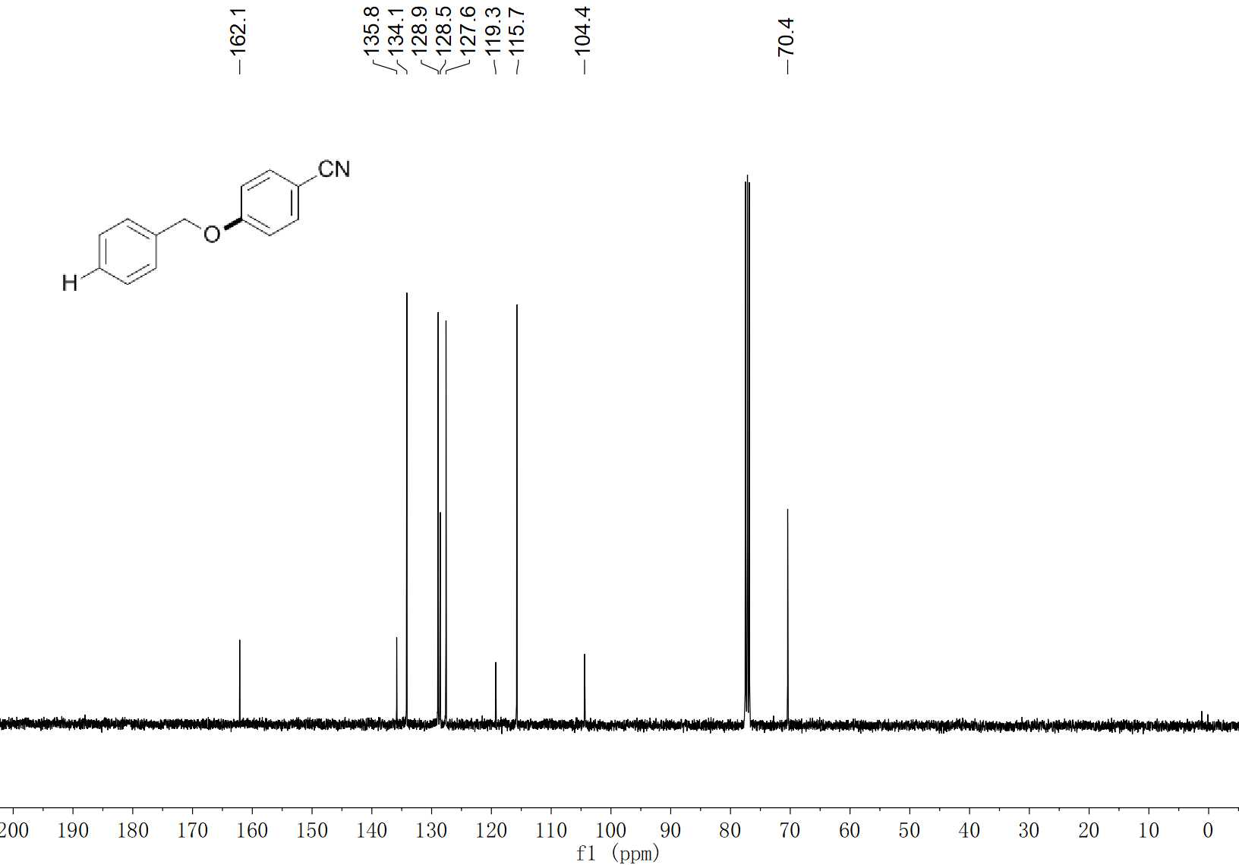
14 ¹³C NMR (100 MHz, CDCl₃)

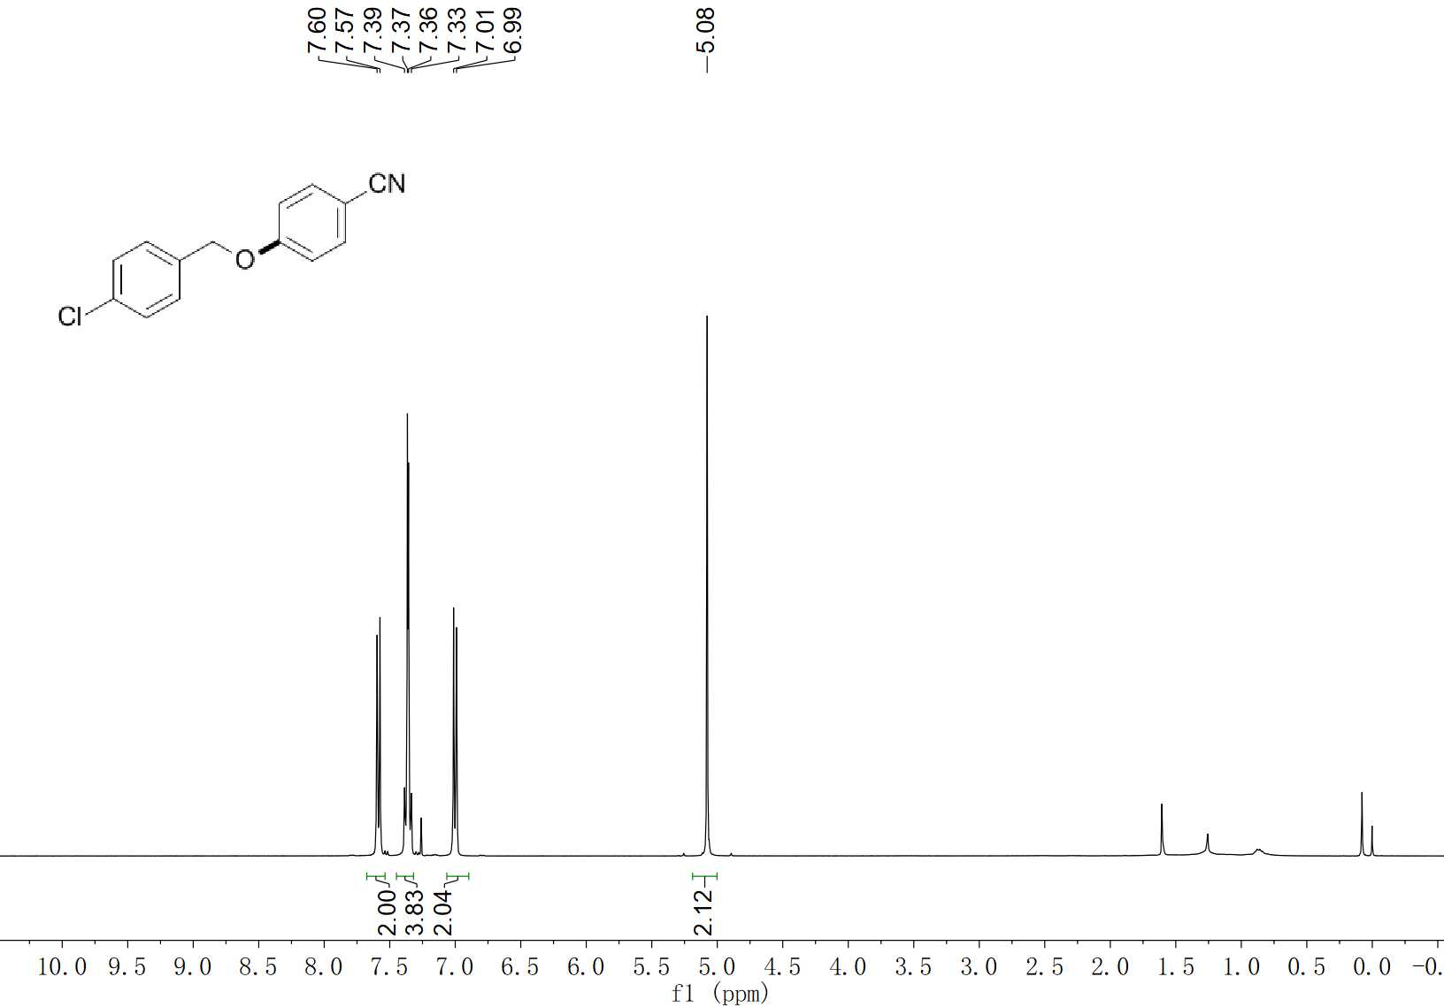
15 ¹H NMR (400 MHz, CDCl₃)

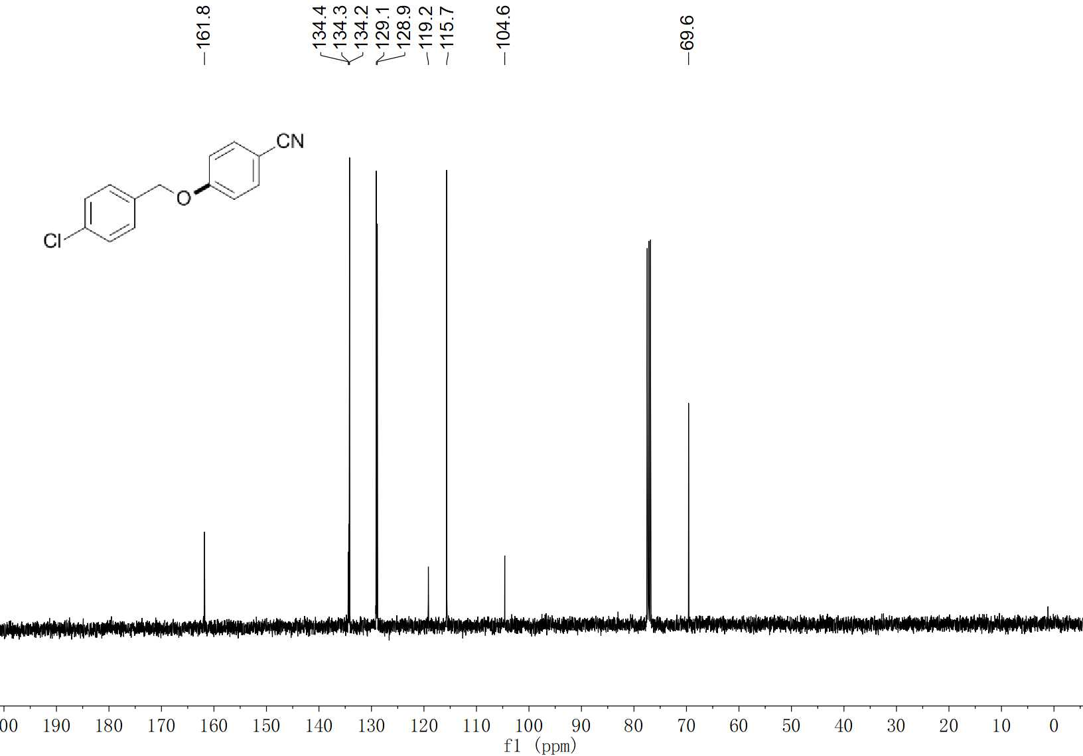
15 ¹³C NMR (100 MHz, CDCl₃)

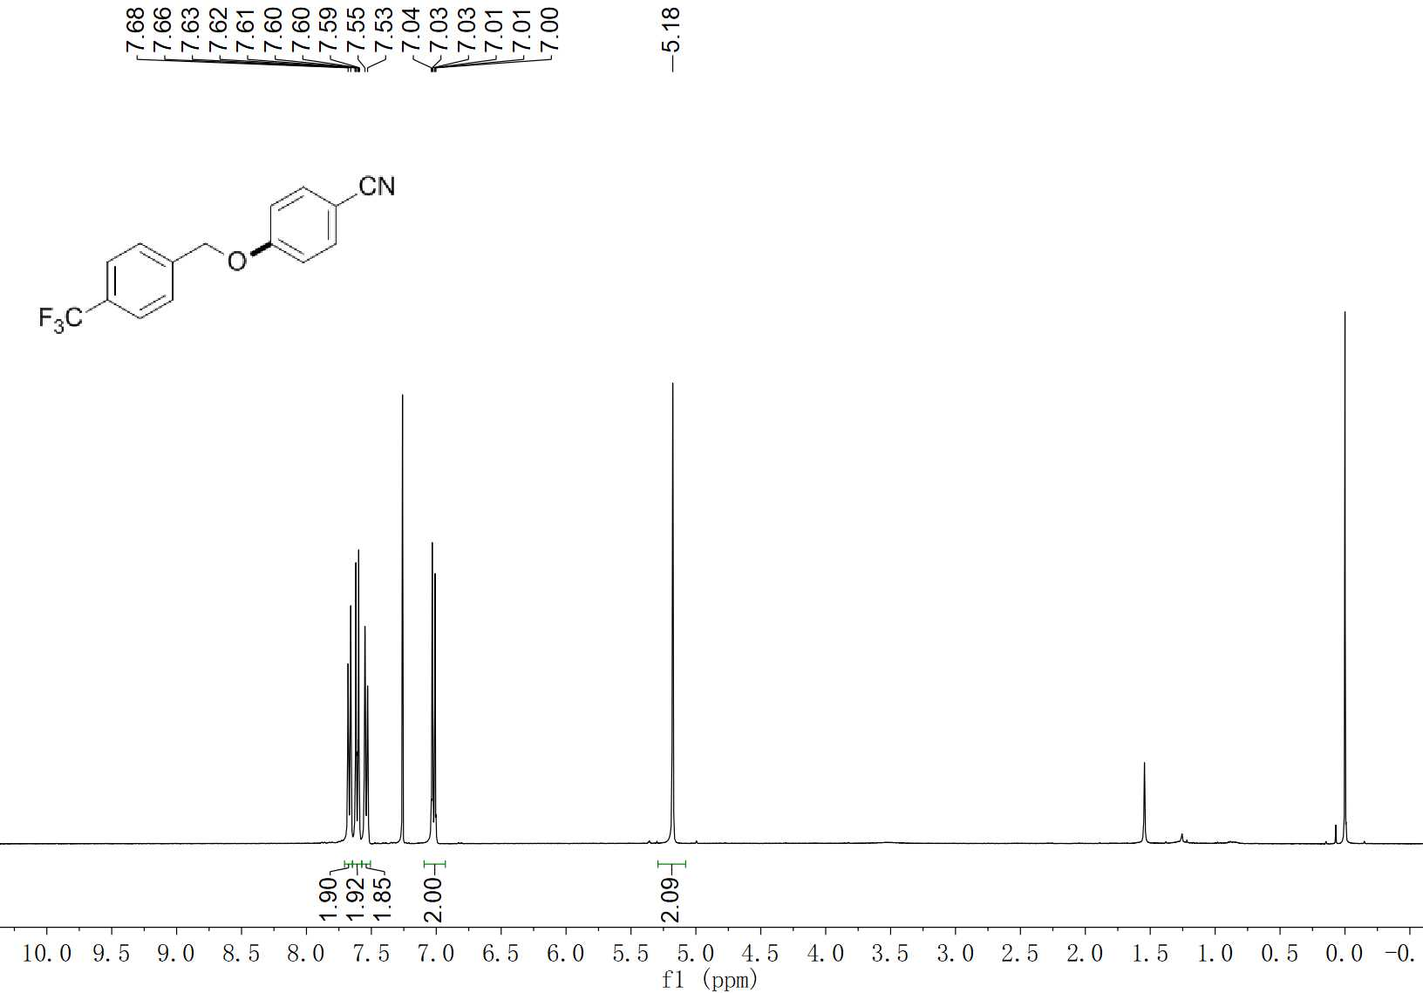
16 ¹H NMR (400 MHz, CDCl₃)

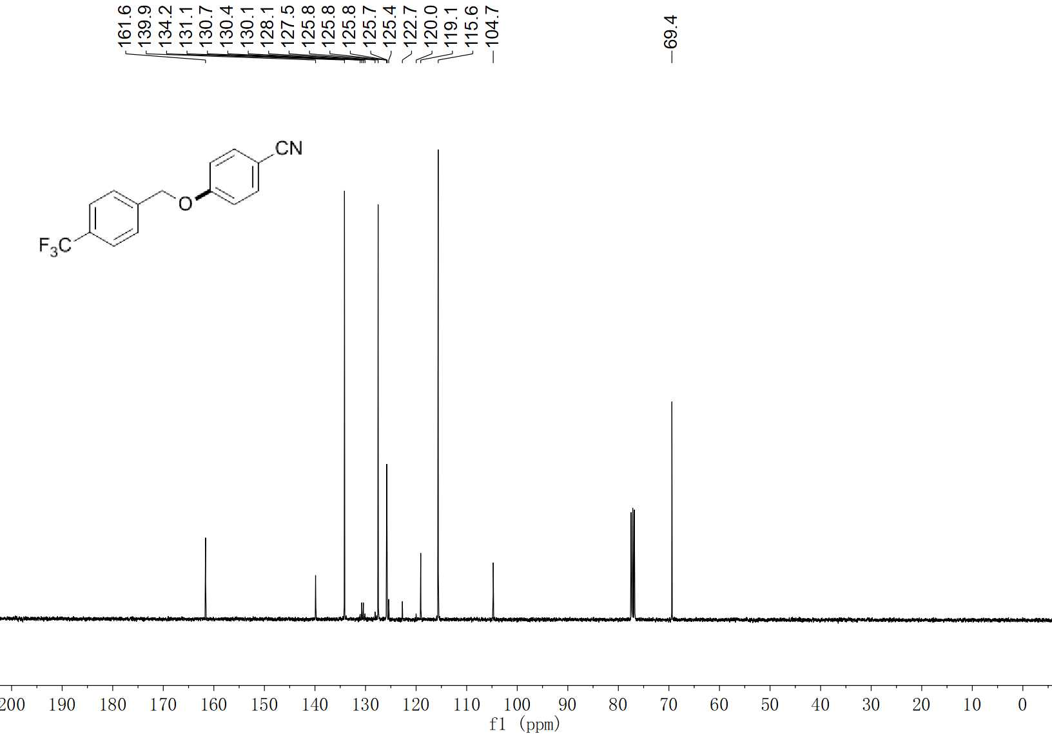
16 ¹³C NMR (100 MHz, CDCl₃)

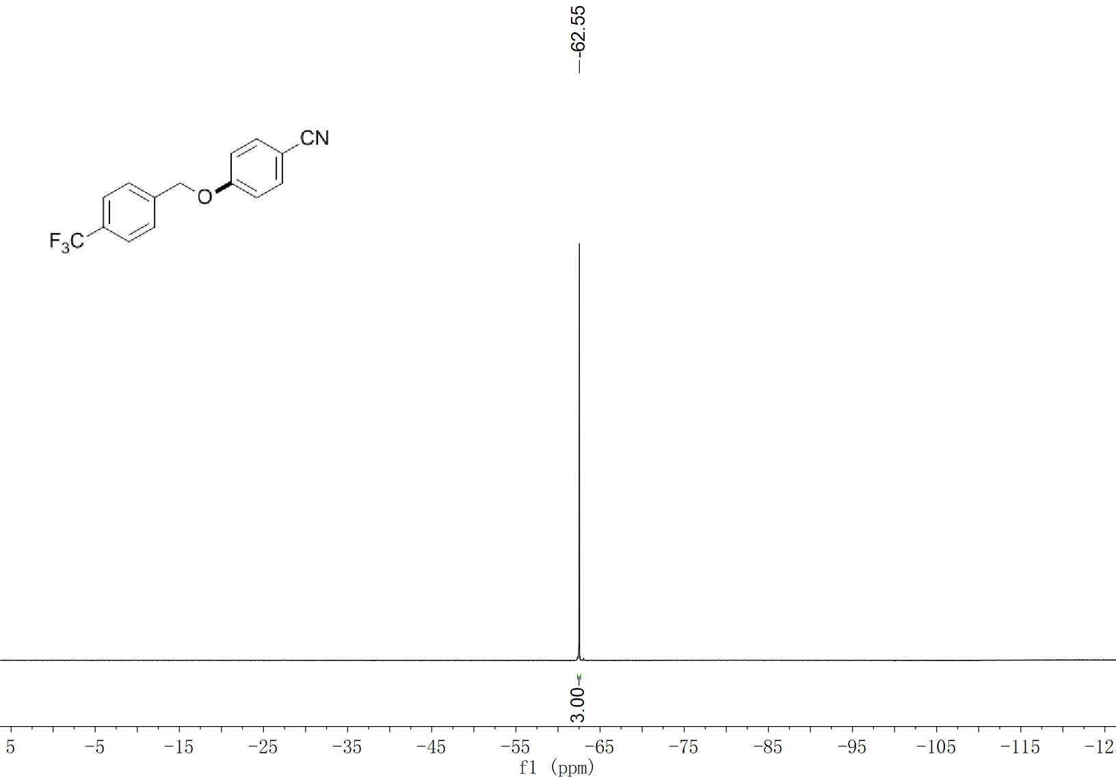
16 ¹⁹F NMR (376 MHz, CDCl₃)

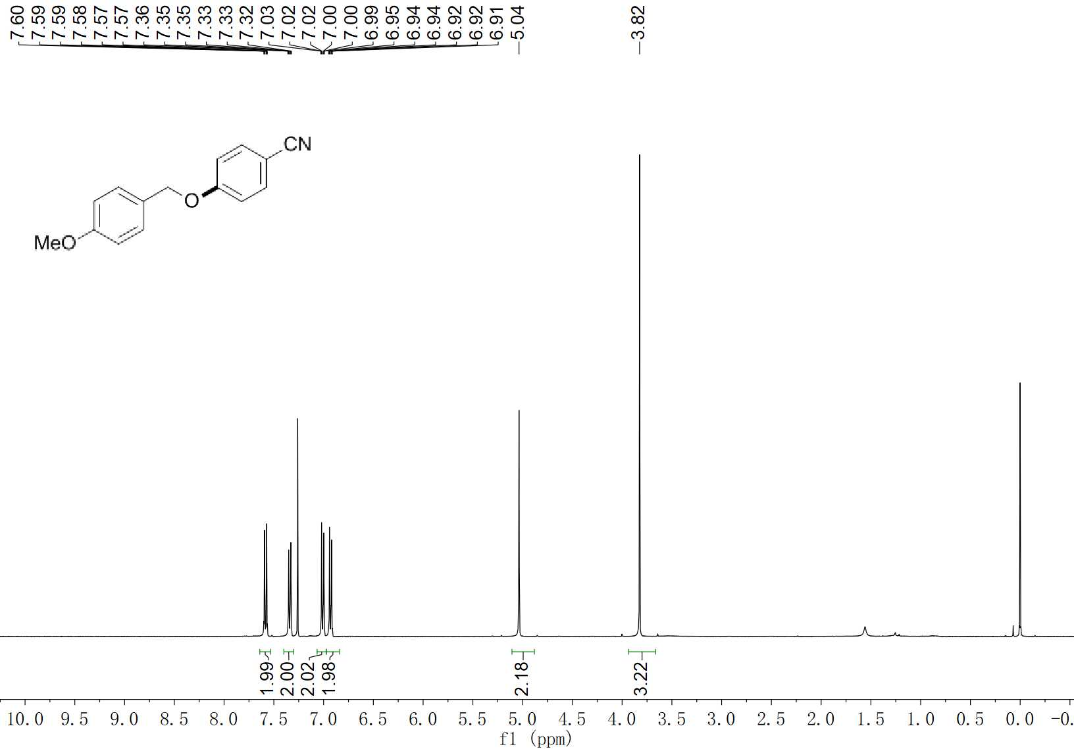
17 ¹H NMR (400 MHz, CDCl₃)

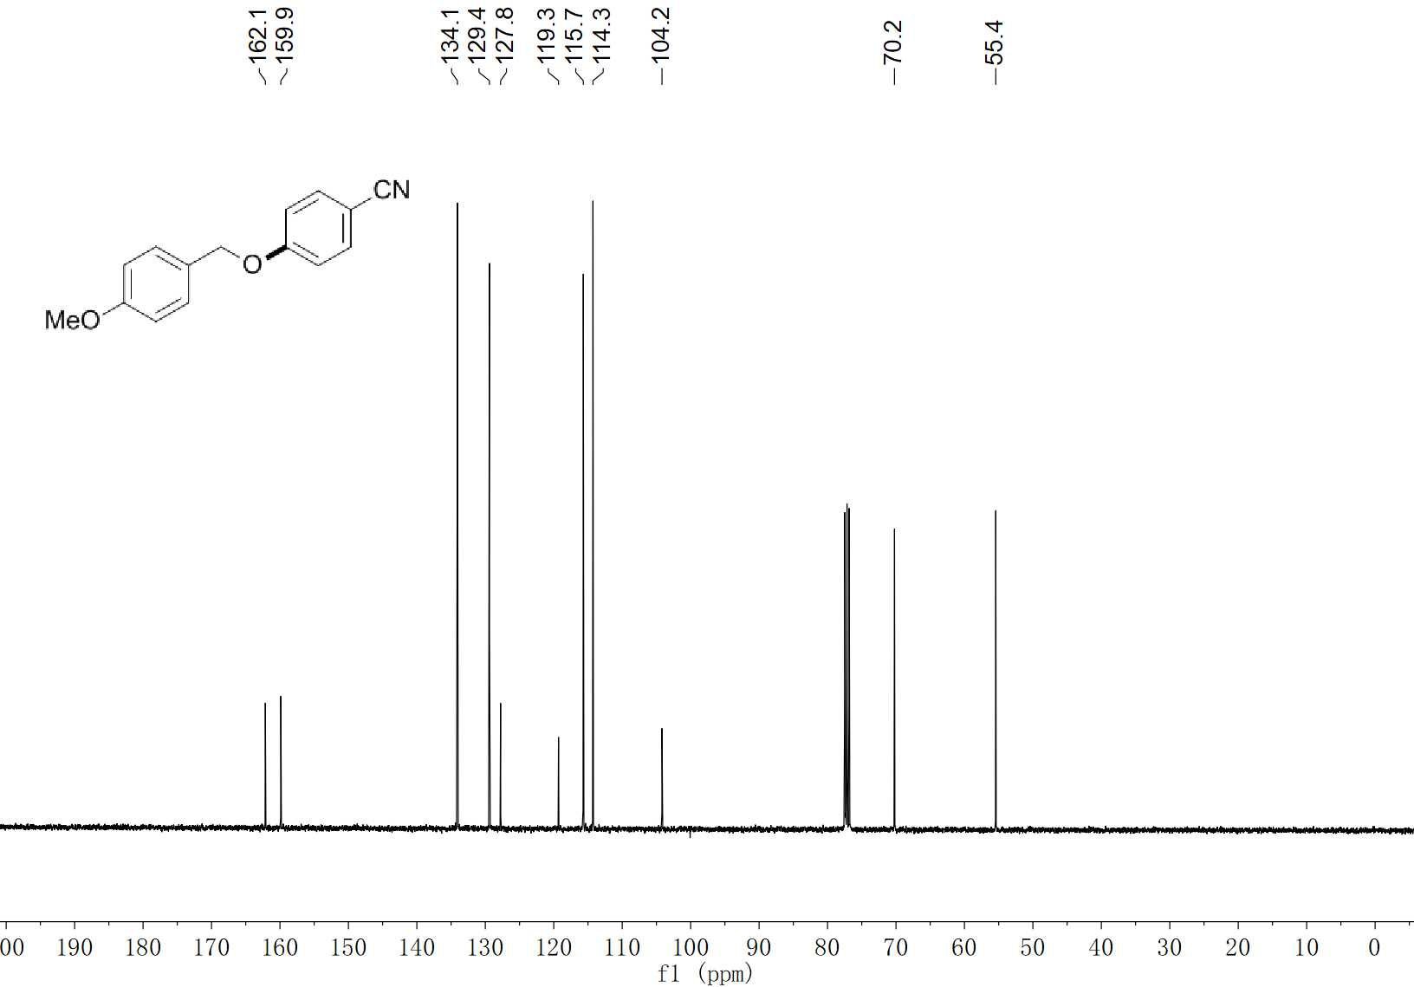
17 ¹³C NMR (100 MHz, CDCl₃)

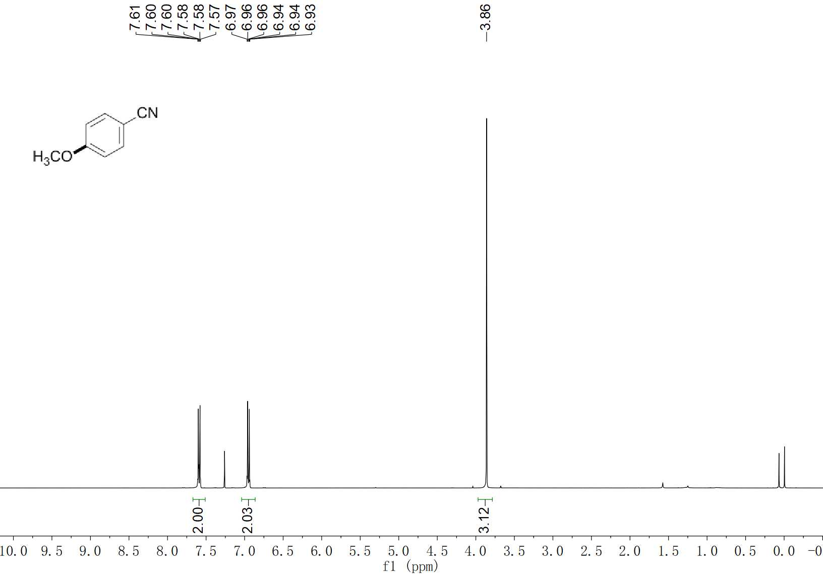
18 ¹H NMR (400 MHz, CDCl₃)

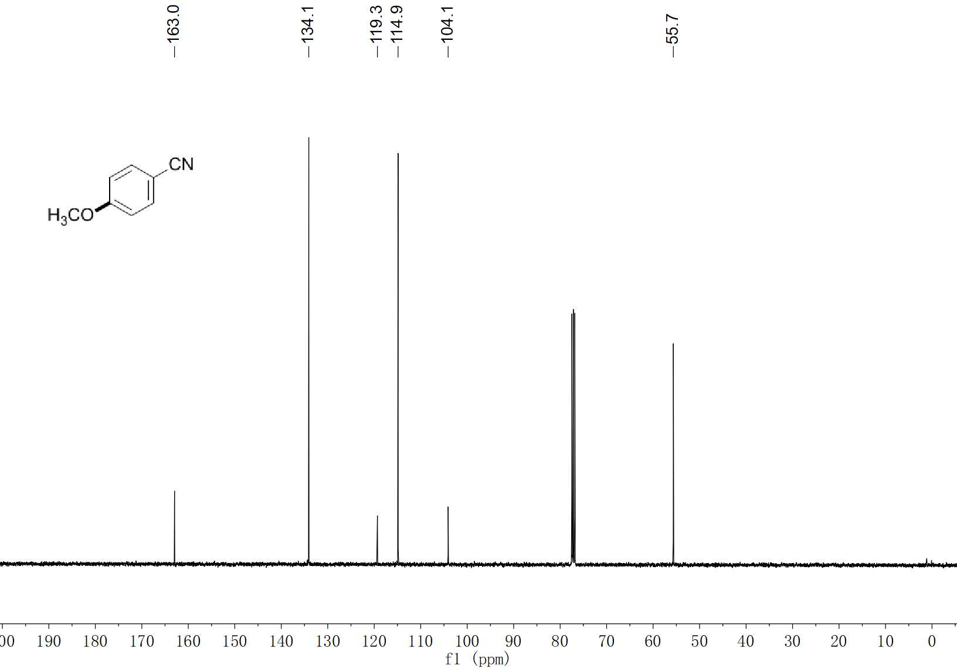
18 ¹³C NMR (100 MHz, CDCl₃)

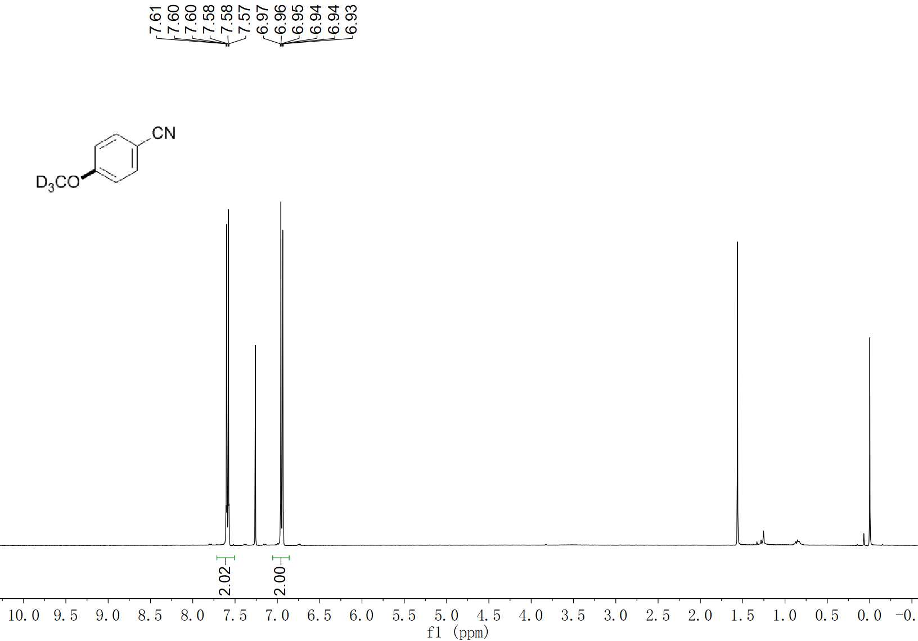
19 ¹H NMR (400 MHz, CDCl₃)

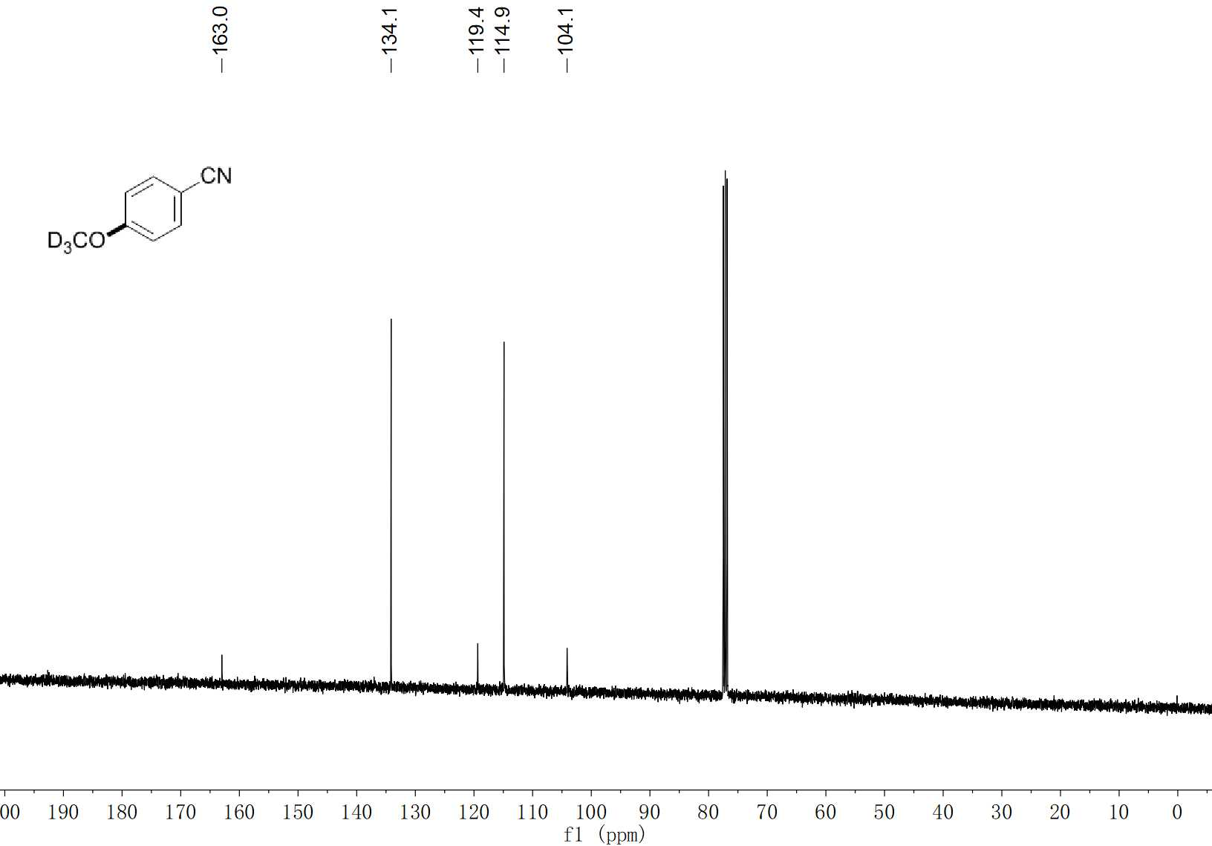
19 ¹³C NMR (100 MHz, CDCl₃)

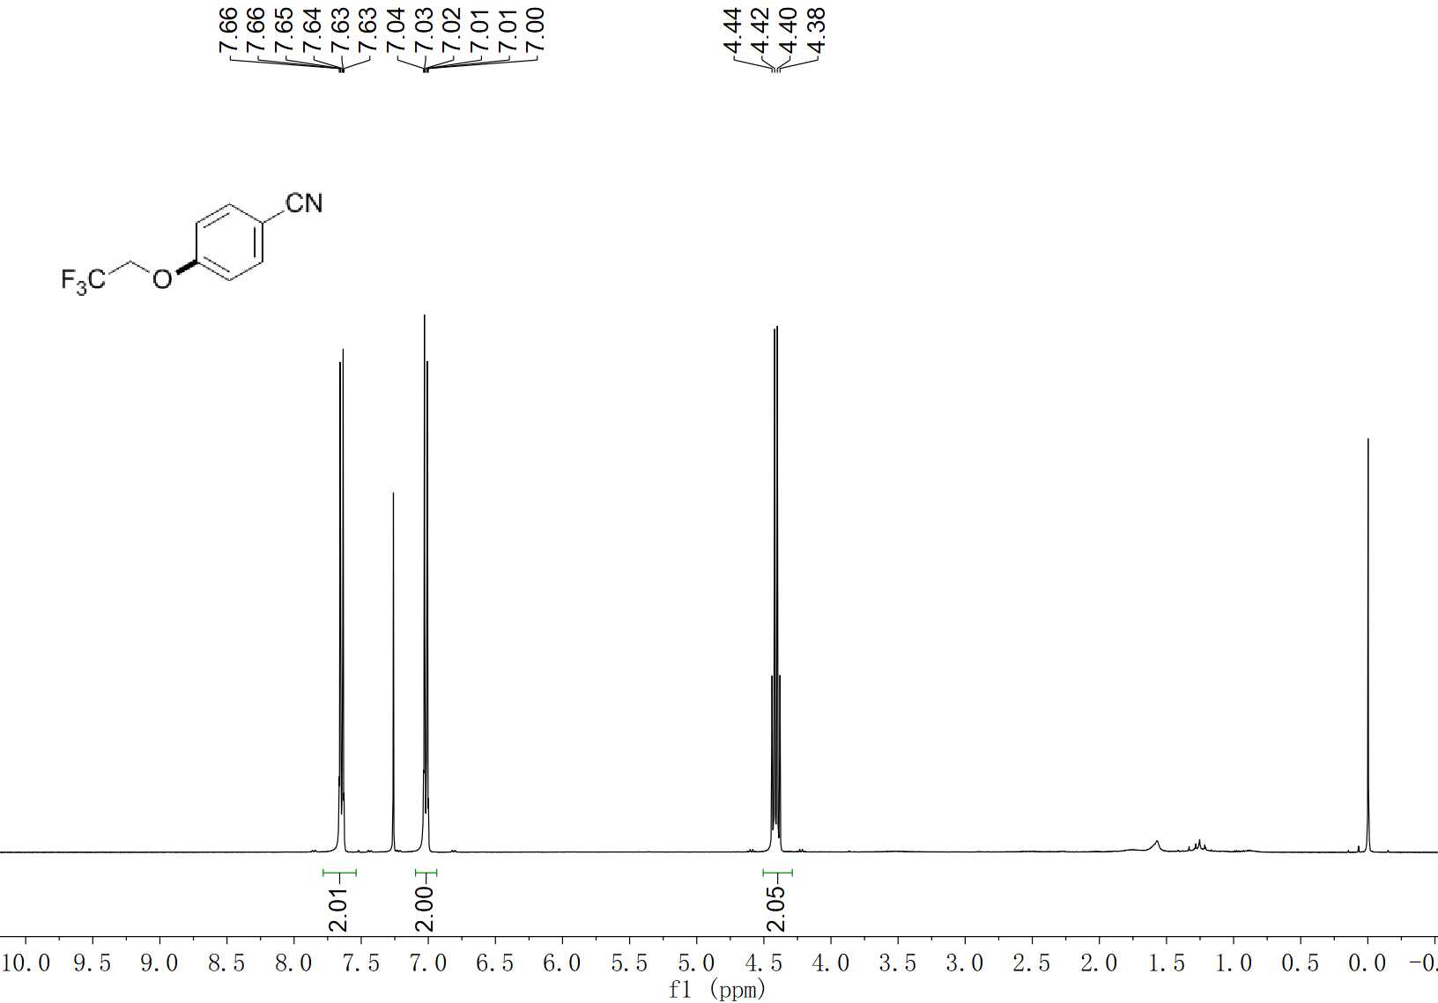
20 ¹H NMR (400 MHz, CDCl₃)

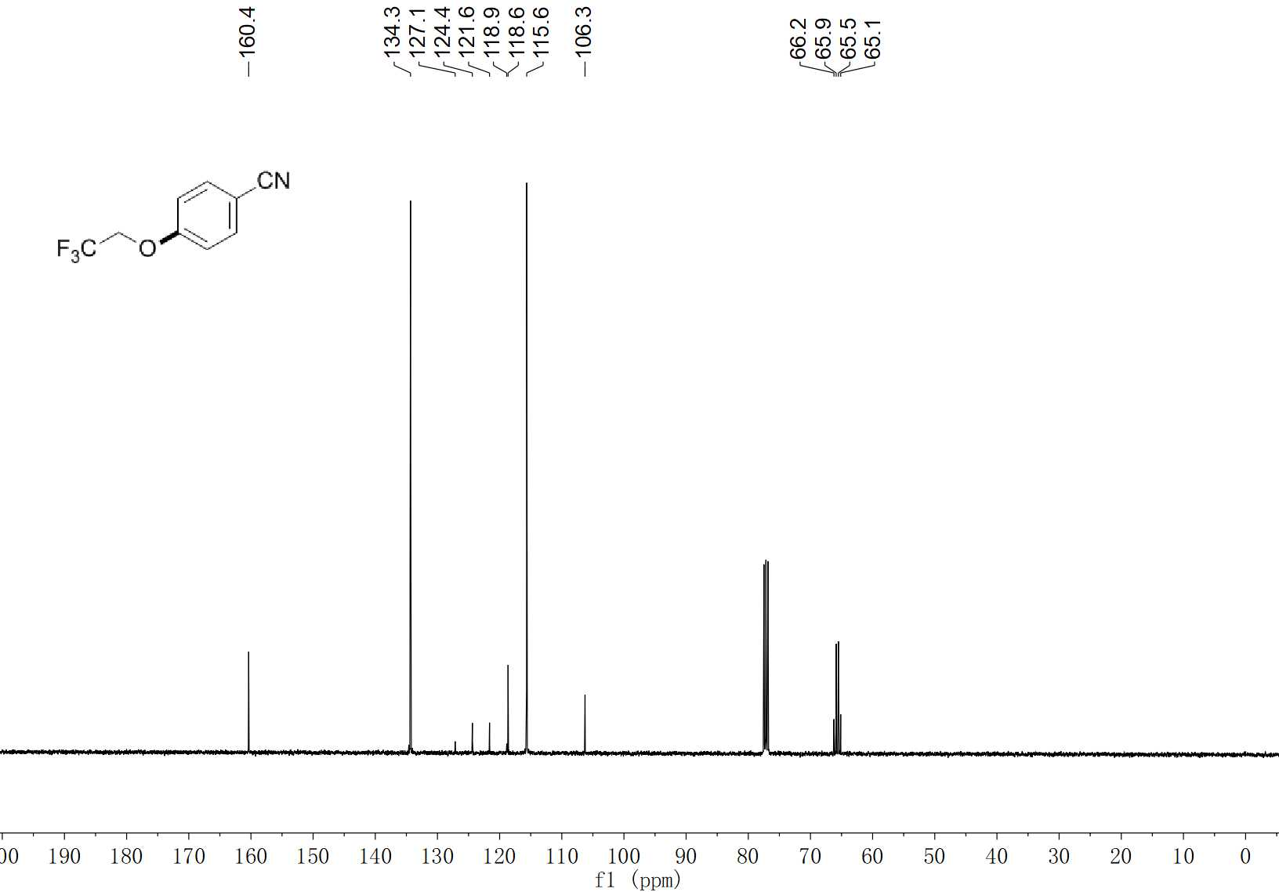
20 ¹³C NMR (100 MHz, CDCl₃)

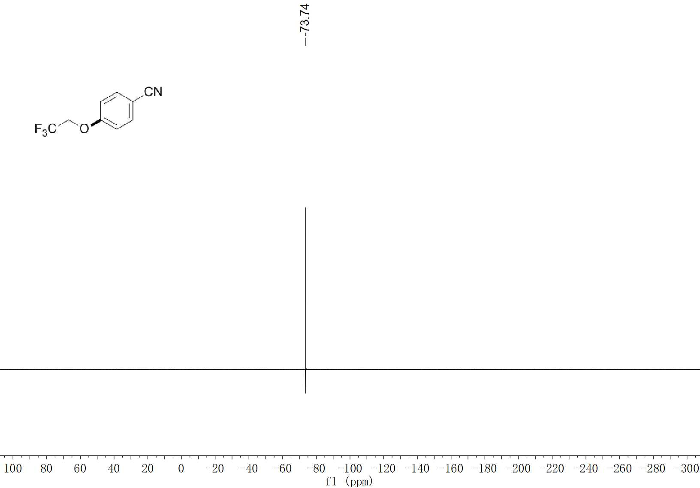
20 ¹⁹F NMR (376 MHz, CDCl₃)

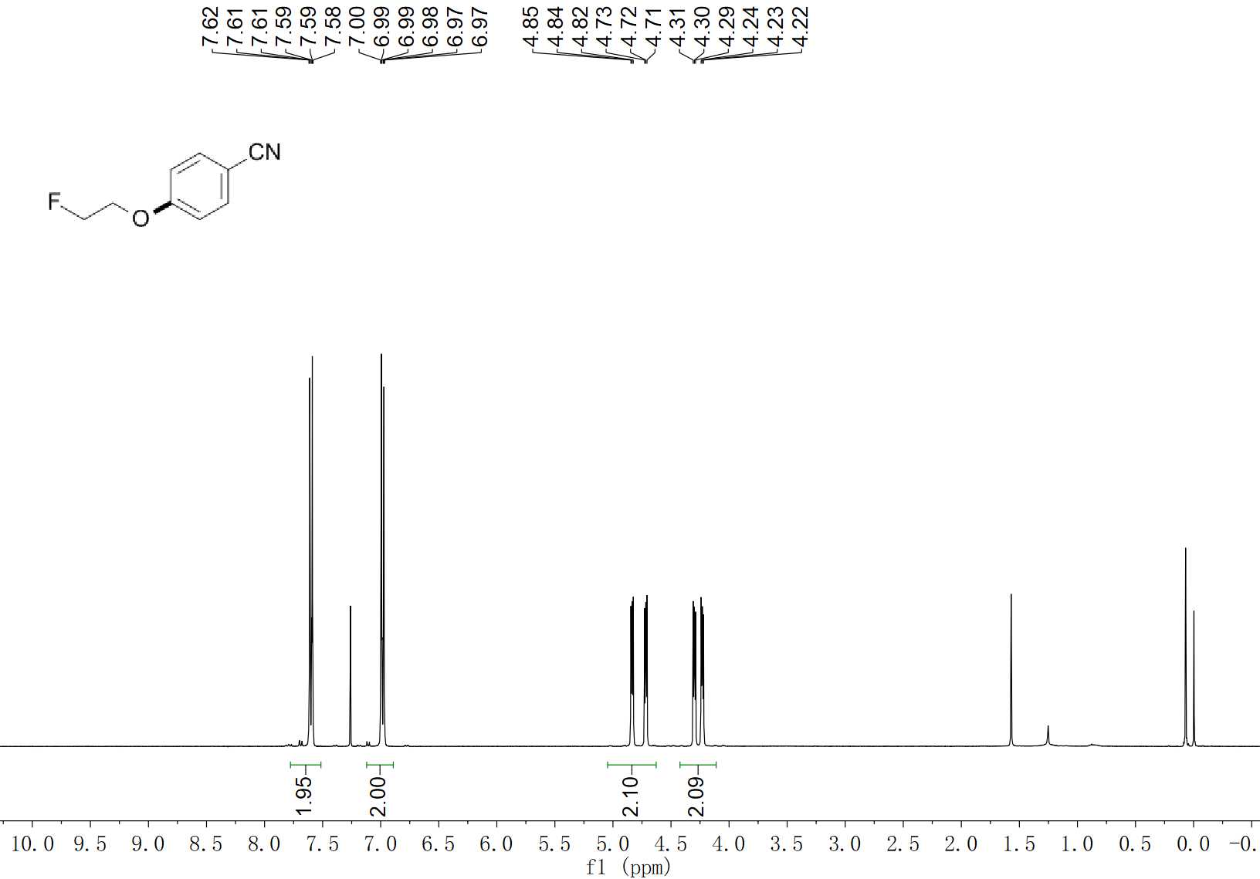
21 ¹H NMR (400 MHz, CDCl₃)

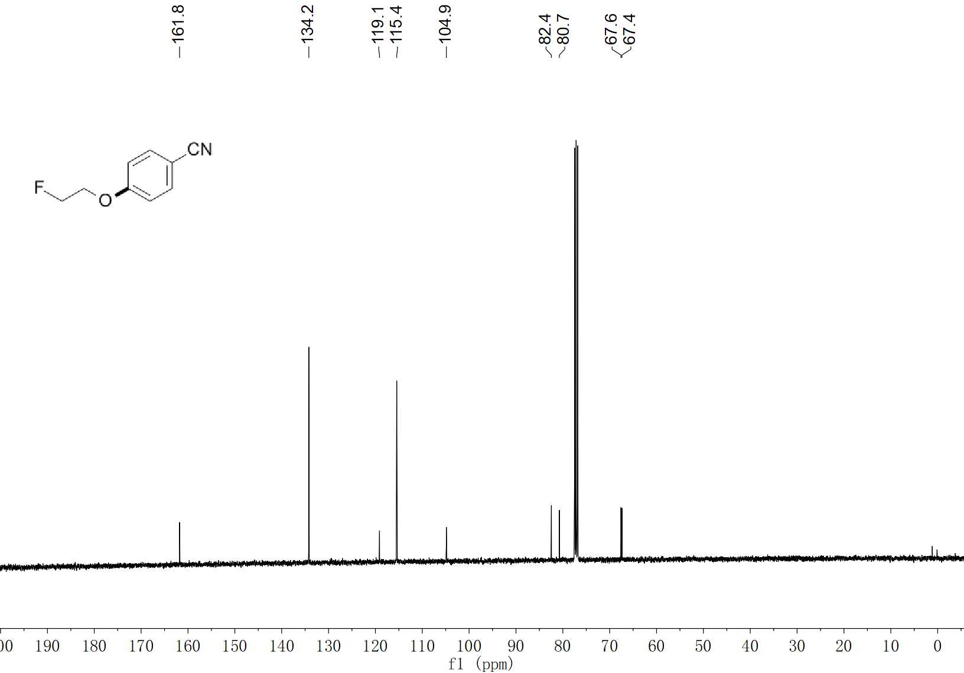
21 ¹³C NMR (100 MHz, CDCl₃)

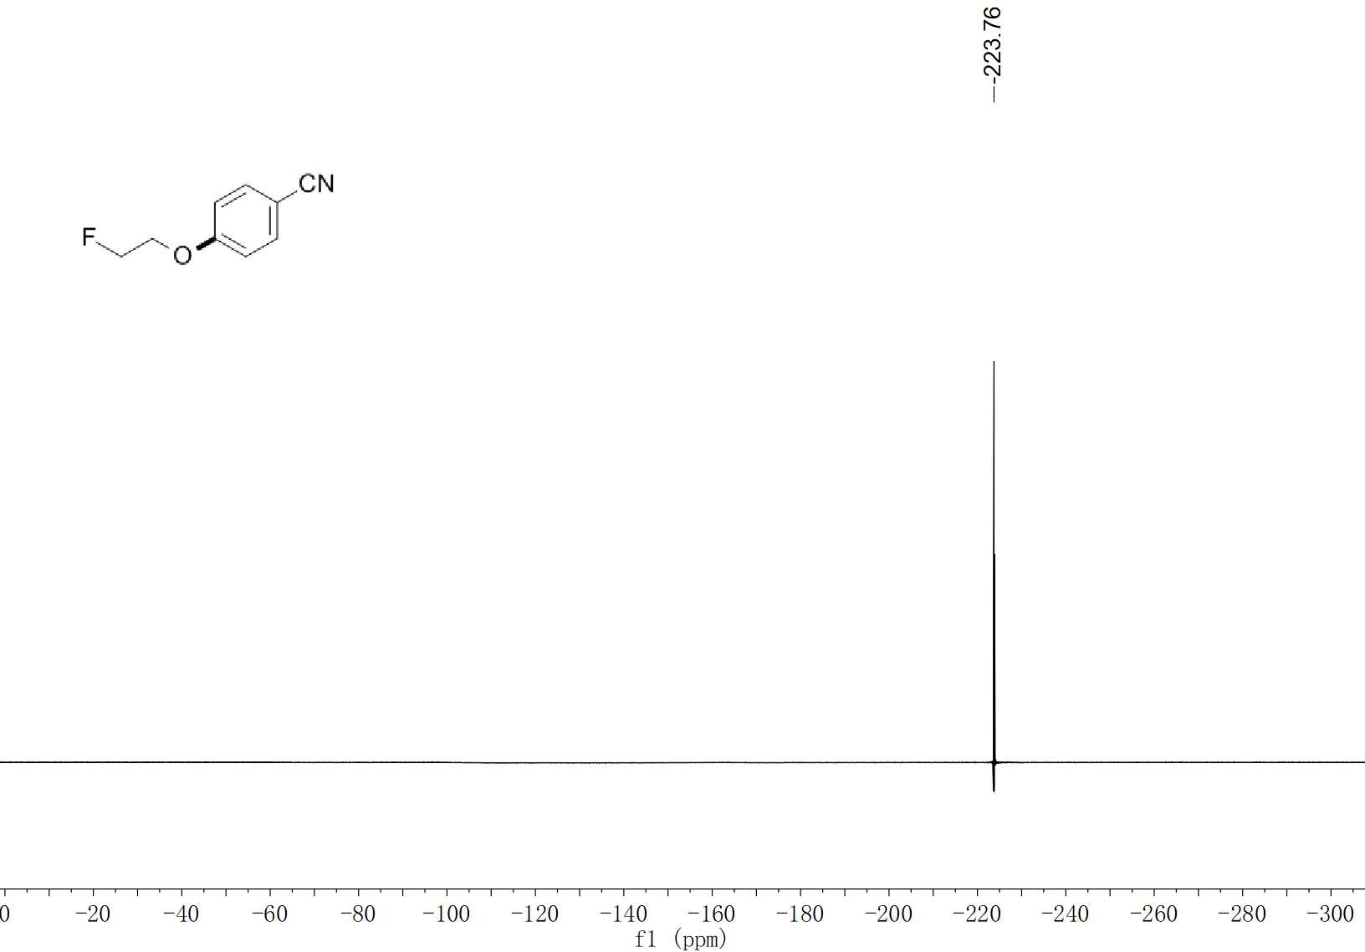
21 ¹⁹F NMR (376 MHz, CDCl₃)

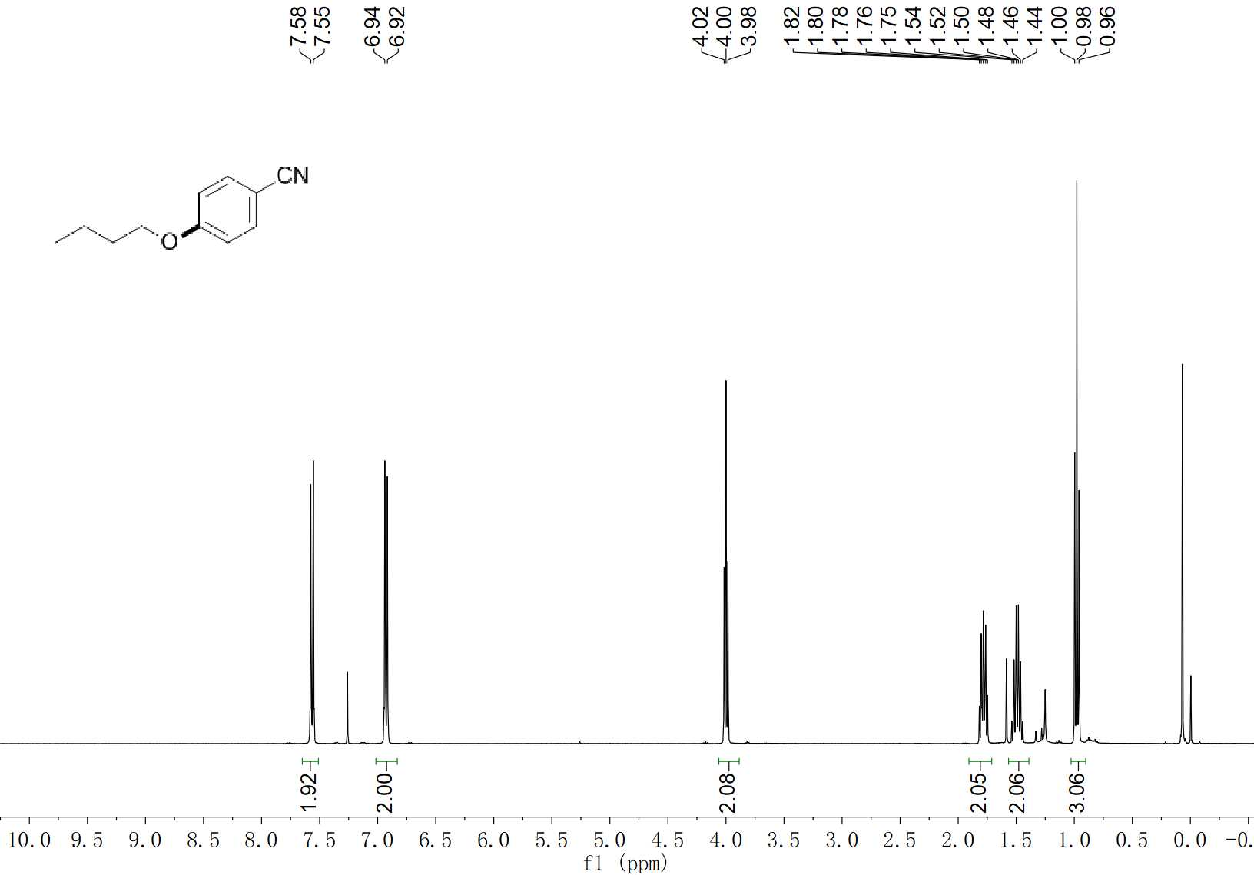
22 ¹H NMR (400 MHz, CDCl₃)

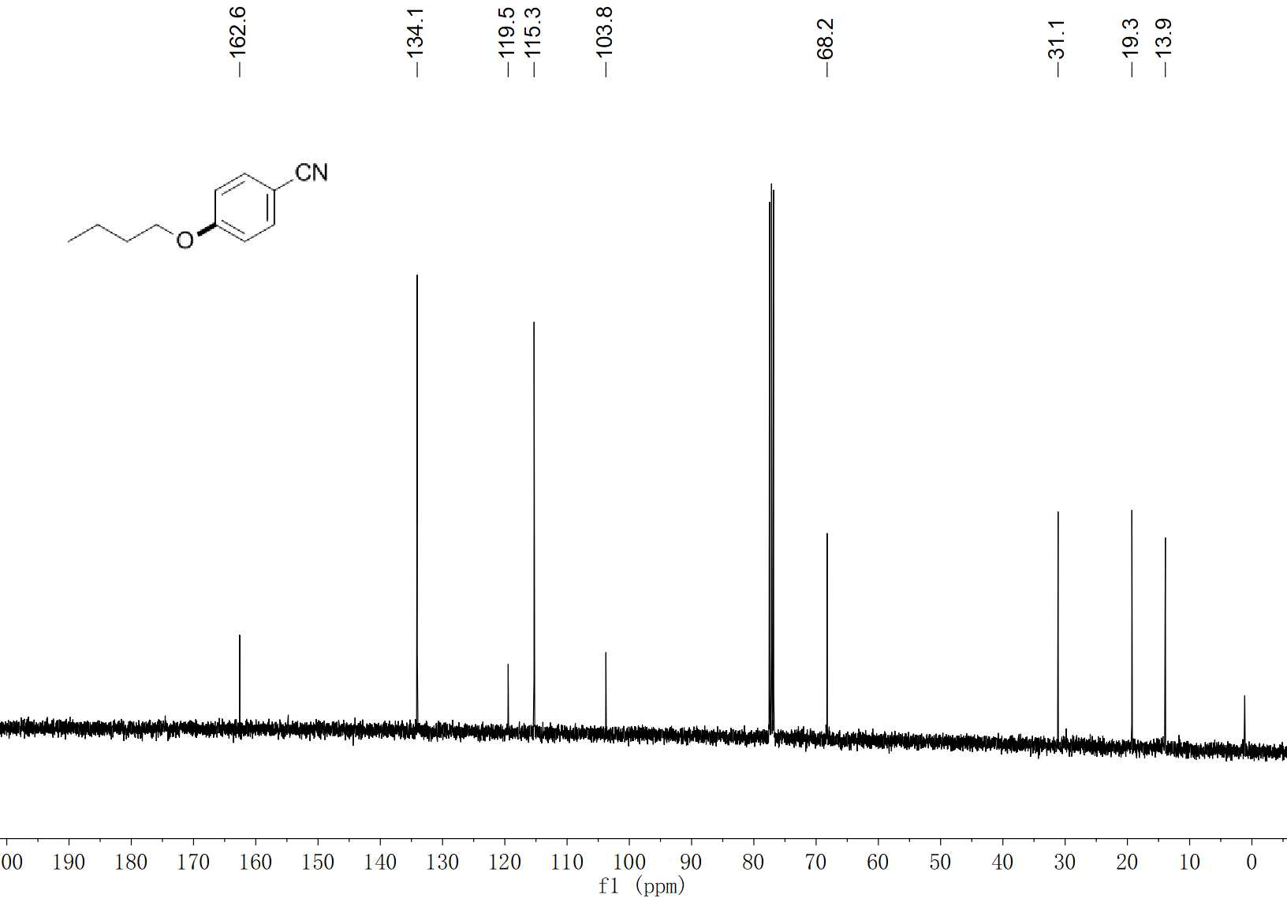
22 ¹³C NMR (100 MHz, CDCl₃)

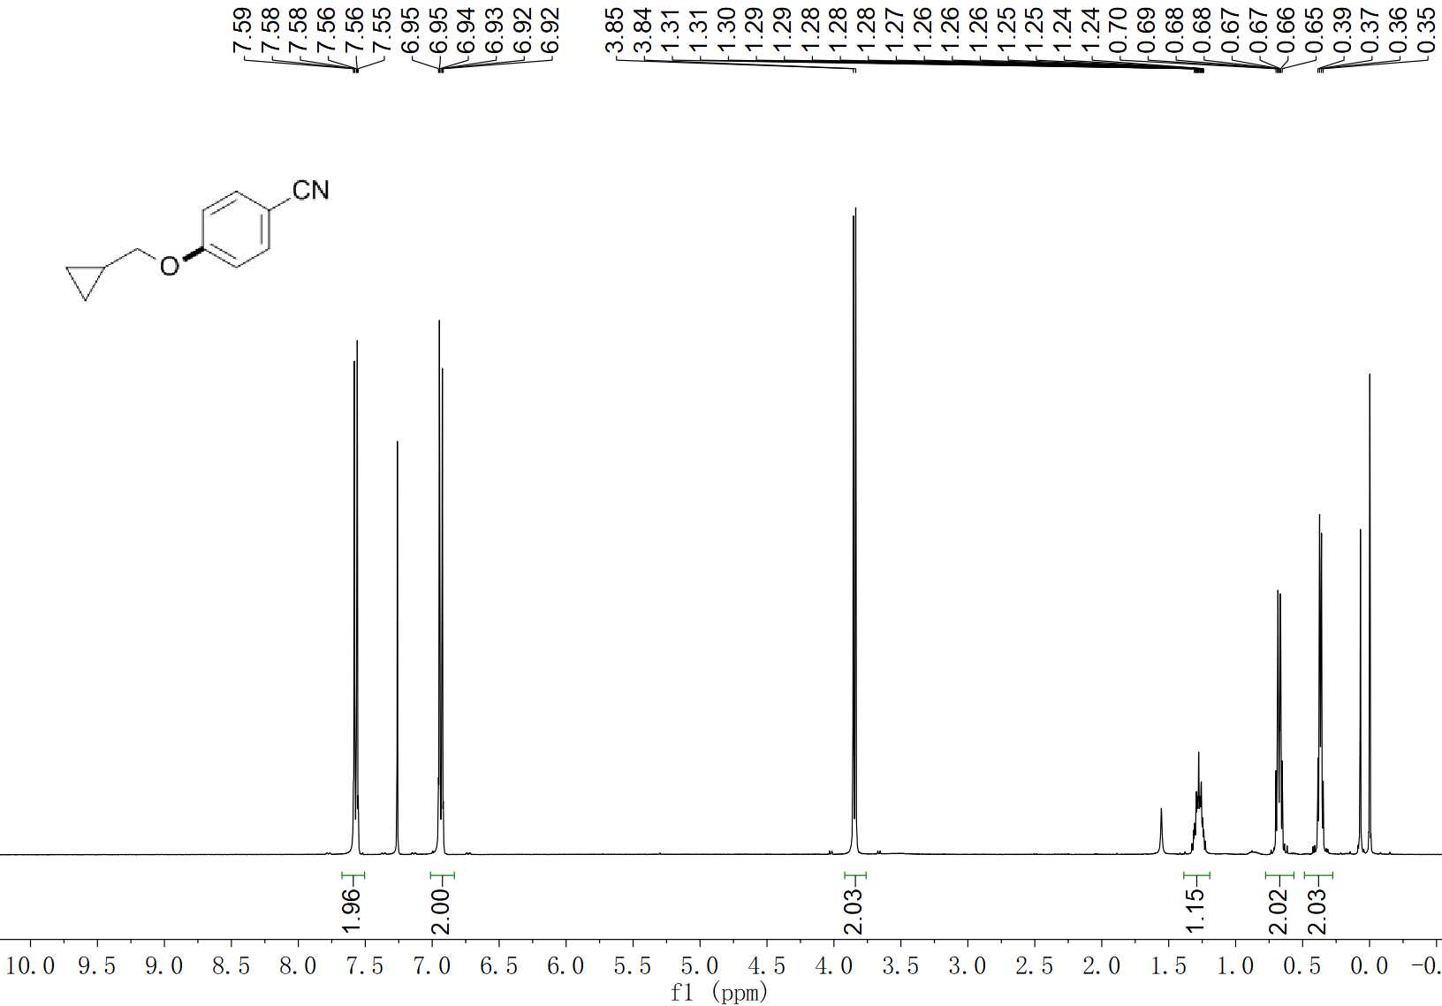
23 ¹H NMR (400 MHz, CDCl₃)

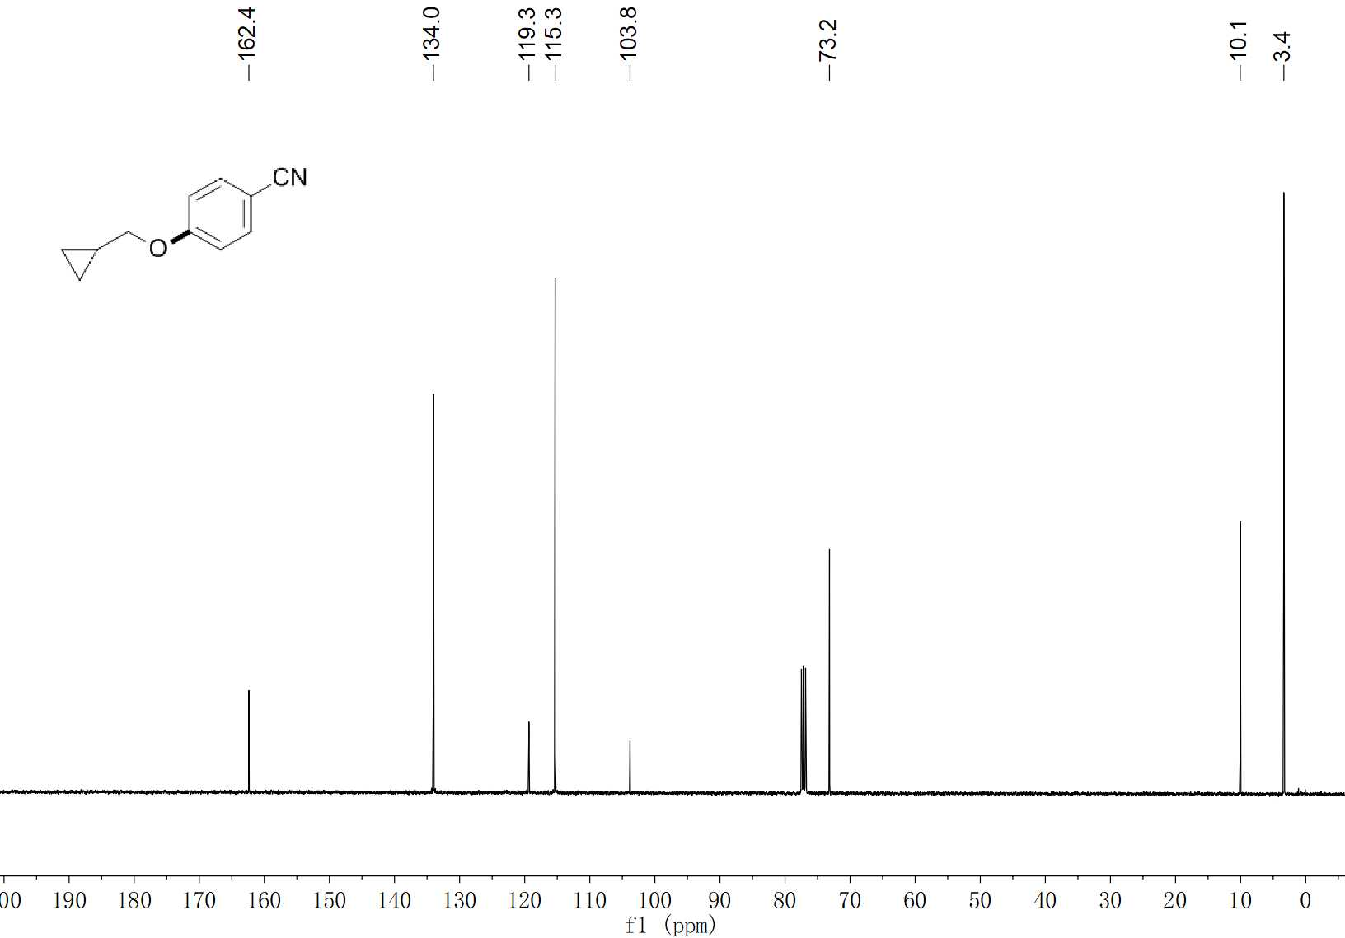
23 ¹³C NMR (100 MHz, CDCl₃)

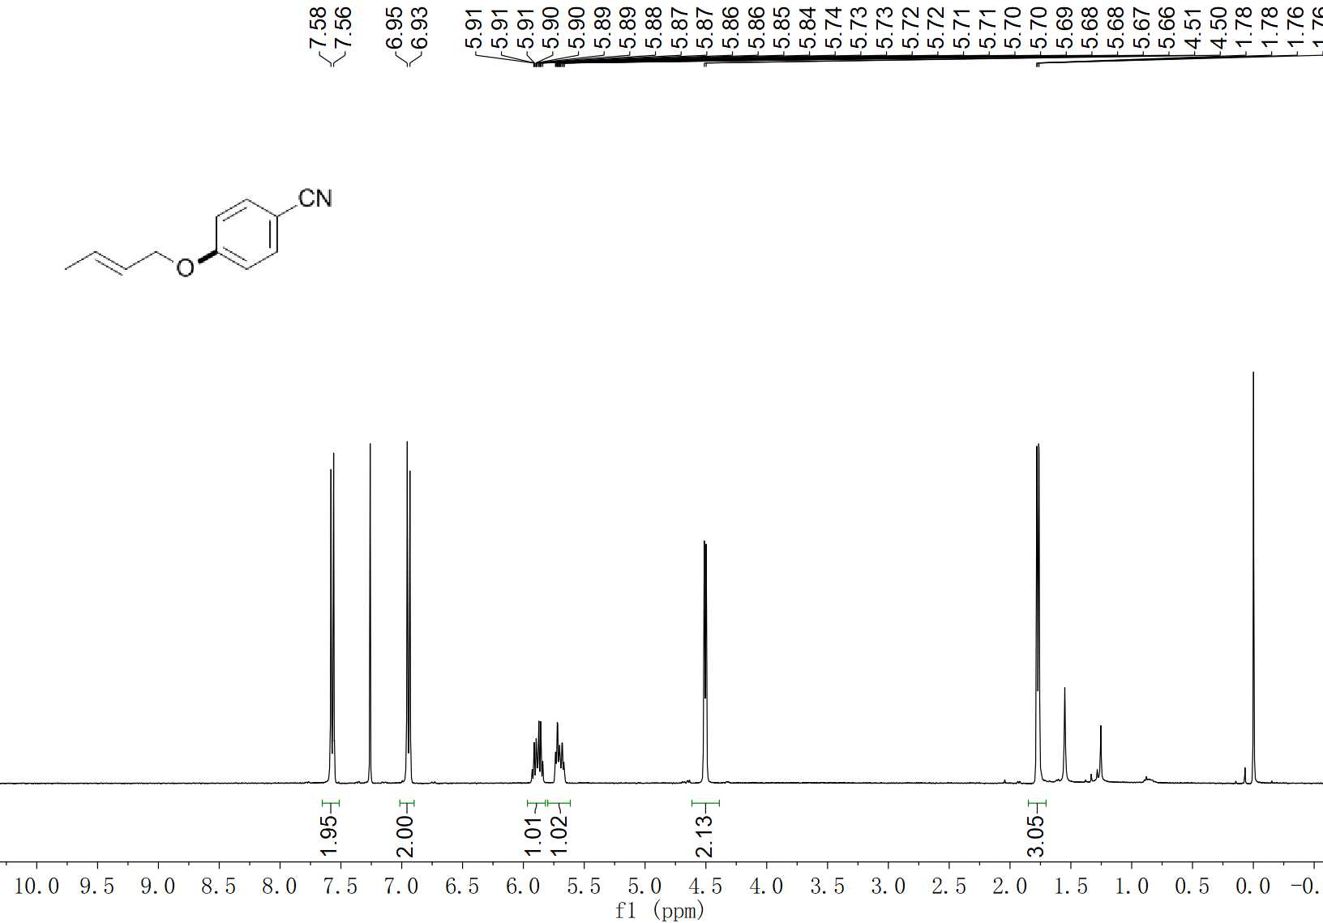
24 ¹H NMR (400 MHz, CDCl₃)

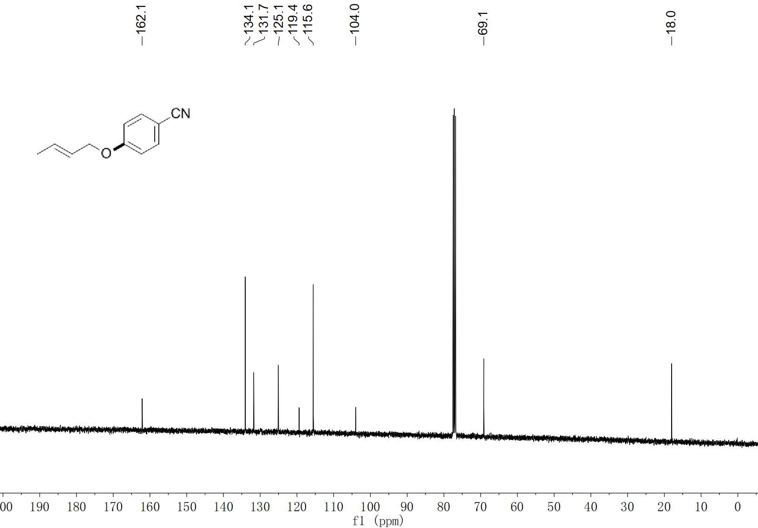
24 ¹³C NMR (100 MHz, CDCl₃)

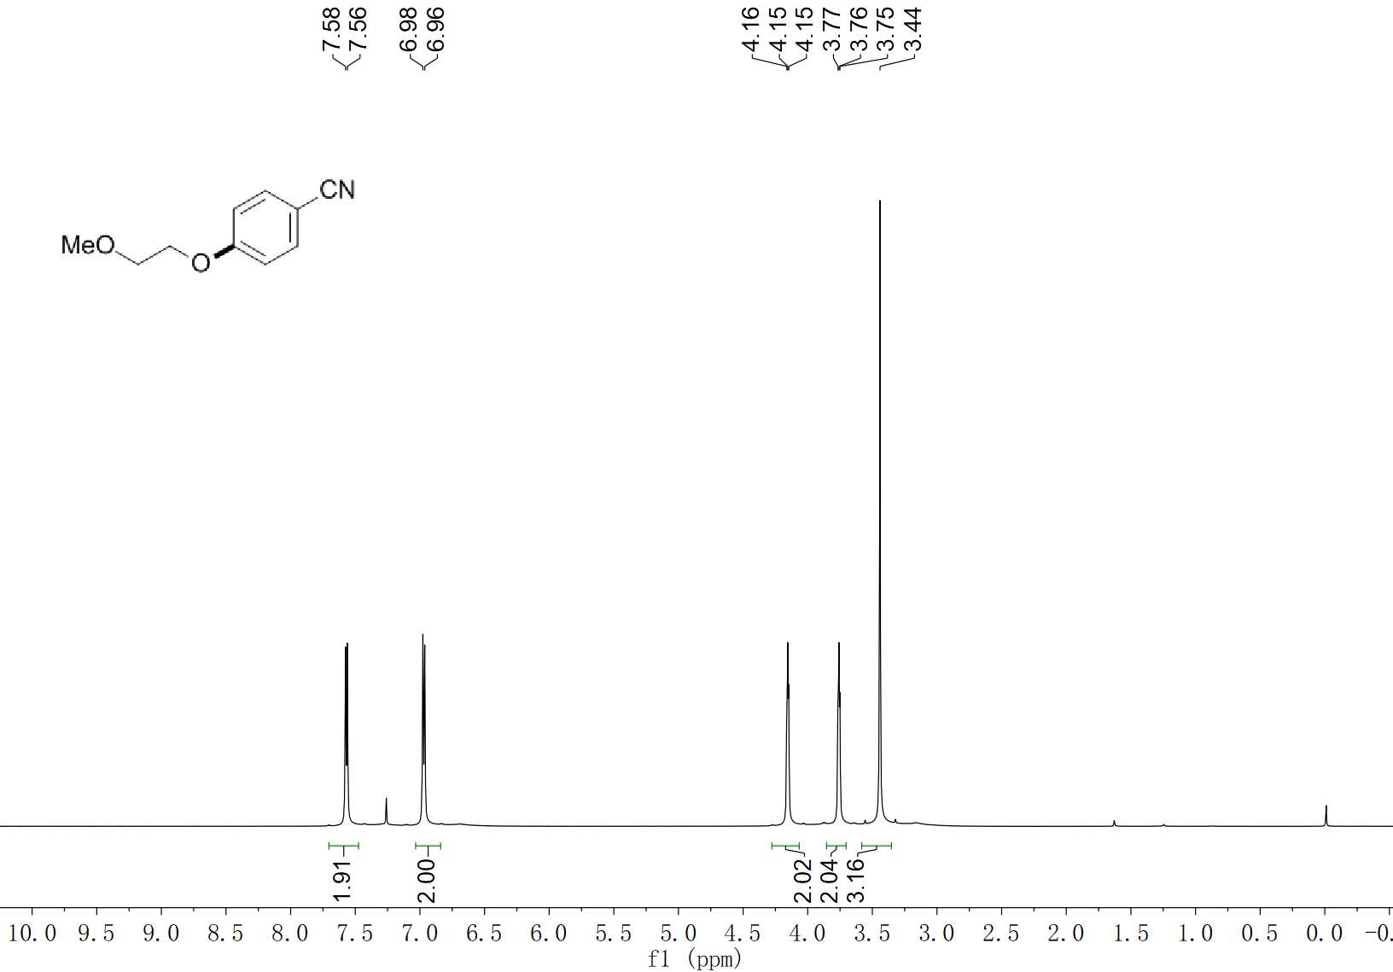
25 ¹H NMR (600 MHz, CDCl₃)

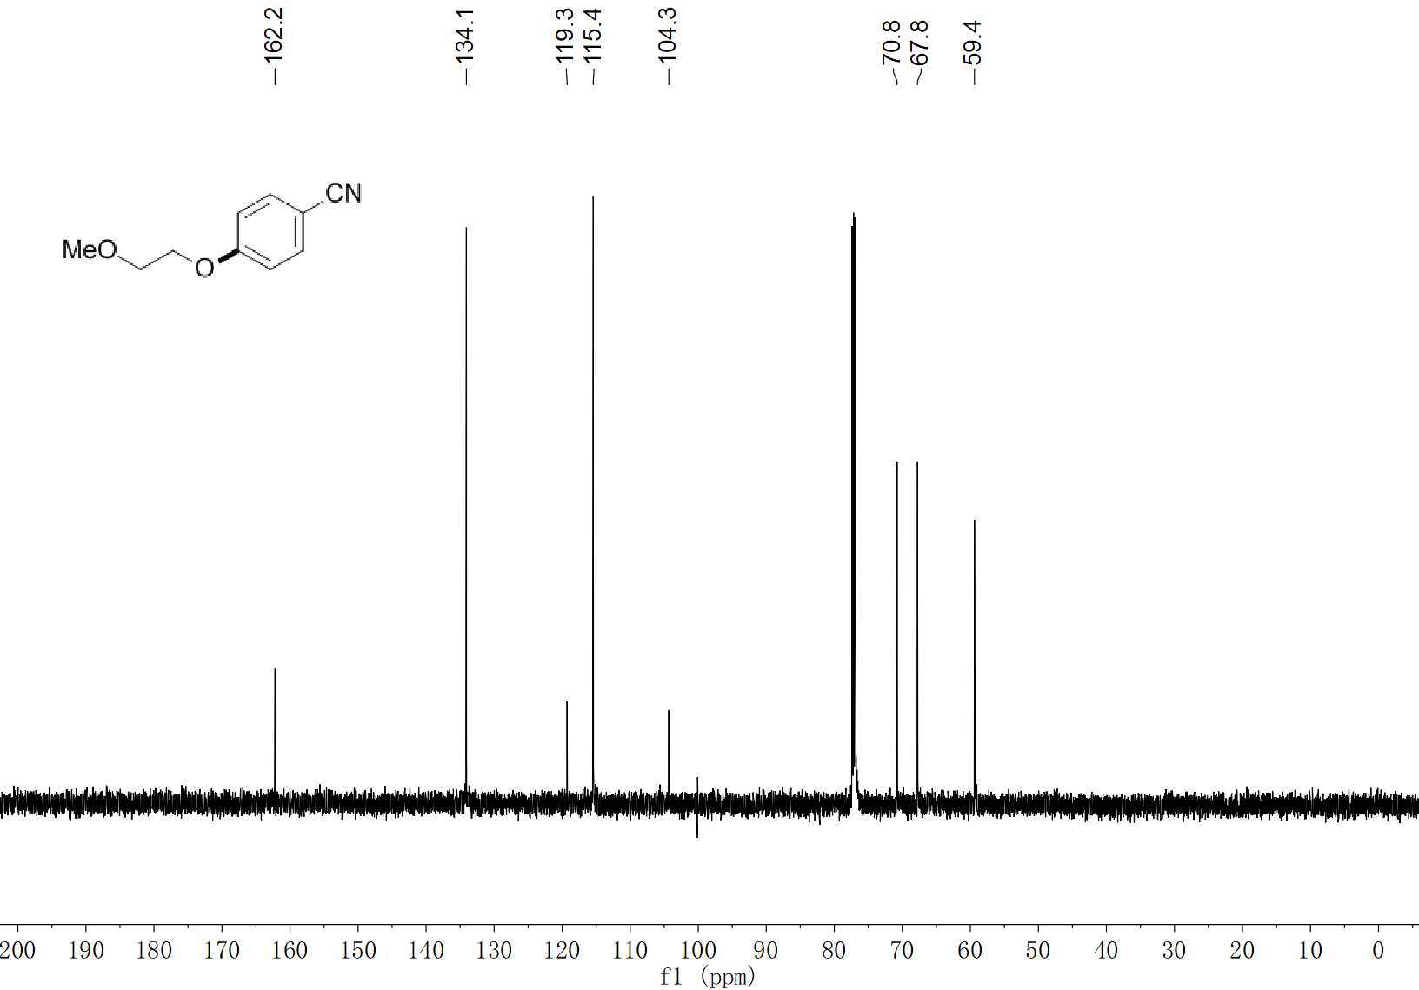
25 ¹³C NMR (150 MHz, CDCl₃)

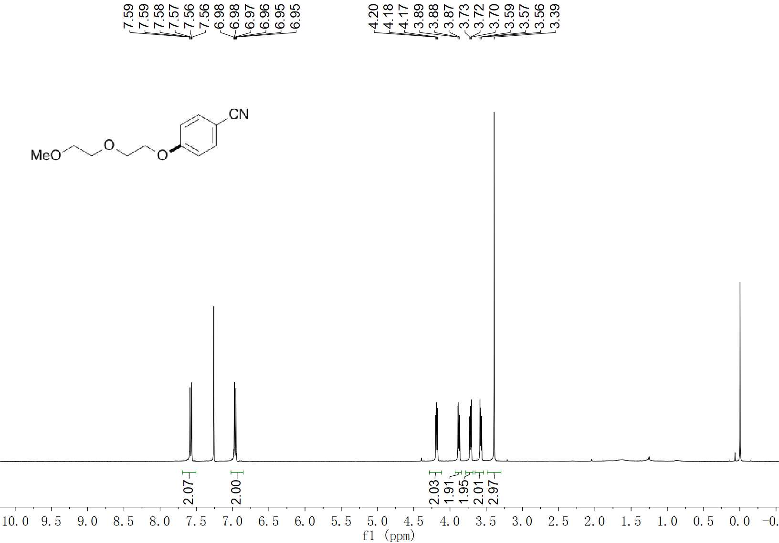
26 ¹H NMR (400 MHz, CDCl₃)

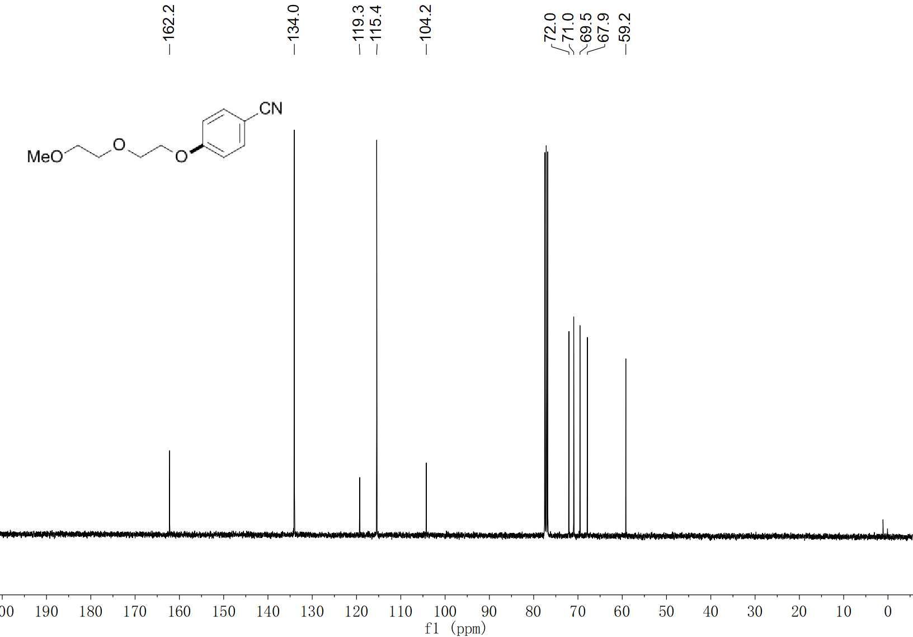
26 ¹³C NMR (100 MHz, CDCl₃)

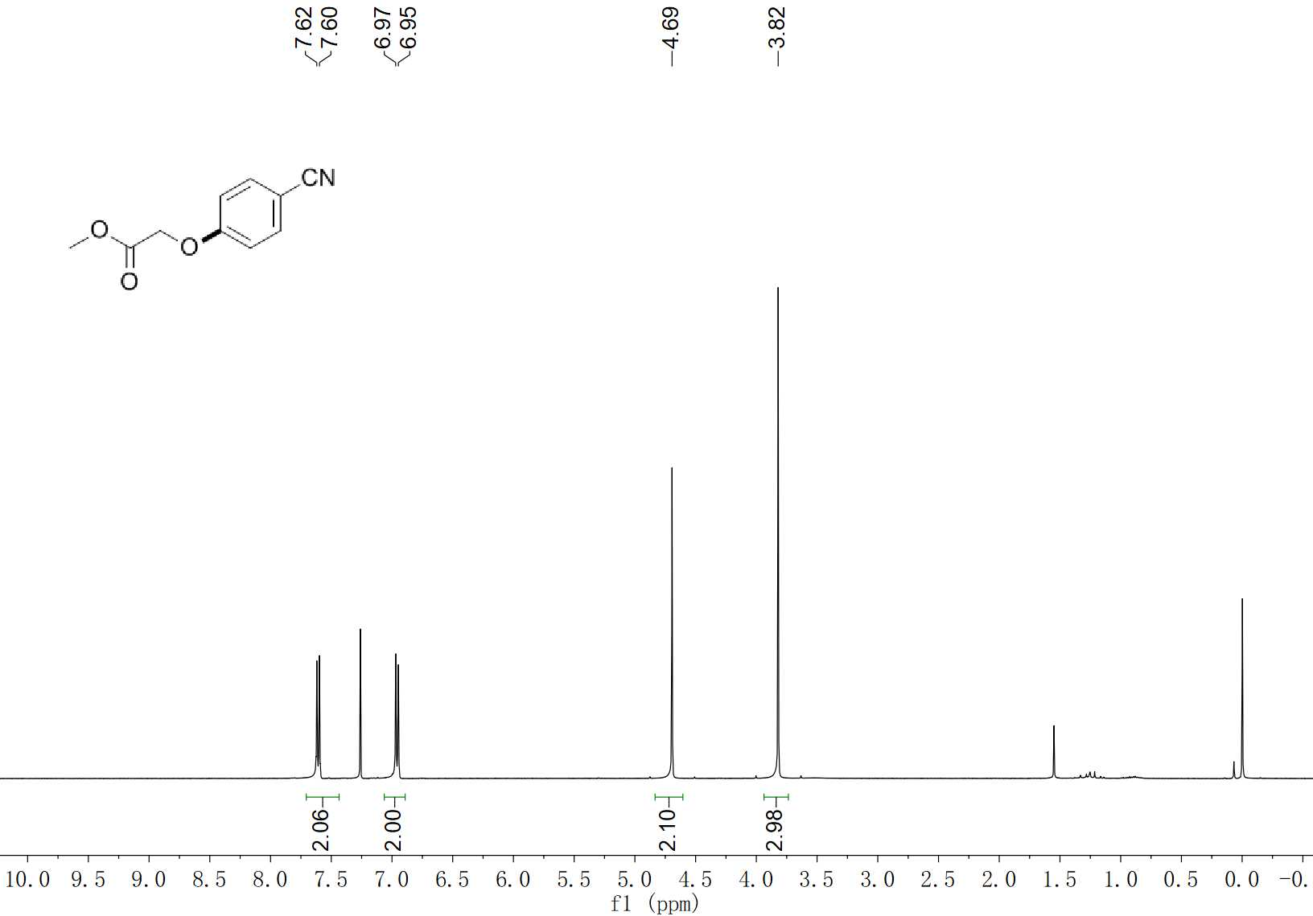
27 ¹H NMR (400 MHz, CDCl₃)

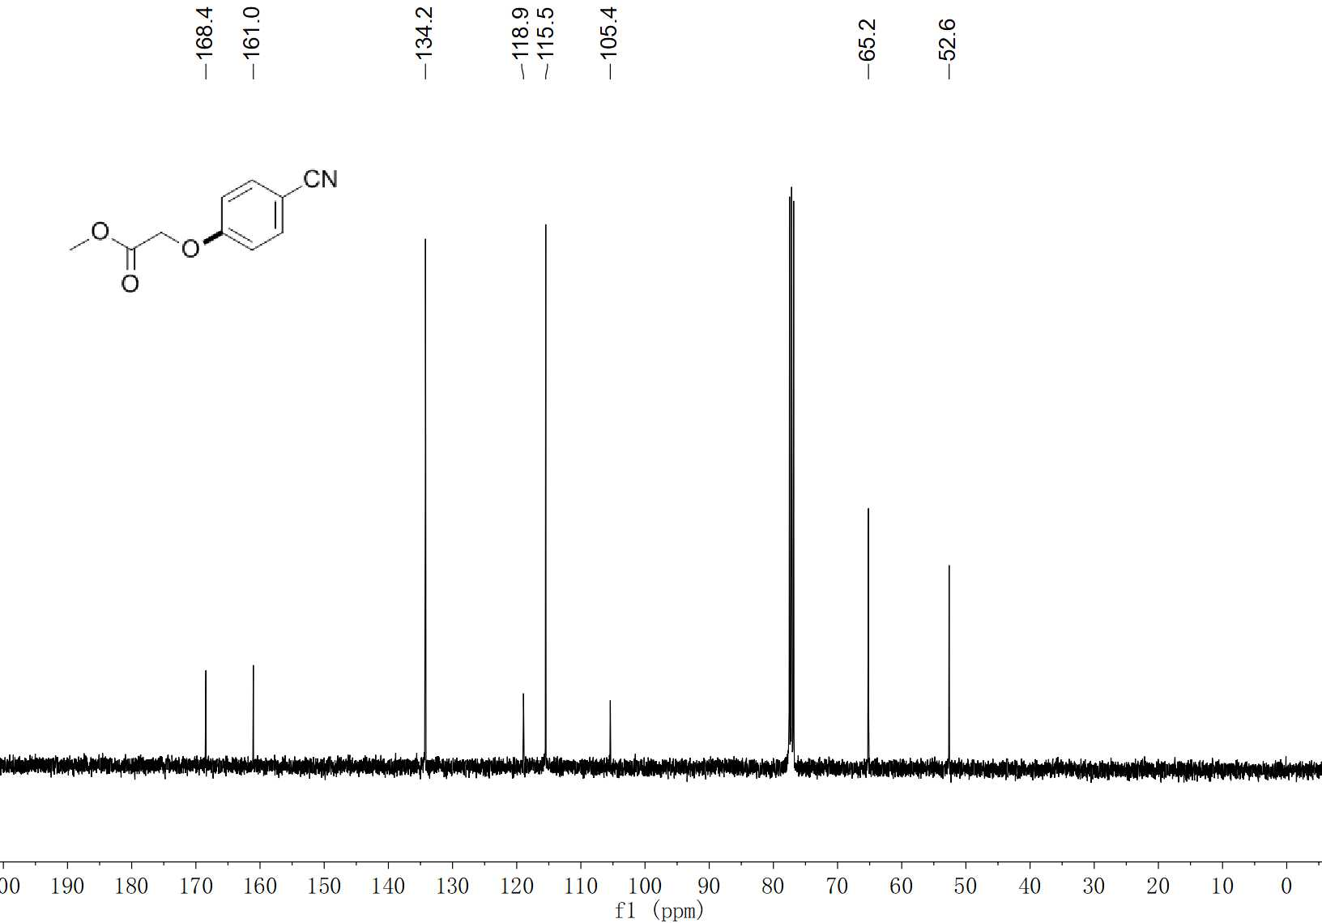
27 ¹³C NMR (100 MHz, CDCl₃)

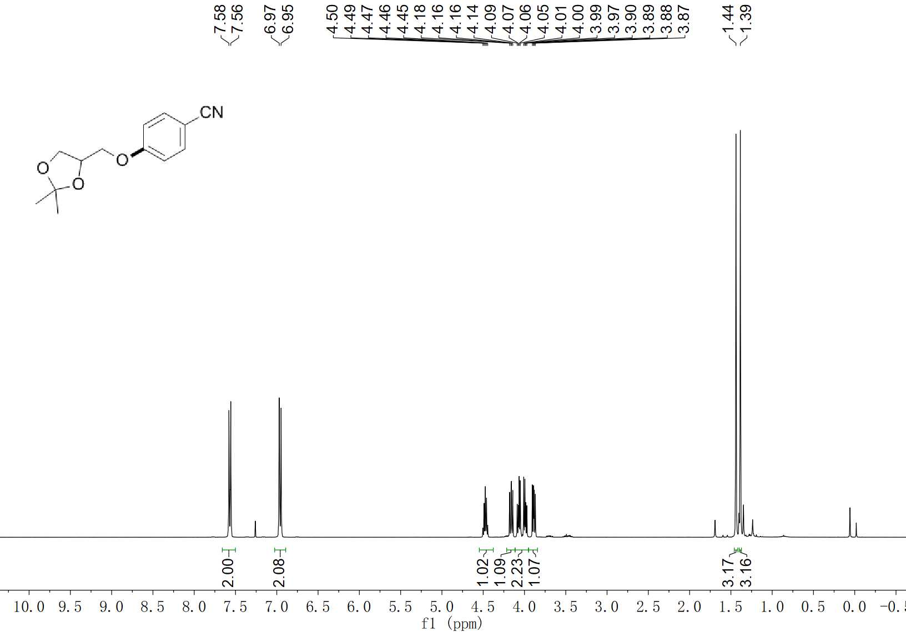
28 ¹H NMR (400 MHz, CDCl₃)

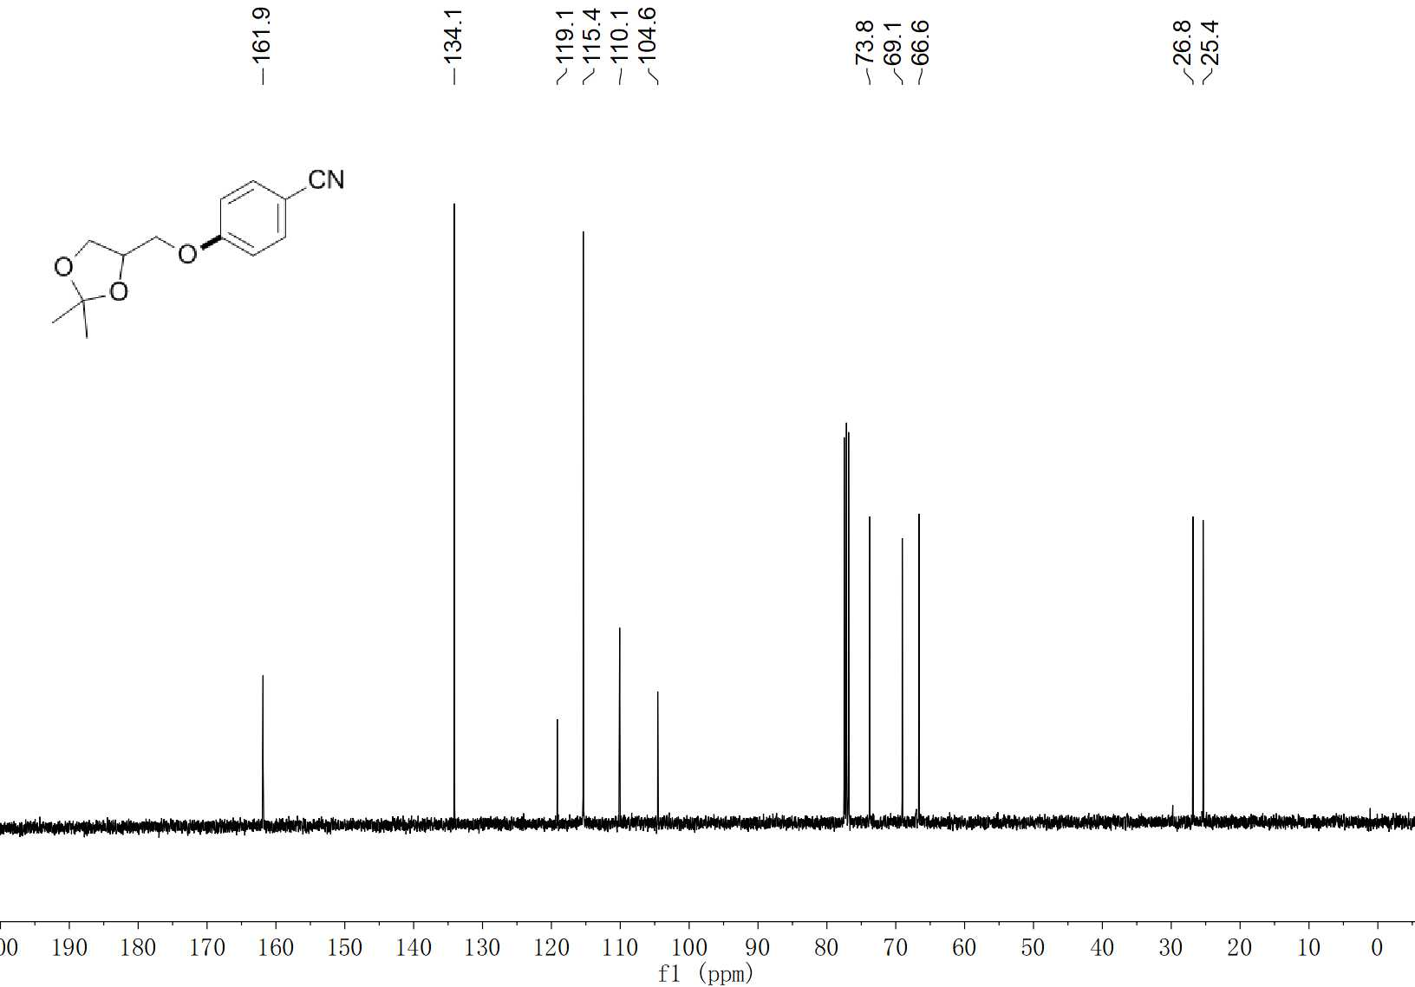
28 ¹³C NMR (100 MHz, CDCl₃)

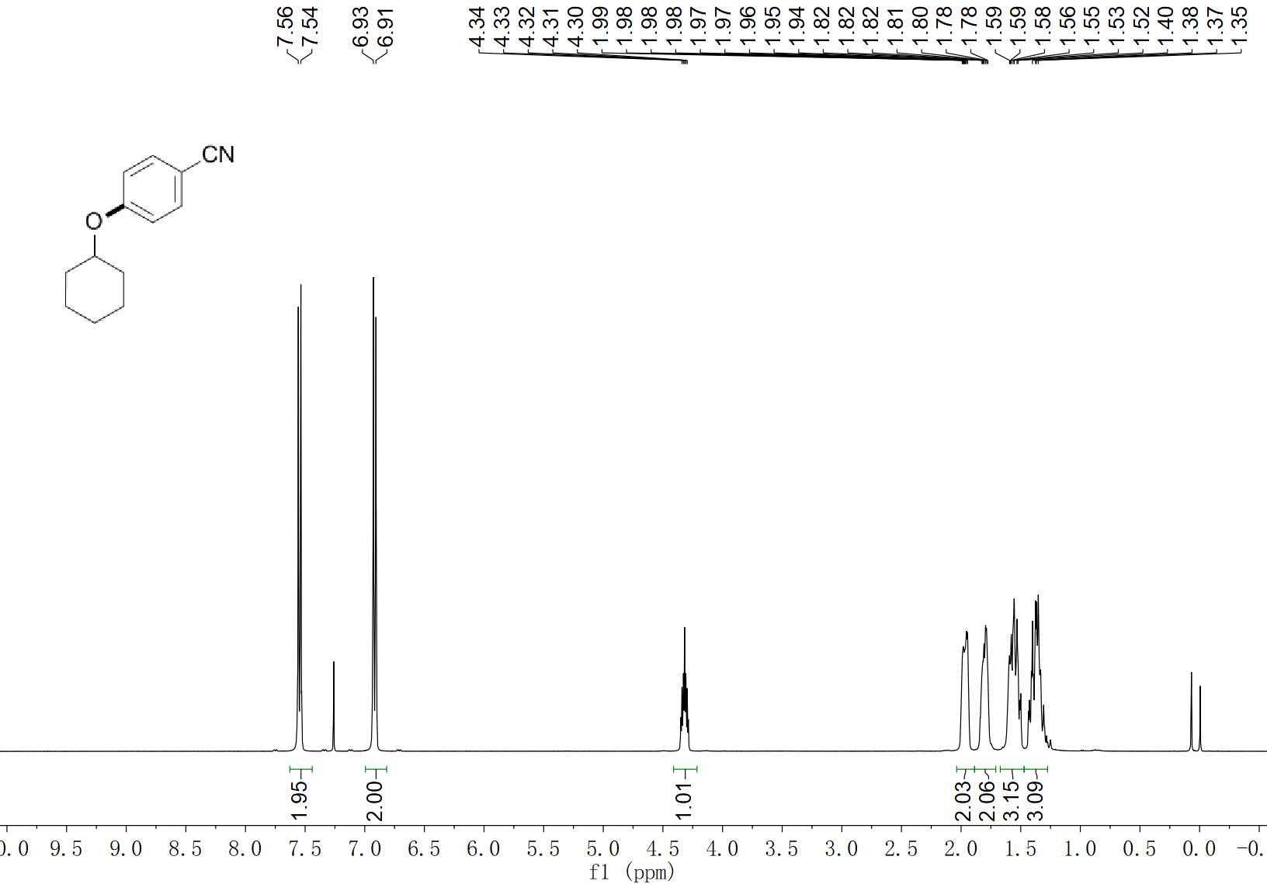
29 ¹H NMR (400 MHz, CDCl₃)

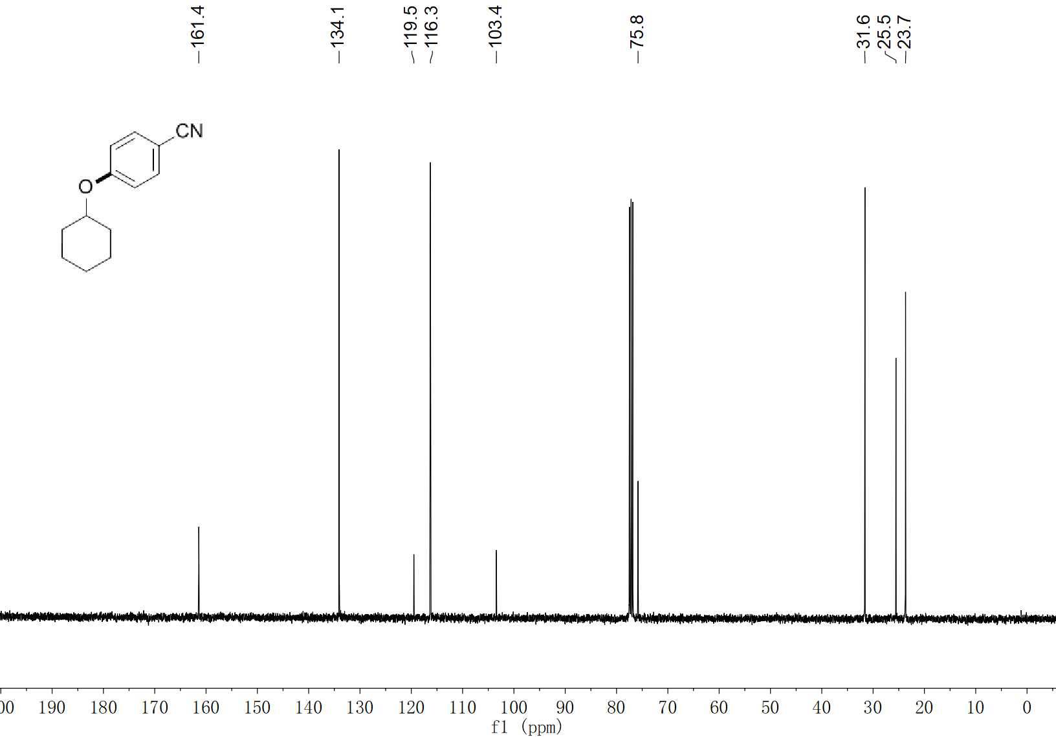
29 ¹³C NMR (100 MHz, CDCl₃)

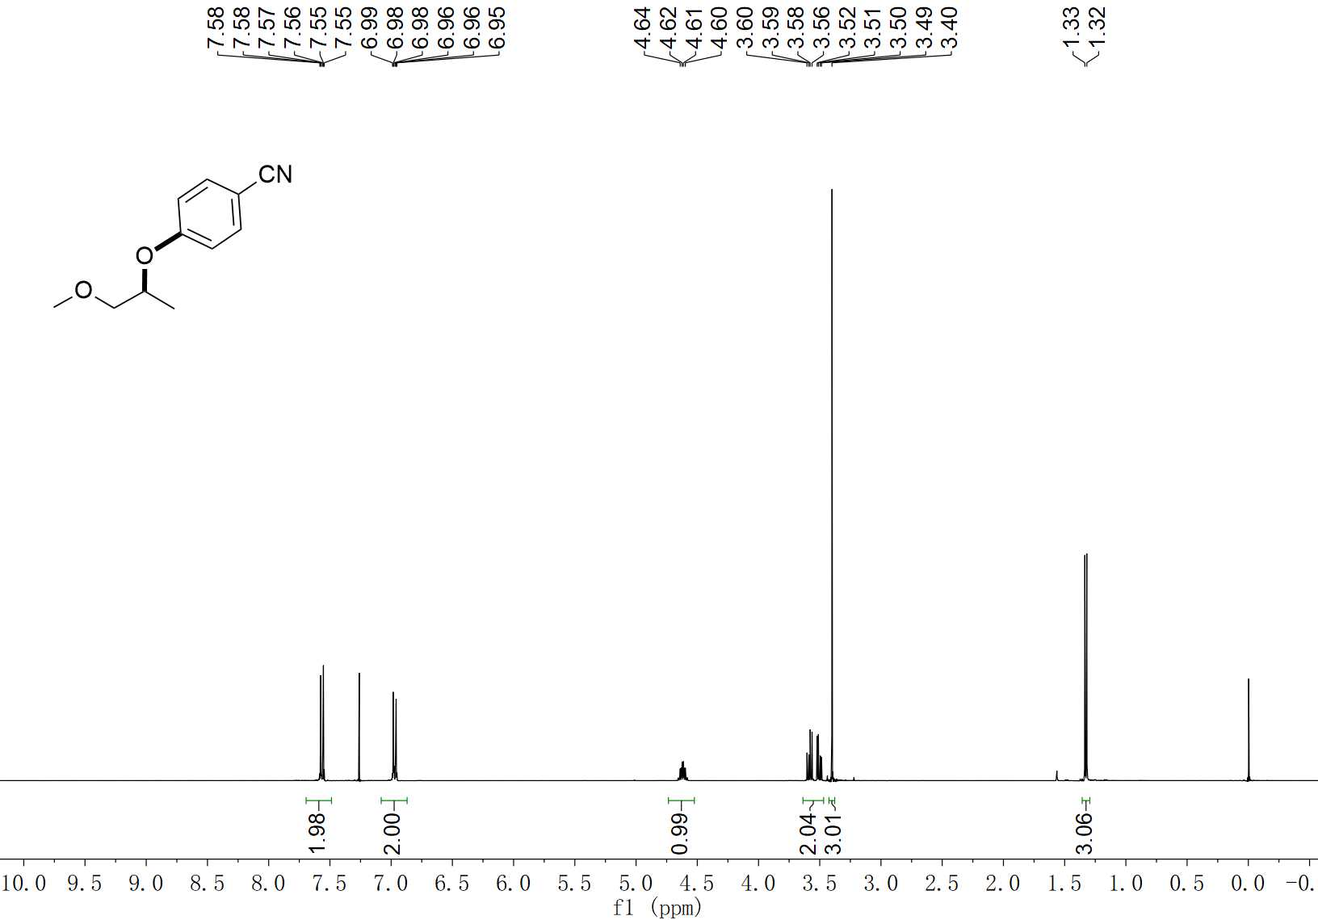
30 ¹H NMR (400 MHz, CDCl₃)

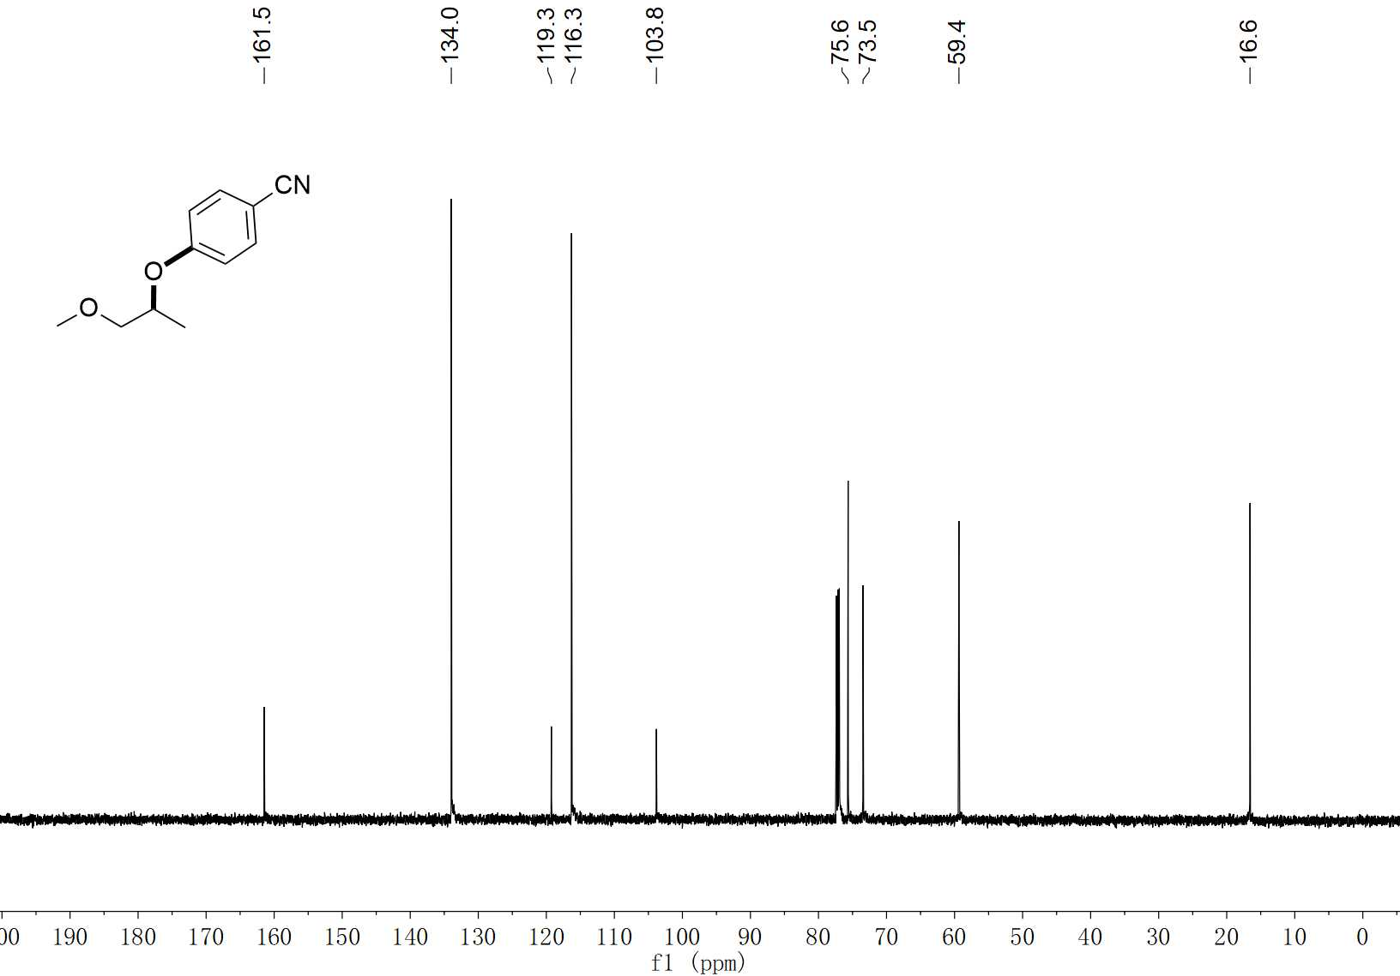
30 ¹³C NMR (100 MHz, CDCl₃)

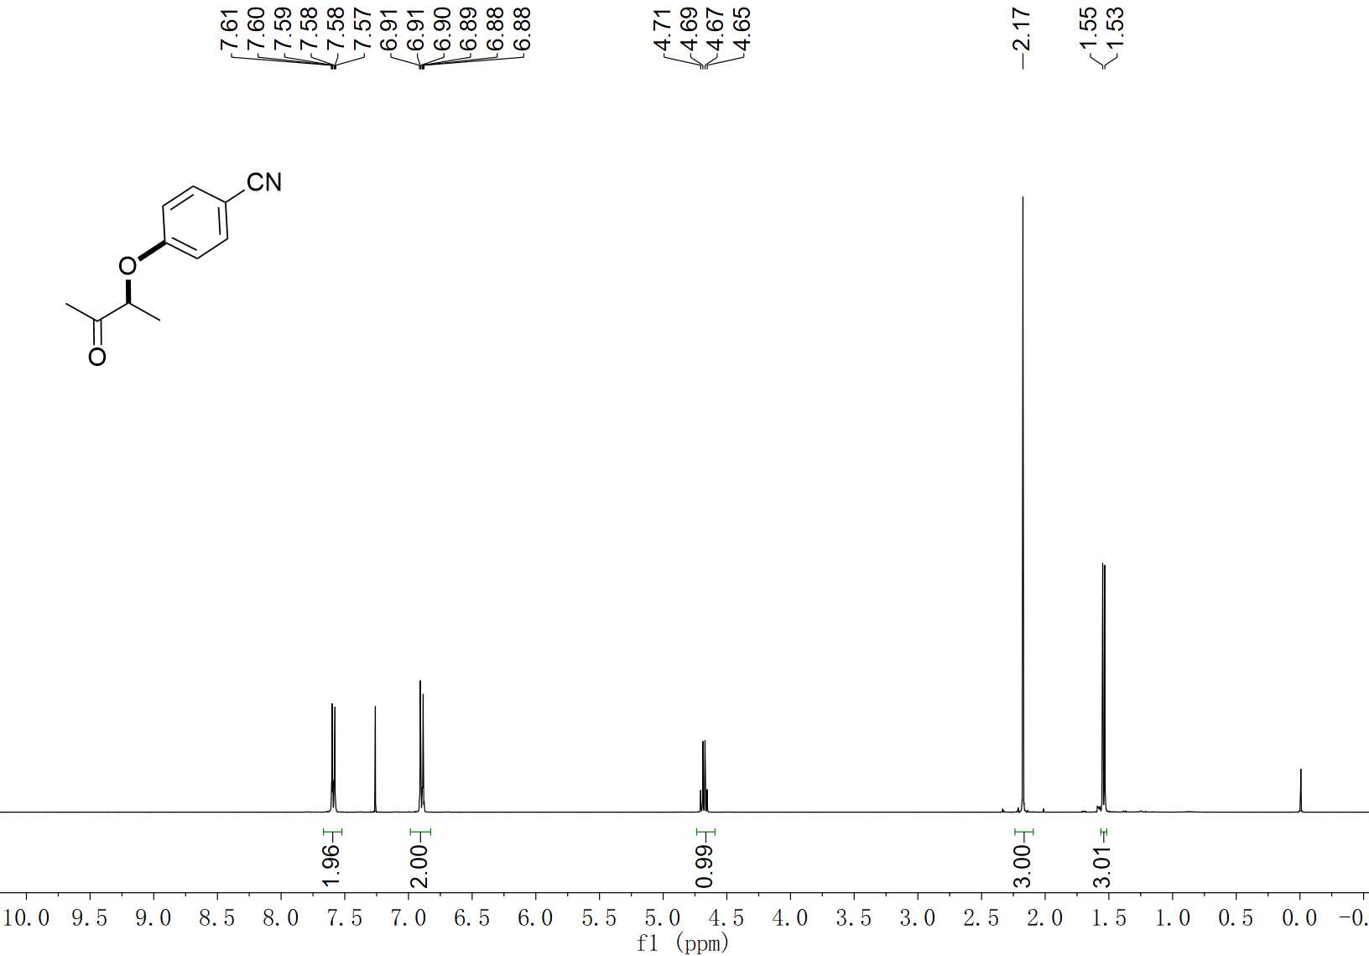
31 ¹H NMR (400 MHz, CDCl₃)

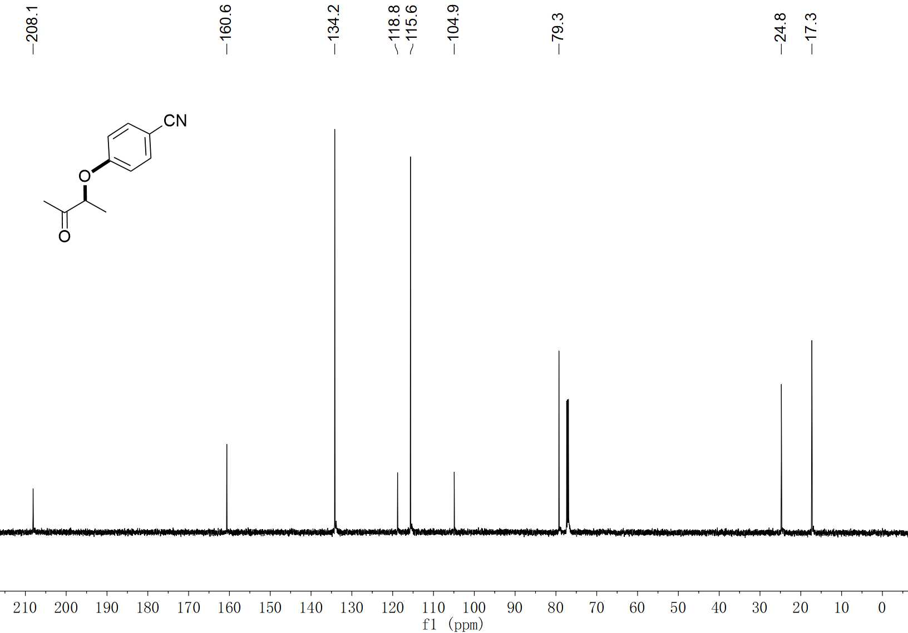
31 ¹³C NMR (100 MHz, CDCl₃)

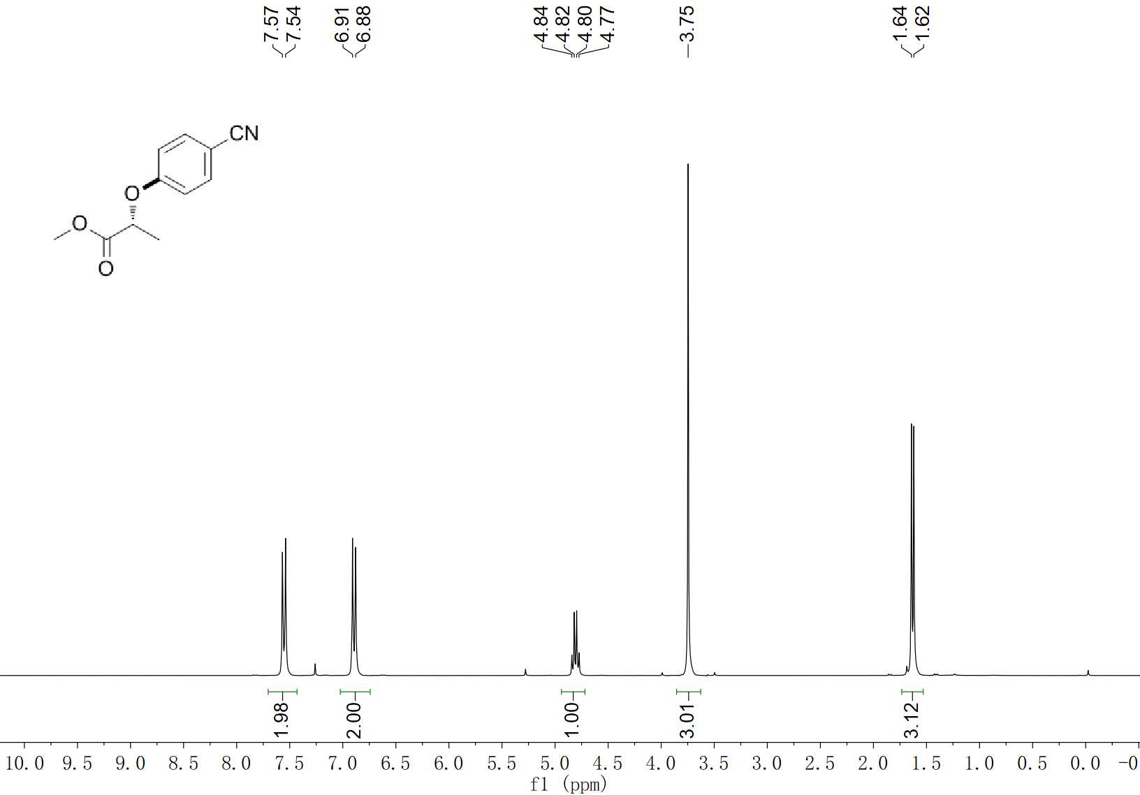
32 ¹H NMR (300 MHz, CDCl₃)

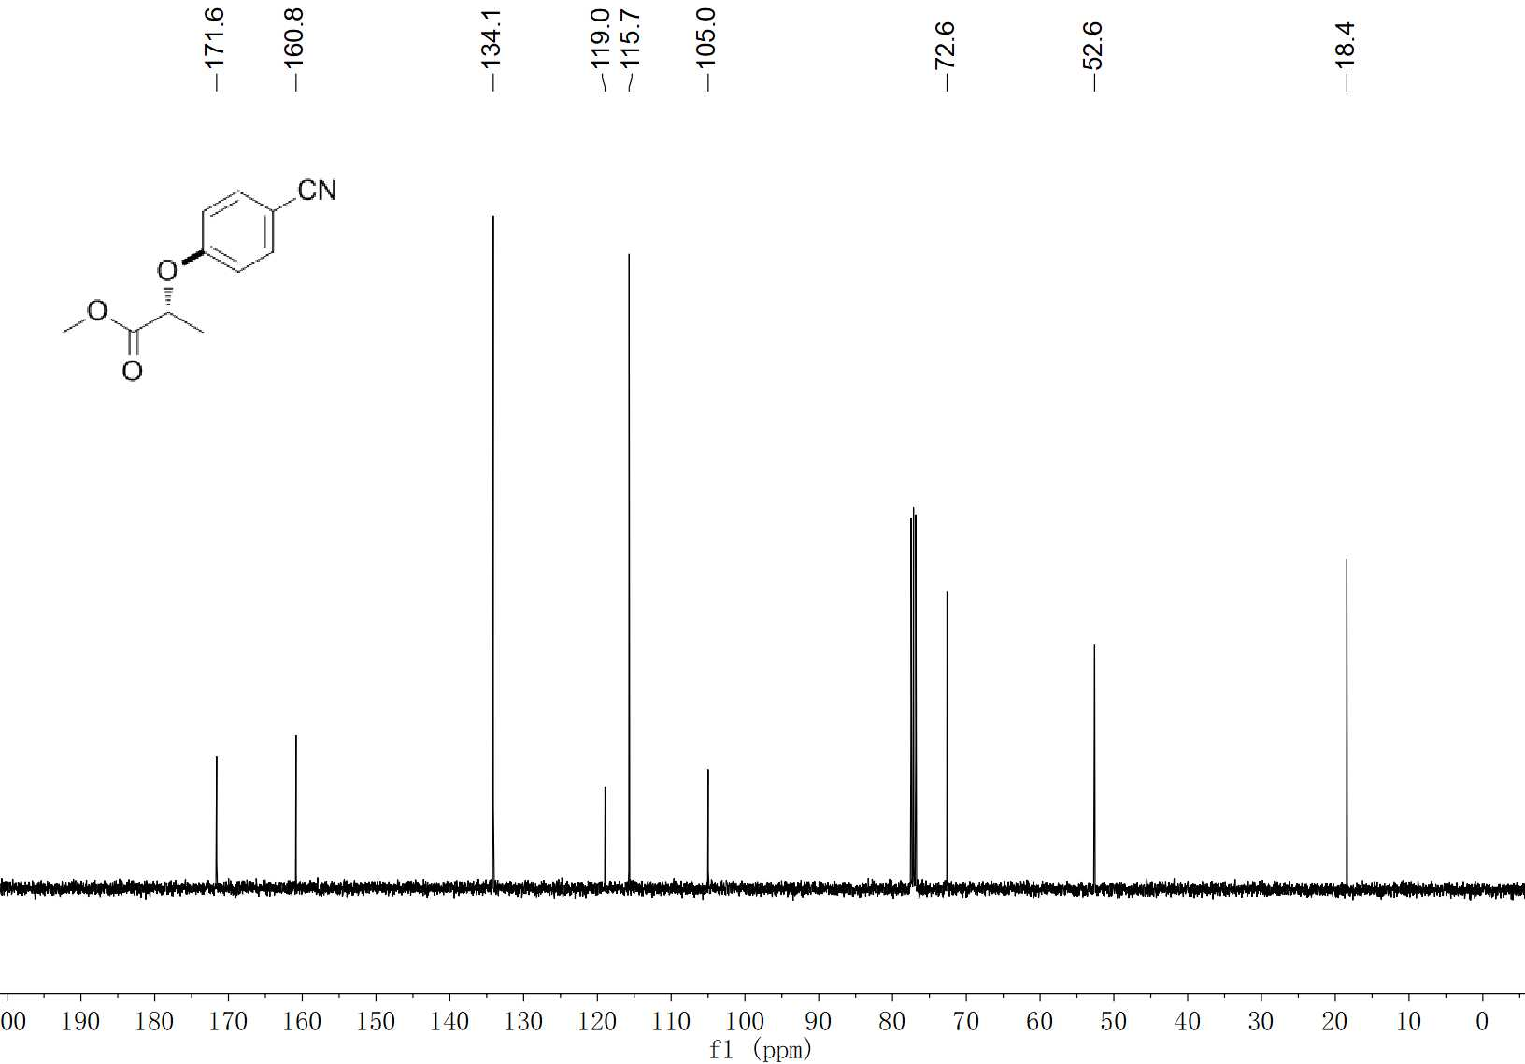
32 ¹³C NMR (100 MHz, CDCl₃)

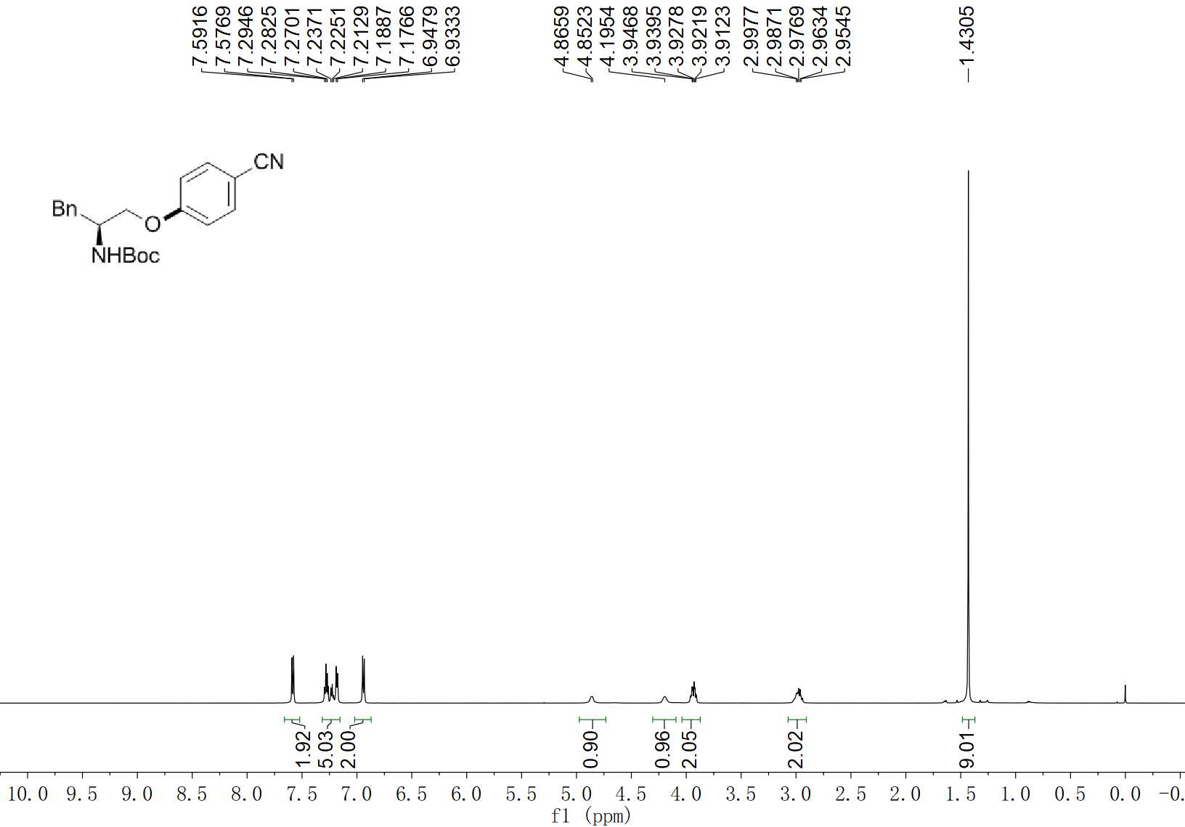
33 ¹H NMR (400 MHz, CDCl₃)

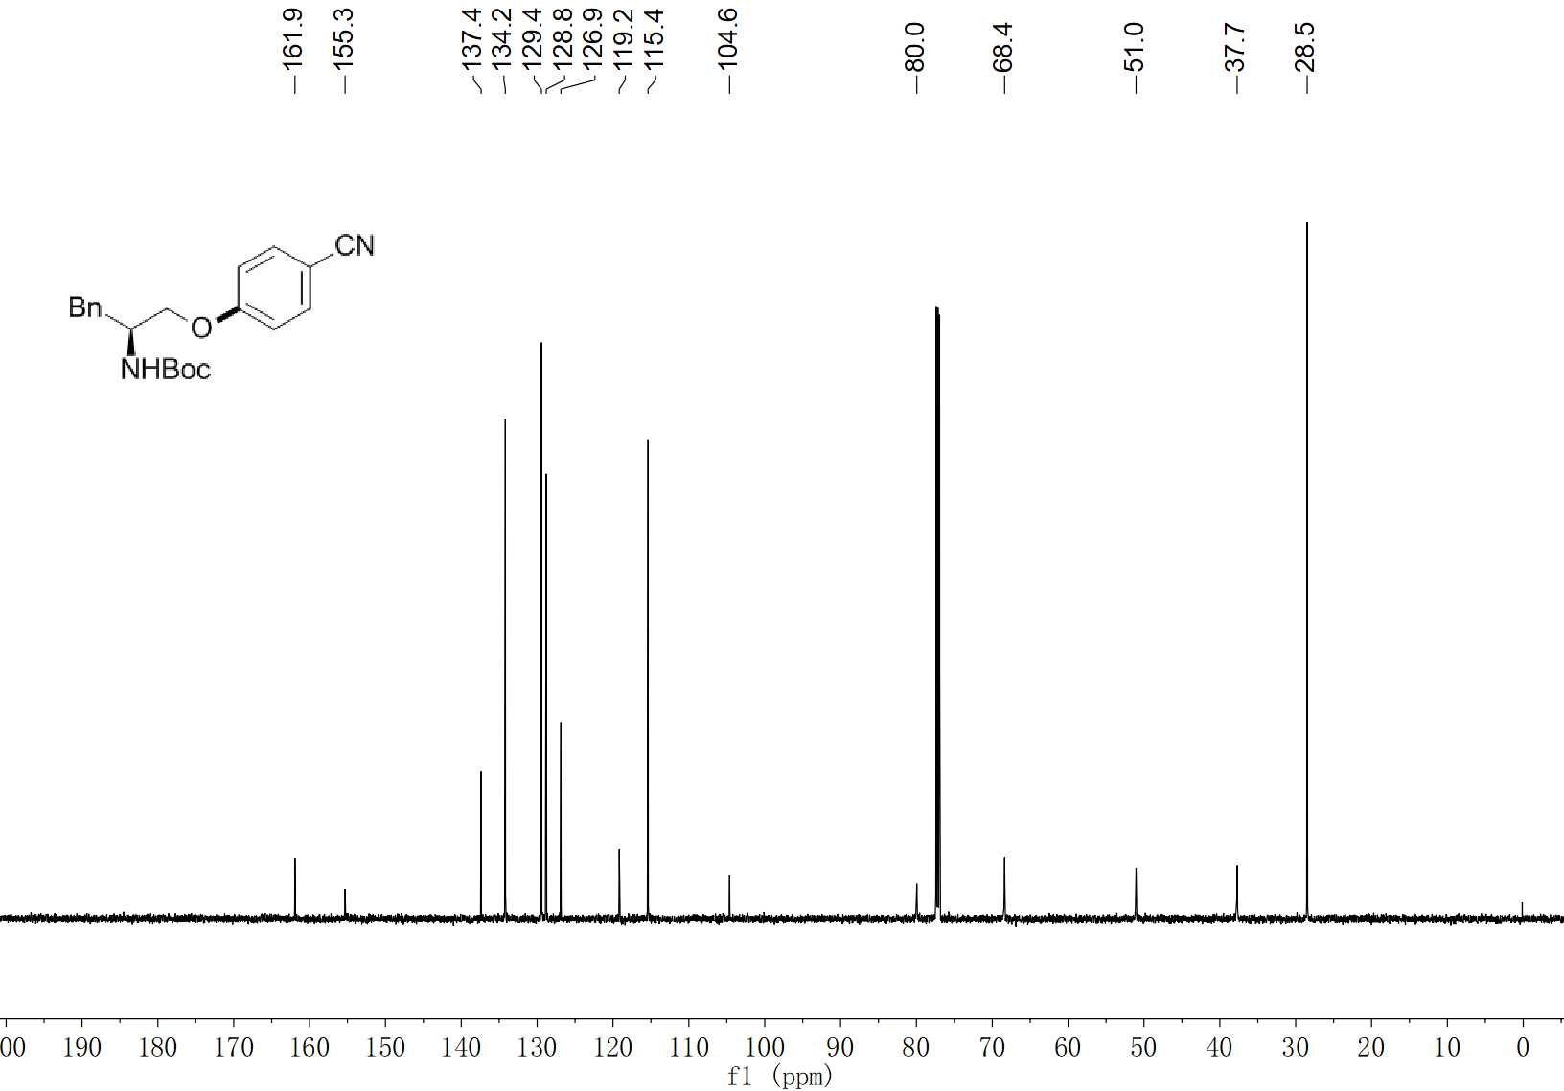
33 ¹³C NMR (100 MHz, CDCl₃)

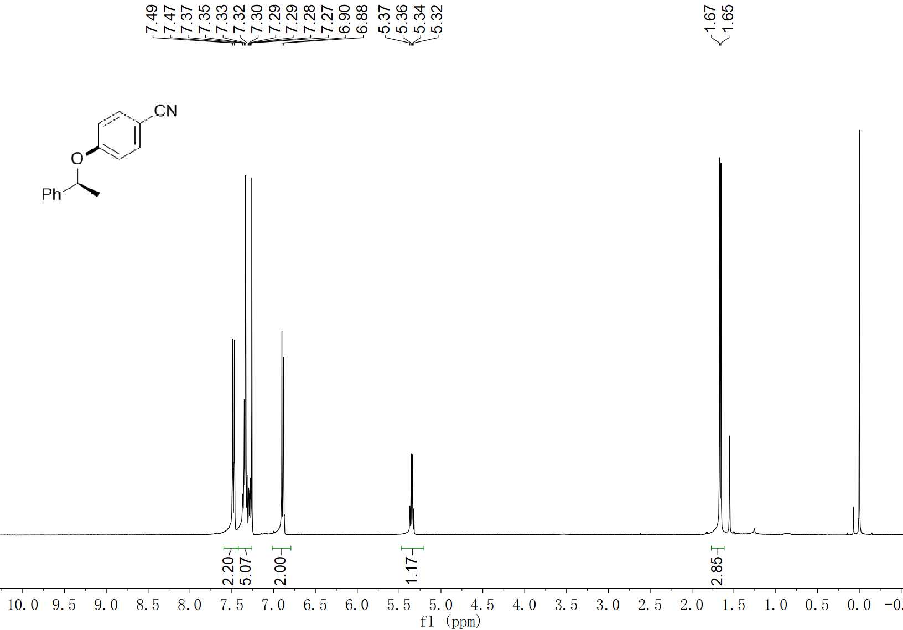
34 ¹H NMR (400 MHz, CDCl₃)

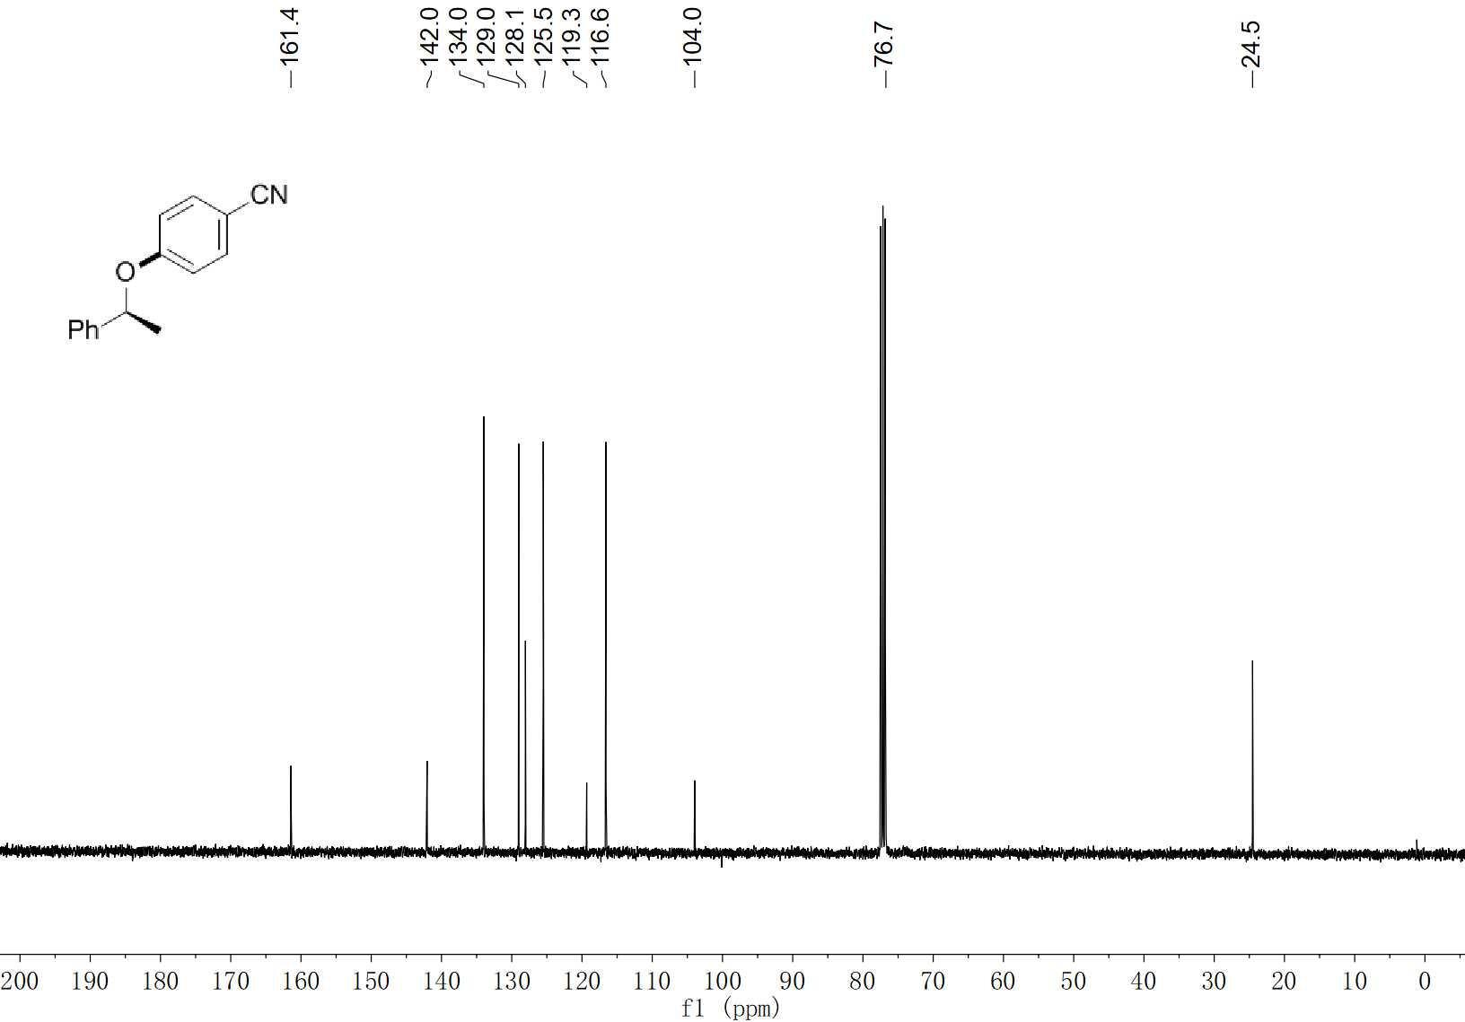
34 ¹³C NMR (100 MHz, CDCl₃)

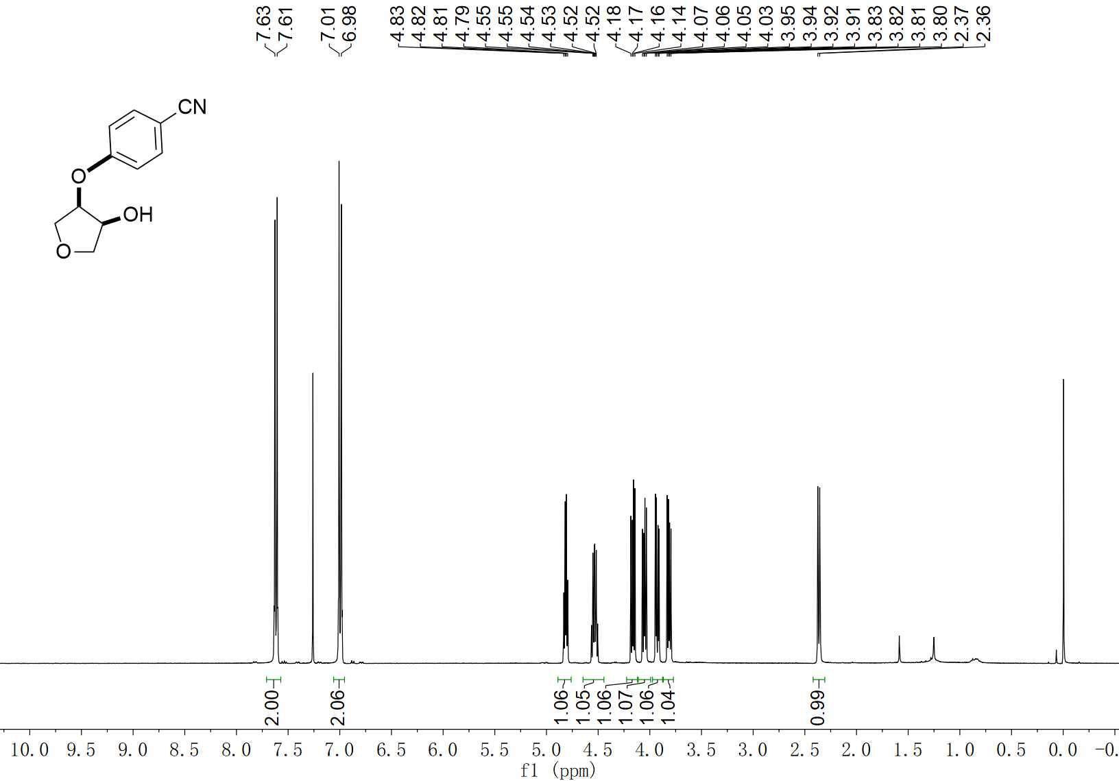
35 ¹H NMR (400 MHz, CDCl₃)

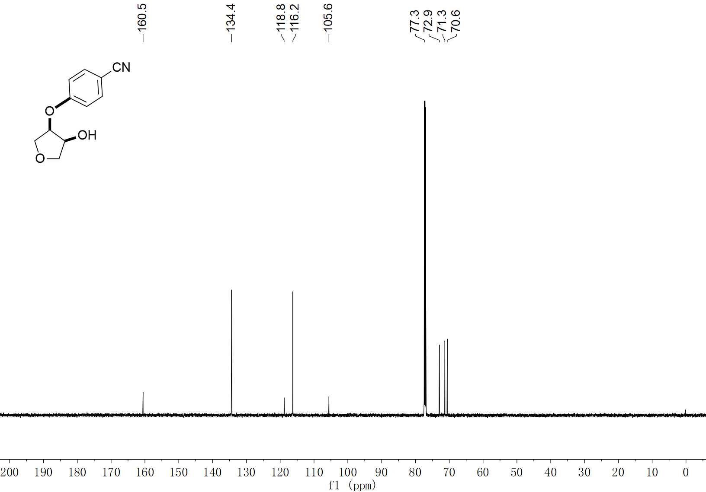
35 ¹³C NMR (100 MHz, CDCl₃)

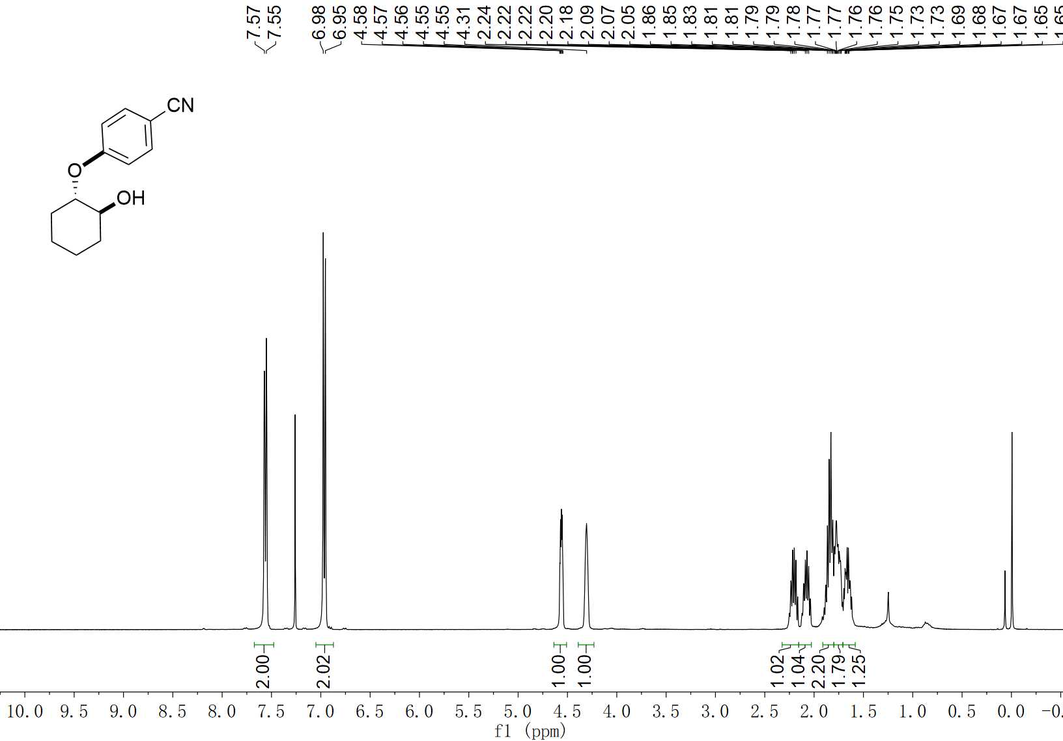
36 ¹H NMR (400 MHz, CDCl₃)

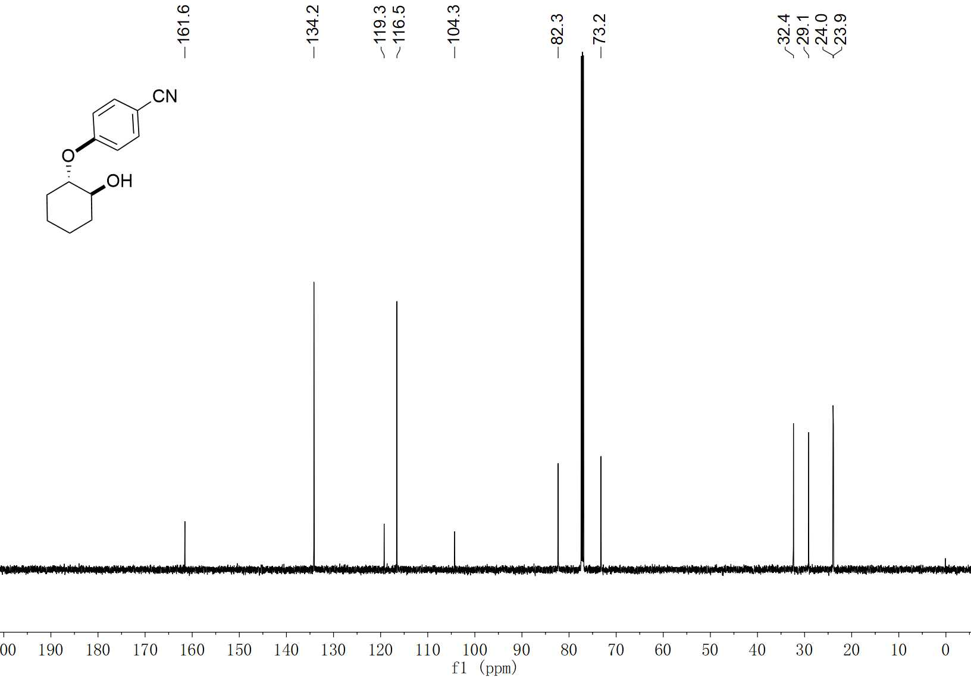
36 ¹³C NMR (100 MHz, CDCl₃)

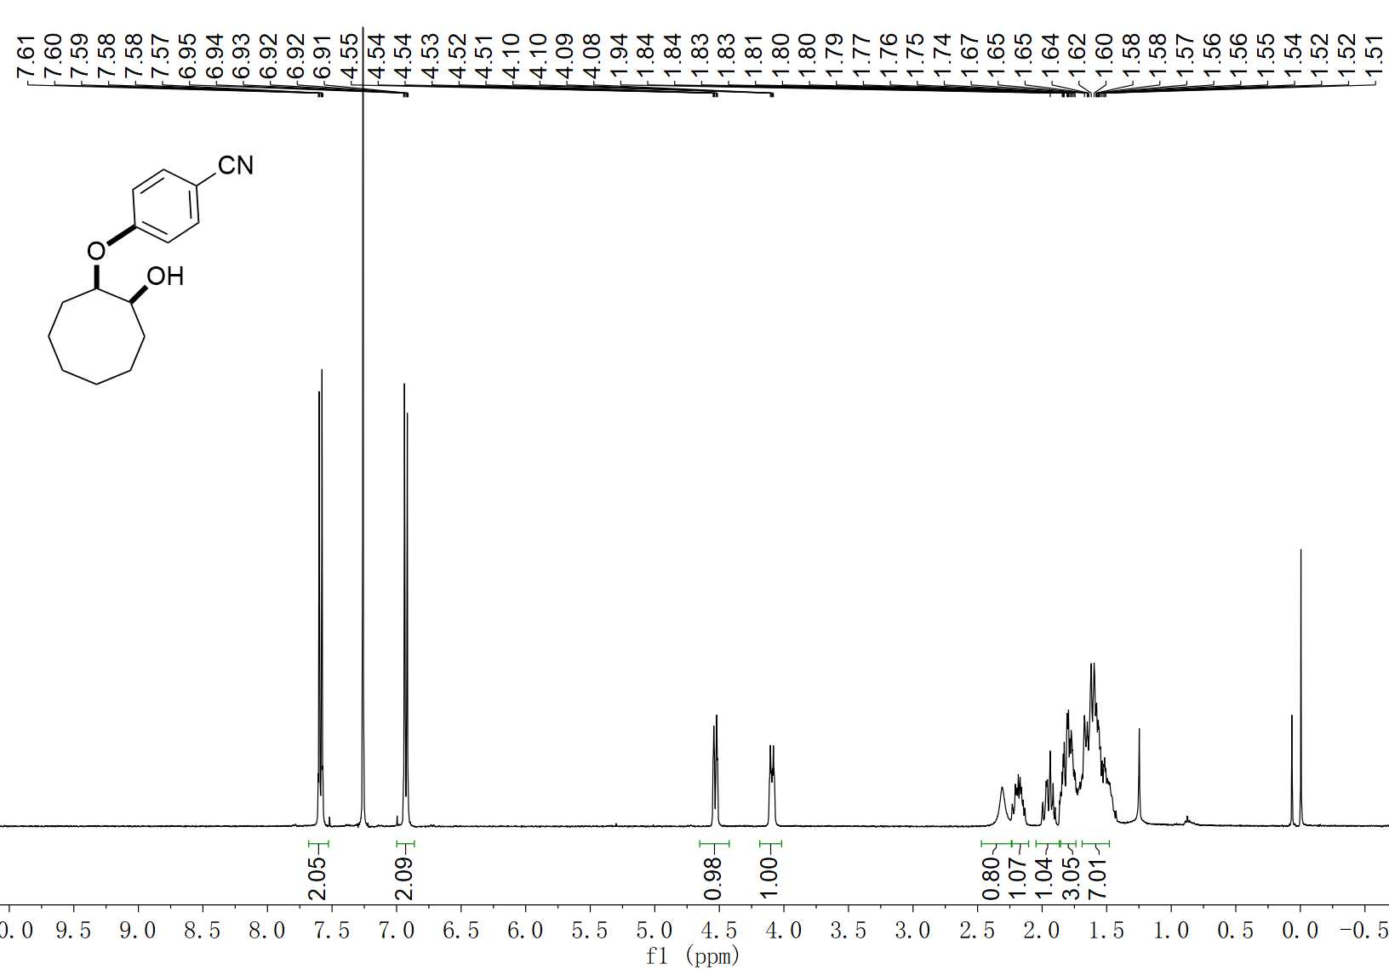
37 ¹H NMR (400 MHz, CDCl₃)

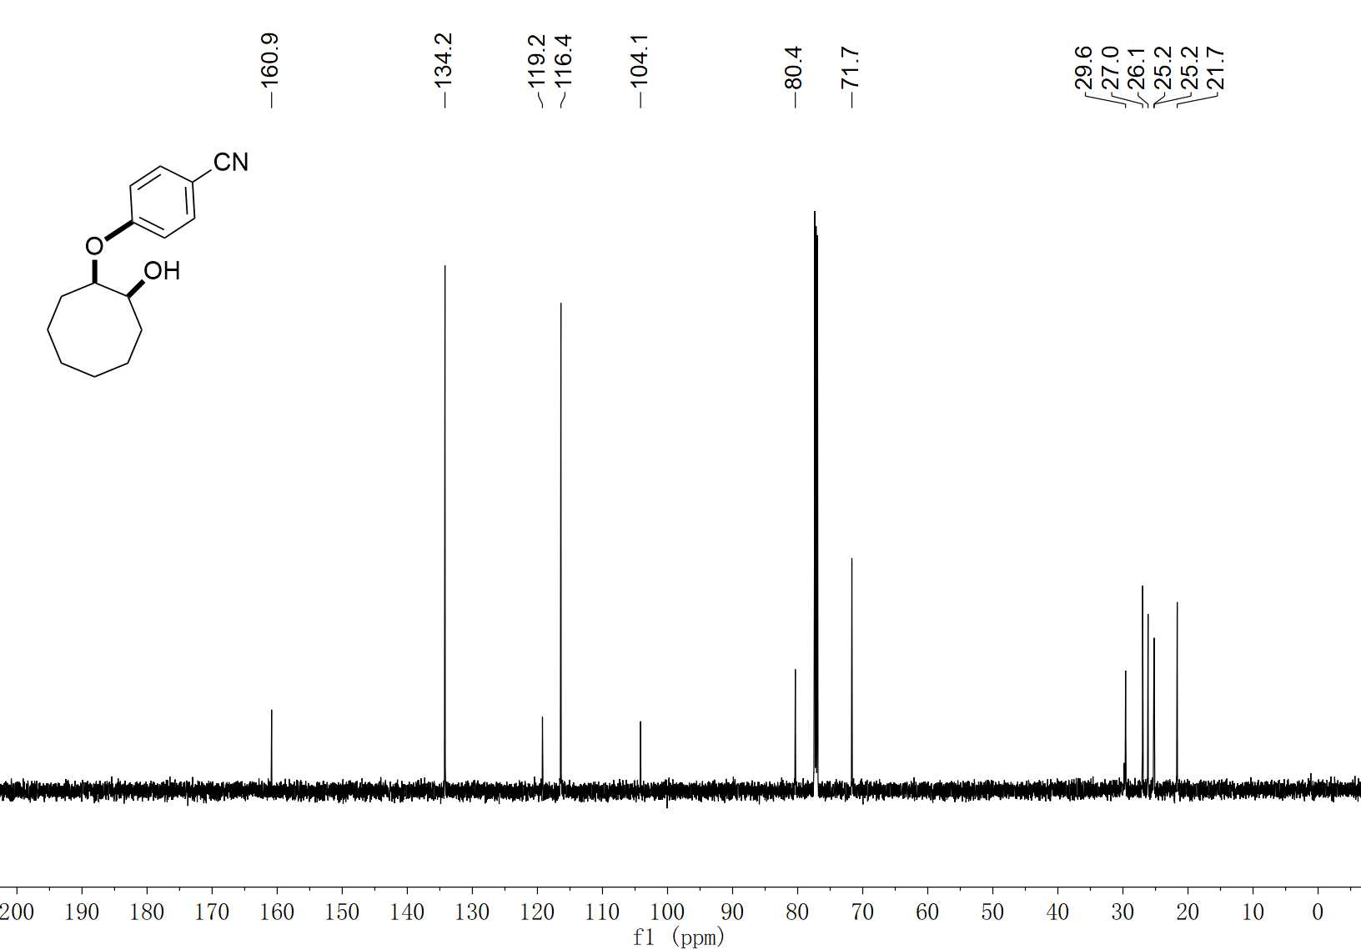
37 ¹³C NMR (100 MHz, CDCl₃)

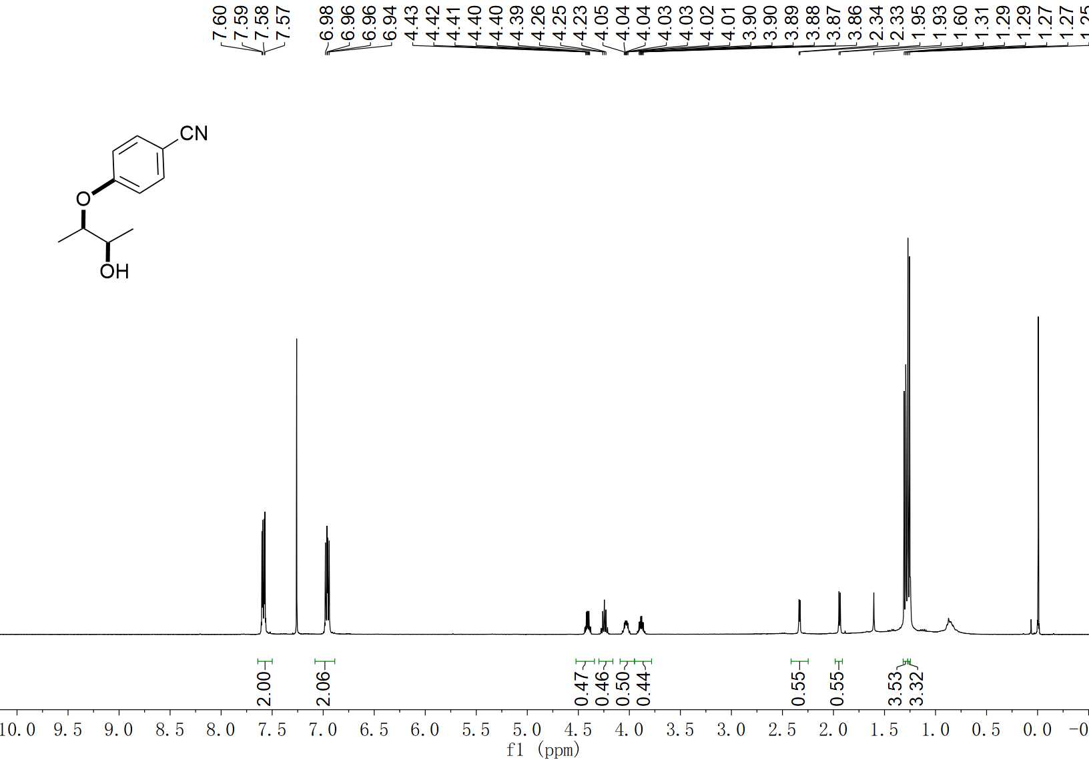
38 ¹H NMR (400 MHz, CDCl₃)

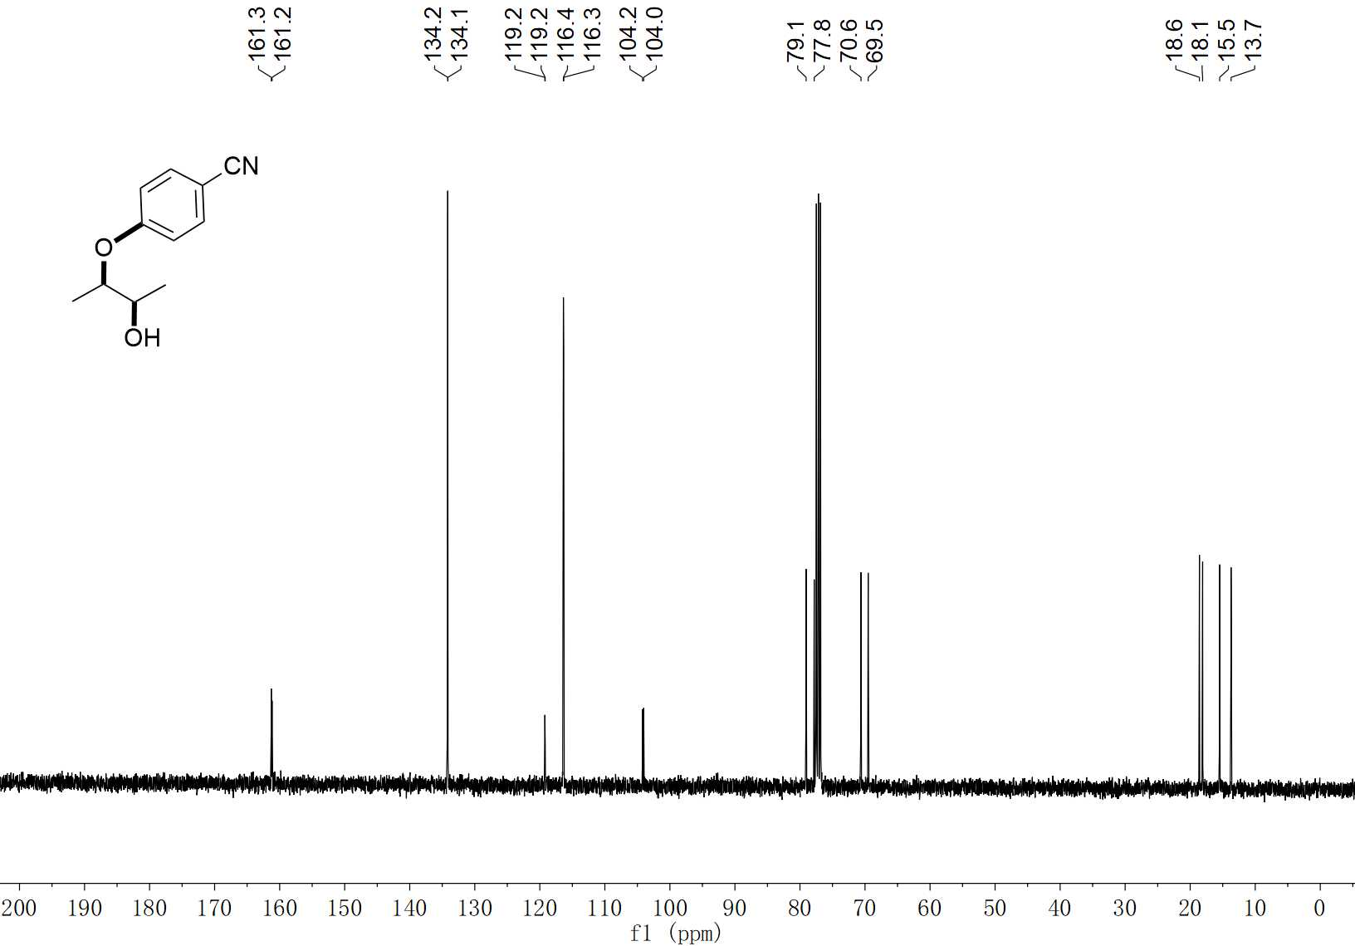
38 ¹³C NMR (100 MHz, CDCl₃)

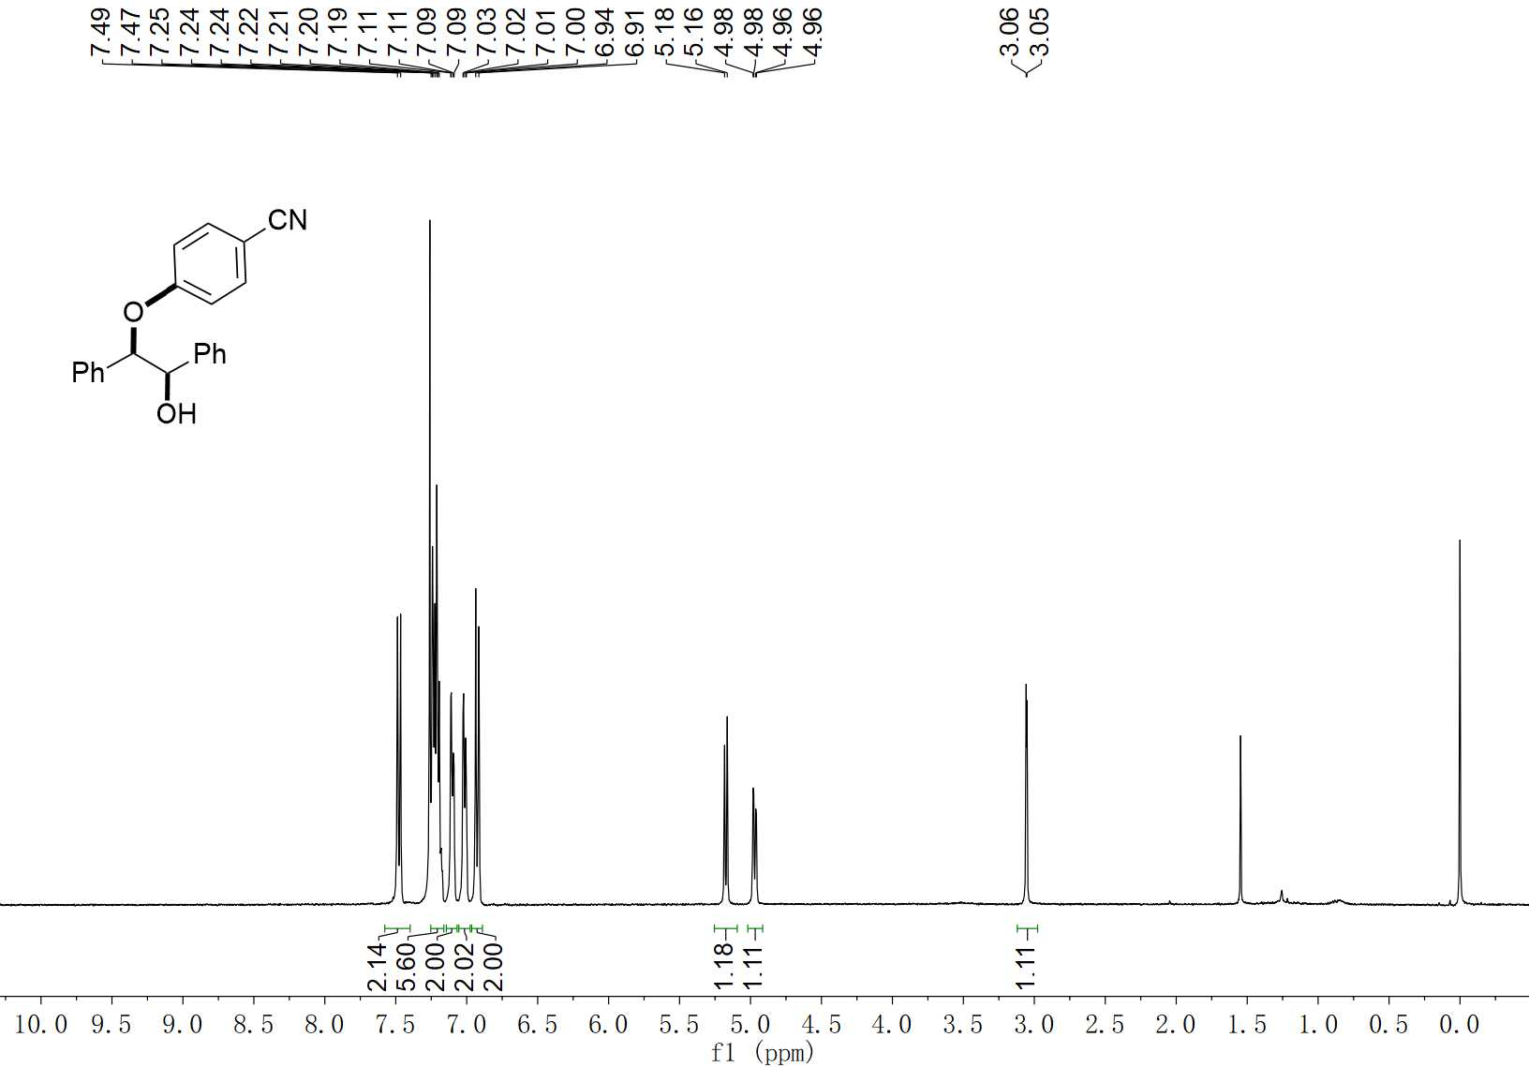
39 ¹H NMR (400 MHz, CDCl₃)

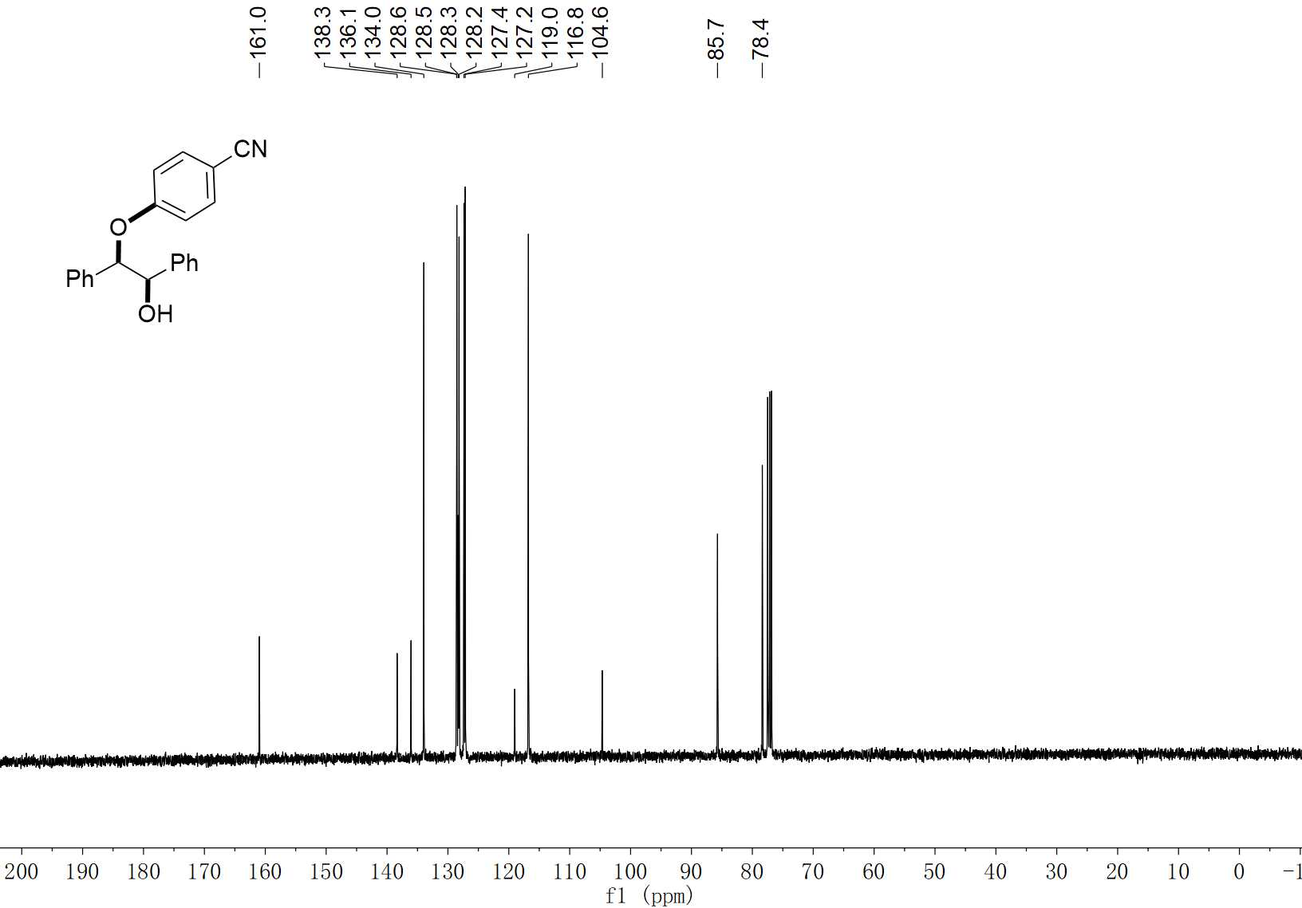
39 ¹³C NMR (100 MHz, CDCl₃)

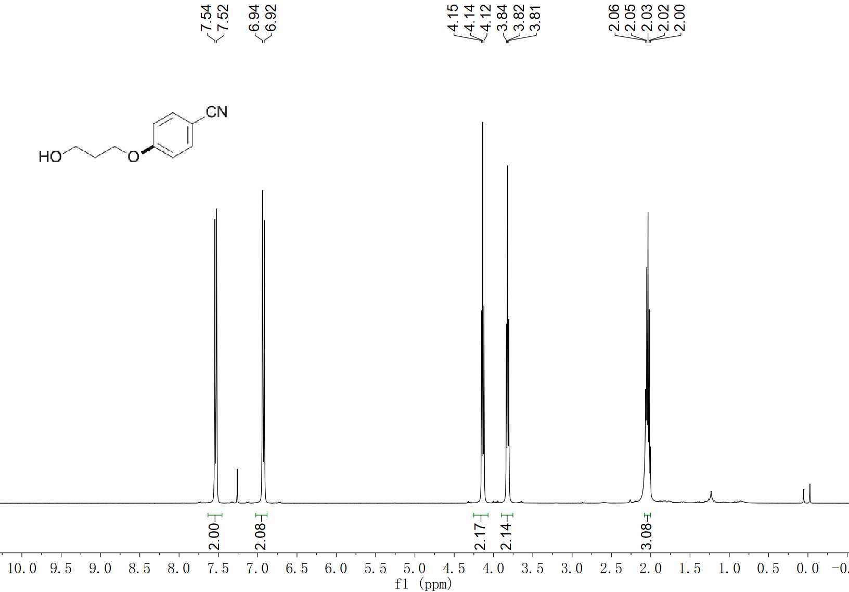
40 ¹H NMR (400 MHz, CDCl₃)

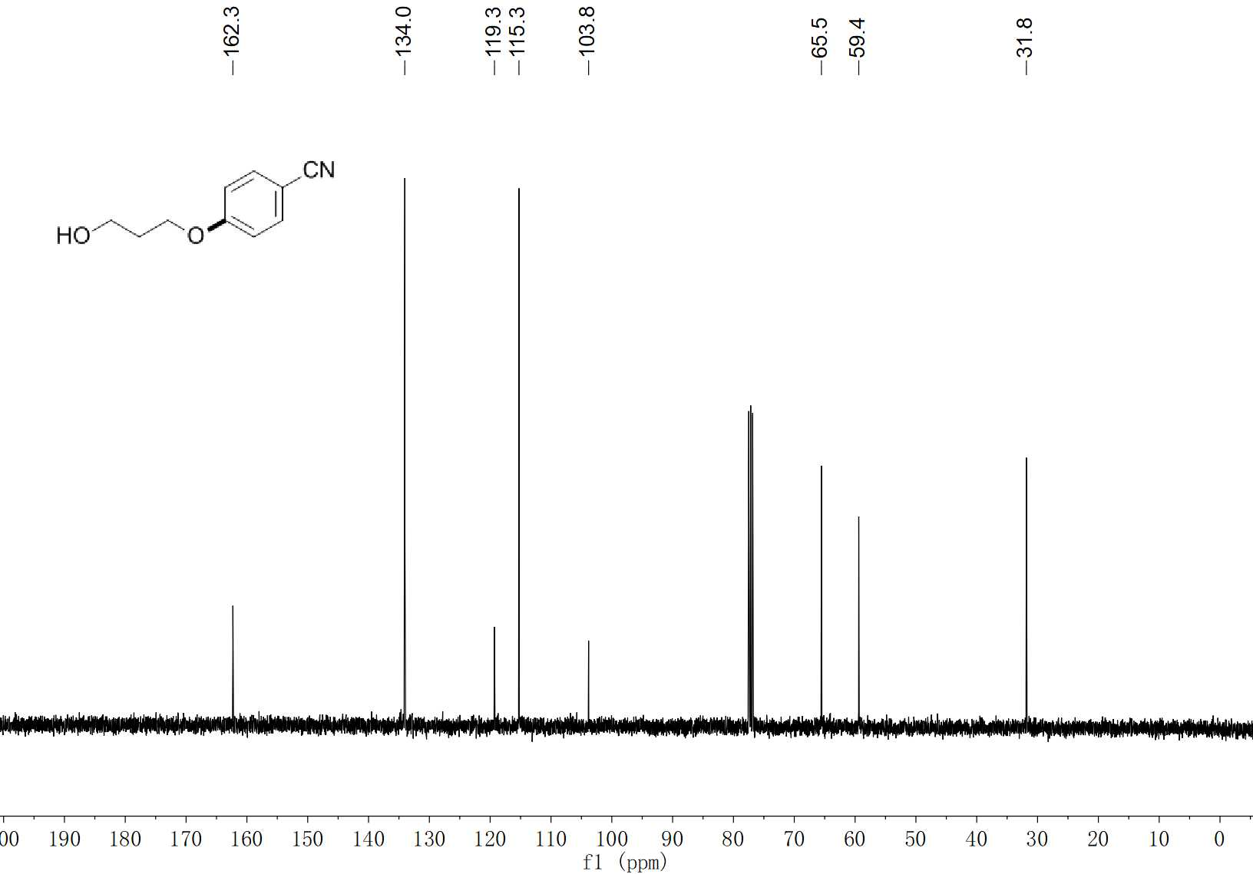
40 ¹³C NMR (100 MHz, CDCl₃)

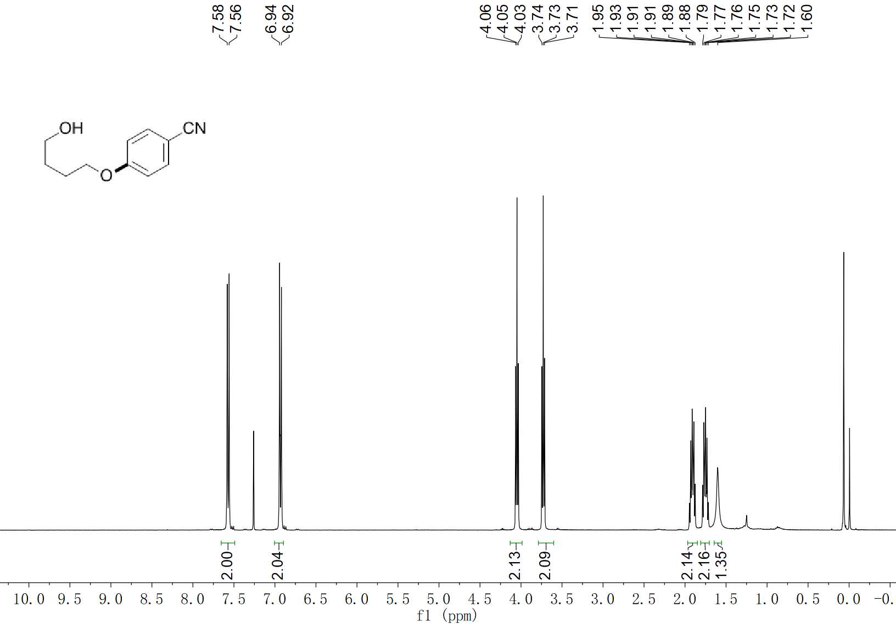
41 ¹H NMR (400 MHz, CDCl₃)

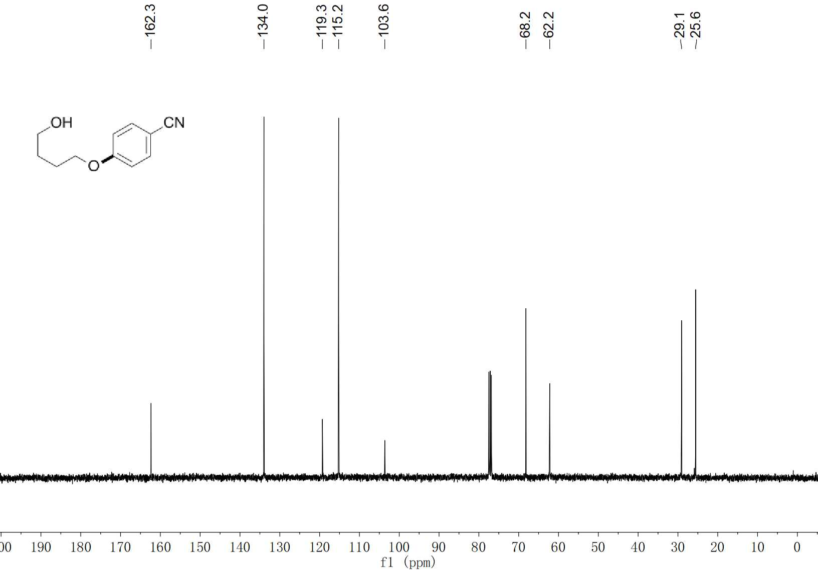
41 ¹³C NMR (100 MHz, CDCl₃)

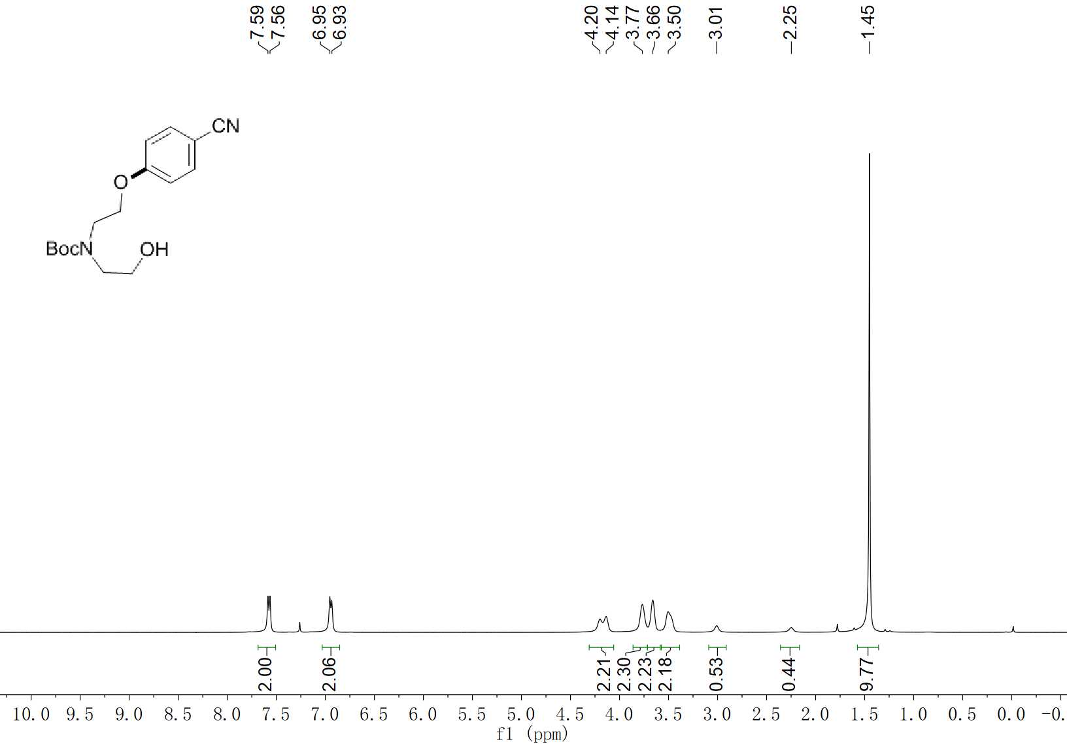
42 ¹H NMR (400 MHz, CDCl₃)

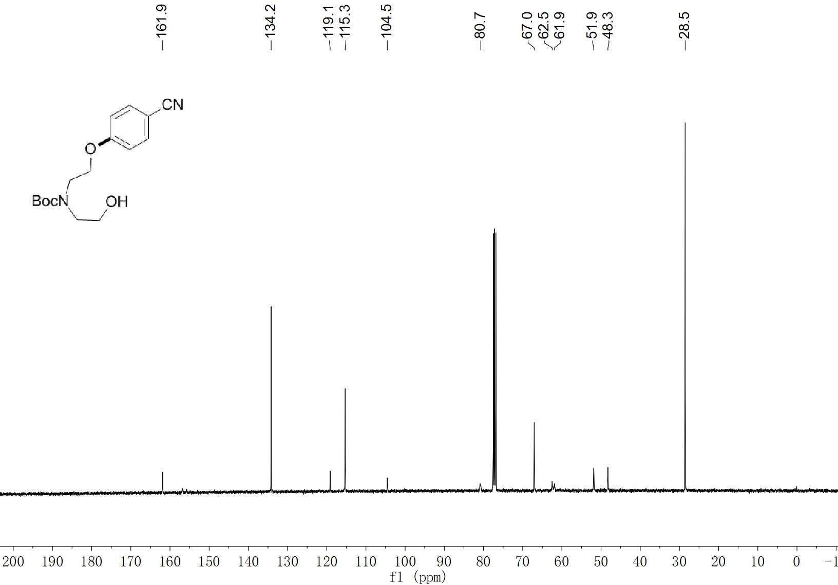
42 ¹³C NMR (100 MHz, CDCl₃)

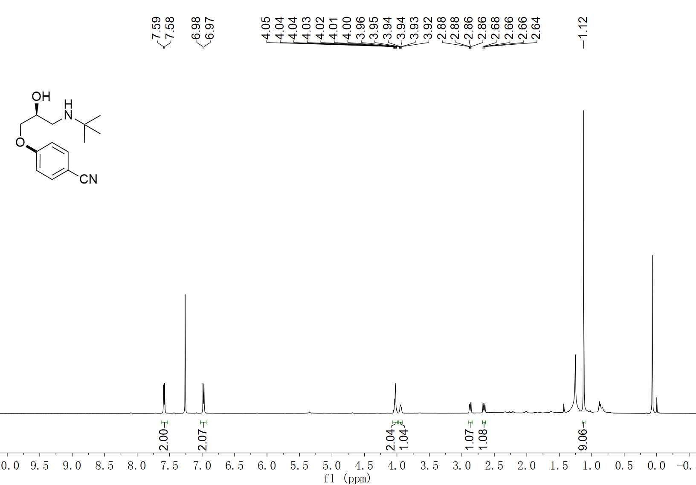
43-1 ¹H NMR (600 MHz, CDCl₃)

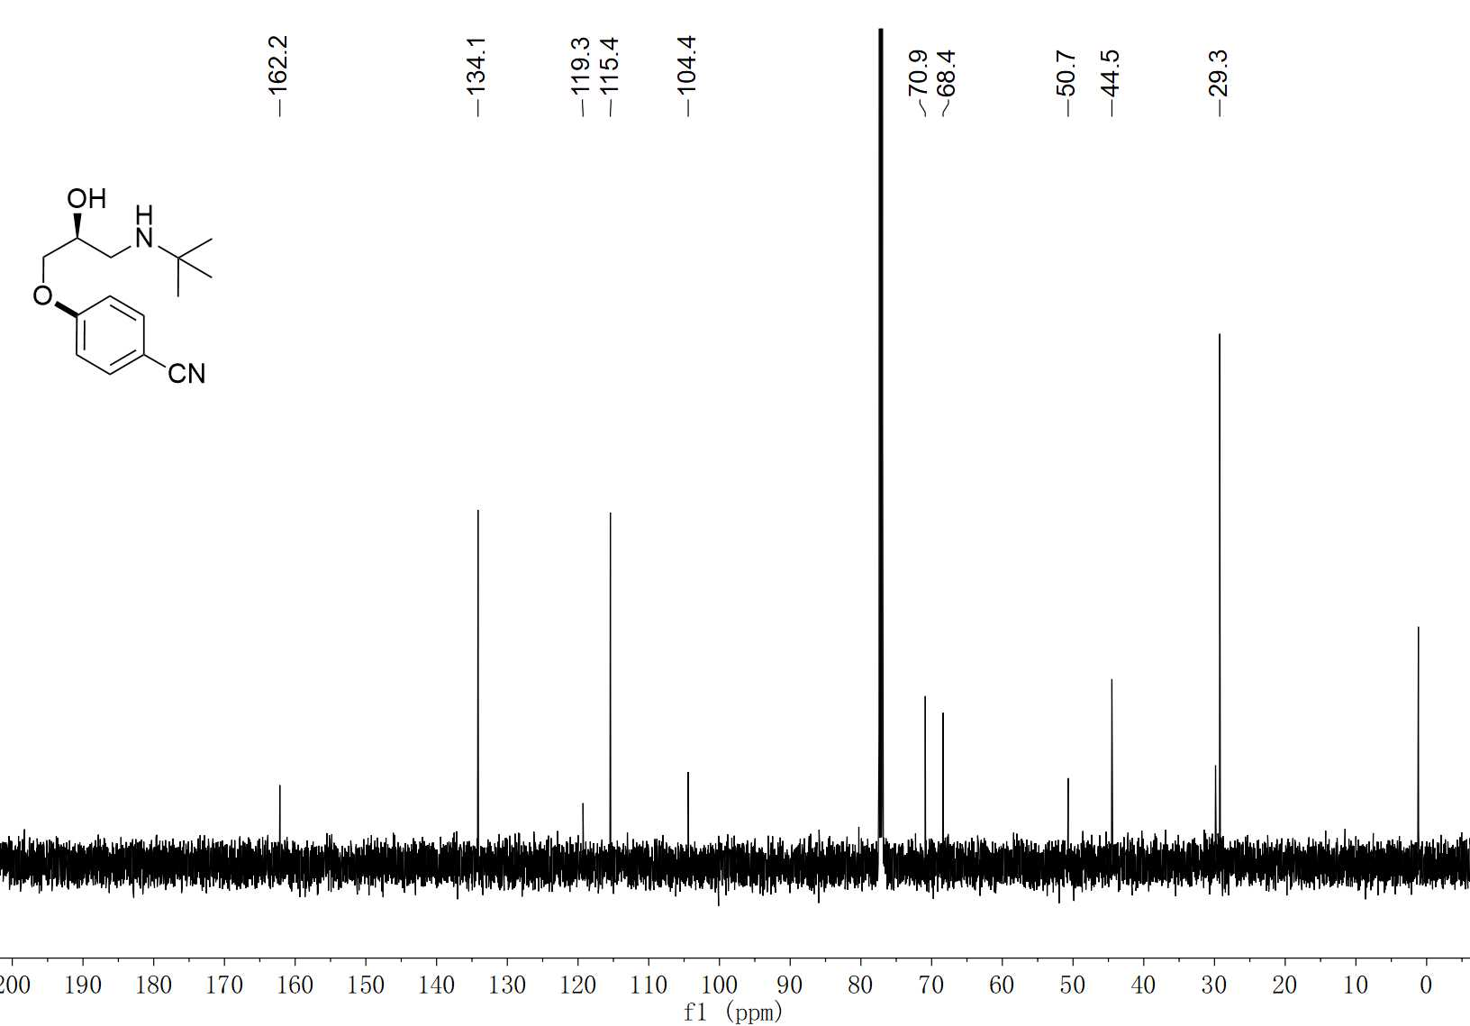
43-1 ¹³C NMR (150 MHz, CDCl₃)

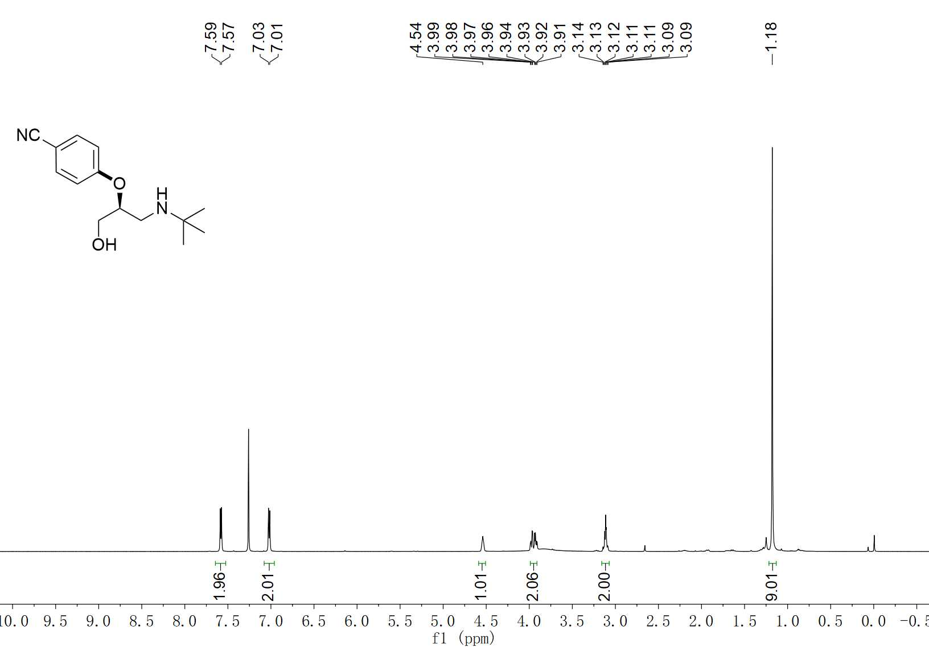
43-2 ¹H NMR (600 MHz, CDCl₃)

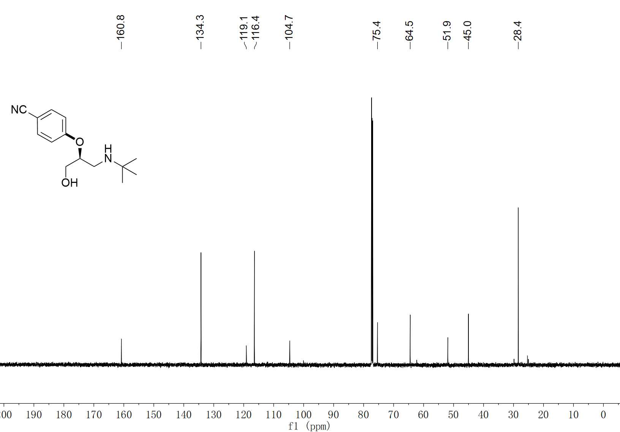
43-2 ¹³C NMR (150 MHz, CDCl₃)

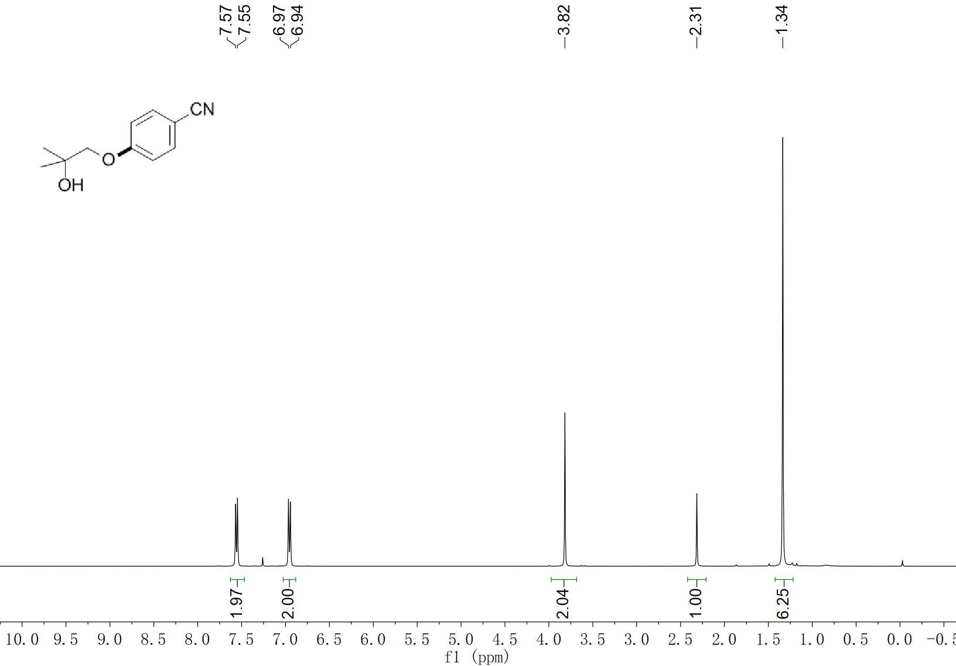
44 ¹H NMR (400 MHz, CDCl₃)

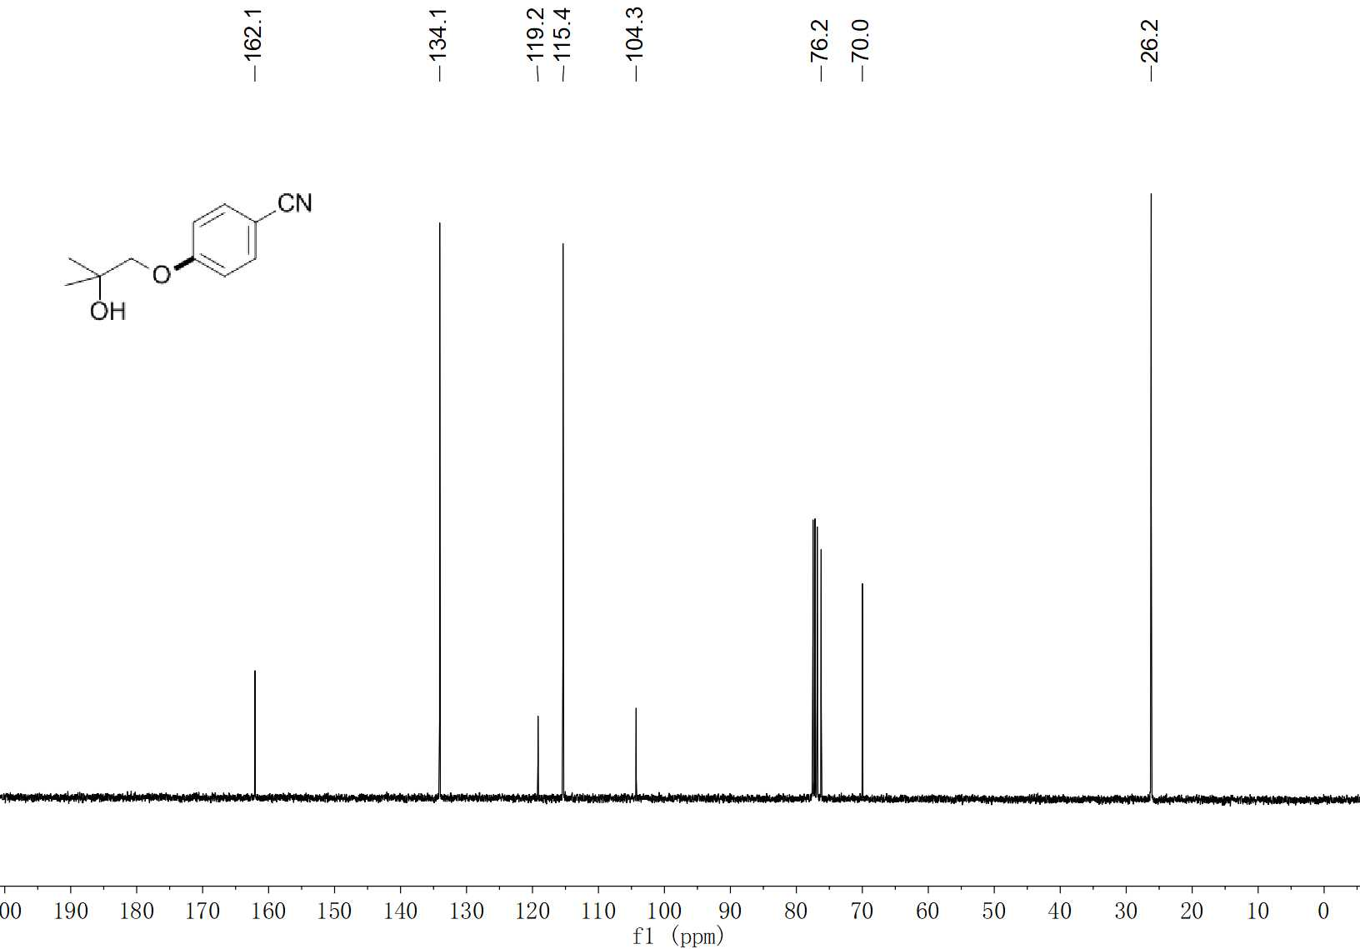
44 ¹³C NMR (100 MHz, CDCl₃)

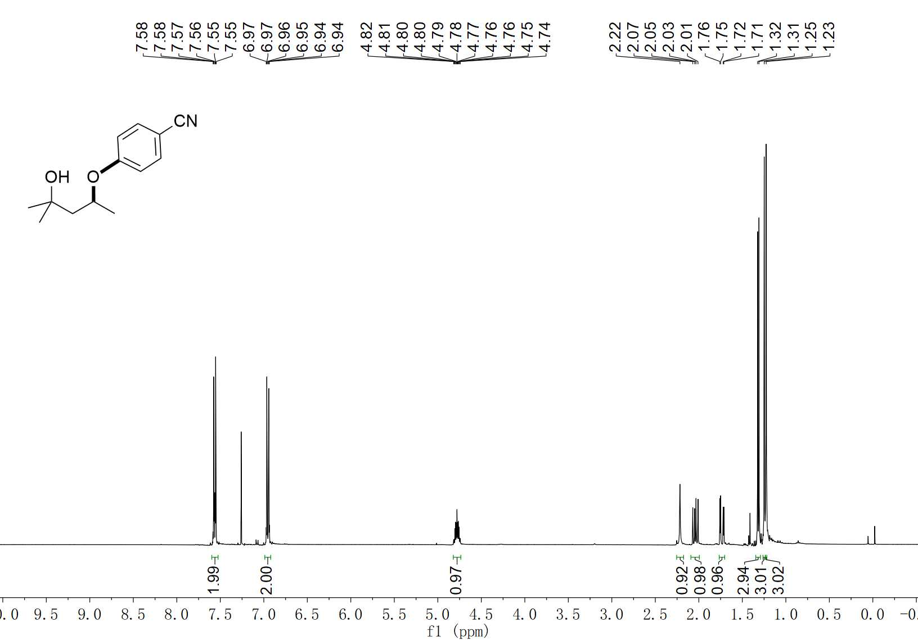
45 ¹H NMR (400 MHz, CDCl₃)

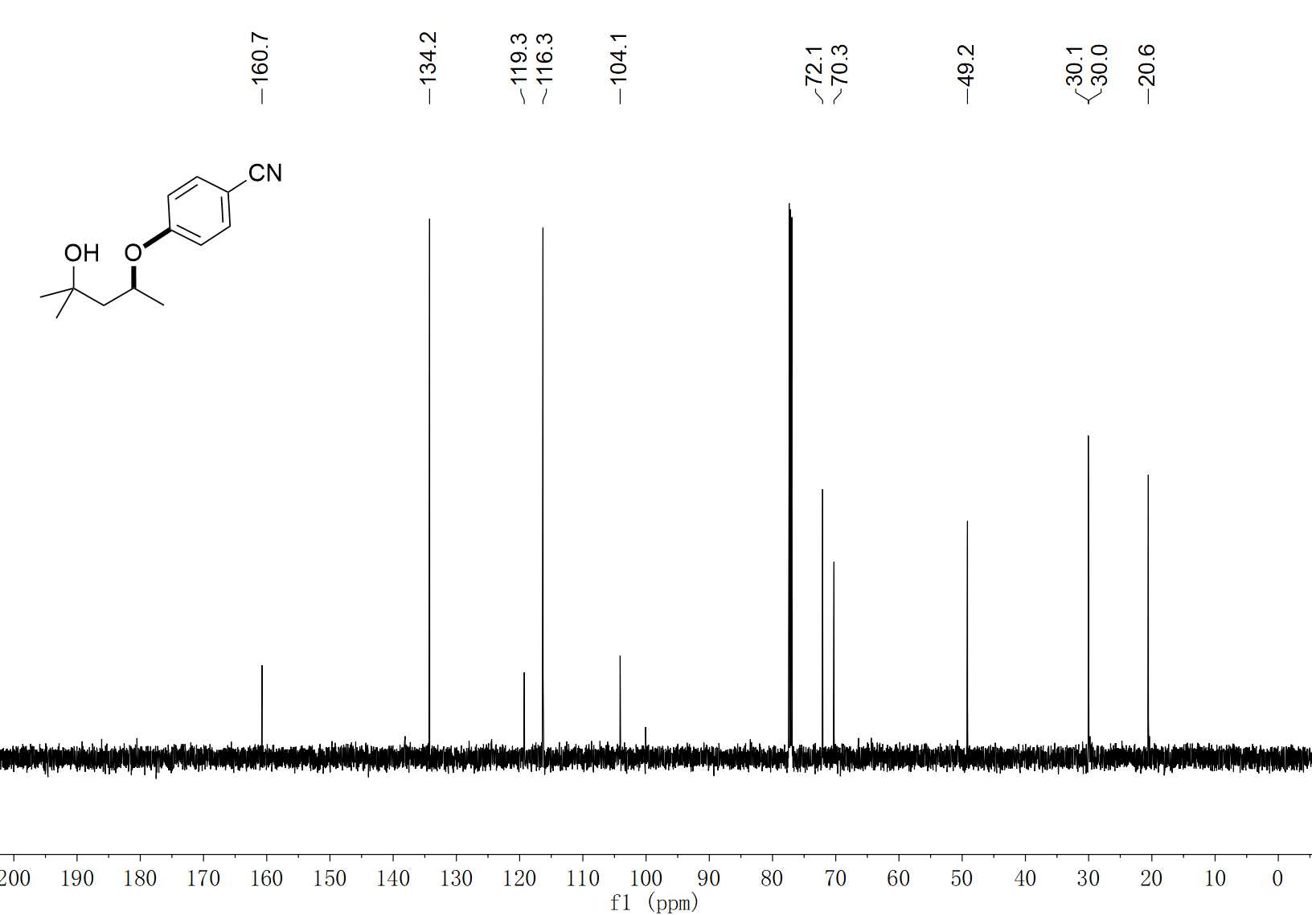
45 ¹³C NMR (100 MHz, CDCl₃)

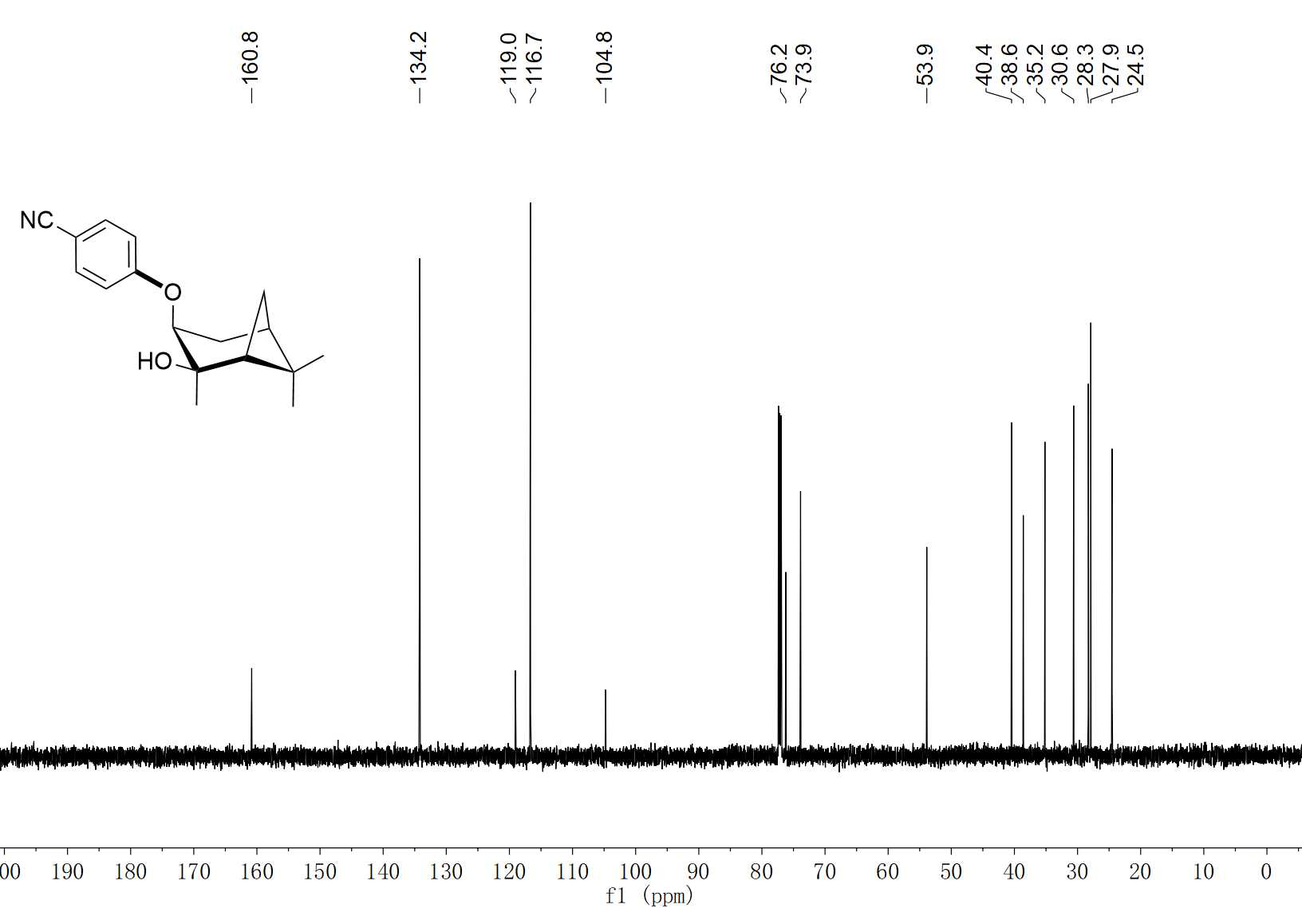
46 ¹H NMR (400 MHz, CDCl₃)

46 ¹³C NMR (100 MHz, CDCl₃)

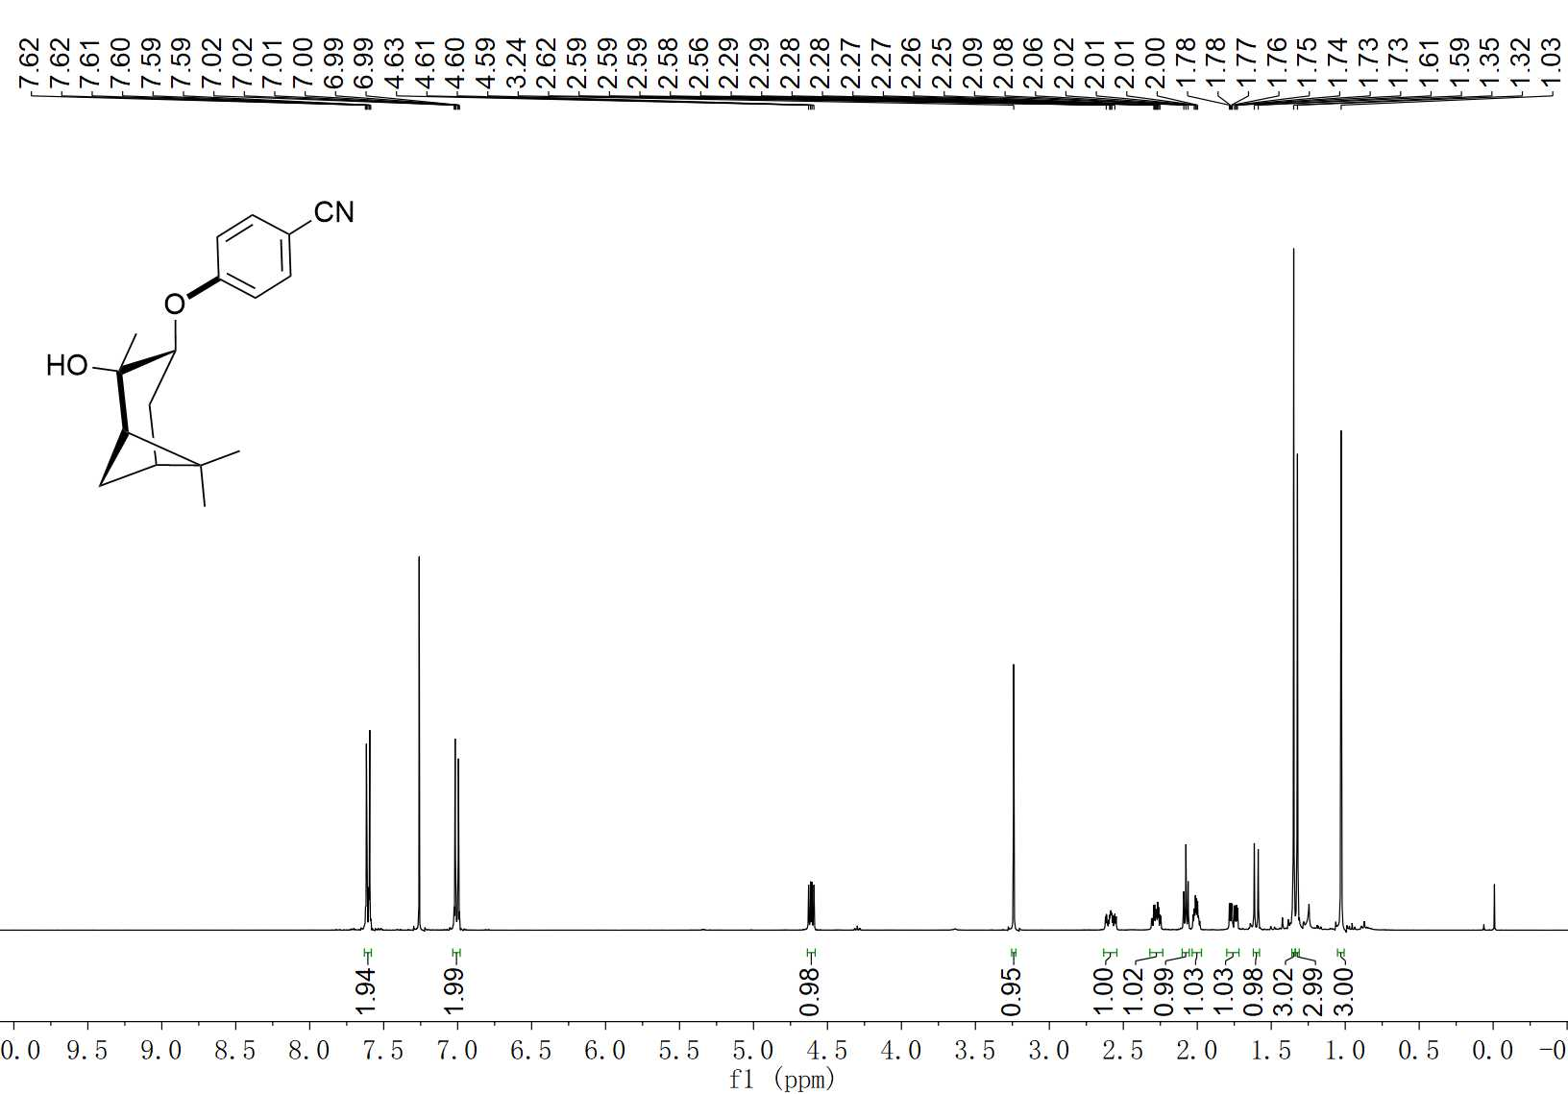
47 ¹H NMR (400 MHz, CDCl₃)

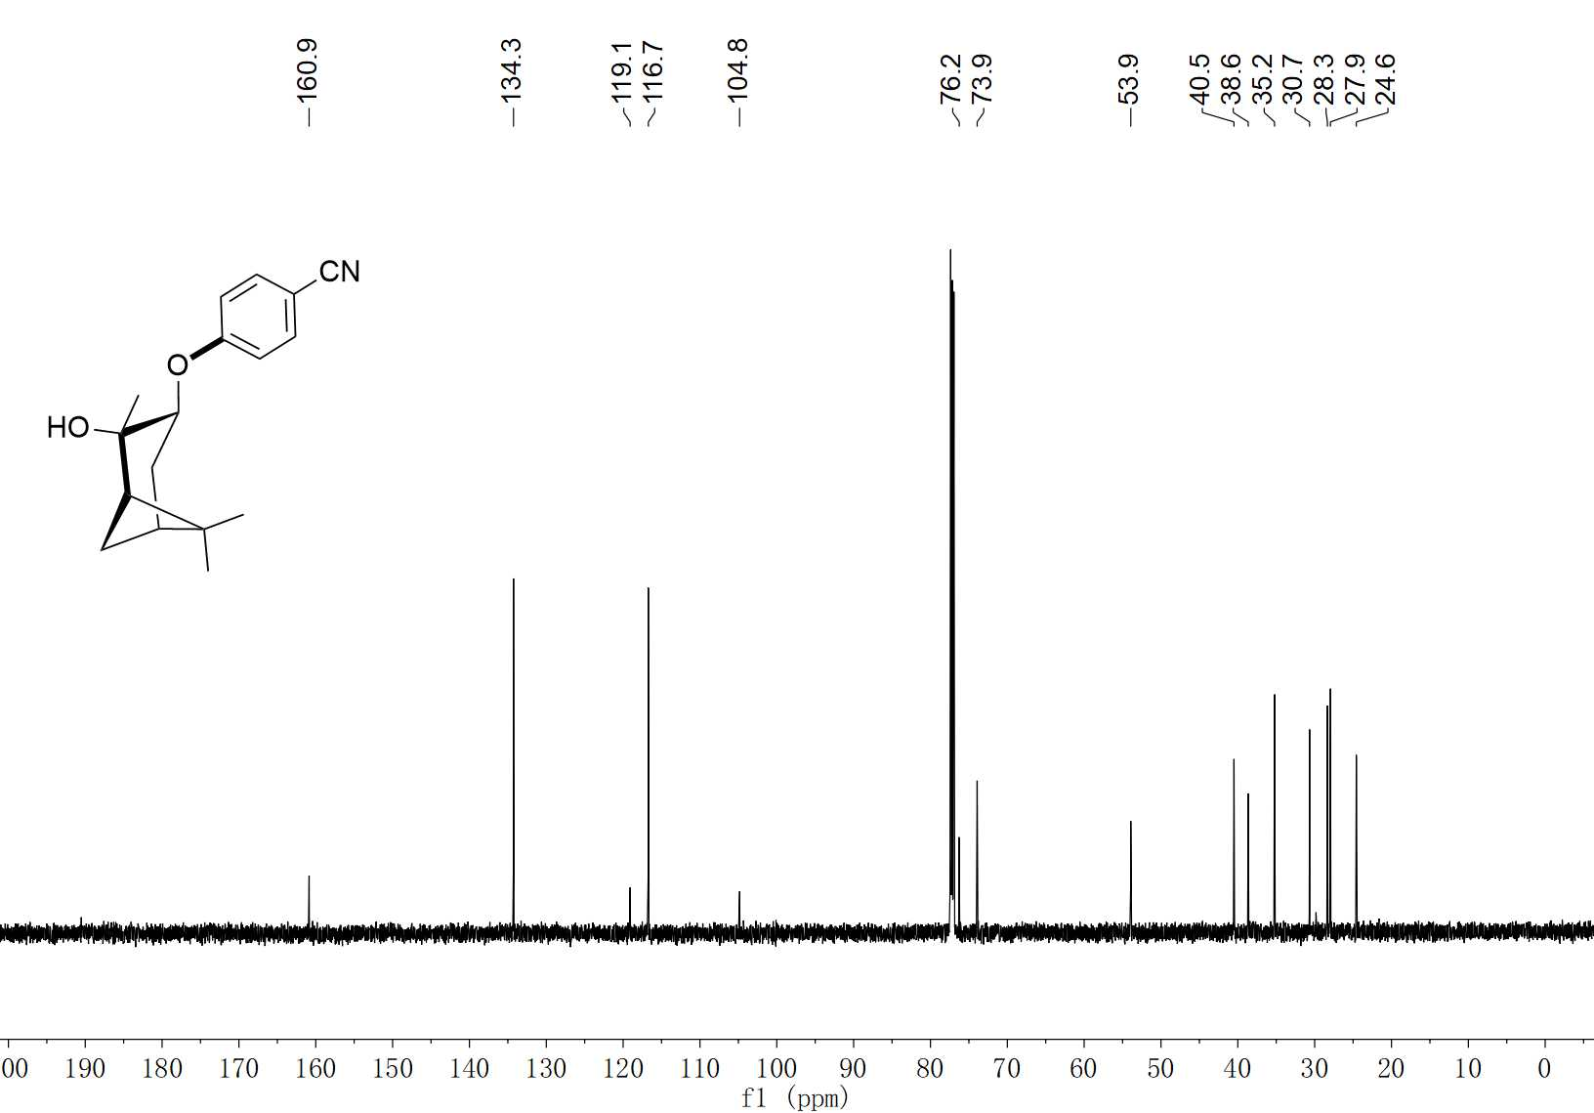
47 ¹³C NMR (100 MHz, CDCl₃)

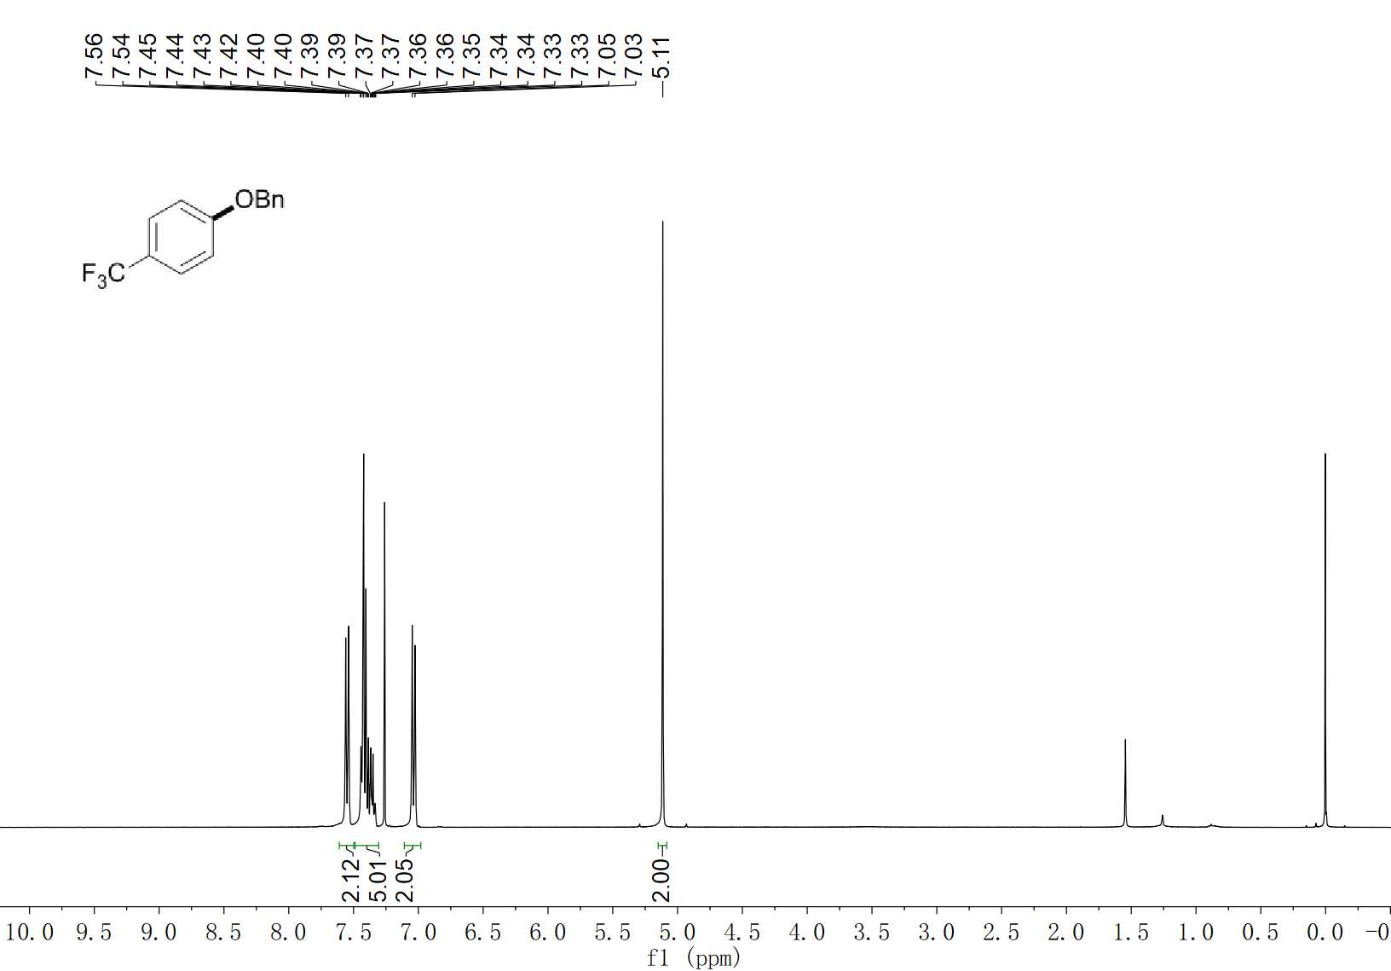
48 ¹H NMR (400 MHz, CDCl₃)

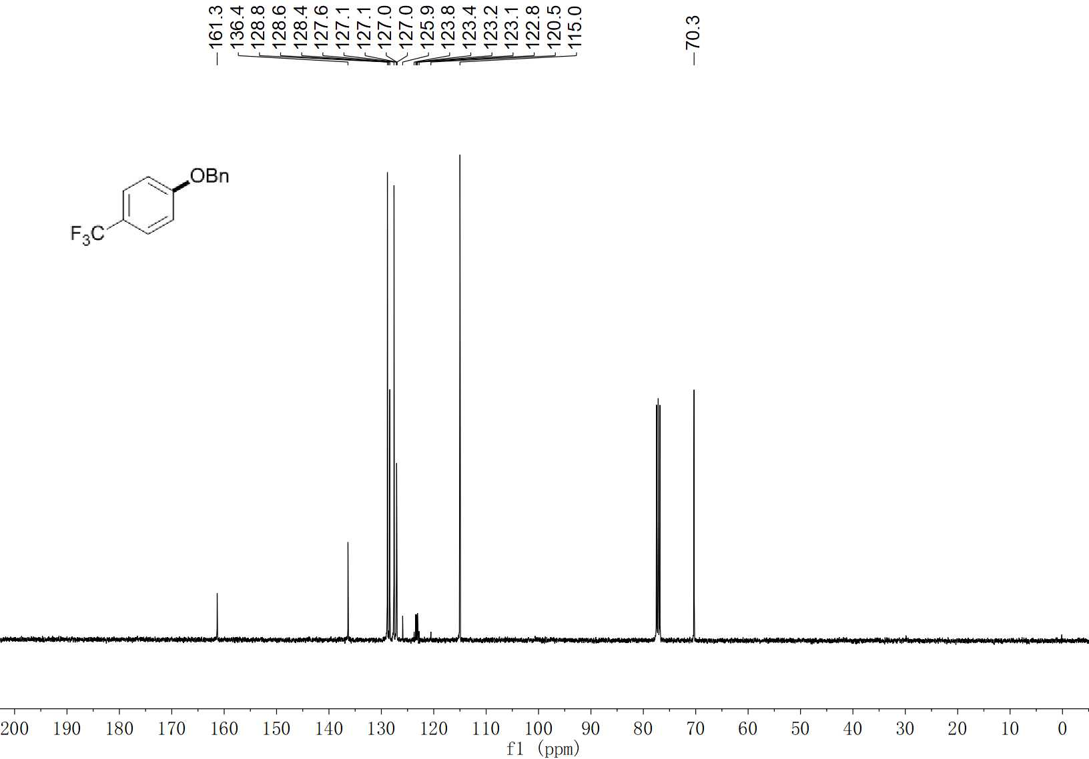
48 ¹³C NMR (100 MHz, CDCl₃)

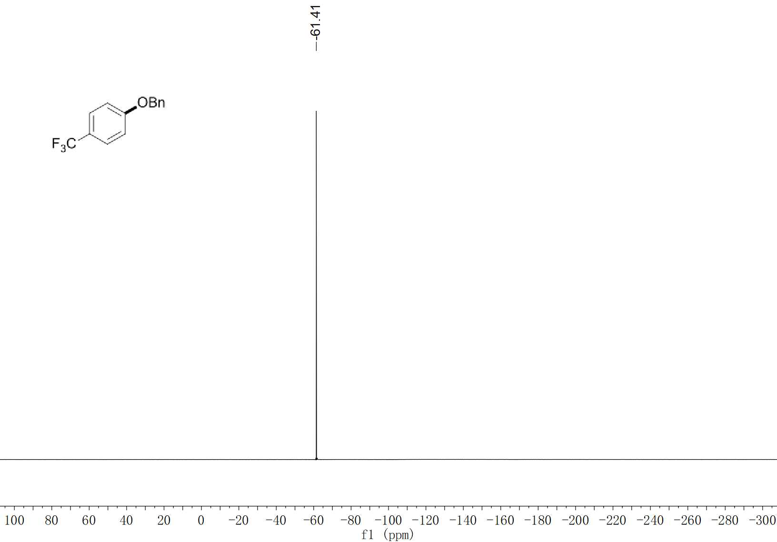
48 ¹⁹F NMR (376 MHz, CDCl₃)

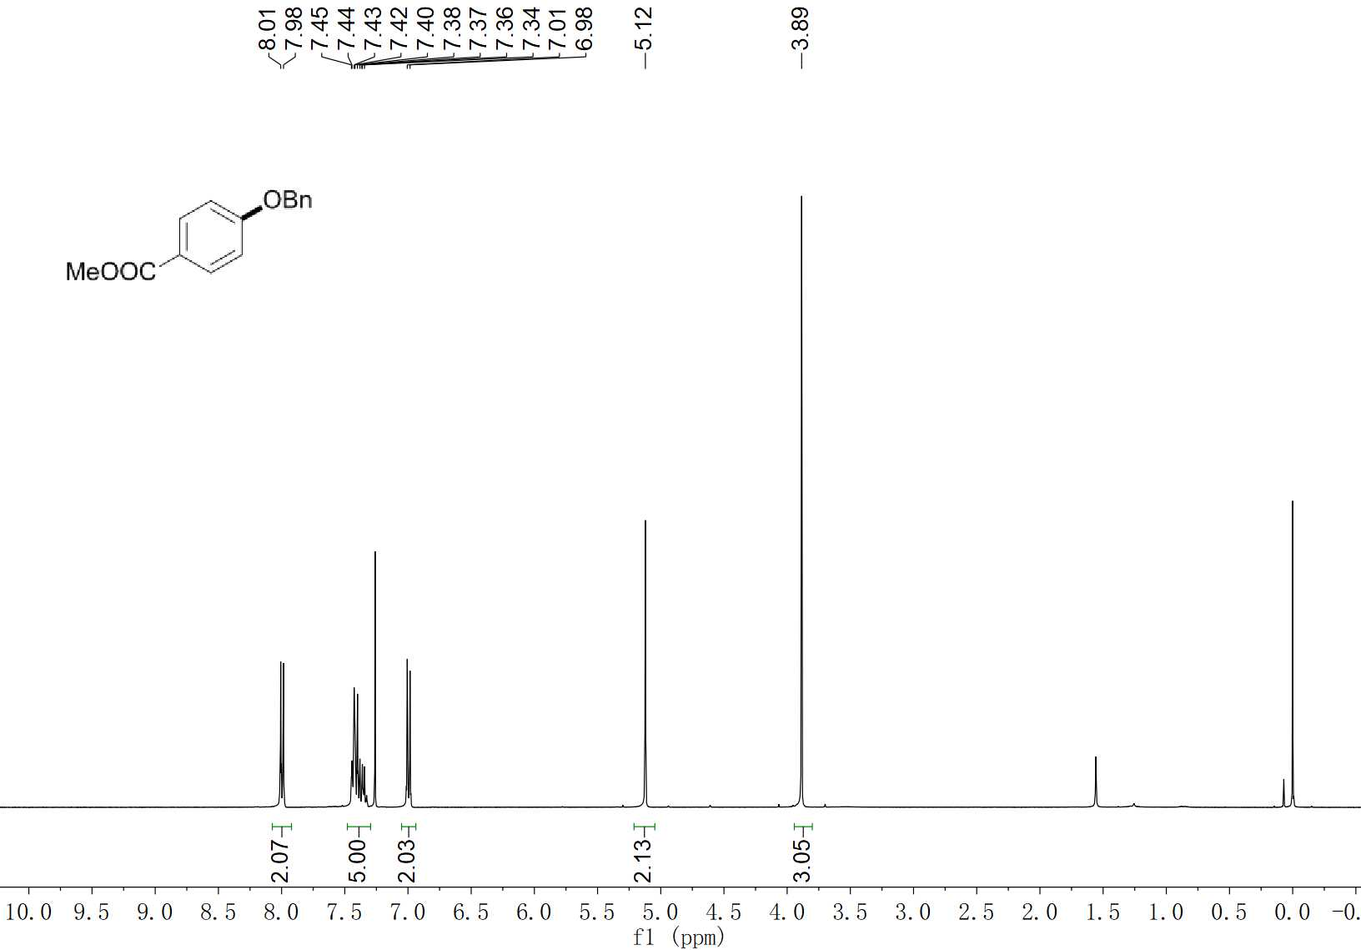
49 ¹H NMR (400 MHz, CDCl₃)

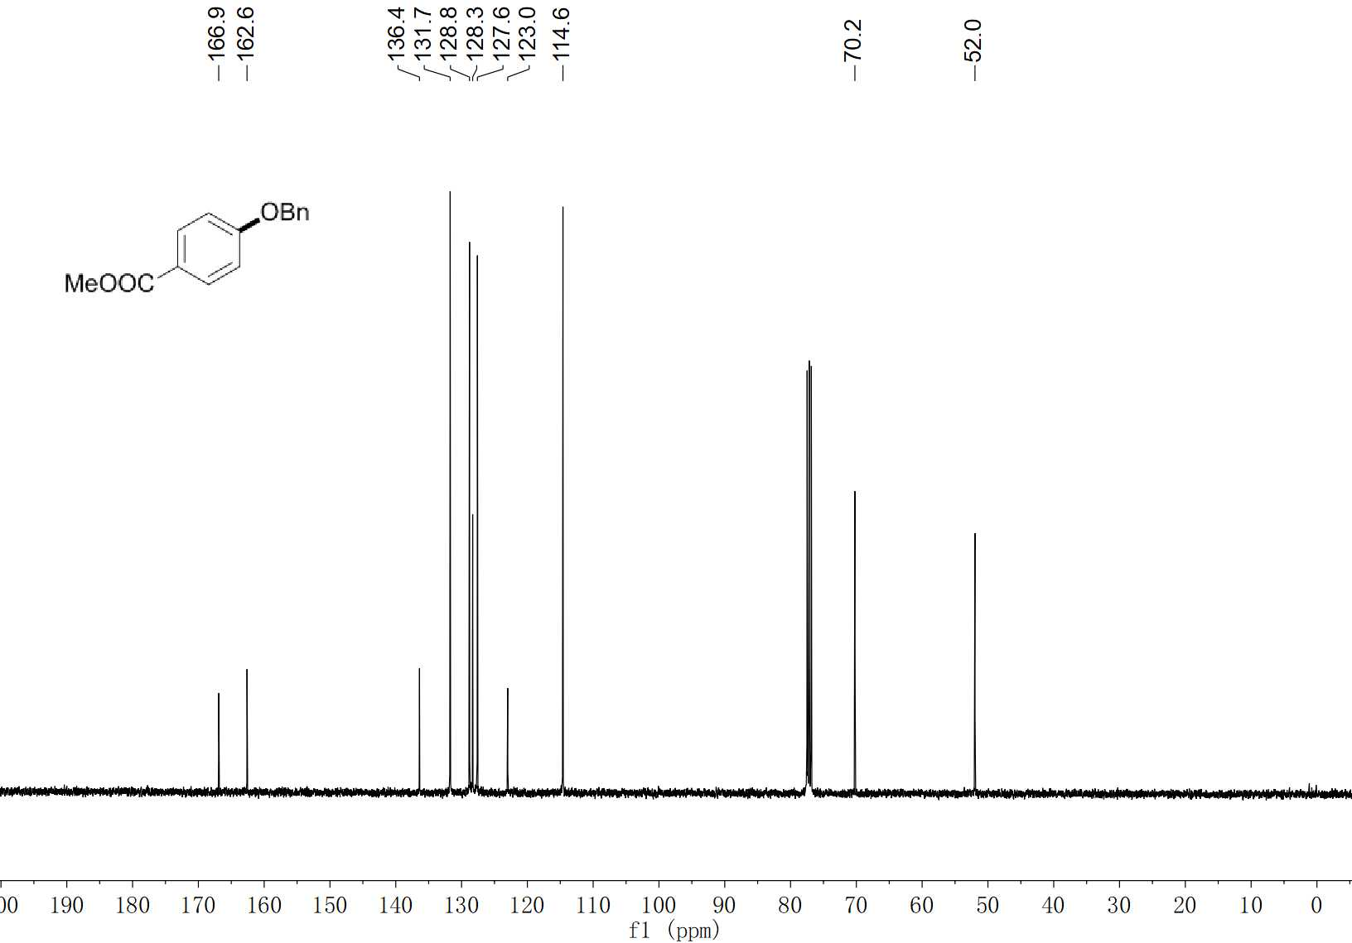
49 ¹³C NMR (100 MHz, CDCl₃)

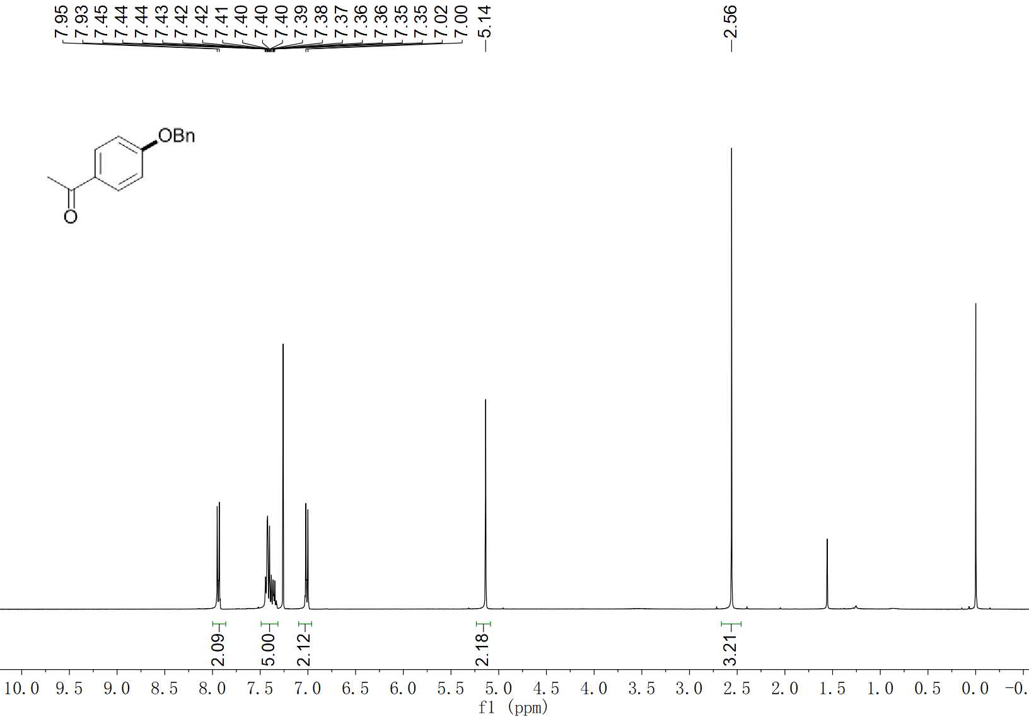
50 ¹H NMR (400 MHz, CDCl₃)

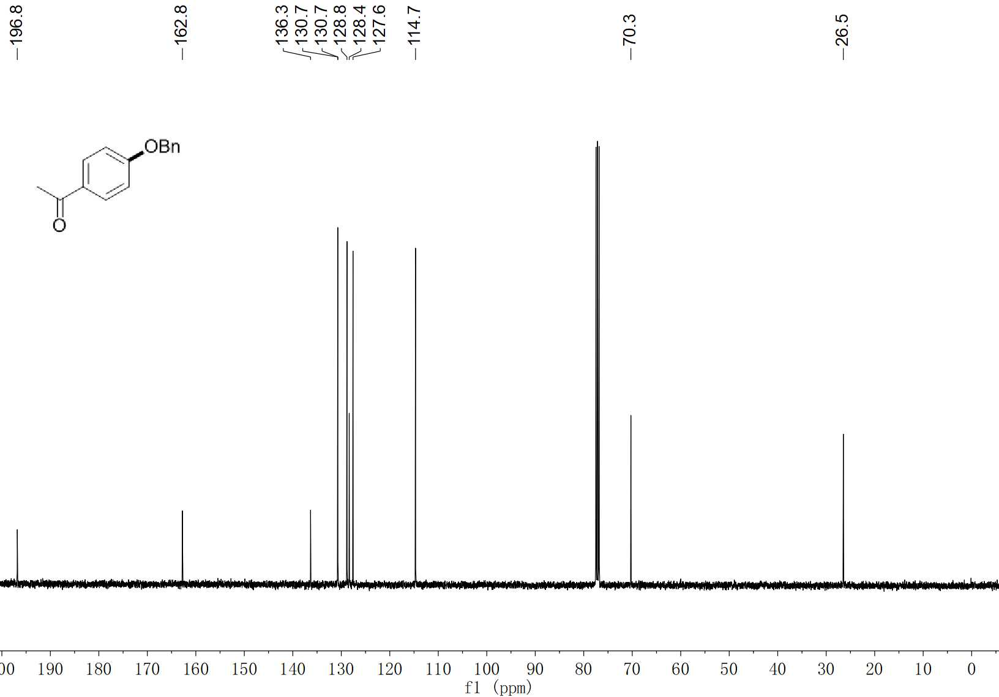
50 ¹³C NMR (100 MHz, CDCl₃)

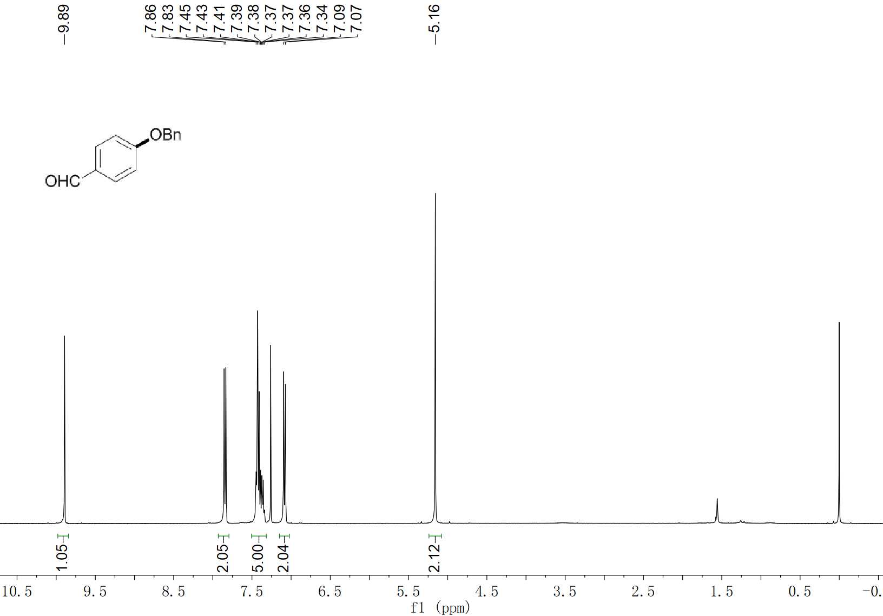
51 ¹H NMR (400 MHz, CDCl₃)

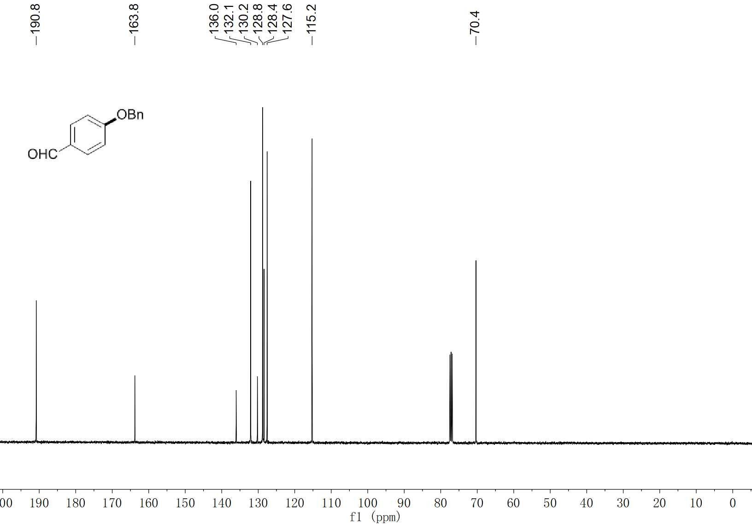
51 ¹³C NMR (100 MHz, CDCl₃)

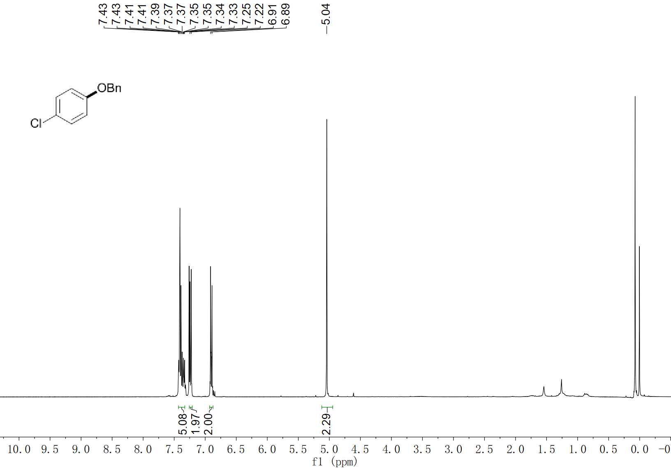
52 ¹H NMR (400 MHz, CDCl₃)

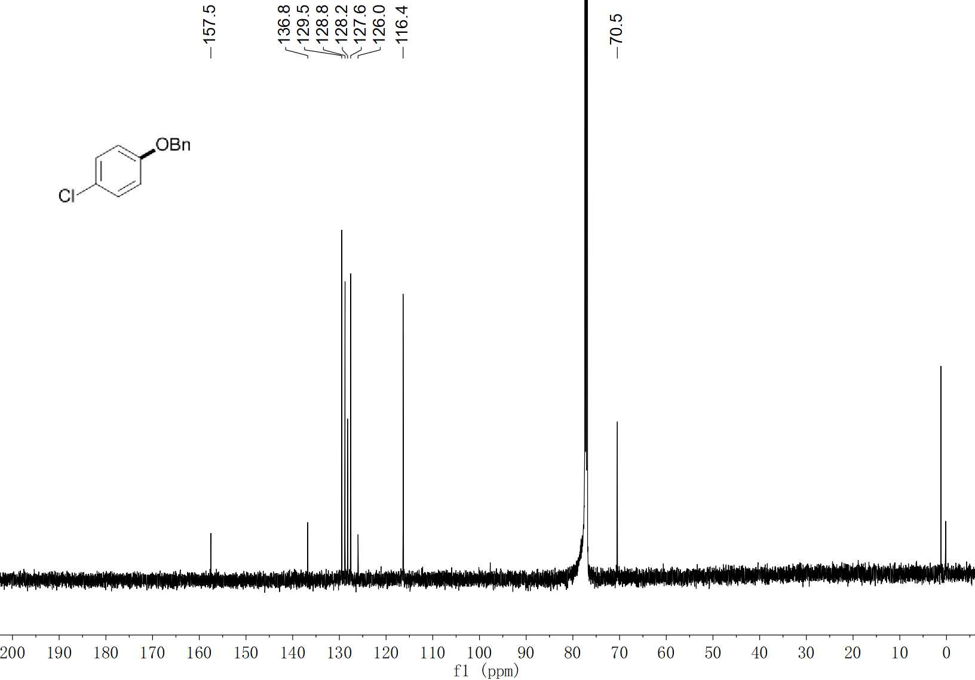
52 ¹³C NMR (100 MHz, CDCl₃)

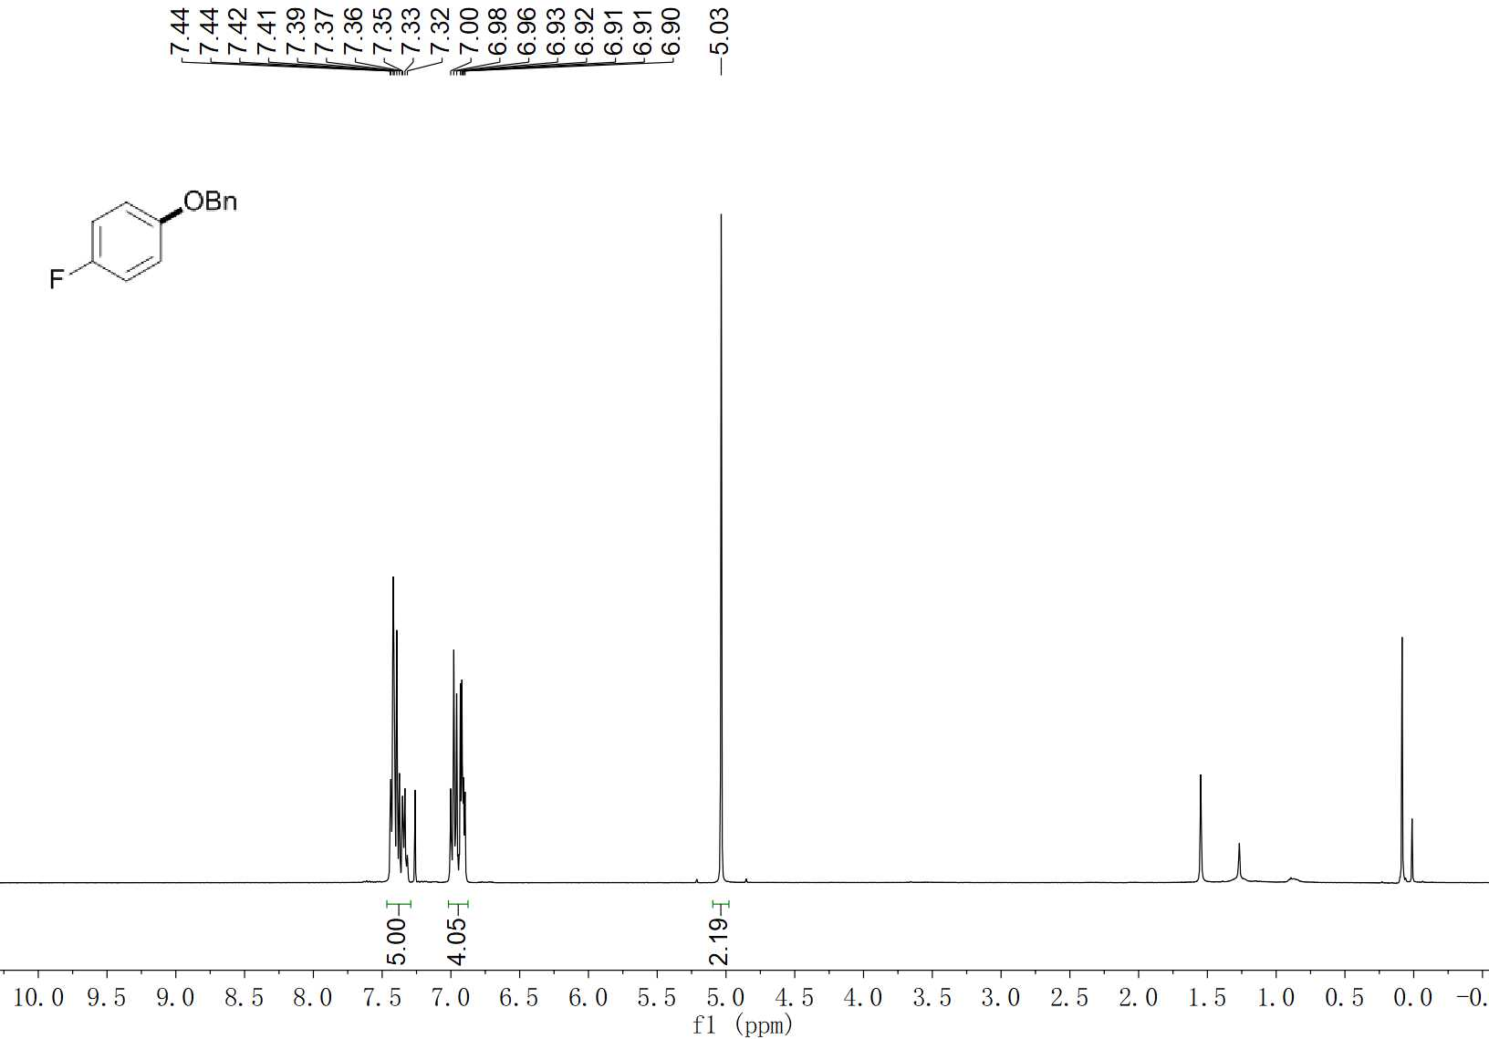
53 ¹H NMR (400 MHz, CDCl₃)

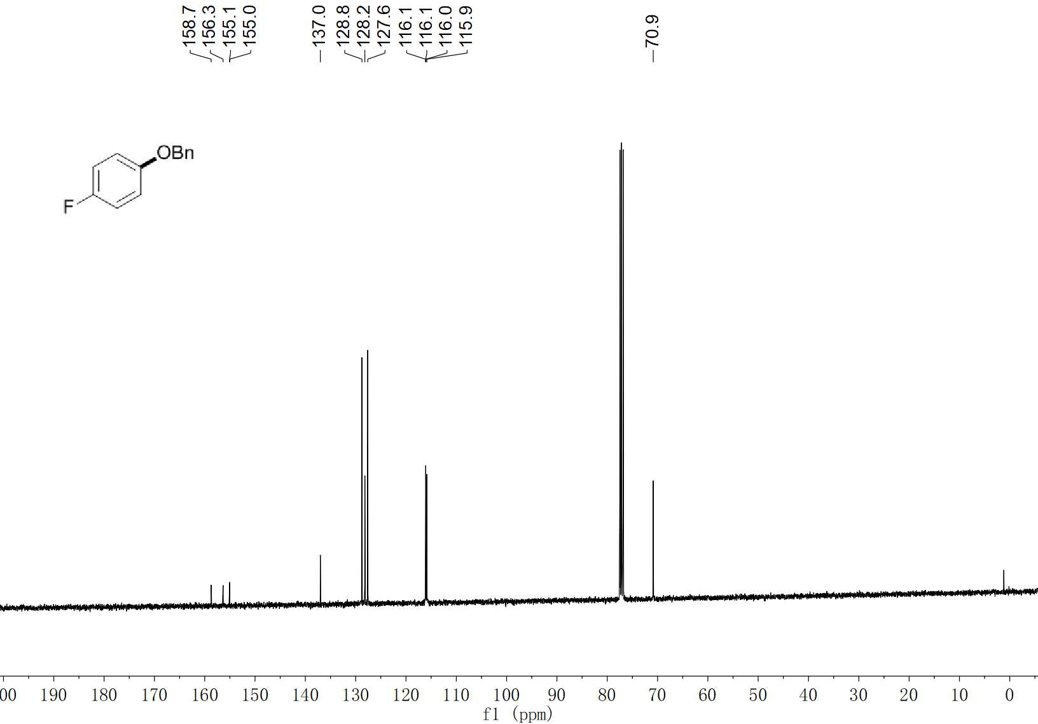
53 ¹³C NMR (100 MHz, CDCl₃)

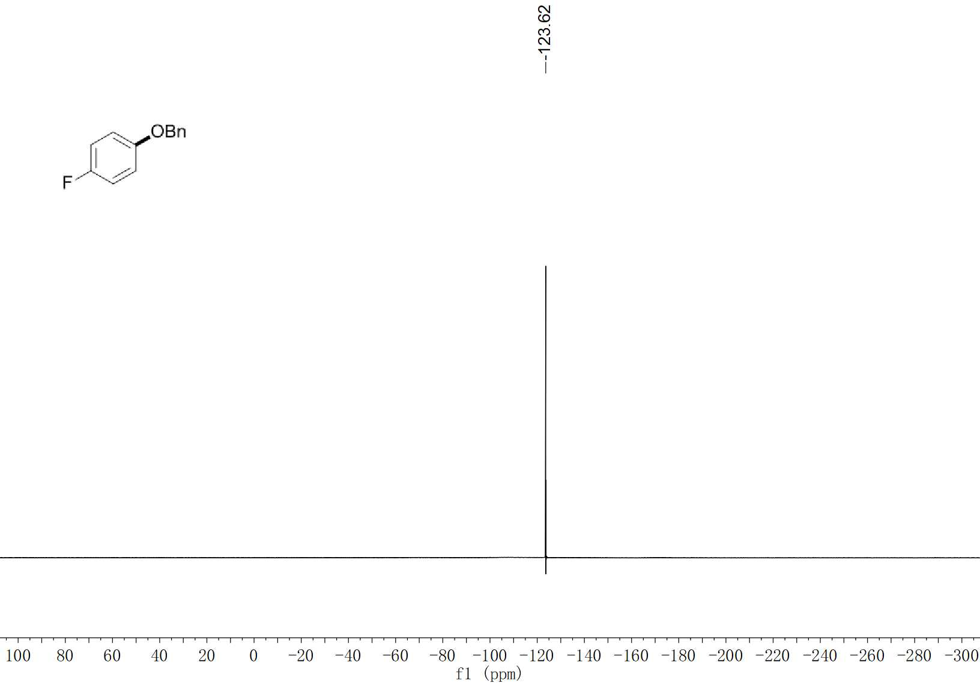
53 ¹⁹F NMR (376 MHz, CDCl₃)

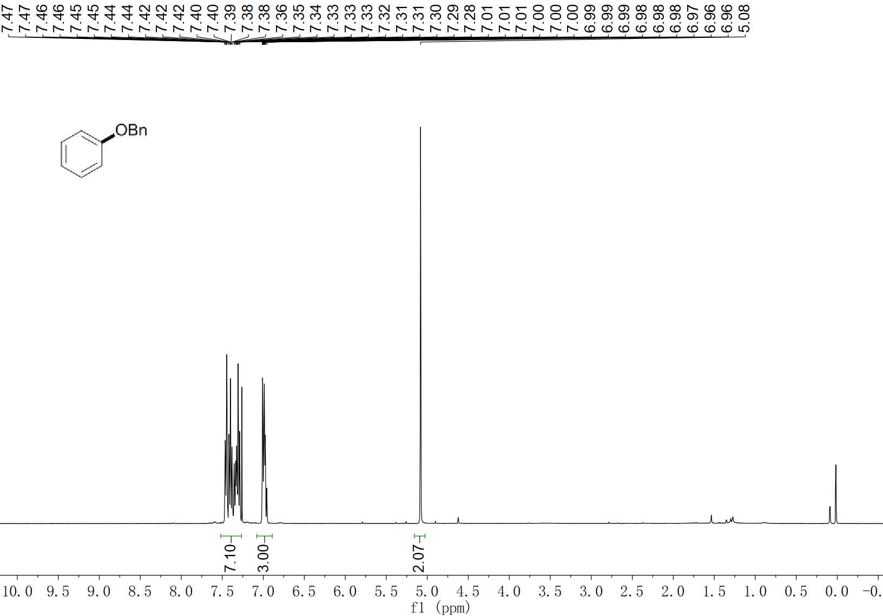
54 ¹H NMR (400 MHz, CDCl₃)

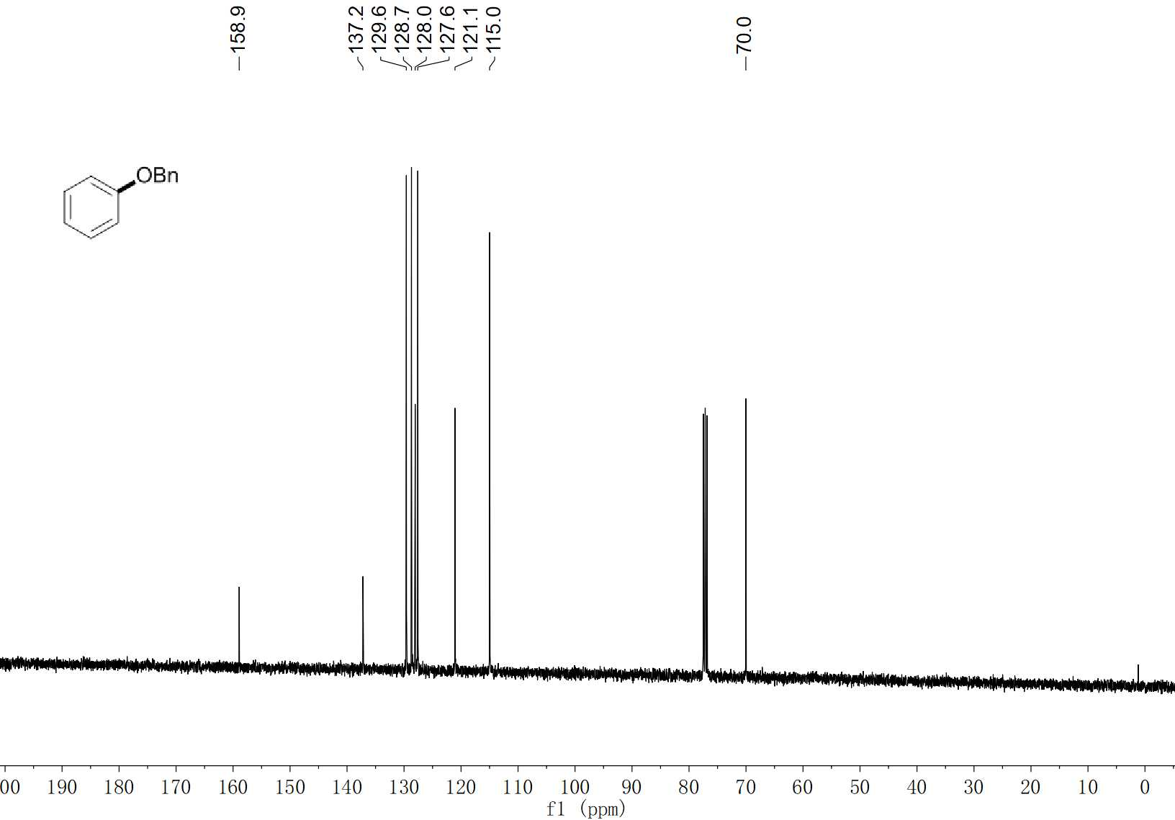
54 ¹³C NMR (100 MHz, CDCl₃)

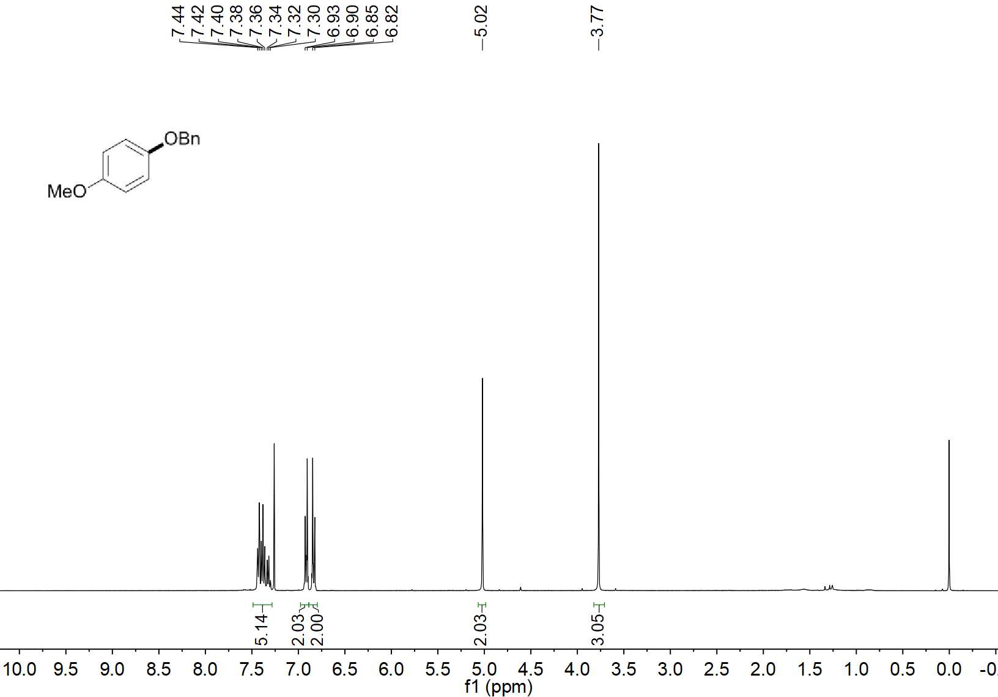
55 ¹H NMR (400 MHz, CDCl₃)

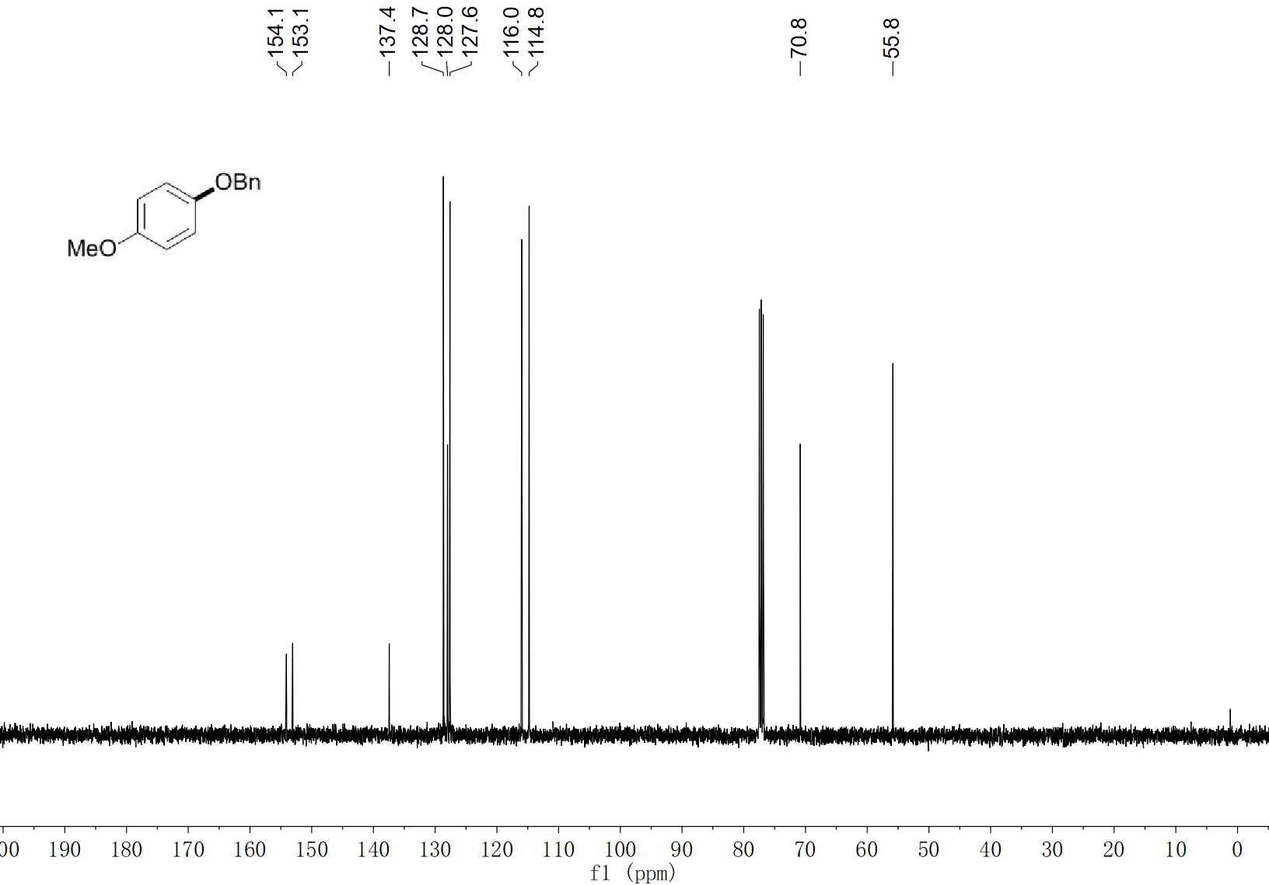
55 ¹³C NMR (100 MHz, CDCl₃)

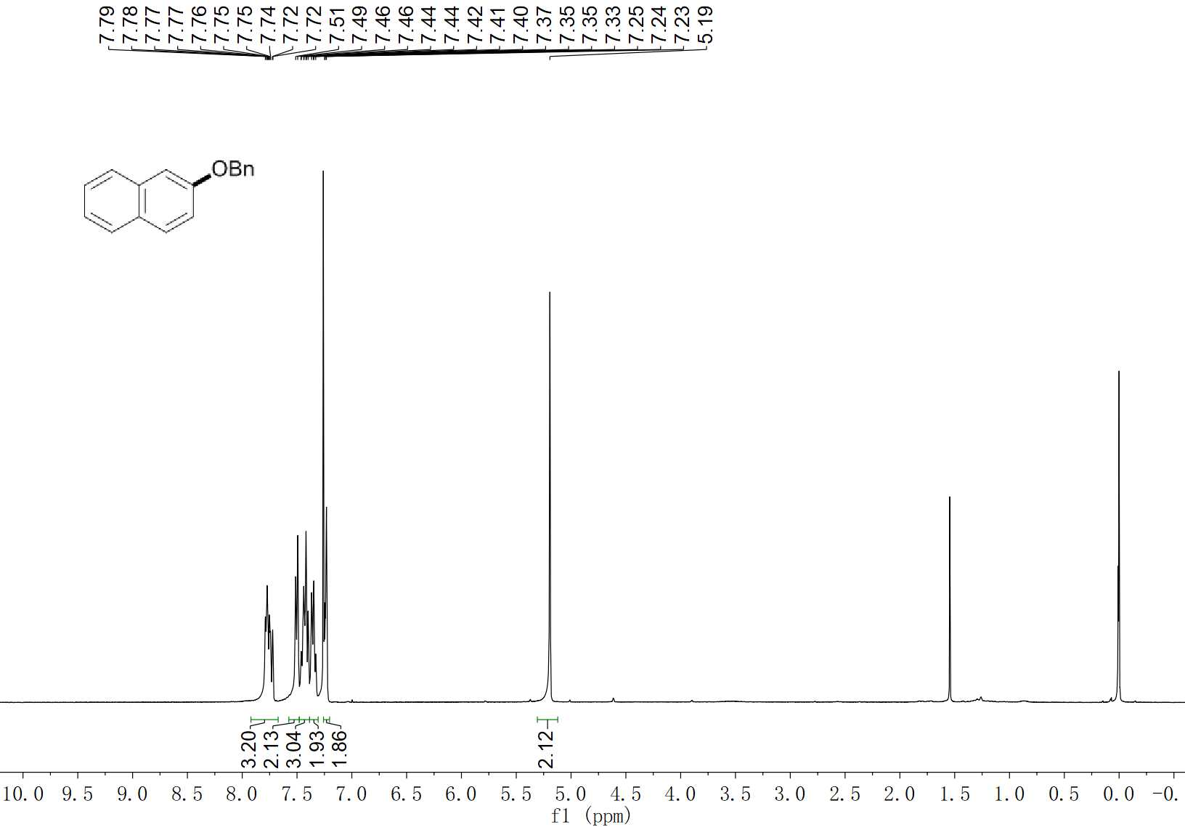
56 ¹H NMR (400 MHz, CDCl₃)

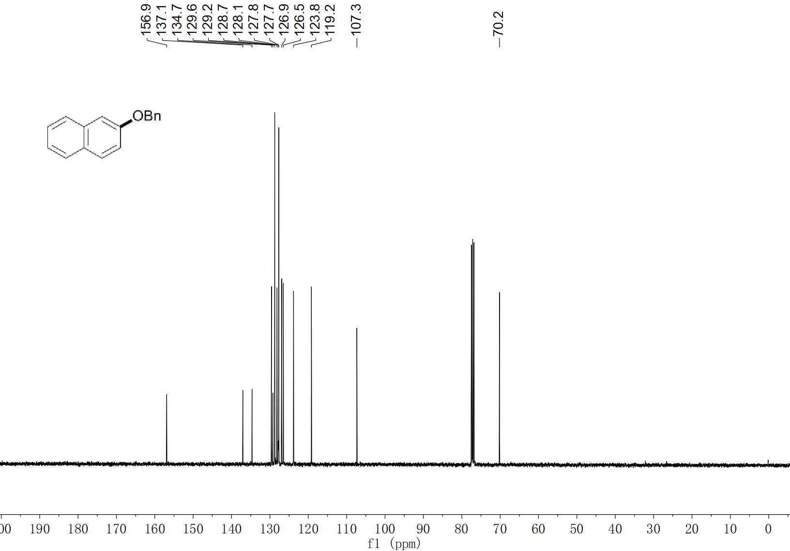
56 ¹³C NMR (100 MHz, CDCl₃)

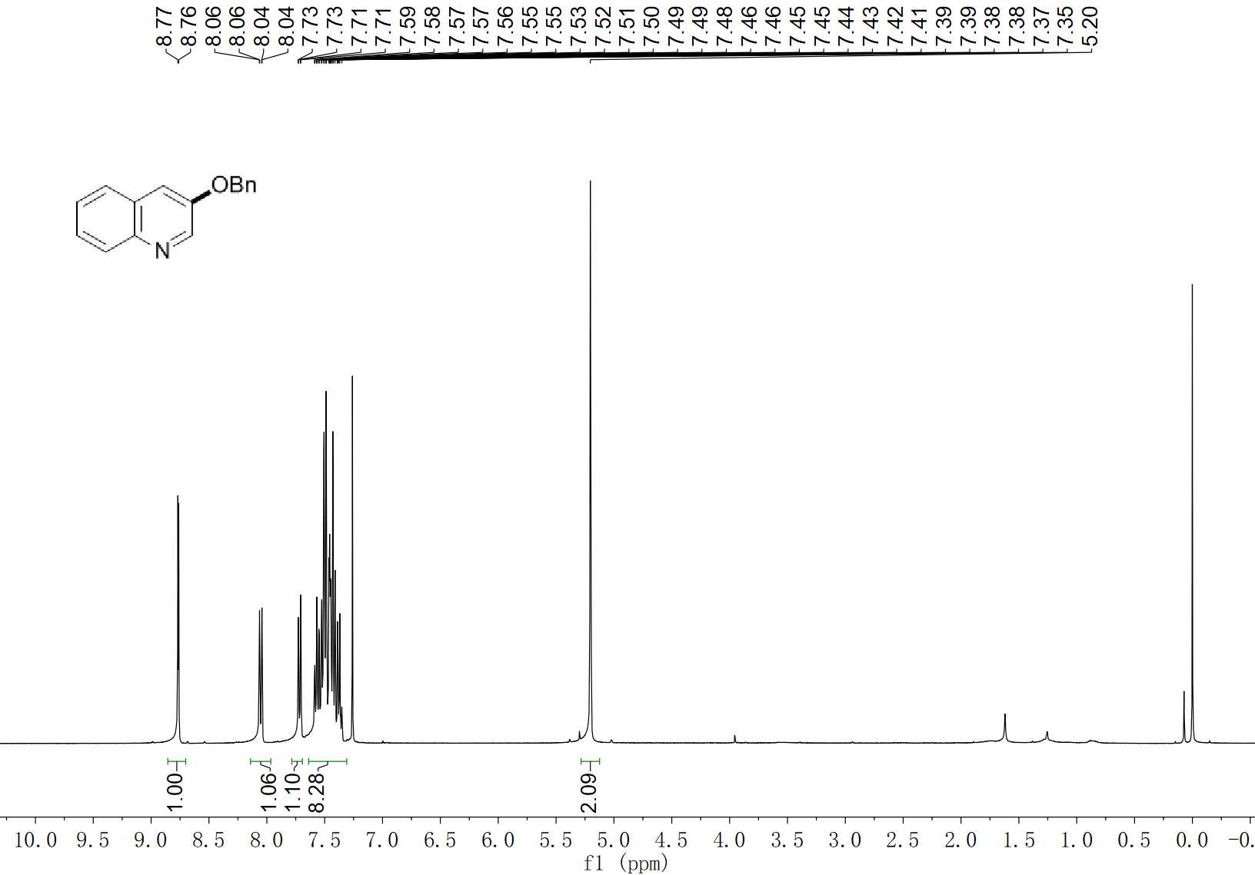
57 ¹H NMR (400 MHz, CDCl₃)

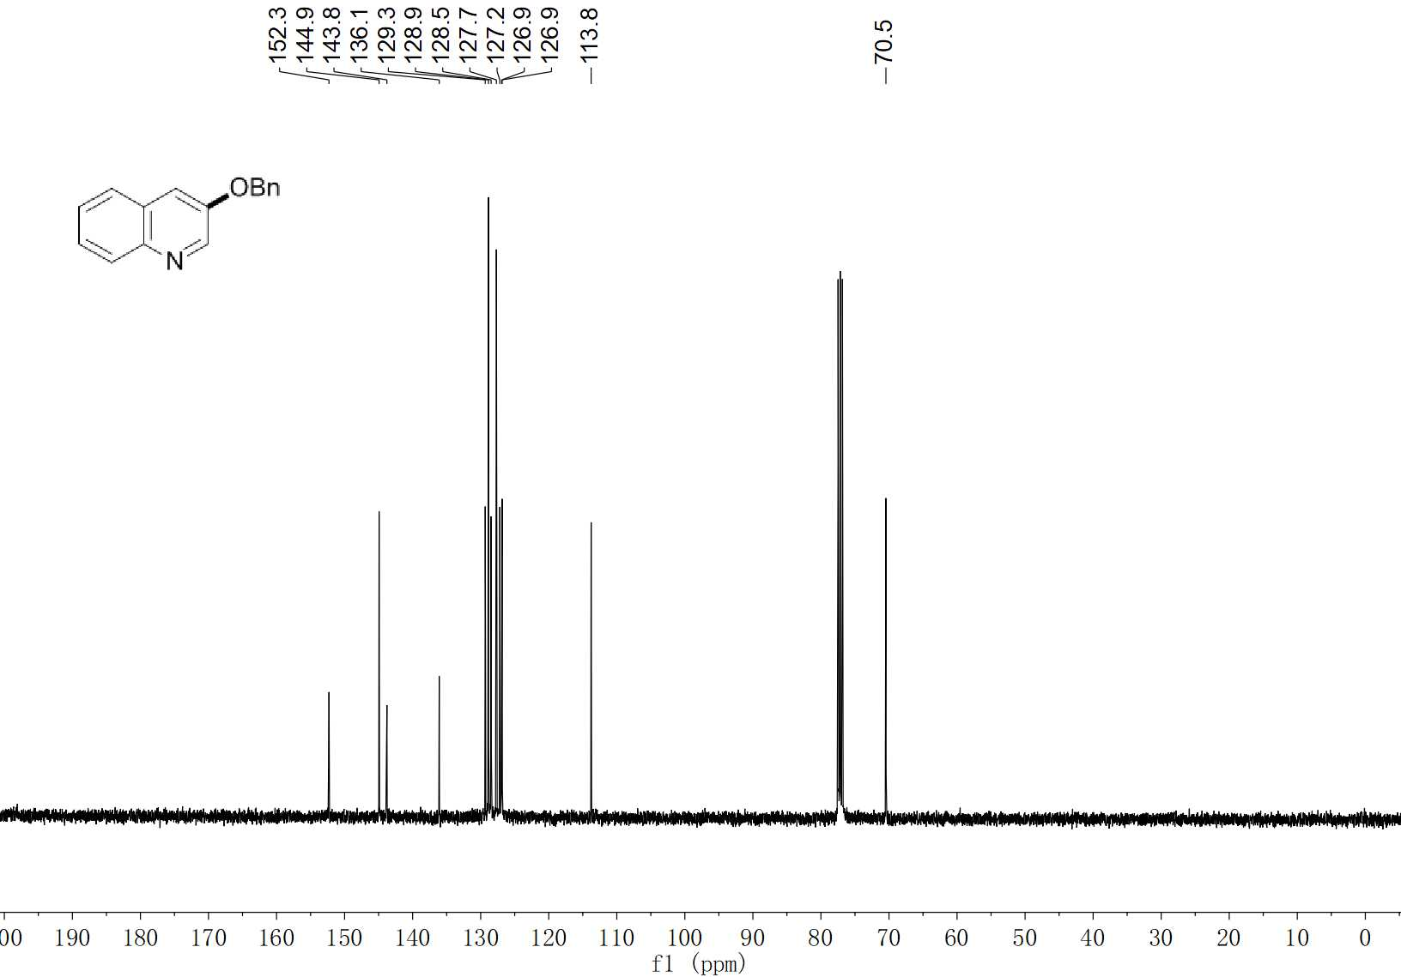
57 ¹³C NMR (100 MHz, CDCl₃)

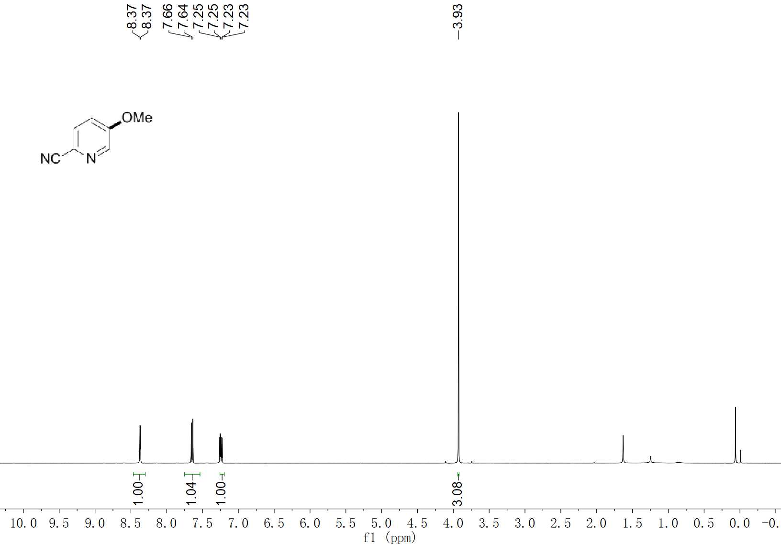
58 ¹H NMR (400 MHz, CDCl₃)

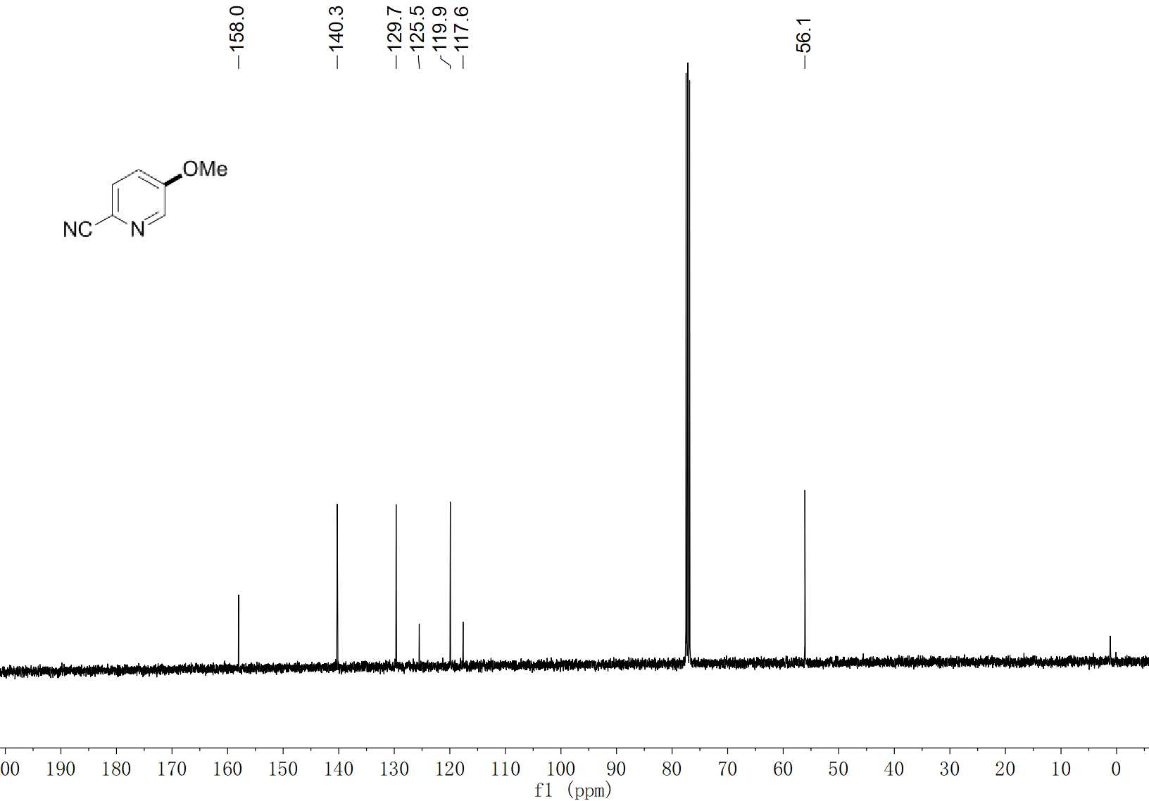
58 ¹³C NMR (100 MHz, CDCl₃)

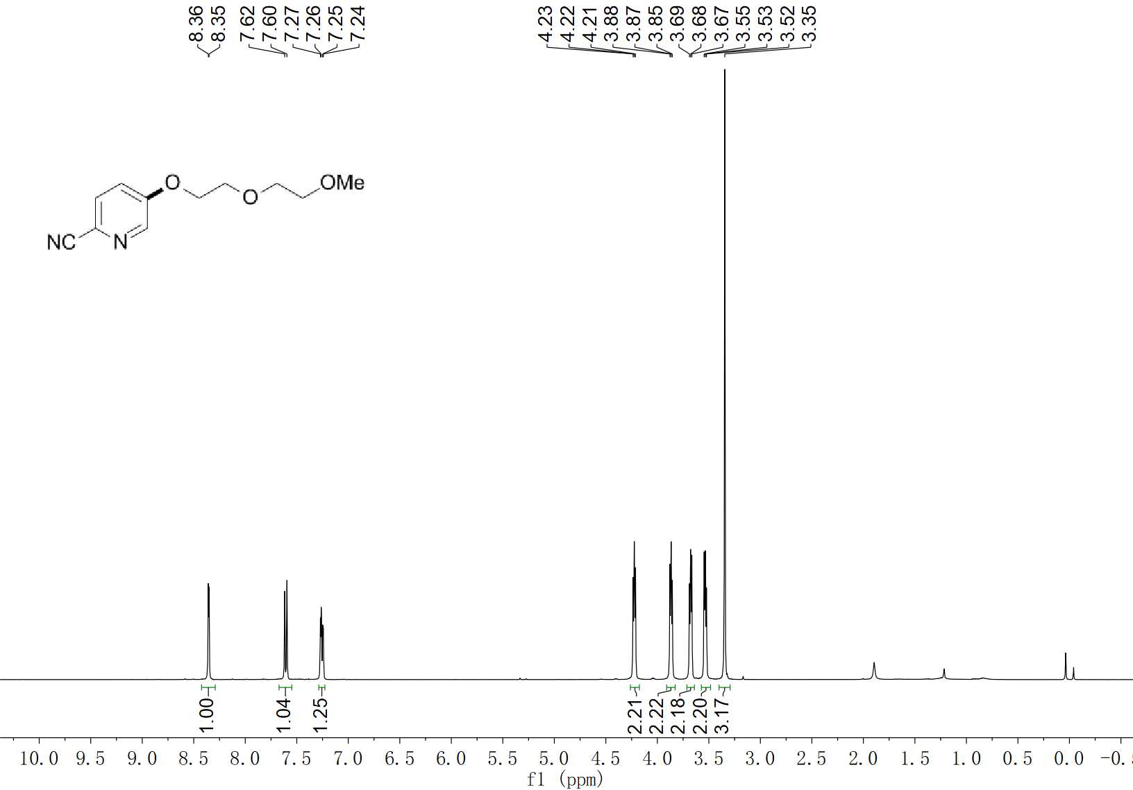
59 ¹H NMR (400 MHz, CDCl₃)

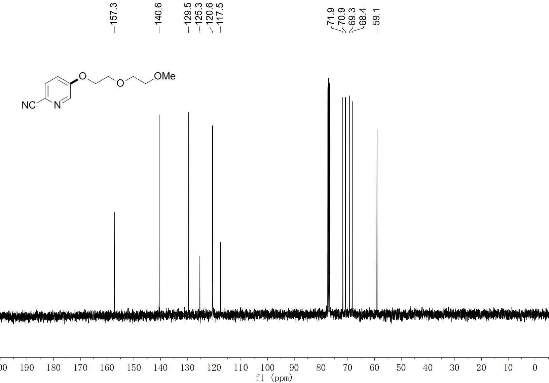
59 ¹³C NMR (100 MHz, CDCl₃)

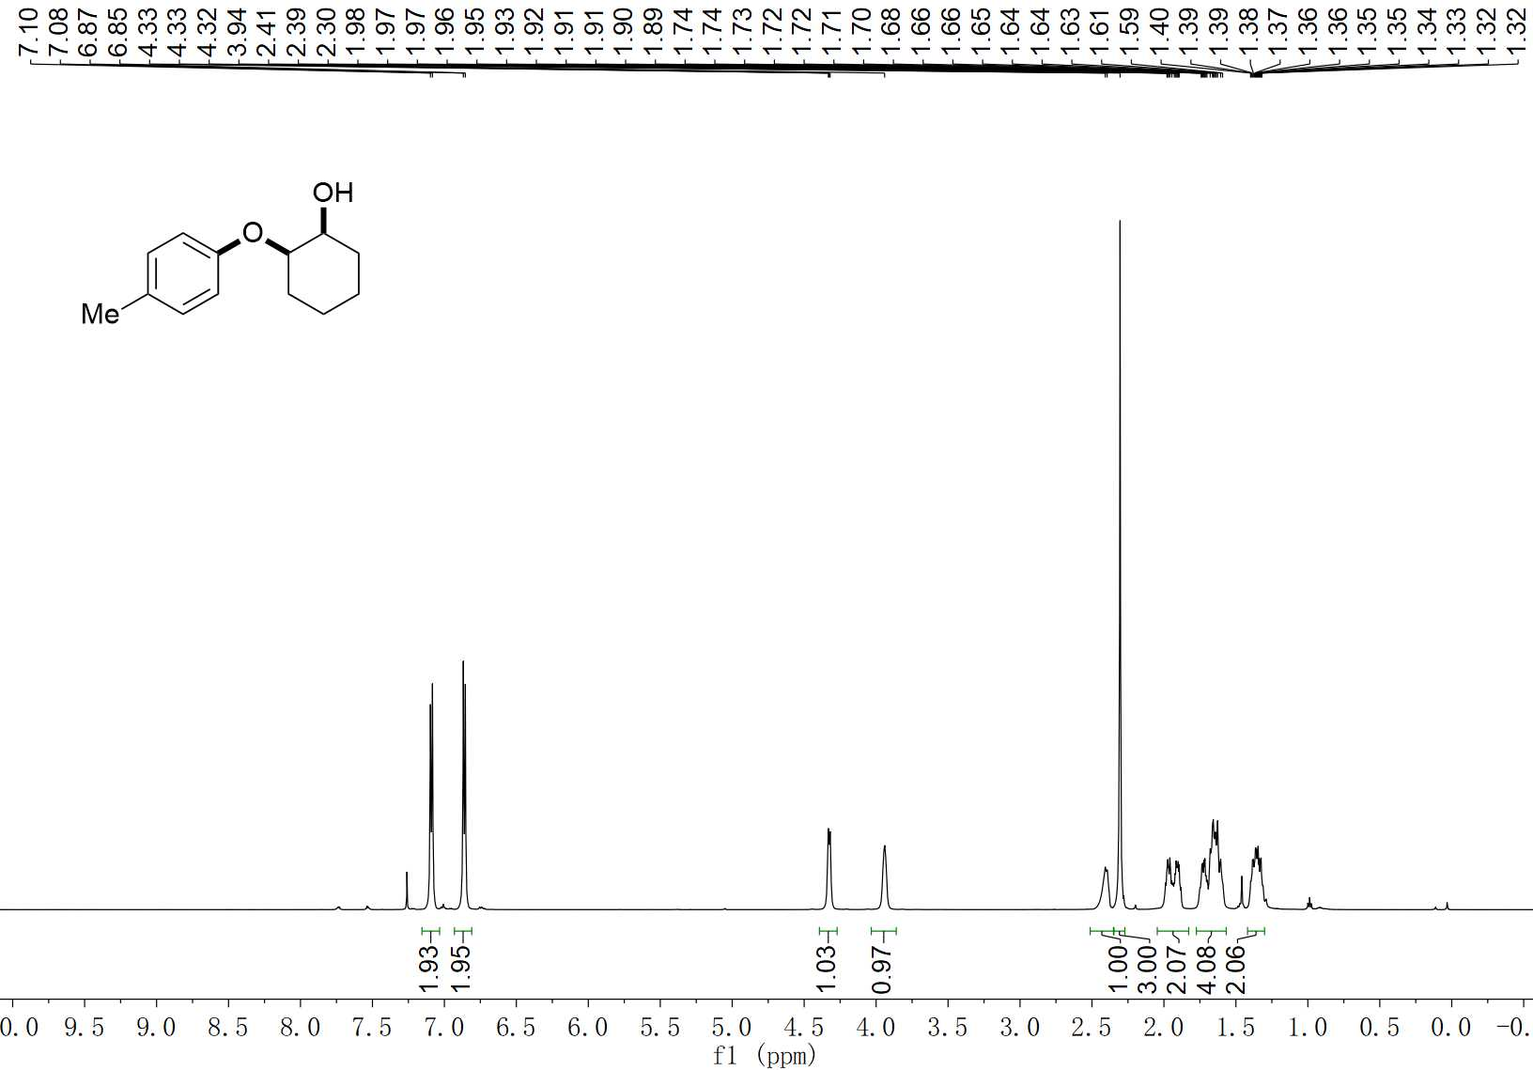
60 ¹H NMR (600 MHz, CDCl₃)

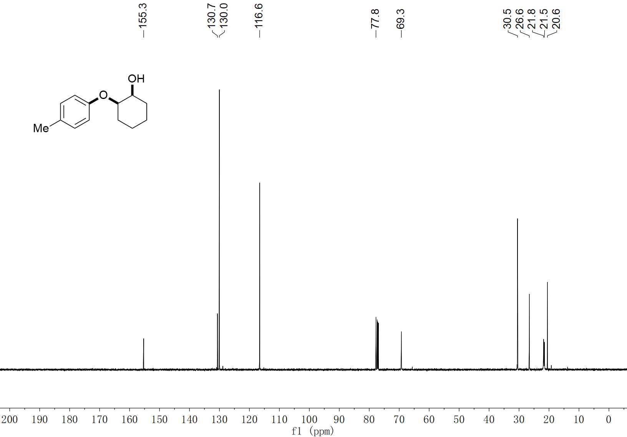
60 ¹³C NMR (150 MHz, CDCl₃)

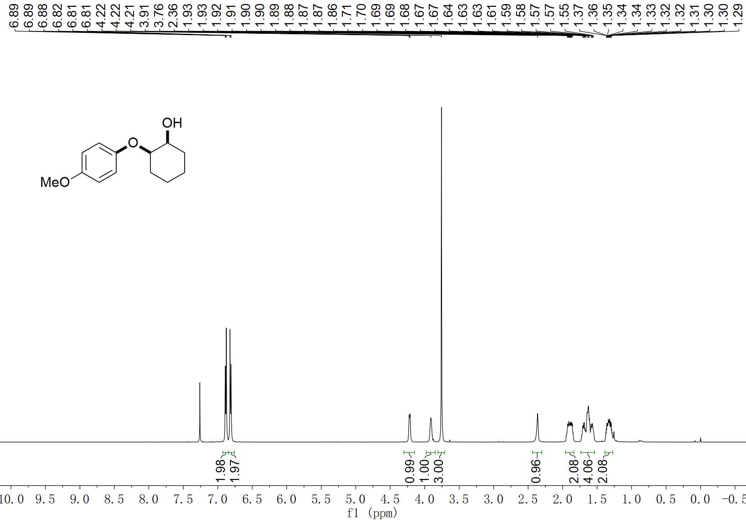
61 ¹H NMR (600 MHz, CDCl₃)

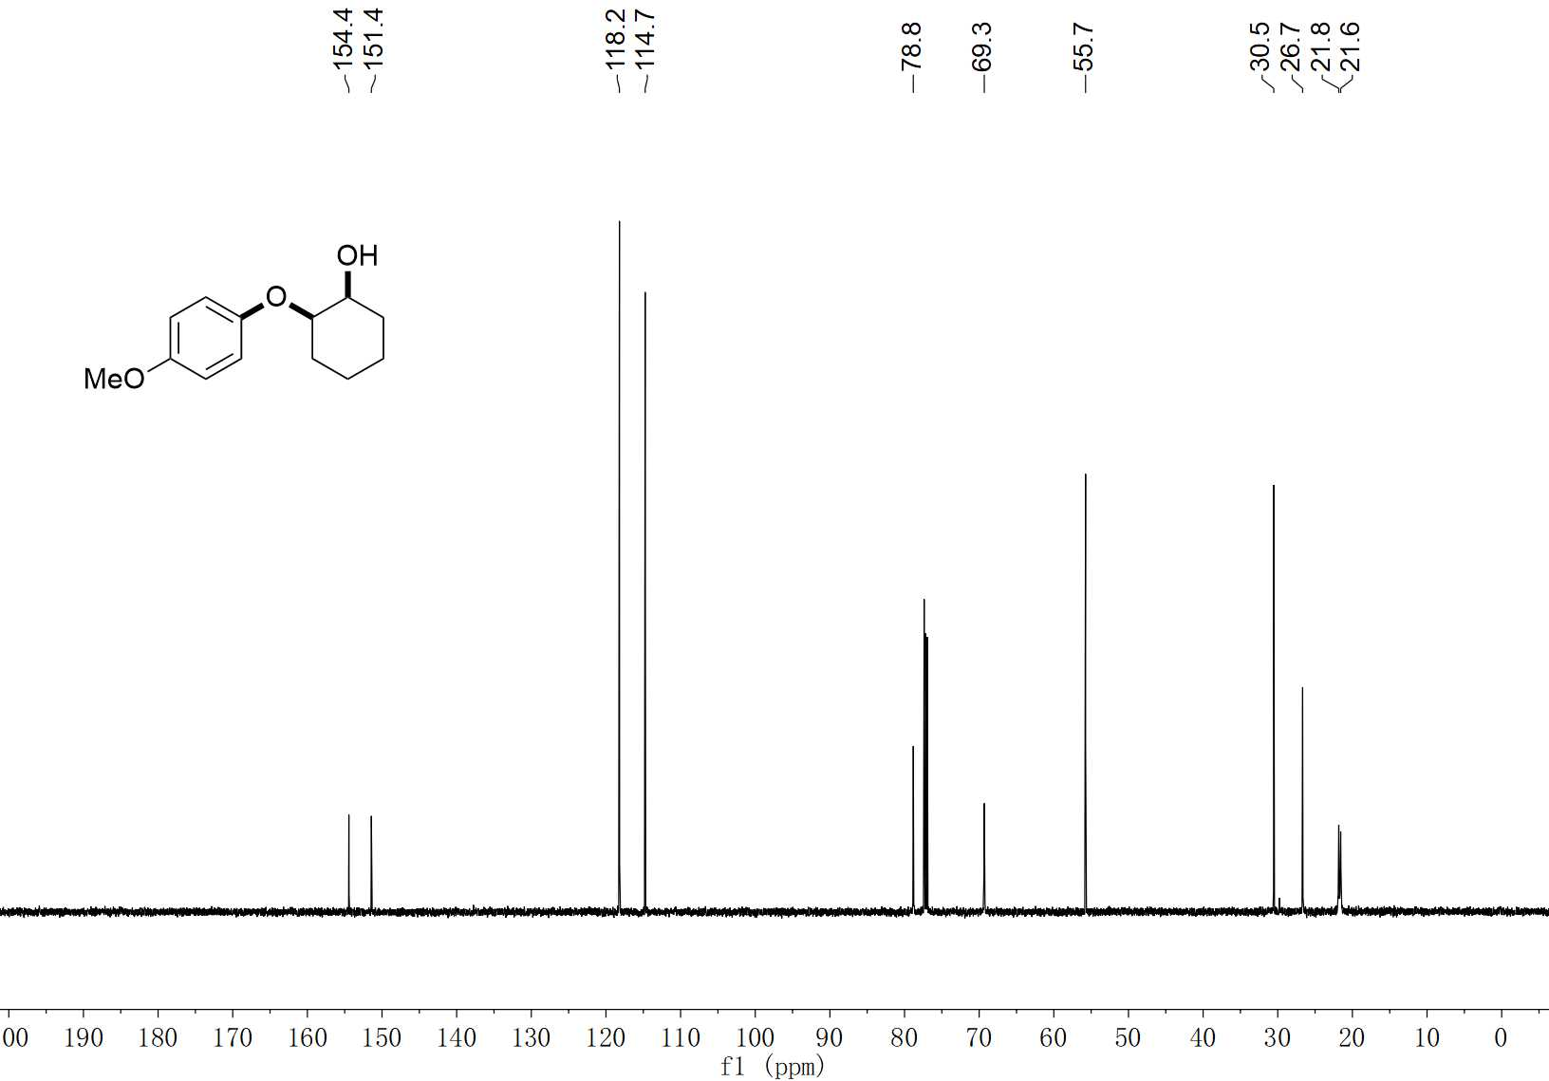
61 ¹³C NMR (150 MHz, CDCl₃)

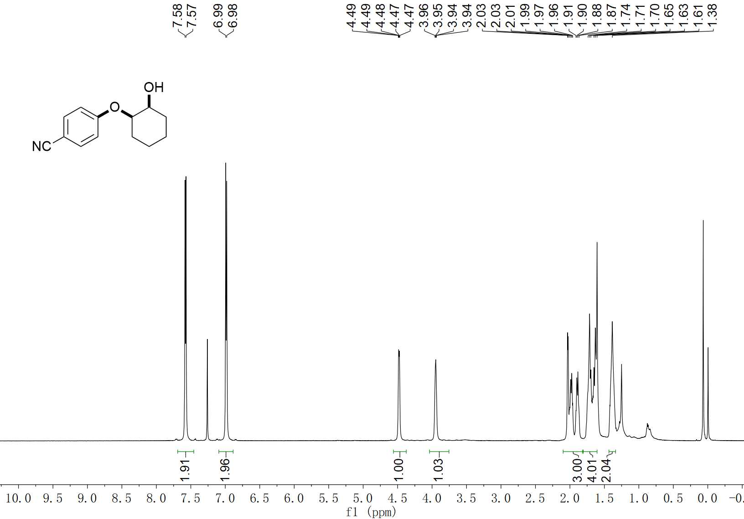
62 ¹H NMR (400 MHz, CDCl₃)

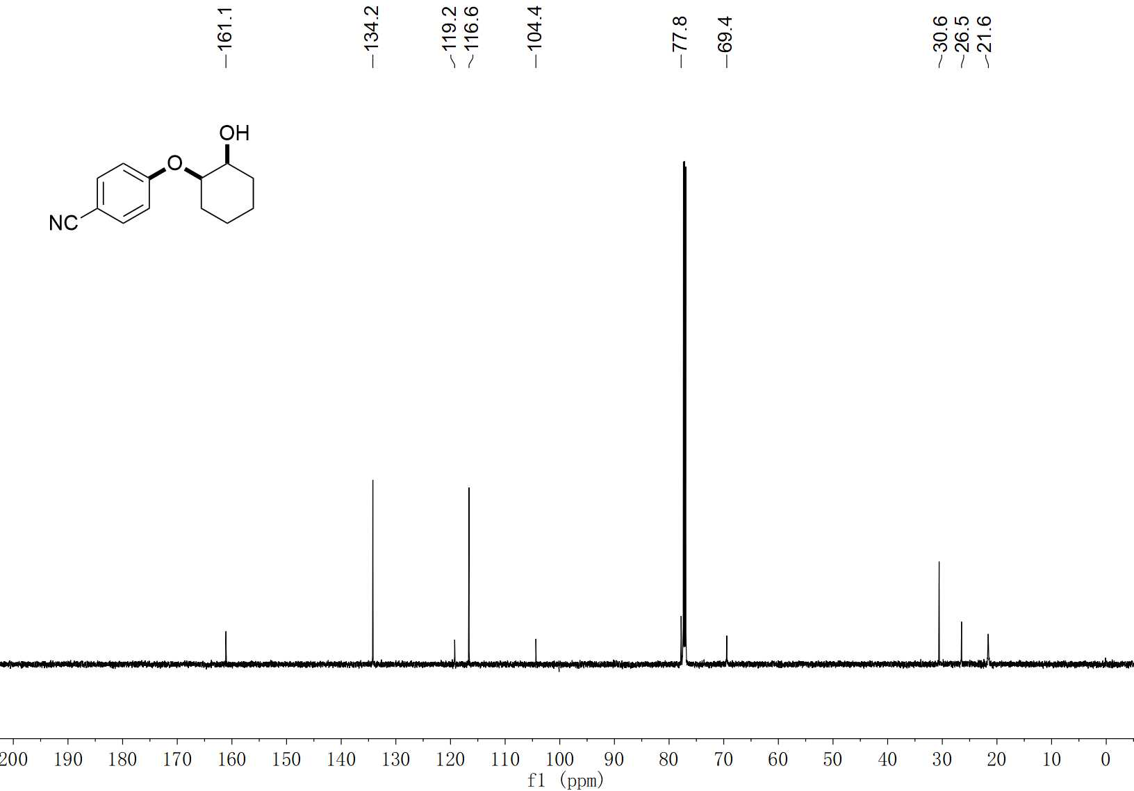
62 ¹³C NMR (100 MHz, CDCl₃)

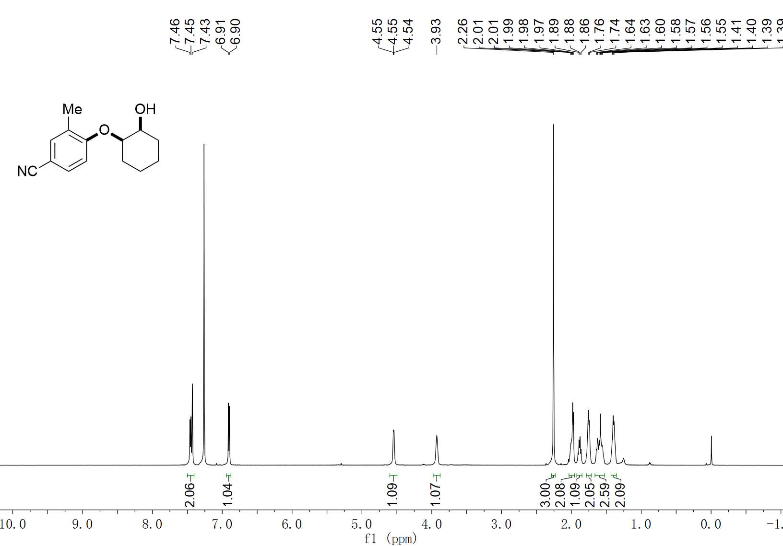
63 ¹H NMR (600 MHz, CDCl₃)

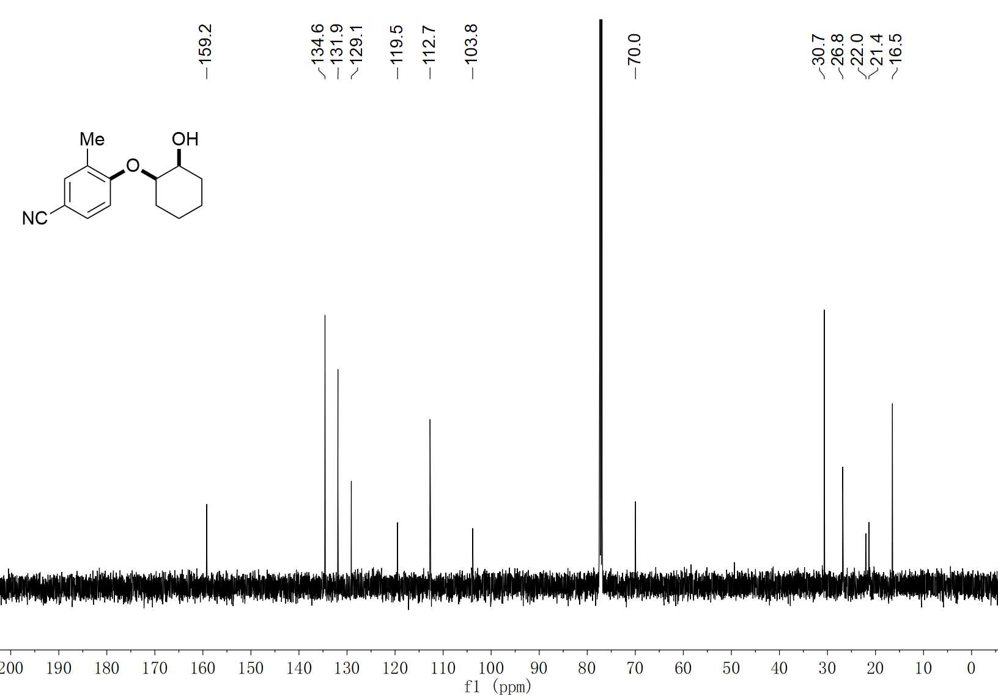
63 ¹³C NMR (150 MHz, CDCl₃)

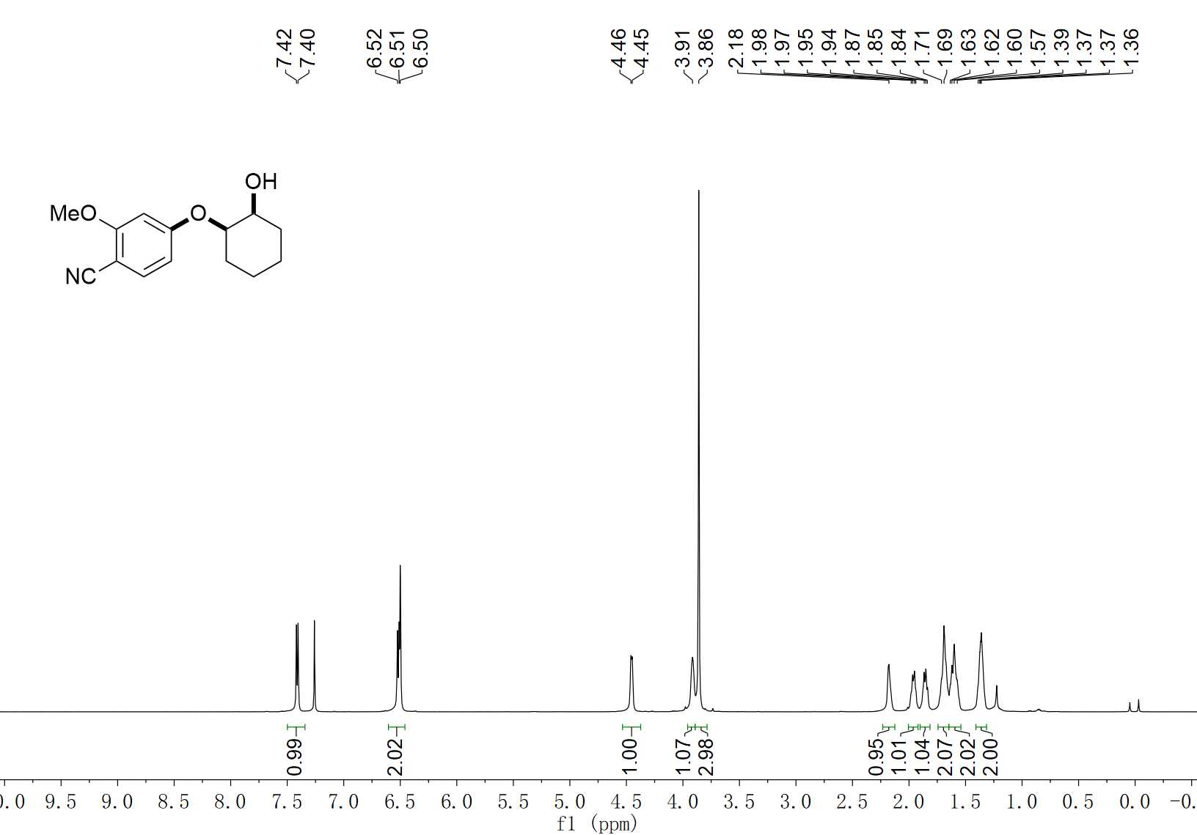
64 ¹H NMR (600 MHz, CDCl₃)

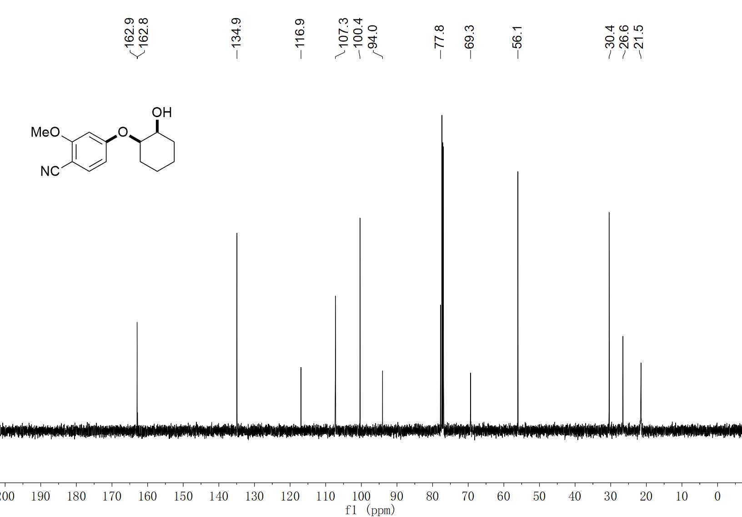
64 ¹³C NMR (150 MHz, CDCl₃)

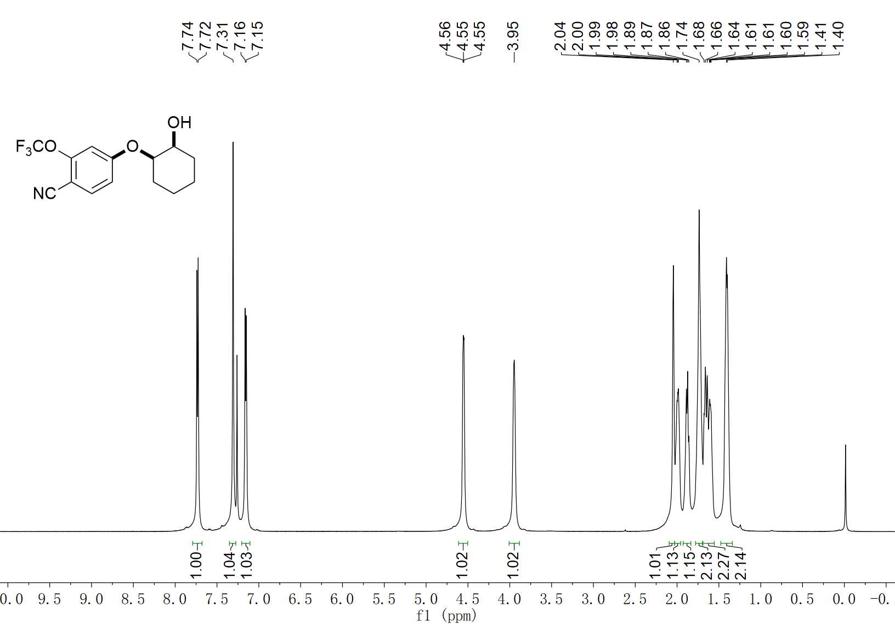
65 ¹H NMR (600 MHz, CDCl₃)

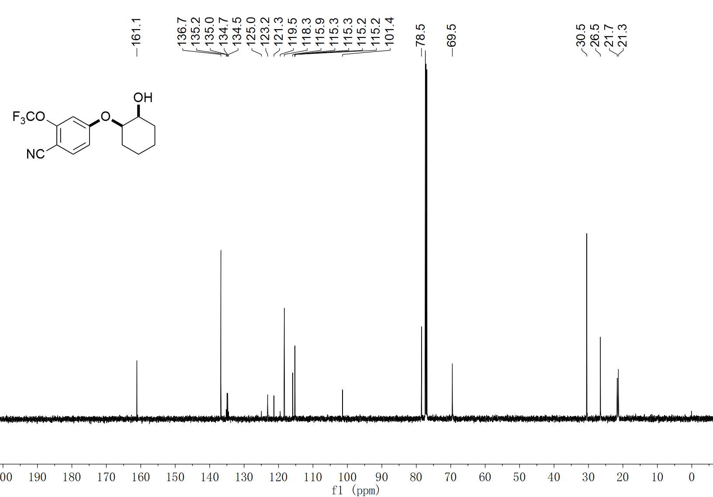
65 ¹³C NMR (150 MHz, CDCl₃)

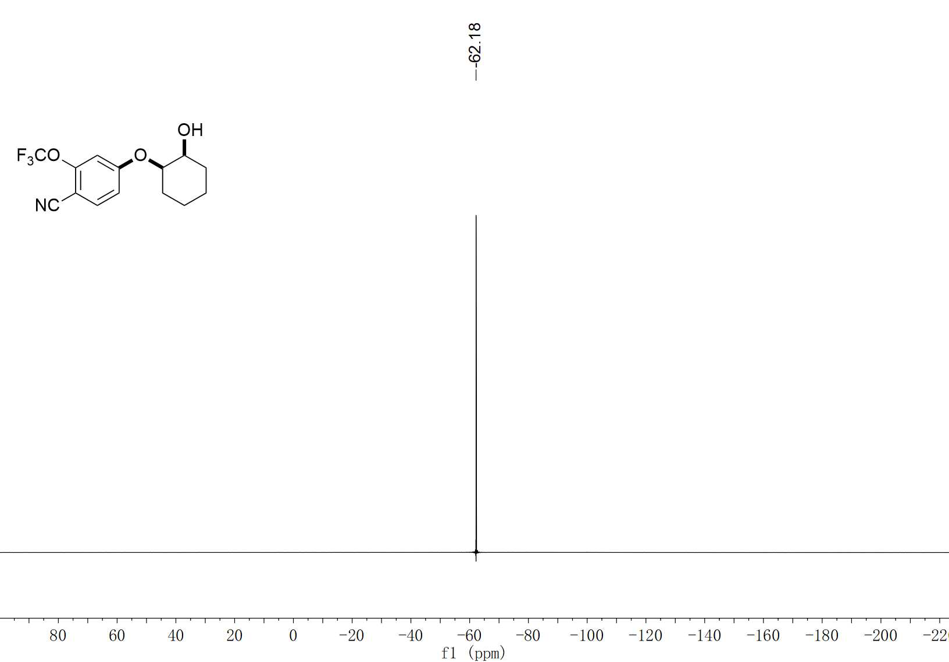
65 ¹⁹F NMR (376 MHz, CDCl₃)

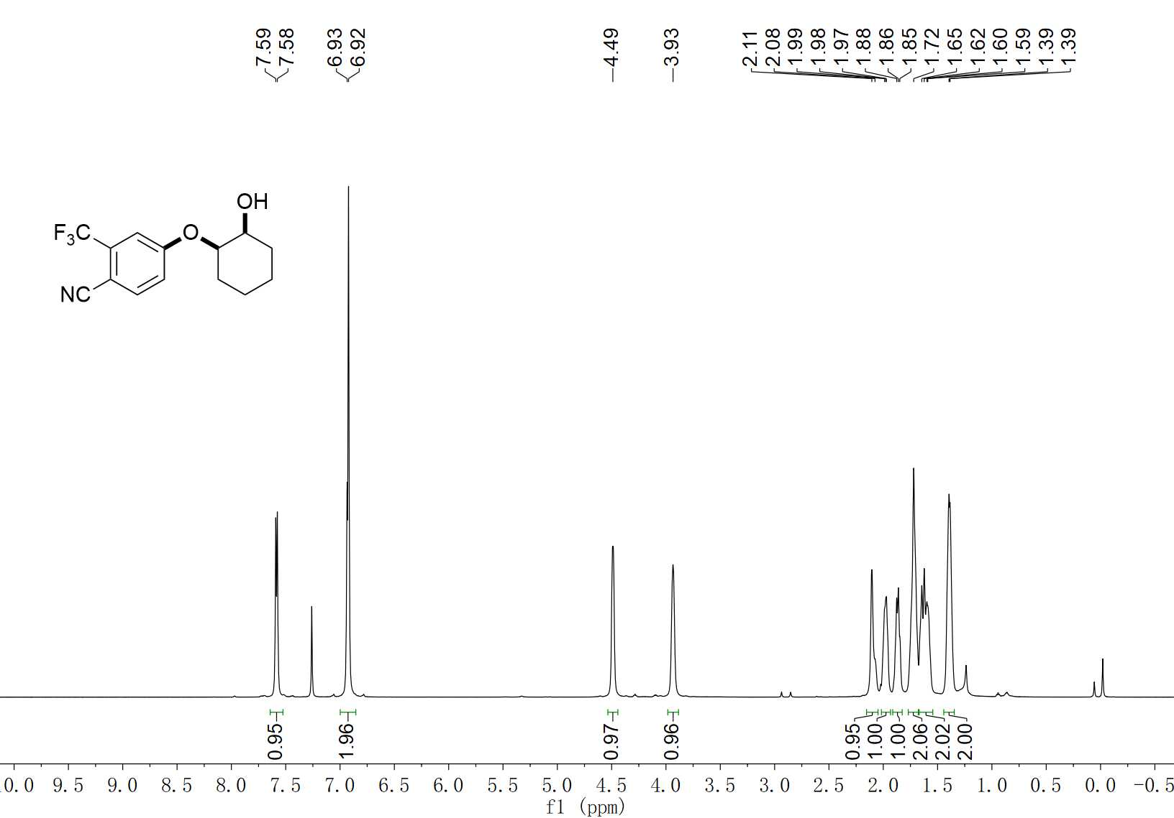
66 ¹H NMR (600 MHz, CDCl₃)

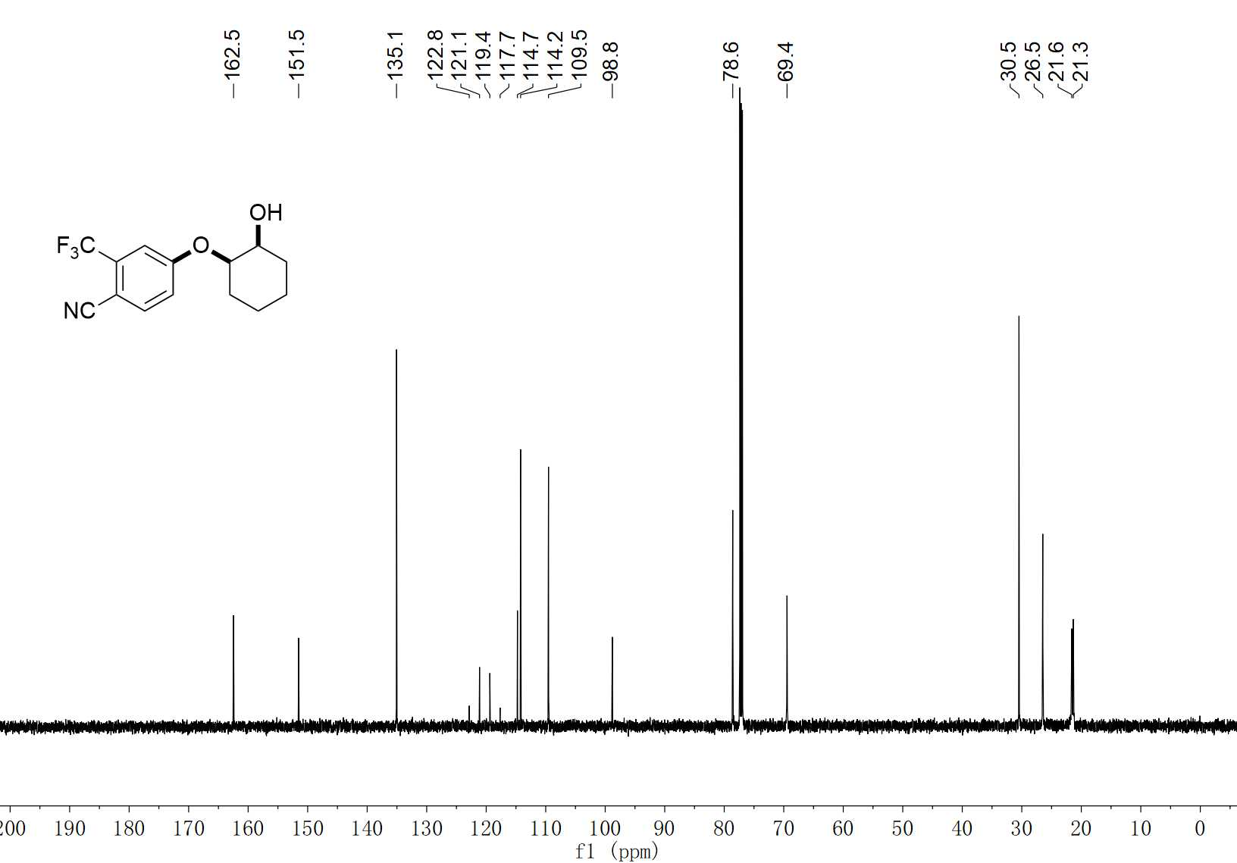
66 ¹³C NMR (150 MHz, CDCl₃)

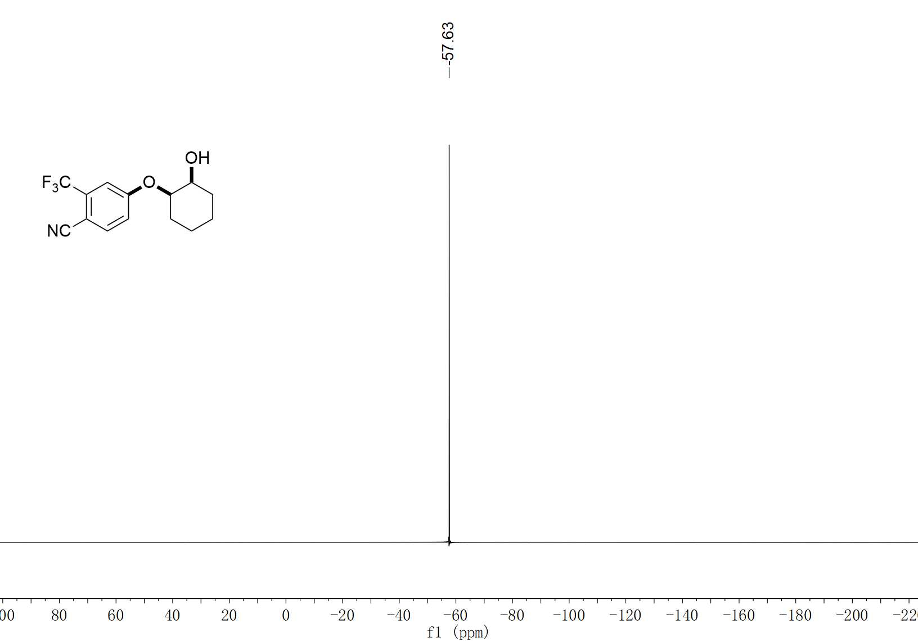
66 ¹⁹F NMR (376 MHz, CDCl₃)

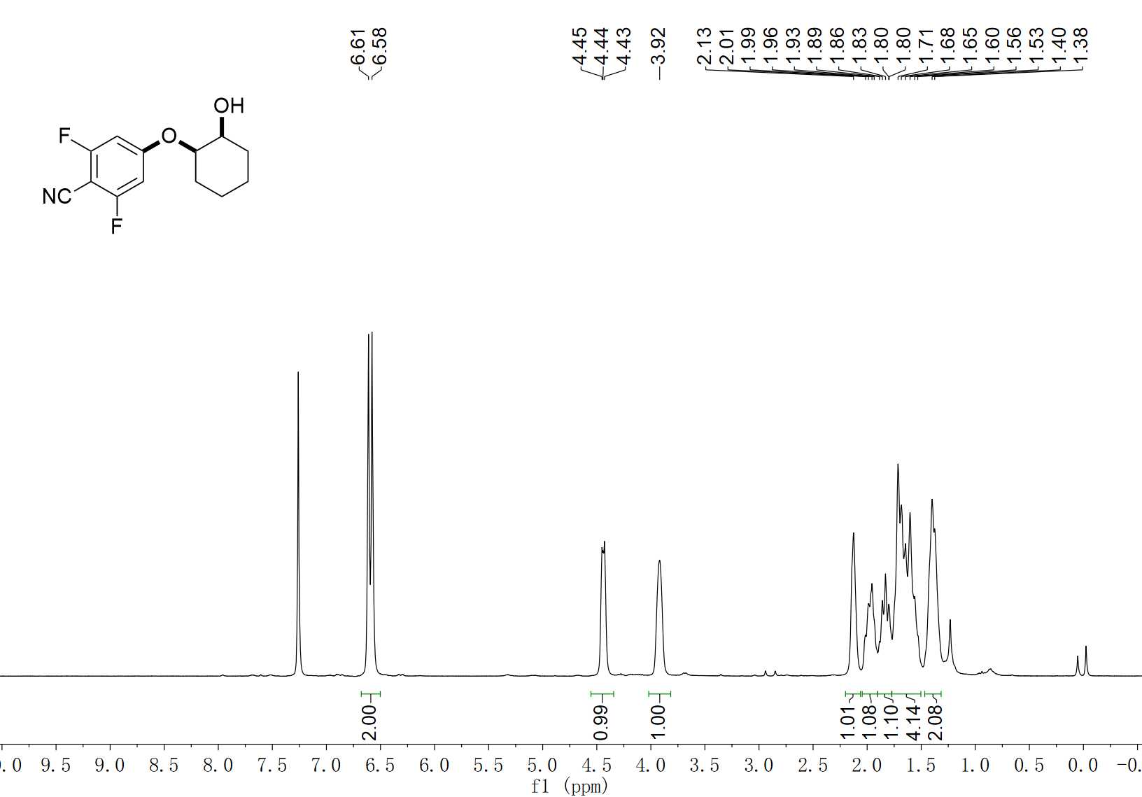
67 ¹H NMR (300 MHz, CDCl₃)

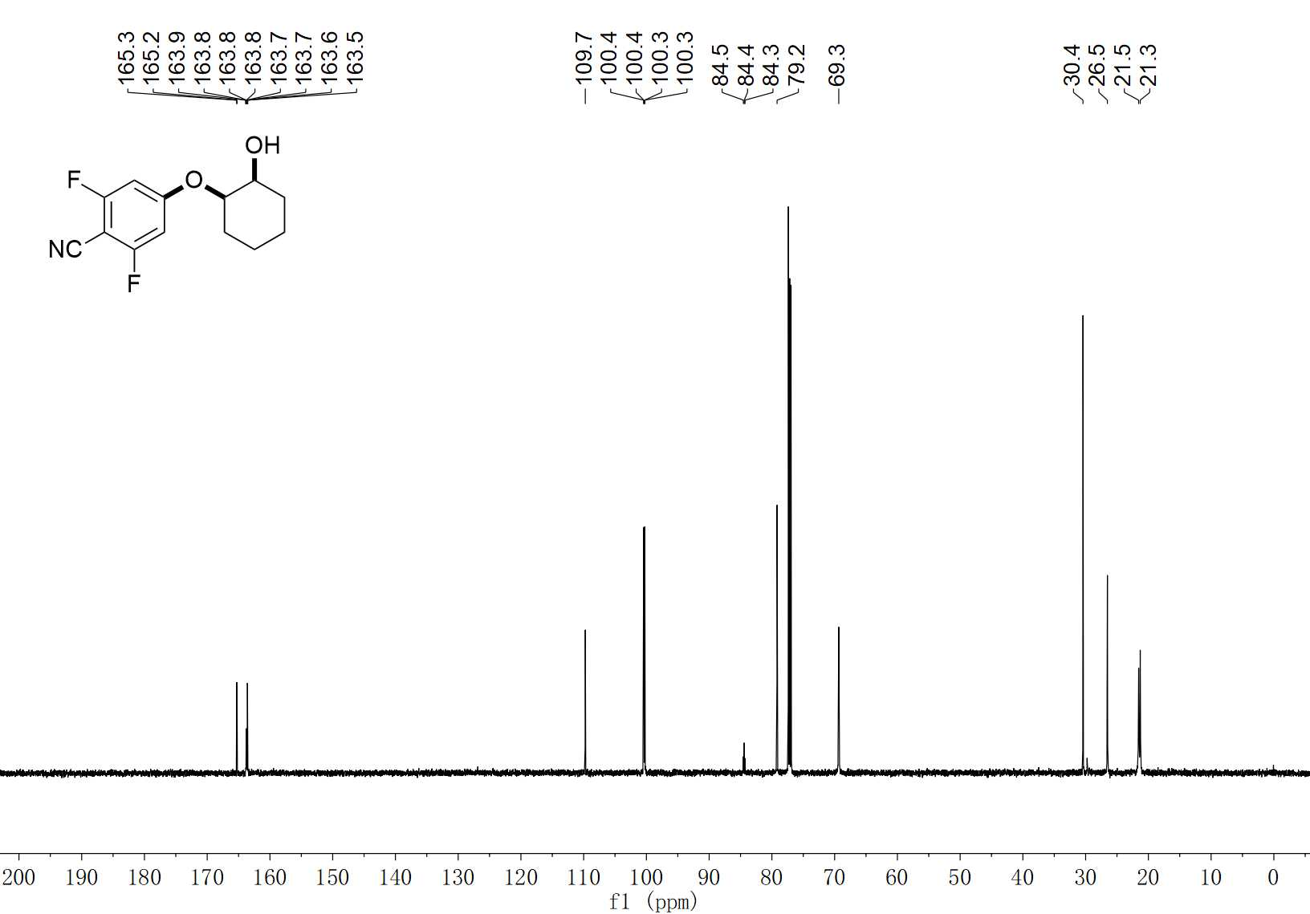
67 ¹³C NMR (150 MHz, CDCl₃)

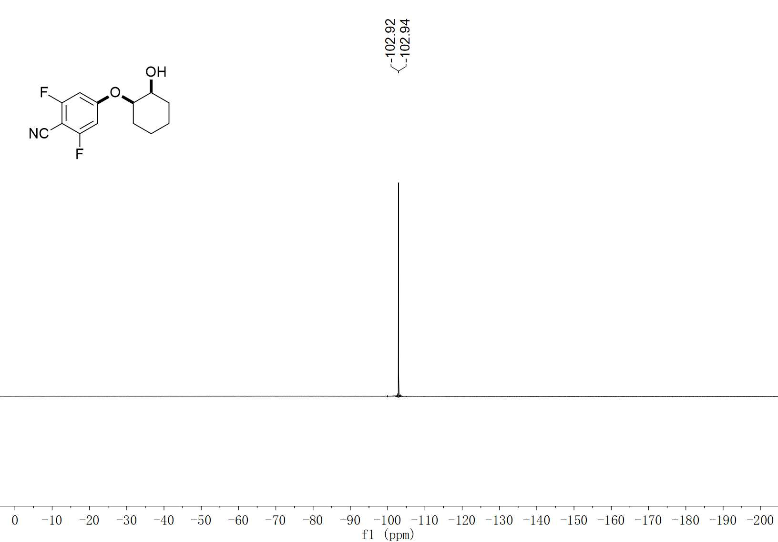
67 ¹⁹F NMR (376 MHz, CDCl₃)

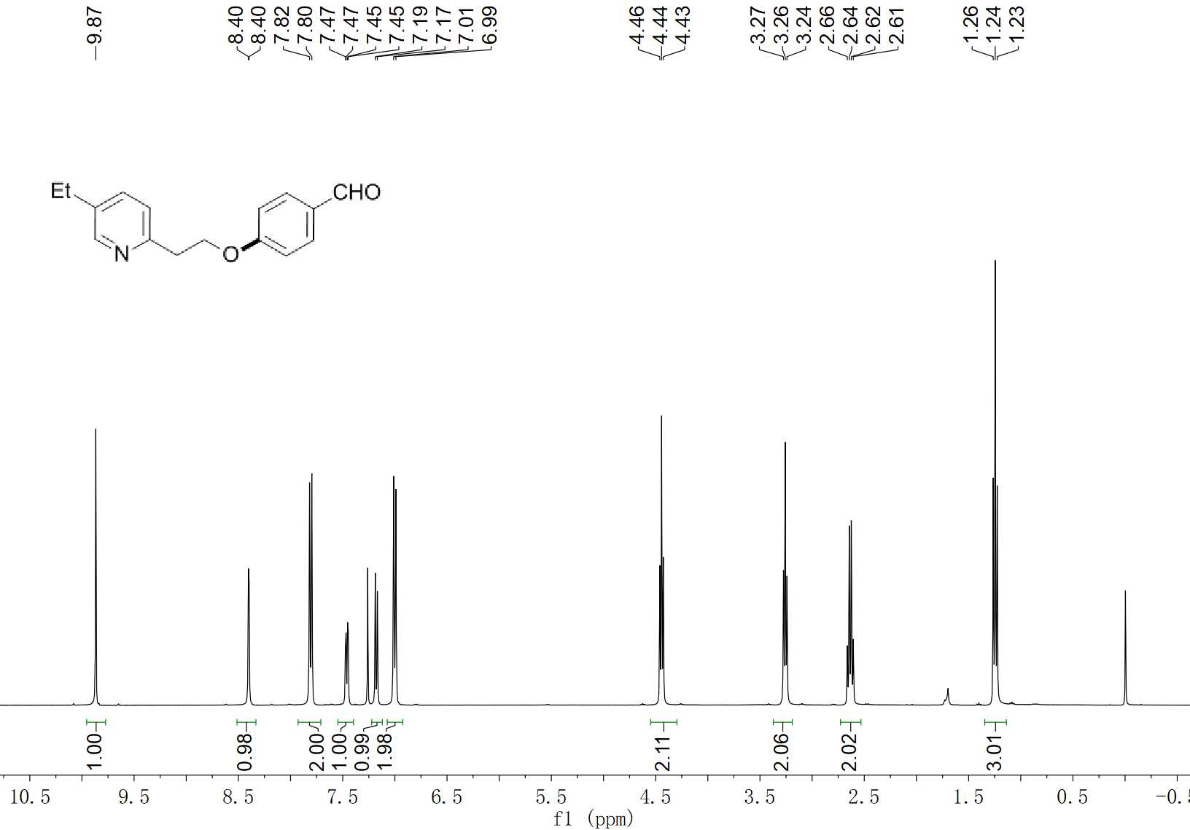
70 ¹H NMR (400 MHz, CDCl₃)

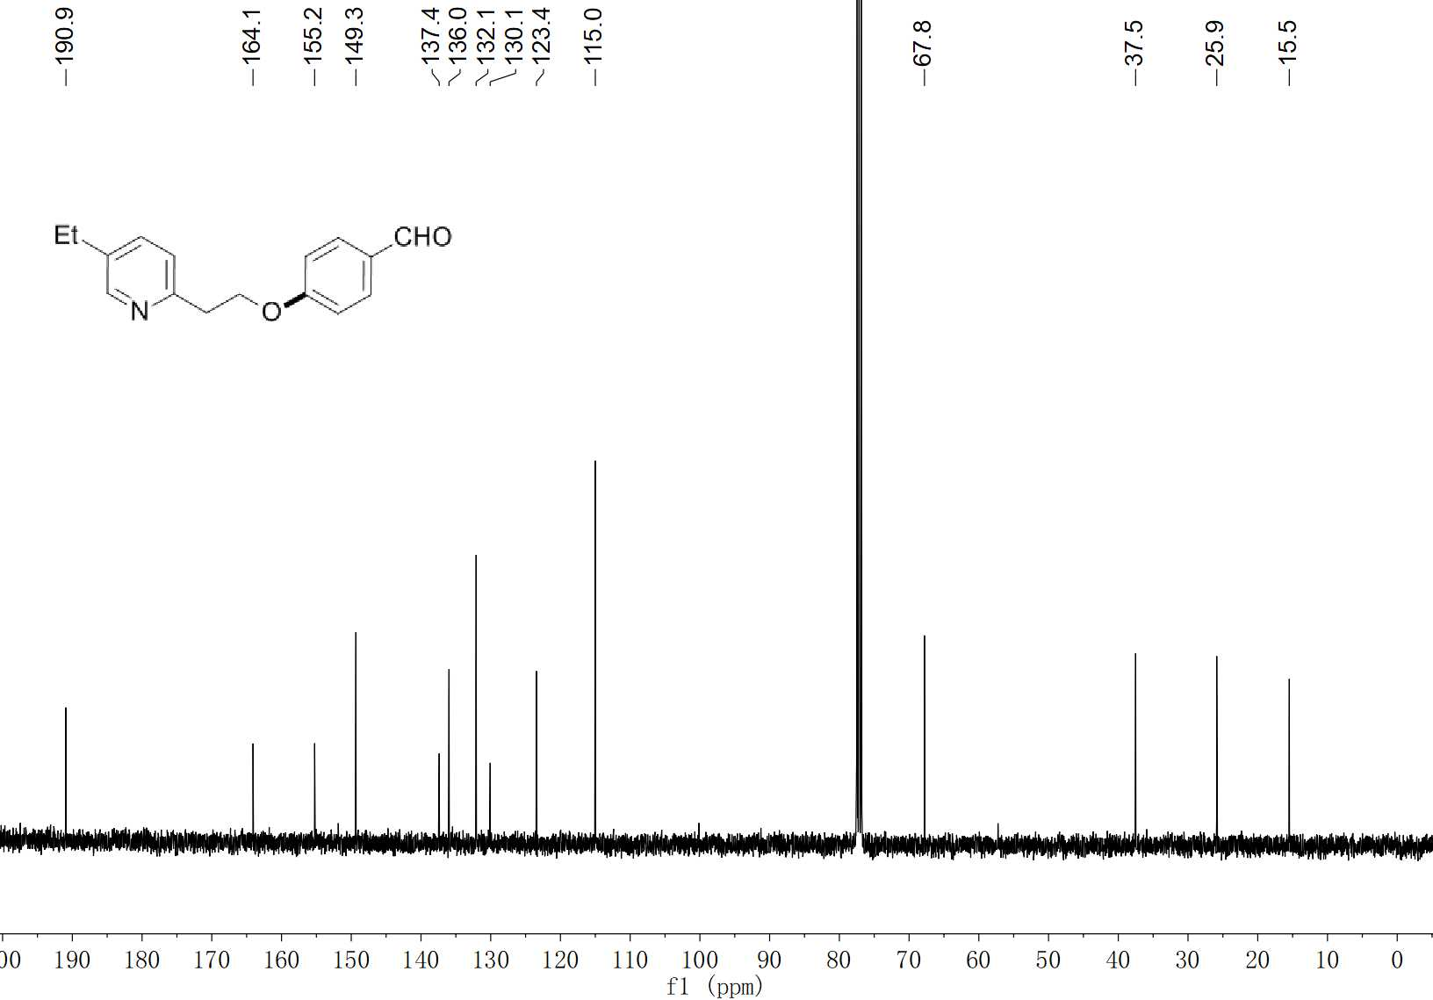
70 ¹³C NMR (100 MHz, CDCl₃)

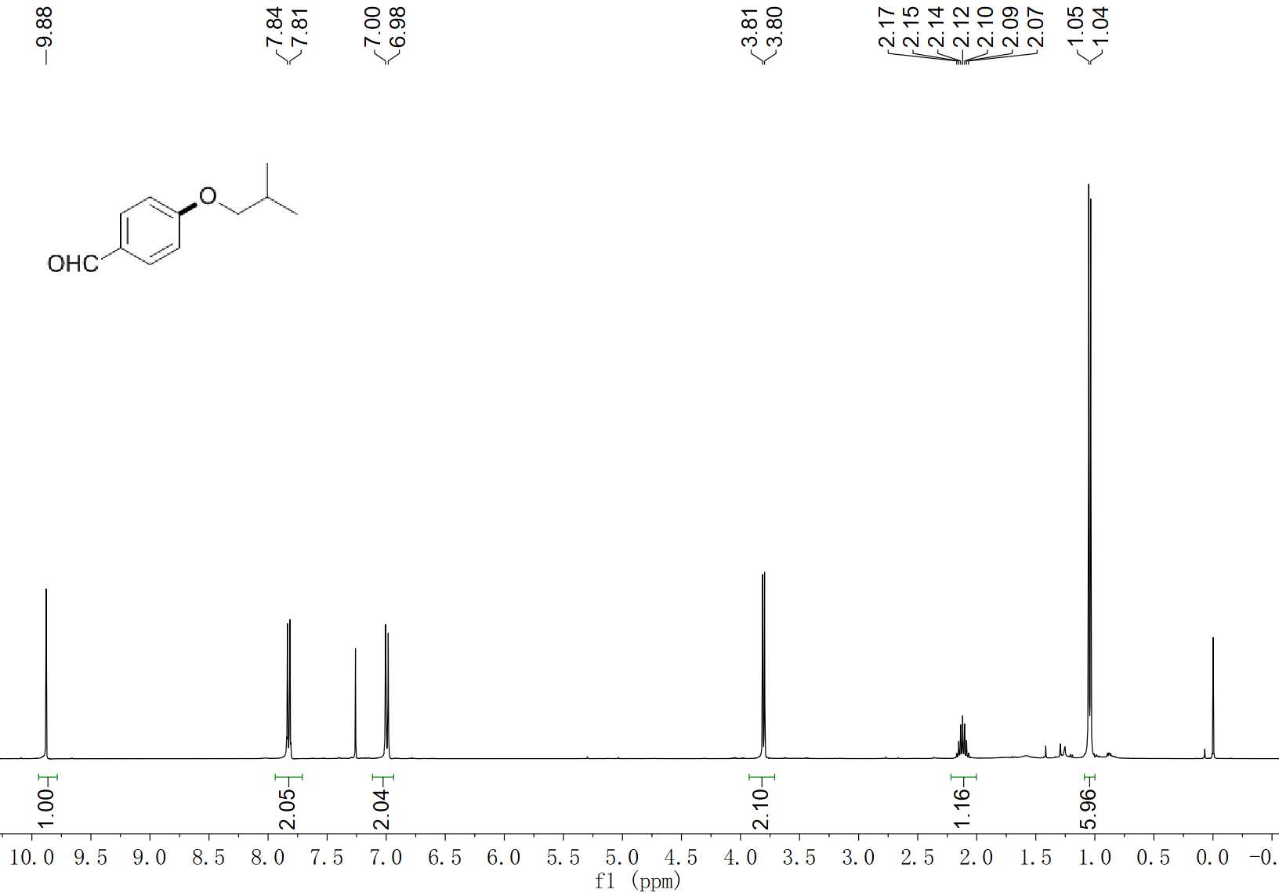
72 ¹H NMR (400 MHz, CDCl₃)

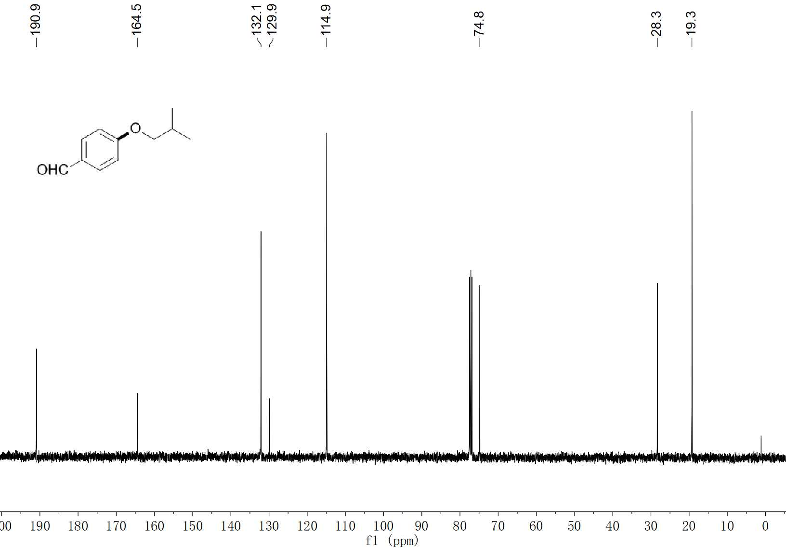
72 ¹³C NMR (100 MHz, CDCl₃)

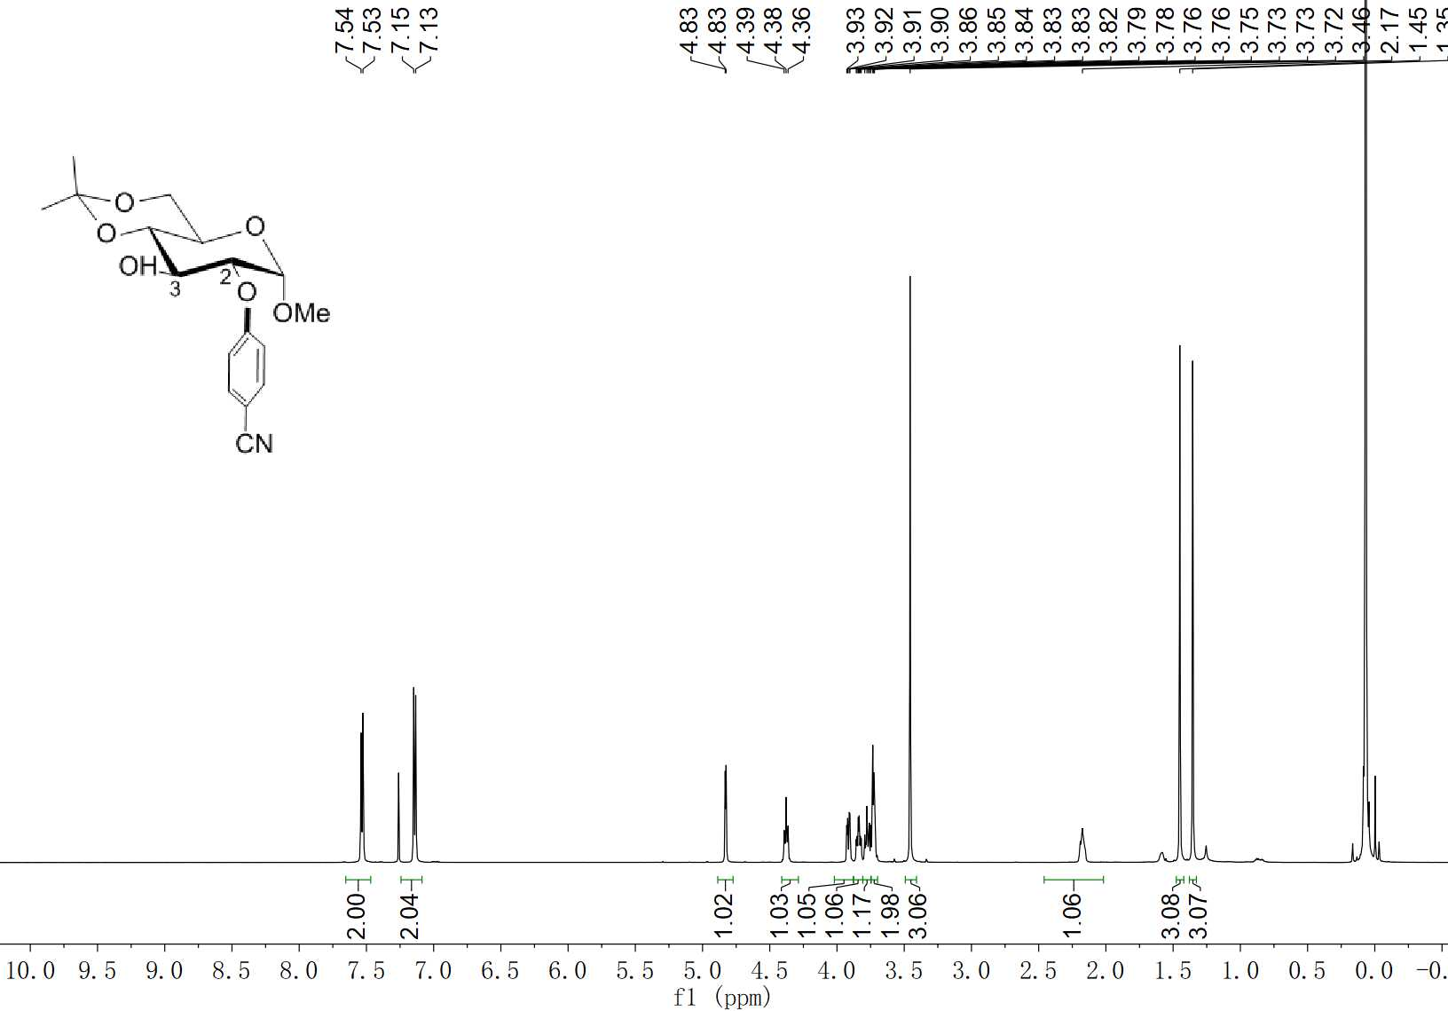
73-C2 ¹H NMR (400 MHz, CDCl₃)

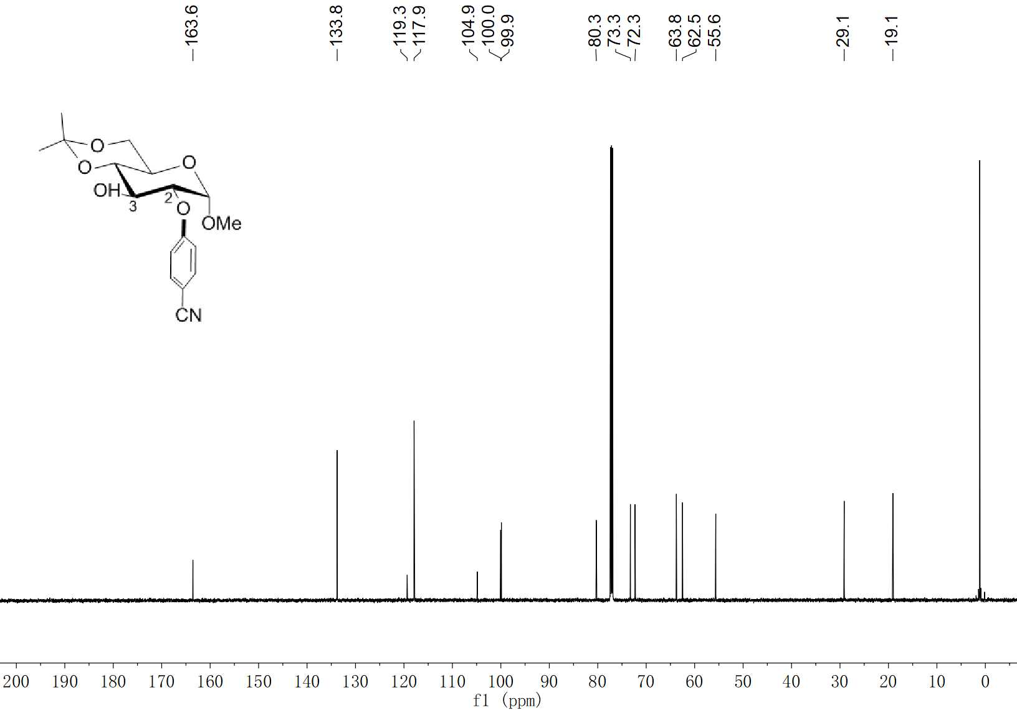
73-C2 ¹³C NMR (100 MHz, CDCl₃)

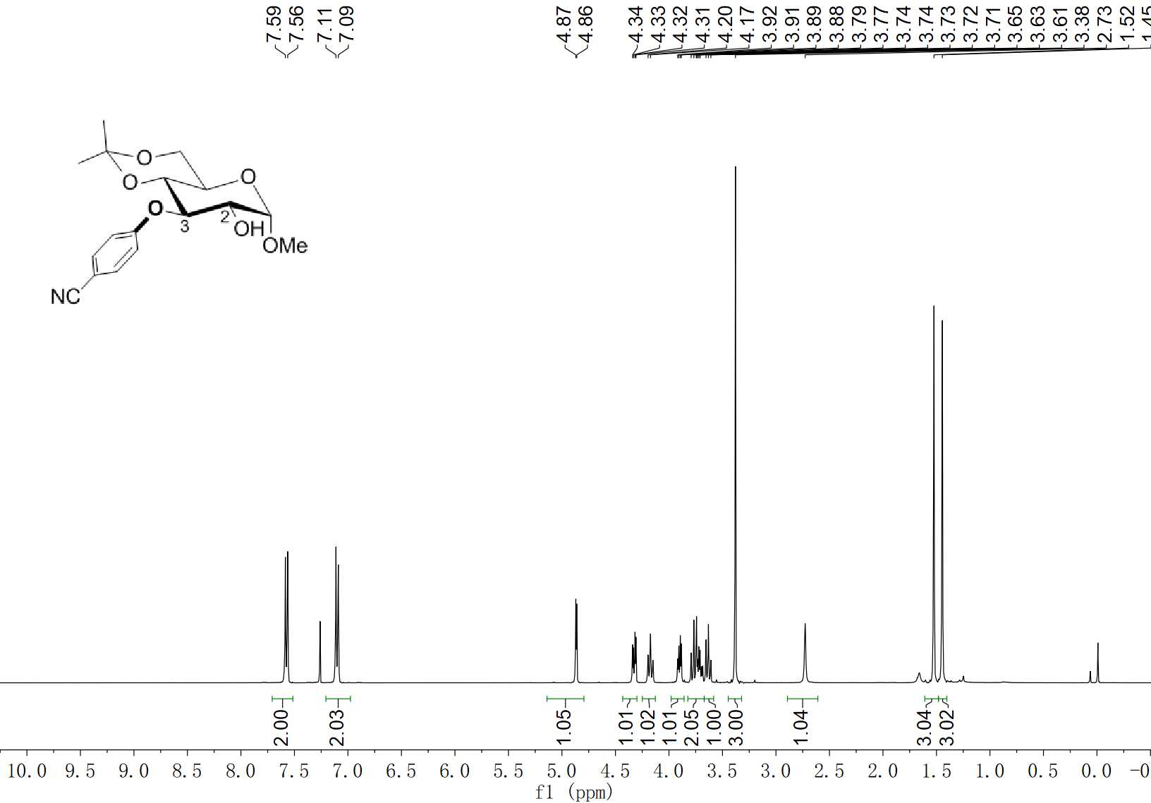
73-C3 ¹H NMR (400 MHz, CDCl₃)

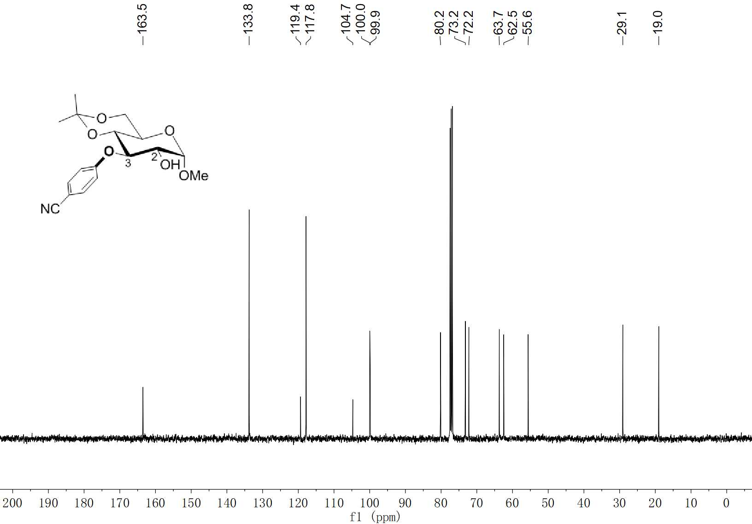
73-C3 ¹³C NMR (100 MHz, CDCl₃)

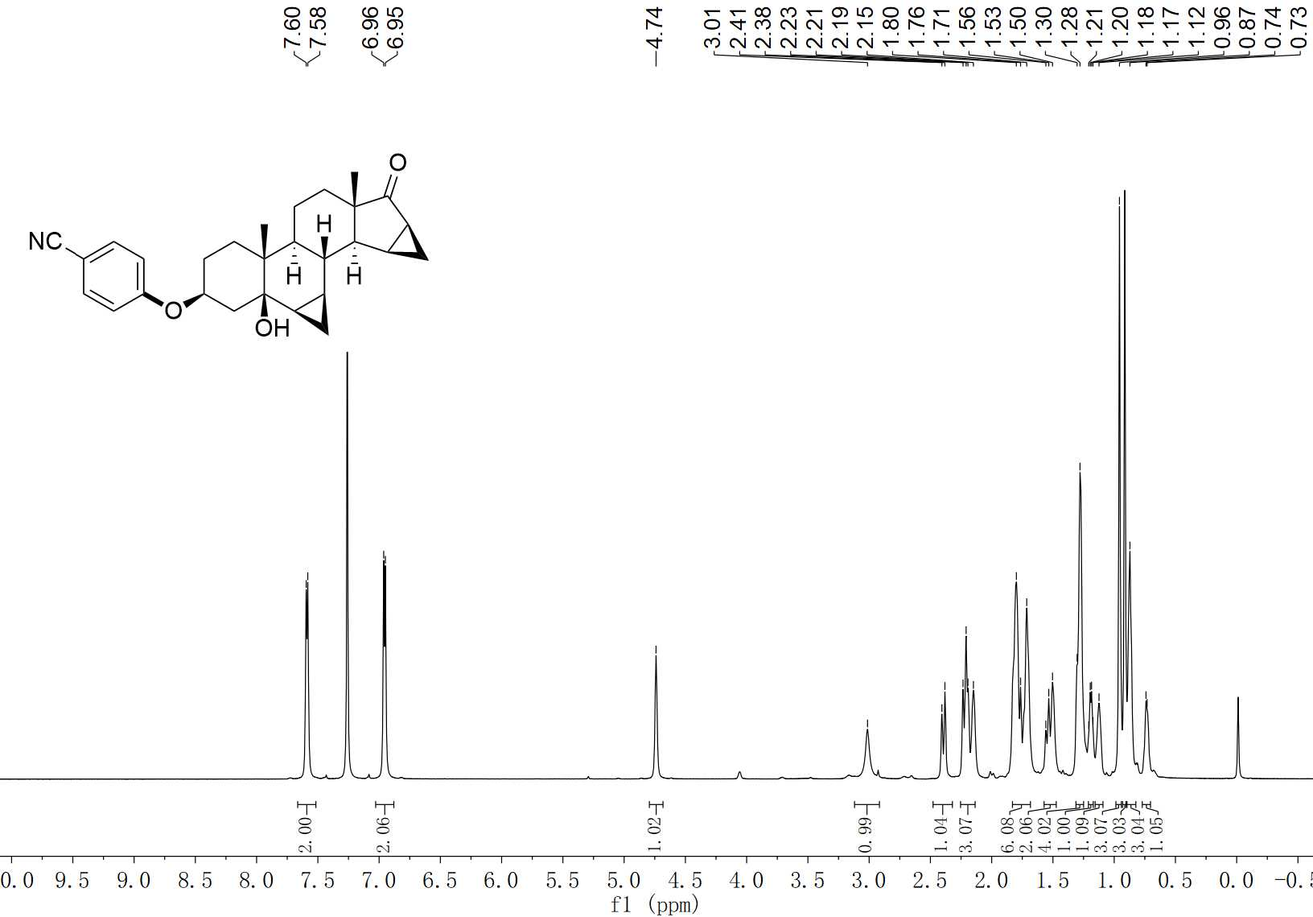
74 ¹H NMR (400 MHz, CDCl₃)

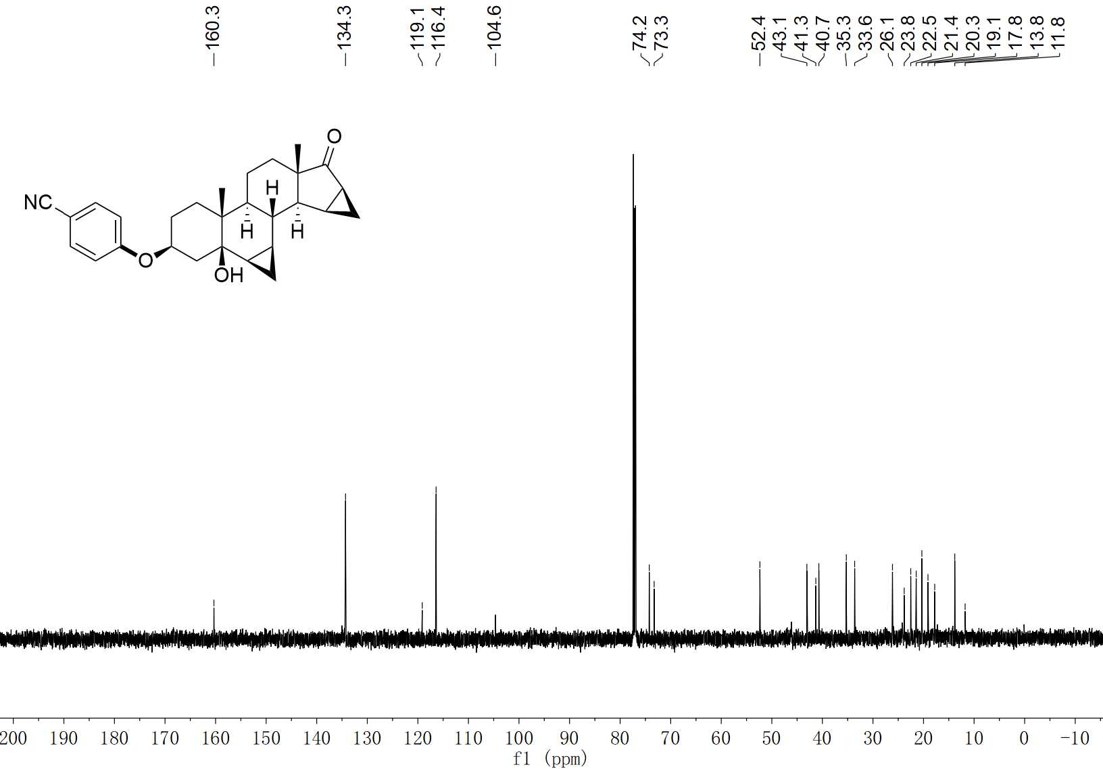
74 ¹³C NMR (100 MHz, CDCl₃)

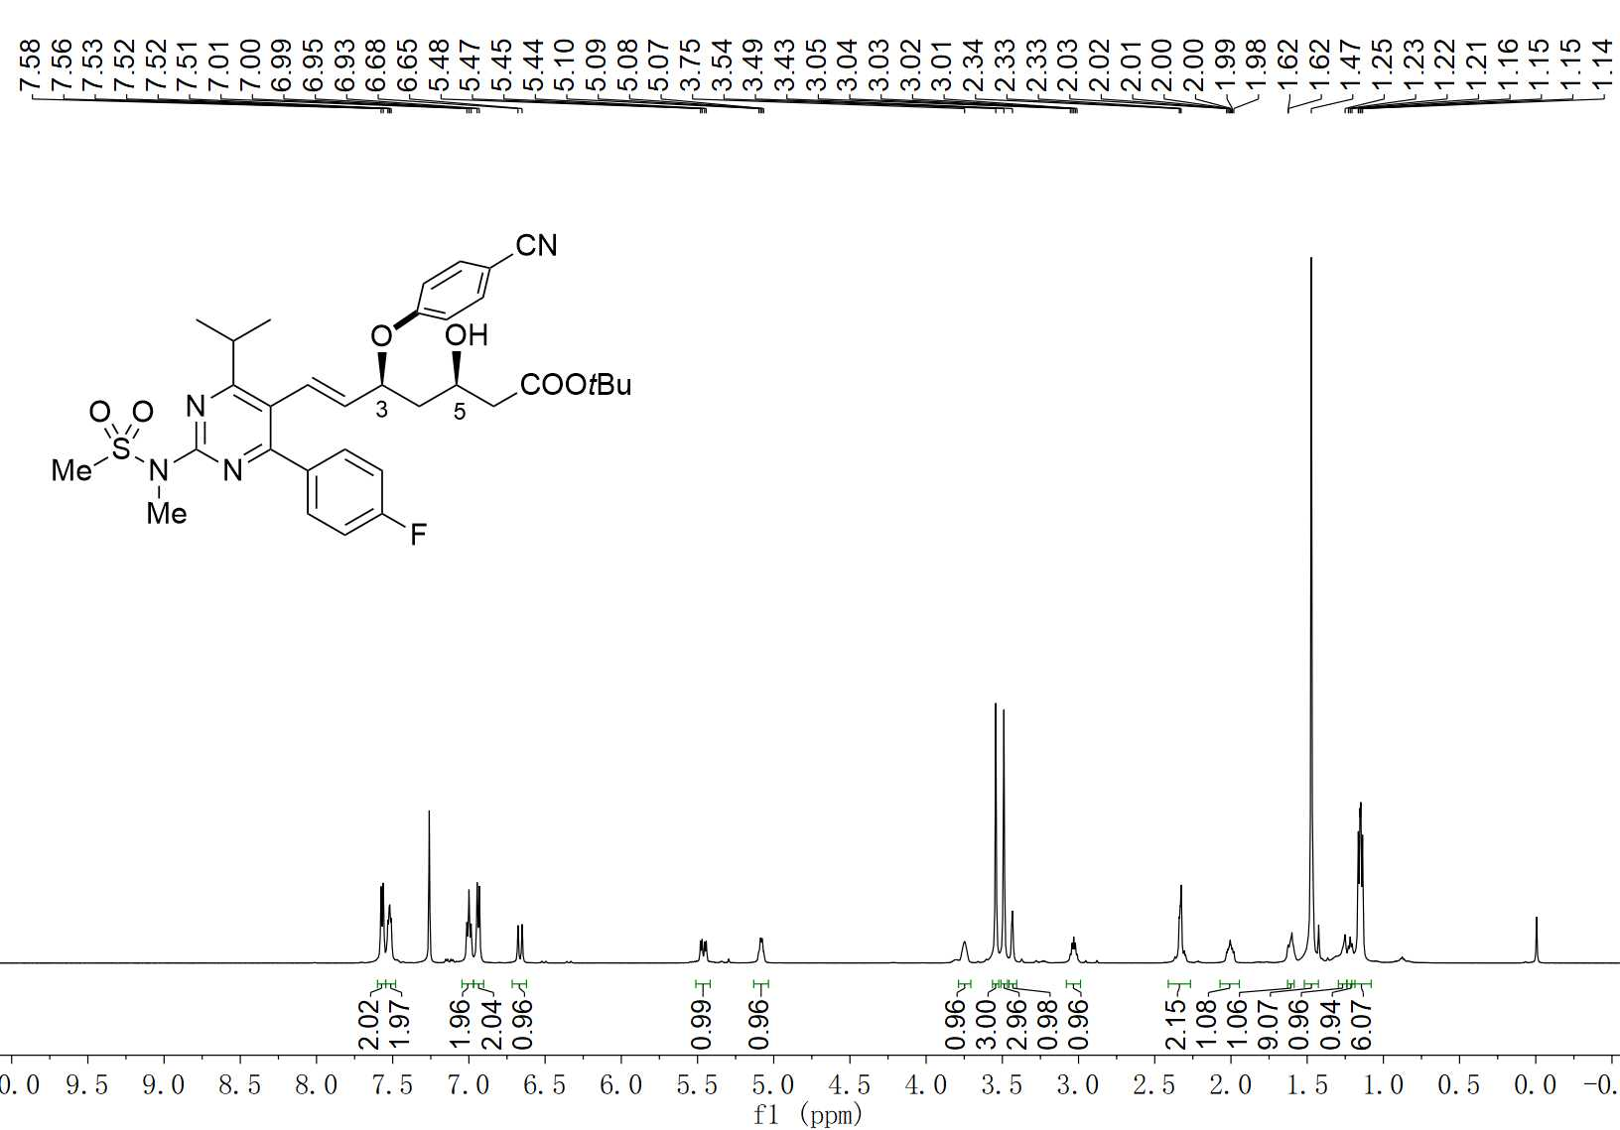
75-C3 ¹H NMR (600 MHz, CDCl₃)

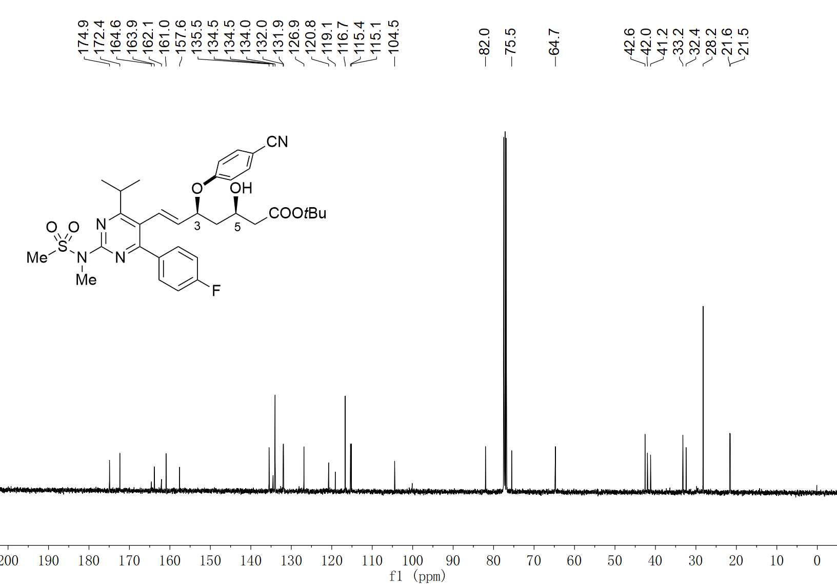
75-C3 ¹³C NMR (100 MHz, CDCl₃)

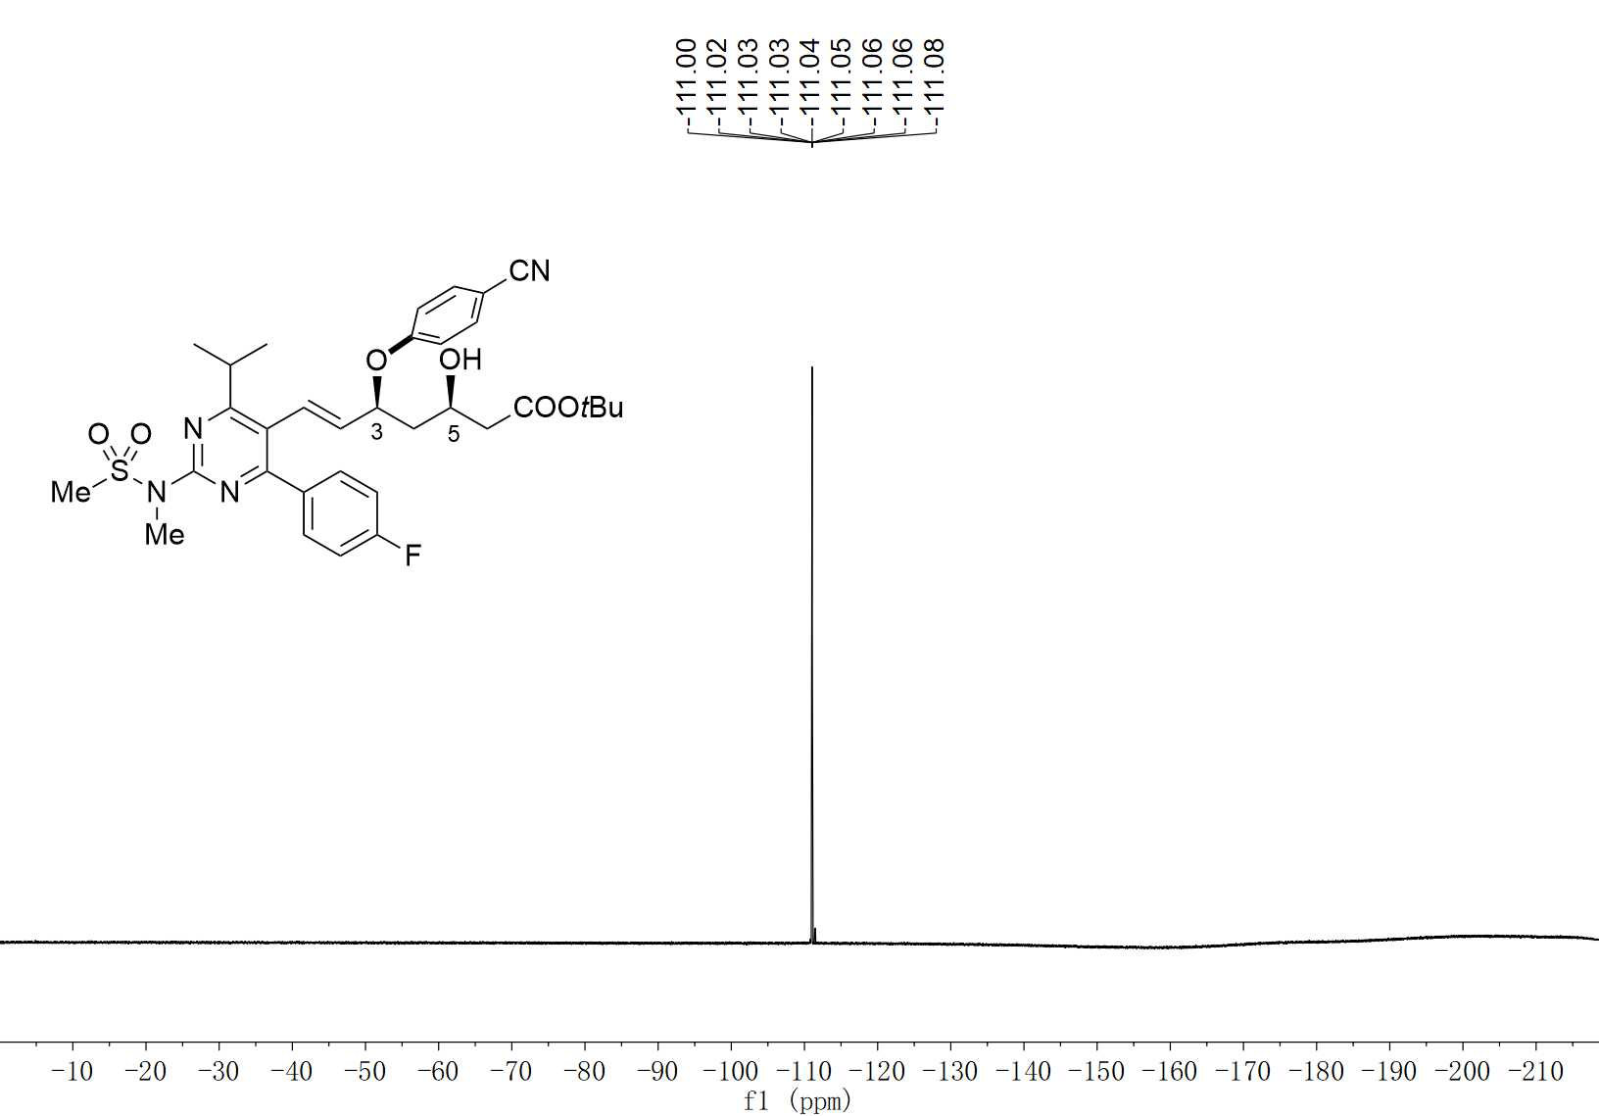
75-C3 ¹⁹F NMR (376 MHz, CDCl₃)

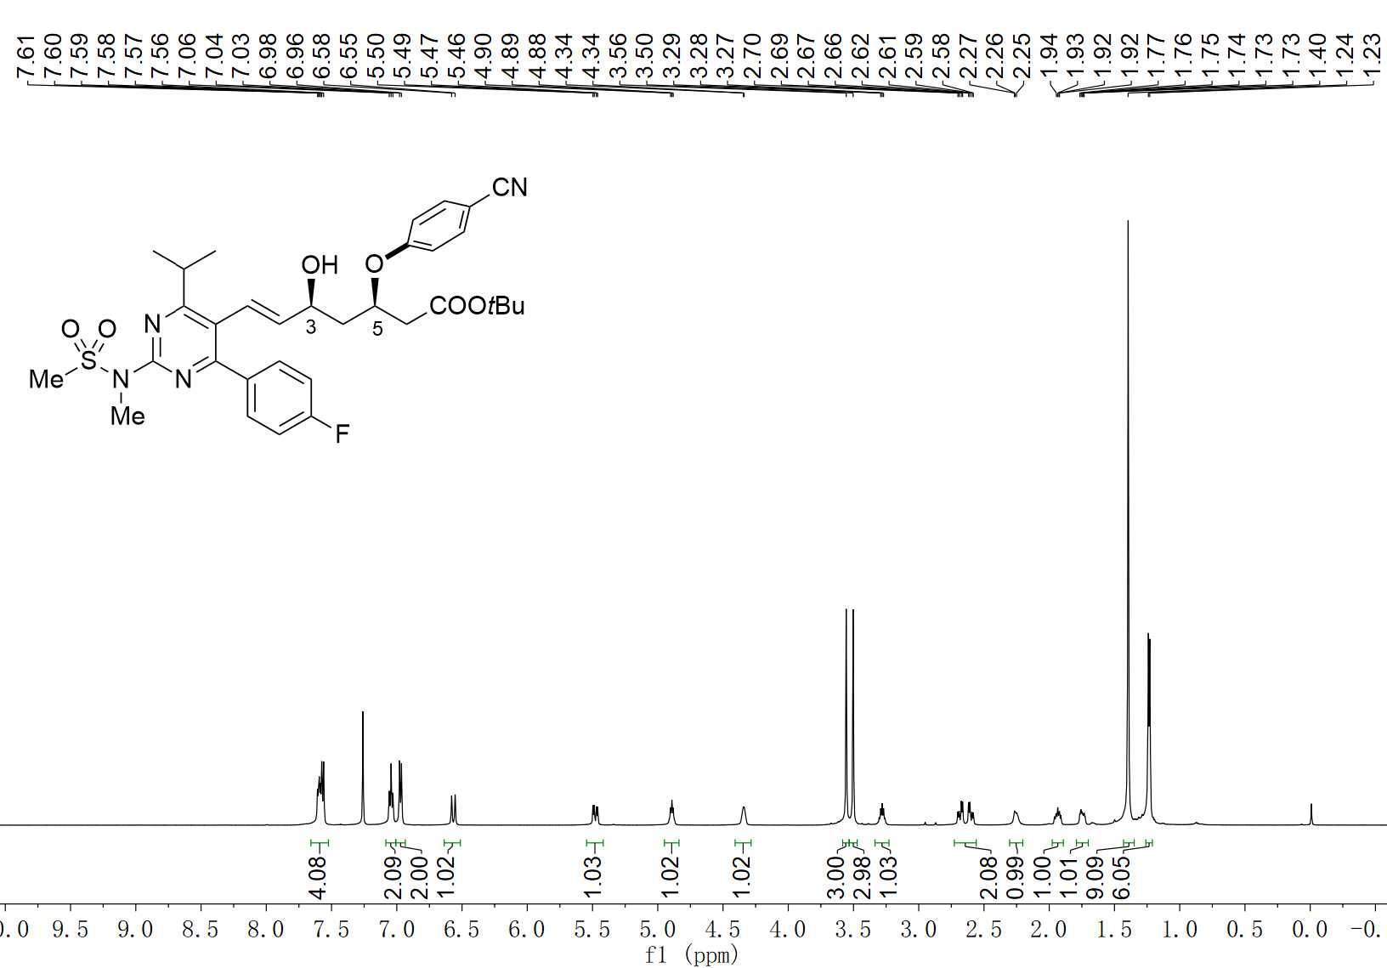
75-C5 ¹H NMR (600 MHz, CDCl₃)

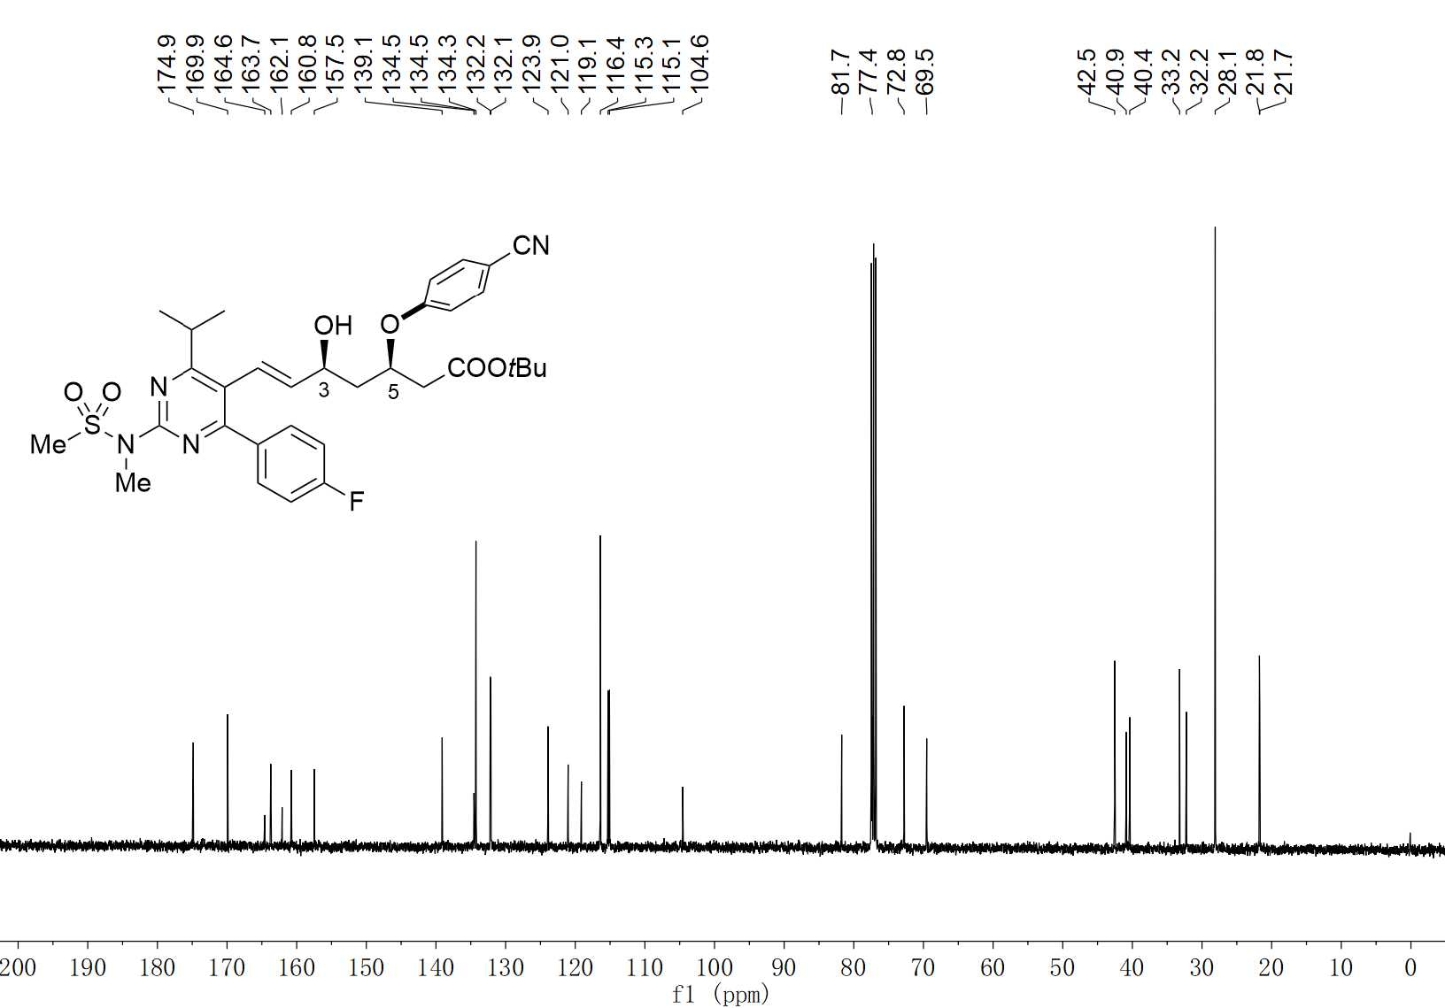
75-C5 ¹³C NMR (100 MHz, CDCl₃)

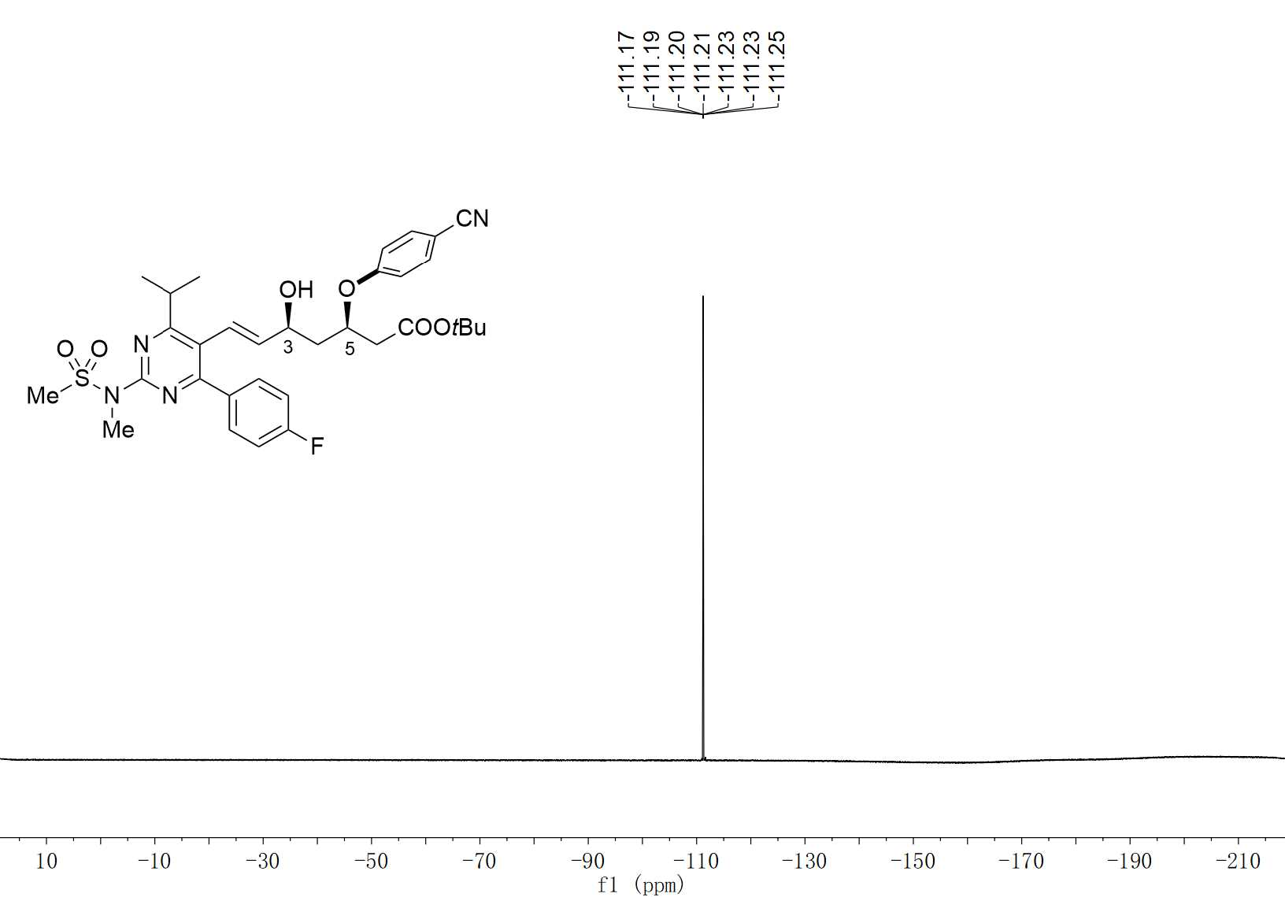
75-C5 ¹⁹F NMR (376 MHz, CDCl₃)

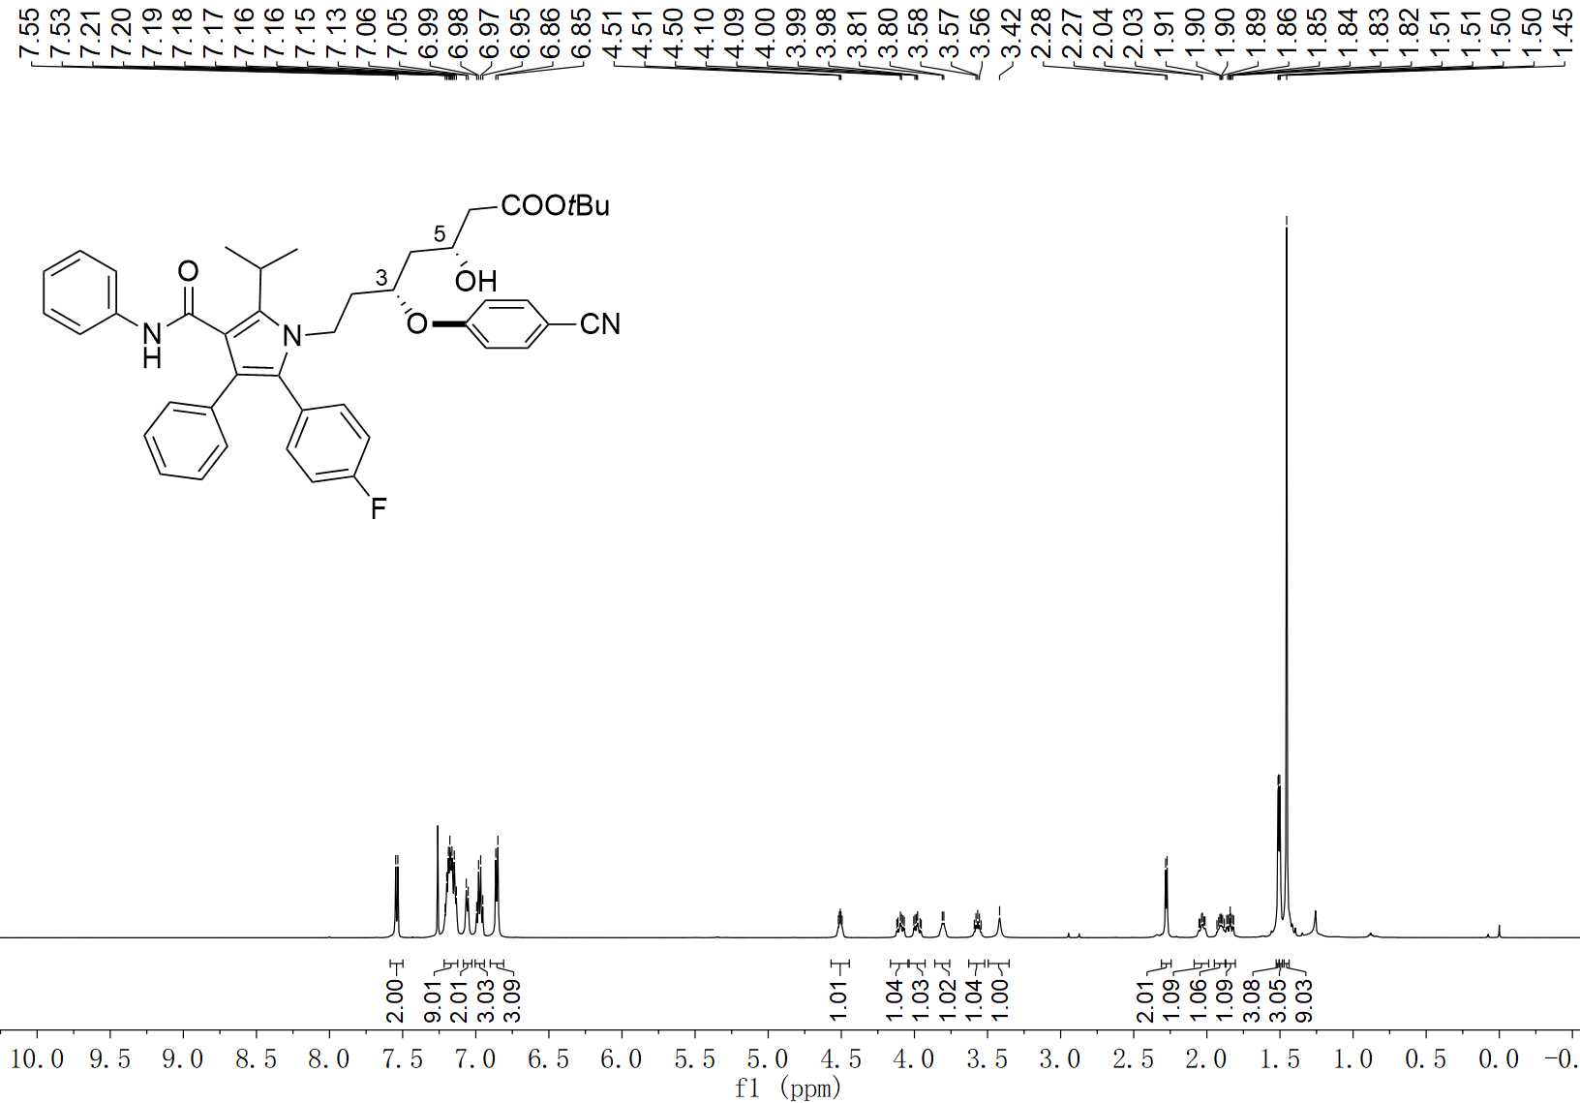
76-C3 ¹H NMR (600 MHz, CDCl₃)

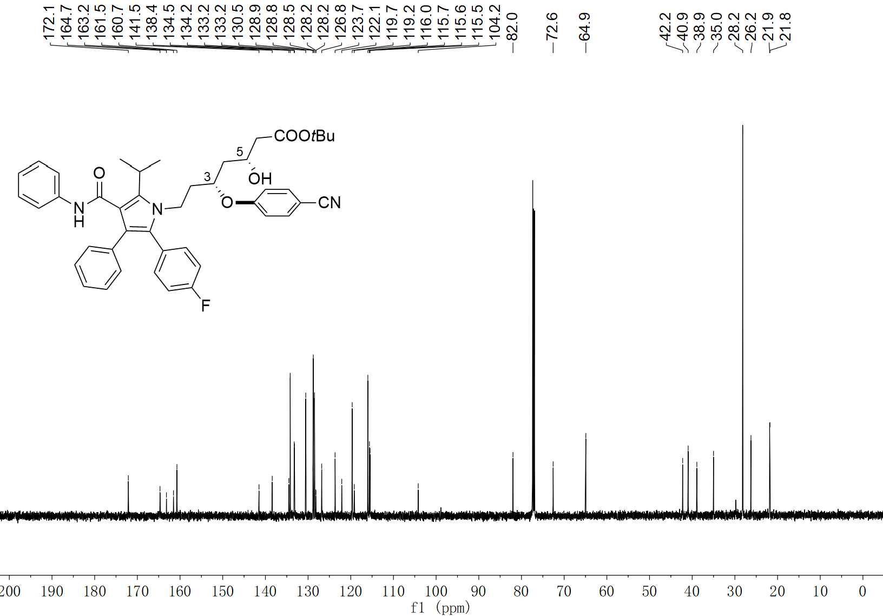
76-C3 ¹³C NMR (100 MHz, CDCl₃)

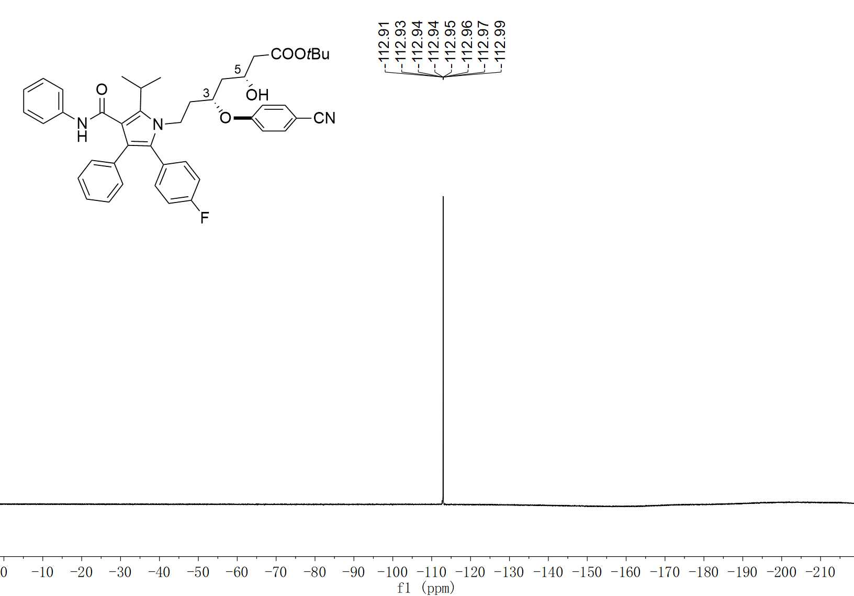
76-C3 ¹⁹F NMR (376 MHz, CDCl₃)

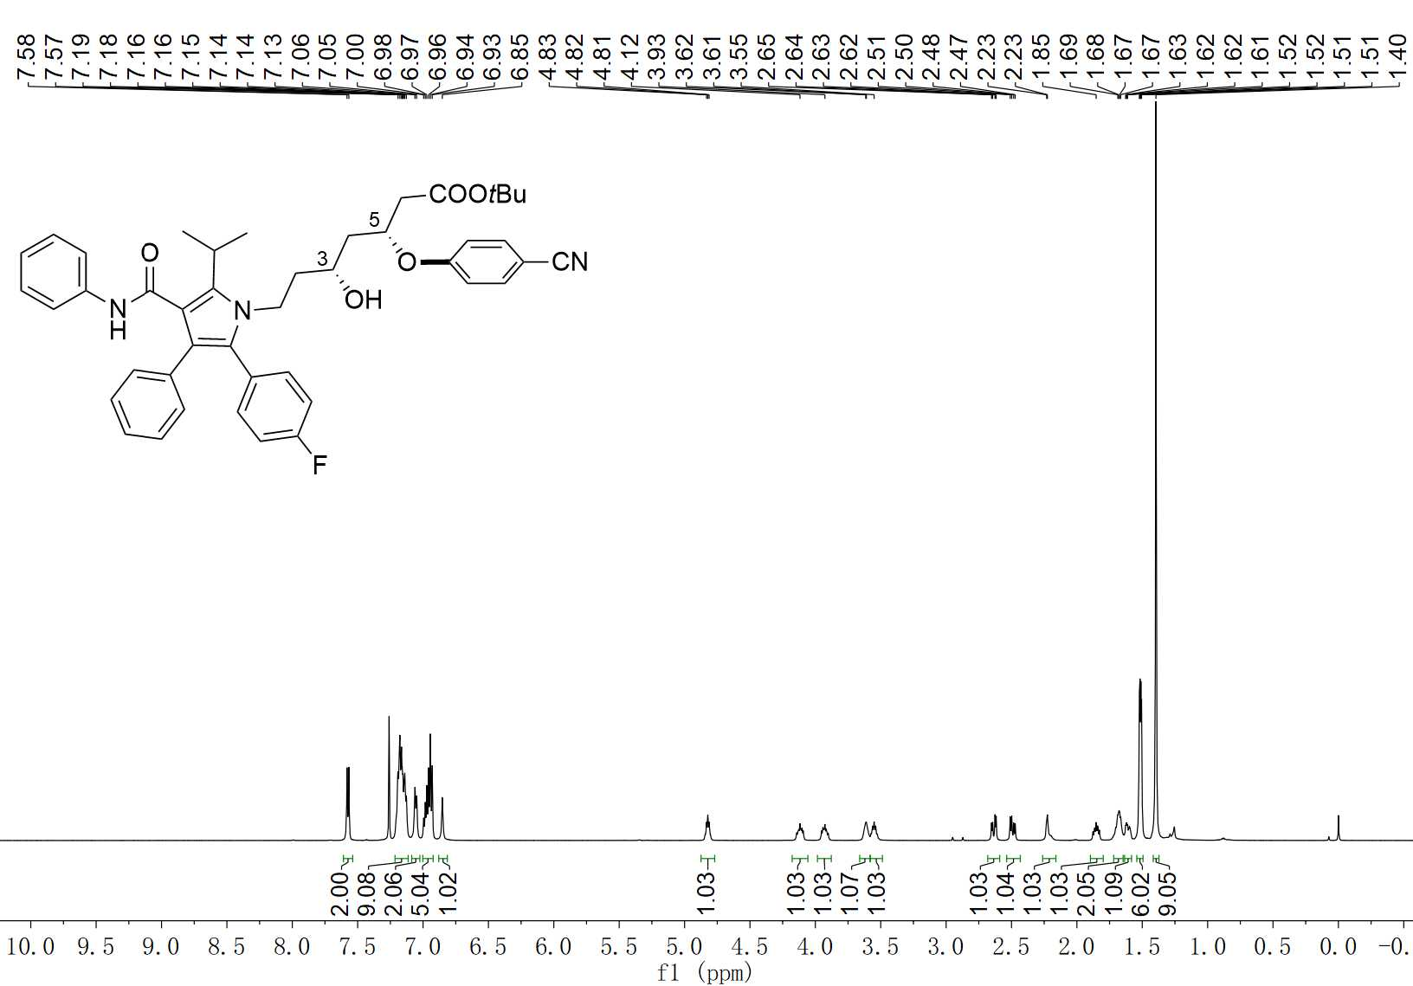
76-C5 ¹H NMR (600 MHz, CDCl₃)

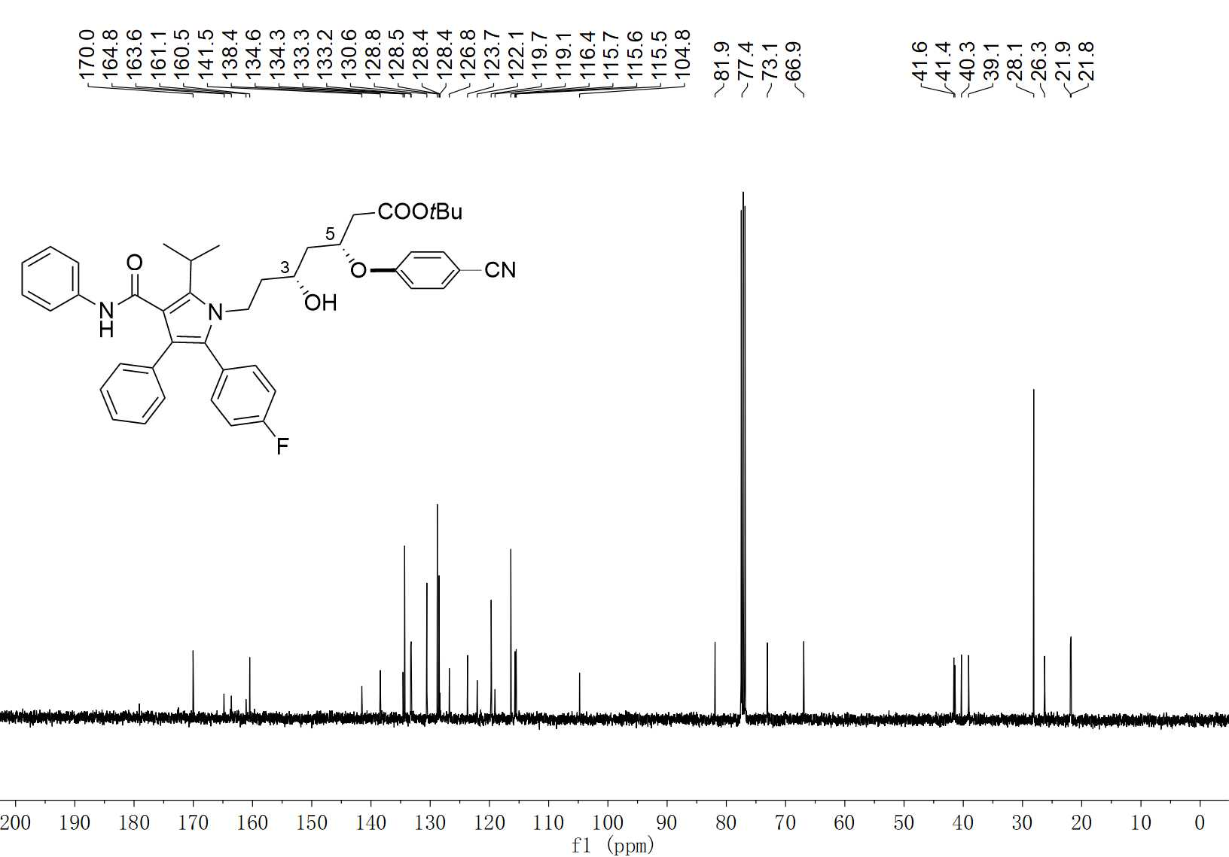
76-C5 ¹³C NMR (100 MHz, CDCl₃)

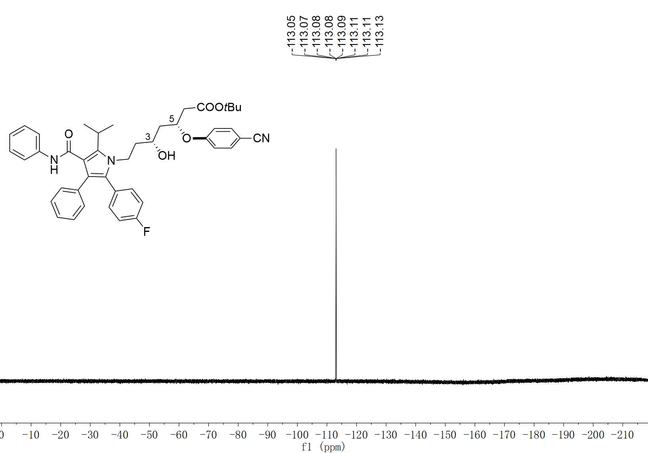
76-C5 ¹⁹F NMR (376 MHz, CDCl₃)

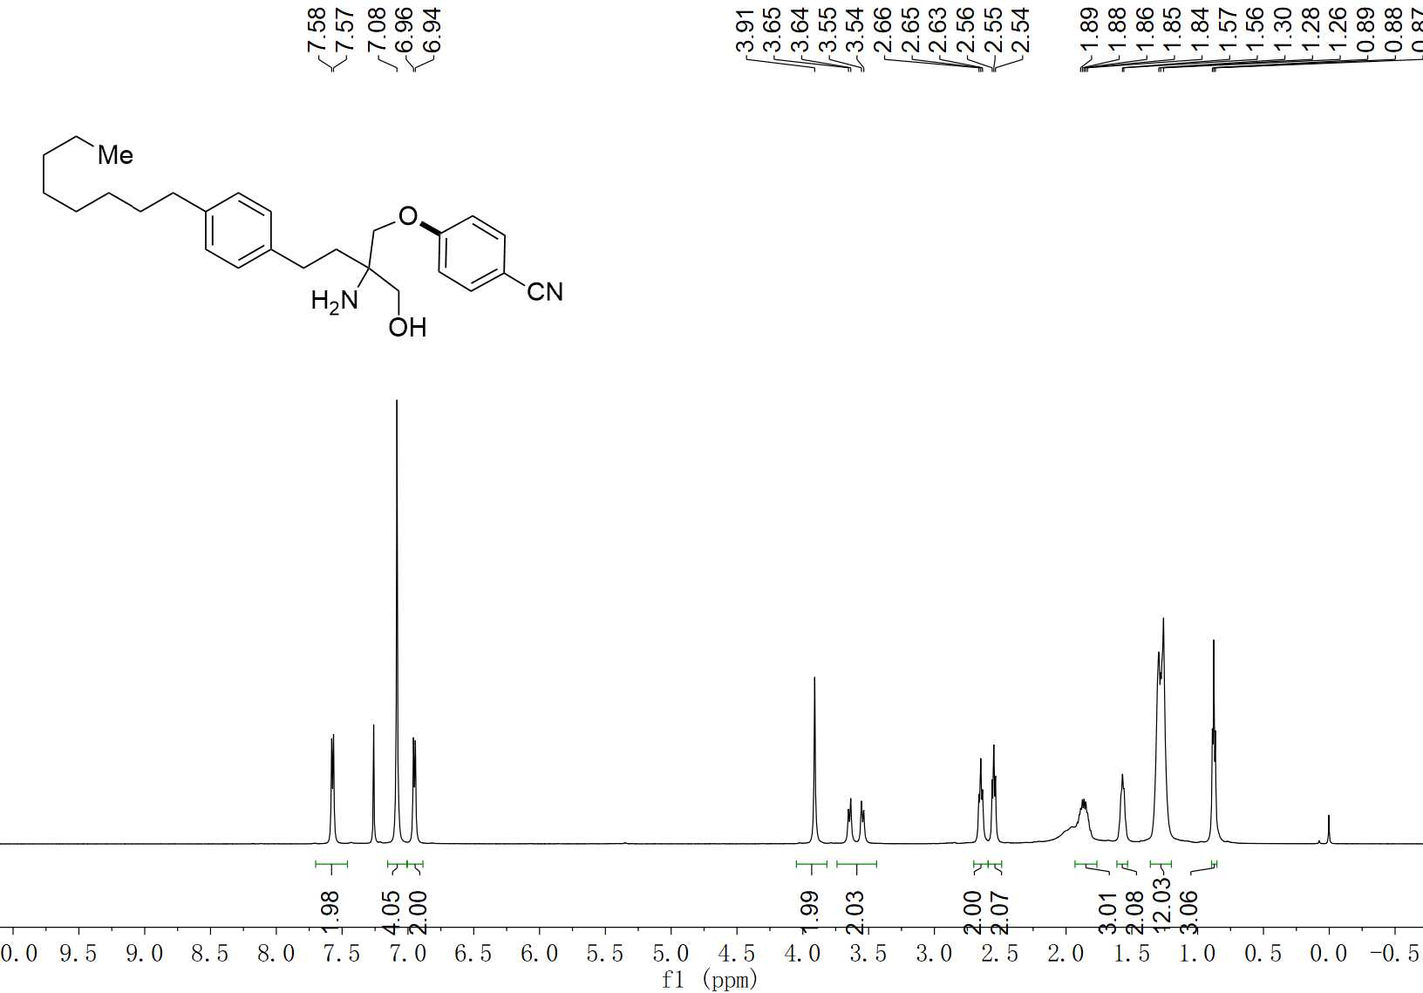
77 ¹H NMR (600 MHz, CDCl₃)

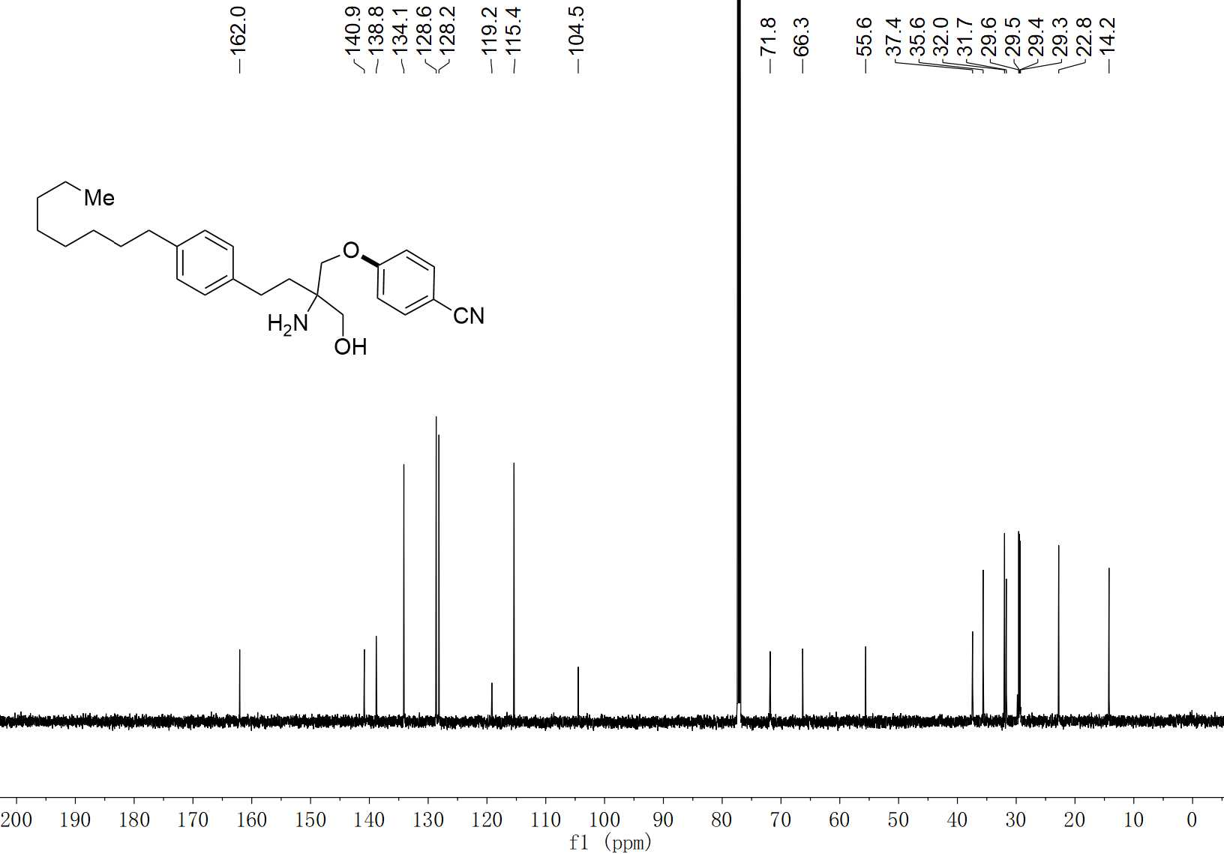
77 ¹³C NMR (150 MHz, CDCl₃)

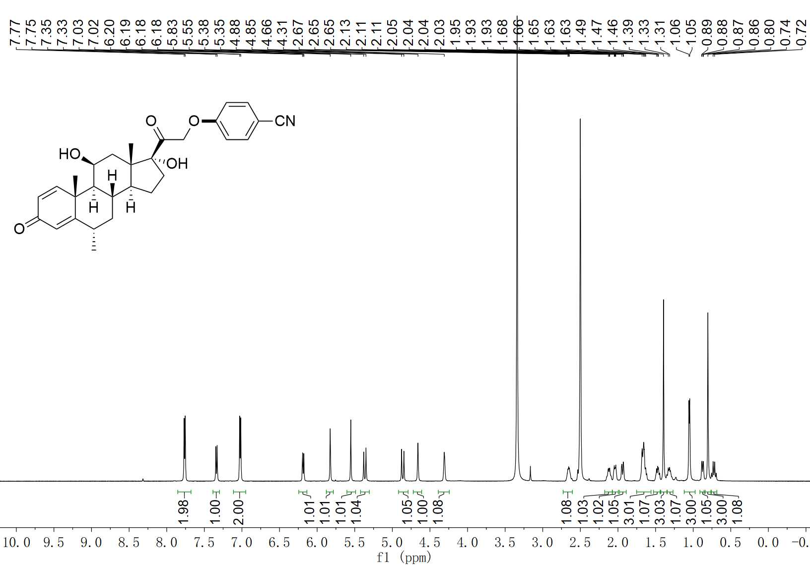
78 ¹H NMR (600 MHz, DMSO-d₆)

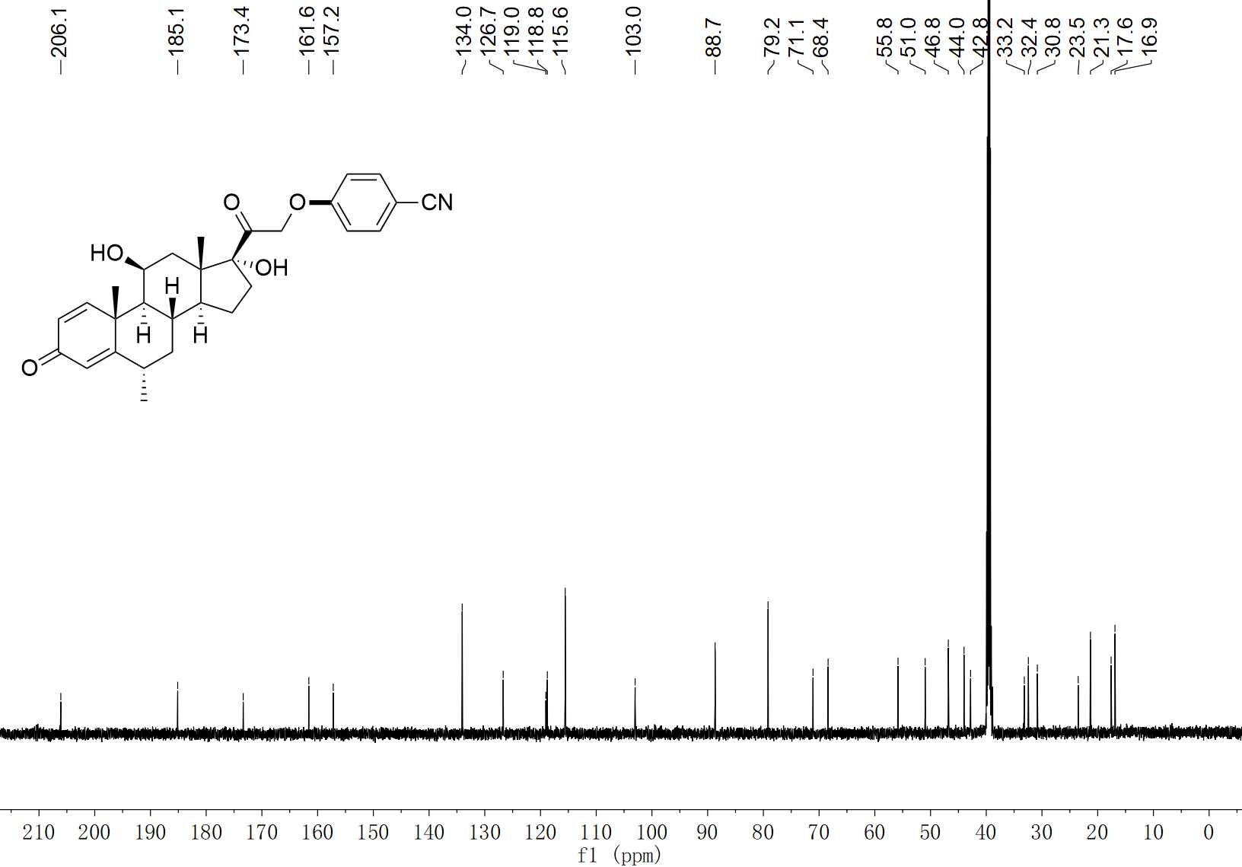
78 ¹³C NMR (150 MHz, DMSO-d₆)

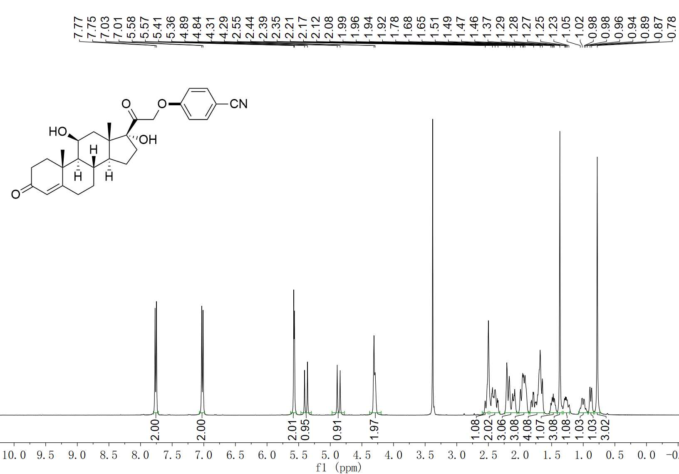
79 ¹H NMR (400 MHz, DMSO-d₆)

79 ¹³C NMR (100 MHz, DMSO-d₆)

