Supplementary Materials for

Multi-trait polygenic risk scores improve genomic prediction of atrial fibrillation across diverse ancestries

Poeya Haydarlou¹, Daria R. Kramarenko^{1,2}, Marre E. Corver¹, Nobuyuki Enzan³, Dominic S. Zimmerman¹, Patrick T. Ellinor³, Connie R. Bezzina^{1,2*}, Sean J. Jurgens^{1,3*}

- Department of Experimental Cardiology, Amsterdam Cardiovascular Sciences, Heart Failure & Arrhythmias, Amsterdam UMC location University of Amsterdam, Amsterdam, the Netherlands
- European Reference Network for rare low prevalence and complex diseases of the heart: ERN GUARD-Heart, Amsterdam, the Netherlands
- Cardiovascular Disease Initiative, Broad Institute of MIT and Harvard, Cambridge, MA, USA
* contributed equally
Table of contents:
Multi-trait polygenic risk scores improve genomic prediction of atrial fibrillation across diverse ancestries 1
Supplementary Note 3
Performance comparisons with previous AF PGSs 3
Technical aspects of our PGS methodology 3
Sex-stratified and sex-optimized polygenic scores 5
All of Us quality control 5
UK Biobank quality control and PGS evaluation 6
Meta-analysis using METAL 9
Preparation of summary statistics for meta-analysis 9
Input file formatting 9
Data conversion and preprocessing 10
AFGen+MVP meta-analysis 10
SBP meta-analysis 10
Running METAL 10
Output processing 11
BMI meta-analysis (excluded due to incompatibility) 11
PGS generation using SBayesRC 13
Input file formatting 13
Other input parameters 13
Data conversion and preprocessing 13
BMI summary statistics conversions 14
Missing sample size (N) column 15
General preprocessing for all summary statistics 15
Running SBayesRC 15
Output processing 15
Quality Control 16
Full alignment with All of Us variants 16
Applying the SBayesRC-multi tool (and the adapted multi tool) 18
Running SBayesRC-multi 18
How the SBayesRC-multi tool works 18
Adapted multi tool 19
Running the adapted multi tool 19
Reference Maps 20
Reference map selection by trait 20
Construction of the combined reference map 20
Reduction in variant loss 20
Figure generation and underlying analyses 22
Development of the Mult-a and Mult-t scores, and Main and UKB results 22
Decomposition of the Mult-t Scores by Trait 22
Performance comparison: The Mult-t-EUR vs Roselli et al. Score 23
Risk Stratification at the Extremes of the Polygenic Score Distribution 23
Secondary Analyses 24
Supplementary Figures 25
References 34

Supplementary Note

Performance comparisons with previous AF PGSs
In this study, we demonstrated that our Mult-t polygenic scores achieve superior predictive performance for AF compared to the previously established gold standard by Roselli et al. To further validate the strength of our scores, we conducted two additional comparisons with existing AF PGSs.
First, within the Roselli et al. study¹, their PGS was benchmarked against the genome-wide PGS developed by Khera et al.², making our Mult-t score indirectly comparable to that model. Specifically, they evaluated performance using Cox proportional hazards models for incident AF and Harrell’s C-index. The Roselli et al. PGS showed improved discrimination over the Khera et al. score in both the UK Biobank (0.77 vs. 0.75) and HUNT (0.87 vs. 0.85) cohorts³. Given that our Mult-t PGS outperforms the Roselli et al. score, it is likely to exceed the predictive performance of the Khera et al. PGS as well.
Second, we compared our PGSs to recent multi-ancestry scores for AF developed by Gunn et al.⁴, which were constructed using the PRS-CSx⁵ framework trained on MVP data and evaluated in the All of Us cohort. In that study, the reported ORs per SD (95% CI) were 1.68 (1.61–1.76) in European ancestry, 1.23 (1.11–1.36) in African ancestry, and 1.41 (1.25–1.60) in Admixed-American ancestry⁶, all of which were exceeded by our Mult‑t scores.
Together, these comparisons underscore the robust predictive performance of our PGSs across both European and non‑European ancestry groups compared to previous AF polygenic scores.

Technical aspects of our PGS methodology
During PGS construction and our analyses, we made several notable observations regarding the technicalities of our PGS methodology.
First, we leveraged the largest available training datasets for both European and non-European ancestries, surpassing prior AF polygenic score efforts^{4,7–9}. This large-scale training sample size was definitely the largest contributor of our Mult-t score’s improvements over the Roselli et al. score.
Second, we used all-ancestry training data rather than ancestry-specific subsets, an approach that probably owed its superiority to increased statistical power. This was exemplified by the Mult-a scores that integrated the all-ancestry (ALLmeta) and the less well performing ancestry-specific scores (e.g. EURmeta), which introduced unnecessary complexity without added predictive value compared to the ALLmeta score.
Third, when applying the multi-trait approach, we used ancestry-specific tuning sets. This strategy outperformed the use of an all-ancestry tuning set, likely because it better reflects the genetic architecture of each population and weight estimation demands less statistical power than genome-wide discovery required for training data. Supporting this, the efficacy of matching the ancestry of the tuning and validation set has previously been demonstrated in the context of integrating ancestry-specific PGSs, using the penalized regression methods lasso and ridge¹⁰.
Fourth, our multi-trait approach suggested a particular utility in non-European populations. With the largest relative gains among Asian and African ancestries, followed by European and Admixed-American ancestries, we could explain the modest gain in Admixed-Americans with its small training sample sizes for AF and the correlated traits. However, the relatively limited improvement in Europeans is less intuitive given its large training data.
One possible explanation involves differences in linkage disequilibrium (LD) patterns across populations. Single-trait PGSs trained predominantly on European data may transfer poorly to other ancestries due to LD mismatches¹¹. In contrast, multi-trait models may be more robust across ancestries by leveraging pleiotropic variants that are less affected by these mismatches. As a result, this approach provides greater benefit in non-European groups, whereas European individuals, whose genetic structure already aligns well with the training data, derive less additional value. Supporting this, a recent study on hematological traits found that multi-trait genetic effect sizes were highly consistent across ancestries: 75% of SNVs showed correlations >0.8 between Europeans and East Asians, and the median European–African correlation was 0.87 after excluding the ancestry-specific ACKR1 locus¹². While these results were observed in the context of locus discovery, they provide a biological rationale for the improved performance of our multi-trait models in non-European populations.
Furthermore, when we decomposed our Mult‑t models by trait, we found additional evidence supporting the enhanced prediction of our multi‑trait approach in non‑European populations. Namely, we observed heterogeneity in mixing weights across the ancestry-specific tuning sets, suggesting that the trait-specific polygenic scores capture ancestry-specific signals beyond the AF-derived PGS alone. Additionally, we evaluated the trait-specific scores individually. The discrepancies between trait contributions and standalone performance imply that multivariate models prioritize traits offering complementary information rather than those with the strongest individual effects. However, some differences may also stem from variation between tuning and validation datasets.

Collectively, these methodological considerations - including the use of diverse large-scale all-ancestry training data in combination with an ancestry-informed multi-trait approach, and the particular utility of this approach in underrepresented populations - have contributed to the strong predictive performance of our Mult‑t scores across diverse populations, and lay a foundation for the development of future PGS methodologies for atrial fibrillation and other complex traits.

Sex-stratified and sex-optimized polygenic scores
As precision medicine advances, individualized PGSs, such as those developed in this study to target specific ancestry groups, are essential for capturing the considerable genetic variability across ancestries and for avoiding the perpetuation of health disparities in underrepresented groups. To further refine risk prediction, future research should also consider sex-stratified PGSs, as the performance of AF polygenic scores may differ by sex¹³.
Our subgroup analysis supported this notion, showing a stronger association between our polygenic score and AF risk in males. Additionally, epidemiological evidence indicates that men have a higher prevalence of AF, along with a greater burden of coronary artery disease and a stronger association with body mass index, whereas women with AF face higher risks of heart failure and stroke¹⁴.
These sex-specific differences in associated traits highlight the potential value of a sex-stratified multi-trait approach to AF risk prediction. However, further investigation is warranted to determine how sex-stratified and sex-optimized PGSs may improve individualized genomic prediction.

All of Us quality control
We obtained genotypes in PLINK binary format from the jointly called ACAF (an Allele Count/Allele Frequency) call set (v8) provided by All of Us (AoU). This dataset includes only high-quality genotypes, with multi-allelic variants already split into bi-allelic variants and variants with allele frequency (AF) = 0 removed, as described in the AoU Genomic Quality Report (https://support.researchallofus.org/hc/en-us/articles/29390274413716-All-of-Us-Genomic-Quality-Report). We further filtered variants based on the following criteria: (1) monomorphic variants and (2) call rate < 90%. For sample-level quality control, we excluded individuals flagged or identified as having known issues by AoU. We retained only samples with dragen_sex_ploidy equal to "XX" or "XY", excluded samples with genotype missingness > 5%, and removed potential duplicates. Duplicate resolution prioritized retaining individuals with linked electronic health record (EHR) data, followed by higher call rate (with greater weight given to EHR availability). Potential duplicates were identified using KING v2.3.2, with one sample from each pair flagged for removal if the heterozygous concordance exceeded 0.8.
To infer population structure across all samples, we conducted principal component analysis (PCA), as the components provided by the AoU were based on external reference datasets (HGDP and 1000 Genomes Project). We first generated a filtered set of autosomal variants for both relatedness estimation and PCA. Variants were required to have a minor allele frequency (MAF) > 0.01 and genotype missingness < 1%. Linkage disequilibrium (LD) pruning was performed using PLINK with the parameters --indep-pairwise 500 200 0.1 and --indep-pairwise 2000 400 0.1. Variants located in long-range LD regions were excluded, and 100,000 variants were randomly selected from the remaining set. Based on this variant set, we estimated pairwise relatedness with KING v2.3.2, and identified unrelated individuals as those with a kinship coefficient < 0.042. PCA was then performed using flashPCA v2.0. Principal components were computed on the unrelated individuals, and the resulting components were projected onto the remaining samples.

UK Biobank quality control and PGS evaluation
Within the UK Biobank cohort, we evaluated the Roselli et al. polygenic score and simpler versions of the non-European final Mult-t polygenic scores excluding the traits height, BMI, and DCM, since these contained non-European UKB training data or only contained European training data (DCM).
The UK Biobank is a large-scale biomedical resource comprising extensive health and genetic data from approximately 500,000 participants across the United Kingdom. Whole-genome sequencing (WGS) data were processed through the DRAGEN pipeline, with additional quality corrections applied via a machine learning-based approach. Details of the processing pipeline are available at:
https://community.ukbiobank.ac.uk/hc/en-gb/articles/26273057297949-ML-Corrected-DRAGEN-whole-genome-sequencing-WGS-release. The processed data were filtered at the cohort-level and converted from DRAGEN pVCFs to PLINK2 format (PGEN, PVAR, PSAM) for further analysis (Field 24310). All analyses were conducted under UK Biobank application number 176602. The initial dataset included 1,340,689,096 autosomal variants and 490,541 individuals. We applied variant- and sample-level QC and filtering steps to the PLINK files across all autosomal chromosomes.
First, we applied variant-level quality control. Variants were excluded if they failed the DRAGEN machine-learning filters or did not meet standard INFO field criteria (INFO ≠ PASS) as assessed using PLINK2 (v- linux_avx2_20250515). Additionally, variants with missingness ≥ 0.1, minor allele count < 1, or those with ExcessHet P < 1×10⁻²⁰ were removed. This process resulted in a final set of 1,108,365,254 autosomal variants.
We then defined a high-quality subset of autosomal variants for downstream analyses using PLINK2 (v-linux_avx2_20250515). Variants were filtered to retain those with a minor allele frequency (MAF) ≥ 0.01 and genotype missingness < 0.01. Variants located in long-range linkage disequilibrium (LD) regions were excluded. We performed LD pruning in two stages using PLINK2’s --indep-pairwise command: initially with 500 200 0.1, then using 2000 400 0.1. This procedure yielded a final set of 267,759 autosomal variants, which were then used to compute sample relatedness and principal component analysis (PCA).
For sample QC, we first excluded all samples with revoked consents (N = 245). Individuals with discrepancies between genetically inferred sex versus self-reported sex were identified using X-chromosome inbreeding coefficients (F) calculated with PLINK2 (v-linux_x86_64_20240818) on pruned variants (MAF > 0.005, missingness < 0.01, pruned with --indep-pairwise 500 200 0.1 and then --indep-pairwise 2000 400 0.1). Samples with an F < 0.5 were assigned female sex and those with F > 0.8 were assigned male sex. A total of 210 samples showed sex mismatch and were removed. Duplicate pairs were identified based on a heterozygote concordance rate > 0.8, and one individual per pair was removed (N=235). Additionally, samples failing centrally computed DNA quality metrics (N=239), samples with DNA contamination score ≥ 2 (N=67), samples with missingness > 0.01 (N=0), and outliers for PC-adjusted Ti/Tv ratio, PC-adjusted Het/Hom ratio, PC-adjusted SNV/indel ratio, and PC-adjusted number of singletons (N=1653) were also excluded. After completing this process, the dataset comprised 487,894 samples.
To assess relatedness within the UK Biobank cohort, samples were split into twenty subsets. Kinship coefficients were then estimated both within and between subsets using KING (v2.3.2). We ran PCA on unrelated individuals (kinship < 0.0442) using FlashPCA (v2.0), and then projected the resulting eigenvectors onto the remaining samples.
Following QC, we conducted ancestry inference to assign individuals from the UK Biobank cohort to continental ancestry groups. We used the 1000 Genomes Project (1KG) cohort, which contains individuals with well-characterized (super)populations, as a reference for ancestry inference. Variants present in both the UK Biobank and 1KG datasets were filtered to retain those with MAF ≥ 0.01 and genotype missingness < 0.01, and excluding variants located in long-range linkage disequilibrium regions (PLINK2 v-linux_avx2_20250515). Only variants common to both cohorts were kept. LD pruning in the 1KG cohort was performed sequentially within superpopulations: starting with pruning in the African subset (AFR), then extracting those AFR-pruned variants from European (EUR) subset, before pruning EUR variants, followed by the same approach for Admixed American (AMR), South Asian (SAS), and East Asian (EAS) populations. For each pruning step, the parameters were --indep-pairwise 1000 100 0.2. This procedure resulted in a final prune set of 98,077 variants which were extracted from the 1KG and UKB datasets. Using ADMIXTURE (v1.3.0), ancestry components were inferred from the pruned 1KG data, and these components were then projected onto UKB samples. Individuals with ≥ 0.8 estimated ancestry proportion were assigned to the corresponding continental group.
To identify individuals diagnosed with atrial fibrillation (AF) within the UK Biobank dataset, we employed the ukbrapR package (v- 0.3.7). AF cases were defined by the presence of relevant ICD-10 codes (I48, I48.0, I48.1, I48.2, I48.3, I48.4, I48.9), or ICD-9 codes (427.3, 427.31, 427.32). Participants with at least one relevant diagnostic code were classified as AF cases, using only the earliest recorded diagnosis date for each individual.
Finally, polygenic scores were calculated for all individuals who passed sample quality control, using the Roselli et al. scoring file or the simpler Mult-t scoring files for AFR, AMR, and ASN populations. PGSs were evaluated only within ancestry-specific subsets, which were restricted to AFR and ASN individuals due to the low number of AF cases in the AMR cohort (N = 5). Case and control numbers for the AFR and ASN validation sets can be derived from Table S9.

Meta-analysis using METAL
We used METAL (version released on 2011-03-25) to perform an inverse-variance weighted meta-analysis of the AFGen and MVP summary statistics for both all-ancestry and ancestry-specific datasets (EUR, AFR, and AMR). EAS summary statistics were not included, as only AFGen data was available for this ancestry.
Data pre- and post-processing were carried out on a high-performance computing cluster (HPC) using Bash shell commands (primarily awk), with R (v4.4.2) used when specialized functions were needed.

Preparation of summary statistics for meta-analysis
To align variants between studies, we matched variants by chromosome, position, reference allele, and alternate allele (CPRA format). This step served two purposes: (i) ensuring correct alignment of alleles across input files, and (ii) determining whether ambiguous SNPs (A/T or C/G) needed exclusion.
If the initial overlap between datasets was high (typically ~90%), we assumed correct alignment and proceeded with the original configuration. If overlap was low, we swapped the reference and alternate alleles and reassessed. In all cases, one configuration resulted in ~90% overlap and the other in ~0%, indicating strand alignment was consistent and ambiguous SNPs did not require removal. Such SNPs would have caused partial, rather than binary, overlap in both configurations. Additionally, indels were checked and excluded where necessary.

Input file formatting
For METAL input, both summary statistics files were formatted to include the following columns:
- CPRA: variant ID in chromosome:position:reference:alternate format
- A1: effect allele (uppercase)
- A2: non-effect allele (uppercase)
- freq: frequency of A1
- b: beta or effect size
- se: standard error of the effect size
- p: p-value
- N: total sample size per variant
For the AFGen+MVP meta-analysis, we also included N_cases (number of AF cases) and N_controls (number of controls) per variant. All input files were sorted numerically by CPRA prior to meta-analysis.

Data conversion and preprocessing

AFGen+MVP meta-analysis
- For MVP, beta values were derived by log-transforming the reported odds ratios: beta = log(OR)
- Standard errors were calculated from beta and p-value using the formula:
z = qnorm(p / 2, lower.tail = FALSE) * sign(beta)
SE = beta / z

SBP meta-analysis
- Due to the large input file sizes (28M and 96M SNPs), a minor allele frequency (MAF) filter >0.0025 was applied to reduce runtime.
- For the Shi dataset, –log₁₀(p) values were converted to p-values, and variants with INFO score <0.8 were excluded.
- Shi reported a rank-based inverse normal transformation, while MVP applied a standard inverse normal transformation. Compatibility was confirmed by comparing effect sizes of the top SNPs (lowest p-values) and their beta distributions after filtering on MAF >0.05. These were comparable, allowing us to proceed without further transformation.
Both analyses included checks for missing values (NA), and variants with missing data were removed.

Running METAL
Meta-analyses were executed using METAL. The execution script for both the AFGen+MVP¹⁵ and SBP¹⁶ datasets is available in the associated GitHub repositories.

Output processing
Following meta-analysis, output files were sorted by CPRA. For the SBP meta-analysis, sample size values in scientific notation were converted to plain numbers using awk with the sprintf function.
METAL output included all input columns, along with:
- FreqSE (standard error of allele frequency)
- Direction (effect direction per study, e.g., ++ for concordant effects)
Since METAL does not output rsIDs when using CPRA format, we added a SNP column containing rsIDs, which was required for SBayesRC:
- For the AFGen+MVP meta-analysis output, rsIDs (hg38) were retrieved from the original summary statistics by matching on chromosome and position (hg38).
- For the SBP meta-analysis output, rsIDs (hg38) were retrieved from the AFGen+UKB reference map by matching on chromosome and position (hg38), as the original Shi dataset lacked rsIDs. Details on this map are provided in the Reference Map section.

BMI meta-analysis (excluded due to incompatibility)
We explored a meta-analysis of BMI summary statistics from Jonsdottir and MVP to increase the sample size with diverse ancestries. MVP included 424,221 EUR, 118,993 AFR, 57,793 AMR, and 6,384 EAS individuals (GCST90479521). Jonsdottir reported raw BMI, whereas MVP applied an inverse normal transformation.
To approximate a raw BMI scale for MVP, we multiplied beta values by 5.5, reflecting the standard deviation (SD) observed in a cohort of 6,242 Mexican American adults (mean BMI: 28.0 kg/m², SD: 5.5 kg/m²)¹⁷. We assessed compatibility before and after this transformation by comparing the effect sizes of the 10–20 most significant SNPs (lowest p-values) and the overall beta distributions after filtering on MAF >0.05. In both cases, comparability remained limited. Additionally, when running SBayesRC with this input, the MCMC iterations yielded unrealistically high SNP heritability estimates (around h² = 0.7).
These findings suggested scale incompatibility between the datasets. Therefore, we excluded the MVP data and proceeded with the Jonsdottir data alone for downstream analyses.

PGS generation using SBayesRC

Input file formatting
For SBayesRC (v0.2.6) input, summary statistics files were formatted to include the following columns:
- SNP: variant ID in rsID format
- A1: effect allele (uppercase)
- A2: non-effect allele (uppercase)
- freq: frequency of A1
- b: beta or effect size
- se: standard error of the effect size
- p: p-value
- N: total sample size per variant

Other input parameters
- LD reference panel: Linkage disequilibrium (LD) reference panels for three ancestries were available, based on imputed genotypes from the UK Biobank (UKB): European (EUR, n = 347,800), African (AFR, n = 7,006), and East Asian (EAS, n = 2,252). We used ancestry-matched LD reference panels for the EUR, AFR, and EAS summary statistics. For summary statistics resulting in the AMRmeta, ALLmeta, or trait-specific PGSs, the European LD reference was used due to the absence of AMR- and all-ancestry LD panels.
- Annotation file: Functional annotations for the 8,140,664 UKB imputed SNPs (Baseline-LD model v2.2¹⁸) were used.
Both the LD reference files and annotation file were downloaded from the Zhili Zheng GitHub repository¹⁹.

Data conversion and preprocessing
The HF and the East Asian AF summary statistics required no conversion, as all required columns were present. The same applied to the SBP, as well as the ancestry-specific (EUR, AFR, AMR) and all-ancestry AF summary statistics derived from METAL, which outputs the columns needed for SBayesRC. An rsID column was added afterward; see the METAL output processing section for details.
Data pre- and post-processing were carried out on a HPC using Bash shell commands (primarily awk), with R (v4.4.2) used when specialized functions were needed.
SBayesRC requires variant identifiers in rsID format. Therefore we converted the summary statistics that lacked this column:
- Height, CAD, and PR interval: rsIDs (hg38) were retrieved from the AFGen+UKB reference map by matching on chromosome and position (hg19).
- BMI: rsIDs (hg38) were retrieved from the AFGen+UKB reference map by matching on chromosome and position (hg38).
- DCM: rsIDs (hg38) were retrieved from a separate UKB reference map by matching on chromosome and position (hg19).
Details on these reference maps are provided in the Reference Map section.

BMI summary statistics conversions
- In the CPRA column, we removed the "chr" prefix and converted the delimiter from "_" to " : ".
- We added a freq1 column by matching on CPRA format and A1 allele from the all-ancestry AFGen+MVP summary statistics. If A2 in the BMI data matched the A1 in the reference, alleles were flipped and the beta value multiplied by -1.
- Variants were filtered on MAF >0.0025, as the file contained ~27 million SNPs after frequency imputation and was initially prepared for METAL input. This filter was retained in subsequent steps. This was considered acceptable, as the final BMI scoring file contained a number of SNPs comparable to those of the other traits.
- Outlier filtering: variants with extreme beta values (>1 SD from the median; -0.845 < b > 0.845) and variants with implausibly high sample sizes (N > 2,005,180; the total sample size for BMI) were removed.
- Standard errors were calculated from beta and p-value using the formula:
z = qnorm(p / 2, lower.tail = FALSE) * sign(beta)
SE = beta / z

Missing sample size (N) column
For BMI and PR interval, we calculated effective sample sizes (Neff) from MAF and SE using:
MAF = ifelse(freq > 0.5, 1 - freq, freq)
Neff = 1 / (2 * MAF * (1 - MAF) * (SE ^ 2))

General preprocessing for all summary statistics
- Checked CPRA overlap with the (AFGen+)UKB reference map and aligned reference and alternate alleles accordingly, as this map was harmonized as much as possible with the All of Us variant set.
- Removed variants with non-ACGT alleles.
- Excluded variants with missing values (NA).

Running SBayesRC
We used Apptainer (formerly Singularity) to run SBayesRC within a pre-built containerized environment provided by the tool’s developer, which included all required packages and dependencies. SBayesRC was run with 16 CPUs and ~70 GB of memory, with a typical runtime of approximately 4.5 hours.
An example execution script for the all-ancestry AFGen+MVP summary statistics is available in the associated GitHub repository²⁰.

Output processing
Since SBayesRC does not output CPRA format, this was added manually, as it was required for downstream analyses in All of Us. We distinguished between input SNPs, present in the original summary statistics, and imputed SNPs, added by SBayesRC due to presence in the annotation file but absence in the input:
- For AF ancestry-specific and all-ancestry summary statistics, CPRA format (hg38) for input SNPs was retrieved from the original summary statistics by matching on rsIDs (hg38). For imputed SNPs, rsIDs from the UKB reference map were used for matching.
- For other trait-specific summary statistics (excluding DCM), CPRA format (hg38) for both input and imputed SNPs was retrieved from the AFGen+UKB reference map by matching on rsIDs (hg38). For DCM, the UKB reference map alone was sufficient, as no variant loss was observed. The original summary statistics were not used here, as most lacked rsIDs.
- Thereafter, for trait-specific summary statistics (excluding AF), A1 and A2 alleles from the original summary statistics were re-added into the CPRA column in alignment with the reference map. This ensured allele consistency with the original summary statistics. For AF, this step was not necessary, as CPRA format was derived directly from the original summary statistics.

Quality Control
- Duplicate rsIDs from input files were removed unless they had identical alleles and effect sizes or represented multi-allelic variants.
- Duplicate rsIDs present in the (AFGen+)UKBrefmap were absent in the files generated after adding CPRA format to the SBayesRC output by matching on rsIDs. Duplicates in these files could have led to incorrect CPRA assignments.
- No duplicate rsIDs or CPRA identifiers were found in the final scoring files.
- Indels were removed from the final scoring files if necessary.

Full alignment with All of Us variants
To minimize variant loss when applying the final scoring files in All of Us, we first concatenated all .pvar chromosome files to generate a merged reference file containing all variants present in All of Us participants with available short-read whole genome sequencing (srWGS) data. We then assessed overlap between this reference and the final PGS file by matching variants using the CPRA format. All steps were performed using Bash shell commands on the All of Us cloud computing platform.
Variants that did not match were separated, and their reference and alternate alleles were flipped. These flipped variants were appended to the bottom of the PGS file. The resulting file was fully aligned with the All of Us variant set and ready for polygenic scoring using the --score flag in PLINK2.

Applying the SBayesRC-multi tool (and the adapted multi tool)
We applied the SBayesRC-multi function by tweaking the publicly available code from Zhili Zheng’s GitHub repository¹⁹. Several adjustments were made to tailor the script to our data and study design:
- Renamed the score column from SCORE to SCORE1_SUM to match our input files.
- Replaced linear regression with logistic regression to accommodate the binary outcome (AF presence vs. absence).
- Substituted adjusted R² with Nagelkerke’s R² for model evaluation in the tuning set.
- Modified the script to read CSV input files instead of TSV.

Running SBayesRC-multi
We ran the tool in RStudio (v4.5.0) on the All of Us cloud computing platform. The execution script is available in the associated GitHub repository²¹.

How the SBayesRC-multi tool works
The SBayesRC multi-tool takes as input a tuning set file, two PGS files, and a phenotype file. It first merges these datasets to retain only individuals present in the tuning set, with columns for each PGS and the phenotype (AF case = 1, control = 0). A logistic regression model is then fitted in the tuning set, using AF status as the outcome and both PGSs as predictors. This yields an intercept and a regression coefficient (weight) for each PGS, so that the scores are mutually adjusted and weighted according to their predictive value in the tuning set. PGSs with higher predictive accuracy receive higher weights.
Using the fitted model and the predict() function in R, the tool computes a new, weighted PGS for each individual in the full dataset. To prevent overfitting, individuals from the tuning set were excluded from downstream evaluation; this step was performed outside the tool. The tool outputs (i) the unscaled regression coefficients for each PGS, (ii) Nagelkerke’s R² in the tuning set for each input PGS and the weighted PGS, and (iii) the final weighted PGS values for each individual.

Adapted multi tool
We later developed an adapted version of the SBayesRC-multi tool to improve flexibility in both input and output handling. The key differences compared to the SBayesRC-multi implementation are:
- Support for more than two input PGS files, allowing integration of multiple scores simultaneously.
- Two output files:
- .unscaled.regcoef.csv, containing:
  - Unscaled regression coefficients, based on the raw PGS inputs
(i.e., without normalization or standardization).
  - Proportions: the coefficients normalized to sum to 100% using abs(regrcoef) / sum(abs(regrcoef)) * 100
  - Nagelkerke’s R².
- .mixing.weights.csv, containing:
  - Scaled regression coefficients (mixing weights), calculated by multiplying each unscaled coefficient by the standard deviation of its corresponding PGS in the tuning set.
  - Proportions
  - Standard deviations
This replaces the original .weight file, which included only the unscaled regression coefficients and Nagelkerke’s R².

Running the adapted multi tool
The execution script is available in the associated GitHub repository²².

Reference Maps
We constructed reference maps to facilitate several essential data conversions:
- Converting CPRA format to rsIDs following METAL output.
- Converting rsIDs back to CPRA format after SBayesRC output.
- Lifting over summary statistics from genome build GRCh37 (hg19) to GRCh38 (hg38).
Each reference map included the following columns: CPRA (hg19), CPRA (hg38), and rsID (hg38). Reference and alternate alleles were aligned to maximize concordance with allele representations in the All of Us dataset.

Reference map selection by trait
The combined AFGen+UKB reference map was used for all traits except AF and DCM, for which the UKB reference map alone was sufficient. For these two traits, variant-level missingness was minimal or nonexistent, either when recovering CPRA format from imputed SNPs from the SBayesRC output (AF) or during build conversion from GRCh37 to GRCh38 (DCM). In contrast, applying the UKB reference map to other traits led to substantial missingness during build conversion: CAD (33.6%), Height (7.1%), and PR-interval (4.0%). This motivated the construction of the AFGen+UKB reference map, which was applied to the remaining traits.

Construction of the combined reference map
To build the combined reference map, we merged reference files derived from the AFGen summary statistics and the UK Biobank. We retained only the unique rows and appended AFGen entries below those of UKB. This was done on a HPC using Bash shell commands.

Reduction in variant loss
Using the AFGen+UKB reference map reduced variant loss during genome build liftover. For example, from 33.6% to 23.0% for CAD. Although some variants were still lost, the number included in the final scoring files was comparable across traits, even in traits with minimal loss. Therefore, we considered the persisting gap acceptable.

Figure generation and underlying analyses
The following analyses were performed in RStudio (v4.5.0) on the All of Us cloud computing platform. Figure generation was done in RStudio (≥ v4.4.1), either on the cloud or locally. However, flowcharts (Figs. 1, S1, S3, and S4) were created using BioRender.com.

Development of Mult-a, Mult-t, Main, PRSmix+, and UKB results
Figures displaying results from the development of the Mult-a (Fig. S2; Table S1) and Mult-t (Fig. S5; Table S2) scores, as well as the main results (Fig. 2; Table S3), the PRSmix+ results (Fig. S6, Table S5), and from the UK Biobank cohort (Fig. 4; Table S9) were created using the forest() function from the metafor package. Each figure shows a forest plot (left) and additional performance metrics in a table-like layout (right), both generated using a single call to metafor::forest().
Most performance metrics were extracted using base R, while AUROC was calculated with the pROC package, AUPRC with the PRROC package, and Nagelkerke’s R² with the fmsb package. Liability R² was derived using a custom function based on the formulas from this study²³.

Decomposition of the Mult-t Scores by Trait
The figure showing the scaled relative regression coefficients (mixing weights) of the Mult-t PGSs across ancestry-specific tuning sets (Fig. 3) was based on the mixing proportions per trait from the .mixing.weights.csv output file of the adapted multi tool (Table S6). The figure showing the unscaled relative regression coefficients (Fig. S7) used the proportions from the .unscaled.regcoef.csv file (Table S7). The derivation of these proportions is described in the Adapted multi tool section. Both bar plots were generated using ggplot() and geom_bar() from the ggplot2 package, with styling from theme_cowplot() in the cowplot package.
Trait-specific PGSs evaluated individually (Figs. S8–S11; Table S8) were visualized using forest plots created with metafor::forest() from the metafor package, following the same approach as in the main results.

Performance comparison: The Mult-t-EUR vs Roselli et al. Score
Both the Roselli et al. and Mult-t-EUR polygenic scores were first normalized by adjusting for the first 20 principal components (PCs) of ancestry, then standardized to a mean of 0 and a standard deviation of 1. Subsequently, the PGSs were divided into 100 percentile groups using percent_rank() from the dplyr package.
To create the figure showing AF prevalence with 95% confidence intervals (Fig. 5), we calculated the prevalence per percentile group as the proportion of cases (cases / N * 100). The 95% confidence intervals were estimated using binom.test(), and bounds were multiplied by 100 to report percentages. The graph was created using ggplot(), with geom_point() for the prevalence dots, geom_errorbar for the confidence intervals, and geom_hline for the horizontal dashed lines displaying the prevalence values at the lowest and highest percentile.
For the figure showing the distribution of cases and controls across percentiles (Fig. S12), we created separate data frames for cases and controls, stratified by PGS percentile. These were combined and labeled, and plotted using geom_boxplot(), which internally calculates and displays the median, interquartile range, and whiskers. To report exact summary values for cases, we also calculated the median and interquartile range using median(), and quantile() with 0.25 and 0.75 as input values.

Risk Stratification at the Extremes of the Polygenic Score Distribution
To identify individuals with a 3-, 4-, or 5-fold increased risk (Fig. 6) or a ⅓-fold decreased risk (Fig. S13) of AF compared to the middle quintile, we sorted individuals by their normalized and standardized PGS values from high to low. This was done separately for both the Roselli et al. and Mult-t-EUR scores. For each risk threshold, we iteratively defined the “top group” as individuals with PGS values above a moving threshold. Starting from the highest PGS value, we progressively included more individuals by lowering this threshold in fixed steps. At each step, the top group was compared to the middle quintile group (defined using the quantile() function at the 40th and 60th percentiles) using logistic regression adjusted for age and sex. The process continued until the smallest group with an odds ratio (OR) ≥3, 4, or 5 was identified. The corresponding PGS threshold and the proportion of individuals within each group were stored. For the decreased risk analysis (⅓-fold), we initiated the search at the 40th percentile and expanded downward to identify the largest group with OR ≤ ⅓ compared to the middle quintile. Groups identified with an even lower risk (e.g., <¼- or ⅕-fold) were too small for reliable interpretation and were therefore excluded.
Density plots were generated using ggplot2, with vertical dashed lines marking the PGS thresholds for each risk group added via geom_vline(). Regions corresponding to >3-, 4-, or 5-fold increased risk (or <⅓-fold decreased risk) were shaded in progressively darker reds using geom_area(), while the middle quintile region (40th–60th percentile) was similarly shaded in grey with geom_area() and bounded by vertical dashed lines.
Histograms displaying the proportion of individuals within the increased risk groups (Fig. 6) or the decreased risk group (Fig. S13) were created using ggplot() and geom_col(), with styling from theme_cowplot() in the cowplot package.

Secondary Analyses
Figures for the sensitivity (Fig. S14; Table S10) and subset analyses (Fig. S15; Table S11) were generated using metafor::forest() from the metafor package. Exclusion of individuals from Massachusetts or affiliated with the Veteran Affairs system (for the sensitivity analysis), as well as subset extraction for the Mult-t-EUR PGS, was performed after PGS normalization and standardization, and following ancestry-specific subset selection, but prior to fitting the logistic regression model.

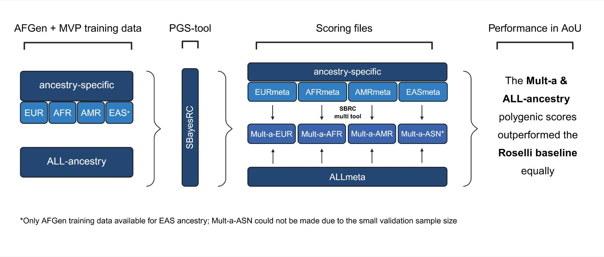
Supplementary Figures

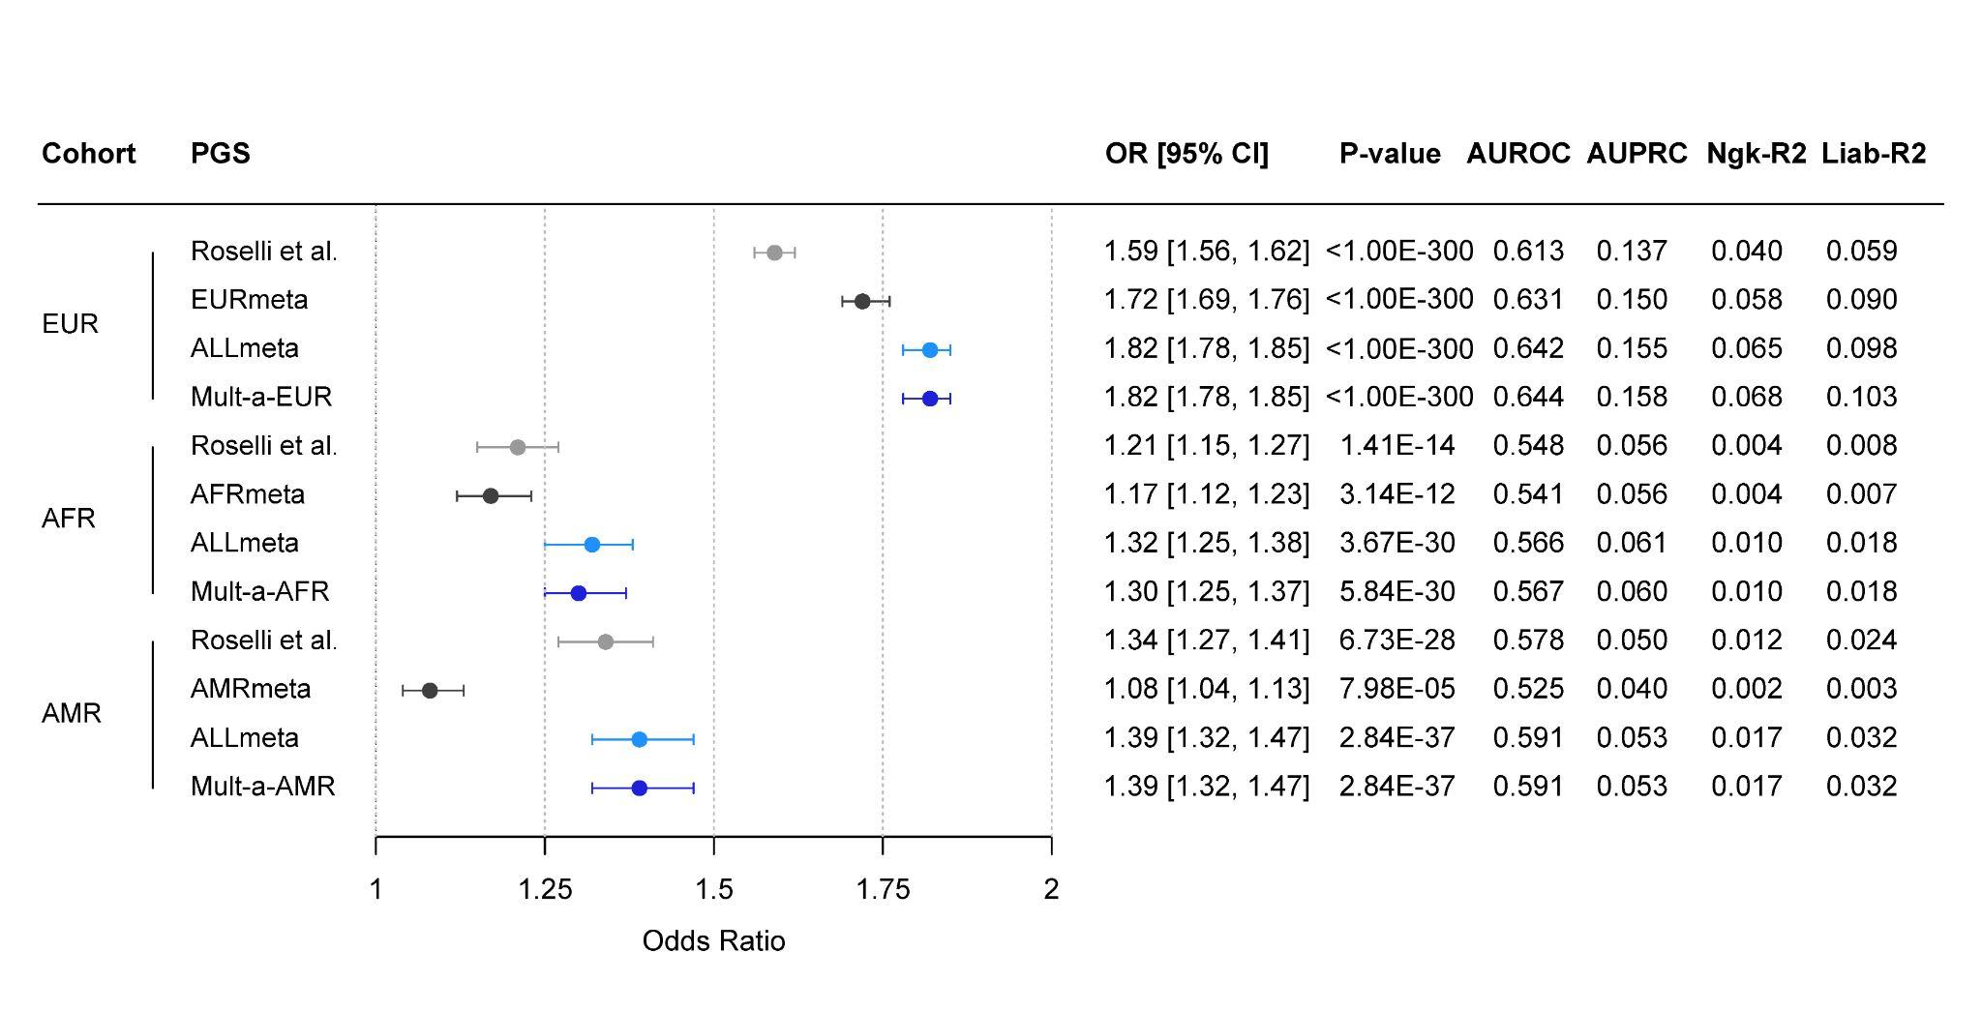
Fig. S1 | Mult-a polygenic scores development, an overview. This flowchart outlines the development of the Mult-a polygenic scores from left to right. Ancestry-specific (EUR, AFR, AMR, EAS) and all-ancestry GWAS summary statistics from the AFGen and MVP cohorts were first processed using SBayesRC to generate scoring files. We then used the SBayesRC-multi tool to combine each ancestry-specific file with the all-ancestry file, weighted by predictive accuracy in the 30% tuning dataset of All of Us, to create ancestry-matched Mult-a scores. In the final step, the scoring files were evaluated in the 70% validation dataset of All of Us (Table S4), where both the Mult-a scores and the all-ancestry score performed equally well and outperformed the all-ancestry trained Roselli baseline. Created with BioRender.com.

Fig. S2 | Comparison of the Roselli et al., ancestry-specific, ALLmeta, and Mult-a polygenic scores. The left panel displays a forest plot of the OR/SD increase in PGS for AF, with 95% CIs on the x-axis. The y-axis lists the ancestry-specific validation cohorts, ordered by decreasing cohort size, each paired with its respective PGSs. The right panel summarizes key performance metrics from the validation set. All estimates are based on logistic regression models adjusted for the first 20 PCs, age, and sex, using case/control counts from the 70% validation dataset of All of Us (Table S4). Due to the limited sample size of the 70% ASN validation dataset, the EASmeta and Mult-a-ASN scores were not evaluated. Model performance details are provided (Table S1).

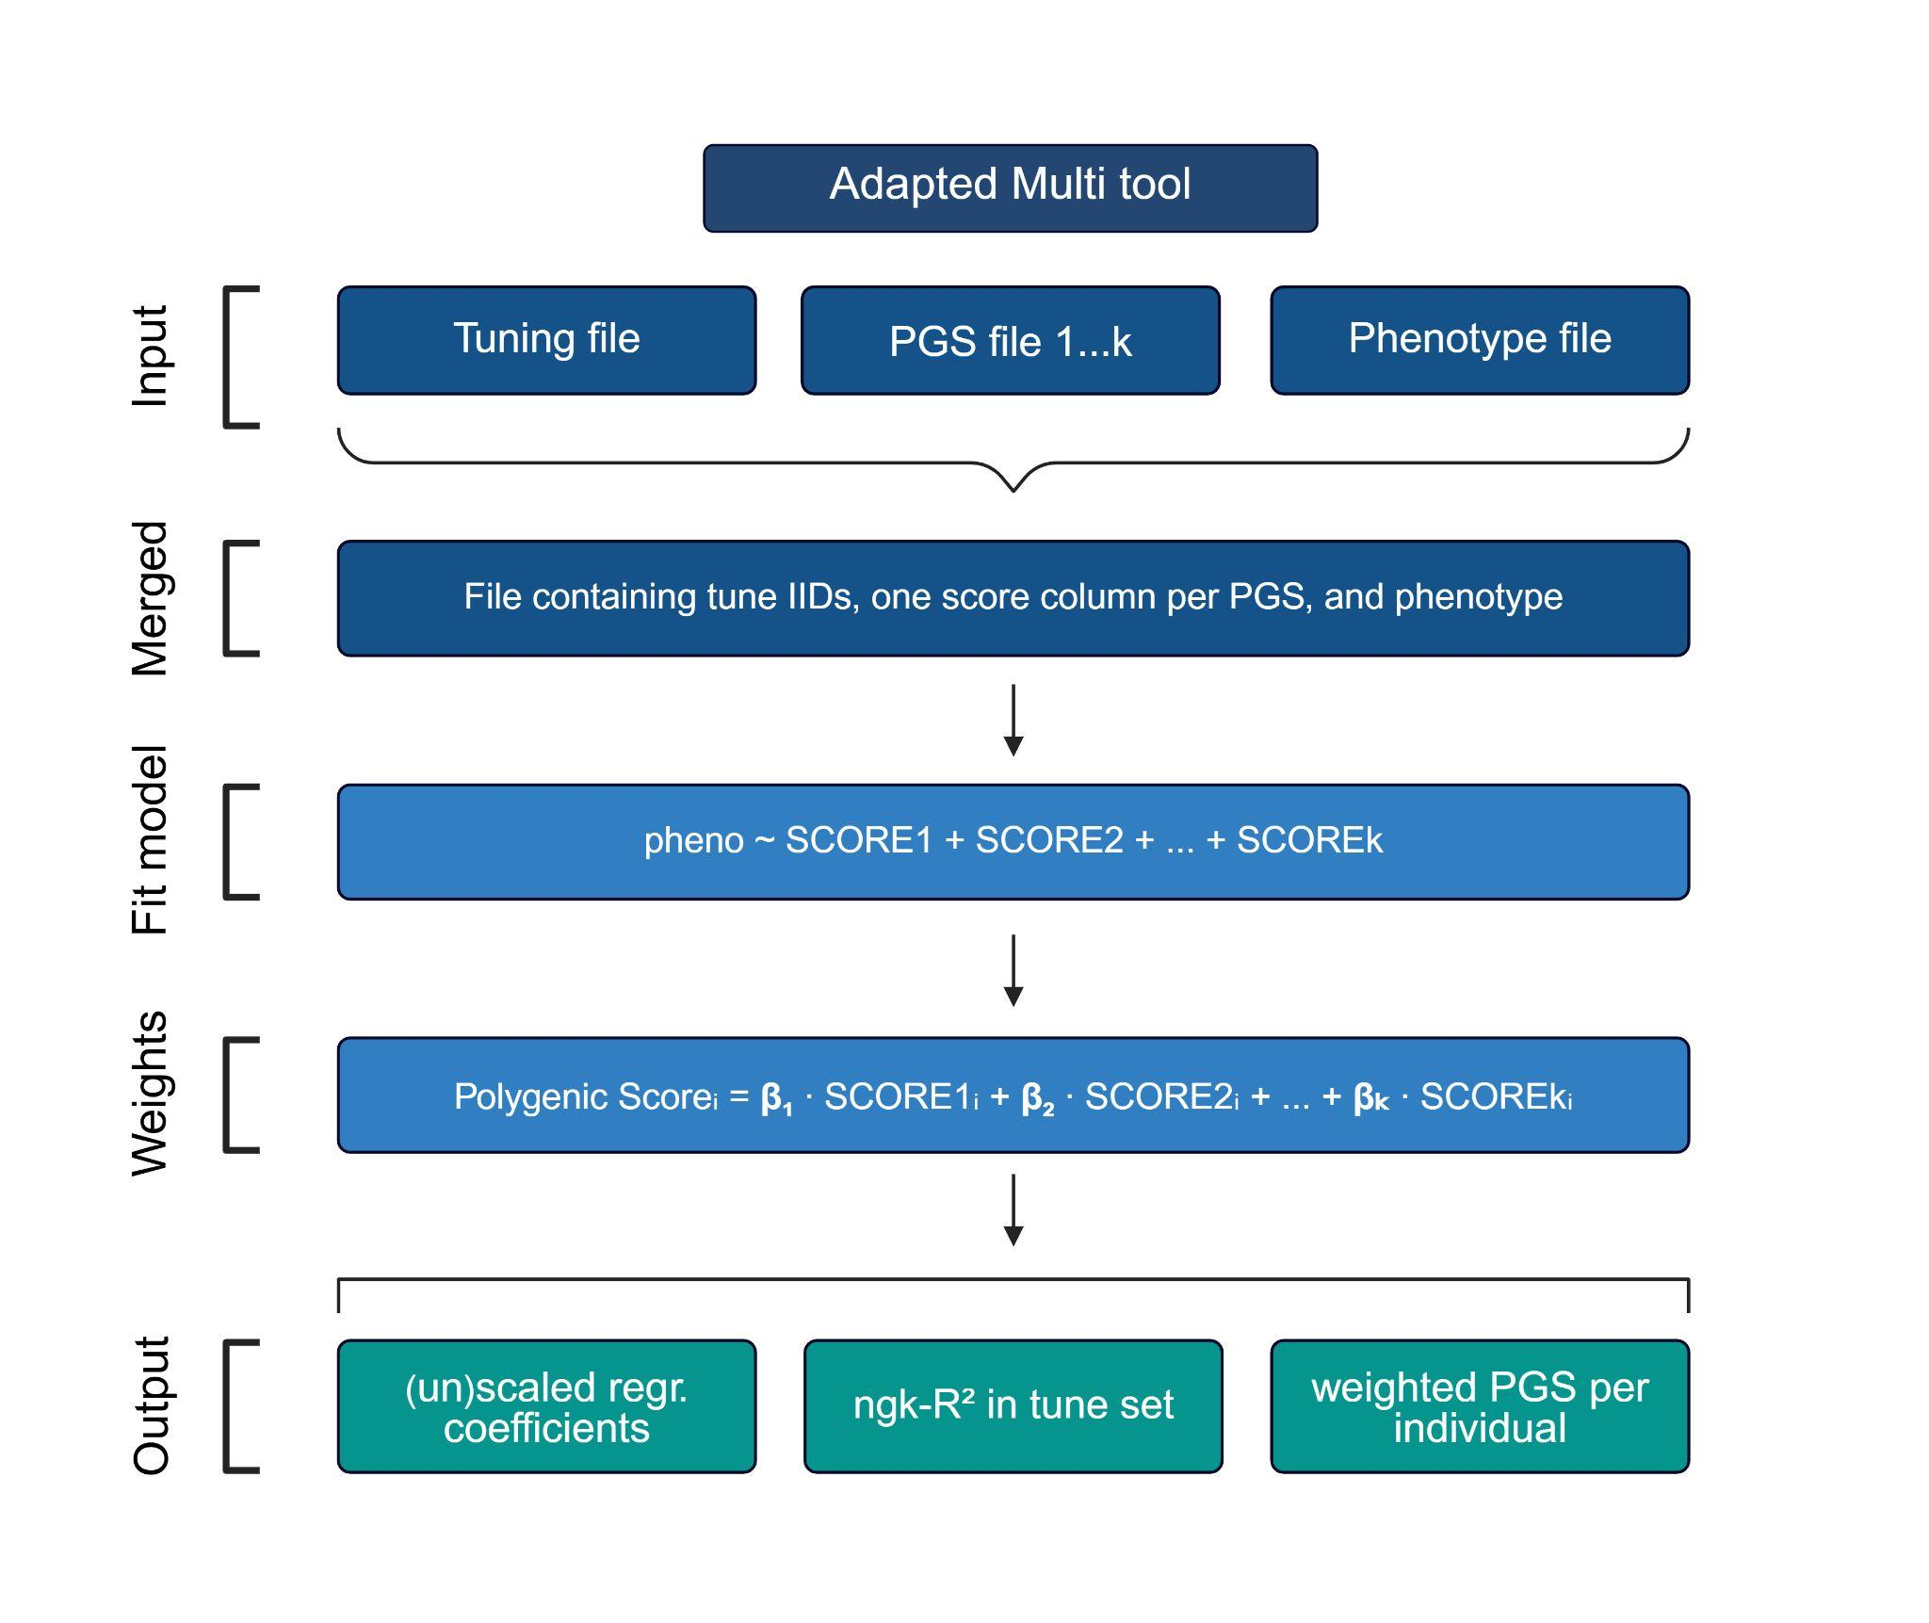

Fig. S3 | Workflow of the adapted multi tool. The adapted tool accepts a tuning file, multiple PGS files, and a phenotype file, merges these data, and fits a logistic regression model using AF status as the outcome and the PGS inputs as predictors. It outputs (i) unscaled regression coefficients based on the raw PGS inputs (i.e., without normalization or standardization), (ii) the scaled coefficients, or mixing weights, obtained by multiplying each unscaled coefficient by the standard deviation (SD) of its corresponding PGS in the ancestry-specific tuning set, (iii) Nagelkerke’s R² for each input PGS and the weighted score, and (iv) the final weighted PGS per individual. Created with BioRender.com.

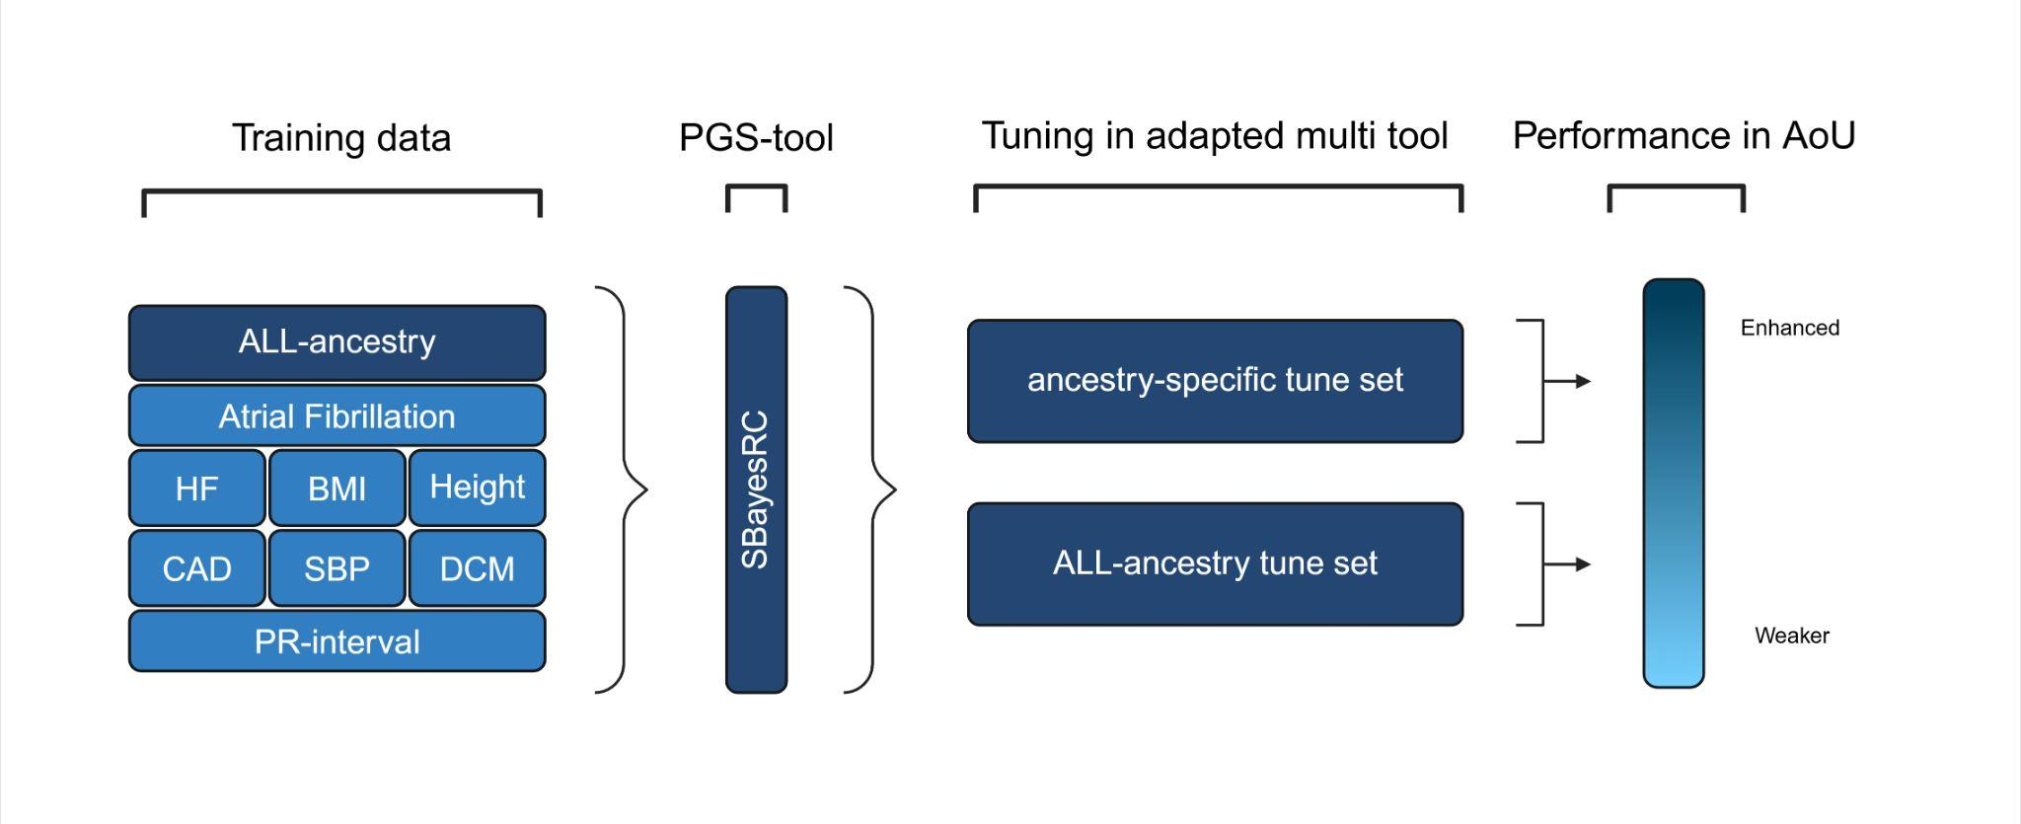

Fig. S4 | Ancestry-specific tuning sets enhance Mult-t score performance over all-ancestry tuning. This flowchart outlines the development of the Mult-t polygenic scores from left to right. All-ancestry GWAS summary statistics for AF and seven correlated traits were first processed using SBayesRC to generate trait-specific scoring files. We then used the adapted multi tool to combine these scoring files, weighted by predictive accuracy in either an ancestry-specific or all-ancestry 30% tuning dataset of All of Us, resulting in the ancestry-tuned and all-tuned Mult-t scores, respectively. In the final step, scores were evaluated in the 70% validation dataset of All of Us (Table S4). Created with BioRender.com.
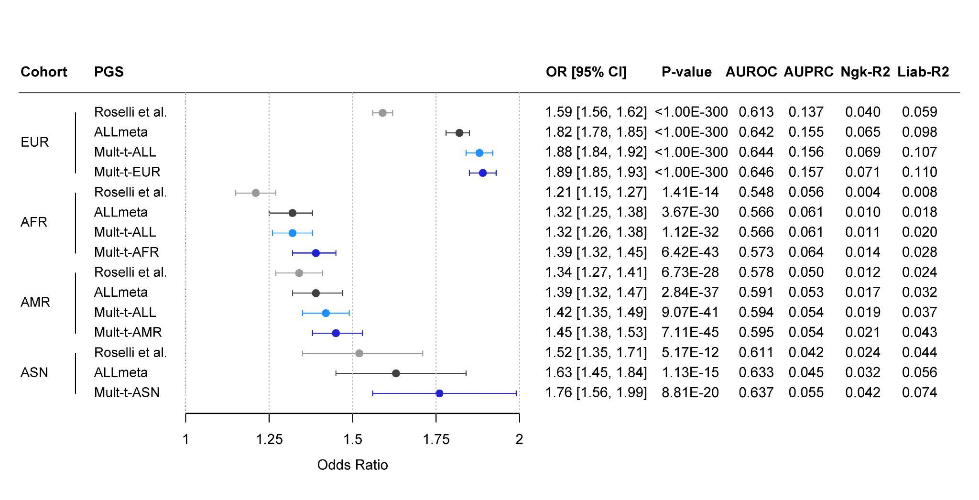

Fig. S5 | Comparison of the Roselli et al., ALLmeta, all-tuned, and ancestry-tuned Mult-t polygenic scores. The left panel displays a forest plot of the OR/SD increase in PGS for AF, with 95% CIs on the x-axis. The y-axis lists the ancestry-specific validation cohorts, ordered by decreasing cohort size, each paired with its respective PGSs. The right panel summarizes key performance metrics from the validation set. All estimates are based on logistic regression models adjusted for the first 20 PCs, age, and sex, using case/control counts from the 70% validation dataset of All of Us (Table S4). Due to limited sample size, the full 100% validation set was used for ASN ancestry. Model performance details are provided (Table S2).
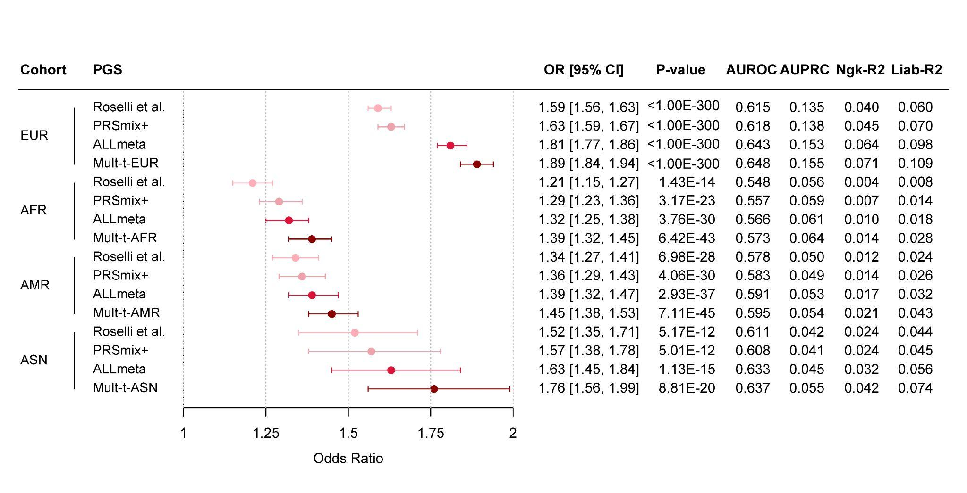

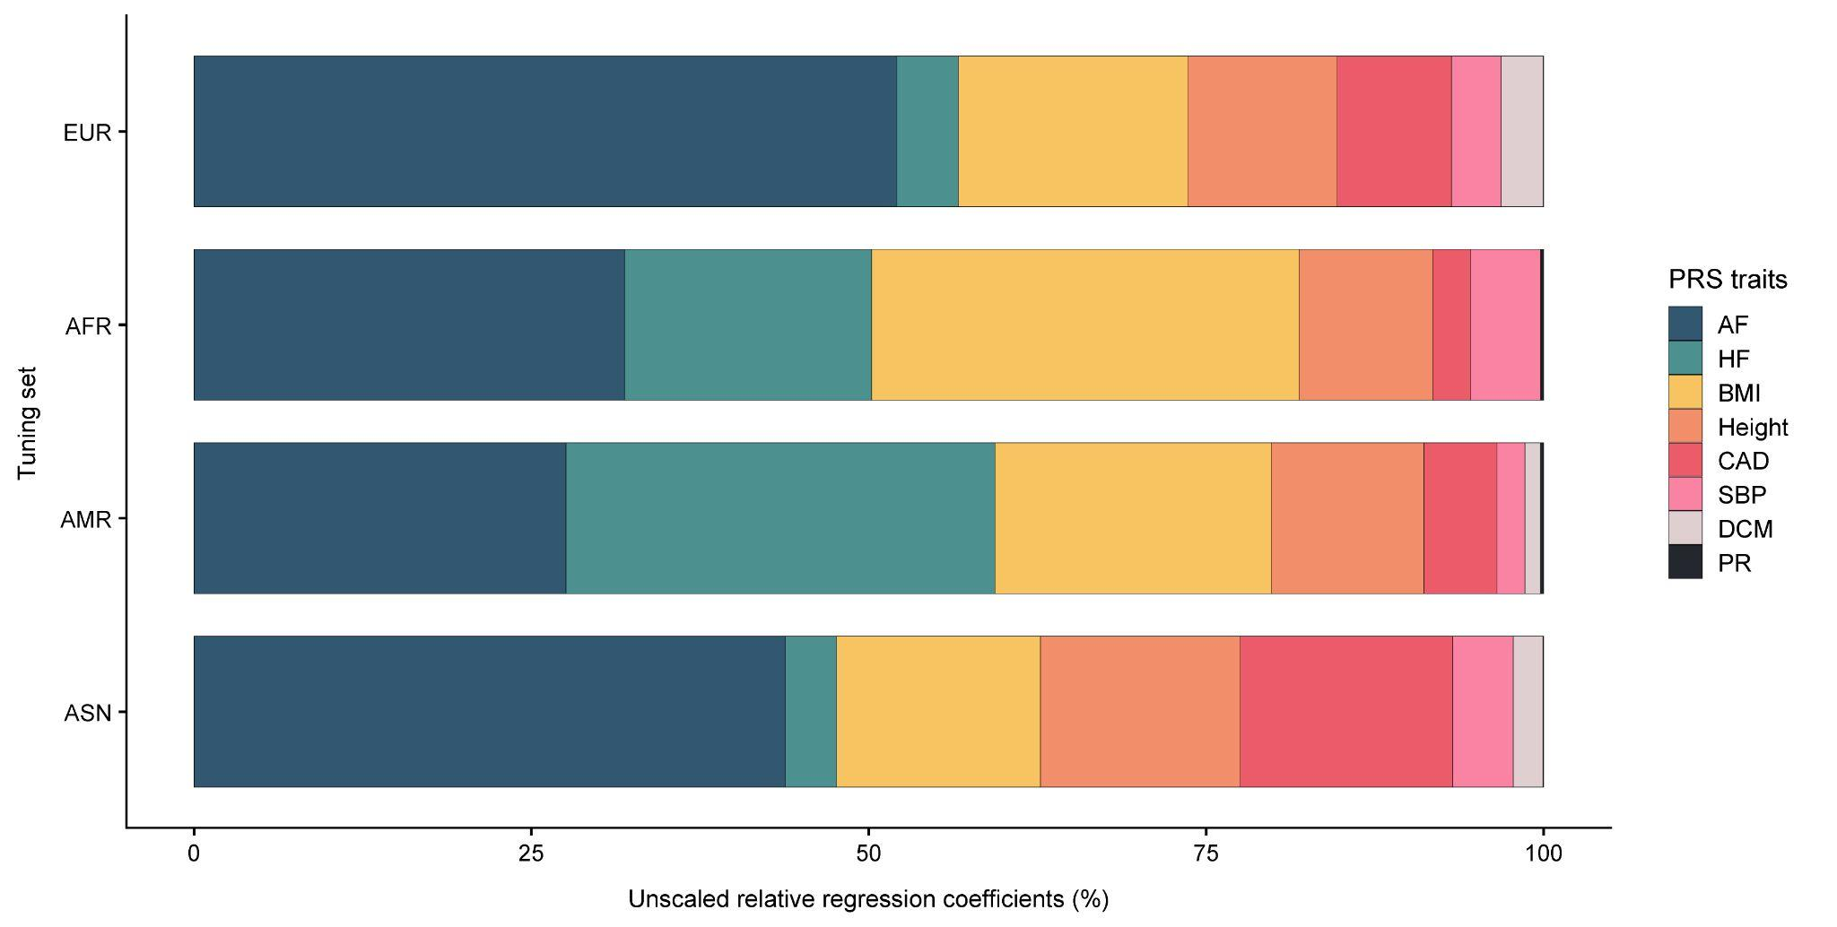
Fig. S6 | Comparison of the Roselli et al., PRSmix+, ALLmeta, and Mult-t polygenic scores. The left panel displays a forest plot of the OR/SD increase in PGS for AF, with 95% CIs on the x-axis. The y-axis lists the ancestry-specific validation cohorts, ordered by decreasing cohort size, each paired with its respective PGSs. The right panel summarizes key performance metrics from the validation set. All estimates are based on logistic regression models adjusted for the first 20 PCs, age, and sex, using case/control counts from the 70% validation dataset of the All of Us v8 Curated Data Repository (CDR) (Table S4). For the European validation set, we excluded European individuals from the All of Us v6 CDR which were used to train the PRSmix+ PGS, leaving us with 8,189 cases and 93,383 controls (Table S5). Due to limited sample size, the full 100% validation set (v8) was used for ASN ancestry. Model performance details are provided (Table S5).

Fig. S7 | Unscaled relative regression coefficients of the Mult-t PGSs across ancestry-specific tuning sets. The plot illustrates the relative contribution of each of the eight traits (legend) to the final Mult-t scores across ancestry-specific tuning sets (y-axis). The x-axis represents the unscaled relative regression coefficients expressed as percentages and normalized to 100% to reflect the trait composition of the Mult-t PGSs. Coefficients were derived from unadjusted logistic regression models based on each trait’s predictive accuracy for AF in the corresponding tuning set. Additional details are available (Table S7).
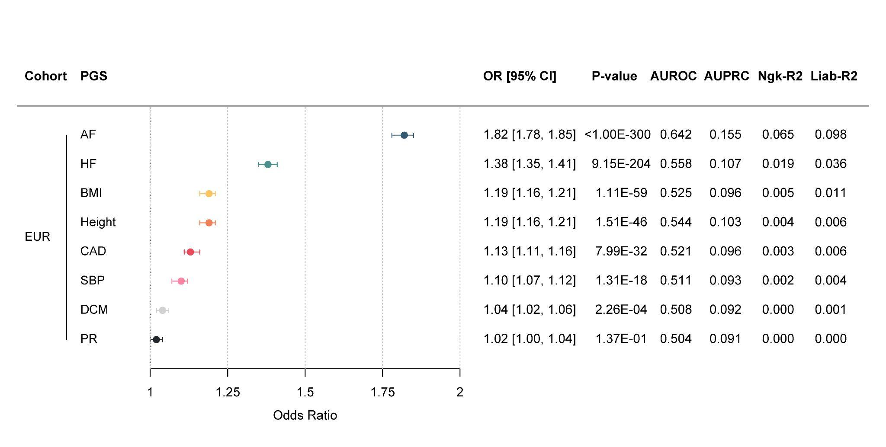

Fig. S8 | The contributing traits evaluated separately in the European validation set in AoU. The left panel displays a forest plot of the OR/SD increase in PGS for AF, with 95% CIs on the x-axis. The y-axis lists the European validation cohort alongside the PGSs for each of the eight traits. The right panel summarizes key performance metrics from the validation set. All estimates are based on logistic regression models adjusted for the first 20 PCs, age, and sex, applied to the 70% European validation dataset of All of Us, including 11,087 cases and 113,280 controls. Model performance details are provided (Table S8).
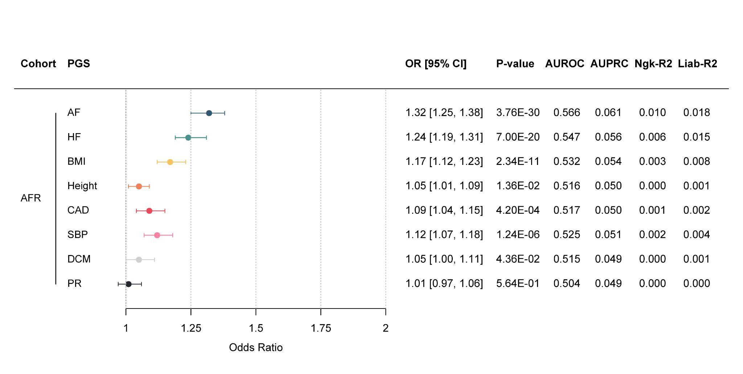

Fig. S9 | The contributing traits evaluated separately in the African validation set in AoU. The left panel displays a forest plot of the OR/SD increase in PGS for AF, with 95% CIs on the x-axis. The y-axis lists the African validation cohort alongside the PGSs for each of the eight traits. The right panel summarizes key performance metrics from the validation set. All estimates are based on logistic regression models adjusted for the first 20 PCs, age, and sex, applied to the 70% African validation dataset of All of Us, including 2,112 cases and 42,580 controls. Model performance details are provided (Table S8).
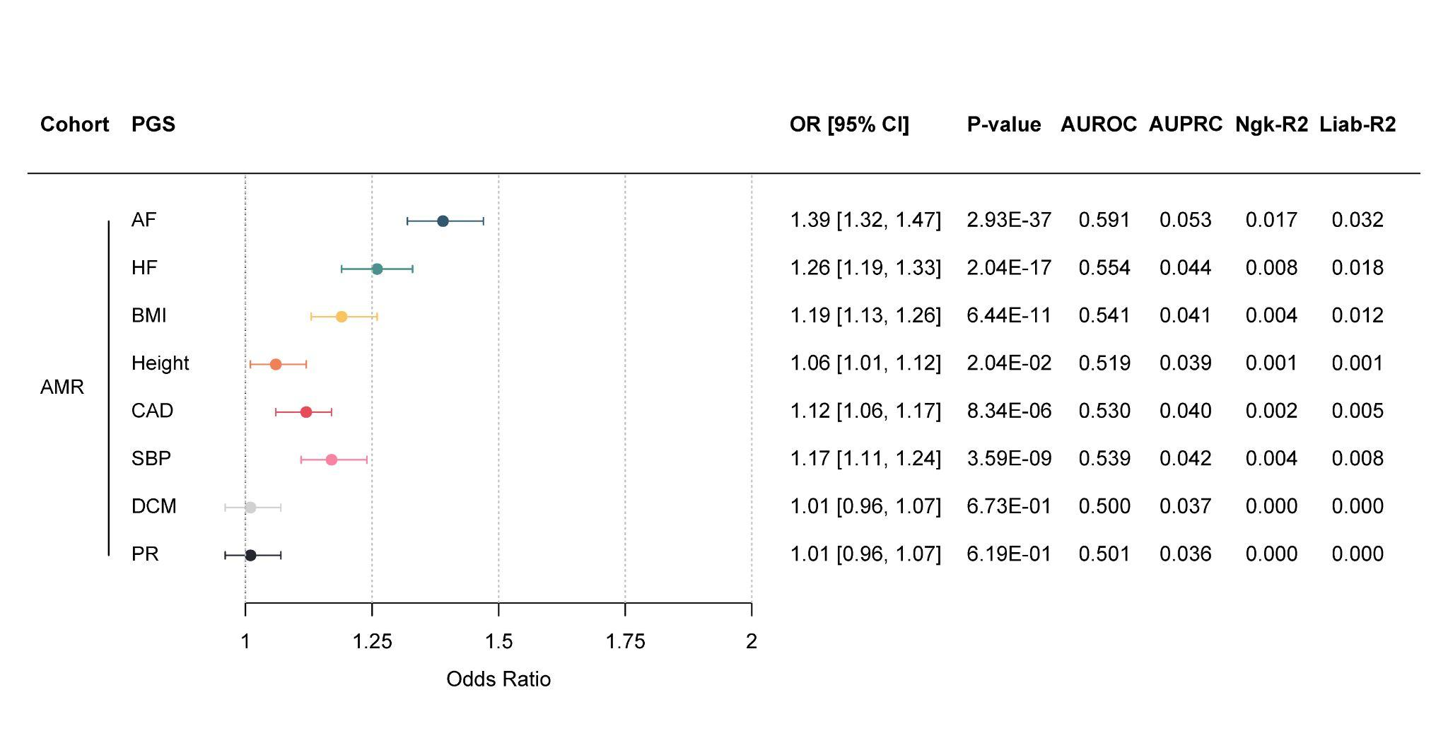

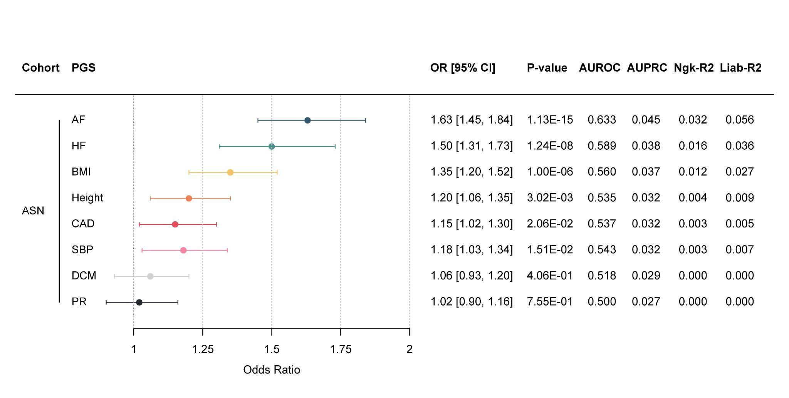
Fig. S10 | The contributing traits evaluated separately in the Admixed American validation set in AoU. The left panel displays a forest plot of the OR/SD increase in PGS for AF, with 95% CIs on the x-axis. The y-axis lists the Admixed American validation cohort alongside the PGSs for each of the eight traits. The right panel summarizes key performance metrics from the validation set. All estimates are based on logistic regression models adjusted for the first 20 PCs, age, and sex, applied to the 70% Admixed American validation dataset of All of Us, including 1,449 cases and 38,770 controls. Model performance details are provided (Table S8).

Fig. S11 | The contributing traits evaluated separately in the Asian validation set in AoU. The left panel displays a forest plot of the OR/SD increase in PGS for AF, with 95% CIs on the x-axis. The y-axis lists the Asian validation cohort alongside the PGSs for each of the eight traits. The right panel summarizes key performance metrics from the validation set. All estimates are based on logistic regression models adjusted for the first 20 PCs, age, and sex, applied to the 100% Asian validation dataset of All of Us, including 288 cases and 10,350 controls. Model performance details are provided (Table S8).

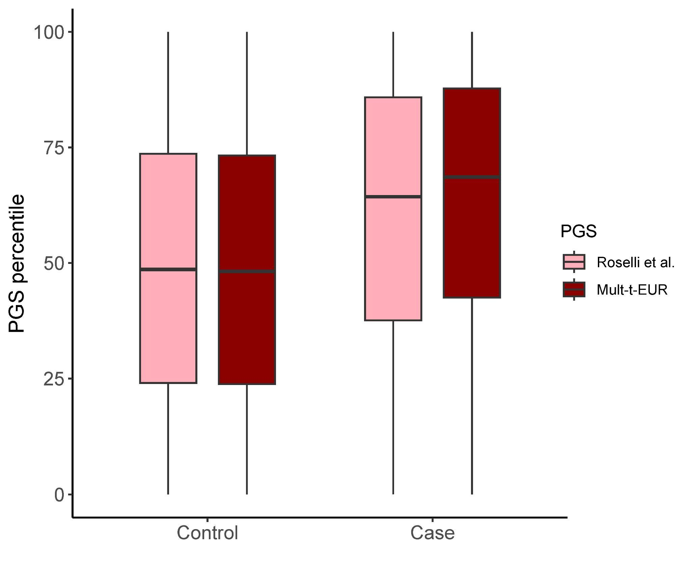

Fig. S12 | Distributions of cases and controls per PGS percentile. Box plots display the distribution of controls (left) and AF cases (right) across PGS percentiles (y-axis). The Roselli et al. PGS is shown in pink, and the Mult-t-EUR PGS in dark red. Each box plot shows the median (center line), first and third quartiles (box edges), and whiskers extending up to 1.5 times the interquartile range beyond the box. Both scores were evaluated in the 70% European ancestry validation dataset of All of Us, comprising 11,087 cases and 113,280 controls.

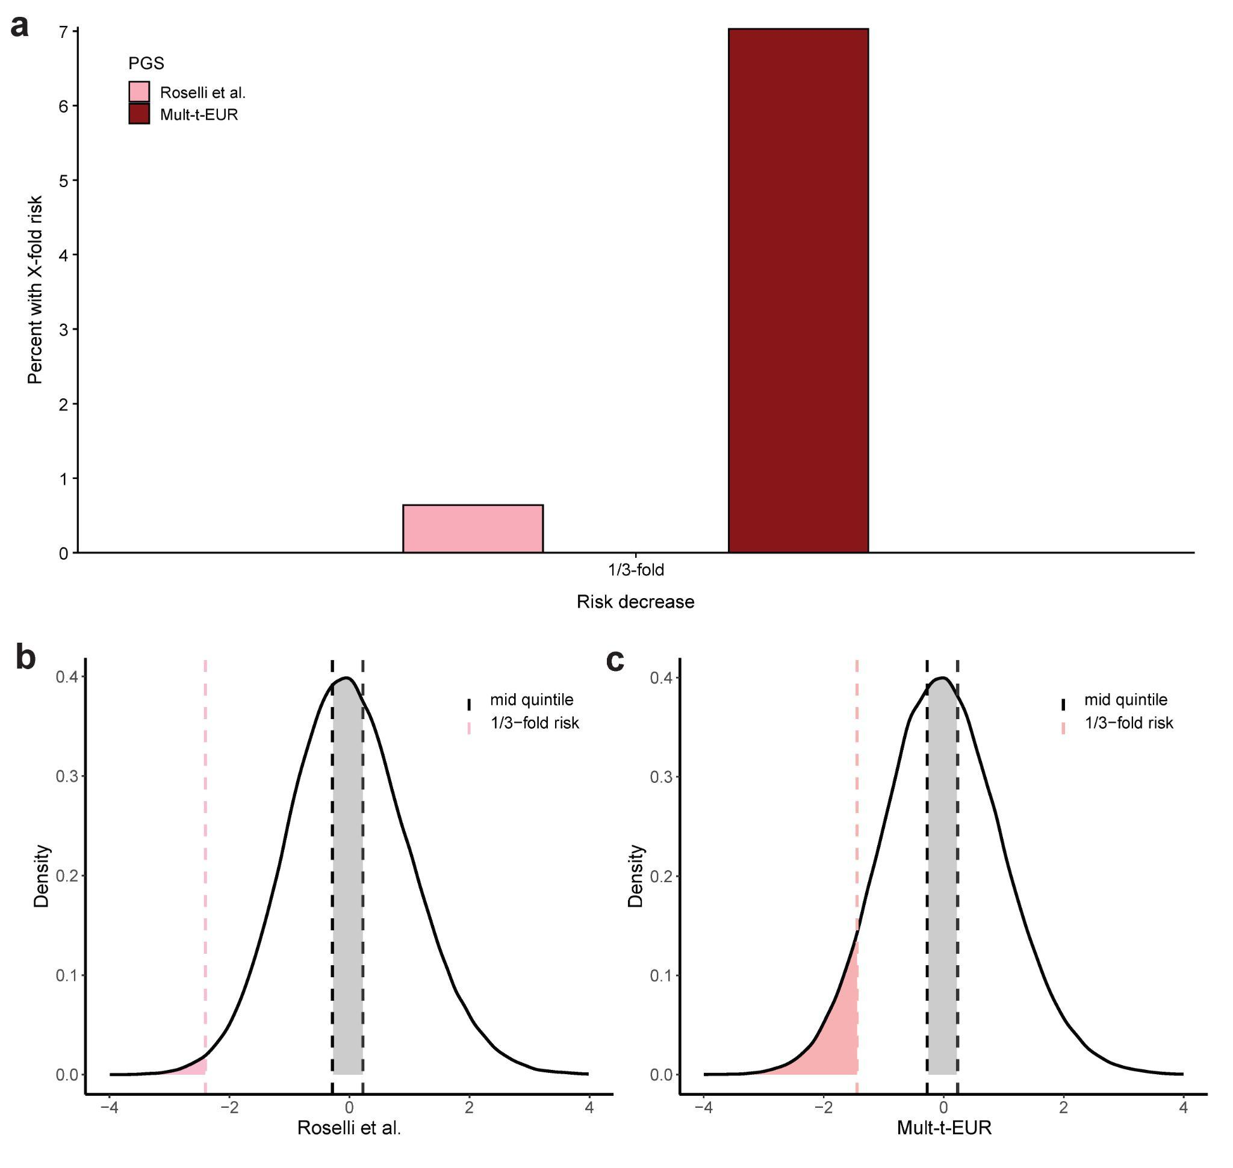

Fig. S13 | Proportion of individuals with 1/3-fold decreased AF risk compared to the middle quintile. All panels show the percentage of European ancestry participants in the 70% validation dataset of All of Us (11,087 cases / 113,280 controls) with a 1/3-fold lower risk of AF relative to the middle PGS quintile. a, Bar plots display the proportion with a 1/3-fold lower risk for the Roselli et al. PGS (pink) and the Mult-t-EUR PGS (dark red). b,c, Density plots of the Roselli et al. (b) and Mult-t-EUR (c) PGSs. The x-axis displays polygenic score values, and the y-axis indicates density, representing the relative frequency of individuals with a specific polygenic score value. The middle quintile is shaded in grey, while the region corresponding to 1/3-fold risk is highlighted in a shade of red. Odds ratios were estimated using logistic regression adjusted for age, sex, and the first 20 ancestry PCs.
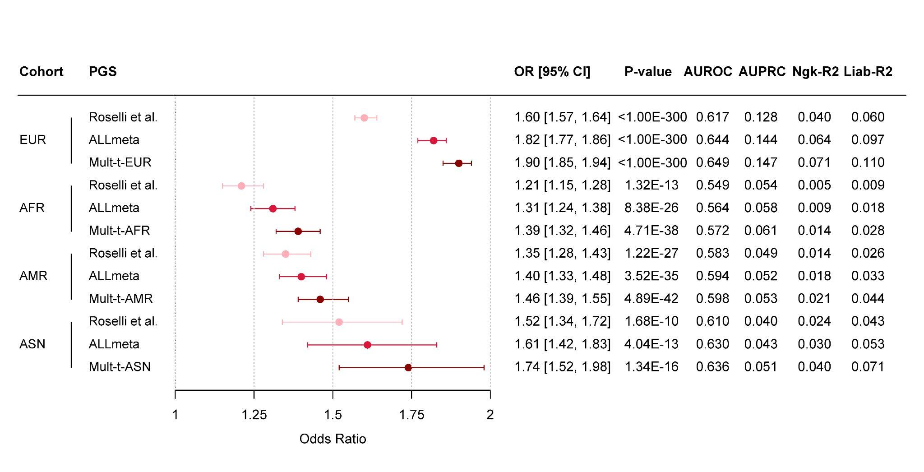

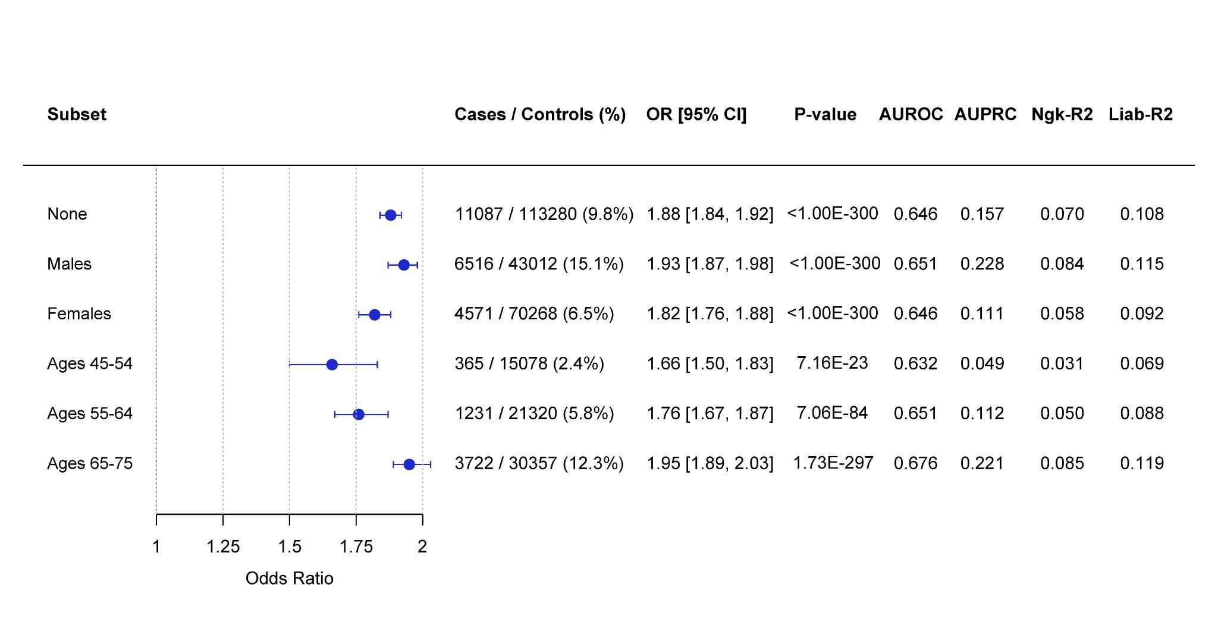
Fig. S14 | Sensitivity analysis excluding individuals from the state Massachusetts and with Veteran Affairs health coverage. The left panel displays a forest plot of the OR/SD increase in PGS for AF, with 95% CIs on the x-axis. The y-axis lists the ancestry-specific validation cohorts, ordered by decreasing cohort size, each paired with its respective PGSs. The right panel summarizes key performance metrics from the validation set. All estimates are based on logistic regression models adjusted for the first 20 PCs, age, and sex, using case/control counts from the 70% validation dataset of All of Us (Table S4), while excluding individuals from the state Massachusetts and with Veteran Affairs health coverage. Due to limited sample size, the full 100% validation set was used for ASN ancestry. Model performance details are provided (Table S10).

Fig. S15 | Subset analysis of the Mult-t-EUR score across sex and three different age ranges. The left panel displays a forest plot of the OR/SD increase in PGS for AF, with 95% CIs on the x-axis. The y-axis lists the analyzed subsets within the Mult-t-EUR PGS. The right panel summarizes case/control counts and key performance metrics for each validation subgroup. All estimates are based on logistic regression models adjusted for the first 20 PCs, age, and sex, applied to subgroups of the 70% European validation dataset of All of Us. Model performance details are provided (Table S11).

References
1. Roselli, C. et al. Meta-analysis of genome-wide associations and polygenic risk prediction for atrial fibrillation in more than 180,000 cases. Nature Genetics 57, 539–547 (2025).
2. Khera, A. V. et al. Genome-wide polygenic scores for common diseases identify individuals with risk equivalent to monogenic mutations. Nature Genetics 50, 1219–1224 (2018).
3. Roselli, C. et al. Meta-analysis of genome-wide associations and polygenic risk prediction for atrial fibrillation in more than 180,000 cases. Nature Genetics 57, 539–547 (2025).
4. Gunn, S. et al. Comparison of methods for building polygenic scores for diverse populations. Human Genetics and Genomics Advances 6, 100355 (2024).
5. Ruan, Y. et al. Improving polygenic prediction in ancestrally diverse populations. Nature Genetics 54, 573–580 (2022).
6. Gunn, S. et al. Comparison of methods for building polygenic scores for diverse populations. Human Genetics and Genomics Advances 6, 100355 (2024).
7. Roselli, C. et al. Meta-analysis of genome-wide associations and polygenic risk prediction for atrial fibrillation in more than 180,000 cases. Nature Genetics 57, 539–547 (2025).
8. Jermy, B. et al. A unified framework for estimating country-specific cumulative incidence for 18 diseases stratified by polygenic risk. Nature Communications 15, 1–14 (2024).
9. Miyazawa, K. et al. Cross-ancestry genome-wide analysis of atrial fibrillation unveils disease biology and enables cardioembolic risk prediction. Nature Genetics 55, 187–197 (2023).
10. Zhang, J. et al. An ensemble penalized regression method for multi-ancestry polygenic risk prediction. Nature Communications 15, 1–14 (2024).
11. Ding, Y. et al. Polygenic scoring accuracy varies across the genetic ancestry continuum. Nature 618, 774–781 (2023).
12. Troubat, L., Fettahoglu, D., Henches, L., Aschard, H. & Julienne, H. Multi-trait GWAS for diverse ancestries: mapping the knowledge gap. BMC Genomics 25, 1–13 (2024).
13. Kavousi, M. & Ellinor, P. T. Polygenic risk scores for prediction of atrial fibrillation. Netherlands Heart Journal 31, 1 (2022).
14. Kavousi, M. Differences in Epidemiology and Risk Factors for Atrial Fibrillation Between Women and Men. Frontiers in Cardiovascular Medicine 7, 3 (2020).
15. GitHub - poeyahay/AFGen+MVP.sh. GitHub https://github.com/poeyahay/AFib_PGS/blob/main/METAL/AFGen%2BMVP.sh (2025).
16. GitHub - poeyahay/SBP_trait.sh. GitHub https://github.com/poeyahay/AFib_PGS/blob/main/METAL/SBP_trait.sh (2025).
17. Howell, C. R. et al. Maximum Lifetime Body Mass Index and Mortality in Mexican American Adults: the National Health and Nutrition Examination Survey III (1988–1994) and NHANES 1999–2010. Preventing Chronic Disease 14, E67 (2017).
18. Márquez-Luna, C. et al. Incorporating functional priors improves polygenic prediction accuracy in UK Biobank and 23andMe data sets. Nature Communications 12, 1–11 (2021).
19. GitHub - zhilizheng/SBayesRC. GitHub https://github.com/zhilizheng/SBayesRC (2024).
20. GitHub - poeyahay/SBRC_Run.sh. GitHub https://github.com/poeyahay/AFib_PGS/blob/main/SBayesRC/SBRC_Run.sh (2025).
21. GitHub - poeyahay/SBRCmulti.R. GitHub https://github.com/poeyahay/AFib_PGS/blob/main/Multi/SBRCmulti.R (2025).
22. GitHub - poeyahay/Multi_Tool.R. GitHub https://github.com/poeyahay/AFib_PGS/blob/main/Multi/Multi_Tool.R (2025).
23. Lee, S. H., Goddard, M. E., Wray, N. R. & Visscher, P. M. A better coefficient of determination for genetic profile analysis. Genetic epidemiology 36, (2012).

