Impacts of Antarctic heatwaves amplified by climate change through water vapor and cloud feedbacks

Sergi González-Herrero¹, Pranab Deb², Sihan Li³, Daniel Argueso⁴, Rainette Engbers^{1,5},
Michael Matějka⁶, Nander Wever^{1,7}, Michael Lehning^{1,5}
1WSL Institute for the Snow and Avalanche Research SLF, Davos Dorf, Switzerland (sergi.gonzalez@slf.ch)
2Indian Institute of Technology, Kharagpur, India
3University of Sheffield, Sheffield, UK
4Universitat de les Illes Balears, Palma, Spain
5EPFL, Sion, Switzerland
6Masarykova University, Brno, Czech Republic
7Meteoswiss, Zurich, Switzerland

1. Event evolution
This section presents the evolution of the event in the control (current-climate) simulation, with particular focus on the atmospheric water-related components: precipitable water (PW), liquid water path (LWP), and ice water path (IWP). Supplementary Figure 1.1 illustrates four key stages: the onset of the event (15 March), the peak intensity (18 March), the decay phase (20 March), and the aftermath (23 March).
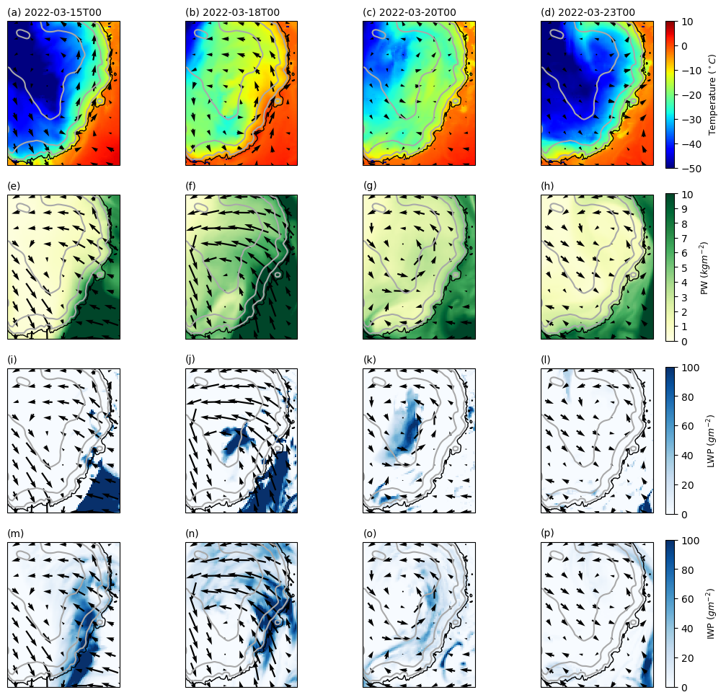
Supplementary Figure 1.1. Evolution of the atmospheric water components during the event. a-d 2m temperature (°C) and 10m wind speed and direction. e-h Precipitable water (kg m⁻²) and 25th sigma level wind speed and direction. i-l Liquid water path (g m⁻²) and 25th sigma level wind speed and direction. m-p Ice water path (g m⁻²) and 25th sigma level wind speed and direction. Gray lines indicate the height contours every 1000 m. Figure shows 4 key stage of the event the onset (a,e,i,m), the peak (b,f,j,n), the decay (c,g,k,o), and the aftermath (d,h,l,p). 25th sigma level correspond to a height ca. 1843 m above Concordia station.

2. Temperature and moisture tendency equation components

This section shows the different components that governs the temperature and moisture tendency in sigma levels following the equations:
$\underset{TendT}{\underbrace{\frac{∆T}{∆t}}}= \underset{HAdvT}{\underbrace{-\vec{v}∙∇_{p}T}}+\underset{VAdvT}{\underbrace{w\frac{∂T}{∂z}}}+\underset{Diab}{\underbrace{Q}}$ (1)
$\underset{TendQ}{\underbrace{\frac{∆q}{∆t}}}= \underset{HAdvQ}{\underbrace{-\vec{v}∙∇_{p}q}}+\underset{VAdvQ}{\underbrace{w\frac{∂q}{∂z}}}+\underset{Source/Sink}{\underbrace{Q}}$ (2)
We depict the temperature tendency equation components at the 25th sigma level and the moisture tendency equation components at the 2nd sigma levels, showing the absolute values for the current simulation (a,b,c,d panels) and the changes between the preindustrial and the current simulations (e,f,g,h panels).
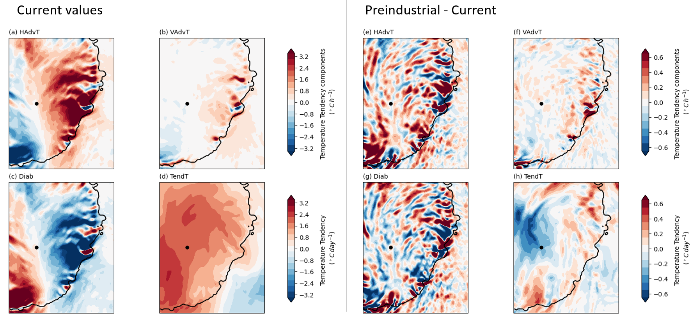
Supplementary Figure 2.1. Changes in the temporally average components of the temperature tendency equation between the preindustrial and current simulations at the 25th sigma level (ca. 1843 m above Concordia station) during the build-up phase of the heatwave (15-18 March 2022). a,e Advection of temperature by the horizontal wind in °C h⁻¹. b,f Adiabatic warming by vertical compression in °C h⁻¹. c,g Diabatic component of the temperature tendency in °C h⁻¹. d,h Temperature tendency in °C day⁻¹. a,b,c,d Average components in the current simulation. e,f,g,h Changes in the average components between the preindustrial and current simulations.

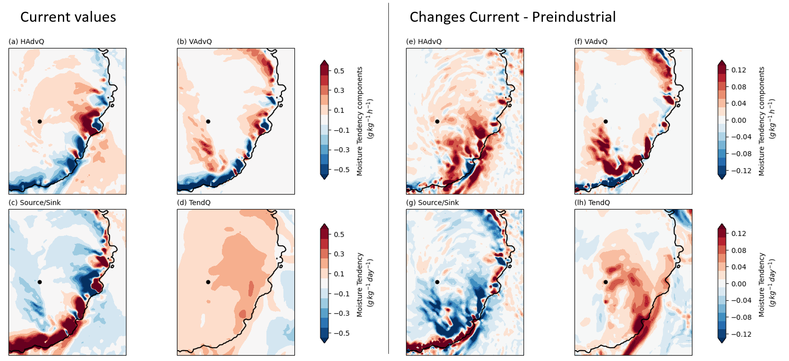
Supplementary Figure 2.2. Changes in the temporally average components of the moisture tendency equation between the past and current simulations at the 2nd sigma level (ca. 48 m above Concordia station) during the build-up phase of the heatwave (15-18 March 2022). a,e Advection of moisture by the horizontal wind in g kg⁻¹ h⁻¹. b,f Advection of moisture due to the vertical wind in g kg⁻¹ h⁻¹. c,g Source/sink component of the moisture tendency in g kg⁻¹ h⁻¹. d,h Moisture tendency in g kg⁻¹ day⁻¹. a,b,c,d Average components in the current simulation. e,f,g,h Changes in the average components between the preindustrial and current simulations.

3. Processes in future scenarios
Here we show the equivalent to Fig. 2 and Extended Fig. 4 for the scenarios SSP2-4.5 and SSP5-8.5. Instead computing the profiles at Concordia station we focus on a point in Wilkes Land (model coordinates S70.0 E129.6 at 2560m height) where temperature amplification increases gradually between the current, SSP2-4.5 and SSP5-8.5 simulations.
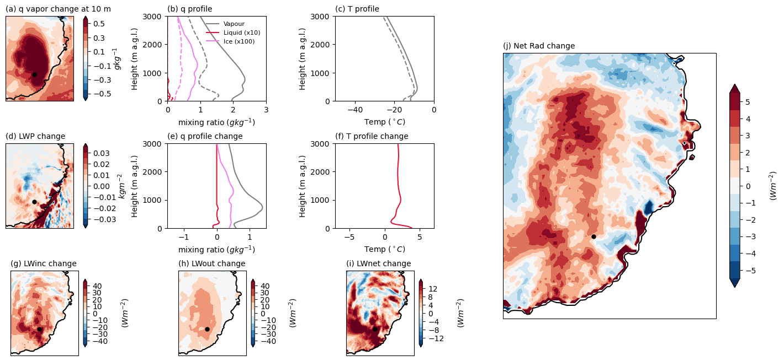
Figure S3.1. Physical processes of future temperature amplification under SSP2-4.5 scenario. a,d Changes in the 17-20 March averaged vapor mixing ratio (q vapor in g kg⁻¹; a) and cloud mixing ratio (q cloud in g kg⁻¹; d) between the SSP2-4.5 scenario and the current simulations. b Vertical profile of q vapor (grey in g kg⁻¹), q liquid (red in 10g kg⁻¹) and q ice (magenta in 1000g kg⁻¹) at the nearest point to Wilkes Land point for the SSP2-4.5 (solid lines) and current (dashed lines) simulations. c As b but for the vertical temperature profiles (red in °C). e,f Changes in the 17-20 March averaged vertical profiles of q vapor and q cloud (panel e; gray in g kg⁻¹ and red in 10g kg⁻¹ panels, respectively), and temperature (red in °C, panel f) at the nearest point to Wilkes Land point between the SSP2-4.5 and the current simulations. g,h,i Changes in the 17-20 March averaged long wave (LW) incoming, outcoming and net radiation in Wm⁻² between the current and the preindustrial simulations. j Changes in the 17-20 March averaged net radiation in Wm⁻² between the SSP2-4.5 scenario and the current simulations. In panels a,d, red (blue) colors represent an increase (decrease) of mixing ratio and LWP during the SSp2-4.5 simulation while in panels g,h,i,j, red (blue) colors represent an increase (decrease) of incoming radiation towards the surface. The black star in the maps represent the position of the Wilkes Land point at S70.0° E129.6°.

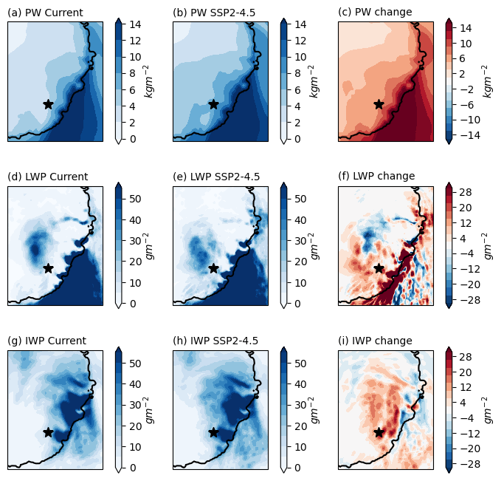
Figure S3.2. Changes in vertically integrated water components under SSP2-4.5 scenario. a,b,c Precipitable water vapor (PW), d,e,f liquid water path (LWP), and g,h,i ice water path (IWP), for the a,d,g current simulation, b,e,h SSP2-4.5 simulation, and c,f,i change between both simulations. Values are averaged from 17 to 20 March.

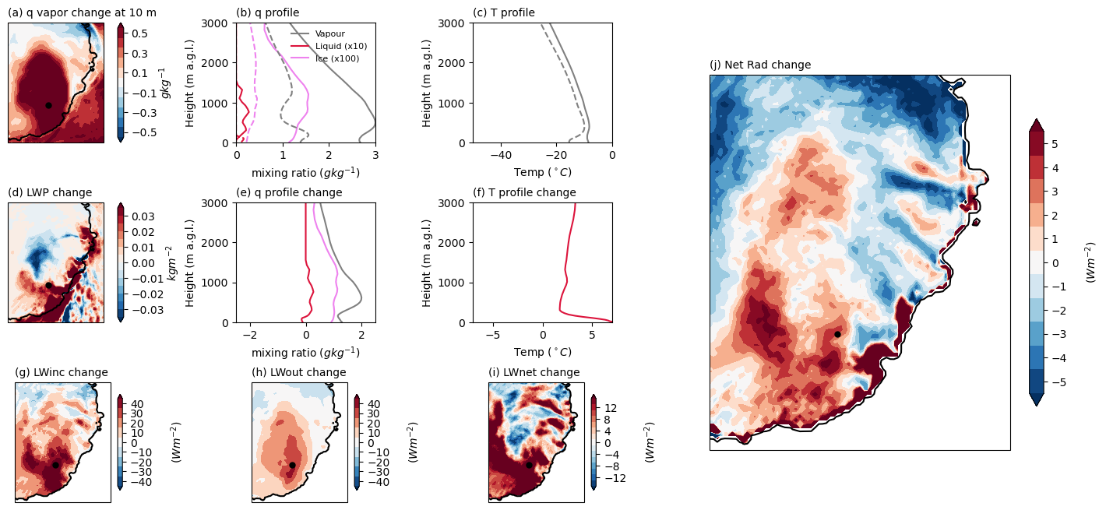
Figure S3.3. Physical processes of future temperature amplification under SSP5-8.5 scenario. a,d Changes in the 17-20 March 2022 averaged vapor mixing ratio (q vapor in g kg⁻¹; a) and cloud mixing ratio (q cloud in g kg⁻¹; d) between the SSP5-8.5 scenario and the current simulations. b Vertical profile of q vapor (grey in g kg⁻¹), q liquid (red in 10g kg⁻¹) and q ice (magenta in 1000g kg⁻¹) at the nearest point to Wilkes Land point for the SSp5-8.5 (solid lines) and current (dashed lines) simulations. c As b but for the vertical temperature profiles (red in °C). e,f Changes in the 17-20 March 2022 averaged vertical profiles of q vapor and q cloud (panel e; gray in g kg⁻¹ and red in 10g kg⁻¹ panels, respectively), and temperature (red in °C, panel f) at the nearest point to Wilkes Land point between the SSP5-8.5 and the current simulations. g,h,i Changes in the 17-20 March 2022 averaged long wave (LW) incoming, outcoming and net radiation in Wm⁻² between the SSP5-8.5 and the current simulations. j Changes in the 17-20 March 2022 averaged net radiation in Wm⁻² between the SSP5-8.5 scenario and the current simulations. In panels a,d, red (blue) colors represent an increase (decrease) of mixing ratio and LWP during the SSP5-8.5 simulation while in panels g,h,i,j, red (blue) colors represent an increase (decrease) of incoming radiation towards the surface. The black star in the maps represent the position of the Wilkes Land point at S70.0° E129.6°.

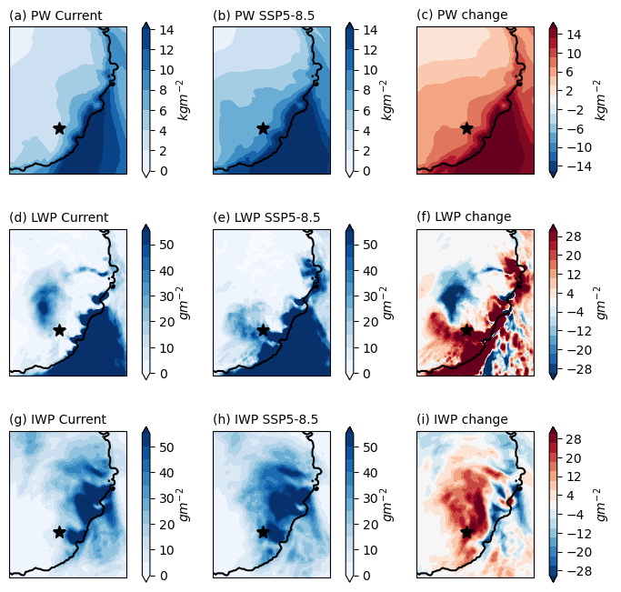
Figure S3.4. Changes in vertically integrated water components under SSP5-8.5 scenario. a,b,c Precipitable water vapor (PW), d,e,f liquid water path (LWP), and g,h,i ice water path (IWP), for the a,d,g current simulation, b,e,h SSP5-8.5 simulation, and c,f,i change between both simulations. Values are averaged from 17 to 20 March.

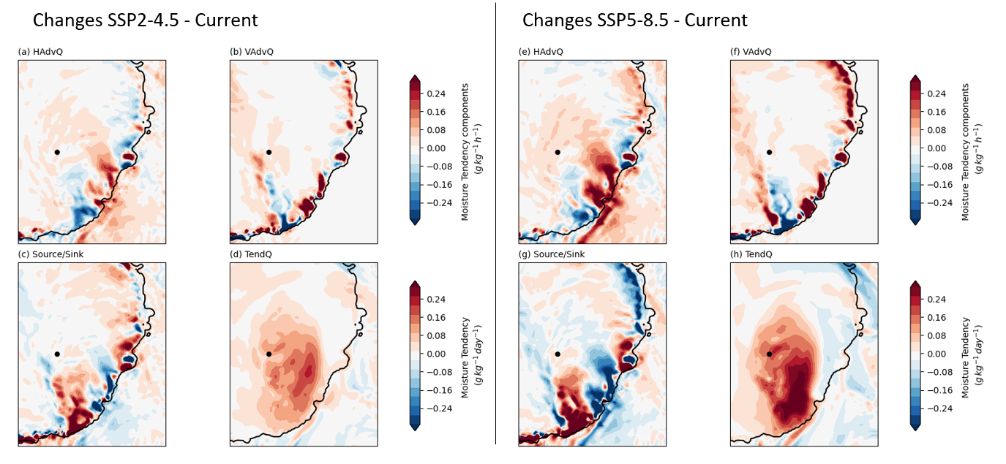
Supplementary Figure 3.5. Changes in the temporally average components of the moisture tendency equation between the SSPs future simulations and current simulation at the 2nd sigma level (ca. 48 m above Concordia station) during the build-up phase of the heatwave (15-18 March 2022). a,e Advection of moisture by the horizontal wind in g kg⁻¹ h⁻¹. b,f Advection of moisture due to the vertical wind in g kg⁻¹ h⁻¹. c,g Source/sink component of the moisture tendency in g kg⁻¹ h⁻¹. d,h Moisture tendency in g kg⁻¹ day⁻¹. a,b,c,d Changes in the average components between the current and the SSP2-4.5 simulations. e,f,g,h Changes in the average components between the current and the SSP5-8.5 simulations.

4. Pseudo-global warming approach
The approach followed in this study consists of modifying different variables as input and boundary conditions using the delta change method based on outputs from multiple Global Climate Models (GCMs). To reduce the influence of any single model, we used climatologies from six CMIP6 GCMs. Model selection was constrained by data availability, especially from polar-related variables like sea ice concentration, at the time when delta changes were calculated. Given the high computational cost of running CRYOWRF, we performed only one realization per experiment, applying the mean delta changes derived from the six selected GCMs. The CMIP6 models selected and the corresponding output variables that were modified are listed in the following table.
Supplementary Table 4.1. Global general circulation models and variables used to calculate climate deltas. The variables are written as the standard variable output name in the CMIP6 models.
CMIP6 models | Output variables
CAS-ESM2-0 | Relative humidity (hur)
CMCC-CM2-SR5 | Near-surface relative humidity (hurs)
CMCC-ESM2 | Surface air pressure (ps)
EC_Earth3 | Mean sea level pressure (psl)
FGOALS-f3-L | Sea Ice Concentration (siconc)
MRI-ESM2-0 | Air temperature (ta)
 | Near-surface air temperature (tas)
 | Sea surface temperature (tos)
 | Surface temperature (ts)
 | Eastward wind (ua)
 | Eastward near-surface wind (uas)
 | Northward wind (va)
 | Northward near-surface wind (vas)
 | Geopotential height (zg)

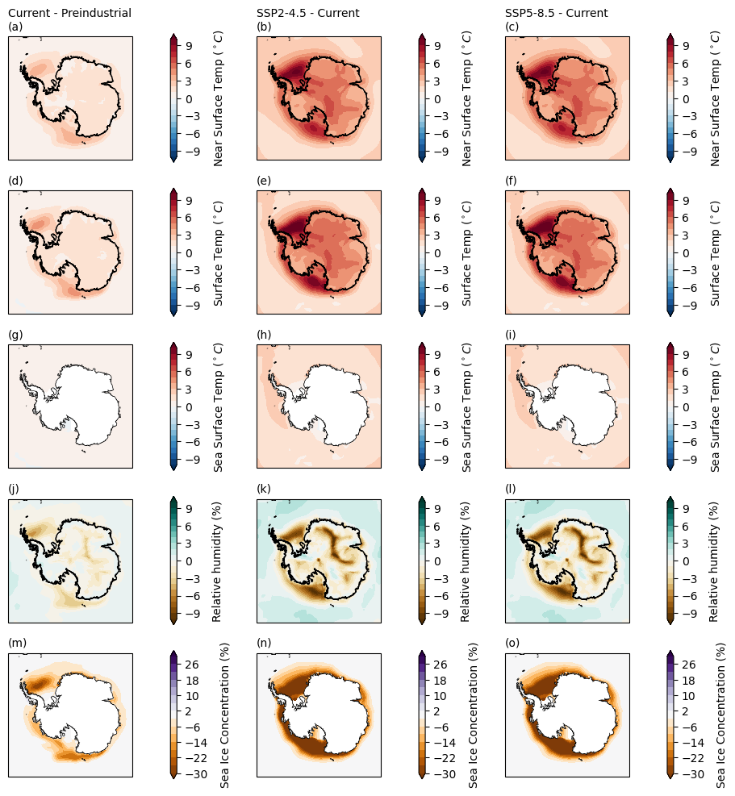
Supplementary Figure 4.1. Average delta components for March from the six CMIP6 models used to modify initial and boundary conditions for our simulations. a,b,c Near-surface temperature (tas in °C), d,e,f Surface temperature (ts in °C), g,h,i Sea surface temperature (tos in °C), j,k,l Relative humidity (hurs in %), m,n,o Sea ice concentration (siconc in %). a,d,g,j,m Changes between current and preindustrial simulations, b,e,h,k,n Changes between the SSP2-4.5 and current simulations, c,f,i,l,o Changes between the SSP5-8.5 and current simulations.

