Photograph A:
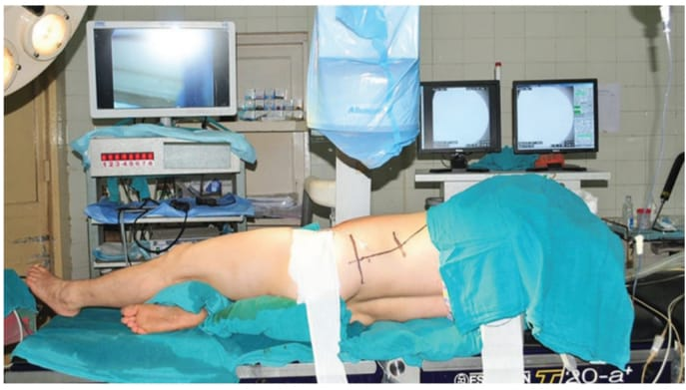
Photograph A: Showing the final position of a patient in FFMSP for PCNL
FFMSP: Flank-Free Modified Supine Position; PCNL: Percutaneous Nephrolithotomy

Photograph B:
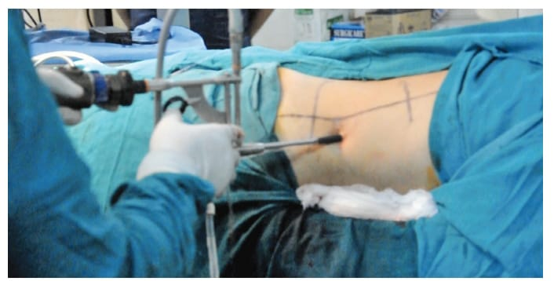
Photograph B: Showing the intra-operative image of a nephroscope working through an Amplatz sheath for PCNL, while the patient is in FFMSP.
FFMSP: Flank-Free Modified Supine Position; PCNL: Percutaneous Nephrolithotomy

Photograph C:
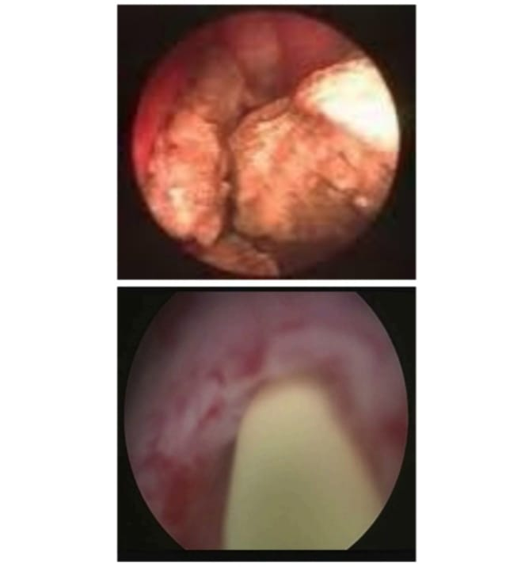
Photograph C: Nephroscopic view during of a stone during fragmentation and after clearance.

