Supplementary material

Unveiling a catalytically promiscuous feruloyl esterase from Clostridium acetobutylicum

Shang Li¹ · Xiaowang Hu¹ · Xinyu Che¹ · Liang Quan¹ · Xianglong Li¹ ·
Ting Feng¹ · Yanbin Feng ^{1#} · Song Xue^{1#}

1 MOE Key Laboratory of Bio-Intelligent Manufacturing, School of Bioengineering, Dalian University of Technology, Dalian, Liaoning, China

#Corresponding Author: xuesong@dlut.edu.cn, afyb@dlut.edu.cn

Contents

Fig. S1. Molecular analysis of CaFAE wild-type and mutant constructs.
Fig. S2. Multiple sequence alignment of CaFAE with other feruloyl esterases.
Table S1. Primers used in this study for mutagenesis.
Table S2. Data-collection and refinement statistics for CaFAE.
Table S3. Specific activity of the enzymes on methyl ferulate.

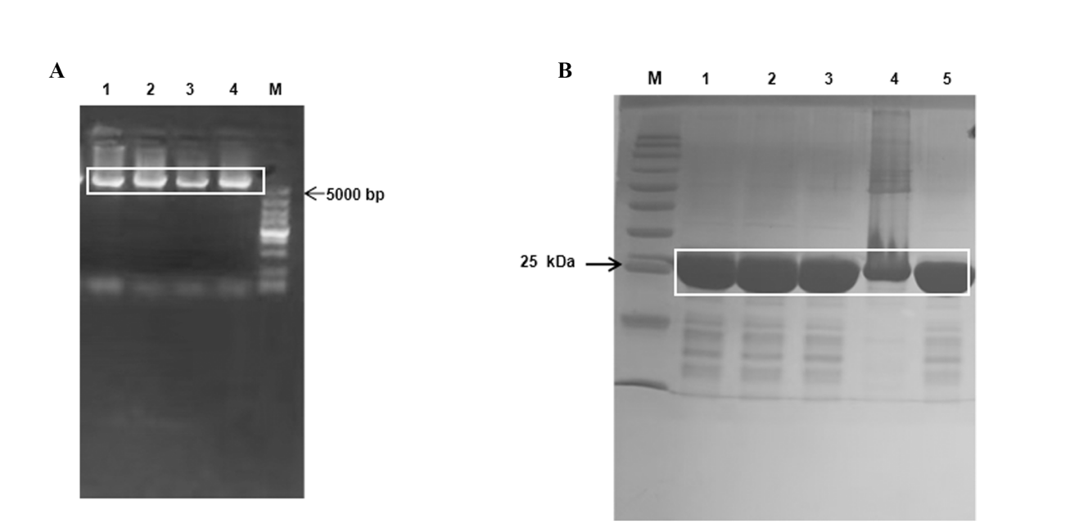
Fig. S1. Molecular analysis of CaFAE wild-type and mutant constructs. (A) Full-plasmid PCR amplification verified by agarose gel electrophoresis. Lane M, DNA marker; lanes 1-4 correspond to the Y151G, Y151V, E168G, and E168R mutants, respectively. (B) SDS-PAGE (12.5%) analysis of the purified proteins. Following expression and purification by gel filtration chromatography, samples of wild-type CaFAE (lane 1) and its mutants (lanes 2-5: Y151G, Y151V, E168G, E168R) were analyzed. Lane M, protein molecular weight marker.
Fig. S2. Multiple sequence alignment of CaFAE with other feruloyl esterases. The alignment includes CaFAE and homologous enzymes with their respective PDB accession numbers: Est1E (2WTM), PET46 (8B4U), LaFAE (7XRI), Lj0536 (3PF8), LbFAE (7Z2X) and GthFAE (7WWH). Sequence alignment was performed using Clustal X v2.0 and visualized with the ESPript server. Key residues Y151 and E168 are highlighted in boxes.

Table S1. Primers used in this study for mutagenesis.
Primer Name | Nucleotide Sequence (5'–3'）
Y151G_Forward | CTGAGCGATACCGGTATTGGCGATAAA
Y151G_Reverse | TTTATCGCCAATACCGGTATCGCTCAG
Y151V_Forward | CTGAGCGATACCGTGATTGGCGATAAA
Y151V_Reverse | TTTATCGCCAATCACGGTATCGCTCAG
Y168G_Forward | ACCTATGATGTGGGTGGCCTGTTACTG
Y168G_Reverse | CAGTAACAGGCCACCCACATCATAGGT
Y168R_Forward | ACCTATGATGTGCGTGGCCTGTTACTG
Y168R_Reverse | CAGTAACAGGCCACGCACATCATAGGT

Table S2. Data-collection and refinement statistcs for CaFAE.
Data Set | CaFAE
PDB code | 9W30
Data collection
Space group | P41
Unit-cell parameters (Å,º) | a=69.26, b=69.26,  c=213.12  α=90, β=90, γ=90
Molecules in asymmetric unit | 4
Wavelength (Å)  Total reflections  Unique reflections | 0.9793  348742 (33240)  36468 (3575)
Resolution (Å)  R_{sym}† (%) | 30.97-2.45 (2.54-2.45)  12.88 (41.07)
Mean I/σ | 16.57 (4.81)
CC_{1/2} | 0.988 (0.969)
CC* | 0.997 (0.992)
Completeness (%) | 98.34 (97.32)
Multiplicity  Wilson B-factor  Refinement | 9.6 (9.2)  39.21
R_{work} ‡ (%)  R_{free} § (%) | 20.28 (25.98)  25.64 (27.84)
No of atoms  Protein  Water  R.m.s.d  Bond lengths(Å)  Bond angles(º)  Ramachandran (%)  Favored  Allowed  Outliers  Clashscore  Average B-factor (Å²)  Protein  Water | 8274  8129  145  0.002  0.49  95.39  4.51  0.10  5.22  43.73  43.73  43.94
*Values in parentheses are for the highest resolution shell.
†R_{sym} = Σ|I-<I>|/Σ<I>, where I is the observed intensity, and <I> is the average intensity of multiple observations of symmetry related reflections.
‡ R_{work}= Σhkl||Fobs|-|Fcalc||/Σhkl|Fobs|, § R_{free} is calculated from 5% of the reflections excluded from refinement.

Table S3. Specific activity of enzymes on methyl ferulate (mU/mg).
Substrate | CaFAE | AnFae1 | AoFae1 | McFae1
Methyl ferulate | 64.00 | 139.15ª | 200.60ª | 21533.33ª
An enzyme activity unit (U) is defined as the amount of product released by 1 mg of purified enzyme per minute under certain conditions. ª Specific activity is calculated from a previous report (Lin et al. 2023).

