Supplementary Materials
The following Supplementary Information accompanies the article “FTIR analysis of experimental adhesives: Investigating spectral reproducibility, chemometric approaches, and archaeological applications.” It provides additional data and figures that complement the main text. The Supplementary Information includes detailed file-naming conventions for FTIR spectra files available for download (Table S1); extended reference library comparisons (Figures S1-S7); examples of spectra from inclusions (Figure S8); and an expanded peak table for Group 1 with associated band assignments and interpretations (Table S2). Full spectral files are provided as downloadable CSV files in the ULiège Dataverse repository at https://doi.org/10.58119/ULG/BVGFPW.

1. Dateset file naming conventions
Dataset | Convention | Example
KBr/LN-MCT-B (Agilent): Exp. 91 Raw data | A (Agilent), Experiment #, sample #, point #, description, resolution (cm-1), analyst | a exp 91 01 point 1 reddish surface
KBr/LN-MCT-B (Agilent): Exp. 91 KKT data | A (Agilent), Experiment #, sample #, point #, description, resolution (cm-1), analyst, processing | a exp 91 01 point 1 reddish surface 2cm sm KKT
ZnSe/TE-MCT-A (Bruker): Exp. 91 Raw data | B (Bruker), Experiment #, sample #, point #, description, resolution (cm-1), analyst | b exp 91 03 point 1 yellow surface 2cm ll
ZnSe/TE-MCT-A (Bruker): Exp. 91 KKT data | B (Bruker), Experiment #, sample #, point #, description, resolution (cm-1), analyst, processing | b exp 91 03 point 1 yellow surface 2cm ll KKT
Validation set: Exp. 121 Raw data | Experiment #, sample #, point #, description, resolution (cm-1), analyst | exp 121 214 point 1 light yellow spot 2cm ll
Validation set: Exp. 121 KKT data | Experiment #, sample #, point #, description, resolution (cm-1), analyst | exp 121 214 point 1 light yellow spot 2cm ll KKT
Orientation test: Exp. 91 Raw data | Experiment #, sample #, point #, description, orientation #, resolution (cm-1), analyst | exp 91 11 point 1 vegetal fiber orientation 1 2cm ll
Orientation test: Exp 91 KKT data | Experiment #, sample #, point #, description, orientation #, resolution (cm-1), analyst, processing | exp 91 11 point 1 vegetal fiber orientation 1 2cm ll KKT
Table S1. Table describing the naming conventions used for the files within the datasets generated for this project. Data files can be found in the ULiège Dataverse respository at https://doi.org/10.58119/ULG/BVGFPW.

Reference library comparisons
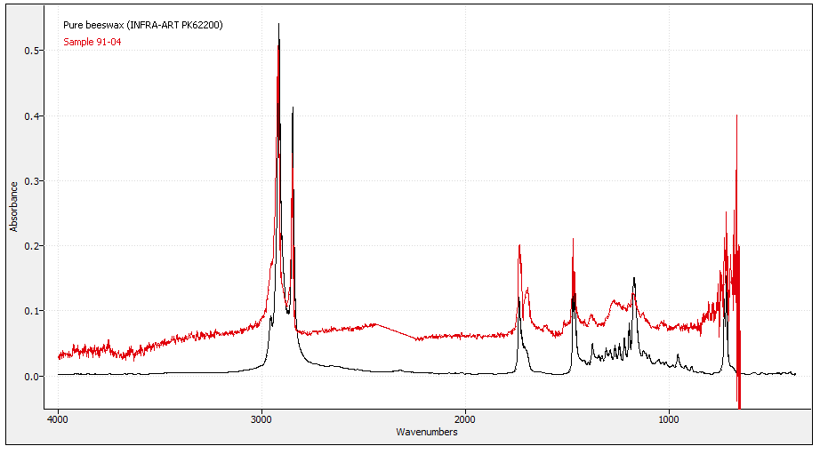Figure S1. Comparison of sample 91-04 to pure beeswax (PK62200) from the INFRA-ART spectral library. PK62200 was collected in transmission mode, presenting a higher resolution than 91-04, but providing a highly consistent match between the two.

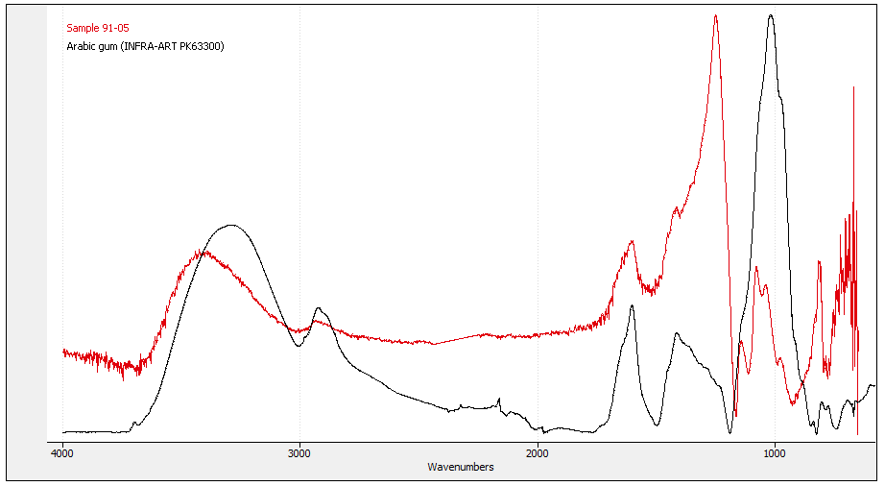Figure S2. Comparison of sample 91-05 to Arabic gum, also known as Acacia gum, (PK63300) from the INFRA-ART spectral library. PK63300 was recorded in transmission mode, presenting a higher resolution than 91-05, but providing a strong match between the two. The interference of the flint substrate can also be observed due to the thin and translucent nature of the sample.
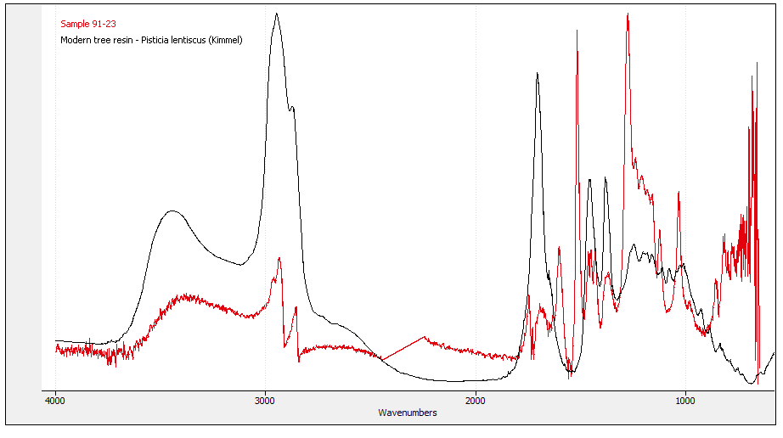Figure S3. Comparison of sample 91-23 to modern tree resin (Pistacia lentiscus) from the Kimmel library. There are minor similarities present but significant differences, suggesting this is a tree resin of a different species as well as a likely admixture.

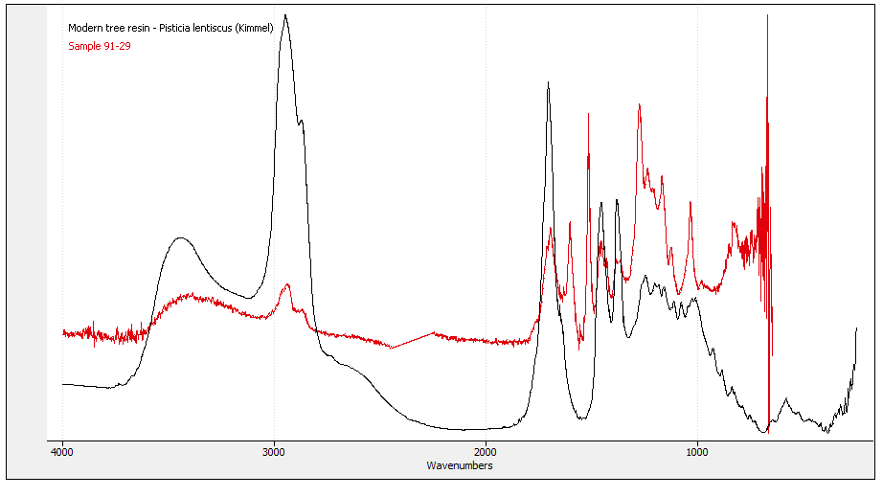Figure S4. Comparison of sample 91-29 to a modern tree resin (Pistacia lenstiscus) in the Kimmel spectral library. There are some shared similarities, but this match is not strong, suggesting that this is a tree resin of a different species as well as a possible admixture.

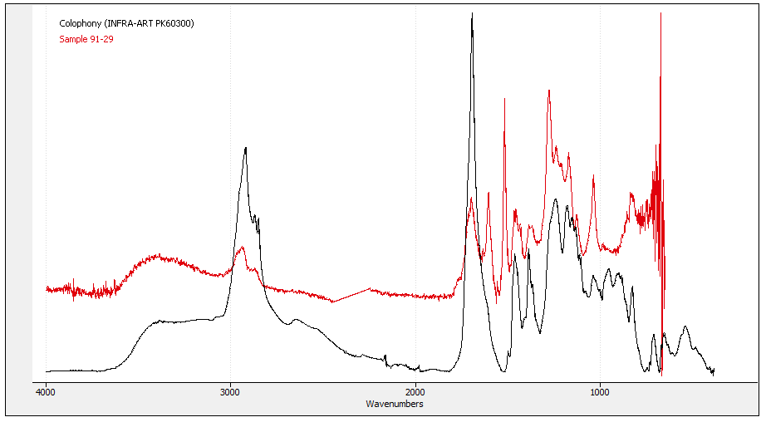Figure S5. Comparison of sample 91-29 to colophony (also known as rosin), a resin derived from pine trees and other coniferous plants, in the INFRA-ART spectral library sourced from Kremer Pigments. There are some shared similarities, but this match is not strong suggesting that sample 91-29 corresponds with a tree resin of a different species, as well as a possible admixture.

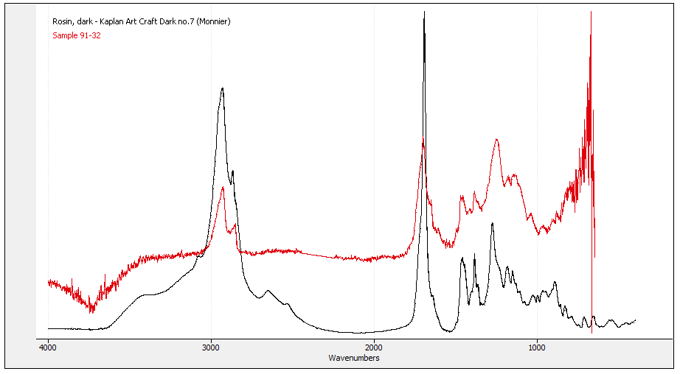Figure S6. Comparison of sample 91-32 to rosin (Kaplan Art Craft Dark, no. 7), also known as colophony, which is a resin derived from pine trees and other coniferous plants, in the University of Minnesota Archaeological Materials Infrared Spectra Library. There are strong similarities suggesting a likely match.

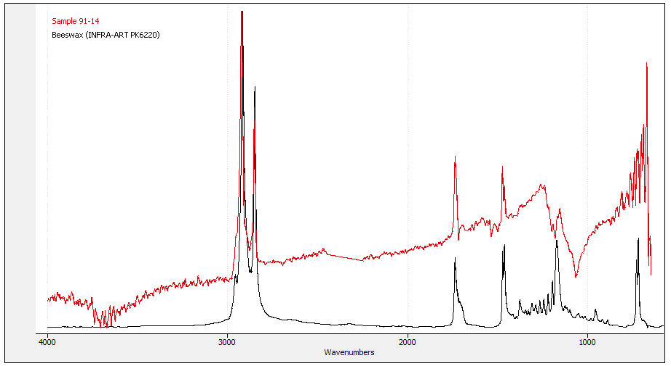Figure S7. Comparison of sample 91-14 to pure beeswax (PK62200) in the INFRA-ART spectral library. There are significant peak matches between the two, though overlapping signals suggest 91-14 is a possible admixture.

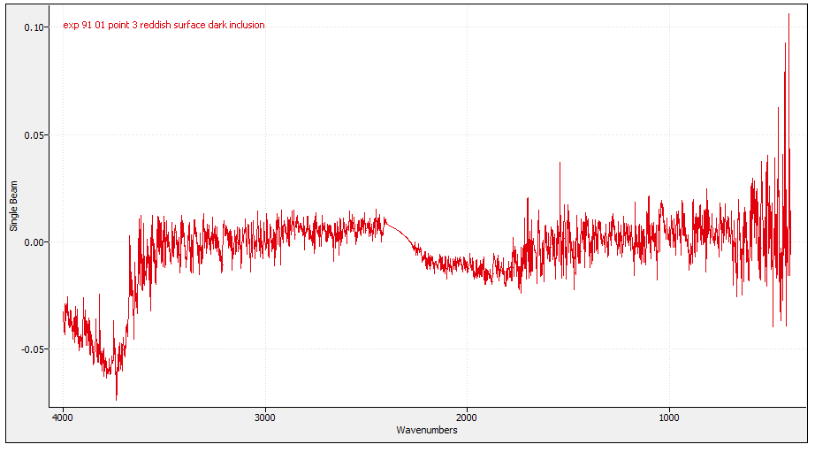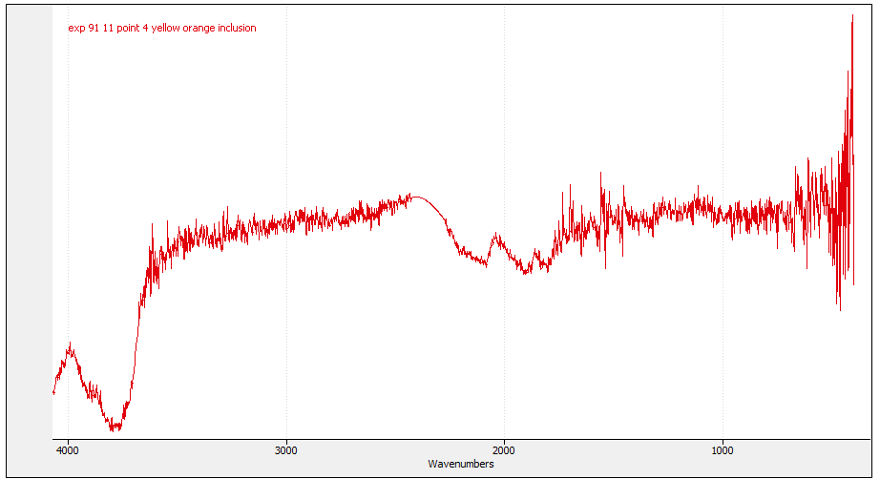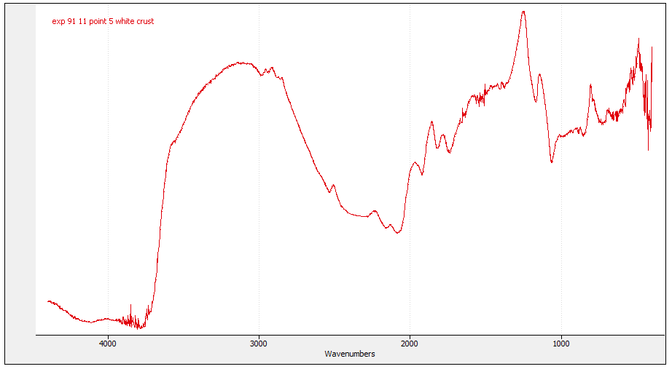
Figure S8. Example spectra from inclusions in samples 91-01 (top), 91-11 (middle) and 91-11 (bottom) collected with the KBr/LN-MCT-B instrument, illustrating the high noise levels and irregular features observed compared to the rest of the dataset.

Expanded Peak Table
Group 1
Wavenumber (cm⁻¹) – KBr/LN-MCT-B | Wavenumber (cm⁻¹) – ZnSe/TE-MCT-A | Assignment | Notes
- | 3380 | O–H (±N–H) stretch | Broad phenolic/alcoholic O–H; moisture/adsorbed water may contribute
2980 | 2945 |  | Aliphatic methyl groups in terpenoid resin acids
  CH₃ asym. stretch
2920 | 2920 | CH₂ asym. stretch | Aliphatic chain backbone
2890 | 2870 | CH stretch, aromatic overlap | Methyl groups in aromatic-substituted resins; weak aromatic effect
2855 | 2855 | CH₂ sym. stretch | Long-chain aliphatic CH₂ moieties; wax/resin components
1867 | - | Overtone / combination band | Weak; possibly combination/overtone from oxidation or resin aging
1843 | - | Overtone / combination band | Similar as above; likely minor overtone contributions
1791 | - | Overtone / combination band | Very weak; perhaps ester carbonyl overtone or conjugated carbonyl stretch from oxidation
1733 | 1733 | C=O stretch | Ester / carboxylic acid carbonyl; strong carbonyl fingerprint
- | 1726 | C=O stretch | Weak shoulder; indicative of mixed carbonyl species
1715 | 1715 | C=O stretch | Carboxylic acid carbonyl; diagnostic in resin aging
1695 | 1695 | C=O stretch | Possibly carbonyls in conjugated or hydrogen-bonded contexts
1683 | 1684 | ν(C–O–C) / conjugated ester | Weak ester or ether link; possible conjugation
1669 | 1669 |  | Weak; shift indicates hydrogen bonding or macromolecular structure
  O–H-associated / H-bonded carbonyl shift
1662 | 1662 |  | Weak; possible unsaturation or exocyclic double bond
  δ(CH₂) / exocyclic -C=C-H bending
1652 | 1655 | C=C stretch / weak amide I overlap | Could also reflect proteins (if present) or unsaturated terpenoid double bonds
1646 | 1648 | C=C stretch / H-bonded O–H | Very weak; likely conjugated double bonds or H-bonded carbonyl interactions
1635 | 1636 | C=C / possibly aromatic / H-O-H bending overlap | Very weak; water bending component possible where residue is thin
1606 | 1604 | Aromatic C=C stretch | Phenolic ring vibrations; key aromatic signature
- | 1590 | Aromatic C=C shoulder | Weak; substitution or partial conjugation effects
- | 1580 | Aromatic C=C shoulder | Very weak; aromatic substitution effects
1575 | 1572 | Aromatic/skeletal | Very weak aromatic skeletal vibration
1568 | 1568 | Aromatic/skeletal | Very weak aromatic skeletal vibration
1539 | 1535 | Aromatic/skeletal | Very weak aromatic skeletal vibration
1516 | 1517 | C=C (phenolic/aromatic) | Diagnostic phenolic band for conifer resins
1506 | 1504 | Aromatic/phenolic | Minor phenolic contribution
1496 | 1493 | Aromatic/phenolic | Weak aromatic band; substitution-dependent
1488 | 1482 | Aromatic/phenolic (shoulder) | Shoulder in phenolic region; low intensity
1471 | 1471 | CH₂ scissoring / ring deformation | Weak shoulder; aliphatic framework and/or ring deformation
1464 | 1464 | CH₂ scissoring | Aliphatic hydrocarbons (resin/wax)
1456 | 1453 | CH₂ deformation (±CH₃ bend overlap) | Chain deformation; can overlap CH₃ bending
1435 | 1435 | CH₂/CH₃ bending | Aliphatic hydrocarbon; waxy component indicator
1418 | 1420 | CH₂ bending | Weak shoulder reflecting local chain environment
1386 | 1383 | CH₃ bending | Methyl deformation; branching in terpenoids/waxes
1338 | 1332 | Skeletal / C–H wag | Very weak skeletal vibration of aliphatic/aromatic systems
1327 | 1322 | Skeletal / C–H wag | Very weak; minor skeletal mode
1273 | 1276 | C–O stretch | Strong acidic C–O; oxidized terpenoid resin acids
1238 | 1238 | C–O stretch | Medium C–O in esters/acids
1208 | 1211 | C–O | Weak C–O from resin-derived linkages
1169 | 1169 | C–O–C / C–C | Terpenoid esters/resin-acid region
1126 | 1124 | C–O–C / C–C | Esters/terpenoid backbone vibrations typical of conifer resins
1035 | 1035 | Si–O stretch; ± carbohydrate C–O | Strong band; can include substrate silicate plus residue C–O
982 | 982 | C–H deformation / ring or lattice mode | Weak; low-frequency deformation; possible phosphate/carbohydrate overtones
967 | 962 | C–H deformation / ring or lattice mode | Weak minor deformation
- | 870 |  | Weak; substituted aromatic ring OOP bending
  Aromatic OOP bend
854 | 850 | Aromatic OOP | Very weak
833 | 834 | N–O stretch (alt: silicate overtone) | Weak; possible nitrate contamination; silicate overtone also possible
- | 825 | Aromatic OOP / weak overtone | Very weak overtone/combination in ring region
822 | 820 | Aromatic OOP / skeletal | Weak aromatic OOP or skeletal vibration
- | 804 | Aromatic/Si–O related (very weak) | Very weak ring or silicate-related feature
- | 790 | Aromatic/Si–O related (very weak) | Very weak ring or silicate-related feature
776 | 776 | Si–O bend | Silicate/clay band; substrate influence when residues are thin or caused by admixtures
745 | 742 | CH₂ rocking / ring deformation | Very weak, long-chain CH₂ rocking and/or aromatic ring deformation
718 | - | CH₂ rocking | Long-chain aliphatic rocking (waxes/resins)
679 | - | SO₄²⁻ ν₄ bending (gypsum/bassanite from ochre/sand contaminants) | Sulfate bending typical of hydrated Ca-sulfates, present in ochre or sand fillers
667 | - | SO₄²⁻ ν₄ bending (gypsum) | Distinct ν₄ at 664–669 cm⁻¹, matches ochre/sand mineral traces
647 | - | SO₄²⁻ ν₄ broad band / Fe-O | Broadened sulfate from clay or sand; possible hematite/goethite
632 | - | OH libration (apatite) or sulfate overprint | 630–632 cm⁻¹ classic for hydroxyapatite OH libration, but more likely sulfate
616 | - | SO₄²⁻ ν₄ | Ochre-derived sulfates
599 | - | SO₄²⁻ ν₄ or PO₄³⁻ ν₄ | Could be gypsum or clay/apatite phosphate
590 | - | Fe–O stretch (hematite/goethite in ochre) | Hematite bands
580 | - | Fe–O stretch | Hematite/goethite range
575 | - | PO₄³⁻ ν₄ bending | Possible apatite/soil phosphate
566 | - | PO₄³⁻ ν₄ bending lower component | Possible apatitic phosphate
558 | - | PO₄³⁻ ν₄ or Fe–O | Low-side PO₄ shoulder; Fe-oxide possible
545 | - | Fe–O (hematite/goethite) | Iron oxide in ochre
535 | - | Fe–O or clay lattice | Silicate/iron lattice bands from clay additives
Table S2. Expanded peak table for Group 1 with associated molecular band assignments. This table lists all shared peaks detected within the defined group; additional peaks may be present within individual samples. Weak peaks may arise from instrument artifacts or substrate contributions. “OOP” indicates out-of-plane vibrations. Full peak lists for all other groups, including minor peaks and shoulders, are provided as CSV spectra files at [link]. Only major peaks are summarized in the main manuscript for clarity. Molecular band assignments draw on a wide range of published FTIR reference data (e.g. Edwards 1996; Edwards and Falk 1997; Socrates 2001; Schiegl and Conard 2006; Vahur et al. 2011; Cinta-Pinzaru et al. 2012; Bruni and Guglielmi 2014; Chukanov 2014; Helwig et al. 2014; Duce et al. 2015; Beltran et al. 2016; Monnier et al. 2017; Martin-Ramos et al. 2018; Shaw 2022; Schmidt and Koch 2024).

References
Beltran, V., Salvado, N., Buti, S., Pradell, T. (2016). Ageing of resin from Pinus species assessed by infrared spectroscopy. Anal. Bioanal. Chem., 408, 4073-4082. DOI 10.1007/s00216-016-9496-x
Bruni, S., and Guglielmi, V. (2014). Identification of archaeological triterpenic resins by the non-separative techniques FTIR and 13C NMR: The case of Pistacia resin (mastic) in comparison with frankincense. Spectrochimica Acta Part A: Molecular and Biomolecular Spectroscopy, 121, 613-622. http://dx.doi.org/10.1016/j.saa.2013.10.098
Chukanov, N. V. (2014). Infrared Spectra of Mineral Species: Extended Library. Springer Science+Business Media, Dordrecht.
Cinta-Pinzaru, S., Pop, D., and Nemeth, L. (2012). FT-Raman and FT-Infrared investigations of archaeological artefacts from Foeni Neolithic site (Banat, Romania). Studia Universitatis Babes-Bolyai, Geologia, 53 (1), 31-37.
Duce, C., Orsini, S., Spepi, A, Colombini, M.P., Rine, M.R., Ribechini, E. (2015). Thermal degradation chemistry of archaeological pine pitch containing beeswax as an additive. Journal of Analytical and Applied Pyrolysis, 111, 254-264. http://dx.doi.org/10.1016/j.jaap.2014.10.020
Edwards, H.G.M., and Falk, M.J. (1997). Fourier Transform Raman Spectroscopic study of ancient resins: a feasibility study of application to archaeological artefacts. Journal of Raman Spectroscopy, 28, 211-218.
Edwards, H.G.M., et al. (1996). Farwell, DW., and Daffner, L. 1996. Fourier-transform Raman spectroscopic study of natural waxes and resins
Helwig, K., Monahan, V., Poulin, J., Andrews, T.D. (2014). Ancient projectile weapons from ice patches in northwestern Canada: Identification of resin and compound resin-ochre hafting adhesives. Journal of Archaeological Science, 41, 655-665. http://dx.doi.org/10.1016/j.jas.2013.09.010
Martin-Ramos, P., Fernandez-Coppel, I.A., Ruiz-Potosme, N.M., and Martin-Gil, J. (2018). Potential of ATR-FTIR spectroscopy for the classification of natural resins. Biology, Medicine, Engineering and Science Reports, 4(1): 03-06. DOI : 10.5530/bems.4.1.2
Monnier, G., Frahm, E., Luo, B., Missal, K. (2017a). Developing FTIR microspectroscopy for analysis of plant residues on stone tools. Journal of Archaeological Science, 78, 158-178. http://dx.doi.org/10.1016/j.jas.2016.12.004
Schiegl, S. and Conard, N.J. (2006). The Middle Stone Age sediments at Sibudu: results from FTIR spectroscopy and microscopic analyses. Southern African Humanities, 18 (1): 149-172.
Schmidt, P., and Koch, T.J. (2024). The molecular composition of birch tar and its infrared spectrum. Archaeological and Anthropological Sciences, 16:193. https://doi.org/10.1007/s12520-024-02102-5
Shaw, C.L. (2022). An evaluation of the infrared 630 cm-1 OH libration band in bone mineral as evidence of fire in the archaeological record. Journal of Archaeological Science: Reports, 46, 103655. https://doi.org/10.1016/j.jasrep.2022.103655
Socrates, G. (2001). Infrared and Raman Characteristic Group Frequencies: Tables and Charts. West Sussex: Wiley.
Vahur, S., Kriiska, A., Leito, I. (2011). Investigation of the adhesive residue on the flint insert and the adhesive lump found from the Pulli early Mesolithic settlement site (Estonia) by Micro-ATR-FT-IR spectroscopy. Estonian Journal of Archaeology, 15, 1, 3-17. https:// doi:10.3176/arch.2011.1.01

