PET/CT radiomics and machine learning enable non-invasive survival stratification and histologic tumor risk profiling in patients with lung adenocarcinoma
Meixi Zhao^{1*}, Kilian Kluge^{2,4*}, Laszlo Papp⁵, Marko Grahovac², Shaomin Yang³, Chunting Jiang¹, Denis Krajnc⁵, Clemens P. Spielvogel^{2,4}, Boglarka Ecsedi⁵, Alexander Haug^{2,4}, Shiwei Wang⁶, Marcus Hacker², Weifang Zhang^{1#}, Xiang Li^{2#}

¹Department of Nuclear Medicine, Peking University Third Hospital, Beijing, People's Republic of China
²Department of Biomedical Imaging and Image-guided Therapy, Division of Nuclear Medicine, Medical University of Vienna, Währinger Gürtel 18-20, 1090 Vienna, Austria
³Department of Pathology, Peking University Health Science Center
⁴Christian Doppler Laboratory for Applied Metabolomics, Vienna, Austria
⁵QIMP Team, Center for Medical Physics and Biomedical Engineering, Medical University of Vienna, Vienna, Austria
⁶Evomics Medical Technology Co., Ltd. Shanghai, China

*Shared the 1st authorship

# Correspondance

Xiang Li, Asso.Prof. Ph.D.
Division of Nuclear Medicine
Department of Biomedical Imaging and Image-guided Therapy
Vienna General Hospital, Medical University of Vienna
1090 Vienna, Austria
Tel: 0043-1-40400-55580
Email: xiang.li@meduniwien.ac.at

Or

Weifang Zhang, Prof. M.D,
Department of Nuclear Medicine,
Peking University Third Hospital,
Beijing 100191, P. R. China
Tel: +8610 82264936
E-mail: tsy1997@126.com

SUPPLEMENTAL MATERIALS

TABLE 1a: Reporting structure of the study according to the Imaging Biomarker Standardization Initiative (IBSI) guidelines¹

Patient
Volume of Interest | [¹⁸F]FDG-positive thoracic lung adenocarcinoma lesions in PET/CT
Patient Preparation | - Fasting 6h prior tracer injection  - Blood glucose measurement (required < 200mg/dl)
Radiotracer | - [¹⁸F]FDG (>90% radiochemical purity)  - 5.55 MBq/kg (0,15 mCi/kg) [¹⁸F]FDG injected intravenously  - 60 minutes uptake time resting recumbent in a calm environment
Contrast agent | - no contrast agent was used
Acquisition and Reconstruction
Scanner type | Siemens Biograph TruePoint PET/CT
Acquisition protocol | Local protocol of 3. Hospital of Peking Medical University – Department of Nuclear Medicine
[¹⁸F]FDG-PET | - Static  - 5-7 bed positions  - 2-2,5 minutes per bed position  - 2.98 mm voxel size  - Matrix size: 168x168  - Slice thickness: 3 mm  - Image slice spacing 0 mm  - Reconstruction: OSEM (21 subsets, 3 iterations)  - Scatter and attenuation correction: CT based
CT | - Deep inspiratory CT with breath holding  - Tube voltage: 120 kVp  - Tube current: 100 mAs  - 0.98 mm voxel size  - Matrix size: 512x512  - Slice thickness: 3 mm  - Image slice spacing 0 mm
Image Co-registration
Software | Hermes Hybrid 3D ver 4.0
Co-registration step 1 | Automated by DICOM coordinate parameters
Data conversion
SUV normalization | by body weight (SUVBW)
Segmentation
Software | Hermes Hybrid 3D ver 4.0
VOI definition | Standard semi-automated with delineation criteria according to PET Response Criteria in Solid Tumors (PERCIST 1.0) for target lesions at baseline with mediastinal blood pools set as background and minimum lesion size greater or equal to 130 voxel with subsequent manual adjustment on basis of CT images
Number of experts | 2 nuclear medicine experts (over 5 years of practice, consensus strategy – discussion)
Image / VOI interpolation
Method | Kriging interpolation in 3D²⁠, including nearest neighbors within distance of voxel size main diagonal + epsilon.
Grid | Align by center
Extrapolation beyond original image | Neighbor distance search calculated as original voxel size main diagonal + epsilon. Missing value: image minimum
Voxel dimensions | 2.0 x 2.0 x 2.0 mm
Partially masked voxels (VOI) | Taken if more than half of original voxel area included
Discretization
Method | Fixed bin width, variable number of bins
Bin width | - [¹⁸F]FDG: 0.05 (in TBR units)  - ADC: 5 (in original units)
Image biomarker computation / Parameters
Biomarker set | - Intensity-based statistical features (6 per image): Minimum intensity, Maximum intensity, Mean intensity, Intensity variance, Intensity range (Maximum – Minimum), Intensity sum  - Intensity histogram features (6 per image): Discretised intensity uniformity, Discretised intensity entropy, (Excess) discretised intensity kurtosis, Mean discretised intensity, Discretised intensity skewness, Discretised intensity variance  - GLCM features (18 per image): Angular second moment, Autocorrelation, Cluster prominence, Cluster shade, Contrast, Correlation, Difference entropy, Difference variance, Dissimilarity, Joint entropy, Joint maximum, Joint variance, Inverse difference, Inverse difference moment, Sum average, Sum entropy, Sum variance, Information correlation 1  - GLSZM features (11 per image): Gray level non-uniformity, High gray level zone emphasis, Large zone high grey level emphasis, Large zone low grey level emphasis, Large zone emphasis, Low grey level zone emphasis, Small zone high grey level emphasis, Small zone low grey level emphasis, Small zone emphasis, Zone size non-uniformity, Zone percentage  - Morphological features (4): Volume (voxel counting), Compactness 1, Spherical disproportion, Area NGTDM features (5 per image): Coarseness, Contrast, Busyness, Complexity, Strength
Software | MUW radiomics engine³ ver. 2.0, developed and validated based on IBSI guidelines and reference datasets¹  Software availability upon reasonable request from the corresponding author.
Distance weighting | No
CM symmetry | Symmetric
CM / ZM distance | Chebyshev distance 1
CM / ZM aggregation | 3D, full-merging
Exclusion criteria | VOIs with less than 64 voxels were excluded from the analysis

Section 4YOS – 4-year Overall Survival

Automated Machine Learning Analysis
Tabular data submission for Dedicaid-Evomics AutoML services was performed on 06/04/2021, 15:48:15 to build and cross-validate automated data preprocessing and mixed, stacked ensemble learning pipelines for predicting reference label label1. For the details of the analysis see Table 1b.
Table 1b. Properties of the automated machine learning (AutoML) analysis of this study.
Data name | 4YOS-FDB+LDB2_sub_tm.xlsx
Data size | 276 samples, 2089 features
Date of analysis | 06/04/2021, 15:48:15
Duration of analysis | 60h 32m 22s
Submitted by | laszlo.papp@outlook.com
AutoML version | 1.0

Methods

Data
The input dataset was composed of 276 samples and 2111 features. The submitted dataset was composed of 2089 features. The selected reference label for the cross-validation was label1 having subgroups of 0 (65.9%) and 1 (34%) label outcomes.

Cross-Validation
Monte Carlo (MC) cross-validation scheme was applied with 80% training and 20% validation ratios across 100 folds⁴. Each fold had unique training-validation configurations. MC split resulted in 221 samples per fold in the training set. The validation set of each fold contained 28 samples per reference label (55 overall). The validation samples were equally subsampled to ensure that none of the label outcomes are over or underrepresented during the cross-validation.

Preprocessing
The data underwent preprocessing steps in each fold before performing machine learning (ML) analysis. Preprocessing resulted in average 328 samples and 36 features across all MC folds. For the preprocessing steps and their parameters, see Table 2a.
Table 2a. Preprocessing step algorithms as well as their parameter values performed in all Monte Carlo folds before machine learning. FN - Feature Normalization; SRR - Smart Redundancy Reduction; SSYN - Sample Synthetizer.
Preprocessing step | Algorithm | Parameter | Value | Reference
1 | FN | Normalization type | Mean-Deviation | ⁵⁠
2 | SRR | Redundancy Threshold (Covariance) | 0.85 | ⁶⁠
3 | SSYN | Oversampling ratio (majority subgroup) | 1 | ⁷⁠
3 | SSYN | Sampling technique | SMOTE | ⁷⁠

Machine Learning Layer 1
Various machine learning algorithms were established in each fold to minimize the effect of algorithm bias⁶. Each model was trained by randomly selecting 80% of the preprocessed training data per MC fold. For details of the ML algorithms, see Table 3a.
Table 3a. Machine learning (ML) algorithms in the first ML layer with their parameters and value ranges across Monte Carlo (MC) folds. Occurrence of each ML type is represented in percentages across MC folds. BYS – Bayesian Classifier; MGWC – Multi-Gaussian Weighted Classifier; RF – Random Forest Classifier; SVM – Support Vector Machine Classifier;
ML Algorithm | Parameter | Value Range | Occurrence | Reference
BYS | – | – | 20.71% | ⁹⁠
MGWC | Initial value multiplier | 1 – 10 | 27.29% | ¹⁰⁠
MGWC | Maximum iterations | 36000 – 180000 | 27.29% | ¹⁰⁠
MGWC | Negative weights allowed | False, true | 27.29% | ¹⁰⁠
MGWC | Scale value multiplier | 0.1 – 50 | 27.29% | ¹⁰⁠
MGWC | Tolerance | 0.00001 – 0.0001 | 27.29% | ¹⁰⁠
RF | Bag fraction | 0.8 – 0.99 | 24.97% | ⁶⁠
RF | Bagging method | normal, equalized | 24.97% | ⁶⁠
RF | Boosting | none, adaboost | 24.97% | ⁶⁠
RF | Maximum tree depth | 11 – 1044 | 24.97% | ⁶⁠
RF | Minimum samples in leaves | 4 – 8 | 24.97% | ⁶⁠
RF | Node feature selection method | none | 24.97% | ⁶⁠
RF | Number of random features per node | 11 | 24.97% | ⁶⁠
RF | Number of selected trees | 101 – 201 | 24.97% | ⁶⁠
RF | Number of trees to build | 301 – 1001 | 24.97% | ⁶⁠
RF | Tree quality metric | gain, gini | 24.97% | ⁶⁠
RF | Tree selection method | 0 | 24.97% | ⁶⁠
SVM | Learning rate | 0.001 – 0.01 | 27% | ⁸⁠
SVM | Maximum iterations | 1000 – 5000 | 27% | ⁸⁠

Machine Learning Layer 2
Meta-training sets were created by evaluating the samples of the preprocessed training set in each MC fold by the trained models in ML layer 1. In order to create the meta-training set, the prediction results of each trained model in ML layer 1 were handled as feature values of the given training sample. The meta-training set was the input for training the second ML layer prediction models. These models were trained to identify patterns in the prediction of the first ML layer models to result in mixed super learners¹¹. For the parameters of the second layer ML algorithms see Table 4a.
Table 4a. Machine learning (ML) algorithms in the second ML layer with their parameters and value ranges across Monte Carlo (MC) folds. Occurrence of each ML type is represented in percentages across MC folds. MGWC – Multi-Gaussian Weighted Classifier; RF – Random Forest Classifier; SVM – Support Vector Machine Classifier;
ML Algorithm | Parameter | Value Range | Occurrence | Reference
MGWC | Initial value multiplier | 10 | 33.33% | ¹⁰
MGWC | Maximum iterations | 5000 – 16000 | 33.33% | ¹⁰
MGWC | Negative weights allowed | true, false | 33.33% | ¹⁰
MGWC | Scale value multiplier | 1 – 5 | 33.33% | ¹⁰
MGWC | Tolerance | 0.0001 | 33.33% | ¹⁰
RF | Bag fraction | 0.8 – 0.99 | 33.33% | ⁶⁠
RF | Bagging method | normal, equalized | 33.33% | ⁶⁠
RF | Boosting | adaboost, none | 33.33% | ⁶⁠
RF | Maximum tree depth | 11 | 33.33% | ⁶⁠
RF | Minimum samples in leaves | 4 – 8 | 33.33% | ⁶⁠
RF | Node feature selection method | none | 33.33% | ⁶⁠
RF | Number of random features per node | 11 | 33.33% | ⁶⁠
RF | Number of selected trees | 201 | 33.33% | ⁶⁠
RF | Number of trees to build | 501 – 1001 | 33.33% | ⁶⁠
RF | Tree quality metric | gain, gini | 33.33% | ⁶⁠
RF | Tree selection method | 0 | 33.33% | ⁶⁠
SVM | Learning rate | 0.001 – 0.01 | 33.33% | ⁸⁠
SVM | Maximum iterations | 1000 – 5000 | 33.33% | ⁸⁠

Top-Layer Model
Combination of the prediction results of the second layer ML models was performed by weighted majority voting to provide the final prediction of the model scheme. Weighting of each ML Layer 2 model was calculated based on training performance. In addition, ML Layer 2 models having less training performance than the median of all ML layer 2 model training performances had weight 0 in the final vote.

Results

Cross-Validation Performance
Model prediction performance was estimated via the MC cross-validation scheme utilizing confusion matrix analytics ¹². True positive, true negative, false positive and false negative confusion matrix entries were calculated by evaluating the validation samples by the established model pipeline in each fold. Sensitivity, specificity, accuracy, positive predictive as well as negative predictive values were calculated across the MC fold validation results. For the average cross-validation performance of ML Layer 1 and 2 models see Table 5a and Table 6a respectively. For the cross-validation results of the final (top-layer) prediction models as well as for the summary of the evaluation, see Table 7a and Figure 1a. For cross-validation area under the curve (AUC), see Figure 2a.
Table 5a. Average Monte Carlo (MC) cross-validation performance (%) of ML Layer 1 (ML-1) predictive models as determined by confusion matrix analytics across all MC folds. BYS – Bayesian Classifier; MGWC – Multi-Gaussian Weighted Classifier; RF – Random Forest Classifier; SVM – Support Vector Machine Classifier; SNS – Sensitivity; SPC – Specificity; PPV – Positive Predictive Value; NPV – Negative Predictive Value; ACC – Accuracy; OCC – Occurrence.; Performance and occurrence values are in percentages.
 | SNS | SPC | PPV | NPV | ACC | OCC
BYS | 83 | 87 | 87 | 84 | 85 | 21
MGWC | 83 | 87 | 87 | 84 | 85 | 27
RF | 75 | 93 | 92 | 79 | 84 | 25
SVM | 86 | 86 | 86 | 87 | 86 | 27

Table 6a. Average Monte Carlo (MC) cross-validation performance (%) of ML Layer 2 (ML-2) predictive models as determined by confusion matrix analytics across all MC folds. MGWC – Multi-Gaussian Weighted Classifier; RF – Random Forest Classifier; SVM – Support Vector Machine Classifier; SNS – Sensitivity; SPC – Specificity; PPV – Positive Predictive Value; NPV – Negative Predictive Value; ACC – Accuracy; OCC – Occurrence. Performance and occurrence values are in percentages.
 | SNS | SPC | PPV | NPV | ACC | OCC
MGWC | 84 | 87 | 87 | 85 | 85 | 33
RF | 79 | 89 | 88 | 82 | 84 | 33
SVM | 85 | 86 | 87 | 86 | 86 | 33

Table 7a. Performance Monte Carlo (MC) cross-validation performance of the established model scheme throughout the performance of the top-layer prediction model. Performance values were determined by confusion matrix analytics across all MC folds. MGWC – Multi-Gaussian Weighted Classifier; RF – Random Forest Classifier; SVM – Support Vector Machine Classifier; SNS – Sensitivity; SPC – Specificity; PPV – Positive Predictive Value; NPV – Negative Predictive Value; ACC – Accuracy; AUC – Area Under the Receiver Operator Characteristics Curve.; LQ – Lower quartile; UQ – Upper Quartile; Dev – Deviation.
 | Min | LQ | Median | UQ | Max | Mean | Dev
SNS | 55.55 | 72.22 | 80.55 | 88.88 | 100 | 79.94 | 7.94
SPC | 61.11 | 83.33 | 88.88 | 94.44 | 100 | 88.16 | 6.13
PPV | 70.83 | 83.33 | 88.23 | 93.09 | 100 | 87.71 | 5.44
NPV | 68 | 77.27 | 81.1 | 88.23 | 100 | 82.16 | 5.73
ACC | 72.22 | 80.55 | 83.33 | 86.11 | 97.22 | 84.05 | 4.18
AUC | 75.77 | 84.41 | 88.42 | 91.04 | 99.38 | 87.68 | 4.2

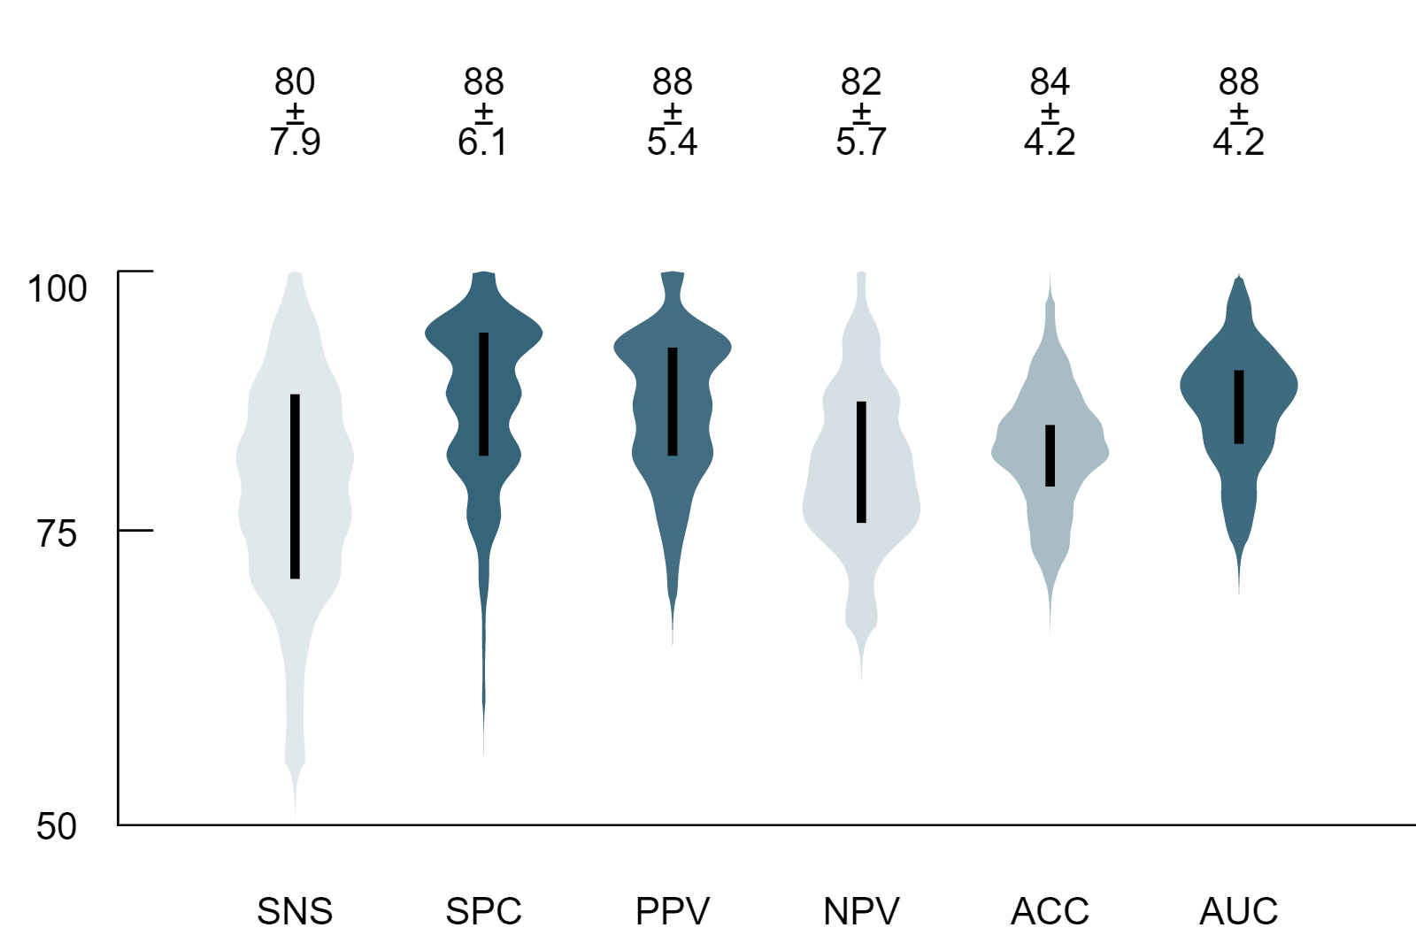
Figure 1a. Box-plot Monte Carlo (MC) cross-validation performance of the established model scheme throughout the performance of the top-layer prediction model. Performance values were determined by confusion matrix analytics across all MC folds. SNS – Sensitivity; SPC – Specificity; PPV – Positive Predictive Value; NPV – Negative Predictive Value; ACC – Accuracy; AUC – Area Under the Receiver Operator Characteristics Curve. Performance values are in percentages.
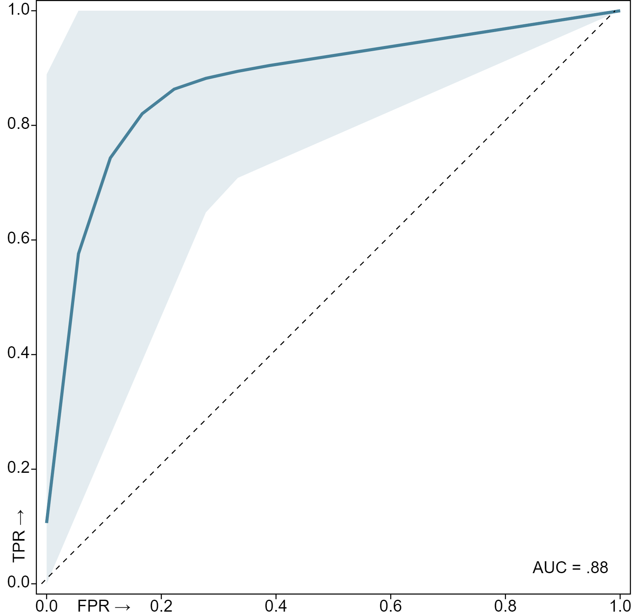
Figure 2a. Mean cross-validation Receiver Operator Characteristics (ROC) curve of the built models. The thick blue line corresponds to the mean ROC curve, while the light blue shaded area represents the spread of all 100 ROC curves generated across the validation folds. AUC – Area Under the Receiver Operator Characteristics Curve (mean of all 100 AUCs); FPR – False Positive Rate, TPR – True Positive Rate. Dashed diagonal line represents a reference random-guess AUC for comparison

Feature Importance
Feature ranking and selection was performed as part of the data preprocessing steps of each fold (see Sec. Preprocessing). The final feature importance was calculated as the mean of all feature rankings across the MC folds. Note that only the highest-ranking 30 features are shown in the table.
Table 8a. Selected features and their ranks as calculated across the MC folds by Smart Redundancy Reduction (SRR - see Table 2a) as well as their respective value distributions. Ranks represent the relative importance of selected features for model building. Features are ordered by ranks. Rank values are in percentages.
Feature Name | Ranking |  | Histogram
PET.GLCM::cm.info.corr.1::MultiLesionKurtosis | 1% | 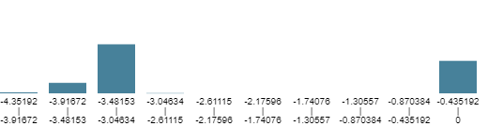
PET.GLCM::cm.energy::MultiLesionKurtosis | 1% | 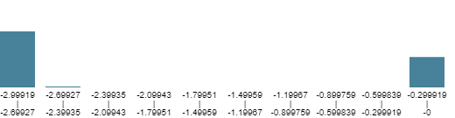
PET.NGLDM::ngl.hdlge::MultiLesionKurtosis | 1% | 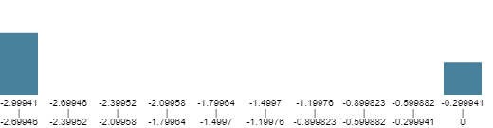
PET.GLRLM::rlm.lrlge::MultiLesionKurtosis | 1% | 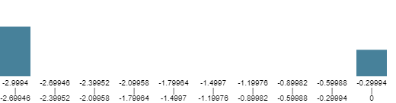
PET.NGLDM::ngl.lgce::MultiLesionKurtosis | 1%
PET.GLRLM::rlm.lgre::MultiLesionKurtosis | 1%
PET.GLRLM::rlm.srlge::MultiLesionKurtosis | 1% | 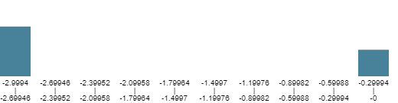
PET.NGLDM::ngl.ldlge::MultiLesionKurtosis | 1%
PET.GLDZM::dzm.sdlge::MultiLesionKurtosis | 1% | 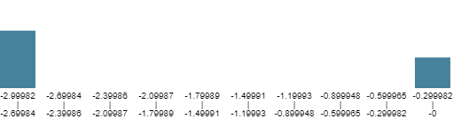
PET.GLDZM::dzm.lgze::MultiLesionKurtosis | 1% | 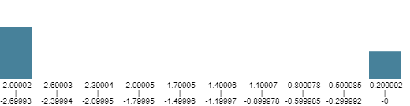
PET.GLRLM::rlm.rl.var::MultiLesionKurtosis | 1% | 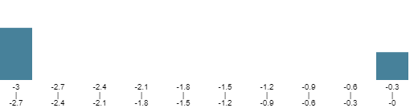
CT.GLRLM::rlm.rl.var::MultiLesionKurtosis | 1%
PET.GLDZM::dzm.ldlge::MultiLesionKurtosis | 1% | 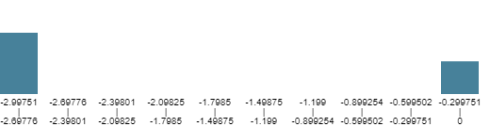
CT.GLCM::cm.energy::MultiLesionKurtosis | 1% | 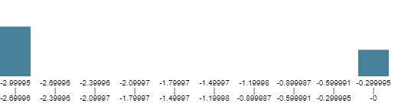
PET.NGLDM::ngl.dc.var::MultiLesionKurtosis | 1%
CT.NGLDM::ngl.dc.var::MultiLesionKurtosis | 1%
CT.GLCM::cm.joint.max::MultiLesionKurtosis | 1% | 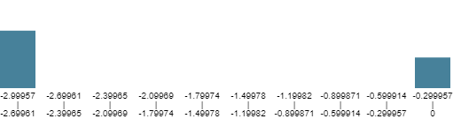
CT.NGLDM::ngl.dc.energy::MultiLesionKurtosis | 1% | 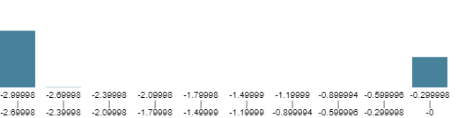
CT.NGLDM::ngl.glnu.norm::MultiLesionKurtosis | 1%
CT.GLRLM::rlm.glnu.norm::MultiLesionKurtosis | 1%
PET.NGLDM::ngl.dc.energy::MultiLesionKurtosis | 1% | 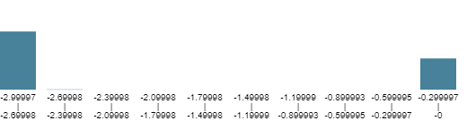
PET.NGLDM::ngl.glnu.norm::MultiLesionKurtosis | 1%
PET.GLRLM::rlm.glnu.norm::MultiLesionKurtosis | 1%
CT.GLDZM::dzm.glnu.norm::MultiLesionKurtosis | 1% | 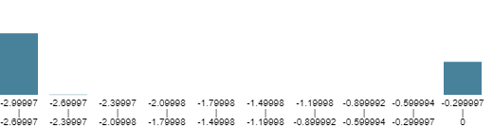
CT.GLSZM::szm.lgze::MultiLesionKurtosis | 1% | 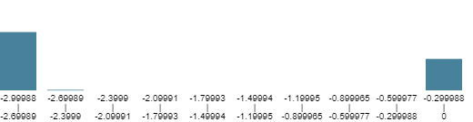
CT.GLSZM::szm.szlge::MultiLesionKurtosis | 1% | 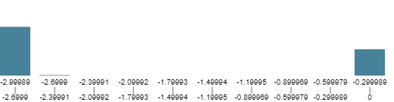
PET.GLCM::cm.joint.max::MultiLesionKurtosis | 1% | 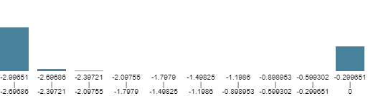
PET.GLDZM::dzm.glnu.norm::MultiLesionKurtosis | 1% | 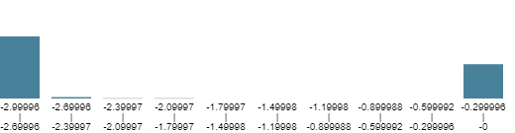
CT.Morphological::morph.comp.1::MultiLesionKurtosis | 1% | 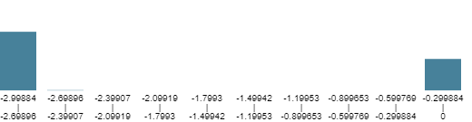
PET.Morphological::morph.comp.1::MultiLesionKurtosis | 1%

Section 3YOS – 3-year Overall Survival

Automated Machine Learning Analysis
Tabular data submission for Dedicaid-Evomics AutoML services was performed on 06/04/2021, 15:48:15 to build and cross-validate automated data preprocessing and mixed, stacked ensemble learning pipelines for predicting reference label label1. For the details of the analysis see Table 1c.
Table 1c. Properties of the automated machine learning (AutoML) analysis of this study.
Data name | 3-YOS-FDB+LDB2_sub_tm.xlsx
Data size | 280 samples, 2089 features
Date of analysis | 06/04/2021, 15:48:15
Duration of analysis | 47h 58m 3s
Submitted by | laszlo.papp@outlook.com
AutoML version | 1.0

Methods

Data
The input dataset was composed of 280 samples and 2111 features. The submitted dataset was composed of 2089 features. The selected reference label for the cross-validation was label1 having subgroups of 0 (56.7%) and 1 (43.2%) label outcomes.

Cross-Validation
Monte Carlo (MC) cross-validation scheme was applied with 80% training and 20% validation ratios across 100 folds⁴. Each fold had unique training-validation configurations. MC split resulted in 224 samples per fold in the training set. The validation set of each fold contained 28 samples per reference label (56 overall). The validation samples were equally subsampled to ensure that none of the label outcomes are over or underrepresented during the cross-validation.

Preprocessing
The data underwent preprocessing steps in each fold before performing machine learning (ML) analysis. Preprocessing resulted in average 270 samples and 32 features across all MC folds. For the preprocessing steps and their parameters, see Table 2b.
Table 2b. Preprocessing step algorithms as well as their parameter values performed in all Monte Carlo folds before machine learning. FN - Feature Normalization; SRR - Smart Redundancy Reduction; SSYN - Sample Synthetizer.
Preprocessing step | Algorithm | Parameter | Value | Reference
1 | FN | Normalization type | Mean-Deviation | ⁵⁠
2 | SRR | Redundancy Threshold (Covariance) | 0.85 | ⁶⁠
3 | SSYN | Oversampling ratio (majority subgroup) | 1 | ⁷⁠
3 | SSYN | Sampling technique | SMOTE | ⁷⁠

Machine Learning Layer 1
Various machine learning algorithms were established in each fold to minimize the effect of algorithm bias ⁶. Each model was trained by randomly selecting 80% of the preprocessed training data per MC fold. For details of the ML algorithms, see Table 3b.
Table 3b. Machine learning (ML) algorithms in the first ML layer with their parameters and value ranges across Monte Carlo (MC) folds. Occurrence of each ML type is represented in percentages across MC folds. BYS – Bayesian Classifier; MGWC – Multi-Gaussian Weighted Classifier; RF – Random Forest Classifier; SVM – Support Vector Machine Classifier;
ML Algorithm | Parameter | Value Range | Occurrence | Reference
BYS | – | – | 22.98% | ⁹⁠
MGWC | Initial value multiplier | 1 – 10 | 27.62% | ¹⁰⁠
MGWC | Maximum iterations | 32000 – 160000 | 27.62% | ¹⁰⁠
MGWC | Negative weights allowed | true, false | 27.62% | ¹⁰⁠
MGWC | Scale value multiplier | 0.1 – 50 | 27.62% | ¹⁰⁠
MGWC | Tolerance | 0.00001 – 0.0001 | 27.62% | ¹⁰⁠
RF | Bag fraction | 0.8 – 0.99 | 21.16% | ⁶⁠
RF | Bagging method | normal, equalized | 21.16% | ⁶⁠
RF | Boosting | none, adaboost | 21.16% | ⁶⁠
RF | Maximum tree depth | 11 – 1044 | 21.16% | ⁶⁠
RF | Minimum samples in leaves | 4 – 8 | 21.16% | ⁶⁠
RF | Node feature selection method | None | 21.16% | ⁶⁠
RF | Number of random features per node | 11 | 21.16% | ⁶⁠
RF | Number of selected trees | 101 – 201 | 21.16% | ⁶⁠
RF | Number of trees to build | 301 – 1001 | 21.16% | ⁶⁠
RF | Tree quality metric | gain, gini | 21.16% | ⁶⁠
RF | Tree selection method | 0 | 21.16% | ⁶⁠
SVM | Learning rate | 0.001 – 0.01 | 28.22% | ⁸⁠
SVM | Maximum iterations | 1000 – 5000 | 28.22% | ⁸⁠

Machine Learning Layer 2
Meta-training sets were created by evaluating the samples of the preprocessed training set in each MC fold by the trained models in ML layer 1. In order to create the meta-training set, the prediction results of each trained model in ML layer 1 were handled as feature values of the given training sample. The meta-training set was the input for training the second ML layer prediction models. These models were trained to identify patterns in the prediction of the first ML layer models to result in mixed super learners¹¹. For the parameters of the second layer ML algorithms see Table 4b.
Table 4b. Machine learning (ML) algorithms in the second ML layer with their parameters and value ranges across Monte Carlo (MC) folds. Occurrence of each ML type is represented in percentages across MC folds. MGWC – Multi-Gaussian Weighted Classifier; RF – Random Forest Classifier; SVM – Support Vector Machine Classifier;
ML Algorithm | Parameter | Value Range | Occurrence | Reference
MGWC | Initial value multiplier | 10 | 33.33% | ¹⁰
MGWC | Maximum iterations | 5000 – 15000 | 33.33% | ¹⁰
MGWC | Negative weights allowed | true, false | 33.33% | ¹⁰
MGWC | Scale value multiplier | 1 – 5 | 33.33% | ¹⁰
MGWC | Tolerance | 0.0001 | 33.33% | ¹⁰
RF | Bag fraction | 0.8 – 0.99 | 33.33% | ⁶⁠
RF | Bagging method | normal, equalized | 33.33% | ⁶⁠
RF | Boosting | adaboost, none | 33.33% | ⁶⁠
RF | Maximum tree depth | 11 | 33.33% | ⁶⁠
RF | Minimum samples in leaves | 4 – 8 | 33.33% | ⁶⁠
RF | Node feature selection method | none | 33.33% | ⁶⁠
RF | Number of random features per node | 11 | 33.33% | ⁶⁠
RF | Number of selected trees | 201 | 33.33% | ⁶⁠
RF | Number of trees to build | 501 – 1001 | 33.33% | ⁶⁠
RF | Tree quality metric | gain, gini | 33.33% | ⁶⁠
RF | Tree selection method | 0 | 33.33% | ⁶⁠
SVM | Learning rate | 0.001 – 0.01 | 33.33% | ⁸⁠
SVM | Maximum iterations | 1000 – 5000 | 33.33% | ⁸⁠

Top-Layer Model
Combination of the prediction results of the second layer ML models was performed by weighted majority voting to provide the final prediction of the model scheme. Weighting of each ML Layer 2 model was calculated based on training performance. In addition, ML Layer 2 models having less training performance than the median of all ML layer 2 model training performances had weight 0 in the final vote.

Results

Cross-Validation Performance
Model prediction performance was estimated via the MC cross-validation scheme utilizing confusion matrix analytics ¹². True positive, true negative, false positive and false negative confusion matrix entries were calculated by evaluating the validation samples by the established model pipeline in each fold. Sensitivity, specificity, accuracy, positive predictive as well as negative predictive values were calculated across the MC fold validation results. For the average cross-validation performance of ML Layer 1 and 2 models see Table 5b and Table 6b respectively. For the cross-validation results of the final (top-layer) prediction models as well as for the summary of the evaluation, see Table 7b and Figure 1b. For cross-validation area under the curve (AUC), see Figure 2b.
Table 5b. Average Monte Carlo (MC) cross-validation performance (%) of ML Layer 1 (ML-1) predictive models as determined by confusion matrix analytics across all MC folds. BYS – Bayesian Classifier; MGWC – Multi-Gaussian Weighted Classifier; RF – Random Forest Classifier; SVM – Support Vector Machine Classifier; SNS – Sensitivity; SPC – Specificity; PPV – Positive Predictive Value; NPV – Negative Predictive Value; ACC – Accuracy; OCC – Occurrence; Performance and occurrence values are in percentages.
 | SNS | SPC | PPV | NPV | ACC | OCC
BYS | 79 | 87 | 86 | 81 | 83 | 23
MGWC | 78 | 87 | 86 | 80 | 82 | 28
RF | 72 | 89 | 87 | 77 | 81 | 21
SVM | 80 | 86 | 85 | 81 | 83 | 28

Table 6b. Average Monte Carlo (MC) cross-validation performance (%) of ML Layer 2 (ML-2) predictive models as determined by confusion matrix analytics across all MC folds. MGWC – Multi-Gaussian Weighted Classifier; RF – Random Forest Classifier; SVM – Support Vector Machine Classifier; SNS – Sensitivity; SPC – Specificity; PPV – Positive Predictive Value; NPV – Negative Predictive Value; ACC – Accuracy; OCC – Occurrence. Performance and occurrence values are in percentages.
 | SNS | SPC | PPV | NPV | ACC | OCC
MGWC | 79 | 86 | 85 | 81 | 83 | 33
RF | 76 | 83 | 82 | 78 | 80 | 33
SVM | 79 | 86 | 86 | 81 | 83 | 33

Table 7b. Performance Monte Carlo (MC) cross-validation performance of the established model scheme throughout the performance of the top-layer prediction model. Performance values were determined by confusion matrix analytics across all MC folds. MGWC – Multi-Gaussian Weighted Classifier; RF – Random Forest Classifier; SVM – Support Vector Machine Classifier; SNS – Sensitivity; SPC – Specificity; PPV – Positive Predictive Value; NPV – Negative Predictive Value; ACC – Accuracy; AUC – Area Under the Receiver Operator Characteristics Curve.; LQ – Lower quartile; UQ – Upper Quartile; Dev – Deviation.
 | Min | LQ | Median | UQ | Max | Mean | Dev
SNS | 58.33 | 75 | 79.16 | 83.33 | 95.83 | 78.33 | 6.46
SPC | 70.83 | 83.33 | 87.5 | 87.5 | 100 | 85.29 | 5.29
PPV | 71.42 | 80.38 | 84.6 | 87.75 | 100 | 84.48 | 5.04
NPV | 66.66 | 75 | 80 | 84 | 95.65 | 80.12 | 4.99
ACC | 68.75 | 78.12 | 81.25 | 85.41 | 93.75 | 81.81 | 4.32
AUC | 72.91 | 80.25 | 83.55 | 88.1 | 95.39 | 83.9 | 4.22
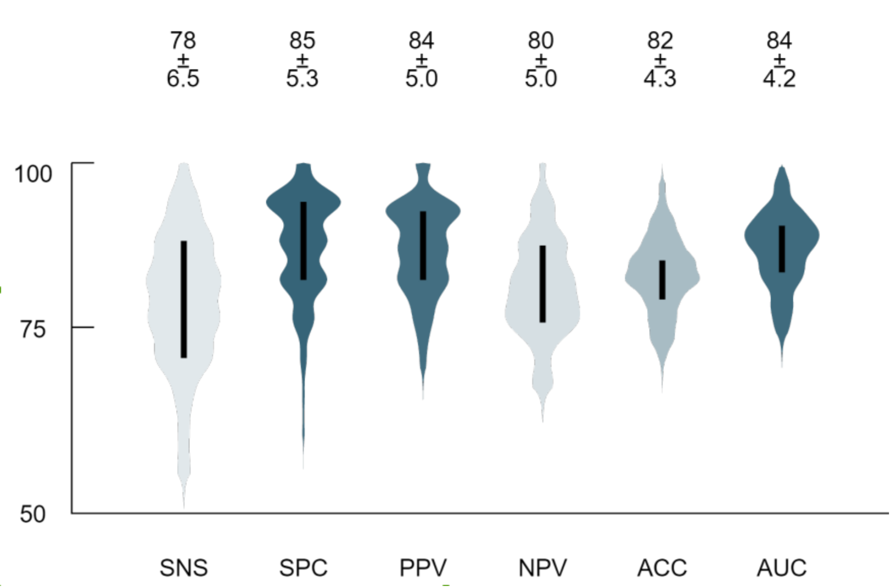
Figure 1b. Box-plot Monte Carlo (MC) cross-validation performance of the established model scheme throughout the performance of the top-layer prediction model. Performance values were determined by confusion matrix analytics across all MC folds. SNS – Sensitivity; SPC – Specificity; PPV – Positive Predictive Value; NPV – Negative Predictive Value; ACC – Accuracy; Performance values are in percentages.
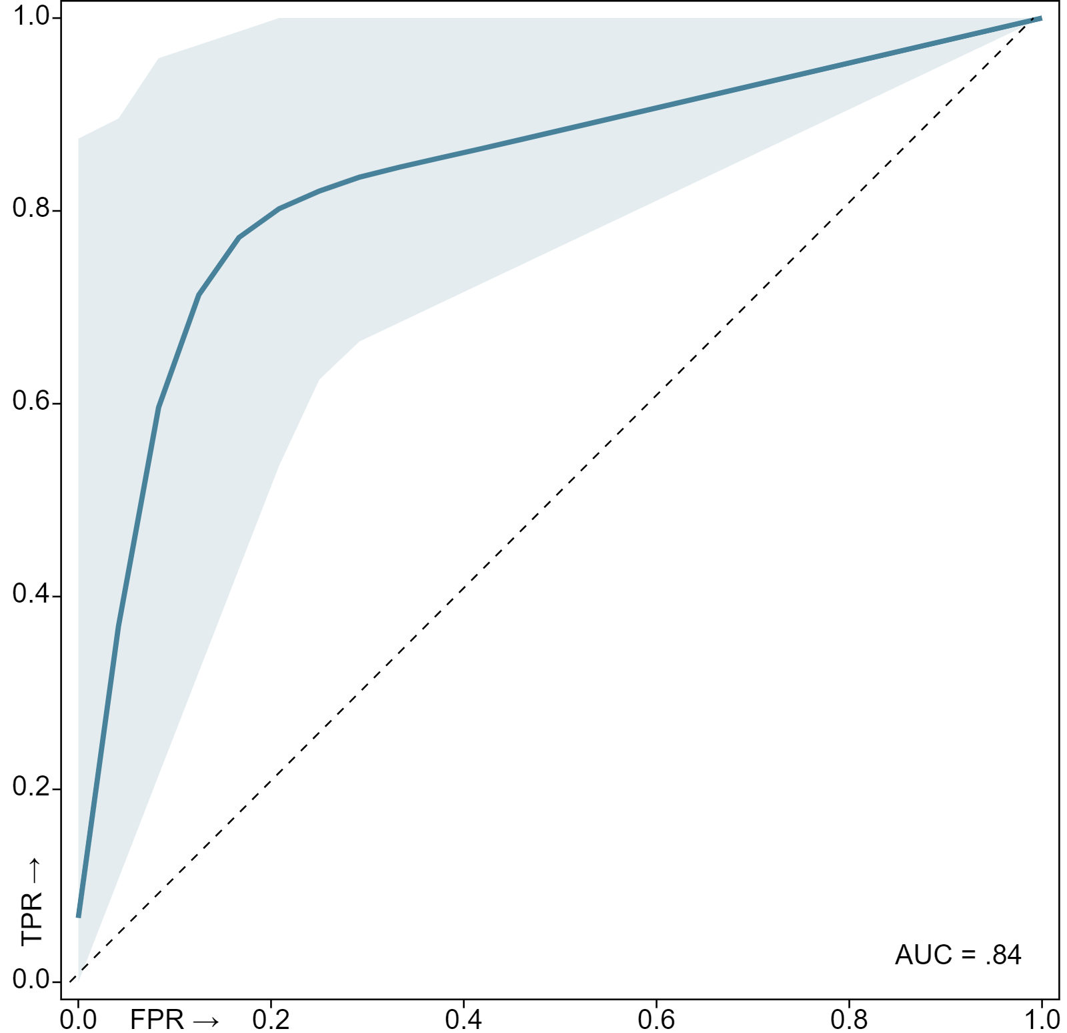
Figure 2b. Mean cross-validation Receiver Operator Characteristics (ROC) curve of the built models. The thick blue line corresponds to the mean ROC curve, while the light blue shaded area represents the spread of all 100 ROC curves generated across the validation folds. AUC – Area Under the Receiver Operator Characteristics Curve (mean of all 100 AUCs); FPR – False Positive Rate, TPR – True Positive Rate. Dashed diagonal line represents a reference random-guess AUC for comparison.

Feature Importance
Feature ranking and selection was performed as part of the data preprocessing steps of each fold (see Sec. Preprocessing). The final feature importance was calculated as the mean of all feature rankings across the MC folds. Note that only the highest-ranking 30 features are shown in the table.
Table 8b. Selected features and their ranks as calculated across the MC folds by Smart Redundancy Reduction (SRR - see Table 2a) as well as their respective value distributions. Ranks represent the relative importance of selected features for model building. Features are ordered by ranks. Rank values are in percentages.
Feature Name | Ranking |  | Histogram
CT.Histogram::ih.uniformity::MultiLesionEntropy | 1% | 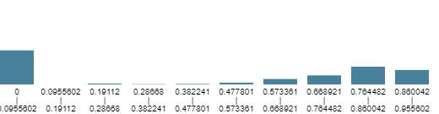
CT.GLCM::cm.energy::MultiLesionEntropy | 1% | 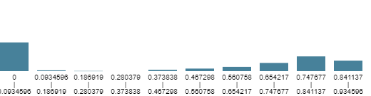
CT.IVHistogram::ivh.V10::MultiLesionEntropy | 1% | 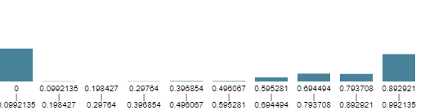
CT.Histogram::ih.mad::MultiLesionEntropy | 1% | 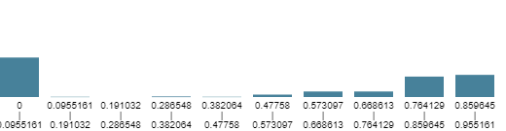
CT.IVHistogram::ivh.V10minusV90::MultiLesionEntropy | 1% | 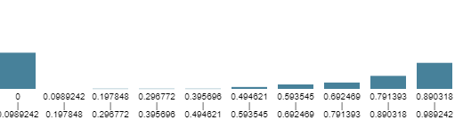
CT.GLSZM::szm.glnu.norm::MultiLesionEntropy | 1% | 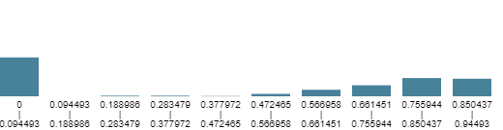
CT.Morphological::morph.sphericity::MultiLesionEntropy | 1% | 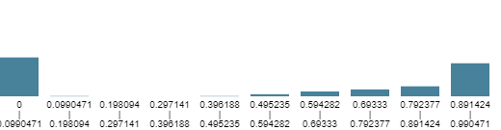
PET.Morphological::morph.sphericity::MultiLesionEntropy | 1%
CT.Morphological::morph.comp.1::MultiLesionEntropy | 1% | 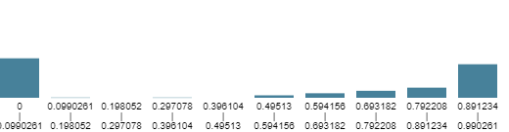
PET.Morphological::morph.comp.1::MultiLesionEntropy | 1%
CT.Morphological::morph.comp.2::MultiLesionEntropy | 1% | 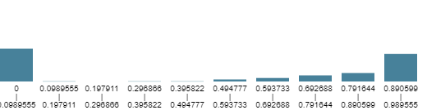
PET.Morphological::morph.comp.2::MultiLesionEntropy | 1%
PET.GLSZM::szm.sze::MultiLesionEntropy | 1% | 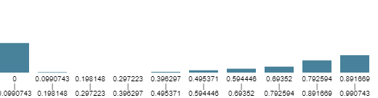
PET.GLCM::cm.info.corr.1::MultiLesionKurtosis | 1% | 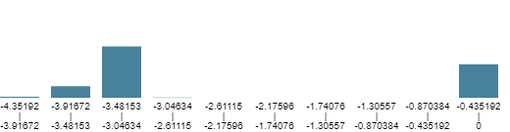
PET.GLSZM::szm.zsnu.norm::MultiLesionEntropy | 1% | 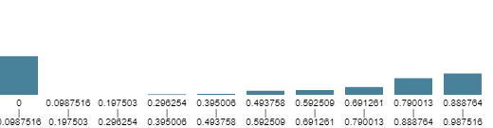
CT.GLSZM::szm.zs.entr::MultiLesionEntropy | 1% | 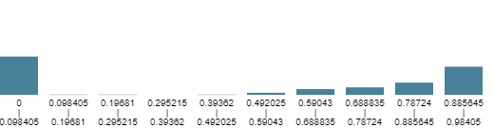
PET.GLCM::cm.inv.diff.mom.norm::MultiLesionEntropy | 1% | 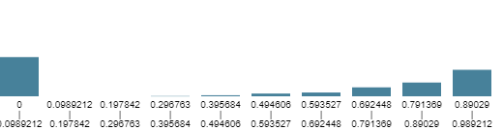
CT.Intensity::stat.skew::MultiLesionEntropy | 1% | 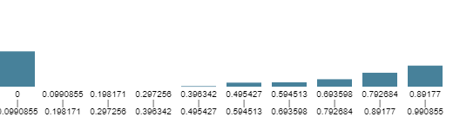
CT.Histogram::ih.skew::MultiLesionEntropy | 1% | 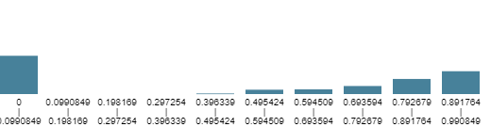
CT.NGTDM::ngt.strength::MultiLesionEntropy | 1% | 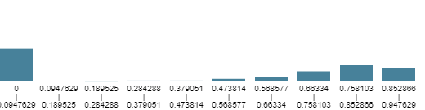
PET.GLCM::cm.inv.diff.norm::MultiLesionEntropy | 1% | 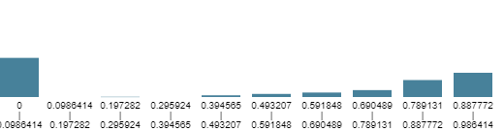
CT.GLCM::cm.inv.diff::MultiLesionEntropy | 1% | 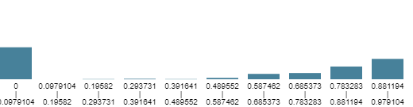
PET.Histogram::ih.max.grad.gl::MultiLesionEntropy | 1% | 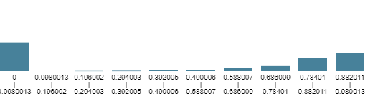
CT.Intensity::stat.range::MultiLesionEntropy | 1% | 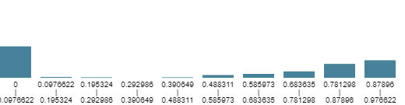
PET.NGTDM::ngt.strength::MultiLesionEntropy | 1% | 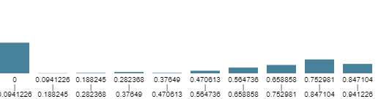
PET.Histogram::ih.mean::MultiLesionEntropy | 1% | 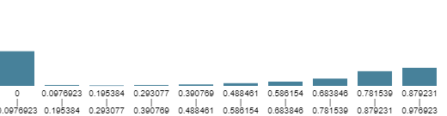
PET.GLCM::cm.diff.entr::MultiLesionEntropy | 1% | 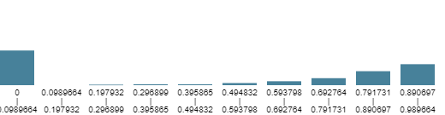
CT.GLCM::cm.info.corr.1::MultiLesionKurtosis | 1% | 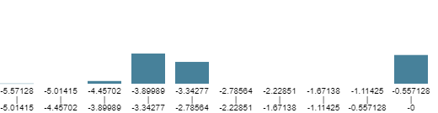
PET.Histogram::ih.mad::MultiLesionEntropy | 1% | 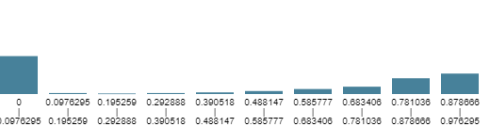
PET.GLSZM::szm.zs.entr::MultiLesionEntropy | 1% | 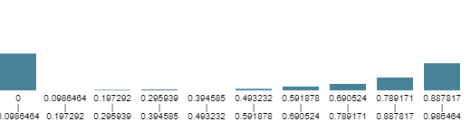

Section TG – Tumor grade

Automated Machine Learning Analysis
Tabular data submission for Dedicaid-Evomics AutoML services was performed on 3/30/2021, 4:23:53 PM to build and cross-validate automated data preprocessing and mixed, stacked ensemble learning pipelines for predicting reference label label1. For the details of the analysis see Table 1d.
Table 1d. Properties of the automated machine learning (AutoML) analysis of this study.
Data name | Diff-FDB+LDB_sub_tm.xlsx
Data size | 298 samples, 2088 features
Date of analysis | 3/30/2021, 4:23:53 PM
Duration of analysis | 95h 26m 9s
Submitted by | laszlo.papp@outlook.com
AutoML version | 1.0

Methods

Data
The input dataset was composed of 298 samples and 2110 features. The submitted dataset was composed of 2088 features. The selected reference label for the cross-validation was Diff (1-vs-2,3) having subgroups of 1 (20.4%) and 2 (79.5%) label outcomes.

Cross-Validation
Monte Carlo (MC) cross-validation scheme was applied with 80% training and 20% validation ratios across 100 folds⁴. Each fold had unique training-validation configurations. MC split resulted in 238 samples per fold in the training set. The validation set of each fold contained 30 samples per reference label (60 overall). The validation samples were equally subsampled to ensure that none of the label outcomes are over or underrepresented during the cross-validation.

Preprocessing
The data underwent preprocessing steps in each fold before performing machine learning (ML) analysis. Preprocessing resulted in average 450 samples and 42 features across all MC folds. For the preprocessing steps and their parameters, see Table 2c.
Table 2c. Preprocessing step algorithms as well as their parameter values performed in all Monte Carlo folds before machine learning. FN - Feature Normalization; SRR - Smart Redundancy Reduction; SSYN - Sample Synthetizer.
Preprocessing step | Algorithm | Parameter | Value | Reference
1 | FN | Normalization type | Mean-Deviation | ⁵⁠
2 | SRR | Redundancy Threshold (Covariance) | 0.85 | ⁶⁠
3 | SSYN | Oversampling ratio (majority subgroup) | 1 | ⁷⁠
3 | SSYN | Sampling technique | SMOTE | ⁷⁠

Machine Learning Layer 1
Various machine learning algorithms were established in each fold to minimize the effect of algorithm bias⁶⁠. Each model was trained by randomly selecting 80% of the preprocessed training data per MC fold. For details of the ML algorithms, see Table 3c.
Table 3c. Machine learning (ML) algorithms in the first ML layer with their parameters and value ranges across Monte Carlo (MC) folds. Occurrence of each ML type is represented in percentages across MC folds. BYS – Bayesian Classifier; MGWC – Multi-Gaussian Weighted Classifier; RF – Random Forest Classifier; SVM – Support Vector Machine Classifier;
ML Algorithm | Parameter | Value Range | Occurrence | Reference
BYS | – | – | 22.1% | ⁹⁠
MGWC | Initial value multiplier | 1 – 10 | 25.68% | ¹⁰⁠
MGWC | Maximum iterations | 42000 – 210000 | 25.68% | ¹⁰⁠
MGWC | Negative weights allowed | false, true | 25.68% | ¹⁰⁠
MGWC | Scale value multiplier | 0.1 – 50 | 25.68% | ¹⁰⁠
MGWC | Tolerance | 0.00001 – 0.0001 | 25.68% | ¹⁰⁠
RF | Bag fraction | 0.8 – 0.99 | 27.09% | ⁶⁠
RF | Bagging method | equalized, normal | 27.09% | ⁶⁠
RF | Boosting | none, adaboost | 27.09% | ⁶⁠
RF | Maximum tree depth | 11 – 1044 | 27.09% | ⁶⁠
RF | Minimum samples in leaves | 4 – 8 | 27.09% | ⁶⁠
RF | Node feature selection method | none | 27.09% | ⁶⁠
RF | Number of random features per node | 11 | 27.09% | ⁶⁠
RF | Number of selected trees | 101 – 201 | 27.09% | ⁶⁠
RF | Number of trees to build | 301 – 1001 | 27.09% | ⁶⁠
RF | Tree quality metric | gain, gini | 27.09% | ⁶⁠
RF | Tree selection method | 0 | 27.09% | ⁶⁠
SVM | Learning rate | 0.001 – 0.01 | 27.09% | ⁸⁠
SVM | Maximum iterations | 1000 – 5000 | 27.09% | ⁸⁠

Machine Learning Layer 2
Meta-training sets were created by evaluating the samples of the preprocessed training set in each MC fold by the trained models in ML layer 1. In order to create the meta-training set, the prediction results of each trained model in ML layer 1 were handled as feature values of the given training sample. The meta-training set was the input for training the second ML layer prediction models. These models were trained to identify patterns in the prediction of the first ML layer models to result in mixed super learners¹². For the parameters of the second layer ML algorithms see Table 4c.
Table 4c. Machine learning (ML) algorithms in the second ML layer with their parameters and value ranges across Monte Carlo (MC) folds. Occurrence of each ML type is represented in percentages across MC folds. MGWC – Multi-Gaussian Weighted Classifier; RF – Random Forest Classifier; SVM – Support Vector Machine Classifier;
ML Algorithm | Parameter | Value Range | Occurrence | Reference
MGWC | Initial value multiplier | 10 | 33.33% | ¹⁰⁠
MGWC | Maximum iterations | 5000 – 16000 | 33.33% | ¹⁰⁠
MGWC | Negative weights allowed | false, true | 33.33% | ¹⁰⁠
MGWC | Scale value multiplier | 1 – 5 | 33.33% | ¹⁰⁠
MGWC | Tolerance | 0.0001 | 33.33% | ¹⁰⁠
RF | Bag fraction | 0.8 – 0.99 | 33.33% | ⁶⁠
RF | Bagging method | equalized, normal | 33.33% | ⁶⁠
RF | Boosting | none, adaboost | 33.33% | ⁶⁠
RF | Maximum tree depth | 11 | 33.33% | ⁶⁠
RF | Minimum samples in leaves | 4 – 8 | 33.33% | ⁶⁠
RF | Node feature selection method | none | 33.33% | ⁶⁠
RF | Number of random features per node | 11 | 33.33% | ⁶⁠
RF | Number of selected trees | 201 | 33.33% | ⁶⁠
RF | Number of trees to build | 501 – 1001 | 33.33% | ⁶⁠
RF | Tree quality metric | gain, gini | 33.33% | ⁶⁠
RF | Tree selection method | 0 | 33.33% | ⁶⁠
SVM | Learning rate | 0.001 – 0.01 | 33.33% | ⁸⁠
SVM | Maximum iterations | 1000 – 5000 | 33.33% | ⁸⁠

Top-Layer Model
Combination of the prediction results of the second layer ML models was performed by weighted majority voting to provide the final prediction of the model scheme. Weighting of each ML Layer 2 model was calculated based on training performance. In addition, ML Layer 2 models having less training performance than the median of all ML layer 2 model training performances had weight 0 in the final vote.

Results

Cross-Validation Performance
Model prediction performance was estimated via the MC cross-validation scheme utilizing confusion matrix analytics¹². True positive, true negative, false positive and false negative confusion matrix entries were calculated by evaluating the validation samples by the established model pipeline in each fold. Sensitivity, specificity, accuracy, positive predictive as well as negative predictive values were calculated across the MC fold validation results. For the average cross-validation performance of ML Layer 1 and 2 models see Table 5c and Table 6c respectively. For the cross-validation results of the final (top-layer) prediction models as well as for the summary of the evaluation, see Table 7c and Figure 1c. For cross-validation area under the curve (AUC), see Figure 2c.
Table 5c. Average Monte Carlo (MC) cross-validation performance (%) of ML Layer 1 (ML-1) predictive models as determined by confusion matrix analytics across all MC folds. BYS – Bayesian Classifier; MGWC – Multi-Gaussian Weighted Classifier; RF – Random Forest Classifier; SVM – Support Vector Machine Classifier; SNS – Sensitivity; SPC – Specificity; PPV – Positive Predictive Value; NPV – Negative Predictive Value; ACC – Accuracy; OCC – Occurrence.; Performance and occurrence values are in percentages.
 | SNS | SPC | PPV | NPV | ACC | OCC
BYS | 81 | 67 | 72 | 79 | 74 | 22
MGWC | 76 | 72 | 74 | 75 | 74 | 26
RF | 90 | 44 | 62 | 82 | 67 | 27
SVM | 70 | 76 | 75 | 72 | 73 | 25

Table 6c. Average Monte Carlo (MC) cross-validation performance (%) of ML Layer 2 (ML-2) predictive models as determined by confusion matrix analytics across all MC folds. MGWC – Multi-Gaussian Weighted Classifier; RF – Random Forest Classifier; SVM – Support Vector Machine Classifier; SNS – Sensitivity; SPC – Specificity; PPV – Positive Predictive Value; NPV – Negative Predictive Value; ACC – Accuracy; OCC – Occurrence. Performance and occurrence values are in percentages.
 | SNS | SPC | PPV | NPV | ACC | OCC
MGWC | 76 | 73 | 74 | 76 | 74 | 33
RF | 83 | 54 | 65 | 77 | 68 | 33
SVM | 75 | 71 | 73 | 75 | 73 | 33

Table 7c. Performance Monte Carlo (MC) cross-validation performance of the established model scheme throughout the performance of the top-layer prediction model. Performance values were determined by confusion matrix analytics across all MC folds. MGWC – Multi-Gaussian Weighted Classifier; RF – Random Forest Classifier; SVM – Support Vector Machine Classifier; SNS – Sensitivity; SPC – Specificity; PPV – Positive Predictive Value; NPV – Negative Predictive Value; ACC – Accuracy; AUC – Area Under the Receiver Operator Characteristics Curve.; Performance values are in percentages. LQ – Lower quartile; UQ – Upper Quartile; Dev – Deviation.
 | Min | LQ | Median | UQ | Max | Mean | Dev
SNS | 50 | 75 | 83.33 | 91.66 | 100 | 82.25 | 8.9
SPC | 25 | 41.66 | 50 | 66.66 | 100 | 55.16 | 12.04
PPV | 46.15 | 58.82 | 64.7 | 69.23 | 100 | 65.47 | 6.76
NPV | 44.44 | 66.66 | 77.77 | 85.71 | 100 | 76.73 | 9.96
ACC | 45.83 | 62.5 | 66.66 | 75 | 91.66 | 68.7 | 7.16
AUC | 44.79 | 69.61 | 76.04 | 82.81 | 97.91 | 76.13 | 7.36

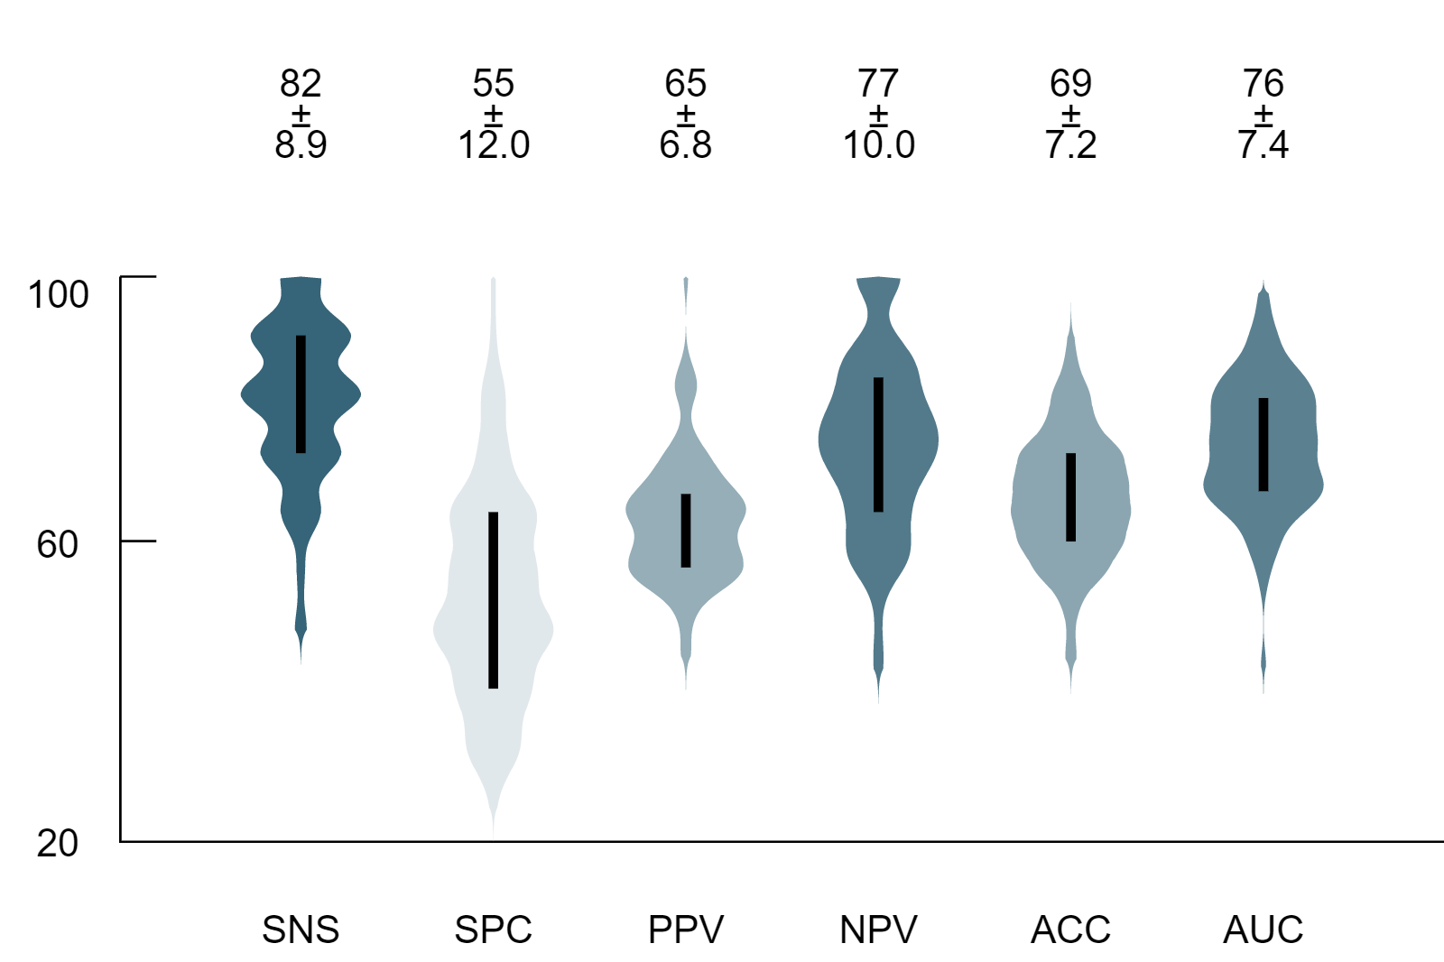
Figure 1c. Box-plot Monte Carlo (MC) cross-validation performance of the established model scheme throughout the performance of the top-layer prediction model. Performance values were determined by confusion matrix analytics across all MC folds. SNS – Sensitivity; SPC – Specificity; PPV – Positive Predictive Value; NPV – Negative Predictive Value; ACC – Accuracy; AUC – Area Under the Receiver Operator Characteristics Curve.; Performance values are in percentages.
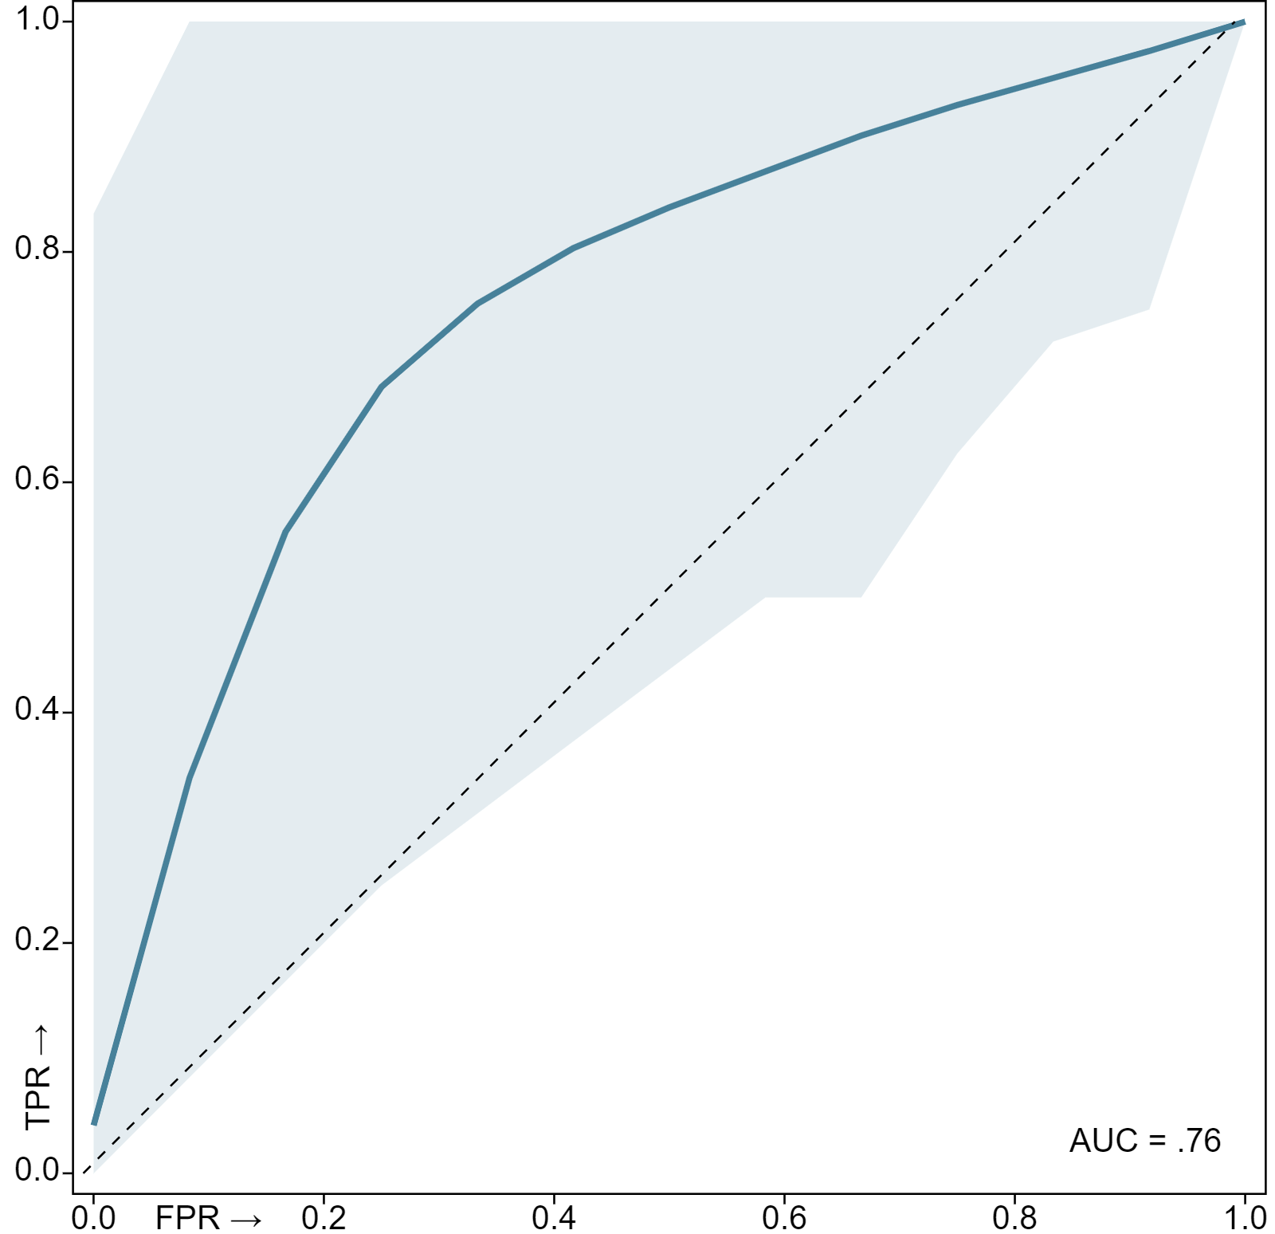
Figure 2c. Mean cross-validation Receiver Operator Characteristics (ROC) curve of the built models. The thick blue line corresponds to the mean ROC curve, while the light blue shaded area represents the spread of all 100 ROC curves generated across the validation folds. AUC – Area Under the Receiver Operator Characteristics Curve (mean of all 100 AUCs); FPR – False Positive Rate, TPR – True Positive Rate. Dashed diagonal line represents a reference random-guess AUC for comparison.

Feature Importance
Feature ranking and selection was performed as part of the data preprocessing steps of each fold (see Sec. Preprocessing). The final feature importance was calculated as the mean of all feature rankings across the MC folds. Note that only the highest-ranking 30 features are shown in the table.
Table 8c. Selected features and their ranks as calculated across the MC folds by Smart Redundancy Reduction (SRR - see Table 2c) as well as their respective value distributions. Ranks represent the relative importance of selected features for model building. Features are ordered by ranks. Rank values are in percentages.
Feature Name | Ranking | Histogram
CT.GLSZM::szm.lzhge::MultiLesionSum | 1% | 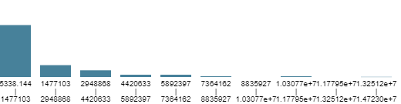
CT.GLCM::cm.auto.corr::MultiLesionVariance | 1% | 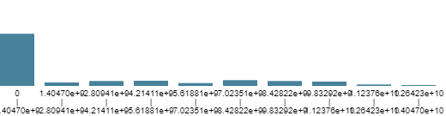
CT.GLSZM::szm.hgze::MultiLesionVariance | 1% | 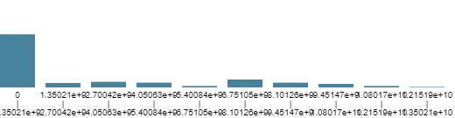
CT.Intensity::stat.medad::MultiLesionVariance | 1% | 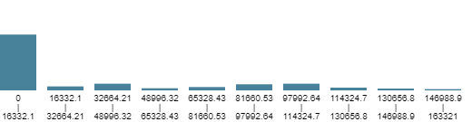
CT.Histogram::ih.mean::MultiLesionVariance | 1% | 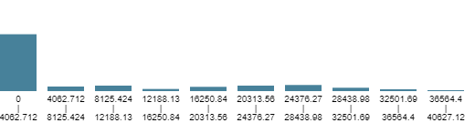
CT.GLCM::cm.sum.avg::MultiLesionVariance | 1% | 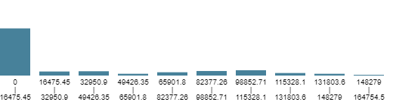
CT.GLCM::cm.joint.avg::MultiLesionVariance | 1% | 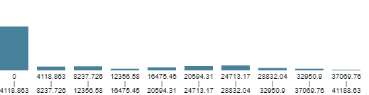
CT.GLSZM::szm.szhge::MultiLesionVariance | 1% | 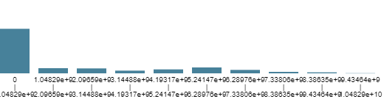
CT.GLCM::cm.clust.shade::MultiLesionSum | 1% | 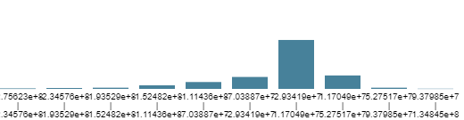
CT.Intensity::stat.median::MultiLesionVariance | 1% | 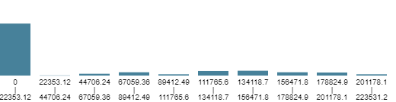
CT.Histogram::ih.min::MultiLesionVariance | 1% | 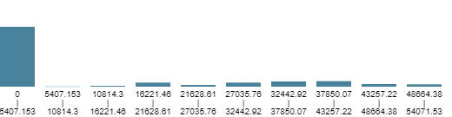
CT.Intensity::stat.min::MultiLesionVariance | 1% | 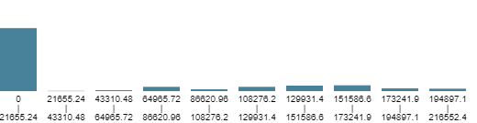
CT.Histogram::ih.min.grad::MultiLesionSum | 1% | 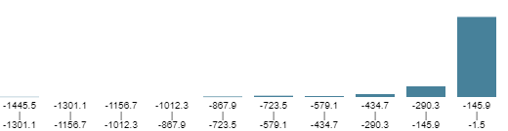
CT.GLCM::cm.auto.corr::MultiLesionSum | 1% | 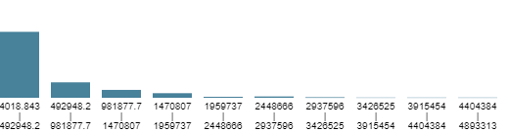
CT.Morphological::morph.asphericity::MultiLesionEnergy | 1% | 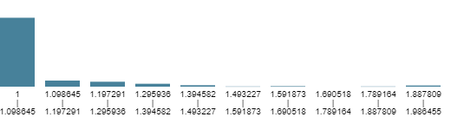
PET.Morphological::morph.asphericity::MultiLesionEnergy | 1%
CT.GLDZM::dzm.z.perc::MultiLesionMean | 1% | 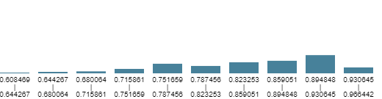
CT.GLSZM::szm.z.perc::MultiLesionMean | 1%
CT.Histogram::ih.max.grad::MultiLesionSum | 1% | 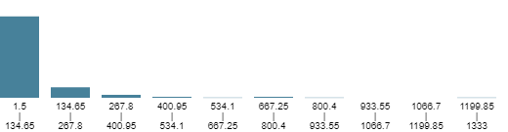
PET.GLCM::cm.joint.max::MultiLesionEntropy | 1% | 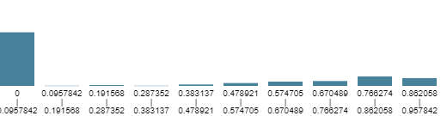
CT.Histogram::ih.mode::MultiLesionVariance | 1% | 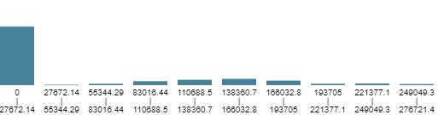
PET.GLCM::cm.energy::MultiLesionEntropy | 1% | 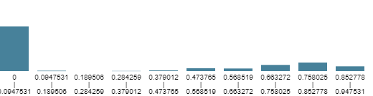
PET.GLSZM::szm.zs.entr::MultiLesionKurtosis | 1% | 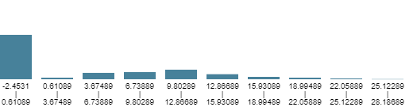
PET.GLCM::cm.inv.diff.mom::MultiLesionEntropy | 1% | 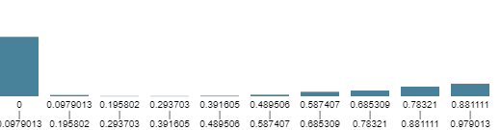
CT.Intensity::stat.P10::MultiLesionEntropy | 1% | 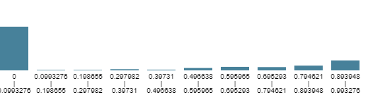
CT.IVHistogram::ivh.I90::MultiLesionEntropy | 1% | 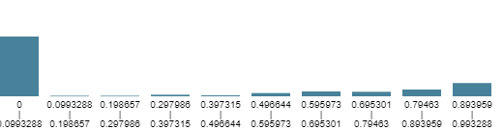
CT.GLCM::cm.info.corr.1::MultiLesionEnergy | 1% | 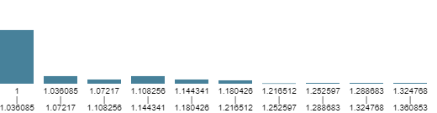
CT.Intensity::stat.median::MultiLesionSum | 1% | 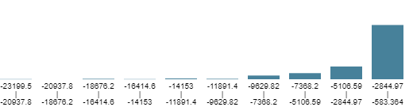
CT.Intensity::stat.range::MultiLesionVariance | 1% | 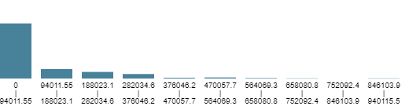
CT.GLSZM::szm.zsnu.norm::MultiLesionMean | 1% | 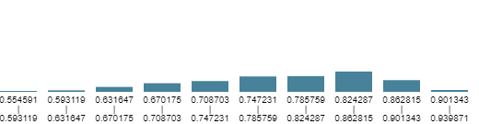

Section GPR - Growth pattern risk

Automated Machine Learning Analysis
Tabular data submission for Dedicaid-Evomics AutoML services was performed on 3/30/2021, 4:24:34 PM to build and cross-validate automated data preprocessing and mixed, stacked ensemble learning pipelines for predicting reference label Subtypes (risk groups). For the details of the analysis see Table 1e.
Table 1e. Properties of the automated machine learning (AutoML) analysis of this study.
Data name | Patho-FDB+LDB_sub_tm.xlsx
Data size | 265 samples, 2089 features
Date of analysis | 3/30/2021, 4:24:34 PM
Duration of analysis | 74h 46m 37s
Submitted by | laszlo.papp@outlook.com
AutoML version | 1.0

Methods

Data
The input dataset was composed of 265 samples and 2111 features. The submitted dataset was composed of 2089 features. The selected reference label for the cross-validation was Subtypes (risk groups) having subgroups of 1 (75.4%) and 2 (24.5%) label outcomes.

Cross-Validation
Monte Carlo (MC) cross-validation scheme was applied with 80% training and 20% validation ratios across 100 folds⁴. Each fold had unique training-validation configurations. MC split resulted in 212 samples per fold in the training set. The validation set of each fold contained 27 samples per reference label (53 overall). The validation samples were equally subsampled to ensure that none of the label outcomes are over or underrepresented during the cross-validation.

Preprocessing
The data underwent preprocessing steps in each fold before performing machine learning (ML) analysis. Preprocessing resulted in average 374 samples and 38 features across all MC folds. For the preprocessing steps and their parameters, see Table 2d.
Table 2d. Preprocessing step algorithms as well as their parameter values performed in all Monte Carlo folds before machine learning. FN - Feature Normalization; SRR - Smart Redundancy Reduction; SSYN - Sample Synthetizer.
Preprocessing step | Algorithm | Parameter | Value | Reference
1 | FN | Normalization type | Mean-Deviation | ⁵⁠
2 | SRR | Redundancy Threshold (Covariance) | 0.85 | ⁶⁠
3 | SSYN | Oversampling ratio (majority subgroup) | 1 | ⁷⁠
3 | SSYN | Sampling technique | SMOTE | ⁷⁠

Machine Learning Layer 1
Various machine learning algorithms were established in each fold to minimize the effect of algorithm bias ⁶. Each model was trained by randomly selecting 80% of the preprocessed training data per MC fold. For details of the ML algorithms, see Table 3d.
Table 3d. Machine learning (ML) algorithms in the first ML layer with their parameters and value ranges across Monte Carlo (MC) folds. Occurrence of each ML type is represented in percentages across MC folds. BYS – Bayesian Classifier; MGWC – Multi-Gaussian Weighted Classifier; RF – Random Forest Classifier; SVM – Support Vector Machine Classifier;
ML Algorithm | Parameter | Value Range | Occurrence | Reference
BYS | – | – | 19.63% | ⁹⁠
MGWC | Initial value multiplier | 1 – 10 | 26.66% | ¹⁰⁠
MGWC | Maximum iterations | 38000 – 190000 | 26.66% | ¹⁰⁠
MGWC | Negative weights allowed | false, true | 26.66% | ¹⁰⁠
MGWC | Scale value multiplier | 0.1 – 50 | 26.66% | ¹⁰⁠
MGWC | Tolerance | 0.00001 – 0.0001 | 26.66% | ¹⁰⁠
RF | Bag fraction | 0.8 – 0.99 | 27.71% | ⁶⁠
RF | Bagging method | equalized, normal | 27.71% | ⁶⁠
RF | Boosting | none, adaboost | 27.71% | ⁶⁠
RF | Maximum tree depth | 11 – 1044 | 27.71% | ⁶⁠
RF | Minimum samples in leaves | 4 – 8 | 27.71% | ⁶⁠
RF | Node feature selection method | none | 27.71% | ⁶⁠
RF | Number of random features per node | 11 | 27.71% | ⁶⁠
RF | Number of selected trees | 101 – 201 | 27.71% | ⁶⁠
RF | Number of trees to build | 301 – 1001 | 27.71% | ⁶⁠
RF | Tree quality metric | gain, gini | 27.71% | ⁶⁠
RF | Tree selection method | 0 | 27.71% | ⁶⁠
SVM | Learning rate | 0.001 – 0.01 | 25.98% | ⁸⁠
SVM | Maximum iterations | 1000 – 5000 | 25.98% | ⁸⁠

Machine Learning Layer 2
Meta-training sets were created by evaluating the samples of the preprocessed training set in each MC fold by the trained models in ML layer 1. In order to create the meta-training set, the prediction results of each trained model in ML layer 1 were handled as feature values of the given training sample. The meta-training set was the input for training the second ML layer prediction models. These models were trained to identify patterns in the prediction of the first ML layer models to result in mixed super learners ¹¹. For the parameters of the second layer ML algorithms see Table 4d.
Table 4d. Machine learning (ML) algorithms in the second ML layer with their parameters and value ranges across Monte Carlo (MC) folds. Occurrence of each ML type is represented in percentages across MC folds. MGWC – Multi-Gaussian Weighted Classifier; RF – Random Forest Classifier; SVM – Support Vector Machine Classifier;
ML Algorithm | Parameter | Value Range | Occurrence | Reference
MGWC | Initial value multiplier | 10 | 33.33% | ¹⁰⁠
MGWC | Maximum iterations | 5000 – 16000 | 33.33% | ¹⁰⁠
MGWC | Negative weights allowed | false, true | 33.33% | ¹⁰⁠
MGWC | Scale value multiplier | 1 – 5 | 33.33% | ¹⁰⁠
MGWC | Tolerance | 0.0001 | 33.33% | ¹⁰⁠
RF | Bag fraction | 0.8 – 0.99 | 33.33% | ⁶⁠
RF | Bagging method | equalized, normal | 33.33% | ⁶⁠
RF | Boosting | none, adaboost | 33.33% | ⁶⁠
RF | Maximum tree depth | 11 | 33.33% | ⁶⁠
RF | Minimum samples in leaves | 4 – 8 | 33.33% | ⁶⁠
RF | Node feature selection method | none | 33.33% | ⁶⁠
RF | Number of random features per node | 8 | 33.33% | ⁶⁠
RF | Number of selected trees | 201 | 33.33% | ⁶⁠
RF | Number of trees to build | 501 – 1001 | 33.33% | ⁶⁠
RF | Tree quality metric | gain, gini | 33.33% | ⁶⁠
RF | Tree selection method | 0 | 33.33% | ⁶⁠
SVM | Learning rate | 0.001 – 0.01 | 33.33% | ⁸⁠
SVM | Maximum iterations | 1000 – 5000 | 33.33% | ⁸⁠

Top-Layer Model
Combination of the prediction results of the second layer ML models was performed by weighted majority voting to provide the final prediction of the model scheme. Weighting of each ML Layer 2 model was calculated based on training performance. In addition, ML Layer 2 models having less training performance than the median of all ML layer 2 model training performances had weight 0 in the final vote.

Results

Cross-Validation Performance
Model prediction performance was estimated via the MC cross-validation scheme utilizing confusion matrix analytics¹². True positive, true negative, false positive and false negative confusion matrix entries were calculated by evaluating the validation samples by the established model pipeline in each fold. Sensitivity, specificity, accuracy, positive predictive as well as negative predictive values were calculated across the MC fold validation results. For the average cross-validation performance of ML Layer 1 and 2 models see Table 5d and Table 6d respectively. For the cross-validation results of the final (top-layer) prediction models as well as for the summary of the evaluation, see Table 7d and Figure 1d. For cross-validation area under the curve (AUC), see Figure 2d.
Table 5d. Average Monte Carlo (MC) cross-validation performance (%) of ML Layer 1 (ML-1) predictive models as determined by confusion matrix analytics across all MC folds. BYS – Bayesian Classifier; MGWC – Multi-Gaussian Weighted Classifier; RF – Random Forest Classifier; SVM – Support Vector Machine Classifier; SNS – Sensitivity; SPC – Specificity; PPV – Positive Predictive Value; NPV – Negative Predictive Value; ACC – Accuracy; OCC – Occurrence.; Performance and occurrence values are in percentages.
 | SNS | SPC | PPV | NPV | ACC | OCC
BYS | 56 | 77 | 72 | 64 | 66 | 20
MGWC | 60 | 75 | 72 | 66 | 67 | 27
RF | 50 | 94 | 90 | 66 | 72 | 28
SVM | 73 | 66 | 69 | 72 | 70 | 26

Table 6d. Average Monte Carlo (MC) cross-validation performance (%) of ML Layer 2 (ML-2) predictive models as determined by confusion matrix analytics across all MC folds. MGWC – Multi-Gaussian Weighted Classifier; RF – Random Forest Classifier; SVM – Support Vector Machine Classifier; SNS – Sensitivity; SPC – Specificity; PPV – Positive Predictive Value; NPV – Negative Predictive Value; ACC – Accuracy; OCC – Occurrence. Performance and occurrence values are in percentages.
 | SNS | SPC | PPV | NPV | ACC | OCC
MGWC | 69 | 74 | 74 | 71 | 72 | 33
RF | 59 | 84 | 80 | 68 | 72 | 33
SVM | 68 | 72 | 71 | 70 | 70 | 33

Table 7c. Performance Monte Carlo (MC) cross-validation performance of the established model scheme throughout the performance of the top-layer prediction model. Performance values were determined by confusion matrix analytics across all MC folds. MGWC – Multi-Gaussian Weighted Classifier; RF – Random Forest Classifier; SVM – Support Vector Machine Classifier; SNS – Sensitivity; SPC – Specificity; PPV – Positive Predictive Value; NPV – Negative Predictive Value; ACC – Accuracy; AUC – Area Under the Receiver Operator Characteristics Curve.; LQ – Lower quartile; UQ – Upper Quartile; Dev – Deviation.
 | Min | LQ | Median | UQ | Max | Mean | Dev
SNS | 23.07 | 50 | 61.53 | 69.23 | 92.3 | 59.15 | 11.02
SPC | 53.84 | 76.92 | 84.61 | 92.3 | 100 | 83.76 | 9.28
PPV | 50 | 71 | 80 | 88.88 | 100 | 79.7 | 10.16
NPV | 50 | 63.15 | 68.58 | 72.22 | 88.88 | 67.87 | 6.04
ACC | 50 | 65.38 | 73.07 | 76.92 | 88.46 | 71.46 | 6.48
AUC | 55.32 | 71.74 | 76.92 | 81.65 | 93.49 | 76.31 | 6.68

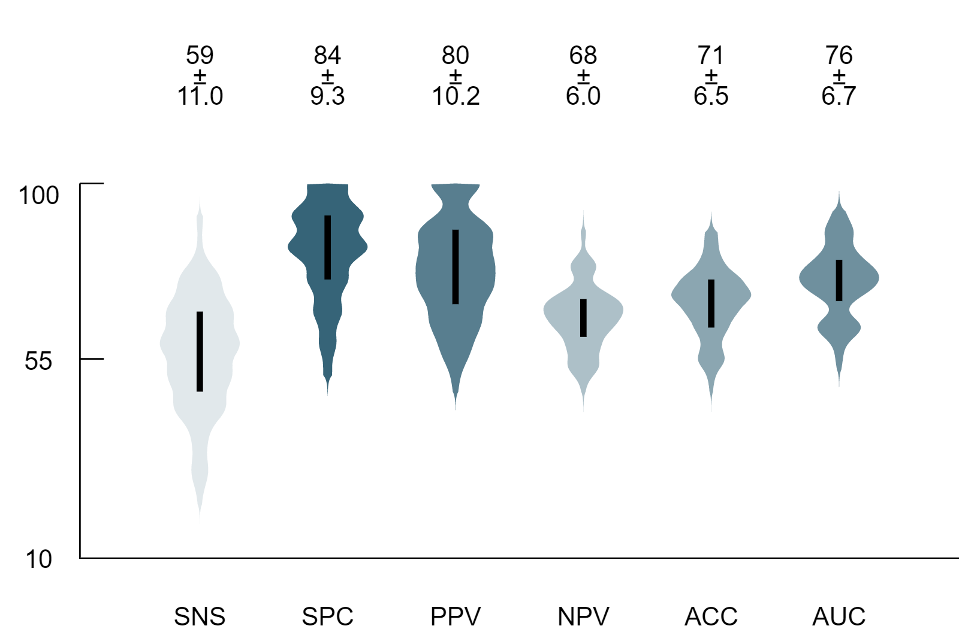
Figure 1d. Box-plot Monte Carlo (MC) cross-validation performance of the established model scheme throughout the performance of the top-layer prediction model. Performance values were determined by confusion matrix analytics across all MC folds. SNS – Sensitivity; SPC – Specificity; PPV – Positive Predictive Value; NPV – Negative Predictive Value; AUC – Area Under the Receiver Operator Characteristics Curve.; ACC – Accuracy; Performance values are in percentages.
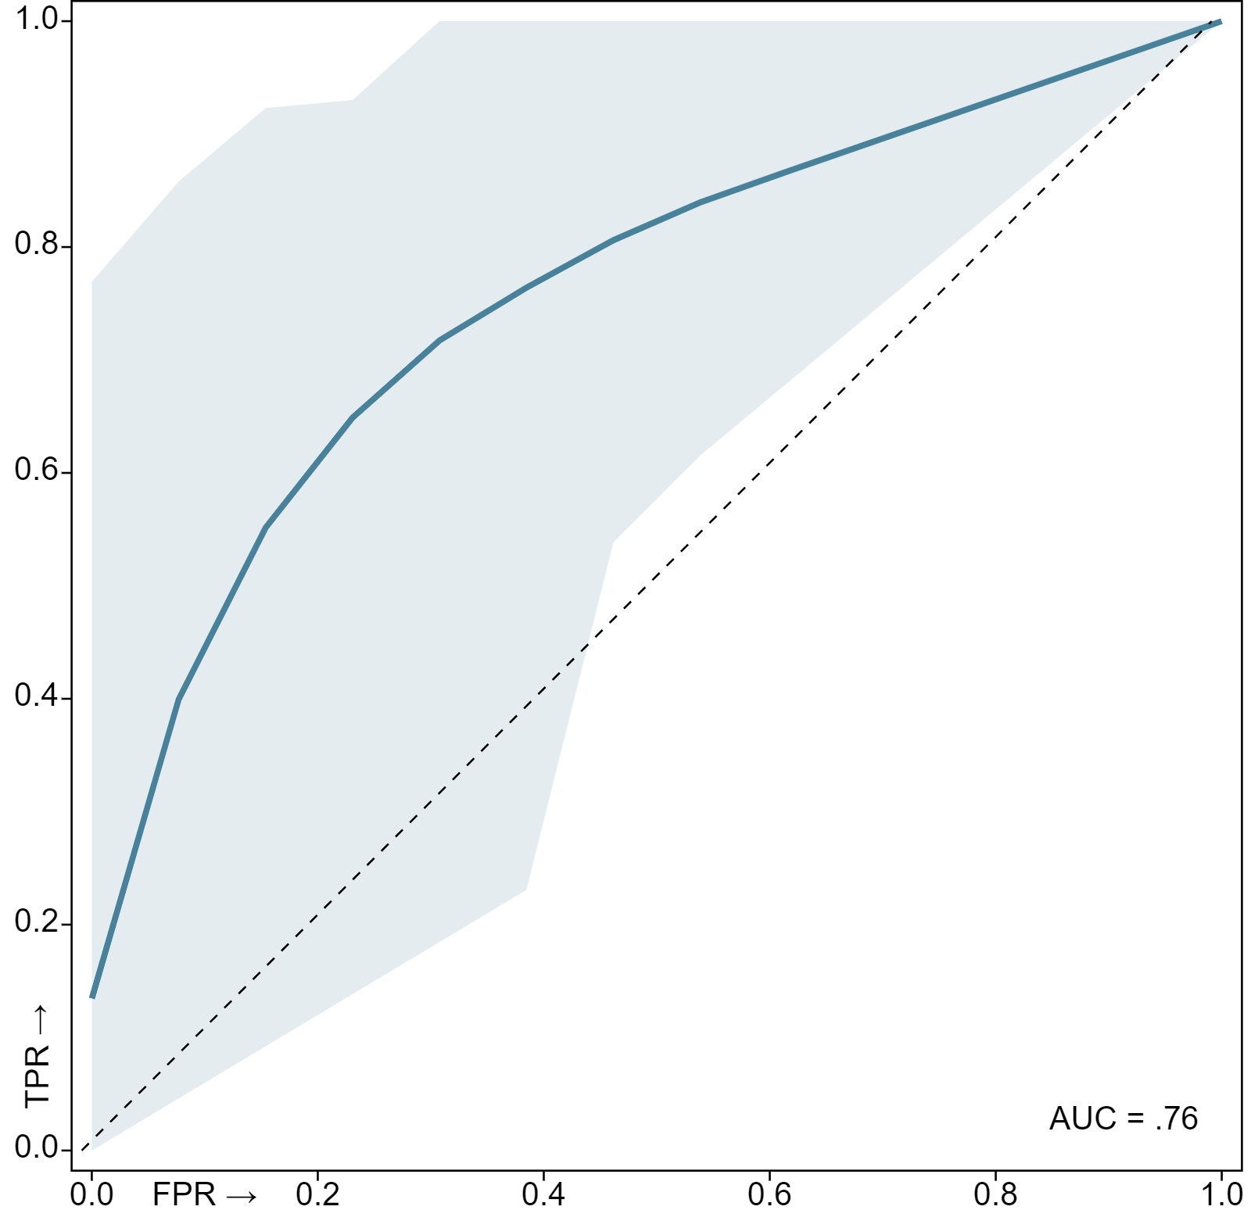
Figure 2d. Mean cross-validation Receiver Operator Characteristics (ROC) curve of the built models. The thick blue line corresponds to the mean ROC curve, while the light blue shaded area represents the spread of all 100 ROC curves generated across the validation folds. AUC – Area Under the Receiver Operator Characteristics Curve (mean of all 100 AUCs); FPR – False Positive Rate, TPR – True Positive Rate. Dashed diagonal line represents a reference random-guess AUC for comparison.

Feature Importance
Feature ranking and selection was performed as part of the data preprocessing steps of each fold (see Sec. Preprocessing). The final feature importance was calculated as the mean of all feature rankings across the MC folds. Note that only the highest-ranking 30 features are shown in the table.
Table 8d. Selected features and their ranks as calculated across the MC folds by Smart Redundancy Reduction (SRR - see Table 2d) as well as their respective value distributions. Ranks represent the relative importance of selected features for model building. Features are ordered by ranks. Rank values are in percentages.
Feature Name | Ranking | Histogram
A::B::Degree_of_tumor_differentiation_(1:_poorly_differentiated__2:_moderately_differentiated__3:_highly_differentiated)_ | 1% | 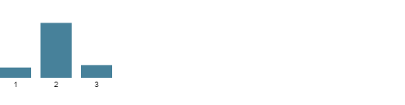
PET.GLCM::cm.diff.var::MultiLesionMean | 1% | 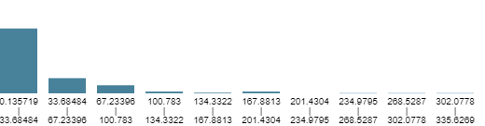
PET.Intensity::stat.max::MultiLesionMean | 1% | 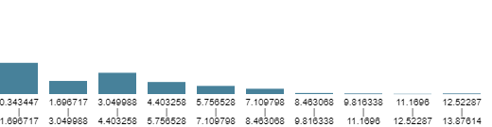
PET.Histogram::ih.max::MultiLesionMean | 1% | 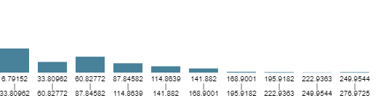
PET.Intensity::stat.range::MultiLesionMean | 1% | 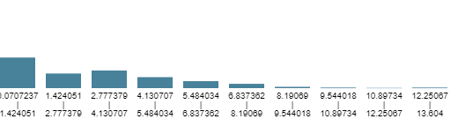
PET.GLDZM::dzm.hgze::MultiLesionMean | 1% | 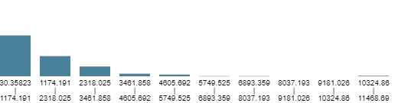
PET.GLCM::cm.contrast::MultiLesionMean | 1% | 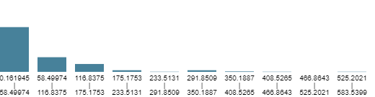
PET.Intensity::loc.peak.global::MultiLesionMean | 1% | 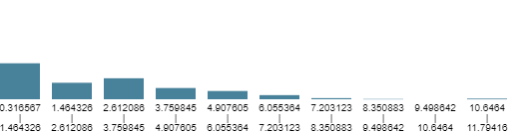
PET.Intensity::loc.peak.local::MultiLesionMean | 1% | 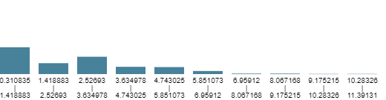
PET.GLSZM::szm.szhge::MultiLesionMean | 1% | 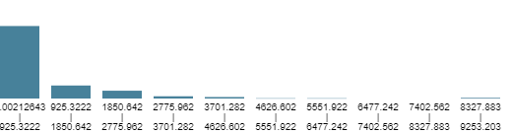
PET.NGLDM::ngl.ldhge::MultiLesionMean | 1% | 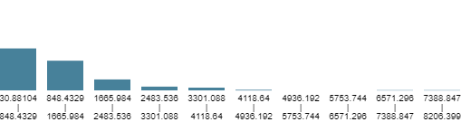
PET.GLRLM::rlm.srhge::MultiLesionMean | 1% | 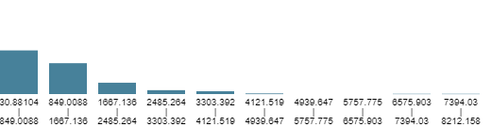
PET.GLRLM::rlm.hgre::MultiLesionMean | 1% | 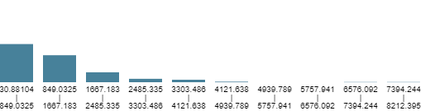
PET.NGLDM::ngl.hgce::MultiLesionMean | 1% | 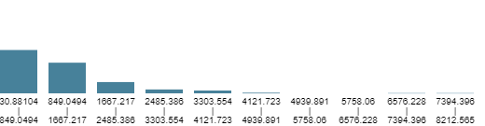
PET.GLRLM::rlm.lrhge::MultiLesionMean | 1% | 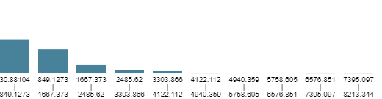
PET.NGLDM::ngl.hdhge::MultiLesionMean | 1% | 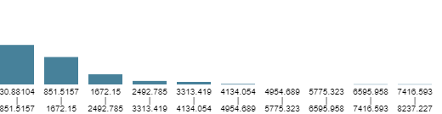
PET.GLSZM::szm.hgze::MultiLesionMean | 1% | 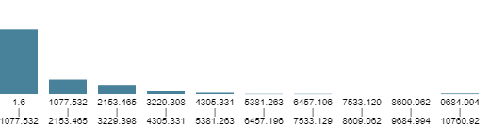
PET.Intensity::stat.rms::MultiLesionMean | 1% | 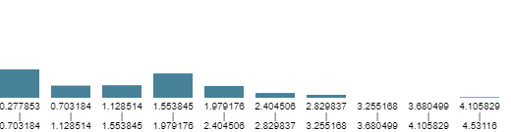
PET.IVHistogram::ivh.I10::MultiLesionMean | 1% | 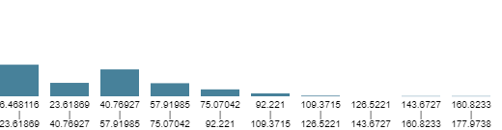
PET.Intensity::stat.P90::MultiLesionMean | 1% | 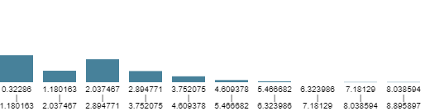
PET.NGTDM::ntg.complexity::MultiLesionMean | 1% | 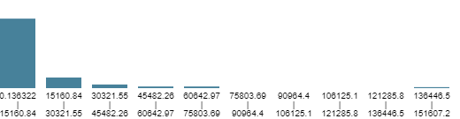
PET.GLCM::cm.auto.corr::MultiLesionMean | 1% | 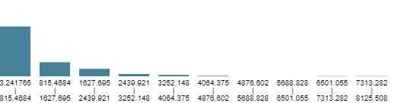
PET.GLCM::cm.joint.var::MultiLesionMean | 1% | 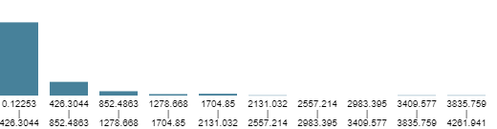
PET.Intensity::stat.mad::MultiLesionMean | 1% | 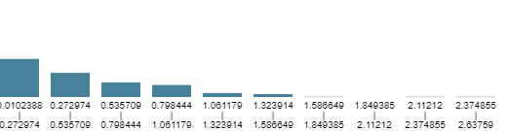
PET.Histogram::ih.var::MultiLesionMean | 1% | 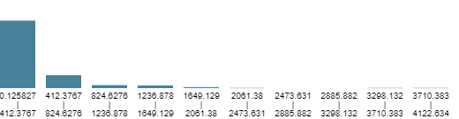
PET.GLRLM::rlm.gl.var::MultiLesionMean | 1% | 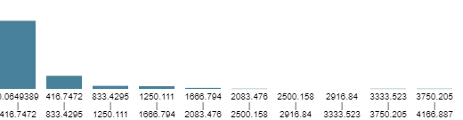
PET.Intensity::stat.var::MultiLesionMean | 1% | 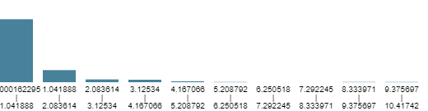
PET.NGLDM::ngl.gl.var::MultiLesionMean | 1% | 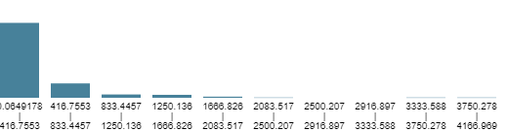
PET.GLDZM::dzm.gl.var::MultiLesionMean | 1% | 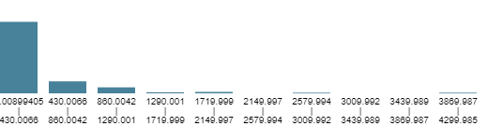
PET.GLSZM::szm.gl.var::MultiLesionMean | 1% | 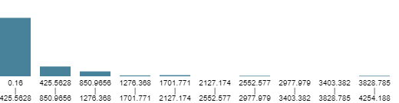

References

1. Zwanenburg, A., Leger, S., Vallières, M. & Löck, S. Image biomarker standardisation initiative. (2016) doi:10.1148/radiol.2020191145.
2. Stytz, M. R. & Parrott, R. W. Using kriging for 3d medical imaging. Comput. Med. Imaging Graph. 17, 421–442 (1993).
3. Papp, L., Rausch, I., Grahovac, M., Hacker, M. & Beyer, T. Optimized feature extraction for radiomics analysis of 18F-FDG PET imaging. J. Nucl. Med. 60, 864–872 (2019).
4. Papp, L., Spielvogel, C. P., Rausch, I., Hacker, M. & Beyer, T. Personalizing medicine through hybrid imaging and medical big data analysis. Front. Phys. 6, 1–19 (2018).
5. Han, J., Kamber, M. & Pei, J. Data Mining: Concepts and Techniques. Data Mining: Concepts and Techniques (Elsevier Inc., 2012). doi:10.1016/C2009-0-61819-5.
6. Papp, L. et al. Supervised machine learning enables non-invasive lesion characterization in primary prostate cancer with [68Ga]Ga-PSMA-11 PET/MRI. Eur. J. Nucl. Med. Mol. Imaging (2020) doi:10.1007/s00259-020-05140-y.
7. Amin, A. et al. Comparing Oversampling Techniques to Handle the Class Imbalance Problem: A Customer Churn Prediction Case Study. IEEE Access 4, 7940–7957 (2016).
8. Gao, X. et al. The method and efficacy of support vector machine classifiers based on texture features and multi-resolution histogram from 18F-FDG PET-CT images for the evaluation of mediastinal lymph nodes in patients with lung cancer. Eur. J. Radiol. 84, 312–317 (2015).
9. Moghbeli, M. Applying Naive Bayesian Networks to Disease Prediction: a Systematic Review. Acta Inform. Medica 24, 284 (2016).
10. Papp, L. et al. Glioma survival prediction with combined analysis of in vivo 11 C-MET PET features, ex vivo features, and patient features by supervised machine learning. J. Nucl. Med. 59, 892–899 (2018).
11. Van Der Laan, M. J., Polley, E. C. & Hubbard, A. E. Super learner. Stat. Appl. Genet. Mol. Biol. 6, (2007).
12. Stehman, S. V. Selecting and interpreting measures of thematic classification accuracy. Remote Sens. Environ. 62, 77–89 (1997).

