What Do Chinese Patients Value in Orthodontic Treatment?
A Discrete Choice Experiment

ONLINE SUPPLEMENTARY FIGURES AND TABLES

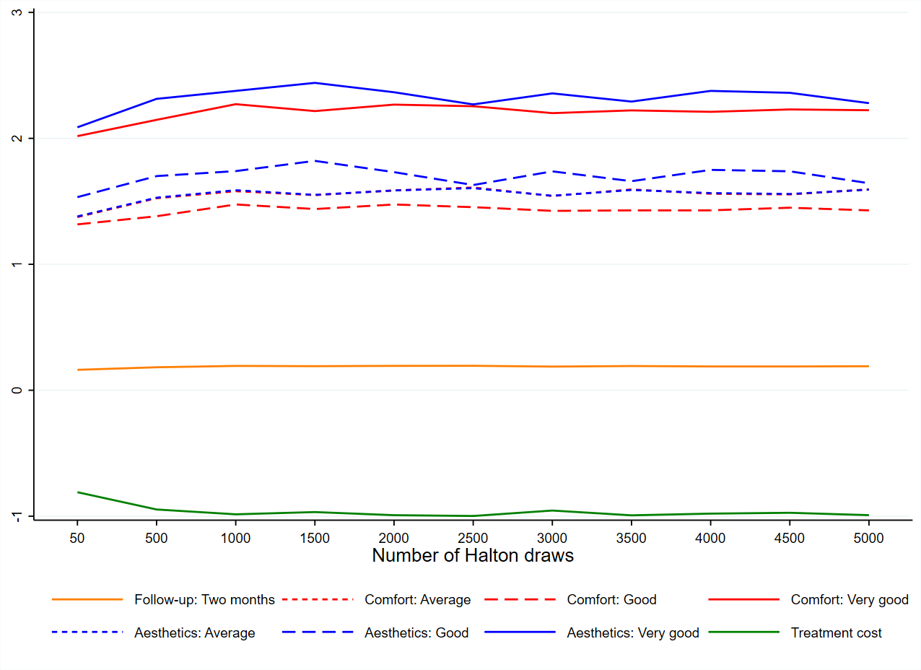
Figure S1. Mixed logit model, mean values of attribute parameters by the number of Halton draws
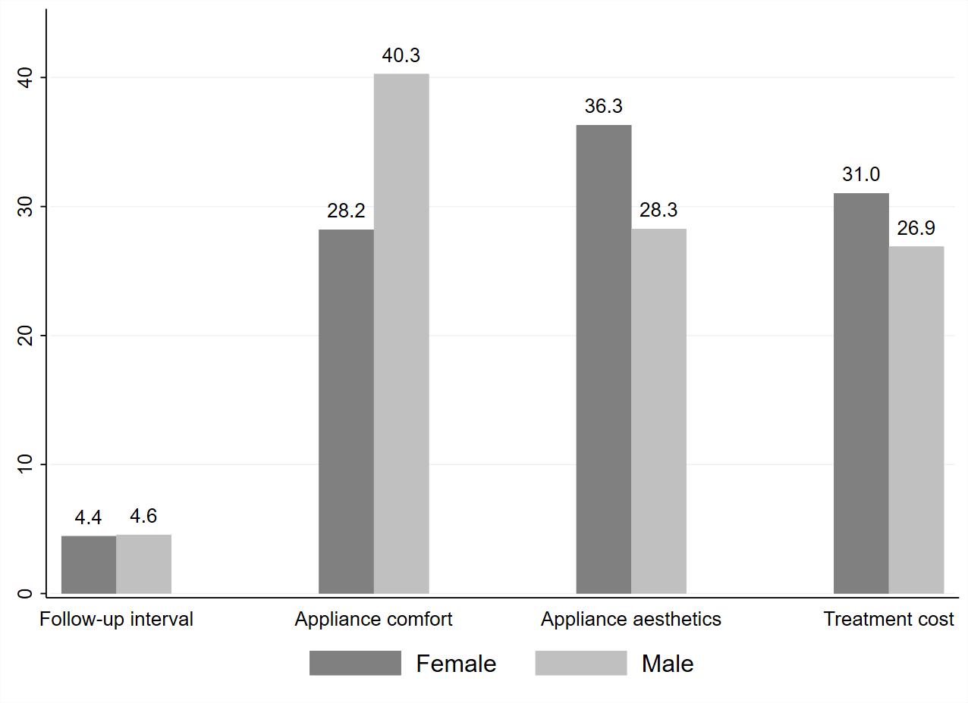
Figure S2. Attribute relative importance, subgroup analysis by gender
Notes: The figure displays median values constructed using the simulation method. Relative importance values in each subgroup were scaled by a common factor to ensure that their sum equals one hundred.

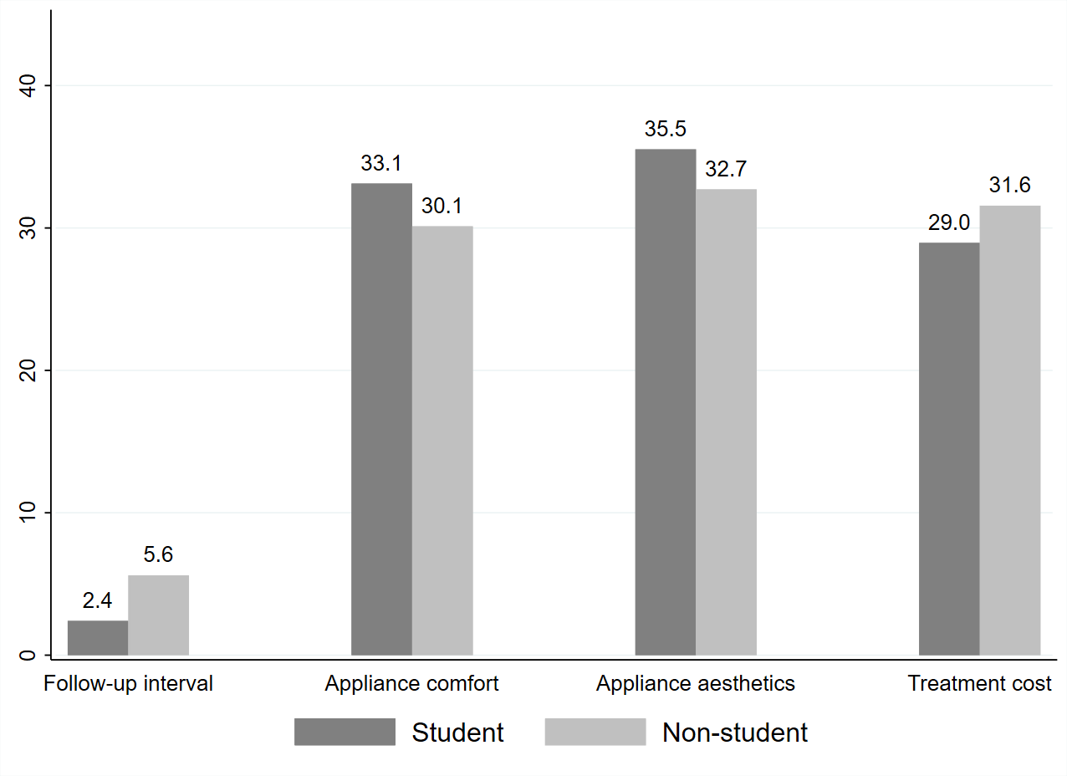
Figure S3. Attribute relative importance, subgroup analysis by occupation
Notes: The figure displays median values constructed using the simulation method. Relative importance values in each subgroup were scaled by a common factor to ensure that their sum equals one hundred.

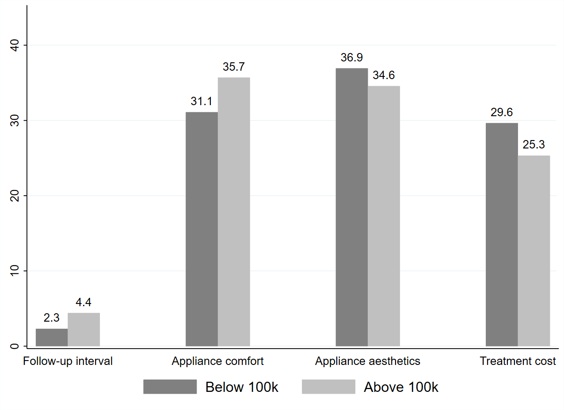
Figure S4. Attribute relative importance, subgroup analysis by annual household income
Notes: The figure displays median values constructed using the simulation method. Relative importance values in each subgroup were scaled by a common factor to ensure that their sum equals one hundred.
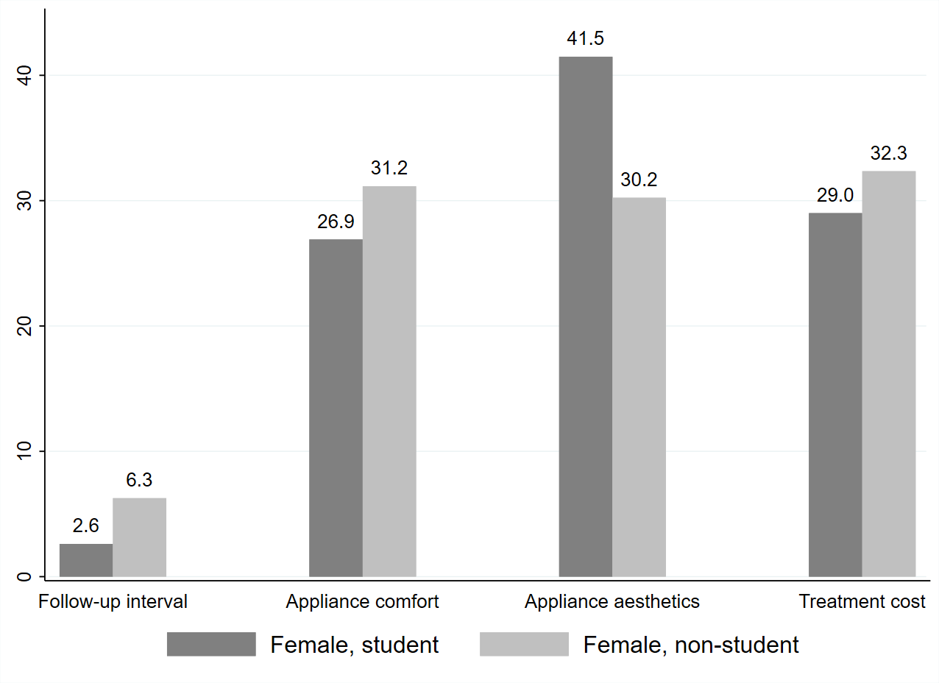
Figure S5. Attribute relative importance, subgroup analysis by occupation in females
Notes: The figure displays median values constructed using the simulation method. Relative importance values in each subgroup were scaled by a common factor to ensure that their sum equals one hundred.

Table S1. Graphic illustrations of attribute levels
Attribute level | Graphic illustration
Appliance comfort: Poor
Appliance comfort: Average
Appliance comfort: Good
Appliance comfort: Very good
Appliance aesthetics: Poor
Appliance aesthetics: Average
Appliance aesthetics: Good
Appliance aesthetics: Very good

Table S2. Mixed logit model estimation comparison
Halton draws | Max. parameter change | Rank of model fit
500 | 17.0 | 9
1000 | 6.8 | 6
1500 | 4.7 | 5
2000 | 4.9 | 4
2500 | 5.9 | 1
3000 | 6.7 | 10
3500 | 4.5 | 3
4000 | 5.4 | 8
4500 | 1.5 | 7
5000 | 5.4 | 2
Notes: The second column displays the maximum absolute percentage changes in mean values of attribute parameters compared to the last estimation. The mixed logit model estimated with 500 draws was compared to the estimation result with 50 draws. Model fit ranks were consistent across log-likelihood, AIC, and BIC.

Table S3. Example pictures of orthodontic treatment appliances
Orthodontic treatment appliance | Example picture
Metal brackets | 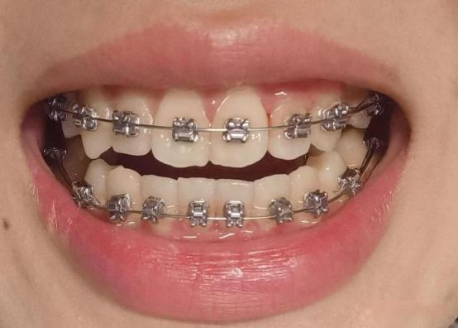
Ceramic brackets | 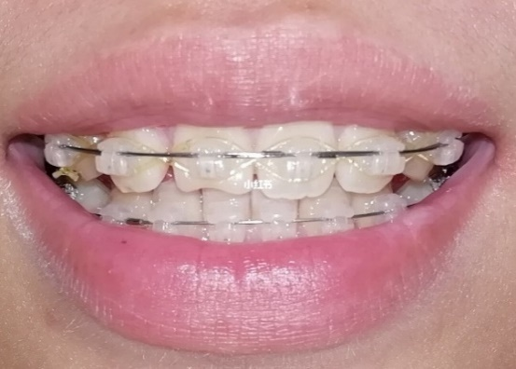
Clear aligners | 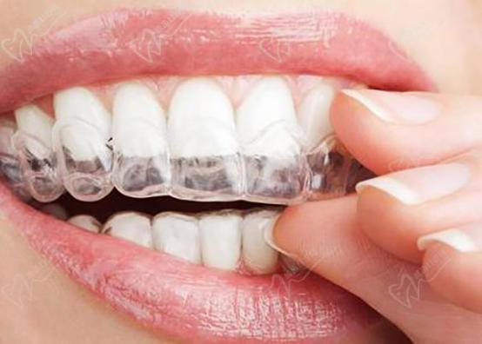

Table S4. Results of mixed logit model by gender
 |  | Female |  |  |  |  | Male
Attribute | Levels | Coefficient | SE | SD | SE |  | Coefficient | SE | SD | SE
Constant (Neither) |  | -14.160*** | (3.673) | 7.004*** | (1.786) |  | -9.097*** | (2.649) | 5.376*** | (1.502)
Follow-up interval | One month ª
 | Two months | 0.145 | (0.087) | 0.560*** | (0.166) |  | 0.289** | (0.109) | 0.077 | (0.653)
Appliance comfort | Poor ª
 | Average | 1.750*** | (0.215) | 1.280*** | (0.255) |  | 1.341*** | (0.236) | 0.851* | (0.346)
 | Good | 0.601 | (0.642) | 0.152 | (0.742) |  | 2.623*** | (0.791) | 0.014 | (0.475)
 | Very good | 1.470* | (0.657) | 0.513 | (0.322) |  | 3.311*** | (0.806) | 0.178 | (0.456)
Appliance aesthetics | Poor ª
 | Average | 1.799*** | (0.207) | 1.046*** | (0.235) |  | 1.266*** | (0.220) | 0.833** | (0.300)
 | Good | 2.032** | (0.683) | 0.772** | (0.284) |  | 1.351 | (0.705) | 0.956** | (0.317)
 | Very good | 2.736*** | (0.691) | 0.244 | (0.508) |  | 1.885** | (0.709) | 0.189 | (0.577)
Treatment cost (thousand CNY) |  | -0.107*** | (0.012) | 0.089*** | (0.020) |  | -0.090*** | (0.014) | 0.071** | (0.023)
Log likelihood |  | -1021 |  |  |  |  | -493.1
AIC |  | 2079 |  |  |  |  | 1022
BIC |  | 2198 |  |  |  |  | 1128
Notes: AIC: Akaike information criterion. BIC: Bayesian information criterion. CNY: Chinese Yuan. SE: standard error. SD: standard deviation. a: reference level. The mixed logit models were estimated using 2,500 Halton draws to maintain consistency with the baseline analysis. * p < 0.05, ** p < 0.01, *** p < 0.001.

Table S5. Results of mixed logit model by occupation
 |  | Student |  |  |  |  | Non-student
Attribute | Levels | Coefficient | SE | SD | SE |  | Coefficient | SE | SD | SE
Constant (Neither) |  | -7.319*** | (1.492) | 3.739*** | (0.904) |  | -17.995*** | (5.229) | 8.313*** | (2.347)
Follow-up interval | One month ª
 | Two months | 0.100 | (0.082) | 0.156 | (0.329) |  | 0.318** | (0.119) | 0.743*** | (0.208)
Appliance comfort | Poor ª
 | Average | 1.495*** | (0.186) | 0.816** | (0.258) |  | 1.859*** | (0.308) | 1.659*** | (0.361)
 | Good | 1.716** | (0.571) | 0.013 | (0.300) |  | 0.718 | (0.848) | 0.646 | (0.656)
 | Very good | 2.439*** | (0.582) | 0.086 | (0.328) |  | 1.654 | (0.860) | 0.558 | (0.703)
Appliance aesthetics | Poor ª
 | Average | 1.401*** | (0.183) | 1.049*** | (0.216) |  | 1.976*** | (0.284) | 0.900** | (0.313)
 | Good | 1.840** | (0.593) | 0.657** | (0.238) |  | 1.613 | (0.892) | 1.198*** | (0.308)
 | Very good | 2.438*** | (0.596) | 0.061 | (0.469) |  | 2.342** | (0.905) | 0.009 | (1.096)
Treatment cost (thousand CNY) |  | -0.085*** | (0.009) | 0.056*** | (0.014) |  | -0.127*** | (0.019) | 0.118*** | (0.033)
Log likelihood |  | -799.2 |  |  |  |  | -712.5
AIC |  | 1634 |  |  |  |  | 1461
BIC |  | 1749 |  |  |  |  | 1575
Notes: AIC: Akaike information criterion. BIC: Bayesian information criterion. CNY: Chinese Yuan. SE: standard error. SD: standard deviation. a: reference level. The mixed logit models were estimated using 2,500 Halton draws to maintain consistency with the baseline analysis. * p < 0.05, ** p < 0.01, *** p < 0.001.

Table S6. Results of mixed logit model by annual household income
 |  | Below 100k |  |  |  |  | Above 100k
Attribute | Levels | Coefficient | SE | SD | SE |  | Coefficient | SE | SD | SE
Constant (Neither) |  | -16.842* | (7.669) | 9.615* | (3.985) |  | -17.842* | (8.636) | 7.385* | (3.587)
Follow-up interval | One month ª
 | Two months | 0.106 | (0.140) | 0.271 | (0.458) |  | 0.282* | (0.116) | 0.650** | (0.201)
Appliance comfort | Poor ª
 | Average | 1.665*** | (0.339) | 0.806 | (0.530) |  | 1.960*** | (0.303) | 1.389*** | (0.326)
 | Good | 2.300* | (1.089) | 0.125 | (0.569) |  | 2.193 | (1.853) | 0.289 | (1.025)
 | Very good | 3.463** | (1.138) | 0.274 | (0.623) |  | 3.012 | (1.856) | 0.915* | (0.369)
Appliance aesthetics | Poor ª
 | Average | 1.959*** | (0.375) | 1.273*** | (0.380) |  | 1.886*** | (0.267) | 0.896** | (0.307)
 | Good | 2.700* | (1.107) | 0.289 | (0.881) |  | 2.770 | (1.426) | 0.450 | (0.859)
 | Very good | 3.808*** | (1.136) | 0.990* | (0.470) |  | 3.212* | (1.441) | 0.826 | (0.510)
Treatment cost (thousand CNY) |  | -0.127*** | (0.022) | 0.086** | (0.029) |  | -0.110*** | (0.016) | 0.091*** | (0.026)
Log likelihood |  | -367.7 |  |  |  |  | -635.5
AIC |  | 771.4 |  |  |  |  | 1307
BIC |  | 873.6 |  |  |  |  | 1419
Notes: AIC: Akaike information criterion. BIC: Bayesian information criterion. CNY: Chinese Yuan. SE: standard error. SD: standard deviation. a: reference level. The mixed logit models were estimated using 2,500 Halton draws to maintain consistency with the baseline analysis. * p < 0.05, ** p < 0.01, *** p < 0.001.

Table S7. Results of mixed logit model by occupation in females
 |  | Female, student |  |  |  |  | Female, non-student
Attribute | Levels | Coefficient | SE | SD | SE |  | Coefficient | SE | SD | SE
Constant (Neither) |  | -8.084** | (2.608) | 3.769* | (1.484) |  | -16.524*** | (4.597) | 5.721*** | (1.535)
Follow-up interval | One month ª
 | Two months | 0.041 | (0.110) | 0.250 | (0.387) |  | 0.261 | (0.155) | 1.002*** | (0.294)
Appliance comfort | Poor ª
 | Average | 1.641*** | (0.255) | 0.728* | (0.356) |  | 2.140*** | (0.441) | 2.002*** | (0.467)
 | Good | 0.716 | (0.833) | 0.016 | (0.376) |  | -0.141 | (1.022) | 0.886 | (0.643)
 | Very good | 1.532 | (0.842) | 0.038 | (0.395) |  | 0.911 | (1.027) | 0.674 | (0.882)
Appliance aesthetics | Poor ª
 | Average | 1.549*** | (0.258) | 1.252*** | (0.292) |  | 2.327*** | (0.415) | 0.875* | (0.426)
 | Good | 2.299* | (1.002) | 0.226 | (0.528) |  | 1.515 | (1.020) | 1.245** | (0.429)
 | Very good | 2.975** | (1.006) | 0.405 | (0.428) |  | 2.334* | (1.031) | 0.493 | (0.677)
Treatment cost (thousand CNY) |  | -0.087*** | (0.013) | 0.059** | (0.020) |  | -0.144*** | (0.027) | 0.127*** | (0.038)
Log likelihood |  | -456.4 |  |  |  |  | -554
AIC |  | 948.7 |  |  |  |  | 1144
BIC |  | 1054 |  |  |  |  | 1253
Notes: AIC: Akaike information criterion. BIC: Bayesian information criterion. CNY: Chinese Yuan. SE: standard error. SD: standard deviation. a: reference level. The mixed logit models were estimated using 2,500 Halton draws to maintain consistency with the baseline analysis. * p < 0.05, ** p < 0.01, *** p < 0.001.
Table S8. Checklist for reporting discrete choice experiments in health
Section Item |  | Page and paragraph
Purpose and rationale
1 | Describe the real-world context and decision-maker that the hypothetical choice context seeks to replicate or inform | Page 4, line 1-31
2 | Provide a rationale for using a DCE to answer the research question | Page 5, line 32-39
Attributes and levels
3 | Describe how attributes and levels were derived (e.g. literature review, interviews, focus groups, expert input) | Page 5-6, line 49-63
4 | Provide the final list of attributes and levels | Page 6, line 60-63  Table 1
Experimental design
5 | Report the number of alternatives per choice set and whether they were labelled or unlabelled | Page 6, line 66-68
6 | Describe response options (e.g. forced choice, opt-out, status quo) | Page 6, line 66-69
7 | Describe the type of experimental design (e.g. orthogonal, D-efficient, Bayesian efficient, partial profile) | Page 6, line 65-66
8 | Describe which effects are identified in the design (e.g. main effects, higher order interactions, functional form) | Page 9, line 135-142
9 | Describe the number of choice sets, blocks and choice sets per block
10 | Indicate how the experimental design was obtained (software, catalogue, other) | Page 6, line 65-66
Survey design
11 | Provide a sample choice set and the instructions and background information given to respondents (e.g. providing the survey as an appendix) | Page 6, Table 2
12 | Report any randomisation (e.g. choice set order, attribute order, alternative order, framing effects)
13 | Describe what was checked in piloting (e.g. understanding, respondent burden, timing, wording) | Page 7, line 83-87
14 | Report whether information from the pilot was used to update the experimental design (e.g. priors, functional form of attributes) or survey design | Page 7, line 88-91
Sample and data collection
15 | Report respondent inclusion/exclusion criteria | Page 7, line 104-105
16 | Describe how data were collected (e.g. mail, personal interview, web survey) | Page 7, line 93-105
17 | Report the response rate or cooperation rate, if possible | Page 12, line 213-215
18 | Report the final sample size and how the sample size was determined | Page 8, line 106-114
19 | Describe respondent characteristics and representativeness of target population, if known | Page 12, line 215-222
Econometric analysis
20 | Indicate coding of data (e.g. effects, dummy, continuous) including definitions | Page 8, line 117-118
21 | Report whether any respondents were removed and why (e.g. suspected fraudulent responses, rationality tests) | Page 12, line 213-214
22 | Provide the rationale for model choice (e.g. conditional logit, mixed logit, latent class) and assumptions (e.g. error variance) | Page 9, line 135-142
23 | Report model specification | Page 9, line 136-142
Reporting of results
24 | Report the model performance, goodness of ft (if comparing models) | Page 9, line 136-142
25 | Describe methods used for analysis of model results (e.g. calculation of marginal rate of substitution, attribute relative importance, welfare gain) | Page 9-12, line 143-210
26 | Report measures of precision for the output(s) of interest (e.g. confidence intervals) and how these were derived | Table 4, Table 5

