Additional Figures for

Quantitative evaluation of volcanic activity at Hakone Volcano, Japan, based on multiple observational datasets—Application of the Volcanic Unrest Index
Ryo Kurihara, Kazutaka Mannen, Kotaro Toyama, Ryou Honda, Yuki Abe, Yutaka Nagaoka, George Kikugawa, Yuji Miyashita and Kazuhiro Itadera
Corresponding author: Ryo Kurihara (kurihara@onken.odawara.kanagawa.jp)

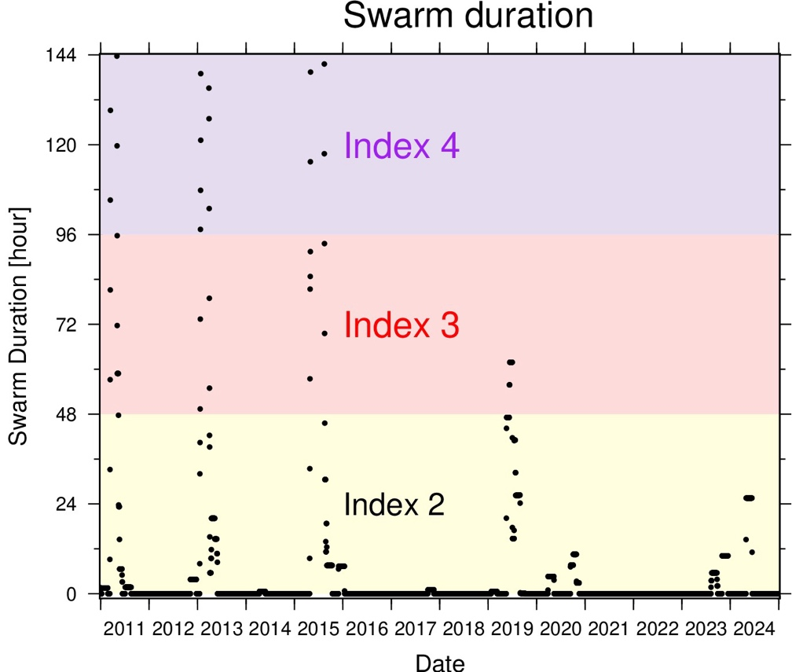
Figure S1. A time series of the duration of swarm earthquakes from 2011 to 2024. Purple background hatching shows the index 4, red shows index 3, yellow shows index 2, and white shows index 1.

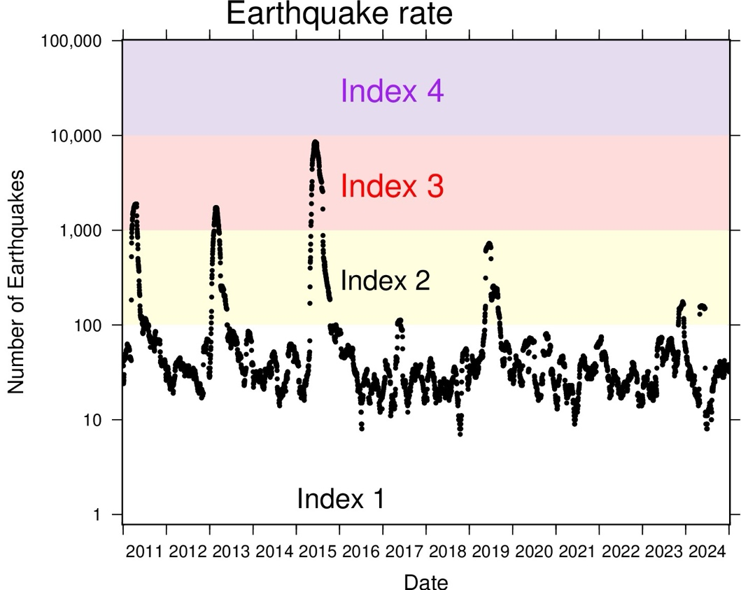
Figure S2. A time series of the number of earthquakes from 2011 to 2024.

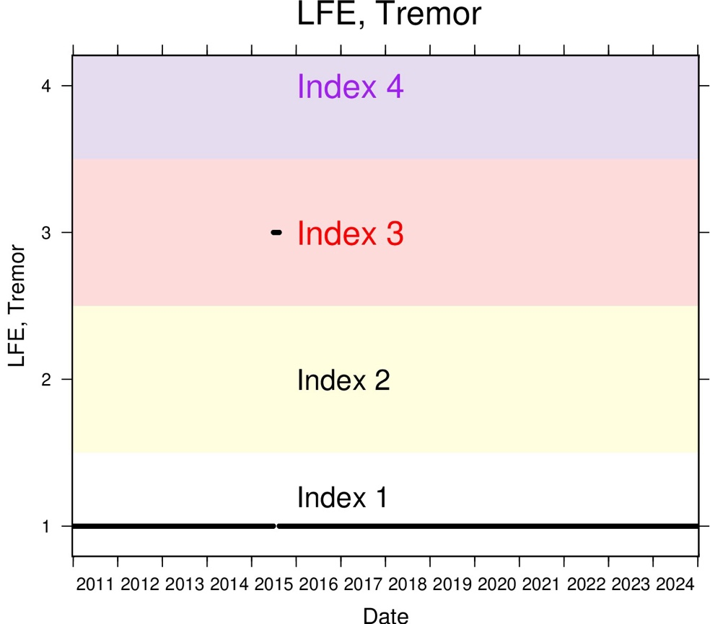
Figure S3. A time series of the index of the parameter "LFE and Tremor" from 2011 to 2024.

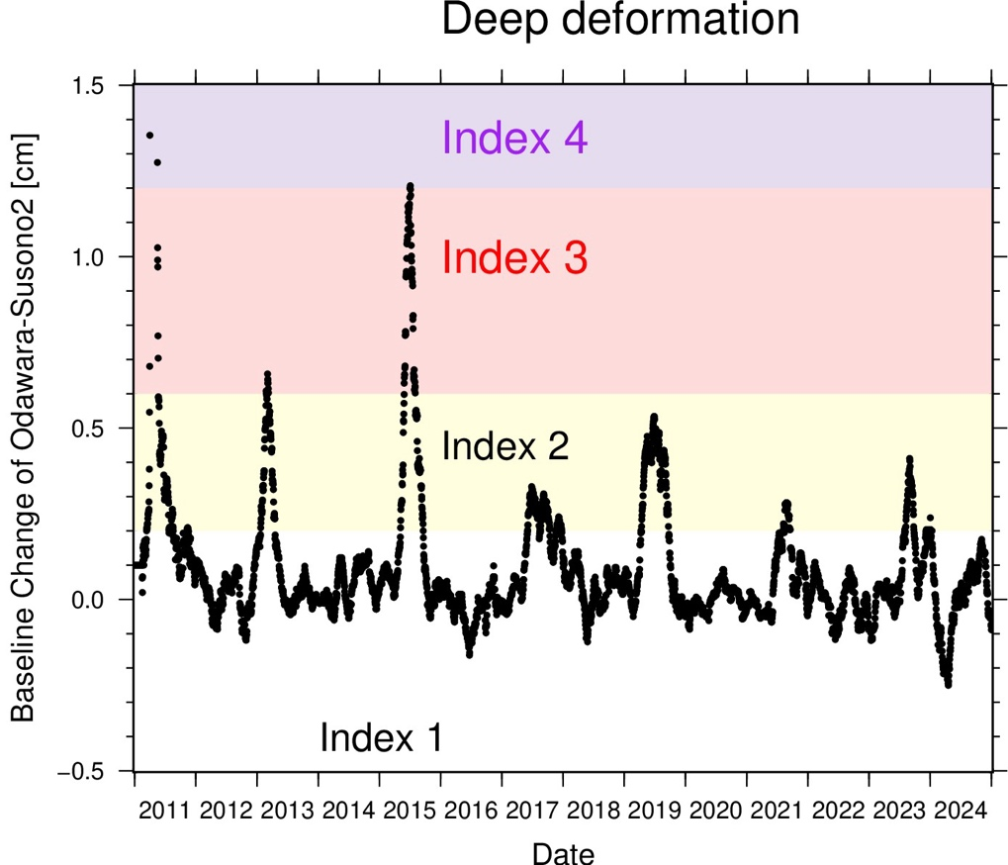
Figure S4. A time series of the baseline length change between Odawara and Susono 2 from 2011 to 2024. The value shows the difference between the median value of 1-45 days ago and that of 46-90 days ago.

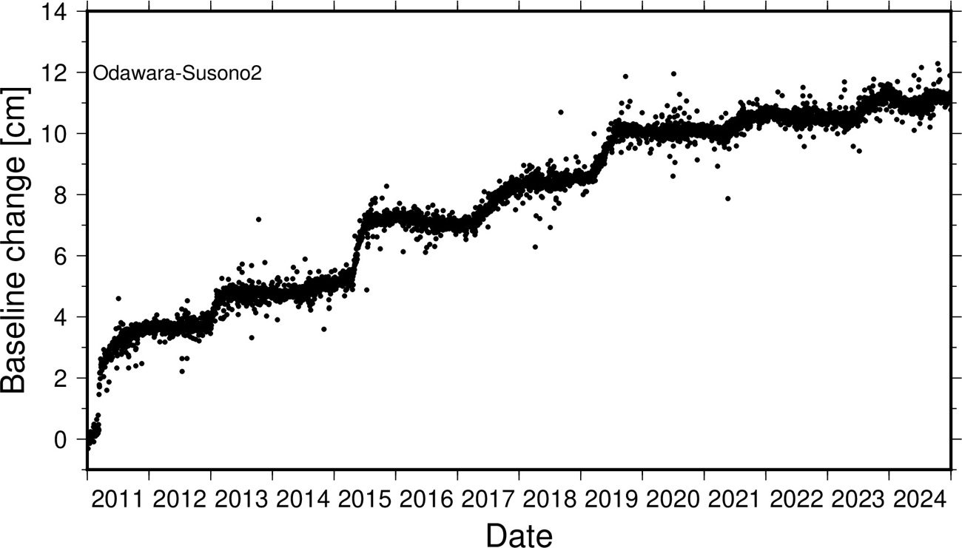
Figure S5. Baseline length A time series of Odawara-Susono2 from 2011 to 2024.

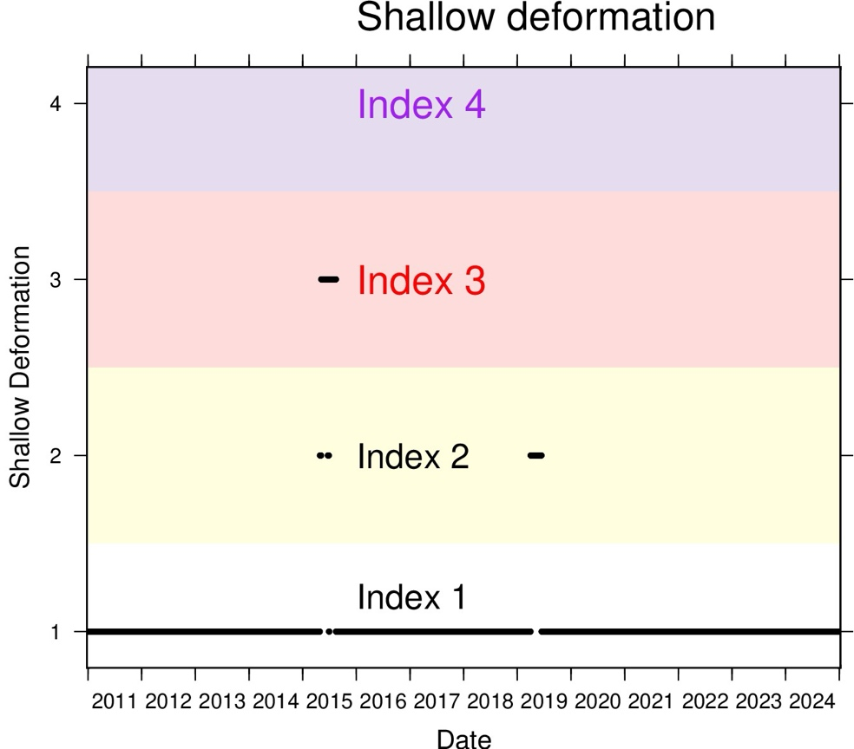
Figure S6. A time series of the index of the parameter "Shallow Deformation" from 2011 to 2024.

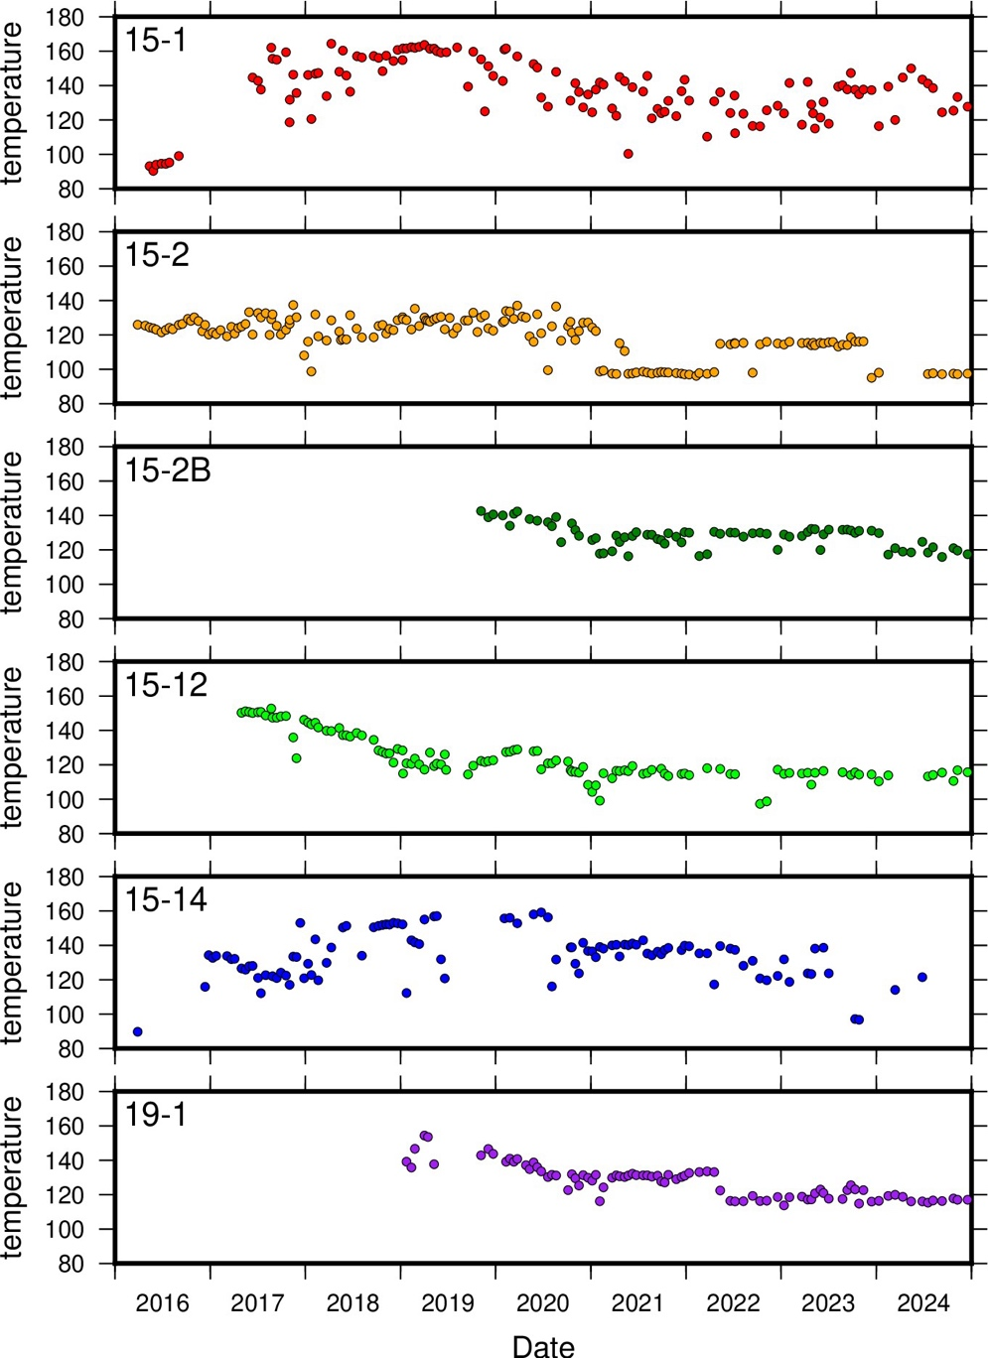
Figure S7. A time series of the temperature of fumaroles in the Owakudani geothermal area (cf. Mannen et al., 2025).
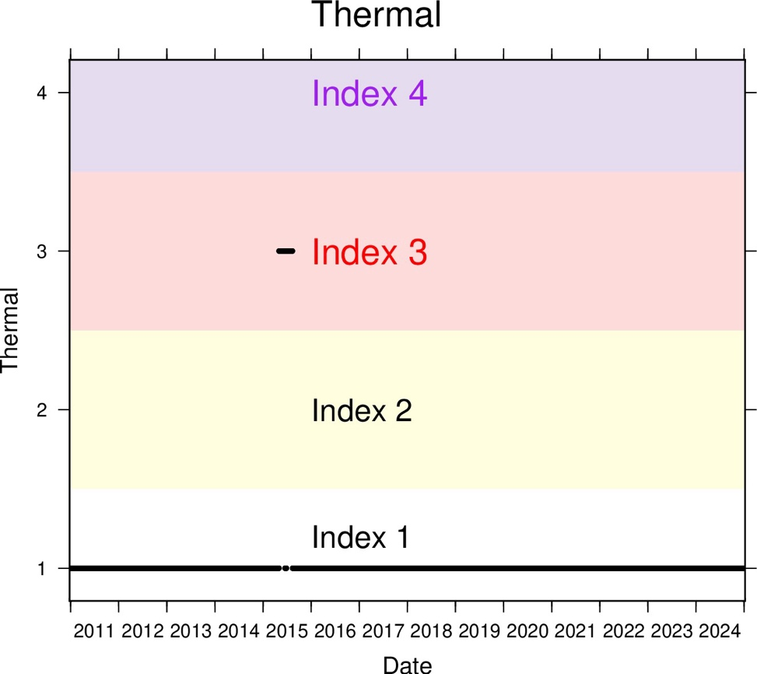
Figure S8. A time series of the index of the parameter "Thermal phenomena" from 2011 to 2024.

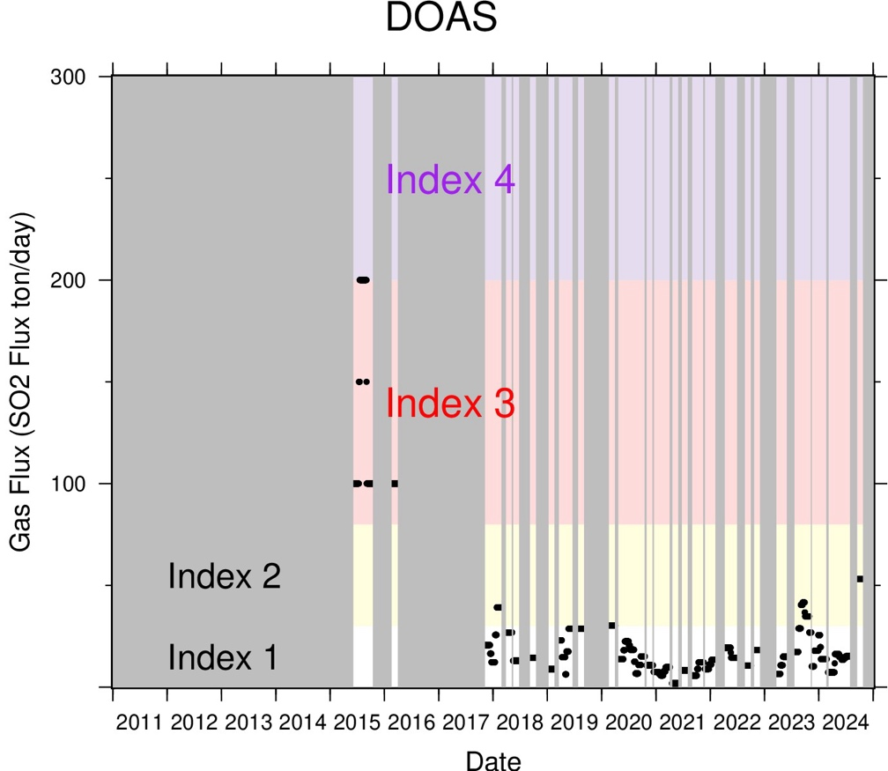

Figure S9. A time series of Gas flux from 2011 to 2024. Gray hatches show the no observation period.

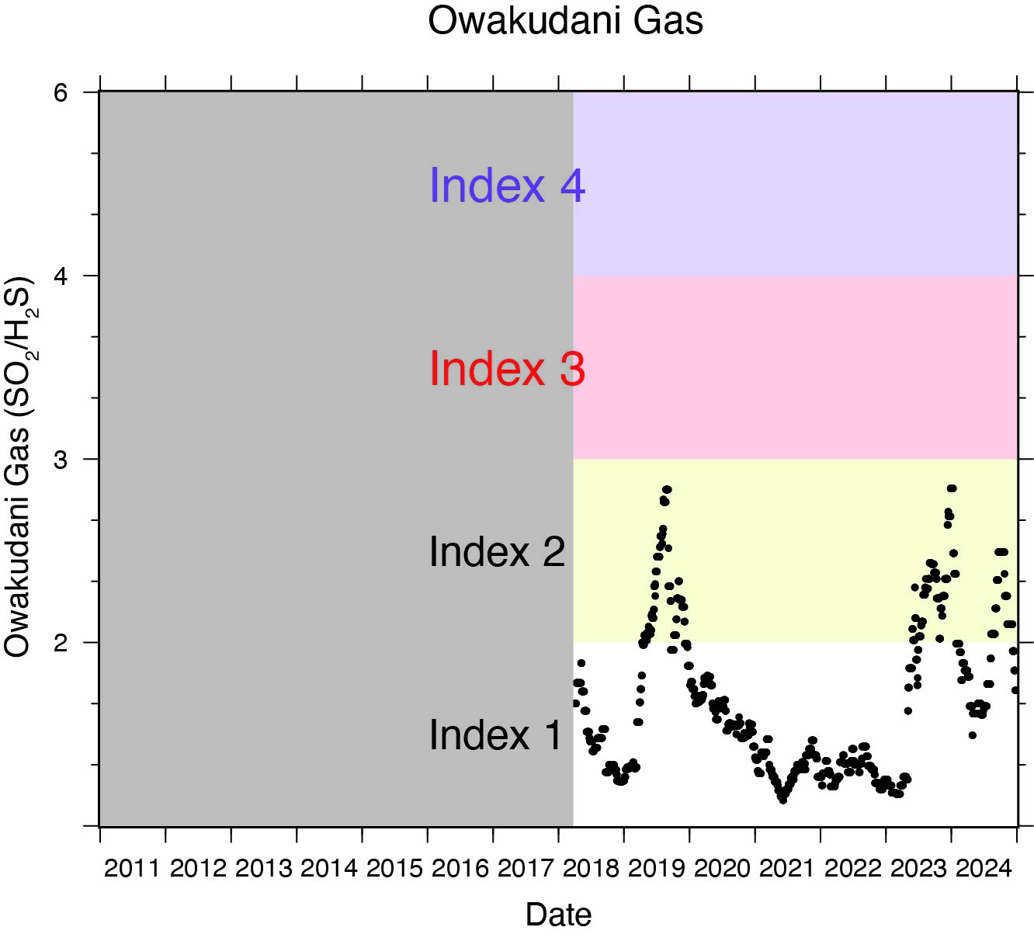
Figure S10. A time series of Gas composition (SO₂/H₂S ratio) of Owakudani from 2011 to 2024. A gray hatch shows the no observation period.

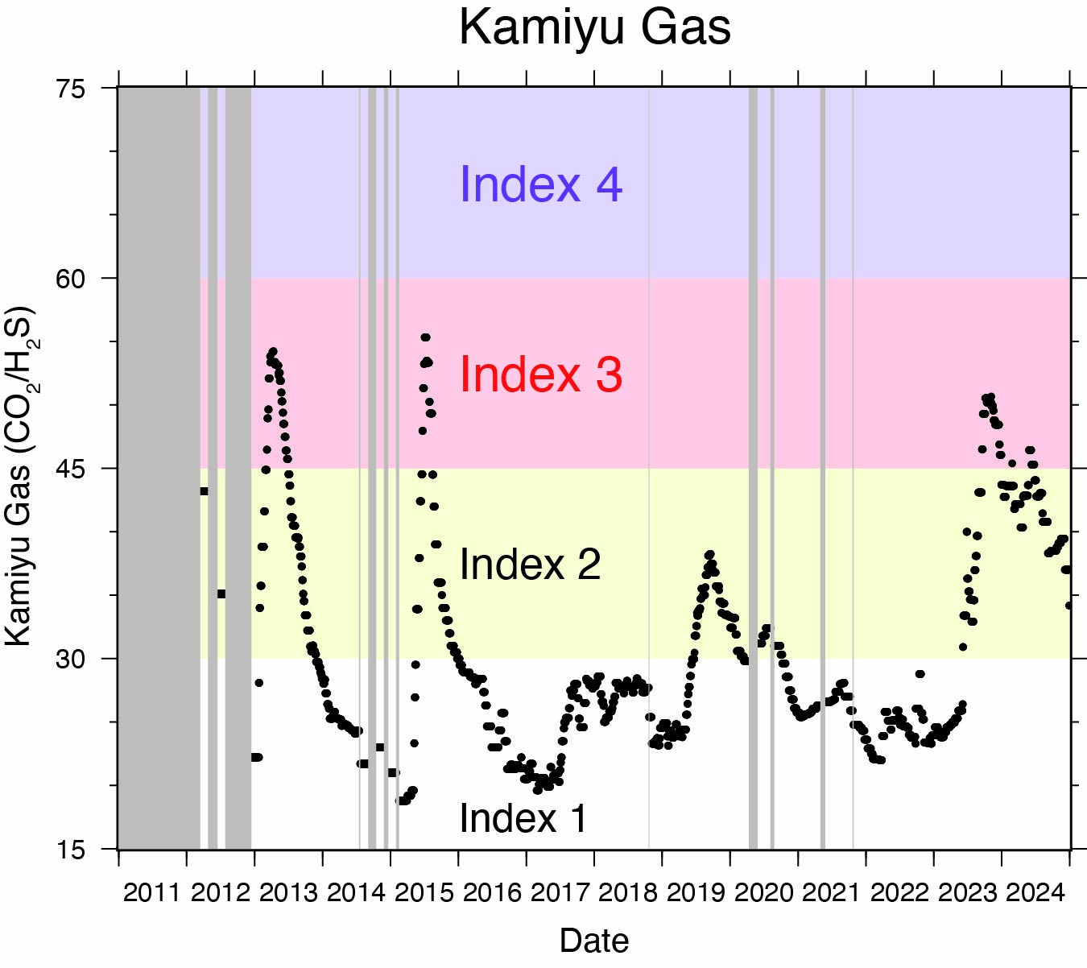
Figure S11. A time series of Gas composition (CO₂/H₂S ratio) of Kamiyu from 2011 to 2024. Gray hatches show the no observation period.

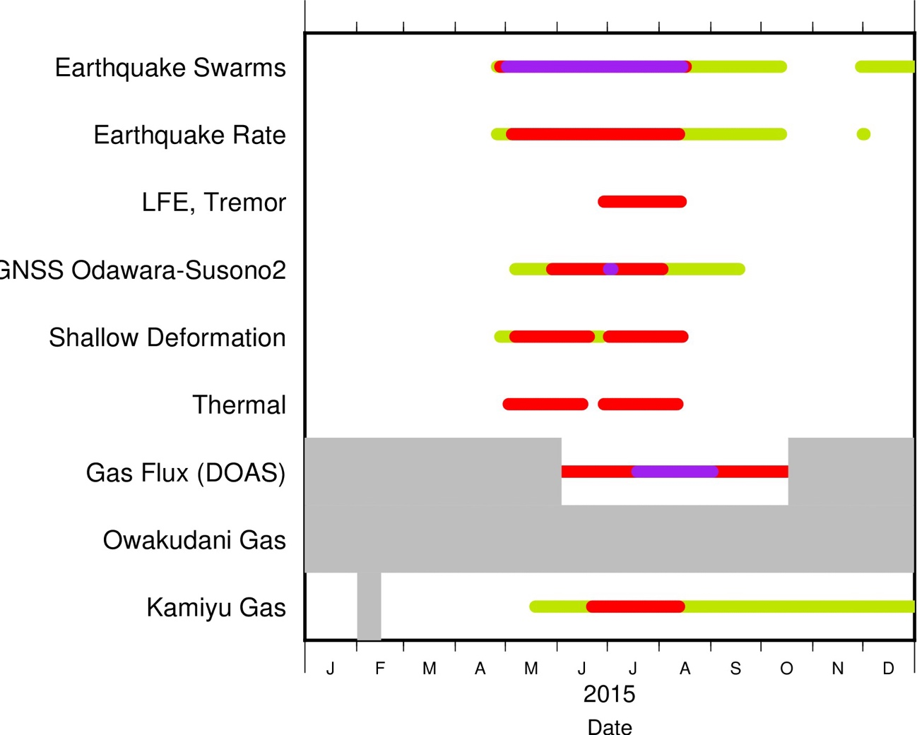
Figure S12. Enlarged view of Figure 9 in the period of 2015.

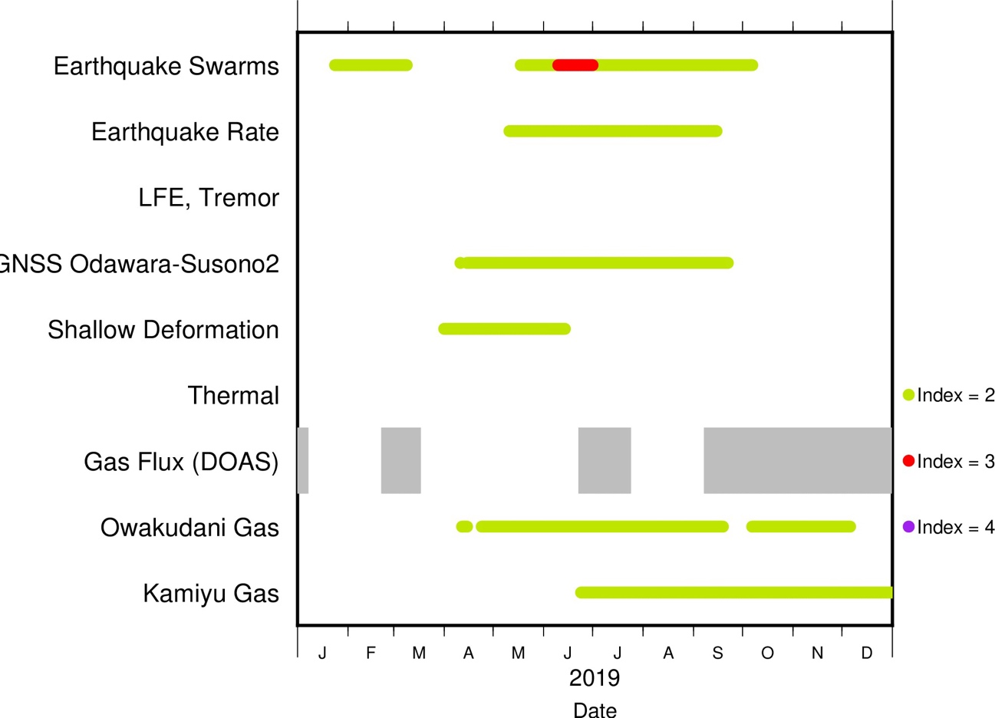
Figure S13. Enlarged view of Figure 9 in the period of 2019.

Reference
Mannen K, Kikugawa G, Miyashita Y, Ninomiya R and Toyama K (2025) Steaming area formed after the 2015 eruption of Hakone volcano, Japan and sequential changes of fumarolic temperature (Part IV: 2022-2024), 56, Bulletin of the Hot Spring Research Institute, p1-15 (in Japanese with English Abstract) https://www.onken.odawara.kanagawa.jp/files/PDF/houkoku/56/houkoku56-1.pdf

