Supplementary Information for “Estimating SARS-CoV-2 prevalence from large-scale wastewater surveillance: insights from combined analysis of 44 sites in England”
Table S1: Wastewater data and meta-data collected by the Environment Agency. These data are used within the modelling to improve estimates of prevalence. Note that only time-varying variables are used in input of the random effect model as it already uses subregion-level coefficients and therefore does not benefit from any subregion-level metadata.
Variable | Time-varying | Log10 | Factor Category
Sample concentration of SARS-CoV-2 in gene copies per litre | Yes | Yes | Population
Sample control value in gene copies per litre | Yes | Yes | Analysis
Population in subregion | No | No | Population
Proportion coverage of subregion population | No | No | Population
Catchment area covered | No | No | Network
Sample pH | Yes | No | Network
Sample concentration of ammoniacal nitrogen | Yes | Yes | Network
Sample concentration of orthophosphates | Yes | Yes | Network
Sample concentration of suspended solids | Yes | Yes | Network
Proportion of composite samples | Yes | No | Sampling
Delay in hour between collection and lab reception | Yes | No | Sampling
Fraction of samples below Limit of Quantification (LoQ) | Yes | No | Analysis
Fraction of samples below Limit of Detection (LoD) | Yes | No | Analysis

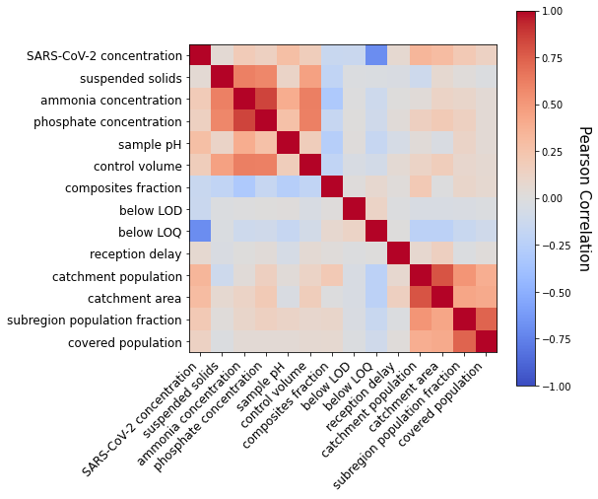
Fig. S1: Pearson correlation coefficients between variables considered in the model. Blue colours indicate negative correlations while red colours indicate positive linear correlation.

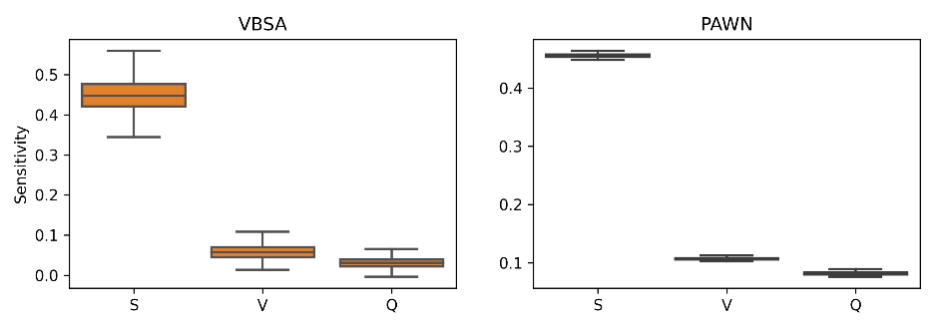
Fig. S2: Sensitivity analysis showing that better knowledge of mean viral concentration in stool (S) is more important than other parameters (volume (V) and flow rate (Q)) for constraint of prevalence estimates in back-calculation (using VBSA (left) and PAWN (right) methods). Using VBSA and PAWN, with 10,000 samples and 1,000 bootstraps, at concentration C = 10,000 gc/L. Parameter values are sampled from the uncertainty distributions.

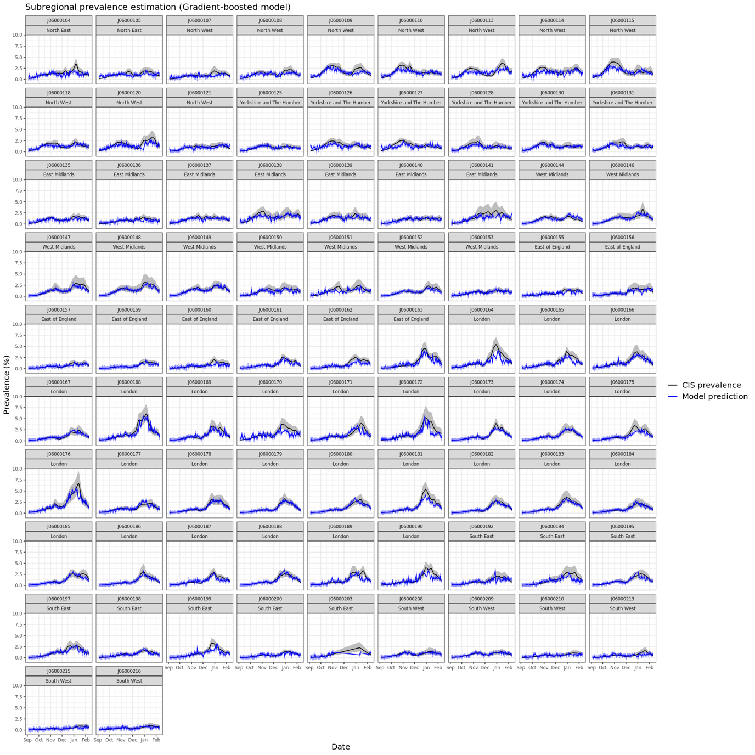
Fig. S3 Model prediction from the Extreme Gradient Boosted (XGB) model and CIS prevalence for the 83 site/CIS pairs at a sub-regional level.
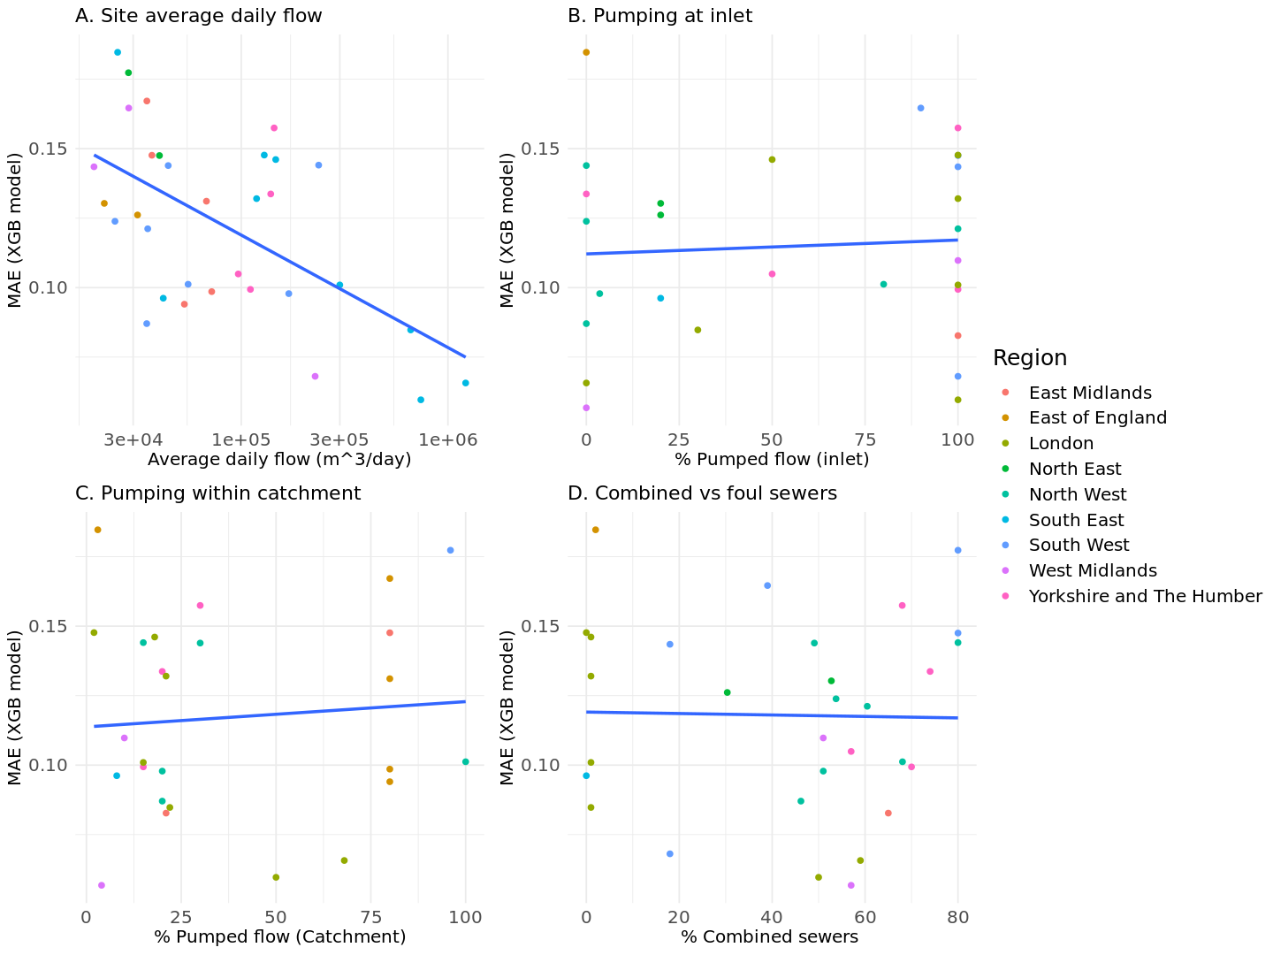
Fig. S4 Model performance at each WTP site depending on network characteristics provided by water companies. A site-level MAE was calculated by averaging, weighting by population covered, the MAE of the CIS subregions included in the catchment, and plotted across sites characteristics. The region of each site is indicated by the color of the dots, with the blue line representing the linear regression between score and site characteristics. None of these regressions yielded a significant result (p>0.05) when included in a linear model (site score ~ site characteristic).

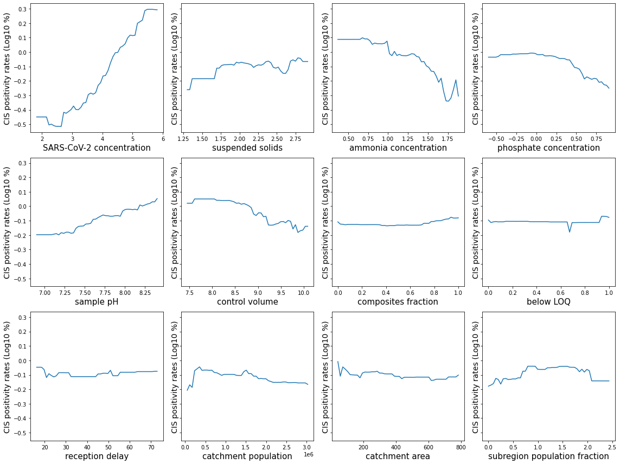Fig. S5 Partial dependency plots extracted from the XGB model trained on the whole dataset.
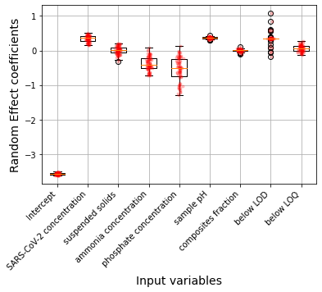
Fig. S6 Random effect intercepts (first column) for the random effects model and coefficients after fitting the whole WW/CIS for each of the 83 CIS subregions. Lower and upper hinges of the box plots correspond to first and third quartile with middle line corresponding to the median.
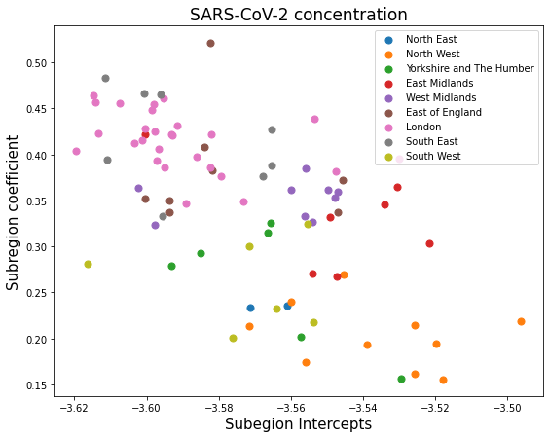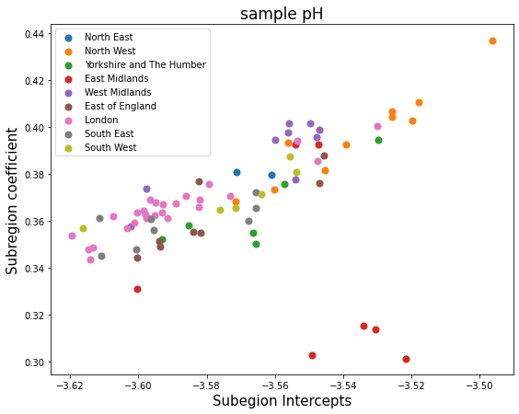
Fig. S7 Scatter plots of random effects for the two variables most correlated with the subregions’ intercepts: SARS-CoV-2 concentration (left) and sample pH (right). In addition, subregional points have been coloured by region to shed light on the geographic clustering which naturally emerges from these representations.
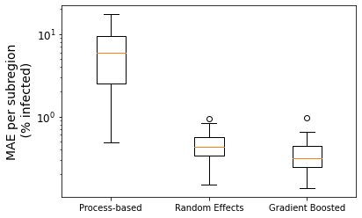
Fig. S8 Models performance measured by their residual error per subregion. Lower and upper hinges of the box plot corresponds to first and third quartile with middle line corresponding to the median.

