Annex/Supplementary Materials:
Supplementary Figure 1: Population and health facility distribution of the study sites

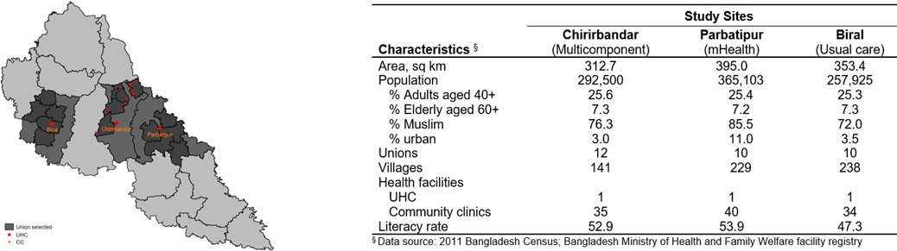

Supplementary Figure 2: Analytic sample of the study

Participants with complete information
(n= 6,849)
Participants with Hypertension (n= 2,690)
- Previously diagnosed with high BP by a health care provider (n= 1,114)
- Newly diagnosed with high BP by the study team (n=1,576)
Participants with Hypertension currently under treatment (taking medication)
(n= 635)
Participants with Diabetes (n= 967)
- Previously diagnosed with high blood sugar by a health care provider (n= 591)
- Newly diagnosed with high blood sugar by the study team (n=376)
Participants with Diabetes currently under treatment (taking medication)
(n= 335)
Total sample considered for the current study (n= 832)

Supplementary Figure 3: Monthly time lost (in minutes) by patients and attendees for hypertension and diabetes care
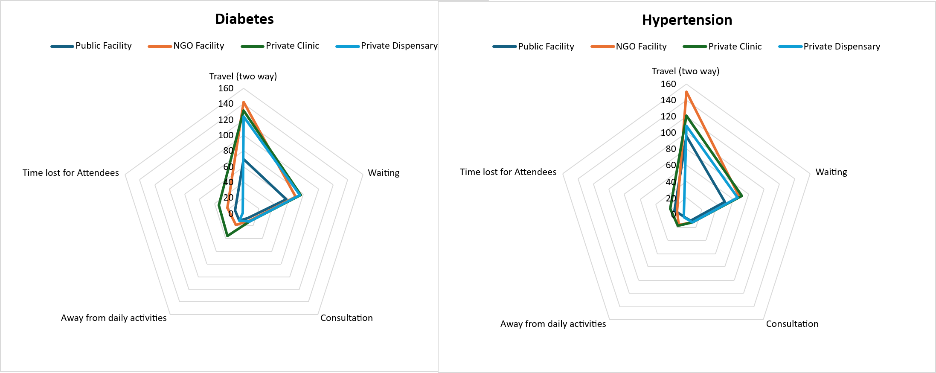

Supplementary Table-1: Factors associated with the direct cost of seeking care for hypertension and diabetes (adjusted for zero-cost observation)
Indicators | Hypertension |  |  | Diabetes
 |  | Model I | Model II | Model I | Model II
 |  | GMR (95% CI)
Age group (Ref: 40-49)
50-59 |  | 1.05 (0.75, 1.46) | 0.86 (0.52, 1.42) | 1.36 (0.97, 1.92) | 1.31 (0.81, 2.14)
60+ |  | 1.00 (0.70, 1.43) | 0.72 (0.39, 1.32) | 1.29 (0.84, 1.97) | 1.47 (0.86, 2.52)
Sex (Ref: Male)
Female |  | 0.94 (0.73, 1.21) | 0.71 (0.43, 1.16) | 1.09 (0.82, 1.46) | 0.85 (0.54, 1.33)
Currently married (Ref: No)
Yes |  | 0.97 (0.70, 1.36) | 1.26 (0.63, 2.51) | 1.37 (0.90, 2.09) | 2.19 (0.85, 5.65)
Education (Ref: No formal schooling)
Primary |  | 1.35 (1.07, 1.70) * | 1.41 (0.86, 2.31) | 1.48 (1.08, 2.02) * | 1.15 (0.76, 1.75)
Secondary or higher |  | 1.37 (0.91, 2.05) | 1.20 (0.52, 2.75) | 1.76 (1.07, 2.92) * | 1.54 (0.80, 2.97)
Employment status (Ref: Self-employed or homemaker)
Employed or retired |  | 1.77 (1.20, 2.60) * | 0.84 (0.30, 2.35) | 1.36 (0.88, 2.11) | 0.63 (0.17, 2.42)
Unemployed |  | 1.31 (0.89, 1.93) | 2.49 (1.41, 4.39) *** | 1.39 (0.84, 2.30) | 1.23 (0.60, 2.54)
Wealth score (Ref: Low)
Medium |  | 1.18 (0.92, 1.51) | 1.10 (0.68, 1.78) | 0.91 (0.56, 1.46) | 1.17 (0.48, 2.84)
High |  | 1.43 (1.09, 1.87) * | 1.38 (0.78, 2.45) | 1.10 (0.82, 1.49) | 1.62 (0.76, 3.44)
Having CVD (Ref: No)
Yes |  | 1.78 (1.35, 2.35) *** | 1.68 (1.03, 2.74) ** | 1.74 (1.01, 3.01) * | 1.61 (0.62, 4.15)
Having Chronic respiratory disease (Ref: No)
Yes |  | 1.34 (0.98, 1.85) | 1.08 (0.60, 1.94) | 1.45 (0.87, 2.42) | 1.89 (0.77, 4.61)
Having High cholesterol (Ref: No)
Yes |  | 2.16 (1.49, 3.14) *** | 1.64 (0.77, 3.48) | 1.76 (1.11, 2.78) * | 1.07 (0.39, 2.93)
Sources of care (Ref: Private Dispensary)
Public Facility |  | 0.46 (0.33, 0.64) *** | 0.28 (0.15, 0.53) *** | 0.15 (0.10, 0.24) *** | 0.19 (0.09, 0.39) ***
NGO Facility |  | 2.08 (1.37, 3.16) *** | 0.66 (0.27, 1.59) | 1.01 (0.72, 1.41) | 0.86 (0.50, 1.49)
Private Clinic |  | 1.34 (1.06, 1.69) * | 0.78 (0.54, 1.13) | 1.07 (0.74, 1.52) | 1.20 (0.71, 2.04)
Observations |  | 582 | 635 | 316 | 335
R-squared |  | 0.26 | 0.12 | 0.41 | 0.20

Model I: Regression without adjustment to zero costs
Model II: Regression with adjustment to the zero costs (1 value added)
Note: p < 0.05*, p < 0.01**, p < 0.001***
Supplementary Table-2: Factors associated with indirect cost of seeking care for hypertension and diabetes (adjusted for zero-cost observation)
Indicators | Hypertension |  |  | Diabetes
 |  | Model I | Model II | Model I | Model II
 |  | GMR (95% CI)
Age group (Ref: 40-49)
50-59 |  | 1.22 (0.83, 1.79) | 0.79 (0.45, 1.38) | 1.13 (0.78, 1.64) | 0.80 (0.39, 1.65)
60+ |  | 1.03 (0.72, 1.47) | 0.93 (0.49, 1.74) | 0.99 (0.68, 1.43) | 0.60 (0.28, 1.32)
Sex (Ref: Male)
Female |  | 0.97 (0.74, 1.28) | 0.87 (0.50, 1.51) | 1.22 (0.87, 1.69) | 0.72 (0.38, 1.33)
Currently married (Ref: No)
Yes |  | 1.15 (0.80, 1.66) | 1.00 (0.60, 1.66) | 1.04 (0.68, 1.58) | 1.09 (0.43, 2.72)
Education (Ref: No formal schooling)
Primary |  | 1.41 (1.06, 1.88) * | 1.91 (1.13, 3.23) ** | 1.49 (1.02, 2.17) * | 1.82 (0.97, 3.42) *
Secondary or higher |  | 1.41 (0.93, 2.12) | 1.58 (0.70, 3.54) | 2.19 (1.16, 4.13) * | 2.23 (0.84, 5.93)
Employment status (Ref: Self-employed or homemaker)
Employed or retired |  | 1.07 (0.72, 1.59) | 0.85 (0.43, 1.67) | 1.19 (0.68, 2.10) | 1.71 (0.62, 4.76)
Unemployed |  | 1.11 (0.73, 1.68) | 1.72 (0.75, 3.97) | 0.97 (0.60, 1.57) | 0.96 (0.27, 3.43)
Wealth score (Ref: Low)
Medium |  | 0.89 (0.63, 1.25) | 0.79 (0.51, 1.22) | 0.87 (0.50, 1.52) | 0.92 (0.39, 2.16)
High |  | 0.82 (0.64, 1.06) | 0.61 (0.35, 1.05) | 0.72 (0.49, 1.07) | 0.66 (0.26, 1.67)
Having CVD (Ref: No)
Yes |  | 1.27 (0.91, 1.76) | 1.02 (0.57, 1.84) | 1.76 (1.21, 2.54) *** | 2.63 (0.89, 7.81) *
Having Chronic respiratory disease (Ref: No)
Yes |  | 1.20 (0.78, 1.83) | 0.89 (0.48, 1.67) | 0.98 (0.63, 1.53) | 0.96 (0.37, 2.52)
Having High cholesterol (Ref: No)
Yes |  | 1.75 (1.20, 2.57) * | 1.07 (0.53, 2.16) | 1.46 (0.98, 2.19) | 0.96 (0.38, 2.42)
Sources of care (Ref: Private Dispensary)
Public Facility |  | 1.99 (1.40, 2.84) *** | 1.69 (0.86, 3.32) | 2.34 (1.52, 3.61) *** | 2.94 (1.13, 7.65) ***
NGO Facility |  | 1.89 (1.27, 2.83) *** | 1.54 (0.73, 3.23) | 2.27 (1.43, 3.61) *** | 1.27 (0.63, 2.55)
Private Clinic |  | 1.90 (1.38, 2.62) *** | 1.02 (0.62, 1.67) | 2.28 (1.55, 3.37) *** | 1.19 (0.52, 2.71)
Observations |  | 414 | 635 | 236 | 335
R-squared |  | 0.15 | 0.03 | 0.19 | 0.06

Model I: Regression without adjustment to zero costs
Model II: Regression with adjustment to the zero costs (1 value added)
Note: p < 0.05*, p < 0.01**, p < 0.001***

Supplementary Table-3: Direct and indirect costs (monthly) of care among patients with hypertension, diabetes and both conditions [in BDT]
Cost Items | Hypertension only (n=497) |  | Diabetes only (n=197) |  | Both Hypertension and Diabetes (n=138)
Cost Items | Mean BDT (95% CI) | % of total cost | Mean BDT (95% CI) | % of total cost | Mean BDT (95% CI) | % of total cost
Direct Medical Cost Items
Registration | 4 (0.09 - 8.80) | 0.5% | 22 (8.61 - 35.37) | 1.3% | 24 (-0.62 - 48.97) | 0.9%
Consultation | 52 (36.25 - 66.77) | 5.4% | 47 (17.23 - 76.37) | 2.8% | 86 (40.93 - 131.54) | 3.3%
Diagnosis | 100 (55.03 - 145.79) | 10.6% | 230 (84.59 - 374.95) | 13.6% | 450 (98.83 - 802.11) | 17.4%
Medicine | 602 (518.47 - 686.03) | 63.4% | 990 (660.27 - 1319.54) | 58.5% | 1589 (1298.15 - 1880.21) | 61.2%
Total direct medical cost | 763 (646.54 -878.90) | 80.3% | 1324 (788.69 - 1859.32) | 78.3% | 2150 (1567.01 - 2733.10) | 82.8%
Direct Non-medical Cost Items
Travel | 44 (27.67 - 60.71) | 4.7% | 66 (38.82 - 92.90) | 3.9% | 89 (44.95 - 132.81) | 3.4%
Food cost | 44 (28.65 - 59.67) | 4.7% | 141 (71.05 - 210.83) | 8.3% | 165 (80.98 - 249.24) | 6.7%
Informal costs (gifts, tips) | 4 (-0.05 - 7.49) | 0.4% | 4 (-2.49 - 9.60) | 0.2% | 6 (-2.22 - 13.23) | 0.2%
Total direct non-medical cost | 92 (63.97 - 120.99) | 9.7% | 211 (114.54 - 307.19) | 12.5% | 260 (152.23 - 367.48) | 10.0%
Indirect Costs
Cost of lost time/productivity (patient) | 87 (74.24 - 99.39) | 9.1% | 145 (112.85 - 178.02) | 8.6% | 156 (114.76 - 196.46) | 6.0%
Cost of lost time/productivity (attendant) | 8 (3.63 - 12.09) | 0.8% | 11 (3.20 - 18.58) | 0.6% | 31 (12.45 - 48.94) | 1.2%
Total indirect cost | 95 (79.83 - 109.53) | 10.0% | 156 (120.26 - 192.38) | 9.2% | 186 (131.67 - 240.93) | 7.2%
Total cost | 950 (814.02 - 1085.73) | 100.0% | 1691 (1092.02 - 2290.35) | 100.00% | 2596 (1896.48 - 3295.95) | 100.0%
Total cost in USD | 8 (6.90 – 9.20) |  | 14 (9.25 – 19.41) |  | 22 (16.07 – 27.93)

