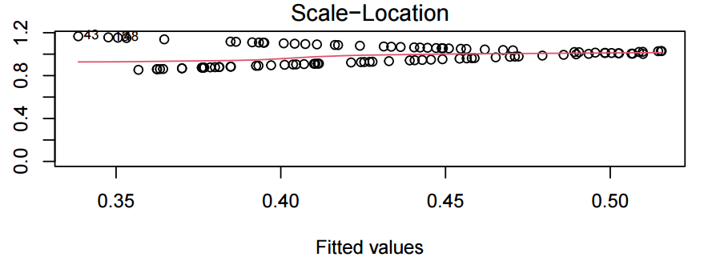
Figure 1 Standardized residual plot of pathogenic E. coli influencing factors in the Nanchong area

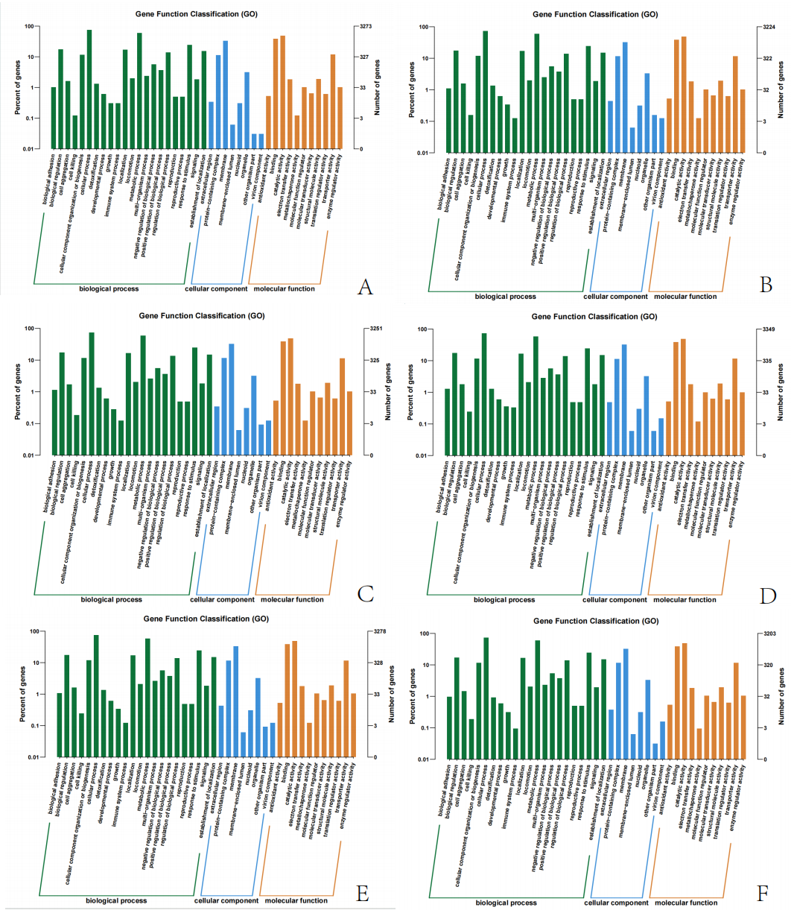
Figure 2 E. coli GO Functional Classification Annotation Database Comparison
Note: Horizontal coordinates GO each classification, vertical coordinates are the percentage of the number of genes on the left, the number of genes on the right

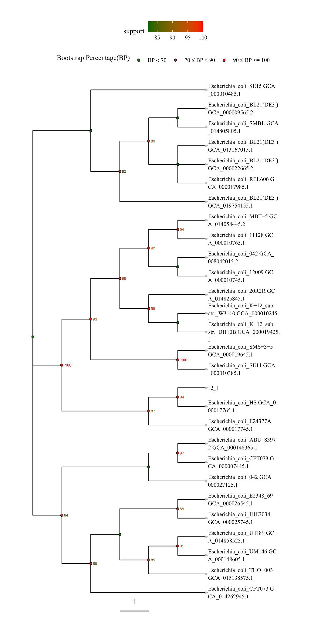
Figure 3 Circular evolutionary tree based on 16S rRNA
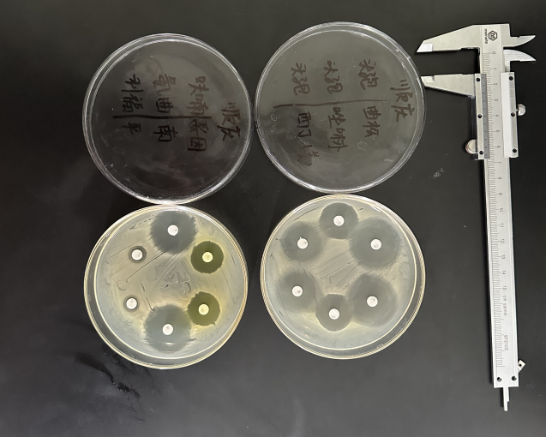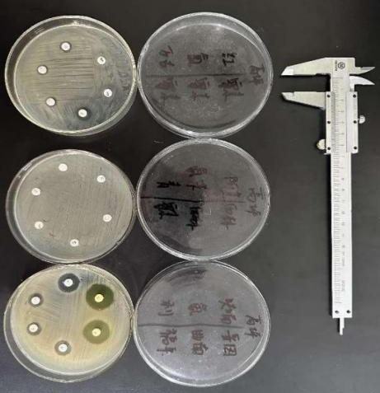
Figure 3 Reaction of pathogenic Escherichia coli to drug-sensitive tablets

