Table 1 Establishment of the PCR reaction system
Reagents | Dosage
Template（genomics） | 1ul
Primer up(10uM) | 0.5ul
Primer down(10uM) | 0.5ul
dNTP mix(10Mm each) | 0.5ul
10*Taq reaction Buffer | 2.5ul
Taq (5u/ul) | 0.2 ul
ddH₂O | 19.8ul

Table 2 PCR sequencing reactions
Reagents added | dosage
BigDye Mix | 1 μL
PCR products to be measured | 1 μL
Forward primers for DNA to be tested | 1 μL
Sterilized deionized water | 2 μL

Table 3 Drug Name for Drug Sensitivity
Drug type | Drug name
Lincosamide | Ciprofloxacin, Levofloxacin, Norfloxacin
Macrolide | Erythromycin, Rifampicin
β-lactams | Ampicillin, Penicillin, Amoxicillin, Cefazolin, Cefoxitin, Ceftriaxone, Amitrazan
Aminoglycoside | Gentamicin, Streptomycin, Butylcarbamate
Tetracycline | Tetracycline, Doxycycline
Nitrofurazolidones | Furantoin
Vancomycin | Vancomycin (antibiotic)
Clindamycin | Chloromycetin
Sulfonamide | Flavaminoisoxazole

Table 4 Homology analysis of Escherichia coli genes
编号 | Description | Scientific Name | Max Score | Total Score | Query Cover | Evalue | Per.Ident | Acc.Len | Accession
1-1 | Escherichia coli strain GRDL-MDR2 16S ribosomal RNA gene, partial sequence | Escherichia coli | 2610 | 2610 | 99% | 0 | 99.51% | 1470 | ON597614.1
1-2 | Escherichia coli strain YJ7 16S ribosomal RNA gene, partial sequence | Escherichia coli | 2606 | 2606 | 98% | 0 | 99.72% | 1445 | OP762755.1
1-3 | Select seq LC428294.1 Escherichia coli IRQBAS57 gene for 16S ribosomal RNA, partial sequence | Escherichia coli | 2588 | 2588 | 99% | 0 | 99.17% | 1444 | LC428294.1
1-4 | Escherichia coli strain A30 16S ribosomal RNA gene, partial sequence | Escherichia coli | 2621 | 2621 | 98% | 0 | 99.86 | 1438 | OK175786.1
1-5 | Select seq MN208206.1 Escherichia coli strain 58-a pink 16S ribosomal RNA gene, partial sequence | Escherichia coli | 2619 | 2619 | 99% | 0 | 99.58% | 1444 | MN208206.1
1-6 | Escherichia fergusonii strain 4608 16S ribosomal RNA gene, partial sequence | Taxonomy for  Escherichia  fergusonii | 2603 | 2603 | 99% | 0 | 99.51% | 1444 | MT545103.1
1-7 | Escherichia coli strain 339-a pink 16S ribosomal RNA gene, partial sequence | Escherichia coli | 2615 | 2615 | 98% | 0 | 99.79% | 1441 | MN208097.1
1-8 | Escherichia coli strain 152-a blue 16S ribosomal RNA gene, partial sequence | Escherichia coli | 2634 | 2634 | 99% | 0 | 99.79% | 1446 | MN208228.1
1-9 | Escherichia coli strain 58-a pink 16S ribosomal RNA gene, partial sequence | Escherichia coli | 2628 | 2628 | 99% | 0 | 99.79% | 1444 | MN208206.1
1-11 | Select seq OK175786.1 Escherichia coli strain A30 16S ribosomal RNA gene, partial sequence | Escherichia coli | 2619 | 2619 | 99% | 0 | 99.79% | 1438 | OK175786.1
1-12 | Escherichia coli strain 58-a pink 16S ribosomal RNA gene, partial sequence | Escherichia coli | 2606 | 2606 | 98% | 0 | 99.79% | 1444 | MN208206.1
1-13 | Select seq MN208096.1 Escherichia coli strain 205-a pink 16S ribosomal RNA gene, partial sequence | Escherichia coli | 2612 | 2612 | 98% | 0 | 99.72% | 1443 | MN208096.1
1-14 | Escherichia coli strain s1428 16S ribosomal RNA gene, partial sequence | Escherichia coli | 2615 | 2615 | 98% | 0 | 99.86% | 1435 | MG388227.1
1-15 | Select seq EF560780.1 Escherichia coli strain BE27 16S ribosomal RNA gene, partial sequence | Escherichia coli | 2604 | 2604 | 98% | 0 | 99.79% | 1423
10-2 | Escherichia coli strain K10 16S ribosomal RNA gene, partial sequence | Escherichia coli | 2621 | 2621 | 98% | 0 | 99.72% | 1448 | OK493608.1
10-3 | Select seq MH532522.1 Escherichia coli strain JCD4 16S ribosomal RNA gene, partial sequence | Escherichia coli | 2612 | 2612 | 98% | 0 | 99.58% | 1445 | MH532522.1
10-4 | Select seq MN208215.1 Escherichia coli strain 95-a pink 16S ribosomal RNA gene, partial sequence | Escherichia coli | 2617 | 2617 | 99% | 0 | 99.58% | 1445 | MN208215.1
10-5 | Select seq OR206147.1 Escherichia coli strain AB121 16S ribosomal RNA gene, partial sequence | Escherichia coli | 2623 | 2623 | 98% | 0 | 99.72% | 1436 | OR206147.1
10-6 | Select seq MH517447.1 Escherichia coli strain JCD1 16S ribosomal RNA gene, partial sequence | Escherichia coli | 2623 | 2623 | 98% | 0 | 99.86% | 1451 | MH517447.1
12-1 | Escherichia coli strain AH01 chromosome, complete genome | Escherichia coli | 2571 | 17924 | 97% | 0 | 99.86% | 4886157 | CP055251.1
12-2 | Select seq CP142590.1 Escherichia coli strain 64 chromosome, complete genome | Escherichia coli | 2608 | 18088 | 98% | 0 | 99.65% | 4745039 | CP142590.1
12-4 | Select seq CP134891.1 Escherichia coli strain 4080 chromosome, complete genome | Escherichia coli | 2612 | 18169 | 98% | 0 | 99.65% | 4622181 | CP134891.1
12-5 | Escherichia coli strain CCFM8338 16S ribosomal RNA gene, partial sequence | Escherichia coli | 2617 | 2617 | 97% | 0 | 99.86% | 1433 | KJ803895.1
12-6 | Select seq CP055251.1 Escherichia coli strain AH01 chromosome, complete genome | Escherichia coli | 2614 | 18221 | 98% | 0 | 99.44% | 4886157 | CP055251.1
12-7 | Select seq MN208184.1 Escherichia coli strain 148-c pink 16S ribosomal RNA gene, partial sequence | Escherichia coli | 2625 | 2625 | 98% | 0 | 99.79% | 1441 | MN208184.1
12-8 | Select seq CP013190.1 Escherichia coli strain FORC_031 chromosome, complete genome | Escherichia coli | 2608 | 18105 | 98% | 0 | 99.38% | 4830073 | CP013190.1
12-9 | Select seq CP099267.1 Escherichia coli strain RHB08-E3-C05 chromosome, complete genome | Escherichia coli | 2603 | 18116 | 97% | 0 | 99.79% | 4852089 | CP099267.1

Table 5 Main virulence genes
virulence factor | gene annotation | Gene number
Pseudomonas aeruginosa PAO1 | diaminobutyrate-2-oxoglutarate aminotransferase PvdH | VFG000458
Haemophilus influenzae  Rd KW20 | UDP-2,3-diacylglucosamine pyrophosphohydrolase | VFG013321
Burkholderia pseudomallei K96243 | type IV prepilin leader peptide type M1 | VFG002428
Yersinia enterocolitica subsp. enterocolitica 8081 | phosphomannomutase | VFG002362
Escherichia coli O157:H7  str. EDL933 | regulator protein EcpR | VFG002413
Neisseria meningitidis  MC58 | fatty acid efflux system protein FarA | VFG036938
Mycobacterium tuberculosis H37Rv | Isocitrate lyase Icl | VFG001381
Legionella pneumophila subsp. pneumophila str. Philadelphia 1 | flagellar L-ring protein precursor FlgH | VFG001997
Salmonella enterica subsp. enterica serovar Typhimurium str. LT2 | Mg2+ transport protein | VFG000574
Yersinia enterocolitica subsp. enterocolitica 8081 | flagella synthesis protein FlgN | VFG002354
Aeromonas hydrophila subsp. hydrophila ATCC 7966 | flagellin | VFG038734
Escherichia coli CFT073 | Type 1 fimbriae Regulatory protein fimB | VFG000871

Table 6 Summary of major drug resistance genes
Gene ID | AROname | Gene Family | Resistance Mechanism
ctg00010 02457  ctg00026 03803  ctg00035 04191 | patA | ATP-binding cassette (ABC) pump | antibiotic efflux
ctg00005 01532  ctg00015 03075  ctg00025 03775  ctg00012 02707 | patB | ATP-binding cassette(ABC)  antibiotic efflux pump | antibiotic efflux
ctg00015 03068 | emrA | major facilitator superfamily (MFS) antibiotic efflux pump | antibiotic efflux
ctg00015 03067 | emrB | major facilitator superfamily (MFS) antibiotic efflux pump | antibiotic efflux
ctg00007 02066  ctg00030 04507  ctg00012 02954 | patA | ATP-binding cassette (ABC) antibiotic efflux pump | antibiotic efflux
ctg00013 03179  ctg00007 01900  ctg00017 03673  ctg00006 01695 | patB | ATP-binding cassette (ABC) antibiotic efflux pump | antibiotic efflux
ctg00006 01703 | emrA | major facilitator superfamily (MFS) antibiotic efflux pump | antibiotic efflux
ctg00006 01704 | emrB | major facilitator superfamily (MFS) antibiotic efflux pump | antibiotic efflux
ctg00018 02667  ctg00025 03204  ctg00044 04070 | patA | ATP-binding cassette (ABC) antibiotic efflux pump | antibiotic efflux
ctg00036 03789  ctg00050 04252  ctg00013 02110  ctg00009 01560 | patB | ATP-binding cassette (ABC) antibiotic efflux pump | antibiotic efflux
ctg00036 03797 | emrA | major facilitator superfamily (MFS) antibiotic efflux pump | antibiotic efflux
ctg00036 03798 | emrB | major facilitator superfamily (MFS) antibiotic efflux pump | antibiotic efflux

Table 7 Sensitivity of pathogenic Escherichia coli to drugs
Sports Event | Colony 1 | Colony 2 | Colony 3 | Colony 4 | Colony 5
Ampicillin | S | S | S | S | S
Amoxicillin | I | S | S | S | S
Cefazolin | S | S | S | S | S
Cefoxitin | S | S | S | S | S
Ceftriaxone | S | S | S | S | S
Voltaren | S | S | S | S | S
Gentamycin | S | S | S | S | S
Streptomycin | S | S | S | I | S
Buprenorphine | S | S | I | S | S
Ciprofloxacin | S | S | S | S | S
Levofloxacin | S | S | S | S | S
Norfloxacin | S | S | S | S | S
Tetracycline | R | S | R | S | S
Doxycycline | S | S | S | S | S
Furantoin | S | S | S | S | S
Flavaminoisoxazole | S | S | S | S | S
Chloromycetin | S | S | S | S | S

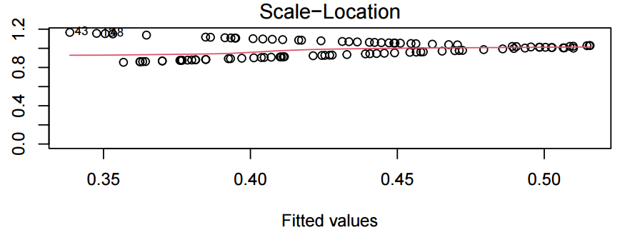
Figure 1 Standardized residual plot of pathogenic E. coli influencing factors in the Nanchong area

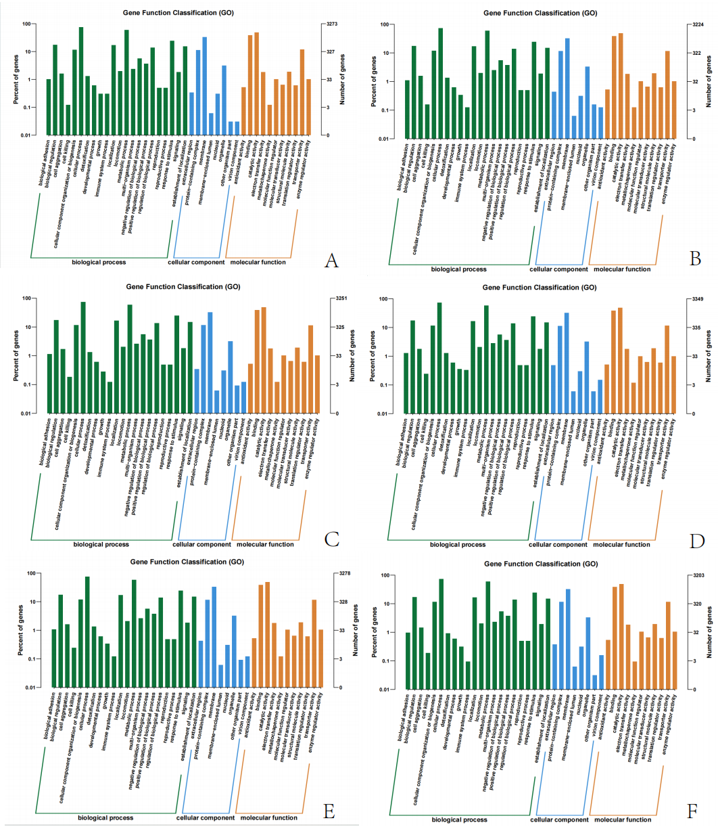
Figure 2 E. coli GO Functional Classification Annotation Database Comparison
Note: Horizontal coordinates GO each classification, vertical coordinates are the percentage of the number of genes on the left, the number of genes on the right

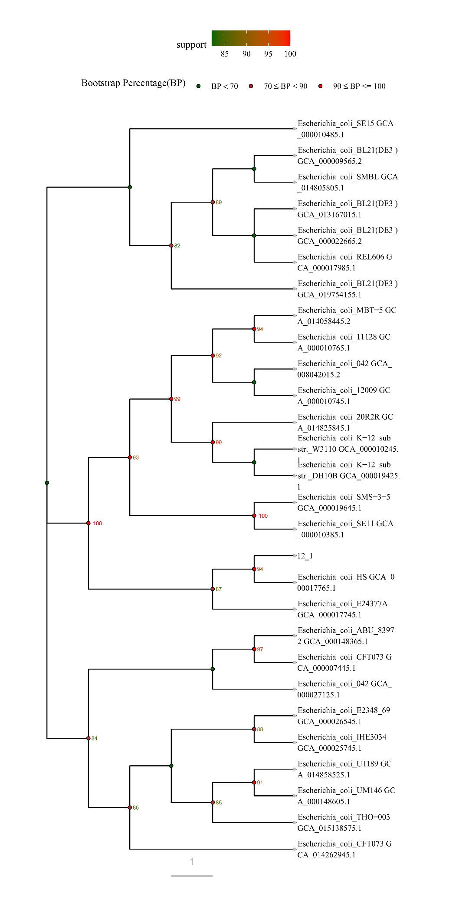
Figure 3 Circular evolutionary tree based on 16S rRNA
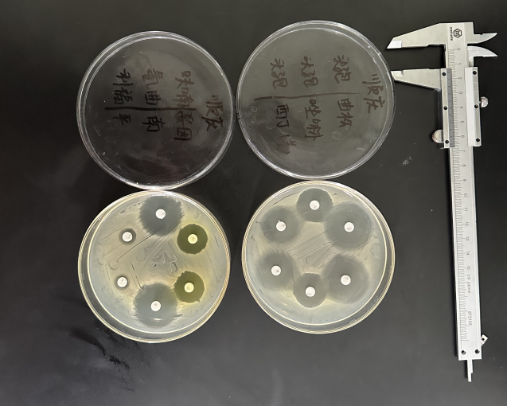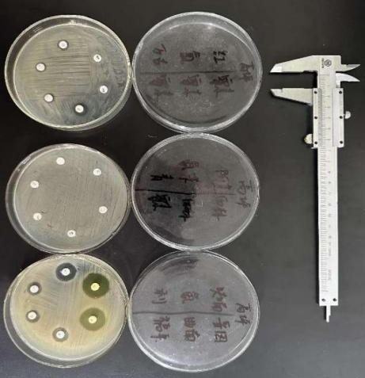
Figure 3 Reaction of pathogenic Escherichia coli to drug-sensitive tablets

