Supplementary Information

Supplementary Analyses.

Pattern separation. Pattern separation is typically observed in the dentate gyrus hippocampal subfield, whose sparse activity and competitive networks induce (near) orthogonalization of representations (Kesner & Rolls, 2015; Treves & Rolls, 1992), which is efficient for information storage. To evaluate whether the current model’s dentate gyrus layer performs pattern separation, cosine similarities between stimuli (i.e., Fashion MNIST images) and dentate gyrus unit activations underlying the stimuli were first obtained. To reduce computational complexity, 1000 stimuli were sampled randomly without replacement and cosine similarities for both dentate gyrus and actual images were computed for those images. This process was repeated 60 times for each of 50 runs so that all 60000 images were used per run. Cosine similarities across the 60 repetitions were then concatenated and binned into 10% quantiles. The quantiles were based on stimulus similarities so that similarity between dentate gyrus activation can be derived for stimuli ranging from low to high similarity. Assuming that the dentate gyrus layer forms sparse, decorrelated representations, its activation similarities should be less than the corresponding stimulus similarities.

Pattern completion. Pattern completion is a fundamental property of hippocampal subfield CA3’s autoassociative computations, which allows memory recall to be symmetric, i.e., a memory can be retrieved in its entirety and completed from any part (McClelland et al., 1995; Rolls, 2013). To ensure that the current model can achieve this goal, 500 stimuli were randomly sampled after one training run and 200 pixels from each image were occluded (set to 0). Then the partial stimuli were fed into the model and CA3 reconstructions were correlated with the original stimulus (non-occluded). Assuming that the model can do pattern completion, Pearson-r correlation coefficients should be high. This process was repeated for 50 runs.

Additional conceptual map metrics. To further elucidate differences in the formats of conceptual representations in CA3 and CA1, four additional measures were computed. All of these measures follow from the 2-simplex analysis used in the main text. That analysis will be reviewed here in greater detail. Following training of the model, three categories are chosen randomly. Call them A, B, and C. The 2-simplex of these categories denotes all possible convex blends of their three prototypes. One can imagine each prototype occupying a triangle’s corner and every point inside the triangle corresponding to a blended stimulus. That is, every point inside the triangle x is equivalent to a mixture of the three prototypes: $x=t_{A}P_{A}+t_{B}P_{B}+t_{C}P_{C},$ where t $≥$0 denotes the proportion of each prototype P used to construct x and $t_{A}+t_{B}+t_{C}=1$. Ts are also known as barycentric weights. X now serves as a stimulus that can be input to the model. Category probabilities were then extracted (notably, all 10 categories are still options; the response options for the model were not limited to the three categories corresponding to the three prototypes used to construct x). Across all stimuli constructed, the similarity between the proportion of category c and predicted probability of category c can then be obtained. These ‘predicted blends’ are visualized in Supplementary Figure 5a,b. Specifically, it shows the 2-simplex, where every point corresponds to a test stimulus and color corresponds to the model’s predicted blend level. Predictions were made from CA1 (Supp. Fig. 5a) and CA3 (Supp. Fig. 5b). The difference in this measure can be seen from the difference in saturation of the colors; whereas CA1 predicted categories with confidence and utilized hard boundaries between categories, CA3’s predictions were much more gradual.

Another measure that is complementary to predicted blend levels is the entropy of predictions (entropy $=\sum_{c=1}^{k}{p_{c}(x)logp_{c}(x)}$). Entropy can more explicitly visualize the difference in confidence with which both CA1 and CA3 made their predictions, which is important given the notion that CA3 supports an interpolative map and CA1 encodes discrete prototypes. An interpolative space should have entropy that is proportional to distance from prototypes, whereas a discrete prototype space should have entropy that is more step-like. Indeed, this is exactly what was found (Supp. Fig. 5c,d).

The Euclidean distance in 2-simplex space was also calculated between x’s true barycentric location and the model’s predicted probabilities. Interestingly, this revealed that CA1 prediction errors scaled with distance from category boundaries (Supp. Fig. 5e), while CA3 prediction errors scaled with distance from the simplex center (Supp. Fig. 5f). Thus, CA3 was most accurate when x was objectively most confusable (i.e., had the highest entropy).

Finally, Supplementary Figure 5g,h shows a vector field for all tested stimuli, or arrows pointing from x’s true location to the model’s predicted location, which reveals that CA1’s predictions were biased toward prototypes and CA3’s predictions were biased toward the simplex center. Together, these measures strongly support two conclusions regarding the nature of the concept representations in CA1 and CA3 as induced in the model: (1) CA1 encodes prototypes and CA3 encodes an abstract metric space, and (2) CA1 will do better at extrapolating from prototypes while CA3 will do better at interpolating between prototypes. These are important highly-testable predictions.

Nondivergent architecture. The currently proposed model was also run without divergent decoders. Specifically, CA3 and CA1 both served as a single pool of 256 units. CA3 received projections from the dentate gyrus layer while CA1 received projections from the entorhinal cortex layer. These projections connected densely to 10 output units in both CA3 and CA1, where each unit in each layer corresponded to a category output. A softmax function was applied to the activations before using the mixing rule introduced in the main text, $E_{i}={λ_{out}E}_{MSP,i}+\left(1-λ_{out}\right)∙E_{TSP,i},$ allowing for differential weighting of the trisynaptic and monosynaptic pathways. The mixing parameter weight was fixed to 0.5 here. All other parts of the model remained the same.

Parameter | Category learning | Grid cell emergence | MSP lesion | TSP lesion | MSP+PP lesion | MSP lesion no replay | TSP lesion no replay | MSP+PP lesion no replay | Concept map metrics
# EC units | 2056 | 2056 | 2056 | 2056 | 2056 | 2056 | 2056 | 2056 | 2056
# DG units | 1024 | 1024 | 1024 | 1024 | 1024 | 1024 | 1024 | 1024 | 1024
# CA3 pool units | 256 | 256 | 256 | 256 | 256 | 256 | 256 | 256 | 256
# CA1 pool units | 256 | 256 | 256 | 256 | 256 | 256 | 256 | 256 | 256
# pools | 10 | 10 | 10 | 10 | 10 | 10 | 10 | 10 | 10
c | 1 | 1 | 1 | 1 | 1 | 1 | 1 | 1 | 1
$$α_{kohonen}$$ | 0.1 | 0.1 | 0.1 | 0.1 | 0.1 | 0.1 | 0.1 | 0.1 | 0.1
$$α_{swarm}$$ | 0.45 | 0.45 | 0.45 | 0.45 | 0.45 | 0.45 | 0.45 | 0.45 | 0.45
$$β$$ | 0.7 | 0.7 | 0.7 | 0.7 | 0.7 | 0.7 | 0.7 | 0.7 | 0.7
$$λ_{rec}$$ | 0.1 | 0.1 | 0.1 | 0.1 | 0.1 | 0.1 | 0.1 | 0.1 | 0.3
$$λ_{out}$$ | 0.5 | 0.5 | 0 | 1 | 0 | 0 | 1 | 0 | 0.5
$$ρ$$ | 1 | 1 | 1 | 1 | 0 | 1 | 1 | 0 | 1
# online replays/trial | 1 | 1 | 1 | 1 | 1 | 0 | 0 | 0 | 1
k | 30 | 30 | 30 | 30 | 30 | 30 | 30 | 30 | 30
DG dropout rate | 0.95 | 0.95 | 0.95 | 0.95 | 0.95 | 0.95 | 0.95 | 0.95 | 0.95
CA3 L2 penalty | 0.0001 | 0.0001 | 0.0001 | 0.0001 | 0.0001 | 0.0001 | 0.0001 | 0.0001 | 0.0001
Weight initialization | Glorot | Glorot | Glorot | Glorot | Glorot | Glorot | Glorot | Glorot | Glorot

Supplementary Table 1. Model parameters. EC = entorhinal cortex; DG = dentate gyrus; c = sensitivity to similarity; $α_{kohonen}$ = grid cell stimulus learning rate; $α_{swarm}$ = grid cell learning rate for centroid of top k activated units; k = top k entorhinal units to be updated; $β$ = dentate gyrus lateral inhibition; $λ_{rec}$ = recurrent connectivity weight; $λ_{out}$ = monosynaptic path weight; $ρ$ = perforant path weight.

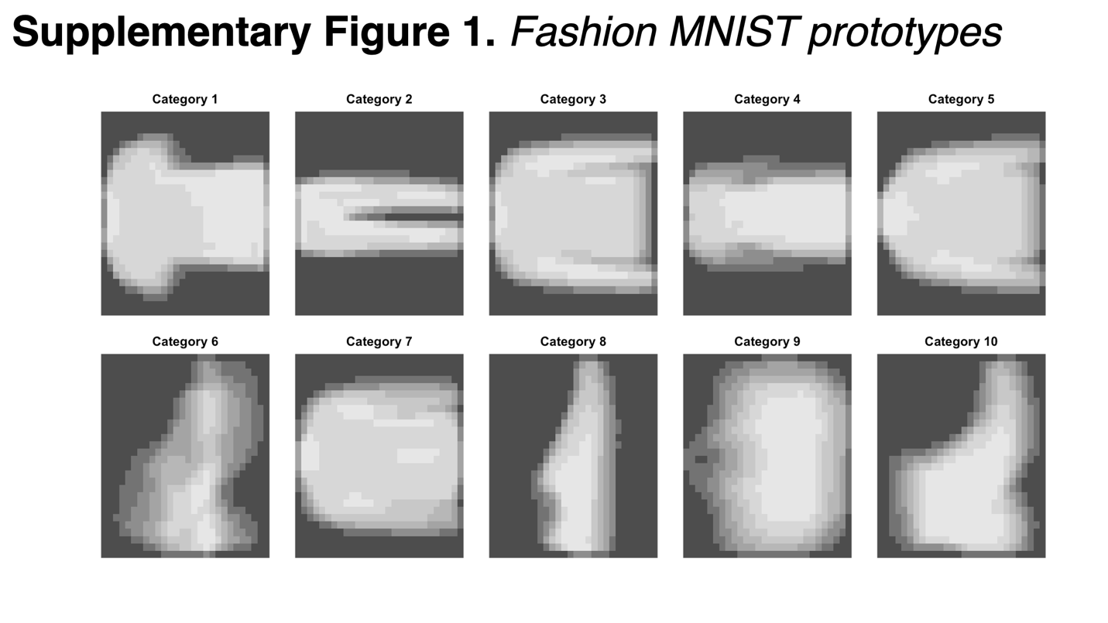
Supplementary Figure 1. Fasion MNIST prototypes. Each image is the average pixel value across exemplars belonging to the corresponding category.

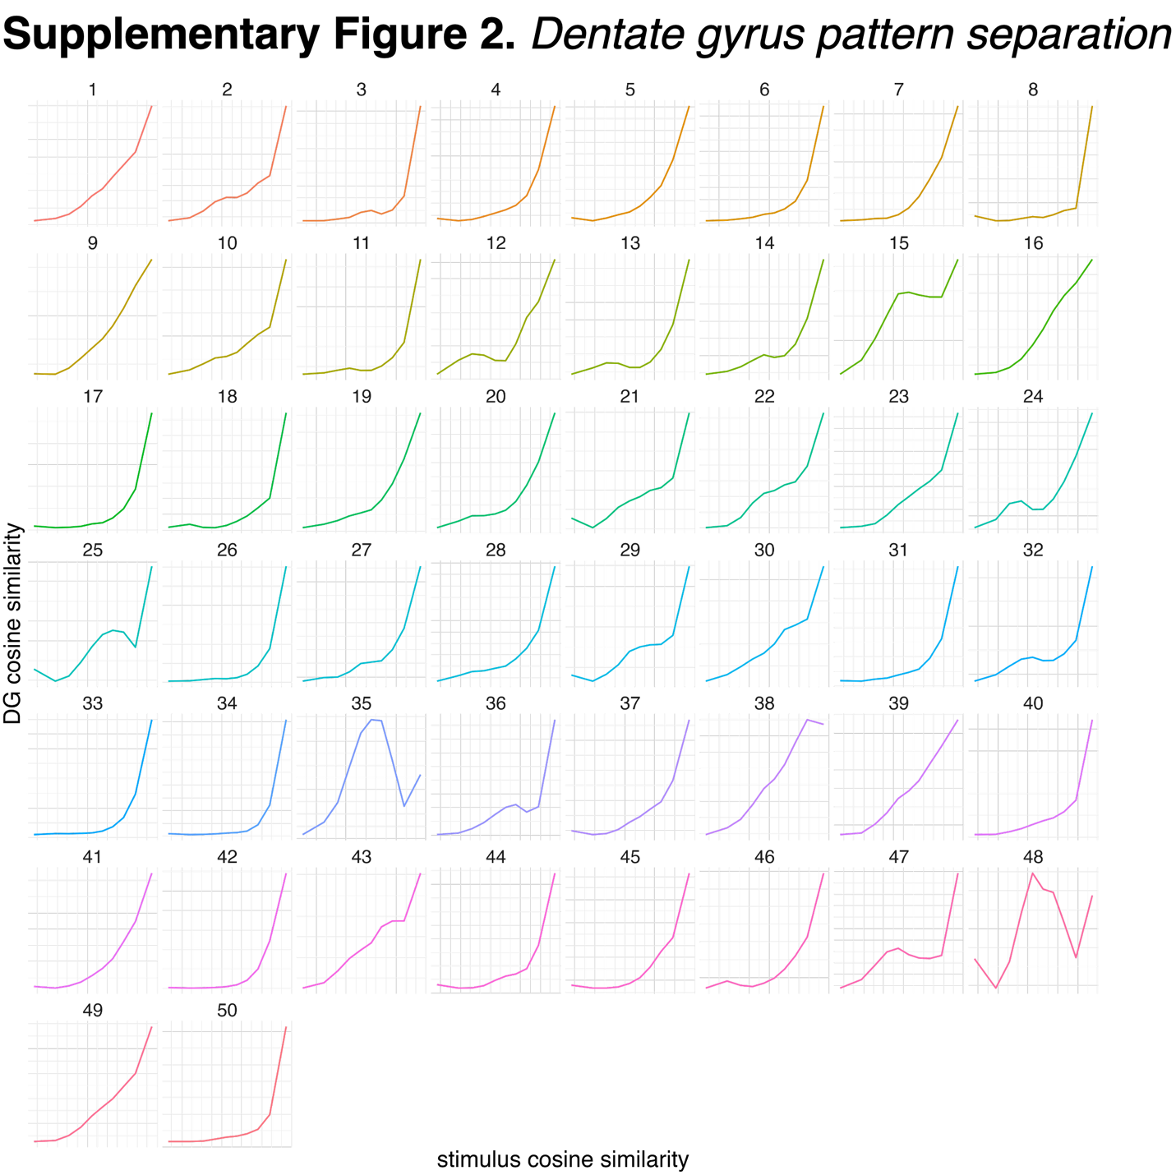
Supplementary Figure 2. Dentate gyrus pattern separation. The x-axis denotes stimulus-to-stimulus cosine similarities, binned into 10% quantiles, such that, moving from left to right, pairwise stimulus similarity increases. The y-axis denotes pattern similarity for dentate gyrus activity underlying stimulus presentation. Each panel denotes a different run, seeded with a different initialization. A positive diagonal would indicate equal pairwise similarities between stimulus pairs and dentate gyrus pattern pairs. As can be seen, dentate gyrus patterns exhibit robust pattern separation, where the slope is below the diagonal for nearly every single run (runs 35 and 48 exhibit nonmonotonic inverse U-shaped curves), indicating that pairwise dentate gyrus similarities are less than their corresponding pairwise stimulus similarities. Additionally, it can be seen that, for many runs, the curve does not increase until the pairwise similarity between stimuli is extremely high. Before this increase, many curves are nearly flat indicating orthogonalization of stimulus representations.

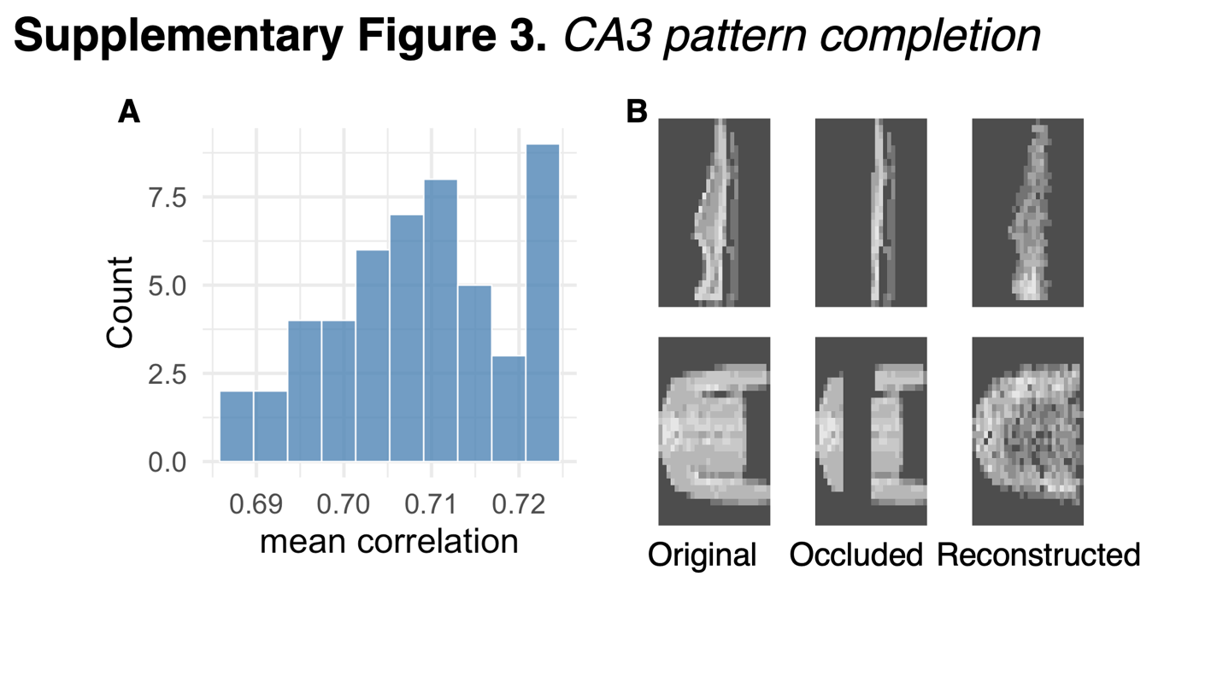
Supplementary Figure 3. CA3 pattern completion. (A) Average correlation across 500 randomly sampled stimuli following training, which get occluded and used as input for the model that then reconstructs the occluded input. Correlations are between the non-occluded input images and the reconstructed images. (A) displays the frequency of average correlations across 50 runs. (B) Two example images (left column) that get occluded (middle column) and then reconstructed by the CA3 layer (right column). Please note that the runs from (A) occluded centers of the images but additional simulations indicate that reconstruction precision is similar whether occlusion is at the top, bottom, center, or randomly sampled parts of the image.

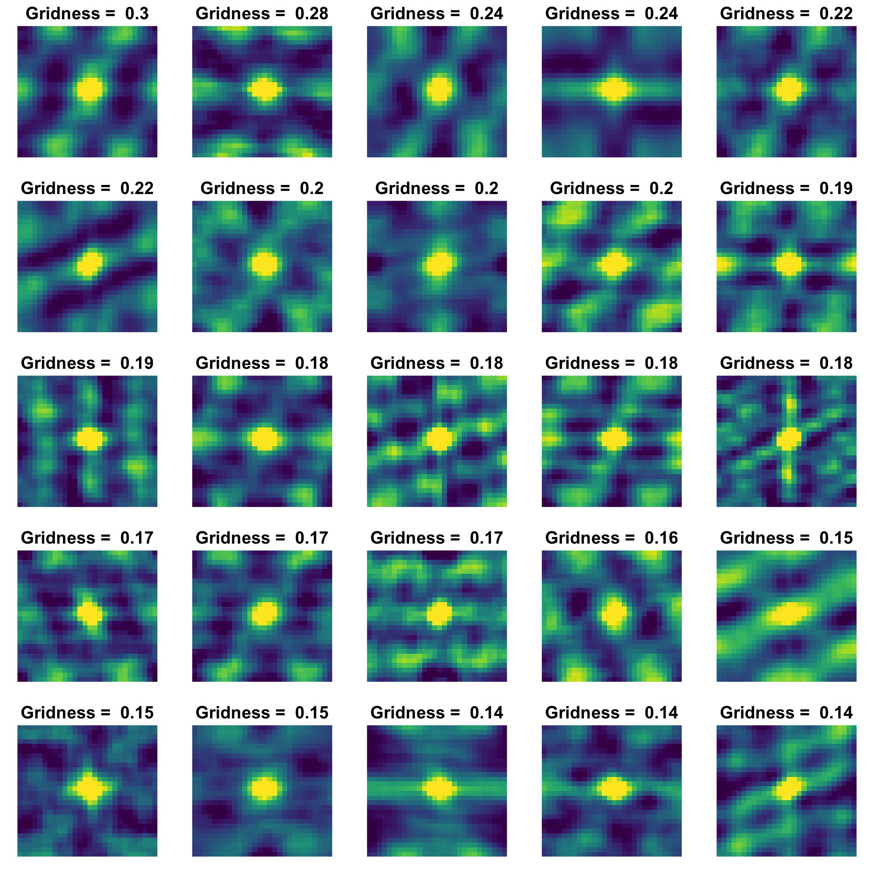
Supplementary Figure 4. Grid cell emergence with nondivergent model architecture. Without divergent decoders, preliminary simulations indicate that spontaneous grid cell emergence remains intact and gridness scores are similar to the scores observed with divergent decoders. This model also performed similarly at categorization (~89%).

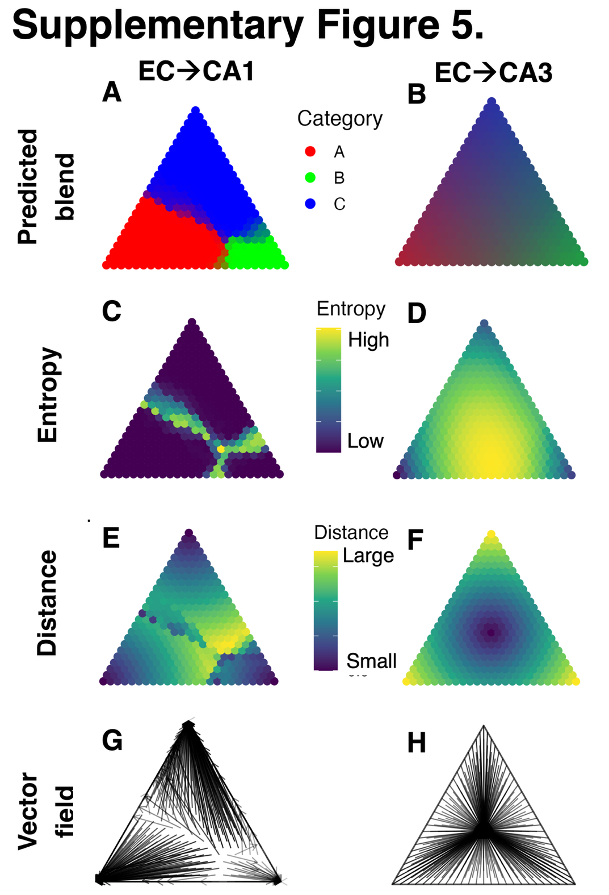
Supplementary Figure 5. Concept map metrics. (A) MSP predicted blends. (B) PP predicted blends. (C) MSP entropy of predictions from (A). (D) PP entropy of predictions from (B). (E) MSP Euclidean distance in 2-simplex space between predicted and actual blend levels. (F) PP Euclidean distance in 2-simplex space between predicted and actual blend levels. (G) Vectors denoting direction of error for MSP. (H) Vectors denoting direction of error for PP.

Predictor | Estimate | t value | p value
Intercept | 0.71 | 58.61 | < 0.001
# prototypes | -0.03 | -28.22 | < 0.001
PP vs MSP | -0.23 | -21.31 | < 0.001
# prototypes x PP vs MSP | 0.04 | 31.95 | < 0.001

Supplementary Table 2. Mixed linear regression model predicting average Spearman correlation between pathway-predicted category probabilities and prototype-predicted category probabilities from the number of prototypes/categories considered in the correlation, the pathway making the prediction (PP, MSP), and their interaction. Run number (1-10) was included as random effects.

Predictor | Estimate | t value | p value
Intercept | 0.71 | 50.42 | < 0.001
# prototypes | -0.03 | -26.39 | < 0.001

Supplementary Table 3. Mixed linear regression model predicting average Spearman correlation between MSP-predicted category probabilities and prototype-predicted category probabilities from the number of prototypes/categories considered in the correlation. Run number (1-10) was included as random effects.

Predictor | Estimate | t value | p value
Intercept | 0.49 | 47.07 | < 0.001
# prototypes | 0.02 | 20.75 | < 0.001

Supplementary Table 4. Mixed linear regression model predicting average Spearman correlation between PP-predicted category probabilities and prototype-predicted category probabilities from the number of prototypes/categories considered in the correlation. Run number (1-10) was included as random effects.

References
Kesner, R. P., & Rolls, E. T. (2015). A computational theory of hippocampal function, and tests of the theory: New developments. In Neuroscience and Biobehavioral Reviews (Vol. 48). https://doi.org/10.1016/j.neubiorev.2014.11.009
McClelland, J. L., McNaughton, B. L., & O’Reilly, R. C. (1995). Why there are complementary learning systems in the hippocampus and neocortex: Insights from the successes and failures of connectionist models of learning and memory. Psychological Review, 102(3). https://doi.org/10.1037/0033-295X.102.3.419
Rolls, E. T. (2013). The mechanisms for pattern completion and pattern separation in the hippocampus. In Frontiers in Systems Neuroscience (Vol. 7, Issue OCT). https://doi.org/10.3389/fnsys.2013.00074
Treves, A., & Rolls, E. T. (1992). Computational constraints suggest the need for two distinct input systems to the hippocampal CA3 network. Hippocampus, 2(2). https://doi.org/10.1002/hipo.450020209

