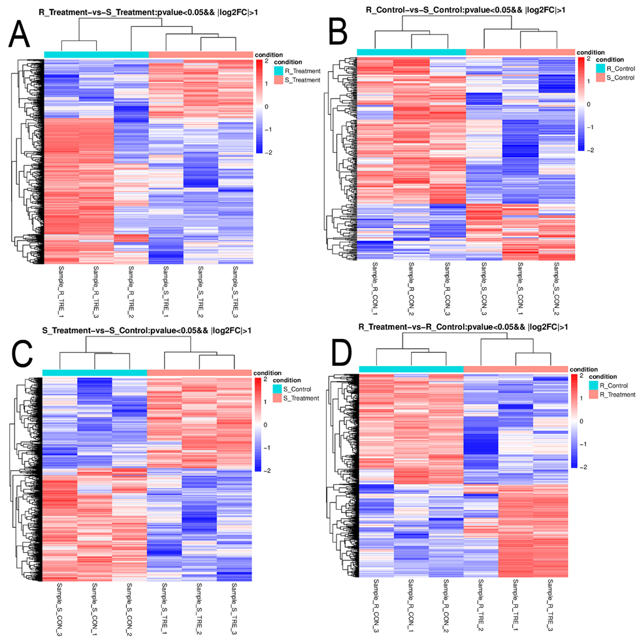

Supplementary Figure 1. The clustering analysis results of each group .Red in the figure indicates a highly expressed gene, and blue indicates a gene with a low expression protein.

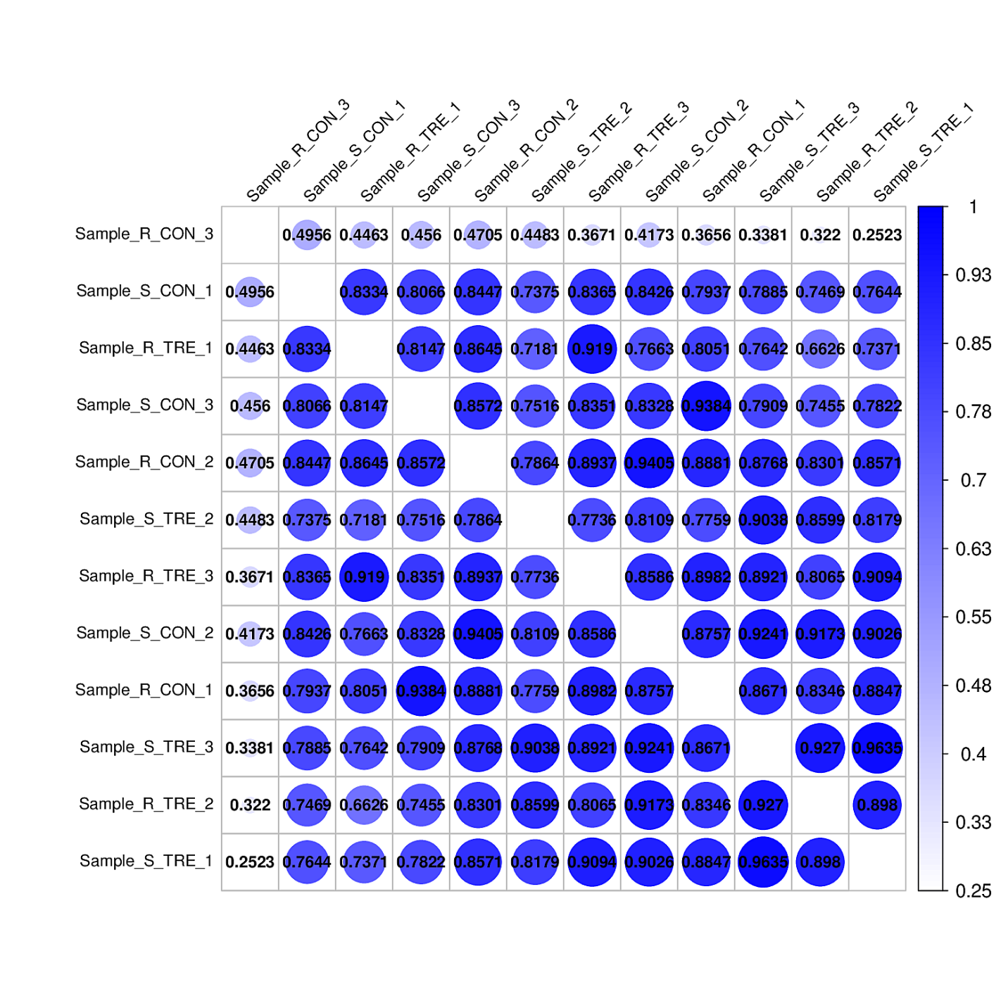

Supplementary Figure 2. Heat map of correlation coefficient between samples.

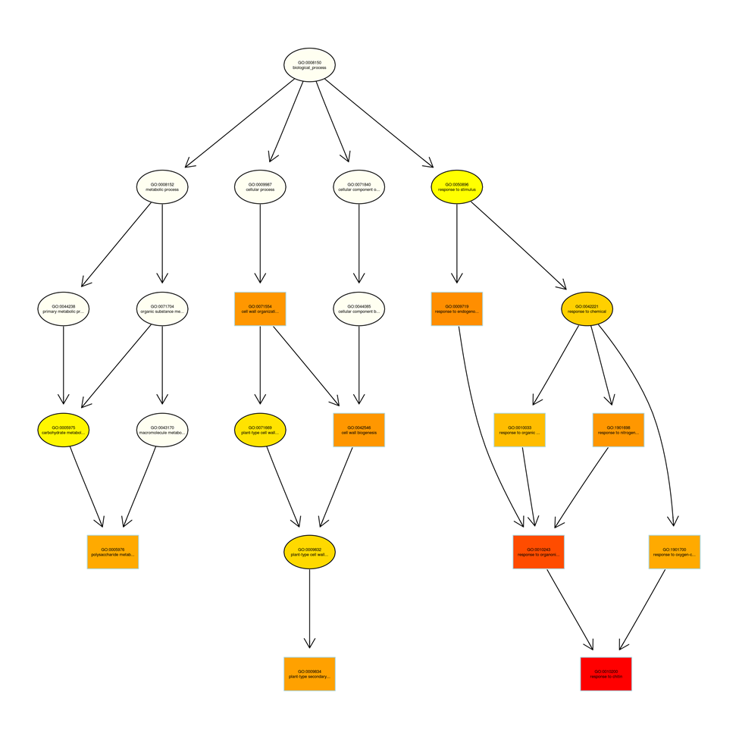

Supplementary Figure 3. Differential gene topGO directed acyclic graph in terms of BP in RT vs RC. The most significant nodes are represented by rectangles. The color of the rectangle represents the saliency of the enrichment, and the saliency from yellow to red is becoming more and more high. The basic information of each node is displayed in the corresponding graphic, which is GO ID and GO term.

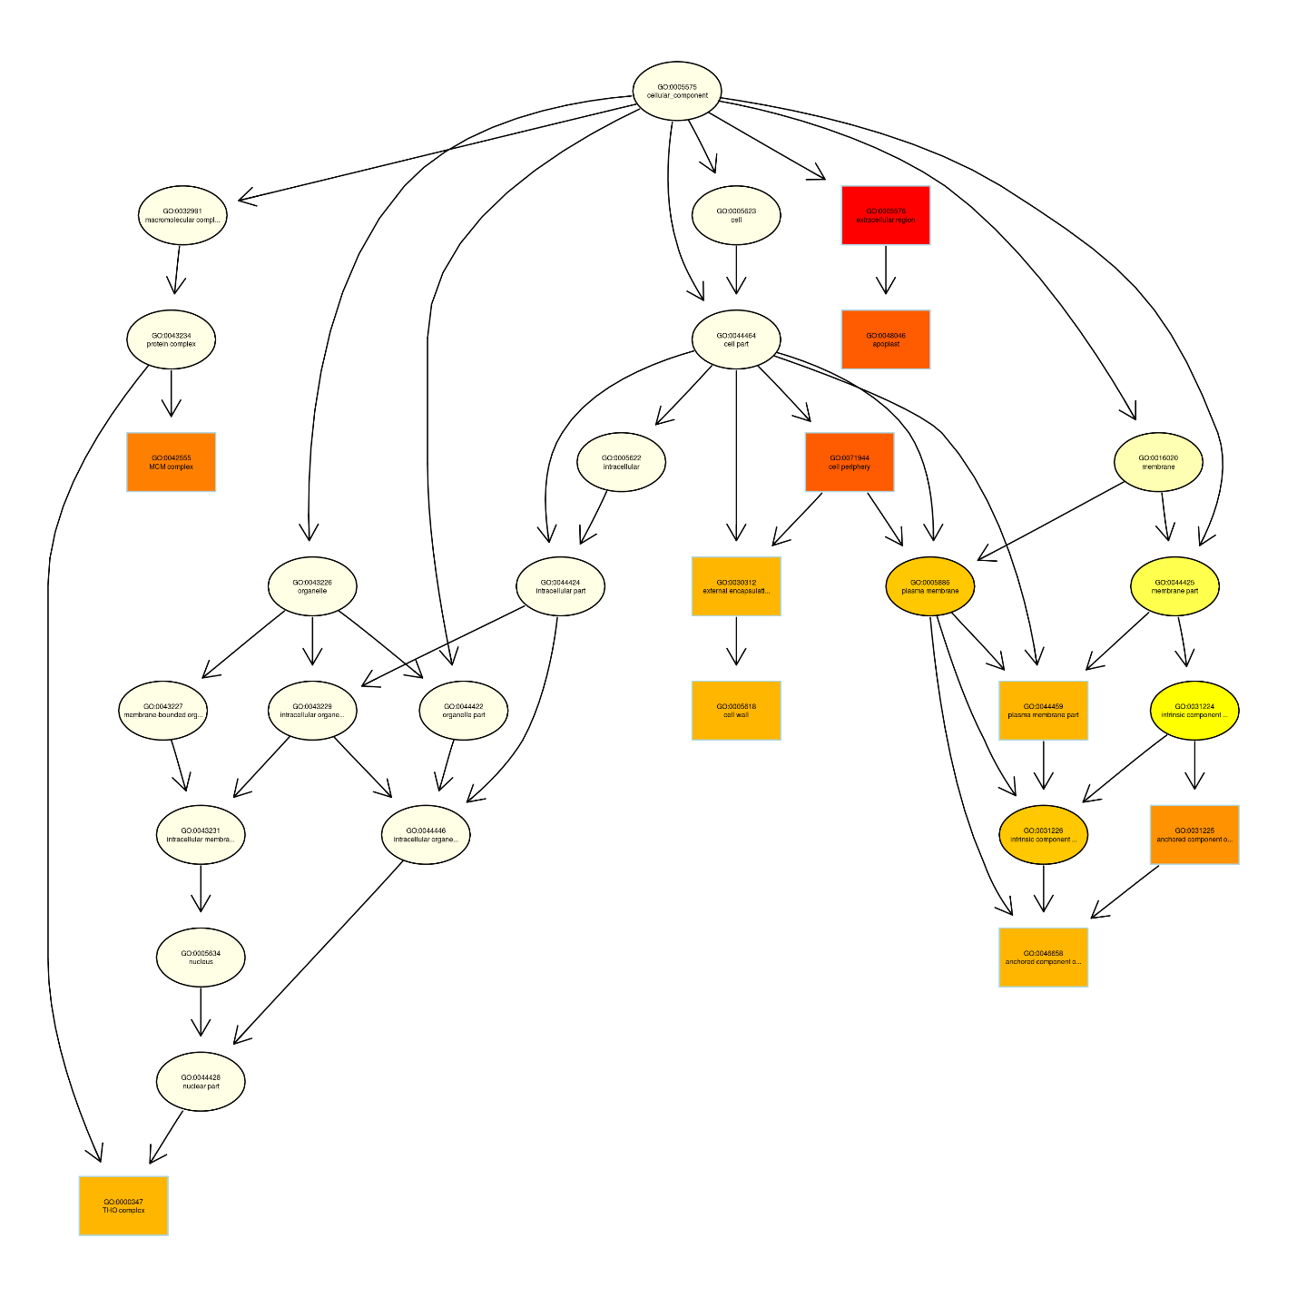
Supplementary Figure 4. Differential gene topGO directed acyclic graph in terms of CC in RT vs RC .The most significant nodes are represented by rectangles. The color of the rectangle represents the saliency of the enrichment, and the saliency from yellow to red is becoming more and more high. The basic information of each node is displayed in the corresponding graphic, which is GO ID and GO term.

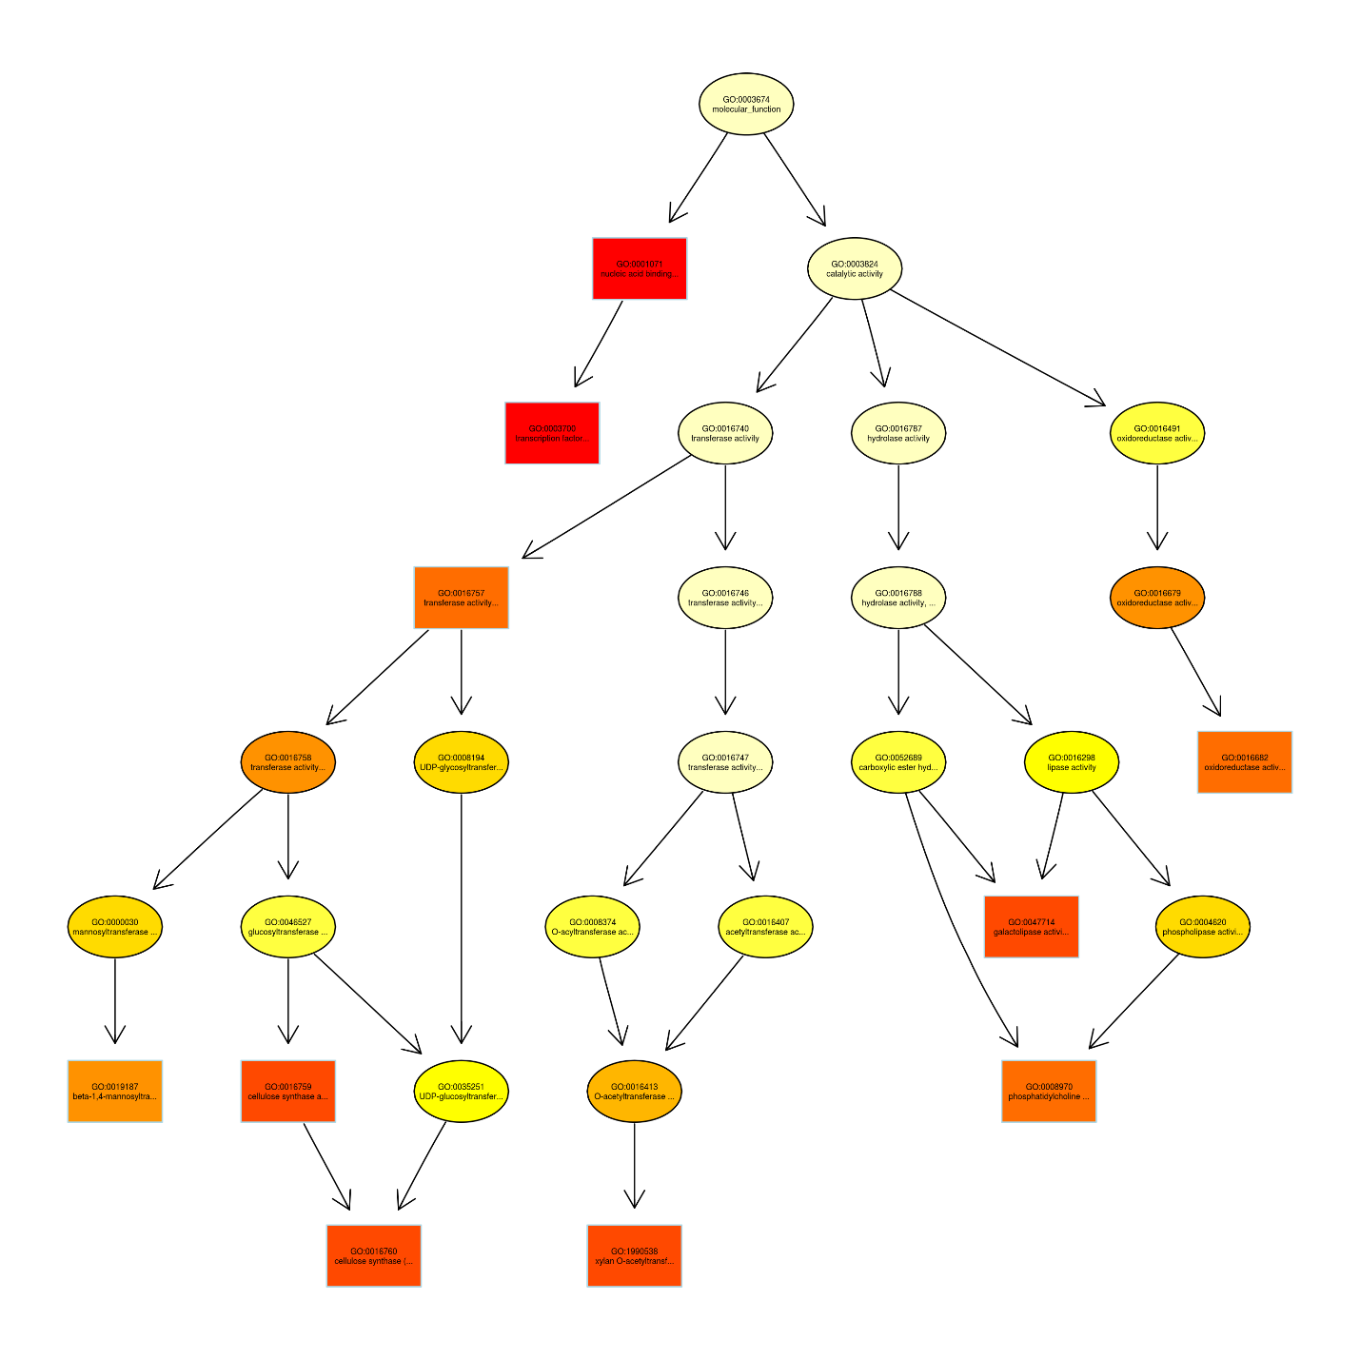
Supplementary Figure 5. Differential gene topGO directed acyclic graph in terms of MF in RT vs RC. The most significant nodes are represented by rectangles. The color of the rectangle represents the saliency of the enrichment, and the saliency from yellow to red is becoming more and more high. The basic information of each node is displayed in the corresponding graphic, which is GO ID and GO term.

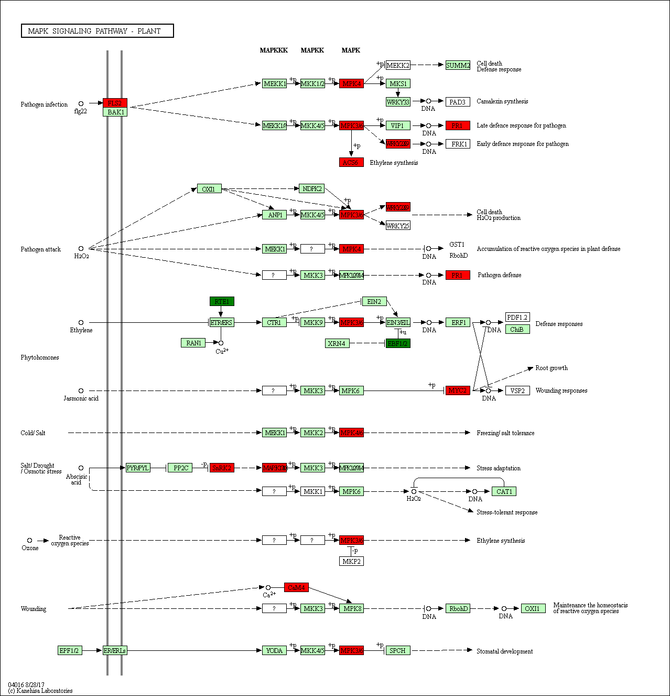

Supplementary Figure 6. KEGG map for MAPK signaling pathway. Red on the KEGG pathway map indicates up-regulated genes, green indicates down-regulated genes, and yellow indicates that the corresponding genes are both up-regulated and down-regulated.
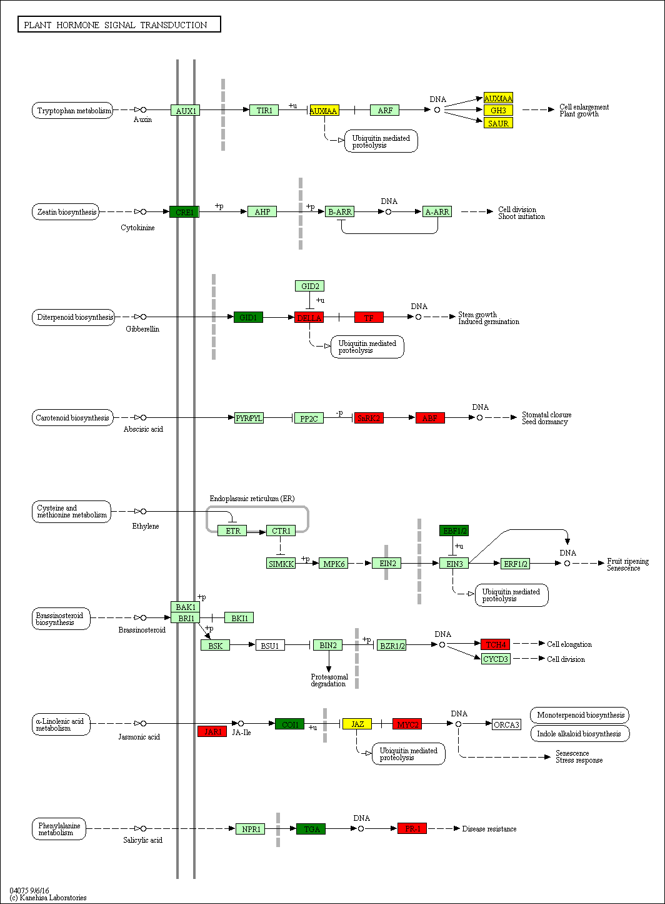
Supplementary figure 7. EGG map for plant hormone signal transduction pathway. Red on the KEGG pathway map indicates up-regulated genes, green indicates down-regulated genes, and yellow indicates that the corresponding genes are both up-regulated and down-regulated. auxin-responsive protein IAA, two-component response regulator ARR-A family, ethylene-responsive transcription factor 1, xyloglucosyl transferase TCH4, jasmonate ZIM domain-containing protein and transcription factor MYC2 were found up regulated.

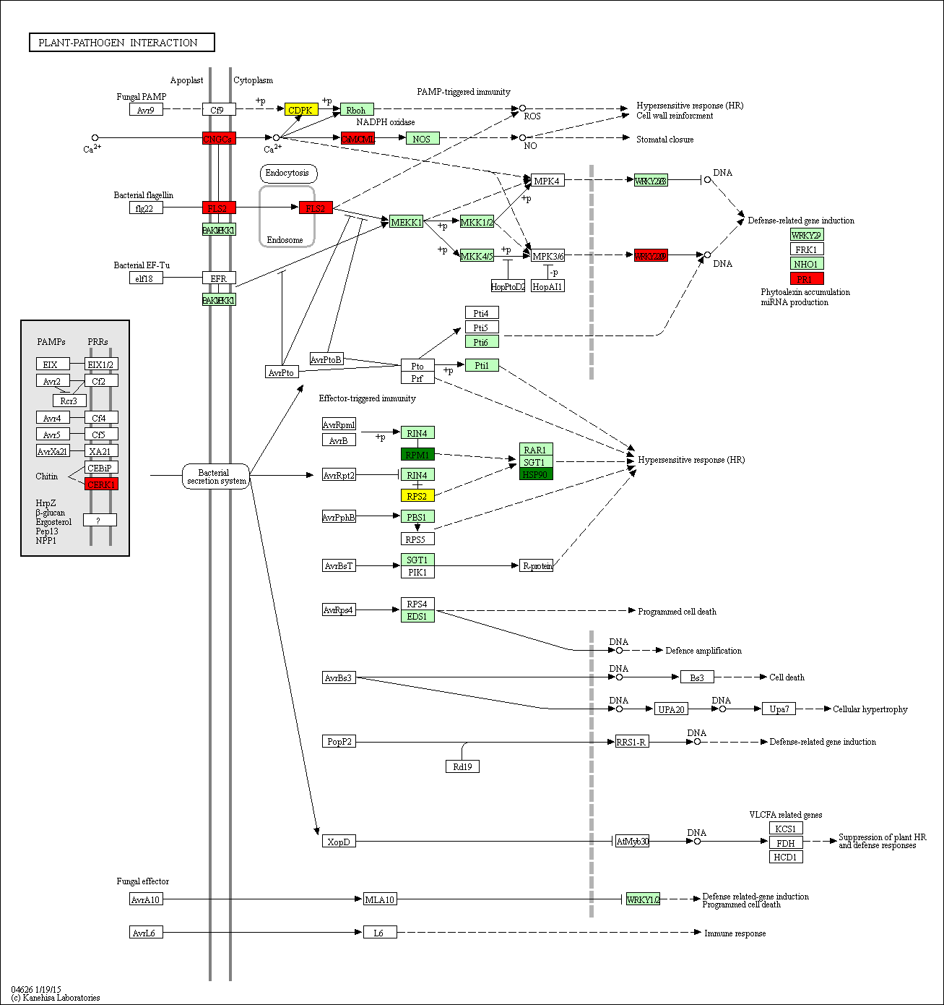

Supplementary Figure 8. KEGG map for plant pathogen interaction. Red on the KEGG pathway map indicates up-regulated genes, green indicates down-regulated genes, and yellow indicates that the corresponding genes are both up-regulated and down-regulated. CDPKs , WRKY33, RPM1-interacting protein 4, putative disease resistance protein At1g50180, disease resistance protein RPS2 were found to be up regulated.

Supplementary Table 3 showing gene id, names, p-value and fold changes in all four datasets

Gene_id | pval | Fold change (log2fc )in RMSM | RT RC  RT ST |  | ST SC | Description | Pathway
107947061 | 0.01 |  | 20.0 | 13.8 |  | 1-aminocyclopropane-1-carboxylate synthase-like | path:ghi00270,path:ghi04016
107949019 | 0.03 |  | 16.3 | 13.7 |  | 1-aminocyclopropane-1-carboxylate synthase-like | path:ghi00270,path:ghi04016
107913823 | 0.01 |  | 0.272 |  | 0.29 | 4-coumarate--CoA ligase 1-like | path:ghi00130,path:ghi00360,path:ghi00940
107897473 | 0.009 |  | 0.223 |  | 0.28 | 4-coumarate--CoA ligase 1-like | path:ghi00130,path:ghi00360,path:ghi00940
107958280 | 0.01 |  | 3.203 |  | 2.2 | 5'-adenylylsulfate reductase 2, chloroplastic-like | path:ghi00920
107912050 | 0.02 |  | 3.96 | 189 | 0.04 | 60S ribosomal protein L15-like | path:ghi03010
107897348 | 0.01 |  | 3.18 |  |  | ABC transporter G family member 35-like
107916837 | 0.00 |  | 5.02 |  |  | ABC transporter G family member 9-like
107900693 | 0.023 |  | 24.5 | 3.20 |  | abscisic acid 8'-hydroxylase 1-like | path:ghi00906
107929452 | 0.04 |  | 9.68 | 2.8 |  | abscisic acid 8'-hydroxylase 1-like | path:ghi00906
107904934 | 0.04 |  | 4.81 | 5.9 |  | allene oxide synthase, chloroplastic-like | path:ghi00592
107910948 | 0.004 |  | 5.11 |  |  | antifungal protein ginkbilobin-2-like
107951046 | 0.014 |  | 12.04 | 50.4 |  | auxin-induced protein 22D-like | path:ghi04075
107941745 | 0.031235 |  | 8.190 | 140 |  | auxin-responsive protein SAUR36-like | path:ghi04075
107950667 | 0.024 | 3.7 | 0.22 |  |  | beta-galactosidase 1-like
107913033 | 0.008 | 5.4 | 0.256 |  |  | beta-galactosidase 3-like
107909431 | 0.025 | 2.8 | 0.170 |  |  | beta-galactosidase 3-like
107909994 | 0.013 |  | 3.196 |  |  | bZIP transcription factor 53-like
107891421 | 0.022 |  | 0.309 |  |  | caffeic acid 3-O-methyltransferase 1-like | path:ghi00940
107947186 | 0.001 |  | 0.164 |  | 0.29 | caffeic acid 3-O-methyltransferase-like | path:ghi00940
107953912 | 0.020 |  | 9.535 | 7.77 |  | calcium-binding protein CML24-like | path:ghi04626
107951788 | 0.025 |  | 7.47 | 5.8 |  | calcium-binding protein PBP1-like
107908981 | 0.023 |  | 4.931 |  |  | calcium-dependent protein kinase 26-like | path:ghi04626
107936545 | 0.016 |  | 5.054 |  |  | calcium-dependent protein kinase 28-like | path:ghi04626
107898045 | 0.010 |  | 0.098 |  |  | callose synthase 7-like
107922616 | 0.010 |  | 6.19 | 3.9 |  | calmodulin-binding protein 25-like
107918457 | 0.027 |  | 7.128 | 5.6 |  | calmodulin-binding protein 60 B-like
107940246 | 0.015 |  | 3.424 |  |  | cellulose synthase-like protein D3
107959525 | 0.00 |  | 20.65 | 21.7 |  | chaperone protein dnaJ 20, chloroplastic-like
107902841 | 0.013 |  | 22.01 | 9.7 |  | chaperone protein dnaJ 49-like | path:ghi04141
107918520 | 0.024 |  | 3.88 |  |  | cysteine-rich and transmembrane domain-containing protein A-like
107935356 | 6.93 |  | 23.81 | 2.64 |  | cysteine-rich repeat secretory protein 38-like
107902469 | 0.001 |  | 6.35 |  | 4.1 | cytochrome P450 71A1-like | path:ghi00905
107931844 | 0.009 |  | 4.735911 | 3.1 |  | cytochrome P450 71A1-like
107905468 | 0.025 |  | 23.8 |  |  | cytokinin dehydrogenase 5-like | path:ghi00908
107904627 | 0.000 | 0 | 149.8 | 79.2 |  | dehydration-responsive element-binding protein 1D-like
107936392 | 0.002 |  | 46.41 | inf | 0 | dehydration-responsive element-binding protein 1E-like
107931998 | 0.015 |  | 3.733 | 15.6 |  | disease resistance protein RGA2-like
107923000 | 0.008 |  | 18.82 | 72.5 |  | ethylene-responsive transcription factor ERF027-like
107908908 | 0.040 |  | 8.043 | 34.1 |  | ethylene-responsive transcription factor ERF109-like
107920086 | 0.014 |  | 3.228 |  |  | ethylene-responsive transcription factor ERF119
107958202 | 0.016 |  | 0.194 |  |  | expansin-A11-like
107905537 | 0.001 |  | 0.050 |  |  | expansin-A11-like
107913063 | 0.005 |  | 3.917 |  |  | F-box protein At5g49610-like
107957772 | 0.048 |  | 3.636 |  |  | F-box protein FBW2-like
107887236 | 0.040 |  | 8.499 |  |  | F-box protein PP2-B13-like
107887492 | 0.037 |  | 5.875 | 5.2 |  | flavonoid 3',5'-hydroxylase-like
107902198 | 0.003 |  | 4.204 | 2.44 |  | flavonol sulfotransferase-like
107940712 | 0.004 |  | 0.246 |  |  | glucan endo-1,3-beta-glucosidase, basic isoform-like
107944179 | 0.039 |  | 0.338 |  |  | glucan endo-1,3-beta-glucosidase-like
107912779 | 0.011 |  | 0.295 | 3.34 | 0.23 | glucomannan 4-beta-mannosyltransferase 2-like
107961976 | 0.020 |  | 18.30 | 12.1 |  | glucose-6-phosphate/phosphate translocator 2, chloroplastic-like
107928749 | 0.033 |  | 2.767 |  | 2.32 | glycine-rich RNA-binding protein GRP1A-like
107959100 | 0.038 |  | 3.597 | 0.17 | 14.66 | heat shock cognate 70 kDa protein 2-like | path:ghi03040,path:ghi04141,path:ghi04144
107919928 | 0.043 |  | 0.347 | 0.08 | 5.7 | heat shock cognate protein 80-like | path:ghi04141,path:ghi04626
107914247 | 0.033 |  | 2.868 |  |  | hypersensitive-induced response protein 1-like
107913687 | 0.034 |  | 10.26 | 18.8 |  | inositol-3-phosphate synthase-like | path:ghi00562
107910306 | 0.023 |  | 4.499 |  | 6.06 | isoflavone 2'-hydroxylase-like
107945349 | 0.039 |  | 3.766 |  | 2.8 | isoflavone 3'-hydroxylase-like | path:ghi00943
107899042 | 0.021 |  | 0.088 |  |  | laccase-4-like
107959171 | 0.034 |  | 0.053 |  | 0.11 | laccase-4-like
107945088 | 0.009 |  | 19.66 | 50.07 |  | L-ascorbate oxidase homolog
107932294 | 0.013 |  | 15.83 | 148.6 |  | L-ascorbate oxidase homolog
107944676 | 0.045 |  | 3.811 |  |  | late embryogenesis abundant protein At1g64065-like
107916177 | 0.042 |  | 2.801 |  |  | late embryogenesis abundant protein Lea5-D
107912744 | 0.023 |  | 5.752 | 4.2 |  | LEAF RUST 10 DISEASE-RESISTANCE LOCUS RECEPTOR-LIKE PROTEIN KINASE-like 2.7
107891371 | 0.038 |  | 3.422 |  |  | leucine-rich repeat receptor-like tyrosine-protein kinase PXC3
107915240 | 0.005 |  | 21.00 | 9 |  | linoleate 13S-lipoxygenase 3-1, chloroplastic-like | path:ghi00591,path:ghi00592
107904213 | 0.011 |  | 12.41 | 6.4 |  | linoleate 13S-lipoxygenase 3-1, chloroplastic-like | path:ghi00591,path:ghi00592
107953199 | 0.010 | 0.03 | 12.85 |  |  | LRR receptor-like serine/threonine-protein kinase GSO1
107945304 | 0.017 |  | 9.166 | 11.1 |  | mitogen-activated protein kinase 8-like
107944011 | 0.032 |  | 3.238 |  |  | mitogen-activated protein kinase kinase kinase 3-like
107927033 | 0.009 |  | 4.254 |  |  | mitogen-activated protein kinase kinase kinase NPK1-like
107897904 | 0.000 |  | 94.95 |  |  | mitogen-activated protein kinase kinase kinase YODA-like
107892581 | 0.001 |  | 12.30 |  |  | mitogen-activated protein kinase kinase kinase YODA-like
107909573 | 0.039 |  | 44.94 |  |  | MLP-like protein 31
107961673 | 0.020 |  | 0.318 | 7.1 |  | MLP-like protein 423
107913620 | 0.013 |  | 5.469 |  |  | myb-like protein Q
107887014 | 0.004 |  | 24.27 | 8.7 |  | myb-related protein A-like
107898929 | 0.003 |  | 78.84 | 26.3 |  | myb-related protein Myb4-like
107930250 | 0.049 |  | 3.751 | 4.6 |  | NAC domain-containing protein 62-like
107935822 | 0.036 |  | 7.679 |  |  | NAC domain-containing protein 83-like
107894112 | 0.000 |  | 6.199 | 3.6 |  | NADH-ubiquinone oxidoreductase chain 5-like | path:ghi00190
107907485 | 0.025 |  | 2.923 | 3 |  | NADPH--cytochrome P450 reductase 2-like
107926776 | 0.005 |  | 10.12 | 7.11 |  | pathogenesis-related protein PR-4-like
107896971 | 0.004 |  | 4.12 | 5.3 |  | pectinesterase-like | path:ghi00040
107932995 | 0.032 |  | 28.86 |  |  | peroxidase 45-like | path:ghi00940
107927057 | 2.86 |  | 9.067 |  |  | peroxidase 4-like | path:ghi00940
107923041 | 0.046 |  | 8.824 |  |  | phospholipase A1-Ibeta2, chloroplastic-like
107912207 | 0.030327 |  | 6.676393 |  |  | phospholipase A1-Ibeta2, chloroplastic-like
107936609 | 0.011 |  | 8.371 |  |  | probable calcium-binding protein CML23 | path:ghi04626
107961056 | 0.004 |  | 23.05 |  |  | probable disease resistance protein At1g12280
107928900 | 0.028 |  | 2.767 |  |  | probable disease resistance protein At5g63020 | path:ghi04626
107927711 | 4.20 |  | 20.52 |  | 5.97E+01 | probable glutathione S-transferase | path:ghi00480
107918871 | 0.015 |  | 15.69 |  |  | probable glutathione S-transferase | path:ghi00480
107928106 | 0.011 |  | 3.552 |  |  | probable LRR receptor-like serine/threonine-protein kinase At1g53430
107913242 | 0.00 |  | 88.31 | 26.4 |  | probable serine/threonine-protein kinase DDB_G0284251
107948975 | 0.007251 |  | 7.299611 |  |  | probable WRKY transcription factor 33 | path:ghi04016,path:ghi04626
107899596 | 0.01 |  | 7.25 |  |  | probable WRKY transcription factor 33 | path:ghi04016,path:ghi04626
107929964 | 0.027 |  | 17.6 | 14 |  | probable WRKY transcription factor 50
107953898 | 0.036 |  | 8.634 | 16 |  | probable WRKY transcription factor 50
107946476 | 0.025 |  | 3.08 |  |  | proline-rich receptor-like protein kinase PERK9
107938246 | 0.03 |  | 2.987 |  |  | proline-rich receptor-like protein kinase PERK9
107928615 | 0.045 |  | 3.30 |  |  | protein NDR1-like
107962565 | 0.000 |  | 82.0 |  |  | protein SRG1-like
107962563 | 0.035 |  | 8.27 |  |  | protein SRG1-like
107951092 | 0.017 |  | 9.78 | 6.2 |  | protein TIFY 10A-like | path:ghi04075
107907089 | 0.003 |  | 10.3 |  |  | protein TIFY 10B-like | path:ghi04075
107891180 | 0.027 |  | 5.77 |  |  | protein YLS9-like
107906200 | 0.04 |  | 3.67 |  |  | protein YLS9-like
107923955 | 0.04 |  | 4.55 |  |  | putative disease resistance protein At1g50180 | path:ghi04626
107929292 | 0.022 |  | 3.2 |  |  | putative disease resistance protein RGA3
107894328 | 0.041 |  | 3.1 |  |  | putative disease resistance protein RGA3
107910359 | 0.00 |  | 76.8 | 83.8 |  | putative wall-associated receptor kinase-like 16
107910353 | 0.031 |  | 7.4 | 7.6 |  | putative wall-associated receptor kinase-like 16
107938972 | 0.041 |  | 5.1 | 4.6 |  | receptor-like protein 12
107932019 | 0.01 |  | 16.4 | 8.3 |  | RING-H2 zinc finger protein RHA1a-like
107944088 | 0.020 |  | Inf |  |  | RNA-binding protein 38-like
107891984 | 0.017 |  | 3.1 | 2.7 |  | rust resistance kinase Lr10-like
107940019 | 0.010 |  | 11.0 |  |  | scarecrow-like protein 21
107917917 | 0.028 |  | 5.292 |  |  | scarecrow-like protein 21
107892240 | 0.027 | 4 | 0.245 | 2.8 | 0.35 | terpene synthase 10-like | path:ghi00902
107929715 | 0.017 |  | 11.18 |  |  | TMV resistance protein N-like
107934976 | 0.043 |  | 4.153 |  |  | TMV resistance protein N-like
107935247 | 0.006 |  | 23.60 |  |  | transcription factor bHLH18-like
107929084 | 6.27 |  | 389.1 | 5.57E+01 |  | transcription factor bHLH92-like
107926867 | 0.000 |  | 114.8 | 28.9 |  | transcription factor MYB108-like
107940677 | 0.003 |  | 29.45 | 28 |  | transcription factor MYB44-like
107933572 | 0.021 |  | 5.009 | 3.88 |  | transcription factor MYC2-like | path:ghi04016,path:ghi04075
107961973 | 0.006 |  | 44.20 | 9 |  | tryptophan synthase beta chain 1-like | path:ghi00260,path:ghi00400
107911835 | 0.023 |  | 0.254 |  | 0.29 | UDP-glycosyltransferase 83A1-like
107901404 | 0.022 |  | 31.9 |  |  | WAT1-related protein At4g08300-like
107935490 | 0.011 |  | 9.475 |  |  | WAT1-related protein At5g07050-like
107960336 | 0.027 |  | 10.05 | Inf | 0 | xyloglucan endotransglucosylase/hydrolase protein 22-like | path:ghi04075
107892234 | 0.028 |  | 9.074 | 57 |  | xyloglucan endotransglucosylyase/hydrolase protein 22-like | path:ghi04075
107886817 | 0.017 |  | 3.071 |  |  | zinc finger protein CONSTANS-LIKE 3-like
107920914 | 0.005 |  | 15.92 | 2.7 |  | zinc finger protein ZAT10-like

