Appendix
SF graphs for four radionuclides: (A) Tc-99m, (B) F-18, (C) I-131, and (D) Lu-177. Error bars are two SDs.
A  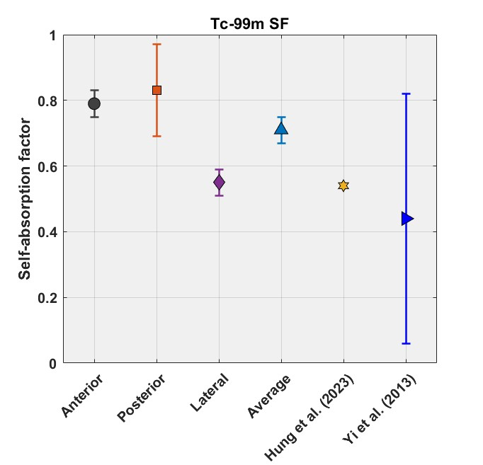 | B  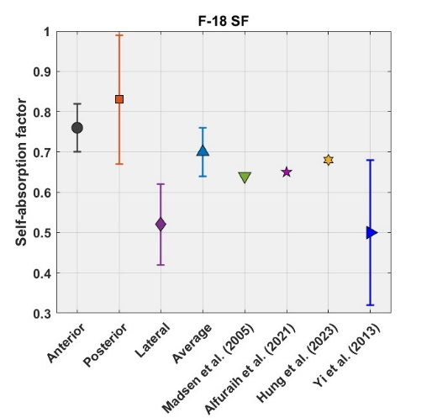
C  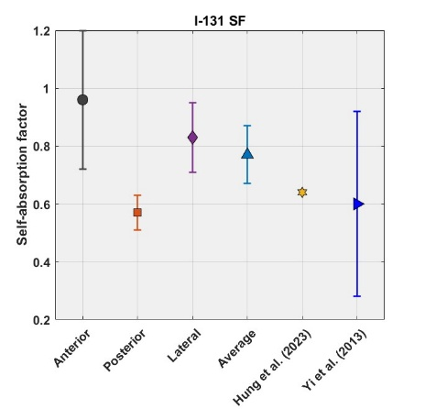 | D  