Supplementary Materials

Table 2.
Identifed mutations in the RS1 gene
Family |  |  | Phenotype(+/-) | Location | Exon/intron | Mutation | Amino acid | Type | Hemi/het | Novel  (+/-) | Mutatio-n taster | SIFT | PolyPh-en_2 | GERP+ | REVEL | ACMG
F1 | Proband | III-3 | + | chrX:1866  5332 | NM_000330;  Exon4 | c.305G>A | p.R102Q | Missense | Hemi | - | D | D | D | D | D | P
F1 | Others | II-4 | - |  |  |  |  |  | Het
F2 | Proband | II-2 | + | chrX:1866  5332 | NM_000330;  Exon4 | c.305G>A | p.R102Q | Missense | Hemi | - | D | D | D | D | D | P
F2 | Others | III-1 | - |  |  |  |  |  | Het
F3 | Proband | III-2 | + | chrX18665332 | NM_000330;  Exon4 | c.305G>A | p.R102Q | Missense | Hemi | - | / | D | D | / | D | LP
F3 | Others | II-3 | - |  |  |  |  |  | Het
F4 | Proband | III-1 | + | chrX:18662723G＞A | NM_000330.3;Exon5 | c.349C>T | p.Gln117* | Nonsense | Hemi | - | D | / | / | / | / | LP
F4 | Others | II-2 | - |  |  |  |  |  | Het
F4 | Others | III-2 | - |  |  |  |  |  | Het
F5 | Proband | III-1 | + | chrX:18662583-18662583 | NM_000330.4;Exon5 | c.489del | p.Trp163Ter | Nonsense | Hemi | - | / | / | / | / | / | P
F5 | Others | II-2 | - |  |  |  |  |  | Het
F6 | Proband | III-1 | + | chrX:18660109 | NM_000330.4;Exon6 | c.608C>A | p.Pro203Gln | Missense | Hemi | - | D | D | D | D | D | P
F6 | Others | II-4 | - |  |  |  |  |  | Het
F7 | Proband | III-2 | + | chrX:18660131-18660131 | NM_000330.4;Exon6 | c.668G>A | p.C223Y | Missense | Hemi | - | D | D | / | / | D | U
F7 | Others | II-2 | - |  |  |  |  |  | Het
F8 | Proband | III-1 | + | chrX:18660162 | NM_000330;Exon6 | c.637C>T | p.R213W | Missense | Hemi | - | D | D | D | D | D | P
F8 | Others | II-3 | - |  |  |  |  |  | Het
F9 | Proband | II-1 | + | chrX:18662649-18662653 | NM_000330.4;Exon5 | c.419_423delinsA | p.G140Dfs*8 | Frameshift | Hemi | + | / | / | / | / | / | LP
Mutation taster , SIFT, PolyPhen_2, GERP+,REVEL：D: Disease causing; LD:Likely disease causing; U:Uncertain; LB:Likely benign; B:Benign.According to the American College of Medical Genetics and Genomics (ACMG) guidelines for the classification of genetic variants, variants are categorized into the following five types: P: Pathogenic, LP: Likely pathogenic, B: Benign, LB: Likely benign,VUS: Uncertain significance.

Fig.5 Fundus changes after treatment of F2-II-2.
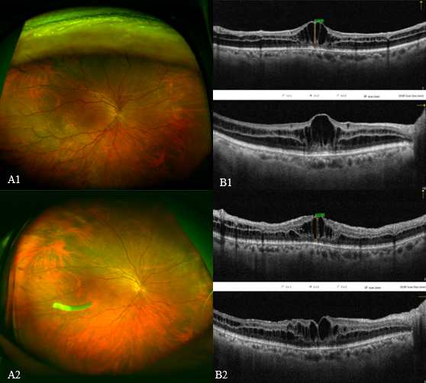
UWFFI (A1) and OCT (B1) of the patient before treatment, UWFFI (A2) and OCT (B2) after vitreous injection of Ozurdex.

