Table 4 Proposed structure of CTC degradation products in the system.
Substance | m/z [M-H]+ | Molecular formula | Proposed structure
CTC | 515.35 | C₂₂H₂₃ClN₂O₈·HCl | 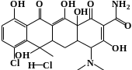
U1 | 462.89 | C₂₂H₂₃ClN₂O₇ | 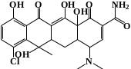
W1 | 443.00 | C₂₂H₂₃ClN₂O₆ | 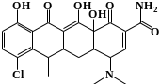
V1 | 444.15 | C₂₂H₂₄N₂O₇ | 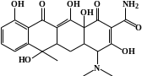
V2 | 362.41 | C₁₉H₂₀O₇ | 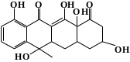
W2* | 338.78 | C₁₇H₁₉ClO₅ | 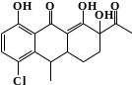
V3 | 318.35 | C₁₇H₁₆O₆ | 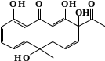
W3* | 297.75 | C₁₅H₁₈ClO₄ | 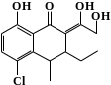
V4 | 274.39 | C₁₅H₁₄O₅ | 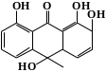
W4 | 244.67 | C₁₁H₁₃ClO₄ | 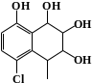
W5 | 244.63 | C₁₀H₉ClO₅ | 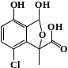
V5 | 246.31 | C₁₅H₁₈O₃ | 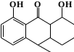
V6 | 218.33 | C₁₂H₁₄O₃ | 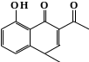
W6* | 173.85 | C₈H₁₀ClO₂ | 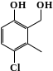
V7 | 150.65 | C₉H₁₀O₂ | 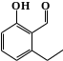
V8* | 94.11 | C₆H₆O | 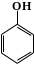
V9* | 88.15 | C₅H₁₂O | 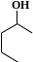
W7* | 58.07 | C₃H₆O

