Data-driven lithium-ion battery capacity estimation from voltage relaxation

Jiangong Zhu ^{a, b}, Yuan Huang ^{a,b}, Michael Knapp ^{b *}, Xinhua Liu ^{c}, Yixiu Wang ^{a, d}, R. Bhushan Gopaluni ^{d}, Yankai Cao ^{d}, Michael Heere ^{b,e}, Martin J. Mühlbauer ^{b}, Liuda Mereacre ^{b} , Haifeng Dai ^{a *}, Anatoliy Senyshyn ^{e}, Xuezhe Wei ª, Helmut Ehrenberg ^{b}

ª Clean Energy Automotive Engineering Center, School of Automotive Engineering, Tongji University, 201804 Shanghai, China
^{b} Institute for Applied Materials (IAM), Karlsruhe Institute of Technology (KIT), 76344 Eggenstein-Leopoldshafen, Germany
^{c} School of Transportation Science and Engineering, 100083, Beihang University, Beijing, China
^{d} Department of Chemical and Biological Engineering, University of British Columbia, BC V6T 1Z3, Canada
^{e} Heinz Maier-Leibnitz Zentrum (MLZ), Technische Universität München, Lichtenbergstr. 1, 85748 Garching b. München, Germany

Table S1 Specifications of NCA and NCM energy
Sample name | NCA battery | NCM battery
Battery type | 18650
Anode material | Graphite/Si
Cathode material | Li_{0.86}Ni_{0.86}Co_{0.11}Al_{0.03}O₂ (NCA) | Li_{0.84}(Ni_{0.83}Co_{0.11}Mn_{0.07})O₂ (NCM)
Electrolyte | Solution of lithium hexafluorophosphate (LiPF₆)
Nominal voltage | 3.6 V
Cutoff voltage | 2.65 V - 4.2 V | 2.5 V - 4.2 V
Nominal capacity | 3.5 Ah
Battery mass | 45.0 g

Table S2 Statistical features extracted from one voltage relaxation curve, $x_{i}$ is the battery terminal voltage, $i=1,…,n,$ n is the number of samples in one relaxation curve
Maxima (MAX) | $$x_{max}=\max\left\{x_{i}\right\}$$
Mean (MEAN) | $$\overline{x}=\frac{1}{n}\sum_{i=1}^{n}{x_{i}}$$
Minima (MIN) | $$x_{min}=\min\left\{x_{i}\right\}$$
Variance (VAR) | $$μ_{2}=\frac{1}{n}\sum_{i=1}^{n}{{\left(x_{i}-\overline{x}\right)}^{2}}$$
Skewness (SKE) | $$μ_{3}=\frac{1}{n}\sum_{i=1}^{n}{{\left(\frac{x-\overline{x}}{\sqrt{μ_{2}}}\right)}^{3}}$$
Excess Kurtosis (KUR) | $$μ_{4}=\frac{1}{n}\sum_{i=1}^{n}{{\left(\frac{x-\overline{x}}{\sqrt{μ_{2}}}\right)}^{4}-3}$$

Table S3 Hyperparameters in ElasticNet, XGBoost, Support Vector Regression (SVR), and Deep Neural Network (DNN)

ElasticNet |  | XGBoost |  | SVR |  | DNN
alphas | {0.001+(20-0.001)/19*i|i=0..19} | learning_rate | 0.8 | kernels | [‘poly’, ‘rbf’, ‘linear’] | Layer type | Number of neurons | Activation function
l1_ratio | {0.001+(20-0.001)/19*i|i=0..19} | N_estimators | 6 | epsilons | [0.01, 0.1, 1, 5, 10, 20] | Dense | 32 | ‘sigmoid’
cv | 5 | Max_depth | 6 | Cs | [0.01, 0.1, 1, 5, 10, 20] | Dropout | 0.1
 |  | Objective | reg:squarederror | gammas | [‘scale’, ‘auto’] | Dense | 32 | ‘sigmoid’
 |  | Lambda | 1 | cv | 5 | Dropout | 0.1
 |  | alpha | 0 |  |  | Dense | 16 | ‘sigmoid’
 |  | subsample | 1 |  |  | Dropout | 0.1
 |  |  |  |  |  | Dense | 16 | ‘sigmoid’
 |  |  |  |  |  | Dropout | 0.1
 |  |  |  |  |  | Dense | 8 | ‘sigmoid’
 |  |  |  |  |  | Dropout | 0.1
 |  |  |  |  |  | Dense | 1 | ‘softplus’

Table S4 Correlation matrix between extracted features
 | VAR | SKE | MAX | MIN | MEAN | KUR
VAR | 1 | -0.456 | -0.503 | -0.812 | -0.714 | -0.290
SKE | -0.456 | 1 | 0.217 | 0.355 | 0.237 | 0.957
MAX | -0.504 | 0.217 | 1 | 0.902 | 0.950 | 0.206
MIN | -0.813 | 0.355 | 0.902 | 1 | 0.985 | 0.268
MEAN | -0.714 | 0.238 | 0.950 | 0.985 | 1 | 0.177
KUR | -0.290 | 0.957 | 0.206 | 0.268 | 0.177 | 1

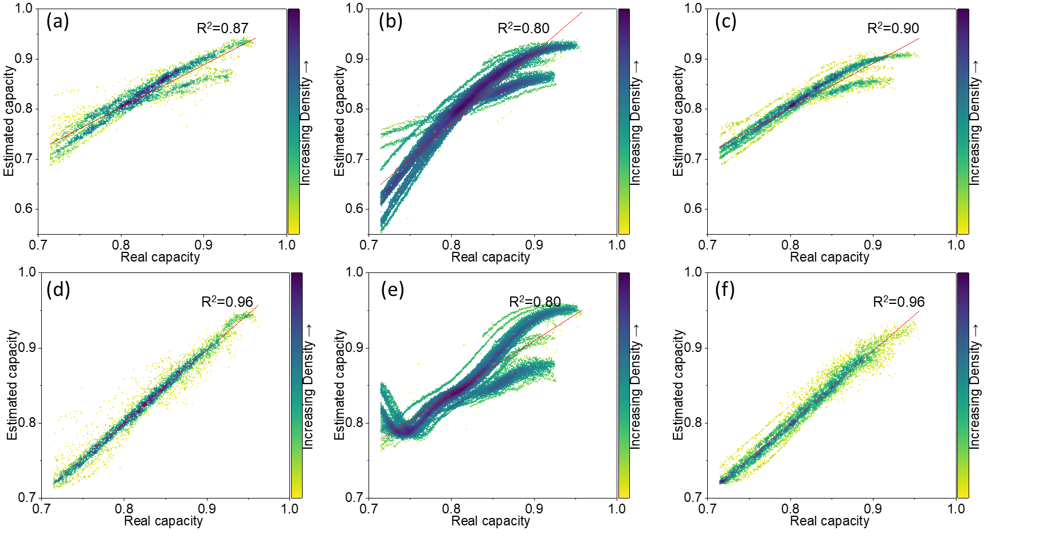
Fig.S1 Test results of estimated capacity versus real capacity for ElasticNet and SVR models. NCA_test (a), NCM_test1 (b), and NCM_test2 (c) of ElasticNet method. NCA_test (d), NCM_test1 (e), and NCM_test2 (f) of SVR method.

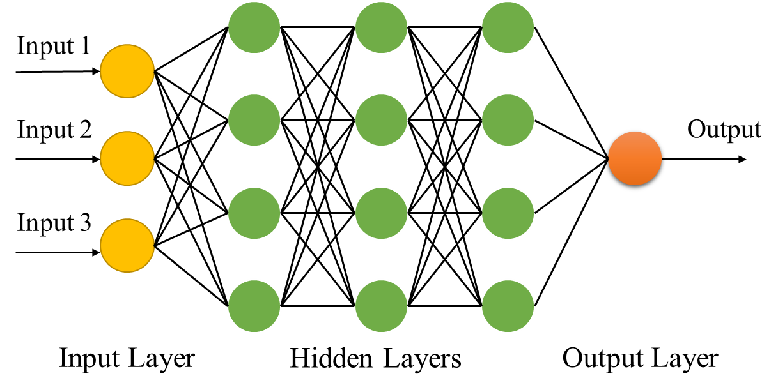
Fig.S2 DNN method structure

