Supplementary Figures:
Supplementary Figure-1:
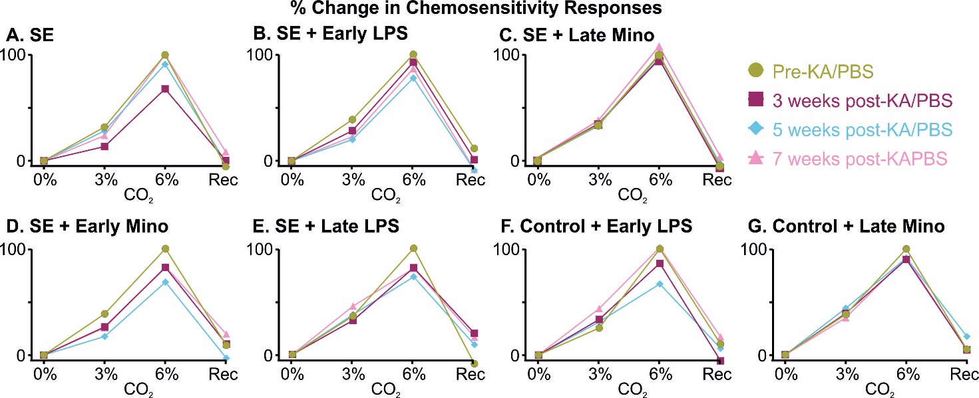
Supplementary Fig. 1: Percent change in chemosensitivity to HCVR challenge in different groups of mice. Change in chemosensitivity in response to 3 and 6% CO₂ challenge before and after induction of epilepsy or PBS treatment across experimental groups: (A) SE, (B) SE + early LPS, (C) SE + late mino, (D) SE + early mino, (E) SE + late LPS, (F) Control + early LPS, (G) Control + late mino.
Supplementary Figure-2:
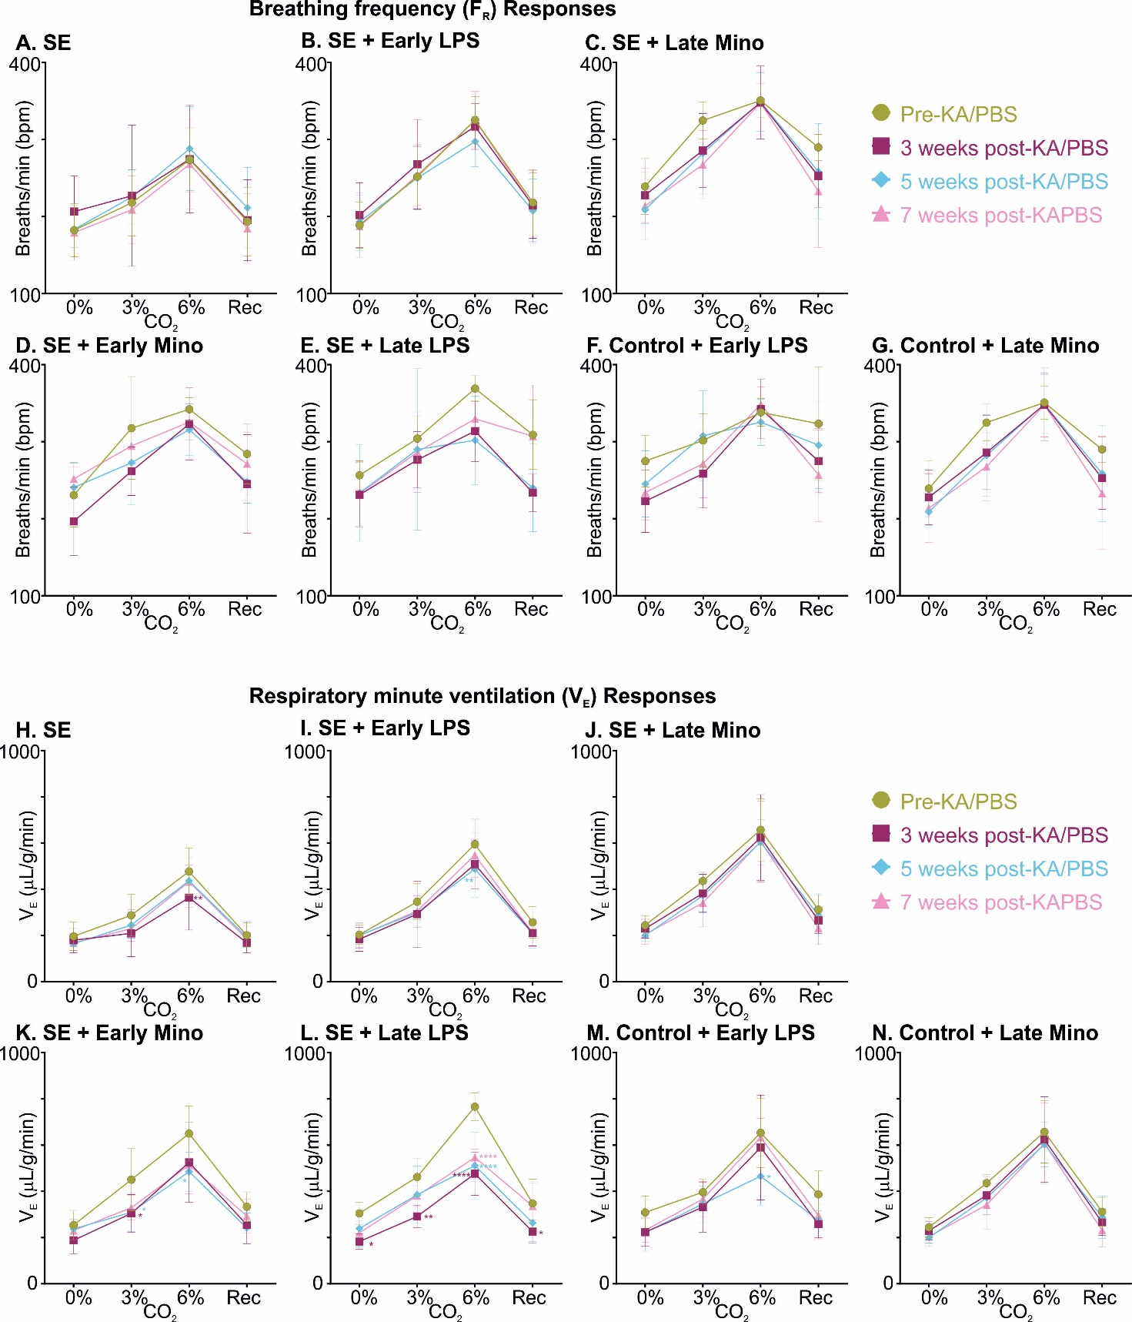
Supplementary Fig. 2: Change in breathing frequency (F_{R}) and minute ventilation (V_{E}) at 3 and 6% CO₂ challenge in different groups of mice and across multiple time points. (A-G) Change in F_{R} at defined time points across experimental groups: (A) SE (n = 11), (B) SE + early LPS (n = 12), (C) SE + late mino (n = 12), (D) SE + early mino (n = 6), (E) SE + late LPS (n = 6), (F) Control + early LPS (n = 5), (G) Control + late mino (n = 5). (H-N) Change in V_{E} at room air and in response to 3% and 6% CO₂ in different groups compared to their pre-SE or PBS response: (H) SE (n = 11), (I) SE + early LPS (n = 12), (J) SE + late mino (n = 12), (K) SE + early mino (n = 6), (L) SE + late LPS (n = 6), (M) Control + early LPS (n = 5), (N) Control + late mino (n = 5). P-values derived from two-way repeated measure (mixed effects) ANOVA with Tukey’s multiple comparisons are *p < 0.05, **p < 0.001, ***p < 0.001, and ****p < 0.0001.

FUNCTIONAL READOUTS | TREATMENT GROUPS
FUNCTIONAL READOUTS | Control | SE | SE + Early LPS | SE + Late Mino | SE + Early Mino | SE + Late LPS | Control + Early LPS | Control + Late Mino
Breathing phenotype | ✘ | ✓ | ✘ | ✘ | ✓ | ✓ | ✓ | ✘
Reduced chemosensitivity at 6% CO₂ | ✘ | ✓ | ✓ | ✘ | ✓ | ✓ | ✓ | ✘
Reduction in seizure frequency |  | ✘ | ✓ | ✘ | ✘ | ✘
TREM2-IBA1 colocalisation | ↑ | compared to | — | — | — | —
P2Y12-IBA1 colocalisation | — | compared to | — | — | — | —
Microglia density | — | compared to | ↓ | ↓ | ↓ | —
Microglia process lengths | — | compared to | ↓ | ↓ | ↓ | —
C1q expression | — | compared to | — | ↓ | ↓ | ↓
GFAP-A2A colocalisation | — | compared to | ↓ | — | — | —
Summary Table-1: Summary of different treatments and their functional readouts.

