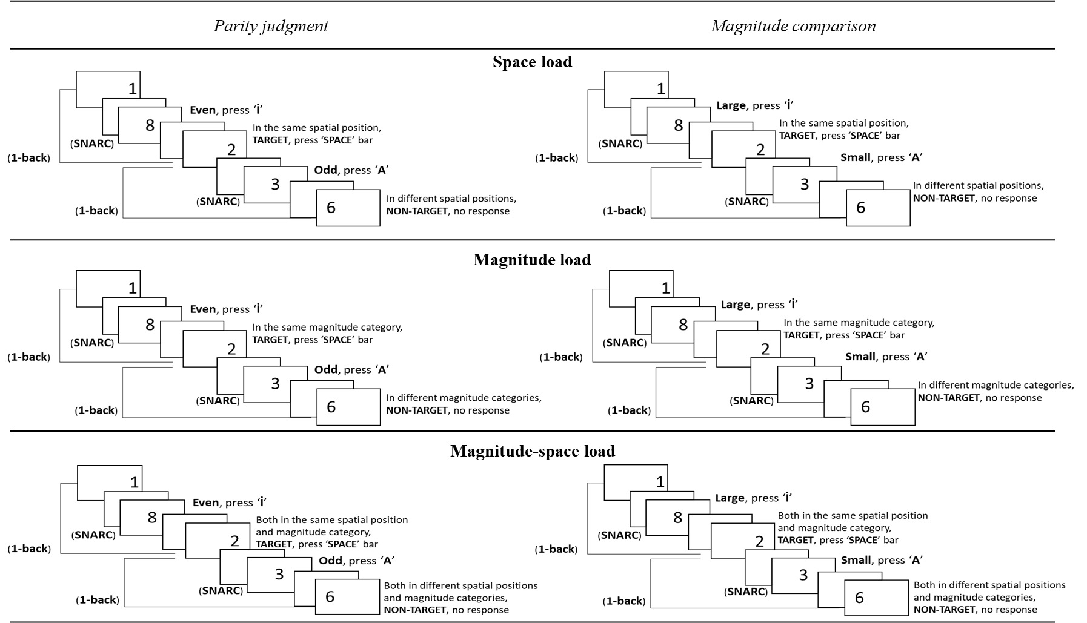
SOM Fig. 1 Experimental Flow for the MNL Incompatible Conditions
SOM Fig 2 Mean RTs as a Function of WM Load Type. Error Bars Represent 95% CIs, Adjusted for Repeated Measures

SOM Fig 3 Mean RTs as a Function of MNL Compatibility (Compatible, Incompatible), Magnitude (Small, Large), and Response-Side (Left, Right). Error Bars Represent 95% CIs, Adjusted for Repeated Measures
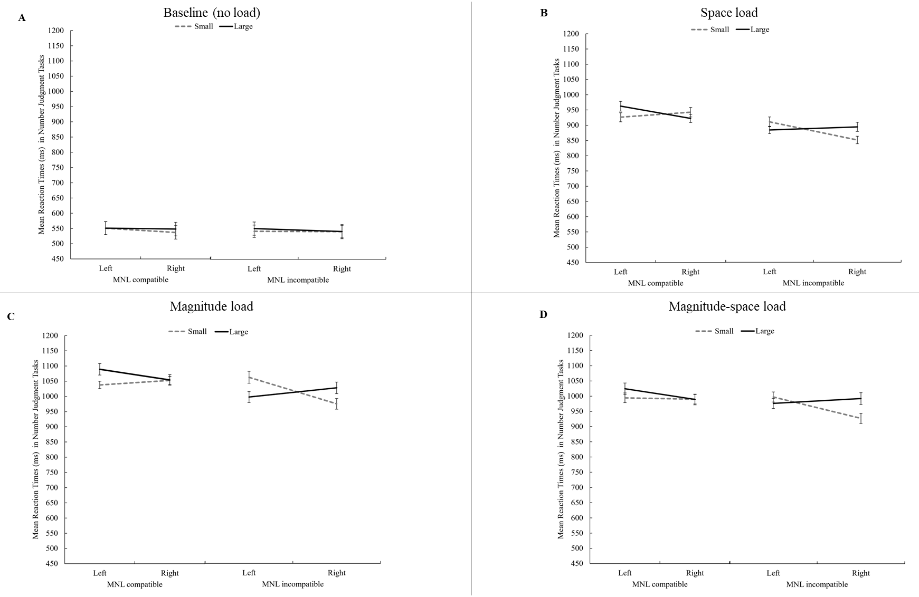
SOM Fig. 4 Mean RTs as a Function of MNL Compatibility (Compatible, Incompatible), WM Load Type (Baseline, Space, Magnitude, and Magnitude-Space Load), Magnitude (Small, Large), and Response-Side (Left, Right). Error Bars Represent 95% CIs, Adjusted for Repeated Measures

