– Extended data figures and Tables

Extended Table 1: Summary of Data Characteristics for the 16 Sites Discussed in Detail. Columns indicate location, observation period, percentage of available data, highest recorded temperature, and highest recorded temperature anomaly. 6-hourly instantaneous data were used for all stations, explaining why the record values or dates in this study differ from those published in the literature (see Methods), the events concerned are highlighted using a star (*).

Station | Latitude | Longitude | Period with data | Data availability (in %) | Temperature  record | Date of Temperature record | Temperature anomaly record | Date of Temperature anomaly record
Amundsen Scott | -90 | 0 | 1957-2022 | 99.99 | -12.3 | 25-12-2011 | 27.89 | 13-09-2013
Casey | -66.28 | 110.52 | 1969-2022 | 99.97 | 8.4 | 30-01-1991 | 16.86 | 31-08-2021
Concordia | -75.1 | 123.33 | 1980-2022 | 91.83 | -9.7* | 25-01-1985 | 37.1 | 18-03-2022
Davis | -68.57 | 77.97 | 1957-2022 | 92.12 | 13 | 07-01-1974 | 16.12 | 27-04-1990
Dumont d’Urville | -66.65 | 140 | 1956-2022 | 99.75 | 8.7 | 02-01-2002 | 17.68 | 07-07-1961
Esperanza | -63.4 | -56.98 | 1960-2022 | 90.78 | 16.5* | 27-05-2016* | 23.13 | 27-05-2016*
Halley | -75.43 | -26.22 | 1957-2022 | 99.97 | 6.3 | 23-12-1991 | 21.2 | 13-08-2016
Marambio | -64.23 | -56.72 | 1971-2022 | 97.69 | 17.1* | 23-03-2015 | 22.03 | 15-07-2010
Mawson | -67.6 | 62.87 | 1954-2022 | 100 | 9 | 09-01-1974 | 19.73 | 14-07-1981
McMurdo | -77.85 | 166.67 | 1956-2022 | 98.19 | 10.6 | 21-12-1987 | 22.31 | 06-07-2017
Neumayer | -70.65 | -8.26 | 1981-2022 | 99.98 | 4.4 | 28-03-1991 | 20.54 | 11-08-2016
Novolazarevskaya | -70.77 | 11.82 | 1961-2022 | 95.98 | 9.7 | 03-02-1996 | 15.37 | 25-08-1996
Rothera | -67.57 | -68.12 | 1976-2022 | 99.67 | 8.7 | 20-01-2003 | 12.24 | 14-07-2010
Syowa | -69 | 39.57 | 1966-2022 | 99.99 | 9.3 | 15-01-1969 | 14.05 | 05-09-2010
Vernadsky | -65.25 | -64.27 | 1947-2022 | 99.7 | 11.9* | 08-02-2022 | 11.87 | 06-08-2021
Vostok | -78.45 | 106.85 | 1958-2022 | 92.24 | -14.4* | 06-01-1974 | 34.29 | 18-03-2022

Extended Table 2: Return period of the highest temperature when the event is included or not in the statistical distribution. 6-hourly instantaneous data were used for all stations, explaining why the record values or dates in this study differ from those published in the literature (see Methods), the events concerned are highlighted using a star (*)
 | date of record | Temperature record (°C) | Return Period (yrs) | Return Period without the record (yrs)
Amundsen Scott | 2011-12-25 | -12,3 | 161 | 424
Casey | 1991-01-30 | 8,4 | 51 | 87
Concordia | 1985-01-25 | -9,7* | 38 | 64
Davis | 1974-01-07 | 13 | 399 | Infinity
Dumont d’Urville | 2002-01-02 | 8,7 | 182 | 1139
Esperanza | 2016-05-27* | 16,5* | 71 | 157
Halley | 1991-12-23 | 6,3 | 88 | 170
Marambio | 2015-03-23 | 17,1* | 171 | 1176
Mawson | 1974-01-09 | 9 | 200 | 1777028
McMurdo | 1987-12-21 | 10,6 | 608 | Infinity
Neumayer | 1991-03-28 | 4,4 | 90 | 10225
Novolazarevskaya | 1996-02-03 | 9,7 | 323 | 4538
Rothera | 2003-01-20 | 8,7 | 267 | Infinity
Syowa | 1969-01-15 | 9,3 | 178 | Infinity
Vernadsky | 2022-02-08 | 11,9* | 98 | 163
Vostok | 1974-01-06 | -14,4* | 124 | 290

Extended Table 3: Occurrence of black swan events in the IPSL-CM6 model simulations. Percentage of the ensemble 60-year pi-control or historical simulations of the IPSL-CM6 model that exhibit occurrence of black swan events at different stations in different environments and at two locations on the Antarctic Peninsula, representing the Larsen C ice shelf and a high-altitude continental site (referred to as Palmer). Calculations are performed using all data, or by removing the value of the strongest maximum.

 | Amundsen Scott | Concordia | Dumont d’Urville | Esperanza | Larsen C | Mawson | Neumayer | Palmer¹ | Vernadsky
T - Pi-control | 12 | 24 | 30 | 18 | 42 | 27 | 52 | 36 | 55
T - Historical | 21 | 12 | 27 | 48 | 27 | 24 | 21 | 18 | 39
AT - Pi-control | 6 | 15 | 21 | 73 | 55 | 18 | 21 | 48 | 94
AT - Historical | 0 | 6 | 27 | 64 | 64 | 15 | 36 | 64 | 82
¹high-altitude (continental) site on the AP
Extended Table 4: Risk ratio of co-occurring Tx (or ATx) with an AR compared to without an AR. Co-occurrences were computed using AR catalogues as retrieved in MERRA-2 and ERA5. AR catalogues consider events as occurrences within±1 day of the detection at each station. Risk ratios not significant at the 95% confidence level are omitted. Due to the low number of events exceeding the 10 years return levels the 95% confidence level should be considered with caution.

 | Tx & AR | Atx & AR | TX10 & AR | ATX10 & AR
Amundsen Scott | 3 | 8 | 12
Casey | 4 | 12 | 27 | infinity
Concordia | 7 | 52 | 9 | infinity
Davis | 5 | 12 |  | 40
Dumont d'Urville | 2 | 20 |  | 45
Esperanza | 7 | 4 | 28
Halley | 2 | 32 |  | 35
Marambio | 7 | 4 | 18 | 18
Mawson |  | 7
McMurdo |  | 5
Neumayer | 4 | 13 | 6 | infinity
Novolazarevskaya | 3 | 6 |  | 10
Rothera | 3 | 20
Syowa |  | 25 |  | 15
Vernadsky | 7 | 8 | infinity | 23
Vostok | 4 | 21 | 31 | infinity

Extended Table 5: Cross-Station co-occurrence of AR-Associated ATx Events Within ±1 Days. This table shows the percentage of annual ATx events associated with an AR at one station that co-occur with AR-associated ATx events at another station within a ±1-day window.

 | Rothera, AP, -68°E | Vernadsky,  AP, -64°E | Esperanza,  AP, -56°E | Marambio,  AP, -56°E | Halley WS, -26°E | Neumayer,  WS, -8°E | Amundsen Scott, WS, 0°E | Novolazarevskaya,WS 11°E | Syowa, EA, 39°E | Mawson, EA, 62°E | Davis, EA, 77°E | Vostok, EA, 106°E | Casey, EA, 110°E | Concordia,  EA, 123°E | Dumont d’Urville,  EA, 140°E | McMurdo,  EA, 166°E
Rothera,  AP, -68°E |  | 13 | 27 | 17 | 3 | 0 | 7 | 0 | 0 | 0 | 0 | 0 | 0 | 0 | 0 | 0
Vernadsky,  AP,-64°E | 17 |  | 4 | 4 | 0 | 0 | 0 | 4 | 0 | 0 | 0 | 0 | 0 | 0 | 4 | 0
Esperanza,  AP, -56°E | 46 | 8 |  | 23 | 0 | 0 | 0 | 0 | 0 | 0 | 0 | 0 | 0 | 0 | 0 | 0
Marambio,  AP, -56°E | 36 | 9 | 27 |  | 0 | 0 | 0 | 0 | 0 | 0 | 0 | 0 | 0 | 0 | 0 | 0
Halley,  WS, -26°E | 3 | 0 | 0 | 0 |  | 14 | 17 | 14 | 3 | 3 | 3 | 0 | 0 | 0 | 0 | 3
Neumayer,  WS, -8°E | 0 | 0 | 0 | 0 | 24 |  | 5 | 0 | 5 | 10 | 0 | 5 | 0 | 0 | 0 | 0
Amundsen Scott,  WS, 0°E | 8 | 0 | 0 | 0 | 20 | 8 |  | 12 | 0 | 0 | 0 | 0 | 0 | 4 | 0 | 0
Novolazarevskaya, WS, 11°E | 0 | 0 | 0 | 0 | 14 | 7 | 7 |  | 14 | 14 | 0 | 0 | 0 | 0 | 0 | 0
Syowa, EA, 39°E | 0 | 0 | 0 | 0 | 0 | 7 | 0 | 14 |  | 7 | 0 | 4 | 7 | 0 | 7 | 0
Mawson, EA, 62°E | 0 | 0 | 0 | 0 | 0 | 0 | 0 | 6 | 19 |  | 38 | 25 | 6 | 0 | 0 | 0
Davis, EA, 77°E | 0 | 5 | 0 | 0 | 5 | 0 | 0 | 11 | 11 | 26 |  | 21 | 16 | 11 | 5 | 11
Vostok, EA, 106°E | 0 | 0 | 0 | 0 | 0 | 0 | 0 | 0 | 0 | 21 | 21 |  | 26 | 26 | 5 | 0
Casey, EA, 110°E | 0 | 5 | 0 | 0 | 0 | 0 | 0 | 5 | 5 | 9 | 14 | 23 |  | 23 | 18 | 5
Concordia,  EA, 123°E | 0 | 0 | 0 | 0 | 0 | 0 | 4 | 0 | 0 | 0 | 7 | 19 | 19 |  | 41 | 7
Dumont d’Urville, EA, 140°E | 0 | 4 | 0 | 0 | 0 | 0 | 4 | 0 | 4 | 0 | 4 | 0 | 8 | 38 |  | 4
McMurdo,  EA, 166°E | 0 | 0 | 0 | 0 | 14 | 0 | 0 | 29 | 14 | 14 | 14 | 0 | 14 | 14 | 14

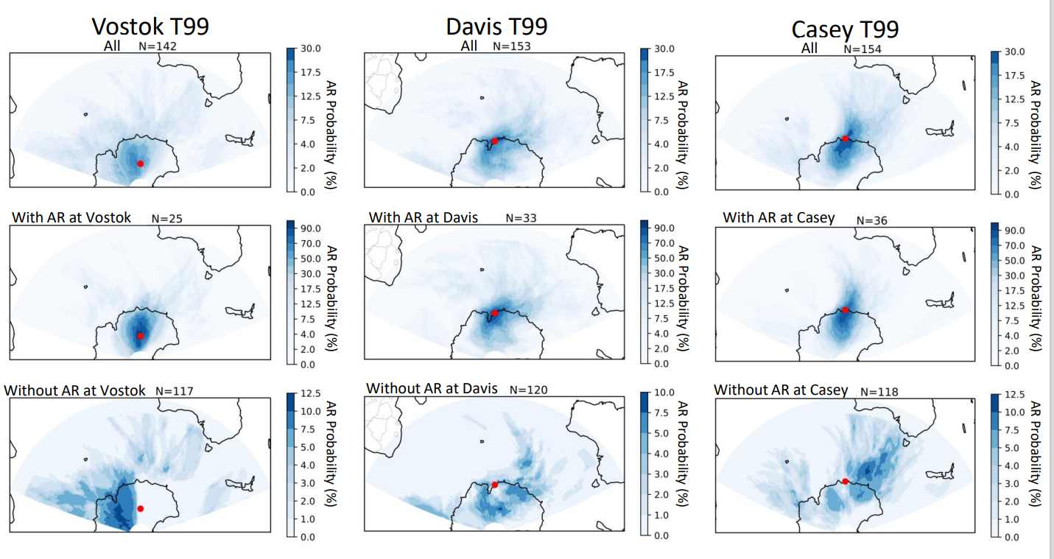

Extended Figure 1: Percentage of ARs linked to temperature days exceeding T99. Panels show the probability of occurrence of an AR at each point on the globe when a high temperature event is observed at Vostok (left) and Davis (center) and Casey (right). This value is expressed as a percentage of the total number of days (value N above each panel) when the temperature exceeds T99 (top), those for which the temperature exceeds T99 and an AR is detected at the station (middle), and those for which the temperature exceeds T99 and no AR is detected at the station (bottom).

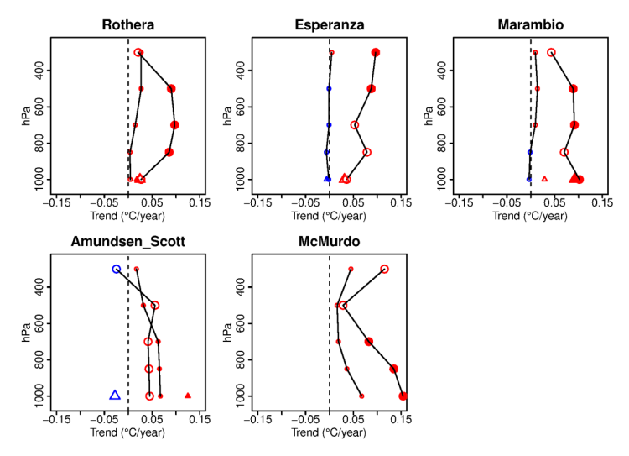

Extended Figure 2: Vertical profiles of temperature trends during temperature where ARs positively impacted TX10 trends. Vertical profiles of ERA5 temperature trends are presented for all atmospheric river (AR) situations (small circles) and for AR situations associated with Tx events (large circles) at each station where ARs significantly impacted the TX10 trend for the 1980–2021 period. Also shown are trends in station data for all AR situations (small triangles) and AR situations associated with Tx events (large triangles). Positive (negative) trends are in red (resp. in blue). Filled (open) symbols represent significant (resp. not significant) trends at the 90% confidence level.

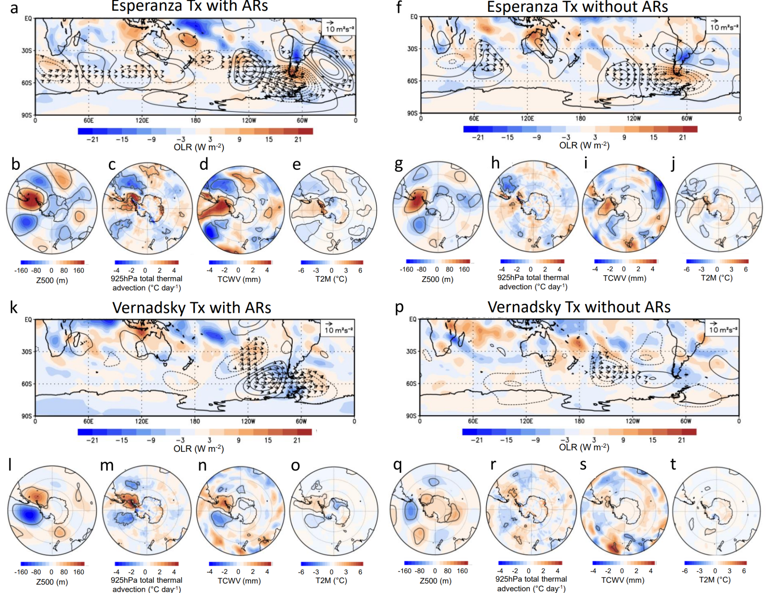Extended Figure 3: Large scale flow anomalies during Tx with atmospheric rivers and without ARs at Esperanza and Vernadsky. Panels show composite anomalies of atmospheric variables for Tx events co-occurring with ARs at Esperanza (accounting for 23 ARs) compared to the mean. The plots show 3-day anomalies/differences for the day of the event and the 2 days leading up to the event: (a) Outgoing Longwave Radiation (shaded, OLR, W m⁻²), 200 hPa stream function (contoured, interval is 3 x 10⁶ m²s⁻¹ with zero contour omitted), and wave flux anomalies (vectors, m² s⁻²). The wave flux vectors less than 2 m² s⁻² (weak to easterly) are omitted. (b) 500 hPa geopotential height anomalies (m). (c) Total thermal total thermal advection at 925 hPa. (d) Total column water vapor (kg m⁻²). (e) 2-meter air temperature (°C). The bold contours are significance levels at 95% using a two-tailed t test. (f-j) same as (a-e) but Tx events without ARs at Esperanza (18 non AR events) compared to the mean. (k-o) same as (a-e) but for Tx events co-occurring with ARs at Vernadsky (accounting for 24 ARs). (p-t) same as (k-o) but Tx events without ARs at Vernadsky (19 non AR events).

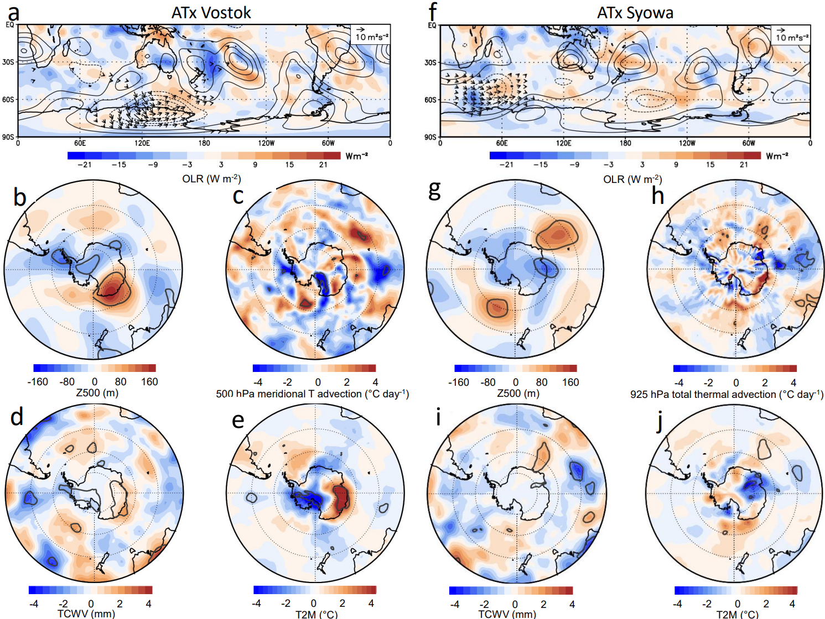

Extended Figure 4: large scale large scale flow differences between ATx events associated with atmospheric rivers and without ARs at Vostok and at Syowa. (a-e) Panels show composite anomalies of atmospheric variables for ATx events co-occurring with ARs compared to ATx events without ARs at Vostok station (accounting for 21 ARs and 18 non AR events). The plots show 3-day anomalies/differences for the day of the event and the 2 days leading up to the event: (a)Outgoing Longwave Radiation (shaded, OLR, W m⁻²), 200 hPa stream function (contoured, interval is 3 x 10⁶ m²s⁻¹ with zero contour omitted), and wave flux anomalies (vectors, m² s⁻²). The wave flux vectors less than 1.75 m² s⁻² (weak to easterly) are omitted. (b) 500 hPa geopotential height, (c) meridional thermal advection at 500 hPa, (d) Total Column of water vapour (mm), (e) Temperature at 2m above the surface (°C). The bold contours are significance levels at 95% using a two-tailed t test. (f-j) same as (a-e) but for Tx days at Syowa (accounting for 30 ARs and 12 non AR events) except for (h) total thermal advection at 925 hPa.
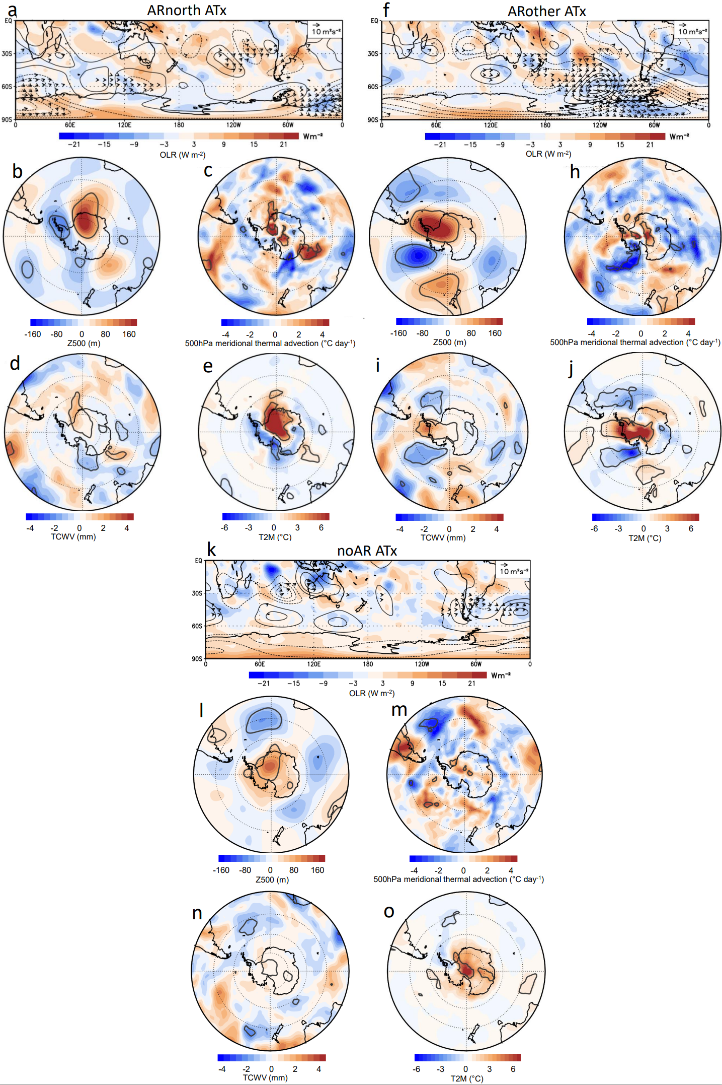

Extended Figure 5: Large scale flow anomalies during ATx with different types of atmospheric rivers at Amundsen Scott station. Panels show composite anomalies of atmospheric variables for ATx events co-occurring with ARs coming from 45°E-45°W sector ("ARnorth", 15 ATx events) compared to the mean. The plots show 3-day anomalies/differences for the day of the event and the 2 days leading up to the event: (a) Outgoing Longwave Radiation (shaded, OLR, W m⁻²), 200 hPa stream function (contoured, interval is 3 x 10⁶ m²s⁻¹ with zero contour omitted), and wave flux anomalies (vectors, m² s⁻²). The wave flux vectors less than 2 m² s⁻² (weak to easterly) are omitted. (b) 500 hPa geopotential height anomalies (m). (c) Meridional thermal advection at 500 hPa. (d) Total column water vapor (kg m⁻²). (e) 2-meter air temperature (°C). The bold contours are significance levels at 95% using a two-tailed t test. (f-j) same as (a-e) but for ATx events co-occurring with an AR coming from another sector ("ARother", 13 ATx events). (k-o) same as (a-e) but for ATx events co-occurring without any AR ("noAR", 14 ATx events).

