Extreme temperature trends in Antarctica exacerbated by explosive atmospheric rivers
Vincent Favier^{1,*}, Juliette Blanchet^{1,*}, Niels Dutrievoz^{1,2,*}, Benjamin Pohl³, Kyle R. Clem⁴, Leonard Barthelemy⁵, Victoire Buffet^{1,3}, Jonathan D. Wille^{1,6}, Francis Codron⁵, Deniz Bozkurt^{7,8,9}, Rebecca Baiman¹⁰, Andrew C. Winters¹⁰, Irina Gorodetskaya¹¹, Tessa Vance^{12,13}, Danielle Udy^{14,15}
¹Institut des Géosciences de l’Environnement, CNRS/UGA, Saint Martin d'Hères, France
²Ecole Normale Supérieure Paris-Saclay, Université Paris-Saclay, 91290 Gif-sur-Yvette, France
³Biogéosciences, UMR6282 CNRS / Université Bourgogne Europe, Dijon, France
⁴School of Geography, Environment and Earth Sciences, Victoria University of Wellington, Wellington, New Zealand
⁵Laboratoire d'Océanographie et du Climat, LOCEAN, Sorbonne Université, CNRS, MNHN, IRD, Paris, France
⁶Institute for Atmospheric and Climate Science, ETH Zurich, Zurich, Switzerland
⁷ Department of Meteorology, University of Valparaíso, Valparaíso, Chile.
⁸ Center for Climate and Resilience Research (CR)2, Santiago, Chile.
⁹ Center for Oceanographic Research COPAS COASTAL, Universidad de Concepción, Concepción, Chile
¹⁰Department of Atmospheric and Oceanic Sciences, University of Colorado Boulder, Boulder, CO, USA
¹¹CIIMAR - Interdisciplinary Centre of Marine and Environmental Research
of the University of Porto, Matosinhos, Portugal
¹²Australian Antarctic Program Partnership, Institute for Marine & Antarctic Studies, University of Tasmania, Battery Point, Tasmania, Australia 7004
¹³Australian Antarctic Division, Channel Highway, Kingston Tasmania. Australia 7050
¹⁴Institute for Marine & Antarctic Studies, University of Tasmania, Hobart, Tasmania, Australia
¹⁵Australian Centre for Excellence in Antarctic Science, University of Tasmania, Hobart, Tasmania, Australia
*authors contributed equally to the present article.
Supplementary information
Supplementary Table 1: TX10 trends and significance at the 90% confidence level over 1980-2020 and the entire period with data
 | Trend 1980-2021 | significant | Trend (entire period) | significant
Amundsen Scott | 1,19 | TRUE | 0,72 | TRUE
Casey | -0,22 |  | -0,13
Concordia | 0,45 |  | 0,45
Davis | -0,06 |  | -0,23
Dumont d’Urville | 0,25 |  | 0,14 | TRUE
Esperanza | 0,96 | TRUE | 0,50 | TRUE
Halley | -0,20 |  | 0,51 | TRUE
Marambio | 0,88 | TRUE | 0,30 | TRUE
Mawson | -0,27 | TRUE | -0,27 | TRUE
McMurdo | -0,56 |  | 0,17 | TRUE
Neumayer | -0,67 | TRUE | -0,67 | TRUE
Novolazarevskaya | -0,35 |  | -0,25
Rothera | 0,05 |  | 0,34 | TRUE
Syowa | -0,24 |  | -0,30
Vernadsky | 0,19 | TRUE | 0,36 | TRUE
Vostok | 0,40 |  | 0,23

Supplementary Table 2: ATX10 trends and significance at the 90% confidence level over 1980-2020 and the entire period with data
 | Trend 1980-2021 | significant | Trend (entire period) | significant
Amundsen Scott | 0,28 |  | 0,15
Casey | 0,34 |  | 0,31
Concordia | -0,40 |  | -0,40
Davis | -0,63 | TRUE | 0,11
Dumont d’Urville | -0,26 |  | -0,13
Esperanza | 0,51 |  | 0,40 | TRUE
Halley | 0,47 |  | 0,18
Marambio | 0,40 | TRUE | 0,33
Mawson | -0,28 |  | 0,10
McMurdo | 0,16 |  | 0,25
Neumayer | 0,24 |  | 0,24
Novolazarevskaya | -0,26 |  | -0,07
Rothera | 0,38 | TRUE | 0,44 | TRUE
Syowa | 0,02 |  | 0,19 | TRUE
Vernadsky | 0,23 | TRUE | 0,10 | TRUE
Vostok | -0,55 |  | -0,15

Supplementary Figures
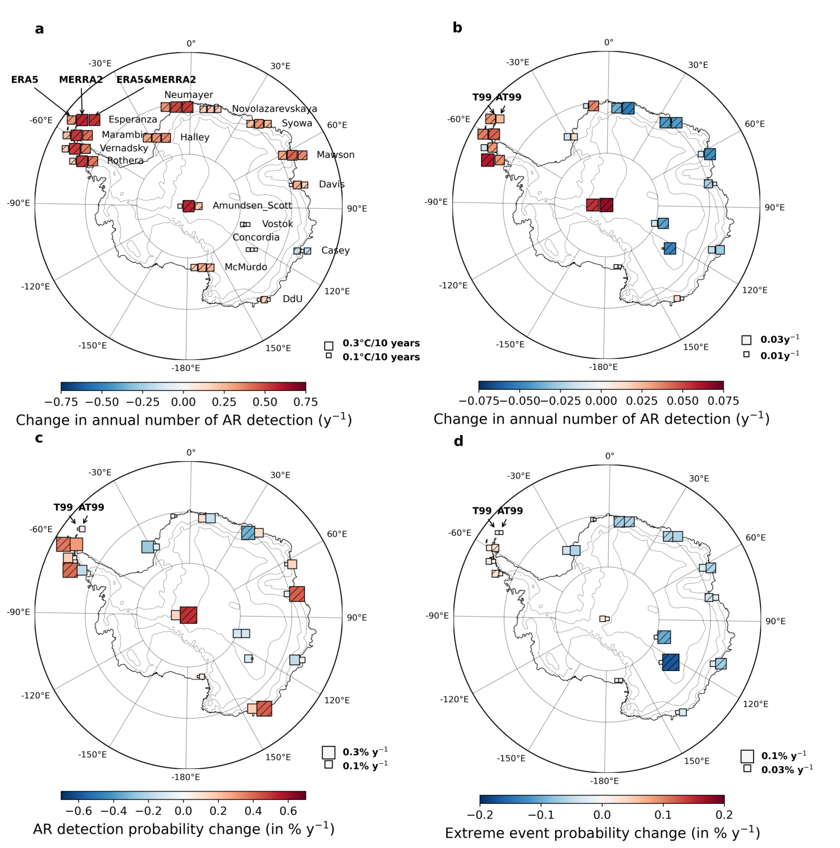
Supplementary Figure 1: Role of AR trends in the variations of high temperature events - Same as Figure 2 but with AR from MERRA-2. For all sites: (a) Trends in the annual detection rate of ARs in ERA5, MERRA-2, and ERA5-MERRA-2 (squares from left to right). (b) Trends in the detection rate of ARs in MERRA-2 associated with temperatures and temperature anomalies exceeding the 99th percentile (T99 and AT99, respectively, squares from left to right). (c) Trends in the probability of detecting an AR during a high temperature event (here T99 or AT99) in MERRA-2 (squares from left to right). (d) Trends in the probability of a high temperature event (here T99 and AT99, squares from left to right) occurring during an AR detection in MERRA-2. The size of the box is changing linearly with the trend, with reference sizes as given in the lower right side of each figure.

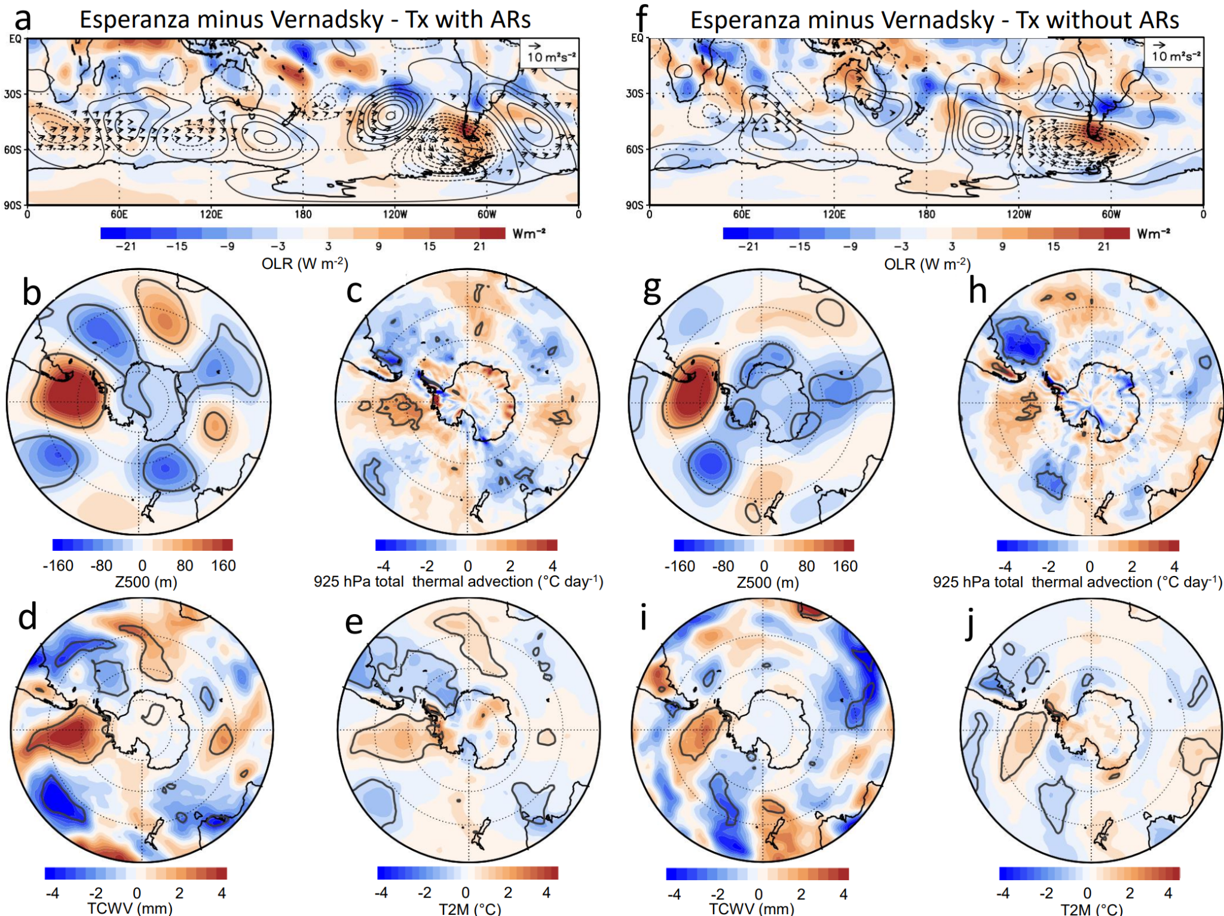

Supplementary Figure 2: Differences in large scale flow anomalies during Tx at Esperanza and Vernadsky associated with ARs. Panels present the difference in composite anomalies between Esperanza (accounting for 23 AR events) and Vernadsky (accounting for 24 AR events) compared to the mean. Panels show (a) Outgoing Longwave Radiation (shaded, OLR, W m⁻²), 200 hPa stream function (contoured, interval is 3 x 10⁶ m²s⁻¹ with zero contour omitted), and wave flux anomalies (vectors, m² s⁻²). The wave flux vectors less than 1.75 m² s⁻² (weak to easterly) are omitted; (b) 500 hPa geopotential height anomalies (m); (c) Total thermal advection at 925 hPa (°C·day⁻¹); (d) Total column water vapor (mm); (e) 2-meter air temperature (°C). The bold contours are significance levels at 95% using a two-tailed t test. (f-j) same as (a-e) but for Tx events that are not co-occurring with an AR.

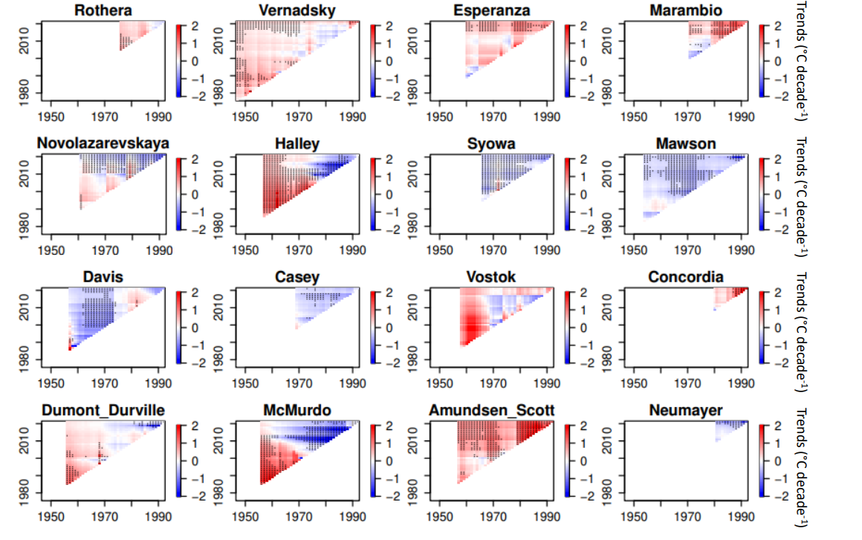

Supplementary Figure 3: Running trend analysis of Tx for successive multi-year periods at each Antarctic station. Years on the x-axis represent the start, and years on the y-axis represent the end of the period for which a trend is calculated. Black dots are where trends are significant at 90% level.

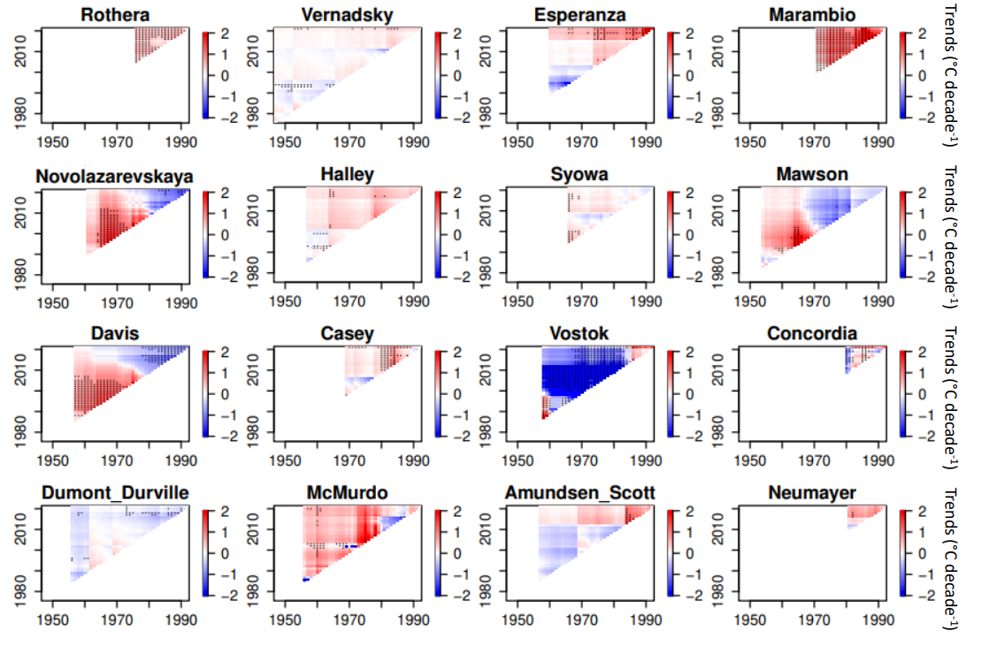

Supplementary Figure 4: same as Supplementary Figure 3 but for ATx.

