LIST OF SUPPORTING INFORMATION

Fig. SI-1. Response surface and contour plot for fluconazole extraction: effects of sample pH and added salt.
Fig. SI-2. Response surface and contour plot for fluconazole extraction: effects of sample pH and solvent volume.
Fig. SI-3. Response surface and contour plot for fluconazole extraction: effects of sample pH and homogenization speed.
Fig. SI-4. Response surface and contour plot for fluconazole extraction: effects of sample pH and homogenization time.
Fig. SI-5. Response surface and contour plot for fluconazole extraction: effects of added salt and solvent volume.
Fig. SI-6. Response surface and contour plot for fluconazole extraction: effects of solvent volume and homogenization speed.
Fig. SI-7. Response surface and contour plot for fluconazole extraction: effects of solvent volume and homogenization time.

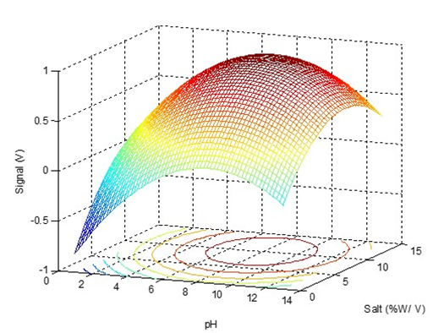
Fig. SI. 1.

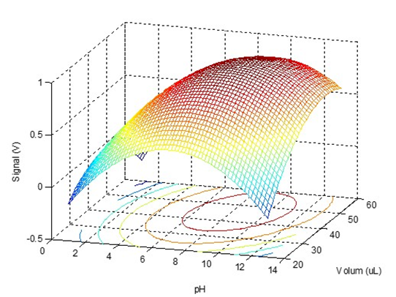

Fig. SI. 2.

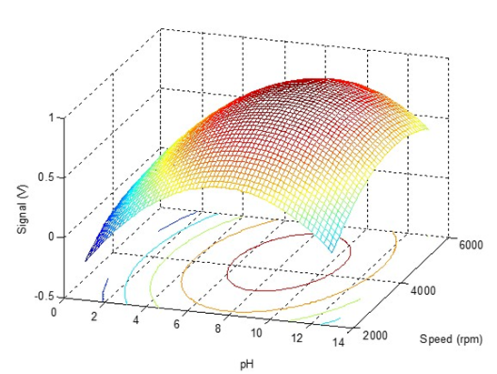

Fig. SI. 3.

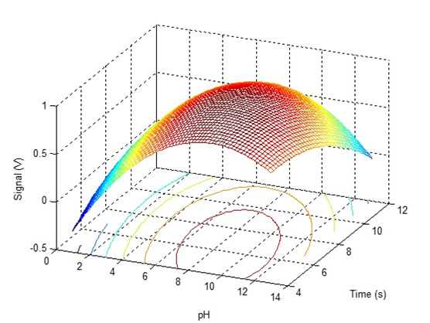
Fig. SI. 4.

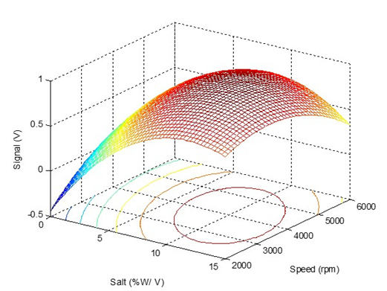

Fig. SI. 5.

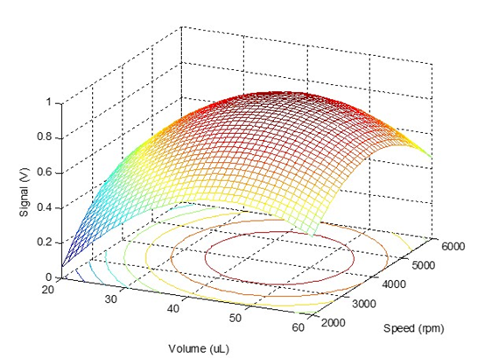

Fig. SI.6.

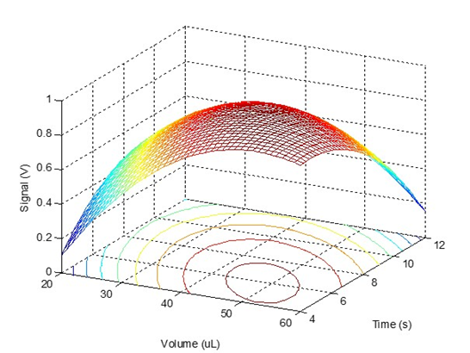

Fig. SI.7.

