Supplementary Material
Evaluation of acid mine drainage sludge as soil substitute for the reclamation of mine solid wastes

Yihan Chi^{a,b,1}, Qinru Lin^{b,1}, Rongchuan Zhuangª, Mingyu Xiongª, Zhihong Ye^{b,*}.

Yihan Chi
ª State key laboratory for comprehensive utilization of low-grade refractory gold ores, Longyan 364200, Fujian, China. Email: chiyihan@mail2.sysu.edu.cn

^{b} School of Life Sciences, Sun Yat-sen University, Guangzhou 510006, China.
Qinru Lin

^{b} School of Life Sciences, Sun Yat-sen University, Guangzhou 510006, China. E-mail: linqr6@mail2.sysu.edu.cn
Rongchuan Zhuang
ª State key laboratory for comprehensive utilization of low-grade refractory gold ores, Longyan 364200, Fujian, China. Email: zhuangsan@yahoo.com
Mingyu Xiong
ª State key laboratory for comprehensive utilization of low-grade refractory gold ores, Longyan 364200, Fujian, China. Email: 125279179@qq.com

Corresponding author
Zhihong Ye

^{b} School of Life Sciences, Sun Yat-sen University, Guangzhou 510006, China. Tel: +86-13424470257; E-mail: lssyzhh@mail.sysu.edu.cn.

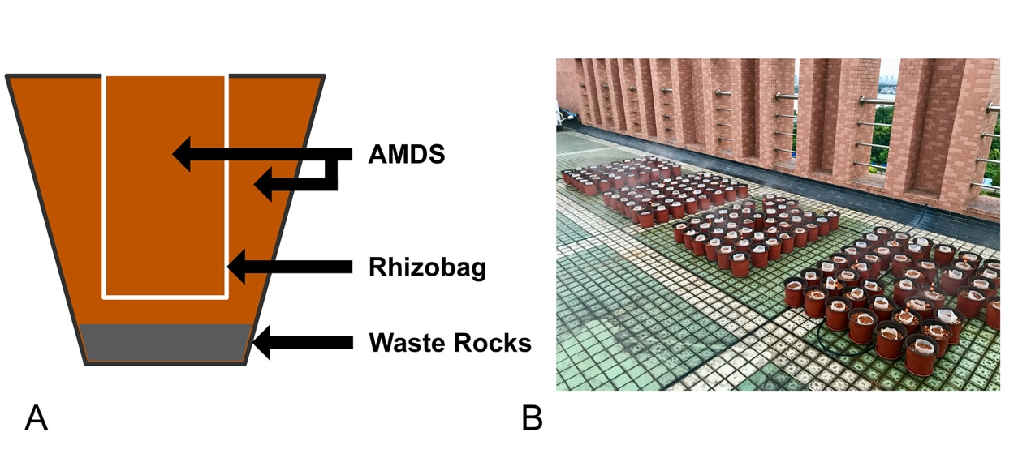
Fig. S1 Schematic illustration of the pot and overall layout of all the pots in this study. AMDS, acid mine drainage sludge.

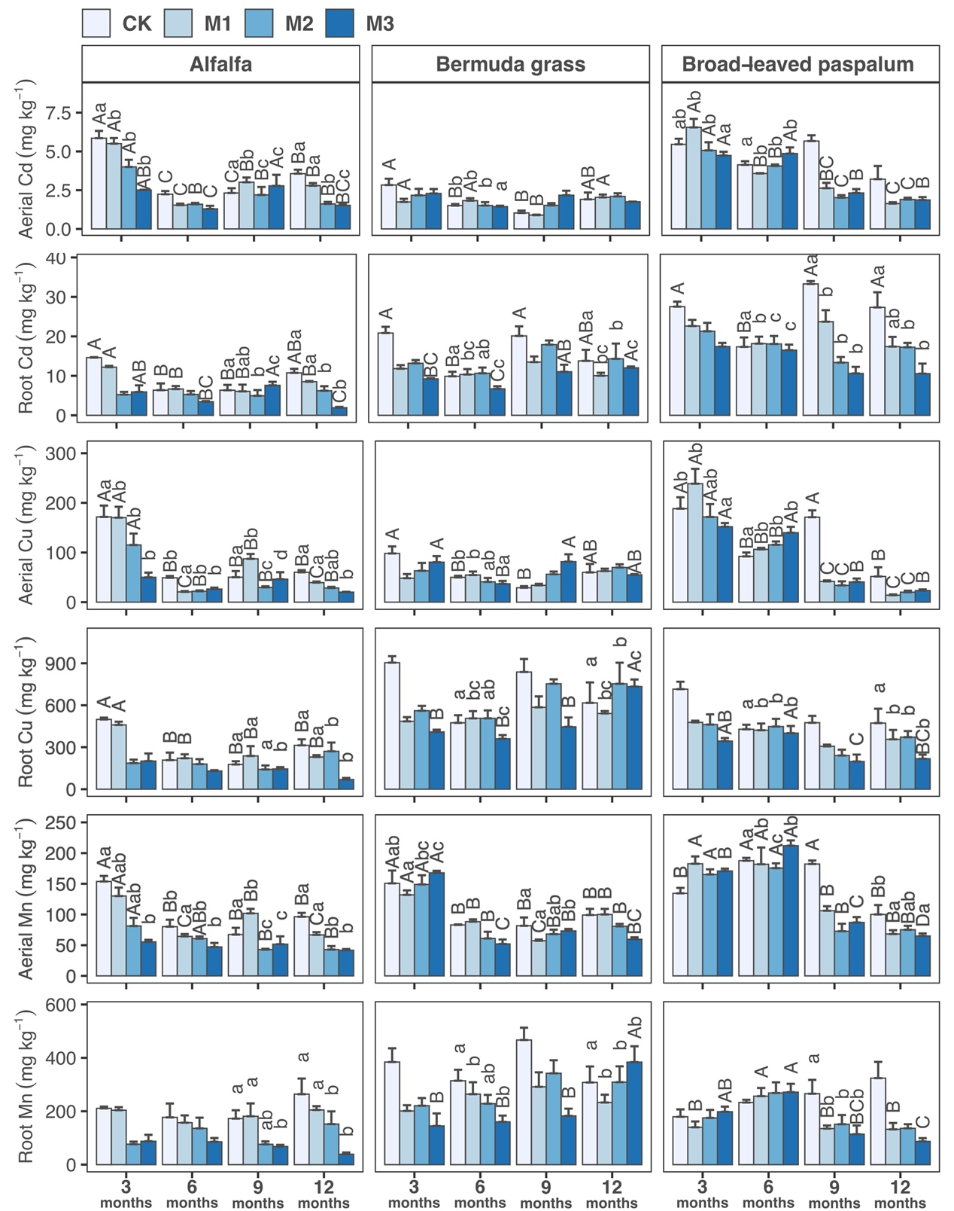
Fig. S2 Concentrations of Cd, Cu and Mn in aerial parts and root of plants with different fertilizer treatments at different sampling times. M1, 2.5% manure application and 1 g of chemical fertilizer applied every three months; M2, 5.0% manure application and 2 g of chemical fertilizer applied every three months; M3, 10.0% manure application and 4 g of chemical fertilizer applied every three months. CK, control, no fertilizer application. Different lower-case letters indicate significant differences at p < 0.05 level between different fertilizer treatments at each sampling time. Different upper-case letters indicate significant differences at p < 0.05 level between different sampling times in each fertilizer treatment.

