Supplementary Information
Micro-scale organization of non-cyanobacterial diazotrophs drives nitrogen fixation in marine particles

Arthur Coët^{1,3}, Olivier Grosso¹, Nicolas Brouilly², Pierre Ronceray³, Mar Benavides^{1,4*}
(1) Aix Marseille Univ, Université de Toulon, CNRS, IRD, MIO UM 110, Marseille, France
(2) CNRS, IBDM, Aix-Marseille Université, 13009 Marseille, France
(3) Aix Marseille Univ, CNRS, CINAM, Turing Centre for Living Systems, Marseille, France
(4) National Oceanography Centre, European Way, Southampton SO14 3ZH, United Kingdom

*Corresponding author : Mar Benavides (mar.benavides@noc.ac.uk)

This file includes:
Supplementary Methods
Supplementary Figures S1-S2
Supplementary Tables S1-S7
Supplementary methods
Image processing
For each channel and annulus, the image was duplicated and cropped to retain only the region of interest. Cell detection was performed in TrackMate using the Laplacian-of-Gaussian detector (estimated spot diameter 2 μm); thresholds were set based on quality histograms and detections verified visually to avoid false positives.
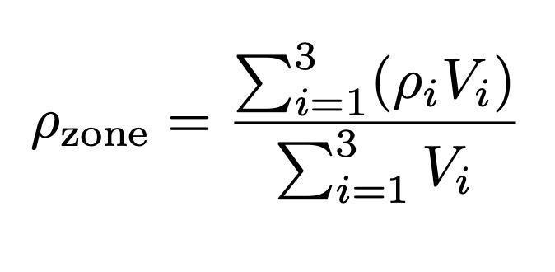
The area of each annulus (measured in Fiji) was multiplied by the slice thickness (2 μm) to obtain its volume (Vi). For each 3D annulus, we determined the density (cells μm⁻³) of DAPI, RSG⁺, and NifH⁺ cells. Densities from three equatorial slices (one per particle) were pooled as a volume-weighted mean, yielding a representative value for each radial zone.

For each zone, an enrichment factor (EF) was calculated as:
where ρfree-living​ is the density of cells in the 0.2–3 μm fraction from the same bottle. Zonal densities were also expressed as percentages of the total DAPI count.
To estimate the number of diatoms per aggregate, we first measured the initial culture concentration (4 × 10⁵ cells mL⁻¹). A 500 mL aliquot was mixed with 500 mL of filtered seawater and incubated in roller tables. Aggregates (0.8 ± 0.25 mL⁻¹) were counted, giving 800 l⁻¹. Aggregate volumes were obtained from projected areas assuming a prolate ellipsoid (V = 4/3 πab²), with a mean of 44,421 ± 16,000 μm³. Thalassiosira pseudonana cells were approximated as cylinders (length 4 µm, diameter 7 µm; 1), yielding 88 µm³ per cell. Based on 2 × 10⁸ cells added, we estimate 2.5 × 10⁵ diatoms and 2.1 × 10⁷ µm³ of diatom biomass per aggregate. Compared to measured aggregate volume (4.4 × 10⁴ µm³), this implies a 500-fold compaction, used to scale free-living cell densities for comparison with particle-associated populations. This approximation ignores porosity, resin shrinkage, and should be interpreted cautiously.
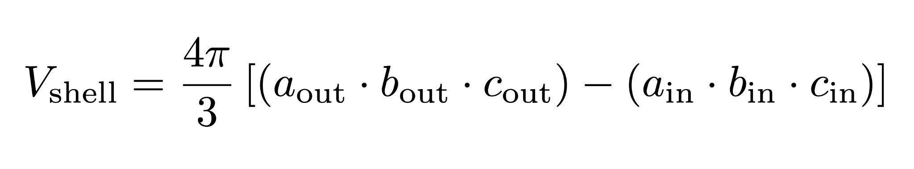
Total particle-associated cell numbers were extrapolated by calculating the volume of each concentric annulus as a 3D ellipsoidal shell (difference between outer and inner ellipsoids). A volume-weighted mean density for the whole particle was then multiplied by mean aggregate volume to yield cell numbers per aggregate, and by aggregate abundance to estimate total particle-associated populations per treatment.

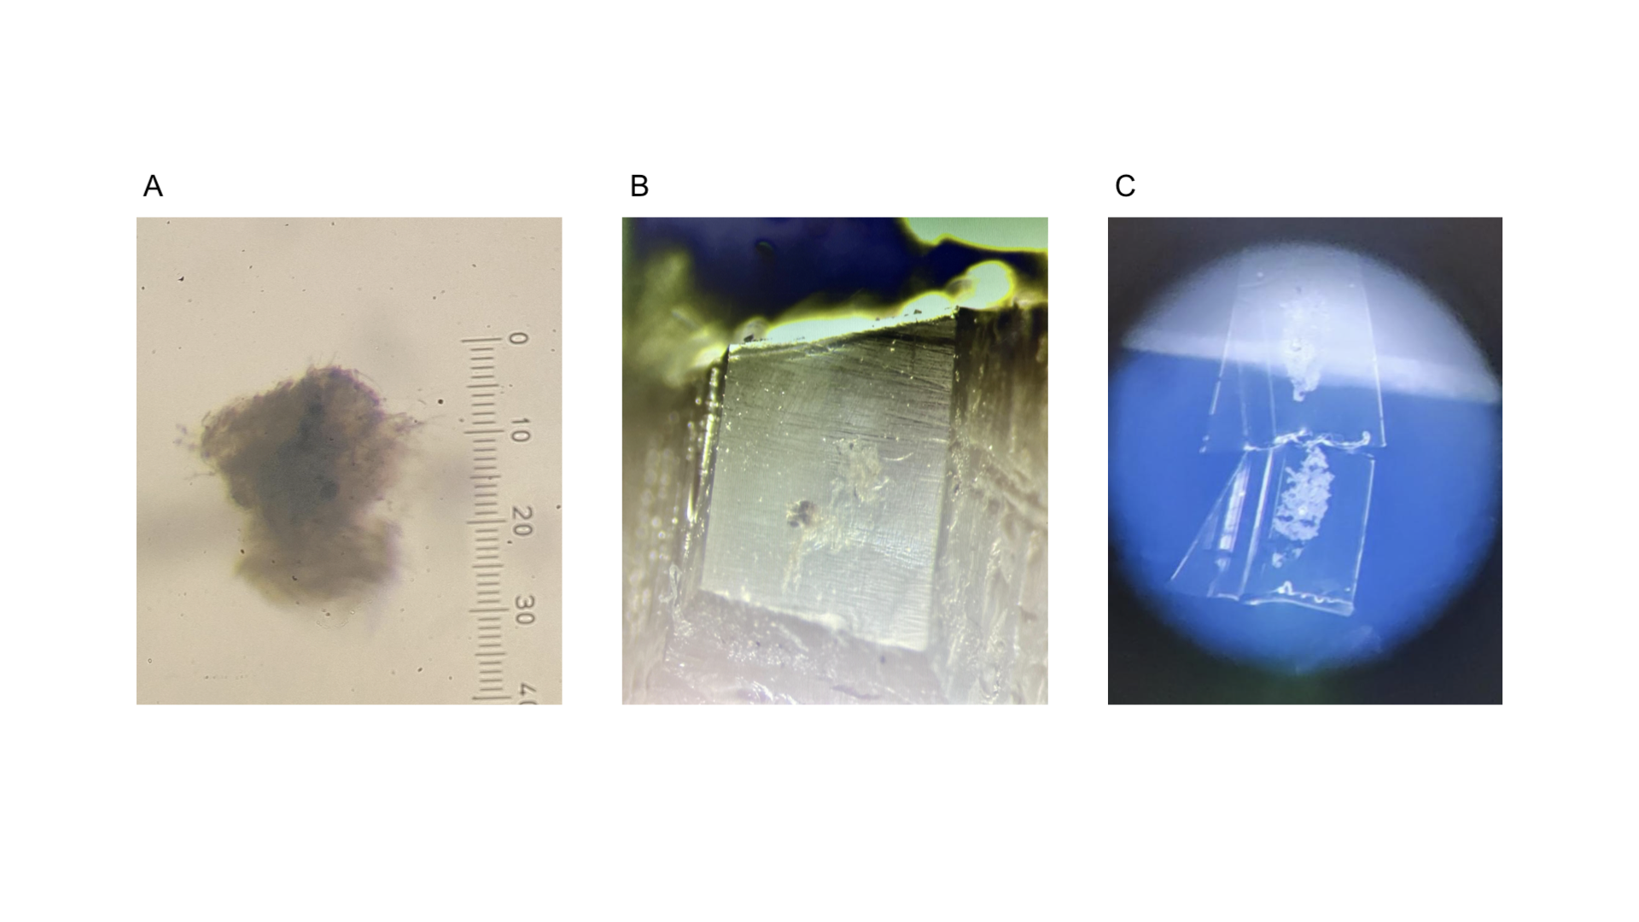
Supplementary figures
Figure S1: Sample preparation workflow for particle embedding and sectioning. (A) Agarose-embedded particle observed under a Leica M165C stereomicroscope, with a calibrated scale bar (1 division = 25 µm). (B) Methacrylate block containing a particle, image taken from the instrument screen. (C) Semi-thin sections (2 µm) obtained from the block using a glass knife.
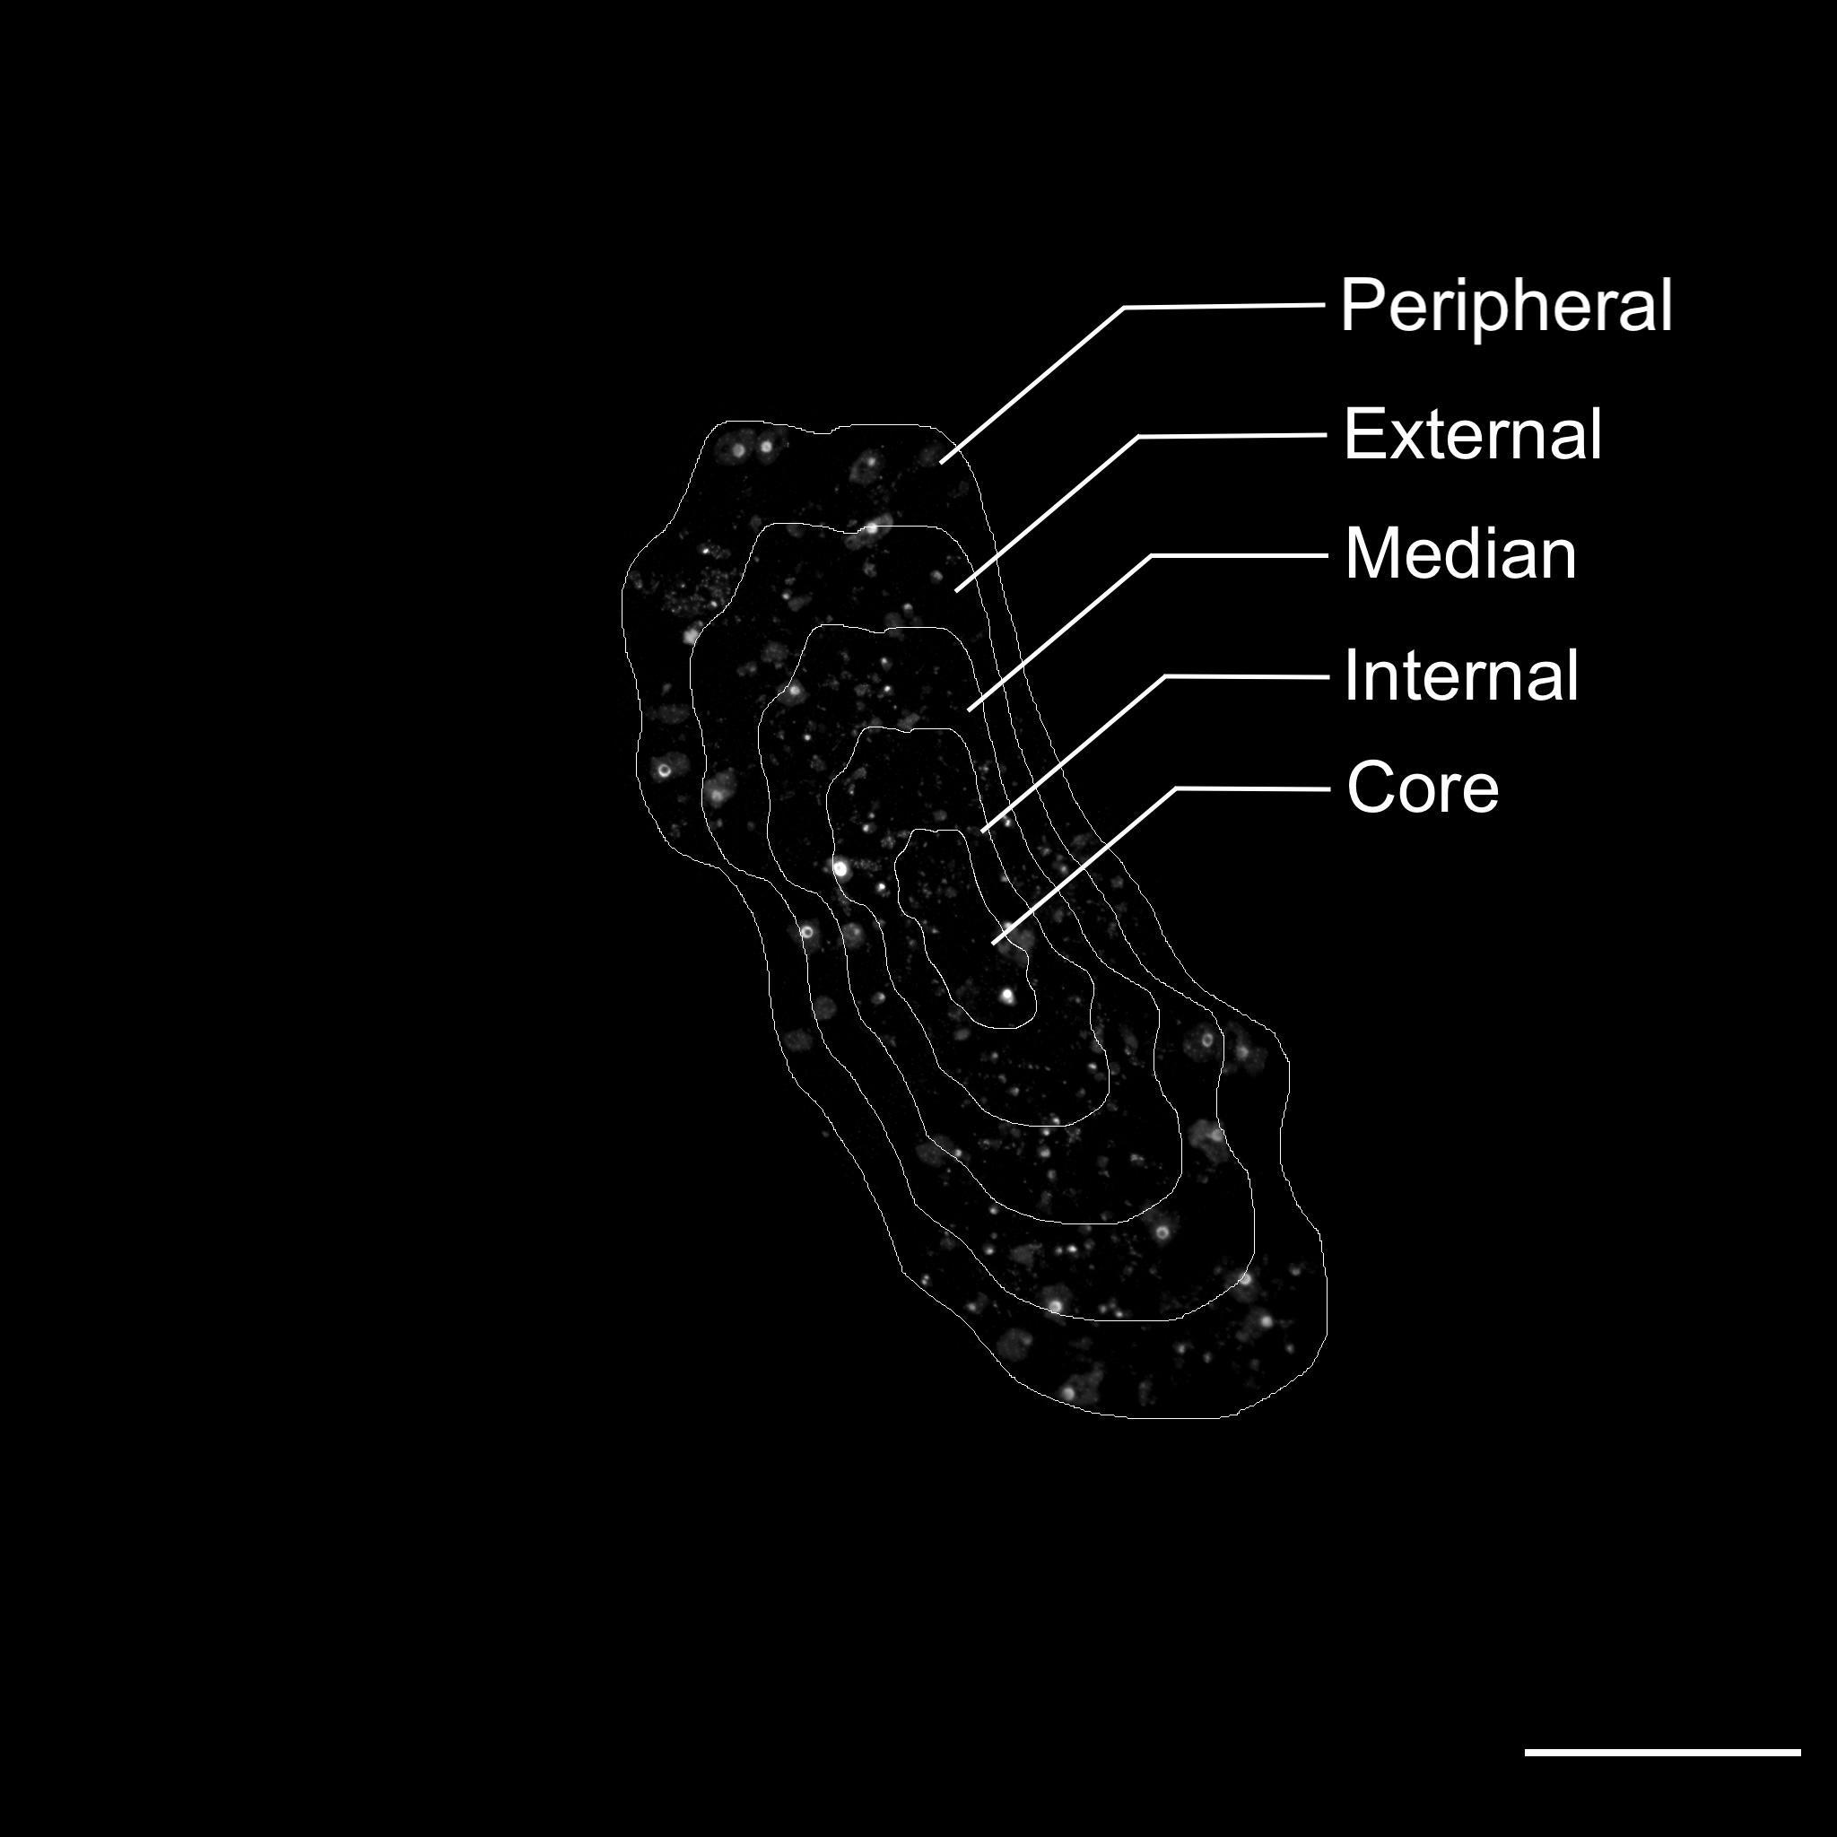
Figure S2: Ultramicrotome equatorial section of a marine particle showing the five concentric zones used for spatial analysis: Peripheral (0-20% of radius), External (20-40%), Median (40-60%), Internal (60-80%), and Core (80-100%). White dots represent individual bacterial cells detected by DAPI staining. This zonation approach enabled quantitative analysis of cell distribution from particle periphery to core. Scale bar = 100 μm.

Supplementary tables

Table S1: DAPI⁺ and NifH⁺ counts in the 0.2–3 µm fraction, obtained from 0.2 µm polycarbonate filters stained with DAPI (for total cells) and anti-NifH antibody (for diazotrophs). Raw counts per filter were converted to cell abundances (cells mL⁻¹) by normalizing to the filtered volume, and are reported by treatment and incubation time.

Table S2: Raw counts of NifH⁺, RSG⁺, and DAPI⁺ cells per concentric layer in particle cross-sections, with calculated shell volumes, slice volumes, and resulting cell densities (cells µm⁻³).

Table S3: MIMS measurements of O₂/Ar ratios and ¹⁵N₂ enrichment.
O₂/Ar ratios (% of initial) by treatment and time, with corresponding dissolved ¹⁵N₂ enrichment values.

Table S4: IRMS results for bulk particulate ¹⁵N enrichment and derived N₂ fixation rates.
Atom % ¹⁵N, δ¹⁵N, and volumetric N₂ fixation rates per bottle across treatments and incubation times.

Table S5: Pairwise Wilcoxon comparisons of enrichment factors (particle-associated vs free-living) across radial zones and incubation times. Reported values include W statistics, p-values, adjusted p-values (BH correction), Cliff’s delta effect sizes with confidence intervals, and qualitative magnitude.

Table S6: Kruskal–Wallis results for N₂ fixation per NifH⁺ cell across incubation times (12, 24, 72 h) within each treatment. Reported values: n, H statistic, df, p-value.

Table S7: Pairwise Dunn’s tests contrasting time points (12, 24, 72 h) within each treatment. Reported values: Z statistic, raw and adjusted p-values, significance codes

References:
1. Hildebrand, M., Kim, S., Shi, D., Scott, K. & Subramaniam, S. 3D imaging of diatoms with ion-abrasion scanning electron microscopy. J. Struct. Biol. 166, 316–328 (2009).

